Microsoft Consulting Services
Telecommunications PRactice

configuring a vpn solution

Document Purpose
This document describes the requirements and setup procedures for a VPN solution using Microsoft® Windows® 2000. This document is also intended for the technical user who has limited understanding of VPN solution and seeks to understand them in greater detail.
Table of Contents

Configuring a VPN Server 1
Server Requirements 1
Disabling Server Services 1
Configuring VPN Server 2
Creating a VPN Connectoid 13
Building A Connectoid 14
Post Configuration Settings 29

Configuring a VPN Server

In order to provide a secure point of entry you can use the following instructions to setup a Virtual Private Network (VPN) for most common environments. When implementing a VPN solution one must be aware of the changes this has on accessing data. Any data that is behind the VPN server needs to be accessed through the VPN server unless you are part of the VPN LAN. This means any server that you need to access (not dependent on the service installed) without the VPN security must be outside of the VPN segment. This is because with a VPN server one cannot single out which services should be locked down, it is an all or nothing approach. What this means for a company hosting secure FTP services the server needs to be sitting behind the VPN Server.

Server Requirements
The following is a baseline for requirements for a VPN Server. You must have a multihomed server. If the server is not multihomed you will not be able to install the VPN services. Your minimum hardware requirements are as follows:

Pentium 133 or higher processor
128 MB RAM (256 recommended)
4 GB HD
Microsoft® Windows® 2000 Server/Windows 2000 Advanced Server

Disabling Server Services
When a VPN server is configured it is an excellent idea to disable all service that are not required. This does two things for you. First it is giving back resources to the server that can be used by other components. Second it is making your backend network more secure by turning off services that are potential entry points for people trying to break into your network. The following is a list of services to shut down at your discretion.

Distributed File System
Distributed Transaction Coordinator
Fax Services
File Replication
Indexing Service
Internet Connection Sharing
Intersite Messaging
Kerberos Key Distribution Center
License Logging Service
Print Spooler
Task Scheduler
Telnet
Windows Installer

Note: Do not disable the remote registry service. If this service is disabled the VPN server will not operate correct.

Configuring VPN Server
In this section you will be taken through a step-by-step process of configuring a VPN server on a computer that has Windows 2000 Server or Windows 2000 Advanced Server installed on it.

- Start the RRAS configuration process by choosing Start|Programs|Administrative tools|Routing and remote access.
- Right-click the server name and choose Configure and Enable Routing and Remote Access.

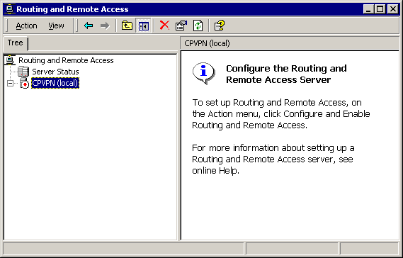

- The Routing and Remote Access Server (RRAS) Setup wizard appears. Click Next.

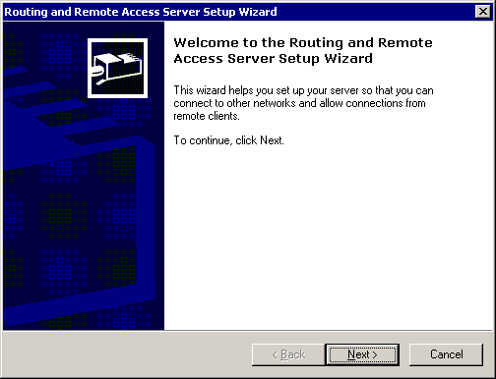

- Do not choose Virtual private network (VPN) server—there is a bug in the wizard that improperly configures routing (see the Microsoft Knowledge Base article Q243374 for more information). Instead, choose Manually configured server. Click Next.

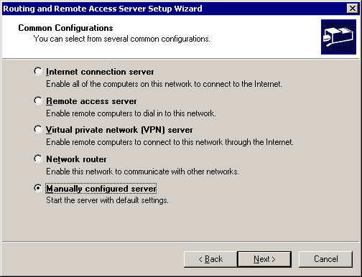

- When the RRAS Wizard is complete, click Finish.

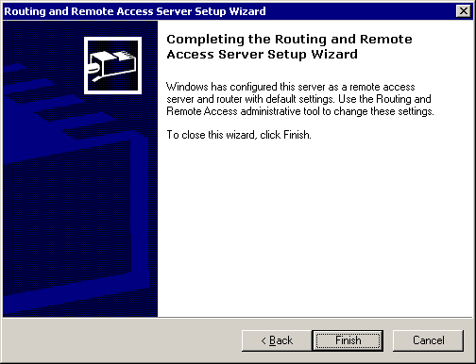

- Now you will want to start RRAS when prompted. Click Yes. RRAS initializes and shows its MMC interface. Make sure that the server is selected.

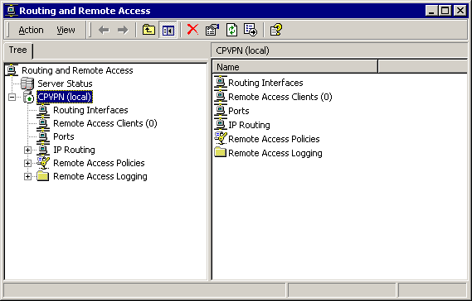

- Next, right-click the server name and choose Properties. Then click the IP tab.

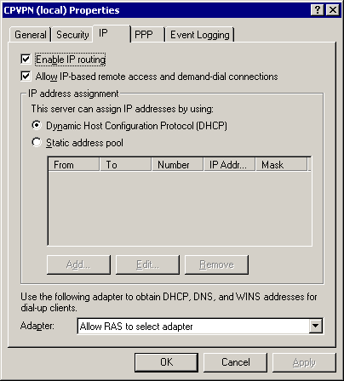

- Choose Static address pool and click Add. Enter a range of IP addresses that the RRAS server should hand out to remote clients. In this example, the range is 10.100.200.1-254 Click OK. Note: If you will have more then 254 simultaneous users you will need span more then one subnet.

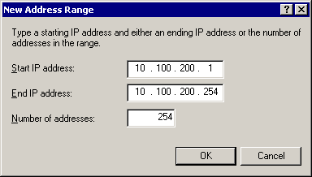

- In the Use the following adapter to obtain DHCP, DNS, and WINS addresses for dial-up clients field, choose the adapter that is connected to your private network or FTP content server. In this example, it is Back Net.

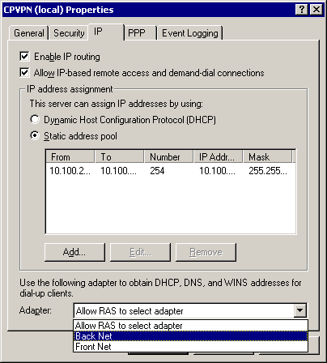

- Next, click the Event Logging tab and choose Log the maximum amount of information. This helps with troubleshooting connection problems. You are now finished configuring the properties of the VPN server. Click OK.

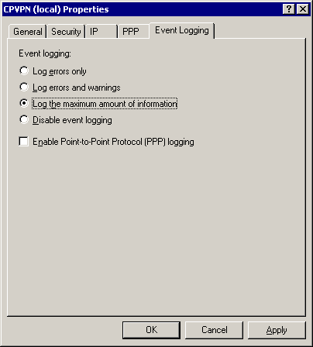

- Next, you will need to configure the PPTP and L2TP ports. In the RRAS interface, select Ports. A list of tunnel ports appears in the RRAS MMC.

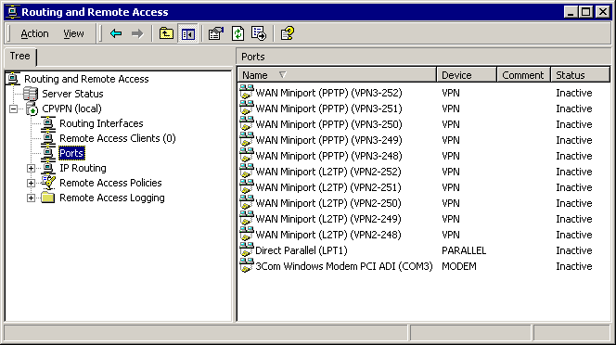
- Right-click Ports and choose Properties.
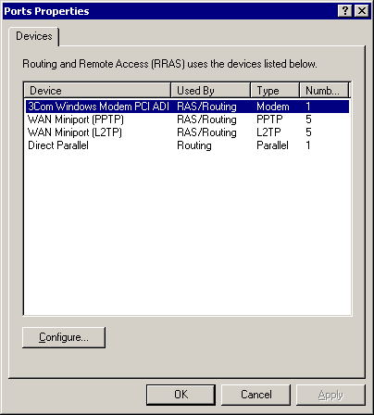

- To configure the PPTP ports, select "WAN Miniport (PPTP)" and click Configure. Because you are not creating server-to-server tunnels with this server, deselect Demand-dial routing connections (inbound and outbound). Increase the number of ports as necessary for your environment (up to 16,384 maximum). In this example, 128 ports are configured. Click OK.

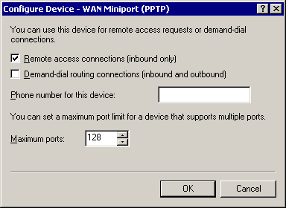

- Since you are not using IPSec in this example, there is no need for L2TP ports. Select WAN Miniport (L2TP) and click Configure. Change the number of ports to zero. Click OK.

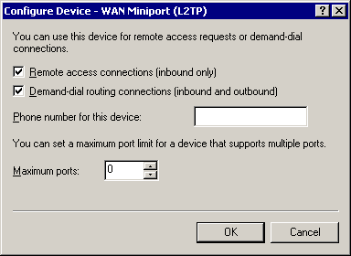

- You may receive a notice indicating that current connections might be disconnected. Click Yes because there are no current connections right now.

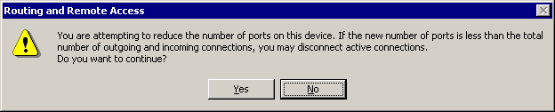

- Once back in the Ports Properties dialog, click OK.

- In the RRAS MMC you will see the new PPTP ports you defined. Note: The port identifier numbers may be different than shown here.
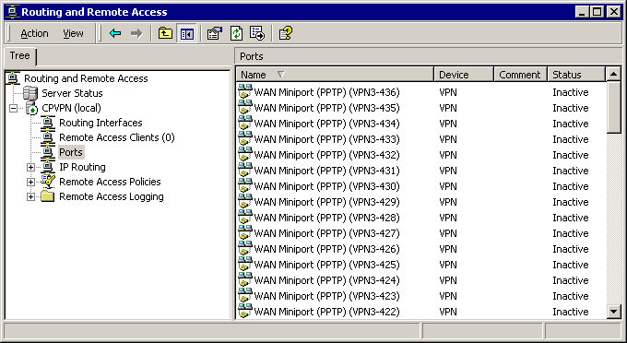

- From the RRAS MMC interface, select Remote Access Logging.

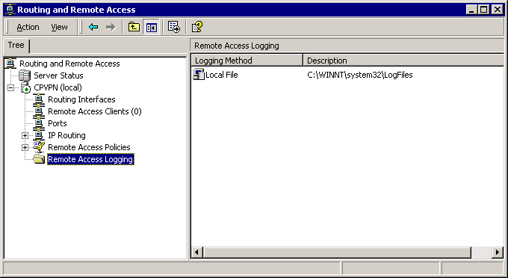
- Right-click Local File from the right hand column and choose Properties. Select Log authentication requests from the Settings tab. Click OK.

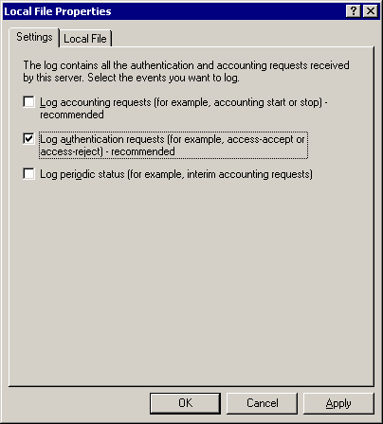

You are finished configuring RRAS on the server. Close the RRAS MMC.

Creating a VPN Connectoid

In order to create a connectoid – a connectoid, in Windows 9x and Windows NT, is an icon representing a dial-up networking connection that will also execute a script for logging onto the network dialed – that can be distributed to many users you must first make sure that you have the Connection Manager Administration Kit installed. In order to verify this go to Programs|Administrative Tools and see if the Connection Manger Administration Kit is present. If it is not you will need to install it. To install it on to a server go to Settings|Control Panel|Add Remove Programs|Add Remove Windows Components then select Management and Monitoring tools. Next click on details and only select Connection Manager Components click OK, then click Next and follow the screen prompts. Once you have verified or installed connection manager you are ready to start.

Note: You can use your own company logos for the connectoid. If you would like to do this make sure the logo is in the form of a .bmp file.

Building A Connectoid
- The first thing that you need to do is start the Connection Manager application by going to Programs|Administrative Tools|Connection Manager Administration Kit. Once you have started the application you will be at the welcome screen which looks like to one below. Click Next.

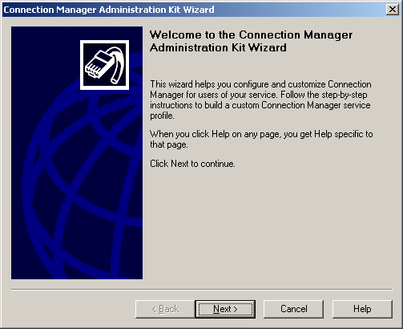

- In the next step you will create a new service profile. Make sure the Create New Service Profile radio button is active. Click Next.

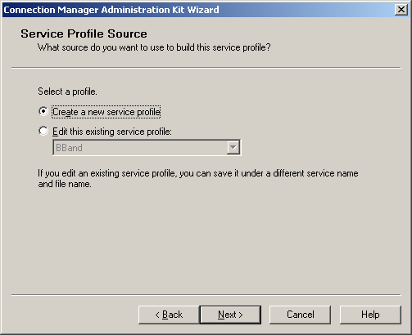

- In the next step, you will be prompted for a service name and a file name. The service name is the name you wish to give the connectoid. The file name is the name of the executable file that will be created. Your screen should look similar to the one below. Click Next.
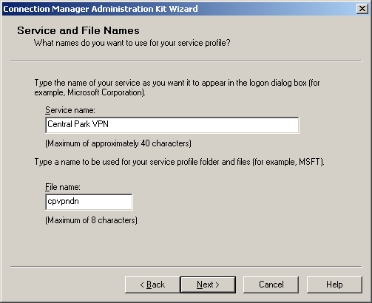

- In the next step you are asked to merge service profiles. Since you do not have an existing profile click Next.

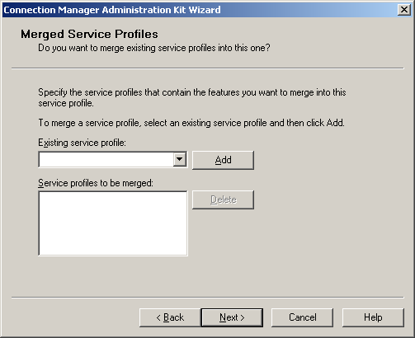

- The next step is the Support Information dialog. This would be a good place to point the users to the help button or provide them a phone number to call to get help. Fill in your information and click Next.

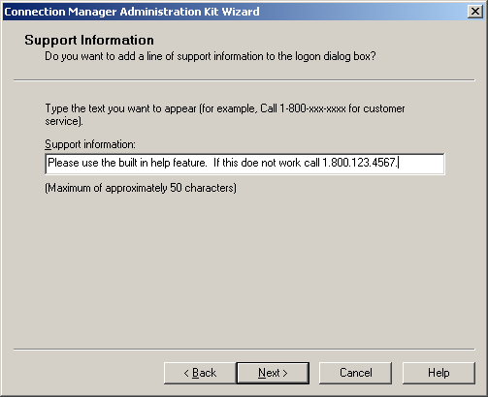

- The next step prompts you for a Realm Name. The VPN service does not require a realm name so you may click Next.

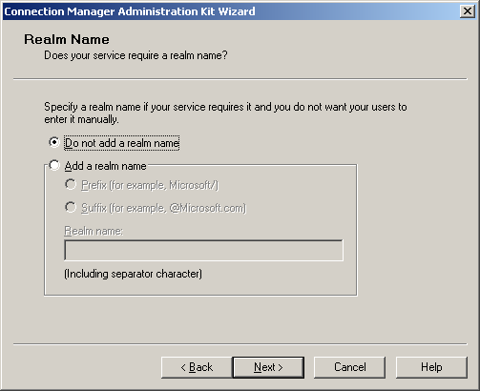

- In the next step you are prompted for dial-up networking numbers. Once again, VPNs do not use this function so click Next.

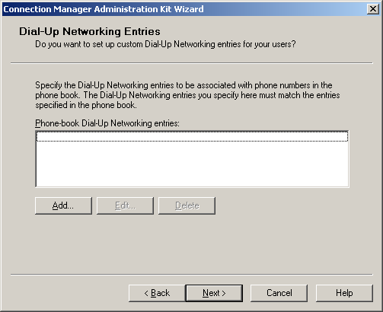

- In the next step you are prompted for VPN support. You will want to select This Service Profile as shown below and click Next.

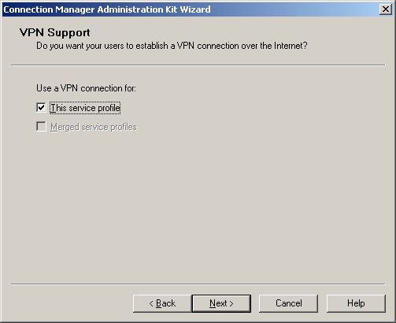

- In the next step you are asked to provide a server name for the VPN connection. You can either use the IP address or you can use the fully qualified name of the server as shown below. When you are finished click Next.
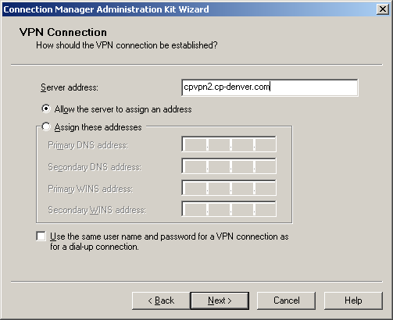

- At the next step, you are asked if you wish to use Connect Actions. A connect action would be an application or batch that is run pre-connect, pre-tunnel, post-tunnel and on disconnect. At this time, you are not using any so deselect all boxes as shown below and click Next.

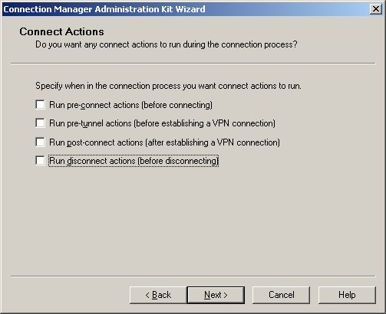

- The next step will prompt you for any auto applications you want to run when a user connects. Click Next.

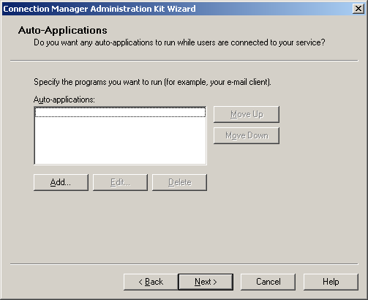

- The next step prompts you for a Logon Bitmap for the logon screen. This is where you will use your company logo or the customer logo if you have one. If you do not have one select the default and click Next.

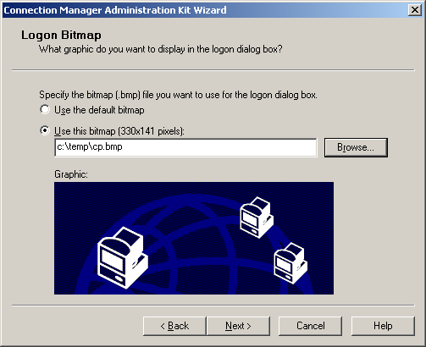

- In the next step you are prompted for a Phone Book Bitmap. Since we are not using dial-up networking you may click Next.

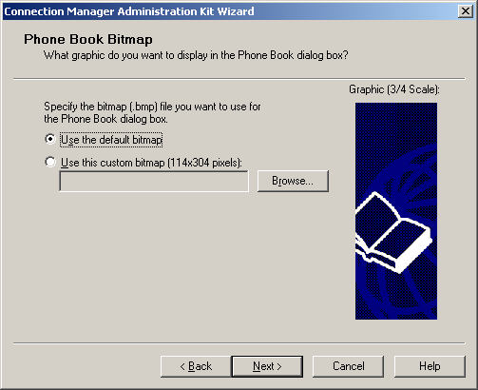

- In the next screen you are prompted for a Phone Book file. Once again since we are not using dial-up networking you may click Next.

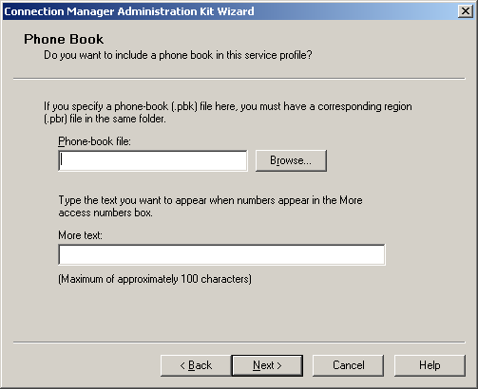

- The next step prompts you for icons. Accept the defaults and click Next.

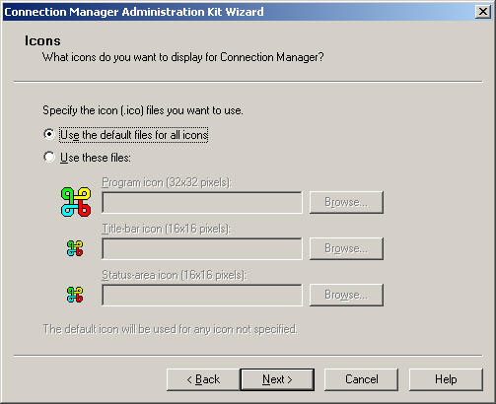

- From the Status-Area-Icon Menu screen accept the defaults and click Next.

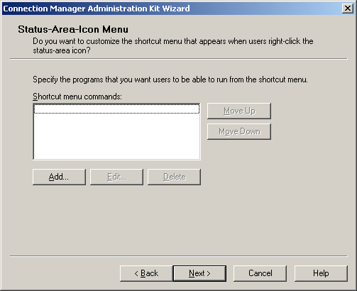

- The next screen prompts you for a Help File. If you have a customized help file select it at this time. If you do not, accept the default and click Next.

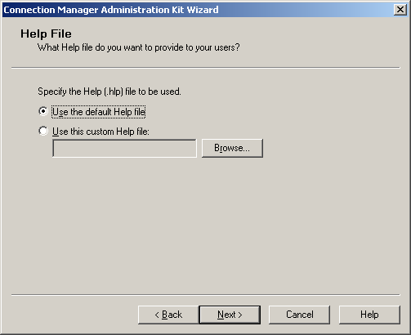

- From the Connection Manager software screen you will want to make sure the include Connection Manager 1.2 software is selected and click Next.

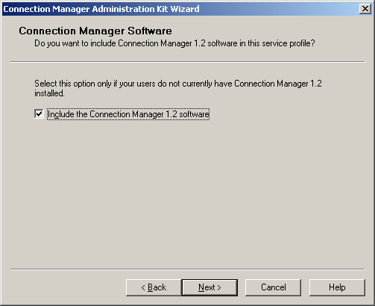

- From the License Agreement screen, accept the defaults unless you have a license agreement file click Next.

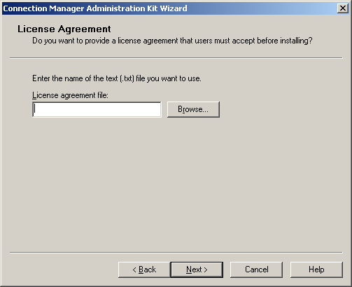

- The next screen prompts you for additional files to provide the end user. At this time we do not have any, so click Next.

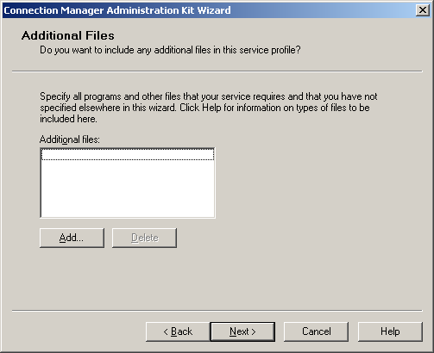

- Now you will see the Ready to Build Service Profile dialog click Next.

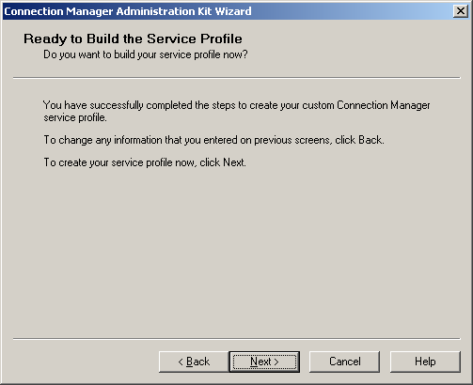
- The final step to complete the Connection Manager Administration Kit Wizard is next. Accept the default file location and click Finish.

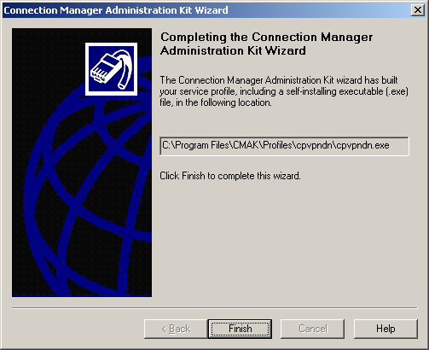

Post Configuration Settings
By default the connectoid that was created can be used for either a dial-up connection or a VPN connection. We have five (5) more steps to ensure a good experience for your users:

- First we need to locate the executable for the connectoid that we just created. You should be able to find this under Program Files|CMAK|Profiles|(connectoid name). In this folder there is a file that has a .CMS extension.

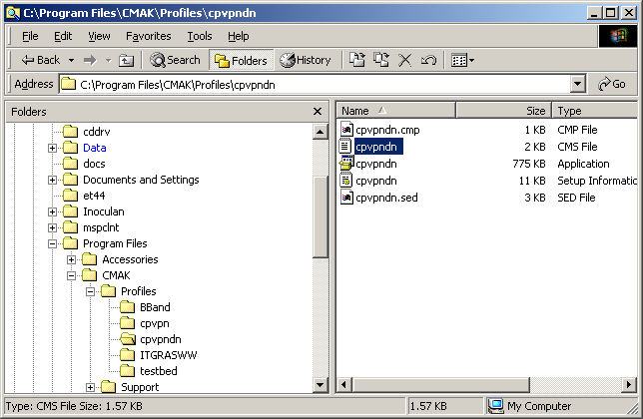

- Next, you will need to open this file up in Notepad in order to edit it. Once you have opened it in notepad, locate the line that says Dialup=1. You will want to change the 1 to a 0 (zero). Once this is completed save the file and exit.

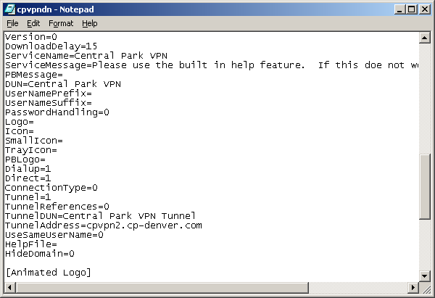

- Now you are ready to reconfigure the connectoid using the Connection Manager Administration Kit. Open up the Connection Manager Administration Kit and click Next.
- From the next screen, you will choose Edit this existing service profile. Then choose your profile from the drop down list as shown below and click Next.

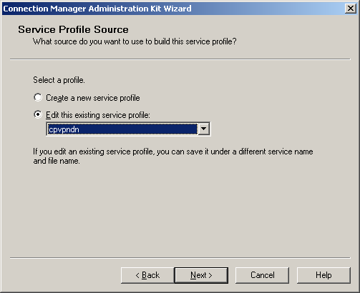

- If you do not need to make any other changes you can continue to click Next until you are prompted to overwrite the existing file. When you are prompted to over write existing file click Yes then click Finish on the completing connection manager administration wizard screen.

At this point you are ready to test the connectoid you have created. All that you need to do is distribute the .exe file from within the profile folder to your end users. This is a self-installing file that has one or two prompts. All your users need to do is run the .exe file from their desktop. This will install the VPN Connectoid to their local machine. If they choose not to create a shortcut on their desktop, they can find the connectoid under My Network Properties on the desktop.

Note: If your end users are going through a router or a firewall they need to make sure that the correct ports for VPN are open and the router or firewall supports GRE. Here is an example of the port and protocol. The most common problem is opening the firewalls to allow both port 1723 and GRE packets (IP protocol 47) through. Not all firewalls can do this so you might need to consult your firewall documentation as to how to set this up.

