
Server Operating System
Monitoring Reliability and Availability of
Windows 2000–based Server Systems

White Paper
Abstract
This paper describes tools and metrics that you can use to monitor the reliability and availability of servers running the Microsoft® Windows® 2000 operating system.
The Windows 2000 operating system contains tools to monitor various conditions of the operating system and the server in general. This paper describes these tools, their metrics, and some commonly monitored conditions. This paper is not an in-depth study of all the capabilities of the tools, but is a reference for setting up and managing the most common measurement conditions.

The information contained in this document represents the current view of Microsoft Corporation on the issues discussed as of the date of publication. Because Microsoft must respond to changing market conditions, it should not be interpreted to be a commitment on the part of Microsoft, and Microsoft cannot guarantee the accuracy of any information presented after the date of publication.
This White Paper is for informational purposes only. MICROSOFT MAKES NO WARRANTIES, EXPRESS OR IMPLIED, AS TO THE INFORMATION IN THIS DOCUMENT.
Complying with all applicable copyright laws is the responsibility of the user. Without limiting the rights under copyright, no part of this document may be reproduced, stored in or introduced into a retrieval system, or transmitted in any form or by any means (electronic, mechanical, photocopying, recording, or otherwise), or for any purpose, without the express written permission of Microsoft Corporation.
Microsoft may have patents, patent applications, trademarks, copyrights, or other intellectual property rights covering subject matter in this document. Except as expressly provided in any written license agreement from Microsoft, the furnishing of this document does not give you any license to these patents, trademarks, copyrights, or other intellectual property.
© 2001 Microsoft Corporation. All rights reserved.
Microsoft, Windows, and Windows NT are either registered trademarks or trademarks of Microsoft Corporation in the United States and/or other countries.
The names of actual companies and products mentioned herein may be the trademarks of their respective owners.
Microsoft Corporation • One Microsoft Way • Redmond, WA 98052-6399 • USA
01/2000

Introduction 1
Contents
Reliability and Availability Metrics 2
Operating System Stop Errors 2
Operating System Reboots 2
Application Failures 2
Operating System Availability 3
Operating System Mean Time to Repair 3
Using the Event Log as a Data Source 4
Event Viewer Utility 4
Exporting the Event List 5
Sorting Events 6
Filtering Events 7
Startup Event 8
Clean Shutdown Event 8
Dirty Shutdown Event 10
System Version Event 11
Service Pack Installation 11
Save Dump 12
Dr. Watson Event 12
Using Perfmon 14
System Uptime Counter 14
Alerts 14
For More Information 16

The Microsoft® Windows® 2000 operating system contains tools to monitor various conditions of the operating system and the server in general. This paper describes these tools, their metrics, and some commonly monitored conditions. This paper is not an in-depth study of all the capabilities of the tools, but is a source for setting up and managing the most common measurement conditions.

Introduction

Operating System Stop Errors

Reliability and Availability Metrics
As with all operating systems, Windows 2000 occasionally encounters serious error conditions and stops responding. Windows stop errors display text on the console video screen with a blue background, and hence are often called blue screens. These conditions are also referred to as bug checks. Fortunately, operating system stop errors are rare events. However, you should still monitor these regularly.
A complete description of procedures for handling Windows stop errors is beyond the scope of this paper. You can find additional information about these conditions in the Microsoft Support Knowledge Base at: http://support.microsoft.com/support. In particular, see these articles:
- Q192463—Gathering Blue Screen Information After Memory Dump
- Q129845—Blue Screen Preparation Before Calling Microsoft
The Windows Event Log service is a useful tool for historical monitoring of operating system crashes. Stop errors are recorded in the Event Log when the system restarts, and the crash dump is saved in a permanent file, usually called Memory.dmp. For details, see Save Dump in the “Using the Event Log as a Data Source” section of this document.

Operating System Reboots
Windows 2000 will reboot for a variety of reasons, including operating system upgrades, software installation, and hardware maintenance. Reboots are recorded in the System Event Log. A system’s reboot frequency tends to drop when the system is stable. Thus, historical reboot frequencies are a long-term indicator of system and data center health. For more information, see Startup Event in the “Using the Event Log as a Data Source” section of this document.

Application Failures
Windows 2000 uses the Dr. Watson utility to record application failures. This utility appends information to the Drwtsn32.log file in the system root for each application failure. It also creates a User.dmp file that contains a memory dump of the user mode program that failed.
As with operating system crashes, complete procedures for handling application crashes is beyond the scope of this paper. For more information, see this article in the Microsoft Support Knowledge Base:
- Q141465—How to Install Symbols for Dr Watson Error Debugging
Application failures are recorded in the Application Event Log; therefore, the historical frequencies of these events are usually available for analysis. For details, see Dr. Watson Event in the “Using the Event Log as a Data Source” section of this document.

Operating System Availability
Most customers are interested in the availability of the application services provided by the Windows operating systems. Each application generally requires different instrumentation; therefore, rather than measuring the application’s availability directly, some customers find it useful to measure the operating system availability. The events needed to do this are contained in the Windows System Event Log.
There are several variations of availability, including planned availability and total availability. Total availability is defined as the percentage of up time over total run time, and can be computed easily using the information in the System Event Log.

Operating System Mean Time to Repair
There is a strong correlation between availability and recoverability of systems. System recoverability is measured as the length of time a system is unavailable following a system outage. Typically, this is reported as mean time to repair. It is easy to measure mean time to repair using the Windows 2000 operating system Event Log. An outage begins when a system is shut down and ends when the system is restarted. To understand how to capture the time stamps associated with these events, see Startup Event, Clean Shutdown Event, and Dirty Shutdown Event, in the “Using the Event Log as a Data Source” section of this document.

Event Viewer Utility

Using the Event Log as a Data Source
You can use the Event Log service and Event Viewer to gather information about hardware, software, and system problems, and to monitor Windows security events.
Windows 2000 records events in three types of logs:
- Application Log. The application log contains events logged by applications or programs. For example, a database program might record a file error in the application log. You can decide which events to record.
- System Log. The system log contains events logged by the Windows system components. For example, the failure of a driver or other system component to load during startup is recorded in the system log. The event types logged by system components are predetermined for the operating system.
- Security Log. The security log can record security events, such as valid and invalid logon attempts, as well as events related to resource use, such as creating, opening, or deleting files. You can specify what events are recorded in the security log. For example, if you enable logon auditing, attempts to log on to the system are recorded in the security log.
Event Viewer displays these types of events:
- Error. A significant problem, such as loss of data or loss of functionality. For example, if a service fails to load during start up, an error is logged.
- Warning. An event that is not necessarily significant, but may indicate a possible problem. For example, a warning is logged when disk space is low.
- Information. An event that describes the successful operation of an application, driver, or service. For example, when a network driver loads successfully, an information event is logged.
- Success Audit. An audited security access attempt that succeeds. For example, a user's successful attempt to log on to the system is logged as a success audit event.
- Failure Audit. An audited security access attempt that fails. For example, if a user tries to access a network drive and fails, the attempt is logged as a failure audit event.
The Event Log service starts automatically when you start Windows. All users can view the application and system logs, but only administrators have access to security logs.
By default, security logging is turned off. You can use Windows 2000 Group Policy to enable security logging. You can also set auditing policies in the registry that cause the system to halt when the security log is full. For more information about using Group Policy, see the Windows 2000 documentation and the Group Policy white papers available at http://www.microsoft.com/windows2000/techinfo/default.asp.
To display the Event Viewer
- On the Start menu, click Run.
- Type Eventvwr
- Click OK. The Event Viewer displays as shown in the following figure.
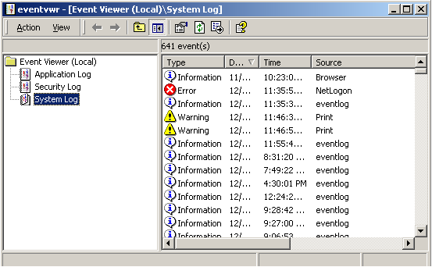
Figure 1. Event Viewer

Exporting the Event List
You can export the event list to Microsoft Excel so that you can save and analyze the data.
To export the list
- On the Action menu, click Export List. A Save As dialog box displays, as shown below.
- Save the file with an .xls extension.
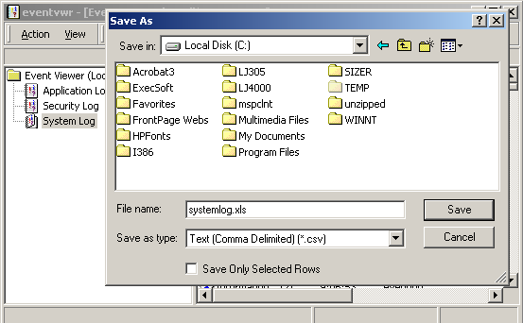
Figure 2. Exporting the event list
The opened Excel file is similar to the following figure.
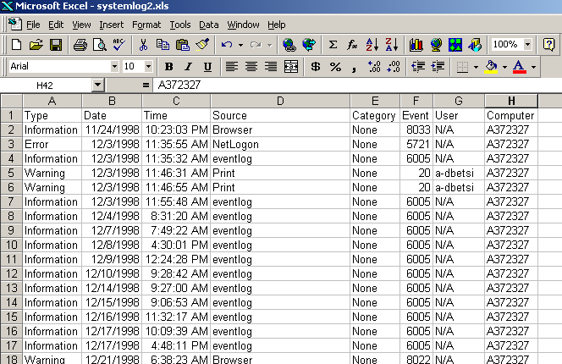
Figure 3. Opened Excel file with exported event data

Sorting Events
You can sort events to more easily review and analyze the data.
To specify sort order
- On the View menu, click Newest First or Oldest First, as shown in the following figure. The default is from newest to oldest.
- (Optional) On the Options menu, check the Save Settings On Exit box to use the current sort order the next time you start Event Viewer.
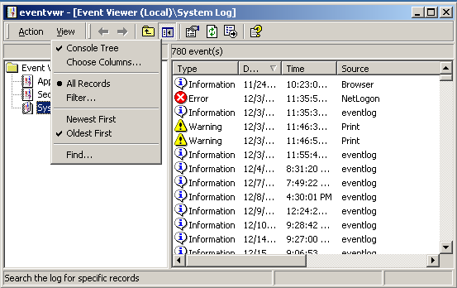
Figure 4. Specifying sort order
Note: When a log is archived, the sort order affects files that you save in text format or comma-delimited text format. The sort order does not affect event records you save in log-file format.

Filtering Events
You can filter events to view only those events that you want to review and analyze.
To filter events
- On the View menu, click Filter Events.
- In the Filter dialog box, shown below, specify the characteristics for displayed events. To return to the default criteria, click Clear.
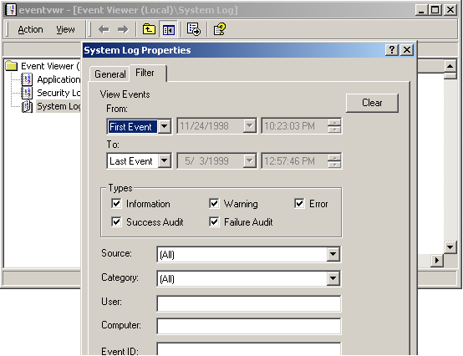
Figure 5. Filtering events
To turn off event filtering, click All Events in the View menu.

Startup Event
Windows 2000 records startup events in the System Event Log, as shown below. In this figure, the Event Log service is the source of this event, and the event ID is 6005. The time of this event is approximately the time the operating system becomes available to applications.
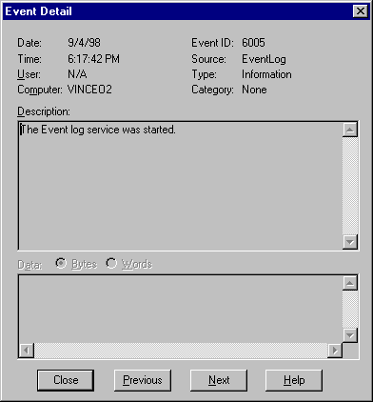
Figure 6. Event Log, Startup Event

Clean Shutdown Event
Windows 2000 records a new event whenever an operating system shutdown is initiated. A clean shutdown can be initiated through several mechanisms.
- Direct user interaction using a shutdown screen as follows:
- Shut Down or Restart using CTRL+ALT+DEL
- Shut Down or Restart using the Start menu
- Shut Down or Restart using the Logon screen
- Programmatically as follows:
- InitiateSystemShutdown WIN32 API – local
- InitiateSystemShutdown WIN32 API – remote
In the following figure, the Event Log service is the source of the event, and the event ID is 6006. The time of this event is approximately the time the operating system becomes unavailable to applications.
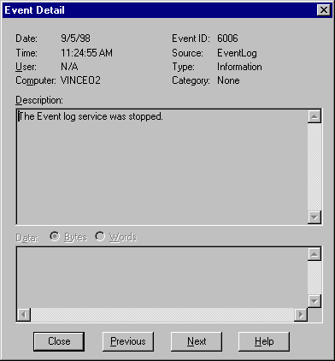
Figure 7. Event Log, Clean Shutdown Event

Dirty Shutdown Event
Windows 2000 records a new event whenever the operating system is shut down using a mechanism other than a clean shutdown. The most common cause is when the system is turned off. In the following figure, the Event Log service is the source of the event, and the event ID is 6008. The event is recorded when the system restarts and Windows 2000 discovers that the previous shutdown was not clean.
Figure 8. Event Log, Dirty Shutdown Event
While the Windows 2000 server is running, the system periodically writes a time stamp to disk. This last alive time stamp is saved in the Windows 2000 registry, always overwriting the previous last alive time stamp. When the last alive time stamp is written, it is also flushed to disk. In this way, if the server crashes, you have a boot stamp and a last alive stamp as the final two entries in the stream. If the computer shuts down normally, the normal shutdown time stamp overwrites the last alive time stamp.
The time in the description portion of this event is the last alive time and is therefore shortly before the time the operating system became unavailable to applications.
The last alive time stamp is written only on Windows 2000 server operating systems. The Windows 2000 Professional operating system does not maintain this time stamp, nor does it record dirty shutdown events.
The last alive time stamp is written to the registry at HKLM\Software\Microsoft\Windows\CurrentVersion\Reliability\LastAliveStamp.
The last alive time stamp interval defaults to five minutes. You can add the registry value TimeStampInterval to can change the interval. This value is in units of minutes. Setting it to zero prevents any last alive time stamp logging; only the boot and normal shutdown stamps are written in that case.

System Version Event
Windows 2000 records a new event containing the operating system version information whenever the system is started. This makes it easier to post-process Windows 2000 Event Logs by operating system version.

Service Pack Installation
Windows 2000 now records service pack version details in the system Event Log, as shown below. This makes it easier to post-process Windows 2000 system Event Logs by operating system version.
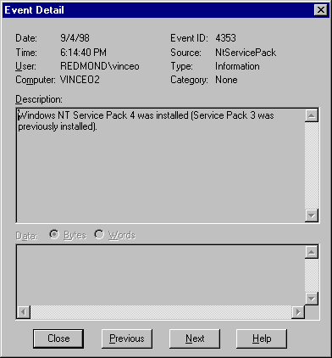
Figure 9. Event Log, Service Pack Installation Event

Save Dump
Save Dump events are always generated on Windows 2000 Server systems after an operating system stop error. They can be disabled on Windows 2000 Professional systems.
Figure 10. Event Log, Save Dump Event

Dr. Watson Event
Windows 2000 records application failures in Dr. Watson log files, and the Dr. Watson utility records application failure events in the Windows 2000 Application Event Log as shown below.
Figure 11. Event Log, Dr. Watson Event
System Performance Monitor (PerfMon) is a tool that enables you to monitor many conditions occurring within a local computer or a remote computer located across the globe.

Using Perfmon
PerfMon performs real-time and short-term historical monitoring of conditions, called counters, that are contained within categories of objects. One such counter, system uptime, is described below.

System Uptime Counter
The system uptime counter measures the time, in seconds, that the system has been alive. PerfMon graphs the results on the screen as they are gathered, and enables you to export the results to Excel for reporting purposes.
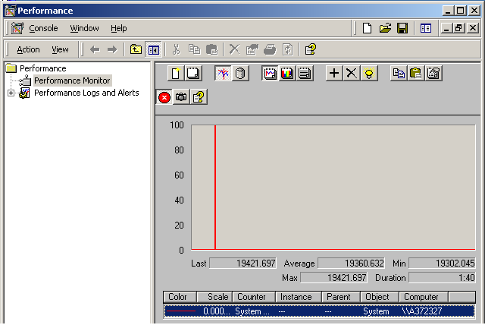
Figure 12. PerfMon System Uptime counter

Alerts
You can configure PerfMon to alert you when thresholds have been exceeded. You choose the criteria you want reported and the manner in which you want it reported. The following figure shows PerfMon configured to report when CPU performance exceeds 80 percent.
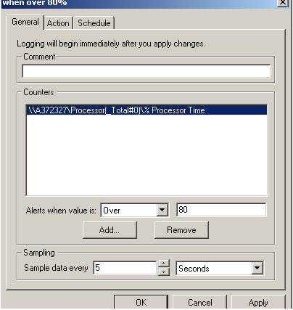
Figure 13. PerfMon Alert

For the latest information on Windows 2000 Server, see http://www.microsoft.com/windows2000/server/default.asp.

For More Information
For the latest information on Windows 2000, see http://www.microsoft.com/windows2000/.

