

Step-by-Step Guide for Setting Up VPN-based Remote Access in a Test Lab
Microsoft Corporation
Published: April 2005
Author: Microsoft Corporation

Abstract
This guide provides detailed information about how you can use five computers to create a test lab with which to configure and test virtual private network (VPN) remote access with the Microsoft® Windows® XP Professional with Service Pack 2 (SP2) operating system and the 32-bit versions of the Microsoft Windows Server™ 2003 with Service Pack 1 (SP1) operating system. These instructions are designed to take you step-by-step through the configuration required for a Point-to-Point Tunneling Protocol (PPTP) connection, a Layer Two Tunneling Protocol (L2TP) with Internet Protocol security (L2TP/IPsec) connection, and a VPN connection that uses certificate-based Extensible Authentication Protocol-Transport Level Security (EAP-TLS) authentication.

Information in this document, including URL and other Internet Web site references, is subject to change without notice. Unless otherwise noted, the example companies, organizations, products, domain names, e-mail addresses, logos, people, places, and events depicted herein are fictitious, and no association with any real company, organization, product, domain name, e-mail address, logo, person, place, or event is intended or should be inferred. Complying with all applicable copyright laws is the responsibility of the user. Without limiting the rights under copyright, no part of this document may be reproduced, stored in or introduced into a retrieval system, or transmitted in any form or by any means (electronic, mechanical, photocopying, recording, or otherwise), or for any purpose, without the express written permission of Microsoft Corporation.

Microsoft may have patents, patent applications, trademarks, copyrights, or other intellectual property rights covering subject matter in this document. Except as expressly provided in any written license agreement from Microsoft, the furnishing of this document does not give you any license to these patents, trademarks, copyrights, or other intellectual property.

© 2005 Microsoft Corporation. All rights reserved.

Microsoft, Active Directory, MS-DOS, Windows, Windows NT, and Windows Server are either registered trademarks or trademarks of Microsoft Corporation in the United States and/or other countries.

All other trademarks are property of their respective owners.

Contents
Step-by-Step Guide for Setting Up VPN-based Remote Access in a Test Lab 7
Setting Up the Test Lab for PPTP, L2TP/IPsec, and EAP-TLS Remote Access VPN Connections 7
PPTP-based Remote Access VPN Connections 9
DC1 9
IAS1 27
IIS1 38
VPN1 39
CLIENT1 47
L2TP/IPsec-based Remote Access VPN Connections 49
DC1 49
VPN1 58
CLIENT1 59
EAP-TLS-based Remote Access VPN Connections 67
DC1 67
IAS1 73
CLIENT1 77
Summary 82
See Also 82

Step-by-Step Guide for Setting Up VPN-based Remote Access in a Test Lab
This guide provides detailed information about how you can use five computers to create a test lab with which to configure and test virtual private network (VPN) remote access with the Microsoft® Windows® XP Professional operating system with Service Pack 2 (SP2) and the 32-bit versions of the Microsoft Windows Server™ 2003 operating system with Service Pack 1 (SP1). These instructions are designed to take you step-by-step through the configuration required for a Point-to-Point Tunneling Protocol (PPTP) connection, a Layer Two Tunneling Protocol (L2TP) with Internet Protocol security (L2TP/IPsec) connection, and a VPN connection that uses certificate-based Extensible Authentication Protocol-Transport Level Security (EAP-TLS) authentication.
Note
The following instructions are for configuring a test lab using a minimum number of computers. Individual computers are needed to separate the services provided on the network and to clearly show the desired functionality. This configuration is neither designed to reflect best practices nor is it designed to reflect a desired or recommended configuration for a production network. The configuration, including IP addresses and all other configuration parameters, is designed to work only on a separate test lab network.

Setting Up the Test Lab for PPTP, L2TP/IPsec, and EAP-TLS Remote Access VPN Connections
The infrastructure for the VPN test lab network consists of five computers performing the following services:
• A computer running Windows Server 2003 with SP1, Enterprise Edition, named DC1 that is acting as a domain controller, a Domain Name System (DNS) server, a Dynamic Host Configuration Protocol (DHCP) server, and a certification authority (CA).
• A computer running Windows Server 2003 with SP1, Standard Edition, named IAS1 that is acting as a Remote Authentication Dial-In User Service (RADIUS) server.
• A computer running Windows Server 2003 with SP1, Standard Edition, named IIS1 that is acting as a Web and file server.
• A computer running Windows Server 2003 with SP1, Standard Edition, named VPN1 that is acting as a VPN server. VPN1 has two network adapters installed.
• A computer running Windows XP Professional with SP2 named CLIENT1 that is acting as a VPN client.
The following diagram shows the configuration of the VPN test lab.
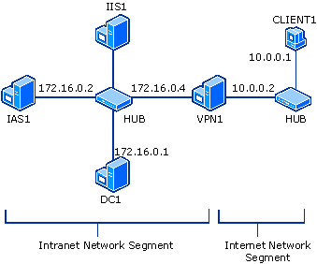

There is a network segment representing a corporate intranet and a network segment representing the Internet. All computers on the corporate intranet are connected to a common hub or Layer 2 switch. All computers on the Internet are connected to a separate common hub or Layer 2 switch. Private addresses are used throughout the test lab configuration. The private network of 172.16.0.0/24 is used for the intranet. The private network of 10.0.0.0/24 is used for the simulated Internet. Windows Firewall is set up and configured on the RADIUS server (IAS1), the Web and file server (IIS1), and the client computer (CLIENT1). Windows Firewall should not be turned on or configured on either the domain controller (DC1) or the VPN server (VPN1). In addition, the Windows Firewall/Internet Connection Sharing (ICS) service should be disabled on VPN1.
IIS1 obtains its IP address configuration using DHCP. CLIENT1 uses DHCP for its IP address configuration; however, it is also configured with an alternate IP configuration so that it can be placed on either the intranet network segment or the simulated Internet. All other computers have a manual IP address configuration. There are no Windows Internet Name Service (WINS) servers present.
To reconstruct this test lab, configure the computers in the order presented, beginning with the PPTP-based remote access VPN connection. Additional sections of this guide describe L2TP/IPsec-based and EAP-TLS-based remote access VPN connections.

PPTP-based Remote Access VPN Connections
The following sections describe how to set up and configure each of the computers in the test lab for a PPTP-based remote access VPN connection. PPTP is typically used when there is no public key infrastructure (PKI) to issue computer certificates that are required for L2TP/IPsec connections.

DC1
DC1 is a computer running Windows Server 2003 with SP1, Enterprise Edition, that is providing the following services:
• A domain controller for the example.com Active Directory® domain.
• A DNS server for the example.com DNS domain.
• A DHCP server for the intranet network segment
• The enterprise root certification authority (CA) for the example.com domain.
Note
Windows Server 2003 with SP1, Enterprise Edition, is used so that autoenrollment of user certificates for EAP-TLS authentication can be configured. This is described in the "EAP-TLS-based Remote Access VPN Connections" section of this guide.
Configure DC1
1. Install Windows Server 2003 with SP1, Enterprise Edition, as a stand-alone server.
2. Configure the TCP/IP protocol with the IP address of 172.16.0.1 and the subnet mask of 255.255.255.0.
Configure DC1 as a domain controller
1. To start the Active Directory Installation Wizard, click Start, click Run, type dcpromo, and then click OK.
2. In the Welcome to the Active Directory Installation Wizard dialog box, click Next.
3. In the Operating System Compatibility dialog box, click Next.
4. Verify that Domain controller for a new domain option is selected, and then click Next.
5. Verify that Domain in a new forest is selected, and then click Next.
6. Verify that No, just install and configure DNS on this computer is selected, and then click Next.
7. On the New Domain Name page, type example.com, and then click Next.
8. On the NetBIOS Domain Name page, confirm that the Domain NetBIOS name is EXAMPLE, and then click Next.
9. Accept the default Database and Log Folders directories, as shown in the following figure, and then click Next.
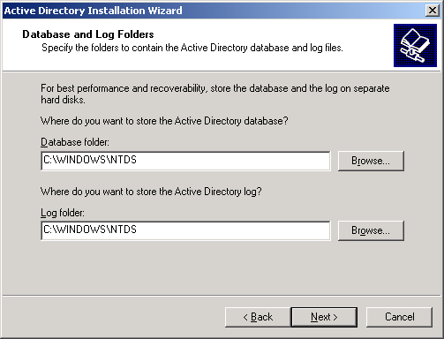

10. In the Shared System Volume dialog box, shown in the following figure, verify that the default folder location is correct. Click Next.
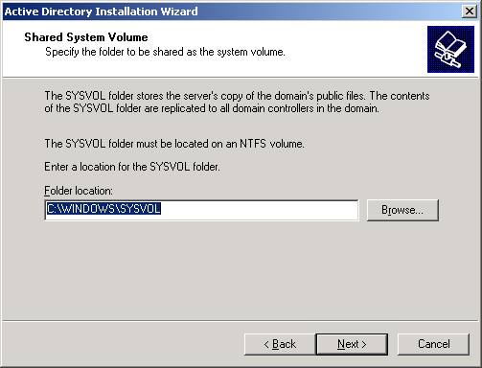

11. On the Permissions page, verify that the Permissions compatible only with Windows 2000 or Windows Server 2003 operating systems check box is selected, as shown in the following figure. Click Next.
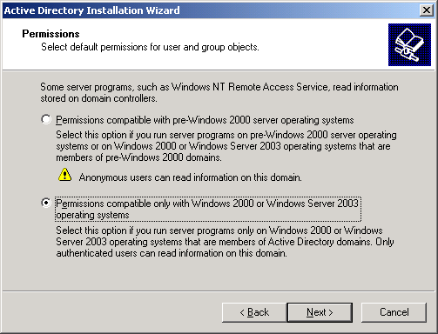

12. On the Directory Services Restore Mode Administration Password page, leave the passwords blank, and then click Next.
13. Review the information that appears on the Summary page, and then click Next.
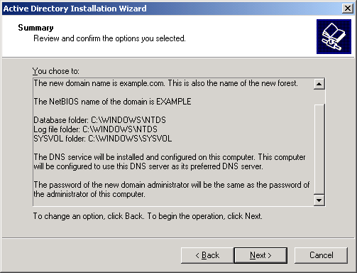

14. On the Completing the Active Directory Installation Wizard page, click Finish.
15. When prompted to restart the computer, click Restart Now.
Raise the domain functional level
1. Open the Active Directory Domains and Trusts snap-in from the Administrative Tools folder, and then right-click the domain computer dc1.example.com.
2. Click Raise Domain Functional Level, select Windows Server 2003 on the Raise Domain Functional Level page, and then click Raise, as shown in the following figure.
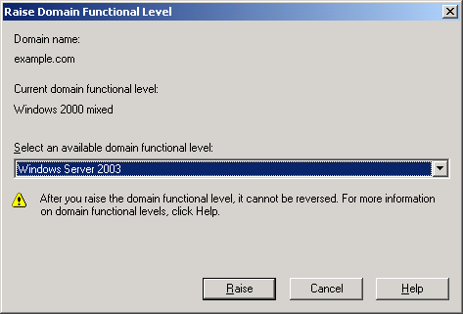

Install and configure DHCP
1. In Control Panel, double-click Add or Remove Programs, and then install DHCP as a Networking Services component.
2. Open the DHCP snap-in from the Administrative Tools folder.
3. Click Action, and then click Authorize to authorize the DHCP service.
4. In the console tree, right-click dc1.example.com, and then click New Scope.
5. On the Welcome page of the New Scope Wizard, click Next.
6. On the Scope Name page, type CorpNet in Name. This is shown in the following figure.
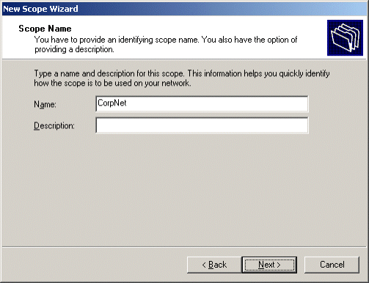

7. Click Next. On the IP Address Range page, type 172.16.0.10 in Start IP address, 172.16.0.100 in End IP address, and 24 in Length. This is shown in the following figure.
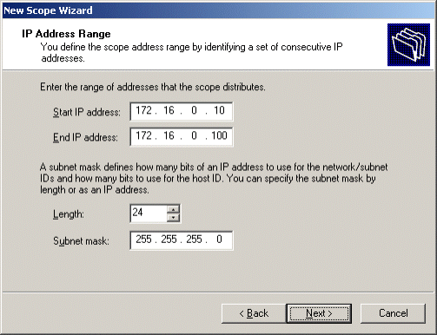

8. Click Next. On the Add Exclusions page, click Next.
9. On the Lease Duration page, click Next.
10. On the Configure DHCP Options page, click Yes, I want to configure DHCP options now. This is shown in the following figure.
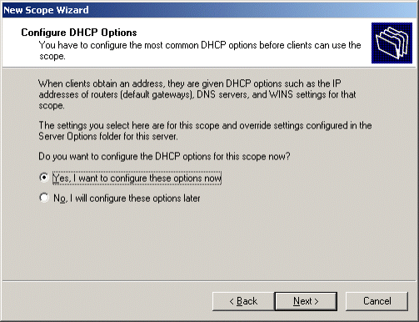

11. Click Next. On the Router (Default Gateway) page, click Next.
12. On the Domain Name and DNS Servers page, type example.com in Parent domain. Type 172.16.0.1 in IP address, and then click Add. This is shown in the following figure.
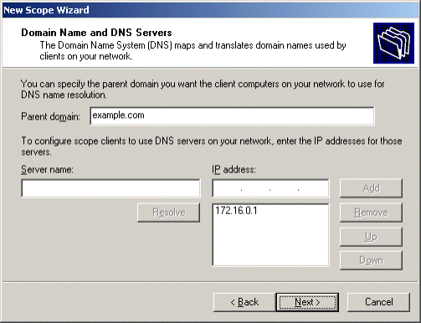

13. Click Next. On the WINS Servers page, click Next.
14. On the Activate Scope page, click Yes, I want to activate this scope now. This is shown in the following figure.
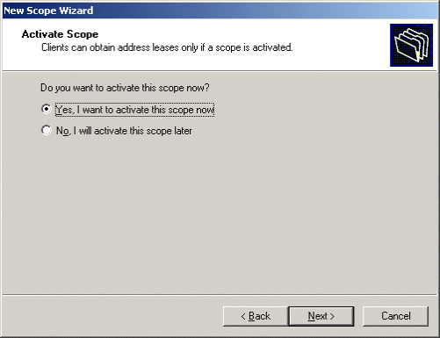

15. Click Next. On the Completing the New Scope Wizard page, click Finish.
Install Certificate Services
1. In Control Panel, double-click Add or Remove Programs, and then install the Certificate Services component as an enterprise root CA with the name Example CA.
2. Select Enterprise root CA, as shown in the following figure, and then click Next.
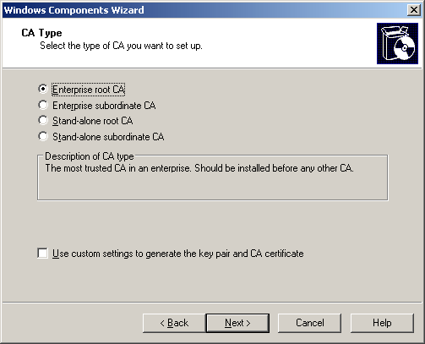

3. Type Example CA for the Common name for this CA, as shown in the following figure, and then click Next.
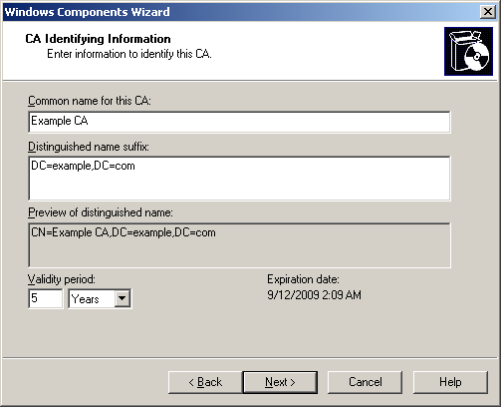

4. Click Next to accept the default Certificate Database Settings shown in the following figure.
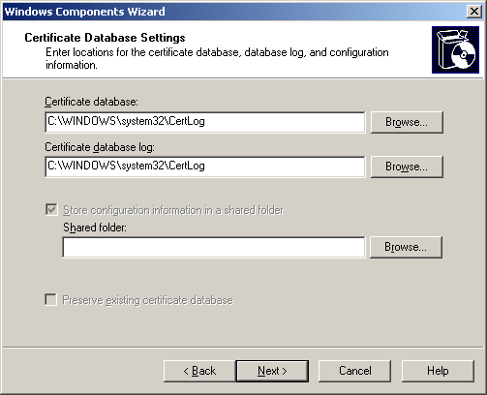

5. Click Finish.
Add computers, users, and groups to the domain
1. Open the Active Directory Users and Computers snap-in.
2. In the console tree, open example.com.
3. Right-click Users, point to New, and then click Computer.
4. In the New Object - Computer dialog box, type IAS1 in Computer name. This is shown in the following figure.
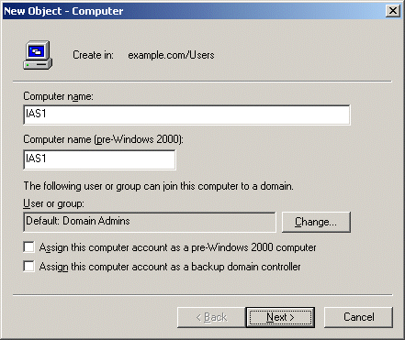

5. Click Next. In the Managed dialog box, click Next. In the New Object - Computer dialog box, click Finish.
6. Use steps 3 through 5 to create additional computer accounts with the following names: IIS1, VPN1, and CLIENT1.
7. In the console tree, right-click Users, point to New, and then click User.
8. In the New Object - User dialog box, type VPNUser in First name, and type VPNUser in User logon name. This is shown in the following figure.
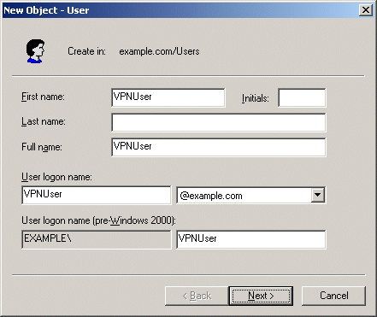

9. Click Next.
10. In the New Object - User dialog box, type a password of your choice in Password and Confirm password. Clear the User must change password at next logon check box and select the Password never expires check box. This is shown in the following figure.
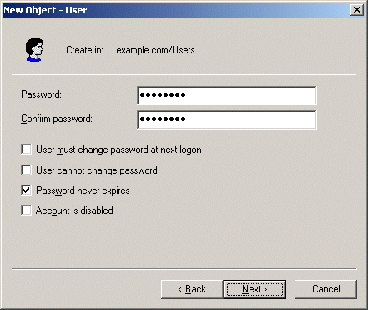

11. In the New Object - User dialog box, click Finish.
12. In the console tree, right-click Users, point to New, and then click Group.
13. In the New Object - Group dialog box, type VPNUsers in Group name, and then click OK. This is shown in the following figure.
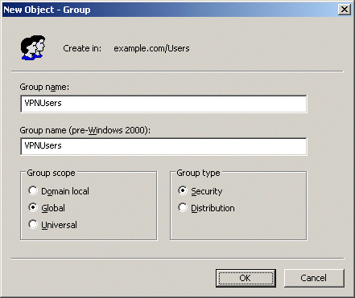

14. In the details pane, double-click VPNUsers.
15. Click the Members tab, and then click Add.
16. In the Select Users, Contacts, Users, or Groups dialog box, type vpnuser in Enter the object names to select. This is shown in the following figure.
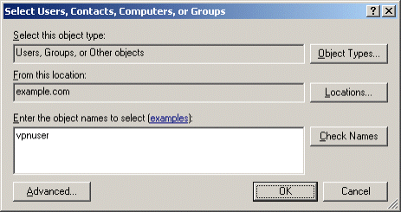

17. Click OK. In the Multiple Names Found dialog box, click OK. The VPNUser user account is added to the VPNUsers group. This is shown in the following figure.
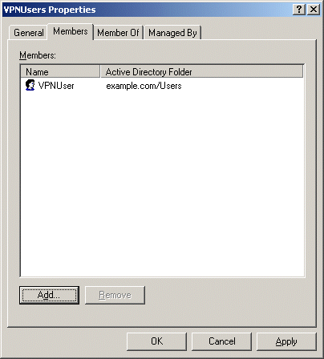

18. Click OK to save changes to the VPNUsers group.

IAS1
IAS1 is a computer running Windows Server 2003 with SP1, Standard Edition, that is providing RADIUS authentication, authorization, and accounting for VPN1.
Configure IAS1 as a RADIUS server
1. Install Windows Server 2003 with SP1, Standard Edition, as a member server named IAS1 in the example.com domain.
2. For the intranet local area connection, configure the TCP/IP protocol with the IP address of 172.16.0.2, the subnet mask of 255.255.255.0, and the DNS server IP address of 172.16.0.1.
3. In Control Panel, double-click Add or Remove Programs, and then install Internet Authentication Service as a Networking Services component.
4. Open the Internet Authentication Service snap-in from the Administrative Tools folder.
5. Right-click Internet Authentication Service, and then click Register Server in Active Directory. When the Register Internet Authentication Server in Active Directory dialog box appears, click OK. This is shown in the following figure.
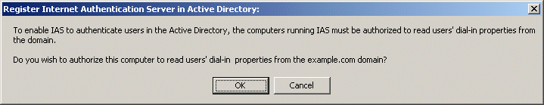

6. In the console tree, right-click RADIUS Clients, and then click New RADIUS Client.
7. On the Name and Address page of the New RADIUS Client wizard, for Friendly name, type VPN1. In Client address (IP or DNS), type 172.16.0.4. This is shown in the following figure.
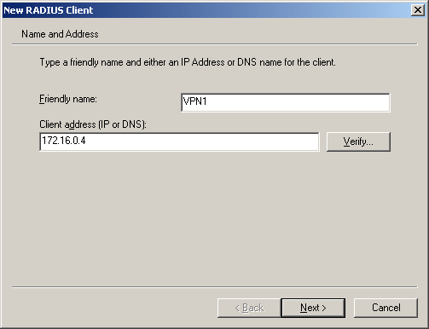

8. Click Next. On the Additional Information page of the New RADIUS Client wizard, for Shared secret, type a shared secret for VPN1, and then type it again in Confirm shared secret. This is shown in the following figure.
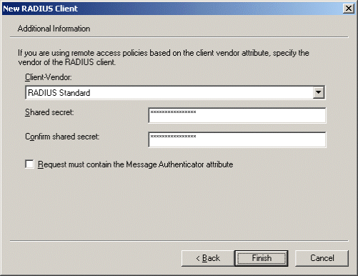

9. Click Finish.
10. In the console tree, right-click Remote Access Policies, and then click New Remote Access Policy.
11. On the Welcome to the New Remote Access Policy Wizard page, click Next.
12. On the Policy Configuration Method page, type VPN remote access to intranet in Policy name. This is shown in the following figure.
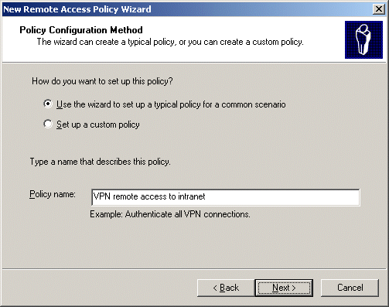

13. Click Next. On the Access Method page, select VPN. This is shown in the following figure.
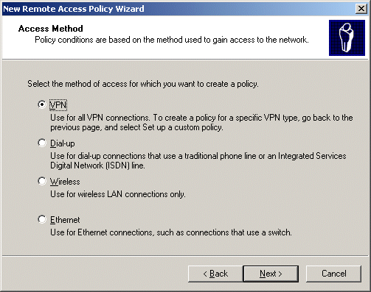

14. Click Next. On the User or Group Access page, click Group. This is shown in the following figure.
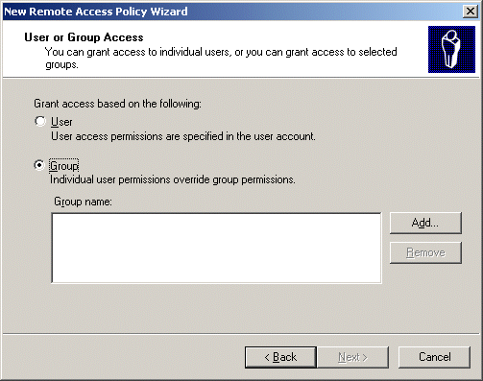

15. Click Add. In the Select Groups dialog box, click Locations, select example.com as the location, and then click OK.
16. Type vpnusers in Enter the object names to select. This is shown in the following figure.
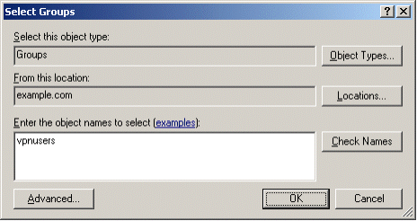

17. Click OK. The VPNUsers group in the example.com domain is added to the list of groups on the User or Group Access page. This is shown in the following figure.
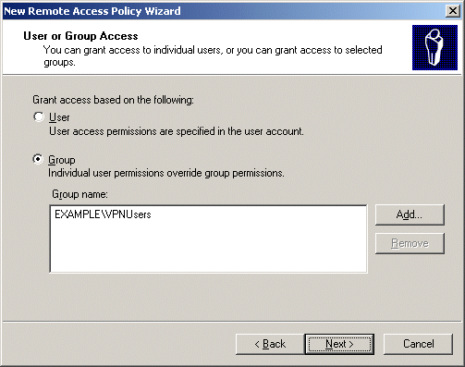

18. Click Next. On the Authentication Methods page, the Microsoft Encrypted Authentication version 2 (MS-CHAPv2) authentication protocol is selected by default. This is shown in the following figure.
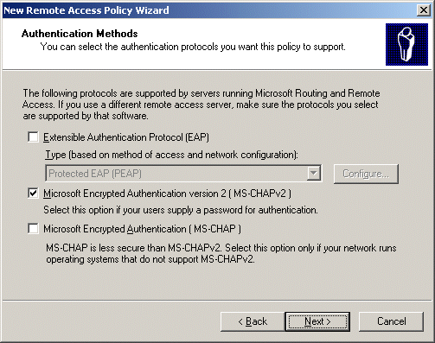

19. Click Next. On the Policy Encryption Level page, clear the Basic encryption and Strong encryption check boxes, leaving only Strongest encryption selected. This is shown in the following figure.
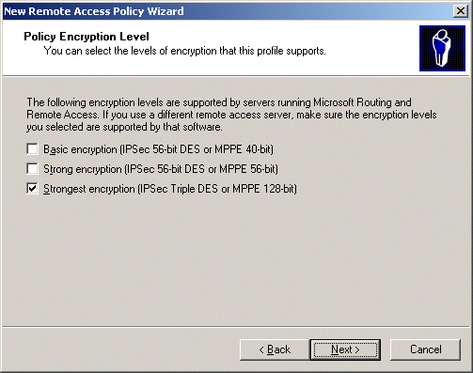

20. Click Next. On the Completing the New Remote Access Policy page, click Finish.
Configure Windows Firewall on IAS1
1. In Control Panel, double-click Windows Firewall.
2. In the Windows Firewall dialog box, click the Exceptions tab.
3. Click Add Port, and in the Add a Port dialog box add the following port exceptions:
Note
You must click Add Port on the Exceptions tab for each port exception.

Name | Port Number | Protocol
Legacy RADIUS | 1645 | UDP
Legacy RADIUS | 1646 | UDP
RADIUS Accounting | 1812 | UDP
RADIUS Authentication | 1813 | UDP

4. Verify that the four port exceptions you added are selected on the Exceptions tab, as shown in the following example.
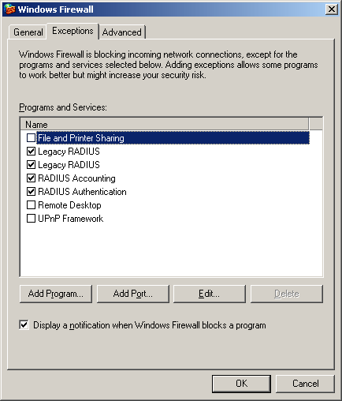

5. Click the Advanced tab, and then click Settings for Security Logging.
6. In the Log Setting dialog box, select Log dropped packets and Log successful connections. Note the path and file name in Name.
The log file allows you to see where connection errors occur, as well as which source and destination ports the errors occurred on. This log file should provide you with the information needed in case you need to add more ports to the exception list.
7. Click OK twice to close Windows Firewall.

IIS1
IIS1 is a computer running Windows Server 2003 with SP1, Standard Edition, and Internet Information Services (IIS). It is providing Web and file server services for intranet clients. To configure IIS1 as a Web and file server and to configure Windows Firewall on IIS1, perform the following steps.
Configure IIS1 as a Web and file server
1. Install Windows Server 2003 with SP1, Standard Edition, as a member server named IIS1 in the example.com domain.
2. In Control Panel, double-click Add or Remove Programs, and then install Internet Information Services (IIS) as a subcomponent of the Application Server component in the Windows Components Wizard.
3. On IIS1, use Windows Explorer to create a new share for the root folder of drive C using the share name ROOT with the default permissions.
4. To determine whether the Web server is working correctly, run Internet Explorer on IAS1. If the Internet Connection Wizard prompts you, configure Internet connectivity for a LAN connection. In Internet Explorer, in Address, type http://IIS1.example.com/iisstart.htm. You should see a message saying the Web site is under construction.
5. To determine whether file sharing is working correctly, on IAS1, click Start, click Run, type \\IIS1\ROOT, and then click OK. You should see the contents of the root folder of drive C on IIS1.
Configure Windows Firewall on IIS1
1. In Control Panel, double-click Windows Firewall.
2. In the Windows Firewall dialog box, click the Exceptions tab.
3. Select File and Print Sharing, and then click Add Program.
4. In the Add a Program dialog box, select Internet Explorer, and then click OK.
5. Click Add a Port.
6. In the Add a Port dialog box, type World Wide Web Publishing Service for the Name, type 80 for the Port number, select TCP as the type of traffic processed by the port, and then click OK.
7. Verify that File and Print Sharing, Internet Explorer, and World Wide Web Publishing Service are all selected in the Exceptions dialog box, and then click the Advanced tab.
8. Click Settings for Security Logging.
9. In the Log Setting dialog box, select Log dropped packets and Log successful connections. Note the path and file name in Name.
10. Click OK twice to close Windows Firewall.

VPN1
VPN1 is a computer running Windows Server 2003 with SP1, Standard Edition, that is providing VPN server services for Internet-based VPN clients.
Configure the VPN server
1. Install Windows Server 2003 with SP1, Standard Edition, as a member server named VPN1 in the example.com domain.
2. Open the Network Connections folder.
3. For the intranet local area connection, rename the connection to CorpNet. For the Internet local area connection, rename the connection to Internet. This is shown in the following figure.
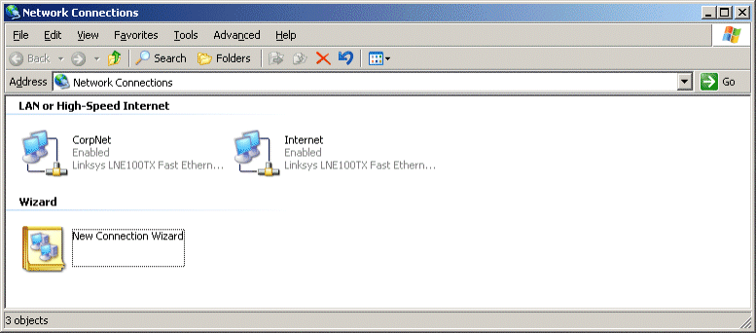

4. Configure the TCP/IP protocol for the CorpNet connection with the IP address of 172.16.0.4, the subnet mask of 255.255.255.0, and the DNS server IP address of 172.16.0.1.
5. Configure the TCP/IP protocol for the Internet connection with the IP address of 10.0.0.2 and the subnet mask of 255.255.255.0.
Windows Firewall and Routing and Remote Access cannot run simultaneously on VPN1. If Windows Firewall is turned on, you will need to turn it off; if the Windows Firewall/Internet Connection Sharing (ICS) service has started or is set to automatic before you configure Routing and Remote Access, you must disable it.
Disable the Windows Firewall/Internet Connection Sharing (ICS) service
1. Click Administrative Tools, and then click Services.
2. In the Services details pane, right-click Windows Firewall/Internet Connection Sharing (ICS) service, and then click Properties.
3. If the service Startup Type is either Automatic or Manual, change it to Disabled.
4. Click OK to close the Windows Firewall/Internet Connection Sharing (ICS) dialog box, and then close the Services page.
Configure Routing and Remote Access
1. Run the Routing and Remote Access snap-in from the Administrative Tools folder.
2. In the console tree, right-click VPN1, then and click Configure and Enable Routing and Remote Access.
3. On the Welcome to the Routing and Remote Access Server Setup Wizard page, click Next.
4. On the Configuration page, Remote access (dial-up or VPN) is selected by default. This is shown in the following figure.
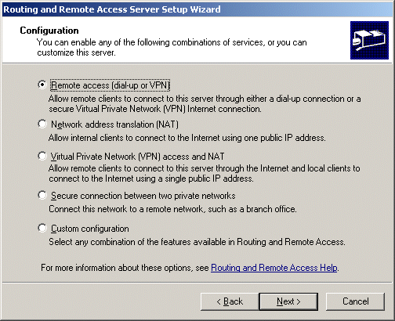

5. Click Next. On the Remote Access page, select VPN. This is shown in the following figure.
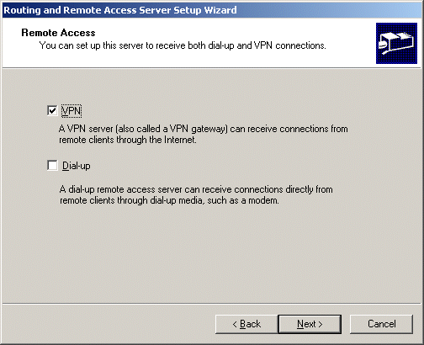

6. Click Next. On the VPN Connection page, click the Internet interface in Network interfaces. This is shown in the following figure.
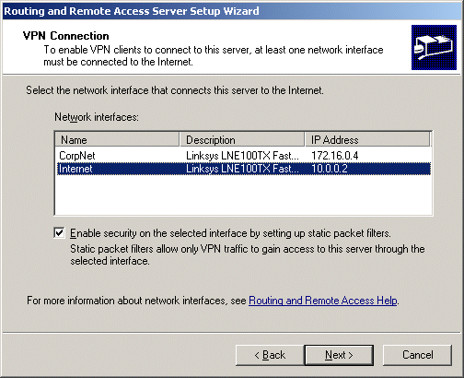

7. Click Next. On the IP Address Assignment page, Automatically is selected by default. This is shown in the following figure.
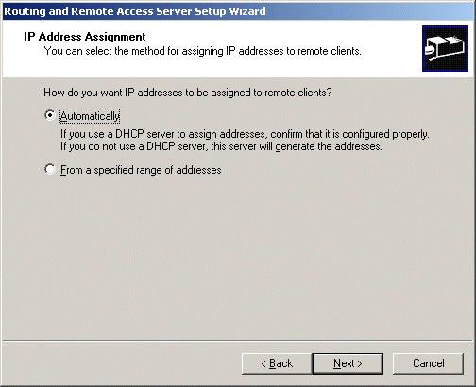

8. Click Next. On the Managing Multiple Remote Access Servers page, click Yes, set up this server to work with a RADIUS server. This is shown in the following figure.
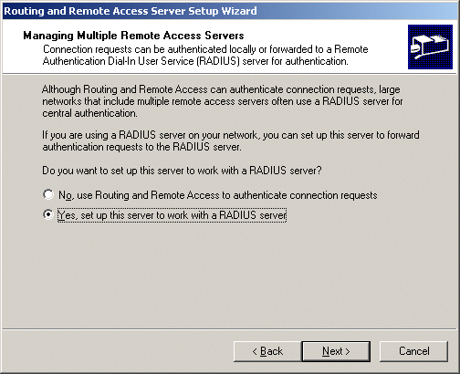

9. Click Next. On the RADIUS Server Selection page, type 172.16.0.2 in Primary RADIUS server and the shared secret in Shared secret. This is shown in the following figure.
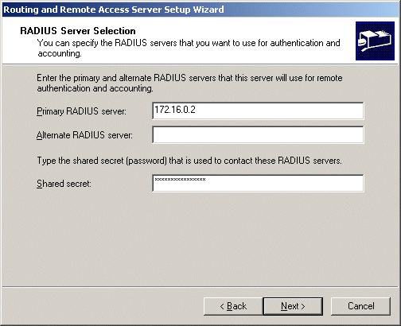

10. Click Next. On the Completing the Routing and Remote Access Server Setup Wizard page, click Finish.
11. You are prompted with a message describing the need to configure the DHCP Relay Agent. This is shown in the following figure.
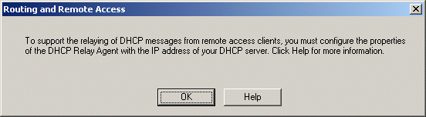

12. Click OK.
13. In the console tree, open VPN1 (local), then IP Routing, and then DHCP Relay Agent. Right-click DHCP Relay Agent, and then click Properties.
14. In the DHCP Relay Agent Properties dialog box, type 172.16.0.1 in Server address. This is shown in the following figure.
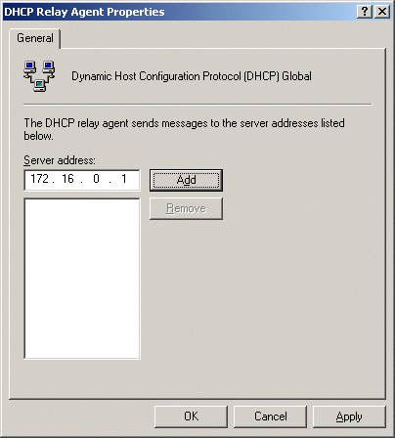

15. Click Add, and then click OK.

CLIENT1
CLIENT1 is a computer running Windows XP Professional with SP2 that is acting as a VPN client and gaining remote access to intranet resources across the simulated Internet.
Configure Client1 as a VPN client for a PPTP connection
1. Connect CLIENT1 to the intranet network segment.
2. On CLIENT1, install Windows XP Professional with SP2 as a member computer named CLIENT1 of the example.com domain.
Note
Installing Windows XP Professional with SP2 also installs and automatically turns on Windows Firewall. Leave Windows Firewall turned on for this scenario. You will not need to configure any port or program exceptions.
3. Add the VPNUser account in the example.com domain to the local Administrators group.
4. Log off and then log on using the VPNUser account in the example.com domain.
5. In Control Panel, open the Network Connections folder, obtain properties on the Local Area Network connection, and then obtain properties on the Internet protocol (TCP/IP).
6. Click the Alternate Configuration tab, and then click User configured.
7. In IP address, type 10.0.0.1. In Subnet mask, type 255.255.255.0. This is shown in the following figure.
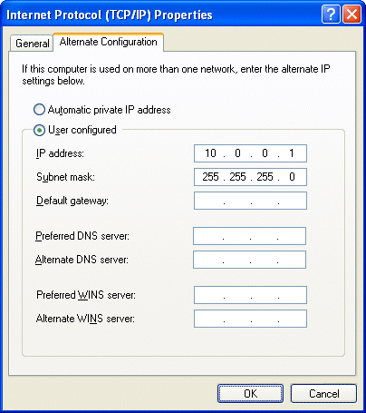

8. Click OK to save changes to the TCP/IP properties. Click OK to save changes to the Local Area Network connection.
9. Shut down the CLIENT1 computer.
10. Disconnect CLIENT1 from the intranet network segment, and connect it to the simulated Internet network segment.
11. Restart CLIENT1 and log on using the VPNUser account.
12. On CLIENT1, in Control Panel, open the Network Connections folder.
13. In Network Tasks, click Create a new connection.
14. On the Welcome to the New Connection Wizard page of the New Connection Wizard, click Next.
15. On the Network Connection Type page, click Connect to the network at my workplace. This is shown in the following figure.
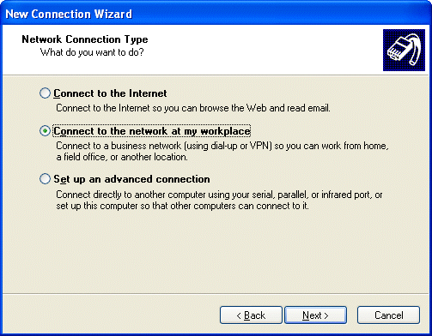

16. Click Next. On the Network Connection page, click Virtual Private Network connection. This is shown in the following figure.
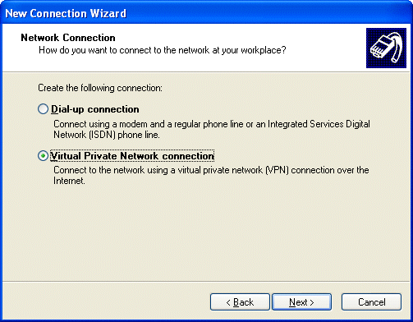

17. Click Next. On the Connection Name page, type PPTPtoCorpnet in Company Name. This is shown in the following figure.
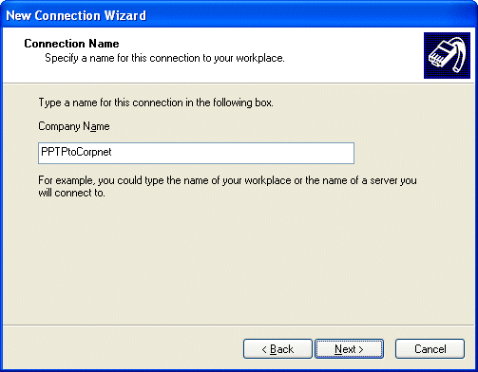

18. Click Next. On the VPN Server Selection page, type 10.0.0.2 in Host name or IP address. This is shown in the following figure.
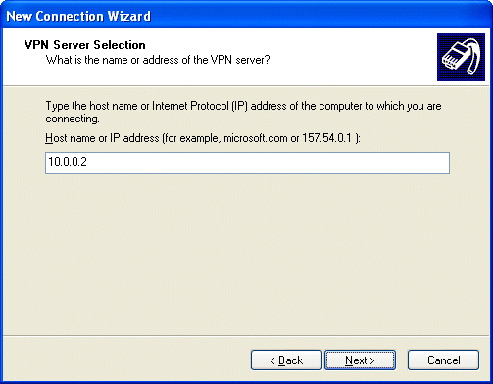

19. Click Next. On the Connection Availability page, click Next.
20. On the Completing the New Connection Wizard page, click Finish. The Connect PPTPtoCorpnet dialog box appears. This is shown in the following figure.


21. Click Properties, and then click the Networking tab.
22. On the Networking tab, in Type of VPN, click PPTP VPN. This is shown in the following figure.
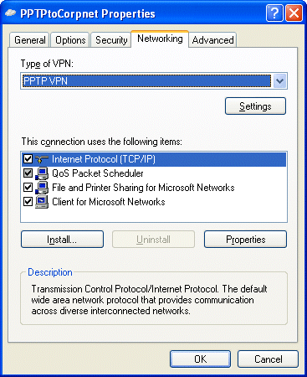

23. Click OK to save changes to the PPTPtoCorpnet connection. The Connect PPTPtoCorpnet dialog box appears.
24. In User name, type example\VPNUser. In Password, type the password you chose for the VPNUser account.
25. Click Connect.
26. When the connection is complete, run Internet Explorer.
27. If prompted by the Internet Connection Wizard, configure it for a LAN connection. In Address, type http://IIS1.example.com/iisstart.htm. You should see a message saying the Web page is under construction.
28. Click Start, click Run, type \\IIS1\ROOT, and then click OK. You should see the contents of the local drive (drive C) on IIS1.
29. Right-click the PPTPtoCorpnet connection, and then click Disconnect.

L2TP/IPsec-based Remote Access VPN Connections
L2TP/IPsec-based remote access VPN connections require computer certificates on the VPN client and the VPN server. L2TP/IPsec is typically used when there are stronger requirements for security and a public key infrastructure (PKI) is in place to issue computer certificates to VPN clients and servers.

DC1
Configure DC1 for autoenrollment of computer certificates
1. Open the Active Directory Users and Computers snap-in.
2. In the console tree, double-click Active Directory Users and Computers, right-click the example.com domain, and then click Properties.
3. On the Group Policy tab, click Default Domain Policy, and then click Edit.
4. In the console tree, open Computer Configuration, open Windows Settings, open Security Settings, open Public Key Policies, and then open Automatic Certificate Request Settings. This is shown in the following figure.
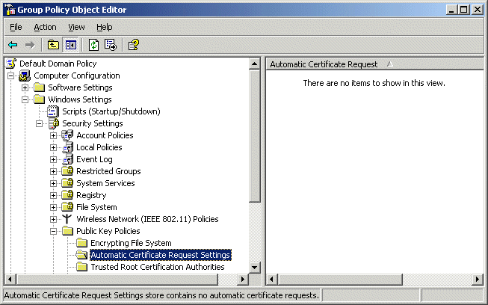

5. Right-click Automatic Certificate Request Settings, point to New, and then click Automatic Certificate Request.
6. On the Welcome to the Automatic Certificate Request Setup Wizard page, click Next.
7. On the Certificate Template page, click Computer. This is shown in the following figure.
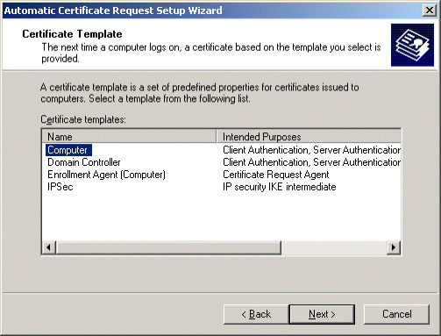

8. Click Next. On the Completing the Automatic Certificate Request Setup Wizard page, click Finish. The Computer certificate type now appears in the details pane of the Group Policy Object Editor snap-in. This is shown in the following figure.
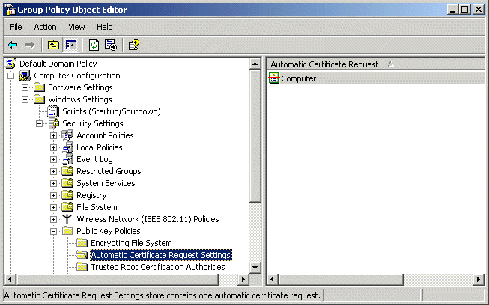

9. Type gpupdate at a command prompt to update Group Policy on DC1.

VPN1
Update Group Policy on VPN1
• To immediately update Group Policy and request a computer certificate, type gpupdate at a command prompt.
After updating VPN1 with the new certificates you need to stop and restart the IPsec Policy Agent and Routing and Remote Access services.
Restart IPsec Policy Agent and Routing and Remote Access
1. Click Start, point to Administrative Tools, and then click Services.
2. In the details pane, point to IPSEC Services, point to Action, and then click Restart.
3. In the details pane, point to Routing and Remote Access, point to Action, and then click Restart.

CLIENT1
To obtain a computer certificate on CLIENT1 and then configure an L2TP/IPsec-based remote access VPN connection, perform the following steps.
Obtain a computer certificate and configure an L2TP/IPsec-based remote access VPN connection
1. Shut down the CLIENT1 computer.
2. Disconnect CLIENT1 from the simulated Internet network segment, and connect it to the intranet network segment.
3. Restart CLIENT1 and log on using the VPNUser account. The computer and user Group Policy is automatically updated.
4. Shut down CLIENT1.
5. Disconnect CLIENT1 from the intranet network segment, and connect it to the simulated Internet network segment.
6. Restart CLIENT1 and log on using the VPNUser account.
7. On CLIENT1, in Control Panel, open the Network Connections folder.
8. In Network Tasks, click Create a new connection.
9. On the Welcome to the New Connection Wizard page of the New Connection Wizard, click Next.
10. On the Network Connection Type page, click Connect to the network at my workplace. This is shown in the following figure.

11. Click Next. On the Network Connection page, click Virtual Private Network connection. This is shown in the following figure.
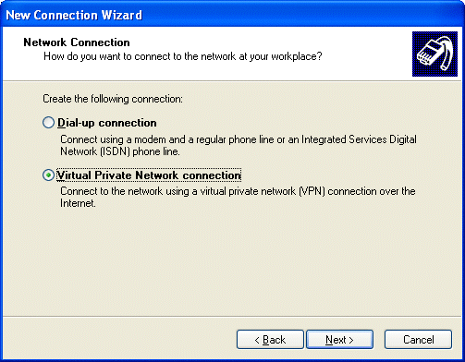

12. Click Next. On the Connection Name page, type L2TPtoCorpnet in Company Name. This is shown in the following figure.
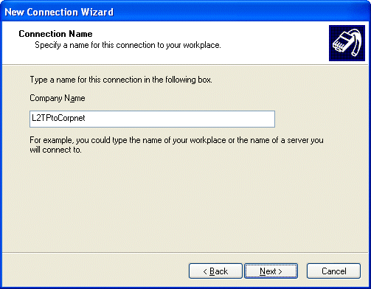

13. Click Next. On the Public Network page, click Do not dial the initial connection. This is shown in the following figure.
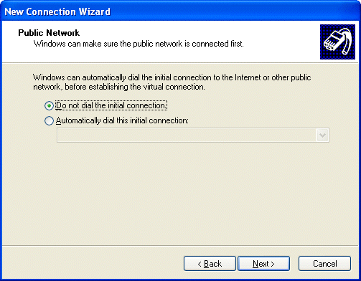

14. Click Next. On the VPN Server Selection page, type 10.0.0.2 in Host name or IP address. This is shown in the following figure.

15. Click Next. On the Connection Availability page, click Next.
16. On the Completing the New Connection Wizard page, click Finish. The Connect L2TPtoCorpnet dialog box appears. This is shown in the following figure.


17. Click Properties, and then click the Networking tab.
18. On the Networking tab, in Type of VPN, click L2TP IPSec VPN. This is shown in the following figure.
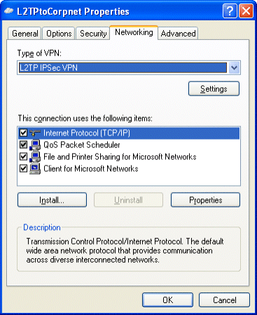

19. Click OK to save changes to the L2TPtoCorpnet connection. The Connect L2TPtoCorpnet dialog box appears.
20. In User name, type example\VPNUser. In Password, type the password you chose for the VPNUser account.
21. Click Connect.
22. When the connection is established, run the Web browser.
23. In Address, type http://IIS1.example.com/iisstart.htm. You should see a message saying the Web site is under construction.
24. Click Start, click Run, type \\IIS1\ROOT, and then click OK. You should see the contents of the local drive (drive C) on IIS1.
25. Right-click the L2TPtoCorpnet connection, and then click Disconnect.

EAP-TLS-based Remote Access VPN Connections
EAP-TLS-based remote access VPN connections require a user certificate on the VPN client and a computer certificate on the IAS server. EAP-TLS is for authenticating your VPN connection with the most secure user-level authentication protocol. Locally installed user certificates, enabled in the following steps, make it easier to set up a test lab. In a production environment, it is recommended that you use smart cards, rather than locally installed user certificates, for EAP-TLS authentication.

DC1
Configure DC1 for autoenrollment of user certificates
1. Click Start, click Run, type mmc, and then click OK.
2. On the File menu, click Add/Remove Snap-in, and then click Add.
3. Under Snap-in, double-click Certificate Templates, click Close, and then click OK.
4. In the console tree, click Certificate Templates. All of the certificate templates will be displayed in the details pane. This is shown in the following figure.
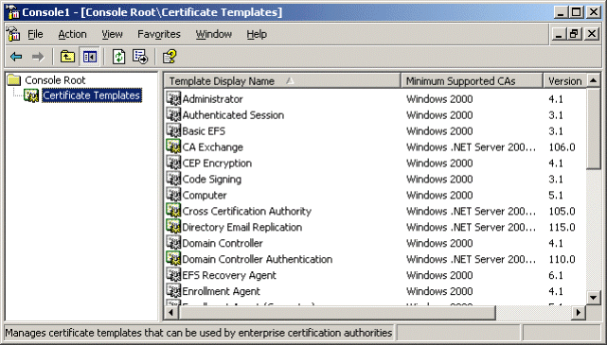

5. In the details pane, click the User template.
6. On the Action menu, click Duplicate Template.
7. In the Template display name box, type VPNUser.
8. Verify that the Publish Certificate in Active Directory check box is selected. This is shown in the following figure.
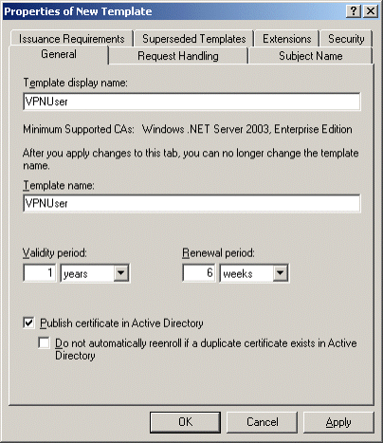

9. Click the Security tab.
10. In the Group or user names list, click Domain Users.
11. In the Permissions for Domain Users list, select the Read, Enroll, and Autoenroll check boxes so that these permissions are allowed. This is shown in the following figure.
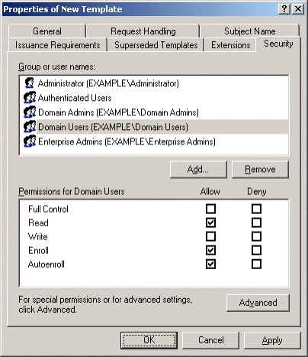

12. Click the Subject Name tab.
13. Clear the Include E-mail name in subject name and E-mail name check boxes. Because you did not configure an e-mail name for the VPNUser user account, you must clear these check boxes to allow a user certificate to be issued. This is shown in the following figure.
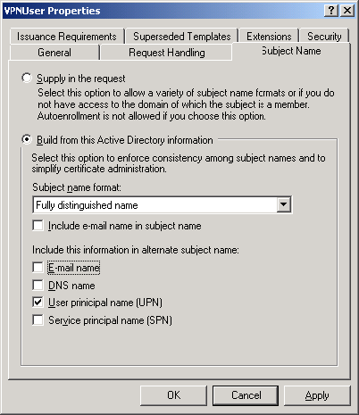

14. Click OK.
15. Open the Certification Authority snap-in from the Administrative Tools folder.
16. In the console tree, open Certification Authority, open Example CA, and then open Certificate Templates. This is shown in the following figure.
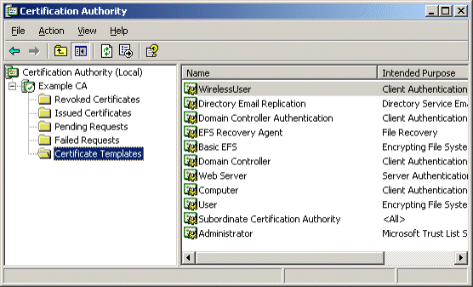

17. On the Action menu, point to New, and then click Certificate Template to Issue.
18. Click VPNUser. This is shown in the following figure.
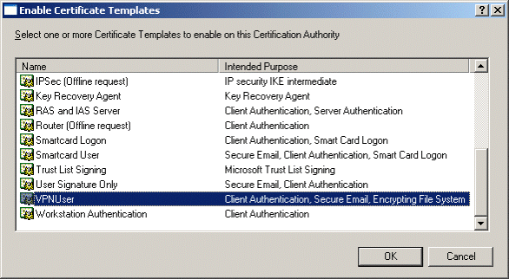

19. Click OK.
20. Open the Active Directory Users and Computers snap-in.
21. In the console tree, double-click Active Directory Users and Computers, right-click the example.com domain, and then click Properties.
22. On the Group Policy tab, click Default Domain Policy, and then click Edit.
23. In the console tree, open User Configuration, open Windows Settings, open Security Settings, and then open Public Key Policies. This is shown in the following figure.
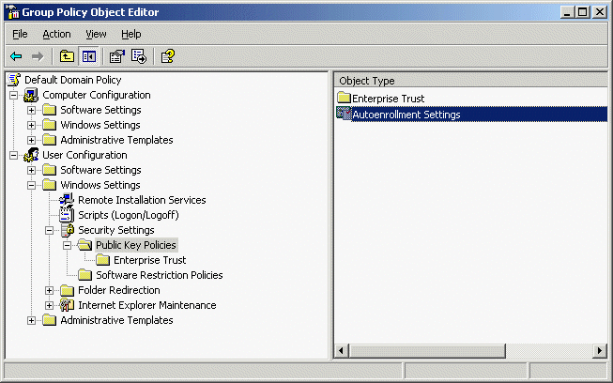

24. In the details pane, double-click Autoenrollment Settings.
25. Click Enroll certificates automatically. Select the Renew expired certificates, update pending certificates, and remove revoked certificates check box. Select the Update certificates that use certificate templates check box. This is shown in the following figure.
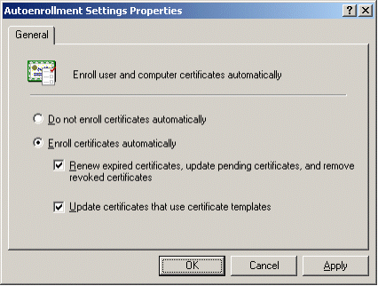

26. Click OK.

IAS1
Configure IAS1 with a computer certificate for EAP-TLS authentication
1. Restart IAS1 to ensure that IAS1 has autoenrolled a computer certificate.
2. Open the Internet Authentication Service snap-in.
3. In the console tree, click Remote Access Policies.
4. In the details pane, double-click VPN remote access to intranet. The VPN remote access to intranet Properties dialog box appears. This is shown in the following figure.
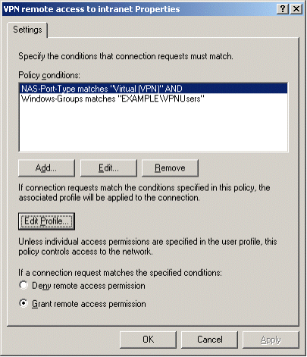

5. Click Edit Profile, and then click the Authentication tab. This is shown in the following figure.
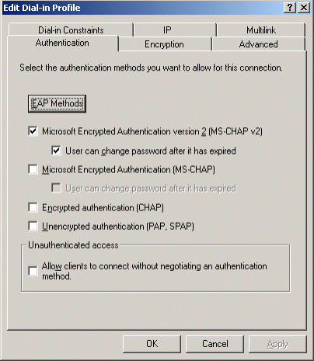

6. On the Authentication tab, click EAP Methods. The Select EAP Providers dialog box appears. This is shown in the following figure.
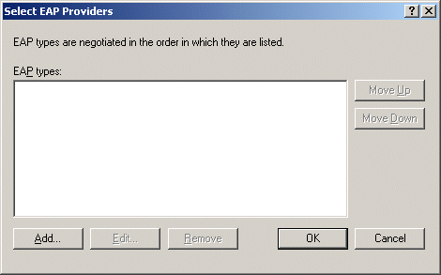

7. Click Add. The Add EAP dialog box appears. This is shown in the following figure.
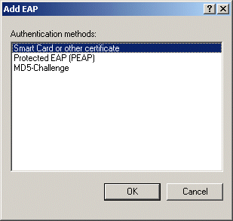

8. Click Smart Card or other certificate, and then click OK.
9. Click Edit. The Smart Card or other Certificate Properties dialog box appears. This is shown in the following figure.
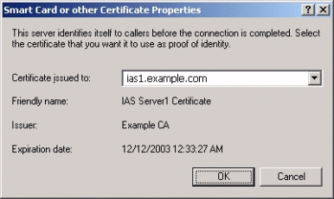

10. The properties of the computer certificate issued to the IAS1 computer are displayed. This step verifies that IAS1 has an acceptable computer certificate installed to perform EAP-TLS authentication. Click OK.
11. Click OK to save changes to EAP providers. Click OK to save changes to the profile settings.
12. When prompted to view help topics, click No. Click OK to save changes to the remote access policy.
These configuration changes will allow the VPN remote access to intranet remote access policy to authorize VPN connections using the EAP-TLS authentication method.

CLIENT1
Obtain a user certificate on CLIENT1, and then configure an EAP-TLS-based remote access VPN connection
1. Shut down the CLIENT1 computer.
2. Disconnect CLIENT1 from the simulated Internet network segment, and connect it to the intranet network segment.
3. Restart CLIENT1 and log on using the VPNUser account. The computer and user Group Policy is automatically updated.
4. Shut down CLIENT1.
5. Disconnect CLIENT1 from the intranet network segment, and connect it to the simulated Internet network segment.
6. Restart CLIENT1 and log on using the VPNUser account.
7. On CLIENT1, in Control Panel, open the Network Connections folder.
8. In Network Tasks, click Create a new connection.
9. On the Welcome to the New Connection Wizard page of the New Connection Wizard, click Next.
10. On the Network Connection Type page, click Connect to the network at my workplace.
11. Click Next. On the Network Connection page, click Virtual Private Network connection.
12. Click Next. On the Connection Name page, type EAPTLStoCorpnet in Company Name.
13. Click Next. On the Public Network page, click Do not dial the initial connection.
14. Click Next. On the VPN Server Selection page, type 10.0.0.2 in Host name or IP address.
15. Click Next. On the Connection Availability page, click Next.
16. On the Completing the New Connection Wizard page, click Finish. The Connect EAPTLStoCorpnet dialog box appears. This is shown in the following figure.
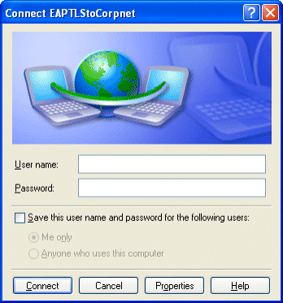

17. Click Properties, and then click the Security tab.
18. On the Security tab, click Advanced, and then click Settings. The Advanced Security Settings dialog box appears.
19. In the Advanced Security Settings dialog box, click Use Extensible Authentication Protocol (EAP). This is shown in the following figure.
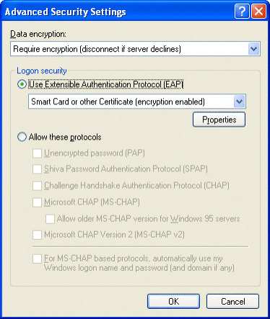

20. Click Properties. In the Smart Card or other Certificate Properties dialog box, click Use a certificate on this computer. This is shown in the following figure.
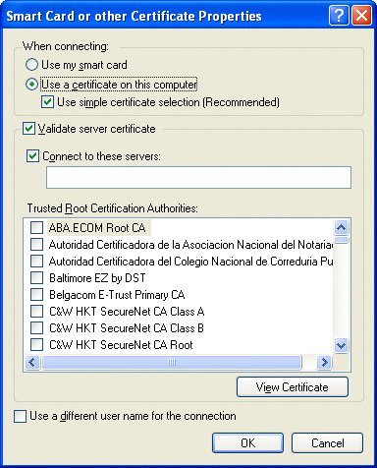

21. Click OK to save changes to the Smart Card or Other Certificate dialog box. Click OK to save changes to the Advanced Security Settings. Click OK to save changes to the Security tab. The connection is immediately initiated using the installed user certificate. The first time you try to connect, it may take several attempts to successfully make a connection.
22. When the connection is successful, run the Web browser.
23. In Address, type http://IIS1.example.com/iisstart.htm. You should see a message saying the Web site is under construction.
24. Click Start, click Run, type \\IIS1\ROOT, and then click OK. You should see the contents of the local drive (drive C) on IIS1.
25. Right-click the EAPTLStoCorpnet connection, and then click Disconnect.

Summary
This guide described in detail the steps required to configure secure VPN remote access using PPTP, L2TP/IPsec, and EAP-TLS in a test lab with five computers simulating an organization intranet and the Internet.

See Also
Microsoft VPN Web site
Windows Server 2003 Web site

