 version 2002
Developer Product Guide
February 2001

For more information, contact:
Rapid Response Team
Waggener Edstrom
(503) 443-7000
rrt@wagged.com

Abstract
This document provides an overview of Microsoft Access version 2002 for developers. It focuses on the new and improved features of Access as a development tool for database solutions. The latest version of Access offers many enhancements for creating Web-based data solutions and solutions that integrate with the rest of the enterprise.
For a complete discussion of Microsoft Access version 2002, see the Microsoft Office Product Guide.
For more information on Microsoft Office XP Developer and the Microsoft Office XP platform, see the Microsoft Office XP Developer Product Guide.

© 2001 Microsoft Corp. All rights reserved.
The information contained in this document represents the current view of Microsoft Corp. on the issues discussed as of the date of publication. Because Microsoft must respond to changing market conditions, it should not be interpreted to be a commitment on the part of Microsoft, and Microsoft cannot guarantee the accuracy of any information presented after the date of publication.
This document is for informational purposes only. MICROSOFT MAKES NO WARRANTIES, EXPRESS OR IMPLIED, IN THIS DOCUMENT.
Complying with all applicable copyright laws is the responsibility of the user. Without limiting the rights under copyright, no part of this document may be reproduced, stored in or introduced into a retrieval system, or transmitted in any form or by any means (electronic, mechanical, photocopying, recording or otherwise), or for any purpose, without the express written permission of Microsoft Corp.
Microsoft may have patents, patent applications, trademarks, copyrights or other intellectual property rights covering subject matter in this document. Except as expressly provided in any written license agreement from Microsoft, the furnishing of this document does not give you any license to these patents, trademarks, copyrights or other intellectual property.
Microsoft, SQL Server, Windows, Windows NT, Visual Basic, are either registered trademarks or trademarks of Microsoft Corp. in the United States and/or other countries.
The names of actual companies and products mentioned herein may be the trademarks of their respective owners.
Microsoft Corp.• One Microsoft Way • Redmond, WA 98052-6399 • USA

Contents
Introduction 1
Packaging and localization 2
Resources for Reviewers 2
New demands for database solutions 3
Web access 3
Collaboration 4
Rapid development 4
Microsoft Access version 2002: enhancements for developers 5
Create sophisticated database solutions 5
SQL Server integration 5
Enterprise Integration 6
Workflow Integration 7
Mobile computing 7
Improved analysis and presentation capabilities 8
Extend your data to the Web 8
Expose enterprise data in Web-based solutions 9
Deliver Web-based reports 9
Deliver Web-based analysis 10
Build database solutions faster 10
Leverage existing skills 11
Design and build Data Access Pages 11
Leverage enterprise and Web-based schema 12
Updated Object Model 13
Distribute and Deploy Access solutions 14
Deploying Web-based solutions 14
Distributing Access solutions 14
Easily upsize or upgrade to SQL Server 14
Backward compatibility 14
Conclusions 14

Introduction
Welcome to the Access version 2002 Developer Product Guide. Microsoft Access has long been recognized as a versatile application, providing the ease of use and simplicity that distinguish the Microsoft Office Suite, as well as a rich set of tools that enable developers to create sophisticated database applications. Access version 2002 extends this feature set by giving developers and advanced users new functionality to view and analyze data and to build powerful new database solutions.
Not only is Microsoft Office one of the world’s most popular productivity suites, it is also one of the most popular platforms for application development, with a base of more than 5 million developers worldwide. Microsoft Access itself claims a developer base of more than 600,000 developers, making it the second most popular development tool behind the Microsoft Visual Basic® development system. These developers include programmers working within companies that have committed to the Office platform as well as independent solution providers and value-added resellers, who create and market custom or shrink-wrapped solutions to the millions of Office users.
Both corporate developers and independent solution providers need powerful tools that enable rapid development of powerful data-driven applications. Solution providers are typically compelled to embrace the Web as the front-end and the transport mechanism for their solutions, while corporate developers are driven integrate their solutions with existing enterprise database infrastructure; however, with the increasing reliance of large organizations on the Internet/intranet, these needs are converging. Thus, a key design goal of Microsoft Access version 2002 was to give all Office developers the tools they need to build powerful, sophisticated database solutions for the intranet against SQL Server™ data.
Access version 2002 meets these needs through many enhancements to features, programmability, and the development environment. These enhancements improve the ease with which solutions are developed and streamline deployment of new applications. In addition, Access version 2002 offers developers new functionality to ensure that their solutions integrate seamlessly with existing enterprise data sources while ensuring forward and backward compatibility with other database solutions. And, Access version 2002 now provides the tools to build solutions that integrate and leverage Internet standards to better allow for the sharing and presentation of data across the Internet and intranet.

Packaging and localization
Microsoft Access version 2002 is available as a standalone product and is included with the following Microsoft Office Suites:
- Microsoft Office Professional
- Microsoft Office Developer
Microsoft Access version 2002 is localized into Greek, Brazilian, Simplified Chinese, Japanese, English, German, French, Italian, Russian, Polish, Czech, Swedish, Dutch, Danish, Finnish, Norwegian, Hungarian, and Spanish

Resources for Reviewers
There are many resources available to help you review Microsoft Access version 2002. If you need help beyond what is included with this document and the accompanying material, your primary resource is the Rapid Response Team at Waggener Edstrom. If you have questions about the product or require technical support, e-mail rrt@wagged.com or phone 503-443-7000.
The following resources are also available to help guide your review:
- Microsoft Access version 2002 Product Guide provides a complete overview of the Access version 2002, including design goals and new/enhanced features of interest to end users as well as developers.
- The Microsoft Office Developer Reviewers Guide provides an overview of enhancements to the Microsoft Office XP development platform, of which Access is a key component.
- Microsoft Office Developer’s Guide is included with Microsoft Office Developer and is available from MS Press.
- The Microsoft Office Developer Center on MSDN includes in-depth articles on a variety of development topics. http://msdn.microsoft.com/office.

New demands for database solutions
The evolution of the digital economy and the explosion of e-commerce have created new challenges for developers who provide data-based solutions to today’s businesses. The emergence of the Web as a dominant force in business has contributed to a dramatic increase in the amount of data available to organization, and in the speed with the data must be analyzed and reported.
These trends have heightened reliance on traditional database applications and increased the demands on these applications in terms of both performance and reliability. In addition, the changes in the way we do business have created demand for new features that extend database applications beyond the traditional feature set and prepare them to do service in the new economy.
Microsoft Access is firmly established as a robust tool for creating database solutions that can handle the traditional requirements. With the release of Access version 2002, Access becomes the perfect tool to meet the demands of the new economy. This document focuses on the new additions that make Access version 2002 that have evolved as a result of the changing business environment. The following sections identify these demands in detail, and then talk about the new features of Access that address each of them. Specifically, organizations are demanding that database solutions provide:
- Web-based access to analysis and reporting tools
- Support for collaborative computing and information sharing
- Rapid development and modification

Web access
To ensure maximum flexibility and accessibility to the widest number of users, businesses are demanding that applications be delivered to the browser and that data be accessible via data portals such as digital dashboards. These businesses rely extensively on intranets and the Internet tor access to data and applications, as well as for interaction with customers and suppliers, emphasizing the imperative for “Web-enabled” or “Web-based” solutions. As an added benefit, adherence to well-defined standards for data exchange (e.g., XML) as well as Web-based communication protocols (e.g., HTTP) ensures a degree of forward and backward compatibility, allowing companies to integrate new solutions with legacy systems and heritage data stores and to quickly develop interfaces with external (supplier/vendor-managed) systems. Thus, even traditional programmers are pressured to identify as “Web developers” and to deliver solutions that leverage the Internet for both presentation and sharing of data.

Collaboration
The past several years have shown a clear trend toward collaboration, as companies seek to improve the return on their investment in vast stores of business knowledge. In the broadest sense, collaboration involves enabling knowledge workers to work together on the same information.
In the enterprise, collaboration also requires that database solutions be able to aggregate data from numerous sources across the enterprise (ranging from the e-commerce click stream to e-CRM to inventory management) and ensure consistent application of business rules and processes throughout the company. These demands call for increasingly sophisticated database solutions.
Further, as the knowledge workforce becomes increasingly mobile, continuous access to the Internet or corporate intranet cannot be taken for granted. Companies need to make sure their workforce has access to shared data and corporate knowledge bases while on the road, at home, or even while in the air, by providing data and services to both online and offline users, and delivering data to mobile devices such as Pocket PCs.

Rapid development
The pace of business has never been faster. To remain competitive, businesses must be able to re-align and execute with unprecedented agility. The developers who support these businesses are likewise feeling the pressure; corporate IT staff typically face large backlogs of client requests, while the independent SP knows only too well that “time is money.” Developers must respond quickly to the changing demands of their clients. This requires flexible solutions as well as tools that support rapid development.

Microsoft Access version 2002: enhancements for developers
A key design goal of Microsoft Access version 2002 was to provide enhancements that enable developers to meet the emerging needs of their business customers. This includes enhancements that directly affect developer productivity and ease of use, as well as improvements and new features to ensure that solutions based on Microsoft Access meet the challenges of today’s businesses.
These solutions must embrace the Internet and integrate seamlessly with enterprise-wide data while ensuring forward and backward compatibility with new and existing database solutions. To achieve this, Access version 2002 now provides the tools to build solutions that integrate and leverage Internet standards, such as XML, XSL, and dynamic Web pages, to better allow for the sharing and presentation of data across the Internet and intranet.
The feature enhancements of interest to Access developers can be categorized according to three broad goals:
- Create sophisticated solutions: build powerful database applications that meet the needs of the small business, the enterprise, and everything in between.
- Extend data to the Web: easily publish data and database solutions on the Web fast for online and offline access for analysis, modification, and viewing.
- Build database solutions faster: develop database solutions— including Web-based solutions—quickly.

Create sophisticated database solutions
Access version 2002 enables developers to create high-performance database applications, ranging from simple desktop applications to sophisticated solutions suitable for deployment across an entire organization. These solutions are capable of meeting the unique needs of the enterprise, for example, by integrating seamlessly with enterprise data sources, such as ERP systems, or by incorporating support for a mobile workforce by allowing users to view and modify data while offline, and then automatically replicate changes to the master database.

SQL Server integration
Microsoft Access enables developers to create client/server solutions that extend beyond simple database files and programs, offering direct access to a Microsoft SQL Server database through Access Data Projects. These client/server applications can be based on Access forms and reports, on Web-based Data Access Pages, or use a combination of both.
Access Data Projects provide efficient, native-mode access to a SQL Server database through the OLE DB component architecture. An Access Data Project includes only code-based or HTML-based database objects: forms, reports, data access pages, macros, and modules. Data-definition objects (e.g., tables, views, database diagrams, or stored procedures) are stored in the SQL Server database.
Access version 2002 improves on its predecessor by offering support for additional SQL Server–specific features, such as updatable views and improved stored procedure support from Access Data Projects. In addition, the Stored Procedure Designer enables developers to create and modify simple SQL Server Stored Procedures (Action Queries) from within an Access Data Project without having to learn Transact SQL.
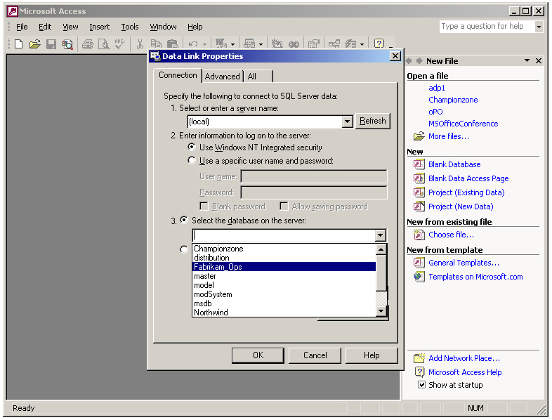
The Data Link Properties dialog enables developers to pick from a list of SQL Server databases available on the selected server.

Enterprise Integration
Integration of Access solutions with other enterprise data stores has traditionally been achieved through support for OLE DB and ODBC. Access version 2002 supports these industry standards, as well as XML and XSL, the emerging standards for data exchange and transformation.
- OLE DB and ODBC. Widespread support for Microsoft standard OLE DB and the Open Database Connectivity (ODBC) API in leading database products ensures Access version 2002 solutions have access to many different types of data, including SQL Server, Oracle, DB2, other relational databases, and flat files.
- XML import and export. The ability to import and export data as XML enables Access version 2002 to share data with a virtually unlimited number of sources. As an established standard for data exchange, XML ensures interoperability between Access version 2002 solutions and third-party, Web-based, legacy, or proprietary database applications.
- XSL Transformations and Presentations. Developers can create their own custom XSL data transformation to be used when exporting data to an XML document. This provides a simple mechanism to translate XML documents from one format to another. For example, data exported from an Access solution could be formatted into a structure understood by a SAP/R3 system or proprietary corporate system.

Workflow Integration
Incorporating workflow support enables developers to build collaborative applications that are closely aligned with businesses processes. By automating a series of tasks, designating task order, and assigning permissions, workflow ensures that business rules are applied consistently throughout the organization.
Through integration with the Workflow Designer for SQL Server, Access version 2002 enables developers to build professional Web-based interfaces for workflow solutions. Access 2000 Data Access Pages provide an easy method to create a Web interface for a database-driven workflow solution.

Mobile computing
Microsoft Access version 2002 enables developers to build solutions that meet the needs of the mobile workforce. Several enhancements allow flexible mobile solutions for a variety of offline scenarios, including the ability to modify data and update a database on reconnect, and the ability to target mobile devices.
The capability to save data as XML allows users to make Data Access Pages available for offline viewing, in much the same way they would make a Web page available offline. When a Data Access Page is saved in this way, data is replicated to the client as an XML island, stored in the Internet Explorer cache. The data itself is read-only, but users are able to perform analysis and conduct ad hoc queries on the data set.
Through SQL Server Merge, Data Access Pages also support replication between SQL Server and the MSDE desktop database engine. This enables users to view and modify data offline, and then automatically replicate the data back to the server when they reconnect via a network or Internet.
Developers can also create solutions that target the wide range of devices that use Windows for Pocket PC. Both SQL Server Windows CE Edition and Pocket Access allow users to replicate databases to their mobile devices, view and modify data, and then synchronize the updated data via a variety of connectivity options.

Improved analysis and presentation capabilities
Access version 2002 enables developers to create solutions that display graphical and multidimensional representations of enterprise data. New to Access version 2002 is the capability to use Office Web Components, PivotTables®, and PivotCharts®, on Access forms. Users can view any Access database table (.mdb file) or analyze SQL Server data using an ADP component in PivotTable and/or PivotChart view. This allows developers to build rich data analysis solutions quickly and simply.
In addition, the capability to save PivotTable and PivotChart views as Data Access Pages allows rich analytical solutions to be viewed and manipulated by others via a Web browser interface.
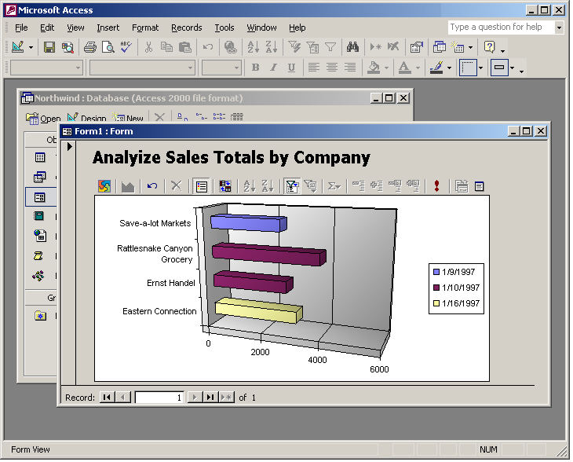
Access version 2002 allows developers to add PivotCharts to Access forms.

Extend your data to the Web
Microsoft Access version 2002 enables developers to create Web-based database solutions that deliver rich presentation and analytical features to the browser and allow users to interact with data sources over the Internet or corporate intranet. For the database developer, this opens a new world of Web-based solutions development. For the organization, this opens new worlds of collaboration, as data is more accessible than ever before, through intuitive browser interfaces or data portals that leverage existing Internet/intranet infrastructure.

Expose enterprise data in Web-based solutions
Access version 2002 enables developers to create Web-based solutions that allow users to view and manipulate data from virtually any corporate data store. These solutions are typically based on Data Access Pages. Introduced in Access 2000, Data Access Pages provide a method to create data-bound HTML pages that can be deployed to an intranet or the Internet.
Access version 2002 extends the functionality of Data Access Pages in several areas, offering simplified deployment, greater stability, and the capability to update data on grouped pages. These enhancements enable developers to create truly enterprise-ready solutions, which offer more reliable access and improved ability drill-down than were available in Access 2000.

Deliver Web-based reports
Access version 2002 enables developers to quickly build simple reports, data sets, and navigation that enable decision makers and analysts to view and edit corporate data—both online and offline.
Any report can be saved as a Web page, using the Save As Data Access Page feature. Reports saved in this way can be deployed immediately to the Web and remain linked to the data they represent.
When reports contain data that rarely changes, developers can publish reports by saving an Access report, form, table or query to an XML document that includes an associated XSL file for presentation. Reports that rely on an XML representation of the data (rather than a link to the database itself) increase performance by limiting active connections to corporate servers. XML-based reports and forms can be run from either the server (using Active Server Pages) or the client (HTML) and can be viewed with any Internet browser that supports HTML 4.0.
For data that changes frequently, developers can create dynamic reports using HTTP-SQL. HTTP-SQL allows users to view live data over the Web, by querying against the SQL store form the browser.
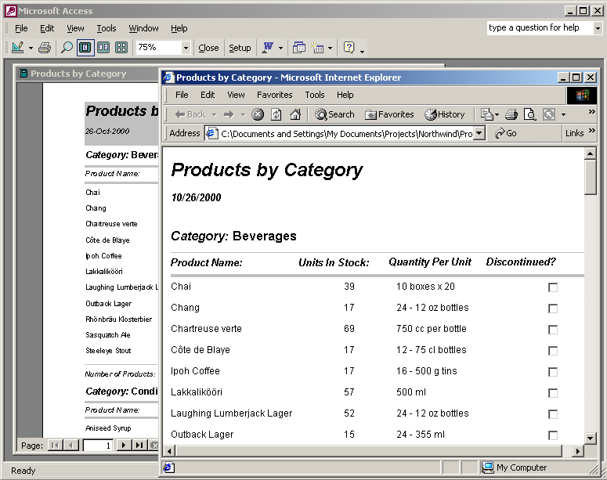
Access reports can be saved as Web pages and viewed in the browser.

Deliver Web-based analysis
For more interactive analysis, Access version 2002 enables developers to easily add rich charts and PivotTables to Web pages. Integrating data across Web pages and Office applications allows broader access, delivering business intelligence to the end users who require it for their day-to-day work.
Access version 2002 provides the capability to save PivotTable and PivotChart views as Data Access Pages, making it easier than ever to deliver sophisticated analysis on the Web.
An updated object model for the PivotTable and PivotChart controls offers both familiarity and performance enhancements. The server component included with Access version 2002 has been improved to offer faster data calculations and improved performance with multiple users accessing the component. The new Office Web Component Object Model is similar to the Microsoft Excel Object Model, enabling to developers to quickly build Web components with a familiar set of tools.

Build database solutions faster
The pace of business has never been as fast as it is today, and developers are feeling the heat as much as their clients. Corporate programmers operate under the same pressure as their companies and typically maintain heavy backlogs. Independent solution providers require tools that allow rapid development of robust solutions. Microsoft Access version 2002 includes enhancements to both programmability and usability that directly address this need for speed, enabling developers to create and distribute sophisticated, Web-based solutions faster than ever.

Leverage existing skills
Microsoft Access version 2002 enables developers to extend their existing skill set to the Web and to the enterprise. Both Web-based solutions and solutions that integrate enterprise data sources can be created using traditional Access developer skills, standard tools, and data access techniques. For the current Access developer, this creates tremendous opportunity in two rapidly expanding markets.

Design and build Data Access Pages
Access version 2002 offers an improved development environment for Data Access Pages, so the creation of sophisticated Web-based interfaces has never been easier. The enhanced Data Access Page Designer provides a variety of new and improved enhancements that allow users to design their Data Access Pages more effectively. In addition, Access version 2002 automates the creation of Data Access Pages from forms and reports. Developers can quickly move solutions to the Web by simply choosing the Save As command to create a Web version of the form or report. Specific enhancements include:
- Extended properties from both Microsoft Jet and Microsoft SQL Server 2000 databases. Access version 2002 inherits extended properties (including, lookups, captions, and formatting information) for data objects imported from both SQL Server and Jet databases.
- Support for drag and drop allows fast placement of controls and page elements.
- Improved hyperlink handling makes it easier to create pages that are linked together.
- Improved control sizing allows developers to see the actual size of the control while sizing, allowing better snap-to-grid support.
- Multi-select support through the keyboard and mouse allows users to apply sizing, horizontal and vertical spacing, alignment, and property settings to Data Access Pages.
- AutoSum makes it easier to create totals.
- The Data Outline feature allows developers to view and set properties on a recordset.
- New connection properties make it simple to build applications that use the same connection string. This makes it easy to move applications from test to live.
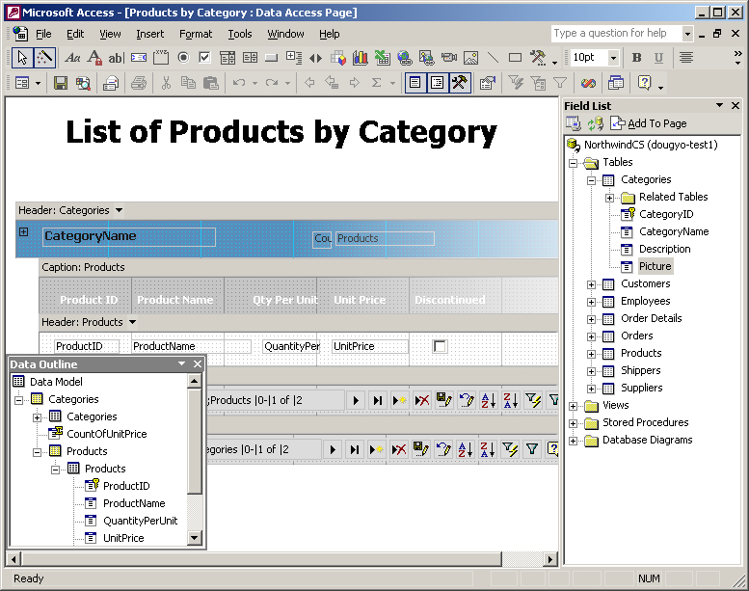
The Data Access Page Designer includes new Data Outline and Field List palettes, making it even easier to develop Access solutions for the Web.

Leverage enterprise and Web-based schema
Access version 2002 facilitates creation of new databases by allowing developers to import schema from existing databases. Schema can be leveraged from existing SQL Server databases or imported from Web-based XSD schema.
Developers can create entire relational databases or parts of databases simply by importing an XSD schema from anywhere on the Web. Access version 2002 enables users to import XML schema or data documents into either SQL Server or Jet, and to include or exclude data or schema and determine whether the data should be appended to overwrite any existing information.
Access version 2002 uses a shared set of XML annotations that are standardized across Microsoft data products. This enables Access developers to generate schema that can be used by other Microsoft products without transformation, and to import data directly into Jet or MSDE from XML schemas generated by other products using the same annotations. Access version 2002 includes a visual relationship designer that can be used to generate schema that can then update SQL Server. When copying data objects from SQL Server, Access version 2002 also inherits the extended properties for these objects, ensuring that they are displayed properly when placed on an Access form or datasheet. Access also copies extended properties from table columns to form and report control properties.

Updated Object Model
Access version 2002 includes an updated Object Model with many new events and properties. Changes to the Object Model enable programmatic control over many of the new features available of Access version 2002. In addition, many changes are based on specific requests made by Access developers. The updated Object Model for PivotTable, Spreadsheet, and Chart controls is compatible with the full Excel application runtime object model.
Extended methods and properties. Access version 2002 provides a variety of new methods and properties that provide programmatic control over database-level operations, including–
- The ability to set up lookup relationships, validation text, formatting, and subdatasheets against tables, views, and functions.
- Programmatic control of printing properties via a new Printer object and Printers collection.
- The ability to get the DataCreated and DataModified properties for any Access object by using the AccessObject object.
- New methods and properties, such as CompactRepair, ConvertAccessProject, AddItem, and RemoveItem methds and a new BrokenReference property that makes it easy to detect if a project has a broken reference.
New events for forms. Several events have been added to forms in Access version 2002. These provide developers with greater control over the application behavior while users modify records on forms. New events include–
- A form-level OnUndo event that occurs whenever a user undoes all edits to a form.
- Control-level OnDirty and OnUndo events that work just like the form-level events of the same name.
New properties for forms and reports. In response to developer requests for greater control over reports, Access version 2002 includes several new properties. In particular, Access version 2002 adds properties that have been available for forms in previous releases, including Modal, PopUp, BorderStyle, AutoResize, AutoCenter, MinMaxButtons, CloseButton, and ControlBox. All properties work the same way the form properties of the same name work. The OpenArgs property has also been added to Access reports to identify the arguments used to open the report. Finally, a Movable property has been added to Forms, Reports, and Controls.
Data Access Page Events. Access version 2002 introduces several new events that enable developers to customize user interactions with Data Access Pages. Data Access Page interfaces and behaviors can now be controlled in a manner similar to Access forms. Specific events include: AfterDelete, AfterInsert, AfterUpdate, BeforeDelete, BeforeInsert, BeforeUpdate, Dirty, Focus, RecordExit, and Undo.

Distribute and Deploy Access solutions
Access version 2002 makes it easy to deploy solutions, whether to a small business or a large enterprise, as a third party or internal developer.

Deploying Web-based solutions
Access version 2002 makes it easy to distribute Web-based data solutions throughout the enterprise, by using relative paths to Access databases and common connections for all Data Access Pages in a solution.

Distributing Access solutions
Microsoft Office Developer includes the royalty-free Access runtime, which allows developers to distribute Access applications with the royalty-free Access runtime included with Office Developer

Easily upsize or upgrade to SQL Server
Access version 2002 includes the new SQL Server 2000 Desktop Runtime Engine. This desktop engine is 100% compatible with SQL Server 2000 and enables users and developers to easily create and modify SQL Server-compatible databases. A database created in Access version 2002 can be redeployed to SQL Server 2000 with no modifications.

Backward compatibility
Access version 2002 ensures backward compatibility with databases and application built in Access 2000, so developers can take advantage of new features and deploy new solutions without concern. Access version 2002 and Access 2000 can use and modify the same Access 2000 database, enabling organizations to continue support for existing Access 2000 users and solutions.
The Access 2000 file format is the default file format for new databases and solutions. The new, optional Access version 2002 file format offers faster data access and data processing for large databases. In addition, this format will seamlessly handle future changes to Access, such as new properties and events, which have caused file format changes in previous releases.

Conclusions
With a developer base of more than 600,000 developers, Microsoft Access is well established as a powerful tool for building traditional database applications. Building on the rich feature set and robust development tools of its predecessor, Access version 2002 provides developers with the tools to extend their solutions beyond the traditional, providing Web-based access to analysis and reporting, and integrating desktop applications with enterprise data sources. Combining this new functionality with tools and product enhancements that ensure maximum developer productivity, Access version 2002 enables developers to build database solutions that meet the challenges of doing business in the new economy.

