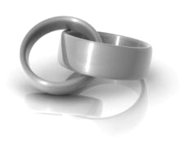

RSVP by June 6 at dobson@live.ca or (123) 555-6789

Sarah Dobson

Jake Thomas

together with their parents

invite you to share in their joy

as they exchange marriage vows

Saturday, the twenty-eighth of June

Two thousand and eight

at five o’clock in the evening

at Gravenhurst Dock

1 Muskoka Drive

Gravenhurst, ON

Reception dinner to follow

together with their parents

invite you to share in their joy

as they exchange marriage vows

Saturday, the twenty-eighth of June

Two thousand and eight

at five o’clock in the evening

at Gravenhurst Dock

1 Muskoka Drive

Gravenhurst, ON

Reception dinner to follow

Sarah Dobson

Jake Thomas

RSVP by June 6 at dobson@live.ca or (123) 555-6789