April 2007

Batter up, if you dare!

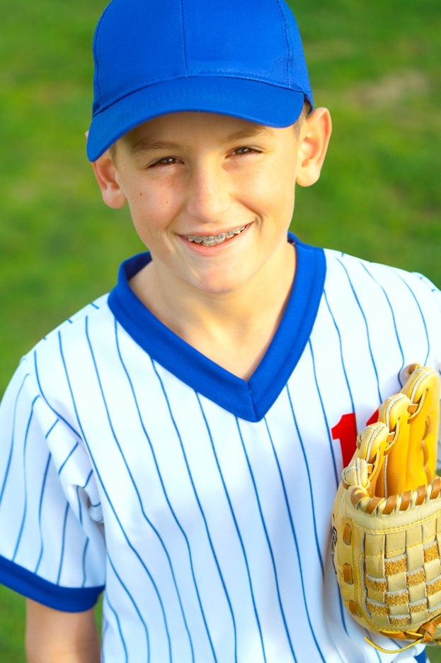

Move over Calu Ripken Jr., Robbie Jamison is the next diamond star. Robbie started the game today and the coach never sent in a relief — why would he when Robbie struck everyone out! It was unbelievable. And our modest son, when asked about his great pitching, could only say, “Yeah, it was a good game.”

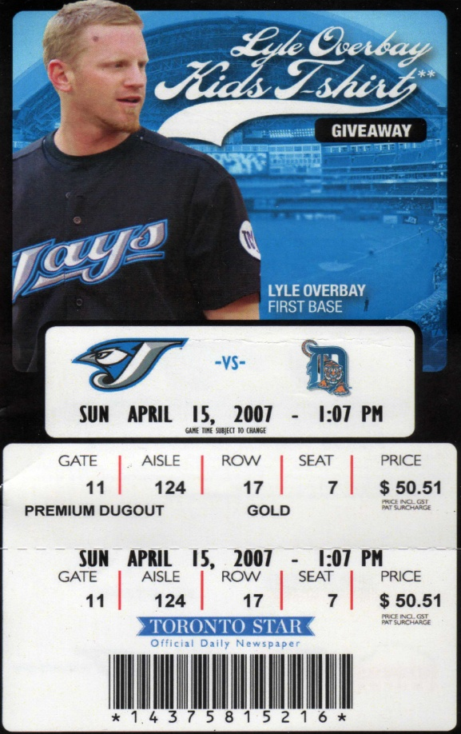

To celebrate, we took him to a Blue Jays game on Sunday. The amazement continued — Robbie actually caught a ball! I wish we had brought the camera. I can only hope that beautiful smile we (and the rest of the game-goers) saw on the jumbotron remains permanently etched in my memory forever. What a fantastic weekend.