**Here’s a handy reference guide outlining what’s on your screen when you power up.**

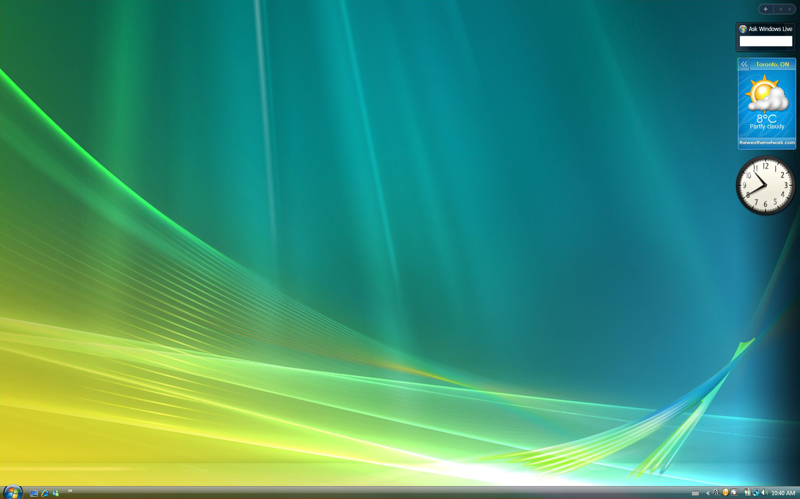

The computer desktop is what you see on the screen when you first turn the computer on.

The computer desktop is what you see on the screen when you first turn the computer on.

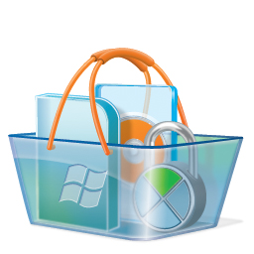

Icons are images that represent all the files, folders and tools available to you.  Use them to access tools and programs on your computer.

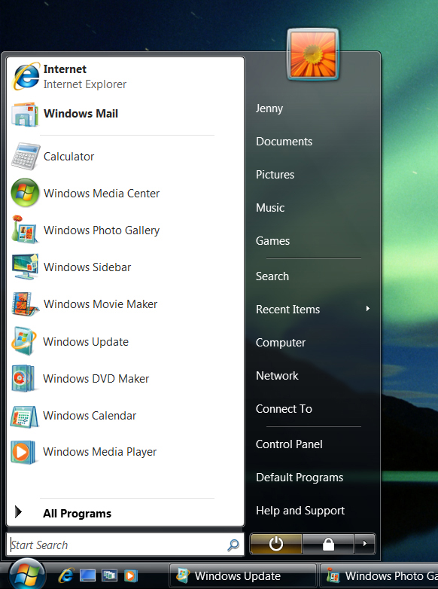

The start-up menu is a list where you can access all the programs in your computer.

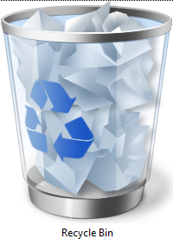

The recycle bin is where you throw away files you no longer need.

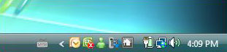

The task bar is your desk’s catch-all drawer. It holds every tool in your computer.

There is a clock for your convenience on the task bar at bottom right. Double-click on it and you open up a calendar as well. Beside the clock, there are more icons. They represent all the programs that are active or ready to go, including Windows Live Messenger.

clock.jpg

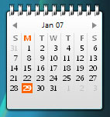

Gadgets are mini-applications that allow you to quickly access information online or from another program on your computer. Some gadgets that come with Windows Vista include a notepad, calendar and feed headlines of the latest news.

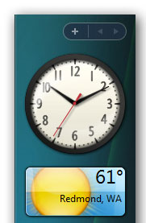

The sidebar is a column that runs down the right side of your desktop where your gadgets are located. Click on them to move them up or down the sidebar.

•

This is your desktop, so you can rearrange the icons or throw away what you don’t use. You can also change the look of your desktop by right-clicking on the mouse, selecting Properties and then choosing the background image you want to see.

