

Reference guide to music in the house

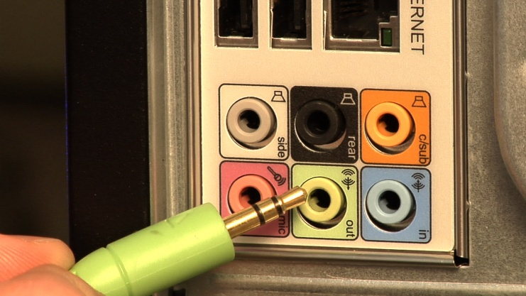

Option #1: Listen directly.

* On the back of your PC, you’ll find audio mini-jack sockets. They resemble the headphone sockets on a portable music player.
* On your sound card, there may be one or many sockets. Fortunately, they’re colour-coded, and the green one is for your computer speakers.

Option #2: Share music.

* The PCs on your home network can share music through Windows Media Player. In Windows Media Player, select Media Sharing under the Library heading.
* The Media Sharing panel allows you to choose whom you share your music with. The panel also lets you access music stored on the computers of other family members.

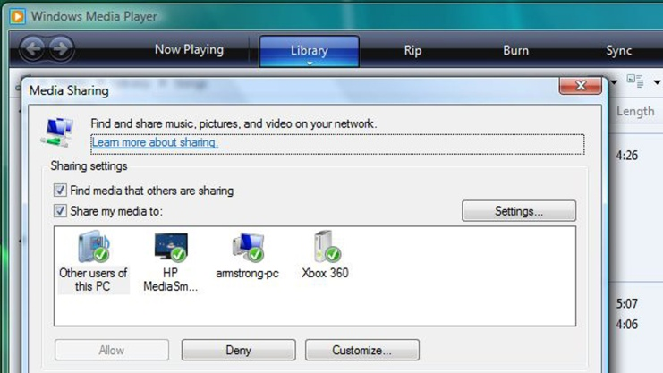

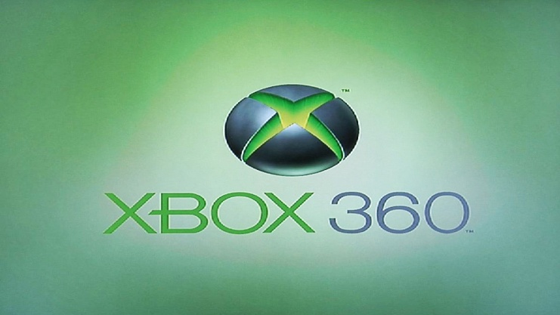

Option #3: Hook up to your home entertainment system.

* Using an Xbox 360, you can turn your gaming setup into a networked multimedia player.
* The Xbox 360 is the ideal digital media hub for playing music, watching videos and even showing off your images.

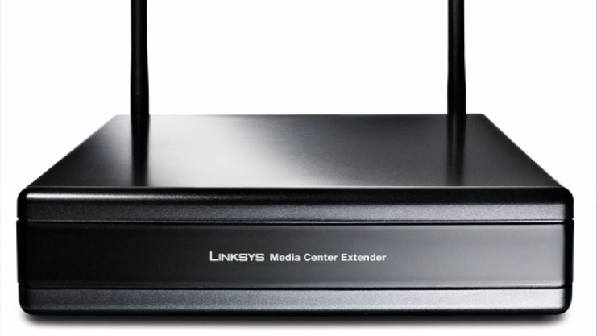

Option #4: Hook up a media extender to your main stereo or bookshelf system.

* A stand-alone media extender has the networking power of an Xbox 360 without the gaming capabilities.
* Your PC, software and the features built into Vista can connect everything from computer speakers to networked multimedia content throughout your home. You can make it happen!