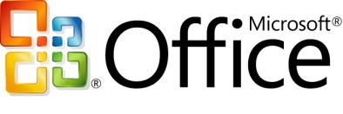Microsoft Office Ultimate 2007

**Microsoft® Office Ultimate 2007 provides people at home or work with a comprehensive toolset to gather and consolidate virtually any type of information, find what they are looking for quickly, and easily share information with others across geographical or organizational boundaries, so they can deliver better results faster.**

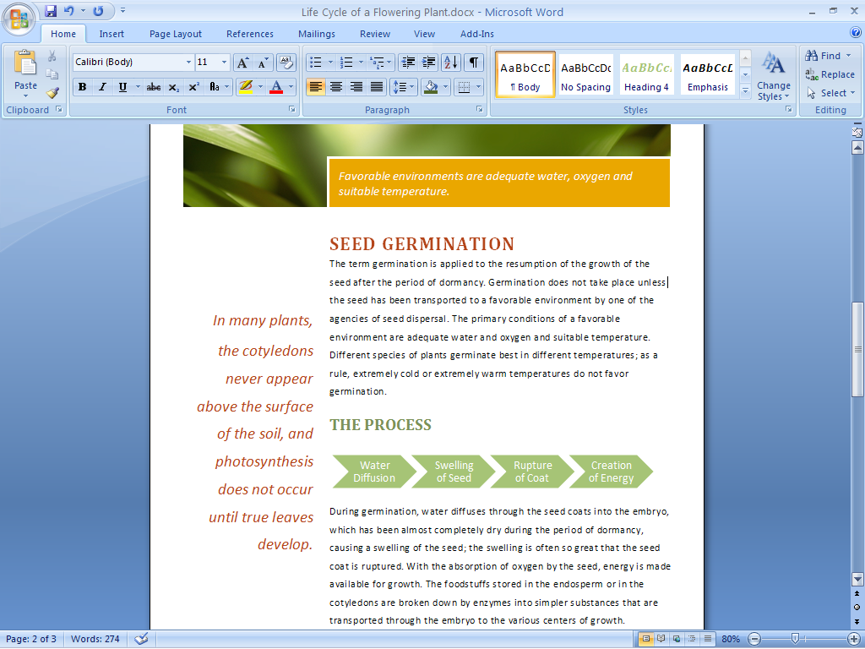

*The new streamlined workspace and easy-to-browse tabs make program features easier to find and use.*

Work from Home

Microsoft Office Ultimate 2007 provides the same tools that you may use at work for use at home.

Work from home as easily as you do at the office.

You can now have at home the entire Microsoft Office system toolset that you’re accustomed to working with at the office—Microsoft Office Word 2007, Microsoft Office Excel® 2007, Microsoft Office PowerPoint® 2007, Microsoft Office Outlook® 2007 with Business Contact Manager, Microsoft Office Access 2007, Microsoft Office Publisher 2007, Microsoft Office InfoPath® 2007, Microsoft Office Groove® 2007, and Microsoft Office OneNote® 2007.

Gain greater efficiency while mobile.

Be more productive and efficient while away from your computer with Office OneNote Mobile, which enables you to both view your notes and collect new notes—even your pictures or your audio recordings—on your device and synchronize them with OneNote on your computer.

Work effortlessly virtually anywhere, online or offline.

Office Groove 2007 stores all your workspaces, tools, and data right on your computer—there’s no need to connect to the corporate network to access information. You stay productive whether you’re working in the office, at a customer site, on the road, or from home.

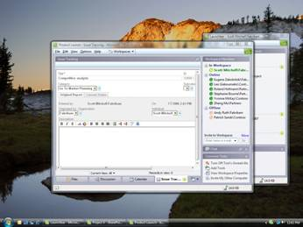

*Your data is with you when you need it.*

Simplify Working Together

Easily work with coworkers, partners, or customers inside collaborative workspaces.

Work in teams.

Office Groove 2007 enables you and your team to work together dynamically inside collaborative workspaces that put team members, tools, and information in one place right on your computer.

* **Collaborate easily with internal and external people.**

Create and customize Groove workspaces with advanced security features right on your computer and invite colleagues, partners, and customers without worrying about security or requesting IT resources.

Keep team members up to date automatically.

You don’t have to download information from Groove workspaces or OneNote notebooks before you go offline, or upload changes when you reconnect. All team members’ offline work is synchronized as soon as an Internet connection is obtained.

Know who’s available.

Users can see which team members are online with indicators of member presence in Groove workspaces, and exchange messages using the chat tool in Office Groove 2007.

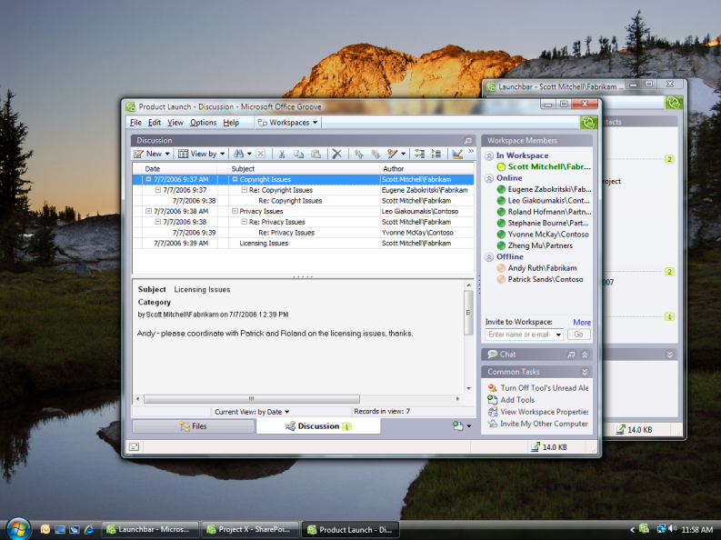

Easily communicate with team members who are online.

Better Information Insight

Extend the capabilities of individuals and teams to gather, access, and analyze critical data easily.

Find what you need faster.

The new search technology in Office Outlook 2007 helps you find the e-mail messages you need much faster than with prior versions of Outlook.

Analyze data quickly.

Office Excel 2007 makes it easy to analyze data quickly with powerful new visualization tools.

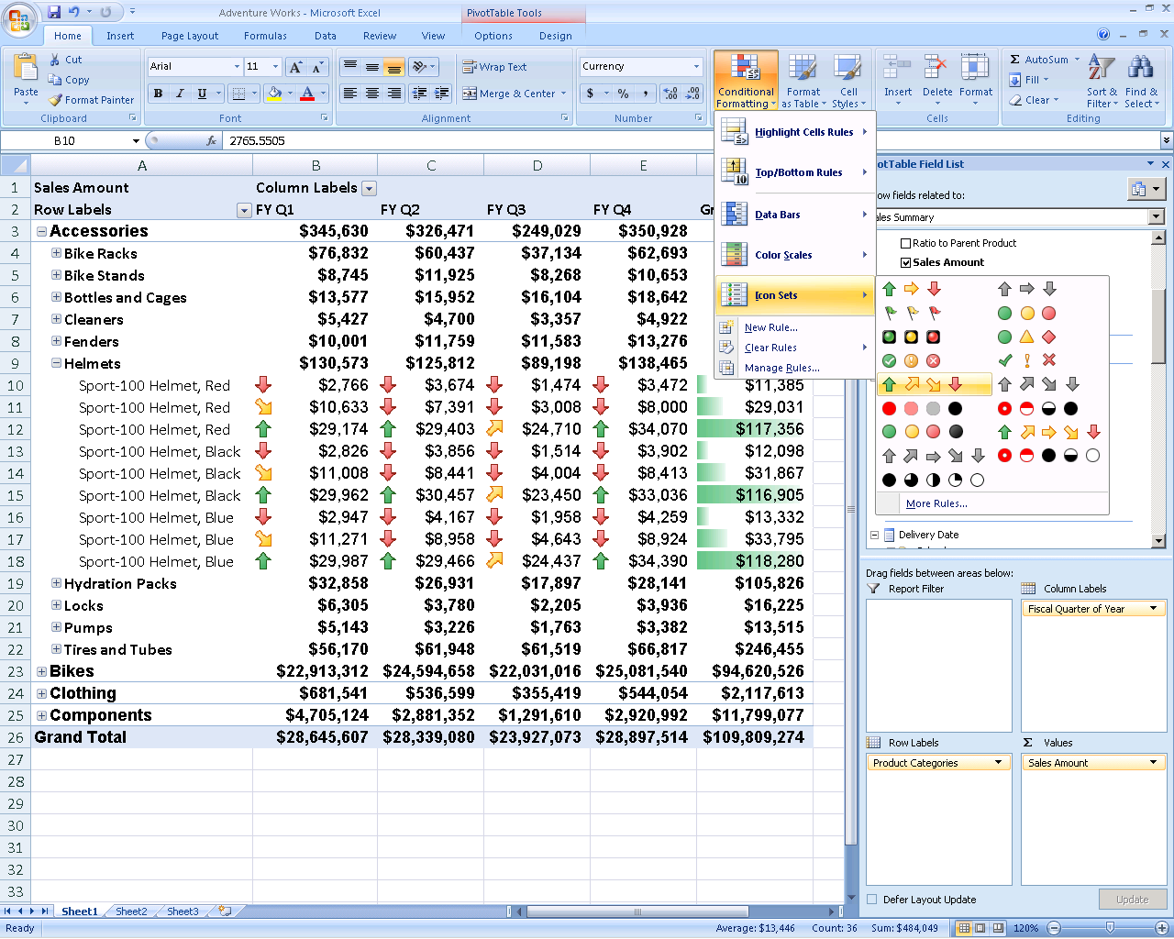

Powerful new visualization tools enable you to analyze data quickly.

Track information from various sources.

Office Access 2007 offers an easy way to compile and track information from different sources so you can quickly filter data.

Create and Manage Content

Office Ultimate 2007 enables individuals to create and manage content efficiently and effectively.

Organize your information.

Office OneNote 2007 enables you to work more productively by organizing and consolidating disparate pieces of project-related information, including digital handwritten notes, audio and video recordings, formatted documents, and still images, into a OneNote notebook.

* **Share many types of data.**

With Office Groove 2007, you can share many types of data, such as documents from a Microsoft Windows® SharePoint® Services document library or structured data from business applications.

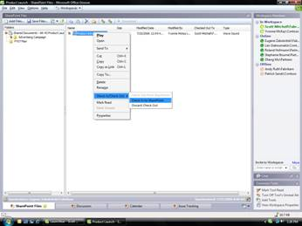

*Easily share data from the SharePoint document library.*

Gain greater visibility.

Groove audible and text alerts notify you of specific changes to content, helping you monitor document changes and gain greater visibility to the most up-to-date project information.

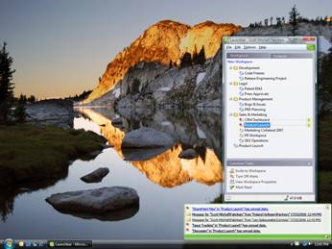

*Customized alerts keep you updated and on track.*

MSlogo_k_1118Remain in control of your information.

Working with Office Groove 2007 helps   
ensure your information has advanced security protection, even on portable computers and wireless networks.

For More Information

Learn more about Microsoft Office Ultimate 2007 and the Microsoft Office system at <www.microsoft.com/office/suites/ultimate>.

For complete system requirements, please visit [www.microsoft.com/office/suites/ultimate](http://www.microsoft.com/office/suites/ultimate).