

Microsoft Exchange 2003 Disaster Recovery Operations Guide

Microsoft Corporation
Published: December 12, 2006
Author: Exchange Server Documentation Team

Abstract
This guide provides installation and deployment information for intermediate and advanced administrators planning to deploy Exchange Server 2003.
Comments? Send feedback to exchdocs@microsoft.com.

Contents
Exchange 2003 Disaster Recovery Operations Guide 13
Introduction to the Exchange 2003 Disaster Recovery Operations Guide 13
Permissions Required 15
What Terminology Is Used? 16
Using the Backup Utility in Windows Server 2003 to Backup and Restore Your Data 20
Starting Backup 21
How to Start the Backup Utility 21
Before You Begin 21
Procedure 21
For More Information 22
How to Switch Backup to Advanced Mode 22
Procedure 22
For More Information 23
Selecting the Default Settings for Backup 23
How to Specify the Default Settings for Backup 24
Procedure 24
For More Information 33
Using Backup to Back Up Your Data 33
Performing a Basic Backup 34
How to Perform a Basic Backup 35
Before You Begin 35
Procedure 36
For More Information 39
Selecting the Destination for a Backup 39
How to Select a Destination for a Backup 40
Before You Begin 40
Procedure 40
For More Information 42
Selecting Options for a Backup 42
Scheduling a Backup 47
Checking the Success of a Completed Backup 48
How to Verify That a Backup Completed Without Errors 48
Procedure 48
For More Information 54
Verifying Backed Up Data 54
Using Backup to Restore Your Data 54
Performing a Basic Restore 55
Rebuilding a Catalog for a Restore 55
Selecting the Advanced Options for a Restore 55
Checking the Success of a Completed Restore Job 57
How to Perform a Basic Restore 59
Before You Begin 59
Procedure 59
For More Information 61
How to Rebuild a Catalog 61
Procedure 61
For More Information 62
How to Check the Application Event Log for Errors 62
Procedure 63
For More Information 63
Backing up Exchange Server 2003 63
Data to Exclude from Windows Backup Sets or Full Computer Backup Sets 64
Creating Windows Backup Sets 66
How to Create a Windows Backup Set 67
Before You Begin 67
Procedure 67
For More Information 70
Creating Full Computer Backup Sets 70
Using Backup to Create Full Computer Backup Sets 70
How to Create a Full Computer Backup Set Using Backup 71
Before You Begin 71
Procedure 71
For More Information 72
Backing Up Domain Controllers 72
Backing Up the System State Data of a Domain Controller 72
Recommendations for Backing Up a Domain Controller 73
Backing Up Exchange Server 2003 Data 74
Backing Up Exchange Server 2003 Databases 75
Backing Up Remote Exchange Server 2003 Databases 76
How Exchange Server 2003 Backup Works 77
How to Use the Remote Store Option in Backup 80
Procedure 80
How to Back Up Exchange Server 2003 Databases 80
Procedure 81
For More Information 82
Backing Up the Microsoft Exchange Site Replication Service (MSExchangeSRS) 83
How to Determine Which Exchange Server Is Running the MSExchange SRS service 84
Procedure 84
How to Back Up the MSExchangeSRS Service Database 85
Procedure 85
For More Information 86
Backing Up the Certification Authority (CA) 87
Backing Up Connector-Specific Information 88
Backing Up Exchange Server 2003 Clusters 88
Backing Up an Exchange Server 2003 Cluster's Shared Disk Resources 90
Backing Up the Quorum Disk Resource 91
Backing Up the Exchange Server 2003 Databases That Are Stored on Shared Disk Resources 92
How to Back Up the Exchange 2003 Databases That Are Stored on Shared Disk Resources 93
Before You Begin 93
Procedure 93
For More Information 95
Maintaining Records About Your Server Clusters 95
Restoring Exchange Server 2003 96
Repairing Windows Server 2003 97
Running the Windows Chkdsk Utility 98
How to Run Chkdsk on an Exchange Server 2003 Computer Running Windows Server 2003 98
Before You Begin 98
Procedure 98
For More Information 99
Running Windows System File Checker 99
Using the Safe Mode Boot Options 99
Using the Last Known Good Configuration Boot Option 100
Using the Windows Recovery Console 100
Reinstalling Windows Server 2003 101
Repairing Exchange Server 2003 101
Reinstalling Exchange over a Damaged Installation 102
How to Reinstall Exchange 2003 over a Damaged Installation 103
Procedure 103
For More Information 107
Repairing Exchange Databases 108
Running Exchange Tools Globally on a Server 108
Using Eseutil and Isinteg to Repair an Exchange Database 108
How to Add the ..\exchsrvr\bin Directory to Your Windows Server 2003 System Path 110
Procedure 110
Repairing Full-Text Indexing 112
Re-Indexing the Data on Your Exchange Databases 113
Restoring Microsoft Search 113
How to Remove Full-Text Indexing Information 114
Before You Begin 114
Procedure 114
How to Re-Create Full-Text Indexes 117
Procedure 117
How to Restore Microsoft Search 119
Before You Begin 119
Procedure 119
Restoring Windows Backup Sets 122
How to Restore a Windows Backup Set 123
Procedure 123
For More Information 126
Restoring Full Computer Backup Sets 126
Restoring a Full Computer Backup Set by Using Backup 126
How to Restore a Full Computer Backup Set 127
Procedure 127
For More Information 129
Restoring Domain Controllers 129
Restoring Individual Mailboxes 130
Restoring Exchange Mailbox or Public Folder Stores 130
Overview of the Database Restore Process 131
Recovering an Exchange Database 132
Dismounting the Exchange Databases That You Are Restoring 133
Configuring the Exchange Databases So That the Restore Process Overwrites Them (Optional) 134
Determining the Database and Log File Locations of the Files You Are Restoring (Optional) 134
Moving or Copying the Existing Versions of the Database Files That You Are Restoring (Optional) 135
Ensure That the Mailbox and Public Folder Store Names in Exchange System Manager Match Your Backup Media 135
Make Sure That the Microsoft Exchange Information Store Service (MSExchangeIS) Is Running 136
Selecting the Backup Files to Restore from Your Backup Media 136
Restore the Selected Files 136
Make Sure That the Restore Process Was Successful 137
Replay the Transaction Log Files Using Eseutil /CC (Optional) 137
Mount the Databases (Stores) 137
How to Dismount Mailbox and Public Folder Stores 138
Before You Begin 138
Procedure 138
How to Configure the Exchange Databases so That the Restore Process Overwrites Them 139
Before You Begin 139
Procedure 140
How to Determine the Database and Log File Locations of the Files You Are Restoring 141
Procedure 142
Reference 144
How to Copy or Move the Existing Versions of the Database Files You Are Restoring 144
Before You Begin 144
Procedure 145
For More Information 146
How to Ensure that Storage Group and Database Display Names Match the Names of the Files You Are Restoring 146
Procedure 146
For More Information 148
How to Rename a Storage Group or Database 148
Procedure 148
How to Create a Storage Group 149
Procedure 150
How to Create a Mailbox or Public Folder Store 151
Procedure 151
How to Start the Microsoft Exchange Information Store Service (MSExchangeIS) 152
Procedure 152
How to Select the Backup Files to Restore from Your Backup Media 153
Procedure 154
For More Information 155
How to Restore Selected Files 155
Procedure 155
For More Information 157
How to Run Eseutil /cc 157
Procedure 157
How to Mount an Exchange Store 158
Procedure 158
Resolving Exchange Database Restore Problems 159
Troubleshooting Failed Restore Processes 160
Restoring Exchange Databases to Another Server 160
Restoring the Microsoft Exchange Site Replication Service (MSExchangeSRS) 161
How to Restore the MSExchangeSRS Service Database 161
Procedure 162
For More Information 167
Restoring the Certification Authority (CA) 167
Restoring Connector-Specific Data 168
Restoring Exchange Clusters 168
Replacing Damaged Exchange Cluster Nodes 169
Evict the Damaged Node from the Cluster 170
Install Windows Server 2003 and Join the New Node to the Domain 170
Connect the New Node to the Shared Disk Resource 170
Add the Replacement Node to the Cluster 170
Install Exchange on the Replacement Node 171
How to Evict a Node from a Cluster 171
Procedure 171
How to Add a Replacement Node to a Cluster 173
Procedure 174
Restoring or Rebuilding a Cluster Node from Backups 174
Restoring Shared Disk Resources 175
Restoring an Exchange Database to a Cluster 175
Restoring a Quorum Disk Resource 175
Exchange Member Server Recovery 176
Member Server Recovery Methods 176
Restoring an Exchange Member Server 176
Rebuilding an Exchange Member Server 177
Using an Exchange Standby Recovery Server 178
Member Server Recovery Procedures 180
Move or Copy the Exchange Database and Log Files (Optional) 180
Repair the Damaged Member Server (Optional) 180
Replace Any Damaged Hardware 180
Restore the Full Computer Backup Set 181
Restore the Exchange Database from Backup Media if Necessary 181
Re-Create Your Full-Text Indexes 182
Try to Repair the Server Again if the Restore Fails 182
Install Windows Server 2003 182
Restore the Windows Backup Set 182
Install Service Packs and Software Updates 183
Install Any Other Applications That Were Installed on the Damaged Server (Except Exchange) 183
Restore Any Additional Non-Exchange Data from Backup 183
Run Exchange Setup in Disaster Recovery Mode 184
Install Exchange Software Updates 184
Install Exchange Service Packs in Disaster Recovery Mode 185
Restore MSSearch 185
Restore Site Replication Services 185
Restore the Certification Authority 186
Move the Physical Hard Drives from the Damaged Server to the Standby Server 186
Connect the Standby Server to the Network 186
How to Move or Copy Exchange Database and Log Files 187
Procedure 187
How to Repair a Member Server 187
Procedure 187
How to Install Windows Server 2003 When Recovering an Exchange Member Server 188
Procedure 188
How to Run Exchange in Disaster Recovery Mode 188
Procedure 188
How to Install a Service Pack in Disaster Recovery Mode 190
Procedure 190
How to Remove Hard Disks from a Damaged Server and Install Them into a Standby Recovery Server 190
Procedure 190
Advanced Recovery Strategies 191
What Information Does This Section Provide? 194
Using Active Directory Attributes to Enable, Disable, and Re-Home Mailboxes 195
For More Information 195
Using the Remove Exchange Attributes Task 195
For More Information 196
Using the Exchange Mailbox Recovery Center 196
For More Information 197
Understanding Mailbox GUIDs 197
Preserving Mailbox GUID Values After a Database Move 198
For More Information 199
Using ADSI Edit to Edit Active Directory Attributes 199
For More Information 200
Using LDIFDE to Manipulate Mailbox Attributes 200
For More Information 200
Sample Script Using ADSI to Re-Home Exchange Mailboxes 201
For More Information 207
How to Re-Home Exchange Mailbox Accounts 207
Before You Begin 208
Procedure 208
For More Information 211
Moving an Exchange Mailbox Database to Another Server or Storage Group 211
Creating and Replicating Public Folder Databases 212
Disaster Recovery and Mailbox Database Portability 212
Moving Exchange Mailbox Databases Between Servers 213
For More Information 215
Issues with Transaction Log Files When Moving an Exchange Mailbox Database 216
For More Information 217
Issues with the System Attendant Mailbox When Moving an Exchange Mailbox Database 217
Scenarios Related to System Attendant Mailbox Generation 219
For More Information 221
Move Mailbox Operations and the Mailbox Tombstone Table 221
For More Information 222
Detecting and Correcting msExchMasterAccountSid Issues 222
For More Information 225
Sample Script to Search Incorrect msExchMasterAccountSid Status 226
For More Information 232
Using Standby Clusters 232
Performing a Standard Exchange Cluster Recovery 232
Using a Standby Cluster for Recovery 233
How to Move All Exchange Virtual Servers from a Production Exchange 2003 Cluster to a Standby Exchange 2003 Cluster 234
Exchange 2003 Standby Cluster Requirements 235
Procedure 236
Implications of Changing the IP Address of the Exchange Virtual Server 238
Recovering User Data 239
For More Information 239
Copyright 240

Exchange 2003 Disaster Recovery Operations Guide
These topics explain how to back up and restore the critical data in your Exchange Server 2003 organization. The topics discuss how to use the backup utility in Microsoft Windows Server 2003 (Backup), how to back up Microsoft Exchange Server 2003, and how to restore Exchange Server 2003. These topics also explain how to perform backup and restore procedures so that you can prepare for (back up) and recover from (restore) a failure that causes some or all of your data to become unavailable. These topics are intended for information technology (IT) professionals who perform backup and restore procedures or who write customized backup and restore procedures for their organization.
Note:
Download Microsoft Exchange Server 2003 Disaster Recovery Operations Guide to print or read offline.

Introduction to the Exchange 2003 Disaster Recovery Operations Guide
This collection of topics explains how to back up and restore the critical data in your Exchange organization. They cover how to use the backup utility in Microsoft® Windows Server™ 2003 (Backup), how to back up Microsoft Exchange Server 2003, and how to restore Exchange Server 2003. In addition, these topics also include information on advanced recovery strategies, such as manipulating Active Directory® directory service attributes to provision mailboxes, moving Exchange databases between servers and storage groups, and how to detect and correct problems caused by an incorrect msExchMasterAccountSid, and how to recover a whole cluster by performing a standard cluster restore, and by using a standby cluster.
It is important that you familiarize yourself with how to perform backup and restore procedures so that you can prepare for (back up) and recover from (restore) a failure that causes some or all of your data to become unavailable. These topics are intended for information technology (IT) professionals who perform backup and restore procedures or who write customized backup and restore procedures for their organization.
Note:
These topics do not cover third-party backup and restore solutions. Instead, they explain how to use the backup utility (Backup) in Windows Server 2003 for both backup and recovery purposes. For information about how to use third-party software products for disaster recovery, see that software's documentation.
These topics focus on deployments of Exchange 2003 that are running on a Windows Server 2003 operating system. For information about how to back up and restore Microsoft Exchange 2000 Server deployments that are running on Microsoft Windows® 2000 Server, see Disaster Recovery for Microsoft Exchange 2000 Server. For information about how to back up and restore Microsoft Exchange 5.5 servers, see Microsoft Exchange 5.5 Disaster Recovery.
Recovery storage groups, which are new in Exchange 2003, are not covered in this guide. For information about recovery storage groups, see Using Recovery Storage Groups in Exchange Server 2003.
To learn more about strategies for maintaining a highly available Exchange 2003 messaging system, see the Exchange Server 2003 High Availability Guide.
Disaster recovery documentation
Guide | Material covered
Exchange Server 2003 High Availability Guide | • Maintaining a high level of uptime.  • Meeting service level agreements.
Using Recovery Storage Groups in Exchange Server 2003 | • Explanation of recovery storage groups.  • How to use recovery storage groups to back up Exchange data.  • How to recover data from a database in a recovery storage group.  • How to use a dial tone database to recover a mailbox database without interrupting service to users.
Disaster Recovery for Microsoft Exchange 2000 Server | • Concepts and procedures necessary to plan and implement backup and restore processes for Exchange 2000 Server and Windows 2000 Server.
Microsoft Exchange 5.5 Disaster Recovery | • Concepts and procedures necessary to plan and implement backup and restore processes for Exchange 5.5 Server.

Permissions Required
You must have the required permissions or rights assigned to the user account that you are logged into when you try to back up or restore files and folders.
To create Exchange backups, you must have domain level backup operator rights. To restore Exchange 2003 backups, you must have full Exchange administrator rights for the domain. To create backups of your Windows Server 2003 operating system, you must have, at a minimum, local backup operator rights. To restore a backup of a Windows Server 2003 operating system, you must have local administrator rights.
Disaster recovery permissions
Task | Minimum permissions
Exchange backups | Domain backup operator
Exchange restore operations | Full Exchange administrator
Windows backups | Local backup operator
Windows restore operations | Local administrator rights

Important:
Logging onto a computer by using administrative credentials might pose a security risk to the computer and network. Therefore, as a security best practice, do not log on to a computer by using administrative credentials when you want to perform routine backup operations. Instead, you can use Run as to start applications or additional commands in a different security context without having to log off. Run as prompts you to type different credentials before it allows you to run the application or command. For more information, see "Using Run as" in the Windows Server 2003, Standard Edition online Help.
For more information about permissions, see "Managing an Exchange Server 2003 Organization" in the Exchange Server 2003 Administration Guide and "Permissions and user rights required to back up and restore" in the Windows Server 2003, Standard Edition online Help.
Accounts and their backup privileges
Account is a member of | Backup privileges
Local Administrators group | Can back up most files and folders on the computer where your account is a member of the Local Administrators group. If you are a local administrator on an Exchange member server, you cannot back up Exchange database files unless you are also a member of the Backup Operator or Domain Administrator groups.
Domain Administrators group | Can back up all files and folders on all computers in the domain.
Local Backup Operators group | Can back up all files and folders on the computer where your account is a member of the Local Backup Operators group.
Domain Backup Operators group | Can back up all files and folders on all computers in the domain.
Any other domain or local group | Can back up all files and folders that your account owns.  Can back up files or folders for which your account has Read, Read and Execute, Modify, or Full Control permissions.

What Terminology Is Used?
To understand this guide, make sure that you are familiar with the following terms. Additional terms that are specific to Exchange are defined in the Exchange Server 2003 Glossary.
back up
(verb) To create a duplicate copy of a database or other system component by preserving the actual files that make up that component. These files are typically stored in a different location, such as on specialized storage media.
backup
(noun) The file or other media, typically compressed, that stores files that have been backed up.
backup job
The act of backing up a set of files at the same time.
boot partition
The hard disk partition where your Windows Server 2003 operating system is installed. This partition contains the %systemroot% folder and the %programfiles% folder.
checkpoint file
A file that tracks the progress of transaction logging. The checkpoint file has a pointer to the oldest log file that contains data that has not yet been written to the database. The name of the checkpoint file is Enn.chk, where Enn is the log file prefix of the storage group.
clean shutdown
Whenever a database is shut down, a flag in the database header keeps track of whether the database did the necessary maintenance to put the database in a consistent state. A database that was shut down in a consistent state is referred to as being shutdown clean.
consistent state
If your database is in a consistent state, the database can be remounted without requiring any type of transaction log replay. The database successfully detached from the log file stream when it was shut down. Such a database can be mounted and attached again to the log stream without requiring additional transaction log replay. Changing a database from an inconsistent state to a consistent state generally entails two processes: Restoring the database from a backup that was completed while the database was online, and replaying the transaction log files into the restored database.
database
In this document, database is a generic term that refers to either a mailbox store or a public folder store. An Exchange database is composed of both information in memory and the database files on the disk. If the information in memory is lost before it is written to the database files on the disk, it can be replayed from the transaction log files.
dirty shutdown
When a database is shut down before you have performed necessary maintenance, it is put into an inconsistent state. This type of shutdown is flagged as a dirty shutdown. This means that some transaction log files must be replayed before the database can be considered consistent. You cannot mount a database that was shut down in this state until the transaction logs have been replayed and the database has properly detached from the current log stream.
Extensible Storage Engine (ESE)
The database engine that Exchange 2003 uses. ESE is a multiuser Indexed Sequential Access Method (ISAM) table manager with full data manipulation language (DML) and data definition language (DDL) capabilities. Applications such as Exchange 2003 use ESE to store records and create indexes.
full computer backup set
You create a full computer backup set when you back up your Windows Server 2003 operating system files, including the System State data and all the applications that you have installed on your server. You must back up these files as part of the same backup job.
hard recovery
Hard recovery is the process that changes a restored database back to a consistent state by playing transactions into the database from transaction log files. To initiate hard recovery, you select the Last Backup Set check box in Backup when you restore your last database, or you can uses the eseutil /cc command. The hard recovery process uses a RESTORE.env file that is generated during the recovery process, to determine how to restore the database files and what transaction log files must be replayed from the temp directory that the backup was restored to. After the databases are copied to their original location, and the transaction log files from the temp directory are replayed into them, hard recovery continues to replay any additional transaction log files that it finds in the transaction log file path specified for the storage group of the restored database. The soft recovery process also replays any additional transaction log files that it finds.
inconsistent state
If your database is in an inconsistent state, it cannot be remounted. A database in an inconsistent state has not been detached from the transaction log stream, and can be mounted only after the appropriate transaction log replay has been done. After the replay, the database is detached from the log stream, and left in a consistent and mountable state.
mailbox store
A database for storing mailboxes in Exchange. Exchange mailbox stores contain data that is private to a user, and also mailbox folders generated when a new mailbox is created for a user. A mailbox store is made up of a rich-text (.edb file) and a streaming native Internet content (.stm file). Although there are two files, the .edb and .stm files, think of them as the two halves of a single database, instead of two distinct databases.
mounted drive
A mounted drive is a drive that is mapped to an empty folder on a volume that uses the NTFS file system. Mounted drives function the same way that other drives function, but they are assigned drive paths instead of drive letters. You can use a mounted drive to add another drive to a computer with all 26 possible drive letters already used, or to extend the size of a volume without having to re-create the volume on a larger disk.
public folder store
The part of the Exchange store that maintains information in public folders. A public folder store is made up of a rich-text .edb file, and a streaming native Internet content .stm file.
restore
To return the original files that were previously preserved in a backup to their location on a server.
recovery
When referring to Exchange databases, recovery means to replay transaction log files into a restored database, thereby bringing the database up-to-date. There are two distinct forms of recovery: soft recovery and hard recovery.
offline backup
A backup made while the Exchange 2003 services are stopped. When you perform an offline backup, users do not have access to their mailboxes.
online backup
A backup made while the Exchange 2003 services are running.
replay
A process in which Exchange 2003 examines the transaction log files for a storage group to identify transactions that have been logged, but have not been incorporated into the databases of that storage group. This process, also known as playing back log files, brings the databases up-to-date with the transaction log files.
resource groups
In a cluster, resource groups are collections of resources that are managed as a single unit. In an Exchange 2003 cluster, these resources include the Microsoft Exchange System Attendant service (MSExchangeSA),the Microsoft Exchange Information Store service (MSExchangeIS), the SMTP virtual server, the Microsoft Search (MSSEARCH) service, routing information, and the physical disk resource. During failover, the whole resource group is moved from the failed node to an available node.
soft recovery
An automatic transaction log file replay process that occurs when a database is remounted after an unexpected stop.
The soft recovery process only replays logs from the transaction log file path specified for the storage group containing the affected databases. Affected databases are described as having been shut down in a dirty state. Soft recovery uses the checkpoint file to determine which transaction log file to start with when it sequentially replays transactions into databases. This process makes the databases up-to-date with all recorded transactions.
system partition
The disk partition from which your computer starts. This partition contains files in the root directory such as NTLDR and BOOT.ini.
transaction log files
Files that contain a record of the changes made to an Exchange 2003 database. All changes to the database are recorded in the transaction log files before they are written into the database files. If a database shuts down unexpectedly, unfinished transactions can be restored by replaying the transaction log files into the database.
Windows backup set
The most basic collection of files and folders that is required to preserve a backup of the Windows Server 2003 operating system. This collection includes all the files and folders that Windows created in both the boot and system partitions. The collection also includes the System State data that are preserved along with the Windows Server 2003 operating system files and folders in the same backup.

Using the Backup Utility in Windows Server 2003 to Backup and Restore Your Data
This topic explains how to use the backup utility (Backup) in Microsoft® Windows Server™ 2003 to back up and restore your Exchange Server 2003 organization. If you are already familiar with Backup, you can continue to "Backing up Exchange Server 2003."
If you are new to backup and restore procedures, some of the information in this topic will make more sense when you perform the backup and restore steps that appear in later chapters.
It is best to practice backup and restore procedures in a test environment before you back up or restore your organization's production servers.
You can use Backup to back up and restore both Windows Server 2003 and Exchange 2003 data. The backup utility (Backup) in Windows Server 2003 is similar to earlier versions of the utility. Backup helps you to back up directories, selected files, and System State data, including Windows Server 2003 operating system registry information. You can also use Backup remotely over the network to back up Exchange databases and information about other computers.
For complete details about Backup and how to troubleshoot it, see "Backing up and restoring data" in the Windows Server 2003, Standard Edition, online Help.
For additional information not covered, see the online Help in your Windows Server 2003 operating system.

Starting Backup
For detailed instructions, see How to Start the Backup Utility.
To back up and restore critical data in your Exchange 2003 organization, you may need to use advanced settings that are not available in the basic Backup orRestore Wizard. For this reason, these procedures use Advanced Mode exclusively.
For detailed instructions, see How to Switch Backup to Advanced Mode.

How to Start the Backup Utility
This topic explains how to start the Backup utility in Windows Server 2003.

Before You Begin
When you start Backup for the first time, the Backup or Restore Wizard will open. However, some backup features are not available in the Backup or Restore Wizard. Therefore, it is recommended that you use Advanced Mode. For detailed instructions, see How to Switch Backup to Advanced Mode.

Procedure
To Start Backup
• Click Start, click Run, type NTBackup, and then click OK.
This process opens the Backup or Restore Wizard.
The Backup or Restore Wizard
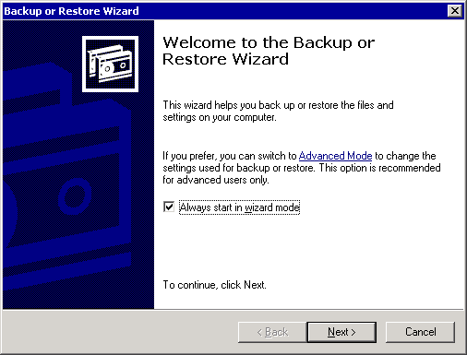

For More Information
For more information about using the Backup utility, see Using the Backup Utility in Windows Server 2003 to Backup and Restore Your Data.

How to Switch Backup to Advanced Mode
This topic explains how to switch the Backup utility to Advanced Mode.

Procedure
To switch to Advanced Mode
1. Start Backup. For detailed instructions, see How to Start the Backup Utility.
2. Clear the Always start in wizard mode check box.
3. Click Advanced Mode to open Backup in Advanced Mode.
Backup in Advanced Mode
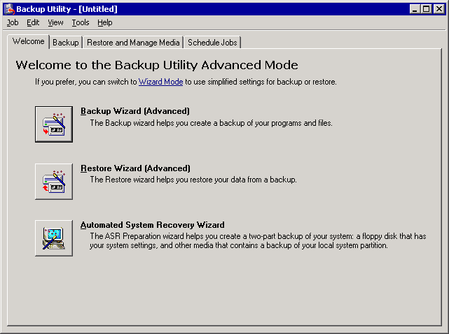

Note:
To switch back to the Backup or Restore Wizard, on the Tools menu, click Switch to wizard mode.

For More Information
For more information about using the Backup utility, see Using the Backup Utility in Windows Server 2003 to Backup and Restore Your Data.

Selecting the Default Settings for Backup
You can specify the default settings used in Backup for every backup and restore that you perform. For detailed instructions, see How to Specify the Default Settings for Backup.

How to Specify the Default Settings for Backup
This procedure explains how to specify the default settings for Backup.

Procedure
To specify the default settings for Backup
1. Start Backup in Advanced Mode.
For detailed instructions, see the following procedures:
• How to Start the Backup Utility
• How to Switch Backup to Advanced Mode
2. On the Tools menu, click Options.
On the General tab, either clear or select the check boxes to select the default settings that you want. The following table provides detailed descriptions of the options available on the General tab. For more information about these options, see the online Help in your Windows Server 2003 operating system.
The General tab in the Options dialog box
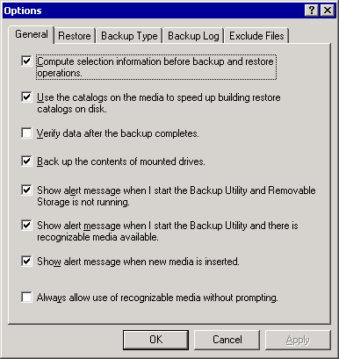

Explanation of the available General options
Option | Explanation
Compute selection information before backup and restore operations. | Estimates the number of files and bytes that will be backed up or restored during the backup or restore operation. This information is calculated and displayed before the backup or restore begins.
Use the catalogs on the media to speed up building restore catalogs on disk. | Specifies that you want to use the on-media catalog to build the on-disk catalog for restore selections. This is the fastest way to build an on-disk catalog. However, if you want to restore data from several tapes, and the tape with the on-media catalog is missing or you want to restore data from media that is damaged, do not select this option. Backup will then scan your whole backup set (or as much of it as you have), and build an on-disk catalog. This might take several hours if your backup set is very large.
Verify data after the backup completes.  Note:  This option does not verify Exchange databases. | Compares the backed-up data and the original data on your hard disk to make sure that they are the same. It is recommended that you only verify backups of data files System backups are difficult to verify because of the large number of changes that happen to system files on a continual basis. Some data files that were in use during the backup might also cause verification errors, but you can generally ignore these errors. If there are many verification errors, there might be a problem with the media or the file you are using to back up data. If this behavior occurs, use different media or designate another file, and run the backup operation again.  Important:  Do not select this option when you back up Exchange databases, although this option helps you verify data integrity in some types of data backups (for example, System State backups and full computer backups). If you select this option, the time it takes to perform an Exchange database backup increases substantially.
Back up the contents of mounted drives. | Backs up the data that is on a mounted drive. If you select this option, and then you back up a mounted drive, the data that is on the mounted drive will be backed up. If you do not select this option, and then you back up a mounted drive, only the path information for the mounted drive will be backed up.
Show alert message when I start the Backup Utility and Removable Storage is not running. | Displays a dialog box when you start Backup, and Removable Storage is not running. Backup will then start Removable Storage automatically. If you typically back up data to a file, and you save the file to a floppy disk, a hard disk, or any type of removable disk, do not select this option. If you primarily back up data to a tape or other media that is managed by Removable Storage, select this option.
Show alert message when I start the Backup Utility and there is recognizable media available. | Displays a dialog box when you start Backup, and there is new media available. If you primarily back up data to a file, and you save the file to a floppy disk, a hard disk, or any type of removable disk, do not select this option. If you primarily back up data to a tape or other media that is managed by Removable Storage, select this option.
Show alert message when new media is inserted. | Displays a dialog box when new media is detected by Removable Storage. If you primarily back up data to a file, and you save the file to a floppy disk, a hard disk, or any type of removable disk, do not select this option. If you primarily back up data to a tape or other media that is managed by Removable Storage, select this option.
Always allow use of recognizable media without prompting. | Automatically moves new media that is detected by Removable Storage to the Backup media pool. If you typically back up data to a file, and you save the file to a floppy disk, a hard disk, or any type of removable disk, do not select this option. If you want all new media to be available to the Backup program only, and no one is using Removable Storage to manage new media, select this option.

3. Click the Restore tab to display the options for restoring a file that already exists on your computer. Then click one of the following options:
• Do not replace the file on my computer (recommended).
• Replace the file on disk only if the file on disk is older.
• Always replace the file on my computer.
The Restore tab in the Options dialog box
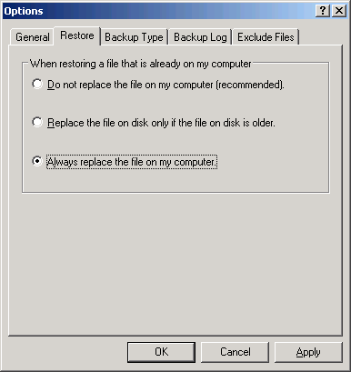

Important:
The settings that you select on the Restore tab do not affect the Exchange database restore process. When you restore an Exchange database, always replace the existing database files. Exchange log files that existed before the restore are not affected because Exchange log files are restored to a temporary directory, not to their original location.
Note:
In contrast, when you restore your operating system, System State data always overwrites the existing operating system files, and will alert you to that fact before the restore process begins. Select Always replace the file on my computer if you want to restore your operating system or the Exchange installation folder (or both) from a backup. Selecting this option prevents file version conflicts when you restore a backup over a fresh installation of your Windows Server 2003 operating system, and ensures that the most current file versions that were preserved in your backup overwrite older versions that the Windows Server 2003 Setup program created. These files include the Exchange .dll files, such as MAPI32.DLL, which exists in the %systemroot%/System32 folder. In this way, you make sure that all the restored operating system or Exchange files will match the file versions that were preserved in your Windows or full computer backup as closely as possible.
Note:
You might receive an error message after you select the default setting, Do not replace the file on my computer (recommended) when you restore your operating system. If this behavior occurs, select the setting, Always replace the file on my computer to force all the files in your backup to overwrite the existing files.
Note:
The files in your backup should be the most current versions if you keep the computer up-to-date with service packs and other critical updates before you back up your Windows Server 2003 operating system or the Exchange folder.
4. Click the Backup Type tab to select the default backup type.
The Backup Type tab in the Options dialog box
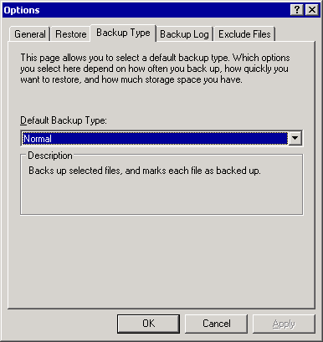

5. In the Default Backup Type list, select one of the following backup types.
• Normal A normal backup entails copying all the files that you selected, and then marking each file as having been backed up. (The archive attribute is cleared.) To perform a normal backup, you need only the most recent copy of the backup file or tape to restore all the files. You usually perform a normal backup the first time that you create a backup set. Normal backups are frequently referred to as full backups, although a backup is only a full backup when you choose to back up all files.
Important:
To restore from backup, you must have the most recent normal, differential, and incremental backup files.
• Copy A copy backup entails copying all the files that you select, but not marking each file as having been backed up. (The archive attribute is not cleared.) To back up files between normal and incremental backups, perform a copy backup because it does not affect other backup operations.
• Differential A differential backup entails copying files created or changed since the last normal or incremental backup, but not marking files as having been backed up. (The archive attribute is not cleared.) To perform a combination of normal and differential backups, you must have the last normal backup set and also the last differential backup set.
• Incremental An incremental backup entails backing up only those files created or changed since the last normal or incremental backup, and then marking files as having been backed up. (The archive attribute is cleared.) If you use a combination of normal and incremental backups, you must have the last normal backup set and also all incremental backup sets to restore your data.
• Daily A daily backup entails copying all the files that you selected and that are also modified on the same day that you perform the daily backup. The backed up files are not marked as having been backed up. (The archive attribute is not cleared.)
6. Click the Backup Log tab to display the options for setting the level of detail that you want to use when backup logs are created for backups and restores.
7. This is a valuable troubleshooting tool if the backup or restore process completes with errors. When you select the Detailed option, all attempts to back up or restore a single file are logged. Therefore, you can search the backup log at the end of the backup or restore process for all failures that occurred when files were copied or restored.
The Backup Log tab in the Options dialog box
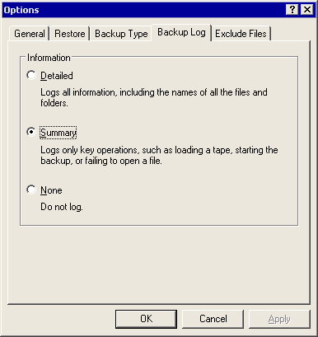

8. Click the Exclude Files tab to exclude certain types of files from your backup job.
The Exclude Files tab in the Options dialog box
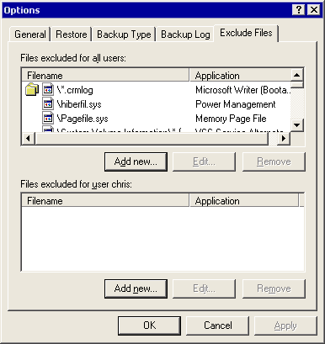

Note:
In the Files excluded for all users list box, it is best to exclude only the default files. You do not have to exclude additional files during an Exchange backup.

For More Information
For more information about using the Backup utility, see Using the Backup Utility in Windows Server 2003 to Backup and Restore Your Data.

Using Backup to Back Up Your Data
Use Backup to preserve all the critical data in your Exchange organization. The following topics give you the general information you need to configure and create backups using the backup utility (Backup) in Windows Server 2003:
• Performing a basic backup
• Selecting the destination for a backup
• Selecting options for a backup
• Scheduling a backup
• Checking the success of a completed backup
• Verifying backed up data

Performing a Basic Backup
Use the procedures in this section to back up your data by using Backup. These procedures apply to a generic backup, and are not Exchange specific. For information about backing up Exchange, domain controllers, and so on, "Backing up Exchange Server 2003."
Using Backup to perform a basic backup
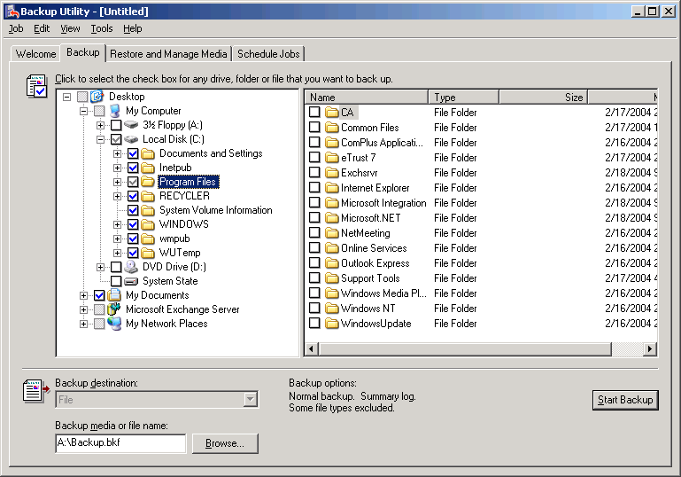

One subtle difference between the backup utility in Windows Server 2003 compared to the backup utility in Microsoft Windows® 2000 is the way that files that are marked for backup and restore appear in the user interface (UI). A cleared check box means that nothing in its corresponding node will be backed up or restored. A check mark that appears dimmed indicates that only a part of the files and folders in that node will be backed up or restored. To see which files will be backed up or restored, expand the node. It is possible for a check mark that appears dimmed to indicate that no files are going to be backed up if nothing in the node is scheduled for backup. For example, although the Program Files node in figure 1.8 is checked, there are no files in that node scheduled for backup.
For detailed instructions, see How to Perform a Basic Backup.

How to Perform a Basic Backup
This topic explains how to perform a basic backup using Backup.

Before You Begin
One subtle difference between the backup utility in Windows Server 2003 and the backup utility in Windows 2000 Server is how files that are marked for backup and restore appear in the user interface (UI). A cleared check box signifies that no items in the corresponding node will be backed up or restored. A check mark that appears dimmed indicates that only some of the files and folders in that node will be backed up or restored. To see which files will be backed up or restored, expand the node. It is possible for a check mark that appears dimmed to indicate that no files will be backed up if nothing in the node is scheduled for backup. For example, although the Program Files node in the following figure is checked, there are no files in that node scheduled for backup.
Using Backup to perform a basic backup

Procedure
To perform a basic backup
1. Start Backup in Advanced Mode.
For detailed instructions, see the following procedures:
• How to Start the Backup Utility
• How to Switch Backup to Advanced Mode
2. Click the Backup tab, and then on the Job menu, click New.
3. Under Click to select the check box for any drive, folder or file that you want to back up, select the check box next to the drive, file, or folder that you want.
4. In the Backup destination list, click a destination device for your backup, such as File if you want to back up to a disk, or the name of an attached tape drive.
5. In the Backup media or file name box, type the backup media or file name to use for your backup.
Note:
For detailed information about the Backup destination list and the Backup media or file name box, see Selecting the Destination for a Backup.
6. On the Tools menu, click Options. Select the appropriate backup options, and then click OK.
Note:
For detailed information about the Options dialog box, see How to Specify the Default Settings for Backup.
7. Click Start Backup, and then in the Backup Job Information dialog box, verify that the settings for the backup are correct.
The Backup Job Information dialog box
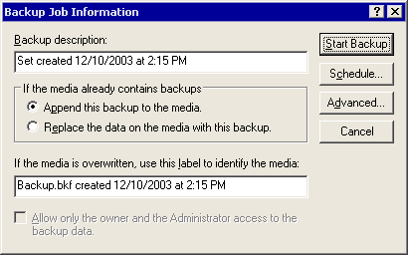

Caution:
If the backup file name you use for this backup already exists in the backup media or file location, confirm that the settings in Backup Job Information are correct to avoid overwriting a backup file that you might want to keep.
Note:
For detailed information about the options in the Backup Job Information dialog box, see Selecting Options for a Backup.
8. In Backup Job Information, click Advanced if you want to set advanced backup options such as data verification or hardware compression. Then, click OK.
Note:
For detailed information about advanced backup options, see Selecting Options for a Backup.
9. If you want to perform this backup immediately, click Start Backup.
10. If you want to schedule this backup to run automatically at a later time, in Backup Job Information, click Schedule.
11. If you choose to schedule the backup job, in Save Selections, specify a name for the backup job you want to schedule, and then click Save.
12. If you choose to schedule a backup, in Set Account Information, enter the user name and password you want Backup to use when it runs the scheduled backup. Make sure that the account you specify has the necessary permissions. For more information, see Permissions Required.
Set Account Information dialog box
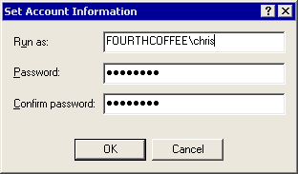

13. If you want to schedule a backup, in Scheduled Job Options, in the Job name box, type a name for the scheduled backup job. Click Properties to enter the date, time, and frequency parameters for the scheduled backup, and then click OK.
Scheduled Job Options dialog box
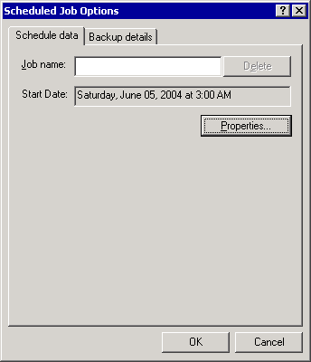

Note:
For general information about scheduling backups, see Scheduling a Backup.

For More Information
For more information about using the Backup utility, see Using the Backup Utility in Windows Server 2003 to Backup and Restore Your Data.

Selecting the Destination for a Backup
Before you proceed with a backup, select a destination for the files you want to back up. You can back up the files to a hard disk, a tape device, or a variety of other supported devices. For detailed instructions, see How to Select a Destination for a Backup.
Backup will not back up to a CD device such as CD-RW, CD-R, or DVD-R drives. To back up your data to these devices, you must first back up the data to a file. Next, archive the .bkf file to the CD. From this point onward, you can restore your data from that CD-R, CD-RW, or DVD-R.
If you are performing a backup, and the backup utility (Backup) in Windows Server 2003 indicates that unused media is not available, you might have to use the Removable Storage Management console to add your tape device to the Backup media pool. For more information, see "Removable Storage" in the Windows Server 2003, Standard Edition online Help.
During a backup, Backup creates a catalog of the files that are being backed up in each backup job. You can use this catalog to select the files that you want to restore from the backup media. The computer on which the backup occurs stores the catalog. However, the catalog can be re-created from the backup media if you restore data on a different or rebuilt computer. For more information about re-creating the catalog, see "How to Rebuild a Catalog."

How to Select a Destination for a Backup
This topic explains how to select a destination for a backup.

Before You Begin
Before you perform the procedure in this topic, consider the following:
• Backup will not back up to a CD device such as CD-RW, CD-R, or DVD-R drives. To back up your data to these devices, you must first back up the data to a file. Next, archive the .bkf file to the CD. From this point onward, you can restore your data from that CD-R, CD-RW, or DVD-R.
• If you are performing a backup, and the backup utility (Backup) in Windows Server 2003 indicates that unused media is not available, you might have to use the Removable Storage Management console to add your tape device to the Backup media pool. For more information, see "Removable Storage" in the Windows Server 2003, Standard Edition online Help.

Procedure
To select a destination for a backup
1. Start Backup in Advanced Mode.
For detailed instructions, see the following procedures:
• How to Start the Backup Utility
• How to Switch Backup to Advanced Mode
2. Click the Backup tab.
3. In the Backup destination list, perform one of the following steps:
• Select File if you want to back up files and folders to a file. If you do not have a tape device installed on your computer, this option is selected by default and cannot be changed.
• Select a tape device if you want to back up files and folders to a tape.
The Backup destination and Backup media fields
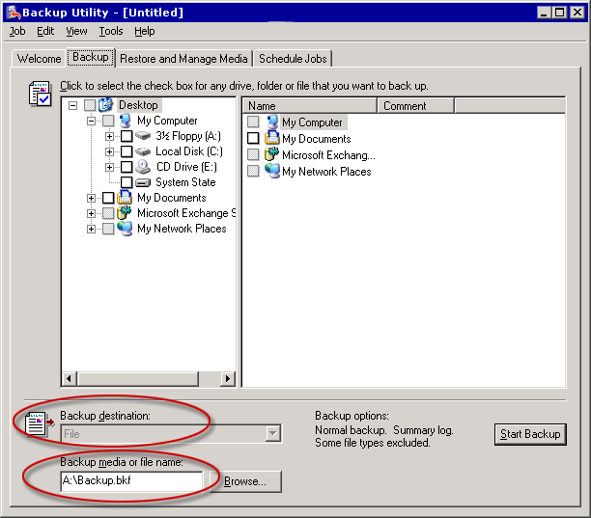

4. Click Browse to select a location and file name for your backup.

For More Information
For more information about using the Backup utility, see Using the Backup Utility in Windows Server 2003 to Backup and Restore Your Data.

Selecting Options for a Backup
When you back up your data, you have the option to change the default settings for the backup set before the process begins. You can also configure advanced options.
Backup and advanced backup options
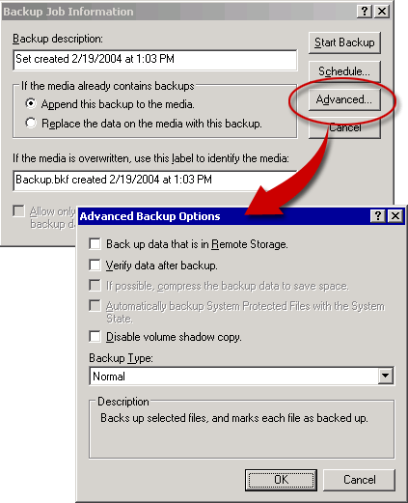

Configure standard and advanced backup options in the Backup Job Information and the Advanced Backup Options dialog boxes. The Backup Job Information dialog box appears after you click Start Backup from the Backup tab. The following tables provide explanations of the available options. For more information about these options, see the online Help in your Windows Server 2003 operating system.
Important:
Exchange databases should not be backed up in the same way you backup static data files. They should be backed up as online Exchange databases. You should specifically exclude Exchange data directories from being backed up normally if you are performing online backups. For more information about how to back up Exchange databases, see "Backing up Exchange Server 2003."
Backup options
Backup options | Explanation
Backup description | You can type a unique name to describe each backup.
Append this backup to the media. | You can append the backup job to an existing backup file or tape. Selecting this option does not affect any previous backup data stored on that media.
Replace the data on the media with this backup. | You can erase the backup file or all previous backup jobs stored on the destination media before the new backup job is saved.  Caution:  If you select this option, you will lose all previous backup data currently stored on the destination media.
Allow only the owner and the Administrator access to the backup data. | You can specify that only the owner or members of the Administrator's group may access the data that is saved on the destination media. This option secures the online tape or file. If you are backing up data to an existing tape or file that you want to overwrite, you can select this option. If you are backing up data to an existing tape or file and you are appending the data to the tape or file, you cannot select this option because ownership of the tape has already been established.

Advanced backup options
Advanced backup options | Explanation
Back up data that is in Remote Storage. | You can back up data that has been designated for Remote Storage. Selecting this option backs up Remote Storage reparse points (placeholder files). If you do not select this option, Remote Storage reparse points are not backed up. You can restore Remote Storage data only to an NTFS file system volume.
Verify data after backup.  (Do not use this option when you back up Exchange databases.) | You can verify that the backed up data matches the original data after the backup completes.  Backup creates a checksum for every file as it is backed up, and stores those checksums in the actual backup. At the end of a successful backup, every file in the backup is read and compared to the checksums that are also stored in the backup to make sure that the file in the backup matches the checksum created at the time the file was backed up.  This means that you are verifying the media instead of verifying that the file in the backup still matches the original at the end of the backup, a subtle distinction to understand.  Important:  Do not use this option when you back up Exchange databases.  Note:  Although this option helps you verify data integrity in some types of data backups (for example, System State backups and full computer backups), do not use this option when you back up Exchange databases. Selecting this option will substantially increase the time that the backup takes to complete. The only added value that this option provides in this case is to verify that the media can still be read immediately after it was written to.  Note:  Additionally, although the backed up Exchange database files were compared to the originals on disk after the backup, the verification would fail because the online databases are constantly changing during a backup.
If possible, compress the backup data to save space. | You can compress the data that you plan to back up so that you can save more data on a tape. If this option is disabled, you do not have a tape drive on your computer or your tape drive cannot manage compressed data.
Automatically backup System Protected Files with the System State.  (Do not disable this option.) | You can back up all the system files that are in your systemroot directory in addition to the boot files that are included with the System State data. Although this option substantially increases the size of a normal backup job, it benefits Exchange backups because it backs up the Internet Information Services (IIS) metabase. The IIS metabase contains information such as your Exchange Virtual Server (EVS) information.  Note:  This option is enabled by default for a System State backup. It is recommended that you do not disable this option.
Disable volume shadow copy.  (Do not disable this option.) | You can disable the use of shadow copy to create the backup. If this option is disabled, some files that are open or in use during the backup might be skipped.  Note:  It is recommended that you do not disable this option. Exchange 2003 does not use the Volume Shadow Copy service in Backup when it backs up the Exchange store.  Note:  Selecting this option does not affect Exchange online backups of the Exchange store, but disabling this option might cause non-Exchange files that are open or in use during the backup to be skipped.
Backup Type. | You can specify how your data is backed up. For a description of the different types of backups, see "Selecting the Default Settings for Backup" earlier in this chapter. For example, you cannot perform an incremental backup of an Exchange store until you have performed a normal backup at least one time before the incremental backup.

Scheduling a Backup
If you configure Backup to run backup jobs automatically, you can save administrative time and provide a way to run unattended backup jobs during off-peak hours. In most Exchange organizations, it is best to perform the largest backup types (such as normal backups of the Exchange databases) when user access to servers is at a minimum. You can schedule a backup job by using Backup to specify the times that you want your backups to run. For more information about how to schedule a backup, see "Performing a Basic Backup."
Important:
Make sure that the Task Scheduler service is running before you schedule a backup. To make sure that Task Scheduler is running, at a command prompt, type net start schedule. You can use the Services snap-in to start, stop, and view the status of services.
You can also schedule a backup to run at a scheduled time by referencing the backup job in a batch file by using the command line switches for Backup (NTBackup.exe). For a list of all the available backup switches, view the command line parameters for Backup by typing ntbackup /? at a command prompt.

Checking the Success of a Completed Backup
Your ability to restore data and servers depends on the quality of your backups. Therefore, it is important to verify that a backup is successful. A successful backup is one that completes without errors. For detailed instructions, see How to Verify That a Backup Completed Without Errors.
Reviewing both the backup log and the application event log in Event Viewer helps you verify the success of a backup. It is a good idea to research and resolve errors or inconsistencies in the logs as soon as possible.
Finally, remember that the condition, quality, and storage location of your backup media are critical to the success of your disaster recovery strategy.

How to Verify That a Backup Completed Without Errors
This topic explains how to verify that a backup has completed without errors.

Procedure
To verify that a backup completed without errors
1. After a backup job completes, make sure that the Backup Progress dialog box displays Status: Completed.
The Backup Progress dialog box
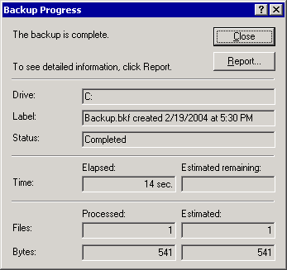

2. Click Report to view the backup log file to determine whether any errors occurred during the backup.
By default, the log file is set to record only a summary of the backup job that is performed. If you receive error messages during a backup and want more detailed data about the failure, you can perform the backup again by using detailed logging. Then you can search the log file to find out exactly what happened. For more information about enabling detailed logging, see Selecting the Default Settings for Backup.
The following is an example of a backup log of a Windows backup, including the Exchange folder, which completed without errors:
----------------------
Backup Status
Operation: Backup
Active backup destination: File
Media name: "Windows Backup created 3/11/2004 at 5:28 PM"

Backup (via shadow copy) of "C: BOOT"
Backup set #1 on media #1
Backup description: "Windows Backup created 3/11/2004 at 5:28 PM"
Media name: "Windows Backup created 3/11/2004 at 5:28 PM"

Backup Type: Normal

Backup started on 3/11/2004 at 5:31 PM.
Backup completed on 3/11/2004 at 5:31 PM.
Directories: 3
Files: 29
Bytes: 2,025,337
Time: 1 second
Backup (via shadow copy) of "D: System"
Backup set #2 on media #1
Backup description: "Windows Backup created 3/11/2004 at 5:28 PM"
Media name: "Windows Backup created 3/11/2004 at 5:28 PM"

Backup Type: Normal

Backup started on 3/11/2004 at 5:31 PM.
Backup completed on 3/11/2004 at 5:48 PM.
Directories: 1675
Files: 12925
Bytes: 1,919,675,569
Time: 16 minutes and 55 seconds
Backup (via shadow copy) of "F: Exchange"
Backup set #3 on media #1
Backup description: "Windows Backup created 3/11/2004 at 5:28 PM"
Media name: "Windows Backup created 3/11/2004 at 5:28 PM"

Backup Type: Normal

Backup started on 3/11/2004 at 5:48 PM.
Backup completed on 3/11/2004 at 5:53 PM.
Directories: 257
Files: 3551
Bytes: 1,083,988,436
Time: 5 minutes and 0 seconds
Backup (via shadow copy) of "System State"
Backup set #4 on media #1
Backup description: "Windows Backup created 3/11/2004 at 5:28 PM"
Media name: "Windows Backup created 3/11/2004 at 5:28 PM"

Backup Type: Copy

Backup started on 3/11/2004 at 5:53 PM.
Backup completed on 3/11/2004 at 5:56 PM.
Directories: 189
Files: 2624
Bytes: 461,069,597
Time: 2 minutes and 36 seconds

----------------------

Verify Status
Operation: Verify After Backup
Active backup destination: File
Active backup destination: H:\Windows Backup 3-11-04.bkf

Verify of "C:"
Backup set #1 on media #1
Backup description: "Windows Backup created 3/11/2004 at 5:28 PM"
Verify started on 3/11/2004 at 5:56 PM.
Verify completed on 3/11/2004 at 5:56 PM.
Directories: 3
Files: 29
Different: 0
Bytes: 2,025,337
Time: 1 second

Verify of "D:"
Backup set #2 on media #1
Backup description: "Windows Backup created 3/11/2004 at 5:28 PM"
Verify started on 3/11/2004 at 5:56 PM.
Verify completed on 3/11/2004 at 5:57 PM.
Directories: 1675
Files: 12925
Different: 0
Bytes: 1,919,675,569
Time: 1 minute and 18 seconds

Verify of "F:"
Backup set #3 on media #1
Backup description: "Windows Backup created 3/11/2004 at 5:28 PM"
Verify started on 3/11/2004 at 5:57 PM.
Verify completed on 3/11/2004 at 5:58 PM.
Directories: 257
Files: 3551
Different: 0
Bytes: 1,083,988,436
Time: 34 seconds

Verify of "System State"
Backup set #4 on media #1
Backup description: "Windows Backup created 3/11/2004 at 5:28 PM"
Verify started on 3/11/2004 at 5:58 PM.
Verify completed on 3/11/2004 at 5:58 PM.
Directories: 189
Files: 2624
Different: 0
Bytes: 461,069,597
Time: 16 seconds
----------------------
3. Check the backup log file for errors. Make sure that there are no errors in the backup log file.
Note:
Each backup job adds information to this log file. You might have to scroll to the bottom of the log file to find the information that relates to the most recent backup.
4. If you enabled verification for this backup job, you can view the Verify Status section of the log file to see which files in the backup (if any) do not match the original files on disk by looking at the Different: line in the log file. Note that some files change regularly, and a discrepancy between files does not always indicate a problem.
5. Close the log file and the Backup Progress dialog box.
6. Click Start, point to All Programs, point to Administrative Tools, and then click Event Viewer.
7. In Event Viewer, in the console tree, click Application. In the details pane, make sure that there are no Error entries reported in the application event log that have "NTBackup" or "ESE" (the Extensible Storage Engine) as their source. These errors indicate that the backup has not been completely successful.
Important:
This step is essential when you back up Exchange data. Some errors that occur will only show up in the application event log. Do not rely only on the backup logs when you back up Exchange.
Note:
To speed up your search, look for events that indicate when the backup and verification processes started and completed. Then review any events that occurred in between. Event 8000 indicates the start of the backup and Event 8019 indicates the end.
8. Close Event Viewer after you have looked for errors.

For More Information
For more information about using the Backup utility, see Using the Backup Utility in Windows Server 2003 to Backup and Restore Your Data.

Verifying Backed Up Data
To verify data, you restore the preserved data from your backup media to a test domain, and then make sure that you can access the data. You probably cannot verify all backups from all servers, particularly in a large organization. However, by rotating a simulated Exchange restore process in a test domain using backups from various production servers, you can test the reliability of your system. This strategy helps you identify potential problems before a real disaster happens.
Verifying the data from a backup also helps you train administrators to perform restore procedures. Training familiarizes administrators with the restore process so that they can respond quickly and appropriately to a real disaster.
If you do not have a separate test domain, you can use recovery storage groups to test restore procedures for an Exchange database. However, you cannot test public folder backups this way. For more information about recovery storage groups, see Using Recovery Storage Groups in Exchange Server 2003.

Using Backup to Restore Your Data
The backup utility (Backup) in Windows Server 2003 helps you restore items (including files, folders, the System State data, and Exchange databases) that were previously backed up. This topic provides the information you need to restore items using Backup:
• Performing a basic restore.
• Rebuilding a catalog for a restore.
• Selecting the advanced options for a restore.
• Checking the success of a completed restore job.

Performing a Basic Restore
For detailed instructions, see How to Perform a Basic Restore.

Rebuilding a Catalog for a Restore
When you back up your data, Backup creates a catalog on the local computer that lists all the files in the backup set. The Restore and Manage Media tab displays the files available to be restored by reading this catalog. If the catalog is missing or if you are restoring the files to a different computer or to a clean installation of your Windows Server 2003 operating system, you must rebuild the catalog.
You can delete any catalogs that you no longer want from the Restore and Manage Media tab. Right-click each catalog, and then click Delete Catalog.
For detailed instructions, see How to Rebuild a Catalog.

Selecting the Advanced Options for a Restore
When you restore most types of data by using the backup utility (Backup) in Windows Server 2003, you can configure advanced restore options before you start to restore the files you have selected.
Note:
These options are not present in Exchange database restores.
You configure advanced restore options while you restore data. To view the complete procedure for restoring data, see "Performing a Basic Restore" earlier in this topic.
The Advanced Restore Options dialog box
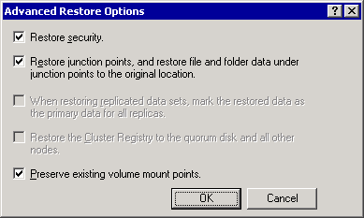

To configure advanced restore options, in the Confirm Restore dialog box, click Advanced to open the Advanced Restore Options dialog box explanations of the advanced options. For more information about these options, see the online Help in your Windows Server 2003 operating system.
Advanced restore options
Advanced restore options | Explanation
Restore security. | You can restore security settings for each file and folder. Security settings include permissions, audit entries, and ownership. This option is available only under two conditions: if you have backed up data from an NTFS file system volume used in the Windows Server 2003 operating system, and you are restoring that data to an NTFS volume used in a Windows Server 2003 operating system.
Restore junction points, and restore file and folder data under junction points to the original location. | You can restore the junction points on your hard disk and also the data that the junction points point to. If you do not select this check box, the junction points will be restored as common directories and the data that the junction points point to will not be accessible. If you are restoring a mounted drive and you want to restore the data that is on the mounted drive, you must select this check box. If you do not select this check box, you will only restore the folder containing the mounted drive.
When restoring replicated data sets, mark the restored data as the primary data for all replicas. | You can perform a primary restore. A primary restore ensures that restored File Replication Service (FRS) data is replicated to your other servers. Select this option only when you restore the first replica set to the network. Do not use this option if one or more replica sets have already been restored.
Restore the Cluster Registry to the quorum disk and all other nodes. | You can ensure that the quorum database is restored and replicated on all nodes in a server cluster. If you select this option, Backup will stop the Cluster service on all the other nodes of the server cluster after the node that was restored is restarted. The whole server cluster will therefore be down during an authoritative restore of the data on the quorum disk resource. For more information, see the online Help in your Windows Server 2003 operating system.
Preserve existing volume mount points. | You can prevent the restore operation from overwriting any volume mount points that you have created on the partition or volume that you are restoring data to. This option is useful when you are restoring data to a whole drive or partition. For example, select this option if you are restoring data to a replacement drive and you have already partitioned the drive, formatted it, and restored its volume mount points. By doing this, you ensure that your volume mount points are not restored. Do not select this option if you are restoring data to a partition or drive that you have recently reformatted, and you want to restore the old volume mount points.

Checking the Success of a Completed Restore Job
It is important to verify that the restore occurred without errors.
When the restore completes, make sure that the Restore Progress dialog box shows Status: Completed. If the status displays Status: Completed with Errors, or Status: Failed, the restore was not successful.
Restore completed successfully
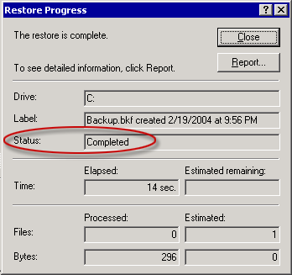

If the restore failed or had errors, click Report to view the Report log file, which displays the errors that occurred. If errors exist, research the possible causes of the errors.
Note:
Each session of Backup adds information to this log file. You might have to scroll to the bottom of the log file to find the log information that relates to the most recent restore attempt. The following is an example of a restore log with errors:
----------------------
Restore Status
Operation: Restore
Backup of "SERVER01\Microsoft Information Store\First Storage Group"
Backup set #1 on media #1
Backup description: "Set created 12/27/2003 at 3:12 PM"
Restore started on 1/28/2004 at 11:01 PM.
Unable to restore data to SERVER01\Microsoft Information Store\First Storage Group, check the application event log for more information.
Restore completed on 1/28/2004 at 11:01 PM.
Directories: 0
Files: 0
Bytes: 0
Time: 1 second
----------------------
By default, the Restore log file is set to record only a summary of the restore process. If you receive error messages during the restore and want more detailed data to troubleshoot the problem, you can perform the restore again using detailed logging, and then search the log to find out exactly what happened. For more information about enabling detailed logging, see "Selecting the Default Settings for Backup."
When you have finished checking the Restore log, make sure to also check the application event log for errors. For detailed instructions, see How to Check the Application Event Log for Errors.
When the Status field in the Restore Progress dialog box is marked as Completed, it means that Backup has successfully finished copying files to their appropriate destinations. However, if you are restoring an Exchange database, transaction log file replay needs to finish before you mount the database. For more information about this issue, see "Make Sure That the Restore Process Was Successful" in Recovering an Exchange Database.

How to Perform a Basic Restore
This procedure will explain how to perform a basic restore using Backup.

Before You Begin
One subtle difference between the backup utility in Windows Server 2003 and the backup utility in Windows 2000 Server is how files that are marked for backup and restore appear in the user interface (UI). A cleared check box signifies that no items in the corresponding node will be backed up or restored. A check mark that appears dimmed indicates that only some of the files and folders in that node will be backed up or restored. To see which files will be backed up or restored, expand the node.

Procedure
To perform a basic restore
1. Start Backup in Advanced Mode.
For detailed instructions, see the following procedures:
• How to Start the Backup Utility
• How to Switch Backup to Advanced Mode
2. Click the Restore and Manage Media tab, and then select the files that you want to restore. If the catalog for the backup that you want to restore does not appear, you might have to rebuild the catalog. For details, see "Rebuilding a Catalog for a Restore" in Using Backup to Restore Your Data.
The Restore and Manage Media tab
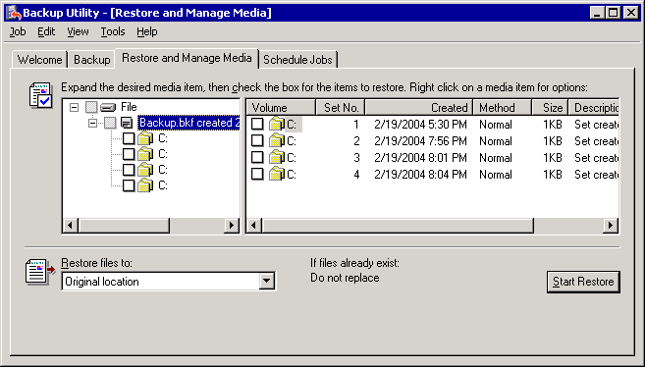

3. In the Restore files to list, select the location where you want the files restored. By default, the location specified is Original location.
4. Click Start Restore.
5. In Confirm Restore, click Advanced to specify advanced restore options, or click OK to start the restore.
Note:
For more detailed information about advanced restore options, see the section "Selecting the Advanced Options for a Restore" in Using Backup to Restore Your Data.

For More Information
For more information about using the Backup utility, see Using the Backup Utility in Windows Server 2003 to Backup and Restore Your Data

How to Rebuild a Catalog
This topic explains how to rebuild a catalog for a backup set.

Procedure
To rebuild a catalog
1. Start Backup in Advanced Mode.
For detailed instructions, see the following procedures:
• How to Start the Backup Utility
• How to Switch Backup to Advanced Mode
2. Click the Restore and Manage Media tab.
3. On the Restore and Manage Media tab, right-click the media that you want to restore files from, and then click Catalog.
4. In Open Backup File, type the path and the file name of the backup file that you want to catalog, and then click OK.
Sometimes this only creates the top node of the tree in the backup set. For example, if you store multiple backup jobs in the same backup file, cataloging the backup set will create the top node for each of the different backup jobs performed. However this will leave question marks for any items contained in that node. When you select a check box with a question mark inside, you will be prompted again for the path and file name of the backup file you are cataloging.
Rebuilding the catalog
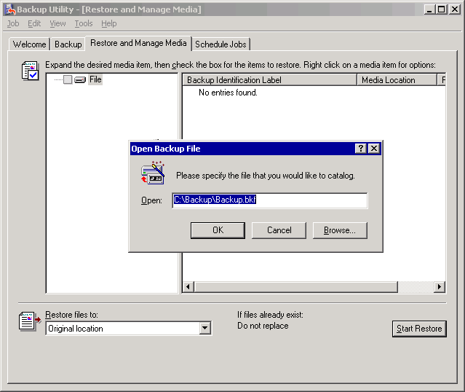

For More Information
For more information about using the Backup utility, see Using the Backup Utility in Windows Server 2003 to Backup and Restore Your Data

How to Check the Application Event Log for Errors
This topic explains how to check the Application Event Log for errors after restoring data from backup.

Procedure
To check the application event log for errors
1. Open Event Viewer: Click Start, point to All Programs, point to Administrative Tools, and then click Event Viewer.
2. In Event Viewer, in the console tree, click Application. In the details pane, make sure that there are no errors reported in the application event log that indicate the restore was unsuccessful.
3. If you notice any events that disclose an error, double-click the event to open the Event Properties, and then read the description of the event.
4. Research and resolve errors or inconsistencies as soon as possible. For more information about the error, click the URL in the Description box, or search for relevant articles in the Microsoft Knowledge Base (http://go.microsoft.com/fwlink/?LinkId=18175).
5. After you have checked for errors, close Event Viewer.

For More Information
For more information about using the Backup utility, see Using the Backup Utility in Windows Server 2003 to Backup and Restore Your Data.

Backing up Exchange Server 2003
Before you implement a backup strategy, you should determine the most appropriate disaster recovery strategy for your environment. After you decide on this strategy, use the information in this topic to help you perform the appropriate backup tasks. This section discusses the Microsoft® Windows Server™ 2003 backup tool (Backup). The following backup-related tasks are covered:
• Data to exclude from Windows backup sets or full computer backup sets.
• Creating Windows backup sets.
• Creating full computer backup sets.
• Backing up domain controllers.
• Backing up Microsoft Exchange Server 2003 data.
• Backing up Exchange Server 2003 clusters.
The procedures in these topics apply only to the backup utility (Backup) in Windows Server 2003. If you want to use third-party software to back up and restore your Exchange Server 2003 data and infrastructure, use these topics to make sure that you back up the appropriate data. For specific procedures, see the documentation for the third-party software.
Several additional backup methods might suit your needs. For example, you can use Automated System Recovery, make shadow copies, and create drive images. For more information about these backup methods, see "Disaster Recovery" in the Windows Server 2003, Standard Edition online Help.

Data to Exclude from Windows Backup Sets or Full Computer Backup Sets
Do not back up the following directories and drives when you create either Windows backup sets or full computer backup sets.
• Installable File System (IFS) drive
By default, the IFS drive (frequently referred to as the M drive) is turned off in Exchange Server 2003. If you have enabled the IFS drive, make sure to clear the check box in the backup utility (Backup) in Windows Server 2003 before you back up your data.
Important:
If you back up the IFS drive, you might damage your Exchange databases. To avoid this type of damage, do not enable the IFS drive. Antivirus software and other programs that affect all drives might also damage or cause problems for Exchange. For more information, see Microsoft Knowledge Base article 298924, "Issues caused by a back-up or by a scan of the Exchange 2000 M drive."
• Exchange databases and log files
Because Exchange database and transaction log files are constantly changing, it is recommended that you back them up by selecting the Microsoft Information Store option under Microsoft Exchange Server in Backup. Selecting this option causes Backup to use the Extensible Storage Engine (ESE) to back up your database and transaction log files correctly. For this reason, do not back up Exchange data when you create Windows or full computer backup sets. Instead, back up your Exchange server's database and transaction log files as part of a separate backup.
When you create Windows or full computer backup sets, do not select the ..\Exchsrvr\MDBDATA folder in Backup, and clear the Microsoft Information Store check box (under the Microsoft Exchange Server node).
Do not back up the ..\Exchsrvr\MDBDATA folder
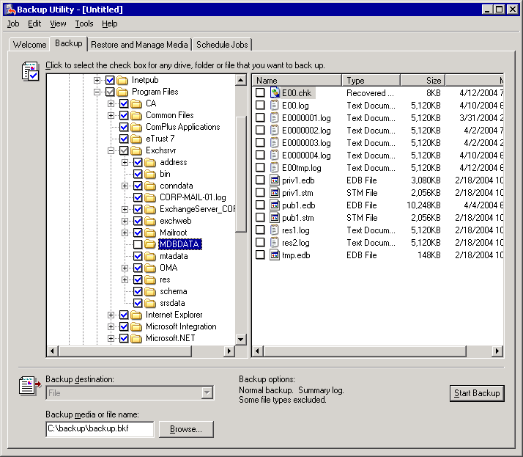

If your backup includes the drives or folders that contain your Exchange database and transaction log files or the Exchange IFS drive (by default, drive M), the files that are in use at the time that the backup occurs are not backed up. Any attempts to restore the backup might cause problems.
For information about how to back up Exchange databases and log files, see "Backing Up Exchange Server 2003 Databases" later in this chapter.
• The cluster shared disk resources (if you are running Exchange on a cluster)
In a full computer backup set, you do not typically include the drives of the server cluster's shared disk resources (for example, the drive where you store your quorum disk resource or the drives where you store your Exchange database files and log files). You must back up these resources by using the System State option and the Microsoft Information Store option in Backup. For more information about how to back up a server cluster's shared disk resources, see "Backing Up an Exchange Server 2003 Cluster's Shared Disk Resources."
• Removable Drives
To save disk space for your Windows or full computer backup set, and also the time required to create and restore backups, do not back up the removable storage media (such as removable disk drives, floppy drives, and CD-ROM drives) that are not a part of your disaster recovery strategy.

Creating Windows Backup Sets
Create Windows backup sets when you want to restore your System State data from a backup, but plan to reinstall all your applications, including Exchange 2003.
To completely back up the operating system of a server that is running Windows Server 2003, you must back up both the System State data and the operating system files. Operating system files include the boot partition and the system partition. A backup of Windows Server 2003, including both the System State data and the operating system files, is referred to as a Windows backup set. Because Windows backup sets are typically created with the expectation that you will reinstall applications such as Exchange, you do not have to back up your applications when you create a Windows backup set. You must include the following data in a Windows backup set, and you must include all this data in one backup:
• The System State data.
• The boot partition. (The disk partition from which your computer starts. This partition contains hidden files such as NTLDR and BOOT.ini in the root directory.)
• The system partition. (The disk partition where your Windows Server 2003 operating system is installed.)
Note:
If you installed your Windows Server 2003 operating system to the hard disk partition that is used to start your computer, your boot partition and system partition are the same.
In the backup utility (Backup) in Windows Server 2003, select the System State data option to back up your System State data along with these partitions. Because of the dependencies among System State components, you cannot use Backup to back up or restore individual components of System State data. Files restored from System State data will always overwrite the originals.
You can customize the backup set to speed up both the backup and restore processes. To customize the backup set, omit unnecessary files from it. Only omit files that you are certain are not part of your Windows Server 2003 operating system. Do not omit anything that was installed during Windows Server 2003 setup, such as Microsoft Internet Explorer. For example, large media files such as training videos are likely candidates for omission.
If you are not sure about a file, back it up. It is also best to test your backup sets in a test environment.
Create Windows backup sets frequently—weekly, if you can—and whenever a change is made to your Windows Server 2003 operating system. Changes to your Windows Server 2003 operating system might include the installation of a service pack or other update, or any process that makes a lot of registry changes. By keeping your Windows backups up-to-date, you can avoid problems and delays when you restore data.
Windows backup sets are valid for a limited time only—60 days, by default. This time limit exists because of the value of the tombstoneLifetime attribute of the organization. Windows backups that are older than the tombstoneLifetime attribute might reintroduce deleted Active Directory® directory service objects. Therefore, problems might arise if you try to introduce a member server, whose System State data is older than the tombstoneLifetime attribute, to your organization. Assume that any backup older than the tombstoneLifetime attribute is not valid. For related information, see Microsoft Knowledge Base article 216993, "Backup of the Active Directory Has 60-Day Useful Life."
For detailed instructions, see How to Create a Windows Backup Set.

How to Create a Windows Backup Set
This topic explains how to create a Microsoft Windows backup set.
A Windows backup set is used to backup Windows, including System State data. A Windows backup does not include applications, such as Exchange or application data, such as mailbox data.

Before You Begin
Before you perform the procedure in this topic, make sure that you read Data to Exclude from Windows Backup Sets or Full Computer Backup Sets.

Procedure
To create a Windows backup set
1. Start Backup in Advanced Mode.
For detailed instructions, see the following procedures:
• How to Start the Backup Utility
• How to Switch Backup to Advanced Mode
2. Select the Backup tab. In the console tree, select the check box next to the drive letter (or letters) for your boot partition and system partition, and then select the check box next to System State.
Selecting a System State backup
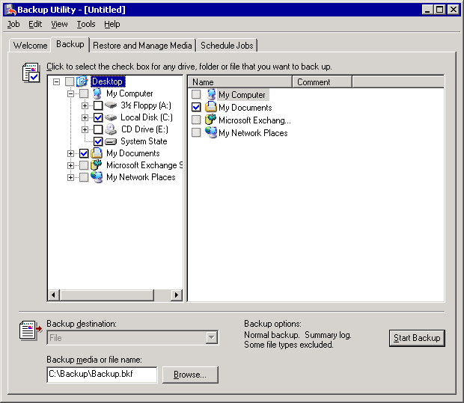

3. Clear the check boxes that are next to anything that you do not want to back up. Remember that a Windows backup set should not include Exchange. Navigate to the Exchsrvr folder (by default, <drive>:\Program Files\Exchsrvr), and then clear the check boxes under Exchsrvr and any other applications that you do not want to back up.
Clear the check box that is next to Exchange
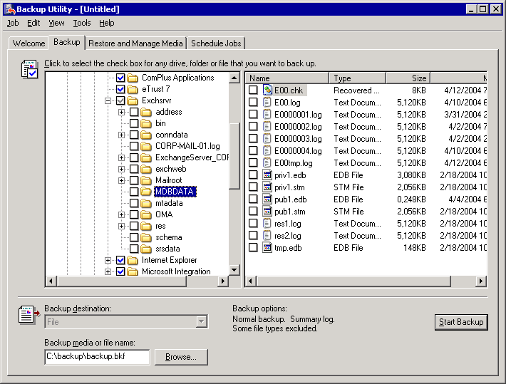

The check box next to Exchsrvr appears dimmed, which indicates that some files in the Exchsrvr node will not be backed up. The check symbol remains in the check box although there is nothing selected for backup in that node. To confirm that you will not back up any part of Exchange, make sure that all check boxes under Exchsrvr are cleared as shown in the above figure.
Caution:
Do not select the drives or folders that are listed as exceptions in the topic Data to Exclude from Windows Backup Sets or Full Computer Backup Sets.
4. In the Backup destination list, perform one of the following steps:
• Select File if you want to back up files and folders to a file. If a tape device is not installed on your computer, this option is selected by default and cannot be changed.
• Select a tape device if you want to back up files and folders to a tape.
5. Select Browse to select the location and file name for your backup.
6. Click Start Backup.
7. In Backup Job Information, in the Backup description text box, type a backup description, set the appropriate options, and then click Start Backup. For more information about how to set the options for the backup, see Selecting Options for a Backup.
8. After the backup is completed, verify that it was successful. For more information about how to verify the success of a backup, see Checking the Success of a Completed Backup.

For More Information
For more information about creating Windows backup sets, see Creating Windows Backup Sets.

Creating Full Computer Backup Sets
A full computer backup set includes all of the information in a Microsoft® Windows® backup set plus most of the data on the hard drives of your computer. Having a full computer backup set available is helpful if you want to make sure that you have a copy of all the data on your server (for example, the contents of your drives on a specific date) and all of your applications.
Important:
Although the drive contents of your computer make up the majority of the data in a full computer backup set, you must also include the System State data in this backup set.

Using Backup to Create Full Computer Backup Sets
You can use the backup utility (Backup) in Microsoft Windows Server™ 2003 to create full computer backup sets. Unlike Windows backup sets, full computer backup sets are typically created with the expectation that you will restore applications such as Microsoft Exchange by restoring the full computer backup set instead of reinstalling them. If you performed a full computer backup by using Backup, this backup can be restored only by using Backup. Therefore, Windows Server 2003 must function sufficiently well after a disaster to allow you to restore your full computer backups. If the disaster renders your Windows Server 2003 operating system unusable, you must repair or reinstall the operating system, and then restore your full computer backup.
If a failure renders your Windows Server 2003 operating system unusable, you do not have to repair or reinstall Windows Server 2003 if you can restore a disk image of the boot partition (which contains the files that start the operating system) and the system partition (which contains the remaining operating system files). For more information about how to restore disk images, see your disk imaging software documentation.
For detailed instructions, see How to Create a Full Computer Backup Set Using Backup.
Note:
Backup might not include all the files on a drive in a backup. By default, Backup does not back up specific file sets, such as swap files and temporary files. For information about how to exclude particular directories or file types from your full computer backup set, see "Selecting the Default Settings for Backup."

How to Create a Full Computer Backup Set Using Backup
This topic explains how to create a full computer backup set.
A full computer backup set backs up Windows, your System State data, and any relevant applications and non-Exchange Data. To backup Exchange Data you will create a separate backup. A full computer backup will help you restore an Exchange server before restoring Exchange data.

Before You Begin
Before you perform the procedure in this topic, make sure you read Data to Exclude from Windows Backup Sets or Full Computer Backup Sets.

Procedure
To create a full computer backup set by using Backup
1. Start Backup in Advanced Mode: Click Start, click Run, type ntbackup, and then click OK. Click the Advanced Mode link on the Welcome screen.
2. Click the Backup tab.
3. Select the check box next to each item that you want to back up.
Caution:
Do not select the drives or folders that are listed as exceptions in the topic Data to Exclude from Windows Backup Sets or Full Computer Backup Sets.
Important:
You must include the Windows boot partition and system partition (by default, located on drive C), the System State data, and your Exchsrvr directory (Exchange installation directory) as part of your full computer backup set. It is recommended that you do not include the ..\Exchsrvr\MDBDATA folder in your backup set.
4. Next to the Backup media or file name box, click Browse to select the media for your backup.
5. Click Start Backup.
6. In Backup Job Information, in the Backup description text box, type a backup description, set the appropriate options, and then click Start Backup. For more information about how to set the options for the backup, see Selecting Options for a Backup.
7. After the backup is completed, verify that it was successful. For more information about how to verify the success of a backup, see Checking the Success of a Completed Backup.

For More Information
For more information about creating full computer backup sets, see Creating Full Computer Backup Sets.

Backing Up Domain Controllers
It is important to back up your domain controllers to ensure their availability. Backing up a domain controller is like backing up a Microsoft® Exchange member server. The primary difference between backing up a domain controller and backing up an Exchange member server is that you do not have Exchange databases to consider when you back up a domain controller. The method that you use to back up your domain controller depends on the disaster recovery strategy you choose.

Backing Up the System State Data of a Domain Controller
When you use Backup to back up the System State data of a domain controller, you also back up the Active Directory® directory service database. To back up the System State data of a domain controller that is running Active Directory, you can use the same procedure as you would for a server that is not a domain controller. However, you must also back up additional files, such as the Active Directory database and log files, and all other files for the system components and services on which Active Directory depends.
The following Active Directory files are part of a System State data backup of a domain controller. By default, these files are located in the Active Directory folder in %SystemRoot%\Ntds.
Active Directory files to back up
File type | Definition
Ntds.dit | The Active Directory database.
Edb.chk | The checkpoint file.
Edb*.log | The transaction log files; each file is 10 megabytes (MB).
Res1.log and Res2.log | The reserved transaction log files.

In addition to the System State data, you must also back up the Microsoft Windows® boot partition and system partition when you perform either a Windows backup or a full computer backup of a domain controller.
Circular logging for Active Directory is enabled on domain controllers and cannot be turned off. If you lose all your domain controllers to a disaster and must restore a backup of Active Directory, you will lose data that was written to Active Directory after the backup set was made. Therefore, make regular backups of Active Directory. It is recommended that you back up one domain controller nightly.

Recommendations for Backing Up a Domain Controller
Consider the following recommendations before you back up a domain controller:
• Create a Windows backup set of at least one domain controller to preserve the Active Directory information which is vital to your Exchange servers. If you make changes to your Exchange organization such as (but not limited to) adding new servers, moving users, or adding new storage groups and databases, it is highly recommended that you make a new backup of a domain controller to preserve these changes to Active Directory. You can use the backup of a domain controller to restore the domain controller and the version of Active Directory that was on the domain controller at the time that it was backed up. Additionally, you can choose whether this Active Directory information replicates to other domain controllers. By default, the backup utility (Backup) in Windows Server 2003 performs non-authoritative restores of Active Directory information. Active Directory objects that are part of an authoritative restore replicate from the restored domain controller to the other domain controllers on the network. The Active Directory objects from the backup replace the Active Directory objects in the domain, regardless of the update sequence numbers (USNs). For more information about authoritative restores, see Microsoft Knowledge Base article 241594, "HOW TO: Perform an Authoritative Restore to a Domain Controller in Windows 2000."
• Create Windows backup sets frequently enough to make sure that they are valid backups. If the date of your System State data backup exceeds the maximum age limit set in Active Directory, the backups are not valid, and your Windows Server 2003 operating system prevents you from restoring Active Directory. For more information, see Knowledge Base article 216993, "Useful shelf life of a system-state backup of Active Directory."
• Re-create the failed domain controller and populate its copy of Active Directory through replication from the unaffected domain controllers in your organization, instead of restoring your data from a backup.
• Perform a non-authoritative restore of Active Directory from backup, and then allow the other domain controllers on the network to update the restored domain controller. This method is especially useful when you have a slow link over which to replicate data, a large Active Directory database, or both.
For more information about how to back up Active Directory information, see Active Directory Operations Guide Version 1.5.

Backing Up Exchange Server 2003 Data
The Exchange 2003 data that you must back up depends on which components are installed on your Exchange 2003 server. This section provides detailed descriptions and procedural information about the following types of backups:
• Backing up Exchange Server 2003 databases.
• Backing Up the Microsoft Exchange Site Replication Service (MSExchangeSRS).
• Backing Up the certification authority (CA).
• Backing up connector-specific information.
Note:
To locate the Microsoft Information Store options that are mentioned in this section, open Windows Backup. In the console tree, expand Microsoft Exchange Server, expand the name of the server that you want, and then expand Microsoft Information Store.
The Microsoft Information Store in Backup
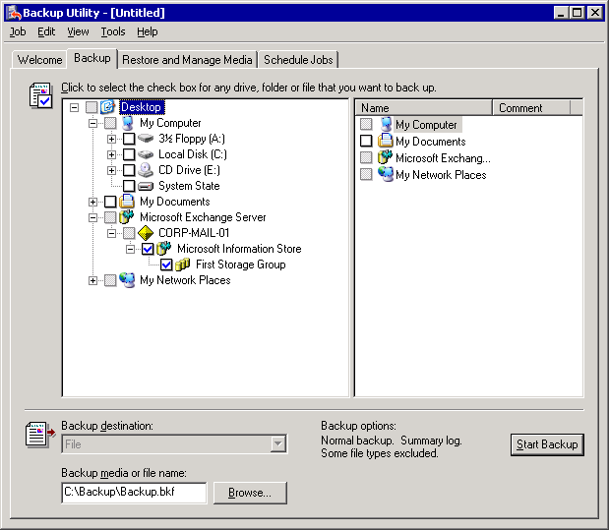

Backing Up Exchange Server 2003 Databases
The mailbox store and public folder store data in your Exchange 2003 databases and transaction log files are the most important data to back up in your Exchange organization. You can use an Exchange database backup to restore damaged mailbox or public folder stores to a functioning server that is running Exchange 2003. You can also use Exchange database backups to restore your Exchange databases to a different server. For more information about how to restore Exchange databases to a different server, see "Restoring Exchange Databases to Another Server."

Backing Up Remote Exchange Server 2003 Databases
For the backup utility (Backup) in Windows Server 2003 to successfully back up the databases of an Exchange 2003 server, you must run it on a computer that meets at least one of the following requirements:
• The Microsoft Exchange Messaging and Collaboration Services component has been successfully installed on the computer.
• The Microsoft Exchange System Management Tools component has been successfully installed on the computer. (This is typically referred to as an admin only Exchange installation.) For information about installing the Exchange System Management Tools, see "Preparing to Administer your Exchange Server 2003 Environment" in the Exchange Server 2003 Administration Guide.
• The computer must be manually configured to make remote backups of Exchange databases. For the manual configuration steps, see Microsoft Knowledge Base article 275876, "XADM: How to Use NTBackup from a Non-Exchange 2000 Computer."
If your computer meets at least one of these requirements, an option named Microsoft Exchange Server appears on the Backup tab in Backup. This option shows you all the Exchange servers in the forest that you are connected to. If you do not see this option on the Backup tab, use the Remote Store option on the Tools menu to manually connect to an Exchange server that is on the network. For detailed instructions, see How to Use the Remote Store Option in Backup.
Assuming that the account that you are logged into has the necessary permissions to back up the server, you will populate the Microsoft Exchange Server option on the Backup tab with all the servers in the Exchange organization. In this way, you can add servers from multiple Exchange organizations to the list of servers that you can back up. This is especially useful for a dedicated backup server that is used to back up databases in multiple Exchange organizations.
Note:
If there is a similar option named only Microsoft Exchange above the Microsoft Exchange Server option, you can ignore it. This option is only for backing up Exchange databases on Exchange 5.5 or earlier versions.
If you still cannot connect to any Exchange servers or see any in the list, make sure that you have logged in to an account that has the required permissions to back up the server. If the problem persists, see the information in Microsoft Knowledge Base article 275676, "XADM: Troubleshooting a Remote Online Backup of Exchange 2000."

How Exchange Server 2003 Backup Works
This section explains the online backup process step-by-step.

Normal (or Full) Backups
The following is a step-by-step description of the normal (or full) backup process.
1. The backup agent establishes communication and initializes a backup with the MSExchangeIS service on the target Exchange server. (In Exchange 5.5, the backup was established with the Microsoft Exchange System Attendant (MSExchangeSA) service process.)
2. The checkpoint is frozen. New changes will still be accepted and written to the database files, but the checkpoint will not move again until the backup ends.
3. The first log that must be copied to tape with the backup is recorded in the database header in the Current Full Backup section. This might not be the current checkpoint log, depending on the backup status of other databases in the storage group.
4. Copying the database files to tape begins. Page changes made to the database during backup that cannot be reconstructed fully from the log files are not flushed to the disk during backup. (In versions of Exchange earlier than Exchange 2000 Server Service Pack 2 (SP2), these changes are stored in a .pat file that is in the same location as the database file. The .pat file is copied to tape after the database files have finished being copied, and then it is deleted.)
Note:
In Exchange 2000 Server SP2 and later, there is no patch file. Instead, a single extra page is constructed and appended to the very end of the .edb file. This page is a mini header that contains information about the transaction log files needed to recover this database. It overrides the Log Required field in the database header, although it will often list the same log range.
If you run Eseutil /MH on a database that has been restored from an online backup, but on which recovery has not yet run, you will see the mini header information displayed as the Patch Current Full Backup section.
The current Enn.log file is forced to roll over immediately after all database files have been copied to tape. This happens regardless of how full the log is.
The reason that the log is forced to roll over is that log files cannot be backed up while they are open. The log needs to be on tape, because it contains operations applicable to the databases that were just backed up. Therefore, the log is closed so that it can be appended to the tape. You will never see a log file called Enn.log in an online backup set. Only closed, numbered log files are backed up.
5. The range of logs needed to reliably recover the backup are copied to tape. These will include at least all the logs starting from the frozen checkpoint up through the log that was just forced to close.
Note:
If all databases are mounted in the storage group and all databases have been selected for backup, this range of logs will only be from the checkpoint log to the highest available numbered log. However, if some databases are dismounted, or not all the databases are being backed up, the range of logs copied to tape might start before the current checkpoint. Exchange ensures that all logs needed for replay into the backed up databases will be present on the tape.
6. Log files that no database in the storage group needs to roll forward beyond the backup logs are truncated (deleted from disk). The headers of all the databases in a storage group keep track of the last backup time for each database, and also which logs were required. If any database in a storage group is dismounted, its header will not be read and Exchange will make no calculations about which log files can be safely deleted.
7. There are two factors that affect which log files will be truncated after a backup:
• Databases can be backed up individually.
• Not all databases in the storage group may be mounted at the time the backup occurs.
If you back up some databases but not others in a storage group, only the transaction logs not needed by the database least recently backed up will be truncated. This means that if you never back up one particular database in a storage group, no transaction logs will ever be deleted. If you have two databases in a storage group, and you back up one of them on Tuesday and the other on Thursday, the Thursday backup will truncate logs only up to Tuesday. If you then back up the Tuesday database on Friday, the logs from Thursday will be truncated.
Note:
If any database in a storage group is dismounted at the time of backup, no log files will be truncated.
8. The Previous Full Backup section of the database header is updated to reflect the time and log range of the backup that just completed.

Copy (or Full Copy) Backups
A copy backup is the same as a normal backup, except that the last two steps of truncating the logs and updating the Previous Full Backup section of the header are not done.

Incremental Backups
The following is a step-by-step description of the incremental backup process:
1. The backup agent establishes communication and initializes a backup with the MSExchangeIS service on the target Exchange server. (In Exchange 5.5, the backup was established with the MSExchangeSA service process.)
2. The checkpoint is frozen. New changes will still be accepted and written into the database files, but the checkpoint will not move again till the backup ends.
3. The current Enn.log file is forced to roll over regardless of how full the log is. The reason that the log is forced to roll over is that log files cannot be backed up while they are open. Therefore, the log is closed so it can be appended to the tape. You will never see a log file named Enn.log in an online backup set. Only closed, numbered log files are backed up.
4. When you perform a normal or copy backup, the log file is rolled over near the end of the backup, after the databases have all been copied to tape. For an incremental backup, the rollover happens at the very beginning.
5. All existing numbered log files are copied to tape.
6. Log files that no database in the storage group needs to roll forward are truncated (deleted from the disk).
7. If any database in a storage group is dismounted at the time of backup, no log files will be truncated.
8. The Current Incremental Backup section of the database header is updated to reflect the time and log range of the backup that just completed.

Differential Backups
A differential backup is similar to an incremental backup, except that the last two steps of truncating the logs and updating the Current Incremental Backup section of the header are not done.
Note:
One of the most important daily tasks of an Exchange administrator is to examine the application event log and verify that backups have completed successfully. Microsoft Product Support Services frequently receives calls from customers who are experiencing problems because their backups have been failing for weeks, and they did not notice it. Failed backups are not the only problem that will arise if you do not verify the success of your backups. A backup job that never completes leaves the checkpoint frozen. If a server crashes, the transaction log replay time after the crash can be extended up to several hours. In Exchange 2003, if the checkpoint is more than 1,000 log files behind, Exchange will automatically dismount the Exchange store. In previous versions of Exchange, the dismount will occur at approximately 256 logs.
The Exchange 2003 backup process
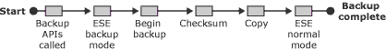

Backing Up Exchange Server 2003 Databases
For detailed instructions about backing up Exchange 2003 databases, see How to Back Up Exchange Server 2003 Databases.

How to Use the Remote Store Option in Backup
This topic explains how to use the Remote Store option in Backup to connect to a remote Exchange server on your network.

Procedure
To use the Remote Store option
1. In Backup, make sure that you are on the Backup tab.
2. Click Tools.
3. Click Remote Store.
4. Type the name or IP address of an Exchange server in the organization that you want to back up.
5. Click OK.

How to Back Up Exchange Server 2003 Databases
This procedure explains how to backup Exchange Server 2003 Databases.

Procedure
To back up Exchange 2003 databases
1. Start Backup in Advanced Mode.
For detailed instructions, see the following procedures:
• How to Start the Backup Utility
• How to Switch Backup to Advanced Mode
2. Click the Backup tab.
3. On the Backup tab, in the console tree, expand Microsoft Exchange Server, and then expand the server that contains the Exchange databases that you want to back up.
If you do not see the Exchange server whose databases you want to back up in the list of servers on the Backup tab, use the Remote Store option on the Tools menu to connect to a server in the organization that you want to back up. For more information about using the Remote Store option, see How to Use the Remote Store Option in Backup.
4. To back up the Exchange databases, perform one of the following steps:
• If you want to back up all the storage groups on the server, select the check box next to Microsoft Information Store
• If you want to back up specific storage groups in their entirety, expand Microsoft Information Store, and then select the check boxes next to the storage groups that you want to back up.
• If you want to back up specific mailbox stores and public folder stores in a storage group, expand Microsoft Information Store, select the storage group that contains the databases you want to back up. (Select the label, such as "First Storage Group," in addition to the check box. For more information, see the following figure.) Then, in the details pane, select the check boxes next to the databases that you want to back up.
Select the specific mailbox stores to back up
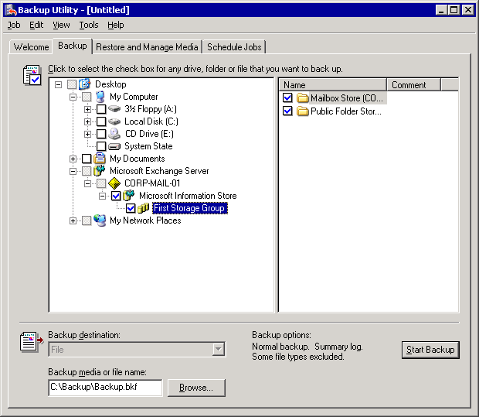

5. Click Browse to select the location for your backup. For more information about how to select the media for your backup, see Selecting the Destination for a Backup.
6. Click Start Backup.
7. In Backup Job Information, in the Backup description text box, type a backup description, set the appropriate options, and then click Start Backup. For more information about the options for the backup, see Selecting Options for a Backup.
8. After the backup is completed, verify that it was successful. For more information about how to verify the success of a backup, see Checking the Success of a Completed Backup.

For More Information
For more information about backing up Exchange Server 2003 databases, see Backing Up Exchange Server 2003 Databases.

Backing Up the Microsoft Exchange Site Replication Service (MSExchangeSRS)
You will only have to back up the Microsoft Exchange Site Replication Service (MSExchangeSRS) if you have coexistence between Exchange 5.5 and Exchange 2000 or later servers. Use Backup to back up the MSExchangeSRS service on the server that is running it. By default, the server that is running the MSExchangeSRS service is the first Exchange 2000 or later server that was installed into an Exchange 5.5 site, although you can create new instances of the MSExchangeSRS service to distribute the replication load. Use Exchange System Manager to determine which Exchange server is running the MSExchangeSRS service in your site. For detailed instructions, see How to Determine Which Exchange Server Is Running the MSExchange SRS service.
Note:
You can also back up the MSExchangeSRS service database (Srs.edb file) manually. The Srs.edb file is located in the SRSData folder under the folder where you installed the first Exchange 2000 Server or later server. For more information, see Microsoft Knowledge Base article 822453, "How to rebuild a Site Replication Service without a backup."
The Microsoft Exchange Site Replication Service (MSExchangeSRS) Database
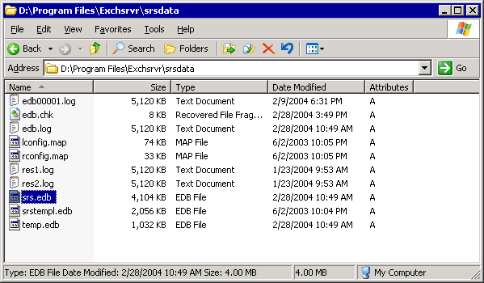

For detailed instructions, see How to Back Up the MSExchangeSRS Service Database.

How to Determine Which Exchange Server Is Running the MSExchange SRS service
This procedure explains how to determine which Exchange server is running Site Replication Service (SRS).

Procedure
To determine which Exchange server is running the MSExchangeSRS service
1. Start Exchange System Manager. (Click Start, point to Programs, point to Microsoft Exchange, and then select System Manager.)
2. In Exchange System Manager, expand Tools, and then expand Site Replication Services to locate the server that is running the MSExchangeSRS service. If an Exchange 5.5 site exists in your organization, under Site Replication Services, you will see at least one entry named Microsoft Exchange Site Replication Service (computer name), where (computer name) is the name of the server that is running the MSExchangeSRS service.
Determining which server is running the Microsoft Exchange Site Replication Service (MSExchangeSRS)
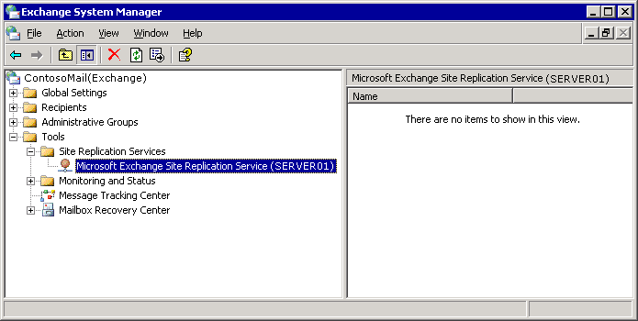

How to Back Up the MSExchangeSRS Service Database
This topic explains how to back up the Site Replication Service (SRS) database.

Procedure
To back up the MSExchangeSRS service database
1. On the server that is running the MSExchangeSRS service, start the Services MMC snap-in. (Click Start, point to Programs, point to Administrative Tools, and then select Services.)
2. In Services, double-click Microsoft Exchange Site Replication Service.
3. In Microsoft Exchange Site Replication Service Properties, in the Startup Type list, select Automatic. If Service status is currently Stopped, click Start to start the MSExchangeSRS service. After the service starts, close the Services MMC snap-in.
4. On any computer in your Exchange organization, start Backup in Advanced Mode.
For detailed instructions, see the following procedures:
• How to Start the Backup Utility
• How to Switch Backup to Advanced Mode
5. In Backup, click the Backup tab.
6. On the Backup tab, in the console tree, expand Microsoft Exchange Server, expand the server that is running the MSExchangeSRS service, and then select the check box next to Microsoft Site Replication Service
Backing up the Microsoft Exchange Site Replication Service (MSExchangeSRS)
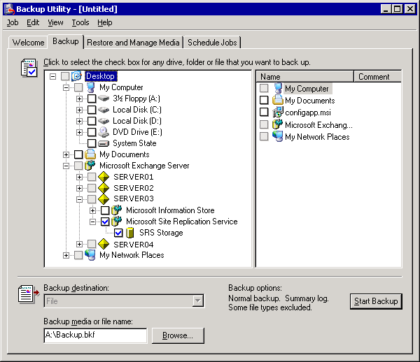

7. Click Browse to select the media for your backup.
8. Click Start Backup.
9. In Backup Job Information, in the Backup description text box, type a description of the backup, set the appropriate options, and then click Start Backup. For more information about how to set the options for the backup, see Selecting Options for a Backup.
10. After the backup is completed, verify that it was successful. For more information about how to verify the success of a backup, see Checking the Success of a Completed Backup.

For More Information
For more information about backing up the MSExchangeSRS database, see Backing Up the Microsoft Exchange Site Replication Service (MSExchangeSRS).

Backing Up the Certification Authority (CA)
If you have to recover a server that is running Certificate Services, you must first back up the computer that is the certification authority (CA). Although you can configure a computer to be both the CA and a server that is running Exchange2003, it is better to run Certificate Services on a separate server to make sure that you meet your standards for reliability and performance.
It is recommended that you back up the CA by creating a full computer backup set of your server that is running Certificate Services. If you cannot create a full computer backup set of your server, you can also back up the CA by creating a Windows backup set on the server that is running Certificate Services. (The System State data part of a Windows backup set includes the Certificate Services database.) For more information about how to perform full computer and System State backups, see "Creating Full Computer Backup Sets" and "Creating Windows Backup Sets."
You can also use the Certification Authority Backup Wizard to back up keys, certificates, and the certificates database. You access this wizard from the Certification Authority MMC snap-in. If you use the Certification Authority MMC snap-in to back up the CA, make sure to back up the Internet Information Services (IIS) metabase also. You back up the IIS metabase file when you create a Windows backup set. (The System State data part of a Windows backup set includes the IIS metabase.) You can also use the IIS snap-in to back up the IIS metabase independently.
For more information, see the following resources:
• "Backing up and restoring a certification authority" in the Windows Server 2003, Standard Edition Help.
• Windows Server 2003 PKI Operations Guide.
• "Backing Up and Restoring the Metabase" in the IIS 6.0 online product documentation.
To use the Backup or Restore Wizard in the Certification Authority MMC snap-in, you must be a Backup Operator or a Certification Authority Administrator, or you must have local administrator permissions on the CA. The Backup or Restore Wizard requires you to supply a password when you back up public keys, private keys, and CA certificates. You must have this password to restore data from the backup.
For more information about using CA and Windows Server 2003 public key infrastructure (PKI) with Exchange 2003, see "Implementing an Exchange 2003-Based Message Security System in a Test Environment" in the Exchange Server 2003 Message Security Guide.

Backing Up Connector-Specific Information
Exchange servers that include connectors to other messaging systems, such as Novell GroupWise or Lotus cc:Mail, contain connector-specific configuration data. Connector-specific configuration data is stored in the registry of the computer where the connector is installed, and also in Active Directory. If your disaster recovery strategy includes restoring either a Windows backup set or a full computer backup set, the connector-specific data is automatically restored to your server when you run the Exchange Setup program in disaster recovery mode. However, for specific e-mail connectors, you must manually back up and restore additional files, such as the contents of the CONNDATA directory and subdirectories.
For more information about how to back up and restore connectors, see Microsoft Knowledge Base article 328835, "XADM: How to Back Up and Restore Connectors on Exchange 2000." This information is relevant to Exchange Server 2003.

Backing Up Exchange Server 2003 Clusters
The disaster recovery processes for backing up and restoring Exchange 2003 server clusters are similar to the processes for backing up and restoring data on stand-alone Exchange 2003 servers.
To successfully back up Exchange server clusters, you must first determine which server recovery method you want to use for each node in the server cluster:
• Restore the node.
• Rebuild the node without using a standby recovery server.
• Rebuild the node by using a standby recovery server.
Disaster recovery methods for server clusters
Recovery method | What you need
Restore the node | • Full computer backup set.  • Exchange database backups of each Exchange Virtual Server (EVS) in the cluster.
Rebuild the node without using a standby recovery server | • A Windows backup set.  • The ability to run the Exchange Setup program and reinstall all Exchange updates.  • Exchange database backups for each EVS.  • Any dynamic data backups for each node.
Rebuild the node by using a standby recovery server  (Prepare the node in advance, updating it whenever you update your production servers.) | • A Windows backup set.  • The ability to run the Exchange Setup program and reinstall all Exchange updates.  • Exchange database backups for each EVS.  • Any dynamic data backups for each node.
Insert a new node into the cluster | • The ability to install Windows Server 2003 and Exchange.  • Exchange database backups for each EVS.  • Any dynamic data backups for each node.

If you choose to rebuild the node by using a standby recovery server, you will do most of the work involved in recovering or inserting a new node before a disaster happens. You keep the standby hardware available to replace any nodes in your server clusters in the event of a disaster.
After you make sure that your backup strategy includes creating backups for each node in the server cluster, you must also make sure that your backup strategy includes backing up the data on your server cluster's shared disk resources. The shared disk resource that maintains the consistency of your server cluster is the quorum disk resource, unless you are using the Majority Node Set. If you are using the Majority Node Set, each node maintains a copy of the cluster configuration data, and you do not have to back up the quorum.
For information about how to back up the quorum disk resource, see "Backing Up the Quorum Disk Resource" later in this chapter.
For information about how to back up shared disk resources that contain your Exchange database files and log files, see "Backing Up the Exchange Server 2003 Databases That Are Stored on Shared Disk Resources."
For an overview of Windows Server 2003 clustering support and troubleshooting, see the Technical Overview of Windows Server 2003 Clustering Services. You do not have to restore the backups described in this section to solve every problem that might occur in your clustering environment. For example, if a single node in a server cluster fails because of a hardware problem, it is relatively easy to replace that server by introducing a new node to the server cluster (either a newly rebuilt server cluster node or a standby cluster node). In this case, you do not have to restore any backups. As long as the maximum number of nodes for the server cluster has not been exceeded, you can add new nodes to a cluster at any time. However, if a different type of disaster occurs (for example, a complete cluster failure, a damaged quorum disk resource, or damaged Exchange databases) you might have to use one or more of your backups. For detailed information about Exchange server cluster restore processes, see "Restoring Exchange Clusters."
To help secure your Exchange server clusters, back up specific information that is stored on each server in the server cluster. This section provides detailed descriptions and procedural information about the following Exchange clustering topics:
• Backing up an Exchange Server 2003 cluster's shared disk resources.
• Backing up the Exchange Server 2003 databases that are stored on shared disk resources.
• Maintaining records about your server clusters.
Note:
To locate the Microsoft Information Store options that are referred to in this section, open Windows Backup. In the console tree, expand Microsoft Exchange Server, expand the server that you want, and then expand Microsoft Information Store.

Backing Up an Exchange Server 2003 Cluster's Shared Disk Resources
The shared disks in an Exchange 2003 server cluster are a critical part of the cluster technology. An Exchange server cluster's shared disk resources can include the quorum disk resource and the resource that contains the Exchange databases and transaction log files. Any node in a server cluster can access the shared disks while the cluster service is running, and all the nodes rely on those disks to be intact. If a cluster's shared disk fails, any new node that joins that cluster will not be able to access the data that is stored on the failed shared disk.
If you plan to use the "restore the server" method to recover your shared disk resources, do not include the drives for those resources in your full computer backup set. To back up the Exchange databases and log files on your server cluster's shared disks, create a separate backup set by using the Microsoft Information Store option in Backup. To back up your quorum disk resource, perform either a full computer backup or a Windows backup of the node that currently owns the quorum disk resource. Make sure that you include the System State data together with the boot and Windows partitions of the node.
Important:
When you create backup sets of your cluster node that contains a server cluster's shared disk, back up any dynamic data that exists on that disk.

Backing Up the Quorum Disk Resource
If you are not using Majority Node Sets, the quorum disk resource maintains the consistency of your server cluster by recording the changes that have been made to the cluster database. Each node in the cluster has access to the most recent database changes. The cluster database contains information about all physical and logical elements in a server cluster, including cluster resource object properties and configuration data. The quorum disk resource uses the quorum log file (Quolog.log), to make sure that the cluster registries on all nodes of the server cluster are consistent with each other. The cluster registry for each node is located in the %systemroot%\Cluster\CLUSDB directory of each node.
Note:
Create a separate cluster group for your quorum disk resource, and keep it on its own physical hard disk.
Quorum disk resource files are located in the /MSCS folder of the drive that contains the quorum disk resource. When you back up the quorum disk resource, the following files are also backed up.
Quorum disk resource files to back up
File type | Definition
chknnnn.tmp | The shadow copy files of the cluster registry.
Quolog.log | The quorum log file.
<GUID of resource>\*.cpt | The registry checkpoint files for the resource identified by the GUID.
<GUID of resource>\*.cpr | The crypto checkpoint files for the resource identified by the GUID.
Clusbackup.dat | The file that indicates that a backup is completed (a read-only, hidden, 0-byte file).

Whenever the System State data is backed up on the node in the server cluster that currently owns the quorum disk, quorum disk resource data is also backed up. Therefore, to back up the quorum disk resource data, you can create either a full computer backup set or a Windows backup set for that node. Both of these backup sets include a backup of System State data.
You only have to back up the node in the server cluster that currently owns the quorum disk resource. If you lose the whole cluster, you can recover the first node and the quorum disk resource that it controls. After that node is running, you can insert new nodes into the cluster. For a full cluster recovery, you can create and restore backups for all the nodes. It is recommended that you label the backup that contains the quorum disk resource. If you must rebuild a whole server cluster, you must restore the node that owned the quorum disk resources before you restore or join any other node. When you make sure to first restore the node that owned the quorum disk resource, you ensure that the cluster resource objects in the cluster are restored before you reintroduce any other nodes to the cluster.

Backing Up the Exchange Server 2003 Databases That Are Stored on Shared Disk Resources
Exchange 2003 database files and transaction log files are stored on one or more of a server cluster's shared disk resources. One instance of the MSExchangeIS service runs per node. Each instance supports multiple storage groups. Each Exchange Virtual Server (EVS) in the cluster that uses these resources has its own set of databases and log files. Back up Exchange databases in your Exchange server clusters by using a method that is similar to that for backing up a stand-alone Exchange server. For detailed instructions, see How to Back Up the Exchange 2003 Databases That Are Stored on Shared Disk Resources.

How to Back Up the Exchange 2003 Databases That Are Stored on Shared Disk Resources
This procedure will explain how to back up Exchange 2003 databases that are stored on shared disk resources.

Before You Begin
Before you perform the procedure in this topic, consider the following:
When you start Backup, start it on any computer that is configured to back up Exchange databases (clustered or not clustered). For more information, see Backing Up Exchange Server 2003 Databases.

Procedure
To back up the Exchange 2003 databases that are stored on shared disk resources
1. Start Backup in Advanced Mode.
For detailed instructions, see the following procedures:
• How to Start the Backup Utility
• How to Switch Backup to Advanced Mode
2. Click the Backup tab, and then in the console tree, expand Microsoft Exchange Server. Under Microsoft Exchange Server is a list of the Exchange stand-alone servers and Exchange clustered virtual servers in the domain. If the server that you want to back up does not appear in this list, see "Backing Up Remote Exchange Server 2003 Databases" in Backing Up Exchange Server 2003 Databases.
Note:
If you see a similar option named "Microsoft Exchange" above the Microsoft Exchange Server option, you can ignore it. The Microsoft Exchange option is only for backing up Exchange 5.5 or earlier databases.
3. Expand the cluster's EVS that contains the Exchange databases that you want to back up.
4. Select the Exchange databases that you want to back up by following one of these procedures:
• If you want to back up all storage groups on the EVS, click the check box next to Microsoft Information Store (see the following figure).
• If you want to back up specific storage groups in their entirety, expand Microsoft Information Store, and then click the check boxes next to the storage groups that you want to back up.
• If you want to back up specific mailbox stores and public folder stores in a storage group, expand Microsoft Information Store, and click the storage group that contains the Exchange databases that you want to back up. Then, in the details pane, select the check boxes that are next to the databases that you want to back up.
Selecting the storage groups under Microsoft Information Store
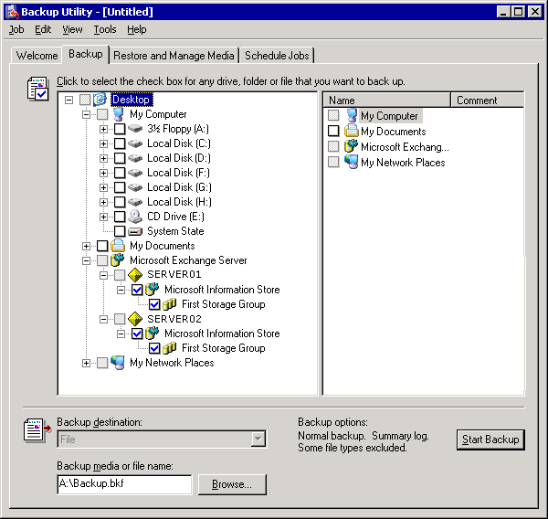

5. Click Browse to select the location of your backup. For more information about how to select the media for your backup, see Selecting the Destination for a Backup.
6. Click Start Backup.
7. In Backup Job Information, in the Backup description text box, type a backup description. Set the options and the advanced options, and then click Start Backup. For more information about how to set the options for the backup, see Selecting Options for a Backup.
8. After the backup is completed, verify that the backup was successful. For more information about how to verify the success of a backup, see Checking the Success of a Completed Backup.

For More Information
For more information about backing up Exchange Server 2003, see Backing up Exchange Server 2003.

Maintaining Records About Your Server Clusters
Make sure to maintain records of the configuration information about your Exchange 2003 clusters. You might need this information to recover your Exchange organization from a major disaster. For example, if all the servers in a cluster are damaged, you might have to completely rebuild the cluster. If you do not have full computer backup sets or Windows backup sets for each node, a record of configuration information for the cluster may help you recover the cluster.
To help you recover an Exchange 2003 cluster, maintain records of the following information about the cluster.
Cluster information to record
Information to record | How to obtain it
Disk Signatures of a cluster's shared disks. | At a command prompt, type:  cluster /cluster: clusterName resource sharedDisk /priv
NetBIOS (network basic input/output system) names of each node. | At a command prompt, type:  Nbtstat –s
Network names of each Exchange Virtual Server (EVS). | On the Administrative Tools menu, click Cluster Administrator.
Names of cluster groups. | On the Administrative Tools menu, click Cluster Administrator.
Names of cluster resources. | On the Administrative Tools menu, click Cluster Administrator.
Names of virtual server storage groups. | Use Exchange System Manager.
Names of virtual server Exchange stores. | Use Exchange System Manager.
IP addresses of virtual servers. | On the Administrative Tools menu, click Cluster Administrator. To view the properties of a virtual server, including its IP address, select its name.

Important:
If you do not keep a record of this information, you might not be able to recover your Exchange server clusters.

Restoring Exchange Server 2003
After you choose the restoration strategy that best suits your needs, you can use the information in this section to perform the appropriate tasks by using the backup utility (Backup) in Microsoft® Windows Server™ 2003. The recovery procedures you perform depend on the following three factors:
• The type of disaster or failure that occurs.
• The types of backups that you have available.
• The time that you can spend performing the recovery.
Note:
For some problems that occur, you do not have to restore any backups. For example, you can resolve some problems by repairing your Windows Server 2003 operating system or Microsoft Exchange Server 2003 installations.
The following topics provide descriptions and procedures for various recovery processes using Backup:
• Repairing Windows Server 2003
• Repairing Exchange Server 2003
• Restoring Windows Backup Sets
• Restoring Full Computer Backup Sets
• Restoring Domain Controllers
• Restoring Individual Mailboxes
• Restoring Exchange Mailbox or Public Folder Stores
• Restoring the Microsoft Exchange Site Replication Service (MSExchangeSRS)
• Restoring Connector-Specific Data
• Restoring Exchange Clusters
• Exchange Member Server Recovery
Several additional restore methods might suit your needs, too. These methods include using Automated System Recovery (ASR), restoring from a shadow copy, and restoring from a drive image. For more information about these methods, see "Disaster Recovery" in the Windows Server 2003 online Help.
If you decide to use third-party software to restore your Exchange data, use these topics for general restoration practices, but see your backup software's documentation for specific procedures.

Repairing Windows Server 2003
There are many troubleshooting techniques that you can use to resolve problems that arise in a Windows Server 2003 operating system installation. However, if a problem arises, consider the following possibilities before you use more complex troubleshooting techniques:
• Recent changes to your Windows Server 2003 operating system installation, such as the installation of new software, new drivers, or configuration changes, might cause or contribute to the problem.
• Other users might have experienced a similar problem and contacted Microsoft Product Support Services for help. In turn, Product Support Services might have written a Microsoft Knowledge Base article describing how to resolve the issue. Search the Microsoft Knowledge Base for an article that describes the problem.
If you cannot resolve the problem using these suggestions, use this section to familiarize yourself with the following basic troubleshooting techniques:
• Running the Windows Chkdsk utility
• Running Windows System File Checker
• Using the Safe Mode boot options
• Using the Last Known Good Configuration boot option
• Using the Windows Recovery Console
• Reinstalling Windows Server 2003
Note:
This section does not provide every possible troubleshooting technique for your Windows Server 2003 operating system.

Running the Windows Chkdsk Utility
If your Windows Server 2003 operating system experiences a problem, you can use the Chkdsk disk repair utility included in the operating system to check the file system on each logical partition and check the disk surface for unreadable or corrupted sectors. The Chkdsk utility creates and displays a status report for a disk based on the file system used. Chkdsk also lists and corrects errors on the disk. You can run Chkdsk from your Windows Server 2003 operating system. If you cannot start your operating system because of the problem, you can run Chkdsk from the Windows Recovery Console in Windows Server 2003 Setup. For detailed instructions, see How to Run Chkdsk on an Exchange Server 2003 Computer Running Windows Server 2003.

How to Run Chkdsk on an Exchange Server 2003 Computer Running Windows Server 2003
This procedure explains how to run Chkdsk on your Exchange Server 2003 running Windows Server 2003 to have Chkdsk repair errors.

Before You Begin
For detailed information about how to run Chkdsk on a computer running Microsoft® Windows Server™ 2003, see the "Chkdsk" topic in the Windows Server 2003 online Help.

Procedure
To run chkdsk and have it repair errors
1. Click Start, and then click Run.
2. In the Open box, type "cmd" (without the quotation marks), and then click OK.
3. At the command prompt, navigate to the directory you want to check.
4. Type chkdsk <drive>: /f (where <drive> is the letter of the drive that you want to repair errors on), and then press ENTER.
Note:
If the Chkdsk utility cannot lock the drive, it will offer to check the drive the next time the computer restarts. In addition, if you run Chkdsk on a hard disk, you must be a member of the Administrators group.
Note:
Some third-party diagnostic and repair software packages have advanced features for verifying the integrity of your hard disk, the file system, and the data contained therein.

For More Information
For syntax, parameters, and other details about running Chkdsk on Windows Server 2003, see Chkdsk.

Running Windows System File Checker
If your Windows Server 2003 operating system experiences a problem, but you can still start Windows Server 2003, you can use the System File Checker tool (Sfc.exe) to make sure that all the operating system files are the correct version and are still intact. System File Checker is a command-line tool that scans and verifies the versions of all protected system files. If System File Checker discovers that a protected file was overwritten, it retrieves the correct version of the file from the %systemroot%\system32\dllcache folder, and then replaces the incorrect file.
To run Windows System File Checker, at a command prompt, type sfc /scannow.
For more information about the System File Checker tool, see Microsoft Knowledge Base article 310747, "Description of Windows XP and Windows Server 2003 System File Checker (Sfc.exe)."

Using the Safe Mode Boot Options
If your Windows Server 2003 operating system experiences a problem, and you cannot start it normally, try using the following Safe Mode advanced startup options:
• Safe Mode
• Safe Mode with Networking
• Safe Mode with Command Prompt
The Safe Mode boot options are troubleshooting modes that load your Windows Server 2003 operating system with a minimal set of device drivers and services. After you start Windows Server 2003 in Safe Mode, you can use troubleshooting techniques such as running System File Checker or restoring backups to resolve the problem.
For more information about the Safe Mode boot options and other advanced startup options, see Microsoft Knowledge Base article 325375, "HOW TO: Troubleshoot Startup Problems in Windows Server 2003."

Using the Last Known Good Configuration Boot Option
If you experience difficulty starting your Windows Server 2003 operating system after you install a new driver or change a driver configuration, you can use the Last Known Good Configuration advanced startup options. If you use this boot option, the registry configuration reverts to the condition it was in before you made the changes that prevented the operating system from starting normally. Additionally, if you use this option, you will lose all configuration changes that were made since you last successfully logged on to your system. When you successfully log on after you make changes that affect the registry, the Last Known Good Configuration option cannot roll back those changes.
For more information about the Last Known Good Configuration options and other advanced startup options, see Microsoft Knowledge Base article 325375, "HOW TO: Troubleshoot Startup Problems in Windows Server 2003."

Using the Windows Recovery Console
With the Windows Recovery Console, you can obtain limited access to NTFS file system volumes without starting the Windows graphical user interface (GUI). In Recovery Console, you can:
• Use, copy, rename, or replace operating system files and folders.
• Enable or disable services or devices from starting when you next start your computer.
• Repair the file system boot sector or the master boot record (MBR).
• Create and format partitions on drives.
You can start the Recovery Console from the Windows Server 2003 CD or at startup, from the Windows Server 2003 boot menu, if the Recovery Console was previously installed to your computer. For more information about how to use Windows Recovery Console, see Microsoft Knowledge Base article 325375, "HOW TO: Troubleshoot Startup Problems in Windows Server 2003."

Reinstalling Windows Server 2003
If the computer still does not operate normally, you can use the Windows Server 2003 Setup CD to perform an in-place upgrade over the existing installation. The time that it takes to perform this in-place upgrade is equal to the time that it took to perform your original Windows Server 2003 installation.
To perform an in-place upgrade of Windows Server 2003, you must use installation media that is the same version as the currently installed version of Windows Server 2003. For example, if you perform an in-place upgrade on a computer running Windows Server 2003 Service Pack 1 (SP1), you must use an installation disc that contains Windows Server 2003 SP1.
If you do not do not have the installation media to match the version of the operating system, you can perform a clean installation of Windows Server 2003, and then apply the appropriate service packs and updates.
Important:
After you perform an in-place upgrade, changes that were made to your system after the original Windows Server 2003 installation (such as service pack upgrades and system customizations) might be lost. Reinstall the most recent service pack and all previous hotfixes and software updates after you reinstall Windows Server 2003.

Repairing Exchange Server 2003
In most situations where you might consider repairing a database, it is recommended instead that you restore the database from the backup, and replay the transaction log files to make the database up-to-date. Sometimes you cannot make the database completely up-to-date. In these instances, you can try to recover additional data from the failed database. For this reason, keep a copy of the failed database when you restore your backup to production hardware. For more information about keeping a copy of the failed database, see "Moving or Copying the Existing Versions of the Database Files That You Are Restoring (Optional)" in Recovering an Exchange Database.
For example: One of the databases in your Exchange organization experiences some type of corruption. You copy the corrupted database to a test server, and then start to restore the most recent backup to your production server. Unfortunately, the tape that you used for the backup was bad, and you have to revert to an earlier backup. Between the time that the two backups were made, some of the transaction log files were truncated (deleted) and you no longer have those transaction log files available. When you have restored all the available database and log files, you are still missing data.
You still might be able to recover some of that missing data by trying to repair the database on your test server, and then merging any additional data from your test server to your production server.
There are situations where repairing your database might be your only option. Examples of these cases include times when you do not have a backup of your Exchange database, or when your only backup is unusable. When you try to repair a backup, make sure to do this with a copy of the damaged database in case your attempts to repair the database fail. You cannot undo repair operations.
You might experience problems with an Exchange server that might not necessarily require you to perform a database restore or a complete recovery of the server. Try restarting your Exchange server first. If that does not solve the problem, you can try to reinstall Exchange before you resort to restoring your database.
Note:
Restarting your server might fix your immediate problem, but make sure to perform basic troubleshooting methods such as checking the event log files to determine the root cause of the problem that you are experiencing.
This section contains the following topics about Exchange repair processes:
• Reinstalling Exchange over a damaged installation.
• Repairing Exchange databases.
• Repairing full-text indexing.

Reinstalling Exchange over a Damaged Installation
Reinstalling Exchange and any relevant service packs and hotfixes helps ensure that all Exchange files are intact and are the correct version. Reinstalling Exchange and any service packs stops Exchange services from running on the Exchange server during the install processes. Therefore, users cannot access the Exchange server until after the installations are complete. For detailed instructions, see How to Reinstall Exchange 2003 over a Damaged Installation.
Note:
If you try to reinstall Exchange on a server that is running Exchange in a cluster, you must first move all Exchange Virtual Servers (EVSs) to another server node in the cluster. The node where Exchange is to be installed cannot be running any Exchange services.

How to Reinstall Exchange 2003 over a Damaged Installation
This procedure explains how to reinstall Exchange Server 2003 over a previous installation.

Procedure
To reinstall Exchange 2003
1. Insert the Exchange Installation CD, and then run the Setup program (Setup.exe) from <drive>:\setup\I386.
2. On the Welcome page, click Next.
3. On the Component Selection page, under Action, select the Reinstall option for the parent component "Microsoft Exchange," and then click Next. Components that are not installed are not available.
If the reinstall option does not appear, you can try to run the Setup program in disaster recovery mode with the /disasterrecovery switch. For more information, "Run Exchange Setup in Disaster Recovery Mode" in Member Server Recovery Procedures.
Reinstalling Exchange
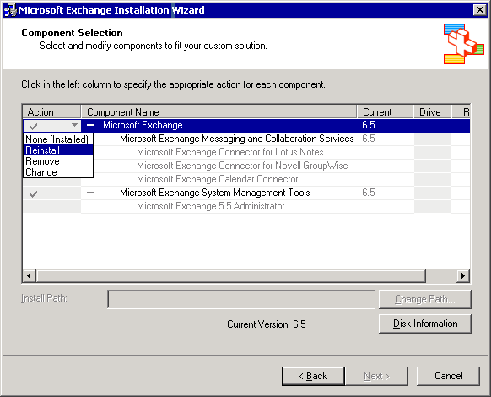

4. On the Installation Summary page, click Next to start the reinstall process.
The Installation Summary page
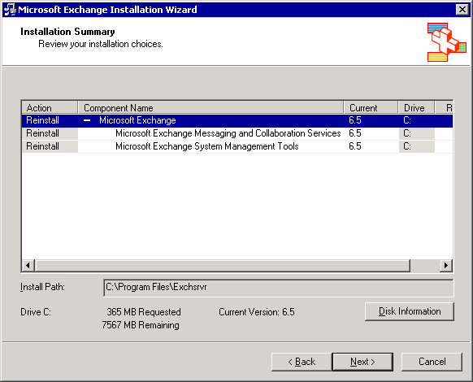

5. Exchange stops all Exchange services and performs all the required steps to reinstall Exchange over the damaged installation, including recopying all files.
The Component Progress page
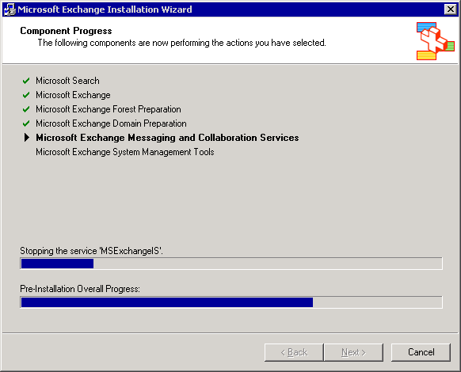

6. As the Setup program tries to copy installation files to your computer, the Confirm File Replace dialog box might appear, prompting you to specify whether you want to overwrite certain files on your server that are newer than the files being copied from the Exchange Setup CD. Because you are trying to repair files that are either damaged or the wrong version, you must click Yes to overwrite these files.
Note:
For Exchange 2000 servers, it is recommended that you do not overwrite these files. Instead, apply all required updates immediately after you run the Setup program in disaster recovery mode. Required updates are all updates that were applied to the server before the failure occurred.
The Confirm File Replace dialog box
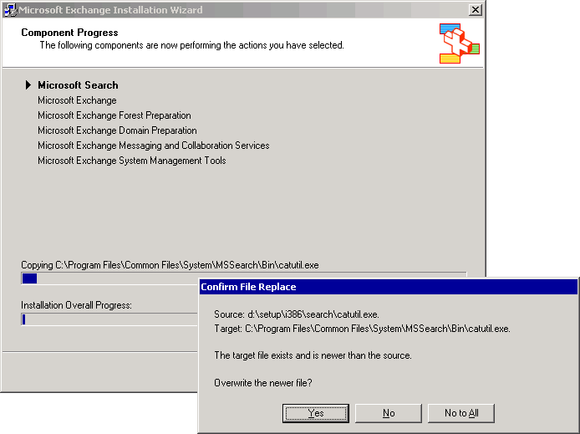

7. After the wizard completes, the Setup program notifies you if there are errors and whether your installation of Exchange is successful.
8. Click Finish to exit Setup.
9. Install any Exchange service packs and hotfixes that were installed to the server before the repair process. If you ran setup with the /disasterrecovery switch, make sure to use the /disasterrecovery switch when you install service packs. For more information, see "Install Exchange Service Packs in Disaster Recovery Mode" in Member Server Recovery Procedures.

For More Information
For more information about restoring Exchange Server 2003, see Restoring Exchange Server 2003.

Repairing Exchange Databases
Try to repair an Exchange database only as a last resort, because such an attempt can lead to loss of data.
You can repair Exchange database files (.edb files) by using Eseutil.exe and Isinteg.exe. You can also use recovery storage groups to salvage data from damaged databases. For information about using recovery storage groups, see Using Exchange Server 2003 Recovery Storage Groups.

Running Exchange Tools Globally on a Server
By default, some tools such as Eseutil and Isinteg are installed to the ..\exchsrvr\bin directory during Exchange setup. To run these tools globally on your server (from any command prompt), add the full path of ..\exchsrvr\bin to your Windows Server 2003 system path.
For detailed instructions, see How to Add the ..\exchsrvr\bin Directory to Your Windows Server 2003 System Path. After adding \bin to your system path, you should be able to run Eseutil and Isinteg from any command prompt on your server. You should also be able to run any other tools stored in the ..\exchsrvr\bin directory.

Using Eseutil and Isinteg to Repair an Exchange Database
This section contains general information that you should know about if you use Eseutil or Isinteg to repair Exchange databases.
For more information about using Eseutil or Isinteg, see Microsoft Knowledge Base articles 812357, "XADM: Maintain Your Exchange Database After You Repair By Using the Eseutil /p Tool" and 182081, "Description of the Isinteg utility." Consider the following information when repairing Exchange databases:
• Repairing Exchange databases with Eseutil and Isinteg can cause lost data in the Exchange databases you repair. For this reason, copy the database files you are repairing before attempting the repair process. (For information about how to copy your database files, see "Moving or Copying the Existing Versions of the Database Files That You Are Restoring (Optional)" in Recovering an Exchange Database.) Because you cannot undo changes that were made to a database during the repair process, only use Eseutil and Isinteg as a last resort. As discussed earlier, it is recommended that you recover a damaged database by restoring a backup set instead of repairing a database.
• If you use Eseutil to repair an Exchange database, you must have sufficient free disk space for Eseutil to run. If you are running Eseutil /P you must have approximately 20 percent of the size of the database you are repairing on the same drive. If you do not have that much room, you can use command-line switches to redirect the temp files to a different location. If you are using Eseutil /D, you must have 110 percent of the size of the database. While you can redirect the temp files to another drive as you can with the /P switch, it will dramatically increase the time it takes to repair your database. If it is possible, have ample free space when using the /D switch.
• Using the Eseutil and Isinteg utilities to repair a database file takes a substantial amount of time. Typically, it takes much longer to repair a database than it does to restore a database from backup.
• If both utilities run successfully (for example, if there are not any errors at the end of the last Isinteg run), the database is generally considered to be repaired and ready to replace the damaged database.
If you plan to put the repaired database back in production you must:
a. Run Eseutil /P.
b. After Eseutil /P completes successfully, run Eseutil /D.
c. After Eseutil /D completes successfully, run Isinteg –fix –test alltests.
If you only plan to salvage data from the disk, and do not plan to put it back in production, you can skip step 2 earlier in this section. Skipping step 2 will save time in your recovery process but might cause the database to have indexing and space allocation errors. These errors are not what you want in a production environment, but are unlikely to affect your ability to salvage data from the database.
• If Eseutil and Isinteg cannot fix every error in the database, it is best not to discard a repaired database. After Isinteg is completed, it should report zero errors in the database. If the error count is greater than zero, run Isinteg again until the count becomes zero or the count does not decrement on successive runs. If you cannot get the error count to zero, do not leave the database in production. Salvage data from it by merging or replicating folders to a new database or by moving mailboxes to a new database.
• You can restore data from a damaged database by using another server. For example, you can restore a damaged database to another server, extract data from it using the Exmerge utility, and then insert the data into a new database file. You can also use a recovery storage group on the same server to restore data from a damaged database. For more information about recovery storage groups, see Using Exchange Server 2003 Recovery Storage Groups.
By default, Eseutil and Isinteg are both installed into the <drive>\Program Files\Exchsrvr\bin directory when Exchange is installed.

How to Add the ..\exchsrvr\bin Directory to Your Windows Server 2003 System Path
This topic explains how to add the Exchange \bin directory to your system path so that the tools in \bin are available from any command prompt.

Procedure
To add the ..\exchsrvr\bin directory to your Windows Server 2003 system path
1. Open System Properties. To open System Properties, click Start, right-click My Computer, and then click Properties.
2. Click the Advanced tab.
3. Click the Environment Variables button.
4. In the System Variables box, scroll down to the variable "Path."
Editing the Path environment variable
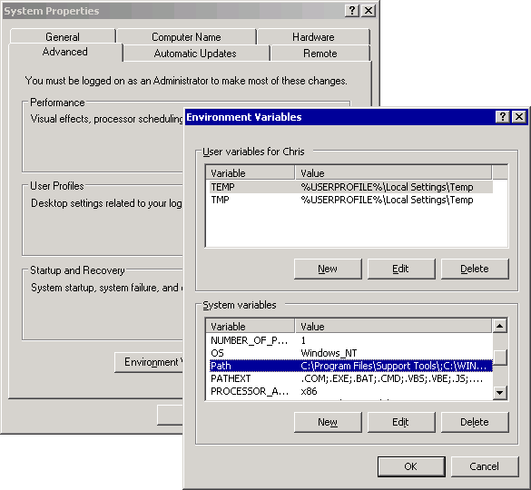

5. Click Path to select it, and then click Edit.
6. In the Variable Value box, add a semicolon (;) to the end of the string.
7. After the semicolon (with no spaces) type the full path of ..\exchsrvr\bin.
8. Add a semicolon at the end of the path variable.
The default path is C:\program files\exchsrvr\bin
Editing the Path variable
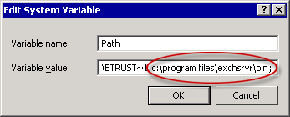

9. Click OK to close Edit System Variable, click OK to close Environment Variables, and then click OK to close System Properties.
10. Close any command shells that are open.
11. Open a new command shell. Click Start, click Run, type cmd, and then click OK. You should now be able to run any tool in the \bin directory from any command prompt on that server.

Repairing Full-Text Indexing
Exchange includes an optional feature that is referred to as full-text indexing (also known as content indexing). Full-text indexing allows your users to perform full-text searches across documents and attachments in messages. Full-text indexes are not stored with your Exchange databases. By default, full-text indexes are located in the Program Files\Exchsrvr\ExchangeServer_<Server Name>\Projects folder and are managed by the Microsoft Search service.
The default location for full-text indexes is the projects folder
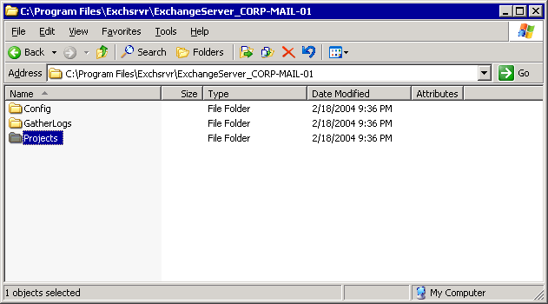

To repair full-text indexes that are corrupted or not synchronized with your Exchange databases, you must re-index the data on your Exchange databases. To restore Microsoft Search as part of your full-text indexing repair when Microsoft Search is damaged, see the procedure in "Restoring Microsoft Search."

Re-Indexing the Data on Your Exchange Databases
Re-indexing the data on your Exchange databases requires that you remove full-text indexing information and re-create full-text indexes. For detailed instructions, see How to Remove Full-Text Indexing Informationand How to Re-Create Full-Text Indexes.
Note:
Incorrectly editing the registry can cause serious problems that may require you to reinstall your operating system. Problems resulting from editing the registry incorrectly may not be able to be resolved. Before editing the registry, back up any valuable data.

Restoring Microsoft Search
The Microsoft Search service (MSSearch) is a Windows Server 2003 service that is installed on your Exchange server that is required for full-text indexing. You cannot create full-text indexes for your Exchange databases if the Microsoft Search component is damaged or if its registry keys are incorrect. If problems occur with Microsoft Search, you must restore it.
If you are in a recovery situation where Exchange is already installed on your server (for example, if you are repairing an existing Exchange installation, or if you have restored your server from either a Windows backup set or full computer backup set), make sure that full-text indexing is functioning correctly before performing this procedure. If full-text indexing is not functioning correctly, you might be able to repair your full-text indexes by removing, and then re-creating the full-text indexes. If you cannot remove, and then re-create your full-text indexes, perform the following procedure. For more information about how to remove full-text indexes, see "Re-Indexing the Data on Your Exchange Databases." For detailed instructions, see How to Restore Microsoft Search.
Caution:
Incorrectly editing the registry can cause serious problems that may require you to reinstall your operating system. Problems resulting from editing the registry incorrectly may not be able to be resolved. Before editing the registry, back up any valuable data.

How to Remove Full-Text Indexing Information
This topic explains how to remove full-text indexing information.

Before You Begin
Before you perform the procedure in this topic, be aware that the procedure contains information about editing the registry.
Caution:
Incorrectly editing the registry can cause serious problems that may require you to reinstall your operating system. Problems resulting from editing the registry incorrectly may not be able to be resolved. Before editing the registry, back up any valuable data.

Procedure
To remove full-text indexing information
1. Open Exchange System Manager. Click Start, point to All Programs, point to Microsoft Exchange, and then click System Manager.
2. In Exchange System Manager, navigate to the storage group which contains the full-text index that you want to remove.
Navigating to a storage group
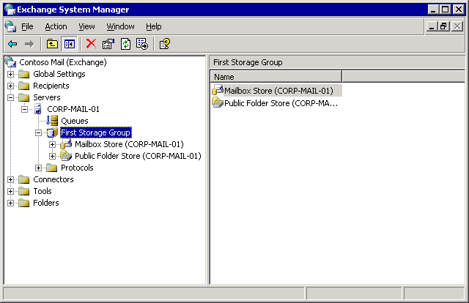

3. Right-click the mailbox or public folder store that contains the full-text index that you want to remove and select Delete Full-Text Index.
4. Close Exchange System Manager.
5. Open Registry Editor. Click Start, click Run, type Regedit, and then click OK.
6. In Registry Editor, locate the following key:
HKEY_LOCAL_MACHINE \SOFTWARE\Microsoft\Search\1.0\Databases

7. Under Databases, click ExchangeServer_<ServerName>, where <ServerName> is the server from which you want to delete full-text indexes.
Viewing the registry
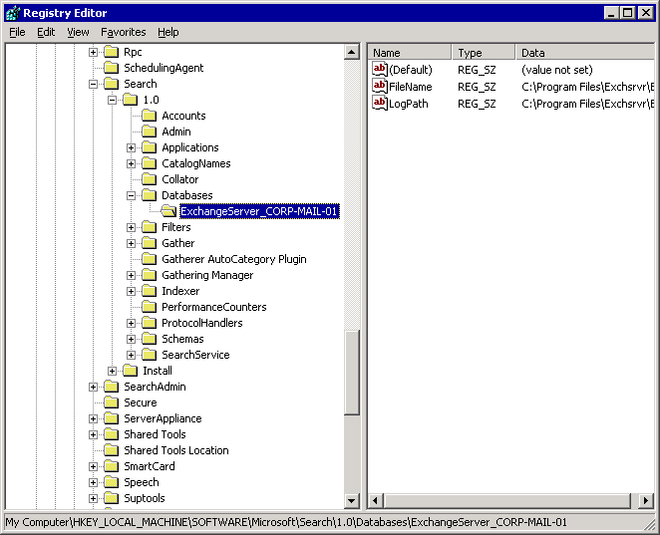

8. Record the value data for the key value LogPath. By default, it is
<drive>:\Program Files\Exchsrvr\ExchangeServer_<ServerName>\
where <drive> is the drive where Exchange was installed and <ServerName> is the name of the server running Exchange.
9. In Windows Explorer, or at a command prompt, find the folder that you recorded in the previous step.
Caution:
Because you are going to delete files from this folder, consider copying the contents of this folder to a safe location to save the folder information in the event an error occurs while deleting the files.
10. Under the ExchangeServer_<ServerName>folder, delete the contents of the Projects and GatherLogs subfolders. Do not delete the Projects and GatherLogs folders. View the contents of the Projects and GatherLogs folders to make sure that the folders are empty.
11. Close Windows Explorer or the command prompt.

How to Re-Create Full-Text Indexes
This topic explains how to re-create full-text indexes.

Procedure
To re-create full-text indexes
1. Open Exchange System Manager. Click Start, point to All Programs, point to Microsoft Exchange, and then click System Manager.
2. In Exchange System Manager, navigate to the storage group where you want to create the full-text index.
Navigating to a storage group

3. Right-click the mailbox or public folder store that you want to index, and then click Create Full-Text Index.
4. For each mailbox store or public folder store where you performed Step 3 of this procedure, right-click each store again, and then click Start Full Population.
5. For each index that you want to make available for full-text index searching, right-click the mailbox store or public folder store, click Properties, click the Full-Text Indexing tab, and then select the This index is currently available for searching by clients check box.
Enabling the indexes for searching
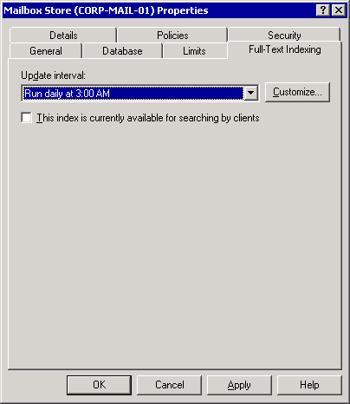

6. Set the update interval by selecting one of the default options from the drop-down list or click Customize, to customize the schedule.

How to Restore Microsoft Search
This topic explains how to restore Microsoft Search.

Before You Begin
Before you perform the procedure in this topic, be aware that the procedure contains information about editing the registry.
Caution:
Incorrectly editing the registry can cause serious problems that may require you to reinstall your operating system. Problems resulting from editing the registry incorrectly may not be able to be resolved. Before editing the registry, back up any valuable data.

Procedure
To restore Microsoft Search
1. In Registry Editor, locate the following key:
HKEY_LOCAL_MACHINE\SOFTWARE\Microsoft\Search

Important:
As a cautionary measure, back up the registry keys in case any errors occur while deleting the registry keys. To back up the Search registry key branch:
a. In the console tree, click Search.
b. On the File menu, click Export.
c. In Export Registry File, under Export range, click Selected branch, and make sure that HKEY_LOCAL_MACHINE\SOFTWARE\Microsoft\Search appears in the corresponding text box.
d. Select a location to save the file.
e. Name the file, and then click Save.
2. In Registry Editor, in the console tree, delete the following registry keys (where <ServerName> is the name of the server running Exchange):
To delete a key, right-click the key, click Delete, and then click Yes (as illustrated in the figure below). HKEY_LOCAL_MACHINE\Software\Microsoft\Search\Install
• HKEY_LOCAL_MACHINE\Software\Microsoft\Search\1.0\Applications\ExchangeServer_<ServerName>
• HKEY_LOCAL_MACHINE\Software\Microsoft\Search\1.0\CatalogNames\ExchangeServer_<ServerName>
• HKEY_LOCAL_MACHINE\Software\Microsoft\Search\1.0\Databases\ExchangeServer_<ServerName>
• HKEY_LOCAL_MACHINE\Software\Microsoft\Search\1.0\Gather\ExchangeServer_<ServerName>
• HKEY_LOCAL_MACHINE\Software\Microsoft\Search\1.0\Gathering Manager\Applications\ExchangeServer_<ServerName>
• HKEY_LOCAL_MACHINE\Software\Microsoft\Search\1.0\Indexer\ExchangeServer_<ServerName>
Deleting the Microsoft Search registry keys
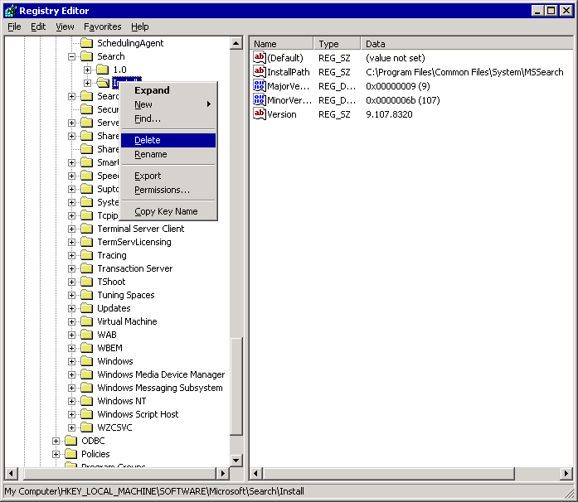

3. Close Registry Editor.
4. Run Exchange Setup in Disaster Recovery mode. At a command prompt, type <drive>:\setup\i386\setup.exe /disasterrecovery where <drive> is the location of your Exchange CD.
5. On the Component Selection page of the Exchange Installation Wizard, under Action, Disaster Recovery is automatically selected for all installed components. To ensure that the Microsoft Search files are correctly reinstalled, under Component Name, set Microsoft Exchange to None, and then reset Microsoft Exchange back to Disaster Recovery.
Note:
Running Setup in Disaster Recovery mode installs the required Microsoft Search files to your computer.
Running Exchange Setup in Disaster Recovery mode
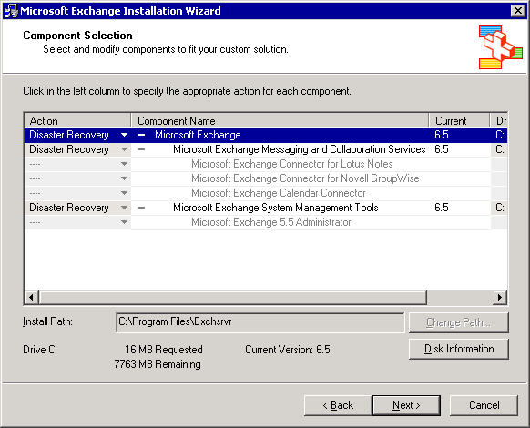

6. Click Next to continue with the installation process.
Note:
During Setup, Microsoft Search files are updated. During this time, the Confirm File Replace dialog box might appear. The dialog box prompts you to specify whether you want to overwrite certain files on your computer that are newer than the files being copied from the Exchange Setup CD. Because you are trying to repair any Microsoft Search files, you should overwrite these files. However, you can retrieve the newer versions of these overwritten when you install Exchange service packs or hotfixes.
7. Apply any Exchange service packs or hotfixes that were previously running on the server. To prevent the Setup program from mounting the databases after installation, you must install service packs and software updates in Disaster Recovery mode.
8. If you have to restore any Exchange database backups as part of this repair, restore your Exchange databases now.
Note:
For information about how to restore Exchange databases, see Restoring Exchange Mailbox or Public Folder Stores.
9. Restart the computer, and then make sure that the Exchange databases are mounted.
10. Re-create full-text indexes. For information about how to re-create full-text indexes, see How to Re-Create Full-Text Indexes.

Restoring Windows Backup Sets
A Windows backup set contains a server's unique operating system data and configuration information. You typically restore this data using the "rebuild a server" recovery method. When you restore a Windows backup set to a server, you restore critical operating system files and registry information from the original server. When you restore the original server's registry, you also restore the original computer name and return the server to its original domain with a computer account that matches the System ID in Active Directory® directory service. For Exchange Setup to complete successfully when run in Disaster Recovery mode, Setup relies on some of the unique configuration information included in the Windows backup set (such as the registry, the Internet Information Services (IIS) metabase, and so on).
For detailed instructions, see How to Restore a Windows Backup Set.
For information about how to create a Windows backup set, see Creating Windows Backup Sets.
Note:
In general, the older your Windows backup set is, the more likely you are to experience problems that must be resolved before you can restore Exchange. Therefore, it is recommended that you create Windows backup sets regularly. For more information, see Creating Windows Backup Sets.
Because of the dependencies among System State components, you cannot use Backup to back up or restore individual components comprising System State data, and when you restore System State data, any existing files in the destination will always be overwritten. However, you can recover the following data individually after you restore the System State data from a Windows or full computer backup to another location:
• Windows Server 2003 registry files.
• Windows Server 2003 boot files.
• SYSVOL directory files.
• Cluster database information files.
Note:
You cannot restore the Active Directory services database, the Certificate Services database, and the COM+ Class registration database to another location.

How to Restore a Windows Backup Set
This topic explains how to restore a Windows Backup set.

Procedure
To restore a Windows backup set
1. Start Backup in Advanced Mode.
For detailed instructions, see the following procedures:
• How to Start the Backup Utility
• How to Switch Backup to Advanced Mode
2. Click the Restore and Manage Media tab and Expand File in the console tree.
3. Set your file restoration preference. Click Tools, click Options, select the Restore tab, and select the criteria for overwriting files.
Although the default setting is Do not replace the file on my computer, you will probably find that selecting Always replace the file on my computer provides the greatest stability and consistency among Windows Server 2003 files by ensuring all the file versions after the restore match exactly what they were when the backup was originally made.
4. Expand the backup media that you want to restore.
Selecting the media to restore
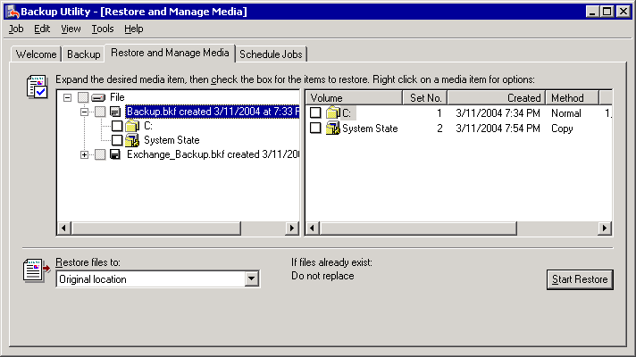

Note:
If the correct media does not display under File, you might have to rebuild the catalog. For information, see "Rebuilding a Catalog for a Restore" in Using Backup to Restore Your Data.
5. Select the check boxes next to the drive letters for your boot partition and system partition (frequently the same drive), and then select the check box next to System State.
Important:
To correctly restore all your Windows Server 2003 operating system components, a Windows backup set must contain the System State data, the boot partition, and the system partition, and must have been backed up as part of the same backup job.
Selecting the boot and system partition, and also the System State data
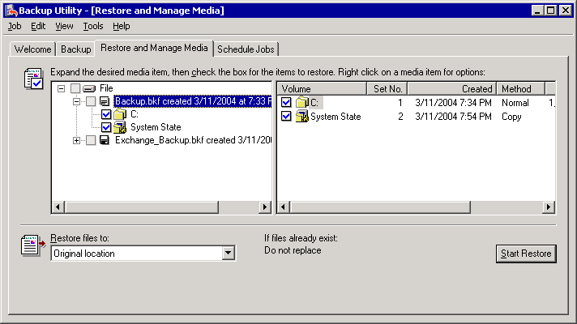

6. In the Restore files to list, select the location to where you want the files restored. By default, the location specified is Original location.
7. Click Start Restore. You will be notified that the current System State data will be overwritten unless you want to restore to a different location. To continue, click OK.
8. In Confirm Restore, click Advanced to specify advanced restore options, or click OK to start the restore. For more information about the advanced restore options in Backup, see "Selecting the Advanced Options for a Restore" in Using Backup to Restore Your Data
9. If Backup prompts you for the location of the backup file to use in the restore, select the correct backup file name, and then click OK.
10. After the restore is completed, make sure that it was successful. For more information about how to check the success of a restore, see "Checking the Success of a Completed Restore Job" in Using Backup to Restore Your Data.
11. After you verify that your Windows backup set is successfully restored, in the Restore Progress dialog box, click Close. You are then prompted to restart your computer to complete the restore. Click Yes to restart.
Important:
If you perform this procedure as part of rebuilding a server, after restarting your computer, you might experience errors that indicate that one or more services cannot start. These errors occur because when you restore the Windows backup set, you also restore the original registry of the server that you are rebuilding. That registry might include entries that try to start services that are not yet reinstalled, such as Simple Mail Transfer Protocol (SMTP). Ignore the errors. These errors should be resolved when you finish rebuilding the computer.

For More Information
For more information about restoring Windows backup sets, see Restoring Windows Backup Sets.

Restoring Full Computer Backup Sets
A full computer backup set includes a backup of System State data and most of the data on your hard disks. A full computer backup set must not include the Exchange Installable File System (IFS) drive and the drives or folders that contain your Exchange log files and database files. For detailed information about how to create full computer backup sets, see "Creating Full Computer Backup Sets."
Restoring a full computer backup set is the primary step in the "restore the server" recovery method. Restoring a full computer backup set to a computer allows you to recover a server running Exchange without having to reinstall applications, such as Exchange, which were running on the server.
Depending on the backup and restore utility or program that you use, the steps that you perform to restore your full computer backup set can vary. For example, if you use Backup to create your full computer backup sets, you use Backup to restore them. Similarly, if you use a disk-imaging software utility to create your full computer backup sets, you would use that same utility to restore those backup sets. For more information about how to create full computer backup sets with Backup, see "Creating Full Computer Backup Sets."
This section provides information about how to restore a full computer backup set by using the backup utility (Backup) in Windows Server 2003.

Restoring a Full Computer Backup Set by Using Backup
If you used the backup utility (Backup) in Windows Server 2003 to create a full computer backup set, you must also use Backup to restore that backup set. Because you must use Backup in this case, make sure that Windows Server 2003 is functioning sufficiently well after the disaster to allow you to start the operating system and run Backup. For detailed instructions, see How to Restore a Full Computer Backup Set.

How to Restore a Full Computer Backup Set
This topic explains how to restore a full computer backup set.

Procedure
To restore a full computer backup set
1. On the computer for which you want to restore your full computer backup set, start your Windows Server 2003 operating system.
2. Start Backup in Advanced Mode.
For detailed information, see the following procedures:
• How to Start the Backup Utility
• How to Switch Backup to Advanced Mode
3. Click the Restore and Manage Media tab, and then in the console tree, click the backup media that you want to restore. If the correct media does not appear under File, you might have to rebuild the catalog. For more information about how to rebuild the catalog, see "Rebuilding a Catalog for a Restore" in Using Backup to Restore Your Data.
4. Select the check boxes next to the drives that you want to restore, and then click System State. Always include the System State data when you restore the drive partitions of your full computer backup set.
Restoring a full computer backup set
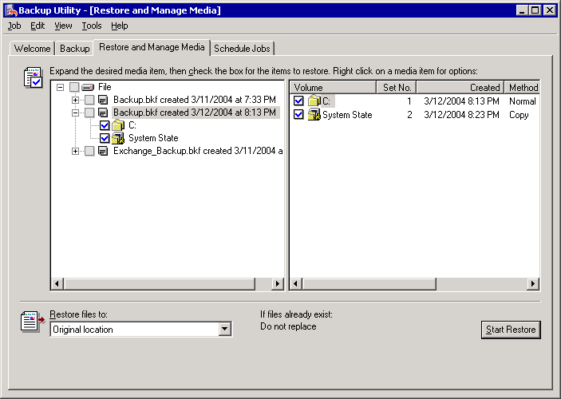

Important:
When you create full computer backup sets, do not back up the IFS drive, Exchange database files, Exchange log files, and cluster shared disk resources. If the full computer backup set that you are restoring includes the Exchange IFS drive or the drives or folders that contain the Exchange database files and transaction log files, do not select those drives or folders. If you restore those drives or folders, your log files might be out of sync, you might overwrite newer copies of the database with older ones, or you might add duplicate and unwanted items to the database. For more information about this issue, see Data to Exclude from Windows Backup Sets or Full Computer Backup Sets.
Note:
To restore your Exchange databases, restore the Exchange database backup that you performed by using the Microsoft Exchange Server option in Backup. For information about how to restore Exchange databases, see Restoring Exchange Mailbox or Public Folder Stores.
5. In the Restore files to list, select the location where you want the files to be restored. By default, the location specified is Original location.
6. Click Start Restore. You will be notified that the current System State data will be overwritten unless you want to restore to a different location. To continue, click OK.
7. In Confirm Restore, click Advanced to specify advanced restore options, or click OK to start the restore. For more information about the advanced restore options in Backup, see "Selecting the Advanced Options for a Restore" in Chapter 1.
8. If Backup prompts you for the location of the backup file to use in the restore, select the correct backup file, and then click OK.
9. After the restore is completed, make sure that it was successful. For more information about how to check the success of a restore, see Checking the Success of a Completed Backup.
10. After you verify that the full computer backup set is successfully restored, in the Restore Progress dialog box, click Close. You are then prompted to restart your computer to complete the restore. Click Yes to restart.

For More Information
For more information about restoring full computer backup sets, see Restoring Full Computer Backup Sets.

Restoring Domain Controllers
Servers running Exchange rely on information stored in Active Directory to function correctly. If you experience problems with the domain controllers in the Windows Server 2003 domain to which your Exchange server belongs, you must repair those domain controllers immediately. If these problems occur, you might experience minor complications with your servers running Exchange, or your servers might stop functioning.
To secure the availability of the domain controllers in your Exchange organization, make sure that you have more than one domain controller in each domain of your organization. Therefore, if a single domain controller fails, the replicated Active Directory information is still available in the remaining domain controllers.
If you have multiple domain controllers and if the failure does not affect all the domain controllers in your organization, one of the simplest and most effective ways to deal with the situation is to build a new domain controller and join it to the existing domain. The required Active Directory information will be replicated from the remaining domain controllers to the new one.
If all the domain controllers in your organization are affected or if you only have one domain controller, you must restore your data from a backup. For information about how to back up a domain controller, see "Backing Up Domain Controllers."
For detailed information about how to recover a Windows Server 2003 operating system domain controller, see Active Directory Operations Guide Version 1.5.

Restoring Individual Mailboxes
Use recovery storage groups to recover individual mailboxes. For more information, see Using Recovery Storage Groups in Exchange Server 2003.
Some third party backup solutions allow brick level backup and restore, which helps you to back up and restore individual mailboxes. For more information, see the documentation for your third-party software.

Restoring Exchange Mailbox or Public Folder Stores
When you use Backup to restore Exchange databases, application programming interface (API) calls are made to the Exchange Extensible Storage Engine (ESE) to restore Exchange database files and their associated log files. You can use Exchange database backups to restore one or more damaged mailbox or public folder stores. In a disaster recovery scenario that involves rebuilding a server, use Backup to restore your Exchange databases after you run Exchange Setup and any Exchange service packs in Disaster Recovery mode.
Note:
Installing Exchange (and any service packs that were running on your server before the disaster) in Disaster Recovery mode prevents the Setup program from mounting the databases after the Setup program is completed. You can then correctly restore and mount your Exchange database backups at the end of the setup process. Before you restart your server, as prompted by Exchange Setup, make sure that the log files have completed replaying.
This section contains the following information about restoring Exchange databases:
• Overview of the database restore process.
• Recovering an Exchange database.
• Resolving Exchange database restore problems.
• Restoring Exchange databases to another server.
Note:
The term database is used to generically refer to Exchange mailbox stores and Exchange public folder stores.

Overview of the Database Restore Process
When a restore operation begins, Backup informs the ESE that the process has begun, causing ESE to enter restore mode. The database (made up of a pair of files: an .edb file and an .stm file ) is then copied from the backup media directly to the database target path. The associated log files are copied to a temporary folder, and a separate instance of ESE is started to replay the transaction logs from their temporary location into the restored database.
The restore process creates the Restore.env file, which keeps track of the storage group that the database belongs to, the paths of the database files when they were backed up, the path to the database when they were restored, the range of log files that were restored, and other pertinent data.
You must restore a full backup set (either a normal or copy backup) before you can restore a differential or incremental backup set. This is because restoring a full backup set creates the Restore.env file. Restoring a differential or incremental backup set only updates the Restore.env file; it does not create one. If the Restore.env file does not exist, the differential or incremental updates cannot restore.
Always use different temporary folders for each full backup set that you are restoring. For example, if you were to restore two normal backups to the same temporary folder the second Restore.env file that would be created would overwrite the first Restore.env file. Therefore, always specify a different temporary folder for each normal or copy backup set that you are restoring.
However, when you restore an incremental or differential backup, specify the same temporary folder you used for the full backup that the incremental or differential backup belongs with, so that they are paired with the correct Restore.env file.
After the database files are copied back to their original locations and the Restore.env and transaction log files have been copied to the temporary folder, ESE initiates a hard recovery to replay log files into the database. This brings the database up-to-date with the time that it was lost if all the log files since the backup was taken are available. First, Restore.env is used to determine which transaction logs will be played from the temporary folder. Then, if it is possible, additional transaction logs from the target storage group are also replayed.
Following hard recovery, the temporary instance of ESE is stopped. If you select the Mount Database After Restore check box in Backup, the newly restored database is automatically mounted in the target storage group.
The following figure illustrates the Exchange restore process.
The flow of the Exchange restore process
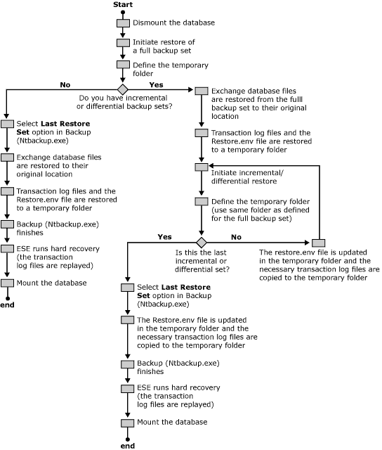

Recovering an Exchange Database
Exchange Database Recovery Checklist

__ | Dismount the databases for each mailbox or public folder store that you are restoring.
__ | Configure the databases so that the restore can overwrite them (optional).
__ | Determine the database and log file locations of the files that you are restoring (optional).
__ | Copy the current database files to another location (optional).
__ | Make sure that the mailbox and public folder store names in Exchange System Manager match your backup media.
__ | Make sure that the Microsoft Exchange Information Store service (MSExchangeIS) is running.
__ | Select the backup files that you want to restore from your backup media.
__ | Restore the selected files.
__ | Make sure that the restore process was successful.
__ | Replay the transaction log files (Eseutil /cc) (optional).
__ | Mount the databases (stores).

Dismounting the Exchange Databases That You Are Restoring
Before you perform the restore process, you must dismount the Exchange databases that you want to restore. If a database that you try to restore is still mounted, the restore process will fail. For detailed instructions, see How to Dismount Mailbox and Public Folder Stores.
Note:
When mailboxes and public folders are dismounted, they are inaccessible to users. Because Exchange supports multiple storage groups and multiple mailbox and public folder stores, you must dismount only the databases that are being restored from your backup. To restore a database without affecting e-mail users who have mailboxes on that database, consider using a recovery storage group instead of its original storage group, Typically, recovery storage groups are used only when you want to extract or merge specific data from the backup database to the original still running database.
Note:
You must dismount every database that you want to restore.

Configuring the Exchange Databases So That the Restore Process Overwrites Them (Optional)
To ensure that the restore process overwrites Exchange databases, you must configure the databases that are being restored. However, you do not have to configure the databases if you restore them to their original locations, or if you use recovery storage groups. It is only required when the databases that you restore have different GUIDs in Active Directory. For example, a different GUID is required when you restore a database to another forest, such as a test forest. A different GUID is also required if the Active Directory object for the database has been deleted. When you re-create deleted objects in Active Directory, you give each object a new GUID.
Unless you know that you must overwrite the database, do not use this option.
For detailed instructions, see How to Configure the Exchange Databases so That the Restore Process Overwrites Them.

Determining the Database and Log File Locations of the Files You Are Restoring (Optional)
If you plan to make copies of the damaged database so that you can try to repair it later if necessary, you determine the location of the database and log files so that you can move or copy them.
In the following procedure, you must record information from the properties dialog boxes from both the database and the storage group that contains the database. You must do this for each database you want to move or copy. For detailed instructions, see How to Determine the Database and Log File Locations of the Files You Are Restoring.

Moving or Copying the Existing Versions of the Database Files That You Are Restoring (Optional)
You can preserve the existing database files before they are overwritten by a restore in case the restore process is unsuccessful. Keeping a copy of the damaged database files allows for more recovery options. For example, if your restore is unsuccessful, a copy of these files helps you to revert to the original versions, which might be repairable.
The disadvantage of copying the database files before the restore is that it might add significant time to the database recovery process. If moving the files to another location on the same logical drive is an option, this will be much quicker than trying to copy the files. For detailed instructions, see How to Copy or Move the Existing Versions of the Database Files You Are Restoring.
Important:
Moving database files from their original location to a different folder on the same logical disk is almost instantaneous, as the only data that must be written to disk is an update to the NTFS Master File Table (MFT). Moving the files to a different logical disk (even if both drives share the same physical disk) or making a copy of them in any location takes much longer because each database file must be rewritten to the new location. Moving or copying the database files to a different location over the network takes even more time, and can use a lot of your network bandwidth. This is just one reason why making full use of the 4 storage group and 20 database capabilities of Exchange Server 2003 (more databases of smaller sizes) is actually more manageable and can decrease the time that you spend on backup and restore-related tasks.

Ensure That the Mailbox and Public Folder Store Names in Exchange System Manager Match Your Backup Media
The names of the storage groups and databases (mailbox stores or public folder stores) that you restore from your backup media must match the names of the storage groups and databases as they exist as objects in Active Directory for the server to which they are being restored. If Exchange System Manager is running on any Exchange server in the organization, it will read this data from Active Directory and display it so that the data can be verified against the names of the storage groups and databases as they appear in your backup. If the names do not match, the restore process fails.
For example, if you delete a storage group and its databases before you try to restore them, the storage group and its database will not exist in Active Directory for that server, and you must re-create a storage group and databases with names that exactly match the storage group and database names on your backup media. For detailed instructions, see How to Ensure that Storage Group and Database Display Names Match the Names of the Files You Are Restoring.

Resolving Mismatched Names Between Exchange System Manager and Your Backup Media
If, after you follow the procedures earlier in this chapter, you find that the names do not match, you must create storage group and databases that match the names of the storage group and databases that you are restoring from backup.
In the case where a database or storage group name has changed, you only have to rename the database or storage group.
In situations where you are setting up a new server, or the database or storage group is missing, you have to create them. For detailed instructions, see the following procedures:
• How to Rename a Storage Group or Database
• How to Create a Storage Group
• How to Create a Mailbox or Public Folder Store

Make Sure That the Microsoft Exchange Information Store Service (MSExchangeIS) Is Running
For detailed instructions, see How to Start the Microsoft Exchange Information Store Service (MSExchangeIS).

Selecting the Backup Files to Restore from Your Backup Media
For detailed instructions, see How to Select the Backup Files to Restore from Your Backup Media.

Restore the Selected Files
In cases where you are restoring differential and incremental backups, make sure to restore the backups in chronological order. Always restore the normal backup first, and then restore any incremental or differential backups in chronological order. If you restore backup sets out of order, some transaction logs might not be replayed. For detailed instructions, see How to Restore Selected Files.

Make Sure That the Restore Process Was Successful
The Status field in the Restore Progress dialog box indicates where Backup is in the restore process. If the status field reads Failed, there were problems with the restore process that must be resolved before you can continue restoring your Exchange database. Click the Report button for more information about these errors.
If the Status field reads Completed, Backup has successfully restored the database and the log files have been restored to the temporary directory. However, the transaction logs must still be replayed for the whole recovery process to complete. Transaction log replay can take several hours to complete.
For more information about how to check the success of the restore process, see "Checking the Success of a Completed Restore Job" in Using Backup to Restore Your Data.

Replay the Transaction Log Files Using Eseutil /CC (Optional)
When a database is restored from backup media, it is in what is referred to as an inconsistent state where the database and log files are not synched together. To fully recover your Exchange data after you restore the database, you must replay the transaction logs to bring the database up-to-date or make it consistent.
Hard recovery is the process that brings a restored database back to a consistent state. To initiate hard recovery, you can select the Last Restore Set check box in Backup when you restore your last database or you can use the Eseutil /cc command.
To run Eseutil from any command prompt, follow the procedure in "Running Exchange Tools Globally on a Server" earlier in this chapter.
It is recommended that you run only one instance of Eseutil /cc at a time, even if you restore multiple databases concurrently. For detailed instructions, see How to Run Eseutil /cc.

Mount the Databases (Stores)
Mounting the store is the last step in recovering an Exchange database. Before you mount the store, make sure that the hard recovery is completed. To make sure that the hard recovery is completed, check whether the Restore.env file has been deleted. Restore.env is not deleted until the hard recovery succeeds. Open the folder that you designated as the temporary location for log files, and then open the folder for the storage group that you are restoring. If the Restore.env file is still there, the hard recovery is not completed. Do not try to mount the store.
Note:
If you have performed hard recovery with the /k switch, which prevents deletion of Restore.env (Eseutil /cc /k), check the database header for a clean shutdown state by using Eseutil /mh.
After you are sure that the transaction log replay is completed, mount each store that you have recovered. For detailed instructions, see How to Mount an Exchange Store.

How to Dismount Mailbox and Public Folder Stores
This topic explains how to dismount mailbox and public folder stores.

Before You Begin
Before you perform the procedure in this topic, consider the following:
When mailboxes and public folders are dismounted, they are inaccessible to users and applications. Because Exchange supports multiple storage groups and multiple mailbox and public folder stores, you should dismount only the databases necessary.

Procedure
To dismount the mailbox and public folder stores that you are restoring
1. Open Exchange System Manager. Click Start, point to Programs, point to Microsoft Exchange, and then click System Manager.
2. In Exchange System Manager, navigate to the database that you want to dismount, right-click the database, and then click Dismount Store.
Dismounting a mailbox store
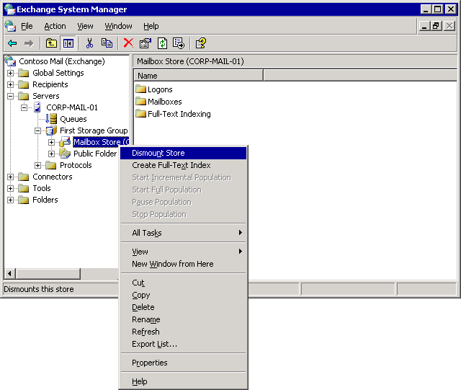

How to Configure the Exchange Databases so That the Restore Process Overwrites Them
This topic explains how to configure Exchange databases so that they will be overwritten during a restore using Backup.

Before You Begin
Before you perform the procedure in this topic, be aware that you should not use this option unless you are certain that you must overwrite the database.

Procedure
To configure the Exchange databases so that the restore process overwrites them
1. Open Exchange System Manager. Click Start, point to Programs, point to Microsoft Exchange, and then click System Manager.
2. In Exchange System Manager, navigate to the database that you want to restore, right-click it, and then click Properties.
Mailbox store properties
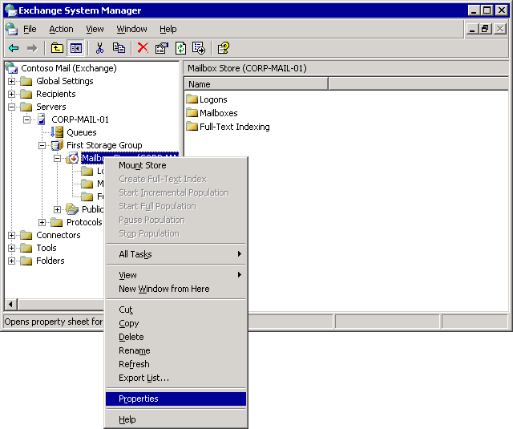

3. On the Database tab, select the This database can be overwritten by a restore check box.
Enabling the database to be overwritten during a restore
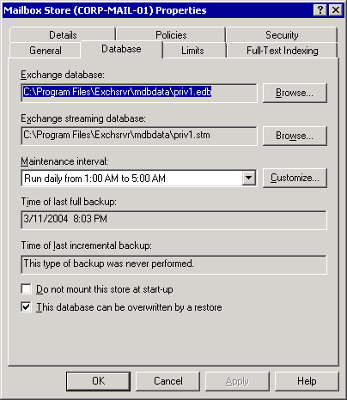

How to Determine the Database and Log File Locations of the Files You Are Restoring
This topic explains how to determine the database and log file locations of files you are restoring.

Procedure
To determine the database and log file locations of the files you are restoring
1. Open Exchange System Manager. Click Start, point to Programs, point to Microsoft Exchange, and then click System Manager.
2. In Exchange System Manager, navigate to the storage group that contains the database that you want to move or copy, right-click the storage group, and then click Properties.
Storage group properties
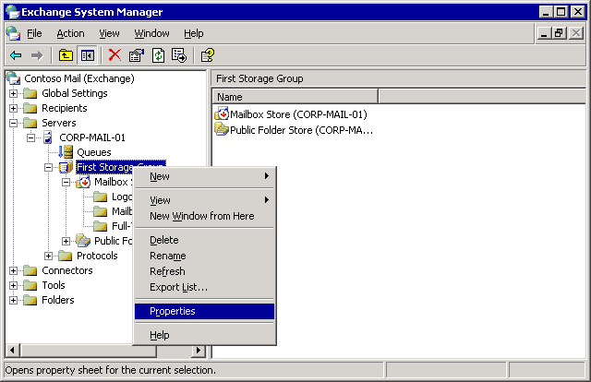

3. On the General tab, note the paths in the Transaction log location and System path location boxes, and then click OK. Record these paths for each storage group that contains a database that you want to move or copy.
The Transaction log location is the path where log files are written for the whole storage group. These log files record every change made to a database in that storage group. The System path location is where other files critical to the storage group are kept, such as the storage group's checkpoint file.
Log file locations and system path locations
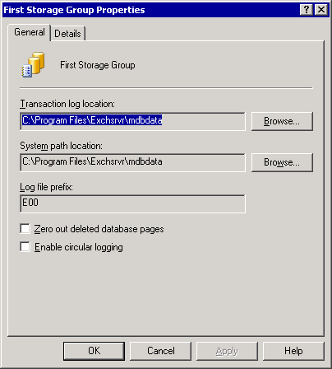

4. In Exchange System Manager, right-click the database that you want to move or copy, and then click Properties.
5. On the Database tab, note the paths of both the Exchange database file and the Exchange streaming database file, and then close the dialog box.
Exchange database file locations
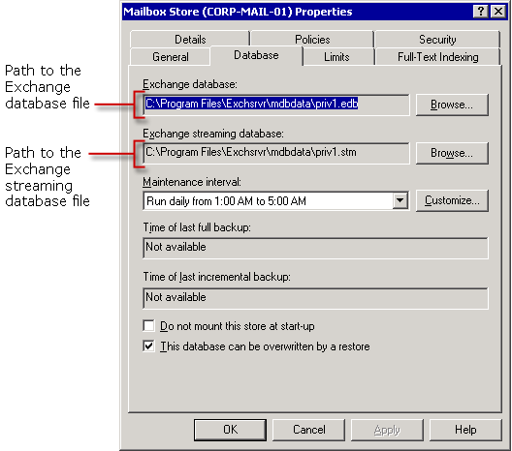

Reference
For more information about restoring Exchange Server 2003, see Restoring Exchange Server 2003.

How to Copy or Move the Existing Versions of the Database Files You Are Restoring
This topic explains how to copy or move a database file that you are trying to restore.

Before You Begin
Before you perform the procedure in this topic, consider the following:
Moving database files from their original location to a different folder on the same logical disk is almost instantaneous, as the only data that must be written to disk is an update to the NTFS Master File Table (MFT). Moving the files to a different logical disk (even if both drives share the same physical disk) or making a copy of them in any location takes much longer because each database file must be rewritten to the new location. Moving or copying the database files to a different location over the network takes even more time, and can use a lot of your network bandwidth. This is just one reason why making full use of the 4 storage group and 20 database capabilities of Exchange Server 2003 (more databases of smaller sizes) is actually more manageable and can decrease the time that you spend on backup and restore-related tasks.

Procedure
To copy or move the existing versions of the database files you are restoring
1. Make sure that the databases that you are moving or making a copy of are dismounted. For more information about how to dismount databases, see "Dismounting the Exchange Databases That You Are Restoring" in Recovering an Exchange Database.
2. Make sure the databases you are copying have been shut down in a clean state. Use Eseutil /mh to dump the header information for the database. Look for State: Clean Shutdown in the dumped information.
If the database is in a dirty state, try to restore the database to a clean state before you repair it. This task entails playing any required transaction logs into the database. The Log Required field in the dump file from Eseutil /mh will show you the logs that are required to restore the database to a clean state. The logs shown in this field are shown in decimal, you must convert these values to hexadecimal to find the appropriate transaction log files.
In many cases, remounting the database causes soft recovery to start so that the database can be shut down in a clean state.
3. Create a folder to store the database files that you want to move or copy. You can create the folder either on a local hard disk or on your network. Make sure the destination location has sufficient room before you start the copy process. Remember that moving the file to another location on the same logical drive is the fastest way to preserve the damaged database.
Copying database files before the restore process
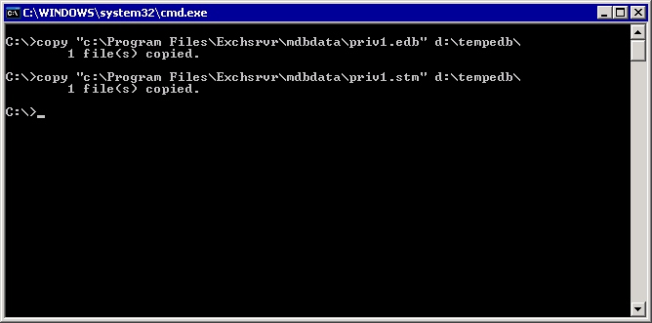

For More Information
For more information about restoring Exchange Server 2003, see Restoring Exchange Server 2003.

How to Ensure that Storage Group and Database Display Names Match the Names of the Files You Are Restoring
This topic explains how to ensure that storage group and database display names match the names of the files you are restoring.

Procedure
To ensure that storage group and database display names match the names of the files you are restoring
1. In your backup or restore device, insert the backup media that contains the backups that you want to restore.
2. Start Backup in Advanced Mode: Click Start, click Run, type ntbackup, and click OK. Then click the Advanced Mode link on the Welcome screen.
3. Click the Restore and Manage Media tab, and then in the console tree, click the backup media that you want to restore.
4. If the correct media does not display in the console tree, you might have to rebuild the catalog. For more information about how to rebuild the catalog, see "Rebuilding a Catalog for a Restore" in Using Backup to Restore Your Data.
5. Expand the tree structure of the media so that the name of each Exchange database that you are restoring appears.
6. Record the names of the storage groups and each mailbox store or public folder store that you want to restore.
Storage group and mailbox store names in Backup
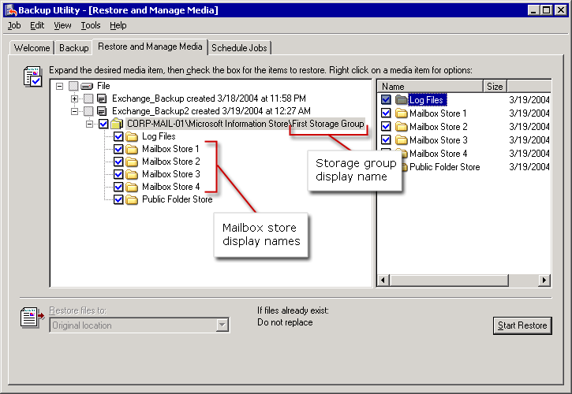

7. Open Exchange System Manager. Click Start, point to Programs, point to Microsoft Exchange, and then click System Manager.
8. In Exchange System Manager, navigate to the server that contains the database that you want to restore.
9. In the console tree and details pane, note the names of the storage group and databases. Compare these with the storage group and database names on your backup media. The names in Exchange System Manager must match those on the backup media or the restore process will fail.
Storage group and mailbox store names in Exchange System Manager
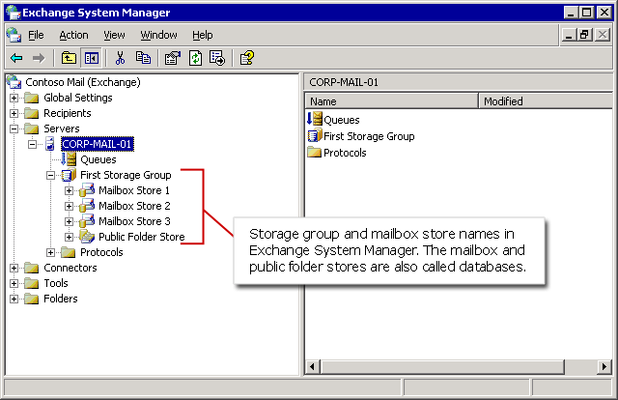

For More Information
For more information about restoring Exchange Server 2003. see Restoring Exchange Server 2003.

How to Rename a Storage Group or Database
This topic explains how to rename a storage group or database.

Procedure
To rename a storage group or database
1. In Exchange System Manager, right-click the storage group or database that you want to rename.
2. Click Rename.
Renaming a database
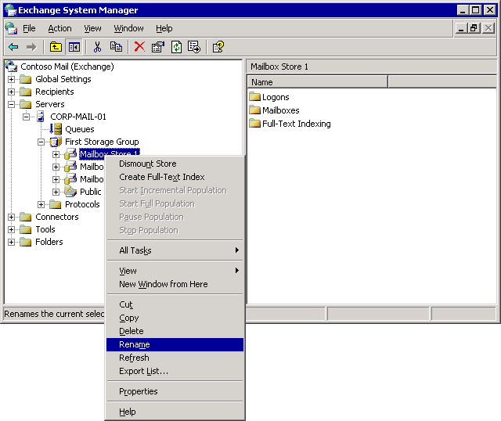

3. Type the name of the database or storage group that you are restoring. Make sure that the name you type exactly matches the name on the backup media, and then press ENTER.

How to Create a Storage Group
This topic explains how to create a storage group.

Procedure
To create a storage group
1. In Exchange System Manager, right-click the server where you want to create the storage group.
2. Click New.
3. Click Storage Group.
Creating a new storage group in Exchange System Manager
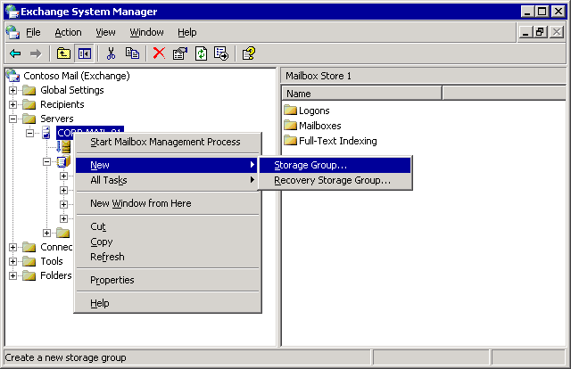

4. On the General tab of the Properties dialog box, type the name exactly as it appears on your backup media.
5. Click OK.

How to Create a Mailbox or Public Folder Store
This topic explains how to create a mailbox or public folder store.

Procedure
To create a mailbox or public folder store
1. In Exchange System Manager right-click the storage group where you want to create the database.
Note:
The structure that you see in the user interface (UI) should mirror the original structure on your backup media.
2. Point to New.
3. Click the type of database that you are restoring.
Creating a new mailbox store in Exchange System Manager
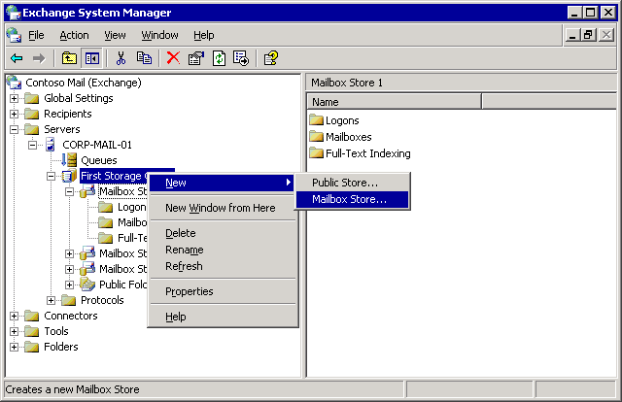

4. In the Name field, type the name of the mailbox or public folder store exactly as it appears on your backup media.
5. Click OK.
6. When prompted to mount the store, click No.
Note:
It is best not to mount the store at this point. Mounting the store can create log files that conflict with the log files on your backup media and therefore interfere with log file replay when you restore the database from backup.

How to Start the Microsoft Exchange Information Store Service (MSExchangeIS)
This topic explains how to start the Microsoft Exchange Information Store service.

Procedure
To start the Microsoft Exchange Information Store service (MSExchangeIS)
1. Start the Services snap-in: Click Start, click Run, and then type services.msc.
2. Locate the Microsoft Exchange Information Store service (MSExchangeIS) and make sure that the Status column displays Started.
Locating the Microsoft Exchange Information Store service (MSExchangeIS)
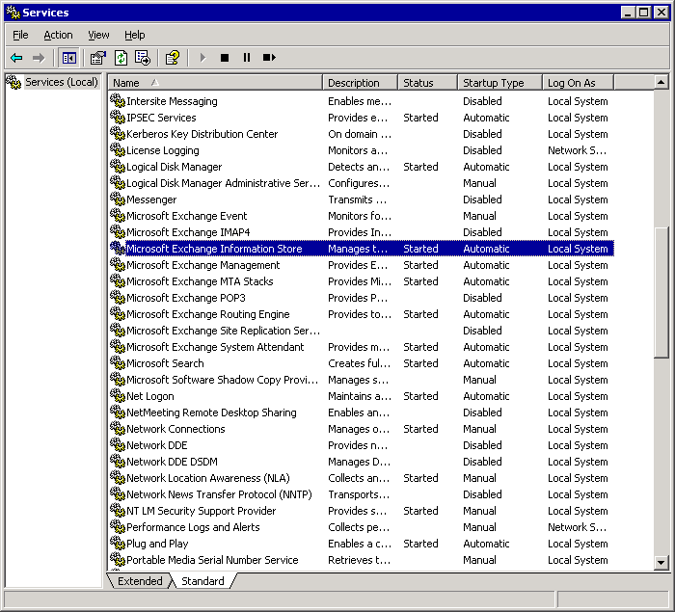

3. If you have to start the service, right-click Microsoft Exchange Information Store, and then click Start.

How to Select the Backup Files to Restore from Your Backup Media
This topic explains how to select the backup files to restore from your backup media.

Procedure
To select the backup files to restore from your backup media
1. Start Backup in Advanced Mode.
For detailed information, see the following procedures:
• How to Start the Backup Utility
• How to Switch Backup to Advanced Mode
2. Click the Restore and Manage Media tab.
3. In the console tree, click the backup media that you want to restore. If the correct media does not display in the console tree, you might have to rebuild the catalog. For more information about how to rebuild the catalog, see "Rebuilding a Catalog for a Restore" in Using Backup to Restore Your Data.
4. Click the check boxes next to the storage groups or databases that you want to restore.
Selecting the storage groups or databases that you want to restore
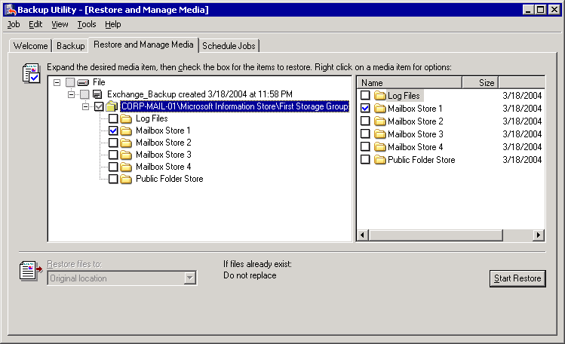

For example, if you want to restore a whole storage group, select the check box next to the storage group that you want to restore. If you want to restore just one database in a storage group, select only the check box next to the database you want to restore.
Note:
Selecting or clearing the Log Files check box in Backup does not affect the restore process. Exchange automatically detects whether log files are to be restored based on the type of backup that you are restoring.

For More Information
For more information about restoring Exchange Server 2003, see Restoring Exchange Server 2003.

How to Restore Selected Files
This topic explains how to use Backup to restore selected files.

Procedure
To restore selected files
1. Start Backup in Advanced Mode.
For detailed instructions, see the following procedures:
• How to Start the Backup Utility
• How to Switch Backup to Advanced Mode
2. On the Restore and Manage Media tab, in the Restore files to list, select the location to where you want the files restored. By default, the location specified is Original location.
3. Click Start Restore.
4. In the Restore To box, specify the Exchange server that you want the databases restored to.
The Restoring Database Store dialog box
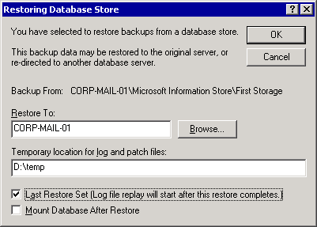

5. In the Temporary location for log and patch files box, specify a directory to store log files during the restore process.
6. To perform the restore, you must have sufficient space in the directory to store the files. The disk space requirement is about 10 MB more than the size of the transaction log files that are being restored.
Important:
The directory that you specify in the Temporary location for log and patch files box must not contain the original database or log files or the restore might fail.
Note:
It is recommended that you create an empty temporary folder for this procedure. Because transaction logs are written per storage group, and not per database, using a temporary folder ensures that transaction log replay is isolated and will not interfere with undamaged databases that are still running in a storage group during recovery.
7. Select the Last Restore Set check box only if this is the last backup set that you have to restore before you remount your databases.
8. If you are restoring a backup that is part of a series of normal, differential, or incremental backups, leave this check box cleared until you restore the final incremental or differential backup in the series. The restore process does not initiate hard recovery to play back the log files to the database that is being restored until this box is selected.
9. If you do not select this check box when you restore the last backup set, you can use Eseutil to manually replay the transaction logs. For a step-by-step explanation of this process, see, "Replay the Transaction Log Files Using Eseutil /CC (Optional)" in Recovering an Exchange Database. For more information about hard recovery and transaction log replay, see Microsoft Knowledge Base article 232938, "The 'Last Backup Set' Check Box and Hard Recovery in Exchange."
10. Only select the Mount Database After Restore check box if this is the last backup set that you plan to restore, and you are sure that you are ready to mount the databases. It is recommended that you do not select this check box.
11. Click OK when you are ready to start the restore process.
12. If Backup prompts you for the location of the backup file to use in the restore, select the correct backup name, and then click OK.

For More Information
For more information about restoring Exchange Server 2003, see Restoring Exchange Server 2003.

How to Run Eseutil /cc
This topic explains how to run Eseutil /cc.

Procedure
To run Eseutil /cc
1. After the last backup has been restored and you want to initiate a hard recovery, open a Command Prompt window: Click Start, click Run, type cmd, and then click OK.
2. Find the folder where the Restore.env file is located.
3. Type eseutil /cc. Do not use any other parameters.
4. When the transaction logs finish replaying successfully, the message, "Operation completed successfully" appears.
Eseutil performs the same function as the Last Restore Set check box. Use all other Eseutil /cc switches with extreme caution.
Replaying transaction logs with Eseutil /cc
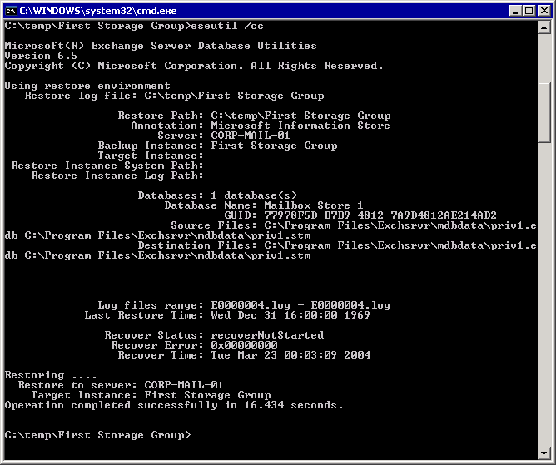

How to Mount an Exchange Store
This topic explains how to mount an Exchange store.

Procedure
To mount an Exchange Store (database)
1. Open Exchange System Manager. Click Start, point to Programs, point to Microsoft Exchange, and then click System Manager.
2. In Exchange System Manager, navigate to the database that you want to mount, right-click the database, and then click Mount Store.
Mounting the store
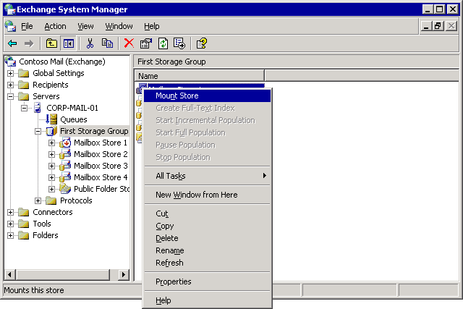

Resolving Exchange Database Restore Problems
If the restore process fails, troubleshoot the problem as soon as possible. Sometimes, performing the restore process again corrects the problem. Other times, you might have to repair one or more Exchange databases. For information about how to repair Exchange databases, see "Repairing Exchange Databases."
For general information about how to search and troubleshoot restore errors, see "Checking the Success of a Completed Restore Job" in Using Backup to Restore Your Data.
If you experience problems with the databases that you tried to restore, check the application log for errors, and then search the Microsoft Knowledge Base for specific solutions to those errors.

Troubleshooting Failed Restore Processes
If the restore process is not completed successfully, search for errors in the Backup status window, the Backup restore log, and the logs in Event Viewer. These errors might help you determine the cause of the failure.
Because Exchange relies heavily on your Windows Server 2003 operating system, look for both Exchange-specific errors in the event logs and errors for non-Exchange components that Exchange relies on. Also consider hardware errors. For example, a bad page file on a hard disk drive can prevent Exchange from moving forward writing to the database.
After you have identified errors in the event log that you suspect might be the cause of the failed restore, search the Microsoft Knowledge Base for those specific errors.
Note:
If one or more Exchange database or log files are damaged or missing, the application log might include the following error: Error -1216 (JET_errAttachedDatabaseMismatch)
Note:
For information about how to troubleshoot database restore issues that include the 1216 error, see Microsoft Knowledge Base article 296843, "XADM: Error -1216 Recovering an Exchange 2000 Database."
If you cannot resolve the problems that are preventing you from restoring your Exchange databases, contact Microsoft Help and Support.

Restoring Exchange Databases to Another Server
If you experience problems when you restore Exchange databases to the original server, or to the server to which you have restored the original server's configuration, you can restore Exchange databases to a different Exchange server. However, restore Exchange databases to a different server only as a last resort. The Exchange server to which you restore Exchange databases must meet specific criteria. For example, Exchange service packs and hotfixes that you install on the server must match those of the server whose Exchange databases you backed up. For more information about how to restore Exchange databases to a different server, see Exchange 2000 Server Database Recovery.
Note:
While the above article refers to the recovery of Exchange 2000, the content also applies to Exchange 2003.
For more information about how to restore Exchange 2003 databases to a Recovery Storage Group on different Exchange 2003 server, see the following Microsoft Knowledge Base articles.
• How to use Recovery Storage Groups in Exchange Server 2003
• You cannot restore a mailbox store from one Exchange 2003 server to a Recovery Storage Group on another Exchange 2003 server.

Restoring the Microsoft Exchange Site Replication Service (MSExchangeSRS)
Recovering the Microsoft Exchange Site Replication Service (MSExchangeSRS) involves restoring the MSExchangeSRS service database. You can use Backup to restore the MSExchangeSRS service database.
Note:
Alternatively, you can manually restore the MSExchangeSRS database (Srs.edb file) if you have a backup of that file. The Srs.edb file is located in the SRSData folder under the folder where you installed Exchange.
If you are restoring the MSExchangeSRS service database as part of recovering a server running Exchange, complete the required steps to restore or rebuild your server before you perform the following procedure. For example, if you are rebuilding an Exchange server that was running the MSExchangeSRS service, restore the local MSExchangeSRS service database after running Exchange Setup in disaster recovery mode. For detailed instructions, see How to Restore the MSExchangeSRS Service Database.
For information about when to restore the MSExchangeSRS service, see "Exchange Member Server Recovery" later in this chapter. For information about how to back up the MSExchangeSRS service database, see "Backing Up the Microsoft Exchange Site Replication Service (MSExchangeSRS)."

How to Restore the MSExchangeSRS Service Database
This topic explains how to restore the Site Replication Service (SRS) database.

Procedure
To restore the MSExchangeSRS service database
1. Open Exchange System Manager. Click Start, point to Programs, point to Microsoft Exchange, and then click System Manager.
2. In Exchange System Manager, in the console tree, expand Tools, and then expand Site Replication Services to locate the server that is running the MSExchangeSRS service.
3. Under Site Replication Services, there is at least one entry named Microsoft Exchange Site Replication Service <computer name>, where <computer name> is the name of the server that is running the MSExchangeSRS service.
Locate the server that is running SRS
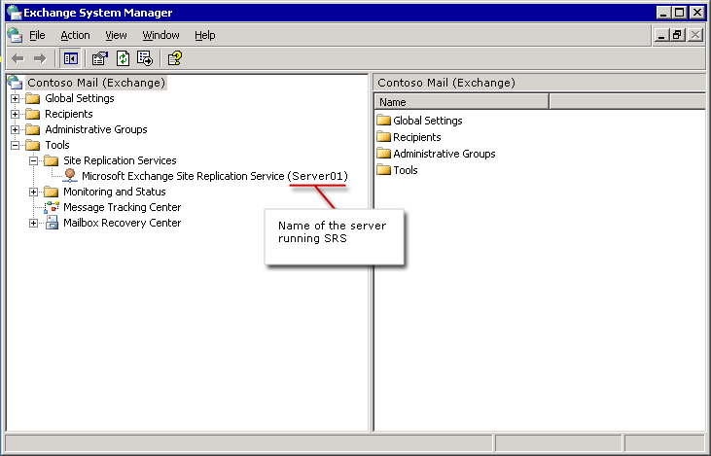

4. On the server that is running the MSExchangeSRS service, click Start, click Run, type services.msc, and then click OK.
5. In Services, in the details pane, double-click Microsoft Exchange Site Replication Service.
6. Click the General tab in Microsoft Exchange Site Replication Service Properties.
7. In the Startup Type box,select Automatic.
8. Stop the MSExchangeSRS service if it is running. On the General tab, click the Stop button to stop the service, and then click Apply.
9. Do not close Microsoft Exchange Site Replication Service Properties.
10. Move any files that exist in the srsdata folder on the server running the MSExchangeSRS service to a temporary location. The original MSExchangeSRS service database files cannot be restored if these files are present.
11. To move the current MSExchangeSRS service files:
a. On the server that is running the MSExchangeSRS service, click Start, point to All Programs, point to Accessories, and then click Windows Explorer.
b. Create a temporary folder to hold the files that you want to move.
c. On the Tools menu, click Folder Options.
d. On the View tab, under Advanced Settings, make sure that the Hide extensions for known file types check box is cleared, and then click OK.
e. Navigate to the srsdata folder. By default, the location for this folder is <drive>:\Program Files\Exchsrvr\srsdata, where <drive> is the location where you installed Exchange Server.
f. Select all existing .edb, .log, or .chk files from the srsdata folder and move them to the temporary folder that you created.
Selecting the MSExchangeSRS service data to move to a temporary folder
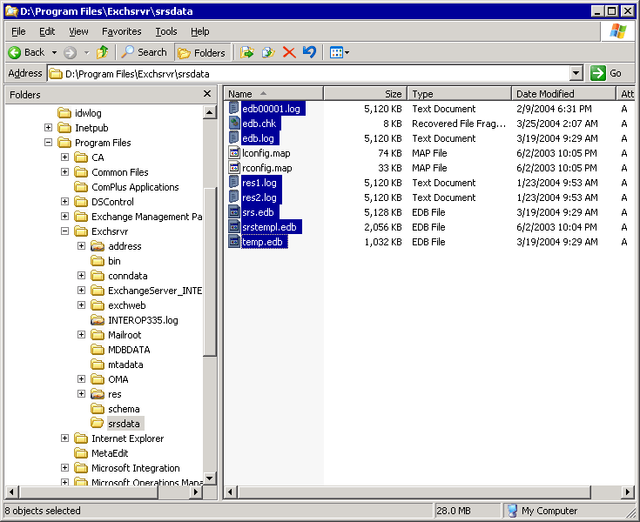

Note:
Although you can choose to delete the files instead of moving them to a temporary location, it is a good idea to keep them. If this restore process fails, you might be able to use the existing files to restore your MSExchangeSRS service data.
12. Start the MSExchangeSRS service: In Microsoft Exchange Site Replication Service Properties, under Service status, click Start.
13. Open Backup in Advanced Mode: Click Start, point to All Programs, point to Accessories, point to System Tools, and then click Backup.
14. Click the Restore and Manage Media tab, and then in the console tree, click the backup media that you want to restore.
If the correct media does not display under File, you might have to rebuild the catalog. For more information about how to rebuild the catalog, see "Rebuilding a Catalog for a Restore" in Using Backup to Restore Your Data.
15. Select the <computer name>\Microsoft Site Replication Service\SRS Storage check box, where <computer name> is the name of your Exchange server that is running the MSExchangeSRS service.
Restoring Exchange SRS data
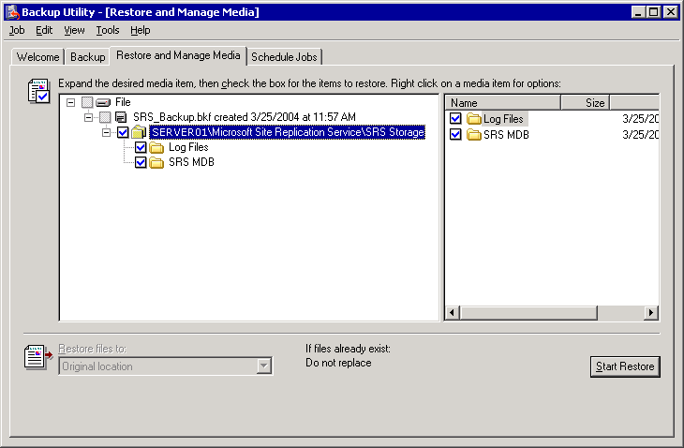

16. In the Restore files to list, select the location to where you want the file to be restored. By default, the location specified is Original Location.
17. Click Start Restore.
18. In Restoring Database Store, in the Restore to box, specify the server that is running the MSExchangeSRS service. The MSExchangeSRS databases will be restored to this server.
Important:
This server must be the server that is running the MSExchangeSRS service.
The Restoring Database Store dialog box
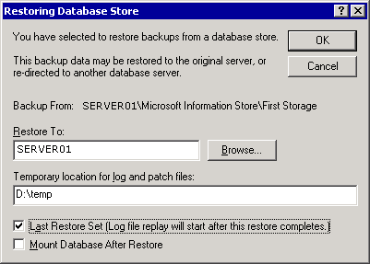

19. In the Temporary location for log and patch files box, specify a directory to store log files during the restore process.
Important:
The directory that you specify in the Temporary location for log and patch files box must not contain the original database or log files or the restore will fail. It is recommended that you create an empty temporary folder for this procedure.
20. Select the Last Restore Set check box only if this is the last backup set that you have to restore.
21. If you want to restore a backup that is part of a series of normal, differential, or incremental backups, leave this check box cleared until you restore the final incremental or differential backup in the series.
Note:
The Mount Database After Restore check box does not affect your MSExchangeSRS service database restore. That control is applicable only to mailbox and public folder store restoration procedures.
22. If Backup prompts you for the location of the backup file to use in the restore, select the correct backup name, and then click OK.
23. After the restore is completed, the Restore Progress dialog box appears. Make sure that the restore was successful. For more information about how to check the success of a restore, see "Checking the Success of a Completed Restore Job" in Using Backup to Restore Your Data.
24. After you verify that the MSExchangeSRS service database backups are successfully restored, in the Restore Progress dialog box, click Close. You are then prompted to restart your computer to complete the restore. Click Yes to restart.
25. Perform any additional steps that your disaster recovery process requires, such as installing Exchange service packs.

For More Information
For more information about restoring Exchange Server 2003, see Restoring Exchange Server 2003.

Restoring the Certification Authority (CA)
The restore method that you use for the certification authority (CA) depends on the type of backups that you performed. For information about the different methods of backing up the CA, see "Backing Up the Certification Authority (CA)."
It is recommended that you restore the CA by restoring the full computer backup set that was created on the computer that is running the CA service. However, if you did not create a full computer backup set of the computer that is running the CA, you can restore the CA by restoring the Windows backup set of the computer that is running Certificate Services (the System State data part of a Windows backup set includes the Certificate Services database). For information about how to restore full computer backup sets and Windows backup sets, see "Restoring Full Computer Backup Sets" and "Restoring Windows Backup Sets."
You can also use the Certification Authority Restore Wizard to restore keys, certificates, and the certificates database. You access this wizard from the Certification Authority MMC snap-in. If you use the Certification Authority MMC snap-in to restore the CA, you must also restore the IIS metabase if it has been damaged or lost.
Note:
If the IIS metabase is not intact, IIS will not start, and Certificate Services Web pages will not load.
You restore the IIS metabase file when you restore a Windows backup set (the System State data part of a Windows backup set includes the IIS metabase). You can also restore the IIS metabase independently by using the IIS snap-in.
Important:
The Certification Authority Restore Wizard in the Certification Authority MMC snap-in requests that you supply a password when you back up public keys, private keys, and CA certificates.
For more information about how to preserve the root certificate, see Exchange 2000 Server Database Recovery. For more information about the Certification Authority Restore Wizard, see "Restore a certification authority from a backup copy."

Restoring Connector-Specific Data
The process that you use to restore connector-specific data (for example Novell GroupWise connector configuration data) depends on the type of connector you are using. For more information about how to back up and restore connectors, see Microsoft Knowledge Base article 328835, "XADM: How to Back Up and Restore Connectors on Exchange 2000." This information applies to Exchange Server 2003.

Restoring Exchange Clusters
The disaster recovery processes for restoring Exchange clusters are similar to the processes for restoring data on stand-alone Exchange servers. However, before you start to perform recovery processes on your clusters, it is helpful to understand how Exchange cluster resources can continue to remain online, even if one of the nodes experiences a failure.
If one of the nodes in a cluster fails (known as a failover event), the Cluster service takes control of the cluster. Following the failover, one of the possible owner nodes for the resource group tries to take control of that group. If all the resources can come online for the new node, that node continues to perform the tasks that were previously performed by the damaged node. If the resources cannot come online for the new node, that node will fail over to the next node. This process continues until all possible owner nodes for that group cannot come online.
Similarly, if one of the resources in an Exchange Virtual Server (EVS) fails, the EVS goes offline. A possible owner node tries to start all the resources for that EVS. If the resources cannot come online for the new node, that new node fails over to the next possible owner node. If all nodes cannot bring the EVS resources online, the resources on that virtual server will be unavailable to Exchange clients until the problem is resolved.
An important difference in disaster recovery processes for Exchange clusters is the task of identifying what caused a particular resource to fail. If a problem occurs, first determine whether the failure is on a single node (which indicates that there are problems with the node's files) or on every node (which indicates that there are problems with the cluster's objects or the shared cluster resources). To determine the cause of the failure, search the event logs in Event Viewer. You can also search for solutions in the Microsoft Knowledge Base.
If you still cannot determine the cause of the failure, you can perform the repair options listed in "Repairing Windows Server 2003" or "Repairing Exchange Server 2003." If you cannot repair the node or the whole cluster, consider replacing the node or recovering the node, cluster, or resources (such as the quorum disk resource or mailbox and public folder stores).
This section provides the following procedural information about restoring Exchange clusters:
• Replacing damaged Exchange cluster nodes.
• Restoring or rebuilding a cluster node from backups.
• Restoring shared disk resources.
• Recovering a whole Exchange cluster.

Replacing Damaged Exchange Cluster Nodes
If one node of a cluster is not functioning correctly, provided there is at least one functioning node in the cluster, you can replace the damaged node with a new node.
Important:
For fault tolerance purposes, repair or replace damaged nodes as soon as possible.
Use one of the following methods to replace a failed node:
• Replace any damaged hardware on the failed node, restore the full computer backup or the Windows backup, and then rejoin the node to the cluster.
• Create a new node by installing your Windows Server 2003 operating system, Exchange, and additional software (such as service packs). Then join the node to the cluster.
Make sure that the hardware in a replacement node is as good or better quality than the hardware in the other nodes of the cluster. The replacement node must have as much RAM and at least as fast a processor as the node it is replacing. The computer NetBIOS (network input/output system) name of the replacement node can be different from the computer name of the failed node, although the replacement node must belong to the same domain.
Make sure to install the same versions of Exchange and your Windows Server 2003 operating system on the new node as that of the rest of the cluster.
Node Creation Checklist

__ | Evict the damaged node from the cluster.
__ | Install your Windows Server 2003 operating system and join the new node to the domain.
__ | Connect the new node to the shared disk resource.
__ | Add the replacement node to the cluster.
__ | Install Exchange on the replacement node.

Evict the Damaged Node from the Cluster
Use the following procedure to evict the damaged node from the cluster. For detailed instructions, see How to Evict a Node from a Cluster.

Install Windows Server 2003 and Join the New Node to the Domain
Install Windows Server 2003, including the service packs, software updates, and other software for your Exchange cluster nodes (such as antivirus software) that matches the versions running on the cluster. You can use any computer name that is not on the network for the new node. Do not install Exchange on the new node yet.
After the operating system is installed and patched, join the replacement node to the same domain as the other nodes in the cluster.

Connect the New Node to the Shared Disk Resource
After you have successfully joined the replacement node to the domain, make sure that the computer has physical access to the cluster's disk resources. Shut down the replacement node and connect the computer to the cluster's disk resource. Then restart the replacement node.
After the new node is running and connected to the shared disk resource, add the replacement node to the cluster.

Add the Replacement Node to the Cluster
Use the following procedure to add the replacement node to the cluster. For detailed instructions, see How to Add a Replacement Node to a Cluster.

Install Exchange on the Replacement Node
Install Exchange Server on the replacement node. Exchange automatically notifies you that the cluster-aware version of Exchange is being installed. (Applications that support the Cluster API are defined as cluster-aware.) After the Exchange Setup program is completed, install any Exchange service packs that are running on the other nodes in the cluster.
For detailed information about how to set up an Exchange cluster, see "Deploying Exchange Server 2003 in a Cluster" in the Exchange Server 2003 Deployment Guide.
Important:
When you run Exchange Setup as part of rebuilding a cluster node, you do not run Exchange Setup with the /disasterrecovery switch. Disaster Recovery mode is not available when the Setup program is running on cluster nodes. The Setup modes available for Exchange clusters are install, change, uninstall, and reinstall.
The reason that you do not use the /disasterrecovery switch is that you do not know which Exchange Virtual Server (EVS) that node might be hosting in the future. Therefore, a specific server's Active Directory data does not have to be recovered and pushed down to the metabase for that node. The server information is kept in the quorum for each EVS. The purpose of running the Exchange Setup program on the cluster node is to install the required Exchange binaries on the node.

How to Evict a Node from a Cluster
This topic explains how to evict a node from a cluster.

Procedure
To evict a node from the cluster
1. Open Cluster Administrator (click Start, point to All Programs, point to Administrative Tools, and then click Cluster Administrator).
2. Choose one of the following methods for connecting to the cluster:
a. Click File, and then click Open Connection.
b. In Open Connection to Cluster, click the cluster that you want to administer in the drop-down list.
Opening a connection to a cluster
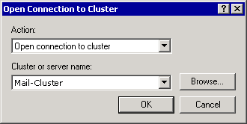

– or –
• In Open Connection to Cluster click Browse, and in the Cluster box, type the NetBIOS name of an active node in the cluster.
– or –
• Open Cluster Administrator on a cluster node and type a period (.) in Cluster or server name.
3. Stop the Cluster service on the node that you want to evict.
To stop the Cluster service, click Start, point to All Programs, point to Administrative Tools, and then click Services. In Services, double-click Cluster Service, and then click Stop. When the Cluster service has stopped successfully, click OK.
4. In Cluster Administrator, right-click the node that you want to evict and select Evict Node.
Note:
After you stop the Cluster service on the node, you can no longer make changes to the cluster. If you are running Cluster Administrator on the node that you want to evict, switch to a different computer to evict the node.
Evicting a node from a cluster
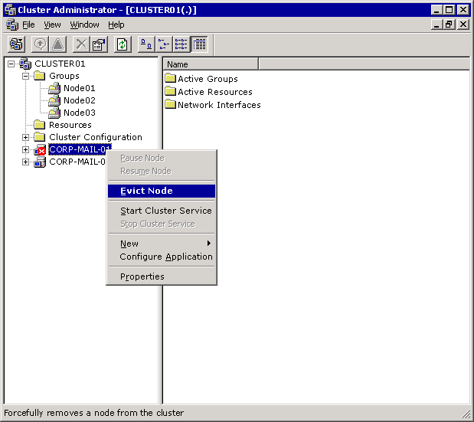

5. Remove the node from the cluster's shared disk resource.

How to Add a Replacement Node to a Cluster
This topic explains how to add a replacement node to a cluster.

Procedure
To add the replacement node to the cluster
1. Open Cluster Administrator: click Start, point to All Programs, point to Administrative Tools, and then click Cluster Administrator.
2. Click File, and then click Open Connection.
3. In Open Connection to Cluster, select Add nodes to cluster from the Action list. Then in Cluster or server name, either type the name of an existing cluster, select a name from the drop-down list box, or click Browse to search for an available cluster.
Adding a new cluster node

4. Click OK to continue.
5. The Add Nodes Wizard appears. Click Next to continue.
6. When the Add Nodes Wizard is completed, click Finish.

Restoring or Rebuilding a Cluster Node from Backups
Another recovery method for replacing a failed node with a new node is restoring or rebuilding a failed node from backup. You would want to restore a node with either a Windows backup or full computer backup if you had special configuration information or dynamic or static data that you wanted to replace from backup to the node instead of having to re-create or reinstall it. It might be a lot of work to prepare a new node for the cluster depending on how your cluster nodes are set up and what applications are installed to them. Consider a strategy that involves restoring a node from backup if it seems easier and makes more sense than creating a new node from scratch. The procedures for restoring or rebuilding a node are the same as the procedures for restoring or rebuilding a stand-alone server. Additionally, to restore or rebuild a failed node, you must have the required backup sets.

Restoring Shared Disk Resources
If the shared disk resources that are used by the groups in the cluster are damaged, you might have to replace the failed hard disk and restore the contents of the lost disk from backups. A cluster server relies on disk signatures to identify and mount volumes. If the disk signature for a shared disk resource changes, it might prevent the Cluster service from starting.
For more information about how to resolve this problem, see Microsoft Knowledge Base article 280425, "Recovering from an Event ID 1034 on a Server Cluster."

Restoring an Exchange Database to a Cluster
If any drives containing database files or transaction log files are lost, you must use your Exchange database backups to recover those drives. To restore a backup of the Exchange cluster node databases, you must perform steps that are similar to the steps for restoring Exchange databases to a stand-alone member server.
The only difference between these processes is that, when you restore the cluster node databases, you use the Network Name resource of the Exchange Virtual Server (EVS) computer instead of the Windows computer name of the cluster node. You must type the Network Name of the EVS in the Restore text box of the backup utility (Backup) in Windows Server 2003. The Network Name of the virtual server is the same name that users use to connect to their EVS that is running in the cluster. If you have the correct permissions, you can back up and restore the Exchange databases of an EVS from any node in the cluster, or from any computer in the domain that is configured to perform Exchange backup and restore procedures. For detailed information about how to restore Exchange databases, see "Restoring Exchange Mailbox or Public Folder Stores."

Restoring a Quorum Disk Resource
The quorum disk resource is a shared disk resource that contains details of all the changes that have been applied to the cluster database. The quorum disk resource is accessible to other cluster resources. Therefore, if one node fails over to another, all cluster nodes have access to the most recent database changes.
If the drive that contains the quorum disk resource is damaged, you can use several methods to restore it.

Exchange Member Server Recovery
The methods for recovering Exchange member servers are detailed in "Member Server Recovery Methods". Because many of the specific procedures are common among the three recovery methods, the procedures are detailed in "Member Server Recovery Procedures."
The methods section provides a brief overview and checklist of the recovery method that you want to use to restore your member servers. If you need specific help on one of the procedures in the checklist, see the procedures section.

Member Server Recovery Methods
This topic discusses the following methods you can use to recover a damaged server running Exchange:
• Restoring an Exchange member server.
• Rebuilding an Exchange member server.
• Using an Exchange standby recovery server.
For detailed information about how to perform the procedures that are listed for each method, see "Member Server Recovery Procedures."

Restoring an Exchange Member Server
Restoring an Exchange member server involves restoring a full computer backup set made from a server running Exchange. A full computer backup set includes a backup of System State data and most of the data on your hard disks. Restoring an Exchange member server requires fewer steps than other server recovery methods.
Restoring Checklist

__ | Move or copy the Exchange database and log files (optional).
__ | Try to repair the damaged member server (optional).
__ | Replace any damaged hardware.
__ | Restore the full computer backup set.
__ | Install service packs and software updates.

Follow these steps if necessary:

__ | Restore the Exchange databases from backup media.
__ | Re-create your full-text indexes.
__ | Try to repair the server again if the restore fails.

Rebuilding an Exchange Member Server
To rebuild an Exchange member server, you must:
• Reinstall your Windows Server 2003 operating system (if you cannot start the server) and other software applications.
• Restore the System State data.
• Run Exchange Setup in disaster recovery mode.
• Restore the Exchange databases.
It takes more time to rebuild a server. However, the resulting operating environment is cleaner than if you were to restore a server from a full computer backup set.
Rebuilding Checklist

__ | Move or copy the Exchange database and log files (optional).
__ | Try to repair the damaged member server (optional).
__ | Replace any damaged hardware.
__ | Install your Windows Server 2003 operating system if you cannot start the server in its current state.
__ | Restore the Windows backup set.
__ | Install service packs and software updates
__ | Install any other applications (not Exchange).
__ | Restore any additional non-Exchange data from backup.
__ | Run Exchange setup in disaster recovery mode.
__ | Install Exchange service packs in disaster recovery mode.
__ | Install Exchange hotfixes.

Follow these steps if necessary:

__ | Restore the Exchange databases from backup media.
__ | Restore MSSearch.
__ | Re-create your full-text indexes.
__ | Try to repair the server again if the restore fails.
__ | Restore Site Replication Service (SRS).
__ | Restore the certification authority (CA).

Using an Exchange Standby Recovery Server
To recover from a disaster using a standby recovery server, you must have one or more spare servers available to replace the damaged server. The spare servers must have hardware and firmware that is the same as the hardware of the server that you are replacing. If a disaster occurs, using standby recovery servers minimizes the downtime that your Exchange organization experiences.
Because servers running Exchange include various types of dynamic data, using the standby server recovery method is not as simple as disconnecting the damaged server and connecting the standby recovery server in its place. For this reason, prepare your standby recovery servers by installing the following:
• The correct version of your Windows Server 2003 operating system.
• Operating system service packs or product updates.
• Software applications (not including Microsoft Exchange Server).
• Software and firmware updates that existed on the damaged server.
Note:
Install your Windows Server 2003 operating system to a workgroup, including both the SMTP and Network News Transfer Protocol (NNTP) IIS components as part of your installation. Additionally, configure the same drive letter and drive space configurations as the server that is running Exchange and that you intend to replace.
Standby Checklist

__ | Move or copy the Exchange database and log files (optional).
__ | Try to repair the damaged member server (optional).
__ | Shut down the damaged server and remove it from the network.
__ | Move the physical hard drives from the damaged server to the standby server.
__ | Connect the standby server to the network.
__ | Restore the Windows backup set.
__ | Install service packs and software updates.
__ | Install any other applications (not Exchange).
__ | Run Exchange Setup in disaster recovery mode.
__ | Install Exchange service packs in disaster recovery mode.
__ | Install Exchange hotfixes.

Follow these steps if necessary:

__ | Restore the Exchange databases from backup media.
__ | Re-create your full-text indexes.
__ | Restore Site Replication Service (SRS).
__ | Restore the certification authority (CA).

Member Server Recovery Procedures
This section explains the details for each procedure listed in "Member Server Recovery Methods."

Move or Copy the Exchange Database and Log Files (Optional)
This procedure applies to the following recovery methods:
• Restoring an Exchange member server.
• Rebuilding an Exchange member server.
• Using an Exchange standby recovery server.
If you can still access the hard disks of the damaged server, and if you have sufficient time, move or copy the Exchange database and transaction log files from that server to a folder on a network share or to a removable storage device. Even if the files are damaged, archive these files as a safety precaution. If the restore process is unsuccessful, you can revert to the original versions, which might be repairable. Moving the files to a folder on the same logical drive is much faster than using the copy command. If you plan to put the damaged database in a location on the same logical drive, use move instead of copy. For detailed instructions, see How to Move or Copy Exchange Database and Log Files.

Repair the Damaged Member Server (Optional)
This procedure applies to the following recovery methods:
• Restoring an Exchange member server.
• Rebuilding an Exchange member server.
• Using an Exchange standby recovery server.
Before trying to recover a member server, consider repairing it instead. You can try to repair your operating system, your Exchange installation, and your Exchange databases. For detailed instructions, see How to Repair a Member Server.

Replace Any Damaged Hardware
This procedure applies to the following recovery methods:
• Restoring an Exchange member server.
• Rebuilding an Exchange member server.
Replace damaged hardware. If you can, make sure that all the replacement hardware in the server that you are rebuilding is the same as hardware that existed in the server that experienced the disaster.

Restore the Full Computer Backup Set
This procedure applies to the following recovery method:
• Restoring an Exchange member server.
Restore the full computer backup set that was performed on the damaged server to the server that you are restoring. To restore these backups, you must be able to start your Windows Server 2003 operating system on the server to which you are restoring your full computer backup set. Use one of the following methods to restore your full computer backup set:
• Use the backup utility (Backup) in Windows Server 2003 to restore your full computer backup set.
For more information about how to restore a full computer backup set, see "Restoring Full Computer Backup Sets."
• Use a Windows disk image to restore your full computer backup set.
If you have a Windows disk image of the server that experienced the disaster, restore the disk image of your Windows Server 2003 operating system, and then start the operating system.

Restore the Exchange Database from Backup Media if Necessary
This procedure applies to the following recovery methods:
• Restoring an Exchange member server.
• Rebuilding an Exchange member server.
• Using an Exchange standby recovery server.
If the drives that contain the Exchange database files and log files were also lost in the disaster, restore the Exchange database backups that were performed on the damaged server to the server that you are restoring. For information about how to restore Exchange databases, see "Recovering an Exchange Database."
Important:
If you were able to move or copy the log files from the damaged server as explained in "Move or Copy the Exchange Database and Log Files (Optional)" earlier in this topic, and these files are not stored on a Storage Area Network (SAN), copy these files to the correct location on the recovery server. If you do not copy the most recent log files to the correct locations on the recovery server, changes that were made to Exchange databases up to the time the disaster occurred are lost.

Re-Create Your Full-Text Indexes
This procedure applies to the following recovery methods:
• Restoring an Exchange member server.
• Rebuilding an Exchange member server.
• Using an Exchange standby recovery server.
If the server that experienced the disaster included any Exchange full-text indexes, you might have to re-create the full-text indexes on the server that you want to restore. For information about how to re-create full-text indexing, see "Repairing Full-Text Indexing."

Try to Repair the Server Again if the Restore Fails
This procedure applies to the following recovery methods:
• Restoring an Exchange member server.
• Rebuilding an Exchange member server.
If the Exchange databases on the restored server cannot mount, try to repair the server again. To repair the server again, use the repair techniques in "Repair the Damaged Member Server (Optional)" earlier in this topic.

Install Windows Server 2003
This procedure applies to the following recovery method:
• Rebuilding an Exchange member server.
Install Windows Server 2003 on the server that you are rebuilding. For detailed instructions, see How to Install Windows Server 2003 When Recovering an Exchange Member Server.

Restore the Windows Backup Set
This procedure applies to the following recovery methods:
• Rebuilding an Exchange member server.
• Using an Exchange standby recovery server.
Restore the Windows backup set that was performed on the damaged server to the server you are rebuilding. Restoring the Windows backup set restores the Windows Server 2003 system files (including the registry database and IIS metabase files). This process also provides the server you are rebuilding with its original NetBIOS name, and returns it to the correct domain. If you do not perform this step, you cannot correctly run the Setup program in Disaster Recovery mode. For more information about how to restore the System State data, see "Restoring Windows Backup Sets."

Install Service Packs and Software Updates
This procedure applies to the following recovery methods:
• Rebuilding an Exchange member server.
• Using an Exchange standby recovery server.
• Restoring an Exchange member server.
Reinstall any software applications or updates that were installed after you created your backup set. These updates include updates to your Windows Server 2003 operating system, Exchange updates, or any other software updates or patches.

Install Any Other Applications That Were Installed on the Damaged Server (Except Exchange)
This procedure applies to the following recovery methods:
• Rebuilding an Exchange member server.
• Using an Exchange standby recovery server.
Install any other applications (other than Exchange) that run on the server.
Note:
Install the applications to the same locations and with the same configurations as the applications that were installed on the damaged server. Include any required service packs or updates.

Restore Any Additional Non-Exchange Data from Backup
This procedure applies to the following recovery method:
• Rebuilding an Exchange member server.
On the server you are rebuilding, restore any additional dynamic data backups that were performed on the damaged server.

Run Exchange Setup in Disaster Recovery Mode
This procedure applies to the following recovery methods:
• Rebuilding an Exchange member server.
• Using an Exchange standby recovery server.
On the server you are rebuilding, run Exchange Setup in disaster recovery mode.
This process installs Exchange applications and any required Exchange files to the server that you are rebuilding. This process also uses the configuration information that is stored on the Exchange Server object in Active Directory to reclaim the configuration of the original server. The configuration information that is reclaimed includes the Exchange storage group names, mailbox store names, public folder store names, virtual server configuration settings, and so on. When you run Exchange in Disaster Recovery mode, make sure that all the components that existed on the damaged server are selected. For detailed steps, see How to Run Exchange in Disaster Recovery Mode.
Important:
When recovering an Exchange server, always use the /disasterrecovery switch. If you run the Setup program without using the /disasterrecovery switch, Setup runs in Reinstall mode and automatically mounts the mailbox stores and public folder stores after the Setup process is completed. If you mount mailbox stores and public folder stores before you restore your Exchange databases, you can cause problems that include the potential loss of data.

Install Exchange Software Updates
This procedure applies to the following recovery methods:
• Rebuilding an Exchange member server.
• Using an Exchange standby recovery server.
Install any Exchange software updates that were running on the damaged server to the new server.

Install Exchange Service Packs in Disaster Recovery Mode
This procedure applies to the following recovery methods:
• Rebuilding an Exchange member server.
• Using an Exchange standby recovery server.
Install the Exchange service pack that was running on the damaged server to the new server. Make sure to install the service pack in disaster recovery mode, using the /disasterrecovery switch. For detailed instructions, see How to Install a Service Pack in Disaster Recovery Mode.
Installing Exchange service packs in Disaster Recovery mode prevents the Exchange databases from being mounted at the end of the service pack installation process. Therefore, you can continue directly to restoring the Exchange databases from a backup.

Restore MSSearch
This procedure applies to the following recovery method:
• Rebuilding an Exchange member server.
When rebuilding an Exchange server, you can experience problems with Microsoft Search (required for full-text indexing). For example, if the Microsoft Search registry keys on the server you are rebuilding are different from the keys that existed on the server at the time that the full-text index was built, Microsoft Search will not function correctly. The registry keys that specify the locations for the full-text indexes will be out of sync (specifically, the registry keys will point to locations that do not exist on the server you have rebuilt).
Make sure to restore MSSearch before you try to build your full-text index.
For information about restoring Microsoft Search, see "Restoring Microsoft Search" in Repairing Full-Text Indexing.

Restore Site Replication Services
This procedure applies to the following recovery methods:
• Rebuilding an Exchange member server.
• Using an Exchange standby recovery server.
If the damaged server was running the MSExchangeSRS service, you must restore the MSExchangeSRS service database to the server you are rebuilding. For more information about how to restore the MSExchangeSRS service database, see "Restoring the Microsoft Exchange Site Replication Service (MSExchangeSRS)."

Restore the Certification Authority
This procedure applies to the following recovery methods:
• Rebuilding an Exchange member server.
• Using an Exchange standby recovery server.
If the damaged server was running the certification authority (CA), you must also restore the CA to the server you are rebuilding. For more information about how to restore the CA, see "Restoring the Certification Authority (CA)."

Move the Physical Hard Drives from the Damaged Server to the Standby Server
This procedure applies to the following recovery method:
• Using an Exchange standby recovery server.
Note:
In a SAN environment, this procedure is unnecessary.
If the physical hard disks of the damaged production server appear to be undamaged, you can remove the disks from the damaged server and install them into the standby recovery server. For detailed instructions, see How to Remove Hard Disks from a Damaged Server and Install Them into a Standby Recovery Server.

Connect the Standby Server to the Network
This procedure applies to the following recovery method:
• Using an Exchange standby recovery server.
Connect the standby recovery server to the network, and then start that computer.
To ensure that your standby recovery server was correctly prepared, verify that the following procedures were performed:
• Hardware was installed that is the same as the original hardware on the damaged server.
• Windows Server 2003 was installed with the following specifications:
• Installed the optional NNTP and SMTP components of Windows Server 2003.
• Installed the computer into a temporary workgroup instead of a domain during Setup.
• Specified that the Setup program create a random computer (NetBIOS) name instead of manually specifying the name of the damaged server.

How to Move or Copy Exchange Database and Log Files
This topic explains how to move or copy Exchange database and log files.

Procedure
To move or copy the Exchange database and log files
1. Determine where on the server the database and log files resided previously. For more information about how to locate these files, see How to Determine the Database and Log File Locations of the Files You Are Restoring.
2. Move or copy these files to another location. For more information about how to move or copy the existing database files, see How to Copy or Move the Existing Versions of the Database Files You Are Restoring.

How to Repair a Member Server
This topic explains how to repair an Exchange member server.

Procedure
To repair your member server
1. Search the Microsoft Knowledge Base for a solution to the problem you are experiencing. Make sure to check the application logs in Event Viewer for any errors that might provide clues as to the cause of the problem.
2. Repair your Windows Server 2003 operating system. For more information about how to repair your operating system, see Repairing Windows Server 2003.
3. Repair your Exchange installation. For more information about how to repair your Exchange installation, see Repairing Exchange Server 2003.
4. Repair your Exchange databases. Do this only as a last resort. Attempting to repair a damaged database can cause data loss. For more information about how to repair Exchange databases, see Repairing Exchange Databases.

How to Install Windows Server 2003 When Recovering an Exchange Member Server
This topic explains how to install Windows Server 2003 when recovering an Exchange member server.

Procedure
To install Windows Server 2003
• Install Windows Server 2003 on the server that you are rebuilding. During Windows Server 2003 Setup, install the operating system with the NNTP and SMTP components, install the computer into a temporary workgroup instead of a domain, and allow Setup to create a random computer name (NetBIOS) instead of manually specifying a name.
– or –
• If you have a Windows Server 2003 disk image of the damaged server, restore that image, and then start the operating system. If the disk image included every Windows Server 2003 service pack and software update that was on the damaged server, you do not have to restore the Windows backup set as described in the section "Rebuilding an Exchange Member Server" in Member Server Recovery Methods.

How to Run Exchange in Disaster Recovery Mode
This topic explains how to run Exchange in Disaster Recovery mode.

Procedure
To run Exchange in Disaster Recovery mode
1. Insert the Microsoft Exchange CD.
2. Click Start, click Run, and then type <drive>:\SETUP\I386\Setup.exe /disasterrecovery, where <drive> is the CD-ROM drive.
3. On the Welcome page, click Next.
4. On the Components Selection page, under Action, make sure that Disaster Recovery is selected for all components that were originally installed .
Running Exchange setup in disaster recovery mode

If any component that was originally installed does not have Disaster Recovery selected, you must manually select them. You also must know which administrative group the server was originally a part of.
Install Exchange to the same drive and directory as it was installed on the damaged server. By default, the Setup program correctly selects this information if you restored a Windows backup set first. Also, make sure that all the drive letters on which databases and log files were kept are available. You can use Exchange System Manager on another Exchange server in the same organization to determine what paths were used for storage group files and database files on the server being recovered.
5. On the Components Summary page, click Next to reinstall Exchange in Disaster Recovery mode.

How to Install a Service Pack in Disaster Recovery Mode
This topic explains how to install a service pack in disaster recovery mode.

Procedure
To install a service pack in disaster recovery mode
• At a command prompt on the computer that you are updating type [path] update.exe /disasterrecovery where [path] is the location of the service pack you are installing.

How to Remove Hard Disks from a Damaged Server and Install Them into a Standby Recovery Server
This topic explains how to remove hard disks from a damaged server and install them into a standby recovery server.

Procedure
To remove the hard disks from a damaged server and install them into a standby recovery server
1. Shut down the server that experienced the disaster.
2. Remove the hard disks from the damaged production server.
3. Replace the hard disks in the standby recovery server with the hard drives from the damaged server.
4. Start the standby recovery server and run Chkdsk on all disk partitions to ensure that there are no problems with the file system. For information about running Chkdsk, see Running the Windows Chkdsk Utility.
Note:
If you verify that the hard disks from the damaged server are not functioning correctly in the standby recovery server, reinstall the standby recovery server's original hard disks.

Advanced Recovery Strategies
Each Microsoft® Exchange 2000 Server and Exchange Server 2003 mailbox must be linked to an Active Directory® directory service user account in order for the mailbox to be accessible to end users. This linking is implemented by setting several Exchange-specific attributes on the Active Directory user account object.
When an administrator uses the Exchange Task Wizard to mailbox-enable a user account, the necessary attributes are added in a two-step process:
1. Several core attributes are immediately set on the user account, including mailNickname, homeMTA, homeMDB, and msExchHomeServerName.
2. To complete the mailbox-enabling process, the Recipient Update Service sets additional attributes based on the recipient policies that apply to the user account.
Active Directory user accounts can also be mailbox-enabled without using the Exchange administrative interfaces. If an administrator sets the mailNickname attribute along with any one or more of the homeMDB, homeMTA, or msExchHomeServer attributes, the Recipient Update Service will configure all other attributes required to fully mailbox-enable the account.
Important:
An Exchange server can host up to 20 Exchange mailbox databases. The homeMDB attribute designates the specific database that hosts a mailbox. If you do not specify the homeMDB attribute, but instead specify either the homeMTA or the homeMDB attribute, then you cannot control which database will be chosen to host the mailbox. The Recipient Update Service will automatically assign the mailbox to a database on the server, which is typically the first database configured on the server.
Administrators can also disable or bypass the Recipient Update Service, and set all Exchange mailbox-enabling attributes manually or with scripts.
For a comprehensive list of mailbox-enabling attributes, see Microsoft Knowledge Base article 296479, "XADM: Requirements for Disabling the Recipient Update Service".
Important:
Prior to Exchange 2000 Server Service Pack 3 with the post-Service Pack 3 rollup for August 2003, the Recipient Update Service did not correctly enable all security attributes for a user account if you enabled the account by directly setting the mailNickname and the homeMDB, homeMTA, or msExchHomeServer attributes, allowing the Recipient Update Service to add the remaining attributes. This situation caused issues with mailbox delegation and access to remote public folder servers.
If you are using a version of Exchange prior to Exchange 2000 Service Pack 3 with the post-Service Pack 3 rollup for August 2003, the supported methods for mailbox-enabling user accounts are:
• The Exchange Task Wizard
• The Collaboration Data Objects for Exchange Management (CDOEXM) APIs
• Disabling the Recipient Update Service and directly setting all attributes, including security attributes, on each user account
Regardless of the Exchange version, direct manipulation of security attributes may require use of scripting interfaces rather than simple modifications of object attributes. If default permissions are not suitable for your purposes, see the following Knowledge Base article and topic in this guide for more information about advanced manipulation of mailbox permissions:
• 304935, "How to set Exchange Server 2000 and 2003 mailbox rights at the time of mailbox creation"
• Detecting and Correcting msExchMasterAccountSid Issues
Not only can you create Exchange mailboxes by directly manipulating Active Directory attributes, you can also delete and re-home them to different databases.
You can delete a mailbox by removing all the Exchange mailbox-enabling attributes from a user object. When you do this, actual mailbox contents previously associated with the user account will not be immediately deleted from the database. Instead, the mailbox will be marked as Disconnected by the Mailbox Cleanup Agent, which runs periodically for each Exchange database. By default, the contents of disconnected mailboxes are hard deleted 30 days after they have been marked Disconnected. Before actual mailbox deletion occurs, it is possible to re-link the mailbox to the same account or to a different Active Directory user account.
It is also possible to re-home a mailbox by changing the values of the homeMDB, homeMTA, and msExchHomeServer attributes for a user object. If you do this, a user’s current mailbox contents are not moved. Instead, another mailbox for the user will be generated in the database location defined by the changed attributes, and the previous mailbox will be marked Disconnected. Re-homing can be done to a different database, a different storage group, or even a different Exchange server in the same administrative group.
Re-homing a mailbox by changing the homeMDB, homeMTA, and msExchHomeServer attributes can have several serious short-term side effects:
• In transit messages may not be delivered, or may be returned to the sender as non-deliverable. Any messages queued on any Exchange server in the same routing group will be returned undeliverable. This situation may be mitigated to some extent by forcing re-categorization of messages on each server that is running Exchange. For more information about re-categorizing messages, see Knowledge Base article 279616, "XCON: Adding a Registry Key to Re-Categorize Messages".
• Client connectivity may be adversely affected. It may be necessary to reboot client workstations before connectivity can be re-established in the new mailbox location, or it may even be necessary to completely regenerate client Microsoft Office Outlook® profiles.
• Latencies in Active Directory and DNS name resolution replication may result in looping messages, loss of messages, non-delivery reports, client connectivity problems, or all of these problems.
• Current mailbox contents will not be re-homed. They will be lost unless you salvage items using ExMerge or another tool, or you move the original database to the new location. For more information about re-homing mailboxes, see Using Active Directory Attributes to Enable, Disable, and Re-Home Mailboxes.
When you use the Move Mailbox tool that is part of Exchange to re-home mailboxes, all of the above problems are avoided. Move Mailbox not only handles the rewriting of Active Directory attributes, but it also interacts with the Exchange database and transport subsystems to correctly re-route mail, move current mailbox contents to the new location, and update client configurations.
Therefore, it is not recommended that you manipulate raw Active Directory attributes to re-home mailboxes as part of your normal administrative processes. Move Mailbox is the recommended tool to use for re-homing Exchange mailboxes. Initial provisioning of mailboxes by setting Active Directory attributes is not subject to the problems listed earlier that occur when re-homing an existing mailbox.
As a best practice in developing an Exchange disaster recovery or site resilience plan, it is recommended that you design the plan to avoid re-homing mailboxes by changing homeMDB, homeMTA, and msExchHomeServer attributes. Re-homing existing mailboxes not only makes it likely that in transit messages will be lost, but it also introduces additional complexity into a recovery plan by requiring updates or reconfiguration of infrastructure services such as routing tables, Active Directory, and DNS.
For more information about designing a disaster recovery or site resilience plan that does not require re-homing mailboxes, see Using Standby Clusters.
For Exchange servers that are not clustered, see Knowledge Base article 822945, "How to move Exchange 2003 to new hardware and keep the same server name". This article discusses use of the /DisasterRecovery setup mode to move an Exchange installation to new hardware while retaining the current Exchange configuration.
There may be unusual circumstances in which the Move Mailbox tool cannot be used. For example, a server may have been destroyed and it becomes necessary to bring users up a different server that is running Exchange.
Important:
Subject to the cautions and limitations described in this topic, re-homing Exchange mailboxes by manipulating raw Active Directory attributes is supported by Microsoft, but it is not recommended as part of normal administrative, operational, or recovery procedures.

What Information Does This Section Provide?
This section covers advanced recovery strategies for servers that are running Microsoft® Exchange, such as:
• Using Active Directory Attributes to Enable, Disable, and Re-Home Mailboxes This set of topics discusses several methods that you can use to enable, disable, and re-home Exchange mailboxes by directly manipulating Active Directory® directory service attributes.
• Moving an Exchange Mailbox Database to Another Server or Storage Group This set of topics discusses how to move mailbox databases between servers that are running Exchange and storage groups, as well as how to re-link each mailbox in the database to an Active Directory user account.
• Detecting and Correcting msExchMasterAccountSid Issues This set of topics discusses how to check for and, if necessary, correct problems with the msExchMasterAccountSid attribute of a user account.
• Using Standby Clusters This set of topics discusses the recovery options for the loss of the entire Exchange cluster, including a standard cluster recovery and using a standby cluster.
You can also use Active Directory Services Interfaces (ADSI) scripting to re-home Exchange mailboxes for recovery purposes. For a sample script that illustrates how to do this, see Sample Script Using ADSI to Re-Home Exchange Mailboxes. For an example of how you might use the Lightweight Directory Access Protocol (LDAP) Data Interchange Format (LDIF) directory export tool (LDIFDE) to re-home mailbox accounts, see How to Re-Home Exchange Mailbox Accounts.

Using Active Directory Attributes to Enable, Disable, and Re-Home Mailboxes
This collection of topics discusses several methods that you can use to enable, disable, and re-home Microsoft® Exchange Server mailboxes by directly manipulating Active Directory® directory service attributes. These topics include:
• Using the Remove Exchange Attributes Task
• Using the Exchange Mailbox Recovery Center
• Understanding Mailbox GUIDs
• Using ADSI Edit to Edit Active Directory Attributes
• Using LDIFDE to Manipulate Mailbox Attributes

For More Information
For more information about moving Exchange mailbox databases, see Moving an Exchange Mailbox Database to Another Server or Storage Group.
For more information about resolving issues with the msExchMasterAccountSid attribute, see Detecting and Correcting msExchMasterAccountSid Issues.

Using the Remove Exchange Attributes Task
Microsoft® Exchange 2000 Server with Service Pack 2 introduced a new task in the Exchange Task Wizard called Remove Exchange Attributes. The functionality of this task is similar to that of the Delete Mailbox task with some important exceptions:
• Remove Exchange Attributes makes no attempt to connect to the server that is running Exchange that is hosting mailboxes for the selected user accounts. Attributes are removed from Active Directory® directory service regardless of the status of the server that is running Exchange. If the server that is running Exchange is down, Remove Exchange Attributes may complete much more quickly than Delete Mailbox would have completed because you do not have to wait for a communication attempt to time out.
• Remove Exchange Attributes deletes the legacyExchangeDN attribute; Delete Mailbox sets the value of legacyExchangeDN to ADCDisabledMail. Deleting the legacyExchangeDN attribute can cause replication issues if there are servers running Exchange Server 5.5 in your Exchange organization.

For More Information
For more information about Remove Exchange Attributes, see Microsoft Knowledge Base article 307350, “XGEN: Using the “Remove Exchange Attributes” Option".
For more information about other methods you can use to enable, disable, and re-home mailboxes, see Using Active Directory Attributes to Enable, Disable, and Re-Home Mailboxes.
For more information about moving Exchange mailbox databases, see Moving an Exchange Mailbox Database to Another Server or Storage Group.

Using the Exchange Mailbox Recovery Center
For each disconnected mailbox in a Microsoft® Exchange Server database, the Mailbox Recovery Wizard suggests a matching Active Directory® directory service user account that is the most likely previous owner of the mailbox. The Mailbox Recovery Center can be useful in cases where you have already used the Remove Exchange Attributes task or the Delete Mailbox task to disconnect multiple mailboxes, and you now want to reconnect the mailboxes to their previous owners.
One scenario where this action may be required is after you restore an Exchange database to a different server or storage group. Because the homeMDB attribute links an Active Directory user account to a specific database in a specific storage group on a specific server, all existing mailboxes in a moved database will be in a disconnected state. The Mailbox Recovery Center can set the appropriate Active Directory attributes to link all disconnected mailboxes to their previous owning accounts.
Important:
Using the Create Mailbox task does not re-link an existing mailbox to an Active Directory account. Instead, a new mailbox will be generated and the previous mailbox will remain in a disconnected state. For more information about this behavior, see Understanding Mailbox GUIDs.
The Mailbox Recovery Center was added to Exchange System Manager in Exchange Server 2003. The Mailbox Recovery Center replaces functionality that was previously available only in the MBConn tool for Exchange 2000 Server. For more information about the MBConn tool, see Microsoft Knowledge Base article 301585, "XADM: Workarounds for Problems with Mbconn.exe".

For More Information
For more information about other methods you can use to enable, disable, and re-home mailboxes, see Using Active Directory Attributes to Enable, Disable, and Re-Home Mailboxes.
For more information about moving Exchange mailbox databases, see Moving an Exchange Mailbox Database to Another Server or Storage Group.

Understanding Mailbox GUIDs
The mailbox globally unique identifier (GUID) is the most fundamental attribute of a Microsoft® Exchange Server mailbox. The value of this attribute is set in the database as the mailbox is created, and it remains the same for the lifetime of the mailbox. The mailbox GUID is designated in the msExchMailboxGUID attribute for each mailbox-enabled Active Directory® directory service account.
In relational database terminology, you can think of the mailbox GUID as the primary key for the mailbox. It is a unique value that distinguishes an individual mailbox from all others. Regardless of which Active Directory user account owns the mailbox, the mailbox GUID always remains the same as long as the mailbox exists.
To explain further, suppose that two different mailboxes in the same database were assigned to two different Active Directory accounts. Each account would have an msExchMailboxGUID attribute corresponding to the appropriate mailbox. If you were to switch the values of the msExchMailboxGUID attributes between the user accounts, you would effectively switch mailboxes between the two users. The next time the users logged on, they would see each others’ mailbox contents.
If you edit the msExchMailboxGUID value, altering it by even a single character, the next time the affected user logs on, a completely new mailbox will be generated, based on the new GUID. In Exchange System Manager, you would see this user as now having two mailboxes. (After a while, the Mailbox Cleanup Agent will run automatically, and the user’s original mailbox will afterward display as disconnected. Therefore, it would be a candidate for purging.) Suppose you were to then return the msExchMailboxGUID to its original value. The next time the user logged on, the original mailbox would again be available, and the new mailbox would become disconnected.

Preserving Mailbox GUID Values After a Database Move
If you move a database to a different server or storage group, and then re-link user accounts to the mailboxes in that database, you must preserve the original mailbox GUID values if you want to connect the users to their previous mailbox contents.
If you use Remove Exchange Attributes to strip all mailbox attributes, and then you use Create Mailbox or you set homeMDB, homeMTA, and msExchHomeServer attributes on users, the result will be that new mailbox GUIDs will be generated. All users will be connected to new mailboxes, and in Exchange System Manager, each user will appear to have both a connected and a disconnected mailbox in the database.
If you do strip all Exchange attributes from a user account, there are two methods you can use to re-link a user account to the mailbox:
• In Exchange System Manager, find the mailbox in the Mailboxes table under the database object. Right-click the mailbox, and then select Reconnect. This action allows you to select an Active Directory user account that is not already mailbox-enabled as the mailbox owner. The account does not necessarily have to be the previous owner. This method allows you to assign a new owner to an existing mailbox.
• Use the Mailbox Recovery Center to automatically match disconnected mailboxes with the user accounts that previously owned them. This facility is very useful when it is necessary to reconnect a large number of mailboxes.
A disconnected mailbox retains some historical data about the last user account connected to it. The Mailbox Recovery Center reads this data and looks for user accounts in Active Directory that match it.
If you re-home a mailbox by changing only the homeMDB, homeMTA, and msExchHomeServer attributes on a user account, then the msExchMailboxGUID attribute will remain intact. One of two things will happen in this case:
• If the database on the new server does not already contain a mailbox with the same GUID, Exchange generates a new mailbox for the user with the same GUID as the old mailbox.
Exchange will not allow two mailboxes with the same GUID to be connected simultaneously to Active Directory accounts. All mailbox GUIDs listed in the entire directory must be unique. If you cause two mailboxes to be generated on different databases with the same mailbox GUID, only one of those mailboxes can be in a connected state at any given time. You will have to disconnect one of the mailboxes before you can connect the other.
Nonetheless, you may generate two mailboxes with the same GUID as part of a “dial tone” recovery scenario. The dial tone strategy assumes that the original database is temporarily unavailable, but that it will eventually be restored. In the interim, a new mailbox is generated in a different location so that users can send and receive mail, even if they do not have access to their previous mailbox contents. After the original database becomes available again, the contents of the dial tone database will be merged with the original database. For more information about the dial tone recovery strategy, see Using Recovery Storage Groups in Exchange Server 2003.
• If the database on the new server does contain a mailbox with the same GUID, the user will be connected to that mailbox.
This behavior means that you can move a database from one server to another server, and reconnect users to their original mailbox contents. For more information about moving databases, see Moving an Exchange Mailbox Database to Another Server or Storage Group.

For More Information
For more information about other methods you can use to enable, disable, and re-home mailboxes, see Using Active Directory Attributes to Enable, Disable, and Re-Home Mailboxes.

Using ADSI Edit to Edit Active Directory Attributes
ADSI Edit (AdsiEdit.msc) is a Microsoft Windows® Server tool that you can use to view and edit raw Active Directory® directory service attributes through the Active Directory Services Interfaces (ADSI) protocol. ADSI Edit is suitable for editing a single object or a small number of objects in Active Directory. ADSI Edit has no search facility. Therefore, you must know in advance the object that you are interested in and its location in Active Directory. Despite these drawbacks, ADSI Edit is a popular tool because it is easier to use than many other tools for making direct edits to Active Directory information.
ADSI Edit is implemented as a snap-in that runs in the Microsoft Management Console (MMC). The name of the default console containing ADSI Edit is AdsiEdit.msc. You can add the snap-in to any .msc file through the Add/Remove Snap-in menu option in the MMC, or you can just open the AdsiEdit.msc file from Windows Explorer.
ADSI Edit will not run unless the adsiedit.dll file is registered. This registration will happen automatically if support tools are installed. However, if the support tool files are copied instead of installed, you must run the regsvr32 command on the adsiedit.dll before you run the adsiedit.msc snap-in.

For More Information
For more information about installing and using ADSI Edit, see Microsoft Knowledge Base article 246926, "Folder Listing of the Support Tools Included in Windows 2000".
For more information about other methods you can use to enable, disable, and re-home mailboxes, see Using Active Directory Attributes to Enable, Disable, and Re-Home Mailboxes.

Using LDIFDE to Manipulate Mailbox Attributes
The Lightweight Directory Access Protocol (LDAP) Data Interchange Format (LDIF) directory export tool (LDIFDE) is installed by default in every Microsoft Windows® Server installation. LDIFDE provides bulk export and import capabilities using the LDIF file format, and it accepts standard LDAP queries for filtering data exported from LDAP directories.
LDIFDE can be used to create, modify, and delete Active Directory® directory service objects from computers running Windows Server™ 2003 or Windows XP Professional. You can also use LDIFDE to extend the schema, export Active Directory user and group information to other applications or services, and populate Active Directory with data from other directory services. Except when creating a new object that does not already exist in the directory, the export and import formats for an LDIF file are significantly different from each other.
LDIFDE can also be used to re-home mailboxes as part of an advanced recovery strategy. For more information about how you can use LDIFDE to re-home mailboxes, see How to Re-Home Exchange Mailbox Accounts. For more information about using LDIFDE to import and export Active Directory objects, see Microsoft Knowledge Base article 237677, "Using LDIFDE to Import and Export Directory Objects to Active Directory".

For More Information
For more information about other methods you can use to enable, disable, and re-home mailboxes, see Using Active Directory Attributes to Enable, Disable, and Re-Home Mailboxes.

Sample Script Using ADSI to Re-Home Exchange Mailboxes
The following sample Microsoft Visual Basic® script can also be used to re-home Exchange mailboxes from one mailbox database to another.
You can copy and paste the following code in a new text file, and then save this file as Rest.vbs in a temporary folder named Restoring. To run this script from a command prompt, go to the Restoring folder, and then run the following command:
cscript rest.vbs
In this example, the script changes the following attributes:
• msExchHomeServerName
• homeMDB
• HomeMTA
You can either enter these three attributes directly, or you can enter this information while the script is running. To enter this information while the script is running, remove the comment line in the script.
'Begin Script

Option Explicit

Dim oRootDSE
Dim strNamingContext
Dim strConfigurationNamingContext
Dim oConnection
Dim oCmd
Dim strADOQuery
Dim strAttributes
Dim strFilter
Dim oRecordSet
Dim oField
Dim usr
Dim UserPath

Dim NewOrganizationName
Dim OldOrganizationName
Dim OldServerName
Dim NewServerName
Dim OldAdminGroupName
Dim NewAdminGroupName
Dim OldStorageGroupName
Dim NewStorageGroupName
Dim OldBaseName
Dim NewBaseName
Dim OldMTAServerName
Dim NewMTAServerName

Dim value
ReDim strArgumentArray(0)
Dim i, iReturnCode
Dim fInteractiveMode, fTrialMode, iSuccessCount, iFailureCount, iRecordCount

fInteractiveMode = False
fTrialMode = False
iSuccessCount = 0
iFailureCount = 0
iRecordCount = 0

For i = 0 to Wscript.arguments.count - 1
ReDim Preserve strArgumentArray(i)
strArgumentArray(i) = Wscript.arguments.item(i)
Next

For i = 0 to Wscript.arguments.count - 1
Select case Left(LCase(strArgumentArray(i)),2)
case "/i"
fInteractiveMode = True
case "/t"
fTrialMode = True
End Select
Next

If fInteractiveMode = False Then

'***********************************************************
'****** Modify this section for your Parameters ************
'***********************************************************

OldOrganizationName = "Contoso Corp"
NewOrganizationName = "Contoso Corp"

OldServerName = "CONTOSO-01"
NewServerName = "CONTOSO-02"

OldAdminGroupName = "First Administrative Group"
NewAdminGroupName = "First Administrative Group"

OldStorageGroupName = "First Storage Group"
NewStorageGroupName = "First Storage Group"

OldBaseName = "Mailbox Store (CONTOSO-01)"
NewBaseName = "Mailbox Store (CONTOSO-02)"

OldMTAServerName = "CONTOSO-01"
NewMTAServerName = "CONTOSO-02"

'*************************************************************
'************** Parameter Section End ************************
'**************************************************************

Trace("You are running in batch mode. The parameters are:")

Else
' Get information
OldOrganizationName = Trim(InputBox("Type the name of the old Exchange Organization : ", "Information"))
NewOrganiZationName = Trim(InputBox("Type the name of the new Exchange Organization : ", "Information"))

OldServerName = Trim(InputBox("Type the name of the old Exchange server : ", "Information"))
NewServerName = Trim(InputBox("Type the name of the new Exchange server : ", "Information"))

OldAdminGroupName = Trim(InputBox("Type the name of the old administrative group : ", "Information"))
NewAdminGroupName = Trim(InputBox("Type the name of the new administrative group : ", "Information"))

OldStorageGroupName = Trim(InputBox("Type the name of the old Storage group : ", "Information"))
NewStorageGroupName = Trim(InputBox("Type the name of the new Storage group : ", "Information"))

OldBaseName = Trim(InputBox("Type the name of the old database name : ", "Information"))
NewBaseName = Trim(InputBox("Type the name of the new database name : ", "Information"))

OldMTAServerName = Trim(InputBox("Type the name of the old MTA Server : ", "Information"))
NewMTAServerName = Trim(InputBox("Type the name of the new MTA Server : ", "Information"))

Trace("Your parameters are:")

End If

'--- Get the Naming Context ----
Set oRootDSE = GetObject("LDAP://RootDSE")
strNamingContext = oRootDSE.Get("defaultNamingContext")
strConfigurationNamingContext = oRootDSE.Get("configurationNamingContext")
Set oRootDSE = Nothing

Trace("Targetted Domain: " & vbTab & strNamingContext)
Trace("Configuration Naming Context: " & vbTab & strConfigurationNamingContext)
Trace("Old Organization Name: " & vbTab & OldOrganizationName)
Trace("New Organization Name: " & vbTab & NewOrganizationName)
Trace("Old Server Name:" & vbTab & OldServerName)
Trace("New Server Name:" & vbTab & NewServerName)
Trace("Old AdminGroup Name:" & vbTab & OldAdminGroupName)
Trace("New AdminGroup Name:" & vbTab & NewAdminGroupName)
Trace("Old Storage Group Name:" & vbTab & OldStorageGroupName)
Trace("New Storage Group Name:" & vbTab & NewStorageGroupName)
Trace("Old Base Name:" & vbTab & OldBaseName)
Trace("New Base Name:" & vbTab & NewBaseName)
Trace("Old MTA Server Name:" & vbTab & OldMTAServerName)
Trace("New MTA Server Name:" & vbTab & NewMTAServerName)

iReturnCode = MsgBox("Is the information correct?", vbYesNo, "Confirmation")
If iReturnCode = vbNo Then
If fInteractiveMode = False Then
MsgBox "Please open the VBScript with a text editor and modify the parameters", vbOKOnly, "Exit"
Trace("Please open the VBScript with a text editor and modify the parameters")
Wscript.Quit 0
End If
End If
If fTrialMode = False Then
iReturnCode = MsgBox("Would you like to perform a trial run of the operation instead of doing a real update?", vbYesNo, "Confirmation")
If iReturnCode = vbYes Then
fTrialMode = True
End If
End If
If fTrialMode = True Then
Trace ("********************************************************")
Trace ("*** You are running in Trial Mode only ***")
Trace ("*** Information in Active Directory will not be updated ***")
Trace ("********************************************************")
End If

' --- Get a filter from the user ---
Trace("")
'strFilter = "(msExchHomeServerName=/o=" + OldOrganizationName + "/ou=" + OldAdminGroupName + "/cn=Configuration/cn=Servers/cn=" + OldServerName + ")"
'Trace("LDAP Filter = " + strFilter)
strFilter = "(homeMDB=" + "CN=" + OldBaseName + ",CN=" + OldStorageGroupName + ",CN=InformationStore,CN=" + OldServerName + ",CN=Servers,CN=" + OldAdminGroupName + ",CN=Administrative Groups,CN=" + OldOrganizationName + ",CN=Microsoft Exchange,CN=Services,"+ strConfigurationNamingContext + ")"
Trace("LDAP Filter = " + strFilter)

' --- Define the attributes to be returned from the query ---
strAttributes = "name,distinguishedName,msExchHomeServerName,homeMDB,homeMTA"

'--- Set up the connection ---
Set oConnection = CreateObject("ADODB.Connection")
Set oCmd = CreateObject("ADODB.Command")
oConnection.Provider = "ADsDSOObject"
oConnection.Open "ADs Provider"
Set oCmd.ActiveConnection = oConnection

'--- Build the query string ---
strADOQuery = "<LDAP://" + strNamingContext + ">;(&(objectCategory=person)(objectClass=user)" + strFilter + ");" + strAttributes + ";subtree"
oCmd.CommandText = strADOQuery
oCmd.Properties("Page Size") = 1000
oCmd.Properties("Timeout") = 1000
oCmd.Properties("Cache Results") = False

'--- Run the query for the user in the directory ---
Set oRecordSet = oCmd.Execute
If oRecordSet.EOF Then
Trace("No Matching Users. Program Aborted")
Wscript.Quit 1
End If

While Not oRecordSet.EOF
Trace("")
Trace("---------------------------------------------------------------------------")
Trace("---------------------------------------------------------------------------")
Trace("---------------------------------------------------------------------------")
Trace("Work to : "+oRecordSet.Fields(0) + vbTab + oRecordSet.Fields(1))
Trace("-----------------------------------------------")
Trace("")
Set usr = GetObject("LDAP://"+oRecordSet.Fields(1))

' Modify msExchHomeServerName attribute
value = usr.Get("msExchHomeServerName")
Trace("OLD msExchHomeServerName = "+value)
Trace("-----------------------")
value = "/o=" + NewOrganizationName + "/ou=" + NewAdminGroupName + "/cn=Configuration/cn=Servers/cn=" + NewServerName
usr.Put "msExchHomeServerName", value
Trace("NEW msExchHomeServerName = "+value)
Trace("-----------------------------------------------")

' Modify homeMDB attribute
value = usr.Get("homeMDB")
Trace("OLD homeMDB = "+value)
Trace("-----------------------")
value = "CN=" + NewBaseName + ",CN=" + NewStorageGroupName + ",CN=InformationStore,CN=" + NewServerName + ",CN=Servers,CN=" + NewAdminGroupName + ",CN=Administrative Groups,CN=" + NewOrganizationName + ",CN=Microsoft Exchange,CN=Services,"+ strConfigurationNamingContext
usr.Put "homeMDB", value
Trace("NEW homeMDB = "+value)
Trace("-----------------------------------------------")

' Modify homeMTA attribute
value = usr.Get("homeMTA")
Trace("OLD homeMTA = "+value)
Trace("-----------------------")
value = "CN=Microsoft MTA,CN=" + NewMTAServerName + ",CN=Servers,CN=" + NewAdminGroupName + ",CN=Administrative Groups,CN=" + NewOrganizationName + ",CN=Microsoft Exchange,CN=Services," + strConfigurationNamingContext
usr.Put "homeMTA", value
Trace("NEW homeMTA = "+value)
Trace("-----------------------------------------------")

On Error Resume Next
If fTrialMode = False Then
usr.SetInfo
If Err.Number Then
Trace("")
Trace("!!!!!!!!!!!!!!!!!!!!!!!!!!!!!!!!!!!!!!!!!!!!!!!!!!!!!!!!!!!!!!!!!!!!!!!!!!!!")
Trace("Error Updating User: " & oRecordSet.Fields(0) & " Reason: " & Err.Description)
Trace("!!!!!!!!!!!!!!!!!!!!!!!!!!!!!!!!!!!!!!!!!!!!!!!!!!!!!!!!!!!!!!!!!!!!!!!!!!!!")
Trace("")
iFailureCount = iFailureCount + 1
Err.Clear
Else
iSuccessCount = iSuccessCount + 1
End If
End If
On Error Goto 0
iRecordCount = iRecordCount + 1
oRecordSet.MoveNext
Wend

' -- Clean up --
oRecordSet.Close
oConnection.Close
Set oField = Nothing
Set oRecordSet = Nothing
Set oCmd = Nothing
Set oConnection = Nothing
Set usr = Nothing

' Provide Summary
Trace ("")
Trace ("************* Summary **************")
If fTrialMode = True Then
Trace ("Running in Trial Mode")
End If
Trace ("Records Found: " & iRecordCount)
Trace ("Successful Update: " & iSuccessCount)
Trace ("Failure Update: " & iFailureCount)

' -------------------------------------------------------
' -------------------------------------------------------
' -------------------------------------------------------
'
' -------------------------------------------------------
' -------------------------------------------------------
' -------------------------------------------------------

Sub Trace(message)
WScript.Echo message
end sub
'End script

For More Information
For more information about the APIs and interfaces available for Exchange administration and development, see the Microsoft Exchange Software Development Kit.
For more information about other methods you can use to enable, disable, and re-home mailboxes, see Using Active Directory Attributes to Enable, Disable, and Re-Home Mailboxes.
For more information about moving Exchange mailbox databases, see Moving an Exchange Mailbox Database to Another Server or Storage Group.

How to Re-Home Exchange Mailbox Accounts
This topic provides an example of how you might use the Lightweight Directory Access Protocol Data Interchange Format directory export tool (LDIFDE) to re-home all mailbox accounts on one server to a different server.
Note:
For more information about LDIFDE, see the topic Using LDIFDE to Manipulate Mailbox Attributes.
The following table provides values related to the example. All of these values are in a single unbroken line, although they may appear wrapped on your display.
Values of attributes used in example of re-homing mailbox values
Attribute | Value
Active Directory® directory service domain name where all user accounts are located | contoso.com
Source database | DB1
Source storage group | SG1
Source server | Exchange1
Microsoft® Exchange organization | Organization
Destination database | DB2
Destination storage group | SG2
Destination server | Exchange2
LDAP name of the domain | DC=contoso,DC=com
Source server msExchHomeServerName | /o=Organization/ou=AG1/cn=Configuration/cn=Servers/cn=Exchange1
Source server homeMTA | CN=Microsoft MTA,CN=Exchange1,CN=Servers,CN=AG1,CN=Administrative Groups,CN=Organization,CN=Microsoft Exchange,CN=Services,CN=Configuration,DC=contoso,DC=com
Source database homeMDB | CN=DB1,CN=SG1,CN=InformationStore,CN=Exchange1,CN=Servers,CN=AG1,CN=Administrative Groups,CN=Organization,CN=Microsoft Exchange,CN=Services,CN=Configuration,DC=contoso,DC=com

Before You Begin
This example assumes that you are generally familiar with Active Directory object naming and hierarchical organization and with general LDAP object and attribute naming conventions.

Procedure

To re-home mailbox accounts from Exchange1 to Exchange2
1. Export the user accounts with this LDIFDE command:
LDIFDE –F [output file] –D [domain and/or container name] –L [attributes to export] –R [LDAP query filter for the database]
For example:
LDIFDE –F EXPORT-EXCHANGE1.TXT –D “DC=contoso,DC=com” –L msExchHomeServerName,homeMDB,homeMTA –R “(homeMDB=CN=DB1,CN=SG1,CN=InformationStore,CN=Exchange1,CN=Servers,CN=AG1,CN=Administrative Groups,CN=Organization,CN=Microsoft Exchange,CN=Services,CN=Configuration,DC=contoso,DC=com)”
This command exports all the user accounts linked to mailboxes in DB1, with each export record appearing similar to this one:
Note:
In the examples below, several lines are formatted with an attribute name on one line followed by value names that are indented a single space and split into multiple lines. This is the LDIF convention for continuing an attribute value across a line break.
dn: CN=User1,CN=Users,DC=contoso,DC=com
changetype: add
homeMTA:
CN=Microsoft MTA,CN=Exchange1,CN=Servers,CN=AG1,CN=Administr
ative Groups,CN=Organization,CN=Microsoft Exchange,CN=Services,CN
=Configuration,DC=contoso,DC=com
homeMDB:
CN=DB1,CN=SG1,CN=InformationStore,CN=Exchange1,CN=Servers,C
N=AG1,CN=Administrative Groups,CN=Organization,CN=Microsoft Ex
change,CN=Services,CN=Configuration,DC=contoso,DC=com
msExchHomeServerName:
/o=Organization/ou=AG1/cn=Configuration/cn=Servers/cn=Exchange1
2. Reformat each record in the export file so that it can be used to modify each user account. The general format of such an import file is:
dn: <value>
changetype: modify
replace: <attribute name>
<attribute name>: <value>
-
Replace: <attribute name>
<attribute name>: <value>
-

#<blank line>
#<next record>

For example:
dn: CN=User1,CN=Users,DC=contoso,DC=com
changetype: modify
replace: homeMTA
homeMTA:
CN=Microsoft MTA,CN=Exchange1,CN=Servers,CN=AG1,CN=Administr
ative Groups,CN=Organization,CN=Microsoft Exchange,CN=Services,CN
=Configuration,DC=contoso,DC=com
-
replace: homeMDB
homeMDB:
CN=DB1,CN=SG1,CN=InformationStore,CN=Exchange1,CN=Servers,CN=
AG1,CN=Administrative Groups,CN=Organization,CN=Microsoft Exchange
,CN=Services,CN=Configuration,DC=contoso,DC=com
-
replace: msExchHomeServerName
msExchHomeServerName:
/o=Organization/ou=AG1/cn=Configuration/cn=Servers/cn=Exchange1
-
Dn: CN=User2,CN=Users,DC=contoso,DC=com
changetype: modify
<and so on……>
If you have a text editor that can perform a search and replace across line breaks, it is relatively easy to transform the export file into the appropriate import format. For example, you can do this in Microsoft Office® Word, where ^p is the Word search, and replace code for a line break:

Search for | Replace with
dn: | -^pdn:
changetype: add | changetype: modify
homeMTA | replace: homeMTA^phomeMTA
homeMDB | -^preplace: homeMDB^phomeMDB
msExchHomeServerName | -^preplace: msExchHomeServerName
[name of original database] | [name of new database]
[name of original storage group] | [name of new storage group]
[name of original server] | [name of new server]

After you have finished the replacements, remove the blank line and “-‘ from the top of the file before the first record, and add a “-“ and a blank line to the end of the last record.
If you are using Microsoft Word or another rich text editor, be sure to save the file as plain text. You should save the file under a new name, such as EXCHANGE2-IMPORT.TXT, so that the original export file is preserved if additional editing is required.
3. Import the file with this command:
LDIFDE –I – F <import file>
For example:
LDIFDE –I –F EXCHANGE2-IMPORT.TXT
Important:
Do not re-home mailboxes for SMTP connectors, the System Attendant, or the System Mailbox. Remove the LDIF records for these mailbox types in your import file before you import again. Search for “SMTP”, “SystemMailbox”, and “System Attendant” to locate these mailboxes.

For More Information
For more information about other methods you can use to enable, disable, and re-home mailboxes, see Using Active Directory Attributes to Enable, Disable, and Re-Home Mailboxes.

Moving an Exchange Mailbox Database to Another Server or Storage Group
Microsoft® Exchange Server mailbox databases are portable between servers that are running the same version of Exchange and that are in the same administrative group. A mailbox database created on one server in an administrative group can be renamed or copied to a different storage group on the same server or to a different server in the same administrative group. After this renaming or copying has been done, the links between user accounts and mailboxes must be reconfigured.
Moving entire mailbox databases to accomplish normal administrative tasks is not recommended. The Move Mailbox task is the recommended method for transferring mailboxes to different databases.
Move Mailbox can be done without database downtime and with minimal interruption to end user service. During a Move Mailbox operation, all end users are allowed full mail access except for the mailbox that is currently being moved. For more information about the Move Mailbox process, see Microsoft Knowledge Base article 821829, "Moving mailboxes in Exchange Server 2003".
In addition to the traditional move mailbox process, you also can move entire mailbox databases between servers or storage groups. After you move a mailbox database, you must re-link each mailbox in the database to an Active Directory® directory service user account before the mailbox will be accessible to an end user. For more information about re-linking mailboxes back to user accounts, see Using Active Directory Attributes to Enable, Disable, and Re-Home Mailboxes and How to Re-Home Exchange Mailbox Accounts.
Special limitations also apply for mailbox databases that host the System Attendant mailbox. For more information about the System Attendant mailbox, see Issues with the System Attendant Mailbox When Moving an Exchange Mailbox Database.

Creating and Replicating Public Folder Databases
This topic only covers moving mailbox databases. You should not move public folder databases between servers that are running Exchange. Microsoft does not support moving public folder databases between Exchange servers in the same Active Directory forest. Public folder databases replicate with each other, and moving databases to different servers can disrupt replication. Instead of moving a public folder database between servers, it is recommended that you create a new public folder database on a different server and then replicate folders to it.
Caution:
If you want to move a public folder database to a laboratory server for test or data salvage purposes, you must never bring that database up again in the Exchange production forest, even on its original server. Running a public folder database in a different Exchange organization will cause it to gain knowledge of the system folders of that organization. When returned to the original organization, the folders in this database may conflict with the original organization’s system folders. This conflict may destroy the original system folders and force you to reset them. If this happens, you will have to reset and rebuild the calendar free/busy information and the offline address books for your entire organization.
For more information about replicating public folder content between servers, see the following Knowledge Base articles:
• 822444, "How to reset system folders in Exchange Server 2003"
• 275171, "XADM: How to Reset System Folders on an Exchange 2000 Server"
• 326637, "Resolve problems that are caused by duplicate free/busy folders and Offline Address Book folders on an Exchange Server 5.5 site"
• 152960, "Reassigning site roles after removing the first server in an Exchange site"

Disaster Recovery and Mailbox Database Portability
The mailbox database portability capabilities of Exchange may also be useful when designing a site resilience disaster recovery plan. In a site recovery scenario, the fundamental assumption is that an entire server that is running Exchange or even an entire geographical site has gone offline and will be offline for a prolonged period. Therefore, you must bring up Exchange resources on new hardware and in a new location.
As a best practice, your plan should be designed to avoid re-homing mailboxes during a disaster. If possible, you should restore or copy databases to new physical systems that retain the original Exchange installation configuration.
For more information about designing a disaster recovery or site resilience plan that does not require re-homing mailboxes, see How to Move All Exchange Virtual Servers from a Production Exchange 2003 Cluster to a Standby Exchange 2003 Cluster.
For Exchange servers that are not clustered, see Knowledge Base article 822945,"How to move Exchange 2003 to new hardware and keep the same server name." This article discusses use of the /DisasterRecovery setup mode to move an Exchange installation to new hardware while retaining the current Exchange installation configuration.

Moving Exchange Mailbox Databases Between Servers
When an Exchange mailbox database is created, naming information is written into it that identifies the database as a member of a particular Exchange organization and administrative group. The database can only be mounted on servers running Exchange that have been installed with the same organization and administrative group names.
However, an Exchange mailbox database is not tied to the server or storage group in which it was created. It can be transferred to any Exchange server that shares the same organization and administrative group names and is of the same major version and service pack revision or is of a higher version that is compatible with the original server.
Note:
If you move a database to a different location by using an online backup, it will be necessary to configure the destination server with the same storage group and logical database names as on the original server. This requirement is a demand of the backup API, not inherent in the database itself. This requirement is explained in detail in Method 1 below.
However, after mounting a database on an up-level server, it is not possible to move the database back to a down-level server. Therefore, you should match server versions and patch levels exactly when moving databases, or treat the move as a one-way operation. Exchange 2000 Service Pack 3 databases are mountable on any server running Exchange 2000 Server or Exchange Server 2003 with a version level equal to or higher than the original server.
As viewed in Exchange System Manager, each Exchange 2000 Server or Exchange Server 2003 mailbox database is hosted in a storage group on a particular server. The database has a logical name that corresponds to an Active Directory database object. The database is composed of two physical files, which are a database file (.edb file) and an accompanying streaming database file (.stm file). You can view the path to these files and the filenames on the Database properties page of each database object.
There are three methods for moving Exchange databases to different storage groups or servers:
• Restore an Exchange-aware online streaming backup of the database, redirecting the restore location to a different server For this method to work, the new server must be configured with a storage group and logical database whose names are identical to those on the original server.
For example, you make an online backup of a database with the logical name “Mailbox Store (Server A)” in storage group “Server-A-SG1” on Server A. You may then create a storage group called “Server-A-SG1” on Server B, and then create a database in that storage group called “Mailbox Store (Server A).”
You restore the online backup, changing the restore location to Server B, and the backup will be restored to the matching storage group and logical database names on Server B.
• Restore an Exchange-aware online Volume Shadow Copy Service (VSS) backup of the database Exact methods for doing this will vary depending on vendor capabilities and limitations in restoring database files to other than their original locations. Consult with your backup vendor for specific instructions.
• Copy Exchange database files from the current path location to the path location for a different logical database, storage group, or server If you use this method, the logical storage group and database names do not have to match, but the database filenames must match those defined in the destination. You may rename database files as necessary to make them match.
For example, database files named “Priv1.edb” and “Priv1.stm” are associated with the logical database “Mailbox Store (Server A)” in storage group “Server-A-SG1” on Server A. You create a Storage Group called “Server-B-SG1 on Server B, and create a database called “SG1-MB1” in that storage group. The file paths listed for the SG1-MB1 database are “F:\Databases\SG1-MB1.edb” and “F:\Databases\SG1-MB1.stm.”
You copy Priv1.edb and Priv1.stm from D:\Databases on Server A to F:\Databases on Server B. You then rename Priv1.edb to SG1-MB1.edb and rename Priv1.stm to SG1-MB1.edb.
When performing the procedures described in this topic, it is recommended that you consider the following:
• When restoring or copying a database to a different location, it may be necessary to select the check box for This database can be overwritten by a restore before you can restore the database from online backup or before the database can be mounted. This checkbox is located on the Database properties page for the logical database object. If you are unable to restore or mount a moved database because of this reason, the problem will be logged in the server’s application log.
• Before copying database files to another location, you should ensure that they are in a consistent or clean shutdown state. For more information about these states, see the “Database States” section of Knowledge Base article 240145, "How to remove Exchange Server transaction log files."
It may also be possible to replay additional transaction logs into a database before or after it is copied or restored to an alternate location. For more information, see Issues with Transaction Log Files When Moving an Exchange Mailbox Database.
• Before starting the move process, stop the destination database, remove the existing database files and mark the database to not start automatically. This will prevent the database from inadvertently coming online during the move process.
• When moving databases to an alternate location, in-transit mail may become undeliverable or become lost. To minimize the effects of this problem, you should link user accounts to the new database location as early as possible in the move process. You can do this before shutting down or moving the original database. Doing so will prevent client access to all mailboxes in the database until the move process has completed. For more information about this, see Using Active Directory Attributes to Enable, Disable, and Re-Home Mailboxes.
• Exchange generates several different mailboxes for performing various system functions, including SMTP, System, and System Attendant mailboxes. After moving a database to a new location, there may be “leftover” mailboxes for these functions in the database. The Mailbox Cleanup Agent will eventually disconnect these mailboxes, and they will be purged 30 days later by default. It is not necessary to manually disconnect or purge these mailboxes.
• As a best practice, you should reboot an Exchange server as soon as is feasible after completing a database move. Core client connectivity and mail delivery functions will work without requiring a reboot, but other system functions and third-party applications may require it.

For More Information
For information about the interaction of Move Mailbox and the mailbox tombstone table, see Move Mailbox Operations and the Mailbox Tombstone Table.
For more information about methods you can use to enable, disable, and re-home mailboxes, see Using Active Directory Attributes to Enable, Disable, and Re-Home Mailboxes.

Issues with Transaction Log Files When Moving an Exchange Mailbox Database
Each Microsoft® Exchange database is associated with a transaction log file stream. All databases in a storage group share the same transaction log file stream. A database can be detached from one transaction log file stream and attached to a different stream. This change is what happens when you move a database from one storage group to another one.
While database files are in dirty shutdown state, they are still attached to the storage group log stream. Therefore, to move a database to a new storage group and log stream, you must first ensure that the database files are in clean shutdown state.
You cannot mix transaction logs from different streams in the same storage group. Therefore, when moving databases, you should leave behind the original transaction log files and transfer only clean shutdown database files.
When feasible, any transaction log replay should be done on the original server before files are moved. If it is necessary to move database files to different logical drive and folder paths than on the original server, you must run Exchange 2000 Server Service Pack 3 or later on the destination server.
The version of Exchange Server Database Utilities (Eseutil.exe) that comes with Exchange 2000 Server Service Pack 3 introduced the /D switch for soft recovery. This switch allows an administrator to override the database paths defined in each transaction log file.
Prior to this service pack, transaction log replay with Eseutil.exe required database files to be in the same logical path location as they were when the transaction logs were generated. This requirement was because the transaction logs store the location of the databases they belong to and expect the databases to be in the stored path.
For example, if databases are in C:\Databases at the time a series of transaction logs is generated, and you later move the databases to D:\Databases, then subsequent transaction log replay will result in a “File not found” error. (The transaction log replay process will still read all logs and finish, but no data will actually be applied to any database for which a “File not found” error is reported.)
The Exchange 2000 Service Pack 3 version of Eseutil.exe provides a new transaction log replay switch that allows an administrator to override the database path written in the transaction log files. Thus, transaction log replay can succeed regardless of the current location of the database files.
To use this new Eseutil.exe functionality, follow these steps:
1. Copy the databases to be recovered and all transaction log files to be replayed into a single folder together.
2. Open a command window, and then set the default directory to the folder that contains all the database and transaction log files.
3. Run the following command:
C:\Program Files\Exchsrvr\Bin\Eseutil.exe /R Enn /D
Note:
You should substitute the log prefix for the storage group for Enn in the above command. The log prefix is the first three characters of the transaction log filenames for the storage group. For example:
C:\Program Files\Exchsrvr\Bin\Eseutil.exe /R E00 /D
Running this Eseutil command from the folder that contains both the databases and transaction log files allows you to simplify the command line by omitting full path specifications and additional command line parameters. Running Eseutil in this way is strongly recommended. Refer to Eseutil documentation for more information about advanced command line parameters.
Note:
It may be necessary to add the /I switch to the command line if you are not recovering all databases in a storage group simultaneously. The /I switch instructs Eseutil.exe to ignore missing database files during recovery. For example: C:\Program Files\Exchsrvr\Bin\Eseutil.exe” /R E00 /I /D

For More Information
For more information about moving Exchange mailbox databases, see Moving an Exchange Mailbox Database to Another Server or Storage Group.
For more information about issues with the System Attendant mailbox when moving Exchange mailbox databases, see Issues with the System Attendant Mailbox When Moving an Exchange Mailbox Database.

Issues with the System Attendant Mailbox When Moving an Exchange Mailbox Database
Each server that is running Microsoft® Exchange has a single system attendant mailbox. This mailbox is created in the first database configured on the server. The system attendant mailbox is required for multiple tasks. These include, but are not limited to:
• Processing server monitor messages
• Updating free/busy calendar information for Microsoft Office® Outlook Web Access users
• Processing Mailbox Manager notifications
• Moving mailboxes to other databases
If the system attendant mailbox is inaccessible, a server running Exchange continues to run and perform basic mail processing. However, many system features and tasks will not function correctly.
The system attendant mailbox for each server is unique and is not interchangeable with the system attendant mailbox on other servers. You cannot move the system attendant mailbox for one server to a different server. If you move the database files that contain the system attendant mailbox from one server that is running Exchange to a different server, this action will disconnect the system attendant mailbox and add it permanently to the mailbox tombstone table. If you were to then move the database back to the original server, the original system attendant mailbox could not be re-created in that database. Instead, the following error will appear frequently in the application log:

Event Type: | Error
Event Source: | MSExchangeIS Mailbox Store
Event Category: | Logons
Event ID: | 1022
Description: | Logon Failure on database "DATABASE_NAME" - Windows 2000 account NT AUTHORITY\SYSTEM; mailbox /o=Microsoft/ou=First Administrative Group/cn=Configuration/cn=Servers/cn=EXCHANGE_SERVER/cn=Microsoft System Attendant.
Error: | 1292

This error is equivalent to error 0x50c, ecMailboxInTransit, which is the error generated when a delivery attempt is made for a mailbox that is listed inside a database’s mailbox tombstone table. Mailboxes listed in the tombstone table cannot be created or reconnected to Active Directory® directory service objects. For more information about the behavior of mailboxes when they are inside a tombstone table, see Move Mailbox Operations and the Mailbox Tombstone Table.

Scenarios Related to System Attendant Mailbox Generation
The following scenarios describe the circumstances under which the system attendant mailbox can and cannot be generated in a database.
Scenario 1
Server Exchange1 hosts Database1, which contains the system attendant mailbox. Server Exchange2 hosts Database2, which contains the system attendant mailbox for Exchange2.
You swap the database files for Database1 and Database2 between Exchange1 and Exchange2. After the databases have been mounted in their new locations, the following two things happen after several minutes, but not necessarily in the order listed:
• The Mailbox Cleanup Agent, which runs automatically and periodically for each Exchange database, will mark the previously existing System Attendant mailbox in each database as Disconnected. This designation is made because the mailbox no longer matches the server running Exchange on which each database is running. When this mailbox is marked as Disconnected, it is added to the mailbox tombstone table for the database. This addition prevents any possibility that the mailbox could be enabled or connected to the system attendant on the wrong server.
• A system attendant task will run that requires delivery of a message to the system attendant mailbox, and this task will create a new system attendant mailbox that matches the system attendant mailbox that is on the current server that is running Exchange.
Creation of an Exchange mailbox is a two-stage process. In the first stage, an Active Directory object is assigned ownership of a mailbox when you set appropriate mailbox-enabling attributes on that object. In the second stage, the first client logon or message delivery attempt to the mailbox causes space in the database to be allocated, and the mailbox is then actually created in the database.
The second stage will fail if a mailbox is already listed in a database’s mailbox tombstone table. However, in this scenario, creation of a new system attendant mailbox succeeds because neither database has ever hosted a system attendant mailbox for the current server. The databases have only hosted system attendant mailboxes for their previous servers, and each system attendant mailbox is unique to an individual server.
Scenario 2
Continuing from Scenario 1, you swap the database files back, putting the files for Database1 back on Exchange1 and the files for Database2 back on Exchange2. After you mount the databases, the following two things will happen, but not necessarily in the order listed:
• The Mailbox Cleanup Agent will mark the previously existing System Attendant mailbox in each database as Disconnected, and the mailbox will be added to the mailbox tombstone table. There are now two System Attendant mailboxes listed on the tombstone table for each database.
Addition of a system attendant mailbox to a mailbox tombstone table is permanent. Neither of these databases can ever be used again to host a system attendant mailbox for either of these servers. However, either database could be transferred to a third Exchange server, and could host that server’s system attendant mailbox.
• A system attendant task will run that requires delivery of a message to the system attendant mailbox. The server will be unable to connect or create a system attendant mailbox for delivery of this message because of the tombstone table entry. Therefore, delivery will fail, and errors will be logged in the application log each time the server tries to create the system attendant mailbox.
Scenario 3
Continuing from Scenario 2, you re-enable the system attendant mailbox for server Exchange1 by doing this:
• Relocate the tombstoned database to another storage group or database location on Exchange1. A single database per server is designated to host the system attendant mailbox. Thus, even if a database contains tombstoned system attendant mailboxes, it can be mounted and run in any storage group or database location except the one that is designated to host the system attendant mailbox. Typically, the first database configured on a server is the system attendant mailbox database.
• Mount the system attendant mailbox database with no database files present. This action will force generation of new database files that do not contain the system attendant mailbox in the mailbox tombstone table. The system attendant mailbox will be automatically created the first time message delivery is attempted to it.
When moving mailbox databases between servers, it is recommended that you consider the following:
• You cannot use Move Mailbox to recover from a disabled system attendant mailbox. This restriction is because a functioning system attendant mailbox is required on both source and destination servers that are running Exchange for the Move Mailbox task to work.
• Purging a disconnected system attendant mailbox from a database will not allow the mailbox to be re-created. Even after the physical mailbox has been purged, the mailbox tombstone entry will remain and will prevent re-creation of the mailbox.
• If you move a system attendant mailbox database to a different database or storage group location on the same server, the mailbox will not be added to the tombstone table. However, the Mailbox Cleanup Agent will run and disconnect the mailbox, and the mailbox may even be purged. It is possible, however, to move the database back to its original location and the mailbox will be re-created or re-connected automatically.
• It is possible to change the database that hosts the system attendant mailbox. If you use Exchange System Manager to completely delete the system attendant mailbox database object, Exchange will automatically designate one of the other databases on the server to host the system attendant mailbox. You cannot control the assignment of the new database unless there are only two databases configured on the server.
• You cannot mount two copies of the same physical database in the same storage group simultaneously. Exchange will fail to mount one of the databases with error -1222, JET_errDatabaseSignInUse. This error indicates a collision of database signatures. If two databases sharing the same signature were allowed to be mounted against the same set of transaction logs, transaction log replay would become impossible.

For More Information
For more information about moving Exchange mailbox databases, see Moving an Exchange Mailbox Database to Another Server or Storage Group.
For more information about issues with transaction log files when moving Exchange mailbox databases, see Issues with Transaction Log Files When Moving an Exchange Mailbox Database.

Move Mailbox Operations and the Mailbox Tombstone Table
Microsoft® Exchange Server 2003 and Exchange 2000 Server use the Active Directory® directory service to store configuration and user information. Typically, most of this information is stored on a server separate from the server that is running Exchange, and the server that is running Exchange may use any of several Active Directory servers to read and write configuration changes.
Therefore, during a Move Mailbox operation, it is possible that source and destination servers that are running Exchange will read from or write to multiple Active Directory servers, and that it will take some time for Active Directory servers to fully synchronize with each other. This possibility can lead to situations in which mail delivery occurs to the source server instead of to the destination server during or after a mailbox move.
To handle this problem, the source Exchange database lists a moved mailbox on its mailbox tombstone table. This table is independent of any Active Directory information. If a message is delivered to the source server after a mailbox has been moved, the source server recognizes that, regardless of the information stored in Active Directory, the message should not be delivered here and reroutes the message. The error ecMailboxInTransit is returned when a delivery attempt is made, and the server then tries to reroute the message instead of delivering it locally.
If you use the Move Mailbox task to move a mailbox back to a server on which it was previously homed, the Move Mailbox task will clear the mailbox tombstone entry so that the move can succeed.
When a database is moved to a different server, the Mailbox Cleanup Agent will mark all mailboxes in the database as Disconnected. In addition, for the system attendant mailbox only, the Mailbox Cleanup Agent makes an entry in the mailbox tombstone table. This prevents a system attendant mailbox from one server from being activated on a different server.
However, this safeguard means that the database cannot be used again on the previous server to host the system attendant mailbox. This situation exists because there is no provision for removing the system attendant mailbox from the tombstone list. Move Mailbox does not apply to system attendant mailboxes. Because the mailbox tombstone table is not replicated or known in Active Directory, but is limited to a specific physical database, you can re-enable the system attendant mailbox by putting in place a physical database that has never had a tombstone entry for that system attendant mailbox.

For More Information
For more information about the System Attendant mailbox, see Issues with the System Attendant Mailbox When Moving an Exchange Mailbox Database.
For more information about moving Exchange mailbox databases, see Moving an Exchange Mailbox Database to Another Server or Storage Group.

Detecting and Correcting msExchMasterAccountSid Issues
A mailbox that is on a server that is running Microsoft® Exchange Server 2003 or Exchange 2000 Server must be linked to an Active Directory® directory service user account to be accessible. This link is accomplished by setting several Active Directory attributes on the mailbox. The Active Directory account to which the Exchange mailbox is linked can be in either an enabled or disabled state. A disabled Active Directory user account cannot be used to log on to the Active Directory domain.
The most common reason for linking an Exchange mailbox to a disabled Active Directory user account is to link a mailbox in one Active Directory forest to a Microsoft Windows® NT or Active Directory account outside the forest. You cannot directly associate a mailbox in one Active Directory forest with an external user account. Therefore, a disabled user account is used to accomplish this task indirectly. This is done by accomplishing the following tasks, not necessarily in the order listed:
• Mailbox-enable an Active Directory account (Account A) in the same Active Directory forest as the server that is running Exchange.
• Disable Active Directory Account A for logon. Only disabled accounts should be used for assigning a mailbox to an external-owning account.
• Grant the Full Mailbox Access and Read Permissions rights to a different account (Account B) that is external to the forest or that is a well-known security identifier (SID). See below for more information about well-known SIDs.
The Full Mailbox Access right can be viewed and changed in the object properties for Account A. This right is visible in the Mailbox Rights dialog box on the Exchange Advanced page. This right can be granted to multiple accounts, both internal and external.
Note:
For the Exchange Advanced properties pages to be visible in the Active Directory Users and Computers console, Exchange System Manager must be installed on the administrative workstation.
• Grant the Associated External Account right to the external account (Account B) or to a well-known SID.
In most cases, SIDs in Windows are uniquely associated with a single account in a single Active Directory forest. A well-known SID is one that is associated with certain standard Windows accounts and that is the same for the same standard accounts across all forests. Self and Anonymous are two examples of accounts with generic well-known SIDs. For more information about well-known SIDs, see Knowledge Base article 243330, "Well-known security identifiers in Windows operating systems."
Only accounts external to the forest where Account A resides or accounts with well-known SIDs can be set as the Associated External Account. The Associated External Account setting is not actually a right, although it appears for convenience in the Mailbox Rights dialog box. It is instead a flag set in the mailbox security descriptor on Account A that identifies Account B as the external account that should “own” the mailbox.
You can set Associated External Account on only one account at a time. You must also grant Full Mailbox Access and Read Permissions rights to Account B before you can set it as the Associated External Account. Active Directory does not enforce simultaneous performance of all these tasks, nor does it enforce removal of the Associated External Account or msExchMasterAccountSid if an Active Directory account is re-enabled. This consideration is important because only disabled accounts should have a user with the Associated External Account right or the msExchMasterAccountSid attribute. When these attributes are not correctly set and synchronized, various issues may occur. These issues can include problems with mail delivery to the affected accounts, delegate and public folder access problems, and, if there are a large number of accounts involved, general performance issues with the server that is running Exchange. For more information about these issues, see the following Knowledge Base articles:
• 812276, "You receive an "Access denied" error message when you try to delete items that you posted to a Public Folder in Exchange 2000"
• 300456, "Client permissions and delegations do not persist after being assigned in Exchange 2000"
• 309222, "The Active Directory Cleanup Wizard sets the "msExchMasterAccountSID" attribute on the enabled users in Exchange 2000"
• 319047, "You receive a non-delivery report when you send a message to a disabled account"
• 278966, "You cannot move or log on to an Exchange resource mailbox"
It is possible to set the Associated External Account and the msExchMasterAccountSid to any well-known SID or external account. However, these values should only be assigned to either Self or to an external account. Designating other well-known SIDs as Associated External Accounts is not supported by Microsoft. Additionally, designating a security group as Associated External Account is not supported.
When an enabled Active Directory account is associated with an Exchange mailbox, the SID for the Active Directory account (objectSid) is used for performing mailbox security related functions.
As an example, consider a scenario in which one user uses Microsoft Office® Outlook to grant folder permissions to another user. In Outlook, you grant permissions to other mailboxes, not directly to Active Directory accounts. This indirection allows Outlook to recognize permissions for accounts that are not Active Directory-based, such as Exchange 5.5 Server accounts.
In Exchange Server 2003 and Exchange 2000 Server, when permission is granted in Outlook to another user’s folder, the normal method of implementing the permission is to grant permission to the SID of the Active Directory account associated with the mailbox. However, if that account is disabled, these permissions will not be useful. The account is prevented from being used to log on or grant access to resources. This is the point where the Associated External Account and the msExchMasterAccountSid become useful. They allow substitution of a different SID, the SID of the external account that actually owns the mailbox, when Exchange is evaluating security credentials.
If the Associated External Account flag is set on Account A’s Mailbox Rights properties, the SID listed in msExchMasterAccountSid will be used in security operations for that mailbox instead of the objectSid for Account A. The only exception is if the msExchMasterAccountSid value is the well-known Self account, in which case the objectSid will still be used. If the msExchMasterAccountSid value does not exist, whether or not the Associated External Account is set, security operations with the mailbox will fail. The Associated External Account and the msExchMasterAccountSid work in tandem. Therefore, it is critical that these rules be followed:
• An account must be disabled if it has an Associated External Account or msExchMasterAccountSid. No enabled Active Directory account should ever have either an Associated External Account or an msExchMasterAccountSid.
• Every logon-disabled Active Directory account that is mailbox-enabled must have both an Associated External Account and an msExchMasterAccountSid attribute.
You can search for enabled Active Directory accounts that have msExchMasterAccountSid attributes with the following LDAP query:
(&(objectCategory=user)(msExchUserAccountControl=0)(msExchMasterAccountSid=*))
This query can be used in various LDAP applications and scripts. For example, you can use it with the Windows 2000 Server and Windows Server™2003 Lightweight Directory Access Protocol (LDAP) Data Interchange Format (LDIF) directory export tool (LDIFDE) tool:
LDIFDE –F BadAccounts.txt –D “DC=CONTOSO,DC=COM” –R “(&(objectCategory=user)(msExchUserAccountControl=0)(msExchMasterAccountSid=*))”
Each of the accounts listed in BadAccounts.txt should be examined and the Associated External Account removed from them.
Removing the Associated External Account in the Mailbox Rights dialog box will automatically remove the msExchMasterAccountSid attribute. Setting the Associated External Account in the Mailbox Rights dialog box will automatically set the msExchMasterAccountSid attribute. This behavior occurs for both enabled and disabled Active Directory accounts.
Conversely, you can also search for disabled Active Directory user accounts that do not have an msExchMasterAccountSid value:
(&(objectCategory=user)(msExchUserAccountControl=2)(!(msExchMasterAccountSid=*)))
As a general rule, you are more likely to notice problems in your environment with disabled Active Directory accounts that do not have an msExchMasterAccountSid than with enabled accounts that do have an msExchMasterAccountSid. This situation occurs because no event is logged for enabled users with msExchMasterAccountSid.

For More Information
For more information about Active Directory and Exchange mailboxes, see Using Active Directory Attributes to Enable, Disable, and Re-Home Mailboxes.
For more information about moving Exchange mailbox databases, see Moving an Exchange Mailbox Database to Another Server or Storage Group.

Sample Script to Search Incorrect msExchMasterAccountSid Status
The following script sample demonstrates a way to search Active Directory® directory service for Microsoft® Exchange Server mailbox accounts that have an incorrect msExchMasterAccountSid status. It will search for both enabled and disabled Active Directory accounts that are Exchange mailbox-enabled. The script also removes the Associated External Account right from enabled Active Directory accounts, which also clears msExchMasterAccountSid, and sets the Associated External Account for disabled accounts, which also sets msExchMasterAccountSid. If a disabled Active Directory account that is mailbox-enabled has no Associated External Account, the Associated External Account and msExchMasterAccountSid will be set to the well-known Self security identifier (SID). The log file that records problems found and changes made is called NoMAS_VBS.log.
' Begin script
Option Explicit
const LOGFILE = "NoMAS_VBS.log"

' Do not change anything below here unless you really know what you are doing.

const ACCESS_ALLOWED = &h0
const FULL_MAILBOX_ACCESS = &h1
const SEND_AS = &h2
const CONTAINER_INHERIT_ACE = &h2
const ASSOCIATED_EXTERNAL = &h4
const READ_PERMISSIONS = &h20000

Dim oConnection
Dim oRecordSet
Dim oRecordSet2
Dim oCommand
Dim strQuery
Dim strDomainNC
Dim oRootDSE
Dim i

Dim FSO
Set FSO = CreateObject("Scripting.FileSystemObject")

Dim TextStream
Set TextStream = FSO.OpenTextFile(LOGFILE, 8, TRUE)

TextStream.WriteLine("****************************************************************************")
TextStream.WriteLine("NoMAS.vbs, v0.2005.1.20, Microsoft Product Support Services")
TextStream.WriteLine("Started logging " + Cstr(Date()) + ", " + Cstr(Time()))
TextStream.WriteLine("****************************************************************************")

Dim oAce
Set oAce = CreateObject("AccessControlEntry")

oAce.Trustee = "NT AUTHORITY\SELF"
oAce.AccessMask = (FULL_MAILBOX_ACCESS + SEND_AS + ASSOCIATED_EXTERNAL + READ_PERMISSIONS)
oAce.AceFlags = CONTAINER_INHERIT_ACE
oAce.AceType = ACCESS_ALLOWED

set oRootDSE = GetObject("LDAP://RootDSE")
strDomainNC = oRootDSE.Get("defaultNamingContext")
set oRootDSE = Nothing

Set oConnection = CreateObject("ADODB.Connection")
oConnection.Provider = "ADsDSOObject"
oConnection.Open "Active Directory Provider"

Set oCommand = CreateObject("ADODB.Command")
Set oCommand.ActiveConnection = oConnection

Dim strDomainQuery
strDomainQuery = "<LDAP://cn=System," + strDomainNC + ">;(objectCategory=trustedDomain);trustPartner;onelevel"

oCommand.CommandText = strDomainQuery
Set oRecordSet = oCommand.Execute

If oRecordSet.Eof Then
TextStream.WriteLine("Didn't find any trusts, assuming single domain...")
PerDomain(strDomainNC)
Else
While Not oRecordSet.Eof
strDomainNC = oRecordSet.Fields(0)
PerDomain(strDomainNC)
oRecordSet.MoveNext
Wend
End If

'Clean up
oRecordSet.Close()
oRecordSet2.Close()
oConnection.Close()
TextStream.WriteLine("Finished at " + Cstr(Date()) + ", " + Cstr(Time()))
TextStream.WriteBlankLines(1)
TextStream.Close()

Set oRecordSet = Nothing
Set oRecordSet2 = Nothing
Set oConnection = Nothing

Sub PerDomain(strDomainNC)

Dim strDisabledQuery
strDisabledQuery = "<LDAP://"&strDomainNC&">;(&(objectCategory=user)(userAccountControl:1.2.840.113556.1.4.803:=2)(!(msExchMasterAccountSid=*))(msExchHomeServerName=*)(homeMDB=*));AdsPath;subTree"

oCommand.CommandText = strDisabledQuery
oCommand.Properties("Page Size") = 100

Set oRecordSet2 = oCommand.Execute

if oRecordSet2.Eof then
TextStream.WriteLine("No broken disabled users were found.")
Else

i = 1

While Not oRecordSet2.Eof

Dim oUser
Set oUser = GetObject(oRecordSet2.Fields("AdsPath").Value)

TextStream.WriteLine("Disabled user " + vbTab + oRecordSet2.Fields("AdsPath").Value + vbTab + " is missing msExchMasterAccountSid")

Dim mailboxSD
On Error Resume Next
Set mailboxSD = oUser.MailboxRights

If (Err.Number <> 0) Then
TextStream.WriteLine("Failed to get MailboxRights, error 0x" + CStr(Hex(Err.Number)) + " : " + Err.Description)
Err.Clear()
End If

Dim oDACL
Set oDACL = mailboxSD.DiscretionaryAcl

Dim bFoundMASInSD
bFoundMASInSD = FALSE

Dim ace
for each ace in oDACL
if ( ace.AccessMask And ASSOCIATED_EXTERNAL ) then
bFoundMASInSD = TRUE
end if
next

if (FALSE = bFoundMASInSD) then
oDACL.AddAce(oACE)
end if

ReorderDACL(oDACL)
mailboxSD.DiscretionaryAcl = oDACL
oUser.MailboxRights = Array(mailboxSD)

On Error Resume Next
oUser.SetInfo

If (Err.Number <> 0) Then
TextStream.WriteLine("Failed to SetInfo, error 0x" + CStr(hex(Err.Number)) + " : " + Err.Description)
Err.Clear()
End If

oDACL = Nothing
mailboxSD = Nothing
oUser = Nothing

i = i+1
On Error Goto 0
oRecordSet2.MoveNext

Wend
TextStream.WriteLine("No more broken disabled users were found.")
End if

'Clean up

oRecordSet2.Close()

Dim strEnabledQuery
strEnabledQuery = "<LDAP://"&strDomainNC&">;(&(objectCategory=user)(!userAccountControl:1.2.840.113556.1.4.803:=2)((msExchMasterAccountSid=*))(msExchHomeServerName=*)(homeMDB=*));AdsPath;subTree"

oCommand.CommandText = strEnabledQuery
Set oRecordSet2 = oCommand.Execute

if oRecordSet2.Eof then
TextStream.WriteLine("No broken enabled users were found.")
Else

i = 1

' Iterate through the objects that match the filter

While Not oRecordSet2.Eof

Set oUser = GetObject(oRecordSet2.Fields("AdsPath").Value)

TextStream.WriteLine("Enabled user " + vbTab + oRecordSet2.Fields("AdsPath").Value + vbTab + " has msExchMasterAccountSid")

On Error Resume Next
Set mailboxSD = oUser.MailboxRights

If (Err.Number <> 0) Then
TextStream.WriteLine("Failed to get MailboxRights, error 0x" + CStr(hex(Err.Number)) + " : " + Err.Description)
Err.Clear()
End If

Set oDACL = mailboxSD.DiscretionaryAcl

for each ace in oDACL
if ((ace.AccessMask And ASSOCIATED_EXTERNAL) = ASSOCIATED_EXTERNAL) then
ace.AccessMask = ace.AccessMask And Not ASSOCIATED_EXTERNAL
end if
next

ReorderDACL(oDACL)
mailboxSD.DiscretionaryAcl = oDACL
oUser.MailboxRights = Array(mailboxSD)

On Error Resume Next
oUser.SetInfo

If (Err.Number <> 0) Then
TextStream.WriteLine("Failed to SetInfo, error 0x" + CStr(hex(Err.Number)) + " : " + Err.Description)
Err.Clear()
End If

oDACL = Nothing
mailboxSD = Nothing
oUser = Nothing

i = i+1
On Error Goto 0
oRecordSet2.MoveNext

Wend
TextStream.WriteLine("No more broken enabled users were found.")
End If

end Sub

Sub ReorderDACL(dacl)

Set newdacl = CreateObject("AccessControlList")
Set ImpDenyDacl = CreateObject("AccessControlList")
Set InheritedDacl = CreateObject("AccessControlList")
Set ImpAllowDacl = CreateObject("AccessControlList")
Set InhAllowDacl = CreateObject("AccessControlList")
Set ImpDenyObjectDacl = CreateObject("AccessControlList")
Set ImpAllowObjectDacl = CreateObject("AccessControlList")

For Each ace In dacl

If ((ace.AceFlags And ADS_ACEFLAG_INHERITED_ACE) = ADS_ACEFLAG_INHERITED_ACE) Then
InheritedDacl.AddAce ace
Else

Select Case ace.AceType

Case ADS_ACETYPE_ACCESS_ALLOWED
ImpAllowDacl.AddAce ace

Case ADS_ACETYPE_ACCESS_DENIED
ImpDenyDacl.AddAce ace

Case ADS_ACETYPE_ACCESS_ALLOWED_OBJECT
ImpAllowObjectDacl.AddAce ace

Case ADS_ACETYPE_ACCESS_DENIED_OBJECT
ImpDenyObjectDacl.AddAce ace

Case Else

End Select

End If
Next

For Each ace In ImpDenyDacl
newdacl.AddAce ace
Next

For Each ace In ImpDenyObjectDacl
newdacl.AddAce ace
Next

For Each ace In ImpAllowDacl
newdacl.AddAce ace
Next

For Each ace In impAllowObjectDacl
newdacl.AddAce ace
Next

For Each ace In InheritedDacl
newdacl.AddAce ace
Next

Set InheritedDacl = Nothing
Set ImpAllowDacl = Nothing
Set ImpDenyObjectDacl = Nothing
Set ImpDenyDacl = Nothing

newdacl.AclRevision = dacl.AclRevision

Set dacl = nothing
Set dacl = newdacl

end Sub
'End Script

For More Information
For more information about the msExchMasterAccountSid attribute, see Detecting and Correcting msExchMasterAccountSid Issues.

Using Standby Clusters
If you lose all the nodes of a Microsoft® Exchange cluster at the same time, you must recover the whole cluster. You can use a standby cluster to recover an entire cluster. The process for recovering a whole cluster includes many of the same procedures used for recovering stand-alone Exchange member servers. For detailed information about how to restore a member server, see "Exchange Member Server Recovery."

Performing a Standard Exchange Cluster Recovery
If you do not have the required full computer backups or Microsoft Windows® backups of the nodes in your cluster, you can still recover your whole cluster. To attempt this type of recovery, you must have backups of your Exchange databases (or your Exchange database files and transaction log files must be intact on one of your cluster's shared disk resources). You must also have sufficient informational records about your cluster configuration. For information about how to record cluster information, see "Maintaining Records About Your Server Clusters."
Important:
To rebuild a whole cluster using your cluster's information records instead of restoring the quorum, contact Microsoft Help and Support. The procedures required in this type of recovery are for advanced-level administrators only. Additionally, advanced-level administrators should only consider this cluster recovery method if there is no alternative method available.
When implementing a recovery strategy for a whole cluster, the first node that you recover (also known as the first node) must be the node that owned the quorum disk resource at the time that you created the backup sets for your nodes. After you recover the first node, make sure that all your cluster resources come online. After your cluster resources are online, you can insert new nodes, insert standby recovery nodes, or continue to restore or rebuild additional failed nodes.
The following information provides more explanation about using the "restore the server" and the "rebuild the server" methods to recover the first node of your cluster.
• Restoring the Server If you use the "restore the server" method to recover the first node, you might have to restore one or more of the cluster's shared disk resources (for example, the quorum disk resource or Exchange databases) after you restore the full computer backup set. For more information about how to restore these shared disk resources, see "Restoring Shared Disk Resources." After you ensure that the first node in the cluster can bring all the cluster resources online, you can insert new nodes, insert standby recovery nodes, or continue to restore nodes from your full computer backup sets.
• Rebuilding the Server If you use the "rebuild the server" method to recover the first node, you must recover the quorum disk resource (if necessary) after you restore the Windows backup set. After you restore your Windows backup set, the Cluster service starts, and the objects in your cluster should appear as they did before the disaster. To view your cluster information, use Cluster Administrator. After you install Exchange (do not use the /disasterrecovery switch, perform a normal install), restore your Exchange database backups (if applicable). After you ensure that the first node in your cluster can bring all the cluster resources online, you can insert new nodes, insert standby recovery nodes, or continue to rebuild nodes from your backup sets.
Important:
When you install Exchange to a cluster node as part of a cluster node recovery, you must run Exchange Setup without the /disasterrecovery switch. The /disasterrecovery switch is not supported and cannot be used on clustered Exchange servers.

Using a Standby Cluster for Recovery
A standby Exchange cluster is a Windows Server cluster that:
• Matches the production Exchange cluster in terms of hardware and software configuration, including Windows and Exchange versions and software updates.
• Has Exchange program files installed on it, but is not yet configured with any Exchange Virtual Servers.
• Can be used only when all Exchange Virtual Servers on the production cluster are offline.
A standby cluster can be used to recover from the loss of an entire Exchange cluster, or as a site resilience solution for Exchange clusters. When transferring Exchange Virtual Servers from a production cluster to a standby cluster, all of the Exchange Virtual Servers in the production cluster must be moved. No Exchange Virtual Server(s) should be running on the production cluster.
Note:
This process is only supported for Exchange Server 2003 clusters running on Windows Server™ 2003. The process described in this topic cannot be applied to and is not supported for Exchange 2000 Server or Exchange Server 5.5.
For more information about moving Exchange Virtual Servers from a production cluster to a standby cluster, see How to Move All Exchange Virtual Servers from a Production Exchange 2003 Cluster to a Standby Exchange 2003 Cluster.

How to Move All Exchange Virtual Servers from a Production Exchange 2003 Cluster to a Standby Exchange 2003 Cluster
A standby Microsoft® Exchange cluster is a Microsoft Windows Server™ cluster that:
• Matches the production Exchange cluster in terms of hardware and software configuration, including Microsoft Windows® and Exchange versions and software updates.
• Has Exchange program files installed on it, but is not yet configured with any Exchange Virtual Servers.
• Can be used only when all Exchange Virtual Servers on the production cluster are offline.
This topic describes how to move all of the Exchange Virtual Servers from a production Exchange 2003 cluster to a standby Exchange 2003 cluster. This process can be used when recovering from the loss of the entire production cluster, or as a site resilience solution for Exchange 2003 clusters. This topic assumes that you are familiar with Windows clustering concepts, as well as how Microsoft Exchange Server 2003 works in a Windows cluster environment.
A Windows Server 2003 cluster can host multiple Exchange Virtual Servers. It is possible to move all the Exchange Virtual Servers from one Windows cluster to another Windows cluster.
When transferring Exchange Virtual Servers from a production cluster to a standby cluster, all of the Exchange Virtual Servers in the production cluster must be moved. No Exchange Virtual Server(s) should be running on the production cluster.
Note:
This process is only supported for Exchange Server 2003 clusters running on Windows Server 2003. The process described in this topic cannot be applied to, and is not supported for, Exchange 2000 Server or Exchange Server 5.5.
When the Exchange System Attendant resource is deleted on an Exchange 2000 cluster using Cluster Administrator, all Active Directory® directory service objects associated with the Exchange Virtual Server are deleted, and the Exchange Virtual Server is removed.
With Exchange 2003 clusters, deleting the System Attendant resource does not delete or affect the Active Directory objects associated with the Exchange Virtual Server. To completely remove the Exchange 2003 Virtual Server, you must right-click the Exchange System Attendant cluster resource or Exchange resource group and then select Remove Exchange Virtual Server.
This change in behavior from Exchange 2000 can be used to transfer an Exchange Virtual Server from a production Exchange 2003 cluster to a standby Exchange 2003 cluster.
This topic is limited to explaining how to transfer Exchange Virtual Servers from a production cluster to a standby cluster. Strategies for replicating or restoring existing user data to the standby cluster are not covered in detail in this topic.

Exchange 2003 Standby Cluster Requirements
Because the standby cluster will reuse the information already stored in Active Directory, the following requirements must be met to configure an Exchange standby cluster:
• The standby cluster hardware configuration should be listed in the Cluster Solutions category in the Windows Server Catalog.
• The public network interface on the standby cluster should reside in the same IP subnet as the production cluster.
Note:
It is possible to have the standby cluster installed in a different IP subnet; however, you should review “Implications of Changing the IP Address of the Exchange Virtual Server” later in this topic for more information about changing IP subnets.
• The standby cluster cannot host any Exchange Virtual Servers from any other clusters.
• The operating system version is Windows Server™ 2003 Enterprise Edition.
• The operating system service pack and hotfixes installed on the standby cluster should be at the same versions as those installed on the production cluster.
• Exchange Server 2003 binaries, service pack, and hotfixes should be pre-installed on all nodes of the standby cluster and match the versions installed on the production cluster.
• The standby cluster node(s) IP address(es) and computer name(s) must not conflict with any other IP address or computer name on the network.
• The standby Cluster IP address and Cluster Network Name resources must not conflict with the Cluster IP address or Cluster Network Name of any other cluster on the network.
• The standby cluster physical disk resources configuration must match the same drive letters in use by Exchange on the production cluster.
Note:
The standby cluster can be configured as a single-node cluster only if the production cluster is a two-node active/passive cluster that hosts one Exchange Virtual Server. If the production cluster hosts more than one Exchange Virtual Server, the standby cluster must have at least one passive node to respect the N+1 rule.
All Exchange Virtual Servers hosted on the production cluster must be moved together to the standby cluster. Microsoft does not support dispersing multiple Exchange Virtual Servers from one cluster to multiple, separate standby clusters.

Procedure
To install the standby cluster
1. You should install the standby cluster with the same configuration as the production cluster and ensure that it meets the requirements listed earlier.
2. Although the hardware for the standby cluster does not necessarily need to be the same as the production cluster, it is recommended that the standby cluster have the same general capabilities to preserve the performance and reliability levels of the production cluster.
3. Ensure that the standby cluster is configured with an appropriate resource group to host the Exchange cluster resources.
4. Ensure that the Exchange resource groups on the standby cluster contain physical disk resources representing the same drive letters in use by Exchange on the production cluster. These drives must not contain any previous Exchange data.
5. For more information about installing Exchange Server 2003 in a cluster, see the Exchange Server 2003 Deployment Guide.
To move the Exchange Virtual Servers to the standby cluster
1. Ensure that all Exchange Virtual Servers are offline on the production cluster.
2. Ensure that the physical disk resources that will be used by Exchange on the standby cluster do not contain any previous Exchange data.
3. On the standby cluster, create the Exchange IP address resource and bring it online. The Exchange IP address resource should be created with the same IP address configured for the Exchange Virtual Server on the production cluster. See “Implications of Changing the IP Address of the Exchange Virtual Server” later for more information.
4. On the standby cluster, create an Exchange Network Name resource. The Exchange Network Name resource must match the Exchange Network Name of the production cluster, and the “DNS Registration must succeed” and “Enable Kerberos” check boxes must be selected.
5. Bring the Exchange Network Name resource online.
6. Verify that you can ping the Exchange Network Name by name.
7. On the standby cluster, create the Exchange System Attendant resource.
Note:
Since the Exchange Virtual Server name already exists in Active Directory, the options to specify Path, Administrative Group, and Routing Group will be unavailable.
8. After you successfully create the Exchange System Attendant resource, bring all Exchange resources online. Due to Active Directory replication latency, all resources may not come online in the first attempt. In this case, wait for replication to occur, and then attempt to bring the resources online again.
Note:
At this point, if the Exchange databases are not present, the Exchange Information Store cluster resource will start successfully; however, the databases will remain dismounted. If the databases are present in their configured locations, they will be mounted automatically.
9. Implement your data restoration or recovery strategy, and then bring databases online. For general information about data recovery strategies, see “Recovering User Data” later in this topic.
To move the Exchange Virtual Servers from the standby cluster back to the production cluster
1. Take the Exchange Network Name resource offline. This action will take all Exchange resources offline, as well.
2. Delete the Exchange System Attendant cluster resource. This action will also delete all Exchange resources, but it will not remove the Exchange Virtual Server object from Active Directory.
3. Delete the Exchange Network Name resource.
4. Delete the Exchange IP address resource.
5. Depending on the state of the production cluster, proceed with the following scenarios:
a. If the production cluster needs to be rebuilt, follow the procedure "To rebuild the production cluster" later in this topic.
b. If the production cluster is offline, but it does not need to be rebuilt, follow the procedure "To move the Exchange Virtual Servers back to the production cluster" later in this topic.
To rebuild the production cluster
1. Rebuild the production cluster on the same or on new hardware.
2. Restore or reconnect the storage hardware to the cluster ensuring that the same physical disk resources, drive letters, and paths are presented to the cluster.
3. Install Exchange Server 2003, service packs, and hotfixes on all nodes.
4. Follow the procedure below "To move the Exchange Virtual Servers back to the production cluster" later in this topic to complete the process.
To move the Exchange Virtual Servers back to the production cluster
1. Bring only the Exchange IP Address resource online on the production cluster.
2. Reset the Exchange computer account by opening the properties of the Exchange Network Name resource, clearing the Enable Kerberos check box and clicking Apply.
3. Next, check Enable Kerberos and then click OK. This action will cause a reset on the Active Directory computer account used by the Exchange Virtual Server name.
4. Bring the Exchange resources online.
Notes:
• Steps 2 and 3 can also be accomplished by using the following cluster.exe commands on the active cluster node, with the Exchange Network Name resource offline:
• cluster res <Exchange Network Name> /priv RequireKerberos=0
• cluster res <Exchange Network Name> /priv RequireKerberos=1

Implications of Changing the IP Address of the Exchange Virtual Server
Although it is strongly recommended that the standby cluster reside on the same IP subnet as the production cluster, some situations may require that the standby cluster be installed on a different IP subnet.
If the IP address for an Exchange Virtual Server changes, this change may delay bringing the server back online and cause temporary client connectivity issues because of latencies in Active Directory, WINS, and DNS replication, as well as client-side name cache updates.
After you change the IP address, the original Exchange Virtual Server IP address may remain in several places. In this scenario, the original values are read by the server cluster. Therefore, the cluster resources fail the IsAlive check and cannot remain online. For more information, see Microsoft Knowledge Base article 315691, “Events are logged after an IP address change on an Exchange cluster,” (http://go.microsoft.com/fwlink/?linkid=3052&kbid=315691).

Recovering User Data
This section focuses on transferring the logical configuration for an Exchange Virtual Server from a production Exchange 2003 cluster to a standby Exchange 2003 cluster. It does not discuss transferring existing mailbox data and folders. There are multiple strategies that can be used for replicating or restoring Exchange databases. This section provides an overview of these strategies, but it is not intended to provide detailed recommendations or procedures.
The most basic recovery strategy is to restore database backups to the standby cluster before bringing the cluster online. Restoring all data before users log on to the standby server is a relatively simple strategy from the perspective of the administrator. When the server comes online, it is in the same state as it was before the move, or at least all data that will be recovered has already been recovered.
A disadvantage of this strategy is that it can take a long time to restore large amounts of data, especially if the data must be transported across lengthy geographical distances. However, newer technologies such as Volume Shadow Copy Service (VSS) backups and storage-based replication can be used to reduce restoration time.
Dial tone recovery is a strategy that is somewhat more complex to administer, but it also has several advantages over a “restore first” strategy. Dial tone recovery is based on restoring e-mail send-and-receive service quickly while recovery efforts for previously existing data are done in parallel.
In a dial tone recovery, there is no immediate attempt to restore previous data. Instead, new Exchange databases are brought online in the standby cluster. Users are able to log on to Exchange and to send and receive new mail, even though their previous mailbox contents are currently unavailable.
Exchange provides facilities for merging the contents of two mailbox databases together. After previously existing databases have been restored and recovered, you can merge the new data from the dial tone database with the production database, and provide users with a single mailbox containing data from before and after the disaster. The merge operation can be done while Exchange is online.

For More Information
For more information about installing Exchange Server 2003 in a cluster, see the Exchange Server 2003 Deployment Guide.
For more information on the dial tone recovery strategy and merging mailboxes, see Using Exchange Server 2003 Recovery Storage Groups.

Copyright
The information contained in this document represents the current view of Microsoft Corporation on the issues discussed as of the date of publication. Because Microsoft must respond to changing market conditions, it should not be interpreted to be a commitment on the part of Microsoft, and Microsoft cannot guarantee the accuracy of any information presented after the date of publication.
This White Paper is for informational purposes only. MICROSOFT MAKES NO WARRANTIES, EXPRESS, IMPLIED OR STATUTORY, AS TO THE INFORMATION IN THIS DOCUMENT.
Complying with all applicable copyright laws is the responsibility of the user. Without limiting the rights under copyright, no part of this document may be reproduced, stored in or introduced into a retrieval system, or transmitted in any form or by any means (electronic, mechanical, photocopying, recording, or otherwise), or for any purpose, without the express written permission of Microsoft Corporation.
Microsoft may have patents, patent applications, trademarks, copyrights, or other intellectual property rights covering subject matter in this document. Except as expressly provided in any written license agreement from Microsoft, the furnishing of this document does not give you any license to these patents, trademarks, copyrights, or other intellectual property.
Unless otherwise noted, the companies, organizations, products, domain names, e-mail addresses, logos, people, places, and events depicted in examples herein are fictitious. No association with any real company, organization, product, domain name, e-mail address, logo, person, place, or event is intended or should be inferred.
© 2006 Microsoft Corporation. All rights reserved.
Microsoft, MS-DOS, Windows, Windows Server, Windows Vista, Active Directory, ActiveSync, ActiveX, Entourage, Excel, FrontPage, Hotmail, JScript, Microsoft Press, MSDN, MSN, Outlook, SharePoint, Visual Basic, Visual C++, Visual Studio, Win32, Windows Mobile, Windows NT, and Windows Server System are either registered trademarks or trademarks of Microsoft Corporation in the United States and/or other countries.
All other trademarks are property of their respective owners.

