SQL Server 2005 Pricing and Licensing

Updated Feb 2007

Executive SUMMARY
SQL Server 2005 is available under three licensing models:
Server plus device client access license (CAL). Requires a license for the computer running the Microsoft server product, as well as CALs for each client device.
Server plus user client access license (CAL). Requires a license for the computer running the Microsoft server product, as well as CALs for each user.
Processor license. Requires a single license for each CPU in the operating system environment running SQL Server. This license includes unlimited client device access.
This document explains key licensing considerations for SQL Server 2005 customers.

SQL Server 2005 SeRver PLUS CAL Licensing
SQL Server 2005 offers separate Server licenses (in Workgroup, Standard and Enterprise Editions) in conjunction with per device or per user client access licenses (CALs). Server plus CAL licenses are useful to customers using SQL Server in non-Web-based scenarios.
Server License. A Server license (for Workgroup, Standard, or Enterprise editions) is required for every operating system environment on which that edition of SQL Server software or any of its components (for example, Analysis Services) is running.
Device CAL. A SQL Server Device CAL is required in order for a device (for example, a PC, workstation, terminal, PDA, mobile phone, and so on) to access or use the services or functionality of Microsoft SQL Server. The Server plus device CAL model will likely be the more cost-effective choice if there are multiple users per device (for example, in a call center). Please see multiplexing section to ensure every device is licensed properly. Exceptions include communication exclusively between SQL Servers and manual data transfer between employees.
User CAL. A SQL Server User CAL is required in order for a user (employee, customer, partner, and so on) to access or use the services or functionality of Microsoft SQL Server. The Server plus user CAL model will likely be more cost effective if there are multiple devices per user (for example, a user who has a desktop PC, laptop, PDA, and so forth).
A CAL is not software; it is a legal document granting a device or user access to server software. A single device CAL grants access to multiple servers for one device (CAL must be same version as latest version of any of the servers). A single user CAL grants access to multiple servers for one user.

SQL SERVER 2005 Processor LicensING
Microsoft offers a processor-based licensing model to help alleviate complexity. Processor licenses can be used for any type of application (not limited to Web-based scenarios).
Processor License. A Processor License is required for each processor installed on each operating system environment running SQL Server or any of its components (for example, Analysis Services). It includes access for an unlimited number of users or devices to connect from either inside or outside the firewall. Customers do not need to purchase additional Server Licenses or client access licenses (CALs) when licensed under the per processor model.
Processor licenses are available in Enterprise, Standard, and Workgroup Editions and offer more simplicity for certain scenarios.

Multiplexing: Use of Middleware, Transaction Servers, and Multitiered architectures
Sometimes organizations develop network scenarios that use various forms of hardware and/or software that reduce the number of devices or users that directly access or use the software on a particular server, often called multiplexing or pooling hardware or software. Use of such multiplexing or pooling hardware and/or software does not reduce the number of CALs required to access or use SQL Server software. A CAL is required for each distinct device or user that is connected to the multiplexing or pooling software or hardware front end.
Figure 1. Multiplexing. Users / devices that access a SQL server indirectly require a CAL
This is true no matter how many tiers of hardware or software exist between the SQL Server and the client devices that ultimately use its data, services or functionality. An exception to this includes the manual transfer of data from employee to employee. For example, if an employee sends an Excel version of a report to another employee, the receiving employee does not require a CAL (as long as the report does not access a SQL Server in some way). An additional exception is communication exclusively between SQL servers.
Figure 2. Multiplexing. Manual transfers of reports, that subsequently don’t access a SQL Server don’t require CALs.

PASSIVE SERVERS / FAILOVER SUPPORT
One of the new features offered by SQL Server is enhanced failover support. For example, two or more servers, each running SQL Server, can be configured such that if one server fails, its processing will be picked-up, recovered and continued by the other. SQL Server 2005 offers 3 types of failover support:
- Database mirroring is a new SQL Server 2005 technology for increasing database availability. Database mirroring transfers transaction log records directly from one server to another and can quickly failover to the standby server.
- Failover clustering. Failover clustering is a process in which the operating system and SQL Server 2005 work together to provide availability in the event of an application failure, hardware failure, or operating-system error. Failover clustering provides hardware redundancy through a configuration in which mission-critical resources are transferred from a failing machine to an equally configured server automatically.
- Backup Log-Shipping. Log-shipping increases a SQL Server database's availability by automatically copying and restoring the database's transaction logs to another database on a standby server. Because the standby database receives all changes to the original database, it's an exact duplicate of the original database—out of date only by the delay in the copy-and-load process. You then have the ability to make the standby server a new primary server if the original primary server becomes unavailable. When the original primary server becomes available again, you can make it a new standby server—effectively reversing the servers' roles.
When doing failover support, a server is designated as the passive server. The purpose of the passive server is to absorb the data and information held in another server that fails. A passive server does not need a license, provided that the number of processors in the passive server is equal or less than those of the active server. The passive server can take the duties of the active server for 30 days. Afterward, it must be licensed accordingly.
Database Mirroring and Failover Clustering will be available for Standard and Enterprise Editions. Backup Log Shipping will be available in Workgroup, Standard, and Enterprise Editions.
Prod.
Server
Passive
Mirror
Queries
Figure 3. Passive Servers. The passive server does not require a license given that no queries are being executed against it.
Prod.
Server
Passive
Mirror
Queries
Snapshot Reporting
Figure 4. Passive Servers. The passive server requires a license, given that queries are being run against snapshot reporting.

MULTICORE
Multicore processors, which consist of multiple processing execution units or “cores” on one chip, are seen as a promising way to boost computing power. Microsoft has been driving thought leadership in this area by charging the same amount per processor, regardless of how many cores are in the processor. In contrast, Oracle asks customers to multiply each “core” by different factors depending on processor type. IBM has a dual policy where customers with x86 platforms are charged per processor and customers on IBM’s POWER5-based systems are charged per core.
Single Core
Processor
Dual Core
Processor
Four Core
Processor
Figure 3. Multicore. In each of these scenarios, a single processor license is required for SQL Server, unlike Oracle and IBM licensing requirements.

VIRTUALIZATION AND MULTI-INSTANCING
Virtualization is defined broadly as the running of software on a “virtual environment.” A virtual environment takes place when an operating system (OS) is somehow emulated, or does not run directly on the physical hardware.
When software is virtualized, one or several applications and their associated operating systems can run on one physical server inside their respective virtual environments. One of the benefits of a virtualized scenario is that multiple applications can run concurrently on a server with isolation at the OS level.
An option to virtualizing software is multi-instancing. In this case, multiple copies of an application run concurrently on a single copy of an OS. Multi-instancing for SQL Server 2005 can take place both in a virtual environment or in a physical environment. While multi-instancing offers a relatively high degree of isolation between copies of SQL2005, this isolation takes place at the application level (instead of at the OS level).
When SQL Server 2005 runs inside a virtual operating environment, it requires at least one license per virtual operating environment, except for SQL Server Enterprise Edition. Several copies or instances of SQL Server 2005 can run inside a virtual operating environment. These must be licensed as follows:
When licensed Server / CAL
Workgroup, Standard, and Enterprise Editions now allow for unlimited instances within each virtual or physical operating environment. Previously, only the Enterprise Edition of the Server license allowed multi-instancing. This is a great incentive for customers to adopt the Server/CAL model.
For Workgroup and Standard each virtual or physical operating environment containing a running instance of SQL Server requires a Server license. For enterprise edition, each physical operating environment containing a running instance of SQL server requires a Server license and no separate licenses are needed for SQL server instances running in virtual operating environments on the same machine.
When licensed Per Processor
Workgroup, Standard, and Enterprise Editions allow for unlimited instances in each virtual or physical operating environment.
For Workgroup, Standard and enterprise edition, each virtual operating environment running SQL Server 2005 must have a processor license for each processor that the virtual machine accesses. If a copy of SQL is running on a physical operating environment, then processor licenses are required for all of the processors on that physical server. For enterprise edition there is an added option : if all processors in a machine have been licensed, then the customer may run unlimited instances of SQL server 2005 on an unlimited number of virtual operating environments on that same machine.
Passive copies / Transferability of VMs
Passive copies of SQL Server 2005 that are on virtual environments which are not running on a machine do not require the purchase of licenses. Copies of SQL Server 2005 that are run on a virtual machine, can only be transferred from server to server every 90 days. Running copies of the VMs can be moved across licensed servers at any time.
Figure 4. In this example, we have two Virtual Operating Environments. Each contains 3 running instances of SQL WG or SE. Only one SQL license is required per each VOE, for a total of 2 SQL licenses
Figure 5. In this example, we have a box with 4 physical processors. On it, two Virtual Operating Environments are running SQL. In this case, two SQL Processor Licenses are required.
Figure 6. In this example, we have a box with 4 physical processors. On it, five Virtual Operating Environments are running SQL, each virtually accessing one processor. In this case, five processor licenses are required for SQL.
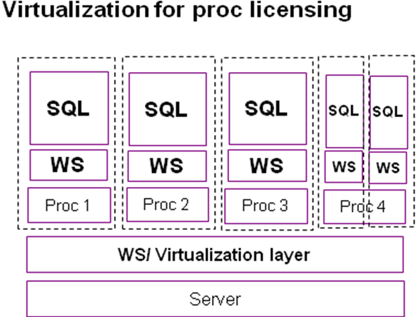
Figure 7. This example shows the extra option available with the enterprise edition only.Number of proc licenses required for EE : 4 SQL Processor Licenses.
Number of proc licenses required for Standard, Workgroup: 5 SQL Processor licenses
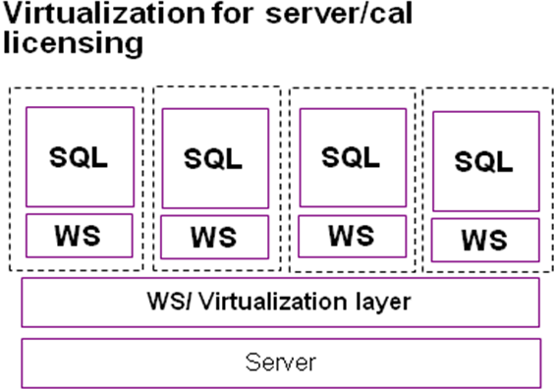
Figure 8. This example shows the extra option available with the enterprise edition only. Required license using additional rights for EE : 1 SQL Server License. Required licenses for all other workgroup and standard:4 SQL Server licenses

BUSINESS INTElLIGENCE / components in additional servers
The Business Intelligence components for SQL Server 2005 include Analysis Services, Reporting Services, and Integration Services. To use any of these components, the server on which Business Intelligence is installed must have a valid SQL Server 2005 license. If these components are in a separate server than the main database server, then they require an additional license of each additional server where they are installed.
SQL
SQL
AS
RS
Figure 7. Licensing Servers with running components. In Scenario 1, a SQL Server is running with all of its components in one server: only one license is required. In Scenario 2, the database is running in one server, analysis services in a second one, and reporting services in a third one. In this case, three server licenses are required.

WORKGROUP EDITION
Workgroup Edition is the easiest to use and most affordable solution for smaller departments and growing businesses. For SQL Server 2005, Workgroup is available in Server + 5 CAL bundles, individual CALs, and Per Processor licenses. Workgroup has its own CALs called Workgroup CALs. Workgroup CALs can only be used with Workgroup Edition. SQL CALs can be used with any Edition of SQL Server 2005, including SQL Workgroup Edition.

Ent.
Server

Std.
Server

Wkgp.
Server
SQL CAL
Workgroup CAL
Figure 8. SQL Workgroup. Workgroup CALs can only be used against a SQL Server Workgroup Edition. SQL CALs can be used against any edition.

SQL CALS
SQL CALs are available now in three platforms (32 bit, 64 bit and IA64). Any SQL Server 2005 CAL can be used against any licensed SQL 2005 Server, regardless of the platform. For example, a 32 bit SQL CAL can be used against a server running SQL Server Enterprise Edition (64 bit). Likewise, a 64 bit SQL CAL can be used against a server licensed for Workgroup Edition (32 bit).

EXPRESS EDITION
Express Edition is the fastest way for developers and enthusiasts to learn, build, and deploy simple data driven applications. It’s available as a free download at www.microsoft.com/downloads

developer Edition
SQL Server Developer Edition is a separate product and is used for development and testing purposes only. It is licensed per developer or tester (person).

evaluation Edition
SQL Server Enterprise Evaluation Edition is for evaluation purposes only and for up to 180 days of use. It is downloadable for free or orderable on CD from the Microsoft.com Web site.

SPLA PROGRAM
SPLA is the only licensing program that allows service providers to offer SQL Server in a hosted environment. Licensing in SPLA is either per hosted processor or per server access license (SAL). A processor is required for each processor accessed by end customers in a hosted environment, while a SAL is required for each end user/device accessing the server in a hosted environment.

ISV PROGRAM
The Microsoft® Independent Software Vendor (ISV) Royalty Licensing Program is a software licensing program designed for ISVs who incorporate Microsoft software into their value-added software business solutions. The ISV Royalty Licensing program makes it easy for ISV partners to combine Microsoft technology with their own software business application for commercial distribution to their customers. It is a one-size-fits-all program that scales across partners selling to large, small, or midmarket customers.

downgrade rights for previous versions
Customers can acquire SQL Server 2005 licenses and run prior versions of SQL Server per downgrade rights outlined in the EULAs (license agreements). Licenses can be added to existing prior version installations with this same method.

upgrades and Software assurance
Customers can choose to upgrade their SQL Server licenses by purchasing the new product outright, or by purchasing Software Assurance in conjunction with the for current version licenses to guarantee future version upgrades.
On top of new version rights, SA offers spread payments, TechNet Plus, Problem Resolution Support, Extended Lifecycle Hotfix support, “cold” backups for Disaster Recovery, corporate error reporting, and TechNet Online Concierge chat. For more information on SA please go to: http://www.microsoft.com/licensing/programs/sa/default.mspx

PRICING AND DISCOUNTING
SQL Server offers highly competitive Estimated Retail Pricing (ERP). Further, Microsoft has several options for customers making volume purchases to realize significant discounts off ERP through volume licensing programs (VL).

For More Information
For more information, go to:
www.microsoft.com/sql/howtobuy
for Answers to Frequently Asked Questions (FAQ), Estimated Retail Pricing, Sample End-User License Agreements (EULAs), and much more Additional Information and Details.

MAIN EDITION SUMMARY

This document is for informational purposes only. MICROSOFT MAKES NO WARRANTIES, EXPRESS OR IMPLIED, IN THIS DOCUMENT. Microsoft and Windows are either registered trademarks or trademarks of Microsoft Corporation in the United States and/or other countries.

