
Flexible Billings

Microsoft Dynamics™ SL

Shorten billing cycles and improve cash flow by taking control of unbilled receivables and converting them more quickly to revenues. Streamline invoicing with automatic generation, formatting, and submission of drafts for approval; then easily note needed corrections, finalize invoices, and post receivables.

Benefits
- Improve cash flow
Reduce the lag time between project
activity and invoicing. Charges such as
time, expenses, materials, and overhead allocations flow directly to billing without paperwork delays or manual data entry.

- Gain flexible control
Assign various billing methods, rate
structures and mark-up rules for each
project or customer, or for a specific
invoice, and then generate invoices
automatically or on demand.

- Prevent invoice errors
Review and annotate draft invoices online for editing and format changes, prior to approval and printing.

- Tailor invoices
Format invoices to customer specifications and link a given format to future customer or project bills.

- Streamline customer service
Provide your customer service personnel with instant access to invoice information, including the ability to drill down to underlying details, for answering customers’ questions about their bills.

Create, adjust,
maintain, and view
in-process invoices or
view billed invoices at
a glance.
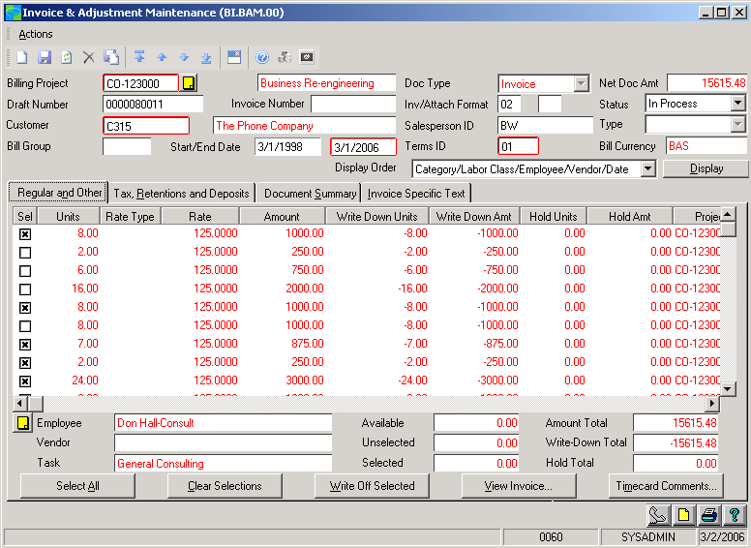

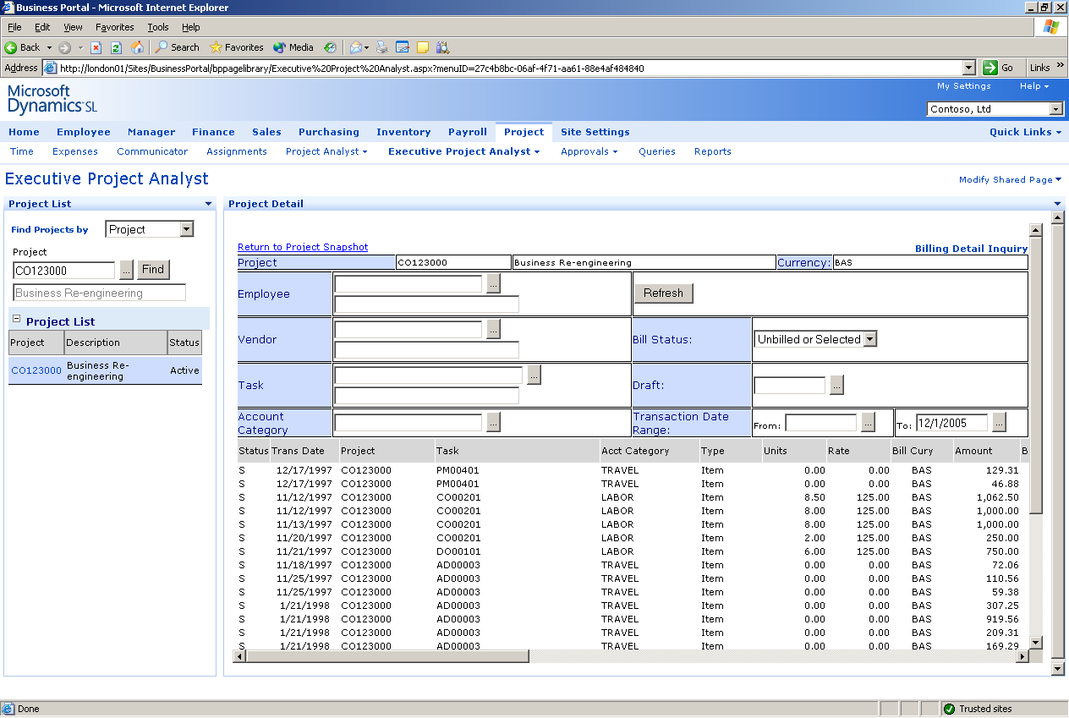

Review invoice
status to ensure timely billing and optimize cash flow.

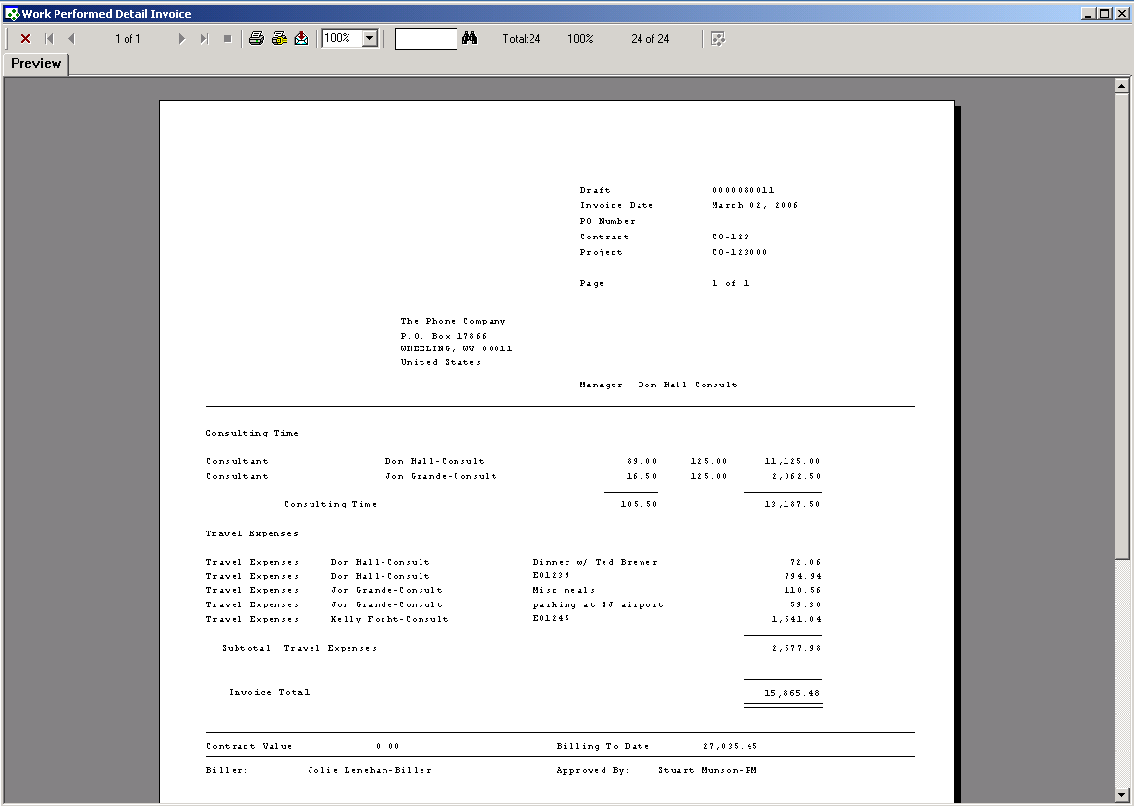

Tailor
invoice format to meet project or customer requirements.

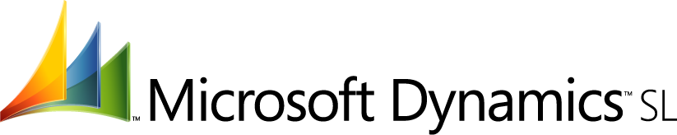

FEATURES

BENEFITS

Efficient Automation | Save time by automatically generating invoices from accounting data captured by other Microsoft Dynamics SL modules.
Multiple Billing Methods | Generate invoices on a preset schedule or on demand based on time  And material, fixed price, lump sum, percent complete, cost plus, cost  plus fixed fee, or retainer methods.
Mark-up Control | Manage write-up and write-down adjustments by specifying rules,  distributing adjustments manually or automatically across project  employees and instantly calculating results during invoice generation.
Flexible Formats | Create invoice formats, defining detail levels for different types of  charges, and associate formats, including AIA-like formats, with specific  customers or projects by using override capabilities.
Custom Graphics | Add logos or change lines, boxes, and shading to customize invoices,  And eliminate the need for preprinted forms.
Online Reviews | Ensure invoice accuracy with quick online preview, annotation, and  rejection or approval.
Split-and Consolidated-Billing Options | Automatically apportion billable amounts for a single project among multiple customers or joint-venture partners, or consolidate billing for numerous projects on a single invoice.
Automated Sales Tax and Retention  Computation | Set project manager-defined retention amounts for invoicing and automatically calculate sales tax.
Integrated Accounting | Post invoice amounts to receivables account books and the general  ledger automatically when invoices are approved and finalized.
Computation Support | Save time and prevent errors with background calculations and tax,  retention and customer deposit tracking.
Invoice History Lookup | Quickly view past invoices online and drill down to details using online  capabilities or Crystal Reports Professional 8.5.

For more information about Microsoft Dynamics™ SL, visit: http://www.microsoft.com/dynamics/sl

This document is for information purposes only.
MICROSOFT MAKES NO WARRANTIES, EXPRESS, IMPLIED, OR STATUTORY, AS TO THE INFORMATION IN THIS DOCUMENT.

© 2005 Microsoft Corporation. All rights reserved.
Microsoft, The Microsoft Dynamics Logo, are either registered trademarks or trademarks of Microsoft Corporation or Microsoft Business Solutions ApS in the United States and/or other countries. Microsoft Business Solutions ApS is a subsidiary of Microsoft Corporation.

