

**Microsoft SharePoint Server 2010**

**Enterprise Search Evaluation Guide**



This is a preliminary document and may be changed substantially prior to final commercial release of the software described herein.

The information contained in this document represents the current view of Microsoft Corporation on the issues discussed as of the date of publication. Because Microsoft must respond to changing market conditions, it should not be interpreted to be a commitment on the part of Microsoft, and Microsoft cannot guarantee the accuracy of any information presented after the date of publication.

This white paper is for informational purposes only. MICROSOFT MAKES NO WARRANTIES, EXPRESS, IMPLIED, OR STATUTORY, AS TO THE INFORMATION IN THIS DOCUMENT.

Complying with all applicable copyright laws is the responsibility of the user. Without limiting the rights under copyright, no part of this document may be reproduced, stored in, or introduced into a retrieval system, or transmitted in any form or by any means (electronic, mechanical, photocopying, recording, or otherwise), or for any purpose, without the express written permission of Microsoft Corporation.

Microsoft may have patents, patent applications, trademarks, copyrights, or other intellectual property rights covering subject matter in this document. Except as expressly provided in any written license agreement from Microsoft, the furnishing of this document does not give you any license to these patents, trademarks, copyrights, or other intellectual property.

Unless otherwise noted, the example companies, organizations, products, domain names, e-mail addresses, logos, people, places, and events depicted herein are fictitious, and no association with any real company, organization, product, domain name, e-mail address, logo, person, place, or event is intended or should be inferred.

© 2009 Microsoft Corporation. All rights reserved.

Microsoft, Windows, SharePoint, FAST, Visual Studio, SQL Server, OneNote, PowerPoint, Outlook, and Excel are trademarks of the Microsoft group of companies. All other trademarks are property of their respective owners.

Contents

Abstract 1

How to Use This Document 2

Introduction 4

Technical Problems Solved by SharePoint Server 2010 Enterprise Search 4

Search Terminology 5

Microsoft Enterprise Search Products Overview 10

Microsoft Server-Side Search Products 10

Content Source Repositories 11

Indexing Scale 12

Developer Information 13

What's New in SharePoint Server 2010 Search? 14

New and Improved Capabilities for Information Workers 14

New and Improved Query Capabilities 14

New and Improved Search Results Capabilities 15

New and Improved Capabilities for IT Professionals 18

Developer Information 21

End-User Search Experience 23

Social Search 27

Search Administration 30

Search Architecture 30

Scalability and Availability 32

Componentization and Scaling 32

High Availability and Resiliency 34

Connector Framework 34

New Connector Features 35

Creating Connectors 35

Search Administrator Walkthrough 37

Search Administration at the Search Service Application Level 37

Crawler Settings 37

Creating Content Sources 37

Configuring People Search 38

Creating Crawl Rules 38

Creating Crawler Impact Rules 39

Queries and Results Settings 40

Creating Authoritative Pages 40

Creating Federated Locations 41

Creating Metadata Properties 44

Search Reports 46

Running Administration Reports 46

Running Web Analytics Reports 47

Search Administration at the Site Collection Level 48

Creating Enterprise Search Centers 48

Creating Keywords, Definitions, Best Bets, and Synonyms 49

Creating Search Scopes 50

Appendix A: Resources Available for Evaluating SharePoint Server 2010 54

# Abstract

This evaluation guide is designed to give you an understanding of the design goals and the details of the enterprise search features provided by Microsoft® SharePoint® Server 2010. This guide is also designed to give you a familiarity with how to implement enterprise search by using SharePoint Server 2010.

This guide includes:

* Descriptions of the new and improved enterprise search features and technologies provided by SharePoint Server 2010.
* Details on the indexing and query architecture implemented by SharePoint Server 2010.
* Tours and walkthroughs of the main search features provided by SharePoint Server 2010.

This guide is designed for technical decision makers, IT professionals, and developers. The overall goal of this guide is to help you perform a thorough and effective evaluation of the search features provided by SharePoint Server 2010.

For the latest information about SharePoint 2010 products, please visit <http://www.microsoft.com/sharepoint>.

# How to Use This Document

This document has been designed to enable you to learn about and evaluate the enterprise search features provided by SharePoint Server 2010. The document provides comprehensive information that can be used to evaluate all of the enterprise search features and components provided by SharePoint Server 2010, from the perspective of the following roles:

* **Technical Decision Makers**. You can use this guide to gain an understanding of the business requirements that are met by enterprise search solutions. You can also learn how specific aspects of the search technologies provided by SharePoint Server 2010 work together to fulfill business and technical requirements for a successful enterprise search solution.  
  You should study each of the following sections in detail to ensure that you gain a thorough overview of the enterprise search features of SharePoint Server 2010:
* *Introduction*
* *Enterprise Search Landscape*
* *What's New in SharePoint Server 2010 Search?*

You should then read the following section to gain a perspective for how information workers in your organization will use the enterprise search features of SharePoint Server 2010:

* *End-User Search Experience*

You should also read the remainder of the document to gain a technical perspective for how IT Professionals and Developers in your organization will work with the enterprise search features of SharePoint Server 2010.

* **IT Professionals**. You can use this guide to gain an understanding of how to configure, administer, and manage the enterprise search features of SharePoint Server 2010. You should read all of the sections in the document. The *Search Administration* section contains architectural information for IT professionals that you will find particularly valuable. Furthermore, the *Search Administration* section contains step-by-step instructions for performing administrative operations, at the search service application level and at the site collection level.

The insight that you gain will enable you to manage custom solutions more effectively.

* **Developers**. You can use this guide to gain an understanding of the enterprise search features of SharePoint Server 2010. You should read all of the sections in this document so that you gain an insight into the platform on which you will develop solutions. Throughout this guide, there are sections identified as *'Developer Information'* that will help you understand how you can create custom solutions for enterprise search in SharePoint Server 2010. You should also refer to the [SharePoint Server 2010 SDK](http://msdn.microsoft.com/en-us/library/ee557253(office.14).aspx) for more detailed developer guidance, walkthroughs, and samples.

# Introduction

Welcome to this evaluation guide for the enterprise search features of Microsoft SharePoint Server 2010. The goal of this guide is to help you gain sufficient knowledge and understanding of the enterprise search features provided by SharePoint Server 2010 to evaluate how they can fulfill your organization's business requirements.

In this section you will learn about technical requirements for enterprise search solutions, and how SharePoint Server 2010 fulfills those requirements.

## Technical Problems Solved by SharePoint Server 2010 Enterprise Search

The general aims of enterprise search solutions are to:

* Ensure that enterprise data from multiple systems can be indexed. This includes collaborative data stored in SharePoint sites, files in file shares, Web pages in other Web sites, third party repositories, and other line of business systems such as CRM databases, ERP solutions, and so on.
* Ensure that content from multiple enterprise repositories systems can be searched both independently and from within the context of your business applications. Ideally, users who perform searches with enterprise search user interfaces should be able to see results from SharePoint sites, files in file shares, pages from other Web sites, and data in custom business solutions. This also means that users do not need to know where the data is, before they start searching.
* Ensure that searches provide accurate ranking for relevant results, if you expect users to adopt and use those search capabilities. The major reason that a user continues to use a search engine is if it returns relevant information near the top of the search results. Similarly, the major reason that a user stops using a search engine is if it does not return relevant results, or if those relevant results are not immediately visible because of poor relevance ranking.
* Ensure that your enterprise search solution identifies people and expertise within your organization. At a minimum, users should be able to search for names of other members of their organization to obtain contact information and availability. Ideally, users should be able to express interest in topics or functional areas of your business and find experts who regularly contribute or provide thought leadership. Your search solution should automatically build out your users profile from interactions with your regular business systems, including e-mail and your content repositories.

SharePoint Server 2010 provides an enterprise search platform for fulfilling these aims. As a brief overview, SharePoint Server 2010 includes a connector framework that enables the crawler to index files, metadata, and other types of data from various types of content source. It also provides an indexing engine that stores the crawled data in an efficient manner in index files, and it provides query servers, query object models, and user interfaces for performing searches on the indexed data.

You will learn more about each of these components later in this guide, but for now just be aware that these components all work together to fulfill the aims and meet the requirements of enterprise search solutions.

## Search Terminology

Before delving into the details of enterprise search features provided by SharePoint Server 2010, it will be useful for you to ensure that you are familiar with search terms and definitions. You can use the following table to review brief descriptions of the terms used later in this guide.

|  |  |
| --- | --- |
| **Term** | **Definition** |
| **Best Bet** | Best Bets are URLs to documents that are associated with one or more keywords. Typically these documents or sites are ones that you expect users will want to see at the top of the search results list. Best Bets are returned by queries that include the associated keywords, regardless of whether the URL has been indexed. Site collection administrator can create keywords and associate Best Bets with them. |
| **Connector** | Connectors are components that communicate with specific types of system, and are used by the crawler to connect to and retrieve content to be indexed. Connectors communicate with the systems being indexed by using appropriate protocols. For example, the connector used to index shared folders communicate by using the FILE:// protocol, whereas connectors used to index Web sites use the HTTP:// or HTTPS:// protocols. |
| **Content Source** | Content sources are definitions of systems that will be crawled and indexed. For example, administrators can create content sources to represent shared network folders, SharePoint sites, other Web sites, Exchange public folders, third-party applications, databases, and so on. |
| **Crawl Rule** | Crawl rules specify how crawlers retrieve content to be indexed from content sources. For example, a crawl rule might specify that specific file types are to be excluded from a crawl, or might specify that a specific user account is to be used to crawl a given range of URLs. |
| **Crawl Schedule** | Crawl schedules specify the frequency and dates/times for crawling content sources. Administrators create crawl schedules so that they do not have to start all crawl processes manually. |
| **Crawled Property** | Crawled properties represent the metadata for content that is indexed. Typically, crawled properties include column data for SharePoint list items, document properties for Microsoft Office or other binary file types, and HTML metadata in Web pages. Administrators map crawled properties to managed properties, in order to provide useful search experiences. See Managed Properties for more details. |
| **Crawler** | The crawler is the component that uses connectors to retrieve content from content sources. |
| **Crawler Impact Rule** | A crawler impact rule governs the load that the crawler places on source systems when it crawls the content in those source systems. For example, one crawler impact rule might specify that a specific content source that is not used heavily by information workers should be crawled by requesting 64 documents simultaneously, while another crawler impact rule might specify less aggressive crawl characteristics for systems that are constantly in use by information workers. |
| **Federation** | Federation is the concept of retrieving search results from multiple search providers, based on a single query performed by an information worker. For example, your organization might include federation with Bing.com, so that results are returned by SharePoint and Bing.com for a given query. |
| **IFilter** | IFilters are used by connectors to read the content in specific file types. For example, the Word IFilter is used to read Word documents, while a PDF IFilter is used to read PDF files. |
| **Index** | An index is a physical file that contains indexed content, and which is used by query servers to satisfy a query. |
| **Indexer** | Indexers manage the content to be included in an index, and propagate that content to query servers where they are stored in index files. |
| **Indexing Engine** | See *Indexer* |
| **Index Partition** | See *Partitioned Indexes* |
| **Managed Property** | Administrators create managed properties by mapping them to one or more crawled property. For example, an administrator might create a managed property named *Client*that maps to various crawled properties called *Customer*, *Client*, and *Cust* from different content sources. Managed properties can then be used across enterprise search solutions, such as in defining search scopes and in applying query filters. |
| **OpenSearch** | OpenSearch is an industry standard that enables compliant search engines to be used in federated scenarios. See *Federation* for more details. |
| **Partitioned Index** | SharePoint Server 2010 includes a new concept that enables administrators to spread the load for queries across multiple query servers. This is achieved by creating subsets of an index, and propagating individual subsets to different query servers. The subsets are known as *partitions*. At query time, the query object model contacts each query server that can satisfy the search so that all results to be returned to the user are included. |
| **Properties Database** | Managed properties and security descriptors for search results are not stored in the physical index files. Instead, they are stored in an efficient database that is propagated to query servers. Query servers typically satisfy a query by retrieving information from both the index file and the properties database. |
| **Query Object Model** | The query object model is responsible for accepting inputs from search user interfaces, and for issuing appropriate queries to query servers. The search Web Parts provided by SharePoint Server 2010 use the query object model to run queries. Developers can also create custom user interfaces and solutions that run queries by using the query object model. |
| **Query Server** | Query servers query retrieve data from index files and property databases to satisfy queries. |
| **Ranking** | Ranking defines the sort order in which results are returned from queries. Typically, results are sorted in order of descending relevance, so that the most relevant documents are presented near the top of the results page. However, information workers might choose to apply a different sort order, such as by date modified. |
| **Relevance** | Relevance describes how well a given search satisfies a user’s information needs. Relevance includes which documents are returned in the results (document recall) and the order of those documents in the results (ranking). |
| **Search Center** | Search Center is a site based on the Search Center site template, and provides a focused user interface that enables information workers to run queries and work with search results. |
| **Search Document** | See *Search Item* |
| **Search Item** | A search item represents a document, list item, file, Web page, Exchange public folder post, or database row that has been indexed. Search items are sometimes referred to as *search documents*, but the key point is that these items are returned by search queries. |
| **Stemming** | Words in each language can have multiple forms, but essentially mean the same thing. For example, the verb '*To Write'* includes forms such as *writing, wrote, write,* and *writes*. Similarly, nouns normally include singular and plural versions, such as *book*and*books.* The stemming feature in enterprise search can increase recall of relevant documents by mapping one form of a word to its variants. |
| **Stop Word** | Stop words (sometimes known as noise words) are those words for which there is no value in indexing them. Some stop words are part of the language (such as 'a', 'and', and 'the'). There is no value in indexing these words as they are likely to be contained in a high percentage of indexed items. Furthermore, information workers rarely search for just these types of terms. |
| **Synonym** | Synonyms are words that mean the same thing as other words. For example, you might consider *laptop* and *notebook* to mean the same thing. Administrators can create synonyms for keywords that information workers are likely to search for in their organization. Additionally, synonyms that can be used to improve recall of relevant documents are stored in thesaurus files. |
| **Word Breaker** | Streams or words are retrieved from content sources, and those streams are broken down into discrete words for indexing. Word breakers are the components that break down streams into individual words. Streams to be indexed are normally broken down by identifying spaces, punctuation marks, and the particular rules of each language. Also, when a user enters multiple words into a search box, that query is broken into discrete terms by a word breaker. |

# Microsoft Enterprise Search Products Overview

There are various search products available from Microsoft, so before delving into the details of enterprise search for SharePoint Server 2010, it will be useful for you to become familiar with all of the products in the enterprise search portfolio.

## Microsoft Server-Side Search Products

The following products all provide varying degrees of indexing and search features.

* Microsoft SharePoint Foundation 2010 search
* Microsoft Search Server 2010 Express
* Microsoft Search Server 2010
* Microsoft SharePoint Server 2010
* FAST™ Search Server 2010 for SharePoint*

You can use the following table to make quick comparisons of the search features provided by each product:

|  |  |  |  |  |  |
| --- | --- | --- | --- | --- | --- |
| **Feature** | **SharePoint Foundation 2010** | **Search Server 2010 Express** | **Search Server 2010** | **SharePoint Server 2010** | **FAST Search Server 2010 for SharePoint** |
| Basic site search | Y | Y | Y | Y | Y |
| Best Bets |  | Y | Y | Y | Y |
| Visual Best Bets |  |  |  |  | Y |
| Similar Results |  |  |  |  | Y |
| Duplicate Results |  |  |  |  | Y |
| Search Scopes |  | Y | Y | Y | Y |
| Search Enhancement based on user context |  |  |  |  | Y |
| Crawled and Managed Properties |  | Y | Y | Y | Y* |
| Query Federation |  | Y | Y | Y | Y |
| Query Suggestions |  | Y | Y | Y | Y |
| Sort Results on Managed Properties or Rank Profiles |  |  |  |  | Y |
| Relevancy Tuning by Document or Site Promotions |  | Y | Y | Y | Y* |
| Shallow Results Refinement |  | Y | Y | Y | Y |
| Deep Results Refinement |  |  |  |  | Y |
| Document Preview |  |  |  |  | Y |
| Windows 7 Federation |  | Y | Y | Y | Y |
| People Search |  |  |  | Y | Y |
| Social Search |  |  |  | Y | Y |
| Taxonomy Integration |  |  |  | Y | Y |
| Multi-Tenant Hosting |  |  |  | Y | Y |
| Rich Web Indexing Support |  |  |  |  | Y |

* - FAST Search Server 2010 for SharePoint provides enhanced capabilities in these areas. Please refer to the evaluation guide for *FAST Search Server 2010 for SharePoint* for more details.

This guide will delve into the features in the above table in later sections.

### Content Source Repositories

In addition to the feature comparisons, you should also consider the types of content sources that can be crawled by each product:

* SharePoint Foundation 2010 can only crawl SharePoint sites in the same farm.
* All the other products in the above table can crawl the following types of content source:
* SharePoint sites (in the same farm, or in external farms)
* Windows file shares
* Microsoft Exchange public folders
* Non-SharePoint Web Sites
* People Profiles
* External Line-of-Business applications
* Structured content in databases
* Content returned by Web services
* Third-party products and solutions including Lotus Notes and Documentum  
    
  **NOTE**: Microsoft SharePoint 2010 Indexing Connector for Documentum (Beta) can be downloaded separately from Microsoft Connect (https://connect.microsoft.com/office/Downloads/DownloadDetails.aspx?DownloadID=23324).

### Indexing Scale

Although there are no hard-coded limits for the number of items that can be indexed by any of the products in the table above, there are some practical guidelines based on feasibility and performance:

* SharePoint Foundation 2010 can index and search up to 10 million items per server.
* Search Server 2010 Express can index and search up to 300,000 items if it is used with SQL Server® Express; otherwise it can index and search up to 10 million items.
* A scaled-out Search Server 2010 farm can index and search up to 100 million items.
* A scaled-out SharePoint Server 2010 farm can index and search up to 100 million items.
* A FAST Search Server 2010 for SharePoint installation can support extreme scale, and can index and search over a billion items.

One of the general aims of enterprise search with SharePoint Server 2010 is to deliver sub-second query latencies for all searches. To achieve this, you must ensure that no query server deals with more than ten million items; you can achieve this by adding multiple query servers to your farm, and therefore by taking advantage of the new index partitioning features of SharePoint Server 2010. Index partitioning enables administrators to spread the load for queries across multiple query servers. This is achieved by creating subsets of an index, and propagating individual subsets to different query servers. SharePoint Server 2010 uses a hash of each document's ID to determine in which partition the index entries for a specific document should be stored. At query time, the query object model contacts each query server needed to satisfy the search so that all results to be returned to the user are included.

For more comparison data between the server-side search products from Microsoft, see   
[Search Technologies for SharePoint 2010 Products](http://www.microsoft.com/downloads/details.aspx?displaylang=en&FamilyID=d7c0091e-5766-496d-a5fe-94bea52c4b15).

### Developer Information

All of the products described above provide a unified [query object model](http://msdn.microsoft.com/en-us/library/ee557319(office.14).aspx). The result is that if you develop a custom solution that uses the query object model for SharePoint Foundation 2010, for example, then it will continue to work if you upgrade to SharePoint Server 2010, or if you migrate your code to FAST™ Search Server 2010 for SharePoint.

# What's New in SharePoint Server 2010 Search?

You can use this section to gain an oversight for what's new in enterprise search for SharePoint Server 2010.

## New and Improved Capabilities for Information Workers

SharePoint Server 2010 provides new capabilities for formulating and submitting queries, and for working with search results.

### New and Improved Query Capabilities

SharePoint Server 2010 enables end users to create and run more effective search queries. It also enables users to issue search queries from the desktop in Windows 7.

The new query capabilities are:

* **Boolean query syntax for free-text queries and for property queries**SharePoint Server 2010 supports use of the Boolean operators AND, OR, and NOT in search queries. For example, a user can execute a query such as the following:  
  (“SharePoint Search” OR “Live Search”) AND (title:”Keyword Syntax” OR title:”Query Syntax”)
* **Prefix matching for search keywords and document properties**  
  Search queries can use the * character as a wildcard at the end of a text string. For example, the search query "comp*" would find documents that contain "computer" or "component" or "competency". Similarly the query "author:Ad*" would find documents created by "Adam" or "Administrator". Therefore, the query "comp* author:ad*" would find documents that contain "component" and that were created by "Adam", as well as finding documents that contain "computer" and that were created by "Administrator".
* **Suggestions while typing search queries**  
  As a user types keywords in the Search box, the Search Center provides suggestions to help complete the query. These suggestions are based on past queries from other users.
* **Suggestions after users run queries**Search center also provides suggestions after a query has been run. These suggestions are also based on past queries from other users, and are distinct from the 'did you mean' feature.
* **Connectors for enterprise search in Windows 7**From an Enterprise Search Center, users can easily create a connector for their SharePoint searches in Windows 7. By typing search queries into the Windows 7 search box users can find relevant documents from SharePoint and take advantage of Windows features such as file preview and drag-and-drop for documents returned in those search results.

### New and Improved Search Results Capabilities

SharePoint Server 2010 provides many improvements for getting and viewing search results. The new search results capabilities are:

* **Results display**The search results page includes a refinement panel, which provides a summary of search results and enables users to browse and understand the results quickly. For example, for a particular search query the summary in the refinement panel might show that there are many Web pages in the search results and many documents by a particular author. A summary might also indicate that there are mostly Microsoft Word® and Microsoft Excel® documents in the top set of results. The refinement panel also enables users to filter results—for example by kind of content (document, spreadsheet, presentation, Web page, and so on), content location (such as SharePoint sites), content author, or date last modified. A user can also filter by category based on managed properties and enterprise content management (ECM) taxonomy nodes that an administrator configures.
* **View in Browser**The *View in Browser* capability allows users to view most Microsoft Office documents in the browser by using *Office Web Applications*.   
  *Office Web Applications* is the online companion to Word, Excel, Microsoft PowerPoint® and Microsoft OneNote®, and it enables information workers to access documents from anywhere. Users can view, share, and work collaboratively on documents by using personal computers, mobile phones, and Web browsers. *Office Web Applications* is available to users through Windows Live. It is also available to business customers with Microsoft Office 2010 volume licensing agreements and document management solutions based on SharePoint Server 2010.
* **People search**People search enables users to find other people in the organization not only by name, but also by many other categories, such as department, job title, projects, expertise, and location. People search improvements include:
* **Improved relevance in people search results**Results relevance for people search is improved, especially for searches on names and expertise.
* **Self search**The effectiveness of people search increases as users add data to their profiles. When a user performs a search for themselves, the search system recognizes this as a “self search” and displays related metadata. The metadata can include information such as the number of times the My Site profile was viewed and the terms that other people typed that returned the user’s name. This can encourage users to add information to their profile pages to help other users when they search. As users update their My Site profiles, other users can find them more easily in subsequent searches. This increases productivity by helping to connect people who have common business interests and responsibilities.
* **Phonetic name matching and nickname matching**Users can search for a person in the organization without knowing the exact spelling of their name. For example, the search query “John Steal” could yield “John Steele” in the search results; results for the search query “Jeff” include names that contain “Geoff.” In addition, nickname matching makes it possible for a search query for “Bill” to yield results that include “William.”  
  **NOTE**: Phonetic matching applies to the following languages supported by SharePoint Server 2010:
  + English
  + Spanish
  + French
  + German
  + Italian
  + Korean
  + Portuguese (Brazil)
  + Russian

**NOTE**: Nicknames apply to the following languages supported by SharePoint.

* + English
  + Spanish
  + German
  + Dutch
* **Enhancements for relevance of search results**SharePoint Server 2010 provides improvements to increase the relevance and usefulness of search results, such as the following:
* **Ranking based on click-through history**If a document in a search result set is frequently clicked by users, this indicates that information workers find the document useful. The document is therefore promoted in the ranking of search results.
* **Relevance based on extracted metadata**Document metadata is indexed along with document content. However, information workers do not always update metadata correctly. For example, they often re-purpose documents that were created by other people, and may not update the *author* property. Therefore, the original author's name remains in the property sheet, and is consequently indexed. However, the search system can sometimes determine the author from a phrase in the document. For example, the search system could infer the author from a phrase in the document such as "By John Doe". In this case, SharePoint Server 2010 includes the original author, but also maintains a shadow value of "John Doe". Both values are then treated equally when a user searches for documents by specific authors.

## New and Improved Capabilities for IT Professionals

SharePoint Server 2010 includes new ways for administrators to help provide the most benefits for end users who are searching for information. IT professionals can take advantage of the following new and improved features:

* **Improved administrative interface**SharePoint Server 2010 includes the new search administration pages that were first available for organizations that deployed Office SharePoint Server 2007 and then installed the Infrastructure Update for Microsoft Office Servers. This new interface centralizes the location for performing administrative tasks. With SharePoint Server 2010, administrators have an interface that provides the following advantages:
* A single starting point for all farm-wide administration tasks, including search administration. The most common search tasks are highlighted.
* A central location where farm administrators and search administrators can monitor server status and activity.
* **Farm Configuration Wizard**After the Installation Wizard finishes, the Farm Configuration Wizard runs automatically. The Farm Configuration Wizard helps simplify deployment of small farms. It provides the option to automate much of the initial configuration process with default settings. For example, when you use the Farm Configuration Wizard to deploy the first application server in a farm, the wizard automatically creates a fully functional search system on that server, including the following:
* A Search Center from which users can issue queries (if the person installing the product selected this option in the Farm Installation Wizard).
* A fully functional search topology that can support an index of up to 10 million crawled documents.
* The ability to crawl SharePoint sites in the server farm immediately after the Farm Configuration Wizard finishes running.
* **Search service administration independent of other shared services**In Microsoft Office SharePoint Server 2007, the Office SharePoint Server Search service was bundled with other shared services (such as Excel Calculation Services) in the Shared Services Provider (SSP). In that architecture, you could not create a new Search service without creating a new SSP. In contrast, in SharePoint Server 2010, you can create and manage Search service applications independently of one another and independently of other service applications.
* **Expanded support for automating administrative tasks**You can automate many search administration tasks by using Windows PowerShell™ 2.0 scripts. For example, you can use Windows PowerShell 2.0 scripts to manage content sources and search system topology. Windows PowerShell support is new for SharePoint Server 2010.
* **Increased performance, capacity, and reliability**SharePoint Server 2010 provides many new ways to configure and optimize a search solution for better performance, capacity, and reliability, as follows:
  + **Scalability for increased crawling capability**In Microsoft Office SharePoint Server 2007, a Shared Services Provider could only be configured to use one indexer. With SharePoint Server 2010, you can scale the number of crawl components by adding additional servers to your farm and configuring them as crawlers. This enables you to do the following:
    - Increase crawl frequency and volume, which helps the search system to provide more comprehensive and up-to-date results.
    - Increase performance by distributing the crawl load.
    - Provide redundancy if a particular server fails.
  + **Scalability for increased throughput and reduced latency**You can increase the number of query components to do the following:
    - Increase query throughput — that is, increase the number of queries that the search system can handle at a time.
    - Reduce query latency — that is, reduce the amount of time it takes to retrieve search results. One of the general aims of enterprise search with SharePoint Server 2010 is to implement sub-second query latencies for all searches. To achieve this, you must ensure that no query server deals with more than ten million items; you can achieve this by adding multiple query servers to your farm, and therefore by taking advantage of the new index partitioning features of SharePoint Server 2010. Microsoft Office SharePoint Server 2007 did not support the concept of index partitioning.
    - Provide failover capability for query components.
* **Topology management during normal operations**You can tune the existing search topology during regular farm operations while search functionality remains available to users. For example, during usual operations, you can deploy additional index partitions and query components to accommodate changing conditions.
* **Operations management**SharePoint Server 2010 provides new capabilities for monitoring farm operations and customizing reports for enterprise search. Specifically, administrators can review status information and topology information in the search administration pages of the Central Administration Web site. They can also review crawl logs, as well as health reports, and can use Systems Center Operations Manager to monitor and troubleshoot the search system.
* **Health and performance monitoring**Health and performance monitoring features enable an administrator to monitor search operations in the farm. This can be especially helpful for monitoring crawl status and query performance.  
  SharePoint Server 2010 includes a health analysis tool that you can use to check for potential configuration, performance, and usage problems automatically. Search administrators can configure specific health reporting jobs to do the following:
* Run on a predefined schedule.
* Alert an administrator when problems are found.
* Formulate reports that can be used for performance monitoring, capacity planning, and troubleshooting.
* **Search Analytics Reports**SharePoint Server 2010 provides new reports that help you to analyze search system operations and tune the search system to provide the best results for search queries. For example, reports can include information about what terms are used most frequently in queries or how many queries are issued during certain time periods. Information about peak query times can help you decide about server farm topology and about best times to crawl.
* **Searches of diverse content by crawling**SharePoint Server 2010 can search content in repositories other than SharePoint sites by crawling or federating. For example, the search system can crawl content in repositories such as file shares, Exchange public folders, and Lotus Notes using connectors included with SharePoint Server 2010. Additional connectors for crawling databases and third-party application data are created easily by using the Business Connectivity Services connector framework. Support for creating connectors using SharePoint Designer 2010 or Microsoft Visual Studio® 2010 enables quicker and easier development compared to protocol handlers for Microsoft Office SharePoint Server 2007.
* **Searches of diverse content by federation**SharePoint Server 2010 search results can include content from other search engines. For example, an administrator might federate search results from www.bing.com or from a geographically distributed internal location.

### Developer Information

All of the new enterprise search features provided by SharePoint Server 2010 for administrators and information workers are reflected in the updated query object model and administrative object models.

For example, if you develop your own custom user interfaces for running queries and rendering search results, you have programmatic access to features such as Best Bets. Furthermore, the built-in search and results Web Parts are easier for you to interact with as a developer than in previous versions.

Similarly, you can also create administrative applications for managing enterprise search in your organization by using the administrative object models. For example, you can create a wizard that enables an administrator to create content sources, crawl rules, priorities, and so on.

Full discussions of the query object model, administrative object models, and development techniques are outside the scope of this guide, but you can learn how to develop enterprise search solutions by using the [MSDN SharePoint Server Developer Center](http://msdn.microsoft.com/sharepoint). Later sections in this guide also include selected information for developers.

# End-User Search Experience

Information workers typically start searches either from the Simple Search box or by browsing to a site based on a Search Center site template. Figure 1 shows the Simple Search box that is available by default on all site pages. By default, this search box issues queries that are scoped to the current site, because users often navigate to sites that they know contain the information they want before they perform a search.

Figure 1 also shows navigation to a search site based on the Enterprise Search Center template. Information workers use Search Center sites to search across all crawled and federated content.

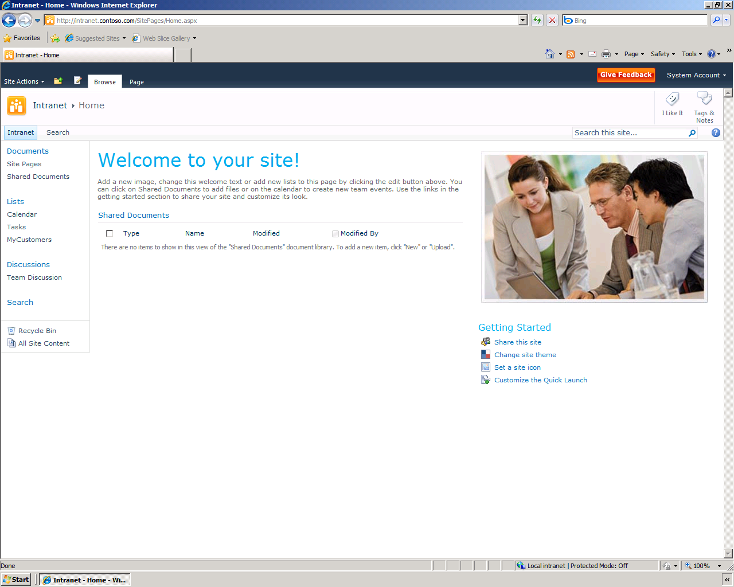

Simple Search Box

Navigation to Search Center

Figure . Search in a SharePoint Site

Figure 2 shows the search site based on the Enterprise Search Center template.

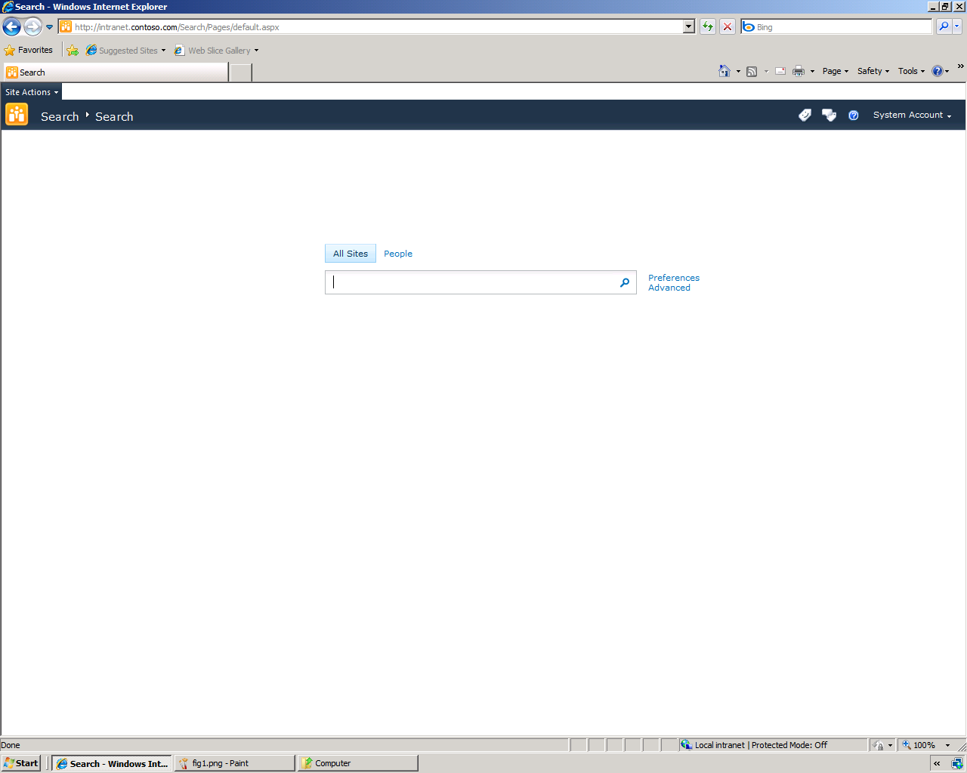

Figure . Search Center

Note how the Search Center includes an Advanced Search Box that provides links to the current user's search preferences and advanced search options. Also, by default, the Search Center includes search tabs: All Sites, and a dedicated People search. You will learn more about People search later in this section.

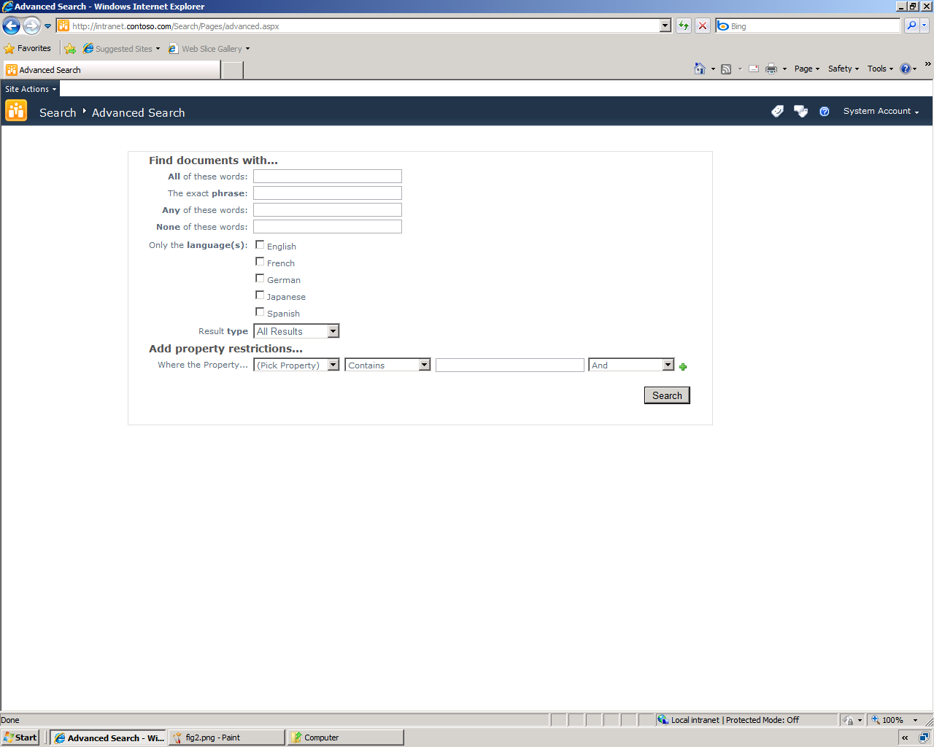

Figure . Advanced Search

Figure 3 shows the default view for performing an advanced search, with access to phrase management features, language filters, result type filters, and property filters.

All of the search user interfaces are intuitive and easy to use, so information workers can start searches in a very straightforward way. When an information worker performs a search, the results are displayed on a results page as shown in Figure 4. The SharePoint Sever 2010 search core results page offers a very user-friendly and intuitive user interface. People can use simple and familiar keyword queries, and get results in a rich and easy to navigate layout. A Search Center site template is provided as well as a simple search box that can be available on every page in a SharePoint Server 2010 site.

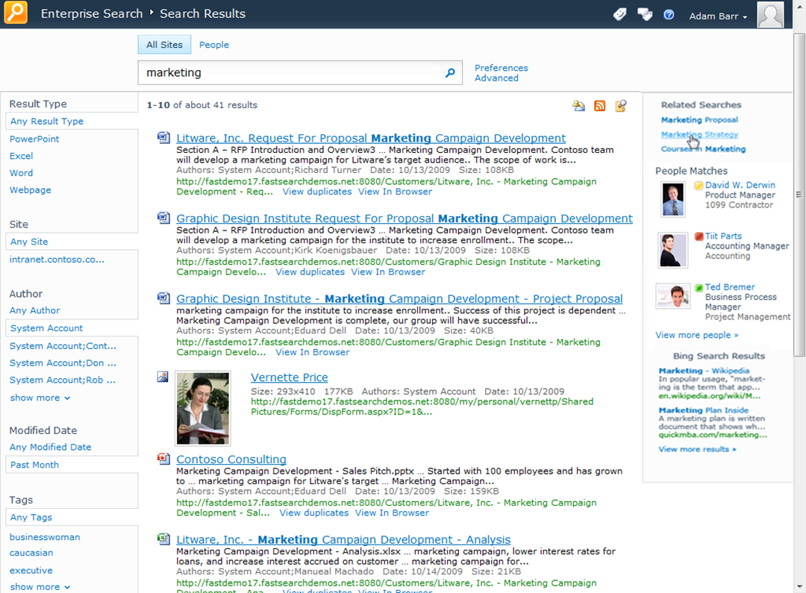

Figure . SharePoint Server 2010 Search Results Page

Search results are straightforward to browse and understand, and include several features to help information workers understand and explore the results. Snippets are included with each result, and definitions are provided at the bottom of the list (these are auto-generated based on the context in which the query words have been seen in the content). "Did you mean" suggestions appear to help with misspelled and ambiguous queries, and acronyms are expanded in the related search sections. For example, searching for ECM will return results for Enterprise Content Management and *vice-versa*. Results are typically returned with sub-second response time.

Information workers can mark a search in several ways to save time in monitoring topics or repeating searches. They can subscribe to an RSS feed of the search results, and bookmark a search for later re-use. They can also quickly create an alert that will rerun the query at scheduled intervals and notify the user via an e-mail or text message of changes to the results.

SharePoint Server 2010 provides more relevant results. The query syntax has been enhanced to allow more expressive queries. Advanced search continues to be available for power users who want to express queries in more complex ways. Significant enhancements have also been made to the core relevance ranking – using additional text fields, taking advantage of the structure of content, click-throughs and optimizing ranking of the search engine. Linguistics have also been enhanced to provide improved language detection and recall in many languages.

|  |  |
| --- | --- |
| SharePoint Server 2010 also provides a new way to explore information - via search refinements, as shown in Figure 5. These refinements are displayed down the left-hand side of the page in the core search results. They provide self-service drill-down capabilities in filtering the search results returned. Refinements are automatically determined by SharePoint Server 2010 using tags and metadata in the search results. Such refinements include searching by the type of content (Web page, document, spreadsheet, presentation, and so on) location, author, last modified date, and metadata tags. Administrators can extend the refinement panel easily, to include refinements based on any managed property. | Figure . Search Result Refinements |

While the out-of-the-box user interface is very intuitive and useful for information workers, power users can create their own search experiences. SharePoint Server 2010 includes many search-related Web Parts for power users to create customized search experiences including Best Bets, refinement panel extensions, featured content, or pre-defined queries. Figure 6 shows the Search Web Parts.

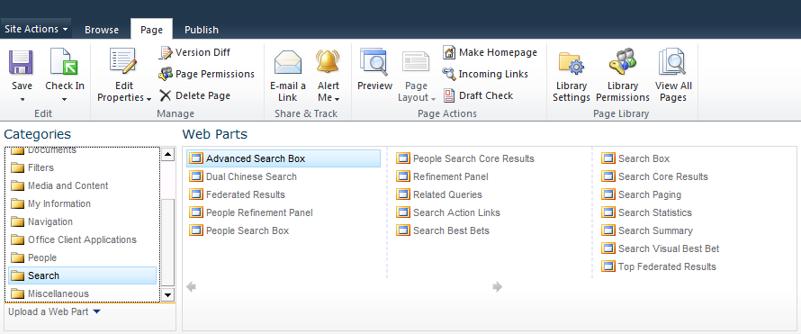

Figure . Search Web Parts

### Social Search

A significant aspect to people's work in an organization is interacting with other people and finding the right people to connect with who have specific skills and talents. This can be a daunting challenge in a large organization. SharePoint Server 2010 addresses this challenge through search, and connects this search to the social capabilities in SharePoint Server 2010. A people search center provides specific capabilities for connecting with people.

#### Finding People

SharePoint Server 2010 provides an address book-style name lookup experience with better name matching, making it easier to find people by name, title and organizational structure. This includes phonetic name matching that will return names that sound similar to what the user has typed in a query. It will also return all variations of common names, including nicknames.

The refiners provided on the core search results are also provided with people search results—exploring results via name, title, and various fields in a user's profile enable quick browsing and selection of people. People search results also include real-time presence through Office Communication Server, making it easy to immediately connect with people once they are found through search. Figure 7 shows a People Search results page.

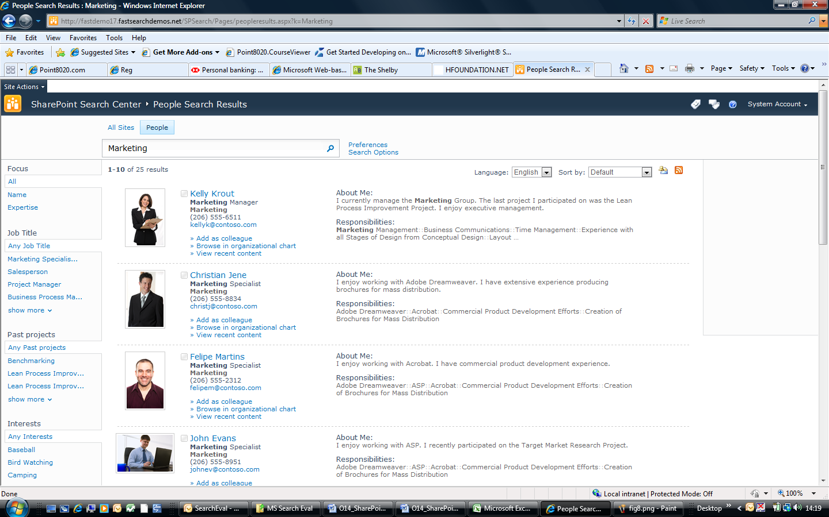

Figure . People Search Result Page

#### Mining and Discovering Expertise

Users can manually submit or automatically generate a list of colleagues mined from Outlook®. Automatically generated lists of colleagues are a way of rapidly inferring social relationships throughout the organization, which speeds the adoption and usefulness of people search results. SharePoint Server 2010 also infers expertise by automatically suggesting topics mined from the user’s Outlook inbox and suggesting additions to their expertise profile in their My Site. This makes it easy to populate My Site profiles and means that more people have well-populated profiles and get the benefits of this in both search and communities.

#### Improving Search based on Social Behavior

For many organizations, SharePoint sites have become gathering places where people create, share and interact with information. Social behavior is taken into account in order to provide high quality search results in several ways. The relevance ranking for people search takes social distance into account: a direct colleague will appear before someone 3 degrees removed. Second, SharePoint Server 2010 supports social tagging of content, and this feedback can influence the relevance of content in search results. People’s day-to-day usage of information in SharePoint Server 2010 and Microsoft Office can have a measurable impact on search relevance, thereby helping the organization harness the collective wisdom of its people.

# Search Administration

IT Professionals can administer some of the enterprise search features in SharePoint Server 2010 from the site collection level, by using the site settings pages. They can also administer other enterprise search features at the Search Service Application level, by using the SharePoint Central Administration site. Before delving into the details of administering search, it is important that you understand the key concepts and topology of the search architecture.

## Search Architecture

Figure 8 provides an overview of the logical architecture for the enterprise search components in SharePoint Server 2010.

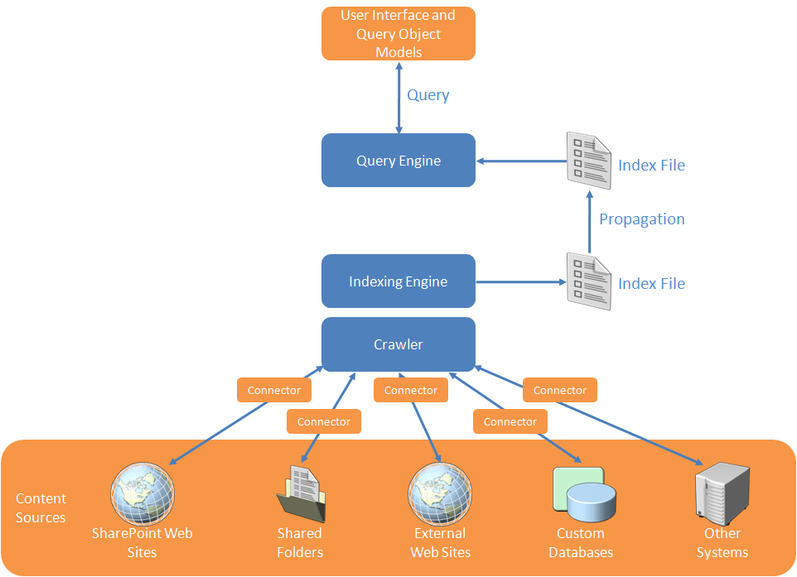

Figure . Logical Search Architecture

As shown in Figure 8, there are four main components that deliver the enterprise search features of SharePoint Server 2010:

* **Crawler**. This component invokes connectors that are capable of communicating with content sources. Because SharePoint Server 2010 can crawl different types of content sources (such as SharePoint sites, other Web sites, file shares, Lotus Notes databases, and data exposed by Business Connectivity Services), a specific connector is used to communicate with each type of source. The crawler then uses the connectors to connect to and traverse the content sources, according to crawl rules that an administrator can define. For example, the crawler uses the file connector to connect to file shares by using the FILE:// protocol, and then traverses the folder structure in that content source to retrieve file content and metadata. Similarly, the crawler uses the Web connector to connect to external Web sites by using the HTTP:// or HTTPS:// protocols, and then traverses the Web pages in that content source by following hyperlinks to retrieve Web page content and metadata. Connectors load specific IFilters to read the actual data contained in files. Refer to the *Connector Framework* section later in this document for more information about connectors.
* **Indexing Engine**. This component receives streams of data from the crawler, and determines how to store that information in a physical, file-based index. For example, the indexer optimizes the storage space requirements for words that have already been indexed, manages word-breaking and stemming in certain circumstances, removes noise words, and determines how to store data in specific index partitions if you have multiple query servers and partitioned indexes. Together with the crawler and its connectors, the indexing engine meets the business requirements of ensuring that enterprise data from multiple systems can be indexed. This includes collaborative data stored in SharePoint sites, files in file shares, and data in custom business solutions, such as CRM databases, ERP solutions, and so on.
* **Query Engine**. Indexed data that is generated by the indexing engine are propagated to query servers in the SharePoint farm where it is stored in one or more index files. This process is known as 'continuous propagation'. That is, while indexed data is being generated or updated during the crawl process, those changes are propagated to query servers, where they are applied to the index file (or files). In this way, the data in the indexes on query servers experience a very short latency. In essence, when new data has been indexed (or existing data in the index has been updated), those changes will be applied to the index files on query servers in just a few seconds. A server that is performing the *query server* role responds to searches from users by searching its own index files, so it is important that latency be kept to a minimum. SharePoint Server 2010 ensures that this is the case automatically. The query server is responsible for retrieving results from the index in response to a query received via the query object model. The query sever is also responsible for the word-breaking, noise word removal, and stemming (if stemming is enabled) for the search terms provided by the query object model.
* **User Interface and Query Object Model**. As mentioned above, searches are formed and issued to query servers by the query object model. This is typically in response to a user performing a search from the user interface in a SharePoint site, but it may also be in response to a search from a custom solution (either hosted in or out of SharePoint Server 2010). Furthermore, the search might have been issued by custom code, such as from a workflow, or from a custom navigation component. In any case, the query object model parses the search terms, and issues the query to a query server in the SharePoint farm. The results of the query are returned from the query server to the query object model, and the object model provides those results to the user interface components (or other components that may have issued the query).

## Scalability and Availability

SharePoint Server 2010 enables you to add multiple instances of each of the crawler, indexing, and query components. This level of flexibility means that you can scale your SharePoint farms. (Previous versions of SharePoint Server did not allow you to scale the indexing components).

The aims of the enterprise search features in SharePoint Server 2010 are to provide sub-second query latencies for all queries, regardless of the size of your farm, and to remove bottlenecks that were present in previous versions of SharePoint Server. You can achieve these aims by implementing a scaled-out architecture. SharePoint Server 2010 enables you to scale out every logical component in your search architecture, unlike previous versions.

### Componentization and Scaling

Figure 9 shows the componentization of search, and the ability to scale out each component in a farm.

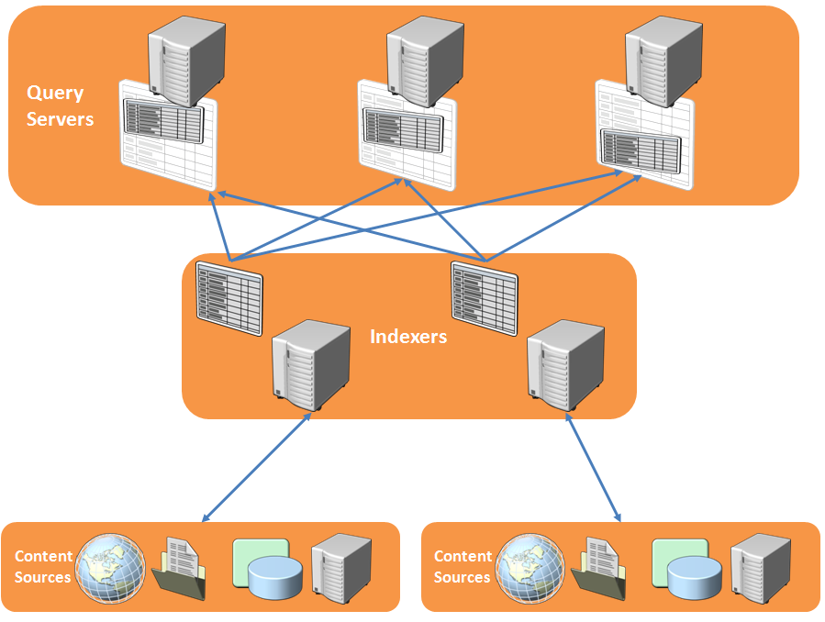

Figure . Scaled Out Architecture for Query Servers and Indexers

As shown in Figure 9, You can add multiple indexers to your farm to provide availability and to scale to achieve high performance for the indexing process. Each indexer can crawl a discrete set of content sources, so not all indexers need to index the entire corpus. This is a new capability for SharePoint Server 2010. Furthermore, indexers no longer store full copies of the index; they simply crawl content sources and propagate the indexes to query servers.

You can also add multiple query servers to provide availability and to scale to achieve high query performance, as shown in Figure 9. If you add multiple query servers, you are really implementing index partitioning; each query server maintains a subset of the entire logical index, and therefore does not need to query the entire index (which could be a very large file) for every query. The partitions are maintained automatically by SharePoint Server 2010, which uses a hash of each crawled document's ID to determine in which partition a document belongs. The indexed data is then propagated to the appropriate query server.

Another new feature is that property databases are also propagated to query servers so that retrieving managed properties and security descriptors is much more efficient than in Microsoft Office SharePoint Server 2007.

### High Availability and Resiliency

Each search component also fulfills high-availability requirements, by supporting mirroring. Figure 10 shows a scaled-out and mirrored architecture.

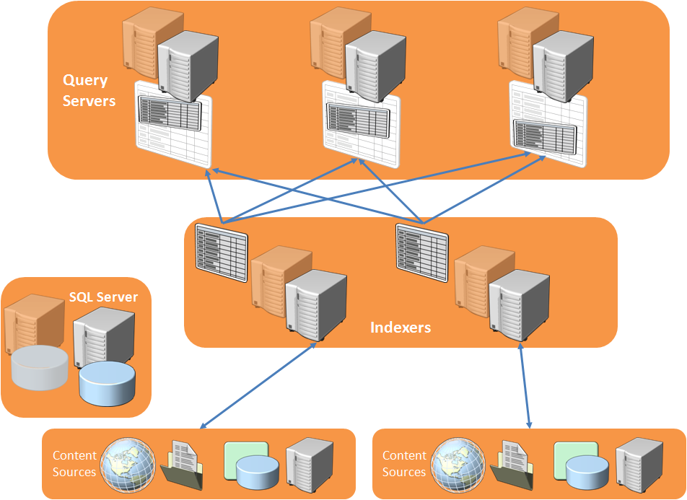

Figure . Scaled and Mirrored Architecture

## Connector Framework

SharePoint Server 2010 provides a new framework for connecting to and crawling content sources. Connectors for SharePoint sites, Web sites, file shares, custom databases and Web services (via Business Connectivity Services), Exchange public folders, and Lotus Notes databases are provided with the product.

### New Connector Features

The connector framework provides improvements over the protocol handlers in previous versions of SharePoint Server. For example, connectors can now crawl attachments as well as the content in e-mail messages. Also, item-level security descriptors can now be retrieved for external data exposed by Business Connectivity Services. Furthermore, when crawling a Business Connectivity Services entity, additional entities can be crawled via its entity relationships. Connectors also perform better than previous versions of protocol handlers, by implementing concepts such as inline caching and batching.

Connectors support richer crawl options than the protocol handlers in previous versions of SharePoint Server. For example, they support the full crawl mode that was implemented in previous versions, and they support timestamp-based incremental crawls. However, they also support change log crawls that can remove items which have been deleted since the last crawl.

### Creating Connectors

In previous versions of SharePoint Server, it was very difficult to create protocol handlers for new types of external systems. Protocol handlers were required to be coded in unmanaged C++ code, and typically took a long time to test and stabilize.

With SharePoint Server 2010, you have many more options for crawling external systems. You can choose to:

* Use SharePoint Designer 2010 to create external content types and entities for databases or Web Services, and then simply crawl those entities
* Use Visual Studio 2010 to create external content types and entities for databases or Web Services, and then simply crawl those entities
* Use Visual Studio 2010 to create .NET types for Business Connectivity Services (typically for back end systems that implement dynamic data models, such as document management systems). Then use either SharePoint Designer 2010 or Visual Studio 2010 to create external content types and entities for the .NET type.

**NOTE**: You can still create protocol handlers (as in previous versions of SharePoint Server) if you need to.

# Search Administrator Walkthrough

The enterprise search features provided by SharePoint Server 2010 can be administered at the site collection level and at the Search Service Application level. The following sections provide step-by-step instructions for working with various aspects of enterprise search in SharePoint Server 2010.

## Search Administration at the Search Service Application Level

Administrators can use the Search Service administration pages to manage search settings that affect all Web applications that consume the search service. Administrators will typically start here when configuring the search system. The main day-to-day operations include creating content sources to be crawled, configuring crawler settings, configuring settings to improve relevance for those content sources, adding federated content sources, and working with search reports. The following step-lists provide instructions for performing common operations in all of these scenarios.

## Crawler Settings

The following step-by-step instructions will help you get started working with crawler settings.

### Creating Content Sources

1. Click **Start>All Programs>Microsoft SharePoint 2010 Products>SharePoint 2010 Central Administration**.
2. In the **Application Management Section**, click **Manage service applications**.
3. Click **Search Service Application**.
4. In the **Quick Launch**, in the **Crawling** section, click **Content Sources**.
5. Click **New Content Source**.

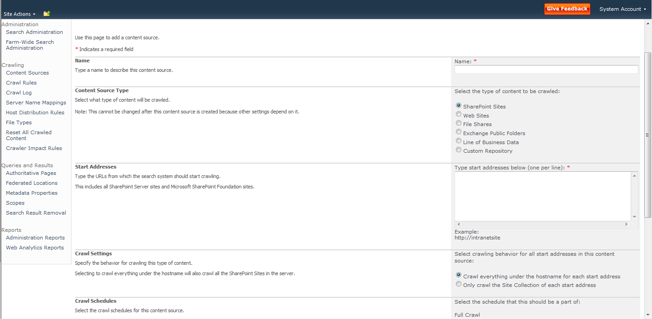

1. Review all of the settings on this page. Experiment with adding different types of content source for your environment.

### Configuring People Search

By default, SharePoint Server 2010 automatically includes user profile details when it crawls the Local SharePoint Sites content source. This indexed user profile data provides the basis for People search in SharePoint Server 2010. However, before people searches yield useful information, you will need to import or create user profiles. Refer to [Post-installation steps for search (SharePoint Server 2010)](http://technet.microsoft.com/en-us/library/ee808863(office.14).aspx) for guidance on working with user profiles, and making other post-installation configuration changes to SharePoint Server 2010.

### Creating Crawl Rules

1. Click **Start>All Programs>Microsoft SharePoint 2010 Products>SharePoint 2010 Central Administration**.
2. In the **Application Management Section**, click **Manage service applications**.
3. Click **Search Service Application**.
4. In the **Quick Launch**, in the **Crawling** section, click **Crawl Rules**.
5. Click **New Crawl Rule**.

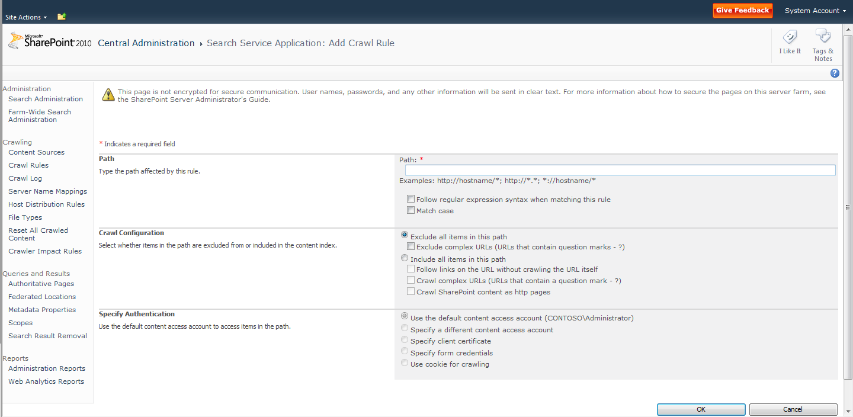

1. Review all of the settings on this page. Experiment with adding different crawl rules for your environment.

### Creating Crawler Impact Rules

1. Click **Start>All Programs>Microsoft SharePoint 2010 Products>SharePoint 2010 Central Administration**.
2. In the **Application Management Section**, click **Manage service applications**.
3. Click **Search Service Application**.
4. In the **Quick Launch**, in the **Crawling** section, click **Crawler Impact Rules**.
5. Click **Add Rule**.

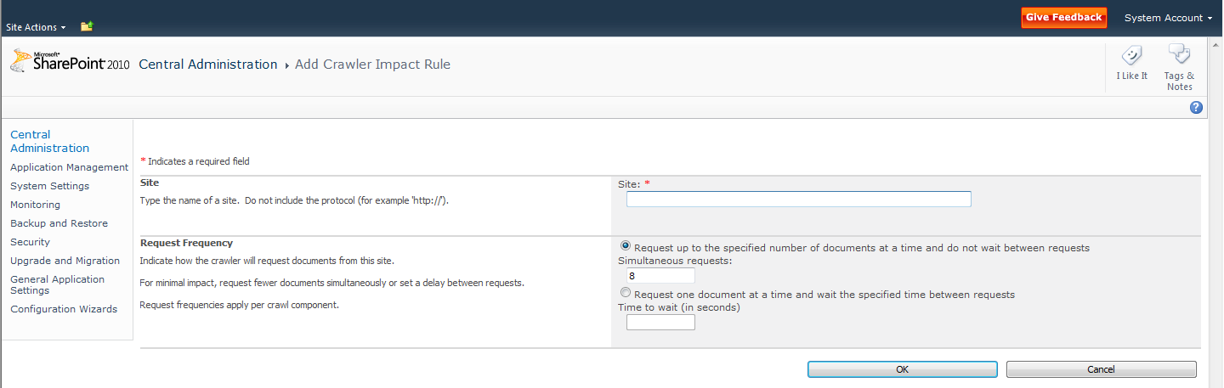

1. Review all of the settings on this page. Experiment with adding different crawler impact rules for your environment.

## Queries and Results Settings

The following step-by-step instructions will help you get started working with queries and results settings.

### Creating Authoritative Pages

1. Click **Start>All Programs>Microsoft SharePoint 2010 Products>SharePoint 2010 Central Administration**.
2. In the **Application Management Section**, click **Manage service applications**.
3. Click **Search Service Application**.
4. In the **Quick Launch**, in the **Queries and Results** section, click **Authoritative Pages**
5. Add a new line and URL in the **Most authoritative pages** box.
6. Add a new line and URL in the **Sites to demote** box.

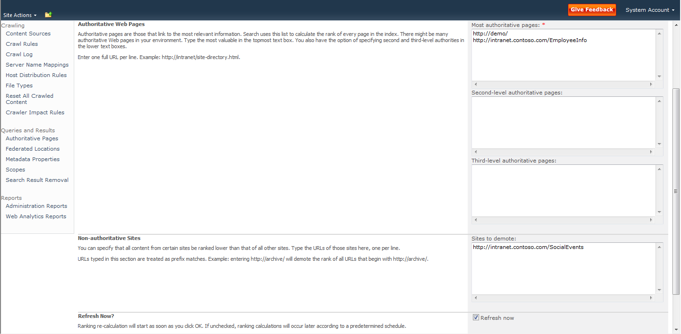

1. Click **OK**.

### Creating Federated Locations

**Note:** This procedure depends on you having created a site based on the Enterprise Search Center site template in one of your site collections.

1. Click **Start>All Programs>Microsoft SharePoint 2010 Products>SharePoint 2010 Central Administration**.
2. In the **Application Management Section**, click **Manage service applications**.
3. Click **Search Service Application**.
4. In the **Quick Launch**, in the **Queries and Results** section, click **Federated Locations**.
5. Click **New Location**.
6. Click the **Online Gallery** link.  
   A web page opens in a new browser window.
7. Click **Federated Search Connectors**.
8. In the **Download Sample Connectors** section, expand the **News** section.
9. Click **Live.com News**.

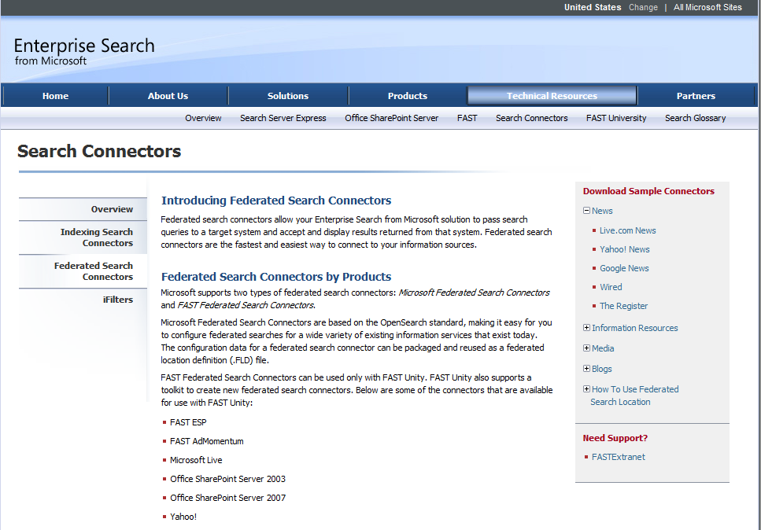

1. Click **Save** and save the **LiveNews.FLD** file to your desktop.
2. Switch back to Central Administration.
3. Click **Import Location**.
4. Click **Browse**.
5. Select the **LiveNews.FLD** file in your **Desktop** folder, and click **Open**.
6. Click **Done**.
7. Start Internet Explorer and browse to your SharePoint site collection. Then browse to your Search Center site.
8. In the search box, type **SharePoint** and press [ENTER].
9. On the **Site Actions** menu, click **Edit Page**.
10. In the **Bottom Zone**, click **Add a Web Part**.
11. In the **Categories** pane, click **Search**.
12. In the **Web Parts** pane, click **Federated Results**.
13. Click **Add**.
14. In the **Bottom Zone**, point to **Top Federated Results**, and then click the dropdown arrow on the Web Part.
15. Click **Edit Web Part**.

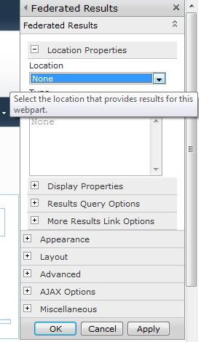

1. In the properties pane for the Web Part, in the **Location** section dropdown list, click **Live News**, and then click **OK**.
2. On the ribbon, click **Save**.

### Creating Metadata Properties

**NOTE**: In this procedure you will create two lists with custom columns. You will then crawl the lists so that their columns are indexed, and then you will create a managed metadata property that maps to columns in the lists.

1. Use Internet Explorer to browse to your SharePoint site.
2. On the site actions menu, click **More Options**.
3. Click **Custom List**.
4. In the **Name** text box, type **Products** and then click **Create**.
5. On the ribbon. Click **List Settings**.
6. Click **Create Column**.
7. In the **Column name** text box, type **Product Name** and then click **OK**.
8. On the site actions menu, click **More Options**.
9. Click **Custom List**.
10. In the **Name** text box, type **SKUs** and then click **Create**.
11. On the ribbon. Click **List Settings**.
12. Click **Create Column**.
13. In the **Column name** text box, type **SKU Name** and then click **OK**.
14. In the **Quick Launch**, click **Products**.
15. Click **Add new item**.
16. In the **Title** text box, type **SharePoint**.
17. In the **Product Name** text box, type **SharePoint Foundation 2010**.
18. Click **Save**
19. In the **Quick Launch**, click **SKUs**.
20. Click **Add new item**.
21. In the **Title** text box, type **SharePoint**.
22. In the **Product Name** text box, type **SharePoint Server 2010**.
23. Click **Save**
24. Click **Start>All Programs>Microsoft SharePoint 2010 Products>SharePoint 2010 Central Administration**.
25. In the **Application Management Section**, click **Manage service applications**.
26. Click **Search Service Application**.
27. In the **Quick Launch**, in the **Crawling** section, click **Content Sources**.
28. Point to **Local SharePoint Sites** and then click the dropdown arrow that appears.
29. Click **Start Full Crawl**.
30. Click **Refresh** until the **Status** column reads **Idle**. This may take a few minutes, depending on the size of your SharePoint sites.
31. In the **Quick Launch**, in the **Queries and Results** section, click **Metadata Properties**.
32. Click **New Managed Property**.
33. In the **Property Name** text box, type **Product**.
34. Click **Add Mapping**.

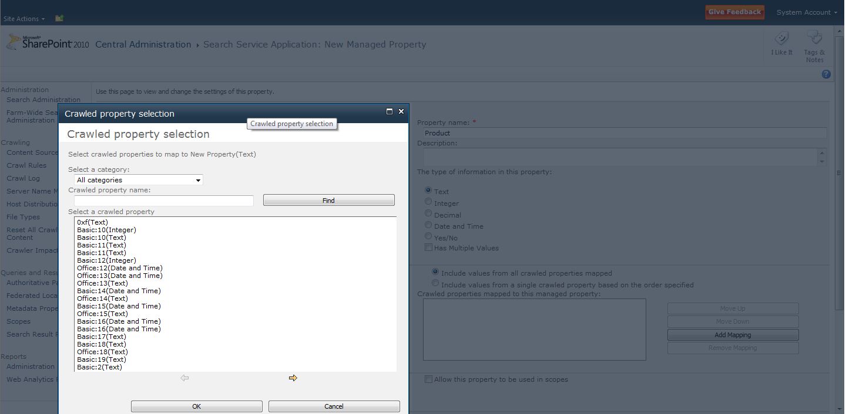

1. In the **Select a category** dropdown list, ensure that **All categories** is selected.
2. In the **Crawled property name** box, type **ows_Product** and then click **Find**.
3. Click the **ows_Product_x0020_Name(Text)** property, and then click **OK**.
4. Click **Add Mapping**.
5. In the **Select a category** dropdown list, ensure that **All categories** is selected.
6. In the **Crawled property name** box, type **ows_SKU** and then click **Find**.
7. Click the **ows_SKU_x0020_Name(Text)** property, and then click **OK**.
8. Check the **Allow this property to be used in scopes** check box.
9. Click **OK**.

## Search Reports

The following step-by-step instructions will help you get started working with search reports.

### Running Administration Reports

1. Click **Start>All Programs>Microsoft SharePoint 2010 Products>SharePoint 2010 Central Administration**.
2. In the **Application Management Section**, click **Manage service applications**.
3. Click **Search Service Application**.
4. In the **Quick Launch** area, in the **Reports** section, click **Administration Reports**
5. Click **Search administration reports**.

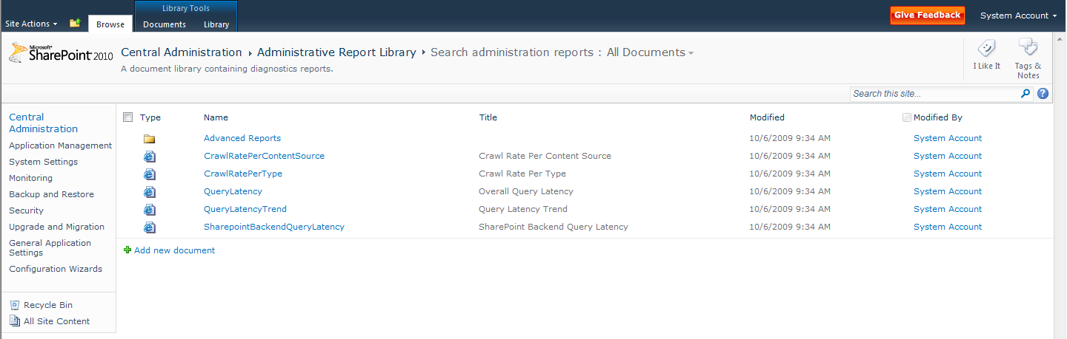

1. Click each of the reports to review the information contained. The following image shows an example of the **Query Latency** report:

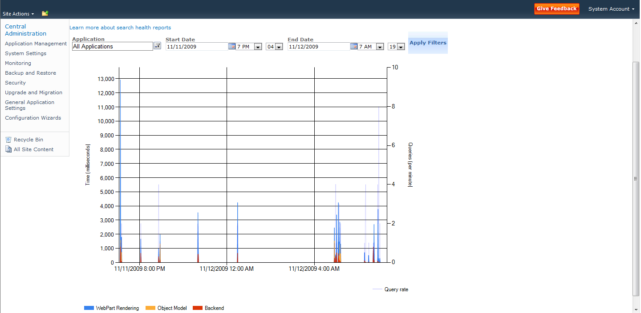

### Running Web Analytics Reports

1. Click **Start>All Programs>Microsoft SharePoint 2010 Products>SharePoint 2010 Central Administration**.
2. In the **Application Management Section**, click **Manage service applications**.
3. Click **Search Service Application**.
4. In the **Quick Launch**, in the **Reports** section, click **Web Analytics Reports**.
5. Click each of the links in the **Quick Launch** area to view the different reports.

## Search Administration at the Site Collection Level

Administrators can use the site collection administration pages to define keywords, Best Bets, synonyms, and definitions. Administrators can also use the site collection administration pages to define search scopes.

**NOTE**: Any settings created or modified at the site collection level affect only that Site Collection

### Creating Enterprise Search Centers

**NOTE**: The following procedure creates a Search Center at the root Web for a Site Collection. This is the generally recommended approach and architecture for creating Search Center sites with SharePoint Server 2010.

1. Click **Start>All Programs>Microsoft SharePoint 2010 Products>SharePoint 2010 Central Administration**.
2. In the **Application Management** section, click **Create site collections**.
3. In the **Web Application** section, use the Web Application changer to select the Web application where you want to create the Search Center.
4. In the **Title** text box, type **Search Center**
5. In the **Description** text box, type **Enterprise Search Center for SharePoint 2010**
6. In the **Web Site Address** section, select **/sites/** in the drop-down list, and then type **search** in the text box.
7. In the **Template Selection** section, click the **Enterprise** tab.
8. Click **Enterprise Search Center**.   
   Note: Do not select *Basic Search Center*, because this template does not include tabs and people search features.
9. In the **Primary Site Collection Administrator** section, type your name in the text box, and then click **Check Names**.
10. Click **OK**.  
    After a short period of time, the site collection is created and the **Top-Level Site Successfully Created** page appears.
11. Click the hyperlink to the new site collection to start exploring Search Center.

### Creating Keywords, Definitions, Best Bets, and Synonyms

1. Browse to the Enterprise Search Center site collection that you created in the previous procedure.
2. On the **Site Actions** menu, click **Site Settings**.
3. In the **Site Collection Administration** section, click **Search keywords**.

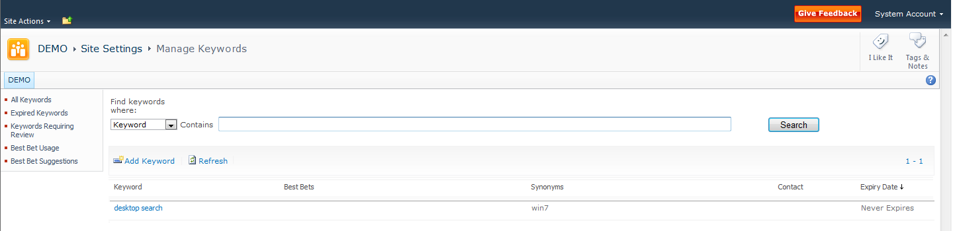

1. Click **Add Keyword**.
2. In the **Keyword Phrase** text box, type **SharePoint**
3. In the **Synonyms** text box, type **SharePoint Foundation; SharePoint Server; Windows SharePoint Services**
4. Click **Add Best Bet**.
5. In the **URL** text box, type **http://www.microsoft.com/sharepoint**
6. In the **Title** text box, type **SharePoint on the Web**.
7. In the **Description** text box, type **SharePoint home page on www.microsoft.com**
8. Click **OK**.
9. Click **Add Best Bet**.
10. In the **URL** text box, type **http://msdn.microsoft.com/sharepoint**
11. In the **Title** text box, type **SharePoint Developer**.
12. In the **Description** text box, type **SharePoint home page on MSDN**
13. Click **OK**.
14. In the **Keyword Definition** text box, type **Collaboration and Search Platform**.

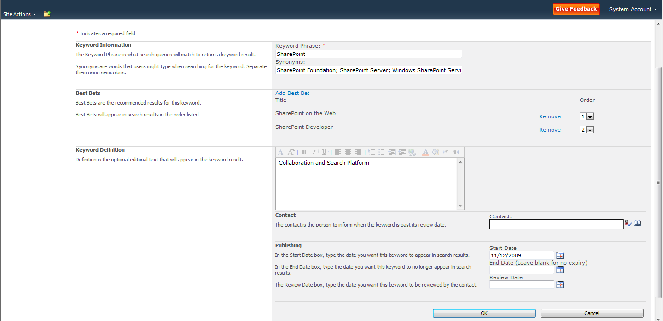

1. Click **OK**.

### Creating Search Scopes

1. Browse to the Enterprise Search Center site collection that you created previously.
2. On the **Site Actions** menu, click **Site Settings**.
3. In the **Site Collection Administration** section, click **Search scopes**.

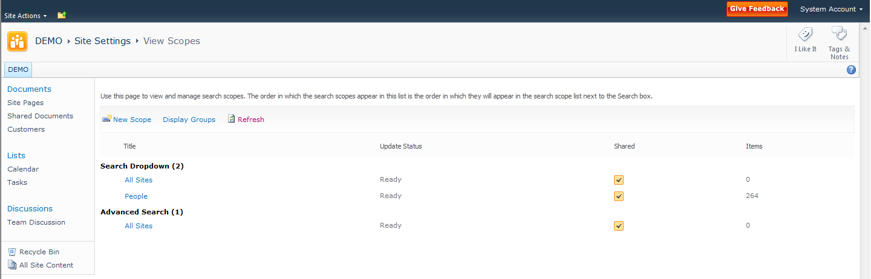

1. Click **New Scope**.
2. In the **Title** text box, type **Admin Docs**
3. In the **Display Groups** section, check all checkboxes.

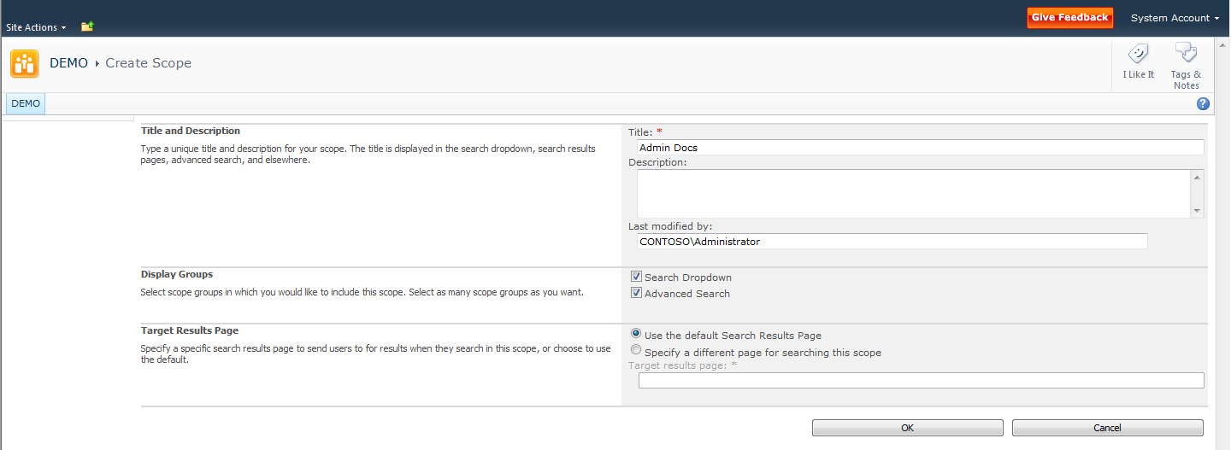

1. Click **OK**.
2. In the **Search** Dropdown section, next to **Admin Docs**, click **Add rules**.
3. In the **Scope Rule Type** section, click **Property Query**.
4. In the **Property Query** section, ensure that **Author** is selected in the dropdown box.
5. In the text box, type your name.

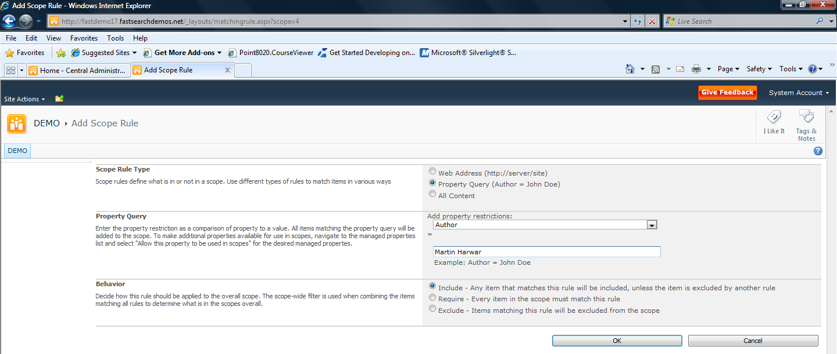

1. Click **OK**.  
   You may be notifies that the scope will be updated in a few minutes. If so, either wait the required number of minutes and then continue at step 18, or perform steps 13 through 17 and then continue at step 18.
2. Click **Start>All Programs>Microsoft SharePoint 2010 Products>SharePoint 2010 Central Administration**.
3. In the **Application Management Section**, click **Manage service applications**.
4. Click **Search Service Application**.
5. In the **System Status** section, next to **Scopes needing updating**, click **Start update now**.
6. Switch back to your SharePoint site collection.
7. Browse to the Search Center site in the site collection.
8. On the **Site Actions** menu, click **Edit Page**.
9. Point to the **Search Box** Web part, and then click the dropdown arrow that appears. Then click **Edit Web Part**.
10. In the properties of the Web Part, expand the **Scopes Dropdown** section.
11. In the **Dropdown mode** dropdown list, select **Show scopes dropdown**.

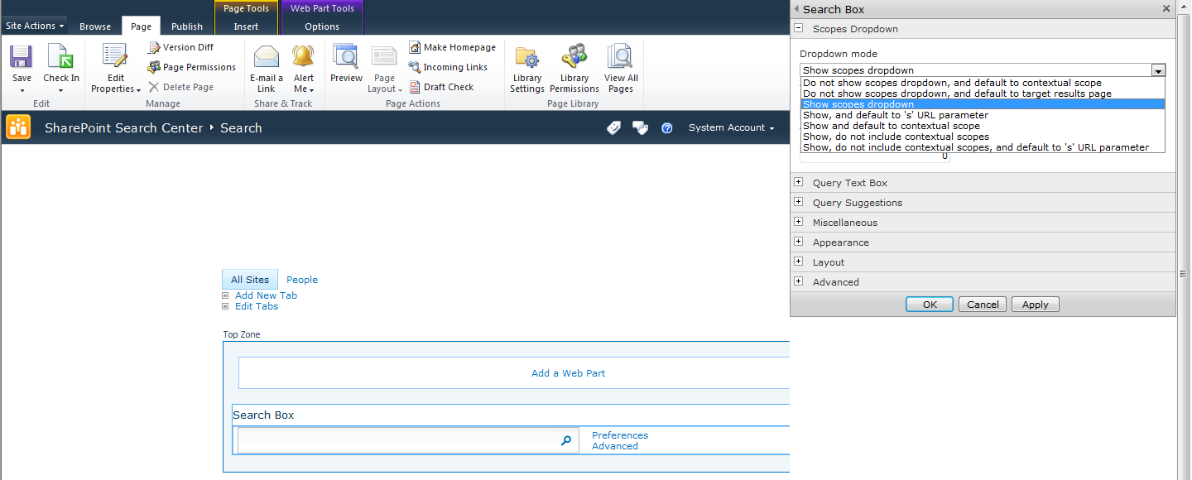

1. Click **OK**.
2. On the ribbon, click **Save**.  
   Note that the scopes dropdown list appears, and that your new **Admin Docs** scope is included in the list.

# Appendix A: Resources Available for Evaluating SharePoint Server 2010

Microsoft encourages you to use the following resources as aids in installing and evaluating SharePoint Server 2010 in addition to this evaluation guide:

* The [product documentation](http://technet.microsoft.com/en-us/library/cc303422(office.14).aspx) on TechNet will help you install SharePoint Server 2010.
* [SharePoint.microsoft.com](http://sharepoint.microsoft.com/) offers a variety of white papers and other resources.
* [MSDN SharePoint Server Developer Center](http://msdn.microsoft.com/sharepoint) contains numerous technical resources from a developer's perspective about Microsoft SharePoint 2010 Products.
* [TechNet](http://technet.microsoft.com/en-us/sharepoint/ee263917.aspx) contains numerous resources on how to deploy, manage, maintain and support SharePoint Server 2010.
* The [Enterprise Search TechCenter](http://technet.microsoft.com/en-us/enterprisesearch/default.aspx) on TechNet has tabs with information about each of the enterprise search products.
* The [Microsoft SharePoint Team Blog](http://blogs.msdn.com/sharepoint/) is the official blog of the SharePoint Product Group.
* The [Microsoft SharePoint Server 2010 Evaluation Guide](http://www.microsoft.com/downloads/details.aspx?displaylang=en&FamilyID=110318ec-0238-4811-8fc7-ec4399d3c100) gives the IT professional an introduction and overview of the SharePoint Server 2010 features that are most pertinent to installing, managing, and configuring the SharePoint farm.
* The [SharePoint 2010 Developer Reviewers Guide](http://www.microsoft.com/downloads/details.aspx?FamilyID=cffb14e8-88a9-43bd-87aa-4792ab60d320&displaylang=en) contains an overview of the extensibility and customization points available for developers.