Windows Connect Now Architecture
WinHEC 2005 Version - April 11, 2005
Abstract
This paper provides information about the Microsoft® Windows® Connect Now architecture for the Microsoft Windows family of operating systems.
This information applies for the following operating systems:
Microsoft Windows codenamed “Longhorn”
Microsoft Windows XP Service Pack 2 (SP2)
The current version of this paper is maintained on the Web at:
http://www.microsoft.com/whdc/
Contents
Introduction 3
Goals and Scenarios 3
New Wireless Network with WCN Support 3
New Device on Existing Network with a Non-WCN Access Point 4
New Device on Existing Network with Non-USB Access Point 4
Wireless Network Setup Wizard Logic Flow 5
Downlevel Support 8
Wireless Network Setup Wizard Architecture 9
LastFlashConfig.wfc 10
Autorun.inf 10
Setupsnk.exe 11
Wsetting.wfc 11
Device Configuration File 11
WCN Support for Devices with no USB Host Ports 12
Wireless Network Setup Wizard Entry Points 12
Hardware Requirements 13
Requirements for USB Flash Drives (UFD) 13
Requirements for WCN-Compliant Devices 13
Firmware and Software Requirements 14
References 14

Disclaimer

This is a preliminary document and may be changed substantially prior to final commercial release of the software described herein.

The information contained in this document represents the current view of Microsoft Corporation on the issues discussed as of the date of publication. Because Microsoft must respond to changing market conditions, it should not be interpreted to be a commitment on the part of Microsoft, and Microsoft cannot guarantee the accuracy of any information presented after the date of publication.

This White Paper is for informational purposes only. MICROSOFT MAKES NO WARRANTIES, EXPRESS, IMPLIED OR STATUTORY, AS TO THE INFORMATION IN THIS DOCUMENT.

Complying with all applicable copyright laws is the responsibility of the user. Without limiting the rights under copyright, no part of this document may be reproduced, stored in or introduced into a retrieval system, or transmitted in any form or by any means (electronic, mechanical, photocopying, recording, or otherwise), or for any purpose, without the express written permission of Microsoft Corporation.

Microsoft may have patents, patent applications, trademarks, copyrights, or other intellectual property rights covering subject matter in this document. Except as expressly provided in any written license agreement from Microsoft, the furnishing of this document does not give you any license to these patents, trademarks, copyrights, or other intellectual property.

Unless otherwise noted, the example companies, organizations, products, domain names, e-mail addresses, logos, people, places and events depicted herein are fictitious, and no association with any real company, organization, product, domain name, email address, logo, person, place or event is intended or should be inferred.

© 2005 Microsoft Corporation. All rights reserved.

Microsoft, Windows, and Windows NT are either registered trademarks or trademarks of Microsoft Corporation in the United States and/or other countries.

All other trademarks are property of their respective owners.
Introduction
With the growing popularity of wireless networking, more users are creating wireless networks in their home and connecting PCs and other wireless devices. Creating a secure wireless network and propagating the wireless settings to wireless clients and additional access points is difficult for even the most knowledgeable user.
Windows Connect Now (WCN) is designed to address the growing need for a simple yet secure method of configuring and bootstrapping wireless networking hardware (access points) and wireless clients, including PCs and other devices.
- The WCN architecture defines a method for easily bootstrapping network devices on a home network.
- Portable media is used to transport network settings from a Windows-based PC to networked devices in the home (USB flash drives).
- The WCN architecture is complementary to but not dependent on WS-Security. There is no dependency on UPnPv1 Security or Radius Authentication.

The Wireless Network Setup Wizard in Windows XP Service Pack 2 uses WCN as a means for a Windows user to easily create and propagate network settings using XML schema and portable media.
This paper provides information about Windows Connect Now (WCN) for the Microsoft® Windows® family of operating systems. For information about licensing this technology, please send email to fconfig@microsoft.com.

Goals and Scenarios
The goals of WCN are to improve consumer experience with Windows and wireless networking and to take advantage of the growing popularity of USB flash drives (UFD) and the broad adoption of USB host ports on consumer electronics devices such as the following:
Wireless access points | Digital media receivers
PCs | Electronic picture frames
Network printers | Set-top boxes
Printer bridges | PDAs
Photo stations | Digital still cameras

The rest of this section describes the key scenarios enabled through WCN support.

New Wireless Network with WCN Support
Jane Doe wants to create a home wireless network. She purchases a new combination residential gateway/wireless access point (RG/WAP) with 802.11a/b/g. She brings the new device home and installs it in place of her existing router.
Jane runs the Wireless Network Setup Wizard on her Windows XP PC, which is connected to the RG/WAP over Ethernet on the LAN side. The wizard automatically creates a new SSID and 104-bit HEX WEP key for Jane and allows her to override these unique default settings. When the wizard finishes, it prompts Jane to plug a USB flash drive (UFD) into her PC. The settings are transferred to the drive and Jane is instructed to plug the UFD into her wireless access point and wireless clients and then return to the PC. Jane plugs the UFD into her access point, which flashes the LEDs three times to acknowledge successful configuration.
Jane then plugs the UFD into her wireless laptop. The wizard automatically runs and asks Jane if she would like to add this PC to the “Doe” wireless network. Jane accepts, a wireless profile is created on her PC, and her PC is immediately associated with the wireless access point. Jane returns to the original PC and plugs the UFD back in. The wizard notifies her that an access point and PC have successfully been configured and asks her if she would like to remove the network key information from the UFD.

New Device on Existing Network with a Non-WCN Access Point
Jane wants to add a new PC and wireless printer to her existing wireless network. She returns home with the new hardware. This is the first time Jane has run the Wireless Network Setup Wizard on this network. She runs the wizard from a PC in her den that is connected to her existing access point over a wired Ethernet connection. The wizard prompts Jane for the name of her network (SSID). Jane types in the SSID of her existing wireless network. The wizard asks Jane if she would like to provide the network key or if Windows should generate a strong key for her. Jane chooses to manually enter the key for her existing wireless network. The wizard then prompts Jane to save the settings to her UFD.
Jane plugs in her new wireless printer and laptop. She plugs the UFD into her new printer, which flashes the LEDs three times to notify her that it has accepted the settings. Jane then plugs the UFD into her new laptop, which displays a screen asking her if she would like to join the wireless network. Jane agrees; the laptop configures itself and notifies her that she can remove the UFD. Jane then plugs the UFD back into her PC in the den and is presented with a list of all of the devices that were configured. The wizard removes the network settings from the UFD unless Jane chooses to override this setting.
From now on, when the wizard is run from the den PC or the new laptop, Jane does not need to enter the wireless settings into the wizard unless she changes her wireless settings on the access point. She can simply select the option to write the settings to a UFD so she can provision new PCs or devices.

New Device on Existing Network with Non-USB Access Point
Jane wants to add a new PC and wireless printer to her existing wireless network. She returns home with the new hardware. Jane runs the Wireless Network Setup Wizard from her PC in her den that is connected to her existing access point over a wired Ethernet connection. The original access point setup wrote a LastFlashConfig.wfc file. The wizard detects the LastFlashConfig.wfc file present on Jane’s computer and prompts Jane to create a WCN key for her existing “Doe” wireless network. Jane agrees and the wizard then prompts Jane to save the existing wireless settings to her UFD.
Jane plugs in her new wireless printer and laptop. She plugs the UFD into her new printer, which flashes the LEDs three times to notify her that it has accepted the settings. Jane then plugs the UFD into her new laptop, which displays a screen asking her if she would like to join the wireless network. Jane agrees; the laptop configures itself and notifies her that she can remove the UFD. Jane then plugs the UFD back into her PC in the den and is presented with a list of all of the devices that were configured. The wizard removes the network settings from the UFD unless Jane chooses to override this setting.
From now on, when the wizard is run from the den PC or the new laptop, Jane does not need to enter the wireless settings into the wizard unless she changes her wireless settings on the access point. She can simply select the option to write the settings to a UFD so she can provision new PCs or devices.

Wireless Network Setup Wizard Logic Flow

Downlevel Support
The Wireless Network Setup Wizard runs only on Windows XP SP2 and later versions. The wizard copies a configuration application to the UFD. This application automatically runs if the UFD device enumerates as DRIVE_FIXED or if the computer is running Windows XP SP2. The application creates a wireless profile on Windows XP SP2-based machines and provides the user with an option to print the settings on computers running Windows 98 through Windows XP SP1.
The following table describes the behavior on different Windows operating systems using UFDs that enumerate as DRIVE_FIXED and DRIVE_REMOVEABLE.
Windows version | Drive type | Result
Windows XP SP2 | DRIVE_FIXED | Autoplay lists Wireless Setup Wizard as first option.
Windows XP (pre SP2) | DRIVE_FIXED | Autorun runs Setupsnk.exe automatically
Windows 2000 | DRIVE_FIXED | Autorun runs Setupsnk.exe automatically
Windows Me | DRIVE_FIXED | Autorun runs Setupsnk.exe automatically
Windows 98 | DRIVE_FIXED | Autorun runs Setupsnk.exe automatically
Windows XP SP2 | DRIVE_REMOVABLE | Autoplay lists Wireless Setup Wizard as first option.
Windows XP (pre SP2) | DRIVE_REMOVABLE | Autorun does not run
Windows 2000 | DRIVE_REMOVABLE | Autorun does not run
Windows Me | DRIVE_REMOVABLE | Autorun does not run
Windows 98 | DRIVE_REMOVABLE | Autorun does not run

The wizard offers the user an opportunity to print the network settings for the wireless profile it created. The information is displayed in Notepad.
Wireless Network Settings

Print this document and store it in a safe place for future reference. You may need these settings to add additional computers and devices to your network.

Wireless Settings

Network Name (SSID):
Network Key (WEP Key):
Key Provided Automatically (802.1x):
Network Authentication Type:
Data Encryption Type:
Connection Type:
Key Index:

To enable File and Print sharing on this computer, run the Network Setup Wizard

To set up your Internet connection, follow the instructions from your Internet Service Provider (ISP)

Wireless Network Setup Wizard Architecture
The wizard generates XML files on the UFD in the “SMRTNTKY” subfolder. The wizard copies an Autorun.inf file and a corresponding script file to configure additional wireless PCs. Each device that is configured generates an XML file that contains configuration information for that device to the drive in the “\SMRTNTKY\DEVICE\” subfolder. The file name is generated by each device using the last 4 bytes of the MAC address and ASCII-HEX (for example, A30f3cd6.wfc). The PC running the wizard generates a device configuration file.
- Autorun.inf – Configuration file used to tell drive to launch the wizard. Autorun.inf executes only if the media enumerates as a fixed drive or the operating system is Windows XP SP2 or later. (Windows XP SP2 supports AUTORUN on any media type).
If an existing Autorun.inf file is present on the drive, it is renamed Autorun.fcb temporarily and then renamed back to Autorun.inf when the drive is reinserted at the end of the wizard, if the user chooses to remove the settings from the drive.
- Setupsnk.exe – Executable file that runs when the UFD is installed in client PCs.
- \SMRTNTKY\Wsetting.wfc – Wireless LAN settings.
- \SMRTNTKY\DEVICE\A023ef83.wfc – Device configuration file. Each device that is configured using WCN creates an XML file whose file name is based on the MAC address of the wireless network adapter (8- character ASCII-HEX representation of the MAC address). The XML file contains configuration information about the device.
- \SMRTNTKY\Wsetting.txt – Text file that describes the process for configuration of wireless settings when the SETUPSNK.EXE file is run on downlevel PCs.

LastFlashConfig.wfc
The wizard looks for this file on the PC when it is first run. If this file is present, the user is prompted to either add a new device to the existing network defined in the LastFlashConfig.wfc file or create a new one, as shown in the following wizard screen.
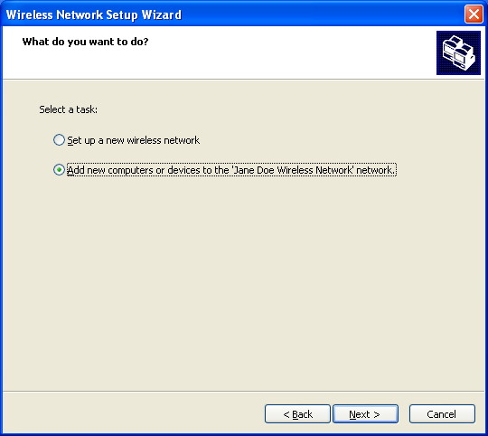
In this example, the file LastFlashConfig.wfc was present in the folder C:\Documents and Settings\< user >\Application Data\Microsoft\. The file is a duplicate of the WSetting.wfc file that was created when the wizard was last run. This file is encrypted using the Windows Crypto APIs. The file is stored in a subfolder in the user’s personal file folder. Only the user who ran the wizard is allowed to propagate the settings. The LastFlashConfig.wfc file is created on any computer that is provisioned by the WCN Wizard. Therefore, any computer that has been provisioned can be used to propagate the settings to other PCs or devices.

Autorun.inf
The Autorun.inf file is created on the root of the portable media. This configuration file tells the operating system which application to execute when the media is inserted. On versions of Windows earlier than Windows XP SP2, if the media is not DRIVE_FIXED, Autorun.inf does not work and the user must run the script file manually.

Setupsnk.exe
The Setupsnk.exe file is created in the root of the portable media. This application is run by the Autorun.inf file when the portable media is installed on subsequent PCs. For Windows XP SP2, this application creates a wireless profile to match the schema on the portable media. For any other operating system, this application offers to print the wireless settings. If the drive does not enumerate as DRIVE_FIXED, this application will not execute on non-Windows XP SP2-based computers.

Wsetting.wfc
The Wsetting.wfc file describes the wireless settings of an access point or wireless client device. Various elements in the XML schema that are not required for a wireless client can be used by an access point. The XML schema contains all known configuration options for access points, but not all configuration options might be supported.

Device Configuration File
Each device that is configured using WCN writes a configuration file (.wfc) back to the UFD. The device configuration file name is generated by using the MAC address of the device that is being configured. Using the MAC address for the file name makes it highly likely that the filename is unique.
When the wizard is complete, it lists all of the devices that have been configured, based on device configuration files in the /SMRTNTNY/DEVICE folder.
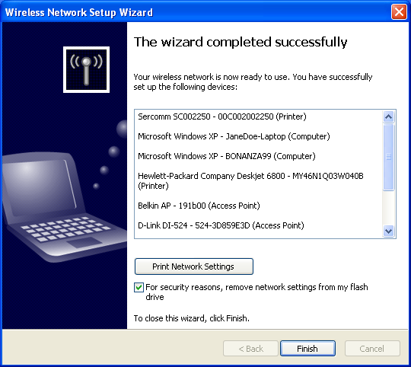

WCN Support for Devices with no USB Host Ports
It is possible to support WCN for provisioning of wireless clients when the wireless networking devices (access points) do not support USB host ports. Configuration of the PC and access point must be done using a third-party proprietary configuration mechanism that creates the LastFlashConfig.wfc file, as described in "Goals and Scenarios" earlier in this paper.
When the WCN wizard runs it looks for the presence of this file. If this file is found, the wizard recommends adding additional devices to the existing wireless network as opposed to creating a new wireless network. A redistribution license agreement for SetupSNK.exe is also available.

Wireless Network Setup Wizard Entry Points
The Wireless Network Setup Wizard can be launched from a variety of different locations in Windows.
There are two links in the Network and Internet Connections folder in Control Panel:
- A task under “Pick a task…”
- An icon under “…pick a Control Panel icon”

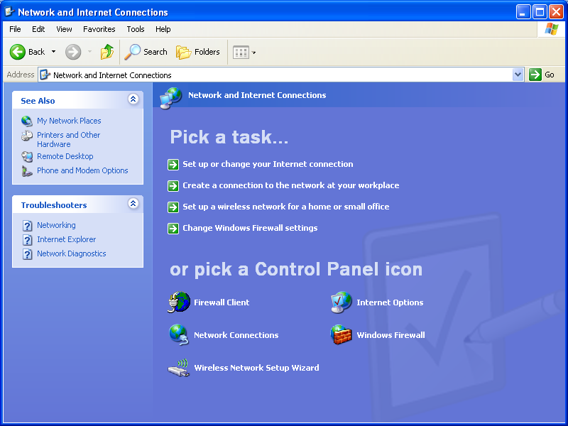
There is also a task link in the View Available Wireless Networks page – “Set up a wireless network for a home or small office”, as shown in the following screen.
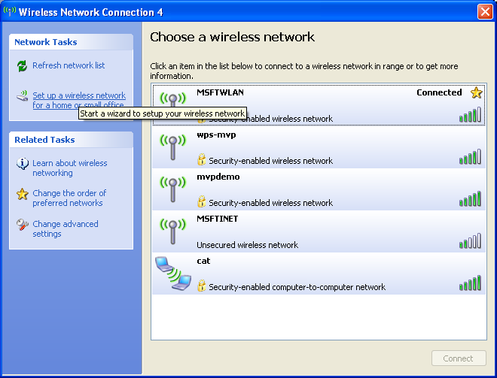

Hardware Requirements
WCN-compliant devices and software must support the features listed in this section.

Requirements for USB Flash Drives (UFD)
WCN-compliant devices should work with a variety of USB flash drives (UFDs) to ensure compatibility. To date, many variations of UFDs have a variety of different characteristics (drive type, master boot record, capacity, and so on). The following list is the recommended configuration for a UFD to maintain broad compliance with WCN devices:
Configuration | Value
USB Interface Class | 0x8
USB Mass Storage Subclass | 0x6
USB Interface Protocol | 0x50
USB Mass Storage INQUIRY RMB Bit value | 0x1
Raw capacity | Between 200KB and 10GB
File system | FAT 16/32
Master boot record | Present
Maximum current sink | 150mA
Partition | Single

Requirements for WCN-Compliant Devices
WCN-compliant devices must support the following hardware requirements to maintain compliance with the WCN licensing agreement and ensure interoperability with WCN implementations in Windows and UFD devices:
- Easily accessible USB host port (USB version 1.1 or higher)
- Support WPA-PSK 64-byte HEX network keys
- Support standard UFDs with the following characteristics:
Configuration | Value
USB Mass Storage Subclass | 0x6
USB Interface Protocol | 0x50
USB Mass Storage INQUIRY RMB Bit value | 0x1 or 0x0
Raw capacity | Between 200KB and 10GB
File system | FAT12, FAT16, or FAT32 format
Master boot record | Present or absent
- Source up to 200mA on USB host port
- Support UFDs with multiple partitions. The WCN device should scan each partition of the UFD looking for the WCN configuration files.

Firmware and Software Requirements
WCN-compliant devices must be able to understand and parse the XML configuration files stored on the UFD. Additionally, devices must write an XML configuration file back to the UFD confirming a successful configuration or providing an explanation for a failure.
The Windows Wireless Network Setup Wizard will not confirm any device that writes a configuration file that does not conform to the device configuration schema. If a WSETTING.WFC file does not conform to the schema, the wizard ignores the file and cannot successfully create a wireless profile.

References
Next Steps
- For system manufacturers: Promote WCN as a simple secure method to configure a wireless network.
- For device manufacturers: License WCN and support this technology in your network devices.
Please send email to fconfig@microsoft.com to find out more about our licensing terms and to receive a complete WCN specification.
- If you have questions about Windows Connect Now, send email to fconfig@microsoft.com

Resources
Microsoft Hardware and Driver Central
Includes Windows Driver Development Kits (DDK] and Windows Logo Program requirements
http://www.microsoft.com/whdc/default.mspx
Networking and Communications on WHDC
http://www.microsoft.com/whdc/device/network/default.mspx

