Windows Driver Testing Best Practices
October 28, 2004
Abstract
This paper makes recommendations for configuring and managing systems that are used for testing drivers for the Microsoft® Windows® family of operating systems.
Contents
Introduction 3
Configuring Hardware for Testing 3
Kernel Debugger Setup 3
Hardware for the Test Lab Debugger System 3
Software for the Debugger System 4
Test System Configuration 5
Installing Software on Test Systems 5
Checked Builds vs. Free Builds 5
Testing Against Different HALs 6
Automation 6
Enabling the Debugger for Setup 6
Enabling Driver Verifier Before Setup 7
Enabling Driver Verifier when Running from CD 8
Manually Enabling Driver Verifier during Setup 8
Additional Automation with Unattend.txt 8
Using the Winnt32 /m: Switch 9
Testing After Installation 9
Manual testing 9
Testing Behind Bridges 10
PCI Expansion Bridge Box 10
Bridge Riser Adapters 11
Bridge Box in Action 11
Plug and Play Driver Test (Pnpdtest) 11
Testing Driver Installation Packages 12
HCT Kits 12
Sample Test Matrix 12
Internal Test Software 13
Lab Automation 13
KVM over IP 13
Remote Desktop 13
Virtual Server 14
Resources 14

Disclaimer
This is a preliminary document and may be changed substantially prior to final commercial release of the software described herein.

The information contained in this document represents the current view of Microsoft Corporation on the issues discussed as of the date of publication. Because Microsoft must respond to changing market conditions, it should not be interpreted to be a commitment on the part of Microsoft, and Microsoft cannot guarantee the accuracy of any information presented after the date of publication.

This White Paper is for informational purposes only. MICROSOFT MAKES NO WARRANTIES, EXPRESS, IMPLIED OR STATUTORY, AS TO THE INFORMATION IN THIS DOCUMENT.

Complying with all applicable copyright laws is the responsibility of the user. Without limiting the rights under copyright, no part of this document may be reproduced, stored in or introduced into a retrieval system, or transmitted in any form or by any means (electronic, mechanical, photocopying, recording, or otherwise), or for any purpose, without the express written permission of Microsoft Corporation.

Microsoft may have patents, patent applications, trademarks, copyrights, or other intellectual property rights covering subject matter in this document. Except as expressly provided in any written license agreement from Microsoft, the furnishing of this document does not give you any license to these patents, trademarks, copyrights, or other intellectual property.

Unless otherwise noted, the example companies, organizations, products, domain names, e-mail addresses, logos, people, places and events depicted herein are fictitious, and no association with any real company, organization, product, domain name, email address, logo, person, place or event is intended or should be inferred.

© 2004 Microsoft Corporation. All rights reserved.

Microsoft, Windows, and Windows NT are either registered trademarks or trademarks of Microsoft Corporation in the United States and/or other countries.

The names of actual companies and products mentioned herein may be the trademarks of their respective owners.

Introduction
Thorough testing is essential to development of robust and reliable Windows drivers. This paper describes testing processes that driver developers can apply to achieve better test coverage for their drivers using available tools from Microsoft.

Configuring Hardware for Testing
A typical testing configuration includes one or more test computers with the hardware and driver to be tested and a debugger system used to debug the driver on each test computer. One debugger system can be used to debug multiple test systems.
This section makes recommendations for the hardware and software you need for each computer in your testing configuration.

Kernel Debugger Setup
This section presents recommendations for setting up hardware and software for the kernel debugger (KD).

Hardware for the Test Lab Debugger System
The chief consideration for selecting the hardware for a debugger system is the number of systems that you are debugging at one time. The debugger system must have enough memory to support the number of debug sessions you expect to be running. For example, a typical debug session running KD.exe, Remote.exe, and Cmd.exe might need 12MB of memory (swapped or physical), and possibly more depending on the buffer size you set for your debug sessions.
The debugger system can be a laptop or any desktop machine that has a serial port. A standard laptop is sufficient to debug one or two test systems, depending on the number of serial or IEEE 1394 ports it has. If you plan to use a single debugger system to debug multiple test systems, you can use a multiport serial device on the debugger system.
For optimal performance, consider the following suggestions:
- Select a multiprocessor system with a minimum of 256 MB RAM to support running multiple remote sessions.
- Disable the onboard serial port for ease of setup.
- For a lab environment, configure the debugger system as a multihomed system for access to both the corporate network and test systems on the lab network. This will allow testers to use VPN or remote access to manage systems in the test lab.
For example, the following figure shows debug system with a dual-channel PCI serial Rocket Port and a 16-port paddle. The dual-channel PCI adapter could handle another 4-port, 8-port, or 16-port paddle.
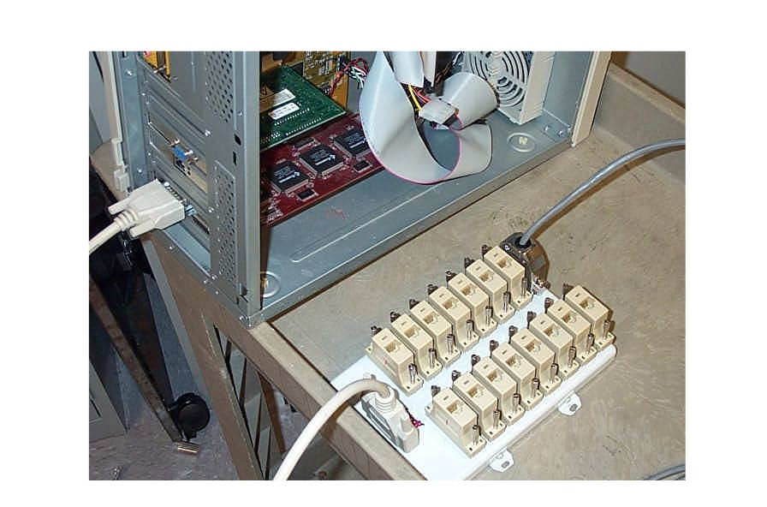
A serial port has several advantages over IEEE 1394 for debugging, such as:
- Serial hardware such as port control adapters and multi-port paddles are widely available.
- It is possible to debug multiple test systems, depending on the configuration of port control adapters on the debug system and the paddles attached to each control adapter. In theory, a debugger that has four 32-port control adapters with two 16-port paddles attached to each control adapter can control 128 test systems.
- You can debug a prototype system over the serial port. Debugging a prototype system might not work over an IEEE 1394 port, especially if you are testing sleep state transitions.

Software for the Debugger System
The Microsoft Windows Server™ 2003 operating system is recommended for running multiple debugger sessions, because this operating system is optimized for background operations and memory management. It also provides licenses for multiple connections across a network.
You will need to install the latest version of Debugging Tools for Windows as well as symbols and any scripts you need for automation. For availability of these tools and Windows symbols, see "Resources" at the end of this paper.
Additionally, you will need to write a script such as the following example to launch multiple kernel debugger sessions.
cd /d d:\debug
Set _NT_ALT_SYMBOL_PATH=d:\private
Set_NT_SYMBOL_PATH=SRV*d:\websymbols*http://msdl.microsoft.com/download/symbols
Set _NT_DEBUG_BAUD_RATE=115200
For /L %%f in (1,1,6) do (set _NT_debug_port=\\.\com%%f) &&
(start cmd /k d:\debug\remote.exe /s "kd -v" X86TESTCOM%%f)
For /L %%f in (7,1,10) do (set _NT_debug_port=\\.\com%%f) &&
(start cmd /k d:\debug\remote.exe /s "kd -v" IA64TESTCOM%%f)

Notes on example script
- In this example, the first line changes the default directory to the location where debug setup data is stored.
- In this example, d:\private is the location used for private symbols.
- The script sets the baud rate to 115200, which works well with both Microsoft Windows XP and Windows Server 2003.
- The last two lines of this script set up the debug port for x86-based and Intel Itanium-based systems, respectively.

Test System Configuration
Each test computer should have two hard disks, one for a test build and one for a safe build. If two hard disks are not available, you should at least use a disk large enough to accommodate two partitions, one for the test build and one for the safe build.
- The test build disk or partition contains the operating system and other software being tested.
- The safe build disk or partition contains a version of a released operating system and is used to store scripts. This configuration can be used to:
- Set up and restore the system in a separate operating system in order to prepare for the next test series.
- Perform regression testing against an earlier version of the operating system when you are testing pre-beta and beta operating systems.

Caution: If the test system is on a network, be sure to keep it secure with antivirus software and other standard precautions. The best practice is to keep the system off the corporate network and especially to isolate the system from the Internet.

Installing Software on Test Systems
To achieve good testing coverage, you will need to test your driver on both checked and free builds of Windows and on different HALs in both ACPI and non-ACPI mode, with the debugger and Driver Verifier enabled. This section discusses what software to install and how to automate setup to save time during testing.

Checked Builds vs. Free Builds
Checked builds (debug builds) and checked drivers should encompass most of the testing scenarios when testing device drivers. In a checked build:
- Optimizations are disabled, which makes disassembled machine instructions easier to understand.
- Asserts and breakpoints are unmasked, which helps identify internal inconsistencies and problems as soon as they occur.

It is especially important to test with checked builds during early development, even though such builds are larger and slower and take longer to install. The performance limitations of checked builds are a small price to pay for the greater effectiveness they give to your testing efforts.
Free builds can be run when entering major milestones. In a free build:
- Full compiler optimizations are enabled.
- Asserts and breakpoints are masked.

If you have enough test machines, you can simultaneously run the same tests on both checked builds and a smaller number of free builds. Later in the development cycle, use only the free build with Driver Verifier enabled, and gradually reduce the use of Driver Verifier to catch any timing issues that might surface when Driver Verifier is not running.

Testing Against Different HALs
Drivers should be tested against all hardware abstraction layer (HAL) types under both checked and free builds of the operating system. It is also important to test in non-ACPI mode because of the differences in APICs and routing on different systems:
- On x86 ACPI systems, you can manually put the system into non-ACPI mode, either through Txtsetup.sif prior to starting an install or during text mode setup.
- To force the operating system to install a non-ACPI HAL using Txtsetup.sif, set the value of ACPIEnable to zero, as follows:
Default=
ACPIEnable=2
Modified=
ACPIEnable=0
- To force the operating system to install a non-ACPI HAL during setup, press F5 during text mode setup and choose Standard HAL.

Only one HAL is available on 64-bit operating systems, HALIA64 for Intel Itanium-based systems and HALX64 for x64-based systems. It is not possible to use the acpi= section statement in Txtsetup.sif to disable ACPI functionality.

Automation
Automating setup is a great time saver during testing, especially if you are testing with multiple machines. Although there are always scenarios where full automation might not work for your testing, some areas that can be automated include:
- Enabling the debugger for setup.
- Testing a driver through setup.
- Enabling Driver Verifier through graphical user interface (GUI) portion of setup.
- Using Unattend.txt files.

Enabling the Debugger for Setup
In checked builds the default setting is for the /debug switch to be enabled during text mode setup. For reliability or for IEEE 1394 debugging, you should also manually specify the port and baud rate by editing either Txtsetup.sif or Unattend.txt.
Txtsetup.sif. When you are installing the operating system from a network share, you can enable the debugger by editing Txtsetup.sif in one of these ways, before rebooting into text mode setup:
- If you have write access to the network share, edit Txtsetup.sif on the share so that debugging is always enabled.
- Copy Txtsetup.sif to the local machine and edit it there before running Winnt32 or Setup.exe.
- Launch Winnt32 with the /noreboot switch, then edit Txtsetup.sif after Winnt32 has copied the files to the local drive but before it begins installing the operating system.
The Txtsetup.sif changes include:
Default on x86chk builds:
SetupDebugOptions = "/debug"
OsLoadOptions = "/fastdetect /noguiboot /debug"

Modified on x86chk builds:
SetupDebugOptions= "/debug /debugport=comx /baudrate=x
OsLoadOptions = "/fastdetect /noguiboot /debug /debugport=comx /baudrate=x"

Modified for IEEE 1394:
SetupDebugOptions="/debug /debugport=1394 /CHANNEL=x"
OsLoadOptions = "/debug /debugport=1394 /CHANNEL=x"
Note: If you modify Txtsetup.sif, you do not need to modify Unattend.txt.
Unattend.txt. A default Unattend.txt can be found in the SKU-specific directory (I386, IA64, AMD64) on the CD. If you edit Unattend.txt, you should add a section like this one. (This will enable the debugger only when the Setup program enters GUI mode setup):
[SetupData]
Osloadoptions=“"/debug /debugport=comx /baudrate=115200
For information about the Unattend.txt file, see the related Windows Resource Kit or the OEM Pre-Installation Kit for the version of Windows you are using for testing.

Enabling Driver Verifier Before Setup
To enable Driver Verifier before Setup, you must manually edit Hivesys.inf on the local test machine. To do so, launch Winnt32 with the /noreboot switch. For example:
\\myserver\release\SKU\i386\winnt32 /noreboot
After Winnt32 has finished copying files locally, open a command window and navigate to the drive where you have stored the local setup files. Hivesys.inf will be stored in one of the following folders, depending on the hardware platform:
- $winnt$.~ls\i386
- $winnt$.~ls\ia64
- $winnt$.~ls\amd64
The easiest way to determine the Driver Verifier settings is to enable Driver Verifier after setup, choosing different levels of verification. Then, check the SessionManager key in the registry for a corresponding value that you can save and add in for setup.
The following registry example enables standard Driver Verifier settings on all drivers:
HKEY_LOCAL_MACHINE,"SYSTEM\CurrentControlSet\Control\Session Manager\Memory Management","VerifyDriverLevel",0x00010001,251
HKEY_LOCAL_MACHINE,"SYSTEM\CurrentControlSet\Control\Session Manager\Memory Management","VerifyDrivers",0x00000000,"*“

The following example enables standard Driver Verifier settings on one driver:
HKEY_LOCAL_MACHINE,"SYSTEM\CurrentControlSet\Control\Session Manager\Memory Management","VerifyDriverLevel",0x00010001,251
HKEY_LOCAL_MACHINE,"SYSTEM\CurrentControlSet\Control\Session Manager\Memory Management","VerifyDrivers",0x00000000," mytestdriver.sys"

Caution: If you make mistakes in editing the registry, the system will crash when you restart it.

Enabling Driver Verifier when Running from CD
If you are booting the system from a CD (El Torito boot), you must manually edit the System.sav registry file during GUI mode setup and then restart the system. For details, see "Manually Enabling Driver Verifier During Setup" later in this paper.
If you are performing an operating system upgrade or full installation from CD over an existing operating system, follow the steps in "Enabling Driver Verifier Before Setup" earlier in this paper.

Manually Enabling Driver Verifier during Setup
To enable Driver Verifier during setup, use Regedit.exe at the beginning of the graphical user interface (GUI) portion of Setup to manually add the following keys to the System.sav hive. Then restart the system to return to Windows Setup.
[HKEY_LOCAL_MACHINE\SYSTEM\CurrentControlSet\Control\Session Manager\Memory Management]
String Value: “VerifyDrivers”
Type: Reg_SZ
Valuedata: * for all, or the name of your driver
Dword Value: “VerifyDriverLevel”
Type: REG_Dword
ValueData: Either use HEX or decimal format

Additional Automation with Unattend.txt
The following example shows some sections that you can add to Unattend.txt to help automate the setup process.
[setupdata]
Osloadoptions="you can add debug settings or boot switches"

[Terminalservices]
allowconnections="1"

[Unattended]
OEMPnPDriversPath = "drivers\audio;drivers\net "
Oempreinstall="yes"

[Guirunonce]
"c:\myscript.cmd"
Notes:
- The [Terminalservices] entry enables remote desktop access.
- The [Unattended] entry provides a path to additional drivers for Setup.
- The [Guirunonce] entry can be set to run scripts on the system or on a UNC path, for example, to run some kind of test, install anti-virus software, or set up for the day’s testing.

Using the Winnt32 /m: Switch
The Winnt32 /m: switch specifies a folder that contains drivers and other binary files that you want installed instead of the corresponding files that are in the default installation folder. The /m: switch can be used to automate Setup in conjunction with the methods discussed earlier in this paper. The /m: switch is easier to use than the OEMPnPDriversPath variable that you specify in Unattend.txt, especially if you are testing a newer, signed version of an in-box driver or other binary file. Driver files in the specified folder must be signed.
This switch works with both local and UNC paths. The syntax is as follows:
Winnt32 /m:c:\test
Winnt32 /m:\\myshare\share

Sample Setup Script
del c:\test\*.* /s/q
call format d: /q /v: /fs:ntfs /force
copy \\myserver\release\ia64chk\pro\ia64\txtsetup.sif c:\test
copy \\myserver\release\ia64chk\pro\ia64\hivesys.inf c:\test
call c:\mydebugautomation.exe c:\test
call c:\myveriferautomation.exe c:\test
\\myserver\release\ia64chk\pro\ia64\winnt32.exe
/tempdrive:d:\ unattend:c:\unattend.txt /m:c:\test

Testing After Installation
This section describes various ways of testing drivers after they are installed on the test computer, as well as some tools that will make your testing more productive.

Manual testing
Manual testing is still a very important portion of development, especially when you are testing devices and drivers. Examples of things to test manually for a device driver include the following:
- Device’s boot configuration, using Boot.ini switches described later in this section. This testing is useful for examining the boot configuration for Code 10 or Code 12 errors.
- Manually disabling and enabling devices. This testing is useful for finding Code 10 or Code 12 errors and to check that resources are reenabled or to find forced reboots.
- Manually uninstalling and rescanning for devices.
- Physically adding and moving devices to different buses.
- Manually placing devices behind bridges.
- Moving the bridges between buses. This testing is useful when you are looking for race conditions in free builds.

The following table shows switches that can be used in Boot.ini to control parameters during system startup. For details about using these switches, see the Boot Parameter Reference in the Windows DDK documentation.
Boot.ini Switches
Parameter | Description
/PCILOCK | Prevents the HAL from reallocating I/O and interrupt request (IRQ) line resources on the PCI bus. The I/O and memory resources set by the BIOS are preserved.
/PAE | Enables physical address extension (PAE). This parameter directs the system to load the PAE version of the Windows kernel.
/NOPAE | Disables physical address extension (PAE) and forces the boot loader to load the non-PAE version of the Windows kernel. This switch is useful for testing large x86-based test systems. Some Windows 2000 drivers will not load in this scenario.
/MAXMEM | Limits the physical memory available to Windows.
/BURNMEMORY | Reduces the amount of memory available to Windows by the specified amount.
/3GB | Enlarges the user-mode virtual address space to 3 GB and restricts the kernel-mode components to the remaining upper 1 GB.

Testing Behind Bridges
Testing behind bridges is important for the robustness of a driver. When a device is placed behind a bridge, the system must pass resources through a bridge window to the device. A device behind a bridge might fail to start due to lack of a resource (Code 10 error), or the device might start with a resource conflict (Code 12 error). If a device can be installed behind a bridge, you should test your driver in that configuration to be sure that the driver can handle potential problems.
This section shows examples of test systems with various devices installed behind bridges.

PCI Expansion Bridge Box
The following figure shows a PCI expansion bridge box. Magma is one of many expansion device companies to choose from.
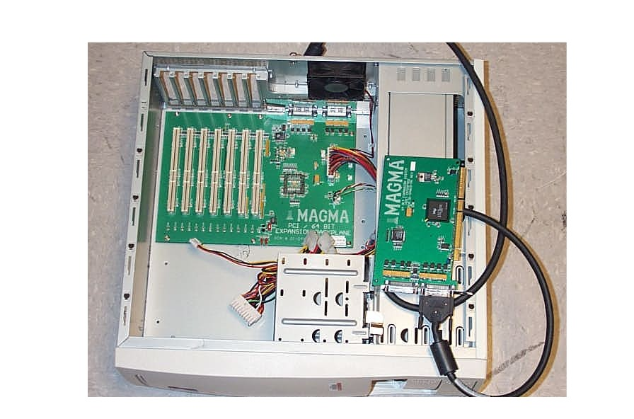

Bridge Riser Adapters
The following figure shows an IEEE 1394 PCI device behind a PCI bridge riser adapter.
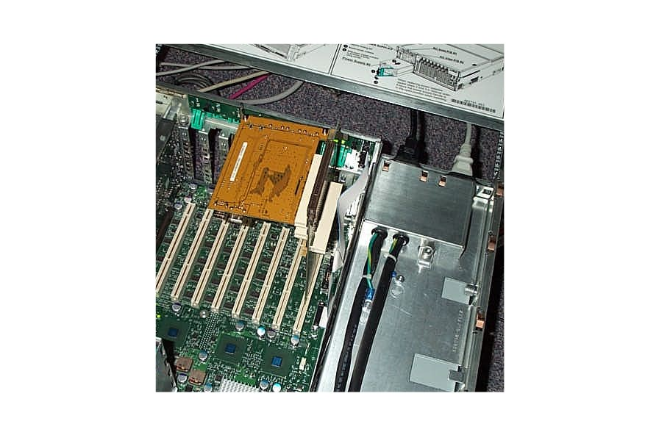

Bridge Box in Action
The following figure shows a bridge box with IEEE 1394 and USB devices installed behind the bridge.
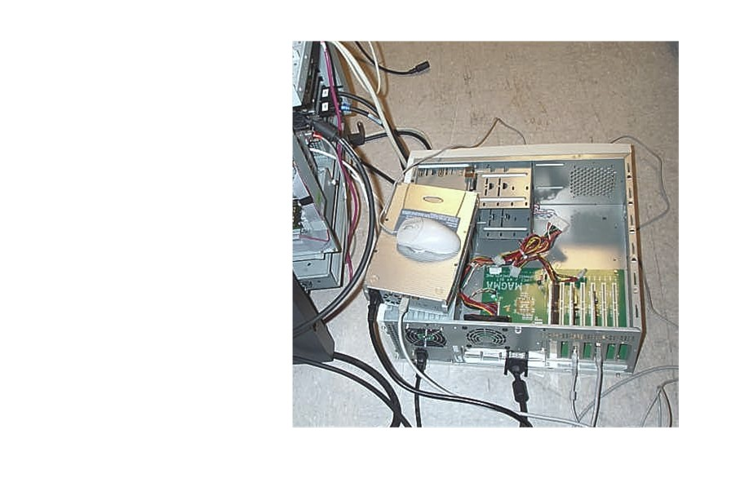

Plug and Play Driver Test (Pnpdtest)
The Plug and Play driver test (Pnpdtest) exercises Plug and Play code paths in drivers and user-mode components for nearly all Plug and Play IRPs, with emphasis on removal, rebalance, and surprise removal. Pnpdtest is available in the %winddk%/tools folder of the Windows Server 2003 SP1 DDK.
A new version of Pnpdtest is planned for Windows codenamed “Longhorn.” This version will be included in the Longhorn Development Kit, beginning with Beta 1. The new version is expected to be scriptable and to support multilevel (full) rebalance.

Testing Driver Installation Packages
You should test driver installation packages with checked builds and checked packages:
- Test the packages across all platforms.
- Test the update driver functionality and driver rollback if you are building a new version of an existing driver.
- Test the installation package with the Application Verifier to identify software problems that cause applications to crash.
To get Application Verifier and the Windows Application Compatibility Toolkit, see "Resources" at the end of this paper.
Note: An audit of applications causing crashes found 67.8% of reported crashes could have been identified by Application Verifier. Heap corruption accounted for 35.4% of the reported crashes.

HCT Kits
Hardware compatibility test (HCT) kits can be a valuable tool during your driver development cycle. HCT kits contain targeted device tests, system and mini-stress suites. The kits evolve as the operating system does and as new technologies emerge.
You should run HCT as often as possible against released versions and new versions of your driver. If you run HCTs throughout the product development cycle, you can find issues early and avoid contingencies and costly resubmissions.

Sample Test Matrix
The following sample text matrix shows the platforms and configurations that you should test to ensure thorough coverage of your driver.
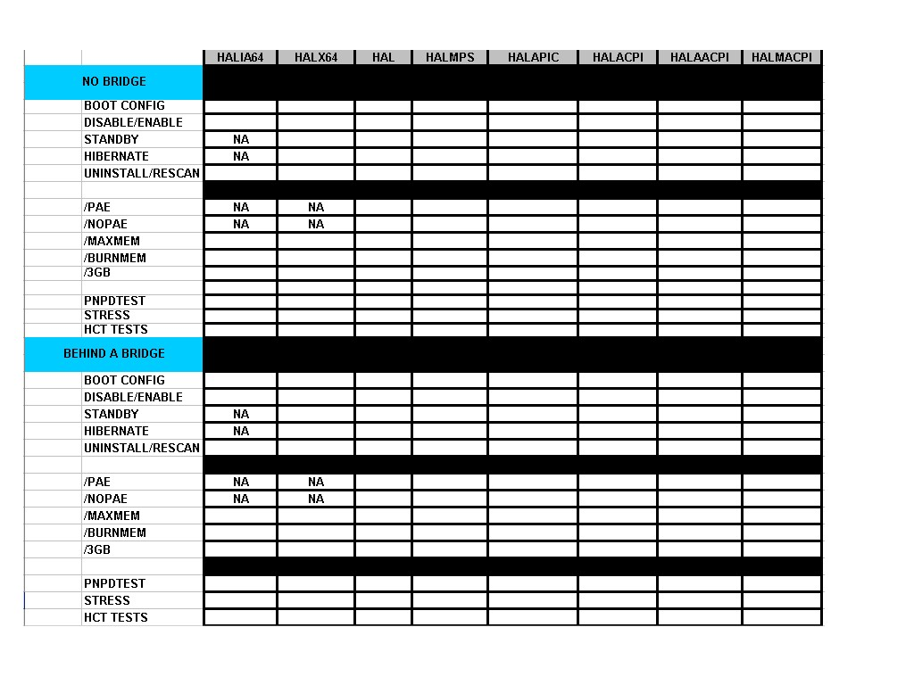

Internal Test Software
When you write software such as validation or functionality tests to test your driver , don't forget to test that software to be sure that it works correctly, that it will test the things you are trying to test, and that the results it returns are valid. Here are some suggestions:
- Attach the Application Verifier to your test installer to identify software problems that could cause the installer to crash
- If your test uses a test driver, be sure to run the test driver under Driver Verifier to help detect errors in the test driver that might affect test results.
- For the same reason, attach Driver Verifier to any dependencies your test driver relies on.

Lab Automation
You can configure computers in your test environment so that you can control them from another computer. You can do this by using KVM over IP (keyboard, video, and mouse switch over TCP/IP), Remote Desktop, or Virtual Server.

KVM over IP
If set up properly, KVM over IP allows access to test systems from anywhere with network access. You can use KVM over IP during testing to control all aspects of the remote computer.

Remote Desktop
Remote Desktop provides similar functionality to that of KVM over IP, but it is available only after the operating system is running on the remote computer and the service is started. Remote Desktop can also be enabled to access systems through the Internet.
Remote Desktop can be set up as an MMC snap-in for ease of management. The following figure shows Remote Desktop configured as a snap-in.
Remote Desktop Snap-in
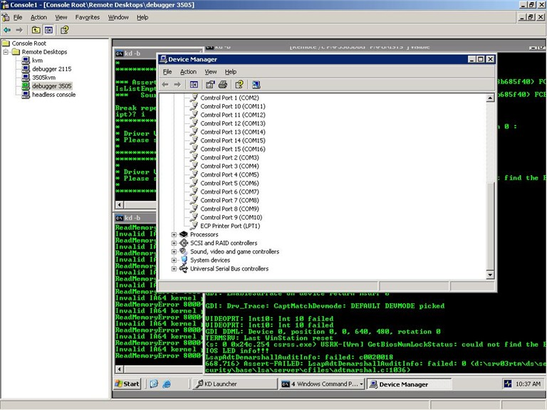

Virtual Server
Virtual Server uses virtual machine (VM) technology to run multiple operating systems concurrently on a single machine. Use Virtual Server to:
- Test multiple operating systems on one computer.
- Quickly roll back any damaging changes with the Undo feature.
- Run tests as if the virtual machine were a physical machine.

For details about the Virtual Server 2005 Evaluation Kit, see "Resources" at the end of this paper.

Resources
Online Software Resources
Debugger Tools Packages (KD)
http://www.microsoft.com/whdc/devtools/debugging/installx86.mspx
Symbols Packages
http://www.microsoft.com/whdc/devtools/debugging/symbolpkg.mspx
Online Symbol Server
http://www.microsoft.com/whdc/devtools/debugging/symbols.mspx
HCTs and Related Documentation
http://www.microsoft.com/whdc/devtools/HCTKit.mspx
Specifications and Whitepapers
http://www.microsoft.com/whdc/DevTools/default.mspx
http://www.microsoft.com/whdc/resources/downloads.mspx
Software Resources
DDK
http://www.microsoft.com/whdc/devtools/ddk/default.mspx
Windows Application Compatibility
Application Verifier
http://www.microsoft.com/windows/appcompatibility/appverifier.mspx
Windows Application Compatibility Toolkit
http://www.microsoft.com/windows/appcompatibility/default.mspx
MSDN
http://msdn.microsoft.com/
HCT Kit
http://www.microsoft.com/whdc/whql/nethctcd.aspx
Virtual Server
Virtual Server 2005 Evaluation Kit
http://www.microsoft.com/windowsserversystem/virtualserver/default.mspx
Hardware Resources
Debugger multi-serial devices
http://www.rocketports.com
Magma PCI expansion Devices
http://www.magma.com/pci/7slot6466/index.html
IBP Instruments
http://www.ibpmt.com/main.asp?area=USA&frame=PCICardBox
Avocent Enterprise KVM switches
http://www.apex.com/web/en.nsf

