
Microsoft Office Project Portfolio
Server 2007
September 2006
Table of Contents

Cover is for
position only

Microsoft Office Project Portfolio Server 2007 Overview 1
Gain Visibility and Control 2
Objectively Prioritize and Evaluate Competing Investments 2
Optimize Budget and Align Investments with Business Strategy 3
Tightly Integrate with Office Project Server 2007 3
Gain Visibility and Control 5
Define Workflows and Automate Governance Controls 5
Automate Governance Processes Across the Organization 5
Centralize and Streamline Portfolio Data Collection 6
Capture All Project, Program, and Application Investments Centrally 6
Use Templates to Streamline the Collection of Data and Metrics 6
Measure and Track Portfolio Performance 11
Track Investments with Personalized Scorecards and Status Reports 11
Governance—Scenarios 12
Objectively Prioritize and Evaluate Competing Investments 14
Prioritize Business Strategy 14
Build Consensus Among Executives 14
Prioritize Competing Investments from Multiple Dimensions 16
Calculate Scores for Strategic Value, Risk, and Financial Return 16
Generate Charts to Map Potential Portfolio Investments 20
Prioritize and Evaluate Competing Investments—Scenarios 21
Optimize Budget and Align Investments with Business Strategy 24
Select the Portfolio Best Aligned with Strategic and Financial Goals 24
Determine Optimal Portfolio Under Budget and Business Constraints 24
Use Advanced Analysis to Improve Portfolio Selection 26
Break Portfolio Constraints with Efficient Frontier Analysis 26
Model Different Strategic Scenarios 27
Dynamically Assess Your Portfolio’s Business Alignment 27
Finalize Portfolio Selection Using the Decision Dashboard 29
Optimization and Alignment Scenario 31
Tightly Integrate with Office Project Server 2007 33
Integration with Office Project Server 2007 34
Exchange Data with Line-of-Business Applications 36
Office Project Portfolio Server 2007 Benefits 37
System Requirements 39
Office Project Portfolio Server 2007 39
Office Project Portfolio Web Access 40
Additional Resources 41

Microsoft Office Project Portfolio Server
2007 Overview
Microsoft® Office Project Portfolio Server 2007 is a top-down portfolio management solution that helps organizations to realize their potential by identifying, selecting, managing, and delivering portfolios that best align with their business strategy. Office Project Portfolio Server 2007, a key component of the Microsoft Enterprise Project Management (EPM) Solution, can help executives gain visibility, insight, and control across their project, program, and application portfolios.
Office Project Portfolio Server 2007 can help organizations to:
- Automate and standardize governance processes to subject projects to appropriate controls.
- Consolidate business and IT investments within an enterprise repository to improve visibility and insight.
- Objectively evaluate and prioritize competing investments from multiple dimensions.
- Optimize budget utilization and select investments that best align with the organization’s business strategy.
- Tightly integrate with Office Project Server 2007 to track the performance of each investment throughout its life cycle, from business case to benefits realization.
Office Project Portfolio Server 2007 is optimized for enterprise and upper midmarket (UMM) organizations that require portfolio analytical tools to improve decision-making and help ensure that selected portfolios align with the organization’s strategic priorities. The solution is intended for the following stakeholders:
- Executives and business decision-makers
- Portfolio analysts and project management office staff
- Program managers and project managers
- Application managers

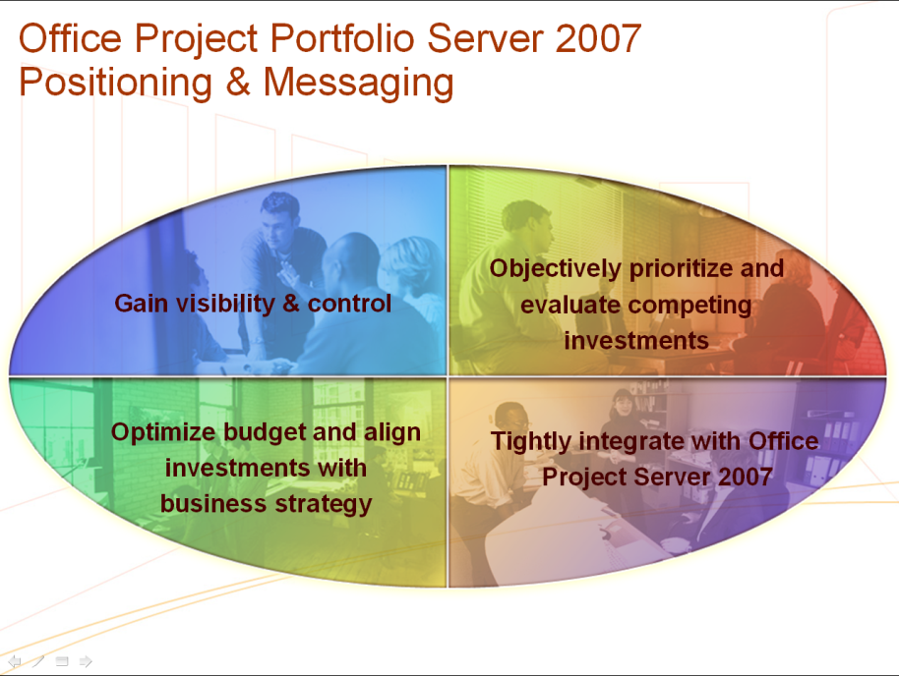
Figure 1: Microsoft Office Project Portfolio Server 2007 Positioning & Messaging Statements

Gain Visibility and Control
Quickly gain visibility and control across your project, program, and application portfolios by automating governance processes, standardizing, and streamlining the collection of data, and tracking portfolio performance to maximize return on investment (ROI) and improve operational efficiencies.
- Consolidate the collection of essential data for all business and IT investments in a central enterprise repository.
- Define multiple workflows to standardize, communicate, and enforce the portfolio governance framework across the organization.
- Create personalized scorecards to track investments throughout their life cycle.

Objectively Prioritize and Evaluate Competing Investments
Employ proven best practice techniques to help objectively prioritize your organization’s business strategy for the upcoming planning period. Automatically derive prioritization
scores to evaluate the project, program, and application portfolios from multiple dimensions.
- Define and prioritize business strategy and drive consensus among executives using the pair-wise comparison matrix.
- Derive prioritization scores such as strategic value, financial value, risk, architectural fit, and operational performance to objectively assess projects, programs, and applications.
- Generate charts to effectively evaluate potential investments within the portfolios.

Optimize Budget and Align Investments with Business Strategy
Use embedded best practice methodologies, including the Business Alignment Framework, to optimize budgets and recommend portfolios that best align with the organization’s business strategy. This objective process enforces a rational rather than emotional approach to portfolio selection, to help ensure that the selected investments deliver the maximum business value.
- Employ sophisticated optimization algorithms to determine the optimal project or program portfolio under varying budget and business constraints.
- Use advanced portfolio analytical techniques, including insight analysis, to identify and break the constraints prohibiting the portfolio from reaching the Efficient Frontier.
- Undertake a business alignment assessment to help ensure that the selected portfolios are optimally aligned with the organization’s business strategy.

Tightly Integrate with Office Project Server 2007
Tight integration between Office Project Portfolio Server 2007 and Office Project Server 2007 provides organizations with an end-to-end project portfolio management solution. Office Project Portfolio Server 2007 is a key component within the Microsoft EPM Solution, providing the following benefits:
- Help ensure that customers and partners can quickly deploy world-class portfolio analytical techniques and tools within the EPM Solution.
- Maintain data integrity between the two environments through regular synchronization events.
- Enable portfolio analysts to link federated computers running Office Project Server 2007 to Office Project Portfolio Server 2007 and consolidate projects into an enterprise repository.
- Provide organizations with a scalable end-to-end project portfolio management solution.

Gain Visibility and Control
Gain visibility into your project, program, and application portfolios by using Office Project Portfolio Server 2007 to standardize and streamline the collection of data within one enterprise system of record. Automate the governance processes across the organization to subject each project to the appropriate governance controls throughout its entire life cycle. Measure and track portfolio performance to help ensure the portfolios are managed effectively and realize the forecasted benefits.

Define Workflows and Automate Governance Controls
Office Project Portfolio Server 2007 enables you to define, communicate, and standardize multiple workflows to help manage the projects throughout their entire life cycle, while enforcing the portfolio governance framework across your organization.

Automate Governance Processes Across the Organization
Office Project Portfolio Server 2007 includes an intuitive workflow designer that enables administrators to define governance phases and multiple workflows, helping to ensure that projects are subject to appropriate controls throughout their entire life cycle. As shown in Figure 2, each workflow is composed of a series of life cycle steps (such as Propose Idea, Initial Review, Complete Request, Request Review, Portfolio Selection, and Selected) which in turn are mapped to governance phases. The governance phases are used as common denominators to aggregate and report on projects across various workflows.
The phases and workflows establish a blueprint for your organization’s governance framework and help ensure all projects complete the necessary deliverables and receive managerial sign-off before moving to the next life cycle step. This audit functionality keeps stakeholders aware and accountable as projects move from business case creation to consideration to implementation.

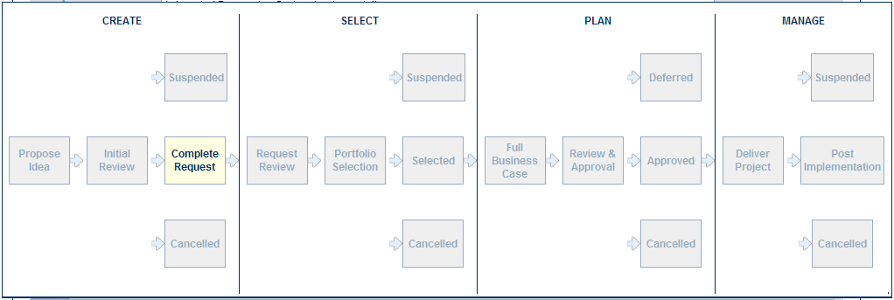
Figure 2: Example of a configurable workflow in Office Project Portfolio Server 2007

Centralize and Streamline Portfolio Data Collection
Office Project Portfolio Server 2007 enables you to quickly capture all project, program, and application investments in an enterprise repository, with easy-to-use customizable templates and flexible forms to help ensure you standardize and streamline the collection of essential data.

Capture All Project, Program, and Application Investments Centrally
With Office Project Portfolio Server 2007 you can capture all projects, programs, and applications in the Portfolio Builder module, providing you with a holistic view of all of your investment portfolios in one central system of record. The flexible scorecard in Portfolio Builder enables you to quickly slice and dice the investments across portfolios to create intuitive and informative reports (for example, by line of business, program, or portfolio).

Use Templates to Streamline the Collection of Data and Metrics
Standardize and streamline the collection of data across the organization by defining templates and forms for each investment type (for example, project, program, and application) using the Portfolio Builder module of Office Project Portfolio Server 2007. The following are some examples of templates that can be created to capture critical project data:
- Project Request Form: Complete a project request form to capture the high-level information for each new request, such as business description, start and end dates, and sponsors.
- Business Case Templates (see Figure 3): Develop a detailed business case for each project request in accordance with the governance workflow including:
  - General Project Information: Capture general project information.
  - Cost Estimate: Capture detailed cost estimates.
  - Resource Estimates: Capture detailed resource estimates at the skill level.
  - Benefits Estimates: Capture both financial and non-financial benefit estimates.
  - Strategic Impact: Assess how each project supports your organization’s business strategy.
  - Risk Assessment Questionnaire: Derive a risk score for each project through a configurable risk questionnaire.
  - Schedule Management: Capture the phases and key milestones.
  - Issues and Risk Management: Log all issues and risks throughout the project’s life cycle.
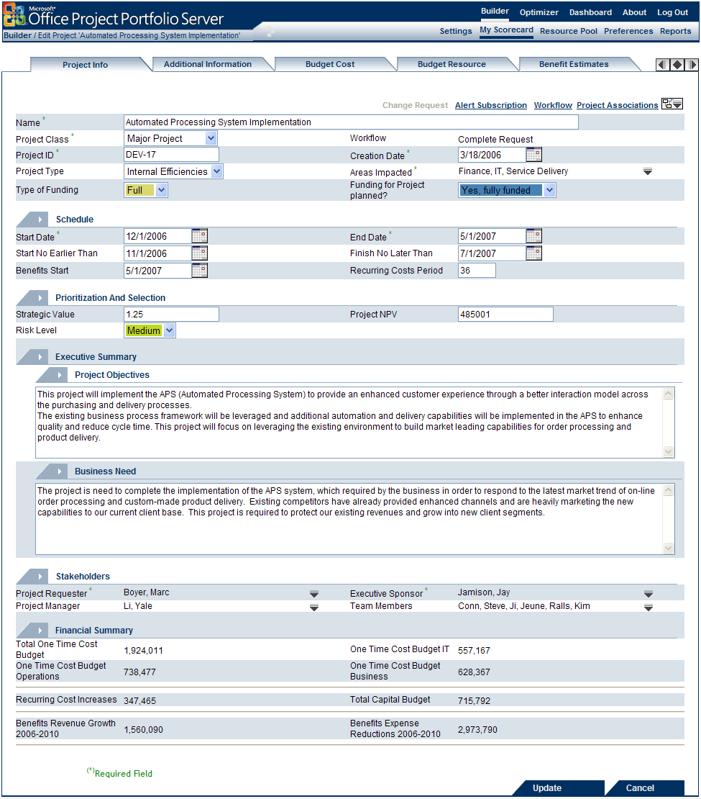
Figure 3: Example of a detailed Business Case template in Office Project Portfolio Server 2007
- Application Inventory Templates (see Figure 4): Define templates to capture the essential metrics necessary to gain visibility into your application portfolio. For example:
- General Application Information: Capture general attributes about the application.
- Cost Estimates: Capture application costs, and calculate annual cost of ownership (ACO) and total cost of ownership (TCO).
- Strategic Impact: Assess how each application supports your organization’s business strategy.
- Architectural Fit: Assess how each application supports your organization’s enterprise architecture standards and strategy.
- Business Process: Evaluate and keep a record of the business processes that each application supports.
- Risk Assessment: Evaluate an application’s risk through a configurable risk questionnaire.
- Operational Performance: Evaluate an application’s performance through a configurable operational performance questionnaire.
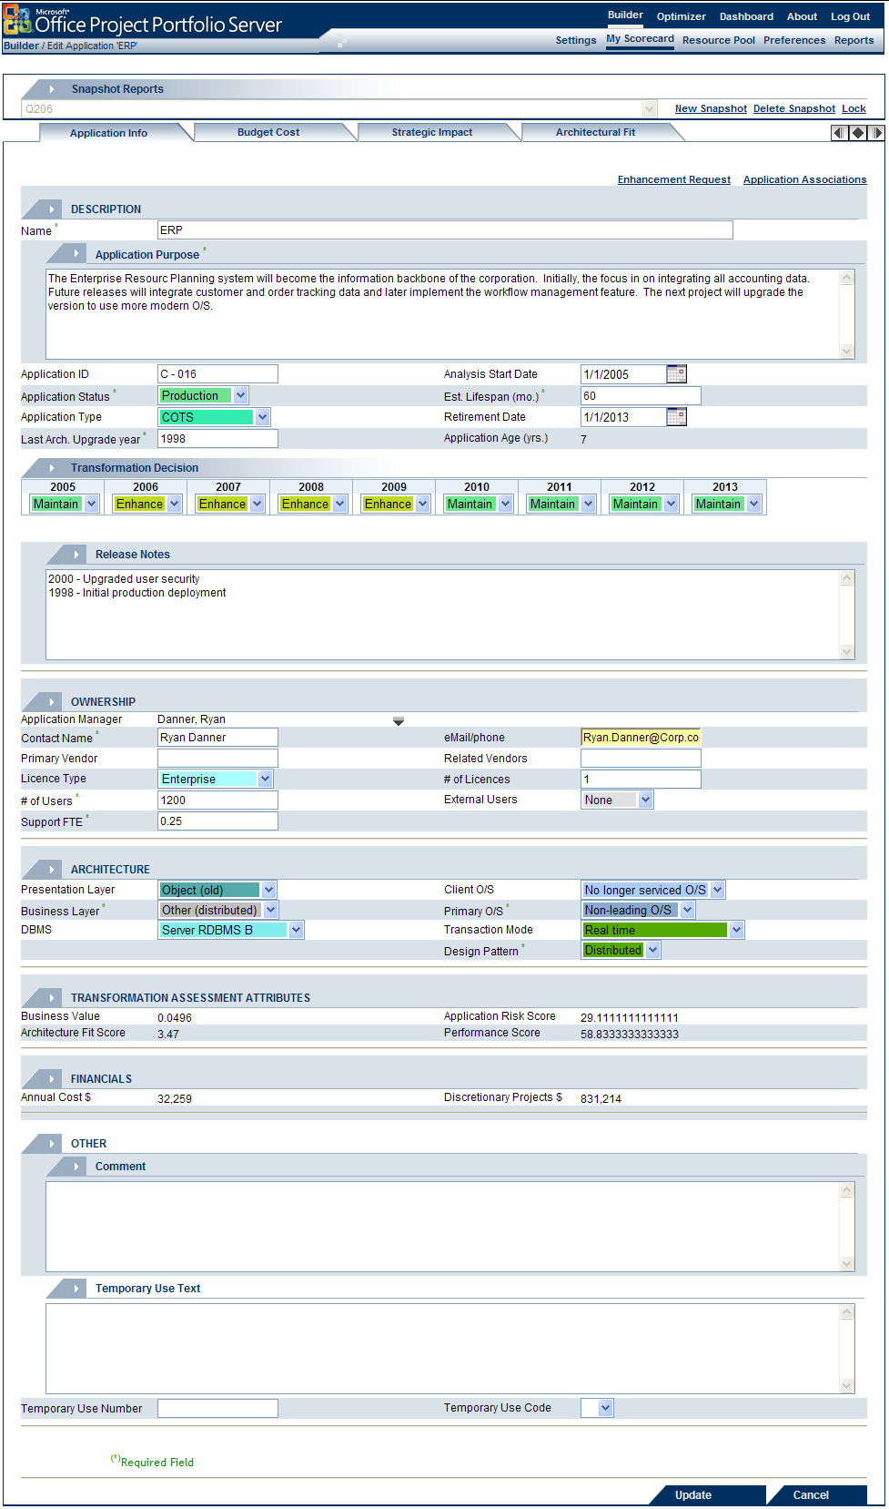
Figure 4: Example of an application record in Office Project Portfolio Server 2007

Measure and Track Portfolio Performance
With the Portfolio Dashboard module of Office Project Portfolio Server 2007, you can measure and track projects, programs, and applications throughout their life cycle, giving you the visibility to proactively identify potential issues, make decisions, and help ensure that your portfolios deliver maximum business value. 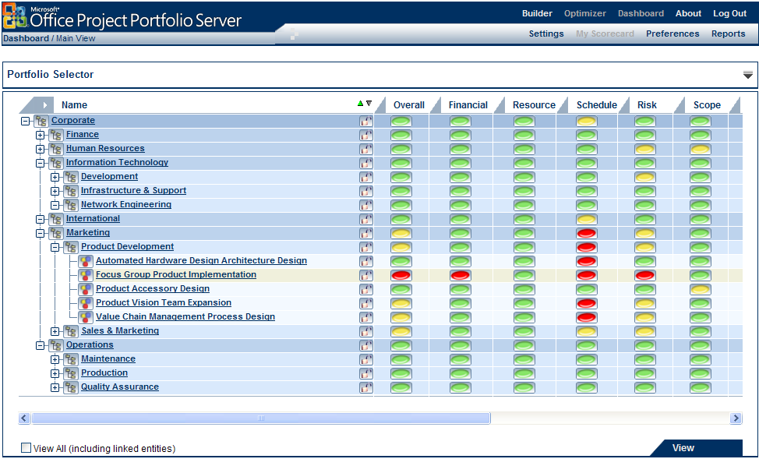
Figure 5: An example of a tracking scorecard in Office Project Portfolio Server 2007

Track Investments with Personalized Scorecards and Status Reports
With the reporting and monitoring functionality in Office Project Portfolio Server 2007, you can create and view reports on your investments at any time.
- My Scorecard: Analysts, managers, and executives can create personalized scorecards to track portfolio investments, and drill down from the organization level to view project, program, and application-level status reports.

- Status Reports: The snapshot reporting mechanism enables project, program, and application managers to generate periodic status reports to measure the overall health of each investment throughout their life cycle.
- Cost Management: Maintain financial controls by assessing budget versus actual for project cost.
- Resource Management: Evaluate staffing and resource utilization.
- Change Request: Raise change requests for approval and automatically update the original budget to keep an accurate baseline.
- Flexible Reporting Framework: Use the Office Project Portfolio Server 2007 report generators to customize and publish report templates so you can standardize and streamline the reporting process across the organization.

Governance—Scenarios
Project Portfolio Management (PPM) Scenario: Jeff Chia, director of reservation processing at Blue Yonder Airlines, believes the airline requires an online customer reservation system. Jeff knows that there is a governance framework in place in order to approve, budget, and implement any project.
Jeff completes a project request form, providing an overview of the project’s objectives and the business rationale. The workflow, defined to automate Blue Yonder Airlines’ governance framework, alerts Christina Lee (senior vice president of Operations) and Axel Delgado (general manager of the E-Business division) about the completed project request. Upon reviewing the proposal, both approve the request and ask Jeff to complete a detailed business case to further justify his project.
Next, Jeff completes a detailed business case, which includes capturing budget cost estimates, budget resource estimates, and benefit estimates, undertaking a strategic impact assessment against Blue Yonder Airlines’ business drivers, and completing a risk questionnaire. When the business case is completed, Christina and Axel are again notified and the project is approved to be considered for the next project portfolio.
Application Portfolio Management (APM) Scenario: Sidney Higa, CIO of Wide World Importers, desperately needed to get more visibility into her application portfolio. More than 70 percent of the annual IT budget went to supporting existing applications across the organization, and Sidney needed a better understanding of how this expense contributed to the business. Sidney wanted to rationalize her portfolio, but she did not have a solid grasp of the number of applications deployed at Wide World Importers, and what business value they provided. She did know that different applications were used in silos across lines of business and geographies, and wanted to understand if there were redundant applications that could be consolidated or retired altogether.
As a first step, Sidney instructed her team to create an inventory of all the applications at Wide World Importers in the Portfolio Builder module of Office Project Portfolio Server 2007. The team agreed on which key metrics and standard descriptive attributes to capture in order to effectively evaluate the applications, including metrics for annual cost, architectural fit, process contribution, risk, and operational performance. The team then began to create the inventory.
One important metric, the process contribution assessment, included mapping each application to the standard library of organizational business processes. That information populated Office Project Portfolio Server 2007 report templates, enabling Sidney’s team to identify functional overlap between applications that support the same business processes, and to highlight opportunities for better application integration. After running the report, Sidney noticed some key processes were supported by multiple enterprise resource planning (ERP) applications, suggesting a functional overlap and a potential opportunity to rationalize these ERP applications.
Upon completing the application repository, Sidney now had reliable visibility into the status of her application portfolio, with the core data and a foundation to effectively rationalize the portfolio and make application life cycle decisions.

Objectively Prioritize and Evaluate Competing Investments
Office Project Portfolio Server 2007 includes proven techniques to help objectively prioritize your organization’s business strategy for the upcoming planning horizon, drive consensus between the key stakeholders, and evaluate and prioritize competing investments from multiple dimensions. Using embedded best practice prioritization methodologies and tools, executives can derive common scoring criteria for projects, programs, and applications, enabling “apples-to-apples” comparisons among dozens or hundreds of competing investments.

Prioritize Business Strategy
One of the most critical tasks in the portfolio management process is to define and prioritize the organization’s business strategy. The Office Project Portfolio Server 2007 Portfolio Optimizer module includes the pair-wise comparison matrix used to help executives objectively prioritize business strategy for the upcoming planning horizon.

Build Consensus Among Executives
In most organizations, executives from distinct functional domains will have different perspectives on which business drivers are most important to the business. A vice president of sales might consider “increase market share” and “develop new products” the most important business drivers, while a CIO might consider “maximize systems uptime” and “modernize enterprise infrastructure” the most important. In organizations where executives will be competing for the same budget and resources, achieving consensus is critical.
In a facilitated business strategy prioritization workshop, the executives collaborate to complete the pair-wise comparison matrix and assess the importance of each business driver against each other for the upcoming planning period to help drive consensus and calculate the business driver priorities. For example, in Figure 6, is “Expand into new markets and segments” is moderately more important when compared to “Improve Customer Satisfaction”?
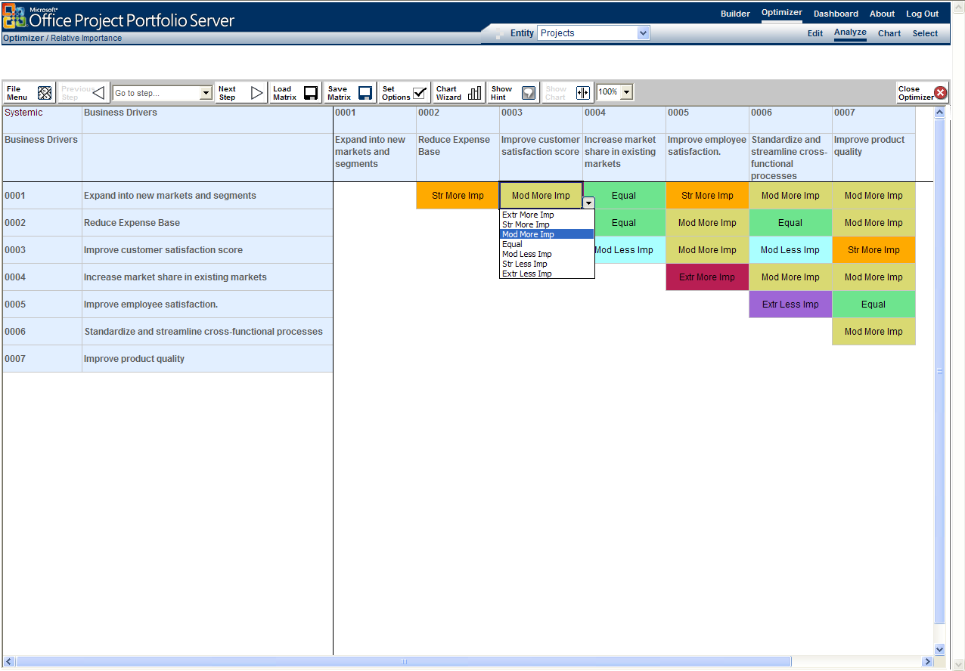
Figure 6: Business driver pair-wise comparison matrix in Office Project Portfolio Server 2007
In Figure 7, we see the resulting consensus on relative business priorities for an organization. It is very important to note that these derived driver priorities are relative scorings and not simply ranked from number 1 to number 7.

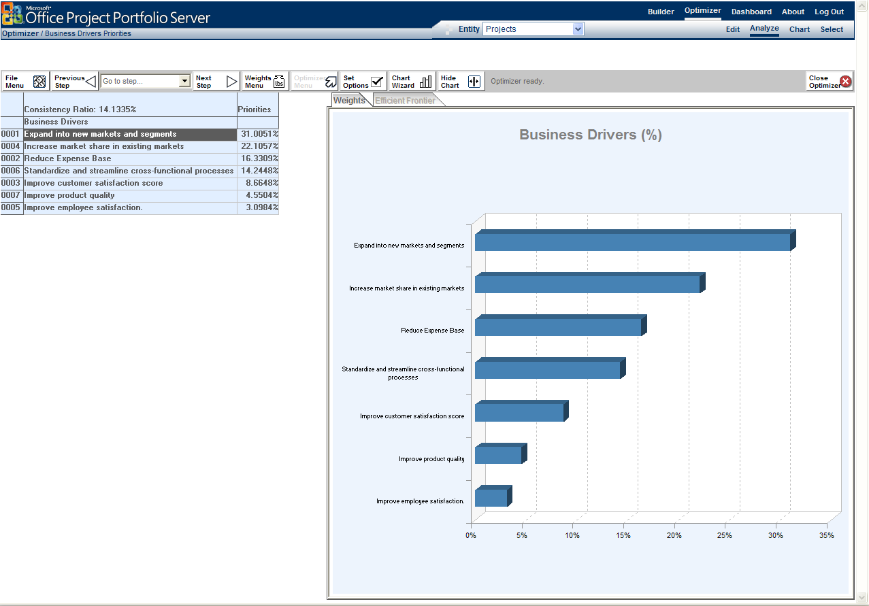
Figure 7: Derived relative priority of business drivers in Office Project Portfolio Server 2007

Prioritize Competing Investments from Multiple Dimensions
With potentially hundreds of projects, programs, and applications competing for the same limited budget and resources, formulating common scoring criteria is essential to effectively prioritize and evaluate the competing investment proposals.

Calculate Scores for Strategic Value, Risk, and Financial Return
Make use of best practice techniques to automatically derive prioritization scores such as strategic value, financial value, risk, architectural fit, and operational performance in order to objectively assess projects, programs, and applications.

Project and Programs—Best practice prioritization scores include:
- Financial Value: Calculate a project’s financial value (ROI, net present value (NPV), internal rate of return (IRR)) based on the cost and benefit estimates captured in each business case.
- Strategic Value: Objectively derive a strategic value score for each project in Portfolio Optimizer based on the project’s impact on the business strategy (see Figures 8 and 9).
- Risk Assessment: Calculate a risk score for each project derived from the risk assessment questionnaire.
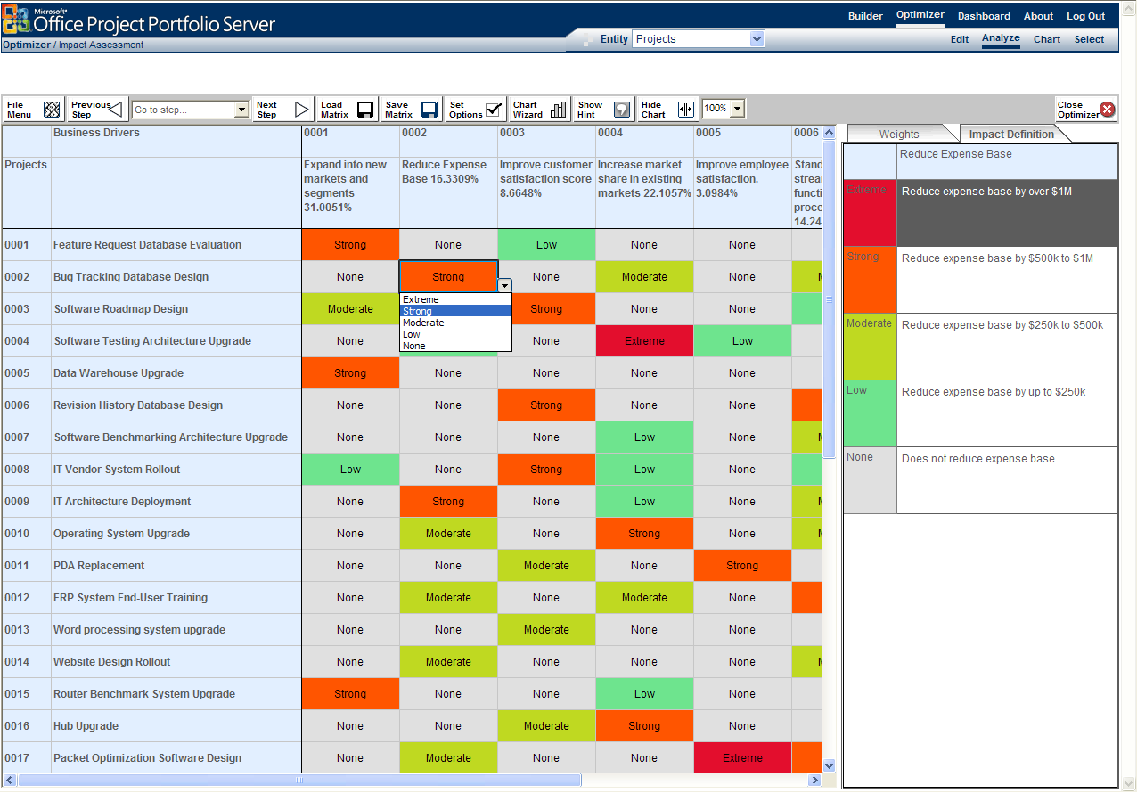
Figure 8: Example of project to driver impact assessment in Office Project Portfolio Server 2007
One of the most important project assessment scores is the strategic value score, which calculates the project’s value to the business. Using the Office Project Portfolio Server 2007 impact matrix shown in Figure 8, each project is evaluated against each business driver and rated on a 5-point scale (for example, “no impact,” “low impact,” “moderate impact,” “strong impact,” and “extreme impact”) depending on the project’s contribution to quantitative key performance indicators (KPIs) defined for each driver. This process derives a strategic value score for each project shown in Figure 9.

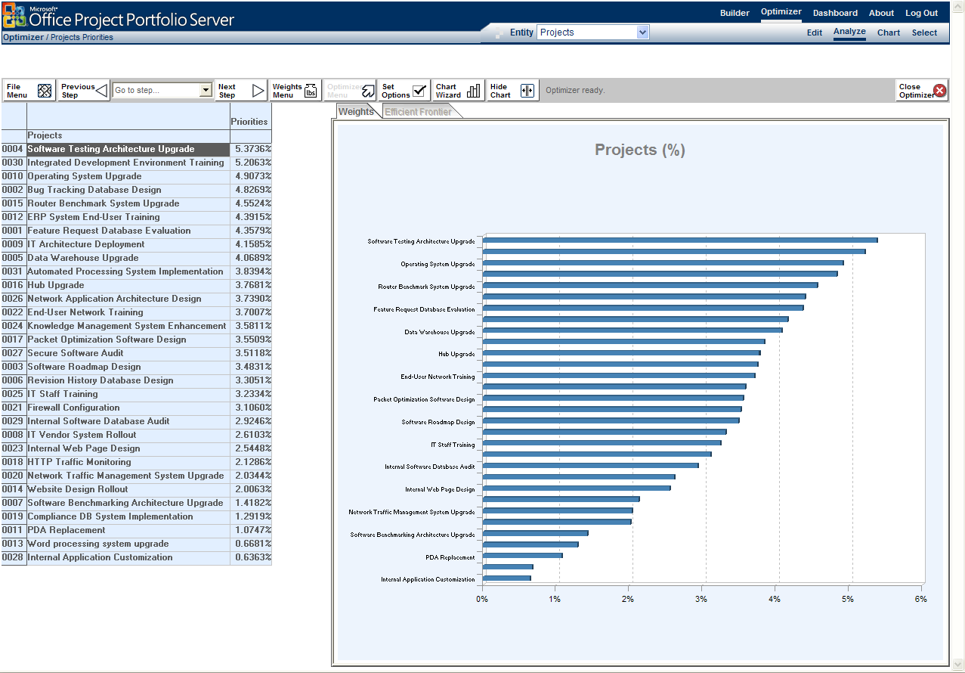

Figure 9: Example of a strategic value priority scores for projects in Office Project Portfolio Server 2007

Applications—Best practice assessment attributes include:
- Business Importance: Objectively derive a business importance score for each application.
- Architectural Fit: Map each application against the organization’s architectural strategy and standards, and calculate an architectural fit score.
- Risk Assessment: Calculate an application’s risk using the Portfolio Builder risk questionnaire.
- Operational Performance: Automatically derive an operational performance score for each application based on a performance questionnaire in Portfolio Builder.

Of particular note, the business importance of an application is computed in Office Project Portfolio Server 2007 using a three-step prioritization process. This prioritization technique uses the pair-wise comparison matrix to prioritize business drivers, then uses two impact matrices to first assess each business process’s contribution to the success of each business driver, and second to assess the level that each application supports each business process. This three-step process results in a business importance score for each application in the portfolio. Application contributions to business processes are best rated as a percentage of the process that is automated by the application (see Figure 10). The sum of application contributions to one process must be equal to or less than 100 percent.
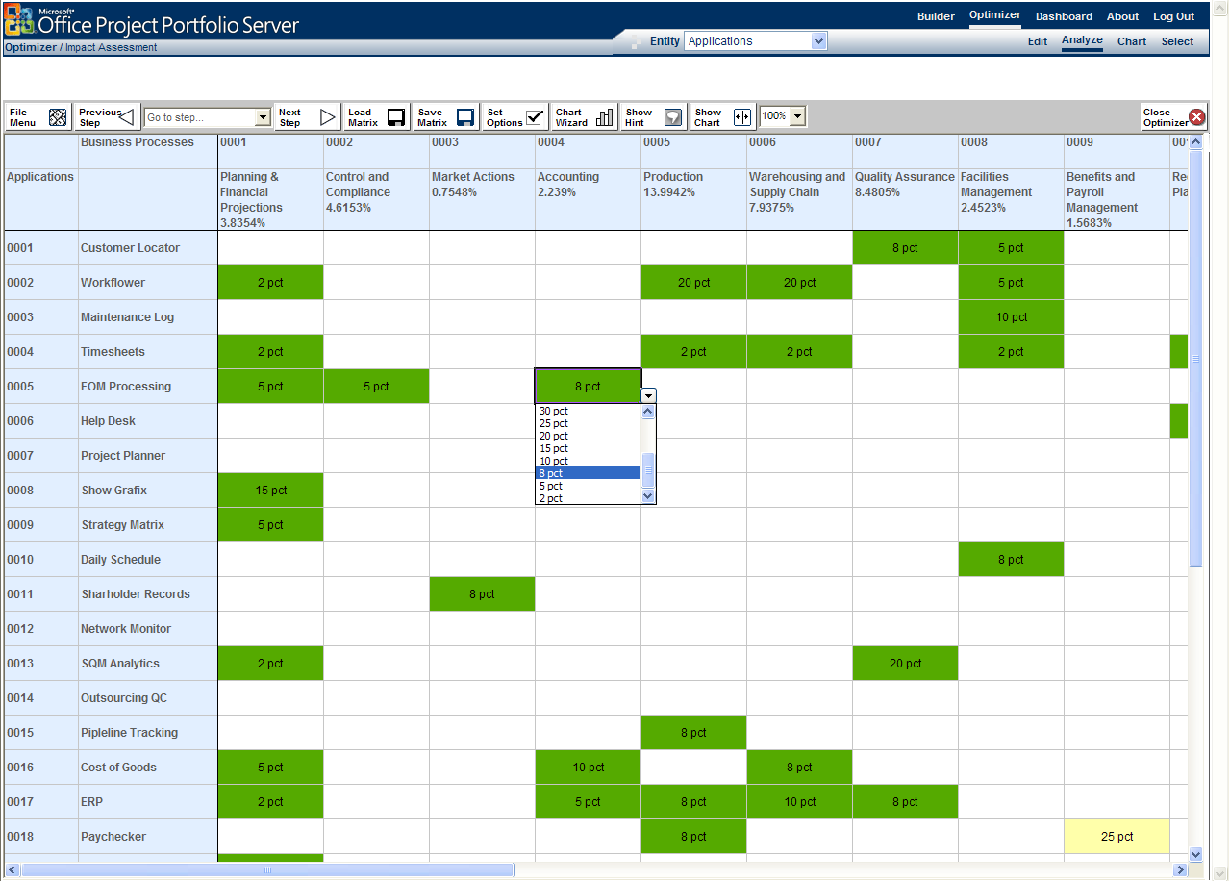
Figure 10: Example of an application to business process impact assessment in Office Project Portfolio Server 2007

Generate Charts to Map Potential Portfolio Investments
Create charts and investment maps to visually evaluate the competing investments from multiple dimensions using the derived prioritization scores (for example, strategic, financial, risk, architectural fit, and performance). As shown in Figure 11, applications are mapped and can be evaluated based on their operational performance and architectural fit.
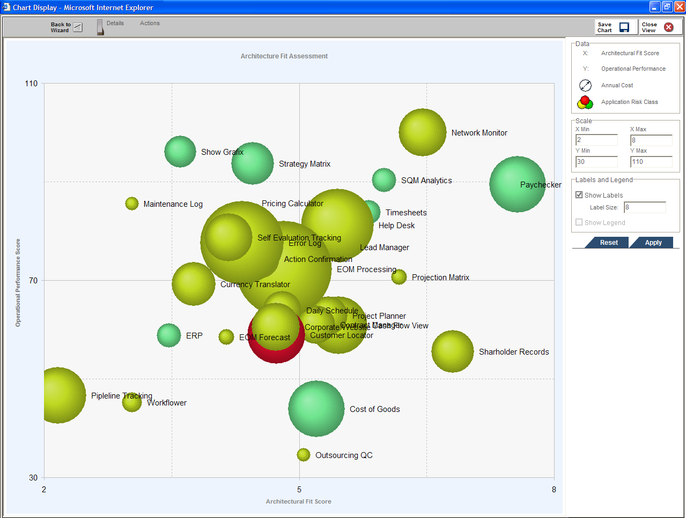
Figure 11: An example of a bubble chart in Office Project Portfolio Server 2007

Prioritize and Evaluate Competing Investments—Scenarios
Project Portfolio Management (PPM) Scenario: The CIO of Woodgrove Bank, Jay Jamison, receives an e-mail notification from Dana Birkby, the PMO director at Woodgrove, indicating that business cases for two more major projects have just been submitted: one for an online customer mortgage system, and another to roll out a wireless CRM solution to the sales field.
With more than 100 other project proposals already submitted, Jay needs to objectively prioritize the project portfolio, as he will not have the budget and resources to select from all those project requests. Jay knows that whatever projects are funded, they must be able to show they are aligned with Woodgrove Bank’s business strategy.
Jay arranges a Business Driver Prioritization workshop with the executive team and uses the pair-wise comparison matrix in Office Project Portfolio Server 2007 to objectively prioritize the business drivers and drive consensus between the CEO and other executive stakeholders. The driver for “grow market share” is calculated to be 5.5 times more important than “diversify product offering,” which likely favors the funding of the sales field CRM system over the new online customer mortgage system.
Having objectively prioritized the business strategy, Jay can now start to prioritize and evaluate the proposed projects. Of paramount importance to Jay is each project’s strategic value, as well as each project’s likely risk. As part of the business case required for every proposed investment, each project had already been subject to a strategic impact analysis and a risk assessment in the Portfolio Builder, which resulted in scores for both criteria.
With both the strategic value score and the risk score, Jay can make equal comparisons between competing projects and even generate charts to visually map them together. Jay can now prioritize his 100-plus projects by their relative scores, which will prove helpful when it is time to select a project portfolio.
Application Portfolio Management (APM) Scenario: Sidney Higa, CIO at Wide World Importers, has her team compile an enterprise application inventory in Office Project Portfolio Server 2007, capturing key metrics to help her make application life cycle decisions. With 70 percent of her budget going to existing applications, it is time to rationalize the portfolio and make necessary changes.
Spurred by some poor risk ratings and likely functional overlap between applications, Sidney has her analyst run a series of bubble charts that correlate risk scores to business importance, number of users, architectural fit, platform type, cost, and a host of different technology attributes.
The charts vividly illustrate potential outliers, including identifying one specific “thick client” ERP application having both high business importance and high risk. Interestingly, another ERP system used in their shipping operations business unit has a Web-based “thin client” and is considered high in business importance and low in risk, and it ranks well in operational performance. The two applications have very high functional overlap as they support the same business processes. Retiring the “thick client” ERP application and replacing it with the Web-based system would likely save $1.25 million in annual cost while streamlining performance and reducing risk.
Excited by the results, Sidney’s analyst further uses the charts to support a proposal for a program to evolve from “thick” client/server architecture to Web-based applications. Moving to a standard technology would enable the IT group to better use support staff, improve responsiveness, and reduce license costs. These aren’t new ideas, but the charts help illustrate to the Board how the technology upgrade provides business benefit, beyond simple return on investment (ROI).
After completing the rationalization of the application portfolio, Sidney’s team has saved Wide World Importers about 10 percent of the IT budget. The application life cycle decisions also result in promising new project candidates to be considered for the next project portfolio.

Optimize Budget and Align Investments with Business Strategy

Select the Portfolio Best Aligned with Strategic and Financial Goals
When you are selecting your project or program portfolio for the upcoming planning horizon, Office Project Portfolio Server 2007 helps optimize budgets and recommend portfolios that best align with your organization’s business strategy. This objective process enforces a rational rather than emotional approach to portfolio selection, helping to ensure that the selected investments are aligned with the organization’s strategic priorities and will maximize return on investment.

Determine Optimal Portfolio Under Budget and Business Constraints
Faced with limited budgets year after year, IT and business executives must thoughtfully and effectively allocate resources to the highest value portfolio of project and program investments. Using sophisticated algorithms and embedded best practices in the Portfolio Optimizer module, you can quickly determine the optimal project or program portfolio under varying budget and business constraints (for example, cost, FTE, and inter-project dependencies) while helping to ensure that the selected portfolio aligns with your organization’s business strategy and delivers the maximum financial value.
- Run What-If Analyses: Apply varying cost and resource constraints, optimize and dynamically assess the impact on the proposed project or program portfolio. The intuitive interface in Portfolio Optimizer enables analysts to run multiple what-if analyses and compare the results in a side-by-side table (see Figure 12). The optimization algorithm identifies the optimal portfolio under the given constraints, selecting projects or programs that have the highest value/cost ratio.
- Consider Dependency Constraints: The Portfolio Optimizer optimization algorithm identifies the highest value portfolio while considering complex inter-project dependencies.
- Force in Compliance or Pet Projects: Portfolio Optimizer enables analysts to force in mandatory projects, or even “pet” projects, overriding the optimization algorithm to ensure these projects are included in the resulting portfolio. This analysis technique enables you to rapidly assess the impact on the portfolio’s business value and effectively communicate the tradeoffs of including these mandated projects within the portfolio.
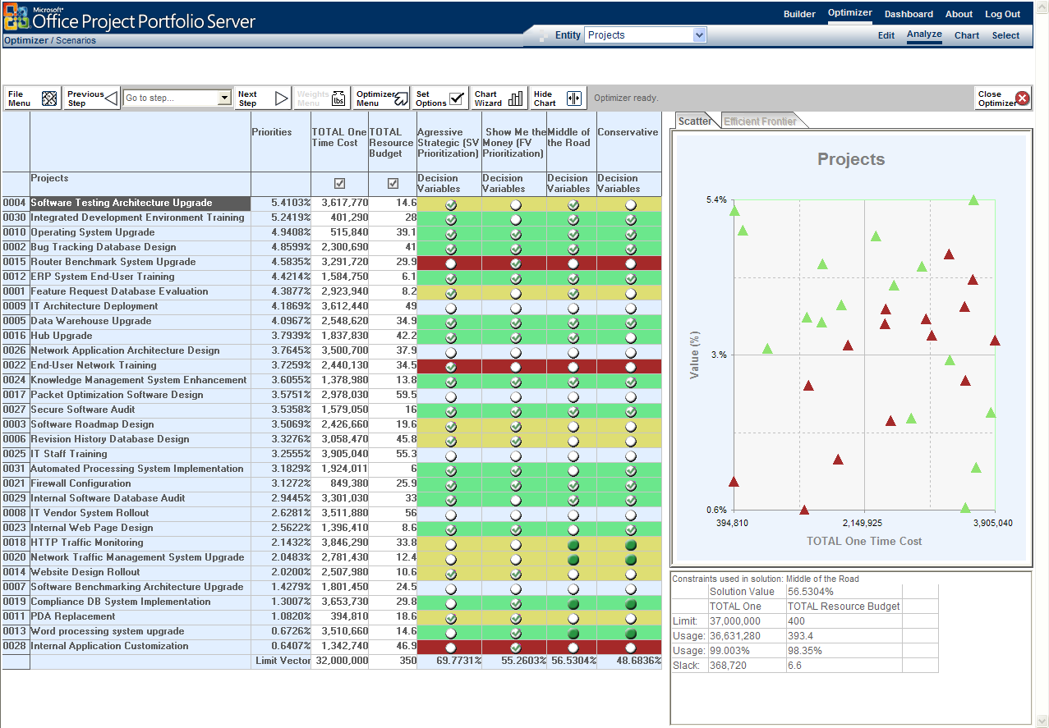
Figure 12: An example of optimization what-if analysis in Office Project Portfolio Server 2007

Use Advanced Analysis to Improve Portfolio Selection
Use advanced portfolio analytical techniques to assess the portfolio’s alignment with the organization’s business strategy and identify and break the constraints prohibiting the portfolio from reaching the Efficient Frontier.

Break Portfolio Constraints with Efficient Frontier Analysis
Efficient Frontier modeling enables analysts to visually identify the project or program portfolio that will deliver the maximum strategic value under varying constraint thresholds (such as $5 million budget or $10 million budget). Each point on the Efficient Frontier represents a different bundle of projects (or programs) from the proposed portfolio. The Efficient Frontier represents the best value. For example, in Figure 13 you can see that with a $34 million budget you can achieve approximately 72 percent of the portfolio’s total potential strategic value, although the current portfolio solution is only achieving 60 percent. Organizations can use the Efficient Frontier in two ways:
- Identify the point of diminishing return: Find the point where the curve begins to flatten, indicating you are paying a lot more to achieve a disproportionate amount of strategic value.
- Benchmark the selected portfolio against the Efficient Frontier: Compare the position of the selected portfolio in relation to the efficient frontier.
In reality, due to varying constraints (for example, interdependencies, project alternatives, mandatory investments, and resource constraints), most portfolios are suboptimal and fall beneath the Efficient Frontier (see Figure 13). Analysts can use Portfolio Optimizer to identify and break these constraints, which will move the portfolio closer toward the Efficient Frontier and increase the total strategic value from the portfolio under the same budgetary constraints.
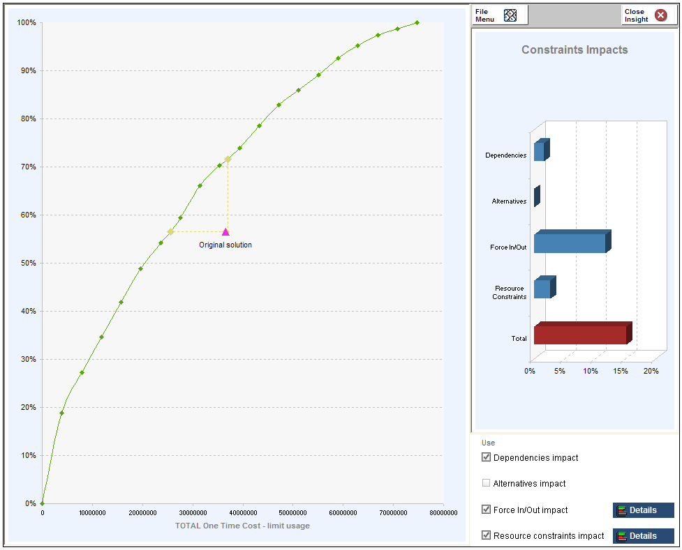
Figure 13: A chart indicating the original portfolio has fallen short of the Efficient Frontier in Office Project Portfolio Server 2007

Model Different Strategic Scenarios
The Portfolio Optimizer enables executives to model changes to the organization’s business strategy and dynamically assess the impact on the existing project or program portfolios. Using this advanced analysis technique, organizations are able to quickly react to fluctuations in the economy or changes in their industry to help ensure that their project and program portfolios remain aligned with their new strategic priorities.

Dynamically Assess Your Portfolio’s Business Alignment
The Portfolio Optimizer Business Alignment Framework methodology provides a rational approach for selecting project and program portfolios that best align with business strategy. Executives can dynamically assess the correlation between the business driver priorities and the investment from the selected project or program portfolio.
This technique helps you quickly see if you are over or under investing in each of the prioritized business drivers. For example, Figure 14 shows the results of the Business Alignment Assessment generated before optimizing the portfolio. Executives can quickly see that this organization is under investing in the higher-priority drivers and over investing in the lower-priority drivers, suggesting the portfolio spending is not aligned with the organization’s business strategy.
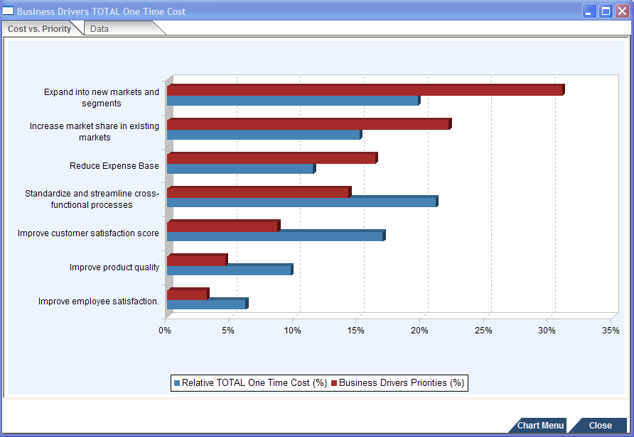
Figure 14: Business Alignment Analysis (before optimization): Relative driver priority versus proposed investment
However, Figure 15 shows the results of the Business Alignment Assessment generated after optimizing the same portfolio. You can see there is a better correlation between the business driver priorities and the total investment in the selected portfolio, suggesting a stronger investment alignment with business strategy.

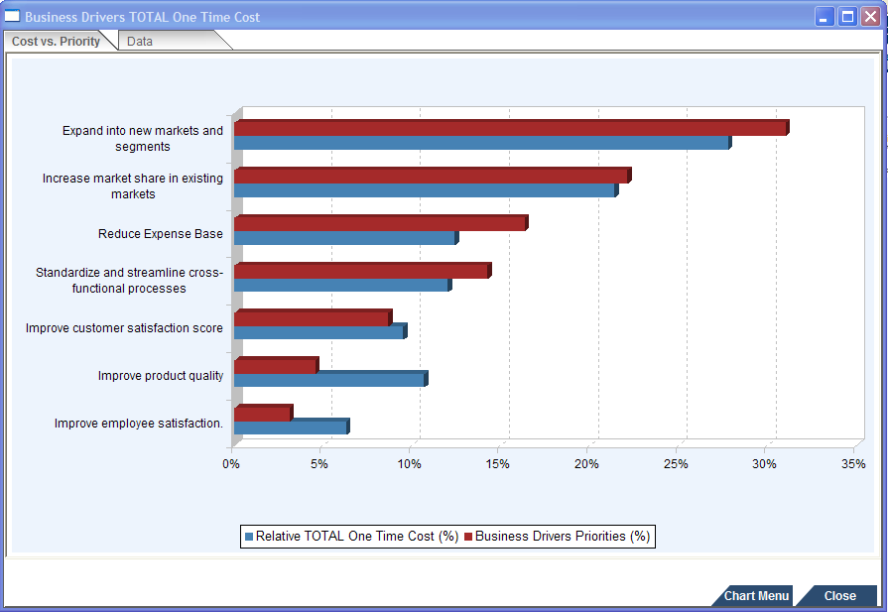
Figure 15: Business Alignment Analysis (after optimization): Relative driver priority versus proposed investment

Finalize Portfolio Selection Using the Decision Dashboard
The Portfolio Optimizer Decision Dashboard (see Figure 16) enables portfolio analysts to publish key metrics and recommended portfolios (such as optimization results) into an intuitive view, to provide executives with the data to support project and program funding decisions (such as Approve, Suspend, Cancel). In real time, executives can model project and program funding decisions and automatically see the impact on the portfolio’s strategic value. The steering committee can then select the portfolio to be funded for the planning period.
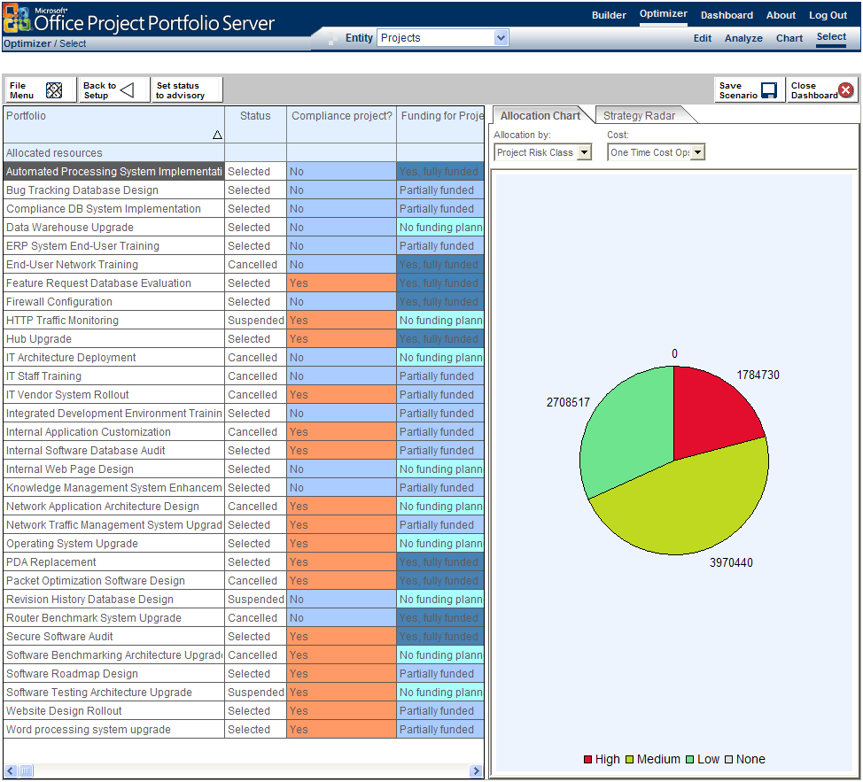
Figure 16: The Decision Dashboard in Office Project Portfolio Server 2007

Optimization and Alignment Scenario
Project Portfolio Management (PPM) Scenario: Wendy Wheeler, vice president of business planning at Contoso Pharmaceuticals, is informed by the CFO that the board approved a $25 million budget for her group. Though an increase over last year’s budget, it is not enough to undertake every project request submitted.
Using Office Project Portfolio Server 2007, Wendy opens a project portfolio and loads the Portfolio Optimizer. A strategic value score for each project is already automatically calculated, so Wendy uploads cost and resource estimates from the detailed business cases. She quickly determines that to complete all projects in the portfolio (to gain 100 percent of the strategic value) would cost $57 million. Wendy enters the budget restriction of $25 million and runs the Portfolio Optimizer module’s optimization algorithm to dynamically identify the best project portfolio under the budgetary constraints. The initial portfolio selection looks good, delivering 68 percent of overall strategic value for that budget level.
However, Wendy notices that a mandatory compliance project and two pet projects of the CFO have not been included in the optimal portfolio. Wendy uses the force-in feature to make sure that the compliance and CFO pet projects are automatically included in the portfolio. This time the Portfolio Optimizer selects a new portfolio of projects, delivering 54 percent of the overall strategic value given the $25 million constraint and the forced-in projects. As expected, some higher-value projects fall out of the portfolio to make room for the compliance project and pet projects.
Using the Portfolio Optimizer advanced portfolio analytics techniques, Wendy plots her portfolio of projects against the Efficient Frontier curve, which shows the best plan under varying cost thresholds. Wendy quickly determines that the forced-in projects were significantly affecting the portfolio’s overall strategic value, and revises her model. After enabling the Portfolio Optimizer to re-optimize, she observes that the new portfolio, which includes only one of the CFO’s pet projects, moved up toward the Efficient Frontier, delivering 63 percent strategic value under the same cost constraints. Wendy decides to save this scenario so that she can discuss the implications with the CFO of forcing in both pet projects.
Using the Decision Dashboard, she creates a scorecard that includes the optimization scenarios she had run the day before, and reviews the results with the CFO and team. Finally, the CFO wants to look at the alignment between the proposed portfolio and Contoso’s business strategy. Wendy uses the charting option in Office Project Portfolio Server 2007 to analyze the proposed portfolio investment in each strategic business driver (see Figure 15), and displays the relative spend from the portfolio into each driver. The CFO likes the alignment between spending and business drivers, and agrees with Wendy’s recommended portfolio.

Tightly Integrate with Office Project
Server 2007
Office Project Portfolio Server 2007 integrates with Microsoft Office Project Server 2007 to provide organizations with an end-to-end project portfolio management solution. Office Project Portfolio Server 2007 is a key component of the Microsoft Enterprise Project Management (EPM) Solution, helping to ensure that executives gain visibility, insight, and control across their project, program, and application portfolios.
Tight integration with Office Project Server 2007 can help ensure that customers and partners can quickly deploy world-class portfolio analytical techniques and tools within the Microsoft EPM Solution. The out-of-the-box integration between the two solutions provides the following benefits:
- End-to-End Project Portfolio Management: Provides organizations with a scalable end-to-end project portfolio management solution.
- Help Ensure Data Integrity: Maintains data integrity between the two environments through regular synchronization events.
- Consolidate Across Project Servers: Enables administrators to link federated Office Project Server computers to a single instance of Office Project Portfolio Server 2007 and consolidate the collection of essential data for all business and IT investments in a central enterprise repository.
- Microsoft Windows SharePoint® Services 3.0 Integration: Integrates with Microsoft Windows SharePoint Services 3.0 for document management.

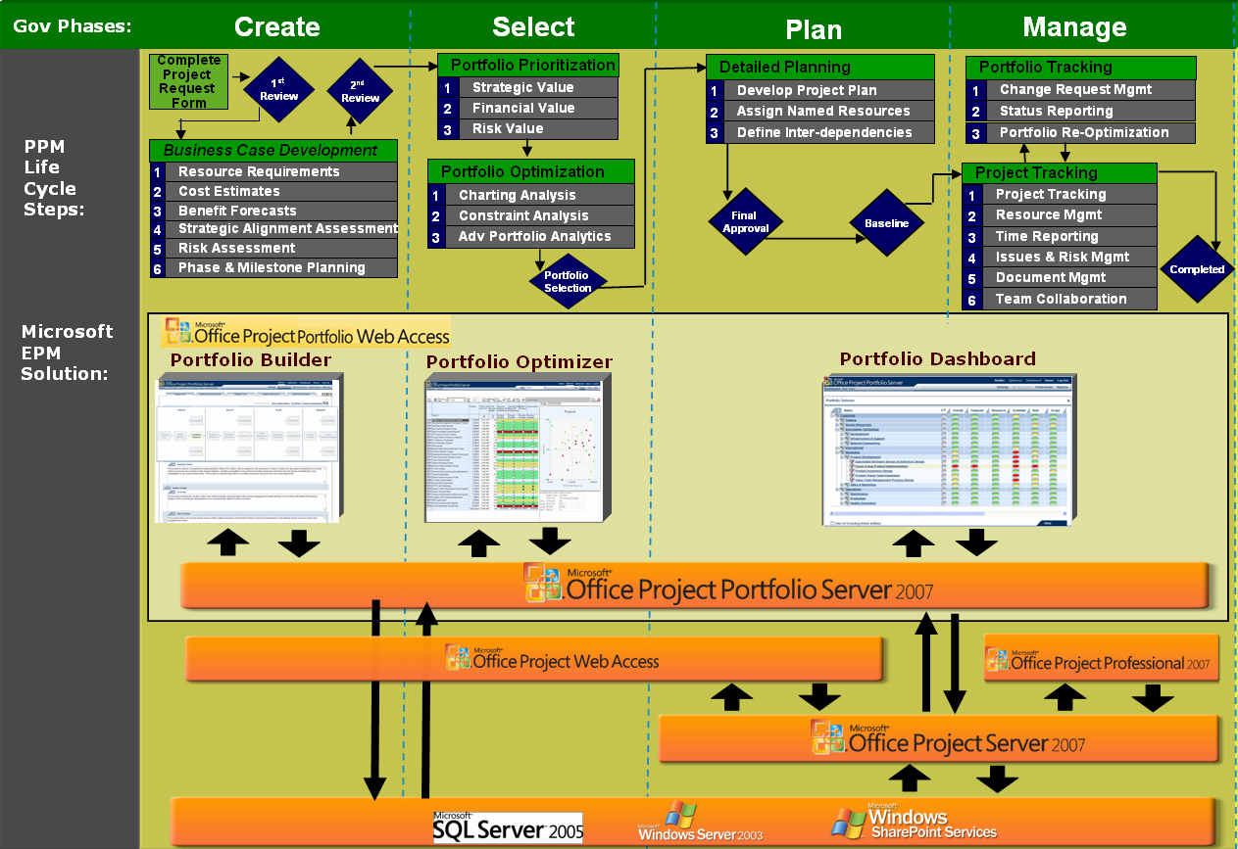
Figure 17: Microsoft EPM Solution architecture and example governance process

Integration with Office Project Server 2007
Office Project Portfolio Server 2007 includes the Project Server Gateway, a bidirectional link with Office Project Server 2007. The gateway enables administrators to import, export, and synchronize phases and milestones, resource requirement data (such as budget, actual and forecast), resource availability data, and enterprise fields between the two environments.
- Resource Data: Office Project Portfolio Server 2007 provides resource management at the resource type level (for example, C++ programmer, project manager). Named resource data is captured in Office Project Server 2007 and mapped to a primary resource type in Office Project Portfolio Server 2007.
- Schedule Data: Office Project Portfolio Server 2007 captures phase and milestone data. The data from the detailed tasks in Office Project Server 2007 is automatically aggregated to the appropriate phases in Office Project Portfolio Server 2007.
- Enterprise Fields: The administrator can map enterprise fields (attributes) between the two environments.
Office Project Portfolio Server 2007 is available in English only, but integrates with localized versions of Office Project Server 2007.
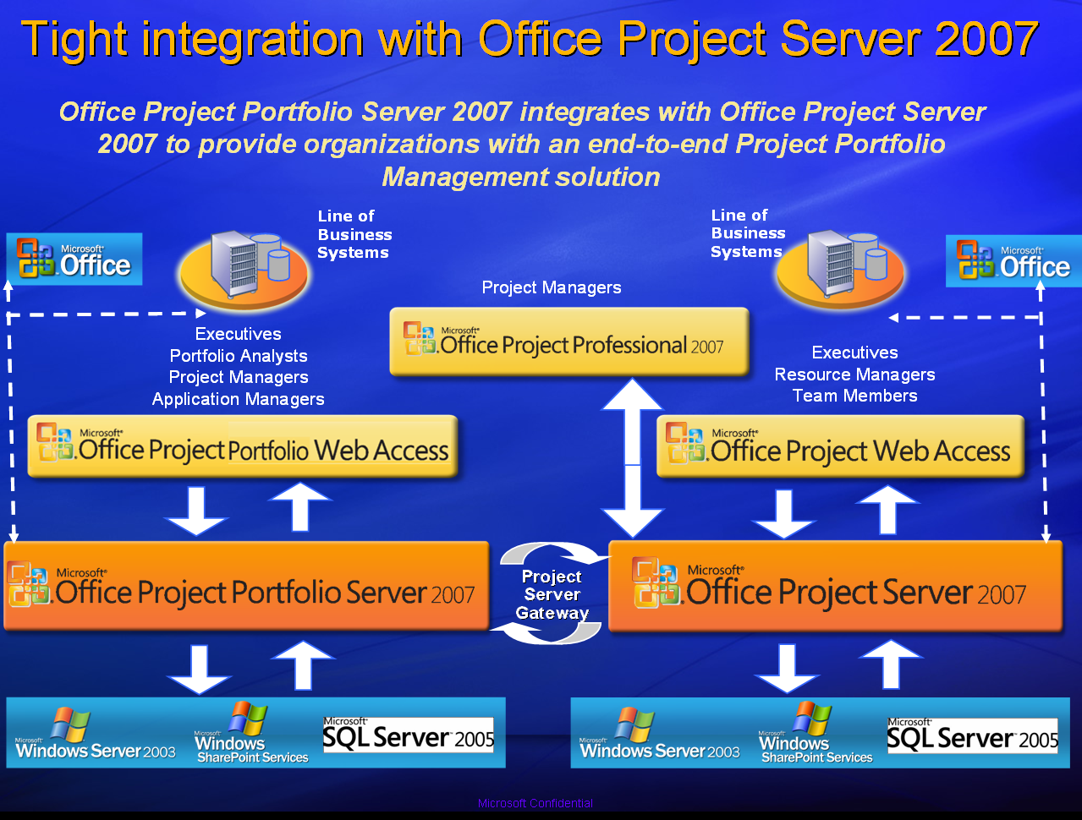
Figure 18: The Microsoft EPM Solution

Exchange Data with Line-of-Business Applications
- Office Project Portfolio Server 2007 includes a flexible import module that enables analysts to manage the data exchange between general ledger systems and Office Project Portfolio Server 2007.
- Office Project Portfolio Server 2007 includes a read-only application programming interface (API) to help ensure that organizations and partners can develop connectors to third-party enterprise systems to improve interoperability.

Office Project Portfolio Server 2007 Benefits
The following describe the top 10 benefits of using Office Project Portfolio Server 2007 in your organization.

#1 Automate and enforce governance processes.
Define multiple workflows to subject each project to the appropriate governance controls throughout its life cycle—from proposal to post-implementation.
#2 Employ best practice methods.
Use configurable templates and embedded best practice methodologies to more effectively manage project, program, and application portfolios across the organization.
#3 Capture all investments within a central repository
Consolidate business and IT investments within an enterprise repository to improve visibility, insight, and control. Flexible configuration forms help administrators quickly build and publish templates, standardizing and streamlining the collection of data for all portfolios.
#4 Objectively prioritize business strategy.
Employ proven techniques to define and prioritize your organization’s business strategy for the upcoming planning period.
#5 Effectively prioritize and evaluate competing investments.
Use best practice techniques to automatically derive prioritization scores—such as strategic value, financial value, and risk—and develop investment maps to effectively evaluate the competing investments from multiple dimensions.
#6 Optimize budget and align selected investments with business strategy.
Run optimization what-if scenarios to identify tradeoffs and select the optimal portfolio under varying budgetary and business constraints that best aligns with your organization’s business strategy.
#7 Reach the Efficient Frontier.
Take advantage of advanced portfolio analytical techniques—for example, insight analysis—to identify and break the constraints that can prohibit the portfolio from reaching the Efficient Frontier.
#8 Measure and track portfolio performance.
Monitor the performance of each investment to help ensure you realize the forecasted benefits. Re-optimize the portfolio in accordance with your governance process to help maintain continuous alignment with your organization’s business strategy.
#9 Tightly integrate with Microsoft Office Project Server 2007.
Quickly deploy world-class portfolio analytical techniques that are tightly integrated with Office Project Portfolio Server 2007, providing your organization an end-to-end project portfolio management solution.
#10 Consolidate and analyze projects across federated servers.
Link federated computers running Office Project Server 2007 to Office Project Portfolio Server 2007 to consolidate all projects within an enterprise repository, helping you to quickly gain visibility, insight, and control across all project portfolios.

System Requirements

Office Project Portfolio Server 2007

Office Project Portfolio Server 2007 processor, RAM, and hard disk requirements are highly dependent on the number of services installed on the computer and the load on the server.
Minimum requirements assume one server where all Office Project Portfolio Server components and supporting technologies (for example, Microsoft SQL Server, Microsoft Windows Server System™) are installed.

To use Office Project Portfolio Server 2007 you need:

Component | Requirement
Operating system | Microsoft Windows Server® 2003 SP1 or higher (32-bit)
Single box installation | - Server with a processor speed of at least 2.5 GHz; RAM capacity minimum of 1 GB, 2 GB recommended; disk space: 1 GB for installation;  - Microsoft SQL Server 2005 SP1 with a processor speed of at least 2.5 GHz, minimum 2 GB of RAM
Drive | CD-ROM or DVD drive
Display | Minimum 800x600; 1024x768 or higher- resolution monitor recommended
Browser | Microsoft Internet Explorer® 6.0 with service packs (or higher) – 32 bit browser version is supported
Network Connection | 100 Megabits per second (Mbps) connection speed is required to utilize Office Project Portfolio Server functionality
Other requirements | Microsoft .NET Framework 2.0; IIS 6.0; ASP.NET 2.0
Additional Components | Office Project Portfolio Server 2007 processor, RAM, and hard-disk requirements are highly dependent on the number of services installed on the computer and the load on the server.  - Microsoft SQL 2005 Reporting Services (included with Microsoft SQL Server) is required for Reporting.  - Office Project Server 2007 is required to use the Project Server Gateway (the bi-directional link between Project Portfolio Server 2007 and Project Server 2007)  - Microsoft Windows SharePoint Services 3.0 (included in Microsoft Windows Server 2003) is required for Document Management

Office Project Portfolio Web Access
Microsoft Office Project Portfolio Web Access is a Web portal used to access the information stored in Microsoft Office Project Server 2007. Using Office Project Portfolio Web Access requires an Office Project Portfolio Server 2007 Client Access License (CAL).

To use Project Portfolio Web Access you need:
Component | Requirement
Computer and processor | 700 megahertz (MHz) processor or higher
Memory | 128 MB of RAM or more recommended (additional memory may be required depending on operating system requirements)
Hard disk | 40 MB of available hard disk space per workstation
Operating system | Windows XP SP2 or later, Windows XP Tablet Edition SP1 or later, Microsoft Windows Vista™ (or higher) required
Display | Minimum 800x600; 1024x768 or higher- resolution monitor recommended
Browser | Microsoft Internet Explorer 6.0 with service packs (or higher) – 32 bit browser version is supported
Network Connection | 256KB or higher connection
Other | - Microsoft Office Excel® 2003 (or higher) is required to load the matrix views in the Portfolio Optimizer module and generate reports.  - Adobe Acrobat 5.0 (or higher) is required to generate reports in PDF

Additional Resources
To learn more about Microsoft Office Project Portfolio Server 2007 and the Microsoft EPM Solution, please refer to the following list of related links for additional resources and information.
- Microsoft Office Project Portfolio Server 2007 Site
http://www.microsoft.com/office/portfolioserver/
- Microsoft Office Project Server 2007 Site
http://www.microsoft.com/office/projectserver/
- Business Value from the Microsoft EPM Solution
http://www.microsoft.com/business/epm.aspx
- Microsoft Project Association
http://www.mpug.org/default.aspx
- Microsoft Project Communities
http://www.microsoft.com/technet/community/en-us/project/default.mspx
- Microsoft Office Project Developer Center http://msdn.microsoft.com/office/understanding/project/default.aspx
- Microsoft Office Project TechNet
http://www.microsoft.com/technet/prodtechnol/project/default.mspx
- Microsoft Office Project Support Information
http://support.microsoft.com/default.aspx?pr=offpr2003

This document is developed prior to the product’s release to manufacturing, and as such, we cannot guarantee that all details included herein will be exactly as what is found in the shipping product. The information contained in this document represents the current view of Microsoft Corporation on the issues discussed as of the date of publication. Because Microsoft must respond to changing market conditions, this document should not be interpreted to be a commitment on the part of Microsoft, and Microsoft cannot guarantee the accuracy of any information presented after the date of publication. The information represents the product at the time this document was printed and should be used for planning purposes only. Information is subject to change at any time without prior notice.

This document is for informational purposes only. MICROSOFT MAKES NO WARRANTIES, EXPRESS OR IMPLIED, IN THIS DOCUMENT.

© 2006 Microsoft Corporation. All rights reserved.

Microsoft, Excel, Internet Explorer, the Office logo, SharePoint, Windows, Windows Server System, Windows Server, and Windows Vista are either registered trademarks or trademarks of Microsoft Corporation in the United States and/or other countries. All other trademarks are property of their respective owners.

