
Microsoft Windows® SharePoint™ Services

Table of Contents
Table of Contents 1
Introduction to SharePoint Training 2
Additional useful links 3
Unable to login? 4
Exploring SharePoint 5
Working with Lists 5
Working with Documents 7
Holding a Discussion 9
About the Web Discussions feature 9
Discuss a whole page or a paragraph 9
Show or hide discussion information 9
Store discussions 10
View a Web discussion 10
Surveys 11
Create a survey 11
Respond to a survey 12
See the results of the survey 12
Announcement and Events 13
Create a list of announcements, contacts, events, tasks, issues, or links 13
Add, edit, or delete an announcement 13
Special Information on User Accounts 15
Update/Add your Windows SharePoint site user accounts 15
Customizing a SharePoint site 16
Frequently Asked Questions 17

Introduction to SharePoint Training

Congratulations!
You’ve made it through signup and provisioning of your SharePoint site. You have learned some things about the product and the customer experience through our website etc.
In this training you will be given an opportunity to learn some of the common tasks to get you jump started. In addition, you will be presented with several practice questions.
Good luck and have fun!

Review:
Microsoft SharePoint Services is a bCentral product that offers a security enhanced online workspace that enables businesses to share documents and other information with a selected group of users.
SharePoint was originally designed for large business clients under the name of SharePoint Portal Server. The product was scaled down to meet the needs of the small business clients and named Windows SharePoint Services. This document covers only some of the Windows SharePoint Services (SharePoint) features. For questions regarding SharePoint Portal Server, please consult the information at www.microsoft.com/sharepoint.

Disclaimer:
SharePoint integrates with other products and is highly customizable. For this reason, as well as time constraints, you will not learn about every feature that SharePoint offers. Our intent is to help you discover some of the main features in this quick training guide. –You will be able to locate the tools you need in order to successfully manage your site, information and users. These tools include Knowledge Center and SharePoint Help.

Additional useful links

- For frequently asked questions on SharePoint on the bCentral.com website:
http://www.bcentral.com/products/sp/faq.asp
- For online forums: http://communities.microsoft.com/newsgroups/default.asp?icp=SharePoint
- For product information:
http://www.microsoft.com/windowsserver2003/technologies/sharepoint
- For any questions regarding getting started or using the SharePoint site, contact us at:
online support center
- For examples on how users are using SharePoint to solve their everyday business problems and unique business needs:
http://www.bcentral.com/products/sp/howto.asp?LID=32596
For answers to specific questions:
  - How a private online workspace can boost your business
  - 7 reasons to use SharePoint for document collaboration
  - Create a global office on the Web
  - Why your small biz needs an intranet
  - 5 tips for creating an intranet
  - Could a private Web site help your business?
  - How to manage 'virtual' offices
  - Tips for sharing documents from a distance

Unable to login?

The login issues you are experiencing may be a result of one of the following:
- It is the first time you are trying to log into SharePoint and you are unsure about the steps. Please refer to the email sent by the SharePoint administrator (wssadmin@bcentral.com) and use the credentials and instructions provided.
- You have forgotten your password. Please click here to contact the SharePoint support team.
- Make sure you have typed the following correctly:
  - Site URL
e.g. http://sitename.sp.bcentral.com
or for the users who signed up for the services before 10/02/2003
http://sitename.sharepoint.bcentral.com
  - Your full user name (for example, SND\johnsmith
  - Your password. The password is case sensitive, which means that Abc is not the same as ABC.
- Check with the site administrator if you have been added as a user with the proper credentials.
- You are trying to sign in using a Microsoft ® .NET Passport and the login fails. It is expected since the Microsoft ® .NET Passport login is used only to access the bCentral site and your billing information.
- Ensure that the site is active. Sites have expiration dates based on subscription and can also be deleted. Please contact Support/Billing to verify the status of the site.
- If you have not yet signed up for SharePoint, you can do so by visiting http://www.bcentral.com/products/sp/default.asp?LID=33038.
If you continue to experience problems, please go to http://www.bcentral.com/help/contactusdefault.asp for further assistance.

Please print this page for reference

Exploring SharePoint
SharePoint is deeply integrated with Microsoft Office System allowing teams to use tools they are already familiar with. Users can perform some of the following tasks as a result:
- Edit and delete lists;
- Import items from and to a spreadsheet;
- Export calendar information from the site into Outlook;
- Copy contact information from Outlook into the site.

“How to” information for all of these tasks is available in SharePoint Help files.

Working with Lists
A user is assigned a ‘role’ by the SharePoint site administrator. The permission levels vary in accordance to the role associated with a login. A user may view, add, edit, or delete lists. Some lists may have specific permissions applied that only allow certain users to make changes.

Create a list of announcements, contacts, events, tasks, issues, or links
- In the top link bar, click Create.
- On the Create Page page, click one of the following for the kind of list that you want to create:
- Links
- Announcements
- Contacts
- Events
- Tasks
- Issues
- In the Name box, type a name for the list.
- This field is required.
- In the Description box, type a description of the purpose of the list.
- This field is optional.
- In the Navigation section, if you want a hyperlink to this list to appear on the Quick Launch bar, click Yes.
- Click Create.
You can open the new list by clicking Documents and Lists on the top link bar and then clicking the list name in the Lists section. If you chose to add the list to the Quick Launch bar, you can also click the list name there to open it.
Note If the site is a Meeting Workspace site, ignore step 1. Instead, from the Modify This Workspace menu, click Add Web Parts. At the bottom of the task pane, click Show More Lists. Follow the remaining steps for the settings that apply to the Meeting Workspace site.

Delete a list or library
- On the page that displays the list or library, click Modify settings and columns.
- Under General Settings, click Delete this list, Delete this document library, Delete this picture library, Delete this form library, or Delete this discussion board.
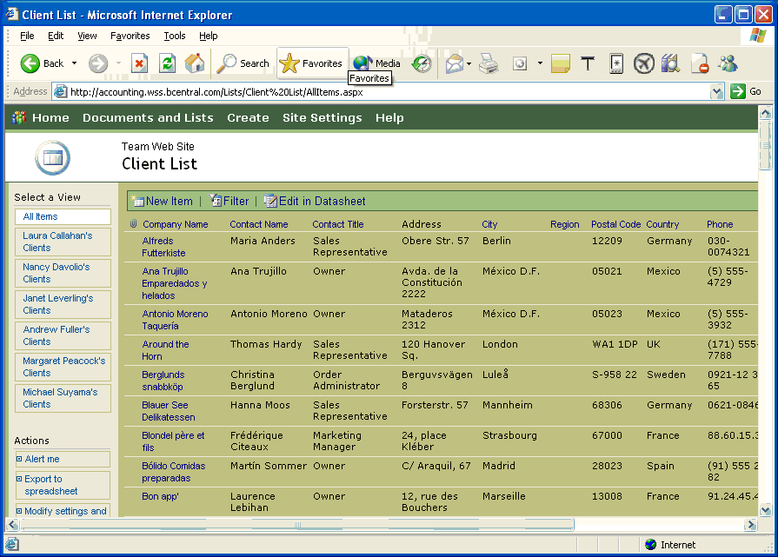

Working with Documents

Working with documents is very similar to working with lists. Many of the functions mirror each other, but may be performed in a different way. One of the great features of SharePoint is the fact that it enables users to access Office documents (Microsoft Word, Excel, PowerPoint, etc.) and data without requiring them to have Office installed on their computer.
In this lesson, you will be working with Document and Picture Libraries as well as the documents themselves.

To edit or delete a document:
  - Determine which document library your document is in and open it.
  - Find the document you are interested in editing/deleting.
  - Click the Edit link. From here you can:
    - Click Delete to delete the document.
    - Click Edit in Microsoft Word, to make changes to the document.
    - Click Discuss to conduct a discussion (we will cover this later!).
    - Click Send For Review to send the document for review. We will cover this later too!

NOTE:
SharePoint utilizes a version control system that creates a back up copy of files whenever it is saved to a library. This is helpful for maintaining a history of a file, or restoring files that have been accidentally deleted.

There are two “types” of documents that can be added to a Document Library. These are:
- New Documents
- Existing Documents

Adding an existing document is pretty easy. To do this, follow the following steps:
- Click the name of the document library where you want to add a file.
- Click Upload Document.
- Click Browse to find the file you want to upload, and then click Open.
  - If the file is replacing a file of the same name in the library, select the Overwrite if document already exists? checkbox.
  - If there are other fields, enter information as desired.
- To save the document in the library, click Save and Close.
- To cancel uploading of the document, click Go Back to Document Library.

Adding a new document requires SharePoint–compatible client programs, such as Microsoft Office XP, and Microsoft Internet Explorer 4.0 or later installed. The process is described in the Knowledge Center or in SharePoint Help.

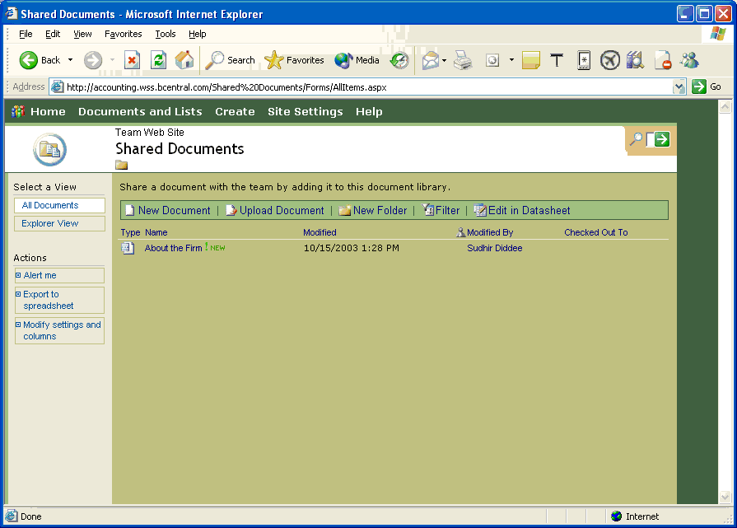

Holding a Discussion

About the Web Discussions feature
The Web Discussions feature enables anyone with discussion permissions to attach comments to a Web page or any document that can be opened with a browser. Comments appear with the document but are stored on a discussion server. The discussions are threaded.
Note The term Web page is used generically here to refer to any file you are viewing with a browser.
Anyone reviewing your Web page can use the Web Discussions toolbar to view and reply to any discussion. The Web Discussions toolbar is available in Microsoft Internet Explorer 4.0 or later to users of a Windows SharePoint Services-compatible client program, such as a Microsoft Office 2003 program.

Discuss a whole page or a paragraph
You can discuss the whole page, using general discussions, or insert comments in a particular part of a page, using inline discussions.
- General discussions When you discuss a page in general, discussion comments appear in a Discussion pane at the bottom of the window. If the page you are discussing is a frames page, the Enter Discussion Text dialog box presents a list of the frames so that you can specify which frame a discussion refers to.
- Inline discussions When you use inline discussions, discussion insertion markers appear at the end of every paragraph consisting of more than 30 characters, in every table cell that contains more than 5 characters, and at the end of every graphic that has a height or width of at least 30 pixels. These insertion markers indicate where you can start a discussion.
Note For pages that you view in a browser, inline discussions are available only in HTML-formatted files.

Show or hide discussion information
You can filter discussions — for example, view comments that are from a particular person or posted on a particular date. You can also show or hide discussion information so that you can focus only on the information you want to see:
- Show and hide individual discussion comments or entire discussions.
- Show and hide the Discussion pane.
- Drag the top border of the Discussion pane to make it larger or smaller.
- Close a discussion once the issues have been resolved. The discussion is not deleted; you can choose to view closed discussions, and you can reopen a closed discussion.
- Show or hide the subject, user name, or other header information.
Note Discussion header information includes two names for each participant: Display name and User name. Display name is the name that participants set in a client program, such as an Office program; User name is the logon name that a system administrator sets.

Store discussions
When you add discussion comments to a Web page, your text is stored in a database on a discussion server. The Web page you are discussing must be located on the same computer as the discussion server where your comments are stored.

View a Web discussion
Note You must be a member of the Administrator site group to complete this procedure.
- On the Site Settings page, click Go to Site Administration.
- On the Site Administration page, under Management and Statistics, click Manage Web Discussions.
- Specify whether you want to view a list of all Web discussions or just those starting from an URL that you specify, and then click Update.
- Click the link to the page with a Web document discussion you would like to view.
- In your Web browser toolbar, click Discuss.

Surveys

Many companies like to find out how their employees feel about certain issues. Using the SharePoint Survey feature is a great way to do this. Users of the SharePoint Survey feature can poll their employees using either a rating scale or a multiple-choice question.
If your site includes a survey, you can go to it by clicking Documents and Lists in the top link bar and then clicking the survey in the Surveys section.
You may be able to respond to a survey more than once, depending on how the survey is set up.
If the survey is set up so that respondents' names are visible, the All Responses view enables you to see how each team member responded. The Graphical Summary view displays a compilation of responses.

Create a survey
- In the top link bar, click Create.
- On the Create Page page, click Survey.
- In the Name box, type a name for the survey.
- This field is required.
- In the Description box, type a description of the purpose of the survey.
- This field is optional.
- In the Navigation section, if you want a hyperlink to this survey to appear on the Quick Launch bar, click Yes.
- In the Survey Options section, if you want respondents' names to be visible when a team member views the survey results, click Yes under Show user names in survey results?.
- If you want to allow team members to respond more than once to the survey, click Yes under Allow multiple responses?.
- Click Next.
- On the Add Question page, in the Question box, type a question.
- Select an option for the type of answer that you want.
- For example, if you want team members to choose from a set of items, click Choice.
- In the Optional settings for your question section, specify the settings that you want.
- The following types of answers are available, with options for each type (please refer to the multiple options in the software to complete this survey).

Respond to a survey
- On the top link bar, click Documents and Lists.
- In the Surveys section, click the name of the survey.
- At the top of the survey, click Respond to this survey.
- Answer the survey questions by filling out the form.
- Click Save and Close.

See the results of the survey
Do the following to see a compilation of responses:
- On the page that displays the survey, under Select a View, click Graphical Summary.
Do the following to see how others responded:
- On the page that displays the survey, under Select a View, click All Responses.
- Click View Response #n next to the name of the respondent.
Note The person who created the survey might have specified that respondents' names not be visible in the survey results.

Announcement and Events

Create a list of announcements, contacts, events, tasks, issues, or links
- In the top link bar, click Create.
- On the Create Page page, click one of the following for the kind of list that you want to create:
- Links
- Announcements
- Contacts
- Events
- Tasks
- Issues
- In the Name box, type a name for the list.
- This field is required.
- In the Description box, type a description of the purpose of the list.
- This field is optional.
- In the Navigation section, if you want a hyperlink to this list to appear on the Quick Launch bar, click Yes.
- Click Create.
- You can open the new list by clicking Documents and Lists on the top link bar and then clicking the list name in the Lists section. If you chose to add the list to the Quick Launch bar, you can also click the list name there to open it.
Note If the site is a Meeting Workspace site, ignore step 1. Instead, from the Modify This Workspace menu, click Add Web Parts. At the bottom of the task pane, click Show More Lists. Follow the remainings steps for the settings that apply to the Meeting Workspace site.

Add, edit, or delete an announcement
To add an announcement
- On the top link bar, click Documents and Lists.
- In the Lists section, click Announcements.
- At the top of the list, click New Item.
- In the Title box, type a heading for the announcement. This field is required.
- In the Body box, type the text of the announcement.
- If you want the announcement to disappear from the home page on a particular date, click the calendar, and then select a date.
- Click Save and Close.
Note If the site you're using is a Meeting Workspace site, ignore steps 1 through 3. Instead, in the Announcements Web Part, click Add Announcement. Then follow the remaining steps above.
To edit an announcement
- On the top link bar, click Documents and Lists.
- In the Lists section, click Announcements.
- Point to the announcement you want to edit, click the down arrow on the menu that appears, and then click Edit Item.
- Change the fields as desired, and then click Save and Close.
Note If the site you're using is a Meeting Workspace site, ignore steps 1 and 2. Instead, from the Announcements Web Part, follow the remaining steps above.
To delete an announcement
- On the top link bar, click Documents and Lists.
- In the Lists section, click Announcements.
- Point to the announcement you want to delete, click the down arrow on the menu that appears, and then click Delete Item.
- Click OK to confirm.
Note If the site you're using is a Meeting Workspace site, ignore steps 1 and 2. Instead, from the Announcements Web Part, follow the remaining steps above.
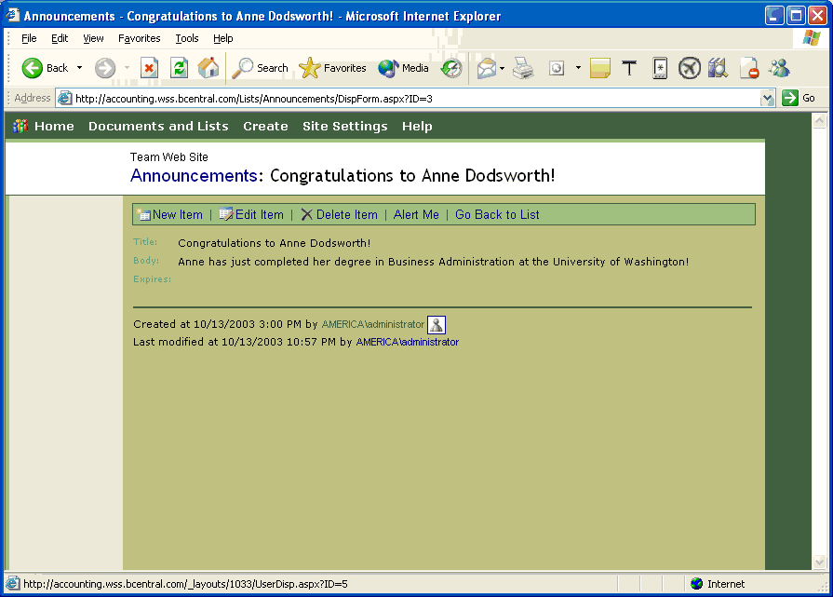

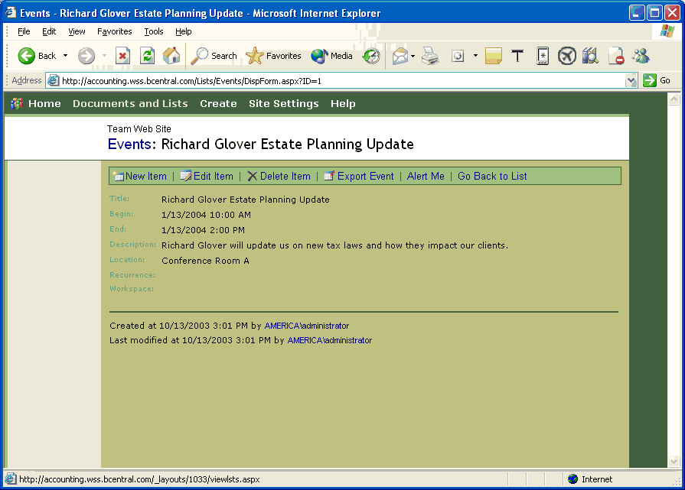

Special Information on User Accounts
bCentral Windows SharePoint Services automatically sends out new user names and passwords but these emails can only be sent if there is a valid email associated with the user account. If you want all of your SharePoint Web site users to be able to use the SharePoint web site please make sure all of the SharePoint site user accounts have an email address associated with them.

Update/Add your Windows SharePoint site user accounts
- Click on Site Settings.
- Manage Users.
- Click on add a new user.
Step 1: Choose Users - You can enter e-mail addresses, user names (e.g., DOMAIN\name), or cross-site group names. Separate them with semicolons.
Step 2: Choose Site Groups - Choose the site groups you want these users to have. (Assign roles)
Step 3: Confirm Users - These users are not members of this site. Accounts will be created for them and they will automatically be added to the site with the information that you provide here
Step 4: Send E-mail - Use this option to send each new user an e-mail containing his/her new user name and password. If this option is unchecked, a site administrator must change the users' passwords before they can access the site. You can choose to enter a personalized message.
  - Click on Finish
Note You will have to do this for each and every sub-site within a site collection.

Customizing a SharePoint site
Is it possible for a customer to use any web editor to customize their SharePoint site, or must they use FrontPage? Are there any special abilities that FrontPage has in customizing a SharePoint site that other web editors do not?

There are 3 ways to customize a site:
    - In the browser
    - In FrontPage 2003
    - Visual Studio.net
You could use any web editor, but you’d find limitation in what other web editors can do simply because they haven’t built the support for SharePoint that FrontPage has.
Some of the built-in features of FrontPage 2003 make it very easy to incorporate web parts (data view and list view web parts), create lists and sub-webs, and other data driven features into the web page designing that other web editors probably do not support

A simple example of this is that in FrontPage you can create and customize lists, fields, and views on list data. I don’t know of another web editor out there that can do this. I also don’t know how many other web editors understand the structure of the SharePoint web sites. If you were to open the pages up in other web editors you would be able to modify the pages as you would for other pages, but depending on the editor, the code that does the SharePoint pages may or may not be honored.

In short, FrontPage 2003 is the tool for editing SharePoint. Other web editors can be used, but it is up to those editors how they handle the pages (and they may or may not break the pages).
To see a customized site please click here (http://accounting.wss.bcentral.com)

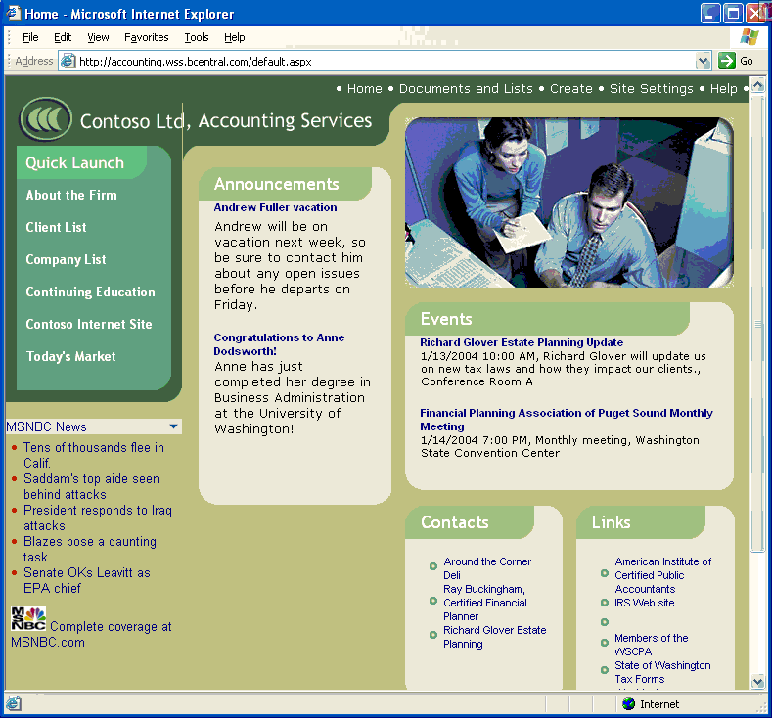
Sample Industry Solutions for SharePoint
Welcome to the Sample FrontPage 2003 site solutions for Windows SharePoint Services! These sites have been developed to give you an idea of the potential solutions for various verticals and help you jumpstart in creating an Internet, intranet or extranet site with Windows SharePoint Services.
Click one of the boxes below to visit the Solutions for sample sites with content for each type of business or organization.
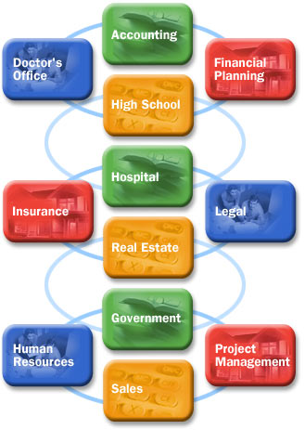
These are just a few of the sample solutions possible. You could use the sites in your own innovative way to solve your business problems. Please let us know if you have used your site in an innovative way or have questions whether Windows SharePoint Services is the right solution for your business. Click here to contact us

Frequently Asked Questions

How can I make my site public? By default, all sites are created private.

If you want your site to be a public Web site, enable anonymous access for the entire site (see detailed steps in the next question). Then you can give out your URL to anybody in your business card, e-mail or any other marketing material. The URL for your Web site will be:
http://yoursitename.wss.bcentral.com
Hence, please take special care to name your site.
These Web sites are ideal for information and knowledge intensive sites and/or sites where you need to have a shared Web workspace.
Remember: Under each parent Web site, you can create up to 10 sub-sites each with unique permissions, settings and security rights.
How do I make my site Public?

If you want your site to have anonymous access enabled (i.e., you want to treat it like any site on the Internet that does not ask you to provide a user name and password to see the content of the site), follow these simple steps:
- Login as an administrator.
- Click on Site settings.
- Click on Go to Site Administration.
- Click on Manage anonymous access.
- Choose one of the three conditions on what Anonymous users can access:
  - Entire Web site
  - Lists and libraries
  - Nothing
The default condition is nothing. Your site has restricted access. The default conditions allow you to create a secure site for your Web site.
What are sub sites and how do the sub sites work?

Sub sites are fully functional sites under the parent site. You can create a sub site for various categories. For example:
- Departments - Finance, Marketing, IT
- Products - Electrical, mechanical, hydraulics
- Projects - Trey Research, Department of Transportation, FDA
- Team - Retention team, BPR team
- Clients - New clients, old clients
- Suppliers - Supplier 1, Supplier 2, Supplier 3
- Customers - Customer A, Customer B, Customer C
- Real estate - Property A, property B
The URLs for each will be, for example:
http://yoursitename.wss.bcentral.com/finance
http://yoursitename.wss.bcentral.com/marketing
You can keep track of permissions for each team separately so that access is restricted while maintaining global access to the parent site.
Can I buy additional storage and user accounts?

Yes. Each SharePoint site includes storage and user accounts. Additional storage and user accounts available as you go and as you grow. Please see the details at:
http://www.bcentral.com/products/sp/faq.asp
Does a SharePoint Web site include search functionality?
Yes. SharePoint Team Services provides a powerful text-based search feature that helps you find documents and information fast.

How do I invite users to join a Windows SharePoint Services Site? Is the site secure?
SharePoint-based Web sites can be password-protected to restrict access to registered users, who are invited to join via e-mail. In addition, the site administrator can restrict certain members' roles by assigning different permission levels to view, post and edit. To add or invite users follow these simple steps:
  - You must be an administrator to add/remove users.
  - Log on to your site.
  - Click on Site settings.
  - Click on Site administration.
  - Manage users.
  - Add the user’ email address. Important: this is the email address where the user’s login and password info will be e-mailed.
  - Click Next, then add a personalized message.
  - Click on the Send button.

Can I post any kind of document?
You can post documents in many formats, including .pdf, .htm and .doc. In addition, if you are using Microsoft Office XP, you can save documents directly to your Windows SharePoint Services site.

Can I download information directly from a SharePoint site to a personal digital assistant (PDA)?
No, you cannot. However, you can exchange contact information lists with Microsoft Outlook.
How do I customize my SharePoint site?
SharePoint includes tools that let you create custom lists, calendars, page views, and the like. To fully customize your site, you can use Microsoft FrontPage 2003. Specifically, you can use FrontPage Themes and shared borders. With FrontPage, you can create photo galleries and top ten lists, utilize standard usage reports, and integrate automatic Web content.

The information contained in this document represents the current view of Microsoft Corporation on the issues discussed as of the date of publication. Because Microsoft must respond to changing market conditions, it should not be interpreted to be a commitment on the part of Microsoft, and Microsoft cannot guarantee the accuracy of any information presented after the date of publication.

This document is for informational purposes only. MICROSOFT MAKES NO WARRANTIES, EXPRESS, IMPLIED OR STATUTORY, AS TO THE INFORMATION IN THIS DOCUMENT.

Complying with all applicable copyright laws is the responsibility of the user. Without limiting the rights under copyright, no part of this document may be reproduced, stored in or introduced into a retrieval system, or transmitted in any form or by any means (electronic, mechanical, photocopying, recording, or otherwise), or for any purpose, without the express written permission of Microsoft Corporation.

Microsoft may have patents, patent applications, trademarks, copyrights, or other intellectual property rights covering subject matter in this document. Except as expressly provided in any written license agreement from Microsoft, the furnishing of this document does not give you any license to these patents, trademarks, copyrights, or other intellectual property.

© 2003 Microsoft Corporation. All rights reserved.

The names of actual companies and products mentioned herein may be the trademarks of their respective owners.

