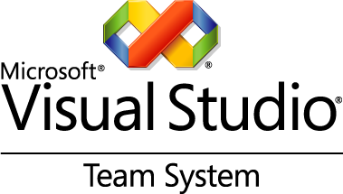

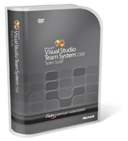

**Five Reasons Why We Need the**

**Visual Studio Team System 2008 to Win.**

Getting Visual Studio Team System 2008 Development Edition and Database Edition for the price of one is a great opportunity to get our teams collaborating better, delivering better code, and meeting your challenges. Here’s why:

1. **Better ROI.** Now we can get the Development Edition and the Database Edition for the price   
   of one. So the upfront costs are lower. But that’s just the beginning. Other savings come from:

* Giving teams all they need to develop from the UI to the database
* Helping them collaborate better, so work moves more quickly
* Reducing the effort to maintain applications and create custom development

1. **Faster delivery.** As the ultimate project management tool for reducing risk and driving predictability, Visual Studio Team System makes life easier for everyone. That’s because it:

* Keeps developers focused on business requirements
* Builds quality into the process to minimize re-coding
* Provides metrics to measure progress and help ensure the predictability of workflows
* Helps eliminate eleventh-hour bugs and other surprises

1. **Smoother custom development.** We’ll get a full set of metrics for the status, quality, and traceability of your projects, so responsibilities, accountability, and sign-offs are clear. So there are fewer risks and it’s easier to recover from errors
2. **Improved collaboration.** The team that communicates better, works faster and more efficiently. With Visual Studio Team System 2008, it’s easier to:

* Manage outsourced and distributed items across functional, geographic,   
  and organizational boundaries
* Automate reporting
* Improve communication and collaboration through the centralized Team Foundation Server

1. **Talk about building stronger teams.** Visual Studio Team System 2008 and an MSDN   
   Premium subscription help all your developers by giving them:

* Skills that translate well across all Microsoft platforms—including Windows, the Microsoft Office system, the Web, and mobile devices—giving them greater flexibility
* A grounding in best practices for working with the Microsoft Solution Framework
* Development, testing, and demonstration support—through MSDN Premium
* Access to Microsoft Software Assurance, our comprehensive software maintenance program

