

Upgrading from SQL Server 2005 Express Edition to Workgroup or Standard Editions
SQL Server Technical Article

Writers: Anthony T. Mann, President, Mann Publishing Group

Published: July 2006
Applies To: SQL Server 2005

Summary: This white paper discusses common scenarios for upgrading from SQL Server 2005 Express Edition to higher editions of SQL Server 2005, especially SQL Server Workgroup Edition and SQL Server Standard Edition. It discusses the features in each edition so you can decide which edition is right for your organization.

Copyright

The information contained in this document represents the current view of Microsoft Corporation on the issues discussed as of the date of publication. Because Microsoft must respond to changing market conditions, it should not be interpreted to be a commitment on the part of Microsoft, and Microsoft cannot guarantee the accuracy of any information presented after the date of publication.

This White Paper is for informational purposes only. MICROSOFT MAKES NO WARRANTIES, EXPRESS, IMPLIED OR STATUTORY, AS TO THE INFORMATION IN THIS DOCUMENT.

Complying with all applicable copyright laws is the responsibility of the user. Without limiting the rights under copyright, no part of this document may be reproduced, stored in or introduced into a retrieval system, or transmitted in any form or by any means (electronic, mechanical, photocopying, recording, or otherwise), or for any purpose, without the express written permission of Microsoft Corporation.

Microsoft may have patents, patent applications, trademarks, copyrights, or other intellectual property rights covering subject matter in this document. Except as expressly provided in any written license agreement from Microsoft, the furnishing of this document does not give you any license to these patents, trademarks, copyrights, or other intellectual property.

Unless otherwise noted, the example companies, organizations, products, domain names, e-mail addresses, logos, people, places and events depicted herein are fictitious, and no association with any real company, organization, product, domain name, email address, logo, person, place or event is intended or should be inferred.

© 2006 Microsoft Corporation. All rights reserved.

Microsoft, SharePoint, Visual Studio, Windows, and Windows Server are either registered trademarks or trademarks of Microsoft Corporation in the United States and/or other countries.

The names of actual companies and products mentioned herein may be the trademarks of their respective owners.

Table of Contents
Introduction 1
SQL Server Editions 1
Business Benefits 1
When to Upgrade 2
Scenarios for Upgrading 3
Reporting 3
Asynchronous communications 3
ISV applications 4
Data management applications 5
Business intelligence 5
Features Obtained by Upgrading to Workgroup Edition 5
Enhanced features 5
Report Builder 5
Integration Services 6
Scalability 7
Database size 7
Memory 7
CPUs 7
Asynchronous communications 7
Replication 7
Service Broker 7
High availability 8
Manageability 8
Management Studio 8
SQL Server Agent 9
Additional Features Obtained by Upgrading to Standard Edition 9
Business intelligence 9
Reporting Services 9
Analysis Services 12
Integration Services 13
Scalability 14
Database size 14
Memory 14
CPUs 14
64-bit support 14
Asynchronous communications 14
Replication 14
Notification Services 14
High availability 15
Database mirroring 15
Failover clustering 16
Manageability 16
SQL Server Profiler 17
Database Tuning Advisor 17
Features to Consider Before Upgrading to Enterprise Edition 18
Upgrade Approaches 19
In-Place 19
Side-by-side 19
Migrating from User Instances 20
Conclusion 20

Introduction
Microsoft® SQL Server™ 2005 Express edition, the free version of SQL Server 2005, comes with the core data management and reporting features of SQL Server 2005. As your business needs grow or requirements dictate, you can upgrade from SQL Server 2005 Express Edition to take advantage of the greater scalability and more powerful features that are available in higher editions. SQL Server 2005 Express can be upgraded to any addition of SQL Server 2005, but it will be most common to upgrade to either SQL Server 2005 Workgroup Edition or SQL Server 2005 Standard Edition. For the most demanding workloads and the highest levels of availability, it may be appropriate to upgrade to SQL Server 2005 Enterprise Edition.
This paper discusses specific scenarios for upgrading and provides feature information for the Workgroup, Standard, and Enterprise editions of SQL Server 2005.

SQL Server Editions
For production environments, SQL Server 2005 comes in four editions. The features in each edition are covered thoroughly throughout this paper. Following is an overview of the targeted business uses for each edition:
- Express – Free to download, free to deploy, and free to redistribute, SQL Server 2005 Express is useful for small applications that need basic data management and reporting features. SQL Server Express Edition is particularly useful for independent software vendors (ISVs) because it can be freely redistributed and embedded with ISV applications. A free database management tool, SQL Server Management Studio Express is also available for SQL Server Express.
- Workgroup – With no limits on database size and support for up to two CPUs, SQL Workgroup Edition is ideal for smaller organizations with applications that have data management, reporting, basic replication, and import/export needs. SQL Server Workgroup Edition also provides asynchronous job scheduling with SQL Server Agent, end-user reporting with Report Builder, backup log shipping for higher availability, and SQL Server Management Studio.
- Standard –Standard Edition is for organizations that require greater scalability than is available in Workgroup Edition. Standard Edition has native 64-bit support, basic high availability and SQL Server Business intelligence features, including SQL Server Analysis Services, full SQL Server Reporting Services capabilities, and the ability to manage data across servers or disparate data sources by using SQL Server Integration Services.
- Enterprise – Designed for the most demanding workloads and the highest level of availability, SQL Server Enterprise edition provides advanced data management, analysis, and reporting features. These features include advanced analysis and analytics, and ultra-high availability.

Business Benefits
SQL Server 2005 Express Edition (SSE) is a free edition of SQL Server 2005 that can be used as a lightweight server, local data store, or client, for basic data management and reporting. SSE is a great way to start using SQL Server 2005, but as your business needs grow, other editions of SQL Server 2005 will provide more capabilities and scalability.
As your business applications grow in sophistication, require more data storage, require more simultaneous users, or need higher availability, consider upgrading the edition of SQL Server 2005 that your organization uses. SQL Server 2005 enables you to upgrade to “higher” editions seamlessly without changing your applications or business processes. The seamless upgrade paths mean that you can use the edition of SQL Server 2005 that best suits your current needs, while giving you confidence that you can upgrade with little effort when your business needs require you to do so.
SQL Server 2005 Express Edition provides a core set of integrated tools with which to manage a SQL Server 2005 installation. In the Express edition, the integrated tools are called SQL Server Management Studio Express (SSMSE). It enables basic management of a SQL Server 2005 Express installation. As your business needs grow and you upgrade the edition of SQL Server 2005, the same core tools are used to manage those installations, but are simply called SQL Server Management Studio (SSMS). SSMS has expanded capabilities for even more control over one or more SQL Server 2005 installations.
The Express edition is a great place to get started designing, developing, and deploying SQL Server 2005 Reporting Services applications. If you need the additional reporting capabilities in SQL Server 2005 Workgroup or Standard edition, your skills will transfer seamlessly to the upgraded editions. All editions of SQL Server 2005 use a tool that is based on Microsoft Visual Studio® 2005, called the Business Intelligence Development Studio (BIDS), so developers can use a consistent set of tools to develop all types of applications, including Reporting Services applications.

When to Upgrade
Understanding the features and capabilities of other editions of SQL Server 2005 will enable you to make an informed decision about which edition is right for your organization and whether to upgrade from SQL Server 2005 Express edition.
Upgrading from SSE gives your applications additional features and benefits. Each is covered in detail in Upgrading to Workgroup Edition and Upgrading to Standard Edition later in this paper. Here is a brief summary of the additional features and benefits of upgrading from SQL Server 2005 Express edition:
- Business Intelligence – A host of new features and technology advances to help your organization make better business decisions are included in SQL Server 2005. SQL Server 2005 Standard Edition is considered to be the platform for business intelligence as these technologies are fully enabled:
- Reporting Services – This is a comprehensive reporting platform to rapidly create and deploy reports within your organization. While SQL Server 2005 Express edition includes SQL Server Reporting Services (SSRS), the features are greatly enhanced in the Workgroup and Standard editions.
- Analysis Services – A key part of Microsoft’s Business Intelligence (BI) strategy, SQL Server Analysis Services (SSAS) enables you to analyze and mine your data through an array of complex technologies, such as Online Analytical Processing (OLAP) and data mining.
- Integration Services – Provides a robust environment to enable you to move and transform data between data sources. The Express edition of SQL Server 2005 does not contain SQL Server Integration Services (SSIS). The Standard edition enables Integration Services features that enable your organization to seamlessly manipulate data between data sources.
- Scalability – Higher editions of SQL Server 2005 enable greater scalability (both scale-up and scale-out) capabilities over SQL Server 2005 Express edition. Each higher edition allows you to support increasingly larger workloads and user bases with increased support for memory and physical CPUs.
- Asynchronous Communications – A variety of technologies that enable your department or whole organization to asynchronously communicate amongst SQL Server and other messaging systems. Each edition of SQL Server 2005 provides additional asynchronous communications technologies and features.
- High Availability – Depending on your business needs, in a high transaction or production environment, you will likely need to implement one or more high availability technologies. Both the Workgroup and Standard editions of SQL Server 2005 include basic high availability features. Enterprise Edition supports the highest level of availability.
- Manageability – SSE includes a lightweight version of SQL Server Management Studio, which is the same tool that is used by the higher editions of SQL Server 2005 to manage your servers, services, features, and configurations.

Scenarios for Upgrading
This section outlines some of the most common scenarios for upgrading from SSE. The four SQL Server 2005 editions provide the right functionality for an organization’s needs, giving you flexibility in deployment and licensing, and helping you make the most of your investment in SQL Server technology.

Reporting
Virtually all database applications need to produce reports. The types of reports that you need to create dictate whether you need to upgrade from SQL Server 2005 Express Edition. SSE includes Reporting Services, but is limited to local relational data on the same computer where SSE is installed.

Asynchronous communications
There are three main asynchronous technologies built into SQL Server 2005:
- Replication – Replication, built into SQL Server, automatically manages the copying, or replication, of data from one source to another. Replication follows a publisher/distributor/subscriber model. Replication is a very useful technology when you cannot always guarantee that the subscriber of a publication is online or has a reliable connection. Replication is built into SQL Server 2005 Express Edition, but it can only be a subscriber to a publication that is available on a higher edition of SQL Server. It cannot serve as a publisher or a distributor. If you need a particular server to be a publisher or distributor, you must upgrade from SQL Server 2005 Express to a higher edition of SQL Server. SQL Workgroup Edition provides basic replication publication and is limited to 25 total merge replication subscribers and 5 transactional replication subscribers. The Standard and Enterprise editions do not limit the number of replication subscribers.
One common scenario for replication is to implement offline processing. Offline processing enables a system to be disconnected from a centralized server, while still allowing for data updates when the central server is reconnected. Another common scenario is to implement load balancing. Load balancing is when multiple servers are implemented and each server handles part of the data load. Replication can be used to automatically populate and segment the data on each server. For example, replication can be used to populate two servers; one to handle users with the last names beginning with “A” through “M” and the other to handle “N” through “Z”.
- Notification Services – SQL Server Notification Services is an asynchronous communications mechanism that can notify subscribers when data changes. For example, notification messages can be sent to subscribers when stock prices (stored in SQL Server) reach a specific level. Notification Services keeps track of all notifications sent to subscribers so that message delivery is guaranteed. Notification Services is not available in SQL Server 2005 Express Edition or Workgroup Edition, so if your application requires this functionality, you will need to upgrade to Standard or Enterprise Editions.
- Service Broker – Service Broker is a new asynchronous messaging technology in SQL Server 2005 that provides guaranteed asynchronous messaging communications between servers running SQL Server by sending and receiving messages. SQL Server 2005 Express Edition can participate in Service Broker messaging as long as an upgraded edition is installed at some point in the message chain. In other words, if you send messages from ServerA to ServerB, either ServerA or ServerB can be using Express Edition, but not both. Therefore, your application may need to upgrade from SQL Server Express Edition to either Workgroup or Standard Edition.
A common scenario for Service Broker is when you need to implement an asynchronous communication mechanism, but the data to be transmitted in each transaction is very small. For example, a Point of Sale (POS) system may send Service Broker messages to a centralized server because each transaction would contain a small amount of data.

ISV applications
Most Independent Software Vendor (ISV) applications use a database to store application data or configuration data. A common scenario is for ISVs to distribute a copy of a stand-alone database with their applications. SQL Server 2005 Express Edition is typically used in such scenarios. However, if your organization already has another edition of SQL Server 2005 installed, you may not want to have multiple stand-alone installations of SSE installed. Doing so would mean more SQL Server installations to manage. Therefore, you would want to upgrade them to another edition of SQL Server, such as Workgroup Edition or Standard Edition.
If ISV applications need basic replication capabilities, upgrading from SQL Server 2005 Express edition to SQL Server 2005 Workgroup Edition is an ideal solution. Additionally, if an ISV application needs to schedule jobs or perform time-based activities, the SQL Server Agent service can be used if you upgrade from SQL Server 2005 Express Edition to SQL Server 2005 Workgroup Edition. For example, if an application needs to export daily transactions at 01:00 every weekday, you can schedule SQL Server Agent to automatically run an export.

Data management applications
Data management applications, such as a basic Web applications, can benefit from SQL Server 2005 Express Edition. For example, a basic site that does not get many daily hits can store data in SSE. However, if your Web site is designed to handle many simultaneous users or significant amounts of data, you will likely need to upgrade to SQL Server 2005 Workgroup or Standard Edition.

Business intelligence
SQL Server 2005 Standard Edition is designed to be the platform for business intelligence. It includes full Reporting Services capabilities, Analysis Services, and full Integration Services capabilities. However, for advanced business intelligence features, such as complex analysis and data mining, Enterprise Edition is the most appropriate edition.

Features Obtained by Upgrading to Workgroup Edition
Workgroup Edition is one step up from SQL Server 2005 Express Edition. It is designed for use in a small organization or for within a single workgroup or small department of a large organization. Workgroup Edition is good for data management and reporting solutions, such as departmental finance applications, Intranet applications, or other localized data management and reporting applications. The following sections outline the specific feature enhancements that are available when you upgrade from SQL Server 2005 Express Edition to SQL Server 2005 Workgroup Edition.

Enhanced features
SQL Server 2005 Workgroup Edition provides enhanced reporting capabilities by expanding the features available to SSRS. These features are discussed in this section.

Report Builder
In SQL Server 2000, designing reports was a task that was done by developers. It used the familiar Visual Studio environment to enable developers to design, develop, and deploy reports. In SQL Server 2005, developers can still use Visual Studio (Visual Studio 2005), but SSRS now comes with Report Builder. Report Builder is a technology that enables business users to develop their own reports even if they do not know the Visual Studio environment. Because business users typically know the data in their organization, Report Builder enables a business user to focus on creating ad-hoc reports without knowing anything about technology. Figure 1 shows what the SSRS Report Builder looks like.

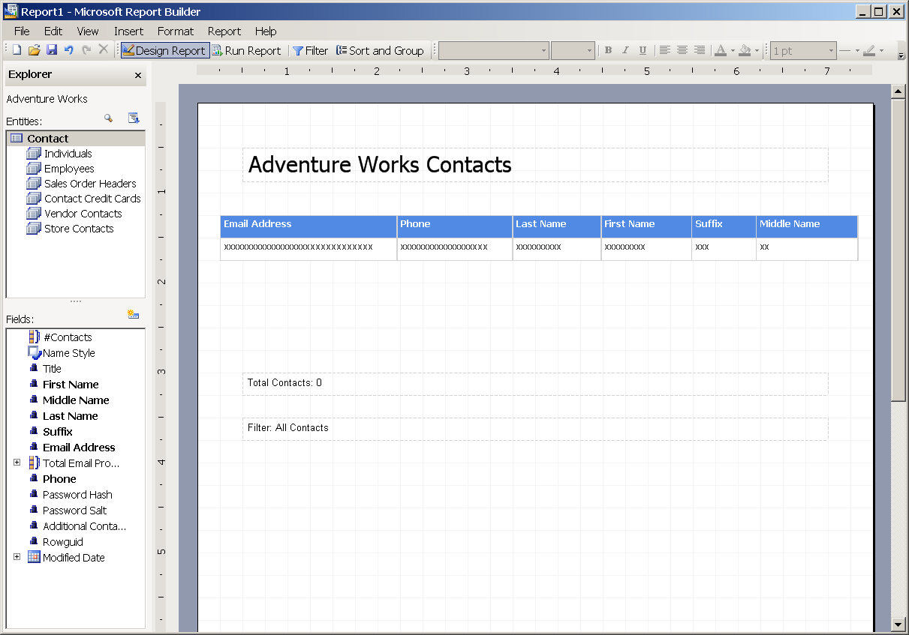
Figure 1 SQL Server 2005 Reporting Services Report Builder

Integration Services
Most database applications need to import or export data, even it is on a one-time basis. SQL Server 2005 Integration Services (SSIS) is included in the Workgroup Edition of SQL Server 2005 through the Import and Export Wizard. While SSIS is the technology that imports and exports data behind the scenes, it does not enable you to build custom transformations between data sources. You need to upgrade to SQL Server 2005 Standard Edition for that. The Import and Export Wizard is shown in Figure 2.
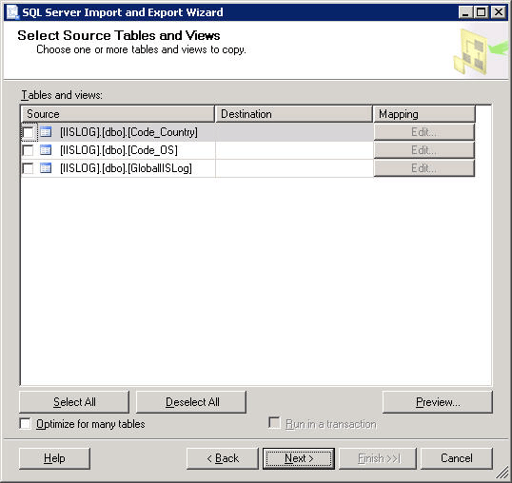
Figure 2 Import and Export Wizard

Scalability
Scalability refers to the ability to increase the capacity of your system as business needs arise. Scalability is enhanced in SQL Server 2005 Workgroup edition in the following ways.

Database size
One reason to upgrade is based on database size. There is a limitation of 4 GB for SSE databases. It is a good idea to calculate your data requirements and plan for growth to determine how large your database will become. If there is a chance that the database will grow beyond 4 GB, consider upgrading from SSE to SQL Server 2005 Workgroup Edition. There is no database size limitation in Workgroup Edition, so your databases can grow as your business needs change.

Memory
SQL Server 2005 Express Edition is limited to 1 GB of memory. If your database application grows beyond just a few users or is doing a lot of processing, you will likely need to upgrade from Express Edition to Workgroup Edition. Workgroup Edition uses up to 3 GB of memory for your database applications.

CPUs
SQL Server 2005 Express Edition is limited to one physical CPU. If business requirements dictate that more processing power is needed, you may need to upgrade to SQL Server 2005 Workgroup Edition, which uses up to two physical CPUs.

Asynchronous communications
Upgrading from SQL Server 2005 Express Edition to SQL Server 2005 Workgroup Edition enables your applications to take advantage of asynchronous communications mechanisms. It enables you to implement replication and Service Broker applications, which are covered in the following sections.

Replication
Replication in SQL Server 2005 Workgroup Edition has significant enhancements over SQL Server 2005 Express Edition. In a replication scenario, SQL Server 2005 Express Edition can only be a subscriber. In Workgroup Edition, SQL Server can be a publisher as well. However, there are some limitations as to the number of subscribers that can subscribe to a publication from Workgroup Edition, as follows:
- Snapshot Replication – No limit
- Merge Replication – Limited to 25 subscribers
- Transactional Replication – Limited to 5 subscribers

Service Broker
SQL Server 2005 Express Edition can take part in a Service Broker message chain between servers running SQL Server. However, SQL Server Workgroup Edition (or higher) must be used somewhere along the message chain, although it does not explicitly need to be first or last in the chain.

High availability
While SSE allows online system changes, thereby reducing the need to shut down the database and applications, SQL Server 2005 Workgroup Edition adds log shipping. Log shipping is a feature that lets you ship the transaction logs to another computer. Shipping logs enables you to quickly bring a standby server online. However, it is possible to have some transactions lost while you bring the standby server online. If your business requirements specify that this is an acceptable risk, consider upgrading to SQL Server 2005 Workgroup Edition to help minimize downtime and keep your applications available.

Manageability
Manageability refers to the tools and technologies that enable you to manage one or more SQL Servers. SQL Server 2005 Express Edition comes with basic management tools. The enhancements to the management tools in SQL Server 2005 Workgroup Edition are discussed in this section.

Management Studio
SQL Server 2005 Express comes with SQL Server Management Studio Express, which contains all of the functionality needed for SQL Express. SQL Server 2005 Workgroup Edition comes with the full version of the tool, called SQL Server Management Studio. It contains all the functionality required to support SQL Server 2005 Workgroup Edition and manage all aspects of your servers, including linked servers, replication, SQL Server 2005 maintenance plans, SQL Server Agent jobs, and legacy (SQL Server 2000) maintenance plans and DTS packages. Figure 3 shows what Management Studio looks like.
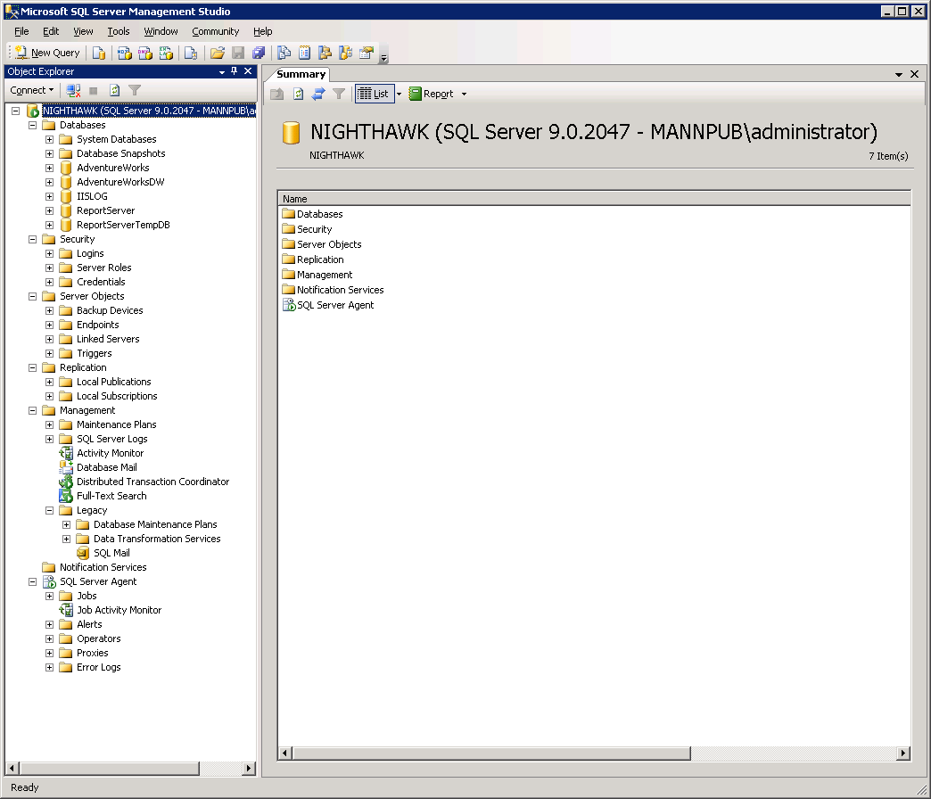

Figure 3 SQL Server 2005 Management Studio

SQL Server Agent
SQL Server Agent is a service that enables you to schedule SQL Server jobs and tasks, such as automated backups and other maintenance functions, such as shrinking databases and checking them for internal consistency.
SQL Server Agent is included in SQL Server 2005 Workgroup Edition. If you use SQL Server in a production environment, it is a good idea to ensure that your server(s) are optimized and tuned on a regular basis. SQL Server Agent is the best way to schedule automation of maintenance of your servers.

Additional Features Obtained by Upgrading to Standard Edition
SQL Server 2005 Standard edition is the next step up from SQL Server 2005 Workgroup Edition. The Standard edition of SQL Server 2005 is provides business intelligence features in addition to the data management and reporting capabilities, making it suitable for line of business applications, e-commerce sites, and data warehousing. SQL Server 2005 Standard Edition includes all features of the SQL Server 2005 Express and Workgroup editions, plus the additional features described in this section.
Note: If you notice a feature is not covered in this section, it is because that feature provides the same level of benefit as is available in SQL Server 2005 Workgroup Edition. The features covered in this section are those that provide additional capabilities beyond the Workgroup edition of SQL Server 2005.

Business intelligence
SQL Server 2005 Standard Edition provides enhanced business intelligence capabilities over the Workgroup edition of SQL Server 2005. This includes Reporting Services enhancements and SQL Server Analysis Services.

Reporting Services
Reporting Services in SQL Server 2005 Standard Edition adds additional capabilities that enhance the business insight you can get from your data. These capabilities are covered in this section.
Subscriptions
The Standard edition of SQL Server 2005 Reporting Services enables clients to subscribe to reports. By subscribing to reports, clients can receive a fresh copy of a report in a variety of delivery methods on a specific schedule. For example, a Sales report can be automatically placed in a user’s e-mail inbox every Monday morning in preparation for a weekly sales meeting. Subscribing to a subscription is shown in Figure 4.
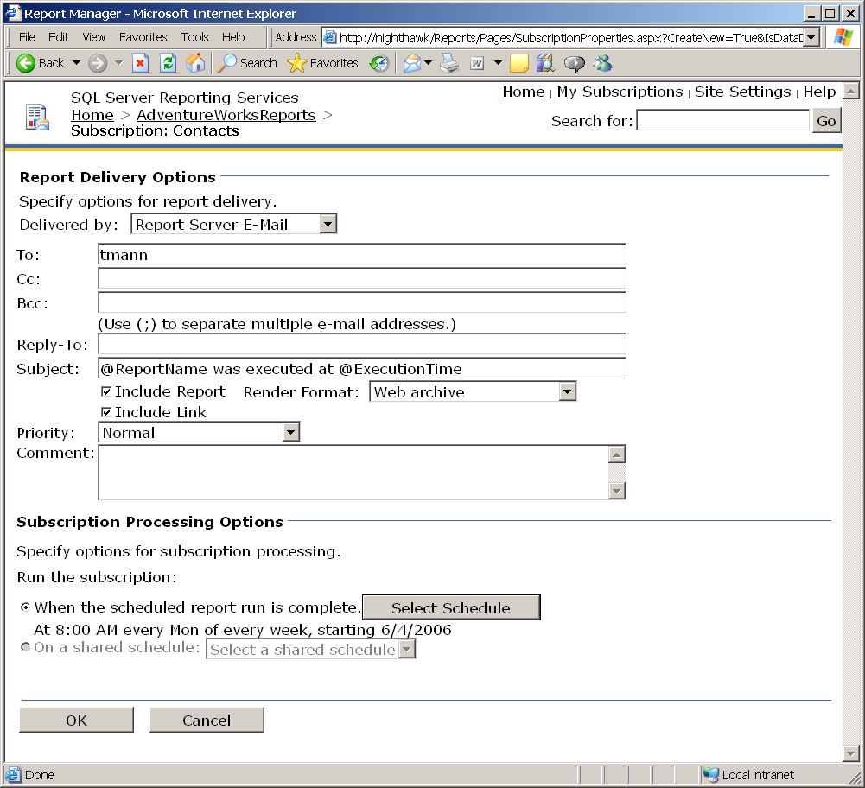

Figure 4 Subscribing to a report
Multiple Data Sources
Upgrading to SQL Server 2005 Standard Edition enables you to use SSRS to report on multiple data sources. The Express and Workgroup editions of SQL Server 2005 allow you to report only on local, relational data that resides only on the same computer as the one where SSRS is installed. If you upgrade to Standard Edition you can construct reports from any number of data sources, whether they reside on the same computer or not.
Export Formats
SSRS reports can be exported in a variety of formats. SQL Server 2005 Workgroup and Express editions support exporting reports to these formats:
- Excel
- PDF
- Image (RGDI and Print)
- DHTML
Standard Edition adds support for these export formats:
- XML
- CSV
- TIFF
- Web Archive
SharePoint Integration
If your organization uses either Microsoft Windows® SharePoint® Services or SharePoint Portal Server 2003, SSRS integrates well with either of these technologies. SQL Server 2005 Standard Edition includes two separate Web Parts: Report Explorer and Report Viewer. The Report Explorer Web Part lets you view the reports available within SSRS. The Report Viewer Web Part enables you to interactively display reports within the SharePoint environment. Both SSRS Web Parts enable your organization to create a single portal from which business users are armed with the information they need to make good business decisions, without needing to search for reports. Figure 5 shows a Windows SharePoint Services environment that makes use of the Report Explorer and Report Viewer Web Parts.
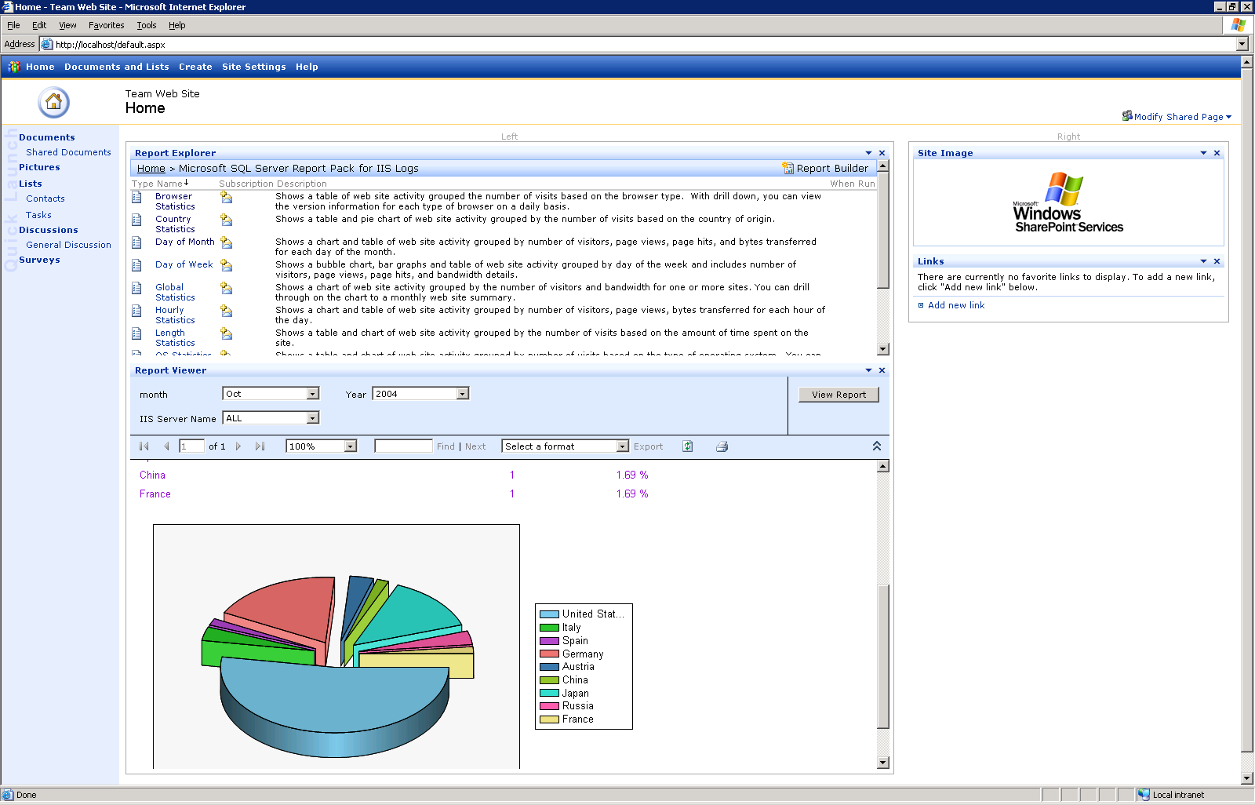

Figure 5 Reporting Services Web Parts shown in a Windows SharePoint Services environment
Caching
Report processing can be quite resource-intensive. A server that is busy with many repetitive report processing operations can affect the overall performance of the server. To aid in performance enhancement, a report that runs on SQL Server 2005 Standard Edition can be configured to render from the SSRS cache instead of processing every time a user requests it. The caching can be configured to expire at a specific interval on a per-report basis.
History
SQL Server 2005 Standard Edition stores historical information about a report. Historical information includes a snapshot of the data at a specific point in time. History can be very important to track changes. Your business requirements may even dictate that you maintain historical information about reports to maintain specific Service Level Agreements (SLAs).
Delivery
SQL Server 2005 Standard edition enables you to specify these delivery methods for reports:
- E-mail – When specifying this delivery method, you can specify the recipients on the To:, Cc:, or Bcc: lines. You can also specify e-mail distribution groups to make it more manageable to distribute reports.
- File Share – When specifying this delivery method, you specify the file name and path for the reports. You can also specify overwrite options to control what happens if a file of the same name exists on the file share.
Extensibility
SQL Server 2005 Standard Edition enables you to extend the built-in functionality of Reporting Services in these ways:
- Delivery extensions – For customizing the locations where report subscriptions can be sent.
- Renderers – For rendering reports in additional formats.
- Data sources – For retrieving data from additional data sources.
If your reporting requirements cannot be met with out-of-the-box functionality, upgrade from SQL Server 2005 Express Edition to SQL Server 2005 Standard Edition.

Analysis Services
SQL Server Analysis Services (SSAS) offers a compelling reason to upgrade to SQL Server 2005 Standard Edition. You can use SSAS to analyze and query OLAP and relational data sources. SSAS includes data mining capabilities so you can mine your data for patterns by using specialized algorithms. SSE does not include analysis services capabilities, so if you need these services, you must upgrade to Standard Edition.
Analysis Services projects are constructed by using Visual Studio 2005. Use Visual Studio 2005 to develop, deploy, test, and debug all aspects of an Analysis Services project. Figure 6 shows an Analysis Services cube in the Cube Browser.
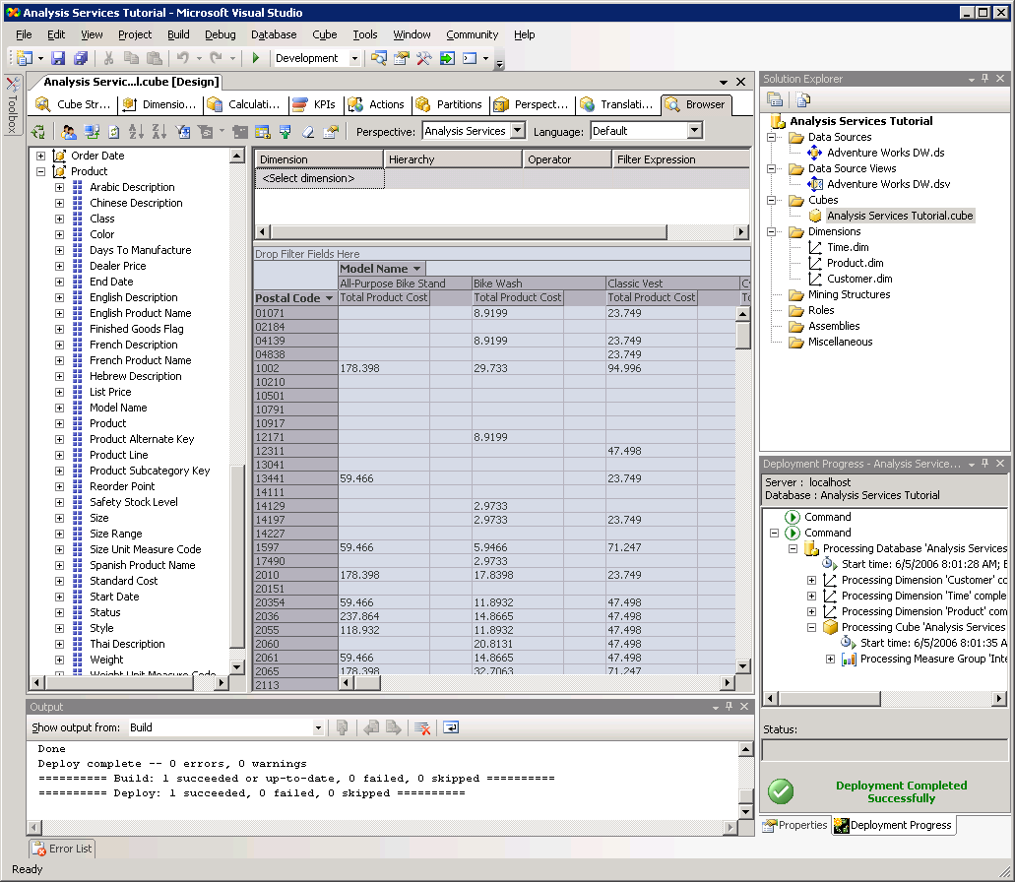

Figure 6 Browsing a cube in SQL Server 2005 Analysis Services

Integration Services
SQL Server Integration Services (SSIS) is an extraction, transformation, and loading (ETL) tool that moves data between data sources. SSIS is not included in SSE. Only the Import and Export Wizard is available in SQL Workgroup Edition.
SSIS provides a robust infrastructure for designing standard and custom transformations of data. Developers create SSIS packages in Visual Studio 2005, so they have a familiar environment in which to develop database applications.
SSIS comes with a complete object model to enable programmers to create virtually any custom functionality that an organization requires, including these types of tasks and transformations:
- ActiveX Script task
- Bulk Insert task
- Data Flow task
- FTP task
- File System task
- Transfer Database task
- Web Service task
- XML task
- Back Up Database task
- Execute SQL Server Agent Job task

Figure 7 shows a SQL Server 2005 Integration Services Project in Visual Studio 2005.
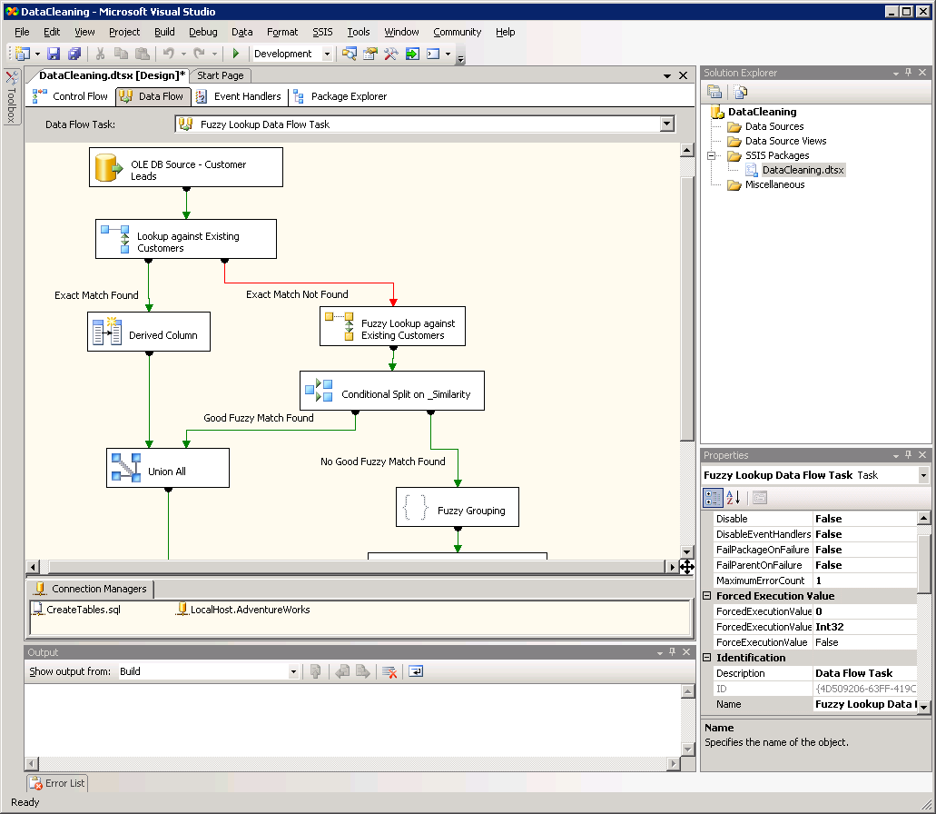

Figure 7 SQL Server 2005 Integration Services project

Scalability
Scalability is enhanced in SQL Server 2005 Standard Edition over SQL Server 2005 Workgroup Edition as described in this section.

Database size
As in Workgroup Edition, there is no database size limitation in Standard Edition. Your databases can grow with your business needs.

Memory
SQL Server Standard Edition allows you to access the operating system maximum amount of memory, so you take full advantage of your hardware’s capabilities. SSE is limited to 1 GB of RAM.

CPUs
SQL Server Standard Edition supports up to four physical processors, giving you more performance and ability to operate on more powerful hardware than with SSE.

64-bit support
Unlike SSE, SQL Standard Edition provides full native 64-bit support. SSE could only operate on IA64 systems when running in Windows on Windows (WOW) emulation mode.

Asynchronous communications
Asynchronous communication features are enhanced in SQL Server 2005 Standard Edition. Service Broker features remain the same as what is available in SQL Server 2005 Workgroup Edition, but replication and notification services are enhanced.

Replication
In SQL Server 2005 Standard Edition, the limitation of the number of subscribers for merge and transactional replication is removed. If, for example, your business needs to have ten computers participate in transactional replication, you must upgrade to SQL Server 2005 Standard Edition.

Notification Services
SQL Server 2005 Standard Edition includes SQL Server Notification Services (SSNS). Notification services differs from other asynchronous communication features. The Service Broker and replication technologies are geared towards asynchronous communications between servers, while Notification Services applications are geared towards sending data to end-users. Notification Services notifies subscribers when data changes, such as when a stock reaches a specific price, or a new sale is offered by a retail store. Notification Services is device-independent, so end-users can be notified on their desktops, mobile devices, and cell phones.
Notification Services is an important technology because it can help companies increase their revenue by notifying subscribers when data that concerns them changes. Notification Services applications can be developed to enable subscribers to configure or select the data that is most relevant to them and to be automatically notified when that data reaches specified thresholds.

High availability
Both SQL Server 2005 Workgroup Edition and SQL Server 2005 Standard Edition include log shipping. Standard Edition also includes support for two additional high-availability features, called database mirroring and failover clustering.

Database mirroring
Database mirroring is a new technology in SQL Server 2005 that makes a copy, or mirror, of an entire database onto another computer. Because database mirroring is done in real-time, networking performance is of utmost importance. It is recommended that each server that takes part in mirroring have a dedicated network card.
In a database mirroring scenario, the source server is called the principal and the target server is called the mirror. The principal server writes transaction logs to the mirror at the same time as the principal. Thus both servers are up-to-date simultaneously. However, when a server fails, it does not automatically fail over to the mirror server. To make this happen, a third server, known as the witness, must take part in the scenario. If automatic failover is implemented, client connections are automatically redirected to the mirror for a truly automated failover solution. This is shown in Figure 8.

Figure 8 Overview of database mirroring
There is a database mirroring limitation in SQL Server 2005 Standard Edition. The SAFETY parameter is always set to FULL. This means that transaction log information is written to the mirror server in a synchronous fashion. Sending transaction log information synchronously can affect the performance of the principal server because every transaction must be written to multiple servers over the network at the same time. Database mirroring does allow for the asynchronous communication of transaction log information (by setting the SAFETY parameter to OFF), but you must upgrade to SQL Server 2005 Enterprise Edition to take advantage of this feature.

Failover clustering
Clustering is a technology for high availability that enables multiple servers to share an external hard disk array. If one server becomes unavailable, another server takes over automatically. Because the disk drive arrays are the same, there is no risk of data loss. The disk drives are shared at the hardware level in a RAID configuration (usually RAID 5 or RAID 10).
Clustering in SQL Server 2005 largely takes advantage of the Windows clustering technology (either Windows Server 2000 or Windows Server 2003). SQL Server 2005 cooperates with Windows clustering by automatically failing over to another node in the cluster in case one of the clusters fails. However, in SQL Server 2005 Standard Edition there can be only two nodes in the cluster.
Note: Implementing clustering technologies can be expensive. It may be less expensive and just as reliable to use database mirroring.

Manageability
SQL Server 2005 Standard Edition provides some additional features over SQL Server 2005 Workgroup Edition. These additional features are covered in this section.

SQL Server Profiler
SQL Server 2005 Standard Edition includes a troubleshooting and monitoring tool called SQL Profiler. It is used for tracing SQL Server activities in real-time. When SQL Server is installed, numerous counters are also installed that enable SQL Profiler to capture events. A partial list of event categories that you can capture using SQL Profiler are:
- Service Broker
- CLR
- Cursors
- Database
- Errors
- Locks
- Performance
- Security
SQL Profiler, shown in Figure 9, is extremely useful in troubleshooting performance problems in a production environment. Traces can even be stored and analyzed at a later time.
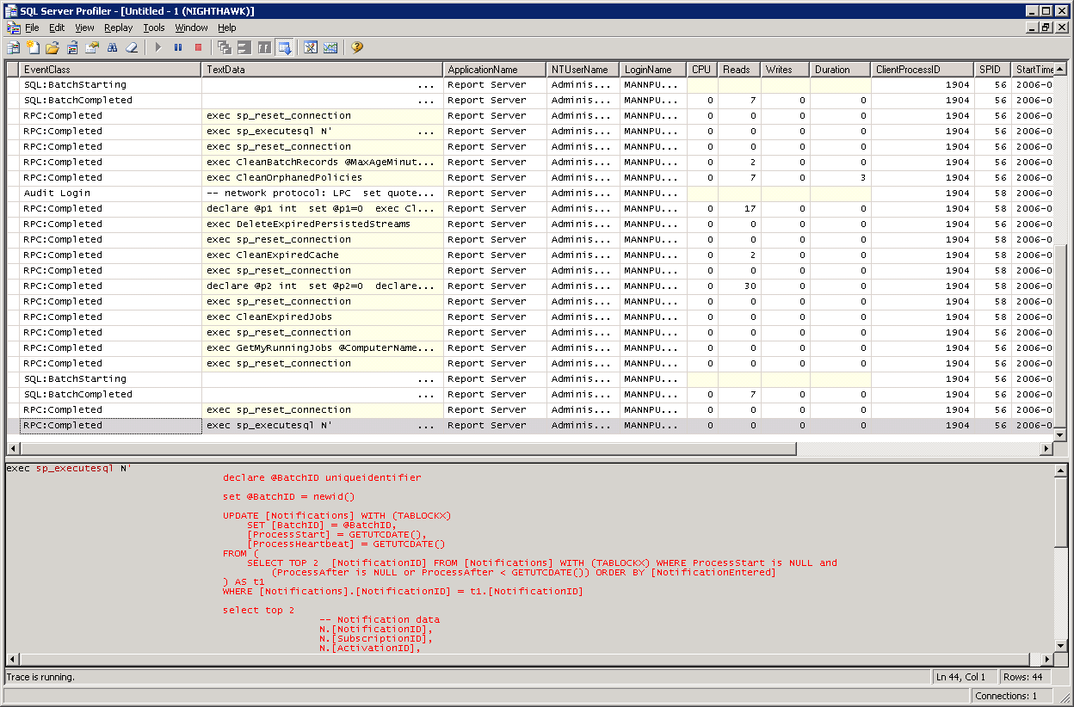

Figure 9 SQL Profiler

Database Tuning Advisor
A very useful tool in SQL Server 2005 Standard edition is the Database Tuning Advisor (DTA). DTA looks at the physical design of a database and recommends where indexes should be placed to yield better server performance. It is recommended that you use DTA in a production environment on a periodic basis.
DTA works by analyzing a workload file that is generated by storing SQL Profiler trace information. It analyzes how tables and views are accessed and considers what data values and parameters are most often used in queries. All of this information is fed into DTA so it can recommend how to adjust indexes in your databases. It even makes the changes for you if you wish. Figure 10 shows the Database Tuning Advisor that comes with SQL Server 2005 Standard Edition.
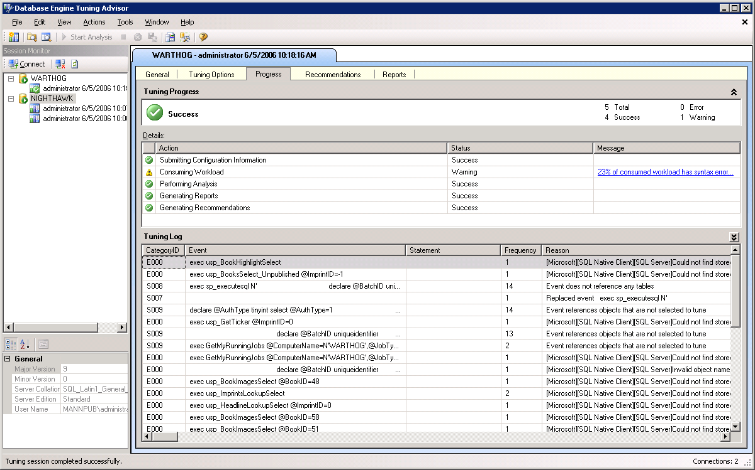

Figure 10 Database Tuning Advisor

Features to Consider Before Upgrading to Enterprise Edition
In every feature category, SQL Server 2005 Enterprise Edition offers significant enterprise-level enhancements for your organization that do not exist in any other edition. Consider whether the features and technologies in the Enterprise edition suit your business requirements. The major categories in SQL Server 2005 Enterprise Edition are:
- Business Intelligence – Enables complex business intelligence by including support for scaling-out reporting servers, data-driven subscriptions, infinite click-through in reports, advanced business analytics, proactive caching, advanced data management, full writeback support, advanced performance tuning, and text mining.
- Integration Services – Includes advanced transforms and SSIS data flow integration.
- Scalability and Performance – Includes partitioning for large-scale databases, parallel processing of indexing operations, and indexed view matching for indexed views.
- Asynchronous Communications – Includes support for implementing transactional replication with an Oracle database as a publisher.
- High Availability – Enables failover clustering with the number of nodes that are supported by the operating system. Also enables you to asynchronously mirror databases and supports online indexing, online restore, and fast recovery.

Upgrade Approaches
There are two basic upgrade approaches. The first is to do an “in-place” upgrade, which simply upgrades an existing SQL Server 2005 SSE installation. The second is to install another “upgraded” instance of SQL Server 2005 and allow it to exist along with SSE. This is known as a side-by-side installation.
SQL Server 2005 comes with an upgrade advisor tool to help you determine whether it is best to perform an in-place upgrade or side-by-side installation. The Upgrade Advisor is shown in Figure 11.
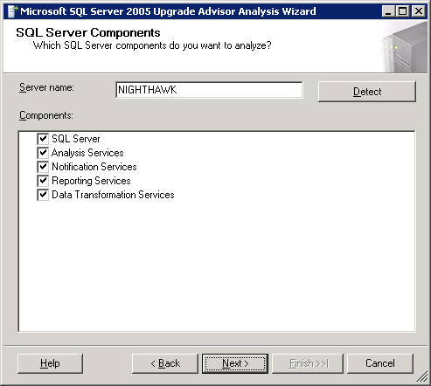
Figure 11 SQL Server 2005 Upgrade Advisor

In-Place
An in-place upgrade is a very simple process. You simply follow the installation instructions on the screen. An in-place upgrade migrates all user settings and configurations, so there is usually nothing else to configure to use your new installation. Following are some factors to consider when deciding to perform an in-place upgrade.
- Fewer resources required – Because the SQL Server installation is upgraded, it requires fewer resources than does a side-by-side installation.
- All applications must be upgraded at once – You cannot upgrade some of your applications as required, to work with SQL Server 2005 on an as-needed basis. All applications must be upgraded at once.

Side-by-side
A side-by-side installation is just like configuring a brand new installation, only that it resides along with SQL Server 2000. When you do a side-by-side installation, you must install SQL Server 2005 using a named instance. Following are some factors to consider when deciding to perform a side-by-side installation.
- More resources required – Since multiple instances will be running, more resources are required.
- Allows individual applications to run on required edition – Enables you to migrate individual applications as needed. You are not required to upgrade them all at once.

Migrating from User Instances
Because SSE is designed to be distributed with applications, it incorporates a feature called user instances. A user instance is sometimes referred to as RANU (Run as Normal User). User instances are a way for SSE to manage security. They give the user a full copy of the database, with full administrative rights to the objects to which the user has access. In other words, the SSE instance for a user contains only the objects that the user has rights to.
Because only SSE incorporates user instances, when you upgrade from SSE to another edition of SQL Server 2005, you must consider the security implications of user instances. A user instance of a database only allows a single connection, so upgrading from SQL Server 2005 Express edition will enable multiple users to connect to a single database.
To upgrade a SQL Server 2005 Express database
- Close the application that uses the SQL Server 2005 Express instance.
- If applicable, copy the .mdf and .ldf files to the data directory of the new server where SQL Server 2005 Workgroup, Standard, or Enterprise Edition is installed.
- Open a new query window. Issue a CREATE DATABASE command and use the FOR ATTACH clause to attach existing .mdf and .ldf files.
- Create logins for each user who will access the new server. Give them access to the newly attached database.
- Grant the appropriate permissions to objects in the database.
- Reconfigure the connection string(s) in your application to connect to the new server and database and remove the AttachDbFilename and User Instance options from the string.

Conclusion
Upgrading from SQL Server 2005 Express Edition provides many technical and business benefits. As a lightweight server, SQL Server 2005 Express Edition can handle basic data management and reporting needs. For more complex workloads, it is recommended that you upgrade from SQL Server 2005 Express. If your business requirements dictate that specific features must be available to support your database applications, those features may only be available in higher editions of SQL Server.

For more information:
http://www.microsoft.com/technet/prodtechnol/sql/default.mspx

Did this paper help you? Please give us your feedback. On a scale of 1 (poor) to 5 (excellent), how would you rate this paper?
!href(mailto: sqlfback@microsoft.com?subject=Feedback: Developing Custom Components in SQL Server Integration Services for Project REAL)

