Microsoft Office Publisher 2007

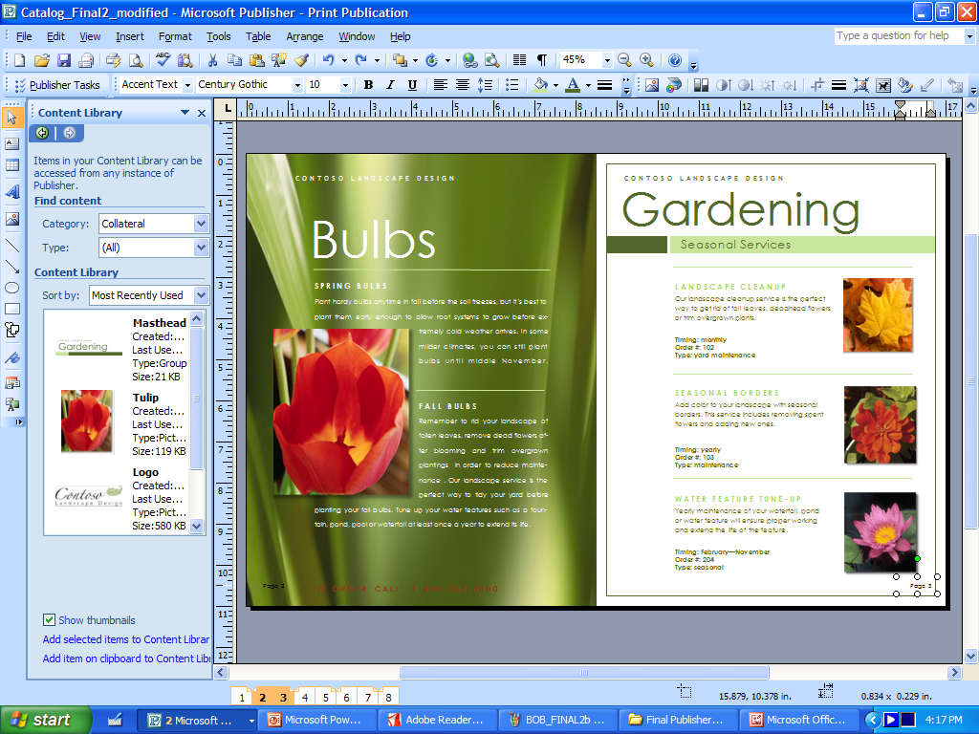Microsoft® Office Publisher 2007 helps you create, personalize, and share a wide range of publications and marketing materials that reflect your business brand. New and improved capabilities guide you through the process of compiling your mailing list, creating your publications, and distributing your marketing materials for print, Web, and e-mail. With all the tools you need in one place, you can achieve fast, professional results in-house.

*Create High-Quality Publications That Reflect Your Business Brand*

Create a wide range of page layouts and marketing materials with Office Publisher 2007.

Office Publisher 2007 includes new and improved tools to help you efficiently create, customize, and reuse a wide variety of marketing communications materials tailored to your company’s needs.

*Streamlined Starting Experience*

Improved! Choose from a template library.

Hundreds of customizable print, e-mail, and Web templates in more than 25 categories help you get started more easily and finish faster.

* **New!** **Preview Office Online templates.**   
  When connected to the Internet, you can find, preview, and open hundreds of Publisher templates from Microsoft Office Online.

New! Use Search to quickly find a specific Publisher template.

Search within Office Publisher 2007 for just the right template, whether it’s offline or online.

Improved! Categorize your templates.

Easily categorize, preview, open, and save your own branded templates within My Templates.

Improved! Choose a recently used layout.

Browse previews of recently used files in the startup screen to speed up finding your work.

Improved! Start from scratch.

Choose from more than 100 blank templates, such as business cards, e-mail, and booklets.

Improved! Create content-rich collateral from a database.

Use Catalog Merge to build custom materials, such as datasheets or catalogs, by merging text and images from a database.

*Tools to Support Your Brand*

New! Preview elements of your brand.

Apply your own colors, fonts, logo, and business information to all Publisher templates before you get started.

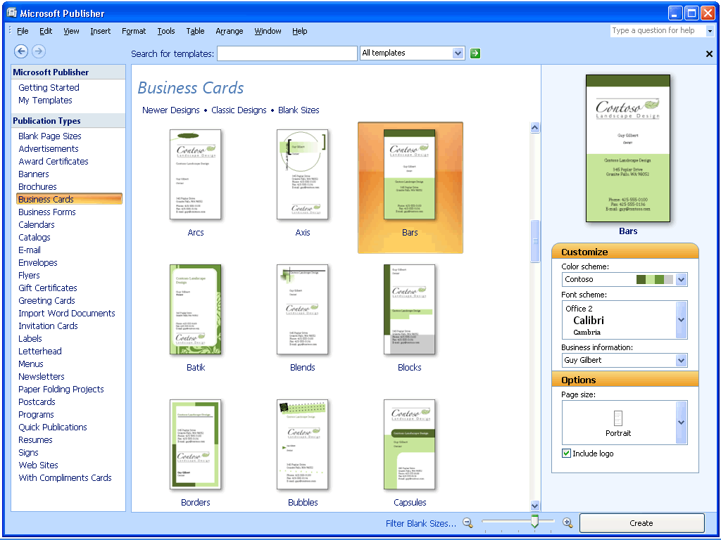

Preview your colors and business information within the Publisher Catalog before choosing a template.

Improved! Create your business identity.

Store your business name, contact information, and logo and use these elements consistently in all your marketing materials.

*Tools to Help You Lay Out, Customize, and Check*

New! Get assistance with basic tasks.

Use Publisher Tasks for help with common Publisher procedures.

Choose your colors and fonts.

Customize your publications with more than 70 color schemes and more than 30 font schemes, or create your own custom schemes.

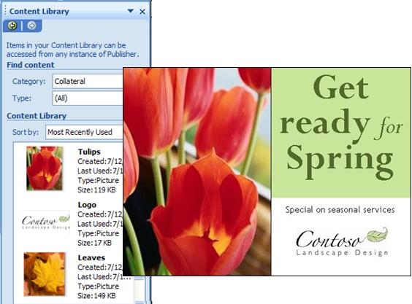Use graphics and text from your Content Library to quickly create new publications.

Take control of your layout.

Use layout guides—margins, grids, and baselines—and alignment tools to easily align text and picture frames.

Improve the appearance of text.

Use baseline guides to format text across multiple columns. Adjust character spacing with tracking and kerning.

Improved! Find out details about images.

Use the Graphics Manager to view image details such as file size, type, resolution, and location.

Improved! Check your publication.

Before printing, publishing, or distributing, run the Design Checker to identify and correct common printing, Web, or e-mail problems.

Save Time by Reusing Content

New! Access frequently used elements.

With the new Content Library, you can easily store text and graphics for use in other Publisher publications.

Improved! Reuse entire publications.

Quickly change one type of publication to another; for example, change a letterhead to a business card.

Improved! Save elements as graphics.

Use the Save as Picture feature to create graphics that can be used in other programs. Choose image resolution and file type.

Personalize Materials for Professional, Targeted Results

Create personalized publications using improved Mail Merge and new E-Mail Merge.

*Personalize E-Mail and Print Communications*

New! Publish effective e-mail communications.

Create and send personalized e-mail publications using new E-Mail Merge   
and personalized hyperlinks.



Create, personalize, preview, and send e-mail publications using   
new E-Mail Merge.

Improved! Send personalized print mailings.

Use Mail Merge to send personalized publications to your mailing list.

*Work with Customer Lists*

New! Combine customer lists within Office Publisher 2007.

Create and store a single customer list for your marketing campaigns by combining and editing lists from multiple sources, including Microsoft Office Excel® 2007, Microsoft Office Outlook® 2007, Microsoft Office Outlook 2007 with Business Contact Manager, and Microsoft Office Access 2007.

New! Use targeted lists from Office Outlook 2007 with Business Contact Manager.

Identify a target set of customers within Office Outlook 2007 with Business Contact Manager and access this filtered list from within Office Publisher 2007.

*Track Marketing Campaigns*

New! Manage marketing campaigns.

Initiate Publisher marketing campaigns from within Office Outlook 2007 with Business Contact Manager or Publisher to help keep track of marketing materials you send.

Easily Share, Print, and Publish   
Your Publications

Office Publisher 2007 provides new and improved ways for you to easily share, print, and publish.

*Save as PDF or XPS*

New! Easily distribute publications to anyone.

Save Publisher files in a fixed file format—PDF or XML Paper Specification (XPS)—for hassle-free sharing and printing.[[1]](#footnote-2) You can also set options for online viewing and printing.

New! Easily create press-ready PDF files within Publisher.

For commercial printers using a PDF workflow, press-ready PDF files from Office Publisher 2007 means easier acceptance of Publisher files.

*E-Mail Publications*

New! Convert multipage publications to   
e-mail messages.

Apply an e-mail template to multipage publications, such as newsletters, and distribute as an e-mail message. Add bookmarks for easy browsing.

Improved! Send quality e-mail publications.2

With enhanced e-mail capabilities, your recipients can view your e-mail publications in a variety of Web-based services and e-mail clients.

Improved! Send publications as attachments.

Use Office Outlook 2007 or Microsoft Outlook Express 6.0 or later to send Publisher files as e-mail attachments, or send as a PDF attachment.

*Create Web-Compatible Publications*

Convert print publications to Web publications.

Use Web templates to create Web sites and tools on the Web toolbar to add pages, hyperlinks, and a customizable navigation bar.

2 Office Outlook 2007 or Outlook Express 6.0 is required for sending e-mail. It is not required that recipients use a specific e-mail client to view the e-mail message.

Post publications to the Web.

Preview your Web publication before posting. Support for incremental file upload makes it easy to update your site.

*Commercial Printing*

Improved! Access commercial printing support.

Full commercial printing support includes four-color process and spot color printing, CMYK composite postscript, and press-ready PDF.

For More Information

This document is for informational purposes only. MICROSOFT MAKES NO WARRANTIES, EXPRESS OR IMPLIED, IN THIS SUMMARY.

The example companies, organizations, products, domain names, e-mail addresses, logos, people, places, and events depicted herein are fictitious. No association with any real company, organization, product, domain name, e-mail address, logo, person, place, or event is intended or should be inferred.

© 2006 Microsoft Corporation. All rights reserved. Microsoft, Excel, the Office logo, and Outlook are either registered trademarks or trademarks of Microsoft Corporation in the United States and/or other countries. All other trademarks are property of their respective owners.

Learn more about Office Publisher 2007 and the Microsoft Office system at <www.microsoft.com/office/publisher>.

For complete system requirements, please visit <www.microsoft.com/office/publisher>.

Microsoft_logo_jpg

1. You can save as a PDF or XPS file from a 2007 Microsoft Office system program only after you install an add-in. For more information, see [Install and use a PDF or XPS add-in](http://r.office.microsoft.com/r/rlidOOPDFXPSAddin?clid=1033). [↑](#footnote-ref-2)