

Reviewer's Guide

Whether you’re thinking of purchasing the Microsoft Office Visio 2003 diagramming program or writing a product review, the Microsoft Office Visio 2003 Reviewer's Guide can help you effectively evaluate the product. It describes the primary uses of Microsoft Visio, key benefits the product offers, and new and enhanced features in Visio 2003.
Sample Visio diagrams: Timeline, organization chart, block diagram, cross functional flowchart, rack diagram
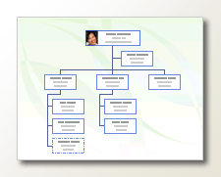
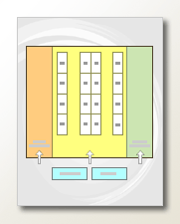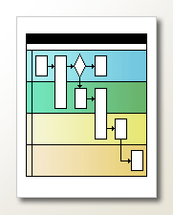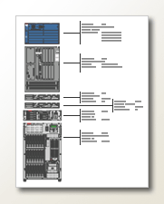

Too much information. Call it overload, call it information fatigue. We’ve all got it. There’s too much data, stored in too many places, changing too fast for workers to track. With so much data, what’s relevant? Even harder than understanding is communicating that data. It’s difficult for departments to design and communicate their own processes, much less understand and facilitate the processes of other groups. Years of technology turnover, mergers, acquisitions, and other factors collide to leave a great deal of valuable corporate data locked up in “silos”. Even reporting and team relationships can be tough to keep straight.
And everyone is trying to do more with less.
Microsoft Office Visio 2003 is designed to meet these challenges and more.

The Visual Advantage
Visio 2003 is the diagramming application in the Microsoft Office System that lets you transform your business processes, sharpen communication, and visualize your complex systems. With business and technical diagrams created in Visio, you’ll spend less time designing, documenting, and maintaining processes and systems, train new employees faster, and communicate complex information clearly, concisely, and effectively in a way that text and numbers alone cannot.
And this release makes it effortless to work collaboratively in a small business or a global enterprise, integrate diagrams with data from other programs, and create custom solutions tailored to your specific requirements.

Productivity
A sophisticated suite of business process management tools and templates make Visio indispensable for planning, design, and communication for business professionals—information workers, sales & marketing, HR, operations, managers, and consultants.
Use Visio templates to create productivity-enhancing diagrams in the following categories and more:
Business Process
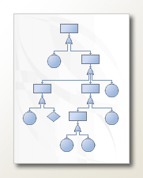
Business process visuals, such as fault-tree analysis diagrams, cause and effect flowcharts, and audit diagrams, illustrate process flow, highlight bottlenecks, and illuminate workflow.
The Business Process category in Visio 2003 is for teams charged with documenting, analyzing, modeling, automating, maintaining, and tracking business processes. Anyone invested in tightening up business processes to reduce cost of business, time to market, or duplication of effort can use these drawing types, some of which are open-ended to support multiple uses and some of which are targeted directly at specific business needs.
For example, a manager might use the cross-functional flowchart template to diagram his or her group’s product development cycle and to see how processes work, which departments they involve, and how to reduce time to market. After illustrating proposed changes for executives and winning approval, the manager can fine-tune resource allocation and determine which departments should make key business process decisions. Finally, the diagram can go to new hires to illustrate workflow and processes.
An example of a more specifically targeted template is Fault Tree Analysis, which supports those who have to keep complex systems error free. An industrial safety engineer charged with educating employees and averting accidents might diagram causes of workplace accidents, including various combinations of mechanical failure and human error. Or a call center manager making a budget proposal might diagram the correlation between equipment limitations and human factors that cause phone system overloads and result in customer dissatisfaction.
Organization charts
Organization charts show reporting relationships and organizational structures.
Organization charts are invaluable tools for managers and HR professionals. For example, a manager participating in reorganizing a department or company can visualize how to restructure departments, estimate staffing needs, see team structures, and determine project roles when developing project schedules. HR professionals can show new hires their position in the larger company structure, and post org charts on the corporate intranet so anyone in the organization can quickly confirm that they’re talking to the right people about the right issues.
Timelines
Timelines show a sequence of events or a process over time, making them a favorite for managers, project leads, administrators, event planners, individual team members.
For example, project managers can use timelines to convey the scope and progress of a project in project status meetings; show team members how deadlines fit into the big picture, and track and publish process-completion dates. Create an expanded view of subsections of the project to provide more detail for the specific individuals involved.
Charts and graphs
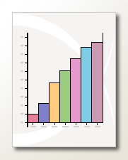
Charts and graphs make numerical data easier to understand at a glance.
For example, a financial planner might illustrate stock portfolio values and market trends, a salesperson might show regional returns, a quality assurance professional might illustrate distribution of problem areas in a product under development.
Marketing diagrams
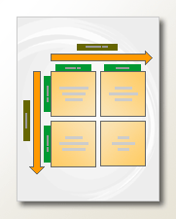
Marketing diagrams, such as feature comparison matrices, Venn diagrams, and other sales and marketing visuals, display data more effectively than text.

Power
The new and enhanced templates and tools in Visio 2003, as well as specific diagram types for facilities management and engineering, give technical professionals—IT, developers, engineers—a window on their data so they can manage and maintain complex systems. Use Visio to document and diagram:
Networks
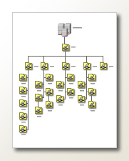
Network diagrams support network managers, IT professionals, and facilities managers, showing network communication flow, cabling, and equipment.
For example, during the planning phase of a network expansion, IT professionals can use detailed network diagrams to determine how remote locations should be interconnected. As they begin implementation, they can illustrate presentations or progress reports for execs with a high-level view of the company network. Once the network is up and running, they can support end users by creating diagrams that show the distribution of products throughout the organization and help users find printers, copy machines, and other devices to connect to. For the maintenance phase, they can use network diagrams to illustrate disaster-recovery plans, cabling runs, and company assets.
Databases
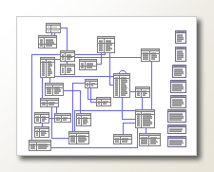
Database diagrams represent database schemas, making them useful for designing and revising database models, troubleshooting schemas, or explaining how to decipher database structures. For example, a database developer might use an Express-G diagram to show one object's relationship to other design components in a model. Or a business domain expert might use an ORM diagram to specify business requirements for application design.
Software
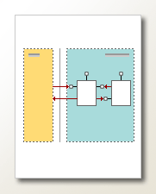
The eight templates in Visio 2003 designed for software developers, architects, program managers, and administrators support and aid in software design, usability testing, implementation, and administration. Specific templates support COM and OLE diagrams; the Gane-Sarson notation; Jackson, ROOM, and UML diagrams; Windows XP UI prototyping; and enterprise-system and program structure diagrams.
For example, before beginning to code, a developer could prototype a UI and run it by usability testing to see if users follow the logic of the screens. Then, she might show high-level static software structures in presentations and specs to communicate to test and program management. Or, a dev team might use the Data Flow Model template to write pseudo-code for an existing process data flow or describe nested layers of data flow throughout systems.
Developers working with object-oriented programming could use the COM and OLE template to diagram publicly-exposed COM and OLE interfaces or show the relationship between COM objects and the interfaces they reference.
Web Sites
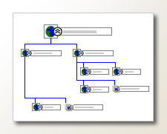
Web site diagrams show the organization, hierarchy, and flow of Web sites. Web developers can use high-level conceptual diagrams to plan site navigation and separate sites into distinct areas of concentration, visualize, data communication between separate areas of a site. Then they can communicate the site structure to content providers to help them more effectively target their information.
For a more detailed view, developers can generate site maps for existing sites and use them to maintain and troubleshoot the sites. Site maps are particularly helpful for those who inherit sites they’re not familiar with and who need to analyze the site's organization and to classify its content. With the site map template, developers can quickly find and fix broken links, generate a report listing all the links in a Web site, or track changes on a Web site by comparing two maps of the same site and generating a report listing the differences. Jump directly from hyperlinks in the diagram to the link on the site it represents.
Electrical, process, and mechanical engineering projects
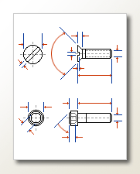
The electrical, mechanical, and process engineering templates in Visio 2003 are designed for engineers. Engineers of any type can use diagrams for planning, designing, and troubleshooting, and for distribution to engineering teams for review and comment on design concepts.
For example, electrical engineers can represent schematics and wiring, design and troubleshoot circuit boards, or estimate the maximum wattage output of a power system.
Mechanical engineers can design and draft parts, including feature definitions, notes, and dimensions; visually represent one part or a series of parts in a mechanical assembly; and illustrate technical documentation, such as service manuals.
Process engineers can create process flow and piping and instrumentation diagrams to represent liquid transfer systems and materials distribution processes.
Building sites and office spaces
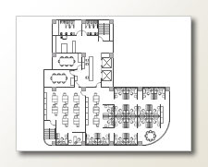
The Visio Building Plan templates illustrate every aspect of a building’s design, architecture, and interior, from floor plans and landscaping to security systems, HVAC components, furniture, and reflected ceiling plans. These diagrams store a wealth of data below the surface, as well, including model and serial numbers with which you can allocate and document assets. Use space and building plans to allocate space for teams, document floor plan distribution, document the wiring and location of controls for work orders, and to design your company's security system and post the plan to prepare employees for an emergency.

Key Benefits
An agile business in a tight economy, distilling direction out of an information-rich environment, requires easy-to-learn tools, watertight business processes, and flawless teamwork. Visio 2003 is designed to meet the demands of both the cost-conscious small businesses and the complex global corporate environment.
Productivity. Pre-drafted diagrams, a diagram gallery designed to help you browse for the template that best suits your needs, and improved search features assist you to find up-to-date shapes and info with a single click. With new and improved templates and shapes, you can start creating sharp, sophisticated diagrams fast.
Integration. Re-use data across multiple applications without retyping, reformatting, or duplicating research. Effortlessly integrate work done in any Microsoft Office System application: Word, Excel, PowerPoint, Access, Project, and Outlook, into Visio diagrams. Extract data from Visio for use elsewhere.
Mobility. With Visio support for Tablet PC and digital ink, you can annotate diagrams in your own handwriting, on the road, in meetings, or on location while reviewing sites or projects with customers.
Collaboration. Collaborate on diagrams and communicate clearly in team settings, whether your team is the entire staff of a small business, or spread out across an enterprise in offices around the world.
Programmability. Use the rich Visio object model, built-in Visual Basic for Applications environment and the Visual Basic Editor, XML file format and extensive Software Development Kit to build custom solutions on the extensible Visio platform. Or embed the Microsoft Office Visio Drawing in LOB applications built on Windows, .NET Framework, and Web platforms.

Productivity

Get started fast
Doing more with less, but sticking to tight schedules and limited training budgets, means getting new staff up and running fast. Because it shares the familiar Microsoft Office user interface, as well as common commands, tools, and comes with the following features designed to provide a jump start, people can get up to speed quickly on Visio.
Feature | Details
Starter diagrams  NEW! | Save as, edit, and go: These Visio templates come with draft content already on the page and instructions for completing the diagram with your own data. Available from the Web at http://office.microsoft.com/templates.
Diagram Gallery  NEW! | Determine the right template for your needs by browsing a collection of sample diagrams. A great source of ideas for how to put your data into a visual form.
New Drawing task pane  NEW! | Choose to open a new or existing drawing, or start with a template.
Getting Started task pane  NEW! | Quickly open your most recently used drawings.
Getting Started Tutorial  IMPROVED! | Follow a self-paced introduction to the Visio drawing environment, available from the Help menu. Art and animation illustrate key Visio skills.

Find up-to-date shapes and info
Shapes and information that come in the Visio 2003 product box are continually updated on and available from the Web. New and improved features make it easy to find shapes and store them in a way that’s intuitive for you.

Search for Shapes  IMPROVED! | Find shapes faster with an improved interface and more comprehensive keywords that improve your search results. Save your searches for reuse later. Drag the shapes you find directly to the drawing page to use now, or save them for use later.
Custom stencils  NEW! | Organize the shapes you use most often on separate stencils so you can find them without hunting. Use the new My Shapes folder to save shapes to a Favorites stencil or custom stencils with transparent naming conventions that you create.
Template Help  NEW! | Visio 2003 tracks the template you’re using so that it can display specifically designed help for that template. You’ll get results quicker knowing how to use it!
Research task pane  NEW! | Look up information online without leaving Visio 2003. Insert definitions, stock market quotes, and other information in your diagrams. Customize settings to suit what you need to research.
Clip Art task pane  NEW! | Retrieve clip art fast, from your computer or, when you’re connected to the Web, from a larger and continually updated collection on Microsoft Office Online.
Microsoft Office Online  NEW! | Microsoft Office Online, available directly from the Visio 2003 Help menu when you’re connected to the Web, is packed with information and downloads to enrich your diagrams:  Assistance. New, constantly refreshed information in the form of how-to articles, conceptual topics, columns, and tips to answer your questions about using Visio 2003.  Training. Short quick packages of information to get you rolling again. You pick when to complete these (20-50 minutes) courses that include graphics, animation, audio, and practice sessions for hands-on experience.  Clip Art and Media Clip art, sounds, animations, and photos to download and use with Visio 2003.  Downloads Product updates, add-ins, converters, and viewers.  Office Marketplace Third-party products and services.

Create business diagrams
Use the power of visuals to communicate workflow, schedules, and reporting relationships across departments in your organization. Plan, design, implement, and communicate the results of business process documentation efforts, including Six Sigma, SAP, and ISO.
Business Process  NEW!  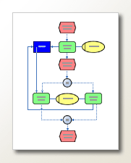  EPC Diagram | Create event-driven process chain (EPC) diagrams, fault tree analysis diagrams, basic flowcharts, cause and effect diagrams, cross-functional flowcharts, data flow diagrams, audit diagrams, and workflow diagrams.

Brainstorming  NEW!  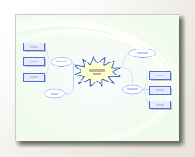  Brainstorming diagram | Capture, arrange, and expand ideas generated in brainstorming meetings or project post-mortems.
Calendar  IMPROVED!  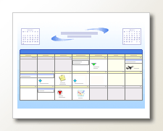 | Compare multiple schedules, create a calendar of any number of weeks, and highlight important dates.
Organization Chart  IMPROVED! | Show dotted-line reporting relationships, add pictures to shapes, and experiment with different layouts without actually moving shapes.
Timeline  IMPROVED! | Communicate dates to teams or groups you depend on, and reinforce progression toward a deadline. Create vertical timelines, synchronize milestones and intervals across multiple timelines on a page, create a detailed view of a subset of an original, edit all date and time formatting at once, and divide your timeline by seconds, minutes, hours, or quarters of the fiscal year.

Create technical diagrams
Use new and improved technical diagram templates to make IT systems, networks, and other complex systems easier and less expensive to manage and maintain. Add custom properties to shapes to store and communicate additional information; then generate reports on the data to audit equipment inventories, create bills of materials, or support budget estimates.

Space Plan  IMPROVED!  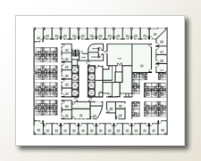 | The new startup wizard gets you off the ground fast, and the improved import data wizard makes it easier to use data stored elsewhere in your space plan. Use new color-coding and labeling options to distinguish elements of your diagram. Add smart tags to help coworkers install a printer or other devices right from your drawing.
Detailed Network  IMPROVED!  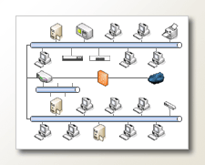 | Document the physical and logical topology of your network. New shapes look better and come with custom properties that make it effortless to generate richly detailed reports.

Rack Diagram  NEW! | Quickly sketch out the rack space requirements of new equipment. Network equipment shapes with industry-standard measurements fit together precisely, and store data such as serial number and location.
Web Site Map  NEW! | New, more compact layout options, faster drawing speed, editable text, and new shapes for current and upcoming technologies. Use the new interactive discovery feature to map protected Web site areas.
Windows XP User Interface  NEW!  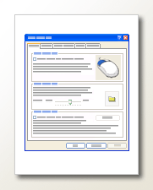 | Prototype user interfaces with drop-down menus, tabbed dialog boxes, and toolbars that have the Microsoft Windows XP look and feel.

Electrical Engineering  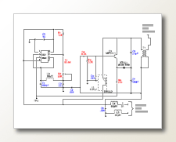 | Enhanced shapes that look better and connect cleanly.
Building Plan  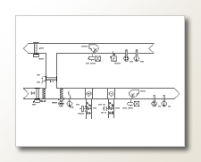 | Enhanced shapes that look better and connect cleanly.

Integration
Visio spares your employees the pain of learning multiple front ends to multiple applications by using the familiar Microsoft Office user interface. And you can tie Visio directly to data sources to provide diagrams that are always up to date, automatically generate diagrams from data stored in Excel, Access, SQL, Exchange Server, or any ODBC data source, and incorporate Visio into powerful, connected .NET solutions to address your specific business needs.

Timelines | Import tasks and milestones from a Microsoft Project 2000 or later (MPP) file to create a Visio timeline using the Import Timeline Wizard. Or import data from an Excel file.
Calendar | Import schedule information from Microsoft Office Outlook, and then easily customize it to share with team members or executives.

Brainstorming | Export brainstorming diagrams to a Microsoft Office Word outline for a more linear view, or to an XML file to reuse elsewhere.
Organization charts | Create organization charts from Excel and Exchange Server.
Map Web sites | Map live sites, including protected areas when you have appropriate permissions.
Database | Automatically create database diagrams from SQL Server and Access databases.
UML | Automatically create UML diagrams from Visual Studio .NET projects.
Custom property sets | New anchored window for creating, storing and quickly applying custom properties to shapes
Export data | Extract data from Visio drawings into XML, Excel, Word, Access, SQL Server, or other tools for integration with business processes and systems.

Mobility
Trade shows, conferences, offsites, telecommuting, site visits. Visio 2003 supports diagramming on the road.

Tablet PC support  NEW! | View task panes horizontally to your work on a tablet. With full support for inking on the tablet computer, you can use your own handwriting to quickly provide direct feedback on Visio diagrams.
Ink  NEW! | Create hand-drawn shapes and insert handwritten notes when reviewing a drawing. Like other Visio shapes, you can copy, move, and resize ink shapes, as well as add them to custom stencils to make them available for other drawings. You can use Visio 2003 ink features on tablet computers and on desktop and laptop computers.

Collaboration
Visio 2003, combined with Windows SharePoint Services, provides new ways to bring employees together from any location, lend specialized expertise to any project, and speed approval and reviewing processes. New features in Visio 2003 simplify the process of co-authoring, editing, and reviewing diagrams with others in real-time. Improved language and language deployment options support global collaboration for enterprises with offices worldwide.
Reviewing  NEW! | Track comments, changes, and digital ink by reviewers.
Document workspaces  NEW! | Share diagrams using Document Workspaces, which reside on Windows SharePoint Services sites. People can easily work together on the document—either by working directly on the server copy or by working on a local own copy, which you can update periodically with changes that have been saved to the server copy.
Visio Viewer  NEW! | With the new Visio Viewer even people who don’t have Visio can view and print Visio drawings and diagrams in Microsoft Internet Explorer. With Visio Viewer it's easy to distribute your drawings to team members, partners, customers, and others. Visio Viewer will be available from Downloads shortly after the Visio 2003 product release.
Multiple language support  NEW! | Support for Unicode, End User Defined Characters (EUDC) sets, and GB18030 is new in Visio 2003. With Unicode you can create drawings in many different languages, create drawings that contain multiple languages, and share and collaborate on drawings across multiple languages. With EUDC you can form Asian names and other Asian words using characters that are not available in standard screen and printer fonts. With support for GB18030, which is a new Chinese character-encoding standard, you can create drawings containing Chinese characters from this new character encoding set.

Corporate deployment and maintenance  NEW! | Enterprise customers can take advantage of Multilingual User Interface packs to manage worldwide deployment of multiple languages.

Programmability
Embed the Visio Drawing Control in LOB applications built on Windows, .NET, and Web platforms, or take advantage of the rich Visio development platform. With an extensive object model, the built-in Visual Basic Editor, an XML file format, and an extensive SDK and online developer resource center, Visio is ideal for creating custom solutions.
And a worldwide partner network provides organizations with dedicated resources to help customize Visio.
Macro Recorder  NEW! | To see how to perform a given Visio task programmatically, turn on the macro recorder and manually perform the action. The macro recorder translates your actions into VBA code. Modify the code generated by the macro recorder to ease the pain of performing repetitive tasks.
Drawing component  NEW! | Use the Visio 2003 ActiveX drawing component to tightly constrain drawing functionality to just what is required by your host application, and your host application controls the user interface.
XML-based Web service support  NEW! | Just select the XML Web Service reference you want in a dialog box to integrate Web services into your diagrams.
Smart tags  NEW! | Use smart tags to display a drop-down menu when a user pauses the mouse over a smart tag button on a shape. Elevate important shape actions and make settings more discoverable, alert users to incomplete custom properties, or let users start processes external to the drawing, such as ordering a replacement unit or sending e-mail, from the smart tag.
Primary Interop Assemblies | Use the Visio PIAs to access the Visio object model from managed code applications that use the common language runtime. The Visio PIA provides the common language runtime with the information it needs to correctly handle Visio type implementations. Visio provides a PIA for every published Visio 2003 interface so that you can integrate Visio with managed code applications.
Visio SDK | The Visio Software Development Kit includes a variety of excellent tools for developers, including an Event Monitor and Persistent Events, as well as Visual Studio 6.0 and Visual Studio .NET 2003 wizards for Visio solutions which will set the correct references for the PIAs for you.  The SDK also includes extensive application samples, including many managed code samples. Sample code includes Visual Basic, Visual Basic .NET, and C#.  Finally, the SDK includes a library of more than 50 reusable functions, classes, and sub-routines for common programming tasks. Just copy the code and reuse it in your application.

System Requirements
The following components are required to install and run Microsoft Office Visio 2003.
Windows Operating System. Microsoft Windows 2000 with Service Pack 3 or later or Microsoft Windows XP or later required.
Processor. Pentium 233 MHz or higher processor, Pentium III recommended.
Random Access Memory. 128 MB of RAM or more recommended.
Storage Requirements. Hard disk space requirements vary depending on configuration; custom installation choices might require more or less. The minimum hard disk requirements for Microsoft Office Visio Standard 2003 and Microsoft Office Visio Professional 2003 are as follows:
- Visio Standard 2003. 160 MB of available hard-disk space, including 75 MB on the hard disk where the operating system is installed.
- Visio Professional 2003. 210 MB of available hard-disk space, including 75 MB on the hard disk where the operating system is installed.
Monitor. Super VGA (800X600) or higher resolution monitor.
Internet. Microsoft Internet Explorer 5.5 or later browser. Dial-up or broadband Internet access, provided separately; local or long-distance charges may apply.
Additional items or services required to use certain features.
Speech recognition. Pentium II 400-MHz or higher processor; close-talk microphone and audio output device for speech recognition
Ink. Certain inking features require that you run Visio 2003 on Microsoft Windows XP Tablet PC Edition.
Advanced collaboration functionality. Certain features require Microsoft Windows Server 2003 running Windows SharePoint Services.

Conclusion
With Visio 2003, you can see the flow of information or documents, capture business knowledge, heighten understanding of process flows, support system analysis efforts, and manage and communicate the requirements of internal and external systems projects.
Cost reduction, high customer satisfaction, and faster time to market can be realized by having a clear understanding of process steps and system components. Visio 2003 helps business and technical people document, design, communicate, and automate complex ideas, processes, and systems so they can make better decisions and take more effective action.

