
Developing a BizTalk Server Solution
White Paper
Published: December 2003
For the latest information, please see http://www.microsoft.com/biztalk
Contents
Introduction 1
BPM/EAI and BizTalk Server 2
Scenario: Creating an Application Integration Interface in BizTalk Server 4
Requirements and Characteristics of Workflow Process Applications 10
Human Workflow Services (HWS) 11
Requirements and Characteristics of Trading Partner Interaction (B2B type) Applications 12
Correlation: The Fundamental B2B Requirement 13
Hub and Spokes 14
Exposing a Web Service 14
Supporting Industry Initiatives and Legislative Mandates with BizTalk Server 15
Conclusion 16

Introduction
The Services Oriented Architecture (SOA) paradigm redefines the concept of an application. Instead of being an opaque, procedural implementation mechanism, it is an orchestrated sequence of messaging, transformation, routing, and processing events in which XML technologies semantically expose both the message content and the functional components that operate on the messages.
A managed workflow, application integration interface, or trading partner interaction can all be described, composed, and implemented by an orchestrated flow of structured XML documents and messages. These documents and messages are routed, transformed, and processed according to message content, formatting requirements, and business logic contingencies. In development platforms based on this model, there is no longer a requirement to write procedural code to access, map, and convert data formats, nor is there a need to understand the APIs of dozens if not hundreds of applications. The tightly coupled, coded interfaces between and among applications and information are effectively eliminated.
Business Process Management/Enterprise Application Integration (BPM/EAI) platforms that incorporate the SOA paradigm provide numerous development and operational benefits:
- They use standards-based protocols and applications.
- They make the most of the Internet’s network infrastructure.
- They significantly decrease the dependency on procedural coding by eliminating the need to know and write to APIs.
- They facilitate the flexible “loose coupling” of components on a highly distributed basis.
- Applications are well documented because the process activities, components and functions are exposed and self-describing.
- They can integrate any information source and application functionality into a process, no matter where the process resides.
- They enable the extensibility and reuse of both application components and entire applications.
- Any process can be easily replicated, extended, and scaled.
- Any process activity or component can be added, removed, or reconfigured without disrupting the process.

BPM/EAI and BizTalk Server
BizTalk® Server is the Microsoft® Business Process Management/Enterprise Application Integration platform that embodies the SOA paradigm. BizTalk Server is designed around a messaging event model in which the messages and documents, as well as the processing components that interact with the messages and documents, are based on XML and Web services technologies.
BizTalk Server 2004 is also tightly integrated with Visual Studio®, providing a consistent interface for all of its design-time functions, which will be familiar to a large part of the developer community. Consequently, BizTalk Server bridges two frameworks: SOA and .NET. The .NET Framework consists of two main parts: The common language runtime (CLR), and a unified set of class libraries (including ASP.NET, Windows Forms, and ADO.NET). Combining the higher-level abstractions of XML functionality and the visual design facilities in BizTalk Server results in a development and deployment environment that offers unprecedented capabilities and efficiencies. Furthermore, this combination provides a coherent opportunity for developers to immerse themselves in the SOA methodologies, and to maximize their .NET expertise.
This paper examines the following BizTalk Server development modules embedded in Visual Studio .NET:
- BizTalk Server Editor. An XML editing tool for defining the semantic meaning and structure of documents in XML schema.
- BizTalk Server Mapper. An XSLT-based mapping tool for dynamically transforming documents into different formats.
- BizTalk Server Pipeline Designer. A BizTalk Server module for creating an ordered sequence of processing operations that take place before a message is received by, or dispatched from a process orchestration or message data store.
- BizTalk Server Orchestration Designer. A development environment within Visual Studio .NET for creating process applications (orchestrations). This is accomplished by assembling visual abstractions of complex XML objects and Web services functionality.
A BizTalk Server application is one or more specialized Visual Studio .NET projects that contain BizTalk Server components. BizTalk Server components consist of schemas, orchestrations, transformation maps, pipelines, and other items that are combined in a “build,” which generates a compiled component assembly. Any BizTalk Server component assembly can be referenced and embedded in an orchestration project, which is itself a BizTalk Server project. A developer can then compile one or more BizTalk Server orchestration projects into an overall “solution” assembly, and then deploy and install it as an application that the BizTalk Server run-time engine executes.
In BizTalk Server, developers and system architects can use the same development methodology and components to create a workflow process, application integration interface, or trading partner interaction. The differences between these three types of applications are in their functional requirements. This paper examines what these differentiating characteristics are, and describes how BizTalk Server addresses their specific development requirements. By way of example, the discussion of creating an application integration interface also includes a walkthrough of the actual development and implementation steps within BizTalk Server.

Requirements and Characteristics of Application Integration Development (Straight-Through Process)
Application Integration is the development activity of making an application’s functionality and the information that it generates accessible and usable to other applications. One manifestation of an information interchange application is a “Straight-Through Process.” A typical Straight-Through Process has the following characteristics:
- The information interchange takes place internally within an organization, but often spans multiple organizational units.
- It is a short-lived transactional event.
- The information interchange may take place on a record-by-record, real-time basis, or in batch mode. In either case, it is critical to the performance and reliability of the interchange that it process within a discrete period.
- The information must be transformed into numerous formats and distributed to numerous applications and platforms.
Historically, building application integration interfaces has been difficult because enterprise framework applications consist of thousands of program modules, databases, and data files whose operational procedures, controls, and access mechanisms are extensive, rigid, and unforgiving. Developing extended programmatic capabilities, or attempting to make information accessible in ways that are not defined in these systems, is an enormously expensive exercise in terms of time, resources, and capital. Furthermore, these diverse applications and platforms typically operate under numerous organizational jurisdictions, making it difficult to coordinate resources and agendas.
The prevalent development methodology used for application interfaces is the creation of direct, point-to-point interfaces. Developers knowledgeable in the respective APIs of the interfacing applications specify, design, code, and debug custom programs to access the source application’s data (usually stored in binary format), map and convert the respective data structures, manipulate the data as required, and bring it into the target application. This produces a tightly coupled, highly specific set of functions that exist and execute in the form of procedural code, just like the applications themselves. Because each integration instance is specialized, and manifested in a monolithic encoded construct that is not modular or reusable, increases in programming resources do not increase programming efficiency.
Developing application integration interfaces in BizTalk Server is significantly more efficient and versatile. Two types of interfaces exist: an interface where an application exchanges information with other applications, and an interface where one or more applications invoke the programmatic operational functions of other applications.
In BizTalk Server, the core mechanism for exchanging information among applications is semantic and structured metadata, based on XML schema, representing the meaning and structure of information that an application generates or receives. These XML schemas are embedded components of a BizTalk Server orchestration. A mapping tool based on XSLT is used to map the conversion of one application’s information format (based on its schema) to any other format. These transformation maps are also embedded components within the same orchestration. An interchange takes place when one application sends information to a BizTalk Server orchestration that identifies it as being the input to another application. The BizTalk Server orchestration executes the format transformation and provides the document, in the format required, to the receiving application.
For accessing programmatic functionality, BizTalk Server offers more than one option for invoking the methods of applications. The first option is BizTalk Server’s ability to function as a Web services management platform. In this mode, BizTalk Server brokers invocation requests among applications exposed as Web services, and provides value-added functions such as authentication, tracking, and monitoring of invocation events, failure options, and compensation mechanisms. The second option is to expose the orchestration itself as a Web service that can be invoked by another application, where once again, BizTalk Server provides additional supporting implementation and deployment capabilities.

Scenario: Creating an Application Integration Interface in BizTalk Server
We can now look at the steps and procedures involved in creating an application integration interface in BizTalk Server where two applications exchange information with each other. We will describe a single directional flow of information (although the same methodology would just as easily accommodate a bidirectional exchange or even a many-to-many exchange of information with multiple transformation variations).
In our application integration scenario, a source application sends a batch file containing multiple flat-file records to a folder designated as a BizTalk Server Receive Location for this file. A BizTalk Server orchestration process is triggered by the presence of the file in the Receive Location and it initiates the following events:
- The file is preprocessed by a BizTalk Server Receive Pipeline where each input record in the file is delineated, its content and structure validated against a schema definition, and then converted into an interim XML document based on the schema definition. Any records that do not validate correctly are placed in a holding queue. A log accounting for all the records processed or not validated is created.
- An XML document is created that represents the input record fields as XML schema elements and attributes. The document is then handed off to the BizTalk Server orchestration process that executes the transformation of all of the XML input information in the document into an output XML document with the content and structure required by the recipient application.
- The XML output document is handed off to a BizTalk Server Send Pipeline that validates the records against the output schema and then converts the XML document into a flat-file record format with the proper headings and footings that allow it to be accessed directly by the recipient application. The pipeline then submits the file to a message queue that feeds the file to the recipient application.

Step 1: Creating Schemas for Input and Output Documents
The first step in building this application integration interface is to create the schemas for the input and output documents. A developer creates the schemas with the BizTalk Server Schema Editor, a module in Visual Studio .NET. BizTalk Server Schema Editor is used to define the structure and semantic metadata that “declares” the meaning, functions, and processing requirements of the content of a document (an “instance”) that is created from the schema. When BizTalk Server receives an instance of a document, the process it is associated with validates the document content against its schema definition to ascertain that the form and content of the document conforms to the schema and the processing requirements of the application.
BizTalk Server Schema Editor creates a W3C-compliant XSD document as well as a visual tree node reference model of the schema. The preceding illustration shows the Schema Editor, the tree node model of the schema on the left panel, and the XML representation of the document schema in the right panel. In BizTalk Server Schema Editor, the developer creates the document schemas representing the input record file and the output record file (named Demo_Input_Records and Demo_Output_Records respectively), and saves them in a BizTalk Server Project named Demo_Documents.
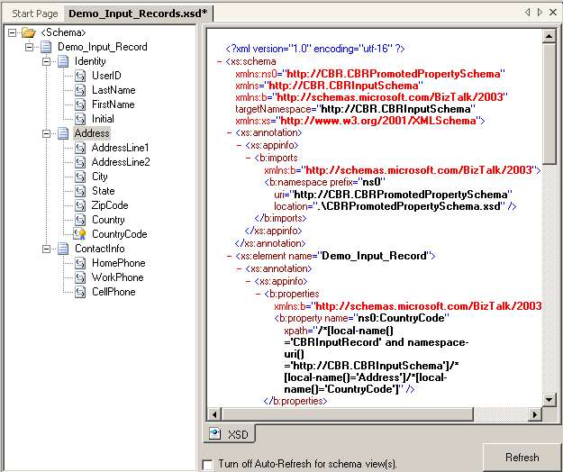

Step 2: Mapping Information between Applications
The second step is to map the format and structure of the information generated by the source application to the format and structure required by the recipient application. This takes place in BizTalk Server Mapper, also a module in Visual Studio .NET. BizTalk Server Mapper creates transformation maps that convert the content and structure of any source information into any target document format or abstract representation of the source information (for example, a report). BizTalk Server Mapper displays the source and destination information formats using a schema tree node model. Information is mapped from one or more nodes in a source schema to one or more nodes in the destination schema by drawing links between the nodes.
Functoids provide additional conversion, processing, and abstraction capabilities (looping, cumulative, date and time, mathematical, iteration, record count, and so on). They are graphically implemented by linking one or more source nodes to a functoid and then linking the functoid to one or more destination nodes. The maps created by BizTalk Server Mapper are based on XSLT, an open standards protocol for transforming XML information.
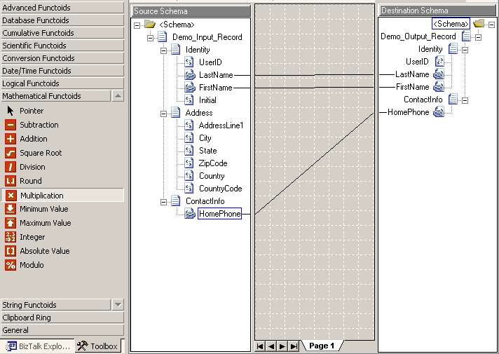
A transformation map (as well as the referenced source and target schemas) becomes a BizTalk Server project resource that is subsequently embedded into a BizTalk Server orchestration as a process step and is compiled in the orchestration assembly. Maps can be reused and modified as needed to implement any number of transformation requirements or be deployed within any number of orchestrations. We can name the XSLT map that we create in this step Demo_Record_Conversion_Map and save it in the Demo_Documents project. After this is done, we have completed one of the BizTalk Server projects that comprise our application, and we compile the completed project into an assembly that can be incorporated into another project within the solution.

Step 3: Creating a Receive Location and Message Queue Send Port
The third step is to create and configure a BizTalk Server Receive Location and a Message Queue Send Port. The Receive Location is a folder configured to initiate the relevant BizTalk Server process application (an orchestration) when a defined file is placed in it. Because this is an internal information interchange application, we will make use of a reliable messaging protocol, MSMQT, to handle the transmission of the output file to the recipient application. Both of these facilities can be created and configured from either the Explorer panel within Orchestration Designer or in the BizTalk Server Administration module, with the assistance of a wizard.
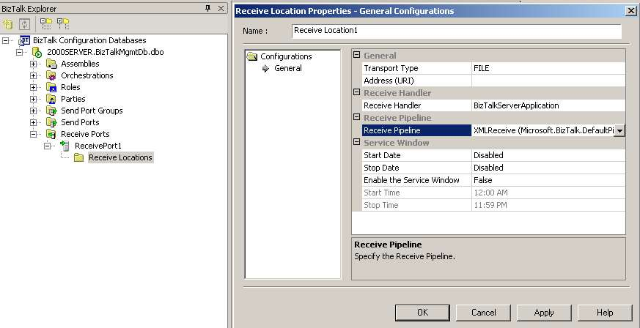
Many application integration scenarios require that many records be processed at once, in a batch mode. BizTalk Server can handle receiving or sending batches of records in two ways: using a single file that contains multiple records, or transmitting individual records in a stream, either synchronously or asynchronously with optional transactional support. In our scenario, the source application furnishes a single flat file of records.

Step 4: Create Receive and Send Pipelines
A BizTalk Server Pipeline parses the native input document, delineates and validates the individual records, and then creates an internal XML representation (a document) of the source file and its respective records. A Pipeline is an ordered sequence of message preprocessing or post-processing operations that take place before the input information is handed off to a process orchestration and after it leaves these facilities.
A “Receive Pipeline” decodes, decrypts, and disassembles the native input data. More precisely, a receive pipeline accepts the message in whatever format it comes in, decrypts or decompresses it as required, breaks the message up if it has multiple parts, converts it into an XML document according to its respective internal BizTalk Server schema, validates it, and then authenticates the identification of the sender of the message. After any, all, or (in the case of an empty pass-through) none of these operations are executed, the messages are handed off to an orchestration and the BizTalk Server MessageBox persistence store. A “Send Pipeline” is structured in reverse; it assembles formats, encrypts, compresses, and digitally signs a message as required by the external recipient.
The fourth step in our development process is to create and configure BizTalk Server Receive and Send Pipelines. This is accomplished in BizTalk Server Pipeline Designer, a tool accessed from the BizTalk Server Orchestration Designer workspace.
Pipeline Designer divides its multiple processing steps into stages that perform specific tasks, such as decoding, disassembling, and then converting a native file into an XML representation (and vice versa). A stage may require multiple recursive substeps to accomplish specific functions. Stage-specific processing components execute these functions. In Pipeline Designer, these components are dragged and dropped onto stages in a visual workspace. When the necessary components of the stages are sequenced, they are configured to address the specific requirements of the information being processed. In addition to being used by a developer working within the visual development workspace, the functions of Pipeline Designer can be accessed programmatically through the BizTalk Server API.
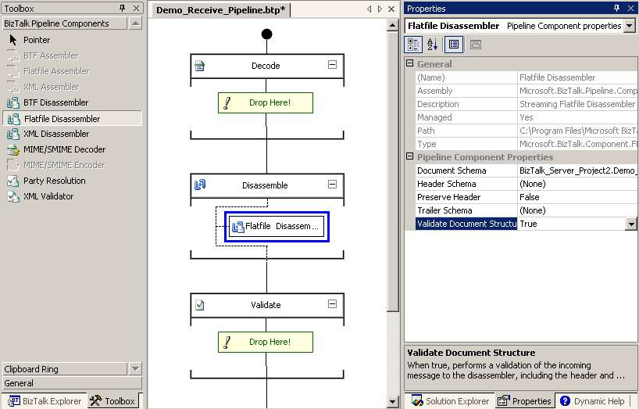
We will name the Receive and Send Pipelines Demo_Receive_Pipeline and Demo_Send_Pipeline, respectively, which we save as a BizTalk Server Project named Demo_Pipelines. This Project will also be compiled into an assembly for inclusion in another Project.
We have now created the schema representations of the input and output documents, the transformation map that facilitates this conversion, the transport mechanisms (Receive Location and Message Queue Send Port) that allow the external applications to interact with BizTalk Server, and the native file handling and record control routines (the Pipelines).

Step 5: Composing the Events and Process Flow
The fifth step is to compose the events and process flow of the application. This is accomplished in BizTalk Server Orchestration Designer, the main workspace within Visual Studio .NET where an overall BizTalk Server application is developed and implemented. In BizTalk Server Orchestration Designer, visual objects representing messages, messaging events, business rules and logic, information flows, activities, operations, transformations, and subprocesses are assembled and linked.
The following screen image shows a completed orchestration that executes our example message interchange. The process steps were assembled by dragging and dropping the following shapes from the Toolbox and modifying them:
- A Receive shape is placed at the top of the design surface and named Input_Records_Received.
- A Construct Message shape is placed below the Receive shape and named Input_Output Conversion. A Transform shape is placed within the shape named Input_Output Conversion.
- A Send shape is placed below the Input_Output Conversion shape and named Send_Output Records.
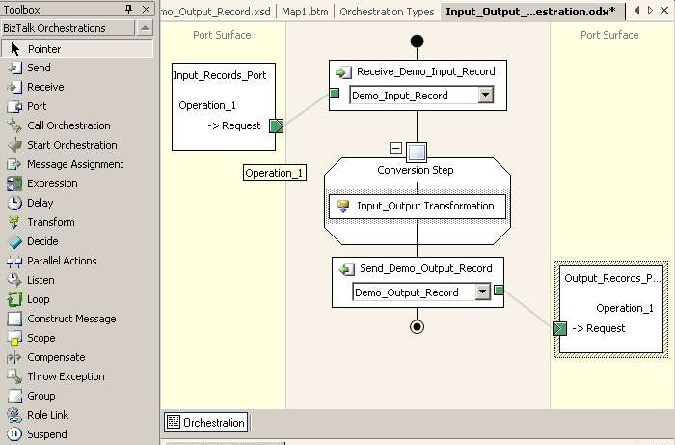

Step 6: Linking the Design Shapes to Objects
After the process events are diagrammed, the next step is to link the process design step shapes to the objects that implement the process represented by the components that we created previously. This is the sixth step of the BizTalk Server application development process.
The Transform step converts an instance of the Demo_Input_Records document to an instance of the Demo_Output_Records document (both of whose schemas were specified earlier) by invoking the Demo_Record_Conversion_Map (which was also created earlier). Linking this step to its implementation mechanisms is accomplished by clicking the Transform shape. A dialog box appears, as shown in the following illustration, where we can link the Transform shape to the Project assembly of the schemas and conversion map referenced by the orchestration project. (We did not specifically document the Project reference step.)
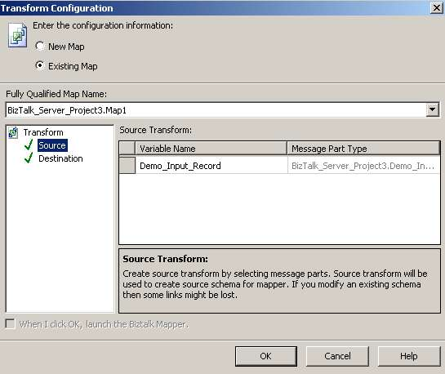
In similar fashion, all other Project assemblies and other implementation objects (transport mechanisms, pipelines, database access procedures, Web services, .NET and COM objects, and other orchestrations) can be bound to the logical process steps within an orchestration.

Deploying the Completed Applications
After all the logical steps in the orchestration are fully implemented and configured, the orchestration is saved as a Project and an assembly is generated from a build of the orchestration Project. This assembly, representing the overall Solution, is then deployed and installed for execution by the BizTalk Server run-time engine as a completed application.
The individual Project assemblies (and their subcomponents) that comprise the overall Solution are exposed and self-documenting, modularly independent, and loosely coupled to each other. If the input file is encrypted differently at some time, only the Receive Pipeline decryption component needs to be modified and the overall integrity of the rest of the application is never affected.

Other Features and Functions
Because our sample application is simplistic, we did not take advantage of BizTalk Server’s numerous implementation features that address the application integration characteristics itemized earlier. Some of these features and functions are described here:
ACID (Atomicity, Consistency, Isolation, Durability) support for short-lived transactions. BizTalk Server ensures that state changes within an atomic transaction take place before the transaction is committed. Any steps embedded in a BizTalk Server Scope shape (a transaction) that modify a variable, message, and object must be performed successfully or none of the modifications is performed and the transaction is aborted. The overall transaction is committed and subsequent orchestration steps can proceed only after the successful completion of all activity steps within the transaction. The intermediate state changes are isolated from other parts of an orchestration.
Bi-directional adaptor communication. BizTalk Server provides a new API for creating adapters that support bidirectional conversations between a BizTalk Server Pipeline and an external application.
BizTalk Server support for very large files. BizTalk Server has streaming support for arbitrary documents.
Single-Sign-On capabilities. BizTalk Server makes it significantly easier to implement authentication and authorization among multiple applications in multiple domains.
Many-To-Many Message Distribution. BizTalk Server’s new MessageBox data store is based on a “Publish and Subscribe” paradigm that makes many-to-many interfaces with custom requirements easy to implement.
The development methodology that we have just described can be used to create virtually any process-centric application. With this fundamental understanding of the BizTalk Server development methodology, we can now examine how it effectively addresses the characteristics and specific development requirements of workflow process applications and trading partner integration applications.

Requirements and Characteristics of Workflow Process Applications
Workflow management is the discipline of optimizing business tasks that depend on the flow of information among people, and between people and systems. Because human resources represent the single largest cost to any organization, increases in worker productivity can significantly improve an organization’s economics and competitive standing. We can generally attribute workflow inefficiencies to the following:
- The generation, handling, and processing of paper documentation.
- Delays in obtaining prerequisite information to complete a task.
- Delays because of bottlenecks and prioritization conflicts.
- Incomplete or incorrect information that stalls a process.
- Unwarranted sequential dependencies in process steps.
The Web substantially improved the efficiency of innumerable workflow tasks by giving participants direct access to functions and information. Conducting business on the Web works best when the activity consists of discrete, short-lived transactions, and the steps are completed all at once, under the control of the originating participant (for example, making a purchase or checking the status of an order).
However, Web-based interactions do not adequately address the documentation requirements and dynamics of a complex workflow. The documentation dynamics of complex workflows typically have the following characteristics:
- The workflow has multiple steps.
- Information is generated by multiple participants and the information typically moves from one participant to another, as well as back and forth, and is modified or extended in the process.
- Original documents may need to be referenced at any time in the process.
- The routing and processing of information is contingent upon the type of information generated and the participant who generated it.
- Documentation and the identities of the participants can be authenticated at any point in the process.
Examples of these types of complex workflows include expense report processing, insurance policy applications, financial reporting, merchant banking letters of credit, tax returns, loan applications, and claims form processing. These workflows can include multiple documents and addenda that must persist throughout the life cycle of the process, which takes place over an extended period and involves multiple participants and applications.
Paper-based documentation, while highly inefficient to process, still satisfies the fundamental documentation requirements of multistep, multiparty, long-running workflows in these specific ways:
- The preservation of information in its original form and context.
- The ability to combine documentation or the information it contains without affecting the integrity of the original documentation.
- The ability to authenticate the documentation and the parties creating or modifying the documentation.
- Ease of understanding, processing, and routing, because of metadata in the form of definitions, instructions, and references.
- Application independence.
An automated workflow process must address the workflow inefficiencies and the documentation requirements described previously. This problem is well within the scope of a solution offered by BizTalk Server with the assistance of other Microsoft technologies.

Human Workflow Services (HWS)
BizTalk Server 2004 contains a fully developed set of high-level functions known as Human Workflow Services (HWS) that facilitate the creation, deployment, and management of workflow processes. These high-level functions coordinate, manage, and track the workflow process. In addition, the HWS Administration Management module accommodates the configuration and management of the numerous implementation objects that complex workflows can engender—users, documents, credentials, source and destination locations, and so on.
The HWS Project Template is a fully developed workflow orchestration. It contains built-in schemas for activation, response and synchronization messages and schema templates for defining workflow tasks. This generic workflow process can be readily modified and augmented using the BizTalk Server Orchestration Designer tools described earlier. The implementation objects that are subsequently linked to the process steps are also predefined and configured in the HWS Administration Management application, which incorporates the following resources:
- A built-in set of Web services that provide the interface to client applications (which InfoPath™, a new application in the Microsoft Office suite, can call directly).
- A Constraint Manager that validates and retrieves a set of actions that a user can execute at a specific time, based on constraints associated with users, roles, properties, and facts retrieved through the Knowledge Base manager.
- An authentication facility that can intercept InfoPath certificate credentials.
- An Action Definition tool for assembling discrete workflow tasks and actions into larger workflow activities.
- A Fact Retriever that accesses and compiles facts and object properties from a variety of sources, including InfoPath documents.
- An Active Activity Flow module that understands state information for workflows.
With HWS, users can create, adapt, and model workflows according to their needs, and then flexibly capture day-to-day activities and continually incorporate them in and modify their workflows. At the core of HWS is the Activity Model, which tracks workflow activities and provides people with a real-time view of a workflow. The Activity Model performs the composition of activities into flows.
HWS stores information about people and organizations in the Constraint Manager. At run time, rules that govern the composition of activities into flows evaluate the stored properties and relationships. Windows SharePoint Services provides the user interface to the activities of the processes, while InfoPath provides the ability to create and distribute forms that are based on XML schema that BizTalk Server can process, track, and route directly.
The XML documents created by InfoPath emulate the characteristics of paper in a conventional workflow in the following ways:
- An original digitally signed document always resides with its originator.
- The document can be distributed to any number of parties anywhere and be protected from unauthorized modification.
- The contents of the document are self-describing and can be processed and routed based on information found within the document itself.
- The document can be combined with other XML documents while maintaining its original integrity.

The Essential Value of HWS
In the application integration development scenario, we started with a clean slate and worked from the bottom up to create, compose, and configure multiple BizTalk Server components to develop an application integration interface. When developing a workflow process application using Human Workflow Services, we move in the opposite direction: from the top down. HWS represents the value proposition of the SOA paradigm—being able to take an abstract yet fully formed end-to-end process model and develop any specialized workflow requirement by reconfiguring its implementation components, with virtually no procedural programming.

Requirements and Characteristics of Trading Partner Interaction (B2B type) Applications
Another development process that we can examine is the creation of automated interchanges among trading partners, also known as business-to-business (B2B) process integration. These applications share some characteristics with application integration and workflow applications, and they have some unique characteristics:
- The interchanges are typically long running and need to be persisted.
- A correlation mechanism is required to identify and process multiple interchange instances.
- The process involves multiple parties.
- The interchanges are typically transactional, meaning that all steps in the process must execute completely for the overall transaction to be committed. In addition, compensation routines are required to reverse a committed transaction.
- The design of the interchange is, in most cases, based on the straight-through processing model, but must also accommodate procedures for exception handling.
- The documentation exchanged is complex and incorporates formal business protocols and message signaling (acknowledgements and receipts) as part of the interchange.
- Security and authentication mechanisms are essential to the interchange.

Correlation: The Fundamental B2B Requirement
Automated B2B transactions would not be possible without correlation mechanisms. Ordinarily, any complex function requires hard-wired customization for each unique interface. Now, each can be offered as a flexible and configurable service of the development and run-time environment.
A correlation identifier executes or references a specific instance of a business process during its life cycle. For example, the submission of a purchase order engenders multiple process steps, state conditions, and document interchanges—acknowledgements, shipping confirmation, out-of-stock and back-order notices, packing slip, invoice, and so on. Each event must reference the originating purchase order transaction. (Typically, the purchase order number would be the correlation identifier.) While many internal systems are capable of some degree of correlation automation within their own domain, they cannot address external interchanges.
Because correlation is the most fundamental functional requirement of a B2B interaction, any platform attempting to facilitate B2B interchanges must be able to define, configure, implement, and execute correlations among disparate systems. The following steps and illustration show how correlation types and sets are implemented in BizTalk Server.
- A special schema called a “Property Schema” is created in the BizTalk Server schema project. A Property Schema contains a list of properties within BizTalk Server project components that will be used to control a process. This particular Property Schema will be called “CorrelationProperties” and will contain the names of document fields (defined in the document schemas created earlier) that will be used to correlate unique instances of the documents when received by the orchestration.
- The next step is the modification of the document schemas to “promote” the fields in the document that will be correlated on as specified in the CorrelationProperties property schema. This is known as “property promotion” and it moves the correlated field value in the document instance into the header of the message so that it can be processed easily by the filter expression of the orchestration Receive Message shape.
- A correlation type is then created in the Orchestration Type window of the orchestration project. The correlation type is configured to use the document field specified in the CorrelationProperties schema and promoted in the preceding document schema.
- A correlation set, which is an instance of the correlation type, is defined as a variable in the orchestration project. This correlation set variable is then assigned and initialized to the Receive Shape that receives the instance of the document being correlated. A filter expression is also created for the Receive Shape that configures it to inspect the promoted field in the document (and specified in the CorrelationProperties property schema) that the correlation is taking place on.
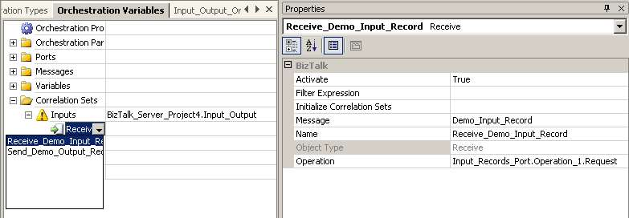

Hub and Spokes
Of course, a B2B application must be developed collaboratively by the interacting parties. However, B2B applications are complex and the coordination of functionality between multiple organizations’ systems can be arduous.
With its Seed Wizard module, BizTalk Server addresses the complications inherent in creating a jointly developed application. A Seed Wizard is a way to automate the implementation of one-to-many business partner interchanges and minimize the iterative testing involved in establishing these interchanges. The Seed Wizard includes a Hub Seed Wizard, which enables a “hub” trading partner to create a package that contains the BizTalk Server assembly components used to engage in message exchanges with its business partners. This package is called a Hub Seed Package.
The trading partners that receive the Hub Seed package, referred to as “spokes” in the wizard, use the BizTalk Server Spoke Seed Wizard to test the hub configurations locally and remotely. The Hub Seed package also configures the appropriate ports, orchestrations, and pipelines on the spoke’s system, which enables the spoke to begin testing transactions directly with the hub partner. If the tests are successful, the spoke creates a Spoke Seed Package from its BizTalk Server assemblies and sends them to the “hub” partner. The hub partner uses the Spoke Seed Package to configure the spoke information on the hub’s side and go live.

Exposing a Web Service
Another way in which BizTalk Server facilitates B2B interactions is by encapsulating and exposing an entire orchestration as a Web service. The E-Business Web Services Wizard illustrated as follows facilitates the easy creation of an ASP.NET Web services project directly from a BizTalk Server orchestration assembly.
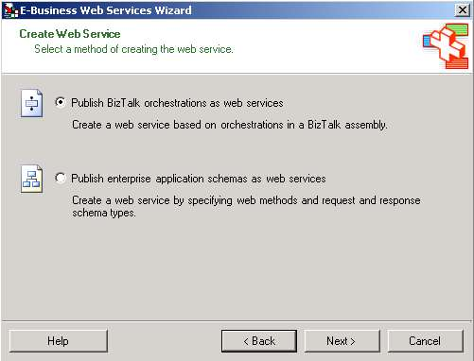
As a result, the functionality of sophisticated business processes developed as BizTalk Server orchestrations is available for public consumption, but published on an isolated host that prevents access to internal resources supporting the orchestration.
Conversely, an external Web service can be consumed by an orchestration by adding a Web reference, a Web port, and message variables to the orchestration. Web ports are specially configured ports that are used to access Web services. A Web port can contain multiple Web operations that represent a mix of one-way (request only) and two-way (request-response) Web methods. Each Web operation in a Web port represents one method of a Web service.

Supporting Industry Initiatives and Legislative Mandates with BizTalk Server
We have discussed how high-level composite functions intrinsic to or composed within BizTalk Server can accommodate the specific development requirements of different classes of applications. There is still another higher level of abstract functionality that BizTalk Server addresses effectively: encapsulating the implementation components of an industry initiative or a legislative mandate. In BizTalk Server this aggregate functionality is called an Accelerator. Following are descriptions of two such Accelerators.
BizTalk Server Accelerator for Financial Services addresses the specific messaging requirements of the financial services industry. It delivers preconfigured messaging formats and schemas for financial services standards and middleware integration tools focused on payment settlement and securities trade settlement. It provides a financial institution with a single, extensible infrastructure for integrating within the organization, and with counterparties and external service providers. BizTalk Server Accelerator for Financial Services includes:
- Message validation support for SWIFT and ISITC messages, with more than 90 document specifications describing SWIFT and ISITC messages for payments, foreign exchange, securities trading, and reporting.
- A BizTalk Server Adapter that enables connectivity to the SWIFT Secure IP Network (SIPN).
- Custom parsers and serializers that enable BizTalk Server to transform data between SWIFT native file formats and their XML representations.
- Custom transformation maps of industry-standard messages such as ISO 7775 and ISO 15022.
- A custom event system, facilitating the development of event handler classes that can capture and react immediately to message validation results.
BizTalk Server Accelerator for HIPAA addresses the standardization of medical insurance documentation as mandated in the Health Insurance Portability and Accountability Act of 1996 (HIPAA). BizTalk Server Accelerator for HIPAA supports the generation, processing and communication of all 12 EDI transaction sets specified in HIPAA. It includes:
- Custom parsers, serializers, and transformation maps for X12N, Health Level 7 (HL7), EDI, XML, and flat file data formats.
- An External Code List Loader to accommodate code lists that are external to the X12N implementation guides, but are required when using many transactions.
- The ability to generate a functional acknowledgement.
- The ability to process individual instances of a document from an inbound batch transaction by separating out individual claims from a larger submitted batch transaction.
Industry initiatives that facilitate common practices, interoperability, and integration have always been focused on business messages. In a SOA development environment, Accelerators represent the highest level of functional abstraction; that is, the ability to incorporate a set of business message protocols specific to an industry sector. The body of business message specifications known as Electronic Data Interchange (EDI) is the most prominent example of these initiatives. A necessary requirement of any XML business-messaging platform is the capability of interacting with, processing, and integrating the non-XML business messages that are already in use within an industry sector. Conforming to the existing industry conventions is the development role of an Accelerator.
BizTalk Server Accelerators not only provide semantic translation of message contents, they also implement the prescribed processing procedures using service-oriented orchestration components and modules. The result is structural transparency and modularity in complex processes, making them significantly more manageable.

Conclusion
Each application class—workflow process, application integration interface, or trading partner interaction—has unique and specialized complexities. The SOA methodology implemented by BizTalk Server provides an effective way to compose a sophisticated solution by breaking down a complex application into clearly defined logical steps and self-describing implementation components.
Whatever the level of encapsulation and abstraction, any embedded functional element remains accessible, comprehensible, and capable of being modified without compromising the integrity of the aggregate application. The holistic clarity and consistency of this development approach makes it possible to work in both a bottom-up or top-down manner. Without a doubt, the SOA development platforms impose a new conceptual model on application development, but the return on investment for the effort is hugely leveraged. A large and growing body of evidence already shows that users of this methodology are obtaining dramatic efficiencies in both the development and life cycle maintenance of the applications created in these development environments.



The information contained in this document represents the current view of Microsoft Corporation on the issues discussed as of the date of publication. Because Microsoft must respond to changing market conditions, it should not be interpreted to be a commitment on the part of Microsoft, and Microsoft cannot guarantee the accuracy of any information presented after the date of publication.
This White Paper is for informational purposes only. MICROSOFT MAKES NO WARRANTIES, EXPRESS OR IMPLIED, AS TO THE INFORMATION IN THIS DOCUMENT.
Complying with all applicable copyright laws is the responsibility of the user. Without limiting the rights under copyright, no part of this document may be reproduced, stored in or introduced into a retrieval system, or transmitted in any form or by any means (electronic, mechanical, photocopying, recording, or otherwise), or for any purpose, without the express written permission of Microsoft Corporation.
Microsoft may have patents, patent applications, trademarks, copyrights, or other intellectual property rights covering subject matter in this document. Except as expressly provided in any written license agreement from Microsoft, the furnishing of this document does not give you any license to these patents, trademarks, copyrights, or other intellectual property.
© 2004 Microsoft Corporation. All rights reserved.
Unless otherwise noted, the example companies, organizations, products, domain names, e-mail addresses, logos, people, places and events depicted herein are fictitious, and no association with any real company, organization, product, domain name, e-mail address, logo, person, place or event is intended or should be inferred.
Biz Talk, Microsoft, Visual Studio, Windows, SharePoint, and InfoPath are either registered trademarks or trademarks of Microsoft Corporation in the United States and/or other countries.
The names of actual companies and products mentioned herein may be the trademarks of their respective owners.

