
BizTalk Server 2004 Architecture
White Paper
Published: December 2003
For the latest information, please see http://www.microsoft.com/biztalk
Contents
Introduction 1
BizTalk Server—SOA implementation 2
SOA—Underlying Technologies 8
Conclusion 9

Introduction
Automating and maintaining business processes in a dynamic and cost-effective manner has proven to be a difficult endeavor for even the most technically sophisticated organizations. However, a new application development and integration methodology has evolved that effectively addresses these issues. Known as Service Oriented Architecture (SOA), the methodology is based on XML and Web services technologies and has been incorporated into Business Process Management and Enterprise Application Integration (BPM/EAI) platforms.
The SOA paradigm has redefined the concept of an application. An application is no longer an opaque, procedural implementation mechanism. Instead, it is an orchestrated sequence of messaging, routing, processing, and transformation events capable of processing the exposed declarative properties of rich (XML) documents.
A workflow process, integration scenario, or trading partner interaction are specialized classes of the SOA paradigm distinguished only by the nature of the participants involved, the point of execution, and the participants’ individual security requirements. BPM/EAI platforms that incorporate the SOA paradigm are highly compelling because they provide numerous development and operational benefits:
- They alleviate significant development inefficiencies and impediments to effective life cycle maintenance.
- They facilitate the flexible “loose coupling” of components on a highly distributed basis.
- They permit the addition, removal, and reconfiguration of any process activity or component without disrupting the process.
- They are fundamentally oriented to supporting long-running, asynchronous transactions that scale well.
- They ensure the applications are well documented and visible because the process activities, components, and functions are exposed and self-describing.
- They enable the extensibility and reuse of both application components and entire applications.
- They maximize the network infrastructure of the Internet and the protocol standards of the World Wide Web.
Approaching a development environment based on the SOA paradigm does require a reorientation in the concepts and methodologies of application development. In this document we describe the fundamental SOA concepts and development methodologies. We then explore how the Microsoft® EAI development environment, BizTalk® Server 2004, implements these concepts and methodologies within two particular contexts: the design, behavior, and functionality of the applications that are created; and the development process itself. Finally the document describes how the BizTalk Server development tools, which are integrated with Visual Studio® .NET, provide a bridge between the .NET framework architecture and the SOA paradigm.

BizTalk Server—SOA implementation
The value of implementing BizTalk Server with SOA is apparent when you consider how one might achieve the development and operational benefits specified previously. To begin with, we can examine the inefficiencies of the development process and the ways in which BizTalk Server addresses them.
Traditional programming methodologies do not adequately translate the conceptual model of an application or business process (that is, a design specification) into an executable form. While development notation systems such as UML allow a business analyst to document functional specifications and Use Cases using a structured methodology, a programmer still has to interpret this documentation and translate its intent into a different language and structure. This manual and highly interpretive conversion process is characterized by its inefficiencies—most notably its recursive revision cycles. After the business processes have been accurately translated into procedural code, another issue typically presents itself: the behavior of the code is less predictable than the behavior of the business process it models. This volatility results from the nature of procedural code implementations. Bound to a machine execution model, procedural code is an opaque embodiment of processes that encapsulate multiple levels of tightly coupled, interdependent functionality. Consequently, procedural code is prone to program errors that are often difficult and time-consuming to identify and repair. Understandably, then, when software is operationally stable, subsequent modifications are discouraged—often to the point of requiring modifications to business processes just to accommodate the limitations of the rigid code.
A BPM/EAI development environment allows the business analyst and the programmer to collaborate in a common workspace on a visual model of the process that combines and correlates their respective contributions. The programmer and analyst create the application by arranging high-level objects representing messages, messaging events, business rules and logic, information flows, activities, operations, transformations, and subprocesses, using a drag-and-drop graphical user interface. The model itself directly generates an executable run-time assembly of the process. This methodology provides significant development efficiencies and life cycle flexibility by minimizing the ambiguities and recursive revision cycles inherent in traditional methodologies. Furthermore, the implementation mechanisms for highly complex functions, such as transactions requiring two-phase commit, roll-back ACID transaction support, and nested and parallel operations, are built in functions of the objects; thus, eliminating the need to write complicated procedural code to implement these capabilities.
To better illustrate the SOA development methodology the following steps describe the procedure for creating an application in BizTalk Server that adheres to this paradigm:
- Create the documents involved in the application/process as well as their respective schema definitions.
This is accomplished in the Schema Editor, a BizTalk Server module accessed from within Visual Studio .NET. The Schema Editor enables you to define the structure and semantic metadata that “declares” the meaning, functions, and processing requirements of the content of a document (an “instance”) that is created from the schema. When BizTalk Server receives an instance of a document, the process to which the document is associated validates the document content against its schema definition to ensure the document’s form and content conform to the schema and the application’s processing requirements. BizTalk Server Schema Editor creates a W3C-compliant XSD document as well as a visual tree node reference model of the schema.
Following is an example of the Schema Editor that shows the tree node model of the schema in the left panel and the XML representation of the document schema in the right panel.
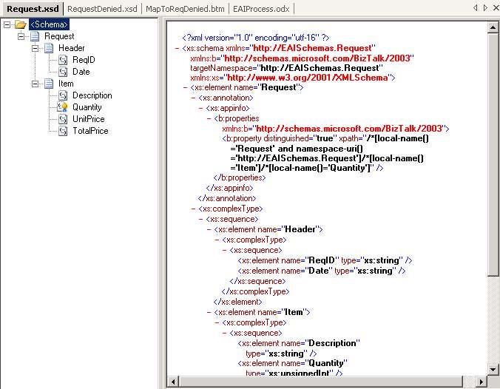
- Create and define the transformation requirements for any document interchanges.
In applications that are composed of loosely coupled interactions between XML objects, document transformation becomes a functionally exposed mapping subprocess. In BizTalk Server this subprocess is created in BizTalk Server Mapper. The transformation maps are used to process and convert the content and structure of any source information (based on its schema representation) into any target document format, such as a report. BizTalk Server Mapper visually displays the source and destination information formats using the schema tree node model used by BizTalk Schema Editor. Information is mapped from one or more nodes in a source schema to one or more nodes in the destination schema by drawing links between the nodes. Functoids, which provide additional conversion, processing, and abstraction capabilities (looping, cumulative, date and time, iteration, and so forth), are graphically implemented by linking one or more source nodes to a functoid, and then linking the functoid to one or more destination nodes.
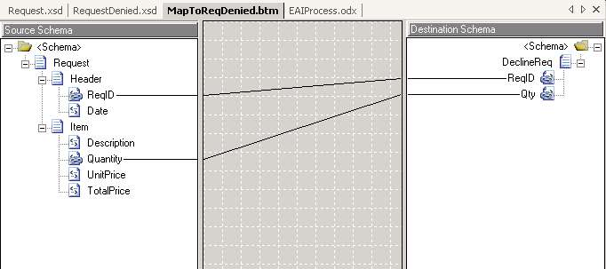
Each transformation map (as well as the referenced source and target schemas) becomes a BizTalk Server project resource that is subsequently embedded into an orchestration as a process step and compiled into the orchestration assembly. Maps can be reused and modified as needed to implement any number of transformation requirements and they be deployed within any number of orchestrations. The maps created by BizTalk Server Mapper are based on XSLT, an open standards protocol for transforming XML information.
- Specify the business logic governing event execution.
If the business logic is simple, it can be embedded as an expression directly within a BizTalk Server orchestration decision step. If the business logic is complex, the BizTalk Server Rules Composer can be used to create and process the sophisticated rule sets. Each rule set (or “Policy”) drives a specific activity or function and becomes a resource object embedded into a BizTalk Server orchestration.
Consistent with the overall BizTalk Server architecture, transparency and loose coupling govern the creation and implementation of business rules. A rule set incorporated within a BizTalk Server orchestration can be viewed, modified, or completely replaced both at design and run time, without affecting any other process operation or interrupting running instances of the affected process. The flexibility that an exposed and componentized rule engine provides for modifying business processes is of fundamental significance. In conventional application development, business rule logic is embedded in procedural code and is not accessible for modification without changing the code itself. Because most modifications to a business process life cycle pertain to changes in business rules (as opposed to technology-related modifications), the ability to isolate business rules entirely from procedural code, or any process implementation mechanisms, dramatically improves the efficiencies of managing and adapting business processes throughout their life cycle.
BizTalk Server Rules Composer supports the creation of domain-specific vocabularies for defining business rules, and its functionality is exposed through public interfaces, making it extremely flexible and extensible. The following is an illustration of the BizTalk Server Rules Composer module.
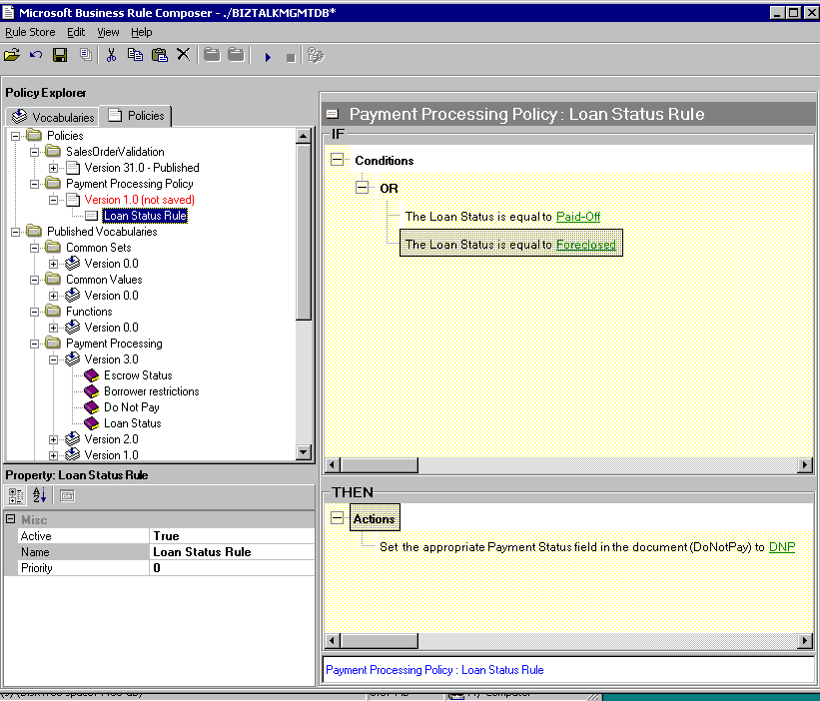
- Determine and implement requirements for message preprocessing and post-processing.
This is accomplished in the BizTalk Server Pipeline Designer module. Accessed through the BizTalk Server orchestration workspace, the Pipeline Designer module is used to implement the interchange requirements for encryption, authentication, and data format conversion with external applications and parties.
A pipeline is a sequence of processing operations that take place before a message is received by, or dispatched from a process orchestration or message data store. A “receive pipeline” accepts an incoming message, decrypts or decompresses it as required, disassembles the message into its parts, converts it into an XML document as specified in the BizTalk Server Schema, validates the message, and authenticates the identity of its sender. When a message passes through a pipeline, it is transferred to the BizTalk Server MessageBox store. A “send pipeline” performs the same operations as the “receive pipeline,” but in reverse. It assembles, formats, encrypts, compresses, and digitally signs a message as required by the external recipient.
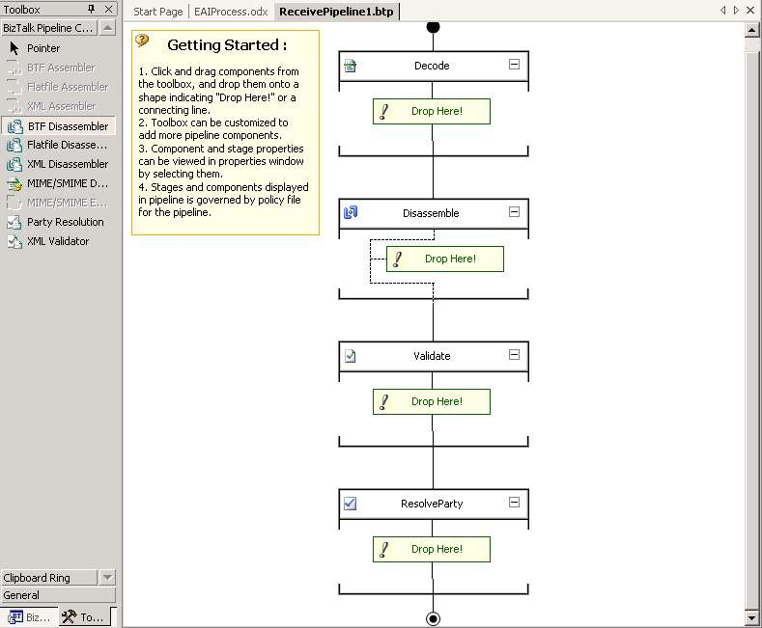
- Compose and orchestrate the application/process steps.
This takes place in BizTalk Server Orchestration Designer, the main workspace within Visual Studio .NET where an overall BizTalk Server application is developed and implemented. A process orchestration diagram is created by dragging and dropping object shapes found on the Orchestration Toolbox and linking them together. These shapes represent process activities such as receive, invoke, sequence, flow, link, and source. These shapes are used to compose and execute message flows, messaging events, business rules, activities, operations, transformations, and subprocesses.
The following figure illustrates a BizTalk Server orchestration diagram that implements the following workflow process steps:
- The process application (a BizTalk Server orchestration) receives an inventory order replenishment request (“Request’).
- The process application checks the quantity of items ordered. If the order contains more than 500 items, it is denied. If the order contains 500 or fewer items, it is accepted.
- If the order is declined, a notification is created (“ReqDenied”) and sent to the person who placed the order.
- If the order is accepted, the original order request is submitted to an ERP system for processing.
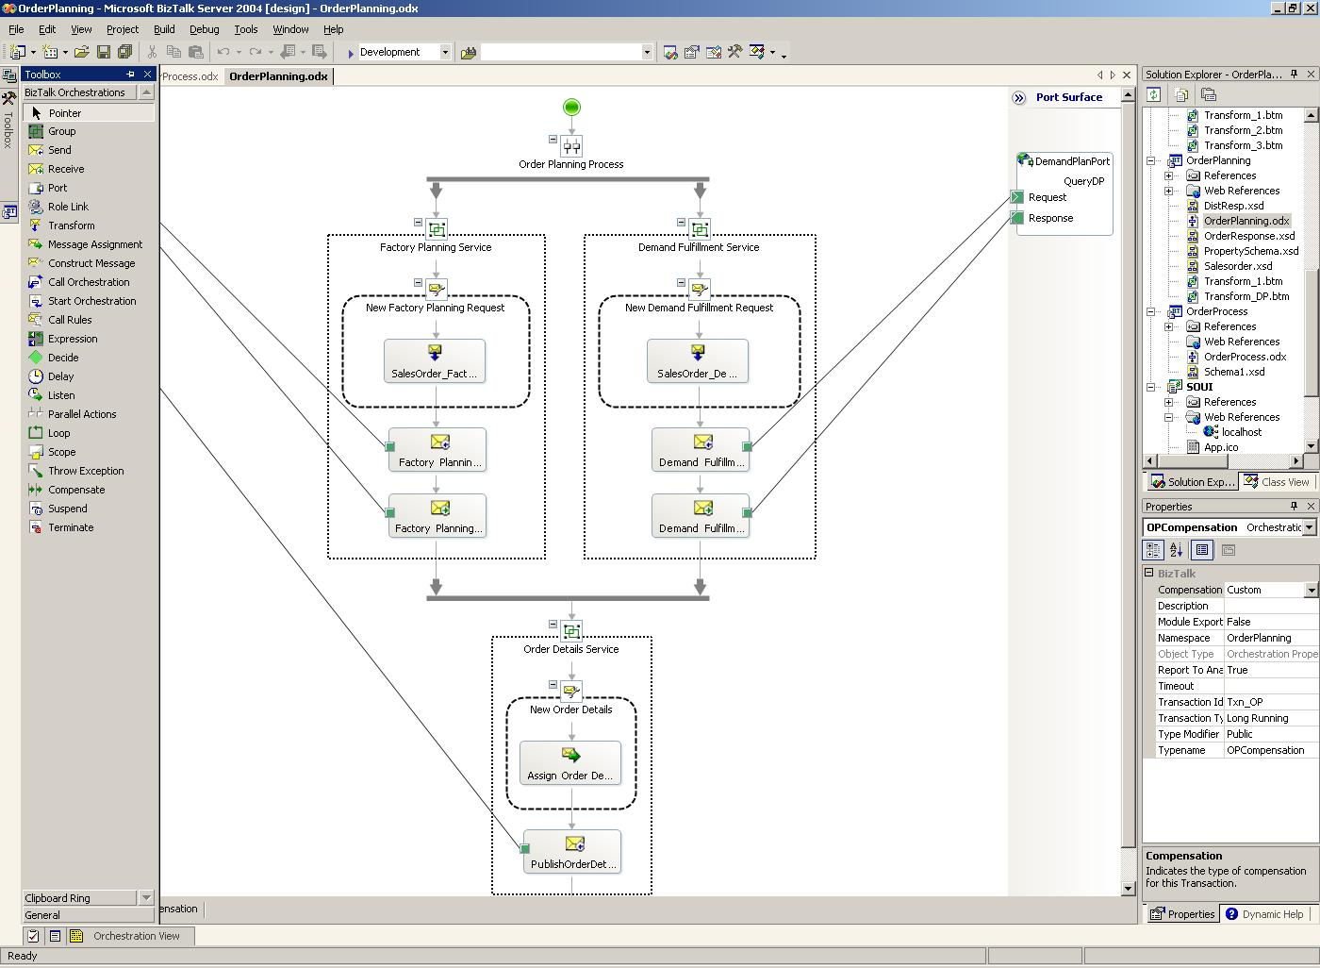
Composing the illustrated process diagram involved dragging and dropping the following shapes from the Toolbox and then modifying them:
- Placed a Receive shape at the top of the design surface and named it Receive_Req.
- Placed a Decision shape directly beneath the Receive Shape and named it CheckQuantity.
The Decision shape automatically creates two activity branch shapes (If or Else) The If shape is renamed Decline. The Decline shape is linked to an expression editor in which the XPATH expression “RequestInstance.Item.Quantity > 500” is created. This XPATH expression will function as the “If” rule that specifies the denial criteria for the order request.
- Placed a Construct Message shape below the Decline shape and named it Construct_ReqDenied.
- Placed a Transform shape within the Construct_ReqDenied shape.
- Placed a Send shape below the Construct_ReqDenied shape and named it Send_ReqDenied.
- Placed a Send shape below the Else shape and named it Send_REQToERP.
- Link the design shapes to implementation objects.
When the process steps are diagrammed, the next step involves linking the shapes to the objects required to implement the process. The objects may include the actual message documents, port locations where the messages are sent and received, and transport mechanisms required to move the messages. This linking stage is also performed in the Orchestration Designer.
In the sample orchestration diagram, when a running process receives an instance of a Request document (note the Receive shape that initiates the process), the process will validate the document’s content against its schema definition to ensure the document’s form and content conform to the schema and the application’s processing requirements. If the Request document does not conform, the Transform subprocess embedded in the Construct Message process references an XSLT transformation map that converts the Request document to a ReqDenied document, as described in the second step.
- Where applicable, define parties and their respective roles and link to orchestration functions.
This is accomplished in BizTalk Server Explorer, a tool that provides configuration information for the orchestrations and external components that make up a specific BizTalk Server project. Organized in a hierarchical tree structure, Explorer is used to configure the relationships and interactions of the project orchestrations to other project components such as roles, parties, send and receive ports, and receive locations.
After all the logical steps are implemented in an orchestration diagram, a Visual Studio .NET run-time assembly (DLL file) is generated from a “build” of the orchestration diagram. This assembly may be implemented as an application on its own, or included as a component of a larger BizTalk Server solution.
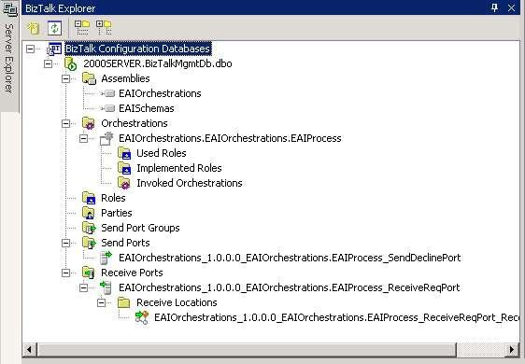
A BizTalk Server solution (a process application) includes one or more Visual Studio .NET projects that contain BizTalk Server components such as schemas, orchestrations, transformation maps, and pipelines. From the example discussed earlier, the schemas for the Request and ReqDenied documents and the transformation map are combined in a discrete BizTalk Server project that builds a compiled assembly.
The BizTalk Server orchestration diagram that details the process workflow is also a discrete BizTalk Server project within the same solution. By referencing (encapsulating) the schema and map assembly, the diagram can incorporate the schemas and map as functional objects. All of the BizTalk Server project assemblies for a solution are then deployed and installed as an executable application under the management of the BizTalk Server run-time engine.

SOA—Underlying Technologies
Having discussed how an application is developed and implemented using the high-level tools within BizTalk Server 2004, we can now relate this development methodology to the underlying technologies that facilitate the Service Oriented Architecture (SOA) paradigm. As noted earlier, the fundamental principles of SOA are exposed functionality, document messaging, loose coupling, and platform independence.
XML provides the transparency and application independence and uses metatags to “declare” the meaning and function of data. The premise of XML is to convert program-dependent data into self-describing, program-independent data. This applies not only to content, but also to instructions for processing the content.
XML Schema provides semantic consistency and interoperability. XML Schema is a specification that formally defines an extensive array of data type primitives and structural components for creating XML documents; it serves as a dictionary of abstract elements, attribute entities, and organizational rules. Creating XML documents that conform to a schema “dictionary” has a significant advantage: the meaning, function and use of a document’s content is comprehensible to, and operable by, any XML-enabled application that can access the document’s underlying schema. Every industry-specific initiative to develop a common vocabulary and set of procedures for the exchange and processing of information is based on XML Schema. In fact, the XML Schema even serves as the basis for Web services protocols.
The Web services protocols, Simple Object Access Protocol (SOAP), and Web Services Definition Language (WSDL) provide the capabilities and messaging facilities required to bind and execute programmatic functionality anywhere, on any platform, without the need for custom code. The significance of the Web services specifications is that they provide the first truly workable architecture for building complex, interoperable computing processes over the Internet.
SOAP is an XML-based messaging protocol used to encode documents for transporting over a network. A “SOAP client” inserts an XML document into a SOAP envelope and posts it using HTTP (referred to as marshalling) to a “SOAP listener” that accepts the delivery. SOAP messaging has a number of benefits:
- The SOAP client and listener applications are simple constructs. A SOAP client can be easily embedded as a routine in any program or Web page, and the URL endpoint can serve as the SOAP listener.
- By using HTTP as its transport mechanism, a SOAP message can go anywhere, use existing SSL facilities for authentication and encryption, and make the most of the infrastructure scale of the World Wide Web.
- Everything in the message, the SOAP envelope, the message header, and the body is expressed in XML, thus making the whole object entirely transparent. Because the semantics and structure of the documents are fully exposed, extensive validation, manipulation, routing, and transformation functions can be applied to the documents without writing application code to do so. Unlike CORBA, a Web services network endpoint (an HTTP, URL, or other address) can support multiple XML formats, providing a real polymorphic interface that will not break down with new versions.
- Because HTTP is one of the transport mechanisms used by SOAP, a Web Service method call can be made to and from any Web-enabled computer anywhere in the world. Consequently SOAP has the potential to construct distributed computing processes on the same massive scale as the World Wide Web.
Web Services Definition Language (WSDL) is a specification for describing, communicating, and invoking programmatic functionality through a message exchange or remote procedure call—both of which use the SOAP protocol and XML encapsulated information. A WSDL document resides at a URL location and is linked to the actual program module located elsewhere. Almost any programmatic function within an orchestration, or accessed from an orchestration, can be exposed as a Web service: a database look-up, the invocation of a complex business rule, or the entire orchestration process itself. Because the public Web services interfaces are not dependent on the private implementation of the program, it is easy to construct applications that are highly modular and distributed.

Conclusion
The Business Rule Framework within BizTalk Server represents an innovative implementation of the Service Oriented Architecture (SOA) paradigm. Every individual and combined level of functionality has been designed to be exposed, independent, and capable of being loosely coupled. Any policy component (vocabulary or rule set) can be viewed or changed at any time, without affecting any other process operation or running instance of the affected process. Furthermore, policies are compiled into Visual Studio .NET assemblies directly from their semantic and declarative XML definitions, thus eliminating the need for any procedural implementation programming. The substantial development and life cycle efficiencies that this individual capability engenders are validation of the Service Oriented Architecture paradigm.
The flexibility that an exposed and componentized rule engine provides for modifying business processes is significant. In conventional application development, business rule logic is embedded in procedural code and cannot be modified without changing the code itself. And code changes, which consume both time and resources, often result in unpredictable program behavior. Clearly the ability to isolate business rules entirely from procedural code, or any process implementation mechanisms, dramatically improves the efficiencies of managing and adapting business processes in response to new requirements or business conditions.
The development process within Orchestration Designer is, in itself, a lesson in exposed functionality and loose coupling. By providing developers with the ability to visualize complex business logic and its respective implementation mechanisms, the Orchestration Designer makes software development more manageable and less abstract. Each logical process step is coupled to a discrete implementation mechanism that contains self-documenting methods. Functionally transparent and isolated, each object property within the solution (orchestrations, schemas, maps, and so forth) is accessible from the host Visual Studio .NET environment or directly through its XML representation. Furthermore, the completed orchestration can generate a Business Process Execution Language (BPEL) document of the entire process.
Because a BPEL instruction set is an XML representation of a process with a precise language and grammar structure, it provides a readable and understandable instruction set for documenting a process. The value of this cannot be overstated; historically, poor documentation prevented software and processes from being readily modified and adapted. In fact, the process shapes in Orchestration Designer symbolize basic and structured BPEL elements such as receive, invoke, sequence, flow, role, link, and source. A process developed in BizTalk Server Orchestration Designer can be exported as a BPEL document and be imported into any other BPEL-compliant application. Conversely, a BPEL document can be imported into BizTalk Server Orchestration Designer to generate an orchestration diagram. The standardized interchange of process instructions can potentially facilitate collaborative business process development between business partners.
The application of the SOA paradigm in BizTalk Server 2004 clearly illustrates how the value of XML functionality has accrued:
- XML and XML Schema have enabled the creation of the Web services protocols SOAP and WSDL.
- BPEL functions on top of the core Web services protocols and facilitates the inclusion of additional XML functionality (such as business rules or processing logic) within processes.
- Each process is independently valuable, but when combined with other processes has the potential to facilitate wholesale efficiencies and provide innovative solutions to numerous challenging problems. It is an object lesson in the whole being greater than the sum of the parts.
Because BizTalk Server Orchestration Designer is embedded within Visual Studio .NET, it bridges two frameworks: SOA and .NET. The .NET framework consists of two main parts: the common language run time (CLR) and a unified set of class libraries. The class libraries include ASP.NET for Web applications and Web services, Windows Forms for smart client applications, and ADO.NET for loosely coupled data access. The .NET framework provides a highly productive, standards-based environment for integrating existing information technology investments with next-generation applications and services. When combined with the higher-level abstractions of XML functionality and the visual design facilities found in BizTalk Server, the result is a development and deployment environment that offers unprecedented capabilities and efficiencies. Furthermore, it provides a coherent way for developers to indoctrinate themselves in the SOA methodologies while leveraging their .NET expertise.
We are entering an era of computing where information will be detached from, and completely independent of applications but where the structure, composition and behavior of each will be fundamentally identical. Information will be generated and published without knowledge of how it will be consumed or used. Applications will both consume information and methods, and be consumed. Processes will be capable of configuring and modifying themselves. Entirely new applications, new business models and new ways in which information will define our experiences will evolve from the Service Oriented Architecture paradigm.
As with any paradigm shift, SOA must be justified by the benefits it provides. The evidence is clear. Those who have adopted the SOA development model have realized dramatic development efficiencies, accelerated return on investment, and increased resource availability. Although XML, Web services, and BPM/EAI platforms impose a new conceptual model on business process development, the technologies required to implement and deploy this model are established and proven Microsoft products that have been augmented to support this new paradigm.


The information contained in this document represents the current view of Microsoft Corporation on the issues discussed as of the date of publication. Because Microsoft must respond to changing market conditions, it should not be interpreted to be a commitment on the part of Microsoft, and Microsoft cannot guarantee the accuracy of any information presented after the date of publication.
This White Paper is for informational purposes only. MICROSOFT MAKES NO WARRANTIES, EXPRESS OR IMPLIED, AS TO THE INFORMATION IN THIS DOCUMENT.
Complying with all applicable copyright laws is the responsibility of the user. Without limiting the rights under copyright, no part of this document may be reproduced, stored in or introduced into a retrieval system, or transmitted in any form or by any means (electronic, mechanical, photocopying, recording, or otherwise), or for any purpose, without the express written permission of Microsoft Corporation.
Microsoft may have patents, patent applications, trademarks, copyrights, or other intellectual property rights covering subject matter in this document. Except as expressly provided in any written license agreement from Microsoft, the furnishing of this document does not give you any license to these patents, trademarks, copyrights, or other intellectual property.
© 2004 Microsoft Corporation. All rights reserved
Unless otherwise noted, the example companies, organizations, products, domain names, e-mail addresses, logos, people, places and events depicted herein are fictitious, and no association with any real company, organization, product, domain name, e-mail address, logo, person, place or event is intended or should be inferred.
Microsoft, BizTalk, and Visual Studio are either registered trademarks or trademarks of Microsoft Corporation in the United States and/or other countries.
The names of actual companies and products mentioned herein may be the trademarks of their respective owners.

