



Deploying Windows® phones with the Windows Mobile® 6.5 operating system on Microsoft® Exchange Server 2010

Microsoft Corporation
Published: November, 2009

Abstract
This guide provides best practices and procedures for implementing a Windows® phone mobile messaging system with the Windows Mobile® 6.5 operating system, and Microsoft® Exchange Server 2010.



Information in this document, including URL and other Internet Web site references, is subject to change without notice. Unless otherwise noted, the companies, organizations, products, domain names, e-mail addresses, logos, people, places, and events depicted in examples herein are fictitious. No association with any real company, organization, product, domain name, e-mail address, logo, person, place, or event is intended or should be inferred.

Complying with all applicable copyright laws is the responsibility of the user. Without limiting the rights under copyright, no part of this document may be reproduced, stored in or introduced into a retrieval system, or transmitted in any form or by any means (electronic, mechanical, photocopying, recording, or otherwise), or for any purpose, without the express written permission of Microsoft Corporation.

Microsoft may have patents, patent applications, trademarks, copyrights, or other intellectual property rights covering subject matter in this document. Except as expressly provided in any written license agreement from Microsoft, the furnishing of this document do not give you any license to these patents, trademarks, copyrights, or other intellectual property.

Available programs, features, and functionality vary by: device, version of Windows Mobile software, mobile network provider, and availability of network connectivity and supporting technology (such as Microsoft Exchange Server). See www.windowsphone.com, your device reseller, and mobile network provider for more information. Office Mobile programs must be purchased separately for some devices. Flash functionality requires Adobe Flash Lite player, which may not be available on all devices. Direct Push Technology requires Exchange Server 2003 Service Pack 2 or newer version.

© 2009 Microsoft Corporation. All rights reserved. Microsoft, Active Directory, ActiveSync, Internet Explorer, Outlook, SharePoint, SQL Server, Windows Mobile, Windows, and Windows Server are trademarks of the Microsoft group of companies. All other trademarks are property of their respective owners.
Contents
Introduction 1
Document Structure 1
Deploying Mobile Messaging 2
Assumptions 2
Software Requirements 2
Optional Items 3
Deployment Software Summary 3
Planning Resources 4
New and notable features from Windows Mobile® 6.5 and Microsoft Exchange Server 2010 5
Features of Windows Mobile 6.5 5
New Features: Microsoft Exchange Server 2010 9
Best Practices for Mobile Messaging Deployment 14
Network Configuration 14
Security Features: Authentication and Certification 16
Network Architecture Scenarios 17
Deployment Options 17
Authentication in ISA Server 2006 SP1 23
Understanding Direct Push Technology 24
Direct Push Technology 24
Windows Mobile 6.5 and Microsoft Exchange Server 2010 Deployment Procedure 30
Step 1: Install Microsoft Exchange Server 2010 with Client Access Server Role 30
Step 2: Update Servers with Security Patches 32
Step 3: Protect Communications between Phones with the Windows Mobile 6.5 operating system and Microsoft Exchange Server 2010 33
Deploy SSL to Encrypt Messaging Traffic 33
Enable SSL for the Default Web Site 42
Configure Basic Authentication 43
Protect IIS by Limiting Potential Attack Surfaces 45
Step 4: Install and Configure ISA Server 2006 SP1 or Other Firewall 46
Procedures 47
Install ISA Server 2006 SP1 47
Install a Server Certificate on the ISA Server Computer 48
Update Public DNS 50
Create the Exchange ActiveSync® Publishing Rule 51
Configure ISA Server 2006 SP1 for LDAP Authentication 58
Set the Idle Session Timeout for Firewalls and Network Appliances to 1800 Seconds 60
Test Exchange Publishing Rule 60
Step 5: Configure and Manage Windows® Phone Access on the Exchange Server 61
Create Exchange ActiveSync® Mailbox Policies 61
Configure Security Settings for Windows® phones with a Mailbox Policy 63
Apply a Mailbox Policy to a User 64
Initiate a Remote Device Wipe 65
Disable Exchange ActiveSync® 67
Step 6: Certificate Enrollment and Device Provisioning 69
Certificates on Windows® Phones 69
Basic Authentication 72
Certificate-based Authentication 72
Managing Device Certificates 72
Windows® phone Security Policies and Device Provisioning 80
Step 7: Manage and Configure Windows® phones 81
Setting Up a Mobile Device Connection to the Exchange Server 81
Summary 86

Introduction
This guide provides best practices and procedures for implementing a mobile messaging system with Windows® phones with the Windows Mobile® 6.5 operating system on Microsoft Exchange Server 2010.

To deploy Windows® phones with the previous version of Microsoft Exchange Server, visit http://technet.microsoft.com/en-us/library/cc182258.aspx

Document Structure
The guide is divided into two main sections:
- The first section, Deploying Mobile Messaging, provides an overview of new features and deployment best practices; mobile messaging architecture alternatives and recommendations; and an introduction to Direct Push Technology.
Deploying Mobile Messaging

- The second section, Windows Mobile® 6.5 and Microsoft Exchange Server 2010 Deployment Procedures, provides the steps and procedures necessary to install a mobile messaging system. This includes setting up Microsoft Exchange Server 2010, creating a protected communications environment, configuring Microsoft Internet Security and Acceleration (ISA) Server or third-party firewall, and mobile device management and configuration.
Windows Mobile 6.5 and Microsoft Exchange Server 2010 Deployment Procedures

Deploying Mobile Messaging
This guide is for Information Technology (IT) professionals responsible for planning and deploying a mobile messaging system using Windows® phones with the Windows Mobile 6.5 operating system and Microsoft Exchange Server 2010.

Assumptions
This guide assumes you have a general understanding of Microsoft Exchange Server 2010 deployment and administration, Microsoft Office Outlook® Web Access, Exchange ActiveSync®, Hypertext Transfer Protocol (HTTP), and Microsoft Internet Information Services (IIS) concepts.
Note:
Microsoft highly recommends reading the Microsoft Exchange Server 2010 technical documentation in the Microsoft TechNet library before attempting to install your Windows Mobile 6.5 and Exchange Server 2010 mobile messaging solution.

To read more about Microsoft Exchange Server 2010 functionality, server roles, architecture, and planning, and Exchange ActiveSync, see the Getting Started with Microsoft Exchange Server 2010.

Software Requirements
The following table presents the operating systems and applications required for a single Microsoft Exchange Server 2010 mobile deployment.

Location | Software requirements
Active Directory® Server  Lightweight Directory Access Protocol (LDAP) | - Microsoft® Windows Server® 2008 R2
Exchange Server | - Microsoft Exchange Server 2010  - Client Access Server Role installed  - Mailbox Server Role installed  - HUB Server Role installed  - Internet Information Services (IIS) 7.0
Mobile Devices | - Phones that run Windows Mobile 5.0 + MSFP and higher.

Note
- A Microsoft Exchange Server 2010 installation requires 64-bit hardware and a 64-bit operating system as prerequisites. This is necessary to help support increased memory, storage, and enhanced security requirements in a cost-effective manner. For larger Exchange deployments in which the Client Access Server is on a separate machine from the Exchange Mailbox Role, it is also strongly recommended that Microsoft Exchange Server 2010 be deployed on a member server, and not on a domain controller.
- For more information about Microsoft Exchange Server 2010 hardware and software prerequisites, see “Planning for Exchange 2010” under Planning and Deployment on the Microsoft TechNet Web site.

Optional Items
You can implement the following optional components for security features and device management:
- Microsoft Internet Security and Acceleration Server 2006
- Windows Certification Authority
- RSA Authentication Manager 6.0, from RSA Security
- RSA Authentication Agent for Microsoft Windows, from RSA Security
- RSA SecurID Authenticator, from RSA Security
For more information, see Network Architecture Scenarios in this document.

Deployment Software Summary
Because corporate network infrastructures and security policies vary, the deployment process for each mobile messaging installation differs. There are both required and recommended steps for deploying a messaging solution using Windows Mobile 6.5 and Microsoft Exchange Server 2010.

The deployment can be accomplished in seven steps:
- Step 1: Install Microsoft Exchange Server 2010 with Client Access Server Role
- Step 2: Update Servers with Security Patches
- Step 3: Protect Communications Between Microsoft Exchange Server 2010 and Windows® phone
- Step 4: Install and Configure ISA Server 2006 SP1 or Other Firewall
- Step 5: Configure and Manage Mobile Device Access on the Exchange Server
- Step 6: Certificate Enrollment and Device Provisioning
- Step 7: Manage and Configure Windows® Phones

Planning Resources
The following Microsoft Web sites and technical articles provide background information for planning and deploying your mobile messaging solution:

Microsoft Exchange Server 2010
Windows® phone for Business
Windows Server 2008 Deployment Guide
Exchange Server 2007 Deployment Guide
Windows Server 2003 Deployment Guide
Publishing Exchange Server 2007 with ISA Server 2006 SP1
Windows Server 2003 Technical Reference
IIS 6.0 Deployment Guide (IIS 6.0)
Microsoft Exchange Server TechCenter
Microsoft Exchange Server Team Blog
Go to http://msexchangeteam.com and subscribe to get RSS updates. Approximately 3-5 articles are created each week in order to help you use Microsoft Exchange Server.

New and notable features from Windows Mobile 6.5 and Microsoft Exchange Server 2010
This section provides information about some of the new functionality of Windows Mobile 6.5 and Microsoft Exchange Server 2010. Features not directly related to mobile messaging deployment are not covered in this document, but can be found at: www.windowsphone.com

Features of Windows Mobile 6.5
Windows Mobile 6.5 is the latest version of Microsoft’s mobile phone software that will deliver new customer experiences through an improved, easy-to-use user interface, better browsing capabilities and access to new services, including Windows Marketplace for Mobile.

New User Features in Windows Mobile 6.5
- Touch, Start, and Lock screens that provide at-a-glance views of important information, such as new e-mail and text messages, unanswered phone calls, and the user’s calendar.
- Finger touchability and an improved user interface that expedites access to content on the user’s phone.
- Internet Explorer® enhancements, including PC-quality browsing, full Web content (with optional Adobe® Flash® Lite), zooming, panning, and auto-complete of Web URL entries.
- My Phone, a Microsoft service that lets users synchronize personal information, such as contacts, personal e-mail, text messages and photos with a password-protected Web site. The site can also be accessed from a PC. (Not available for Exchange-based accounts.)
- More application choices, offering a greater number and variety of applications and games via an online marketplace, Windows Marketplace for Mobile.

New Windows Mobile 6.5 Enterprise Functionality
- Expanded native mobile device management and security features
- Enhanced certificate enrollment and management
- Microsoft SharePoint® and Windows file share document access*
- Enhanced E-mail: Search, HTML support*
Note:
* These functions require Microsoft Exchange Server 2007 or newer. They are available on Windows® phones with Windows Mobile 6.0 and newer operating systems.

Expanded Native Mobile Device Management and Security
Windows Mobile 6.5 software architecture helps deliver increased device management and security capabilities, and tighter integration with Microsoft Exchange Server 2010 and other productivity tools so businesses can more efficiently deploy, manage, and secure Windows® phone solutions.
The flexible policy management features of Microsoft Exchange Server 2010, along with increased device control and security features enhance integrated mobile business performance. These new features and device capabilities help make it easier to build security-enhanced line of business (LOB) applications.

Additionally, the following security enhancements have been augmented in Microsoft Exchange Server 2010:
- Set Sync Frequency
- Set Peak Start Time
- Set Peak End Time
- Disable OTA Email Sync
- Disable OTA Calendar Sync

Security features in Windows Mobile 6.5
Secure by design | Secure by default | Secure in deployment
Application security model  Built-in support for FIPS 140-2 cryptography  Platform support for third-party smart cards and two-factor authorization  Built-in storage card encryption and remote device wipe  Support for information rights management  Includes improved certificate management toolset  Windows Mobile 6.5 includes device encryption  Compliance with security development lifecycle (SDL) | Requires SSL for over-the-air synchronization  Ships with expanded set of trusted root certificates  No third-party network or network ops center (NOC) required for data synchronization | Exchange ActiveSync provides  security-enhanced desktop synchronization  Integration with Active Directory, PKI, and the network  Policy controls for device lock and password strength  Mobile versions of the programs you use  Integration with security features of Microsoft Internet Security and Acceleration (ISA) Server 2006, Exchange Server, and Microsoft Office Communications Server 2007

Enhanced Certificate Enrollment and Management
Windows Mobile 6.5 includes a device-side enroller that is in ROM on all phones. In addition, an Exchange ActiveSync 4.5 desktop-side enroller enables the user to configure and initiate enrollment using a desktop user interface. Functionality includes creating certificate enrollment settings from Active Directory information, and the ability to use the desktop domain logon for device certificate enrollment.

Desktop Certificate Enroll enables the user to enroll a certificate to his or her device using desktop smart card authentication to the domain, without requiring a smart card reader or smart card software on the device. Enhanced security features available in Windows Mobile 6.5 support application-initiated enrollment, support deployments that require non-password authentication of the enrollment (smart card), and provide a way to renew expiring certificates.
These features:
- Provide certificate-based authentication that can replace standard user name and password authentication
- Enable flexible platform certificate enrollment that is configurable on the device
- Allow applications to call into the certificate enrollment process programmatically to initiate enrollment
- Support easy certificate renewal
- Provide the ability to install additional certificates on the device without having to create a .CAB file

SharePoint and Windows File Share Document Access
SharePoint document access gives authenticated mobile users the ability to select links embedded in HTML e-mail to open documents stored on SharePoint servers. The same applies for Universal Naming Convention (UNC) shared documents. This can be used as an alternative to attaching files to e-mail messages, which is costly in terms of bandwidth and storage. This approach helps ensure that the recipient gets the most recent version of a document.

Mobile users are generally unable to access documents from outside a company firewall, but this problem is solved by using Microsoft Exchange Server 2010 as a proxy or redirector for the document. This approach allows HTML e-mail to contain links to SharePoint documents just like standard attachments.
Note:
Windows Mobile 6.5 provides read-only access to items stored in both SharePoint and UNC shares.
These functions require Microsoft Exchange Server 2007 or newer. They are available on Windows® phones with Windows Mobile 6.0 and newer operating systems.

Exchange Search for E-mail
Exchange Search for e-mail enables Windows Mobile 6.5 users to search their Microsoft Exchange mailboxes for items that match specified criteria. The search results are downloaded and displayed in a search results folder. Having the ability to search e-mail in the user’s Exchange store is a powerful feature that helps users access critical information in their Exchange mailbox while away from a desktop.

The following features are supported:
- Search for information in e-mail messages not stored on the phone
- Search results appear in a standard messaging folder view
- User can specify fields and folders to search, as well as date ranges
- User can retrieve body content and attachments from search results
- Results remain in the search folder until the next search, or until the user manually clears them
- User can see the maximum number of search results available
Note:
These functions require Microsoft Exchange Server 2007 or newer. They are available on Windows® phones with Windows Mobile 6 and newer operating systems.

HTML Support in E-mail
HTML e-mail support for Microsoft Outlook Mobile® allows end users to receive, view, compose, and send e-mail in HTML format. The following messaging transports are supported: Exchange ActiveSync, POP, IMAP, and Exchange Server 2010. HTML functionality includes bullets, tables, hyperlinks, formatted text, and inline images.

HTML capabilities for Windows Mobile 6.5 software include:
- E-mails synchronized with Exchange Server 2010 can display the original HTML formatting
- HTML Smart Reply, Inline Smart Forward, Compose, and Fetch Mail are supported
- Forwarded e-mail is not shown inline, as it is in desktop Outlook
- E-mail preserves inline hyperlinks to Web content
- Policy and user options: Control HTML payload per account via Configuration Service Provider and user options
Note:
These functions require Microsoft Exchange Server 2007 or newer. They are available on Windows® phones with Windows Mobile 6 and newer operating systems.

Windows Mobile 6.5 - Mobile Messaging Features At-A-Glance

To view how the latest Windows Mobile 6.5 features compare to those of older versions, see Mobile phone match-up on the Windows® phone Web site.
Feature | WM 6.5 Standard | WM 6.5 Pro | What does it do for you?
Conversation View | New! | New! | Single view of e-mails in one simple-to-read thread instead of multiple individual e-mails, even if email messages are located in different folders in the mailbox.
Unified Messaging¹ | New! | New! | Easily listen to your Exchange delivered voicemails and read the transcribed text.
Nickname Cache¹ | New! | New! | Quickly address new e-mails with access to a suggestion list of previously used e-mail addresses.
Reply State¹ | New! | New! | Identify which e-mails have been forwarded and replied to.
Free/Busy Lookup¹ | New! | New! | View calendar “free/busy” status for contacts.
SMS Sync¹ | New! | New! | Send/Receive SMS messages from Outlook and Outlook Web Access.
Threaded Text Messaging | ✓ | ✓ | Text messages threaded together into a single conversation, allowing user to view the entire conversation as they type.
Exchange Server Auto-discovery | ✓ | ✓ | E-Mail Setup Wizard takes user directly to the Exchange ActiveSync e-mail set-up.
Custom Domain E-mail Setup | ✓ | ✓ | E-Mail Setup Wizard provides step-by-step setup of custom domains in Outlook Mobile.
E-Mail Setup Wizard | ✓ | ✓ | Set-up e-mail in Outlook E-Mail for other service providers, including Gmail, AOL, and Yahoo!
Auto-Complete for Recipients | ✓ | ✓ | Allows user to find an address by simply typing a few letters of the name, and viewing the nearest matches in a drop-down menu.
Direct Push E-Mail for Microsoft Exchange Server | ✓ | ✓ | See messages as soon as they arrive from the e-mail server without performing a manual or scheduled Send/Receive.
Direct Push E-Mail for Windows² Live Hotmail | ✓ | ✓ | View Windows Live Hotmail messages as soon as they arrive from the e-mail server without performing a manual or scheduled Send/Receive.
Microsoft Exchange Server  e-mail search | ✓ | ✓ | Search e-mail by specific words, subject matter, and more.
HTML E-Mail Support³ | ✓ | ✓ | Mail shows up on Windows® phone just like it does on a PC, with all the colors, photos, and formatting. Receive, view, write, and send e-mail in HTML format (for Exchange 2007, Hotmail, and POP/IMAP accounts like Gmail, AOL, and Yahoo!).
Fetch Mail³ | ✓ | ✓ | Download an entire message, including inline images and attachments—without having to do a full Send/Receive.

New Features: Microsoft Exchange Server 2010
Microsoft Exchange Server 2010 brings a new and rich set of technologies, features, and services to the Microsoft Exchange Server product line. This topic lists many of the new features and functionality that are included in Exchange Server 2010. The list is not comprehensive; however, it provides important information to use when you're planning, deploying, and administering Microsoft Exchange Server 2010 in your organization:
- New Rights-Protected E-Mail Functionality with Active Directory RMS
- New Transport and Routing Functionality
- New Permissions Functionality
- New High Availability Functionality
- New Messaging Policy and Compliance Features
- New Outlook Web Access Features
- New Unified Messaging Features
- Web Management Interface
- New Exchange Core Store Functionality
- New Administration Functionality in the Exchange Management Console
- New Administration Functionality in the Exchange Management Shell
Note:
To learn more about the new features of Exchange Server 2010, see What's New in Exchange Server 2010 on the Microsoft TechNet Web site.

Microsoft Exchange Server 2010 Exchange ActiveSync Functionality
Exchange ActiveSync is enabled by default on Microsoft Exchange Server 2010 with the Client Access server role installed. Exchange ActiveSync has been enhanced in Exchange Server 2010. Exchange ActiveSync features include:
- SMS Sync (text messaging sync)
  - Send and receive SMS messages from Outlook 14 and OWA
- Email conversation view
- Nickname cache sync that is shared with OWA
- Unified Messaging form enhancements
- Support categories in email
- Highlight when mail was received via BCC
- Support for non-Gregorian calendar recurrences
- New Meeting fields
- Text notes sync

Exchange ActiveSync Mailbox Policies
Exchange ActiveSync mailbox policies allow an administrator to apply a common set of policy and security settings to a group of users. Several additional policies have been introduced in Microsoft Exchange Server 2010 to provide greater management control over your mobile messaging environment.
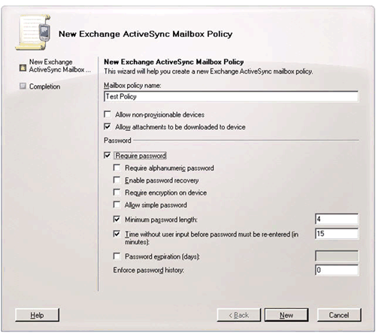

The following mobile policy options can be implemented using the Exchange Management Console:

Security Option | Description
Require alphanumeric password | Use this option if you want to require users to choose a password that contains both numbers and letters. This option is not selected by default.
Enable password recovery | Administrator may obtain a recovery password by using the Exchange Management Console.
Require encryption on device | Requires encryption on the device for SD cards.
Allow simple password | Enables or disables the ability to use a simple password such as 1234.
Minimum password length | Specifies the minimum password length.
Time without user input before password must be re-entered | Specifies whether users must log on to their phones after a specified number of minutes of inactivity. This option is not selected by default. If selected, the default setting is 5 minutes.
Password expiration | Enables the administrator to configure a length of time after which a device password must be changed.
Attachments enabled | Enables attachments to be downloaded to the phone.
Allow non-provisional devices | Allows older devices to connect to Microsoft Exchange Server 2010 through Exchange ActiveSync.

For a more detailed overview of Microsoft Exchange Server 2010 mailbox policies, see Understanding Exchange ActiveSync Mailbox Policies on the Microsoft TechNet Web site.

Distributed Server Roles
Two options are available for a Microsoft Exchange Server 2010 deployment, typical and custom.
In a typical installation, multiple service components (server roles) are added to a single server platform. A server role is a unit that logically groups the required features and components needed to perform a specific function in the messaging environment. The requirement of a server role is that it is a server that could be run as an atomic unit of scalability.
Server roles, the primary unit of deployment, enable administrators to easily choose which features are installed on an Exchange server. Logically grouping features in server roles offers the following advantages:
- Reduces the attack surface on an Exchange server.
- An administrator has the ability to add additional backend servers without disrupting Client Access Server operation or exposing these servers outside of the corporate LAN.
- Offers simple installation, and the ability to fully customize a server to support your business goals and needs.
- Potentially increases server performance by dispersing the overall workload (CPU and memory utilization) to additional server platforms.

The Microsoft Exchange Server 2010 server roles in a mobile messaging deployment are:
- Client Access Server: This server hosts the client protocols, such as Post Office Protocol 3 (POP3), Internet Message Access Protocol 4 (IMAP4), Secure Hypertext Transfer Protocol (HTTPS), Outlook Anywhere, Availability service, and the Autodiscover service. The Client Access Server also hosts Web services and is required for all Active Directory sites that contain mailbox servers.
- Mailbox Server: This server hosts mailboxes and public folders.

Note:
Additional server roles that are not mentioned or only briefly mentioned in this document include Edge Transport, Hub Transport, and Unified Messaging. The Client Access Server role is responsible for Exchange ActiveSync communication with a Windows® phone, and is the essential component of a mobile messaging deployment. See Network Architecture Scenarios in this document.

For more information on Microsoft Exchange 2010 server roles, see “Server Role Documentation Roadmap” under Microsoft Exchange Server 2010 on the Microsoft TechNet Web site.

Exchange Management Console - Overview
In Microsoft Exchange Server 2010, the Exchange Management Console allows you to manage all servers, recipients, and organizational components in your IT infrastructure.

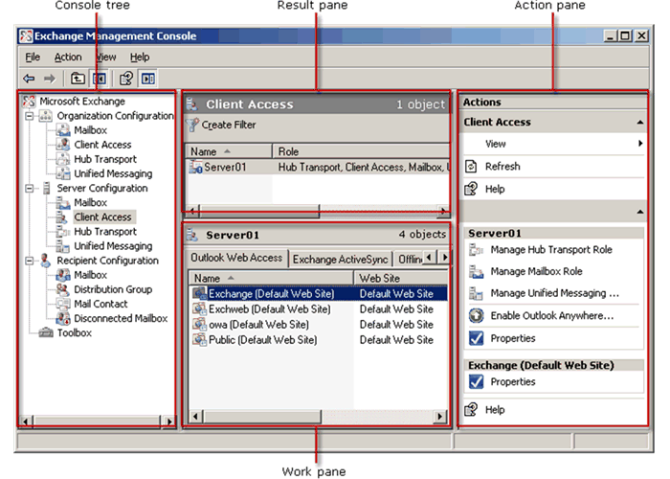

The Action pane lists the actions available to administrators, based on the items selected in the console tree or result pane. From a mobile messaging perspective, the Action pane is where a new mailbox policy may be created or a data wipe initiated for a phone.

Best Practices for Mobile Messaging Deployment
This section details the best practices for deploying Microsoft mobile messaging in a manner that will help meet your organization's security requirements.

Network Configuration
Regardless of the network configuration you implement, there are some network configuration best practices that will help strengthen your mobile messaging solution.

Distributed Server Roles in Microsoft Exchange Server 2010
Microsoft Exchange Server 2010 enables you to create Exchange Server roles that let you select which Exchange components are installed on each server. For Exchange ActiveSync, the Exchange component used to communicate with the phone, the Exchange Server role is the Client Access Server role. As a best practice, the Client Access Server role should be domain joined and in the same Active Directory site as the Exchange Mailbox role. Another best practice is to route Internet traffic through a reverse proxy or firewall, such as ISA 2006. ISA 2006 has built-in security functionality, such as SSL bridging, user authentication, and packet inspection.

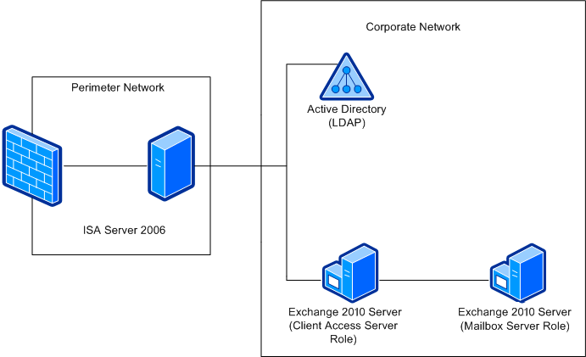

In this network diagram, the Client Access Server is responsible for Exchange Server 2010 Exchange ActiveSync communication. ISA Server 2006 SP1 sits in the perimeter network and filters inbound requests to the Client Access Server. One advantage of using a distributed architecture is offloading CPU and memory utilization from a single server. Depending on the size of your organization, this topology may help to increase overall mobile messaging system performance. In smaller implementations, you can deploy both the Client Access Server and the Mailbox Server roles on the same machine.
For more information on server roles and planning an Exchange Server 2010 distributed deployment, see Planning and Deployment” under Microsoft Exchange Server 2010 on the Microsoft TechNet Web site.

Best Practice: Configuring your Firewall for Optimal Direct Push Performance
To optimize mobile client bandwidth, it is important to understand the consequences of HTTP timeout settings on your firewalls and other devices that are in line with your Exchange Client Access Server.
When a phone that is Direct Push enabled establishes a long-lived HTTPS connection with Exchange ActiveSync, there are only two ways that the connection is returned back to the client via a response. The first is when a change is made to the user’s mailbox and Exchange ActiveSync returns a response to the phone alerting it to synchronize with the Exchange server. The second case is when the Direct Push connection heartbeat interval expires and Exchange ActiveSync directs the phone to send up a new Direct Push request. If your firewall’s HTTP timeout is shorter than the Direct Push heartbeat interval, the phone will need to send up a new request. Over time, this can cause extra bandwidth utilization, so Microsoft recommends setting your firewall timeout to 30 minutes. The longer the timeout, the fewer timeouts will be experienced, thus improving bandwidth consumption.
The following illustration shows the recommended firewall settings.
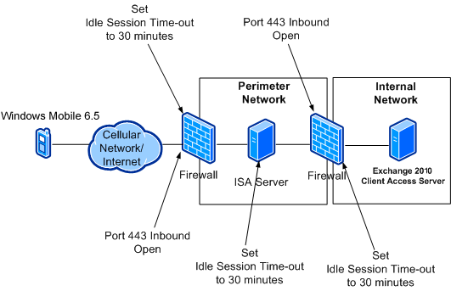
For a technical discussion of Direct Push Technology, see Understanding Direct Push in this document.

Security Features: Authentication and Certification
Microsoft strongly recommends that you use SSL to encrypt the channel between the phone and Exchange ActiveSync. This deployment step is relevant regardless of the size of your organization. Some SSL vendors who sell less expensive SSL certificates already have their trusted root certificate on Windows® phones, so you may not need to “touch” each phone.
Another best practice is to pass all Internet traffic for Exchange ActiveSync through a reverse proxy and firewall, such as ISA 2006.

Best Practice: Use SSL for Encryption and Server Authentication
To help protect outgoing and incoming data, deploy SSL to encrypt all traffic. You can configure SSL security features on an Exchange server to help prevent internet attacks such as the "man in the middle" and certain server spoofing attacks. The Exchange server, just like any Web server, requires a valid server certificate to establish SSL communications.
Phones with Windows Mobile 6.5 are shipped with trusted root certificates. Check with your device manufacturer for a list of the certificate authorities that shipped with your devices. If you obtain a root certificate from one of the trusted services, your client phones should be ready to establish SSL communications with no further configuration. If you create your own certificates, you must add those certificates to the root store of each phone.
Note:
Some server certificates are issued with intermediate authorities in the certification chain. If IIS is not configured to send all certificates in the chain to the phone during the SSL handshake, the phone will not trust the certificate because the phone does not support dynamically retrieving the other certificates.
For more information about Windows Mobile 6.5 and certificates, see: Step 6: Certificate Enrollment and Device Provisioning in this document.

Best Practice: Determine and Deploy a Device Password Policy
Microsoft Exchange Server 2010 includes existing security enforcements, such as password expiration and password history, which can be applied on Windows® phones. An IT professional can administer these settings using the Exchange Management Console. For more information on setting security policies, see Step 5: Configure and Manage Mobile Device Access on the Exchange Server in this document.

Best Practice: Use Web Publishing with Basic Authentication
Many companies require basic authentication over an encrypted channel (SSL). These companies can further secure their mobile deployment by leveraging ISA 2006 to Web-publish the Exchange Server 2010 server. The benefit of leveraging ISA server's Web-publishing capabilities is that ISA server has built-in logic to distinguish well-formed requests, such as Exchange ActiveSync requests, which can help protect the Exchange Client Access server from malicious attacks.
As a best practice, Web publishing is easier to implement and provides a higher level of security than server publishing.

Network Architecture Scenarios
This section provides network topology information for your Microsoft Exchange Server 2010 and Windows Mobile 6.5 deployment. The following scenarios are illustrated:
- ISA Server 2006 SP1 as an advanced firewall (behind a third-party firewall)
- Use of a third-party firewall
- Co-existence of Exchange Server 2007 and Exchange Server 2010

Deployment Options
The following scenarios represent a few of the many ways to implement a mobile messaging solution using Exchange Server 2010, ISA Server 2006 SP1, third-party firewalls, and devices with Windows Mobile 6.5. The scenarios are not presented in a preferred order.
Important:
These options illustrate possible deployment strategies for your network. The final topology should take into account the specifics of your network, including available hardware and software, security considerations, projected usage, and the ability to provide optimal performance. Microsoft recommends that you thoroughly research all security considerations for your network prior to implementation. For ISA server reference material, see Step 4: Install and Configure ISA Server 2006 SP1 or Other Firewall in this document. For third-party firewalls, consult the manufacturer's documentation for related security issues.

Option 1: ISA Server 2006 SP1 as an Advanced Firewall in a Perimeter Network
The first option is implementing ISA Server 2006 SP1 as your security gateway. ISA Server 2006 SP1 and Exchange Server 2010 enhance security features by providing protocol inspection in addition to SSL bridging and user authentication.
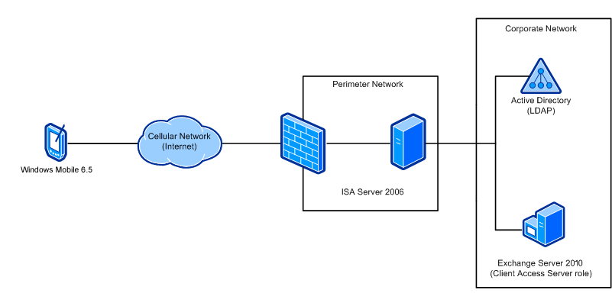

Note:
The ISA server acts as the advanced firewall in the perimeter network that is exposed to Internet traffic. It directly communicates with LDAP servers and the internal Exchange server(s). For increased security, the ISA server intercepts all SSL client requests and proxies them to the back-end Exchange server(s).

In this configuration, Exchange servers are within the corporate network and the ISA server acts as the advanced firewall in the perimeter network. This adds an additional layer of security to your network.
All incoming Internet traffic over port 443 is intercepted by the ISA 2006 Server. The ISA server terminates the SSL connection, authenticates the user, and inspects the request. If it is well formed, it will send the request on to the Exchange Client Access server for processing.
For more information, see Microsoft Internet Security and Acceleration (ISA) Server 2006 on the Microsoft TechNet Web site.
The following table lists considerations for deploying ISA Server 2006 SP1 as an advanced firewall in a perimeter network, domain joined, and other potential ISA topologies.

Setup Type | Description | Consideration
Firewall in Workgroup in perimeter network | - All Exchange servers are within the corporate network  - FBA or basic authentication  - SSL configured for Exchange ActiveSync to encrypt all messaging traffic  - ISA server acts as the advanced firewall in the perimeter network that is exposed to Internet traffic  - ISA Server 2006 SP1 directly communicates with LDAP and RADIUS servers  - LDAP authentication  - LDAP, LDAPS, LDAP-GC, and LDAPS-GC are supported  - Because each domain controller can only authenticate the users in its domain, the ISA server by default queries the global catalog for a forest to validate user credentials  - RADIUS authentication  - RADIUS provides credentials validation  - The ISA server is the RADIUS client, depending upon RADIUS authentication response  - Password changes are not possible | - All Exchange traffic is pre-authenticated, reducing surface area and risk  - Client authentication to Exchange is possible with Windows, Kerberos, LDAP, LDAPS, RADIUS, or RSA SecurID  - Client authentication to ISA is limited to FBA, basic, LDAP, and RADIUS  - Requires port 443 open on the firewall for inbound and outbound Internet traffic  - Requires a digital certificate to connect to Configuration Storage server  - Limited to one Configuration Storage server (ADAM limitation)  - Domain administrators do not have access to the firewall array  - Workgroup clients cannot use Windows authentication  - Requires management of mirrored accounts for monitoring arrays.  For further information on ISA authentication, see: http://go.microsoft.com/fwlink/?LinkID=87068.
ISA Server 2006 SP1 domain-joined in perimeter network | - Exchange Client Access Server (CAS in the enterprise forest)  - As a domain member, ISA Server 2006 SP1 works with Active Directory | - Additional ports on the internal firewall are opened to facilitate domain member communication to Active Directory  - IPSec can be configured between the ISA server and Exchange server to eliminate the need for additional open ports  - Some organizations may not wish to deploy domain resources outside the trusted Local Area Network, which may pose a security risk for some network topologies
ISA Server 2006 SP1 domain-joined in enterprise forest | - Exchange FE in enterprise forest  - As an enterprise domain member, ISA acts as a trusted domain member, following domain policies as well. Also provides for more resilient CSS deployment. | - No special firewall ports or IPSec tunnels are required; KCD works more smoothly

Option 2: Third-Party Firewall
The second option is to deploy your mobile messaging solution with a third-party firewall. The following conditions should be met to help create an efficient and more secure architecture:
- Use SSL to encrypt all traffic between the mobile device and Exchange Server 2010
- Open port 443 inbound on each firewall between the Windows® phone and Exchange Server
- Set Idle Session Timeout to 30 minutes on all firewalls and network appliances on the path between the phone and Exchange server to optimize bandwidth for Direct Push Technology
Note:
Consult firewall manufacturer documentation for instructions on opening port 443 inbound and setting the Idle Session Timeout. For more information and guidelines on Direct Push Technology, see Understanding Direct Push in this document.

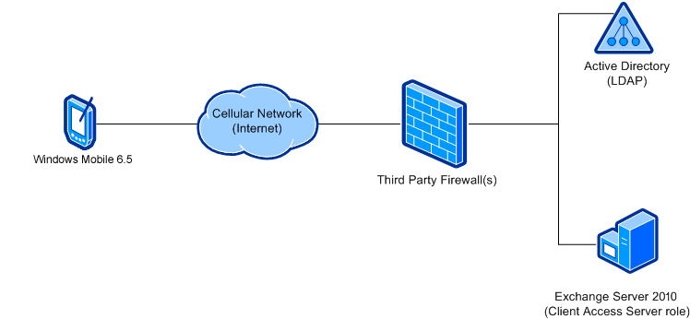

Setup Type | Description | Consideration
Third-party firewall | Open port 443 inbound on third-party firewall(s). Configure Direct Push access for phones. | Does not require additional hardware or software for mobile messaging deployment.

Option 3: Exchange Server 2010 and Exchange Server 2007 Co-existence
For organizations that do not wish to migrate their enterprise architecture to Exchange Server 2010, a third alternative is available. To use the new Exchange Server 2010 features, you will need to use Exchange Server 2010 in both the Client Access server and Mailbox Server roles.
Note:
Although this illustrates a possible topology for your IT infrastructure, Microsoft strongly recommends that all servers within a site run the same version of Microsoft Exchange.
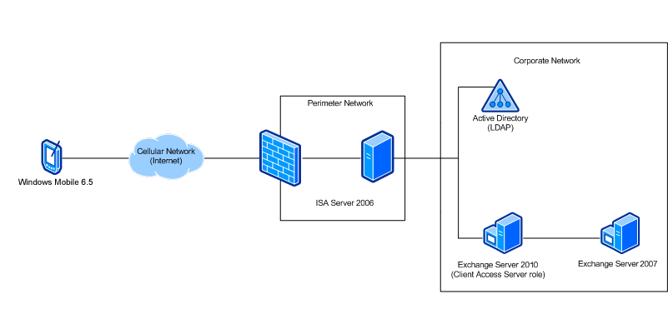
The version of Exchange ActiveSync that clients use also depends on the server version that is hosting the user's mailbox. When a client connects to the Exchange Server 2010 Client Access server, the system checks to see where the user is located. If they are on a 2007 Mailbox server, the system uses the Exchange Server 2007 version of the Exchange ActiveSync protocol; if their mailbox is on an Exchange Server 2010 Mailbox, then the system passes on the connection to the Mailbox server where they use the new version of Exchange ActiveSync with the phone. So a user whose mailbox is located on an earlier server version will be unable to use features such as SharePoint/UNC access and Exchange Search.
Note:
The Client Access Server role should never be installed in the perimeter network unless you are deploying Exchange in a Windows Small Business Server deployment. In that configuration, Microsoft recommends that you use a firewall to funnel all Internet traffic that is bound for your Client Access Server. It is also a best practice to run Exchange Best Practice Analyzer before proceeding with your deployment.
Important:
The following features require the use of an Exchange Server 2010 Client Access server and Exchange Server 2010 Mailbox server, and are not available with this co-existence topology:
- Set Out of Office (OOF) remotely
- SharePoint and UNC access
- Flagging e-mail
- Search mailbox for mail
- Attendee viewing enhancements
- New security policy features for SD card encryption
- Group-based policies
- Any other features that rely on the new version of Exchange ActiveSync or the user's mailbox
When you transition from Microsoft Exchange Server 2007 to Microsoft Exchange Server 2010, you will typically transition all the Exchange servers in a particular routing group or Active Directory site to Exchange 2010 at the same time, configure co-existence, and then transition the next site.
Important:
Before you configure Client Access servers and decommission your Exchange 2007 servers, determine whether you want to retain any Outlook Web Access settings or custom configurations, security updates, themes, and customization configurations from your Exchange Server 2007 servers. Installation of Exchange Server 2010 requires 64-bit hardware, and no settings or custom configurations from Exchange Server 2007 are retained. Before you decommission your front-end servers and install Client Access servers, make sure that the Outlook Web Access settings and custom configurations in Exchange Server 2010 Client Access servers match the configurations on your Exchange Server 2010 Mailbox server.
Microsoft recommends that you deploy the server roles as follows:
- For e-mail messages to flow correctly, you must install both the Mailbox server role and the Hub Transport server role in the same Active Directory site.
- You can also install the Mailbox server role, the Hub Transport server role, the Client Access server role, and the Unified Messaging server role on the same computer or on separate computers.
- If you choose to install the Edge Transport server role, note that it cannot coexist on the same computer with any other server role. You must deploy the Edge Transport server role in the perimeter network and outside the Active Directory forest.

Note
Further information on installing Exchange Server 2010 in your organization is discussed in Step 1: Install Exchange Server 2010 ith Client Access Server Role in this document.

Setup Type | Description | Consideration
Exchange Server 2010 Client Access Server and Exchange Server 2007 network in corporate network. | Ability to utilize Exchange Server 2010 management capabilities. | Microsoft recommends that all servers running within a site use the same Exchange version.

Authentication in ISA Server 2006 SP1
Users can be authenticated using built-in Windows, LDAP, RADIUS, or RSA SecurID authentication. Front-end and back-end configuration has been separated, providing for more flexibility and granularity. Single sign on is supported for authentication to Web sites. Rules can be applied to users or user groups in any namespace.
For most enterprise installations, Microsoft recommends ISA Server 2006 SP1 with LDAP authentication. In addition, ISA Server 2006 SP1 enables certificate-based authentication with Web publishing. For more information, see Authentication in ISA Server 2006 SP1 on the Microsoft TechNet Web site.
The following table summarizes some of the features of ISA Server 2006 SP1:

Feature | Description
Support for LDAP authentication | LDAP authentication allows ISA server to authenticate to Active Directory without being a member of the domain.  For more information, see http://go.microsoft.com/fwlink/?LinkID=87069.
Authentication delegation | Published Web sites are protected from unauthenticated access by requiring the ISA Server 2006 SP1 firewall to authenticate the user before the connection is forwarded to the published Web site. This prevents exploits by unauthenticated users from reaching the published Web server. This functionality is detailed in Authentication in ISA Server 2006 SP1 on the Microsoft TechNet Web site.
SecurID authentication for Web proxy clients | ISA Server 2006 SP1 can authenticate remote connections using SecurID two-factor authentication. This provides a high level of authentication security because a user must know something and have something to gain access to the published Web server.
RADIUS support for Web proxy client authentication | With ISA Server 2006 SP1, you can authenticate users in Active Directory and other authentication databases by using RADIUS to query Active Directory. Web publishing rules can also use RADIUS to authenticate remote access connections.
Forms-based authentication with password and passphrase | With ISA Server 2006 SP1, you have the ability to perform two-factor authentication using username/password combined with passphrase (SecureID/RADIUS OTP).
Session management | ISA Server 2006 SP1 includes improved control of cookie-based sessions to provide for better security and SSO for web-based clients such as OWA.
Certificate management | ISA Server 2006 SP1 simplifies certificate management. It is possible to utilize multiple certificates per Web listener and to use different certificates per array member.

Understanding Direct Push Technology
Direct Push Technology uses Exchange ActiveSync to keep data on a Windows® phone synchronized with data on a Microsoft Exchange server. There is no longer a reliance on SMS for notification.

Direct Push Technology
Direct Push Technology has two parts: one resides on the phone (client), and the other resides on an Exchange Server 2010 mail server. The following list describes these parts of the technology:
- Windows® phones and other devices that don’t necessarily using Windows Mobile technology use Direct Push. Exchange ActiveSync technology on the phone manages Direct Push communication with the Exchange server. It establishes an HTTP or HTTPS connection with the server for a specified time, and then goes to sleep while waiting for the server to respond. The server responds with either a status indicating that new items were received or that no new items arrived. The phone then sends either a synchronization request or another Direct Push request. The rate at which this occurs is dynamically adjusted based on parameters set by the OEM or mobile operator and how long an idle HTTP or HTTPS connection can be maintained on the operator's network and the customer's enterprise network.
- Exchange Server 2010 (Client Access Server role installed). This version of Exchange server includes a Direct Push component that augments the Exchange ActiveSync infrastructure by supporting manual and scheduled synchronization. Exchange Server uses IP-based notifications to deliver e-mail, contact, calendar, and task updates to a phone as soon as the information arrives at the server.
When data changes on the server, the changes are transmitted to the phone over a persistent HTTP or HTTPS connection that is used for Direct Push. The time-out value in the mobile operator's network specifies how long the persistent connection will be maintained with no activity.
To keep this connection from timing out between updates, the phone reissues a request when the server responds. This periodic transmission is referred as the heartbeat. The heartbeat is what maintains the connection to the server for Direct Push; each heartbeat alerts the server that the phone is ready to receive data.

The Direct Push Process
Direct Push traffic looks like small HTTP requests to an Internet Web site that takes a long time to issue a response. Microsoft recommends that the content of the packets be encrypted using Secure Sockets Layer (SSL) to make it difficult to identify Direct Push traffic by sniffing.
The following steps describe the Direct Push process:
1. The client issues an HTTP message known as a ping request to an Exchange server, asking that the server report whether any changes that occurred in the user’s mailbox within a specified time limit. In the ping request, the client specifies the folders that Exchange should monitor for changes. Typically these are the inbox, calendar, contacts, and tasks.
2. When Exchange receives this request, it monitors the specified folders until one of the following occurs:
- The time limit expires. The time limit is determined by the shortest time out in the network path. If this occurs, Exchange issues an HTTP 200 OK response to the client.
- A change occurs in one of the folders, such as the arrival of mail. If this occurs, Exchange issues a response to the request and identifies the folder in which the change occurred.
3. The client reacts to the response from the Exchange server in one of the following ways:
- If it receives an HTTP 200 OK response indicating that no change occurred, it re-issues the ping request.
- If it receives a response other than HTTP 200 OK, it issues a synchronization request against each folder that has changed. When the synchronization is complete, it re-issues the ping request.
- If it does not receive a response from the Exchange server within the time specified, it lowers the time interval in the ping request and then re-issues the request.

Direct Push Adjustment
During the Direct Push process, the phone waits for successive round trips before attempting to adjust the amount of time it needs to keep a connection open with the server. The amount of time that the server should wait for Personal Information Manager (PIM) changes or new mail to arrive before sending OK to the client is called the heartbeat interval.
The heartbeat interval is specified by the client and is sent as part of the ping request. The heartbeat begins at the default rate. The Direct Push algorithm on the client then dynamically adjusts the heartbeat interval to maintain the maximum time between heartbeats without exceeding the time-out value. The adjustment is based on network conditions and on how long an idle HTTP or HTTPS connection can be maintained on the mobile operator's or corporation's network, as well as some settings that the mobile operator can specify.
To determine the optimal heartbeat interval, the algorithm keeps a log of ping requests. If a ping request receives a response, the algorithm increases the interval. If no response is received at the end of the interval, the client determines that the network timed out and decreases the interval.
Using this algorithm, the client eventually determines the longest idle connection possible across the wireless network and corporate firewall.
The following illustration shows how the heartbeat interval is adjusted during typical Direct Push communication between the client and the Exchange server.

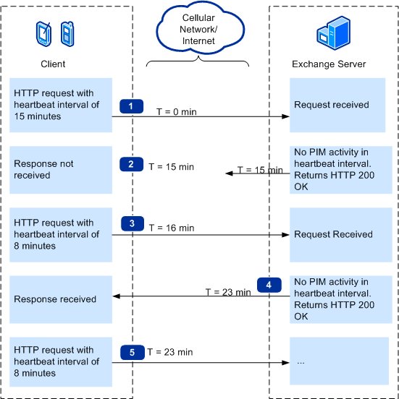

*The "T" in this illustration indicates the progression of time.

The following steps describe the communication. Numbers correspond to the numbers in the illustration above:
1. The client wakes up and issues an HTTP request over the Internet to the Exchange server, and then goes to sleep.
To keep the session active, the request states the heartbeat interval, which is the amount of time that the server should wait for PIM changes or new mail to arrive before sending OK to the client. In this illustration, the heartbeat interval is 15 minutes.
2. Because no mail arrived during the heartbeat interval, the server returns an HTTP 200 OK.
In this example, the response is lost because either the operator network or the enterprise network was unable to sustain the long-lived HTTP connection; the client never receives it.
3. The client wakes up at the end of the heartbeat interval plus 1 minute (15 + 1 = 16 minutes total).
Note
The phone waits for successive round trips before attempting to adjust the heartbeat interval. A tuning component in the algorithm can change the increments to an amount different than what is specified.
If this was a successive round trip with no response from the server, the client issues a shorter-lived request (8 minutes).
In this example, because the heartbeat was not increased during the last ping, the heartbeat is changed to the minimum heartbeat value (8 minutes).
4. Because no mail arrived during the heartbeat interval, the server returns an HTTP 200 OK.
5. The server response wakes up the client. Because the connection did not time out during the interval, the client determines that the network can support idle connections for at least this length of time.
If this was a successive round trip, the client determines that it can increase the interval for the next request.

The Impact of Direct Push on Networks and Exchange Servers
The algorithm that sets the heartbeat also minimizes bytes sent over the air and helps maximize battery life.
Implementing data compression will reduce the packet sizes sent between the Exchange server (Client Access Server role) and the client. However, the amount of bandwidth consumed and whether it will impact the user’s data plan greatly depend on the following factors:
- What the user chooses to synchronize, such as more than the default folders
- How much data is changed in the mailbox and on the Windows® phone

The Impact of Changing the Direct Push Settings
To help you maintain adequate device performance during Direct Push, Microsoft recommends values for the various Direct Push settings.

Heartbeat Interval
The heartbeat interval is set on the phone by the mobile operator. Using a heartbeat interval of 30 minutes helps conserve battery life and reduces bandwidth consumption. When Direct Push sessions are permitted to live longer (such as 30 minutes), there are fewer HTTP round trips, less data sent and received, and less power consumed by the phone.
A heartbeat interval that is too short will keep the user more up to date, but will shorten battery life because of the constant pinging to the server.

Minimum Heartbeat
If a phone that has a heartbeat below the minimum heartbeat level requests a connection to the Exchange server, the server logs an event to alert the administrator that Direct Push is not working.

Exchange Session
To keep phone information up to date while helping to maximize battery life, the Exchange server session duration should be a little greater than the maximum heartbeat setting. If the server session is shorter, it may reach idle timeout, causing it to drop the session. This would result in mail being undelivered until the client reconnects, and the user could be unsynchronized for long periods of time.

Firewall Timeouts
The network idle connection timeout indicates how long a connection is permitted to live without traffic after a TCP connection is fully established.
The firewall session interval must be set to allow the heartbeat interval and enterprise session interval to communicate effectively. If the firewall closes the session, mail would be undelivered until the client reconnects, and the user could be unsynchronized for long periods of time. By setting the firewall session timeout equal to or greater than the idle timeout on the mobile operator's network, the firewall will not close the session.
Set the firewall's idle connection timeouts:
- Microsoft recommends that mobile operators set the idle connection timeouts on outgoing firewalls to 30 minutes
- Organizations need to set timeouts on their incoming firewalls to 30 minutes
Web servers, network security appliances, and system network stacks have several time-based thresholds that are intended to insulate them from insufficiently tested or malicious clients. You can safely increase the idle connection timeout setting without compromising the security of the network.
In a Direct Push scenario, the connection is idle between the time that the HTTP request is made and either 1) the time that the heartbeat interval expires, or 2) the server responds to the request with a change (such as when mail is received). Direct Push makes no assumption as to the length of its sessions; e-mail is delivered rapidly whether the heartbeat interval is one minute or 30 minutes.
Increasing the idle connection timeout typically does not increase or decrease exposure to attack. The following table shows examples of attacks and describes how other settings are used to mitigate exposure to them.

Denial of service (DoS) threat | Mitigation of exposure to attacks
A DoS attack is launched by failing to complete the handshake that is implicit in the creation of a TCP connection. The attacker attempts to create a large number of partially open TCP connections. | Increasing the idle connection timeouts is unrelated to this type of attack.  The time within which a TCP handshake must be completed is a separate threshold that is governed by the Windows TCP/IP stack.
A DoS attack is launched against IIS by opening a large number of TCP connections but never issuing an HTTP request over any of them. | Increasing the idle connection timeouts is unrelated to this type of attack.  IIS mitigates this threat by requiring that a client submit a fully-formed HTTP request within a certain time before dropping the connection. The name of the connection timeout setting in the IIS management console is misleading; TCP connections are closed when the connection timeout value is exceeded (120 seconds by default).
An attacker establishes a large number of TCP connections, issues HTTP requests over all of them, but never consumes the responses. | Increasing idle connection timeouts is unrelated to this type of attack.  This threat is mitigated by the same timeout as the previous scenario. The connection timeout setting in IIS defines the time within which a client must issue either its first request after a TCP connection is established or a subsequent request in an HTTP keep-alive scenario.  Note:  Applies to Exchange Active Sync listener only.

Windows Mobile 6.5 and Microsoft Exchange Server 2010 Deployment Procedure
This set of documents describes the procedure necessary to deploy Windows® phones in an Exchange Server 2010 environment. Although Microsoft Internet Security and Acceleration Server 2006 is not a requirement for this mobile messaging infrastructure, Microsoft recommends its installation; Step 4 below provides installation procedures for this platform.
- Step 1: Install Exchange Server 2010 with Client Access Server Role
- Step 2: Update Servers with Security Patches
- Step 3: Protect Communications Between Exchange Server 2010 and Windows® phones
- Step 4: Install and Configure ISA Server 2006 SP1 or Other Firewall
- Step 5: Configure and Manage Mobile Device Access on the Exchange Server
- Step 6: Certificate Enrollment and Device Provisioning
- Step 7: Manage and Configure Windows® phone

Step 1: Install Microsoft Exchange Server 2010 with Client Access Server Role
Microsoft Exchange Server 2010 has five server roles that you can implement and configure on a server running Microsoft Windows Server 2008. The Client Access Server role is required for all active directory sites that contain a mailbox server—it provides access to the following applications and services:
- Microsoft Outlook Web Access
- Exchange ActiveSync
- Post Office Protocol version 3 (POP3)
- Internet Messaging Application Protocol version 4 (IMAP4)
- Outlook Anywhere
- Availability Service
- Autodiscover Service
- Exchange Control Panel
Note:
Exchange ActiveSync is enabled when the Client Access Server role is installed.

The Client Access Server role is added by default during a typical Exchange installation. It may also be installed on a separate server by selecting a custom option. The decision to deploy Exchange Server 2010 on a single server or in distributed-role architecture depends on the messaging needs and requirements of your organization.
Note:
The Client Access Server role should never be installed in the perimeter network unless you are deploying Exchange in a Microsoft Small Business Server deployment. In that configuration, Microsoft recommends that you use a firewall to funnel all Internet traffic that is bound for your Client Access Server. It is also a best practice to run Exchange Best Practice Analyzer before proceeding with your deployment.
You can download the Microsoft Exchange Best Practices Analyzer in the Microsoft Download Center.

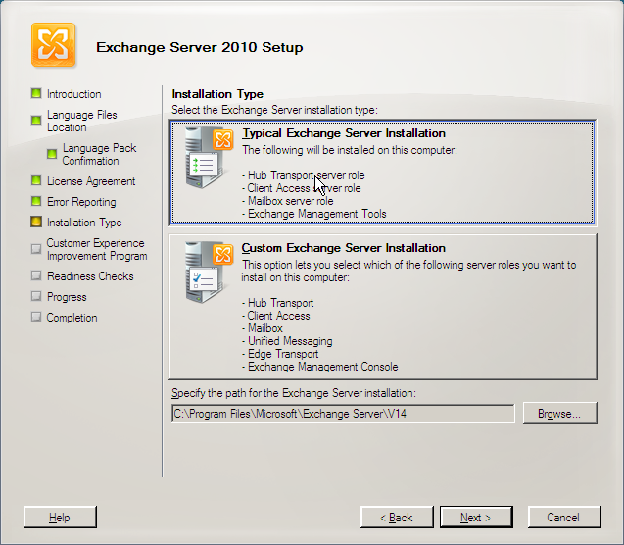

To deploy Microsoft Exchange Server 2010, see the following technical documentation:

Exchange Server 2010 Documentation
Getting Started
Planning and Deployment

Deployment

System Requirements

The topics presented in these articles include planning and architecture for simple, standard, large, and complex Exchange deployments. The topologies in Network Architecture Alternatives enable both a typical (single-server) and a custom (multiple-server) installation.
Note:
This document describes procedures and guidelines for deploying Windows Mobile 6.5 with Exchange Server 2010. Exchange Server 2010 roles other than the Client Access Server or Mailbox Server roles are not core components of a mobile messaging system, and are not documented here.
Note:
Make sure to visit the Exchange team blog!
Simply go to http://msexchangeteam.com and subscribe to get RSS updates. Approximately 3-5 articles are created every week in order to help you use Microsoft Exchange Server.

Step 2: Update Servers with Security Patches
Before proceeding, update your server environment -- all Exchange servers, global catalog servers, and domain controllers -- with the latest Microsoft security patches. Compliance will help ensure a more secure end-to-end mobile messaging network.
To update your servers with security patches, see the Microsoft Update Web site: http://go.microsoft.com/fwlink/?LinkID=87151

For more information about updating your software with the latest security patches, see the Security and Updates page on the Microsoft TechNet Web site.

For more information about Microsoft security, see the Microsoft Security Web site: http://go.microsoft.com/fwlink/?LinkId=62649

Step 3: Protect Communications between Phones with the Windows Mobile 6.5 operating system and Microsoft Exchange Server 2010
Follow these steps to help protect communications between your Exchange Client Access Server and Windows® phones:
- Deploy SSL to encrypt messaging traffic.
- Enable SSL on the default Web site.
- Configure basic authentication for the Exchange ActiveSync virtual directory.
- Protect IIS by limiting potential attack surfaces.
See Best Practices for Mobile Messaging Deployment in this guide for more information about authentication and certification.

Deploy SSL to Encrypt Messaging Traffic
To help protect incoming and outgoing e-mail, deploy SSL to encrypt message traffic. You can configure SSL security features on an Exchange server to verify the integrity of content, to verify the identity of users, and to encrypt network transmissions.
The following steps show how to configure SSL for Exchange ActiveSync
1. Obtain and install a server certificate
2. Validate the installation
3. Back up the server certificate
4. Enable SSL for the Exchange ActiveSync virtual directory

Note:
To perform the following procedures, you must be a member of the Administrators group on the local computer, or you must have been delegated the appropriate authority. As a security best practice, log on to your computer using an account that is not in the Administrators group, and then use the Run as command to run IIS Manager as an administrator. From the command prompt, type the following command:
run as /user:administrative_accountname "mmc%systemroot%\system32\inetsrv\iis.msc"

Obtain and Install a Server Certificate
Follow these directions to obtain a server certificate, install it, verify the installation, and back it up. When you use the Web Server Certificate Wizard to obtain and install a server certificate, the process is referred to as creating and assigning a server certificate.

To obtain a server certificate from a Certification Authority
- Log on to the Exchange server using an Administrator account.
- Click Start, Programs, Microsoft Exchange Server 2010, and then click Exchange Management Console.
- Expand the Microsoft Exchange On-Premises tree and then click Server Configuration.
- In the Actions pane, click New Exchange Certificate.
- In the New Exchange Certificate wizard, type an administrator-friendly name in the text box and click Next.
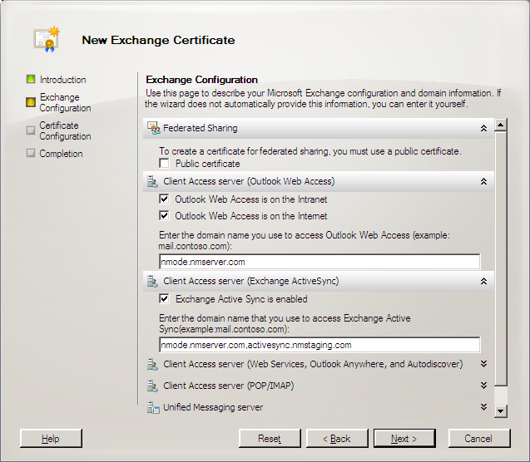

6. In the Client Access server (Outlook Web Access) list, select both the checkboxes and type the domain names that Outlook requires.
7. In the Client Access server (Exchange ActiveSync) list, select the checkbox and type the domain names that Outlook requires, and then click Next.
8. In the Organization and Location section, type the organization details.
9. Verify the details in the Configuration Summary and click New. You will see the following screen below.
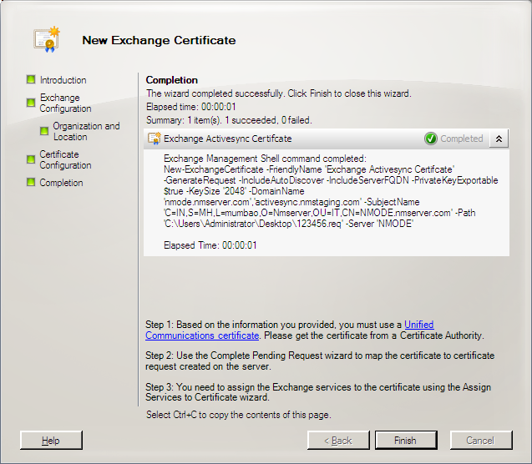

Next, you must request a server certificate from a valid Certification Authority. To do this, you must access the Internet or an intranet, depending on the Certification Authority that you choose, using a properly configured Web browser.
The steps detailed here are for accessing the Web site for your Certification Authority. For a production environment, you will probably request a server certificate from a trusted Certification Authority over the Internet.
To submit the certificate request
1. Start Microsoft Internet Explorer. Type the Uniform Resource Locator (URL) for the Microsoft Certification Authority Web site, http://<server_name>/certsrv/. When the Microsoft CA Web site page displays, click Request a Certificate, and then click Advanced Certificate Request.
2. On the Advanced Certificate Request page, click Submit a certificate request by using a base-64 encoded PKCS#10 file, or submit a renewal request by using a base-64 encoded PKCS #7 file.
3. On your local server, navigate to the location of the C:\NewKeyRq.txt file that you saved previously.
4. Double-click to open the C:\NewKeyRq.txt file in Notepad. Select and copy the entire contents of the file.
5. On the Certification Authority Web site, navigate to the Submit a Certificate Request page. If you are prompted to pick the type of certificate, select Web Server. The following illustration shows an example of a Submit a Certificate Request page.

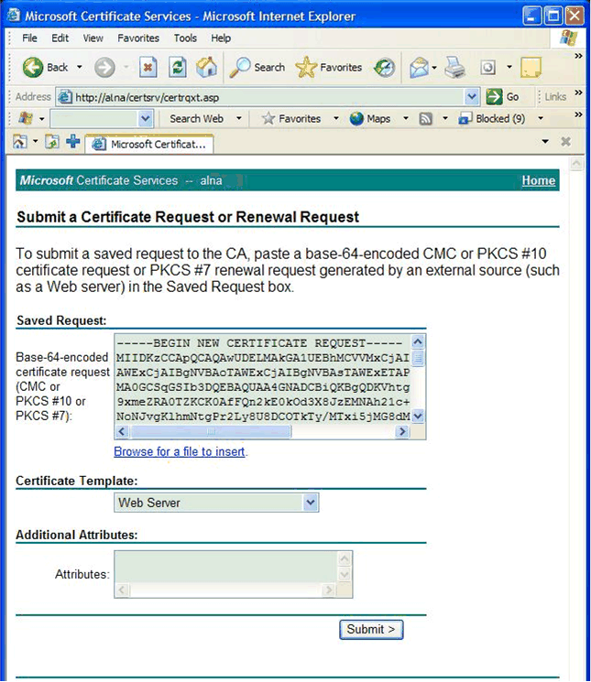

6. Click inside the Saved Request box, paste the contents of the file into the box, and then choose Submit. The content of the Saved Request dialog box should look similar to the following example:
-----BEGIN NEW CERTIFICATE REQUEST-----

MIIDXzCCAsgCAQAwgYMxLDAqBgNVBAMTI2toYWxpZHM0LnJlZG1vbmQuY29ycC5
taWNyb3NvZnQuY29tMREwDwYDVQQLEwhNb2JpbGl0eTEMMAoGA1UEChMDTVRQ
MRAwDgYDVQQHEwdSZWRtb25kMRMwEQYDVQQIEwpXYXNoaW5ndG9uMQswCQ
YDVQQGEwJVUzCBnzANBgkqhkiG9w0BAQEFAAOBjQAwgYkCgYEAs0sV2UZ1WAX2
ou+F5S34+6M3A32tJ5qp+c7zliu4SMkcgebhnt2IMMeF5ZMD2IqfhWu49nu1vLtGH
K5wWgHYTC3rTFabLZJ1bNtXKB/BWWOsmSDYg/A7+oCZB4rHJmpc0Yh4OjbQKkr6
4KM67r8jGEPYGMAzf2DnUg3xUt9pbBECAwEAAaCCAZkwGgYKKwYBBAGCNw0CAz
EMFgo1LjAuMjE5NS4yMHsGCisGAQQBgjcCAQ4xbTBrMA4GA1UdDwEB/wQEAwIE8
DBEBgkqhkiG9w0BCQ8ENzA1MA4GCCqGSIb3DQMCAgIAgDAOBggqhkiG9w0DBAI
CAIAwBwYFKw4DAgcwCgYIKoZIhvcNAwcwEwYDVR0lBAwwCgYIKwYBBQUHAwEw
gf0GCisGAQQBgjcNAgIxge4wgesCAQEeWgBNAGkAYwByAG8AcwBvAGYAdAAgAFI
AUwBBACAAUwBDAGgAYQBuAG4AZQBsACAAQwByAHkAcAB0AG8AZwByAGEAcA
BoAGkAYwAgAFAAcgBvAHYAaQBkAGUAcgOBiQCO5g/Nk+lsuAJZideg15faBLqe4jiiy
tYeVBApxLrtUlyWEQuWdPeEFv0GWvsjQGwn+WC5m9kVNmcLVsx41QtGDXtuETFO
D6dSi/M9wmEy8bsbcNHXs+sntX56AcCxBXh1ALaE4YaE6e/zwmE/0/Cmyje3a2olE
5rlk1FFIlKTDwAAAAAAAAAAMA0GCSqGSIb3DQEBBQUAA4GBAAr7zjg2ykZoFUYt1
+EgK106jRsLxJcoqj0oEg575eAlUgbN1e2i/L2RWju7cgo9W7uwwpBIaEqd6LJ6s1BR
pZz0yeJTDzGIXByG5O6kouk+0H+WHCj2yI30zik8aSyCQ3rQbNvHoURDmWqv9Rp
1BDC1SNQLEzDgZjKPrsGZAVLb

-----END NEW CERTIFICATE REQUEST-----

7. On the Certificate Issued page, click DER encoded, and then click Download certificate.
8. In the File Download dialog box, click Save this file to disk, and then click OK. Keep the default setting to save the file to the desktop, and click Save.
9. Close Internet Explorer.

At this point, a server certificate exists on your desktop that can be imported into the Exchange server certificate store. Next, you must install the certificate.
- To install the server certificate
1. In the Exchange Management Console, in the Actions pane, click Import Exchange Certificate.
2. In the Import Exchange Certificate wizard, browse and select the downloaded certificate, assign a password to the certificate, select the Assign the services to the certificate now checkbox, and click Import.
3. Select the services required, click Import, and then click Finish.

The certificate is now installed as shown in the figure below.

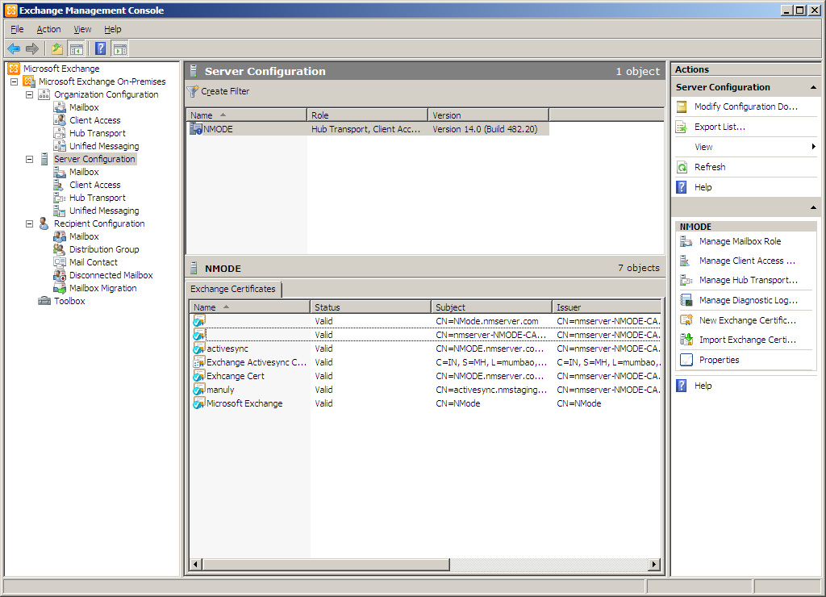

Validate the Installation
To verify the installation, view the server certificate.
To view the server certificate
1. In the Default Web Site Properties dialog box, click Directory Security. Under Secure Communications, select View Certificate. The following illustration shows the Certificate dialog box.
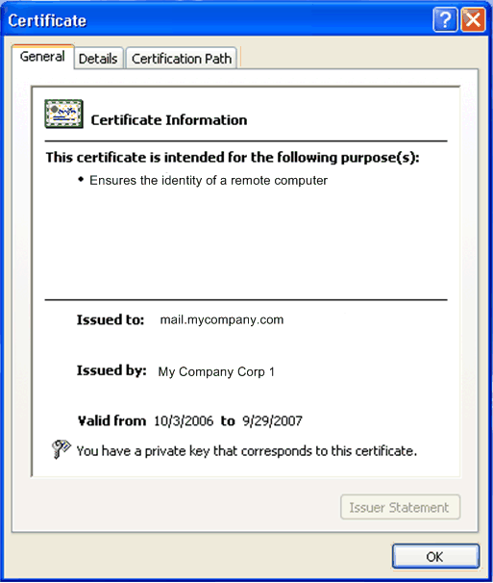

2. At the bottom of the Certificate dialog box, a message indicates that a private key is installed, if appropriate. Click OK to close the Certificate dialog box.
Note:
If the certificate does not show that the phone carries the private key that corresponds to the certificate, over-the-air synchronization will not work.

For authentication to function, you must add the Certification Authority to the trusted root Certification Authority list.
To add a Certification Authority to the trusted root Certification Authority list
1. Start Internet Explorer and type the URL for your Certificate Authority. For example, if you received your server certificate from the Certification Authority that you configured earlier, type http://<server_name>/certsrv.
2. Click Download a CA certificate, certificate chain, or CRL, and then on the following page click Download CA certificate. In the File download dialog box, click Save this file to disk, and then click OK.
3. Type a server certificate Name (for example, <certnewca.cer>) and then save the file to the desktop.
4. Navigate to the desktop. Right-click on the file that you created in step 3, and then click Install Certificate. In the Certificate Import Wizard dialog box, click Next.
5. Click Place all certificates in the following store and then click Browse. Select the Trusted Root Certification Authorities folder, and then click OK. The following illustration shows the Select Certificate Store dialog box.
Note:
You may use the Intermediate Certificate Authorities instead of the Trusted Root Certificate Authorities.
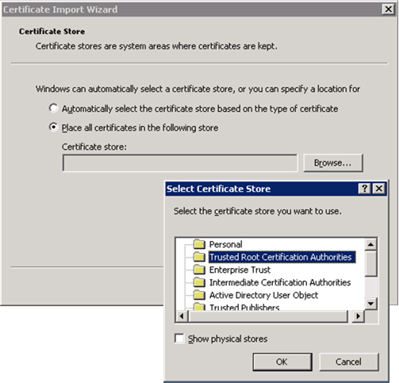

6. Click Next. A dialog box stating that the certificate is being added to the trusted certificate store appears; click Yes to close this dialog box. Click Finish, and the message import successful displays.

Back up the Server Certificate
You can use the Web Server Certificate Wizard to back up server certificates. Because IIS works closely with Windows, you can use Certificate Manager, which is called Certificates in the Microsoft Management Console (MMC), to export and to back up your server certificates.
If you do not have Certificate Manager installed in MMC, you must add Certificate Manager to MMC.
To add Certificate Manager to MMC
1. From the Start menu, click Run.
2. In the Open box, type mmc, and then click OK.
3. On the File menu, click Add/Remove Snap-in.
4. In the Add/Remove Snap-in dialog box, click Add.
5. The following illustration shows the Add/Remove Snap-in and Add Standalone Snap-in dialog boxes. In the Available Standalone Snap-ins list, click Certificates, and then click Add.
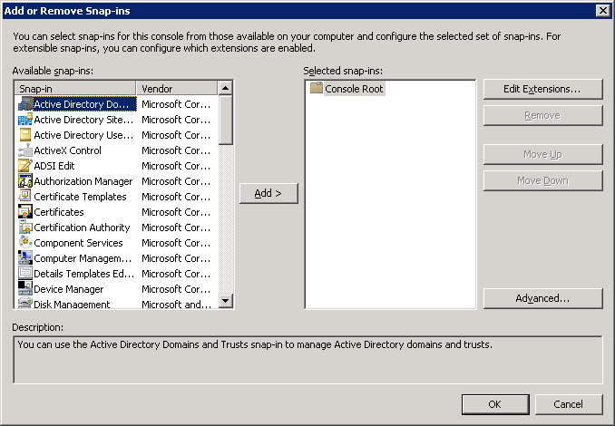

6. Click Computer Account, and then click Next.
7. Click the Local computer (the computer that this console runs on) option, and then click Finish.
8. Click OK.

With Certificate Manager installed, you can back up your server certificate.
To back up your server certificate
1. Locate the correct certificate store. This store is typically the Local Computer store in Certificate Manager.
Note:
When you have Certificate Manager installed, it points to the correct Local Computer certificate store.
2. In the Personal store, click the server certificate that you want to back up.
3. On the Action menu, click More Actions, point to All tasks, and then click Export.
4. In the Certificate Manager Export Wizard welcome screen, click Next, click Yes, export the private key.
5. Use the wizard default settings, click Next, and when prompted, type a password for the server certificate backup file.

Note:
Do not select Delete the private key if export is successful, because this option disables your current server certificate.
6. To complete the wizard to export a backup copy of your server certificate, click Finish.
After you configure your network to issue server certificates, you must update your Exchange Client Access server and its services by requiring SSL communication with the Exchange Client Access server. The following section describes how to enable SSL for your default Web site.

Enable SSL for the Default Web Site
After you obtain an SSL certificate to use with either your Exchange Client Access server on the default Web site or on the Web site where you host the \OWA, \Exchweb, \Microsoft-Server-Exchange ActiveSync, and \Public virtual directories, you can enable the default Web site to require SSL.
- Note:
SSL is enabled by default. Exchange installs with a self-signed certificate so that EAS will work with SSL; however, you need to replace the self-signed certificate with a valid third-party certificate from a CA because the Windows Mobile operating system will not accept a self-signed certificate.

The \OWA, \Exchweb, \Microsoft-Server-Exchange ActiveSync, and \Public virtual directories are installed by default during any Exchange Server 2010 installation. The \RPC virtual directory for RPC over HTTP communication is installed manually when you configure Exchange Server 2010 to support RPC over HTTP.
To require SSL on the default Web site
1. In the Internet Information Services (IIS) Manager, select the Default Web Site or the Web site where you are hosting your Exchange Server 2010 services, and then click the SSL Settings feature.

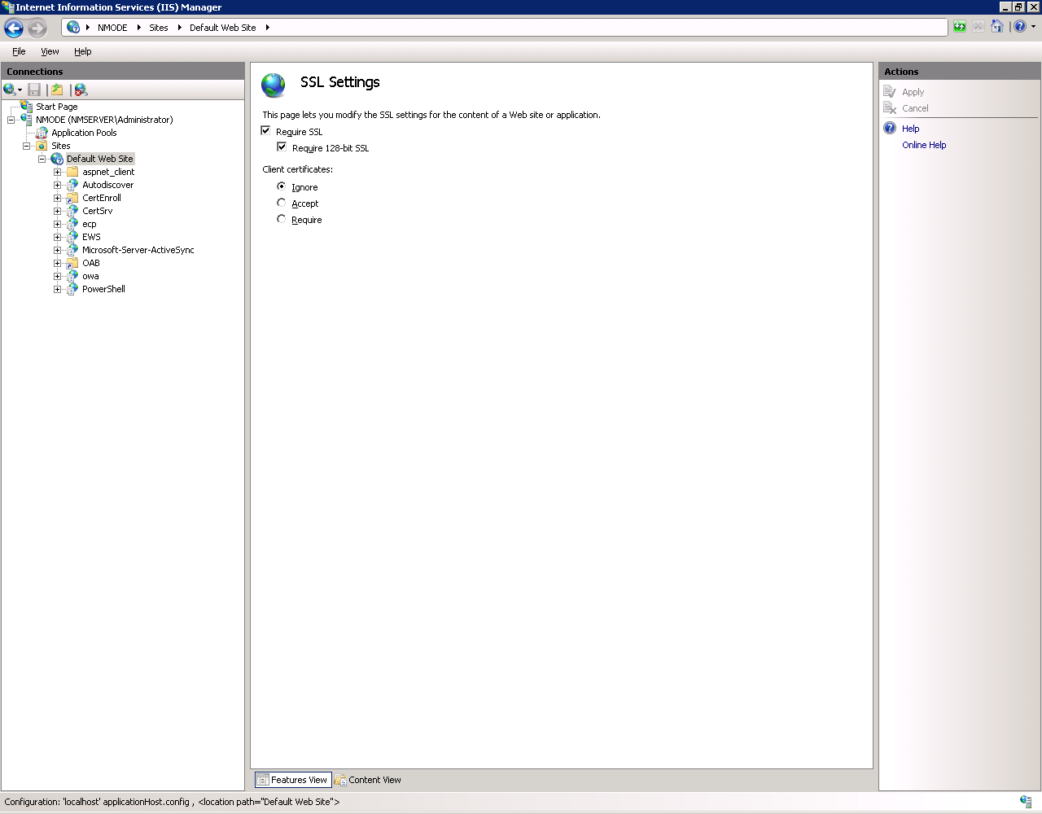

2. Modify the settings as per your requirements, right click, and then click Apply.

After you complete this procedure, the virtual directories on the Exchange Client Access server that is on the default Web site are configured to use SSL.

Configure Basic Authentication
The Exchange ActiveSync Web site supports SSL connections as soon as the server certificate is bound to the Web site. However, users still have the option of connecting to the Exchange ActiveSync Web site using a non-secure connection. You can require all client Windows® phones to successfully negotiate an SSL link before connecting to Exchange ActiveSync Web site directories.
Microsoft recommends that you enforce basic authentication on all HTTP directories that the ISA server makes accessible to external users. In this way, you can take advantage of the ISA server feature that enables the relay of basic authentication credentials from the firewall to the Exchange ActiveSync Web site.

- Note:
This is a default configuration and does not have to be user-modified.

Require SSL Connection to the Exchange ActiveSync Web Site Directories
This step helps prevent non-authenticated communications from reaching the Exchange ActiveSync Web site.
Unlike prior versions, all virtual directories are SSL-enabled by default in Microsoft Exchange Server 2010. Assuming you are setting up both OWA and EAS, you will need to configure the following additional directories to enable SSL, and make them accessible to remote users:
- /Public
- /OWA
To require an SSL connection to the Exchange ActiveSync Web site directories
1. Click Start, point to Administrative Tools and then click Internet Information Services (IIS) Manager. In Internet Information Services (IIS) Manager, expand your server name and then expand the Default Web Site node in the left pane of the console.
2. Click on the Microsoft-Server-Exchange ActiveSync directory so that it is highlighted, and then click the Authentication feature.
3. The following illustration shows the Authentication dialog box. Right-click an attribute to modify it.
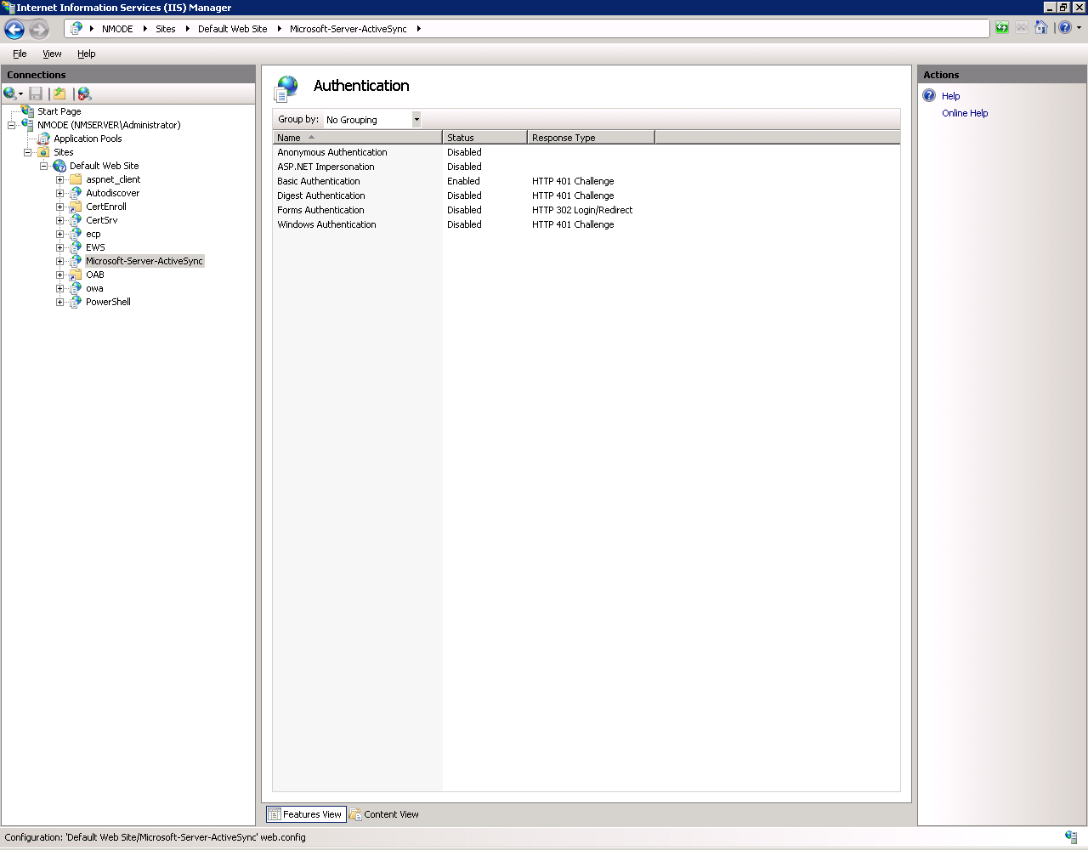

4. After you have required basic authentication on the directories you have chosen, close the Internet Information Services (IIS) Manager console.

Configure or Update RSA SecurID Agent (Optional)
If you have chosen to deploy RSA SecurID as an additional security layer, you should set up your Exchange server as an Agent Host within the RSA ACE/Server’s database.
Note:
There have been timing limitations between IIS 7.0 and the RSA/ACE Agent. Be sure to update your RSA/ACE Agent for better compatibility with IIS 7.0. For more information, see the RSA Security Web site.

Protect IIS by Limiting Potential Attack Surfaces
Before you expose servers to the Internet, Microsoft recommends that you help protect IIS by turning off all features and services except those that are required.
- In Windows Server 2008, IIS features are disabled by default to help improve security.

Windows Server 2003 SP2 and IIS 6.0
Microsoft Windows Server 2003 has many built-in features that help secure IIS 6.0 servers. To help protect against malicious users and attackers, the default configuration for members of the Windows Server 2003 family does not include IIS. When IIS is installed, it is configured in a highly secure, "locked down" mode that allows only static content. By using the Web Service Extensions feature, you can enable or disable IIS-specific functionality based on the exact needs of your organization.

Using UrlScan
UrlScan version 2.5 is a security tool that helps restrict the types of HTTP requests that Internet Information Services (IIS) will process. By blocking specific HTTP requests, the UrlScan security tool helps prevent potentially harmful requests from reaching the server. UrlScan 2.5 will now install as a stand-alone installation on servers running Microsoft IIS 4.0 and later.
UrlScan 2.5 is not included with IIS 6.0 because IIS 6.0 has built-in features that provide security functionality equal to or better than most of the features of UrlScan 2.5. However, UrlScan provides some additional functionality, such as verb control, beyond what IIS 6.0 provides. If you have incorporated the UrlScan security tool into your server management practices for IIS and for other Microsoft servers, you may want to utilize the additional functionality and features of UrlScan 2.5.

To download the UrlScan security tool, visit the UrlScan Security Tool Web site at http://go.microsoft.com/fwlink/?LinkID=89648.

For more information about the UrlScan and functionality beyond what is provided by IIS 6.0, see "Determining Whether to Use UrlScan 2.5 with IIS 6.0" on the UrlScan Security Tool Web site. Microsoft has now released UrlScan 3.0. This augments UrlScan 2.5 with additional functionality, including the ability to filter based on query strings, which can help mitigate SQL injection attacks.

Step 4: Install and Configure ISA Server 2006 SP1 or Other Firewall
Microsoft Internet Security and Acceleration (ISA) Server 2006 and Microsoft Exchange Server 2010 are designed to work closely together in your network to help provide a more secure mobile messaging environment.
ISA Server 2006 SP1 is the security gateway that helps protect your applications from Internet-based threats. ISA Server enables your business to do more, by helping to secure access to Microsoft applications and data.
The Microsoft preferred topology for a mobile messaging environment is the use of ISA Server 2006 SP1 with Exchange Server 2010. Before attempting to install ISA Server 2006 SP1, Microsoft strongly recommends that you review the following articles:

ISA Server 2006 SP1 Documentation
Publishing Exchange Server 2007 with ISA Server 2006
Best Practices for Performance in ISA Server 2006
ISA Server 2006 Enterprise Edition Installation Guide
ISA Server 2006 Standard Edition Installation Guide
Authentication in ISA Server 2006
Firewall Policy Best Practices for ISA Server 2006

Note:
If a third-party firewall is utilized, the only additional required step is to set the idle session timeout for all firewalls and network appliances to 1800 seconds (30 minutes). Refer to the firewall vendor's documentation for the proper procedure. To read more on Direct Push best practices for your firewall, see Understanding Direct Push in this document.

Procedures
During this part of the process, you will:
- Install ISA Server 2006 SP1
- Install a server certificate on the ISA server
- Update Public DNS
- Create the Exchange ActiveSync publishing rule using Web publishing
Note:
An available update for ISA Server 2006 facilitates the step of creating an Exchange ActiveSync publishing rule and Web Listener. To download this update, visit http://go.microsoft.com/fwlink/?LinkId=166218.

- Configure the ISA server with your Active Directory (LDAP) or RADIUS server set
Note:
This step is required only if ISA is not a domain member. Also, RADIUS does not support user-to-group mapping.

- Set all firewalls and proxy server idle session timeouts to 1800 seconds (30 minutes)
Note:
Increasing the timeout values helps maximize performance of the Direct Push Technology and helps optimize phone battery life. The default value for all ISA Server 2006 SP1 Web listeners is 1800 seconds (30 minutes).

- Test Outlook Web Access (OWA) and Exchange ActiveSync.

Install ISA Server 2006 SP1
Important:
Before attempting to install ISA Server 2006 SP1, Microsoft strongly recommends that you read the ISA Server 2006 SP1 Enterprise Edition Installation Guide or the ISA Server 2006 SP1 Standard Edition Installation Guide, depending on the edition you are installing.
To install ISA Server 2006 SP1
1. Install and configure Microsoft Windows Server 2008 on the firewall computer.
2. Install ISA Server 2006 SP1.
Important:
Considerations for installing ISA Server 2006 SP1 in a workgroup or domain joined are discussed in the Network Architecture Scenarios section in this document. Microsoft recommends that you read these scenarios before installing ISA Server 2006 SP1 in either a workgroup or domain. Your final implementation strategy should be influenced by the security and performance requirements of your network.
3. Go to Microsoft Update and install all updates and service packs for ISA Server 2006 SP1.
4. Export the OWA SSL Certificate from the Exchange Client Access server to a file.

Install a Server Certificate on the ISA Server Computer
To enable a more secure connection between phones and the ISA Server computer, you must install a server certificate on the ISA server computer. This certificate should be issued by a public Certification Authority because it will be accessed by users on the Internet. If a private Certification Authority is used, the root Certification Authority certificate from the private Certification Authority must be installed on any computer that will need to create a secure (HTTPS) connection to the ISA server computer, as well as the ISA local machine store.
You may perform the following procedures on any server that has IIS installed. Use the following procedures to import a certificate on the ISA server computer.
In this section, you will
- Request and install a server certificate from a public Certification Authority
- Export the server certificate to a file
- Import the server certificate to the ISA server computer

Note:
For a list of public certificate vendors, see Step 6: Certificate Enrollment and Device Provisioning in this document.

Request and Install a Server Certificate from a Public Certification Authority
Perform the following procedure to request and install a server certificate on a computer with IIS installed.
To request and install a server certificate from a public Certification Authority
1. In IIS, create a new Web site, pointing the Web site to a new, empty directory.
2. In IIS Manager, expand the local computer, right-click the Web Sites folder, click New, and then click Web Site to start the Web Site Creation Wizard.
3. Click Next on the Welcome page.
4. Type a name for the Web site in the Description field. For example, type ISA Cert Site, and then click Next.
5. Accept the default settings on the IP Address and Port Settings page.
6. Enter a path for the Web site on the Web Site Home Directory page. For example, enter c:\temp.
7. Accept the default settings on the Web Site Access Permissions page and click Next.
8. Click Finish to complete the Web Site Creation Wizard.
Important:
By default, the new Web site is stopped. You should leave this Web site in the stopped state. There is no reason to start this Web site.
Note:
For more information about creating a new Web site, see IIS product documentation.
9. Follow the steps provided by the public Certification Authority to create and install a server certificate using the Web site you created in Step 1.
Important:
The important information in the certificate is the common name, or FQDN. Enter the FQDN that will be used by Internet users to connect to the Exchange Outlook Web Access site.
Note:
Confirm that the private key for the certificate that you will install is exportable.

Export the Server Certificate to a File
After the certificate is installed on the Web site that you just created, you will export the certificate to a file. You will then copy this file and import it to the ISA server computer.
Perform the following procedure to export the server certificate that you just installed.
To export the server certificate to a .pfx file
1. In IIS Manager, expand the local computer, and then expand the Web Sites folder.
2. Right click the Web site for the Exchange front-end services, by default the Default Web Site, and then click Properties.
3. On the Directory Security tab, under Secure communications, click Server Certificate to start the Web Server Certificate Wizard.
4. Click Next on the Welcome page.
5. Select Export the current certificate to a .pfx file on the Modify the Current Certificate Assignment page.
6. Type the path and file name on the Export Certificate page. For example, type c:\certificates\mail_isa.pfx, and then click Next.
7. Enter a password for the .pfx file. This password will be requested when a user is importing the .pfx file. Microsoft recommends that you use a strong password because the .pfx file also has the private key.
Important:
Transfer the .pfx file to the ISA server computer in a secure fashion; it contains the private key for the certificate to be installed on the ISA server computer.

Import the Server Certificate on the ISA Server Computer
Perform the following procedure on the ISA server computer to import the server certificate to the local computer store.
To import a server certificate on the ISA server computer
1. Copy the .pfx file created in the previous section to the ISA server computer in a secure fashion.
2. Click Start, and then click Run. In Open, type MMC, and then click OK.
3. Click File, click Add/Remove Snap-in, and in the Add/Remove Snap-in dialog box, click Add to open the Add Standalone Snap-in dialog box.
4. Select Certificates, click Add, select Computer account, and then click Next.
5. Select Local Computer, and then click Finish. In the Add Standalone Snap-in dialog box, click Close, and in the Add/Remove Snap-in dialog box, click OK.
6. Expand the Certificates node, and right-click the Personal folder.
7. Select All Tasks, and then click Import. This starts the Certificate Import Wizard.
8. On the Welcome page, click Next.
9. On the File to Import page, browse to the file that you previously created and copied to the ISA Server computer, and then click Next.
10. On the Password page, type the password for this file, and then click Next.
Note:
The Password page provides the option Mark this key as exportable. If you want to prevent the exporting of the key from the ISA server computer, do not select this option.
11. On the Certificate Store page, verify that Place all certificates in the following store is selected and Certificate Store is set to Place Cert Automatically, and then click Next.
12. On the wizard completion page, click Finish.
13. Verify that the server certificate was properly installed. Click Certificates, and then double-click the new server certificate. On the General tab, there should be a note that shows you have a private key that corresponds to this certificate. On the Certification Path tab, you should see a hierarchical relationship between your certificate and the Certification Authority, and a note that shows This certificate is OK.

Update Public DNS
Create a new DNS host record in your domain's public DNS servers. Users will initiate a connection using the name of the Web site. This name must match the common name, or Fully Qualified Domain Name (FQDN), used in the certificate installed on the ISA server computer. For example, a user might browse to https://mail.contoso.com/exchange. In this case, the following conditions must be met for the user to successfully initiate a connection:
- The FQDN used in the server certificate installed on the ISA server computer must be mail.contoso.com.
Important:
Contoso.com is a fictitious company domain name used for demonstration purposes in this section, and is not relevant to your specific network. The certificate common name must match the FQDN.
- The user needs to resolve mail.contoso.com to an IP address
- The IP address that mail.contoso.com resolves to must be configured on the external network of the ISA server computer.
Note:
For ISA Server Enterprise Edition, if you are working with an NLB-enabled array, the IP address may be a virtual IP address configured for the array. For more information about NLB, see Microsoft ISA Server 2006 Help on the Microsoft TechNet Web site.

Create the Exchange ActiveSync Publishing Rule
Now that the Exchange Client Access server and the ISA server have been properly configured and have the proper server certificates installed, you can start the procedures to publish the Exchange Client Access server. Using the Exchange Publishing Wizard, you can provide more secure access to your Exchange Client Access server.
Note:
The process of creating an Exchange ActiveSync Publishing Rule and Web Listener may be facilitated by using the new update for ISA server at http://go.microsoft.com/fwlink/?LinkID=87161.

The following procedures are used to publish your Exchange Client Access server:
- Create a Web listener
- Create an Exchange Web client access publishing rule

Create a Web Listener
When you create a Web publishing rule, you must specify a Web listener. The Web listener properties determine the following:
- IP addresses and ports on the specified networks that the ISA server computer uses to listen for Web requests (HTTP or HTTPS)
- Server certificates to use with IP addresses
- Authentication method
- Number of concurrent connections allowed
- Single sign on (SSO) settings

Collect the following information for use when you use the New Web Listener Wizard:

Property | Value
Web listener name | Name: ________________________
Client connection security  Note the following:  - If HTTP is selected, information between the ISA Server computer and the client will be transferred in plaintext  - If HTTPS is selected, a server certificate needs to be installed on the ISA Server computer | HTTPS or HTTP (circle one)  Important:  Although it is possible to use HTTP for plaintext data transfer, Microsoft strongly recommends the HTTPS option for configuring the Web listener.
Web listener IP address  Web listener IP address (cont’d) | Network: ___________________  Optional  Specific IP address: ___.___.___.___  Note:  If this specific IP address is not the primary network adapter IP address, a secondary IP address needs to be configured on the ISA server computer before creating the Web listener.
Authentication settings for the Web listener SSL certificate  Note:  This is only required if HTTPS has been selected for client connectivity security. | ___Use a single certificate for this Web listener.  Certificate issued to: ___________________  ___Assign a certificate for each IP address. (This option will only be available if a specific IP address has been assigned to the Web listener. It is only required if the listener uses more than one IP address.)  Certificate issued to: _____________________
Authentication  For forms-based authentication, you have options to authenticate your users to ISA Server. Select the authentication method that best suits your authentication requirements. | For more information about authentication, see Authentication with ISA Server 2006 at http://go.microsoft.com/fwlink/?LinkID=87068
Single sign on settings  (Appropriate for Forms Based Authentication (FBA) only.) | ___Enable single sign on.  Single sign on domain name:  ___________________________

Create a Web listener with the information on the worksheet, and then perform the following procedure.
To create a Web listener
1. In the console tree of ISA Server Management, click Firewall Policy:
- For ISA Server 2006 SP1 Standard Edition, expand Microsoft Internet Security and Acceleration Server 2006, expand Server_Name, and then click Firewall Policy
- For ISA Server 2006 SP1 Enterprise Edition, expand Microsoft Internet Security and Acceleration Server 2006, expand Arrays, expand Array_Name, and then click Firewall Policy
2. On the Toolbox tab, click Network Objects, click New, and then select Web Listener. Use the wizard to create the Web listener as outlined in the following table.

Page | Field or property | Setting
Welcome | Web listener name | Type a name for the Web listener. For example, type Exchange FBA.
Client Connection Security | Select what type of connections this Web listener will establish with clients | Select Require SSL secured connections with clients.
Web Listener IP  Addresses | Listen for incoming Web requests on these networks  ISA server will compress content sent to clients | Select the External network.  Check box should be selected (default).  Click Select IP Addresses.
External Network Listener IP Selection | Listen for requests on  Available IP Addresses | Select Specified IP addresses on the ISA Server computer in the selected network.  Select the correct IP address and click Add.  Note:  For ISA Server Enterprise Edition with an NLB-enabled array, you should select a virtual IP address.
Listener SSL Certificates | Select a certificate for each IP address, or specify a single certificate for this Web listener | Select Assign a certificate for each IP address.  Select the IP address you just selected and click Select Certificate.
Select Certificate | Select a certificate from the list of available certificates | Select the certificate that you just installed on the ISA server computer. For example, select mail.contoso.com, and click Select. The certificate must be installed before running the wizard.
Authentication Settings | Select how clients will provide credentials to ISA server  Select how ISA server will validate client credentials | Select HTML Form Authentication for forms-based authentication and select the appropriate method that ISA server will use to validate the client's credentials.  For example, select LDAP Authentication if you are installing in workgroup mode. Select Windows (Active Directory) if your ISA server computer is in a domain configuration.
Single Sign on Settings | Enable SSO for Web sites published with this Web listener  SSO domain name | Leave the default setting to enable SSO.  To enable SSO between two published sites such as portal.contoso.com and mail.contoso.com, type .contoso.com.
Completing the New Web Listener Wizard | Completing the New Web Listener Wizard | Review the selected settings, and click Back to make changes or Finish to complete the wizard.

Create an Exchange Web Client Access Publishing Rule
Publishing an internal Exchange Client Access server through ISA Server 2006 SP1 is designed to protect the Web server from direct external access by making the name and IP address of the server inaccessible to the user. The user accesses the ISA server computer, which then forwards the request to the internal Web server according to the conditions of your Web server publishing rule. An Exchange Web client access publishing rule is a Web publishing rule that contains default settings appropriate to Exchange Web client access.
Collect the following information to use when you use the New Exchange Publishing Rule Wizard:

Property | Value
Exchange publishing rule name | Name: ________________________
Services  Note:  You can publish multiple services in a single rule using the same Web listener configured with forms-based authentication. ISA Server 2006 SP1 will use Basic authentication for services that do not support forms-based authentication. | Exchange version: ____________  __Outlook Web Access  __Outlook RPC over HTTP  __Outlook Mobile Access  _X_Exchange ActiveSync
Publishing type | __Publish a single Web site  or  __Publish a server farm of load balanced servers  and  Server farm name:_____________
Server connection security | HTTPS or HTTP (circle one)  Note the following:  - If HTTP is selected, information between the ISA Server computer and the Web server will be transferred in plaintext  - If HTTPS is selected, a server certificate needs to be installed on the Exchange Client Access server
Internal publishing details | Internal site name (FQDN): ______________________  If the FQDN is not resolvable by the ISA Server computer:  Computer name or IP address:_____________________  Note:  Must match the upstream certificate common name.
Public name details | Accept request for:  __This domain name:______________  or  __Any domain name
Select Web listener | Web listener:________________
User set | List user sets that will have access to this rule:  _________________  __________________  Important:  Must be non-Windows user sets if ISA server is not configured as a domain member and RADIUS is used.

In the next procedure, you'll use the information on the worksheet to create an Exchange Web client access publishing rule.

New Exchange Publishing Rule Wizard for a Single Web Site
To create an Exchange Web client access publishing rule
1. In the console tree of ISA Server Management, click Firewall Policy:
- For ISA Server 2006 SP1 Standard Edition, expand Microsoft Internet Security and Acceleration Server 2006, expand Server_Name, and then click Firewall Policy.
- For ISA Server 2006 SP1 Enterprise Edition, expand Microsoft Internet Security and Acceleration Server 2006, expand Arrays, expand Array_Name, and then click Firewall Policy.
2. On the Tasks tab, click Publish Exchange Web Client Access. Use the wizard to create the rule as outlined in the following tables.
For a single Web server, use the table in New Exchange Publishing Rule Wizard for a single Web site.

New Exchange Publishing Rule Wizard for a Single Web Site

Page | Field or Property | Setting
Welcome | Exchange Publishing rule name | Type a name for the rule. For example, type Exchange Web Client Publishing.
Select Services | Exchange version  Web client mail services | Select the proper version of Exchange.  Select the desired access methods.
Publishing Type | Select if this rule will publish a single Web site or external load balancer, a Web server farm, or multiple Web sites | Select Publish a single Web site or load balancer.
Server Connection Security | Choose the type of connections ISA server will establish with the published Web server or server farm | Select Use SSL to connect to the published Web server or server farm.  Note:  A server certificate must be installed on the published Exchange Client Access server, and the root Certification Authority certificate of the Certification Authority that issued the server certificate on the Exchange Client Access server must be installed on the ISA server computer.
Internal Publishing Details | Internal site name | Type the internal FQDN of the Exchange Client Access server. For example, type exchfe.corp.contoso.com.  Important:  The internal site name must match the name of the server certificate that is installed on the internal Exchange Client Access server.  Note:  If you cannot properly resolve the internal site name, you can select Use a computer name or IP address to connect to the published server, and then type the required IP address or name that is resolvable by the ISA server computer.
Public Name Details | Accept requests for  Public name | This domain name (type below)  Type the domain name for which you want ISA server to accept the connection. For example, type mail.contoso.com.
Select Web Listener | Web listener | Select the Web listener you created previously. For example, select Exchange FBA.
Authentication Delegation | Select the method used by ISA server to authenticate to the published Web server | Select Basic authentication.
User Sets | This rule applies to requests from the following user sets | Select the user set approved to access this rule.
Completing the New Exchange Publishing Wizard | Completing the New Exchange Publishing Rule Wizard | Review the selected settings, and click Back to make changes and Finish to complete the wizard.

Configure ISA Server 2006 SP1 for LDAP Authentication
Note:
This is only required when ISA Server 2006 SP1 is not a domain member.

Lightweight Directory Access Protocol (LDAP) authentication is similar to Active Directory authentication, except that the ISA server computer does not have to be a member of the domain. ISA Server 2006 SP1 connects to a configured LDAP server over the LDAP protocol to authenticate the user. Windows domain controllers are also LDAP servers, by default, with no additional configuration changes required. LDAP authentication offers these benefits:
- ISA Server 2006 SP1 Standard Edition or ISA Server 2006 SP1 Enterprise Edition array members in workgroup mode
- Authentication of users in a domain with which there is no trust relationship.

In this section you will:
- Create an LDAP Server Set
- Create an LDAP User Set

Create an LDAP Server Set
Perform the following procedure to create an LDAP Server set:
- For ISA Server 2006 SP1 Standard Edition, perform the following procedure on computer isa01
- For ISA Server 2006 SP1 Enterprise Edition, perform the following procedure on computer storage01
To create an LDAP server set
1. In the console tree of ISA Server Management, click General:
- For ISA Server 2006 SP1 Standard Edition, expand Microsoft Internet Security and Acceleration Server 2006, expand isa01, expand Configuration, and then click General.
- For ISA Server 2006 SP1 Enterprise Edition, expand Microsoft Internet Security and Acceleration Server 2006, expand Arrays, expand Main, expand Configuration, and then click General.
2. In the Details pane, click Specify RADIUS and LDAP Servers.
3. On the LDAP Servers Sets tab, click Add to open the Add LDAP Server Set dialog box.
4. In LDAP server set name, type CorpLDAP.
5. Click Add, to add each LDAP server name or IP address.
6. In Server name, type dc01 and click OK.
7. Click OK to close the Add LDAP Server Set dialog box.
8. Click New to open the New LDAP Server Mapping dialog box.
9. In Login expression, type corp\*. In LDAP server set, select CorpLDAP, and click OK.
10. Click Close to close the Authentication Servers window.

Create an LDAP User Set
To authenticate users through LDAP, you need to determine which users to authenticate and who authenticates the users. To do this, you need to create an LDAP user set.
Perform the following procedure to create an LDAP user set:
- For Standard Edition, perform the following procedure on computer isa01
- For Enterprise Edition, perform the following procedure on computer storage01

To create an LDAP user set:
In the console of ISA Server Management, click Firewall Policy:

Page | Field or property | Setting
Welcome | User set name | Type LDAPUsers.
Users | Select the users to include in this user set. | Click Add, and select LDAP.
Add LDAP User | LDAP server set  User name | From the drop-down list, select CorpLDAP, the LDAP server set.  Select All Users in this namespace.  Note:  You can also specify user groups or specific user accounts if you do not want all users to be part of this LDAP user set.
Completing the New User Set Wizard | Review settings. | Click Back to make changes, and Finish to complete the wizard.

Upon finishing the above wizard, click the Apply button in the details pane to save the changes and update the configuration.

Set the Idle Session Timeout for Firewalls and Network Appliances to 1800 Seconds
In this step, you will modify idle session timeout times on all firewalls, proxy servers, and other network appliances to accommodate the time required for successful functioning of the Direct Push technology.
Note:
The default idle session timeout in ISA Server 2006 SP1 is set at the Microsoft recommended 1800 seconds (30 minutes), so you do not need to modify it.
For more information about modifying the idle session timeout time, see "Best Practice: Configuring your Firewall for Optimal Direct Push Performance" in Best Practices for Mobile Messaging Deployment and Understanding Direct Push in this document.
To confirm the firewall Idle Session Timeout
1. In the console tree of ISA Server Management, click Firewall Policy.
2. On the Toolbox tab, click Network Objects.
3. From the list of folders, expand the Web Listeners node, and view the Properties of the appropriate Web Listener.
4. Select the Connections tab and then click the Advanced… button.
5. Make sure the Connection Timeout is set at 1800 seconds (30 minutes). Change it if needed.
6. Click OK twice to accept any change.
7. Click Apply to make these changes.

Test Exchange Publishing Rule
In this section, you will test the new Exchange publishing rule that you just created.

Test Exchange ActiveSync
Configure a phone to connect to your Exchange server using Microsoft Exchange ActiveSync, and make sure that the ISA server and Exchange ActiveSync are working properly. When configuring your phone and you are prompted to enter a name in the server name field, type the name of the Exchange ActiveSync server that was just published, such as https://mail.contoso.com/owa.
Note:
You can also test Exchange ActiveSync using Internet Explorer. Open Internet Explorer, and in Address, type the URL https://published_server_name/Microsoft-Server-Activesync, where published_server_name is the published name of the Outlook Web Access server (the name a user would use to access Outlook Web Access). After you authenticate yourself, if you receive an Error 501/505 – Not implemented or not supported, ISA server and Exchange ActiveSync are working together properly.

Step 5: Configure and Manage Windows® Phone Access on the Exchange Server
With the Microsoft Exchange Server 2010 installation, Exchange ActiveSync features are enabled for all client phones at the organizational level. If your security setup accepts the trusted certificates that are shipped on the phones, all you need to do is instruct your users who have phones that run the Windows Mobile 6.5 operating system to sign in using the Exchange ActiveSync application on the device.
Note:
If you want to establish a central security policy, use the Exchange Management Console to configure it for all users; follow the instructions in Configuring Security Settings for phones in this chapter.

You can perform the following management functions on your Exchange Server:
- Create Exchange ActiveSync mailbox policies
- Configure security settings for phones with mailbox policy
- Apply a mailbox policy to a user
- Initiate a remote device wipe
- Disable Exchange ActiveSync

All Exchange ActiveSync features are enabled during a default installation of Microsoft Exchange Server 2010. You can modify the feature settings at the Exchange server level with Exchange Management Console, and enable or disable Exchange ActiveSync features for individual users or groups of users with Active Directory.

Create Exchange ActiveSync Mailbox Policies
You can create Exchange ActiveSync mailbox policies to simplify management of your Exchange ActiveSync devices. These policies can be applied to each Exchange ActiveSync user and can help you apply specific settings to a user's phone. A mailbox policy holds a group of settings for Microsoft Exchange ActiveSync. These settings include password, encryption, and attachment settings. You can use default mailbox policies when you install the Client Access server role on a computer running Microsoft Exchange Server 2010. You can create multiple mailbox policies and assign users to these policies.

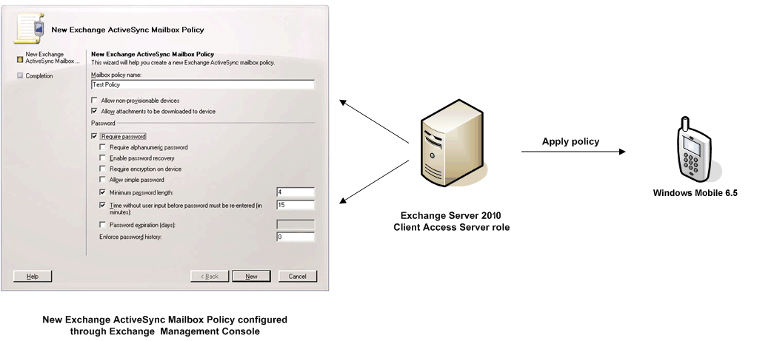

To perform the following procedures on a computer that has the Client Access Server role installed, you must log on using a domain account that has the permissions assigned to the Exchange Recipient Administrators group. The account must also be a member of the local Administrators group on that computer.
Use the Exchange Management Console to create an Exchange ActiveSync mailbox policy
- In the console tree, expand the Organization Configuration node, click Client Access, and then click the Exchange ActiveSync Mailbox Policies tab.
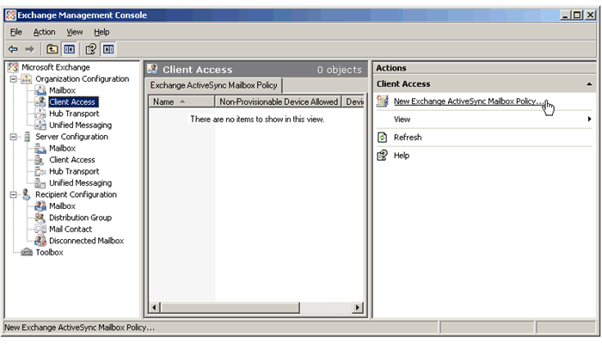

2. In the action pane, click New Exchange ActiveSync mailbox policy.
3. On the New Exchange ActiveSync Mailbox Policy wizard page, enter a name in the Mailbox policy name box.
4. Click the Require password check box and elect one or more of the optional check boxes.
5. Click New.
6. Click Finish to close the New Exchange ActiveSync Mailbox Policy wizard.

Configure Security Settings for Windows® phones with a Mailbox Policy
You can specify security options for Windows® phone users who connect to your Exchange server. With the Exchange Management Console, you can set the length and strength of the password, the amount of inactivity time, and the number of failed attempts that can occur before the mobile device is wiped.
For more information about understanding and setting mailbox policies, see Managing Exchange ActiveSync with Policies on the Microsoft TechNet Web site.
Note:
The term password in this chapter refers to the password that a user enters to unlock his or her phone. It is not the same as a network user password.

The following table presents the options you can use to set your security policies.

Exchange Security Policies or Mailbox Policies | Microsoft Exchange Server 2007 | Microsoft Exchange Server 2010
Require a password to access and configure the phone | X | X
Set a minimum password length | X | X
Require an alphanumeric password | X | X
Specify how many minutes of inactivity before the phone locks | X | X
Wipe the phone remotely | X | X
Wipe the storage card remotely | X | X
Allow access to non-provisional (pre-Messaging and Security Feature Pack) phones | X | X
Set the policy refresh interval | X | X
Allow or disallow attachments to be downloaded | X | X
Set maximum attachment size | X | X
Enable encryption on the removable storage card | X | X
Set password expiration date | X | X
Enable password recovery | X | X
Prevent patterned PIN (1111 or 1234) on the phone | X | X
Specify how many failed password attempts before device wipe | X | X
Specify how many failed password attempts before storage card wipe | X | X
Allow or disallow access to files on Universal Naming Convention (UNC) shares | X | X
Allow or disallow access to files on SharePoint Services sites | X | X

Apply a Mailbox Policy to a User
After you create an Exchange ActiveSync mailbox policy, you can add users to it. By default, users are assigned to a mailbox policy. You can add a user to only one mailbox policy at a time. If you add a user to an Exchange ActiveSync mailbox policy and that user is already a member of another Exchange ActiveSync mailbox policy, that user is removed from the original Exchange ActiveSync mailbox policy and added to the new Exchange ActiveSync mailbox policy. You can add users individually or add a filtered group of users to an Exchange ActiveSync mailbox policy.
To apply a mailbox policy to a user
1. In the console tree, expand the Recipient Configuration node, and then click Mailbox.
2. In the work pane, right-click the user who you want to assign to a policy, and then click Properties.
3. In the user's Properties dialog box, click Mailbox Features.
4. Click Exchange ActiveSync, and then click Properties.
5. Select the Apply an Exchange ActiveSync mailbox policy check box.
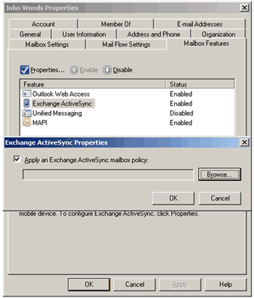

6. Click Browse to view the Select Exchange ActiveSync Mailbox Policy dialog box.
7. Select an available policy, and then click OK to apply the policy.

Initiate a Remote Device Wipe
Procedures for performing a device wipe are detailed in this section.

Remote Device Wipe vs. Local Device Wipe
Local device wipe is the mechanism by which a device wipes itself without the request coming from the server. If your organization has implemented Exchange ActiveSync policies that specify a maximum number of password attempts and that maximum is exceeded, the device will perform a local device wipe. The result of a local device wipe is the same as that of a remote device wipe. The device is returned to its factory default condition. No confirmation is sent to the Exchange Server when a device performs a local device wipe.
Note:
In addition to resetting the phone to factory default condition, a remote device wipe also deletes all data on any storage card in the phone. If you are performing a remote device wipe on a phone in your possession and want to retain the data on the storage card, remove the storage card before you initiate the remote device wipe.
To use the Exchange Management Console or Outlook Web Access to perform a remote device wipe
1. Open the Exchange Management Console.
2. Under Recipient Configuration, select Mailbox.
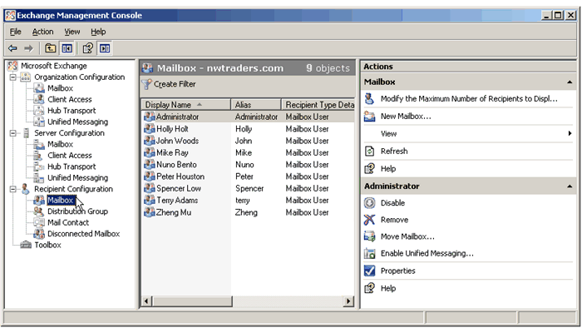

3. Select the user from the Mailbox window.
4. In the action pane, click Manage mobile device, or right-click the user's mailbox, and then click Manage mobile device.
5. Select the Windows® phone to be wiped.
6. In the Action section, select Perform a remote wipe to clear mobile phone data.
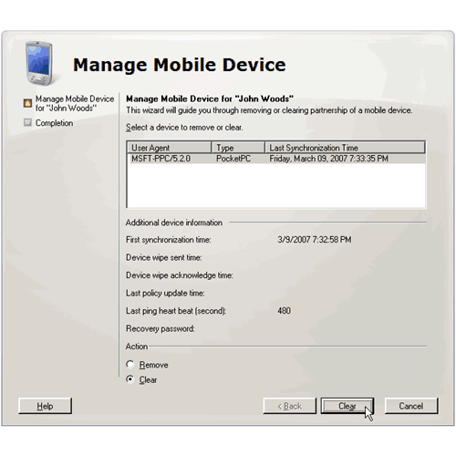

- Click Clear at the bottom of the window to finish.

To use Outlook Web Access to perform a remote device wipe:
1. Open Outlook Web Access.
2. Log on to the phone owner's mailbox.
3. Click Options.
4. In the Navigation pane, select Mobile Phones.
5. Select the ID of the phone that you want to wipe and remove from the list.
6. Click Wipe all data from device.
7. Click OK.
8. Click Remove device from list.

Disable Exchange ActiveSync
This section describes how to disable Microsoft Exchange ActiveSync. When you disable Exchange ActiveSync on a computer that is running Microsoft Exchange Server 2010 that has the Client Access Server role installed, you disable the application pool that Exchange ActiveSync uses. An application pool is a group of processes used by Internet Information Services (IIS) to perform a task.
Note:
Although this guide focuses on the implementation of a mobile messaging system with Exchange ActiveSync enabled, it may be necessary at times to disable this functionality during maintenance of your network infrastructure or mobile messaging system, and for testing.
To perform the following procedures on a computer that has the Client Access Server role installed, you must log on by using a domain account that has the permissions assigned to the Exchange Organization Administrators group. The account must also be a member of the local Administrators group on that computer.
Also, before you perform these procedures, confirm the following:
- You have installed the Microsoft Internet Information Services (IIS) component Microsoft ASP.NET.
- The ASP.NET Web service extension status is set to Allowed. You can verify the status of the ASP.NET Web service extension in IIS Manager by expanding the server name, and then clicking Web Service Extensions. If the ASP.NET Web service extension is not set to Allowed, right-click the Web service extension to change the status.
To use IIS Manager to disable Microsoft Exchange Server 2010 Exchange ActiveSync
1. Click Start, click Administrative Tools, and then click Internet Information Services (IIS) Manager.
2. Double-click to expand the server name, and then double-click to expand the Application Pools folder.
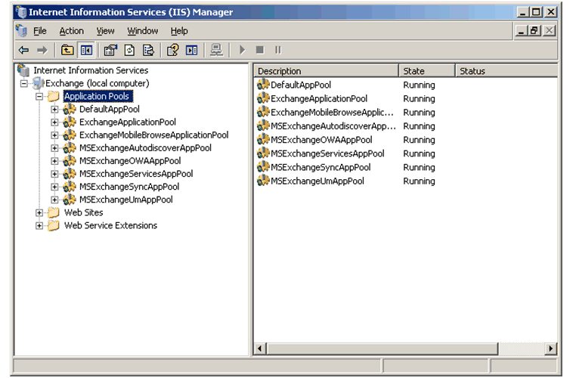
3. Right-click MSExchangeSyncAppPool, and then click Stop to disable Exchange ActiveSync.
Note:
If the Stop command is unavailable, Exchange ActiveSync is already disabled on this server.
For more information about how to enable Exchange ActiveSync, see Managing Exchange ActiveSync on the Microsoft TechNet Web site.

Step 6: Certificate Enrollment and Device Provisioning
This section addresses digital certificates and how you can use them to identify your phones and provide a more secure authentication path to access your corporate network. It also introduces device provisioning, which can be helpful in managing phones in the enterprise.

Certificates on Windows® Phones
Digital certificates play a significant role in network authentication and in helping to secure a phone. Certificates are electronic credentials that bind the identity of the certificate owner or the phone to a public and private pair of electronic keys used to encrypt and digitally sign information. Signed digital certificates help to assure that the keys actually belong to the specified application, phone, organization, or person, and that they can be trusted.
Digital certificates are used on Windows® phones in two essential roles:
- In authentication, presenting trusted credentials for connecting to a corporate e-mail server or network, or helping to verify the identity of a remote server.
- In code signing, determining whether an application can be run on the phone and if so, the permissions (privileged or normal) with which it will run.
For example, to authenticate with a network, the phone must present a certificate from its root store that is recognized and accepted by the server before an SSL connection can be established with the network server.
Further, in order for an application to be installed and run on the phone, the application must present a digital certificate that proves it was accepted and signed by a trusted source.

Certificates Shipped on Windows® Phones
By default, Windows® phones are shipped with a variety of certificates:
- Trusted root certificates from major certificate vendors that can be used for authentication purposes
- Mobile2Market and other trusted certificates that designate applications that are signed for use on Windows® phones
- Additional certificates that may be added by the OEM or mobile network operator

The following table lists the certificates shipped with phones that run the Windows Mobile 6.5 operating system as of the publishing date of this deployment guide.

Vendor | Certificate Name
Comodo | AAA Certificate Services
Comodo | AddTrust External CA Root
Cybertrust | Baltimore CyberTrust Root
Cybertrust | GlobalSign Root CA
Cybertrust | GTE CyberTrust Global Root
Verisign | Class 2 Public Primary Certification Authority
Verisign | Thawte Premium Server CA
Verisign | Thawte Server CA
Verisign | Secure Server Certification Authority
Verisign | Class 3 Public Primary Certification Authority
Entrust | Entrust.net Certification Authority (2048)
Entrust | Entrust.net Secure Server Certification Authority
Geotrust | Equifax Secure Certification Authority
Geotrust | GeoTrust Global CA
Godaddy | Go Daddy Class 2 Certification Authority
Godaddy | http://www.valicert.com/
Godaddy | Starfield Class 2 Certification Authority

Certificate Stores
The certificates in a Windows® phone reside in the certificate store in the registry. In the Windows Mobile 6.5 software, the certificate store includes separate User Root and Certification Authority stores to allow phone users with the less-powerful authenticated user permissions to add or to enroll for trusted digital certificates. The system Root and Certification Authority stores can only be changed if you have Manager or Enterprise role permissions.
The following table shows the certificate stores on phones that run the Windows Mobile 6.5 operating system, and their uses and permissions.

Certificate store | Physical Store | Description
Privileged Execution Trust Authorities | HKLM | Contains trusted certificates. Applications signed with a certificate from this store will run with privileged trust level (Trusted).
Unprivileged Execution Trust Authorities | HKLM | Contains normal certificates. On a one-tier device, an application signed with a certificate in this store will run with privileged trust level (Privileged). On a two-tier device, applications signed with a certificate from this store will run with normal trust level (Normal).
SPC | HKLM | Contains Software Publishing Certificates (SPC) used for signing .cab or .cpf files and assigning the correct role mask to the file installation.
Root (system) | HKLM | Contains root certificates, which can be certificates signed by Microsoft, the OEM, or the mobile operator. These certificates are used for SSL server authentication. These cannot be changed without Manager role permissions. Users with the Manager role can add certificates in this store.  OMA DM transport client only checks this store for root certificates when establishing an SSL connection.
Root (user) | HKCU | Contains root, or self-signed, certificates that can be installed by someone with Authenticated user role.
CA (system) | HKLM | Contains certificates and information from intermediary certification authorities. They are used for building certificate chains. In Windows Mobile 6.5, users with Manager role can add certificates in this store.  OMA DM transport client only checks this store for intermediate certificates when establishing an SSL connection.  Certificates are added to this store by Microsoft, the OEM, or the mobile operator.
CA (user) | HKCU | Contains certificates, including those from intermediary certification authorities that can be installed by the phone user with Authenticated User role. They are used for building certificate chains.
MY | HKCU | Contains end-user personal certificates used for certificate authentication or S/MIME.

Certificate Chains
A certificate chain consists of all the certificates needed to certify the subject identified by the end certificate. In practice, this includes the end certificate, the certificates of intermediate Certification Authorities, and the certificate of a root Certification Authority trusted by all parties in the chain. Every intermediate Certification Authority in the chain holds a certificate issued by the Certification Authority one level above it in the trust hierarchy. The root Certification Authority issues a certificate for itself.
When importing the certificate for a client, the certificate chain may be included in the file. This enables the phone to authenticate the intermediate and root certificates associated with the end certificate. All certificates in the chain will be added to the appropriate certificate stores on the phone in order to enable trust validation.

Basic Authentication
Exchange ActiveSync relies on SSL to help secure the connection between the Windows® phone and the Exchange Client Access server. The client phone provides the domain user’s credentials using the SSL basic authentication method. This authenticates the client to the server. The device must have the root certificate of the Exchange client access server in order to establish a secure connection.
Windows® phones are shipped with a set of third-party trusted root and intermediate certificates. If you use one of these trusted certificates to help secure your Exchange Server, users of these phones will be able to access your corporate network by entering their domain, name, and password.
Note:
Wildcard certificates, which are certificates not supplied by a Microsoft Certification Authority server, can be used with Windows Mobile 6.5.

Certificate-based Authentication
Windows Mobile 6.5 devices with the Messaging and Security Feature Pack and later devices can use SSL with Transport Layer Security (TLS) client authentication in place of SSL basic authentication. Certificate-based authentication offers a potential security advantage over the use of single-factor password-based authentication. This advantage comes from two factors. First, the strength of the key is determined by the administrator and can be very strong. Together Windows® phone and Windows Server support up to 2,048-bit keys. Second, requiring certificate-based authentication greatly reduces the risk that a user’s credentials will be compromised. If a user shares their password, the authentication process helps prevent an attacker from recovering usable credentials. The credentials are hashed and protected by SSL encryption during transport.
To use certificate-based authentication with Windows® phone, the phone must contain the root certificate for the Client Access Exchange Server it is communicating with; the phone must also have its own client user certificate with the associated private key. The user certificate enrollment process can only occur when the device is connected to a desktop in the same domain as the enrollment web site.

Managing Device Certificates
Digital certificates afford a powerful tool in helping to establish device and user identities for authentication. In a corporate environment, distributing and renewing digital certificates on hundreds or thousands of phones can be a daunting task. With Windows Mobile-based software and desktop Exchange ActiveSync, the management of device certificates has been simplified. The certificate enrollment tools enable the system administrator to manage device certificates to help create a more secure environment.
You can use Windows Mobile 6.5 software and Exchange ActiveSync certificate enrollment tools for the following company-wide activities:
- Deploying enterprise-wide Exchange ActiveSync or SSL TLS certificate-based authentication
- Renewing existing certificates
- Distributing 802.1x wireless certificates
- Providing certificates for S/MIME digital signing

Note:
The process for adding certificates differs between Windows Mobile 6 and Windows Mobile 6.5.

Adding Certificates to Windows® phones
With Windows® phones that run the Windows Mobile 6.5 operating system, you can create a CAB file with a certificate appropriate for your organization. The User role allows your users to install this CAB file to add the certificate to the HKCU Root and Certification Authority stores on the phone. You can also distribute the encrypted certificate/key pair required for certificate-based authentication or 802.1x wireless connection using ActiveSync Desktop enroll.
The certificate installer in Windows Mobile 6.5 will install certificates delivered in the following file formats:
- PFX/.P12 – Public-Key Cryptography Standards #12 (PKCS #12) files that include personal certificates with private keys as well as certificates that install into the intermediate and root certificate stores
- CER – Base64-encoded or DER-encoded X.509 certificates that install into the intermediate and root certificate stores
- P7B - Public-Key Cryptography Standards #7 (PKCS #7) files that install multiple certificates to any certificate store on the phone
The files can be delivered to the phone using desktop ActiveSync, Windows Mobile Device Center (WMDC), removable storage card, e-mail attachment, or Mobile Internet Explorer file download. Phones that run Windows Mobile 6.5 operating system also allow download from a file share. When the file is opened from the file explorer, the certificate installer is designed to process and install the file automatically.
Note:
Those with User role permissions can install a certificate on a Windows® phone by copying the CAB or .cer file to the phone and running it. However, in order to enroll for a certificate from a Certification Authority, your phone users should use either the desktop application, Microsoft ActiveSync (for Windows XP or previous clients), or Windows Mobile Device Center - WMDC (for Windows Vista or newer clients).

Using Desktop Enrollment with Microsoft ActiveSync
The desktop application, Microsoft ActiveSync, enables users with cradled Windows® phones to enroll for a certificate from the corporate server. Your users connect to your network using the existing corporate desktop logon procedure -- password, smartcard, or other means of user identification. The two levels of authentication control the certificate enrollment, streamlining the distribution of the certificates.
Desktop certificate enrollment can be used to query for and to renew certificates on phones. You can also use the Certificate Enroller Configuration Service Provider to define certificate types and to create the provisioning XML file that can be pushed out to the phones.
To prepare for desktop certificate enrollment, the system administrator should:
- Set up or have access to a Windows 2000, Windows 2003, or later Windows Certificate Server
- Create the certificate type or use an existing certificate published to Active Directory
- Inform users of the location of the certificate on the corporate network
- Provide users with instructions for using the ActiveSync Get Device Certificate feature on the desktop PC
Once you have published the certificate to Active Directory and directed phone users to enroll for the certificate, the users will step through the following process:
To enroll for a certificate with a Windows® phone
1. Using ActiveSync, synchronize your Windows® phone with a desktop PC and log into the corporate network in the same domain as the certificate enrollment server.

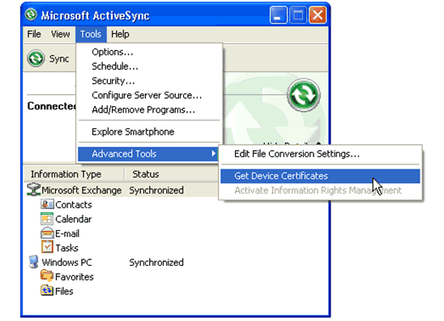
2. From Advanced Tools, choose Get Device Certificate. From the View drop-down combo box in Get Device Certificates, select Certificate types from Active Directory, select the desired certificate from the list, and click Enroll.
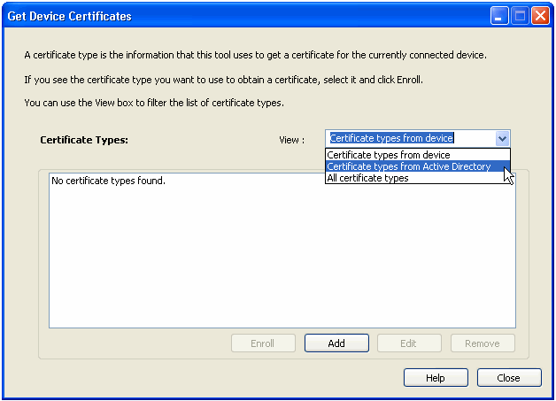

3. Under Get Device Certificate, click Yes to proceed.
4. To approve the certificate request on a phone that is based on the Windows Mobile 6.5 operating system, a screen prompt will ask you to confirm the installation process. Click Continue on the phone.
5. A second prompt may appear on the phone asking if you wish to install the certificate or block this request. Choose Install.
6. The desktop processes the enrollment. During this time, the phone generates a public/private key set and proxies the enrollment to the Windows Certificate Server through the desktop.
7. The Certification Authority returns a signed certificate to the desktop, which in turn delivers the certificate to your phone.
8. The phone stores the certificate and its chain of certificates to the root Certification Authority. If the root certificate is not already in the root certificate store of the phone, you will be asked to accept the certificate.
9. You will see a success dialog at the end of the enrollment process. Click Ok on Get Device Certificate, and then Close.
Once the certificate is in the user Root or Certification Authority store, the phone will be ready to authenticate with the desired protocol.

Using Desktop Enrollment with Windows Mobile Device Center (WMDC)
The desktop application, Microsoft WMDC, enables users with cradled Windows® phones to enroll for a certificate from the corporate server. Your users connect to your network using the existing corporate desktop logon procedure—password, smartcard, or other means of user identification. The two levels of authentication control the certificate enrollment, streamlining the distribution of the certificates.
Desktop certificate enrollment can be used to query for and to renew certificates on phones. You can also use the Certificate Enroller Configuration Service Provider to define certificate types and to create the provisioning XML file that can be pushed out to the phones.
To prepare for desktop certificate enrollment, the system administrator should:
- Set up or have access to a Windows 2000, Windows 2003, or later Windows Certificate Server
- Create the certificate type or use an existing certificate published to Active Directory
- Inform users of the location of the certificate on the corporate network
- Provide users with instructions for using the WMDC Get Device Certificate feature on the desktop PC
Once you have published the certificate to Active Directory and directed phone users to enroll for the certificate, the users will need to step through the following process to install the certificate on their Windows phones.
- To enroll for a certificate with a Windows® phone using WMDC
- Using Windows Mobile Device Center, synchronize your Windows® phone with a Vista PC, and log into the corporate network in the same domain as the certificate enrollment server.
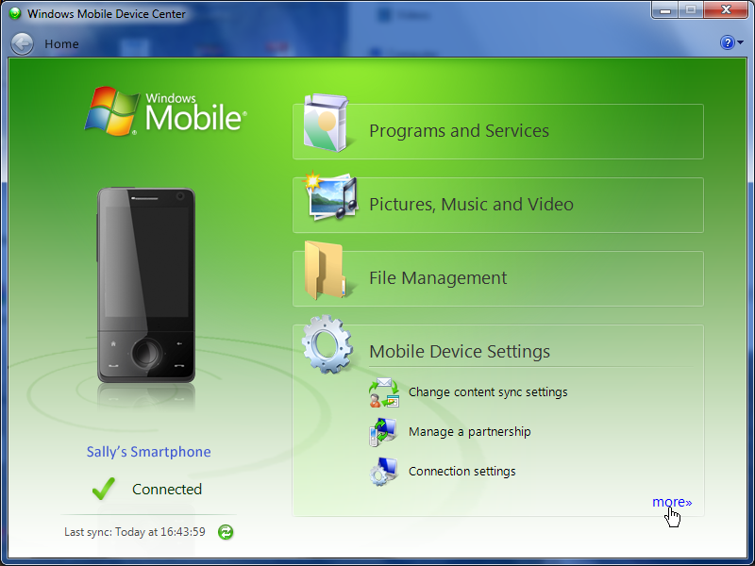
Click Mobile Device Settings, then click more>>.
- From Mobile Device Settings, choose Get device certificates.
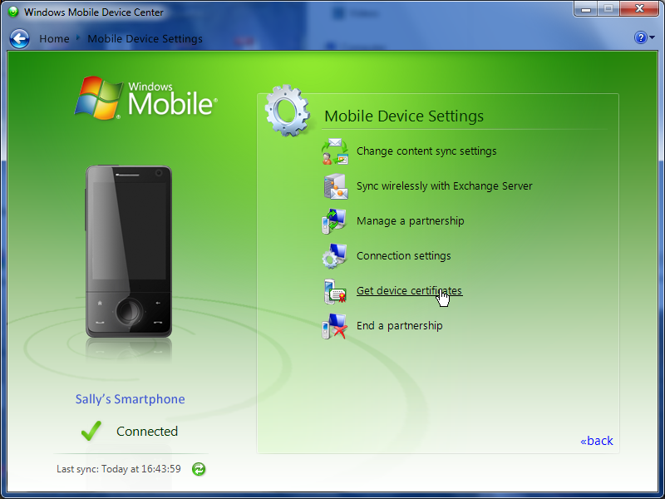
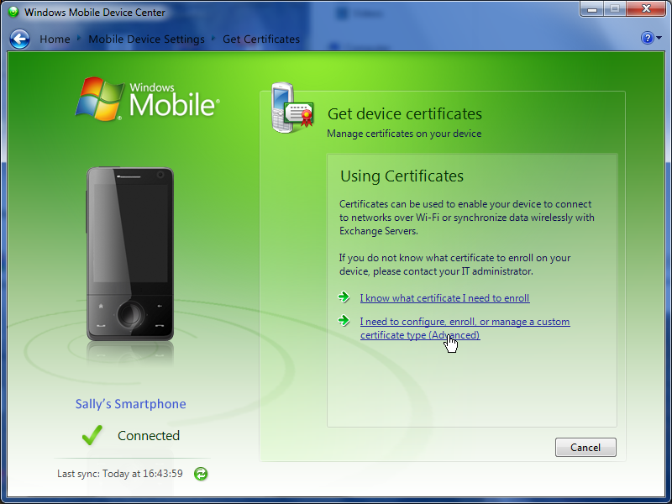
- Under Get device certificates, click I need to configure enroll, or manage a custom certificate type (Advanced) to proceed.
- To approve the certificate request on a Windows Mobile 6.5 phone, a screen prompt will ask to confirm the installation process. Click Continue on the phone, and then click ADD on the WMDC screen.
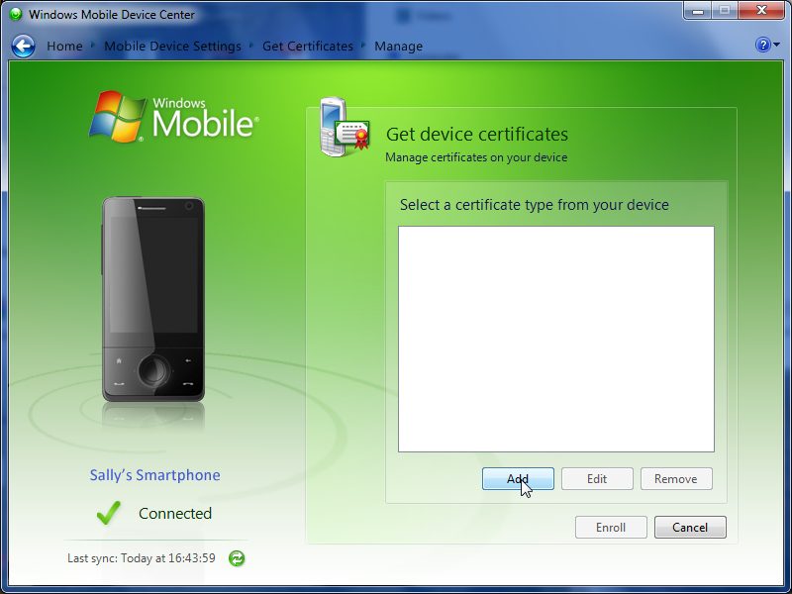
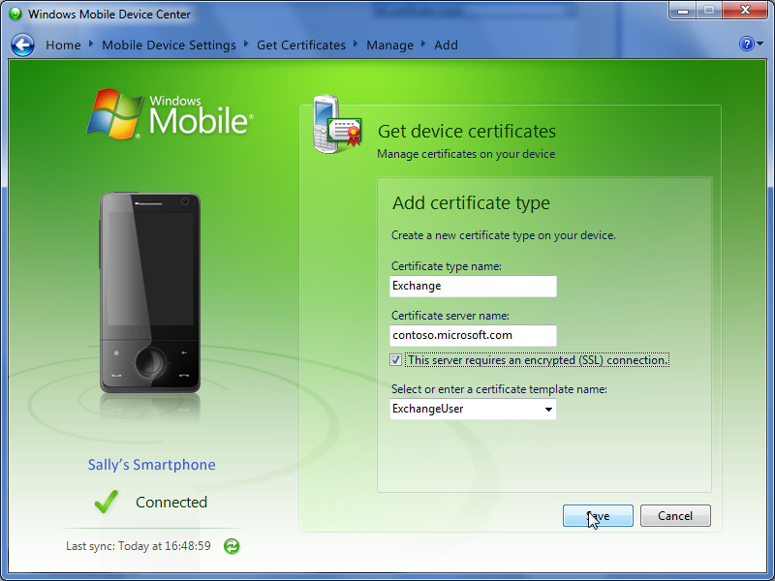
- Enter the Certificate type name and Certificate server name. Select the This server requires an encrypted (SSL) connection checkbox. Select the certificate template name as ExchangeUser.

- A prompt may appear on the phone asking if you wish to install the certificate or block this request. Choose Install.
- The desktop processes the enrollment. During this time, the phone generates a public/private key set and sends the enrollment to the Windows Certificate Server through the desktop.
- The Certification Authority returns a signed certificate to the desktop, which in turn delivers the certificate to your phone.
- The phone stores the certificate and its chain of certificates to the root Certification Authority. If the root certificate is not already in the root certificate store of the phone, you will be asked to accept the certificate.
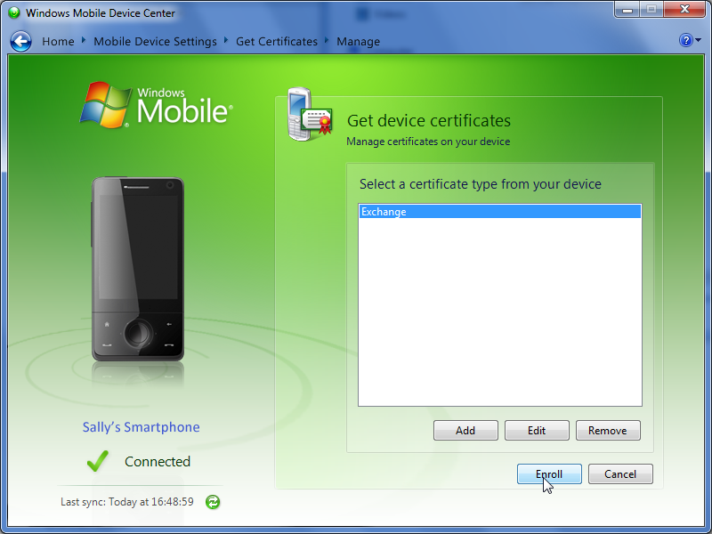
- Finally, click the Enroll button to complete the process.

Windows® phone Security Policies and Device Provisioning
In the enterprise, you may be dealing with both front-door and back-door devices. Front-door devices are new devices purchased in large quantities directly from an OEM or mobile operator. In this case, you may be in a position to request specific features and work with the device provider to create a unique device configuration that meets your corporate requirements. Back-door devices are ones that are brought into the corporate environment by individuals or groups who have procured the devices from a retailer or that have additional requirements preventing them from using front-door devices.
Your challenge will be to control both front-door and back-door devices, which you can do with ongoing device configuration, called provisioning, that can alter the security level settings and other features on an already functioning device.
For more information about the security features available on Windows® phones and how they interact with Exchange ActiveSync, see the following white papers:
Security Considerations for Windows Mobile Messaging in the Enterprise

Security Policies and Roles
The built-in security policy settings on Windows® phones define levels of security. For example, security policies determine whether a phone can be configured over the air (OTA), and whether it can accept unsigned messages, applications, or files. Security policy settings provide flexible control over authentication, data encryption, virtual private networking, Wi-Fi encryption, and SSL services. These policies are defined globally and enforced locally in their respective components at critical points across the phone architecture.
Security roles, such as Manager or Enterprise, help to control access to phone resources and define who can change each policy. The Manager role, usually reserved for the phone manufacturer, allows complete control over the phone. This is the role used to pre-load and configure settings on phones before they are purchased.
By default, only someone with Manager Role permissions on the phone can change most of the security policies. Using Mailbox Policies in Exchange ActiveSync, network administrators may use the Enterprise role to change the policies outlined in New Enterprise Features for Windows Mobile 6.5 and Exchange Server 2010 in this document. Additionally, if the OEM has given you Manager Role permissions on your Windows® phones, you can change all security policies on the phone by provisioning.

Provisioning Windows® phones
Provisioning refers to updating the phone after manufacture, and involves creating a provisioning XML file that contains configuration information that specifies the attributes of features and security policies. The XML file is signed with a certificate and then transferred to the phone, where the Configuration Service Providers configure the phone based on the contents of the file.

A completed provisioning file can be delivered to a Windows® phone using any one of the following means:
- OTA using an OMA DM Server
- OTA using an OMA Client Provisioning (formerly WAP Client Provisioning) server
- Wrapped in a .cpf file and sent using Internet Explorer Mobile, Exchange ActiveSync, SI/SL, or storage card.
Note:
Microsoft recommends that you provision the device using OTA methods when possible. If you must deliver the XML in a file, we recommend that you package and sign provisioning documents in the CAB Provisioning Format (.cpf). An XML provisioning document may not install on a Windows® phone if the file containing the document is not signed.
Note:
Cabinet files and each DLL and executable within a cabinet file must be signed, including resource-only DLLs.

For more information about provisioning phones that are based on the Windows Mobile 6.5 operating system, see Windows Mobile Home on the Microsoft Developer Network (MSDN) Web site at http://go.microsoft.com/fwlink/?LinkID=99766.

Step 7: Manage and Configure Windows® phones
As an administrator using Microsoft Exchange Server 2010, you now have tools designed to set and enforce mobile device security policies. You can also control some of the features on Windows® phones by using provisioning tools.

This topic provides you with instructions and pointers for setting up a phone connection to Exchange Server 2010 (establishing an Exchange ActiveSync partnership).

Setting Up a Mobile Device Connection to the Exchange Server
If mobile users have a data usage plan through a mobile operator, Exchange ActiveSync on the Windows® phone can be used to synchronize e-mail, contacts, calendar, and tasks over the air. Alternatively, they can use Desktop Exchange ActiveSync to partner their phone that runs the Windows Mobile 6.5 operating system with an Exchange Server by using a USB cable from a desktop computer that is connected to your network.
Regardless of the connection method, you will need to provide users with the following information before they can synchronize with your Exchange Server:
- The user's e-mail address
- The mailbox password
Your users can use Exchange ActiveSync on their phones or on their computer to choose which types of data, such as contacts, calendar, tasks, and e-mail that they will synchronize with Exchange. You may advise your users to uncheck any data types that should not be stored on their phones.
Note:
For more information about Exchange ActiveSync, see Managing Exchange ActiveSync Devices on the Microsoft TechNet Web site.

If your users use the desktop ActiveSync or WMDC setup, advise them to be sure to choose the option to synchronize their phones directly with the Exchange Server. Direct Push Technology and security policy enforcement will be effective only when the phones are synchronized directly with the Exchange Server. Synchronizing phones with the desktop computer is not recommended.

Connecting to an Exchange Server Over the Air (OTA) or Over a Wireless Network
Your phone users can use Exchange ActiveSync in Windows Mobile 6.5 to synchronize directly with their Exchange Server.
At the first installation, a user can use Exchange ActiveSync to synchronize either using the desktop computer or wirelessly. If your users have the address of their Exchange Server and know their respective Exchange usernames, passwords, and domains, the Exchange ActiveSync wizard will walk them through the steps.
To connect a Windows® phone to an Exchange Server:
1. On the Home screen, choose Exchange ActiveSync, choose Menu, and then choose the Configure Server tab. If the phone has not yet been synchronized with Exchange Server, Add Server Source… will be the available option.

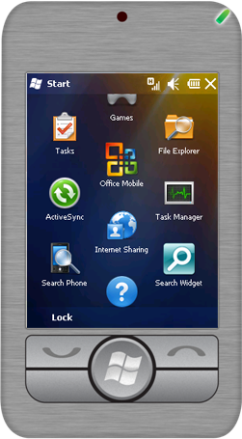

2. In Enter Email Address, type the e-mail address and then choose Next
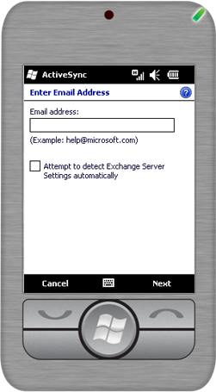

3. In Edit Server Settings, type server address from where you will access e-mails and choose Next.
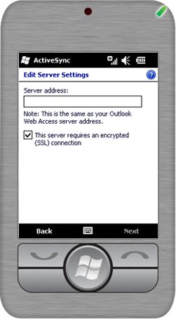
4. Enter your user name, password, and domain name, and then choose Next. If you want the phone to save your password so that you will not need to enter it again the next time that you connect your phone to the Exchange Server, select the Save password check box.
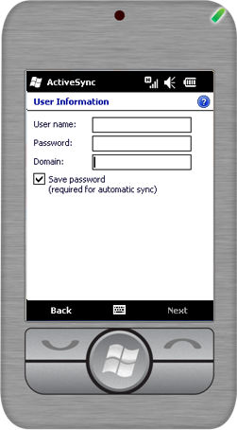
- Choose the content that you want to synchronize and then choose Finish.
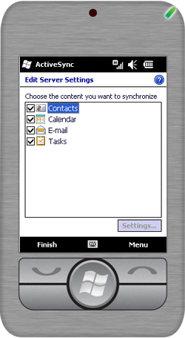

Summary
This paper covered the installation and deployment procedures of Windows Mobile® 6.5 on Microsoft Exchange Server 2010, and also touched upon the enhancements in these products. Among its several new features, Microsoft Exchange Server 2010 includes better administrative functionality, more Web access features, higher availability, and an improved Web management interface. Window Mobile 6.5 includes device features such as screens that provide an at-a-glance view of key information, finger-touch functionality, better synchronization, more application support, and enhancements to existing applications. Exchange ActiveSync has been enhanced to include functionality such as e-mail conversation views, support for more types of calendars, and unified messaging form enhancements.

Use this document as a guide to help you understand the best practices, intricacies, and architecture scenarios for deploying Windows Mobile 6.5 with Microsoft Exchange Server 2010. The step-by-step instructions will help you update servers with security patches, protect communications between the mail server and phone, configure the firewall, and configure device policies and certificates, eventually enabling Windows Mobile 6.5 users to securely access their messaging, contact and information resources on Microsoft Exchange Server 2010.

Requires Exchange Server 2010
Requires cellular connection. Does not work over Wi-Fi.
Requires Exchange Server 2007 and later

