
Printing Effectively with Internet Printing Protocol (IPP) 1.0

Microsoft Corporation
Published: January, 2003
Updated: October, 2007

Abstract
Microsoft® Windows® 2000 print servers introduced support for the Internet Printing Protocol (IPP) 1.0 specification, both in the form of a Web-based management infrastructure as well as support for printing over HTTP, and this support was continued in Windows Server 2003. This paper discusses the different aspects of IPP and recommended deployment methods. The paper is designed for systems integrators, administrators, and architects who are planning, deploying, or managing Windows print servers.

This is a preliminary document and may be changed substantially prior to final commercial release of the software described herein.
The information contained in this document represents the current view of Microsoft Corporation on the issues discussed as of the date of publication. Because Microsoft must respond to changing market conditions, it should not be interpreted to be a commitment on the part of Microsoft, and Microsoft cannot guarantee the accuracy of any information presented after the date of publication.
This document is for informational purposes only. MICROSOFT MAKES NO WARRANTIES, EXPRESS OR IMPLIED, AS TO THE INFORMATION IN THIS DOCUMENT.
Complying with all applicable copyright laws is the responsibility of the user. Without limiting the rights under copyright, no part of this document may be reproduced, stored in or introduced into a retrieval system, or transmitted in any form or by any means (electronic, mechanical, photocopying, recording, or otherwise), or for any purpose, without the express written permission of Microsoft Corporation.
Microsoft may have patents, patent applications, trademarks, copyrights, or other intellectual property rights covering subject matter in this document. Except as expressly provided in any written license agreement from Microsoft, the furnishing of this document does not give you any license to these patents, trademarks, copyrights, or other intellectual property.
© 2007 Microsoft Corporation. All rights reserved.
Microsoft, Active Directory, Windows, the .NET logo, Windows NT and the Windows logo are either registered trademarks or trademarks of Microsoft Corporation in the United States and/or other countries.
The names of actual companies and products mentioned herein may be the trademarks of their respective owners.

Contents
Introduction 1
Enabling Web-Based Printer Management and Internet Printing 1
ASP Pages Installed for Internet Printing 3
Web-Based Printer Management 5
Internet Printing 7
HTTP Printer Connection from a Web Browser 8
RPC Printer Connection from a Web Browser—Preferred Method 8
Summary 8
Related Links 9

Introduction
Microsoft® Windows® 2000 introduced support for the Internet Printing Protocol (IPP) 1.0 specification and Windows Server 2003 continues this support. There are two main components to IPP:
- Web-based printer management which offers the ability to administer, to connect to, and to view printers by using a Web browser.
- Internet printing which allows you to use the printer's URL to connect to a printer.
This white paper discusses both aspects of internet printing and describes how to enable and disable each of them.

Enabling Web-Based Printer Management and Internet Printing
The only prerequisite to enable Web-based printer management and Internet printing is that you install and run Internet Information Server (IIS) on the print server. IIS is installed by default with Windows 2000 Server versions and it can also be installed as an optional component on Windows 2000 Professional, Windows XP, and Windows Server 2003.
Web-based printer management is available by default after you install IIS on a computer running Windows 2000 or Windows XP; however, because Windows XP and Windows 2000 Professional have a 10-connection limit, they don’t perform very well as Internet print servers. If you disable the Web-based Printing policy, you will disable Web-based printer management and Internet printing on a server.
Note: If you install IIS on Windows 2000 or Windows XP, you must either reboot the system or restart the spooler service after you install IIS before you can use Web-based printer management and Internet printing.
Note: The Web-based Printing policy does not exist on Windows Server 2003. Instead, use the IIS Security Console that is described below to add and remove Internet printing and Web-based printer management functionality.
When IIS is installed on a computer running Windows Server 2003, the Internet Printing and Active Server Pages components that are necessary to enable Web-based printer management and Internet printing are not installed by default. If you elect to install the Internet Printing component when you install IIS, the Active Server Pages component will also be installed by default. This behavior is controlled by the Internet Printing and Active Server Pages check boxes in the IIS installation.
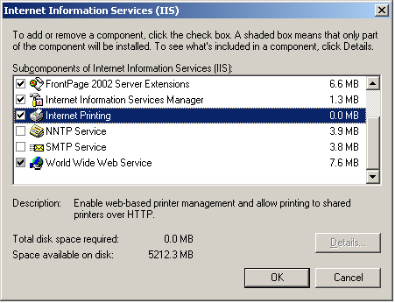
To install IIS and Internet Printing:
- Open Control Panel, select Add or Remove Programs, and click Add/Remove Windows Components.
- Select Application Server, and then click Details.
- Check Internet Information Service (IIS), and then click Details.
- Select the Internet Printing check box to enable the component, or cancel the selection to disable it as shown in the figure above.
- Select World Wide Web Services and then click Details.
- Select the Active Server Pages check box to enable the component, or cancel the selection to disable it, and then click OK in all remaining open dialog boxes. After you enable the Internet Printing component, the Active Server Pages check box will automatically be selected.
- Click Next to continue the installation.

If the Internet Printing and Active Server Pages components were installed during the IIS installation, Web-based printer management and Internet printing will work with the default settings in the IIS Security Console.
To modify the Web-server extension configuration for these components, run the IIS Security Console and select the Web Service Extensions folder.
To enable Web-based printer management, set the status of Active Server Pages to Allowed, the default value.
To enable Internet Printing as well as Web-based printer management, set the status of Internet Printing to Allowed, the default value.
To accomplish these tasks, right-click My Computer, expand Services and Applications, expand Internet Information Services (IIS), select Web Service Extensions, select Internet Printing or Active Server Pages, and then click Allow.
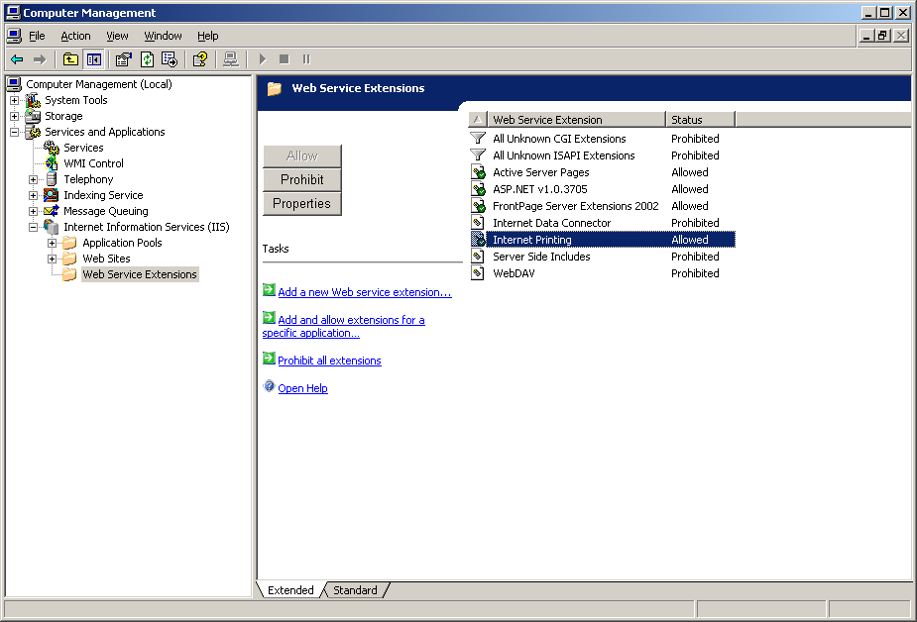
If you change the status of a Web service, for example, if you change Internet Printing from Prohibited to Allowed, save the new configuration in case IIS is restarted. To do this, right-click the Internet Information Service (IIS) node in the left pane, select All Tasks, and then select Save Configuration to Disk.

Note: If Active Server Pages is set to Allowed and Internet Printing is set to Prohibited, only Web-based management is enabled. Users cannot connect to any shared printers through Internet Printing. The Connect button is dimmed and not available on the printer management Web page.
If the Internet Printing option is set to Allowed but Active Server Pages is set to Prohibited, users can connect to printers through their URLs in the Add Printer Wizard; however, they cannot access the Web-management pages at all.

ASP Pages Installed for Internet Printing
When Internet Printing has been installed, the following ASP pages for the server side IPP components will be installed in %windir%\web\printers. The virtual directory of the printer in IIS points to this directory.
%windir%\web\printers
│ ipp_0000.inc
│ ipp_0001.asp
│ ipp_0002.asp
│ ipp_0003.asp
│ ipp_0004.asp
│ ipp_0005.asp
│ ipp_0006.asp
│ ipp_0007.asp
│ ipp_0010.asp
│ ipp_0013.asp
│ ipp_0014.asp
│ ipp_0015.asp
│ ipp_adsi.inc
│ ipp_res.inc
│ ipp_util.inc
│ page1.asp
│ prtwebvw.css
│
├───images
│ ipp_0002.gif
│ ipp_0003.gif
│ ipp_0004.gif
│ ipp_0005.gif
│ ipp_0012.gif
│ ipp_0015.gif
│
└───PrtCabs

When a user enters http://servername/printers in a Web browser, ipp_0001.asp is displayed and enumerates the printers by using Active Directory Services.
The following example illustrates the program logic used to enumerate the printers.
Dim objPrinter, objPrinters
Dim objHelper

' get ComputerName.
Set objHelper = Server.CreateObject(PROGID_HELPER)
If strComputer = "localhost" or _
strComputer = "127.0.0.1" or _
Not CBool(objHelper.IsCluster) Then
strComputer = objHelper.ComputerName
End If
If Err Then Exit Function

' build query string for ADSI
Set objPrinters = GetObject("WinNT://" & strComputer & ",computer")
If Err Then Exit Function

' get list of printers
objPrinters.filter = Array("PrintQueue")
If Err Then Exit Function

' iterate through all the (shared) printers
For Each objPrinter In objPrinters
' do stuff
Next

Note that the PROGID_HELPER object in the previous example is an ActiveX control with helper functions that can be installed with the server-side IPP components and accessed by the ASP pages. More complex operations, such as listing the jobs for a particular printer, can also be programmed. Page ipp_0004.asp lists printers and provides actions to take such as cancel, pause, and resume.
See http://go.microsoft.com/fwlink/?LinkId=98928 for more information about ASP pages.

Web-Based Printer Management
Web-based printer management is very simple to use. When a printer is created and shared, it becomes available for management through an Internet browser. To open the Web-based printer management dialog, use http://printserver/printers, where printserver is the print server’s computer name.
The Web page lists all shared printers on the server along with their status, location, jobs, and other details. For example, page for the TPRINT print server might look like this:
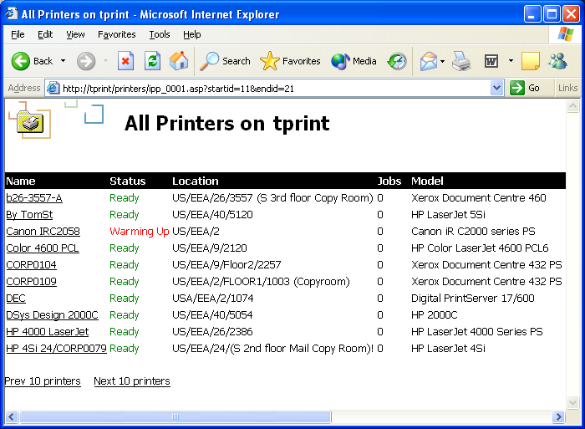
When you select a printer, you can view the document list, properties, and device status for that printer. You can also select the Connect option under Printer Actions to connect to the printer. Users can use the Web page to pause and resume the printer; purge the print queue, and pause, resume, or cancel specific print jobs provided they have permission to perform these actions on the printer. The following figures show the Document List, Properties, and Device Status view for a particular printer on TPRINT.

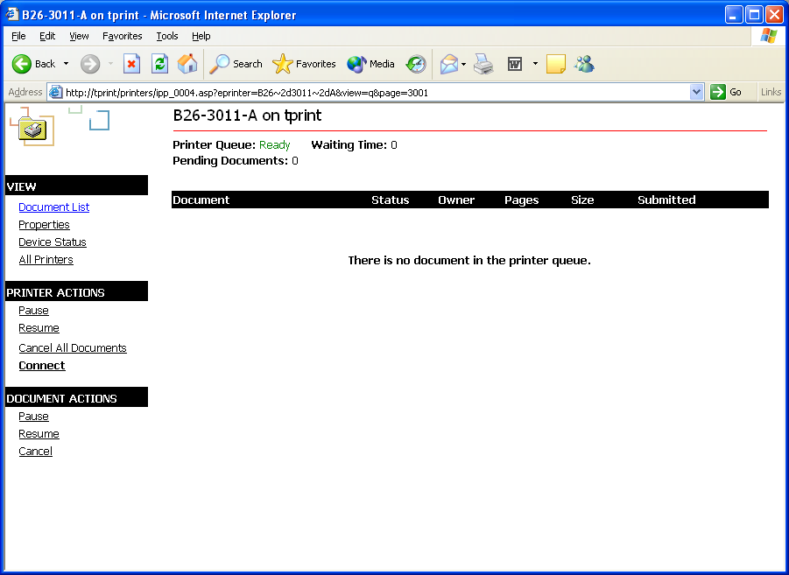

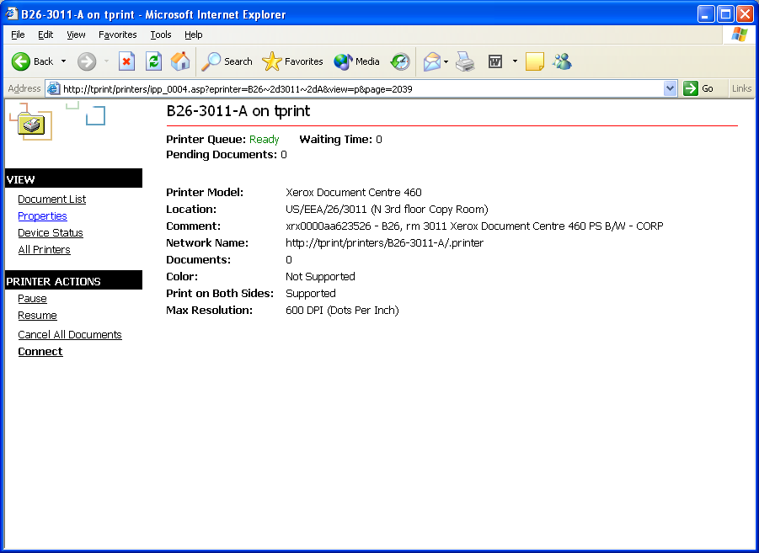

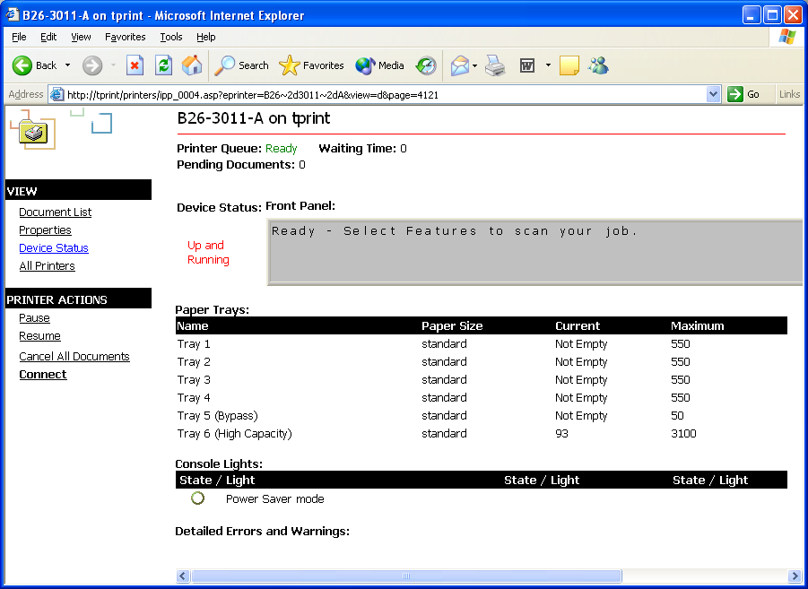

Most Windows clients in use today include support for IPP or can download IPP support from the Microsoft Web site (http://www.microsoft.com). When a client computer has IPP support installed, users can use their Web browser to view and connect to printers. Microsoft strongly recommends the use of the Web-based printer management technology, particularly for corporations that want to deploy a Web-based solution to find and to connect to printers.
By using Web-based printer management, many organizations then create customized Web pages that make it easier for their users to find and select printers. For example, a business could create a map of their corporate campus in HTML and then add links to all the public printers.

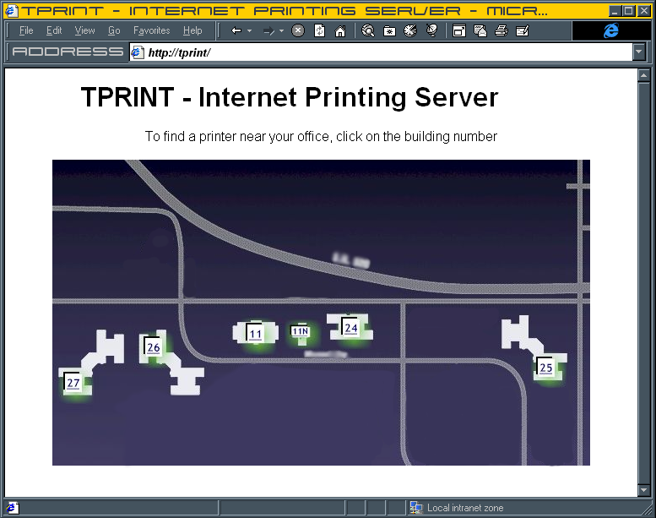
The example to the right shows a server that uses a custom image map to show a graphical layout of the area served by the print server. A user can click one of the buildings highlighted in green to browse the printers on each floor of that building. If the user selects a specific printer, they can view the printer’s status pages or install the printer.

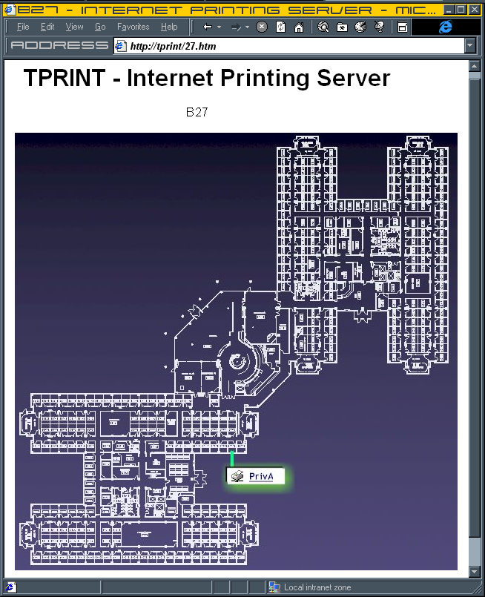

Internet Printing
When a user connects to a printer through the Web-based printer management, one of two things can happen: Either Windows can use an HTTP port to create an IPP printer connection or Windows can create a remote procedure call (RPC) true-connect printer connection.

HTTP Printer Connection from a Web Browser
On the client computer, if the Microsoft® Internet Explorer security settings for the Web content zone of the print server are set to medium or higher, Windows uses an HTTP port to create an IPP printer connection. Because using an HTTP port requires the use to install a local printer queue on the client computer, unlike a true Point-and-Print connection which uses RPC, the user must have either Local Admin or Power User privileges, including the additional Load and unload device drivers privilege, on the local machine. On computers running Windows 2000, this connection can be made if the client has only Power User privilege.
Using the HTTP printer connection is recommended only for Internet sites–specifically, untrusted sites that are viewed by a Web browser in which the security settings must be set to medium or higher.
Note: If the Internet Explorer security is set to high, the Connect link on the Web management page for that printer is not displayed. This prevents users from connecting to the printer through the Web page.
Using an HTTP printer connection to print works very well when you want to print data in one location from a page at another location that does not share security or network infrastructure. However, HTTP printer connections are more limited than RPC true-connect printer connections in a Windows printing environment because they do not support enhanced metafile (EMF) features.
Note: If a client enters the printer's URL in the Add Printer Wizard to connect to the printer rather than using a Web browser, HTTP printer connection will always result regardless of the Internet Explorer security settings. For more information on this, see the Knowledge Base article “Add Printer Wizard Forces HTTP Connections to Windows 2000 Internet Print Servers” at http://go.microsoft.com/fwlink/?LinkId=98929

RPC Printer Connection from a Web Browser—Preferred Method
On the client computer, if the Internet Explorer settings for the Web content zone that the print server is a part of are set to medium-low or lower, when the client chooses the Connect option in a Web browser, Windows will create an RPC true-connect printer connection. True-connect, or UNC, connections have many benefits over IPP printer connections and should be used in intranet printing scenarios such as where the printer is within the organization and the security setting in Internet Explorer can be safely set to medium-low. RPC true-connect printer connections are supported by the Windows remote spooler.
For additional information about RPC connections, see the “Point and Print Technical Overview” white paper at http://go.microsoft.com/fwlink/?LinkId=98930

Summary
The two components of IPP printing are powerful tools when used properly. Although the Web printer management framework provides ease of user access and powerful administrative capabilities, Microsoft recommends that users connect through RPC whenever possible and that organizations use the IPP printing over HTTP only when they must use the Internet to connect to a printer.

Related Links
See the following resources for further information:
- For more information about deployment and management of Windows print servers, see the Windows Deployment and Resource Kits at http://go.microsoft.com/fwlink/?LinkId=98921.
- For more information about the Windows 2000 and Windows Server 2003 architecture, see the “Display and Print Devices” sections in the Windows Driver Kit at http://go.microsoft.com/fwlink/?LinkId=98922
- For more information about connectivity options and support protocols in Windows 2000, see Microsoft Windows 2000 Server Resource Kit published by Microsoft Press and available online at http://go.microsoft.com/fwlink/?LinkId=98923.
- For the latest information about Windows 2000 Printing, see the Windows 2000 Print Server Web site at http://go.microsoft.com/fwlink/?LinkId=98924.
- For the latest information about Windows 2000 Server, see the Windows 2000 Server Web site at http://go.microsoft.com/fwlink/?LinkId=98925.
- For the latest information about Windows Server 2003, see the Windows Server 2003 Web site at http://go.microsoft.com/fwlink/?LinkId=98927.

