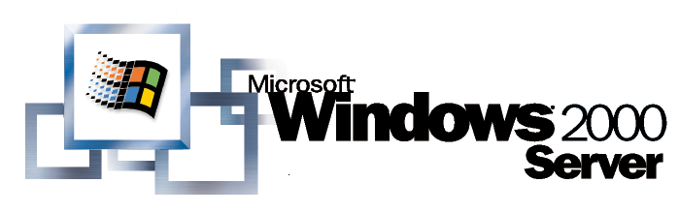
Operating System
Using Terminal Services for Graphical Remote Administration of the Windows 2000 Server Family

White Paper
Abstract
This white paper provides an overview of the remote administration mode of the Terminal Services component in the Windows 2000 Server family. Terminal Services is built into each version of Windows 2000 Server, and is the recommended method for all graphical remote administration tasks performed on computers running Windows 2000 Server. This white paper is specifically designed as a usage guide for IT professionals who are new to Terminal Services and/or its remote administration mode.
© 1999 Microsoft Corporation. All rights reserved.
The information contained in this document represents the current view of Microsoft Corporation on the issues discussed as of the date of publication. Because Microsoft must respond to changing market conditions, it should not be interpreted to be a commitment on the part of Microsoft, and Microsoft cannot guarantee the accuracy of any information presented after the date of publication.
This white paper is for informational purposes only. MICROSOFT MAKES NO WARRANTIES, EXPRESS OR IMPLIED, IN THIS DOCUMENT.
Microsoft, BackOffice, NetMeeting, Windows, and Windows NT are either registered trademarks or trademarks of Microsoft Corporation in the United States and/or other countries.
Other product and company names mentioned herein may be the trademarks of their respective owners.
Microsoft Corporation • One Microsoft Way • Redmond, WA 98052-6399 • USA
0399

Overview of Terminal Services 1
Summary of Features and Benefits 1
Introducing Terminal Services REMOTE ADMINistration 3
Terminal Services Modes 3
Terminal Services Integration 3
Deployment 4
Enabling Terminal Services for Remote Administration 4
Enabling Terminal Services During an Unattended Setup 5
Changing the Session Encryption Levels 5
The MicrosoFt Terminal Services Client 7
Installing the Microsoft Terminal Services Client 7
Connecting to a Server 7
Terminal Services Client 7
Client Connection Manager 7
Copying Files Between the Server and the Client 8
REMOTE ADMINISTRATION BEST PRACTICES 9
Coordinate Remote Administration Tasks with Other Administrators 9
Remote Administration Is Not Application Serving 9
Configure the Terminal Services Session to Disconnect on Broken 9
Configure Disconnect and Reset Timeouts 9
Tasks that Require Reboots 10
Server Console Messages 10
Administrator Collaboration 10
Adminstration Tools 11
Terminal Services Manager 11
Terminal Services Configuration 11
Event Viewer 11
Query User 11
Disconnect 11
Terminal Services Client Creator 11
Summary 12
For More Information 12

Terminal Services is a component that is included with each member of the Windows 2000 Server family: Windows 2000 Server, Windows 2000 Advanced Server, and Windows 2000 Datacenter Server. It provides the Windows graphical user interface to remote devices over LAN, WAN, or Internet connections. All of the application processing is performed at the server and only data from devices such as the display monitor, keyboard, and mouse are transmitted between the server and the Terminal Services client.

Overview of Terminal Services
Terminal Services may be enabled in one of two modes: Application Server or Remote Administration. Application server mode allows multiple remote clients to simultaneously access Windows-based applications that run on the server. This is the traditional Terminal Server deployment.
Remote administration mode is a new feature in Terminal Services for Windows 2000. It is designed to provide operators and administrators with remote access to typical BackOffice® servers and domain controllers. The administrator has access to the graphical user interface-based tools that are available in the Windows environment, even if he or she is not using a Windows-based computer to administer the server.
Note: Terminal Services Client software for 16-bit and 32-bit Windows-based computers is included with Windows 2000 Server. Non-Windows-based clients require a third party add-on.
Remote administration mode allows this without affecting server performance or application compatibility. Up to two remote administration sessions are supported, in addition to the console session. Since this is meant as a single-user remote access solution, no Terminal Server Client Access License (CAL) is required to use Remote Administration.

Summary of Features and Benefits
The Remote administration mode of Terminal Services includes the following features and benefits:
- Graphical administration of Windows 2000 servers from any Terminal Services client. Clients are available for computers running Windows for Workgroups, Windows 95, Windows 98, Windows CE 2.11, Windows NT®, and Windows 2000.
- Remote upgrades, reboots, and promotion and demotion of domain controllers.
- Access to servers over low-bandwidth connections, with up to 128-bit encryption (56-bit outside of North America).
- Roaming disconnect support, allowing data-sensitive or time-consuming tasks to be completed successfully if the remote session is disconnected deliberately or due to network problems.
- Remote application installation and execution, with fast access to local disks and media (for example, when copying large files and virus scans).
- Console session is left unaffected while remote administration takes place, eliminating eavesdropping.
- Negligible performance impact on the server and no impact on application compatibility.
- No Terminal Services Client Licensing requirements.
- Two remote administrators can share a session for collaboration purposes.
- Remote Desktop Protocol (RDP) feature set, including local printing, clipboard mapping (cut, copy and paste), and support for any RDP virtual channel applications such as local drive mapping (available in the Windows 2000 Resource kit).
The remainder of this document explores the design goals and implementation of the Remote administration mode of Terminal Services in Windows 2000 Server, and explains how an enterprise can make use of this feature.

Terminal Services Modes

Introducing Terminal Services REMOTE ADMINistration
There are two modes to choose from when enabling Terminal Services. The original mode is named Application Server, and is similar in usage to Windows NT Server 4.0, Terminal Server Edition. This mode is designed to supply many users with Windows-based applications run from a server. Application server mode configures Terminal Services in a number of specific ways. These include:
- Memory and CPU utilization geared towards interactive applications.
- Terminal Services optimized to handle many sessions, which increases the service overhead.
- Terminal Services application compatibility enhancements to aid applications that are not aware of the Terminal Services environment.
- License allocation for each device that connects to a Terminal Services session.
These configurations are not required when using Terminal Services in Remote administration mode. Although the performance costs of using configuring application server mode are reasonable on a server dedicated to application serving, they can be detrimental on a mission-critical BackOffice server. Similarly, specialized installation and device licensing are critical to an application server, but cumbersome and unnecessary in a focused operations environment.
It is for these reasons that a second Terminal Services mode was added to the Windows 2000 operating system. Remote administration mode addresses these concerns.
- Memory and CPU utilization settings are left unaffected.
- Terminal Services is enabled with minimal impact on the server.
- Terminal Services application compatibility settings are completely disabled.
- Terminal Services licensing requirements are dropped, and replaced by two concurrent administrator connections without installing a license on the client.

Terminal Services Integration
The Terminal Services component is tightly integrated into the kernel and is available on every Windows 2000 Server installation. Enabling Terminal Services in remote administration mode requires no additional disk space and has a minimal performance impact. It requires only about 2 MB of server memory and has a negligible impact on CPU usage. Performance is only affected when a remote session is logged on, similar in cost to the console.
It is for these reasons that Microsoft recommends enabling Terminal Services in remote administration mode on every Windows 2000 BackOffice Server or domain controller.

Enabling Terminal Services for Remote Administration

Deployment
Deploying Terminal Services for Remote Administration requires that the Terminal Services component is enabled either during installation, or afterward using the Windows Components wizard found by clicking Add/Remove Programs in Control Panel, and then clicking Add/Remove Windows Components. Note that the Terminal Services Licensing service must be enabled only if there are other Windows 2000 Servers running Terminal Services in application server mode. It is not required for remote administration mode.
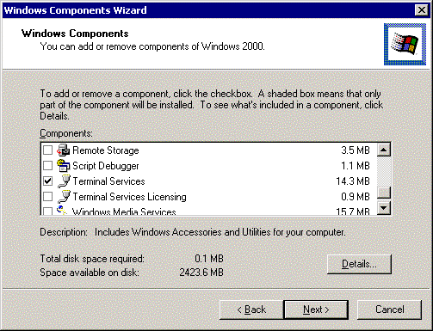
Figure 1. Enabling Terminal Services
By default, the various Terminal Services client software is installed in the %systemroot%\system32\clients\tsclient directory. In large server farms it may be desirable to prevent the client software from being installed on every server. To do this, select Terminal Services, click Details, clear the Client Creator Files check box, and click OK.
Once the Terminal Services check box is selected, clicking Next gives the administrator the option of specifying in which mode Terminal Services should be enabled. Remote administration is the default mode.
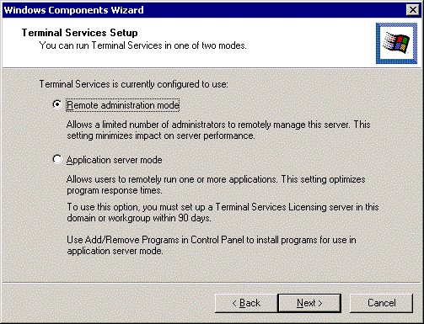
Figure 2. Terminal Services Setup choices
Once Terminal Services is enabled, the server must be rebooted. This can either be done immediately, or can be scheduled during the next maintenance window. Remote administration mode cannot be used until this is performed.

Enabling Terminal Services During an Unattended Setup
Terminal Services is enabled by using the key TSEnable in the Components section of the unattend setup file. The TS configuration mode can be specified through a key called ApplicationServer, found in the TerminalServices section. If this key isn’t specified the value is assumed to be “0”, (that is, remote administration mode). Note this key is only referenced if Terminal Services is enabled (TSEnable = ON). To disable the installation of the Terminal Services clients, set the key TSClients = OFF. The following unattended setup keys are supported:
[Components]
TSEnable = ON | OFF
TSClients = ON | OFF
[TerminalServices]
ApplicationServer = 1 | 0

Changing the Session Encryption Levels
By default, all Terminal Services sessions connect using medium encryption. This means that all data sent between the client and the server is protected by encryption based on the server’s standard key strength. The standard key strength is 56-bit. If there is a possibility that remote administration will be initiated from outside a secure LAN, it may be desirable to strengthen the protection. High encryption is available in North America, which provides bi-directional security using a 128-bit cipher.
Changing the encryption level is performed within the Terminal Services Configuration utility, located under Programs/Administrative tools. Open the Properties dialog box of the Microsoft RDP 5.0 protocol type in the Connections folder, and click the General tab. This reveals the Encryption level box, which can be changed from low to medium or high.
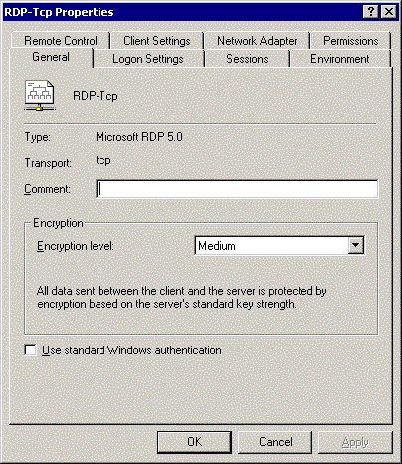
Figure 3. Changing the encryption level
Note that raising the encryption level increases the client and server CPU requirements for each active remote session.
The Microsoft Terminal Services Client software is made available for installation when the Terminal Services Client Creator Files have been installed. (See: DEPLOYMENT/Enabling Terminal Services for Remote Administration).

The MicrosoFt Terminal Services Client
The Microsoft Terminal Services Client software communicates over a TCP/IP network connection using the Microsoft Remote Desktop Protocol (RDP). This protocol is based on the International Telecommunications Union’s (ITU) T.120 protocol, an international, standard, multi-channel protocol used first in Microsoft NetMeeting® conferencing software. It is tuned for high and low bandwidth environments and also supports three levels of encryption. Terminal Services Client software supports the following devices:
- 16-bit Windows-based PCs running Windows for Workgroups with MS TCP/IP-32.
- 32-bit Windows-based PCs running Windows 95, Windows 98, Windows NT 3.51, Windows NT 4.0, or Windows 2000 Professional.
In addition, there is Terminal Services Client support for the following devices:
- Windows CE-based Handheld Professional devices (H/PC Pro 3.0).
- Windows CE-based terminals.

Installing the Microsoft Terminal Services Client
There are two installation methods for the Windows-based clients. The first is to use the Terminal Services Client Creator utility that is available under Programs/Administrative Tools. This utility creates floppy disks for the various PC client types. Each client typically fits on two floppy disks.
The second option is to share the %systemroot%\system32\clients\tsclient directory and install over the network.
Terminal Services Client will run on a PC with 8-MB available RAM, and a new installation does not require the PC to be rebooted. It can be installed with as little as 1.5-MB disk space available.

Connecting to a Server
The Terminal Services Client programs are installed by default in %systemdrive%\Program Files\Terminal Services Client, with shortcuts placed in Programs\Terminal Services Client. There are two methods of connecting to a Windows 2000 Server-based computer using the Terminal Services Client.

Terminal Services Client
The Terminal Services Client program, mstsc.exe, allows for a quick connection to any server running Terminal Services. Simply type the name of the server (IP address, DNS or WINS name) into the Server box, and press Enter, or pick from the server from the available server list.

Client Connection Manager
The Client Connection Manager, conman.exe, can be used to create more permanent definitions for servers and connections can be placed in different program groups or even on the desktop. For more information on the Terminal Services Client, please refer to the Windows 2000 Product Help Web site or to Help in Windows 2000 Server.

Copying Files Between the Server and the Client
File exchange between the client and server can be accomplished by sharing the client’s drive and connecting to it from the server, or by using the Drive Share or File Copy utilities from the Terminal Services section of the Windows 2000 Server Resource Kit.
For best results with Terminal Services Remote Administration, it is worth noting the following:

REMOTE ADMINISTRATION BEST PRACTICES

Coordinate Remote Administration Tasks with Other Administrators
Remote administration mode is not meant to provide a managed multi-user experience. Using the two remote connections plus the console can implement a collaborative operation, but should not be used to support general access by multiple simultaneous administrators. In particular, ensure that administrators don’t run potentially destructive applications at the same time. For instance, two administrators trying to reconfigure the disk subsystem can undermine each other’s work, or worse, destroy data. The presence of other administrators can be checked for using the Terminal Services Manager utility (Programs/Administrative Tools) or the quser command line utility. A special tool is available in the Windows 2000 Server Resource Kit to help with this need, which provides a system tray icon showing the number of active sessions.

Remote Administration Is Not Application Serving
Many general office applications require special installation, install scripts, or environment management to perform well in a remote session. Terminal Services provides these in its application server mode, but not in remote administration mode. For general desktop and application remote access requirements, use a dedicated server with Terminal Services in application server mode.

Configure the Terminal Services Session to Disconnect on Broken
This is the default setting when you enable Terminal Services, and is especially important if you perform system updates over unreliable network connections (that is, dial-up connections). If a session is interrupted due to a network problem, the session will go into a disconnect state and continue executing whatever processes the session was running at the time. If set to reset on broken, all processes running in that session will be abruptly terminated, a process which is similar to stopping an application using End Task. Note, this means that if an administrator loses connection, the previous session still runs, and may need to be manually terminated.

Configure Disconnect and Reset Timeouts
Because it is not possible to log on to more than two remote sessions, remote administrators may find themselves locked out of a server if there are two remote sessions (using different user accounts) that are either in an active or disconnected state. When configuring disconnect timeouts, it is critical that sessions that were accidentally or deliberately disconnected do not get reset prematurely. For this reason, it may be useful to perform remote administration tasks that should not be accidentally reset using a shared administrator account, such as a local machine account. This account can be configured not to reset after it is disconnected, using the account properties tab.
Information on disconnect and reset timeouts can be found in the product documentation.

Tasks that Require Reboots
Although tasks that require reboots at their completion (system upgrades, domain controller promotion, for example) work perfectly well from within a Terminal Services session, be aware that something as simple as a floppy disk in the drive or a bad boot sector on the disk could prevent the server from restarting. Therefore, it is advisable not to remotely reboot mission critical servers unless you have the able to physically intervene at the server should a problem occur.

Server Console Messages
It is not possible to see server console messages when logging on using Terminal Services. Therefore, it is good practice to check the Server event logs, rather than relying on a system pop-up.

Administrator Collaboration
Using the Terminal Services Manager, it is possible to control another Terminal Services session remotely. Note that it is not possible to interact with the console session in this manner.
For more details, refer to the Help in the Terminal Services Manager program.
The following administration tools can help you manage remote sessions. Please note that this is not intended to be an exhaustive list:

Adminstration Tools

Terminal Services Manager
This utility, tsadmin.exe, is used to manage Terminal Services sessions on a server. Using this tool, you can disconnect, log off, reset, and remotely control sessions. You can also use it to connect to other servers in trusted domains, to manage sessions on a remote server.

Terminal Services Configuration
This utility, tscc.msc, is used to change the default encryption settings, and to configure reset, and disconnect timeouts. To configure reset and disconnect timeouts for individual accounts, use the Sessions tab of the user’s Account Properties page.

Event Viewer
Use Event Viewer, eventvwr.msc, to look for events that may have occurred as pop-up dialogs on the server console.

Query User
This command line utility, quser, lists active and disconnected users.

Disconnect
This command line utility, tsdiscon, disconnects the session, a procedure analogous to turning off the monitor while leaving the PC running. Disconnect is also accessible through the Start/Shutdown list box. To reconnect to the session, simply log back onto the server as the same user using the Terminal Services Client.

Terminal Services Client Creator
The Programs/Administrative tools are used to create floppy disk images of the Terminal Services Client. Alternatively, share out the %systemroot%\system32\clients\tsclient directory and install using a network share.
Using Terminal Services for graphical remote administration of computers running Windows 2000 Server can greatly reduce the administrative overhead in any Windows 2000 Server environment.

Summary
Administrators can access the servers from anywhere, be it inside the computer room or from halfway around the world over a WAN, VPN, or dial-up connection. They can start time-consuming batch administrative jobs (for example, tape backups), disconnect, and dial-in to the corporate network at a later time to check the progress.
Server application and operating system upgrades can be completed remotely, as well tasks that are not usually possible unless the administrator is sitting at the console, such as domain controller promotion/demotion and disk defragmentation.
Server file system tasks such as copying large files and virus scanning are much more efficient when performed within a Terminal Services session, rather than using utilities that are executed on a PC client.
Administration tasks are quicker and more intuitive than using command line utilities, although it is still possible to open up a command shell.
Administrators can also fully administer Windows 2000 Servers using non-Windows 2000 clients.

For More Information
For the latest information on Windows 2000 Server, Terminal Services and Remote Administration, visit the Windows 2000 Server Web site. Also refer to the Windows 2000 Server Resource Kit and Deployment Guide.

