

Guide to Creating and Configuring a Server Cluster under Windows Server 2003 White Paper
Microsoft Corporation
Published: November 11, 2003
Author: Elden Christensen

Abstract
Instructions for creating and configuring a server cluster with servers connected to a shared cluster storage device and running Windows Server 2003 Enterprise Edition or Windows Server 2003 Datacenter Edition.

Information in this document, including URL and other Internet Web site references, is subject to change without notice. Unless otherwise noted, the example companies, organizations, products, domain names, e-mail addresses, logos, people, places, and events depicted herein are fictitious, and no association with any real company, organization, product, domain name, e-mail address, logo, person, place, or event is intended or should be inferred. Complying with all applicable copyright laws is the responsibility of the user. Without limiting the rights under copyright, no part of this document may be reproduced, stored in or introduced into a retrieval system, or transmitted in any form or by any means (electronic, mechanical, photocopying, recording, or otherwise), or for any purpose, without the express written permission of Microsoft Corporation.

Microsoft may have patents, patent applications, trademarks, copyrights, or other intellectual property rights covering subject matter in this document. Except as expressly provided in any written license agreement from Microsoft, the furnishing of this document does not give you any license to these patents, trademarks, copyrights, or other intellectual property.

© 2005 Microsoft Corporation. All rights reserved.

Microsoft, Active Directory, Windows, Windows logo, Windows NT, and Windows Server are either registered trademarks or trademarks of Microsoft Corporation in the United States and/or other countries.

All other trademarks are property of their respective owners.

Contents
Guide to Creating and Configuring a Server Cluster under Windows Server 2003 White Paper 1
Abstract 1
Contents 3
Introduction (Guide to Creating and Configuring a Server Cluster under Windows Server 2003 White Paper) 5
Checklists for Server Cluster Configuration 6
Software Requirements 6
Hardware Requirements 7
Network Requirements 7
Shared Disk Requirements: 8
Cluster Installation 9
Installation Overview 9
Installing the Windows Server 2003 Operating System 11
Setting Up Networks 11
General Network Configuration 13
To rename the local area network icons 13
To configure the binding order networks on all nodes 14
Configuring the Private Network Adapter 15
Configuring the Public Network Adapter 19
Verifying Connectivity and Name Resolution 20
Verifying Domain Membership 20
Setting Up a Cluster User Account 21
To set up a cluster user account 22
Setting up Shared Disks 23
About the Quorum Disk 23
To configure shared disks 24
To verify disk access and functionality 26
Configuring the Cluster Service 27
To configure the first node 28
Validating the Cluster Installation 37
To validate the cluster installation 37
Configuring the Second Node 38
Post-Installation Configuration 40
Heartbeat Configuration 40
To configure the heartbeat 40
Heartbeat Adapter Prioritization 42
Configuring Cluster Disks 43
Quorum Disk Configuration 44
To configure the quorum disk 44
Creating a Boot Delay 45
Test Installation 45
Test Failover 45
To verify that resources will failover 45
Appendix (Guide to Creating and Configuring a Server Cluster under Windows Server 2003 White Paper) 46
Advanced Testing 46
SCSI Drive Installations 48
Configuring the SCSI Devices 49
Terminating the Shared SCSI Bus 49
Storage Area Network Considerations 50
Arbitrated Loops (FC-AL) 51
Switched Fabric (FC-SW) 52
Using SANs with Server Clusters 52
SCSI Resets 53
HBAs 54
Zoning and LUN Masking 54
Requirements for Deploying SANs with Windows Server 2003 Clusters 56
Guidelines for Deploying SANs with Windows Server 2003 Server Clusters 57
Related Links (Guide to Creating and Configuring a Server Cluster under Windows Server 2003 White Paper) 58

Introduction (Guide to Creating and Configuring a Server Cluster under Windows Server 2003 White Paper)
A server cluster is a group of independent servers working collectively and running the Microsoft Cluster Service (MSCS). Server clusters provide high availability, failback, scalability, and manageability for resources and applications
Server clusters allow client access to applications and resources in the event of failures and planned outages. If one of the servers in the cluster is unavailable because of a failure or maintenance requirements, resources and applications move to other available cluster nodes.
For Windows Clustering solutions, the term “high availability” is used rather than “fault tolerant.” Fault-tolerant technology offers a higher level of resilience and recovery. Fault-tolerant servers typically use a high degree of hardware redundancy plus specialized software to provide near-instantaneous recovery from any single hardware or software fault. These solutions cost significantly more than a Windows Clustering solution because organizations must pay for redundant hardware that waits in an idle state for a fault.
Server clusters do not guarantee non-stop operation, but they do provide sufficient availability for most mission-critical applications. The cluster service can monitor applications and resources and automatically recognize and recover from many failure conditions. This provides flexibility in managing the workload within a cluster. It also improves overall system availability.
Cluster service benefits include:
• High Availability: With server clusters, ownership of resources such as disk drives and Internet protocol (IP) addresses is automatically transferred from a failed server to a surviving server. When a system or application in the cluster fails, the cluster software restarts the failed application on a surviving server, or disperses the work from the failed node to the remaining nodes. As a result, users experience only a momentary pause in service.
• Failback: The Cluster service will automatically re-assign the workload in a cluster when a failed server comes back online to its predetermined preferred owner. This feature can be configured, but is disabled by default.
• Manageability: You can use the Cluster Administrator tool (CluAdmin.exe) to manage a cluster as a single system and to manage applications as if they were running on a single server. You can move applications to different servers within the cluster. Cluster Administrator can be used to manually balance server workloads and to free servers for planned maintenance. You can also monitor the status of the cluster, all nodes, and resources from anywhere on the network.
• Scalability: Cluster services can grow to meet increased demand. When the overall load for a cluster-aware application exceeds the cluster’s capabilities, additional nodes can be added.
This document provides instructions for creating and configuring a server cluster with servers connected to a shared cluster storage device and running Windows Server 2003 Enterprise Edition or Windows Server 2003 Datacenter Edition. Intended to guide you through the process of installing a typical cluster, this document does not explain how to install clustered applications. Windows Clustering solutions that implement non-traditional quorum models, such as Majority Node Set (MNS) clusters and geographically dispersed clusters, also are not discussed. For additional information about server cluster concepts as well as installation and configuration procedures, see the Windows Server 2003 Online Help.

Checklists for Server Cluster Configuration
This checklist helps you prepare for installation. Step-by-step instructions begin after the checklist.

Software Requirements
• Microsoft Windows Server 2003 Enterprise Edition or Windows Server 2003 Datacenter Edition installed on all computers in the cluster.
• A name resolution method such as Domain Name System (DNS), DNS dynamic update protocol, Windows Internet Name Service (WINS), HOSTS, and so on.
• An existing domain model.
• All nodes must be members of the same domain.
• A domain-level account that is a member of the local administrators group on each node. A dedicated account is recommended.

Hardware Requirements
• Clustering hardware must be on the cluster service Hardware Compatibility List (HCL). To find the latest version of the cluster service HCL, go to the Windows Hardware Compatibility List at http://www.microsoft.com/whdc/hcl/default.mspx, and then search for cluster. The entire solution must be certified on the HCL, not just the individual components. For additional information, see the following article in the Microsoft Knowledge Base:
309395 The Microsoft Support Policy for Server Clusters and the Hardware
Note
If you are installing this cluster on a storage area network (SAN) and plan to have multiple devices and clusters sharing the SAN with a cluster, the solution must also be on the “Cluster/Multi-Cluster Device” Hardware Compatibility List. For additional information, see the following article in the Microsoft Knowledge Base: 304415 Support for Multiple Clusters Attached to the Same SAN Device
• Two mass storage device controllers—Small Computer System Interface (SCSI) or Fibre Channel. A local system disk for the operating system (OS) to be installed on one controller. A separate peripheral component interconnect (PCI) storage controller for the shared disks.
• Two PCI network adapters on each node in the cluster.
• Storage cables to attach the shared storage device to all computers. Refer to the manufacturers instructions for configuring storage devices. See the appendix that accompanies this article for additional information about specific configuration needs when using SCSI or Fibre Channel.
• All hardware should be identical, slot for slot, card for card, BIOS, firmware revisions, and so on, for all nodes. This makes configuration easier and eliminates compatibility problems.

Network Requirements
• A unique NetBIOS name.
• Static IP addresses for all network interfaces on each node.
Note
Server Clustering does not support the use of IP addresses assigned from Dynamic Host Configuration Protocol (DHCP) servers.
• Access to a domain controller. If the cluster service is unable to authenticate the user account used to start the service, it could cause the cluster to fail. It is recommended that you have a domain controller on the same local area network (LAN) as the cluster is on to ensure availability.
• Each node must have at least two network adapters—one for connection to the client public network and the other for the node-to-node private cluster network. A dedicated private network adapter is required for HCL certification.
• All nodes must have two physically independent LANs or virtual LANs for public and private communication.
• If you are using fault-tolerant network cards or network adapter teaming, verify that you are using the most recent firmware and drivers. Check with your network adapter manufacturer for cluster compatibility.

Shared Disk Requirements:
• An HCL-approved external disk storage unit connected to all computers. This will be used as the clustered shared disk. Some type of a hardware redundant array of independent disks (RAID) is recommended.
• All shared disks, including the quorum disk, must be physically attached to a shared bus.
Note
The requirement above does not hold true for Majority Node Set (MNS) clusters, which are not covered in this guide.
• Shared disks must be on a different controller then the one used by the system drive.
• Creating multiple logical drives at the hardware level in the RAID configuration is recommended rather than using a single logical disk that is then divided into multiple partitions at the operating system level. This is different from the configuration commonly used for stand-alone servers. However, it enables you to have multiple disk resources and to do Active/Active configurations and manual load balancing across the nodes in the cluster.
• A dedicated disk with a minimum size of 50 megabytes (MB) to use as the quorum device. A partition of at least 500 MB is recommended for optimal NTFS file system performance.
• Verify that disks attached to the shared bus can be seen from all nodes. This can be checked at the host adapter setup level. Refer to the manufacturer’s documentation for adapter-specific instructions.
• SCSI devices must be assigned unique SCSI identification numbers and properly terminated according to the manufacturer’s instructions. See the appendix with this article for information about installing and terminating SCSI devices.
• All shared disks must be configured as basic disks. For additional information, see the following article in the Microsoft Knowledge Base:
237853 Dynamic Disk Configuration Unavailable for Server Cluster Disk Resources
• Software fault tolerance is not natively supported on cluster shared disks.
• All shared disks must be configured as master boot record (MBR) disks on systems running the 64-bit versions of Windows Server 2003.
• All partitions on the clustered disks must be formatted as NTFS.
• Hardware fault-tolerant RAID configurations are recommended for all disks.
• A minimum of two logical shared drives is recommended.

Cluster Installation

Installation Overview
During the installation process, some nodes will be shut down while others are being installed. This step helps guarantee that data on disks attached to the shared bus is not lost or corrupted. This can happen when multiple nodes simultaneously try to write to a disk that is not protected by the cluster software. The default behavior of how new disks are mounted has been changed in Windows 2003 Server from the behavior in the Microsoft® Windows® 2000 operating system. In Windows 2003, logical disks that are not on the same bus as the boot partition will not be automatically mounted and assigned a drive letter. This helps ensure that the server will not mount drives that could possibly belong to another server in a complex SAN environment. Although the drives will not be mounted, it is still recommended that you follow the procedures below to be certain the shared disks will not become corrupted.
Use the table below to determine which nodes and storage devices should be turned on during each step.
The steps in this guide are for a two-node cluster. However, if you are installing a cluster with more than two nodes, the Node 2 column lists the required state of all other nodes.

Step | Node 1 | Node 2 | Storage | Comments
Setting up networks | On | On | Off | Verify that all storage devices on the shared bus are turned off. Turn on all nodes.
Setting up shared disks | On | Off | On | Shutdown all nodes. Turn on the shared storage, then turn on the first node.
Verifying disk configuration | Off | On | On | Turn on the first node, turn on second node. Repeat for nodes 3 and 4 if necessary.
Configuring the first node | On | Off | On | Turn off all nodes; turn on the first node.
Configuring the second node | On | On | On | Turn on the second node after the first node is successfully configured. Repeat for nodes 3 and 4 as necessary.
Post-installation | On | On | On | All nodes should be on.

Several steps must be taken before configuring the Cluster service software. These steps are:
• Installing Windows Server 2003 Enterprise Edition or Windows Server 2003 Datacenter Edition operating system on each node.
• Setting up networks.
• Setting up disks.
Perform these steps on each cluster node before proceeding with the installation of cluster service on the first node.
To configure the cluster service, you must be logged on with an account that has administrative permissions to all nodes. Each node must be a member of the same domain. If you choose to make one of the nodes a domain controller, have another domain controller available on the same subnet to eliminate a single point of failure and enable maintenance on that node.

Installing the Windows Server 2003 Operating System
Refer to the documentation you received with the Windows Server 2003 operating system package to install the system on each node in the cluster.
Before configuring the cluster service, you must be logged on locally with a domain account that is a member of the local administrators group.
Note
The installation will fail if you attempt to join a node to a cluster that has a blank password for the local administrator account. For security reasons, Windows Server 2003 prohibits blank administrator passwords.

Setting Up Networks
Each cluster node requires at least two network adapters with two or more independent networks, to avoid a single point of failure. One is to connect to a public network, and one is to connect to a private network consisting of cluster nodes only. Servers with multiple network adapters are referred to as “multi-homed.” Because multi-homed servers can be problematic, it is critical that you follow the network configuration recommendations outlined in this document.
Microsoft requires that you have two Peripheral Component Interconnect (PCI) network adapters in each node to be certified on the Hardware Compatibility List (HCL) and supported by Microsoft Product Support Services. Configure one of the network adapters on your production network with a static IP address, and configure the other network adapter on a separate network with another static IP address on a different subnet for private cluster communication.
Communication between server cluster nodes is critical for smooth cluster operations. Therefore, you must configure the networks that you use for cluster communication are configured optimally and follow all hardware compatibility list requirements.
The private network adapter is used for node-to-node communication, cluster status information, and cluster management. Each node’s public network adapter connects the cluster to the public network where clients reside and should be configured as a backup route for internal cluster communication. To do so, configure the roles of these networks as either "Internal Cluster Communications Only" or "All Communications" for the Cluster service.
Additionally, each cluster network must fail independently of all other cluster networks. This means that two cluster networks must not have a component in common that can cause both to fail simultaneously. For example, the use of a multiport network adapter to attach a node to two cluster networks would not satisfy this requirement in most cases because the ports are not independent.
To eliminate possible communication issues, remove all unnecessary network traffic from the network adapter that is set to Internal Cluster communications only (this adapter is also known as the heartbeat or private network adapter).
To verify that all network connections are correct, private network adapters must be on a network that is on a different logical network from the public adapters. This can be accomplished by using a cross-over cable in a two-node configuration or a dedicated dumb hub in a configuration of more than two nodes. Do not use a switch, smart hub, or any other routing device for the heartbeat network.
Note
Cluster heartbeats cannot be forwarded through a routing device because their Time to Live (TTL) is set to 1. The public network adapters must be only connected to the public network. If you have a virtual LAN, then the latency between the nodes must be less then 500 milliseconds (ms). Also, in Windows Server 2003, heartbeats in Server Clustering have been changed to multicast; therefore, you may want to make a Madcap server available to assign the multicast addresses. For additional information, see the following article in the Microsoft Knowledge Base: 307962 Multicast Support Enabled for the Cluster Heartbeat.
Figure 1 below outlines a four-node cluster configuration.
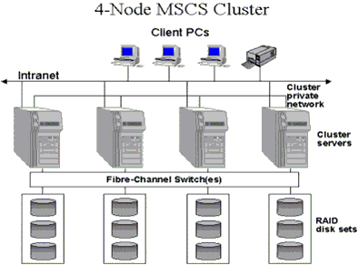

Figure 1. Connections for a four-node cluster.

General Network Configuration
Note
This guide assumes that you are running the default Start menu. The steps may be slightly different if you are running the Classic Start menu. Also, which network adapter is private and which is public depends upon your wiring. For the purposes of this white paper, the first network adapter (Local Area Connection) is connected to the public network, and the second network adapter (Local Area Connection 2) is connected to the private cluster network. Your network may be different.

To rename the local area network icons
It is recommended that you change the names of the network connections for clarity. For example, you might want to change the name of Local Area Connection 2 to something like Private. Renaming will help you identify a network and correctly assign its role.
1. Click Start, point to Control Panel, right-click Network Connections, and then click Open
2. Right-click the Local Area Connection 2 icon.
3. Click Rename.
4. Type Private in the textbox, and then press ENTER.
5. Repeat steps 1 through 3, and then rename the public network adapter as Public.
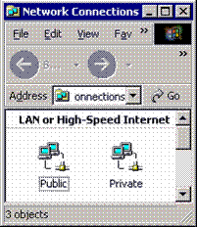

Figure 2. Renamed icons in the Network Connections window.
6. The renamed icons should look like those in Figure 2 above. Close the Network Connections window. The new connection names will appear in Cluster Administrator and automatically replicate to all other cluster nodes as they are brought online.

To configure the binding order networks on all nodes
1. Click Start, point to Control Panel, right-click Network Connections, and then click Open
2. On the Advanced menu, click Advanced Settings.
3. In the Connections box, make sure that your bindings are in the following order, and then click OK:
a. Public
b. Private
c. Remote Access Connections

Configuring the Private Network Adapter
1. Right-click the network connection for your heartbeat adapter, and then click Properties.
2. On the General tab, make sure that only the Internet Protocol (TCP/IP) check box is selected, as shown in Figure 3 below. Click to clear the check boxes for all other clients, services, and protocols.
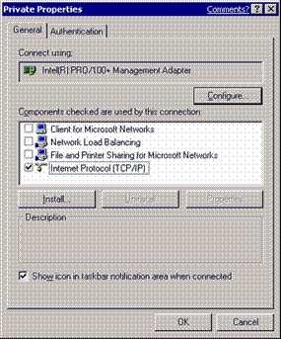

Figure 3. Click to select only the Internet Protocol check box in the Private Properties dialog box.
3. If you have a network adapter that is capable of transmitting at multiple speeds, you should manually specify a speed and duplex mode. Do not use an auto-select setting for speed, because some adapters may drop packets while determining the speed. The speed for the network adapters must be hard set (manually set) to be the same on all nodes according to the card manufacturer's specification. If you are not sure of the supported speed of your card and connecting devices, Microsoft recommends you set all devices on that path to 10megabytes per second (Mbps) and Half Duplex, as shown in Figure 4 below. The amount of information that is traveling across the heartbeat network is small, but latency is critical for communication. This configuration will provide enough bandwidth for reliable communication. All network adapters in a cluster attached to the same network must be configured identically to use the same Duplex Mode, Link Speed,Flow Control, and so on. Contact your adapter's manufacturer for specific information about appropriate speed and duplex settings for your network adapters.
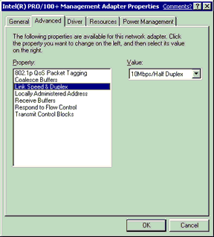

Figure 4. Setting the speed and duplex for all adaptors

Note
Microsoft does not recommended that you use any type of fault-tolerant adapter or "Teaming" for the heartbeat. If you require redundancy for your heartbeat connection, use multiple network adapters set to Internal Communication Only and define their network priority in the Cluster configuration. Issues seen with early multi-ported network adapters, verify that your firmware and driver are at the most current revision if you use this technology. Contact your network adapter manufacturer for information about compatibility on a server cluster. For more information, see the following article in the Microsoft Knowledge Base: 254101 Network Adapter Teaming and Server Clustering.

4. Click Internet Protocol (TCP/IP), and then click Properties.
5. On the General tab, verify that you have selected a static IP address that is not on the same subnet or network as any other public network adapter. It is recommended that you put the private network adapter in one of the following private network ranges:
• 10.0.0.0 through 10.255.255.255 (Class A)
• 172.16.0.0 through 172.31.255.255 (Class B)
• 192.168.0.0 through 192.168.255.255 (Class C)
An example of a good IP address to use for the private adapters is 10.10.10.10 on node 1 and 10.10.10.11 on node 2 with a subnet mask of 255.0.0.0, as shown in Figure 5 below. Be sure that this is a completely different IP address scheme then the one used for the public network.

Note
For more information about valid IP addressing for a private network, see the following article in the Microsoft Knowledge Base: 142863 Valid IP Addressing for a Private Network.

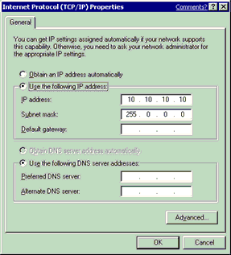

Figure 5. An example of an IP address to use for private adapters.
6. Verify that there are no values defined in the Default Gateway box or under Use the Following DNS server addresses.
7. Click the Advanced button.
8. On the DNS tab, verify that no values are defined. Make sure that the Register this connection's addresses in DNS and Use this connection's DNS suffix in DNS registration check boxes are cleared.
9. On the WINS tab, verify that there are no values defined. Click Disable NetBIOS over TCP/IP as shown in Figure 6 on the next page.
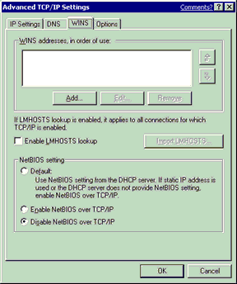

Figure 6. Verify that no values are defined on the WINS tab.
10. When you close the dialog box, you may receive the following prompt: “This connection has an empty primary WINS address. Do you want to continue?” If you receive this prompt, click Yes
11. Complete steps 1 through 10 on all other nodes in the cluster with different static IP addresses.

Configuring the Public Network Adapter
Note
If IP addresses are obtained via DHCP, access to cluster nodes may be unavailable if the DHCP server is inaccessible. For this reason, static IP addresses are required for all interfaces on a server cluster. Keep in mind that cluster service will only recognize one network interface per subnet. If you need assistance with TCP/IP addressing in Windows Server 2003, please see the Online Help.

Verifying Connectivity and Name Resolution
To verify that the private and public networks are communicating properly, ping all IP addresses from each node. You should be able to ping all IP addresses, locally and on the remote nodes.
To verify name resolution, ping each node from a client using the node’s machine name instead of its IP address. It should only return the IP address for the public network. You may also want to try a PING –a command to do a reverse lookup on the IP Addresses.

Verifying Domain Membership
All nodes in the cluster must be members of the same domain and be able to access a domain controller and a DNS server. They can be configured as member servers or domain controllers. You should have at least one domain controller on the same network segment as the cluster. For high availability. another domain controller should also be available to remove a single point of failure. In this guide, all nodes are configured as member servers.
There are instances where the nodes may be deployed in an environment where there are no pre-existing Microsoft® Windows NT® 4.0 domain controllers or Windows Server 2003 domain controllers. This scenario requires at least one of the cluster nodes to be configured as a domain controller. However, in a two-node server cluster, if one node is a domain controller, then the other node also must be a domain controller. In a four-node cluster implementation, it is not necessary to configure all four nodes as domain controllers. However, when following a “best practices” model and having at least one backup domain controller, at least one of the remaining three nodes should be configured as a domain controller. A cluster node must be promoted to a domain controller by using the DCPromo tool before the cluster service is configured.
The dependence in Windows Server 2003 on the DNS further requires that every node that is a domain controller also must be a DNS server if another DNS server that supports dynamic updates and/or SRV records is not available (Active directory integrated zones recommended).
The following issues should be considered when deploying cluster nodes as domain controllers:
• If one cluster node in a two-node cluster is a domain controller, the other node must be a domain controller
• There is overhead associated with running a domain controller. An idle domain controller can use anywhere between 130 and 140 MB of RAM, which includes having the Clustering service running. There is also increased network traffic from replication, because these domain controllers have to replicate with other domain controllers in the domain and across domains.
• If the cluster nodes are the only domain controllers, then each must be a DNS server as well. They should point to each other for primary DNS resolution and to themselves for secondary resolution.
• The first domain controller in the forest/domain will take on all Operations Master Roles. You can redistribute these roles to any node. However, if a node fails, the Operations Master Roles assumed by that node will be unavailable. Therefore, it is recommended that you do not run Operations Master Roles on any cluster node. This includes Scheme Master, Domain Naming Master, Relative ID Master, PDC Emulator, and Infrastructure Master. These functions cannot be clustered for high availability with failover.
• Clustering other applications such as Microsoft® SQL Server ™ or Microsoft® Exchange Server in a scenario where the nodes are also domain controllers may not be optimal due to resource constraints. This configuration should be thoroughly tested in a lab environment before deployment
Because of the complexity and overhead involved in making cluster-nodes domain controllers, it is recommended that all nodes should be member servers.

Setting Up a Cluster User Account
The Cluster service requires a domain user account that is a member of the Local Administrators group on each node, under which the Cluster service can run. Because setup requires a user name and password, this user account must be created before configuring the Cluster service. This user account should be dedicated only to running the Cluster service, and should not belong to an individual.
Note
The cluster service account does not need to be a member of the Domain Administrators group. For security reasons, granting domain administrator rights to the cluster service account is not recommended.
The cluster service account requires the following rights to function properly on all nodes in the cluster. The Cluster Configuration Wizard grants the following rights automatically:
• Act as part of the operating system
• Adjust memory quotas for a process
• Back up files and directories
• Increase scheduling priority
• Log on as a service
• Restore files and directories
For additional information, see the following article in the Microsoft Knowledge Base:
269229 How to Manually Re-Create the Cluster Service Account

To set up a cluster user account
1. Click Start, point to All Programs, point to Administrative Tools, and then click Active Directory Users and Computers.
2. Click the plus sign (+) to expand the domain if it is not already expanded.
3. Right-click Users, point to New, and then click User.
4. Type the cluster name, as shown in Figure 7 below, and then click Next.
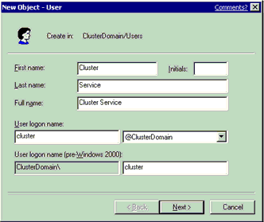

Figure 7. Type the cluster name.
5. Set the password settings to User Cannot Change Password and Password Never Expires. Click Next, and then click Finish to create this user.

Note
If your administrative security policy does not allow the use of passwords that never expire, you must renew the password and update the cluster service configuration on each node before password expiration. For additional information, see the following article in the Microsoft Knowledge Base: 305813 How to Change the Cluster Service Account Password.

6. Right-click Cluster in the left pane of the Active Directory Users and Computers snap-in, and then click Properties on the shortcut menu.
7. Click Add Members to a Group.
8. Click Administrators, and then click OK. This gives the new user account administrative privileges on this computer.
9. Quit the Active Directory Users and Computers snap-in.

Setting up Shared Disks
Important
To avoid corrupting the cluster disks, make sure that Windows Server 2003 and the Cluster service are installed, configured, and running on at least one node before you start an operating system on another node. It is critical to never have more then one node on until the Cluster service is configured.
To proceed, turn off all nodes. Turn on the shared storage devices, and then turn on node 1.

About the Quorum Disk
The quorum disk is used to store cluster configuration database checkpoints and log files that help manage the cluster and maintain consistency. The following quorum disk procedures are recommended:
• Create a logical drive with a minimum size of 50 MB to be used as a quorum disk, 500 MB is optimal for NTFS.
• Dedicate a separate disk as a quorum resource.

Important
A quorum disk failure could cause the entire cluster to fail; therefore, it is strongly recommended that you use a volume on a hardware RAID array. Do not use the quorum disk for anything other than cluster management.

The quorum resource plays a crucial role in the operation of the cluster. In every cluster, a single resource is designated as the quorum resource. A quorum resource can be any Physical Disk resource with the following functionality:
• It replicates the cluster registry to all other nodes in the server cluster. By default, the cluster registry is stored in the following location on each node: %SystemRoot%\Cluster\Clusdb. The cluster registry is then replicated to the MSCS\Chkxxx.tmp file on the quorum drive. These files are exact copies of each other. The MSCS\Quolog.log file is a transaction log that maintains a record of all changes to the checkpoint file. This means that nodes that were offline can have these changes appended when they rejoin the cluster.
• If there is a loss of communication between cluster nodes, the challenge response protocol is initiated to prevent a "split brain" scenario. In this situation, the owner of the quorum disk resource becomes the only owner of the cluster and all the resources. The owner then makes the resources available for clients. When the node that owns the quorum disk functions incorrectly, the surviving nodes arbitrate to take ownership of the device. For additional information, see the following article in the Microsoft Knowledge Base: 309186 How the Cluster Service Takes Ownership of a Disk on the Shared Bus.
During the cluster service installation, you must provide the drive letter for the quorum disk. The letter Q is commonly used as a standard, and Q is used in the example.

To configure shared disks
1. Make sure that only one node is turned on.
2. Right click My Computer, click Manage, and then expand Storage.
3. Double-click Disk Management.
4. If you connect a new drive, then it automatically starts the Write Signature and Upgrade Disk Wizard. If this happens, click Next to step through the wizard.

Note
The wizard automatically sets the disk to dynamic. To reset the disk to basic, right-click Disk n (where n specifies the disk that you are working with), and then click Revert to Basic Disk.

5. Right-click unallocated disk space.
6. Click New Partition.
7. The New Partition Wizard begins. Click Next.
8. Select the Primary Partition partition type. Click Next.
9. The default is set to maximum size for the partition size. Click Next. (Multiple logical disks are recommended over multiple partitions on one disk.)
10. Use the drop-down box to change the drive letter. Use a drive letter that is farther down the alphabet than the default enumerated letters. Commonly, the drive letter Q is used for the quorum disk, then R, S,and so on for the data disks. For additional information, see the following article in the Microsoft Knowledge Base:
318534 Best Practices for Drive-Letter Assignments on a Server Cluster

Note
If you are planning on using volume mount points, do not assign a drive letter to the disk. For additional information, see the following article in the Microsoft Knowledge Base: 280297 How to Configure Volume Mount Points on a Clustered Server.

11. Format the partition using NTFS. In the Volume Label box, type a name for the disk. For example, Drive Q, as shown in Figure 8 below. It is critical to assign drive labels for shared disks, because this can dramatically reduce troubleshooting time in the event of a disk recovery situation.
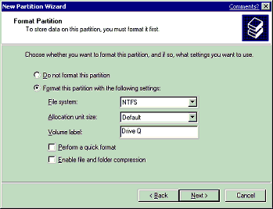

Figure 8. It is critical to assign drive labels for shared disks.
If you are installing a 64-bit version of Windows Server 2003, verify that all disks are formatted as MBR. Global Partition Table (GPT) disks are not supported as clustered disks. For additional information, see the following article in the Microsoft Knowledge Base:
284134 Server Clusters Do Not Support GPT Shared Disks
Verify that all shared disks are formatted as NTFS and designated as MBR Basic.

To verify disk access and functionality
1. Start Windows Explorer.
2. Right-click one of the shared disks (such as Drive Q:\), click New, and then click Text Document.
3. Verify that you can successfully write to the disk and that the file was created.
4. Select the file, and then press the Del key to delete it from the clustered disk.
5. Repeat steps 1 through 4 for all clustered disks to verify they can be correctly accessed from the first node.
6. Turn off the first node, turn on the second node, and repeat steps 1 through 4 to verify disk access and functionality. Assign drive letters to match the corresponding drive labels. Repeat again for any additional nodes. Verify that all nodes can read and write from the disks, turn off all nodes except the first one, and then continue with this white paper.

Configuring the Cluster Service
You must supply all initial cluster configuration information in the first installation phase. This is accomplished using the Cluster Configuration Wizard.
As seen in the flow chart, the form (Create a new Cluster) and the Join (Add nodes) take a couple different paths, but they have a few of the same pages. Namely, Credential Login, Analyze, and Re-Analyze and Start Service are the same. There are minor differences in the following pages: Welcome, Select Computer, and Cluster Service Account. In the next two sections of this lesson, you will step through the wizard pages presented on each of these configuration paths. In the third section, after you follow the step-through sections, this white paper describes in detail the Analyze, ,Re-Analyze and Start Service pages, and what the information provided in these screens means.
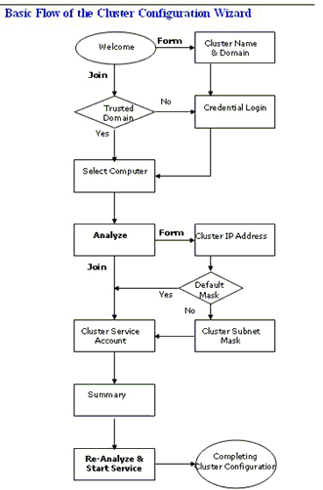

Note
During Cluster service configuration on node 1, you must turn off all other nodes. All shared storage devices should be turned on.

To configure the first node
1. Click Start, click AllPrograms, click Administrative Tools, and then click Cluster Administrator.
2. When prompted by the Open Connection to Cluster Wizard, click Create new cluster in the Action drop-down list, as shown in Figure 9 below.
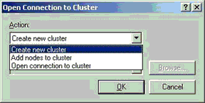

Figure 9. The Action drop-down list.
3. Verify that you have the necessary prerequisites to configure the cluster, as shown in Figure 10 below. Click Next.
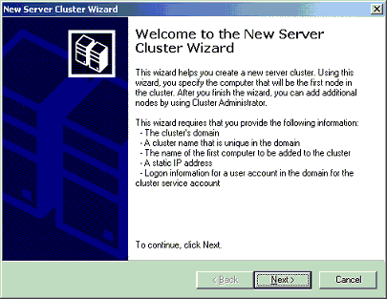

Figure 10. A list of prerequisites is part of the New Server Cluster Wizard Welcome page.
4. Type a unique NetBIOS name for the cluster (up to 15 characters), and then click Next. In the example shown in Figure 11 below, the cluster is named MyCluster.) Adherence to DNS naming rules is recommended. For additional information, see the following articles in the Microsoft Knowledge Base:
163409 NetBIOS Suffixes (16th Character of the NetBIOS Name)
254680 DNS Namespace Planning
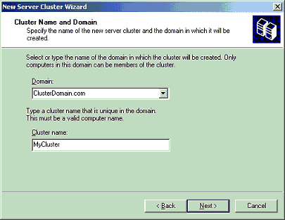

Figure 11. Adherence to DNS naming rules is recommended when naming the cluster.
5. If you are logged on locally with an account that is not a Domain Account with Local Administrative privileges, the wizard will prompt you to specify an account. This is not the account the Cluster service will use to start.

Note
If you have appropriate credentials, the prompt mentioned in step 5 and shown in Figure 12 below may not appear.

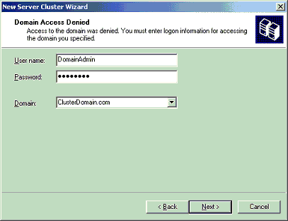

Figure 12. The New Server Cluster Wizard prompts you to specify an account.
6. Because it is possible to configure clusters remotely, you must verify or type the name of the server that is going to be used as the first node to create the cluster, as shown in Figure 13 below. Click Next.
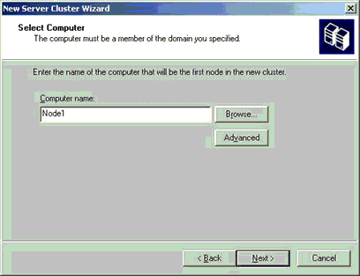

Figure 13. Select the name of the computer that will be the first node in the cluster.

Note
The Install wizard verifies that all nodes can see the shared disks the same. In a complex storage area network the target identifiers (TIDs) for the disks may sometimes be different, and the Setup program may incorrectly detect that the disk configuration is not valid for Setup. To work around this issue you can click the Advanced button, and then click Advanced (minimum) configuration. For additional information, see the following article in the Microsoft Knowledge Base: 331801 Cluster Setup May Not Work When You Add Nodes

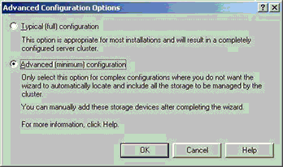

7. Figure 14 below illustrates that the Setup process will now analyze the node for possible hardware or software problems that may cause problems with the installation. Review any warnings or error messages. You can also click the Details button to get detailed information about each one.
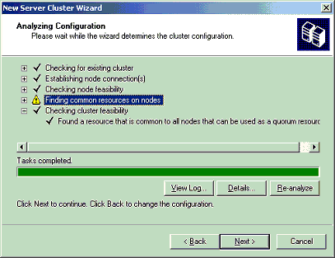

Figure 14. The Setup process analyzes the node for possible hardware or software problems.
8. Type the unique cluster IP address (in this example 172.26.204.10), and then click Next.
As shown in Figure 15 below, the New Server Cluster Wizard automatically associates the cluster IP address with one of the public networks by using the subnet mask to select the correct network. The cluster IP address should be used for administrative purposes only, and not for client connections.
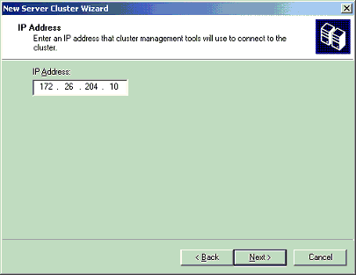

Figure 15. The New Server Cluster Wizard automatically associates the cluster IP address with one of the public networks.
9. Type the user name and password of the cluster service account that was created during pre-installation. (In the example in Figure 16 below, the user name is “Cluster”). Select the domain name in the Domain drop-down list, and then click Next.
At this point, the Cluster Configuration Wizard validates the user account and password.
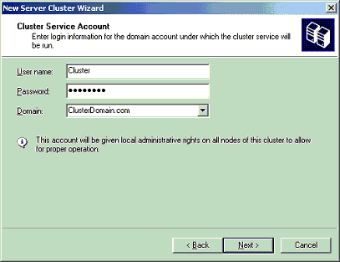

Figure 16. The wizard prompts you to provide the account that was created during pre-installation.
10. Review the Summary page, shown in Figure 17 below, to verify that all the information that is about to be used to create the cluster is correct. If desired, you can use the quorum button to change the quorum disk designation from the default auto-selected disk.
The summary information displayed on this screen can be used to reconfigure the cluster in the event of a disaster recovery situation. It is recommended that you save and print a hard copy to keep with the change management log at the server.

Note
The Quorum button can also be used to specify a Majority Node Set (MNS) quorum model. This is one of the major configuration differences when you create an MNS cluster

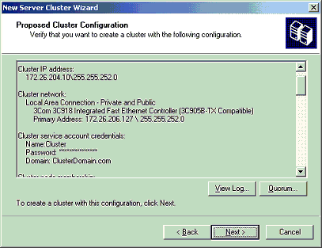

Figure 17. The Proposed Cluster Configuration page.
11. Review any warnings or errors encountered during cluster creation. To do this, click the plus signs to see more, and then click Next. Warnings and errors appear in the Creating the Cluster page as shown in Figure 18.
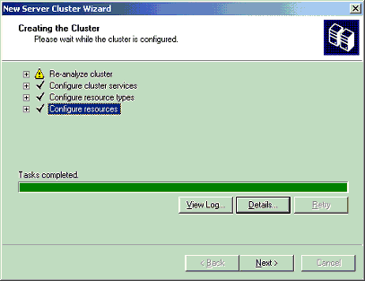

Figure 18. Warnings and errors appear on the Creating the Cluster page.
12. Click Finish to complete the installation. Figure 19 below illustrates the final step.
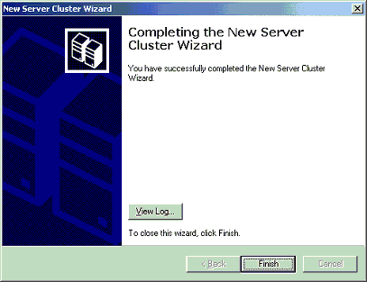

Figure 19. The final step in setting up a new server cluster.
Note
To view a detailed summary, click the View Log button or view the text file stored in the following location:
%SystemRoot%\System32\LogFiles\Cluster\ClCfgSrv.Log

Validating the Cluster Installation
Use the Cluster Administrator (CluAdmin.exe) to validate the cluster service installation on node 1.

To validate the cluster installation
1. Click Start, click Programs, click Administrative Tools, and then click Cluster Administrator.
2. Verify that all resources came online successfully, as shown in Figure 20 below.
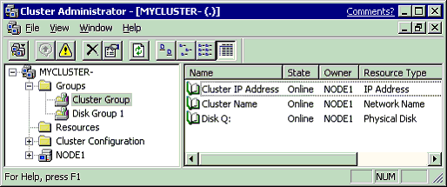

Figure 20. The Cluster Administer verifies that all resources came online successfully.
Note
As general rules, do not put anything in the cluster group, do not take anything out of the cluster group, and do not use anything in the cluster group for anything other than cluster administration.

Configuring the Second Node
Installing the cluster service on the other nodes requires less time than on the first node. Setup configures the cluster service network settings on the second node based on the configuration of the first node. You can also add multiple nodes to the cluster at the same time, and remotely.
Note
For this section, leave node 1 and all shared disks turned on. Then turn on all other nodes. The cluster service will control access to the shared disks at this point to eliminate any chance of corrupting the volume.
1. Open Cluster Administrator on Node 1.
2. Click File, click New, and then click Node.
3. The Add Cluster Computers Wizard will start. Click Next.
4. If you are not logged on with appropriate credentials, you will be asked to specify a domain account that has administrative rights over all nodes in the cluster.
5. Enter the machine name for the node you want to add to the cluster. Click Add. Repeat this step, shown in Figure 21 below, to add all other nodes that you want. When you have added all nodes, click Next.
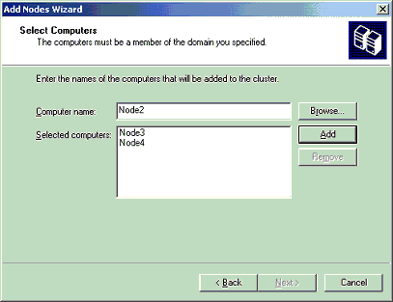

Figure 21. Adding nodes to the cluster.
6. The Setup wizard will perform an analysis of all the nodes to verify that they are configured properly.
7. Type the password for the account used to start the cluster service.
8. Review the summary information that is displayed for accuracy. The summary information will be used to configure the other nodes when they join the cluster.
9. Review any warnings or errors encountered during cluster creation, and then click Next.
10. Click Finish to complete the installation.

Post-Installation Configuration

Heartbeat Configuration
Now that the networks have been configured correctly on each node and the Cluster service has been configured, you need to configure the network roles to define their functionality within the cluster. Here is a list of the network configuration options in Cluster Administrator:
• Enable for cluster use: If this check box is selected, the cluster service uses this network. This check box is selected by default for all networks.
• Client access only (public network): Select this option if you want the cluster service to use this network adapter only for external communication with other clients. No node-to-node communication will take place on this network adapter.
• Internal cluster communications only (private network): Select this option if you want the cluster service to use this network only for node-to-node communication.
• All communications (mixed network): Select this option if you want the cluster service to use the network adapter for node-to-node communication and for communication with external clients. This option is selected by default for all networks.
This white paper assumes that only two networks are in use. It explains how to configure these networks as one mixed network and one private network. This is the most common configuration. If you have available resources, two dedicated redundant networks for internal-only cluster communication are recommended.

To configure the heartbeat
1. Start Cluster Administrator.
2. In the left pane, click Cluster Configuration, click Networks, right-click Private, and then click Properties.
3. Click Internal cluster communications only (private network), as shown in Figure 22 on the next page.
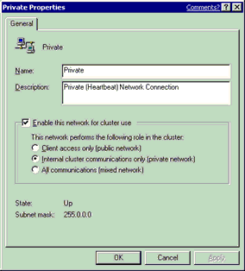

Figure 22. Using Cluster Administrator to configure the heartbeat.
4. Click OK.
5. Right-click Public, and then click Properties (shown in Figure 23 below).
6. Click to select the Enable this network for cluster use check box.
7. Click the All communications (mixed network) option, and then click OK.
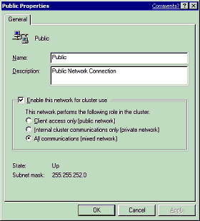

Figure 23. The Public Properties dialog box.

Heartbeat Adapter Prioritization
After configuring the role of how the cluster service will use the network adapters, the next step is to prioritize the order in which they will be used for intra-cluster communication. This is applicable only if two or more networks were configured for node-to-node communication. Priority arrows on the right side of the screen specify the order in which the cluster service will use the network adapters for communication between nodes. The cluster service always attempts to use the first network adapter listed for remote procedure call (RPC) communication between the nodes. Cluster service uses the next network adapter in the list only if it cannot communicate by using the first network adapter.
1. Start Cluster Administrator.
2. In the left pane, right-click the cluster name (in the upper left corner), and then click Properties.
3. Click the Network Priority tab, as shown in Figure 24 below.
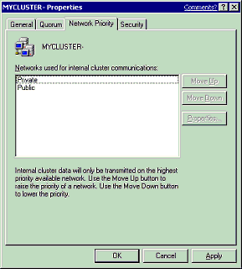

Figure 24. The Network Priority tab in Cluster Administrator.
4. Verify that the Private network is listed at the top. Use the Move Up or Move Down buttons to change the priority order.
5. Click OK.

Configuring Cluster Disks
• Start Cluster Administrator, right-click any disks that you want to remove from the cluster, and then click Delete.
Note
By default, all disks not residing on the same bus as the system disk will have Physical Disk Resources created for them, and will be clustered. Therefore, if the node has multiple buses, some disks may be listed that will not be used as shared storage, for example, an internal SCSI drive. Such disks should be removed from the cluster configuration. If you plan to implement Volume Mount points for some disks, you may want to delete the current disk resources for those disks, delete the drive letters, and then create a new disk resource without a drive letter assignment.

Quorum Disk Configuration
The Cluster Configuration Wizard automatically selects the drive that is to be used as the quorum device. It will use the smallest partition that is larger then 50 MB. You may want to change the automatically selected disk to a dedicated disk that you have designated for use as the quorum.

To configure the quorum disk
1. Start Cluster Administrator (CluAdmin.exe).
2. Right-click the cluster name in the upper-left corner, and then click Properties.
3. Click the Quorum tab.
4. In the Quorum resource list box, select a different disk resource. In Figure 25 below, Disk Q is selected in the Quorum resource list box.
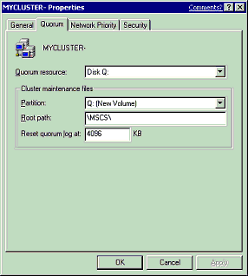

Figure 25. The Quorum resource list box.
5. If the disk has more than one partition, click the partition where you want the cluster-specific data to be kept, and then click OK.
For additional information, see the following article in the Microsoft Knowledge Base:
Q280353 How to Change Quorum Disk Designation

Creating a Boot Delay
In a situation where all the cluster nodes boot up and attempt to attach to the quorum resource at the same time, the Cluster service may fail to start. For example, this may occur when power is restored to all nodes at the exact same time after a power failure. To avoid such a situation, increase or decrease the Time toDisplay list of operating systems setting. To find this setting, click Start, point to My Computer, right-click My Computer, and then click Properties. Click the Advanced tab, and then click Settings under Startup And Recovery.

Test Installation
There are several methods for verifying a cluster service installation after the Setup process is complete. These include:
• Cluster Administrator: If installation was completed only on node 1, start Cluster Administrator, and then attempt to connect to the cluster. If a second node was installed, start Cluster Administrator on either node, connect to the cluster, and then verify that the second node is listed.
• Services Applet: Use the services snap-in to verify that the cluster service is listed and started.
• Event Log: Use the Event Viewer to check for ClusSvc entries in the system log. You should see entries confirming that the cluster service successfully formed or joined a cluster.
• Cluster service registry entries: Verify that the cluster service installation process wrote the correct entries to the registry. You can find many of the registry settings under HKEY_LOCAL_MACHINE\Cluster
• Click Start, click Run, and then type the Virtual Server name. Verify that you can connect and see resources.

Test Failover

To verify that resources will failover
1. Click Start, click Programs, click Administrative Tools, and then click Cluster Administrator, as shown in Figure 26 below.
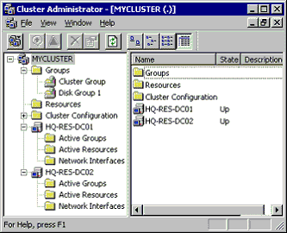

Figure 26. The Cluster Administrator window.
2. Right-click the Disk Group 1 group, and then click Move Group. The group and all its resources will be moved to another node. After a short period of time, the Disk F: G: will be brought online on the second node. Watch the window to see this shift. Quit Cluster Administrator.
Congratulations! You have completed the configuration of the cluster service on all nodes. The server cluster is fully operational. You are now ready to install cluster resources such as file shares, printer spoolers, cluster aware services like Distributed Transaction Coordinator, DHCP, WINS, or cluster-aware programs such as Exchange Server or SQL Server.

Appendix (Guide to Creating and Configuring a Server Cluster under Windows Server 2003 White Paper)

Advanced Testing
Now that you have configured your cluster and verified basic functionality and failover, you may want to conduct a series of failure scenario tests that will demonstrate expected results and ensure the cluster will respond correctly when a failure occurs. This level of testing is not required for every implementation, but may be insightful if you are new to clustering technology and are unfamiliar how the cluster will respond or if you are implementing a new hardware platform in your environment. The expected results listed are for a clean configuration of the cluster with default settings, this does not take into consideration any user customization of the failover logic. This is not a complete list of all tests, nor should successfully completing these tests be considered “certified” or ready for production. This is simply a sample list of some tests that can be conducted. For additional information, see the following article in the Microsoft Knowledge Base:
197047 Failover/Failback Policies on Microsoft Cluster Server
Test: Start Cluster Administrator, right-click a resource, and then click “Initiate Failure”. The resource should go into an failed state, and then it will be restarted and brought back into an online state on that node.
Expected Result: Resources should come back online on the same node
Test: Conduct the above “Initiate Failure” test three more times on that same resource. On the fourth failure, the resources should all failover to another node in the cluster.
Expected Result: Resources should failover to another node in the cluster
Test: Move all resources to one node. Start Computer Management, and then click Services under Services and Applications. Stop the Cluster service. Start Cluster Administrator on another node and verify that all resources failover and come online on another node correctly.
Expected Result: Resources should failover to another node in the cluster
Test: Move all resources to one node. On that node, click Start, and then click Shutdown. This will turn off that node. Start Cluster Administrator on another node, and then verify that all resources failover and come online on another node correctly.
Expected Result: Resources should failover to another node in the cluster
Test: Move all resources to one node, and then press the power button on the front of that server to turn it off. If you have an ACPI compliant server, the server will perform an “Emergency Shutdown” and turn off the server. Start Cluster Administrator on another node and verify that all resources failover and come online on another node correctly. For additional information about an Emergency Shutdown, see the following articles in the Microsoft Knowledge Base:
325343 HOW TO: Perform an Emergency Shutdown in Windows Server 2003
297150 Power Button on ACPI Computer May Force an Emergency Shutdown
Expected Result: Resources should failover to another node in the cluster
Important
Performing the Emergency Shutdown test may cause data corruption and data loss. Do not conduct this test on a production server
Test: Move all resources to one node, and then pull the power cables from that server to simulate a hard failure. Start Cluster Administrator on another node, and then verify that all resources failover and come online on another node correctly
Expected Result: Resources should failover to another node in the cluster
Important
Performing the hard failure test may cause data corruption and data loss. This is an extreme test. Make sure you have a backup of all critical data, and then conduct the test at your own risk. Do not conduct this test on a production server
Test: Move all resources to one node, and then remove the public network cable from that node. The IP Address resources should fail, and the groups will all failover to another node in the cluster. For additional information, see the following articles in the Microsoft Knowledge Base:
286342 Network Failure Detection and Recovery in Windows Server 2003 Clusters
Expected Result: Resources should failover to another node in the cluster
Test: Remove the network cable for the Private heartbeat network. The heartbeat traffic will failover to the public network, and no failover should occur. If failover occurs, please see the “Configuring the Private Network Adaptor” section in earlier in this document
Expected Result: There should be no failures or resource failovers

SCSI Drive Installations
This appendix is provided as a generic set of instructions for SCSI drive installations. If the SCSI hard disk vendor’s instructions conflict with the instructions here, always follow the instructions supplied by the vendor.
The SCSI bus listed in the hardware requirements must be configured prior to cluster service installation. Configuration applies to:
• The SCSI devices.
• The SCSI controllers and the hard disks so that they work properly on a shared SCSI bus.
• Properly terminating the bus. The shared SCSI bus must have a terminator at each end of the bus. It is possible to have multiple shared SCSI buses between the nodes of a cluster.
In addition to the information on the following pages, refer to documentation from the manufacturer of your SCSI device or to the SCSI specifications, which can be ordered from the American National Standards Institute (ANSI). The ANSI Web site includes a catalog that can be searched for the SCSI specifications.

Configuring the SCSI Devices
Each device on the shared SCSI bus must have a unique SCSI identification number. Because most SCSI controllers default to SCSI ID 7, configuring the shared SCSI bus includes changing the SCSI ID number on one controller to a different number, such as SCSI ID 6. If there is more than one disk that will be on the shared SCSI bus, each disk must have a unique SCSI ID number.

Terminating the Shared SCSI Bus
There are several methods for terminating the shared SCSI bus. They include:
• SCSI controllers
SCSI controllers have internal soft termination that can be used to terminate the bus, however this method is not recommended with the cluster server. If a node is turned off with this configuration, the SCSI bus will be terminated improperly and will not operate correctly.
• Storage enclosures
Storage enclosures also have internal termination, which can be used to terminate the SCSI bus if the enclosure is at the end of the SCSI bus. This should be turned off.
• Y cables
Y cables can be connected to devices if the device is at the end of the SCSI bus. An external active terminator can then be attached to one branch of the Y cable in order to terminate the SCSI bus. This method of termination requires either disabling or removing any internal terminators that the device may have.
Figure 27 outlines how a SCSI cluster should be physically connected.
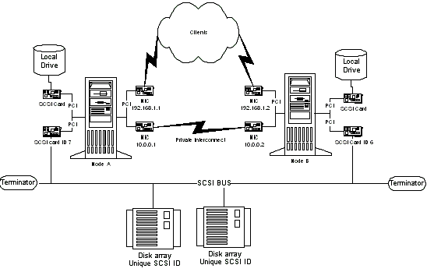

Figure 27. A diagram of a SCSI cluster hardware configuration.
Note
Any devices that are not at the end of the shared bus must have their internal termination disabled. Y cables and active terminator connectors are the recommended termination methods because they will provide termination even when a node is not online.

Storage Area Network Considerations
There are two supported methods of Fibre Channel-based storage in a Windows Server 2003 server cluster: arbitrated loops and switched fabric.
Important
When evaluating both types of Fibre Channel implementation, read the vendor’s documentation and be sure you understand the specific features and restrictions of each.
Although the term Fibre Channel implies the use of fiber-optic technology, copper coaxial cable is also allowed for interconnects.

Arbitrated Loops (FC-AL)
A Fibre Channel arbitrated loop (FC-AL) is a set of nodes and devices connected into a single loop. FC-AL provides a cost-effective way to connect up to 126 devices into a single network. As with SCSI, a maximum of two nodes is supported in an FC-AL server cluster configured with a hub. An FC-AL is illustrated in Figure 28.
Figure 28 FC-AL Connection
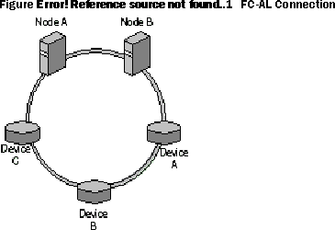

FC-ALs provide a solution for two nodes and a small number of devices in relatively static configurations. All devices on the loop share the media, and any packet traveling from one device to another must pass through all intermediate devices.
If your high-availability needs can be met with a two-node server cluster, an FC-AL deployment has several advantages:
• The cost is relatively low.
• Loops can be expanded to add storage (although nodes cannot be added).
• Loops are easy for Fibre Channel vendors to develop.
The disadvantage is that loops can be difficult to deploy in an organization. Because every device on the loop shares the media, overall bandwidth in the cluster is lowered. Some organizations might also be unduly restricted by the 126-device limit.

Switched Fabric (FC-SW)
For any cluster larger than two nodes, a switched Fibre Channel switched fabric (FC-SW) is the only supported storage technology. In an FC-SW, devices are connected in a many-to-many topology using Fibre Channel switches (illustrated in Figure 29).
Figure 29 FC-SW Connection
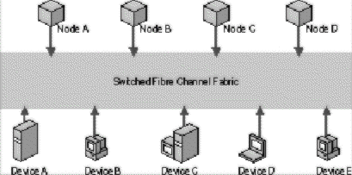

When a node or device communicates with another node or device in an FC-SW, the source and target set up a point-to-point connection (similar to a virtual circuit) and communicate directly with each other. The fabric itself routes data from the source to the target. In an FC-SW, the media is not shared. Any device can communicate with any other device, and communication occurs at full bus speed. This is a fully scalable enterprise solution and, as such, is highly recommended for deployment with server clusters.
FC-SW is the primary technology employed in SANs. Other advantages of FC-SW include ease of deployment, the ability to support millions of devices, and switches that provide fault isolation and rerouting. Also, there is no shared media as there is in FC-AL, allowing for faster communication. However, be aware that FC-SWs can be difficult for vendors to develop, and the switches can be expensive. Vendors also have to account for interoperability issues between components from different vendors or manufacturers.

Using SANs with Server Clusters
For any large-scale cluster deployment, it is recommended that you use a SAN for data storage. Smaller SCSI and stand-alone Fibre Channel storage devices work with server clusters, but SANs provide superior fault tolerance.
A SAN is a set of interconnected devices (such as disks and tapes) and servers that are connected to a common communication and data transfer infrastructure (FC-SW, in the case of Windows Server 2003 clusters). A SAN allows multiple server access to a pool of storage in which any server can potentially access any storage unit.
The information in this section provides an overview of using SAN technology with your Windows Server 2003 clusters. For additional information about deploying server clusters on SANs, see the Windows Clustering: Storage Area Networks link on the Web Resources page at http://www.microsoft.com/windows/reskits/webresources.
Note
Vendors that provide SAN fabric components and software management tools have a wide range of tools for setting up, configuring, monitoring, and managing the SAN fabric. Contact your SAN vendor for details about your particular SAN solution.

SCSI Resets
Earlier versions of Windows server clusters presumed that all communications to the shared disk should be treated as an isolated SCSI bus. This behavior may be somewhat disruptive, and it does not take advantage of the more advanced features of Fibre Channel to both improve arbitration performance and reduce disruption.
One key enhancement in Windows Server 2003 is that the Cluster service issues a command to break a RESERVATION, and the StorPort driver can do a targeted or device reset for disks that are on a Fibre Channel topology. In Windows 2000 server clusters, an entire bus-wide SCSI RESET is issued. This causes all devices on the bus to be disconnected. When a SCSI RESET is issued, a lot of time is spent resetting devices that may not need to be reset, such as disks that the CHALLENGER node may already own.
Resets in Windows 2003 occur in the following order:
1. Targeted logical unit number (LUN)
2. Targeted SCSI ID
3. Entire bus-wide SCSI RESET
Note
Targeted resets require functionality in the host bus adapter (HBA) drivers. The driver must be written for StorPort and not SCSIPort. Drivers that use SCSIPort will use the Challenge and Defense the same as it is currently in Windows 2000. Contact the manufacturer of the HBA to determine if it supports StorPort.

SCSI Commands
The Cluster service uses the following SCSI commands:
• SCSI reserve: This command is issued by a host bus adapter or controller to maintain ownership of a SCSI device. A device that is reserved refuses all commands from all other host bus adapters except the one that initially reserved it, the initiator. If a bus-wide SCSI reset command is issued, loss of reservation occurs.
• SCSI release: This command is issued by the owning host bus adapter; it frees a SCSI device for another host bus adapter to reserve.
• SCSI reset: This command breaks the reservation on a target device. This command is sometimes referred to globally as a "bus reset."
The same control codes are used for Fibre Channel as well. These parameters are defined in this partner article:
309186 How the Cluster Service Takes Ownership of a Disk on the Shared Bus
317162 Supported Fibre Channel Configurations
The following sections provide an overview of SAN concepts that directly affect a server cluster deployment.

HBAs
Host bus adapters (HBAs) are the interface cards that connect a cluster node to a SAN, similar to the way that a network adapter connects a server to a typical Ethernet network. HBAs, however, are more difficult to configure than network adapters (unless the HBAs are preconfigured by the SAN vendor). All HBAs in all nodes should be identical and be at the same driver and firmware revision

Zoning and LUN Masking
Zoning and LUN masking are fundamental to SAN deployments, particularly as they relate to a Windows Server 2003 cluster deployment.

Zoning
Many devices and nodes can be attached to a SAN. With data stored in a single cloud, or storage entity, it is important to control which hosts have access to specific devices. Zoning allows administrators to partition devices in logical volumes and thereby reserve the devices in a volume for a server cluster. That means that all interactions between cluster nodes and devices in the logical storage volumes are isolated within the boundaries of the zone; other noncluster members of the SAN are not affected by cluster activity.
Figure 30 is a logical depiction of two SAN zones (Zone A and Zone B), each containing a storage controller (S1and S2, respectively).
Figure 30 Zoning
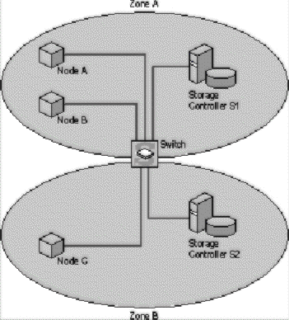

In this implementation, Node A and Node B can access data from the storage controller S1, but Node C cannot. Node C can access data from storage controller S2.
Zoning needs to be implemented at the hardware level (with the controller or switch) and not through software. The primary reason is that zoning is also a security mechanism for a SAN-based cluster, because unauthorized servers cannot access devices inside the zone (access control is implemented by the switches in the fabric, so a host adapter cannot gain access to a device for which it has not been configured). With software zoning, the cluster would be left unsecured if the software component failed.
In addition to providing cluster security, zoning also limits the traffic flow within a given SAN environment. Traffic between ports is routed only to segments of the fabric that are in the same zone.

LUN Masking
A LUN is a logical disk defined within a SAN. Server clusters see LUNs and think they are physical disks. LUN masking, performed at the controller level, allows you to define relationships between LUNs and cluster nodes. Storage controllers usually provide the means for creating LUN-level access controls that allow access to a given LUN to one or more hosts. By providing this access control at the storage controller, the controller itself can enforce access policies to the devices.
LUN masking provides more specific security than zoning, because LUNs provide a means for zoning at the port level. For example, many SAN switches allow overlapping zones, which enable a storage controller to reside in multiple zones. Multiple clusters in multiple zones can share the data on those controllers. Figure 31 illustrates such a scenario.
Figure 31 Storage Controller in Multiple Zones
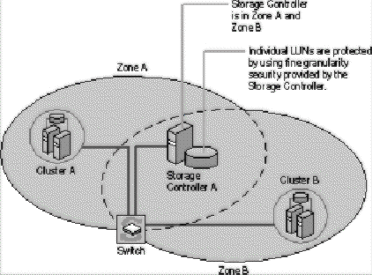

LUNs used by Cluster A can be masked, or hidden, from Cluster B so that only authorized users can access data on a shared storage controller.

Requirements for Deploying SANs with Windows Server 2003 Clusters
The following list highlights the deployment requirements you need to follow when using a SAN storage solution with your server cluster. For a white paper that provides more complete information about using SANs with server clusters, see the Windows Clustering: Storage Area Networks link on the Web Resources page at http://www.microsoft.com/windows/reskits/webresources.
Each cluster on a SAN must be deployed in its own zone. The mechanism the cluster uses to protect access to the disks can have an adverse effect on other clusters that are in the same zone. By using zoning to separate the cluster traffic from other cluster or noncluster traffic, there is no chance of interference.
All HBAs in a single cluster must be the same type and have the same firmware version. Many storage and switch vendors require that all HBAs on the same zone—and, in some cases, the same fabric—share these characteristics.
All storage device drivers and HBA device drivers in a cluster must have the same software version.
Never allow multiple nodes access to the same storage devices unless they are in the same cluster.
Never put tape devices into the same zone as cluster disk storage devices. A tape device could misinterpret a bus rest and rewind at inappropriate times, such as during a large backup.

Guidelines for Deploying SANs with Windows Server 2003 Server Clusters
In addition to the SAN requirements discussed in the previous section, the following practices are highly recommended for server cluster deployment:
In a highly available storage fabric, you need to deploy clustered servers with multiple HBAs. In these cases, always load the multipath driver software. If the I/O subsystem sees two HBAs, it assumes they are different buses and enumerates all the devices as though they were different devices on each bus. The host, meanwhile, is seeing multiple paths to the same disks. Failure to load the multipath driver will disable the second device because the operating system sees what it thinks are two independent disks with the same signature.
Do not expose a hardware snapshot of a clustered disk back to a node in the same cluster. Hardware snapshots must go to a server outside the server cluster. Many controllers provide snapshots at the controller level that can be exposed to the cluster as a completely separate LUN. Cluster performance is degraded when multiple devices have the same signature. If the snapshot is exposed back to the node with the original disk online, the I/O subsystem attempts to rewrite the signature. However, if the snapshot is exposed to another node in the cluster, the Cluster service does not recognize it as a different disk and the result could be data corruption. Although this is not specifically a SAN issue, the controllers that provide this functionality are typically deployed in a SAN environment.
For additional information, see the following articles in the Microsoft Knowledge Base:
301647 Cluster Service Improvements for Storage Area Networks
304415 Support for Multiple Clusters Attached to the Same SAN Device
280743 Windows Clustering and Geographically Separate Sites

Related Links (Guide to Creating and Configuring a Server Cluster under Windows Server 2003 White Paper)
See the following resources for further information:
• Microsoft Cluster Service Installation Resources at http://support.microsoft.com/?id=259267
• Quorum Drive Configuration Information at http://support.microsoft.com/?id=280345
• Recommended Private "Heartbeat" Configuration on Cluster Server at http://support.microsoft.com/?id=258750
• Network Failure Detection and Recovery in a Server Cluster at http://support.microsoft.com/?id=242600
• How to Change Quorum Disk Designation at http://support.microsoft.com/?id=280353
• Microsoft Windows Clustering: Storage Area Networks at http://www.microsoft.com/windows.netserver/techinfo/overview/san.mspx
• Geographically Dispersed Clusters in Windows Server 2003 at http://www.microsoft.com/windows.netserver/techinfo/overview/clustergeo.mspx
For the latest information about Windows Server 2003, see the Windows 2003 Server Web site at http://www.microsoft.com/windowsserver2003/default.mspx

