Microsoft® Visual FoxPro® 8.0 Evaluation Guide

Visual FoxPro 8.0 provides the tools needed to create and manage
high-performance, 32-bit database applications and components
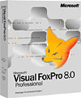

© 2003 Microsoft Corp. All rights reserved.
This is a preliminary document and may be changed substantially prior to final commercial release of the software described herein.
The information contained in this document represents the current view of Microsoft Corp. on the issues discussed as of the date of publication. Because Microsoft must respond to changing market conditions, it should not be interpreted to be a commitment on the part of Microsoft, and Microsoft cannot guarantee the accuracy of any information presented after the date of publication.
This white paper is for informational purposes only. MICROSOFT MAKES NO WARRANTIES, EXPRESS OR IMPLIED, AS TO THE INFORMATION IN THIS DOCUMENT.
Complying with all applicable copyright laws is the responsibility of the user. Without limiting the rights under copyright, no part of this document may be reproduced, stored in or introduced into a retrieval system, or transmitted in any form or by any means (electronic, mechanical, photocopying, recording or otherwise), or for any purpose, without the express written permission of Microsoft.
Microsoft may have patents, patent applications, trademarks, copyrights or other intellectual property rights covering subject matter in these documents. Except as expressly provided in any written license agreement from Microsoft, the furnishing of this document does not give any license to these patents, trademarks, copyrights or other intellectual property.
Microsoft, Visual Studio, the Visual Studio logo, Windows, IntelliSense, Visual Basic, Visual C++, Visual C#, Visual J#, FrontPage, MSDN, ActiveX, Windows NT, Visio, Visual SourceSafe, Visual FoxPro, Win32, the Windows logo and the Internet Explorer logo are either registered trademarks or trademarks of Microsoft Corp. in the United States and/or other countries.
The names of actual companies and products mentioned herein may be the trademarks of their respective owners.
Microsoft Corp. • One Microsoft Way • Redmond, WA 98052-6399 • USA

Table of Contents
Microsoft® Visual FoxPro® 8.0 Evaluation Guide 1
Welcome 4
Visual FoxPro 8.0 Overview 4
What's New in Visual FoxPro 8.0 4
Product Highlights 4
Structured Error Handling 5
Universal Data Access 6
Views and Query Designers 8
Auto-Incrementing Field Values 10
Windows Platform Support 11
Advanced Controls 13
Event Binding 14
XML Data Import and Export 15
XML Web Services 16
Visual FoxPro OLE DB Provider 18
Microsoft SQL Server 2000 Desktop Engine (MSDE) 19
Deployment Tools 20
Powerful Base Classes 20
Developer Productivity 22
Task Pane Manager 22
Toolbox 24
Code References Window 25
Conclusion 26
Upgrading to Visual FoxPro 8.0 26

Welcome
Welcome to the Microsoft Visual FoxPro® 8.0 Evaluation Guide. This guide is designed to help you review and evaluate the differences between Visual FoxPro 8.0 and previous versions of the product. Its objective is to show that Visual FoxPro continues to evolve as a serious tool for building high-performance, state-of-the-art, data-centric components and solutions.
The following sections are included in this guide to assist you in your evaluation:
- Visual FoxPro 8.0 Overview
- What's New in Visual FoxPro 8.0
- Conclusion

Visual FoxPro 8.0 Overview
With its local cursor engine, tight coupling between language and data, and powerful features, Visual FoxPro 8.0 is a great tool for building database solutions of all sizes. Its data-centric, object-oriented language offers developers a robust set of tools for building database applications for the desktop, client-server environments, or the Web. Developers will have the necessary tools to manage data—from organizing tables of information, running queries, and creating an integrated relational database management system (DBMS) to programming a fully-developed data management application for end users.

What's New in Visual FoxPro 8.0
Visual FoxPro 8.0 includes structured error handling, CursorAdapter class for universal data access, new auto-increment support for data tables, Microsoft Windows XP Themes support, new base classes and controls, new GDI+ image support, new event binding for objects, full hierarchical support, new XML Web services features, updated OLE DB provider, improved development productivity, and new and improved compatibility with Microsoft Visual Studio .NET and SQL Server 2000.

Product Highlights
- Structured error handling - Control and encapsulate error handling in code using TRY...CATCH...FINALLY structure, escalate exceptions using THROW, and manage using Exception objects.
- Universal data access - Use the CursorAdapter class for unified data access to native Visual FoxPro tables, XML, Microsoft SQL Server 2000, and ODBC or OLE DB data sources.
- View Designer - SQL SELECT statement queries using two-way editing between the Query/View designer and source code output.
- Auto-increment support - Auto-increment counter fields for primary key fields in Visual FoxPro data tables.
- Windows XP Themes support - Apply Microsoft Windows XP Themes to Visual FoxPro applications, including controls at the form and container level.
- Advanced controls - Build smart client desktop forms using rich features, such as orienting tabs on page frames, locking and automatically resizing columns, highlighting grid rows, changing background color, and positioning images on command buttons.
- GDI+ image support - Display and rotate images on forms with support for file formats such as .bmp, .jpeg, .gif, animated .gif, .wmf, .emf, .tiff, and more.
- Event binding - Bind native and custom events and methods to other Visual FoxPro objects.
- XML data import and export - Import and export hierarchical XML using support for XML DiffGrams between Visual FoxPro data cursors and ADO.NET DataSets.
- XML Web services - Publish and consume SOAP-based XML Web services compatible with .NET technology over HTTP using the Microsoft SOAP Toolkit 3.0 (included).
- OLE DB Provider - Provide access to Visual FoxPro data from other clients, such as Microsoft Visual Studio .NET and Office XP.
- Microsoft SQL Server 2000 Desktop Engine (MSDE) - Build desktop and shared solutions compatible with Microsoft SQL Server 2000 and migrate them to SQL Server 2000 directly without modifying code.
- Deployment tools - Create setup programs for your applications using an exclusively developed version of InstallShield Express for Visual FoxPro.
- Powerful base classes - Subclass member classes, such as pages in page frames and headers and columns in grids. Subclass the DataEnvironment class and use the DataEnvironment and CursorAdapter builders. You can manage application objects using the new Collection class.
- Development productivity - Use the Task Pane to manage development tasks and access Visual FoxPro Help, XML Web services, and community news. The new Toolbox provides easy access to frequently used items, such as classes, controls, and code snippets. You can search for and replace symbol and text references throughout projects and files using the Code References tool.

Structured Error Handling
For quality assurance, all applications require source code to include adequate error handling. Computers can run out of memory; files become missing, lost, or corrupted; network connections can be interrupted, or the user does something unexpected. Though these are unpredictable events, not program bugs, they can still destabilize applications, which must be prepared to deal with them.
Ideally, when an error occurs, the program should handle it silently and continue or provide the user with other alternatives. For example, a program retries a failed connection, hoping it does not time out again. If it fails, the user might be offered the opportunity to correct the situation, for example, by closing other programs to free up memory or to release a lock on a file. The application could also close gracefully. All these are better options than the application crashing.
Visual FoxPro 8.0 now includes new structured error handling that developers can use to detect, indicate, and respond to unexpected errors in a block of procedural code. This approach uses the TRY/CATCH/FINALLY syntax found in other modern programming languages, such as Visual Basic .NET. This error handler structure has a number of advantages over global ON ERROR statements and event handling provided at the class or container level in previous versions of Visual FoxPro. Previous error handling in Visual FoxPro, which is still available in Visual FoxPro 8.0, handled errors globally throughout an application and must be approached generically. However, with the addition of structured error handling, Visual FoxPro 8.0 uses exception objects and handlers to capture, detect, and indicate that something irregular has happened in the program. Exception objects are used to encapsulate an irregular circumstance, such as when an application runs out of memory, while exception handlers detect these exceptions.
Exceptions provide more information and details about an error, such as the location of incorrect code, an error message, or a link to Help files. Developers can also use exceptions to perform actions such as writing an error message to a log file. Structured error handling makes it possible to nest errors by using the THROW command. You can use this command to escalate an error to a higher-level or outer TRY/CATCH structure so that when a function or method cannot handle the error, the exception handler can pass the error up through the call stack until it finds another exception handler that can process it.
To capture exceptions in code, enclose procedural code in a TRY block and follow it with a CATCH block containing statements that handle potential errors in the TRY block. When an exception occurs in the TRY block, program execution halts at that location, and Visual FoxPro searches for a CATCH block that matches the exception. If the CATCH block exists, it runs the code it contains to handle the exception, and the program continues with the first statement following the CATCH block. The FINALLY block contains code that should run regardless of whether an error occurs.
By handling errors and their effects in the local environment where they occur, TRY/CATCH/FINALLY structured error handling in Visual FoxPro 8.0 increases the ability of an application to handle errors that occur outside a program's control.

Universal Data Access
Visual FoxPro 8.0 now provides an easy-to-use and consistent interface to remote data. Sometimes, Visual FoxPro developers need to store data elsewhere besides Visual FoxPro databases, for example, Microsoft SQL Server Desktop Engine (MSDE) supplied with Visual FoxPro or Microsoft SQL Server 2000. In previous versions of Visual FoxPro, developers could access non-Visual FoxPro data using methods such as remote views, SQL Pass-Through, and ActiveX Data Objects (ADO). However, each method had a different learning curve and converting from one method to another required a substantial amount of code to redesign the application.
Visual FoxPro 8.0 introduces a new CursorAdapter base class, which provides an additional method for accessing data. This new method makes it possible to access remote data using Open Database Connectivity (ODBC), ADO, and XML, while also supporting access to native Visual FoxPro tables. The CursorAdapter class makes it very easy to switch between these methods as the needs of the application change. Regardless of the method you choose, the CursorAdapter class provides a consistent interface.
For example, developers can design an application that uses Visual FoxPro data based on the existing needs of application. However, application requirements might grow over time to need the storage capacity of Microsoft SQL Server 2000. By developing the application using the new CursorAdapter class, switching data access to Microsoft SQL Server 2000 requires changing only one property and the connection string. The remaining application components still see the same cursor regardless of the mechanism used to access the data.
The CursorAdapter class provides many advantages over ADO, XML, remote views, or SQL Pass-Through. When working with data from various sources, developers can use a consistent methodology and shorten the learning curve. The result set of a CursorAdapter is a Visual FoxPro cursor. It offers the same benefits as remote views and SQL Pass-Through, even when data is retrieved through ADO or XML. Visual FoxPro 8.0 converts data retrieved through different mechanisms into a cursor without needing to understand the details about how each mechanism works. You can bind data retrieved using the CursorAdapter directly to controls on a form, such as a grid. You do not need to convert the data into a cursor first as is required when using ADO or XML to retrieve data from its source.
Remote views do not allow retrieval of information from a stored procedure because they require direct access to the underlying tables. However, by setting a CursorAdapter class property, the application can now take advantage of all performance and security benefits that stored procedures offer. With many of the previous methods, performing updates required substantial coding. As application needs changed and updates occurred, more time was required to implement changes. However, performing updates with the CursorAdapter class can be as easy as setting a few properties, thus reducing coding time and increasing programming flexibility through the capability to specify how delete, insert, and update operations are handled.
Because XML is considered the industry standard for passing information between applications, the importance of working with XML data has increased. XML Web services use XML to return results from method calls. Microsoft SQL Server 2000 also returns XML when queries are run on a Web server. By providing properties and methods that make it possible to work with data in a familiar environment, the CursorAdapter class removes the need to know all the complexities of working with XML data.
Visual FoxPro 8.0 also includes a builder so you can create CursorAdapter objects more quickly. The CursorAdapter Builder sets properties needed to retrieve and update data. It also includes a SelectCmd builder that makes it possible retrieve specific data from remote tables by picking from a list of fields.
With Visual FoxPro 8.0, you can create reusable data classes for both DataEnvironment and CursorAdapter classes. Prior versions of Visual FoxPro required that the data environment for every form be set up manually, even when the environment was the same. With reusable data classes, you can increase productivity by creating a data environment that can be reused with multiple forms.
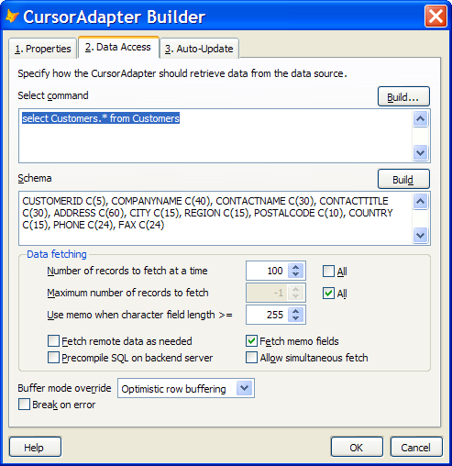
Figure 1: Create CursorAdapter objects quickly using the CursorAdapter Builder
All these enhancements for providing universal data access provide benefits that applications designed with versions before Visual FoxPro 8.0 do not have, such as having a consistent methodology for working with data, reducing the amount of code needed to retrieve and update data, and increasing productivity. As an application's data needs change, the data source can change without requiring rewriting code to accommodate such changes. Thus, Visual FoxPro 8.0 provides far more advanced development options and offers more choices and flexibility for working with disparate data sources.

Views and Query Designers
Visual FoxPro 8.0 enhances the View and Query designers included in previous versions by improving how they construct join conditions between multiple tables and how they handle user-defined SQL SELECT commands. These enhancements create scenarios where using the View and Query designers is easier and more productive than manually coding SELECT statements.
The Visual FoxPro View and Query designers make it possible for developers to visually create and modify queries and views. The top pane in each designer displays the tables in a query or view. A resizable window represents each table and lists the fields and indexes for each table. The designer shows join conditions, indicated by lines connecting fields between the tables. You can drag indexed fields between tables to create join conditions.
Visual FoxPro 8.0 now provides "two-way" editing support in the View and Query designers. You can manually edit the SQL SELECT statement for the query or view and view properties, which are set by DBSETPROP( ) function calls in the SQL window, and load the changes back into designer window. Visual FoxPro 8.0 also adds granular control over join operations by making it possible for developers to set the priority of each join operation relative to other join operations. Developers can select all tables in the designer with a single click, making the creation of SELECT statements even faster. Filter conditions now support subqueries and the setting of priorities relative to other condition expressions. You can also set priorities for the GROUP BY clause, making it possible for developers to create SELECT statements the way they were intended.
Figure 2: View Designer
Thus, these enhancements to the Visual FoxPro 8.0 View and Query designers, such as two-way editing support, granular control over join operations, subqueries, and priorities provide more scenarios for using the View Designer to visually create and modify queries and makes creating SELECT statements easier and more robust.
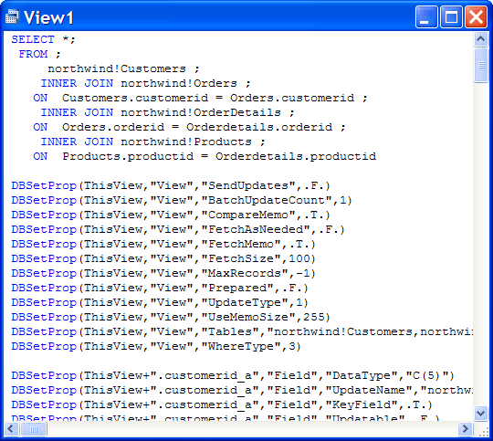
Figure 3: SQL statement output from the View Designer

Auto-Incrementing Field Values
Auto-incrementing is commonly used to generate unique ID numbers where the ID number is based on a counter rather than on data in the table. Developers can now specify automatically incrementing field values for both database container (DBC) tables and free tables using the new auto-incrementing feature in Visual FoxPro 8.0. This feature performs similarly in functionality to Microsoft Access and Microsoft SQL Server 2000. Of Integer data type, the auto-incrementing field increments automatically by a specified value, or counter, when a new record is appended to a table. A table can contain multiple fields that use auto-incrementing. A number generated for a record cannot be changed or deleted.
The SQL language and the newly restructured Table Designer in Visual FoxPro 8.0 both include support for auto-incrementing. The Table Designer supports the new auto-incrementing Integer data type and provides developers control over the value at which the counter begins and increments.
Figure 4: Table Designer includes options for automatically incrementing field settings
Before the auto-incrementing feature became native to Visual FoxPro, developers needed to write code that simulated this functionality. Therefore, auto-incrementing in Visual FoxPro now eliminates the need to write and execute extra code, improving performance.

Windows Platform Support
Keeping up with the latest technology helps accomplish the important strategy of moving applications forward. For customers to continue shipping Visual FoxPro applications, it is critical for these applications adopt the latest user interface (UI) of the current Windows platforms. Most Visual FoxPro applications require some compatibility with the Windows forms UI. Visual FoxPro 8.0 supports the latest Windows XP technologies, including support for Windows XP Themes and GDI+.
Windows XP Themes Support
The underlying UI architecture in Windows XP supports a new technology called Themes. Themes control a number of visual attributes for UI elements, including the appearance of controls, border color and style, selection and mouse hover effects.
When Visual FoxPro 8.0 forms are set up to use Themes, all controls, containers, and other UI elements take on characteristics of the currently selected theme based on the Themes property at the container level. Therefore, applications are synchronized with the current platform theme.
Visual FoxPro 8.0 provides granular control over enabling Themes at the desktop, form, or container level, making it possible for some forms or controls to show Themes while others do not.
Figure 5: Themes solution sample
GDI+ Support
Visual FoxPro 8.0 leverages advanced Windows technology by including support for Microsoft Windows GDI+ (Graphics Device Interface+) imaging. GDI+ is an application programming interface (API) that is exposed through a set of Visual C++ classes and is a subsystem of the Windows XP operating system or Windows Server 2003 family. It is responsible for displaying information on screens and printers.
Visual FoxPro 8.0 supports image file formats, including the .bmp, .jpeg, .gif, animated .gif, .wmf, .emf, and .tiff formats. Visual FoxPro 8.0 applications no longer require third-party ActiveX controls to support these image file formats.
Using the Image control and other controls that support the Picture property, Visual FoxPro 8.0 can display images and rotate them on forms. Visual FoxPro 8.0 can also display images in the textbox portion of a ComboBox control.
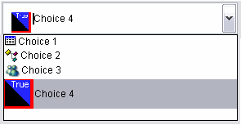
Figure 6: Pictures displayed in the textbox portion of ComboBox controls
Both Windows XP Themes and GDI+ support in Visual FoxPro 8.0 provide enhancements to Visual FoxPro applications. Taking advantage of these features requires simple property settings with minimal, if any, coding. By incorporating these latest Windows platform technologies, Visual FoxPro 8.0 succeeds by providing developers with the capability to create applications with the latest UI "look and feel."

Advanced Controls
Visual FoxPro 8.0 provides developers the capability to build smart client desktop forms and provide a richer user experience by including the following features:
- Locking columns and resizing columns automatically
- Using grids as list boxes
- Highlighting for grid rows
- Aligning pictures relative to captions
- Positioning tabs on page frames
- Changing the background color of and positioning images on command buttons
- Displaying and enabling hyperlinks in TextBox and EditBox controls
You can incorporate many of these new features into your Visual FoxPro applications by simply configuring property settings with little need to write code.
You can programmatically control grid features using properties to determine the behavior of column locking and automatic resizing when a user clicks certain locations on the grid. Visual FoxPro's automatic column resizing feature for grids and Browse windows performs similarly to functionality in Microsoft Excel. You can resize a column by double-clicking the area between column headers. Double-clicking the upper left corner of the grid resizes all columns. You can control the user experience by either by setting the AllowAutoColumnFit property or in code using the AutoFit method.
Locking and hiding columns are two more grid and Browse window column features. You can specify which columns to lock by using the BROWSE command with the LOCK clause and by setting the grid's LockColumns and LockColumnsLeft properties. Users lock columns by right-clicking any area between headers, thereby locking the columns to the left of the grid or Browse window. When the user press the TAB key to move the view of the grid to the right, the locked columns do not scroll out of view in the grid/Browse window.
You can now use the grid to mimic a list box so that the contents of the grid are read-only by setting the grid's AllowCellSelection property. When this property is properly set, clicking any row in the grid selects the entire row as a single item but does not highlight individual fields. Editing capabilities within the field are suppressed. For example, users cannot use the insertion pointer to select and copy text from the field. You can also control color display for selected rows and items in TextBox controls in a grid by setting the HighlightForeColor, HighlightBackColor, SelectedItemBackColor, and HighlightStyle properties.
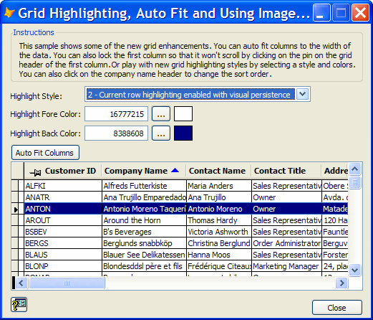
Figure 7: New grid features provide more control over the user interface
You can position pictures relative to their captions by setting the PicturePosition property for the CommandButton, OptionButton, and CheckBox controls. Previous versions of Visual FoxPro could not perform this functionality without ActiveX controls.
You can control the location of tabs on a PageFrame control by setting the TabOrientation property. You can place tabs on the sides, top, and bottom of page frames. When tabs appear on the sides of page frames, tab text displays in a vertical position automatically.
You can also choose to display and enable hyperlinks in TextBox and EditBox controls by setting the EnableHyperlinks property.
Combined with the new Windows XP support and GDI+ enhancements, these advanced control features provide developers the opportunity to create and deploy modern applications with improved UI on the latest Windows platform.

Event Binding
Visual FoxPro 7.0 introduced the capability to bind methods from Visual FoxPro objects to events of COM objects. Visual FoxPro 8.0 now includes event handler support so you can bind to events from Visual FoxPro objects. Using event binding, you can attach the method of an object to the event of any Visual FoxPro object as a way to "hook" on to the event. This is particularly useful when creating and using custom methods because you can use event binding to trigger a Visual FoxPro event when running the custom method. You can attach more than one method to the same event, thereby chaining events. In addition, you can unbind events either individually or as a group.
For example, event binding makes it possible to refresh a grid on a form when the Click event for a list box on another form occurs, eliminating the need to write code for the event. Event binding also makes creating error logs and refreshing forms that are linked to changes on another form much easier.
Event binding functionality in Visual FoxPro 8.0 also includes the capability to raise an event. You can raise events for methods so that they behave like event methods. When an event is raised for a method, the event is triggered as a result of the method call and supports event binding to any other Visual FoxPro object method, such as native Visual FoxPro event methods.
For example, suppose you create a print method for a class that sends information to a printer. Using event binding, this print method can raise an event so that your application runs any Visual FoxPro object method when the event is triggered. One such Visual FoxPro object could be a PrintLog class that tracks individual print jobs by adding a row to a print log table every time information is sent to the printer. Therefore, you can use event binding to attach the method from the PrintLog class method to the print method you created. Every time information is sent to the printer, a row is added to the print log table.
The benefit that event binding offers is that you can couple the two components, the code in the class and the print log, using events and not code.
Event binding in Visual FoxPro 8.0 brings new capabilities and flexibility to applications not available in previous versions of Visual FoxPro.

XML Data Import and Export
Visual FoxPro 7.0 included the capability for converting Visual FoxPro cursors to and from XML. This feature supports basic XML structures that contain information about a single table. Now, Visual FoxPro 8.0 introduces the new XMLAdapter class as an alternative and more modern way to work with XML.
One of the capabilities of this new class is support for hierarchical XML. You can render an XML file representing a collection of different and potentially related tables, such as Windows .NET DataSet, into separate Visual FoxPro cursors. You can also control the XML schema that is created and the data types that the cursor creates from schema XML, thus enhancing flexibility and control over data. You can load the XML, change the schema, and generate a cursor. You can also load a Visual FoxPro cursor from memory, modify the schema, and generate XML.
The XMLAdapter class includes two member classes: XMLTable and XMLField. These classes provide the capability to traverse the schema programmatically and access or set information. The XMLAdapter class contains a collection of XMLTable objects that describe the tables contained in the XML, making it possible to step through each table and perform procedures on them. Each XMLTable object contains a collection of XMLField objects, which describe the fields in each table. You can iterate through the fields and make any needed changes.
The XMLAdapter class supports XML DiffGrams, which provide an efficient way of transferring data between applications. DiffGrams are a special type of XML document formatted to include information only for changed data, not the entire set of data. This format helps reduce the size of the XML sent between applications. You can load XML into Visual FoxPro, convert it to a cursor, update the data, and convert the data back to an XML DiffGram. Only the changed data is sent to the XML recipient. You can also use XML DiffGrams with other applications that support data in DiffGram format and are compatible with ADO.NET in applications built on the Windows .NET Framework.
For example, you can use the XMLAdapter class to retrieve data from a Windows .NET Framework application through an XML Web service. First, the Windows application retrieves data using ADO.NET from Microsoft SQL Server 2000. The Windows application then exposes the data to other applications, including a Visual FoxPro 8.0 application, using an ASP.NET XML Web service, which passes the data as XML to the calling Visual FoxPro application. The Visual FoxPro application uses the XMLAdapter class to generate cursors from the XML based on the XML schema. The Visual FoxPro application can make changes to the cursors and uses the XMLAdapter class to generate an XML DiffGram, which contains the changes, and calls a method from the ASP.NET XML Web service to send the updated data as XML back to the Windows application.
With enhanced support for XML offered by the XMLAdapter class, Visual FoxPro 8.0 now provides better integration of and capabilities for working with data between Visual FoxPro, Windows .NET Framework, and other applications, mobile devices, platforms, and systems that support XML.

XML Web Services
Previously, developers added XML Web services to their Visual FoxPro applications by using the Types tab in the IntelliSense Manager. Visual FoxPro 8.0 now offers significant enhancements for registering and using XML Web services by providing the new Task Pane Manager and a section for XML Web Services in the new Toolbox. You can now also search the Microsoft Universal Description, Discovery, and Integration (UDDI) database for other existing XML Web services in the Visual FoxPro XML Web Service Registration dialog box.
In the new Task Pane Manager, the new XML Web Services pane makes it easier for developers to use, publish, and manage XML Web services and provides dynamic links to resources about XML Web services. The XML Web Service Tools section on the task pane contains links that open dialog boxes for registering, publishing, and managing XML Web services. For example, the Manage XML Web Services dialog box displays all registered XML Web services, which you can open, create, or delete.
After registering XML Web services, you can select methods and view syntax and sample code for registered XML Web services in the Explore an XML Web Service section. You can test registered XML Web services and call methods interactively without writing code, similar to how ASP.NET makes it possible for developers to test XML Web services. In Visual FoxPro 8.0, you can specify any parameters for an XML Web service method and display the result set on an XML Web Method Test form. If the method returns data that can be converted into a table or multiple tables, the test form displays those results in a grid.
Figure 8: The new Task Pane Manager contains helpful tools for working with XML Web services
The new Toolbox contains a section called My XML Web Services, which provides access to all registered XML Web services, similar to how ActiveX controls are shown in the Options dialog box when they are installed. You can choose from the list of registered XML Web services that appear there or register new XML Web services. You can drag an XML Web service from the toolbox into code, thereby creating wrapper code from a FoxPro Foundations Class (FFC) to call the XML Web service. Using this wrapper code, you can access the last set of data results from the XML Web service even when you are not connected to it. By setting a property, you can store XML Web service results in a Visual FoxPro table, making it possible for a Visual FoxPro application to call the XML Web service, even when the XML Web service is not available.
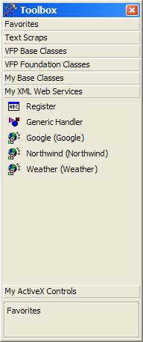
Figure 9: Toolbox with registered XML Web services
The Toolbox also makes it possible for developers to drag a registered XML Web service to a form as a non-visual class. You can then open the XML Web Service Builder by right-clicking the XML Web service on the form, choosing Builder, and then use the builder to configure the XML Web service more quickly. The XML Web Service Builder provides a way to work with XML Web services on forms and extensive binding capabilities without the need to write code. Using the XML Web Service Builder, you can bind an XML Web service to a control on a Visual FoxPro form or to an object, such as a CursorAdapter object in the form's data environment. The XML Web service on the form can have parameters set or configured to use controls on the form for interactive input by users.
By providing a rich set of classes and tools for using and publishing of all types of XML Web services and capabilities for binding and manipulating data, Visual FoxPro 8.0 strengthens its support for XML Web services.

Visual FoxPro OLE DB Provider
Before Visual FoxPro 7.0, other applications could access Visual FoxPro data only through the Open Database Connectivity (ODBC) driver. However, the Visual FoxPro ODBC driver was not much different from the one for FoxPro 2.6, and the technology could not adequately support the newer Visual FoxPro database features such as stored procedures, triggers, and rules. However, the development of OLE DB technology changed all that. Developers can now use an object-oriented approach to data access through a series of COM objects. In addition, Visual FoxPro 8.0 has enhanced the OLE DB Provider to take advantage of classes in the Windows .NET Framework, providing even more control and productivity. The Visual FoxPro OLE DB Provider replaces the ODBC driver, which is currently in maintenance mode. No updates or enhancements are planned.
The Visual FoxPro OLE DB Provider makes it possible for application developers to access Visual FoxPro data from other languages and applications in addition to Visual FoxPro when appropriate. The OLE DB Provider features an improved threading model for better scalability while preserving all the functionality of the ODBC driver from earlier versions of Visual FoxPro. The OLE DB Provider offers developers a number of significant benefits, including faster access to data than was possible using ODBC, support for Visual FoxPro database events and stored procedures, even those that require parameters, and access to triggers, rules, and default values in the database container.
When using Visual Studio .NET, the OLE DB Provider is the best way to access Visual FoxPro data directly. However, the OLE DB Provider does not include an object manager; therefore, it does not support COM objects. COM objects must be accessed directly in the application instead of through the OLE DB Provider. However, the Visual FoxPro 8.0 has enhanced the OLE DB Provider significantly to take advantage of Windows .NET Framework classes. Compatibility with the Windows .NET Framework provides applications with the strategic advantage of providing more accessibility to other applications and development tools.

Microsoft SQL Server 2000 Desktop Engine (MSDE)
Visual FoxPro 8.0 includes MSDE 2000, a data engine that is fully compatible with Microsoft SQL Server 2000. MSDE is the optimal data engine for building and developing mobile, desktop, and shared solutions solution that can easily migrate to SQL Server 2000 without changing code and supports hundreds or thousands of users, from tens of gigabytes of data to terabytes of data.
MSDE is available to Visual FoxPro 8.0 developers who wish to build custom applications with SQL-compliant embedded databases. Compliance with SQL makes it possible for you to scale desktop and shared database solutions using MSDE up to SQL Server without code modifications. You can use MSDE as a free data store or a development tool for deploying applications using SQL Server 2000. Although MSDE databases are limited to 2 gigabytes (GB) of data, this limit applies to each database, not for each server. Therefore, a single MSDE server can support multiple MSDE databases, each containing data up to the 2 GB limit. MSDE is suitable for desktop and shared solutions where than the database must deal with fewer than five concurrent workloads at any one time.
You can distribute desktop, mobile, and shared database solutions built with MSDE royalty-free and provide enterprise-class reliability, including support for transaction logging, point-in-time recovery, and dynamic back up-and-restore. Your applications can support business-critical requirements, 24 hours a day, 7 days a week. New Visual FoxPro 8.0 data classes, such as the CursorAdapter class, work with MSDE in the same way as with SQL Server 2000. MSDE enables security integration with Windows NT.
MSDE solutions provide SQL Server features such as merge replication with a central SQL server to enable mobile computing and easy migration to SQL Server 2000 when the solution must scale. Therefore, tables, stored procedures, triggers, and any other database objects created in MSDE can operate without modification in a SQL Server database. In contrast, many Visual FoxPro queries cannot migrate to SQL Server without modification.
MSDE is the most suitable choice for developers considering future migration to SQL Server or anticipating that their database application will exceed the standard limitations of Visual FoxPro. MSDE provides the easiest path to upsizing a database to SQL Server without changing a single line of code. For more information about MSDE online, refer to http://www.microsoft.com/sql/msde.

Deployment Tools
InstallShield Express - Visual FoxPro Limited Edition continues to provide an easy and intuitive way to package and deploy Visual FoxPro applications for installation. InstallShield Express uses Microsoft® Windows Installer, which makes it possible for users to install and configure products and applications efficiently. Windows Installer is part of the Windows 2000 and Zero Administration Windows efforts to reduce the overall cost of deploying, using, and managing desktop computers. You can create a setup project or package by specifying files and their properties and then distributing the application files from Setup using the InstallShield Express — the comprehensive and flexible Setup creation technology for Windows Installer.
InstallShield Express provides the advantage of offering three installation options: Typical, Minimal, and Custom. Minimal installs only the application .exe file. Typical performs a full installation including the .exe file, database files, and documentation. Custom lets users decide what they want to install.
Visual FoxPro 8.0 has enhanced InstallShield Express to provide even greater functionality. You can now create new product versions that uninstall the previous version automatically. InstallShield Express includes Windows XP on its list of supported operating systems and makes it possible for the developer to install the project or individual files conditionally. Moreover, InstallShield Express also takes advantage of using Windows Installer 2.0. You can include a dialog box that appears at the end of installation and contains a check box for launching an .exe file to provide custom enhancements to an application.
These enhancements for InstallShield Express in Visual FoxPro 8.0 provide developers an installation tool that continues the trend of simplifying deployment for clients and end users.

Powerful Base Classes
Base classes save developers valuable time by reducing the amount of code that needs to be written and increasing usability throughout application development. Although additional base classes have always been offered with each new version since Visual FoxPro 3.0, Visual FoxPro 8.0 contains a significant number of new base classes, such as collections, reusable data classes, and the capability to create subclasses for pages, grid columns, grid headers, and the data environment. By providing these classes as native base classes, developers using Visual FoxPro 8.0 no longer need to create wrappers for emulating collections or to copy, paste, and redo member objects because they could not create them as subclasses in earlier versions of Visual FoxPro.
Collection Class
Visual FoxPro 8.0 introduces a collection class as found in most modern objected-oriented programming languages such as Visual Basic 6.0 and Visual Basic .NET. A collection contains a group of related items, usually objects, of any type. The position of a specific collection item can vary and change when the collection changes. Management of the collection is wholly contained within the collection, thus providing a standard interface for dealing with groups of related items and a central location for managing these items. The Collection class includes standard ways for accessing and iterating through the objects and provides a great mechanism for working with contained objects. Sometimes it is appropriate to create lists using an array or a table. However, by providing collections as a third option, Visual FoxPro 8.0 offers developers better performance with less coding.
Reusable Data Classes
In previous versions of Visual FoxPro, you could create subclasses from data environments and cursors in code; however, you could not use those subclasses on a native Visual FoxPro form. Visual FoxPro 8.0 now includes visual classes for data environments, cursors, and relations that developers can use on forms or to create subclasses from. The DataEnvironment class can contain Cursor, Relation, or CursorAdapter member objects. By having these new native base classes in Visual FoxPro 8.0, developers gain significant advantage by being able to reuse code and develop applications more efficiently.
Creating Subclasses from Visual Components
Developers can now create subclasses from pages, grid columns, and grid headers in Visual FoxPro 8.0. This helps save development time because developers can reuse existing classes without copying and pasting code. For these container classes, developers can specify member classes and class libraries using two new properties, MemberClass and MemberClassLibrary. Thus, when a container object is created, these properties determine the classes to use for member objects. When the count property for the container increases, programmatically or interactively, new member objects are added.
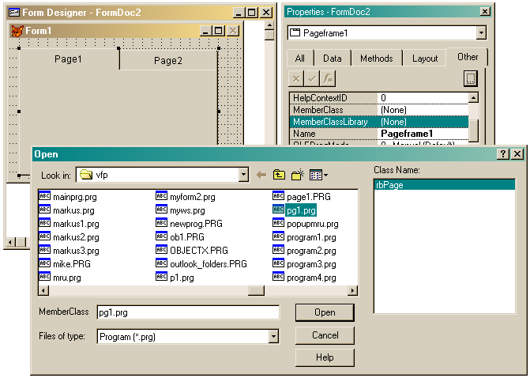Figure 10: Example of a PageFrame control containing a page created from a subclass

Developer Productivity
Visual FoxPro 8.0 introduces new tools for increasing developer productivity:
- Task Pane Manager - Provides capabilities for managing development tasks and accessing Visual FoxPro Help, XML Web services, and community news.
- Toolbox - Provides easy access to frequently used items such as classes, controls, and code snippets.
- Code References window - Search for and replace symbol and text references throughout projects and files.

Task Pane Manager
The Task Pane Manager displays and manages individual panes that enhance the Visual FoxPro integrated development environment (IDE) in the following ways:
- Exposes wizards and shortcuts for performing routine and essential tasks.
- Increases discoverability of new and existing features.
- Provides easy access to information and community news.
- Displays Help topics and presents samples
- Delivers dynamic content to the Visual FoxPro desktop.
The Task Pane Manager supports pane customizations and third-party add-in panes for providing specialized content. Developers can easily create and share Visual FoxPro task panes. The Task Pane Manager opens with the Start pane first by default. In the My Tools section, this pane contains installed development tools provided by other developers or Visual FoxPro. Recent Projects displays information about the most recently opened projects. Recent Databases shows the most recently opened Visual FoxPro databases.
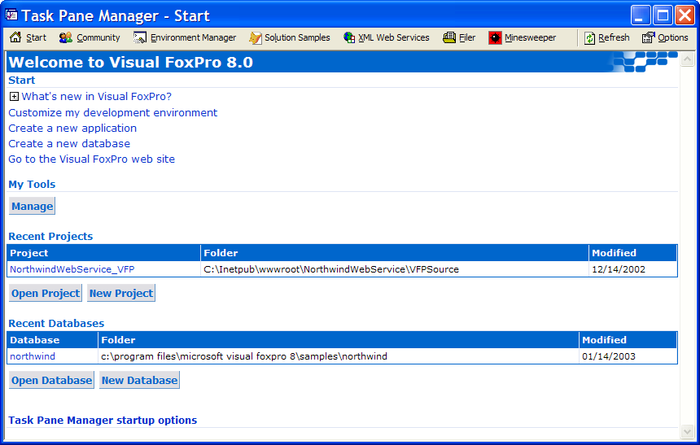
Figure 11: Start pane in the Task Pane Manager
The Community pane lists hyperlinks to Visual FoxPro and general development community and resources on the Web, including downloads, articles, training, topics, and news. You can change user settings such as the default news provider in the Task Pane Options dialog box.
The Environment Manager pane makes it possible for you to manage environment settings and associate projects with those environment settings. You can then open these projects with the specified environment.
The Solution Samples pane displays solution samples created with Visual FoxPro. You can install additional samples using an Install Sample feature. You can then share code samples and display them in the Solutions Samples pane.
The XML Web Services pane makes it easier to use, publish, and manage XML Web services and provides dynamic links to resources about XML Web services. The XML Web Service Tools section on the task pane contains links that open dialog boxes for registering, publishing, and managing XML Web services, for example, the Manage XML Web Services dialog box displays all registered XML Web services, which you can open, create, or delete.
After registering XML Web services, you can select methods and view syntax and sample code for registered XML Web services in the Explore an XML Web Service section. You can test registered XML Web services and call methods interactively without writing code, similar to how ASP.NET makes it possible for developers to test XML Web services. In Visual FoxPro 8.0, you can specify any parameters for an XML Web service method and display the result set on an XML Web Method Test form. If the method returns data that can be converted into a table or multiple tables, the test form displays those results in a grid.
The Task Pane Manager improves the Visual FoxPro development experience by displaying information and creating easier access to essential tasks. Individual panes can expose wizards for performing routine tasks, show static or dynamic information, gather content from the Web, display Help, and present samples. You can also create customized panes to share with other developers and users.

Toolbox
Similar to the Visual Studio .NET Toolbox, the Visual FoxPro Toolbox enhances the development environment by organizing tool sets, such as class libraries, builders, and code snippets, and displaying customizable tool sets by category. Toolsets can contain common resources, such as text, images, files, and tables or other items such as ActiveX controls, COM classes, builders, and wizards. You can drag these items to the workspace or click them to perform other actions. You can fully customize individual toolsets and add one ones that contain preferred groups of items.
The following default categories are available in the Toolbox:
- Favorites - Stores frequently used items. You can move items from other categories for easy access.
- Text Scraps - Contains text snippets that you add by selecting and dragging text to the Toolbox. You can use this toolset to store and organize reusable code that you can drag to different places in an application and to.
- VFP Base Classes - Contains the native Visual FoxPro classes.
- VFP Foundation Classes - Contains some of the most popular Visual FoxPro foundation classes.
- My Base Classes - Contains FoxPro Foundation base classes from the class library in FFC\_Base.vcx relative to the Visual FoxPro 8.0 root directory. You can also store custom base classes to make using them in applications more efficient.
- My XML Web Services - Contains registered XML Web services. You can choose from the list of registered XML Web services that you create or register new XML Web services.
- My ActiveX Controls - Contains registered ActiveX controls.
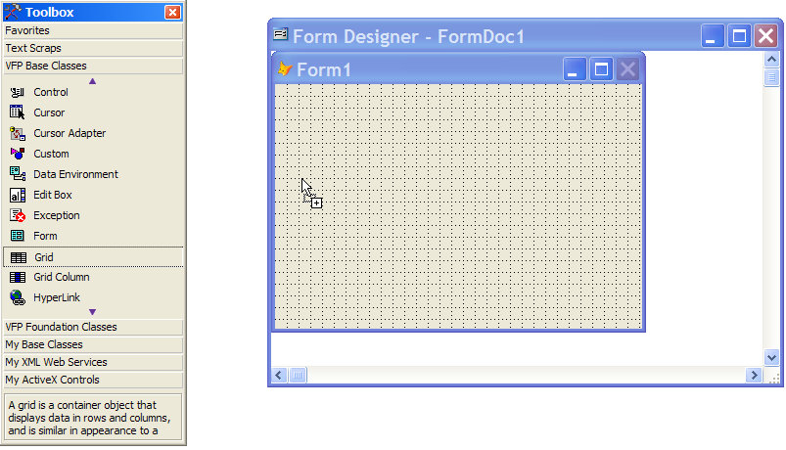
Figure 12: Drag controls to a form using the new Toolbox
The Toolbox supports third-party add-in toolsets, replaces the Form Controls toolbar, and provides an integrated, organized, customizable way to use native and custom toolsets.

Code References Window
You can use the Code References window to search and replace code references or text using the Look Up Reference dialog box. You can specify whether to search an entire project or folder and whether to filter on specific file types. You can customize your search in the Look Up Reference dialog box by providing search text, including regular expressions. You can define the scope of the search to include a folder, subfolders, or a project. You can select from a wide variety of file types so you can limit the search to a smaller group of files.
The Code References window appears after performing a search or when selecting Code References from the Tools menu after a previous search for a code reference in the same project or folder. The results pane in the Code References window displays results from a code reference search, including any potential definitions, and indicates multiple references in single lines of code. If multiple references in a line exist, the entry in the results pane indicates the number of references.
When performing text replacement, you can choose from various options to control the process more precisely, such as confirming each replacement, preserving case, and backing up modified files. You can also print the results and customize the printout to include only the result set needed. You can export the results to various formats, including XML and HTML.
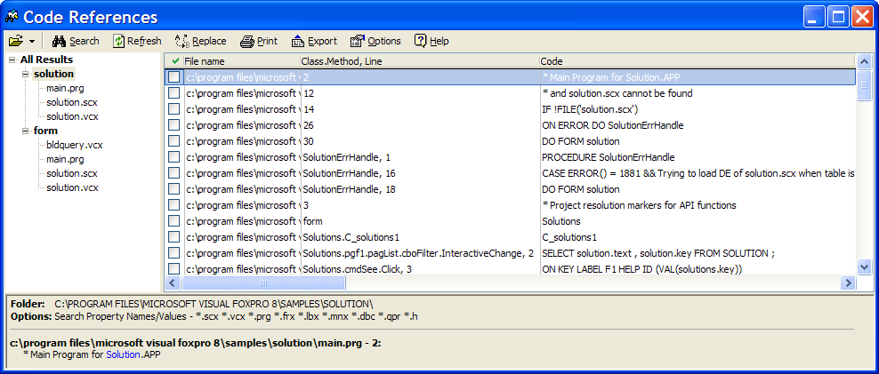
Figure 13: Code References window

Conclusion
Visual FoxPro 8.0 continues the evolution of Visual FoxPro from a procedural desktop database development system to a fully object-oriented development environment. New tools help developers to build state-of-the-art client/server and web based database applications, as well as data-intensive components that can be used with a variety of front and back ends.
Visual FoxPro 8.0 includes many important enhancements designed to make the product capable of building high-performance, scalable components. It is easier to learn and use, and is more stable, productive, and extensible than any previous version of Visual FoxPro. For additional product information, refer to http://msdn.microsoft.com/vfoxpro.

Upgrading to Visual FoxPro 8.0
Upgrading to Visual FoxPro 8.0 is easy and rewarding, as it is the most advanced and reliable version of FoxPro ever released, and is 100-percent compatible with Visual FoxPro 7.0. Developers can even create applications with Visual FoxPro 8.0 and deploy them using the Visual FoxPro 7.0 runtime, as long as no new commands and features are implemented in the distributed application. This allows developers and teams to upgrade to Visual FoxPro 8.0 and benefit from the wealth of new productivity features, while transitioning existing applications to the newer runtime engine. Most developers have provided feedback indicating that the feature packed Visual FoxPro 8.0 is the best upgrade since Visual FoxPro 3.0.

