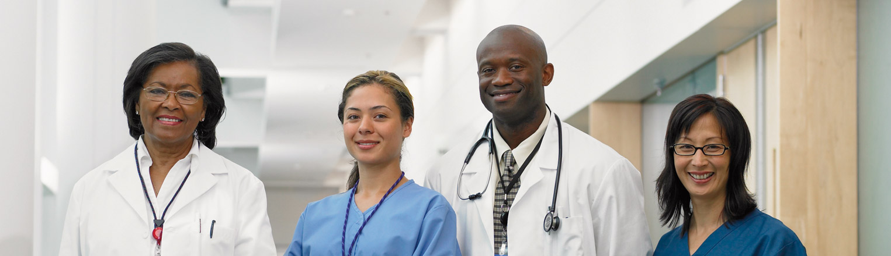
<<< invisible sidebar and image anchor here
Pfizer
Better Collaboration and Deeper Context Improve Research Decision Making

Pfizer Global Research and Development (PGRD) is a leading research and development organization in the pharmaceutical industry, with 12,000 scientific and medical researchers and a budget of more than U.S.$7 billion. Discovery researchers may test millions of chemical compounds to find just a dozen candidate medicines, of which only one might result in an approved medication.

The time from drug discovery to approval can take up to 15 years, and the average cost of bringing a pharmaceutical product to market is U.S. $800 million and growing. The key to reducing costs lies in compressing the discovery cycle by eliminating redundant research and identifying unsuitable candidates as early as possible in the cycle.
At PGRD, researchers start exploring new paths to better, more effective drugs by reviewing existing research. PGRD stores its research results in several databases throughout the organization, in a variety of formats and standards. Without a comprehensive view of existing research, scientists might spend valuable time seeking answers to questions that have already been answered, or they might fail to ask new questions that could speed up the discovery process.
Pfizer needed a way for its research biologists worldwide to sort through large volumes of data, analyze that data quickly, and share the results of their research with other scientists in order to speed up the process of developing new drugs. A faster development cycle would help Pfizer bring drugs to the marketplace and create new hope for people struggling with health problems.
OBA PILOT WORKBENCH APPLICATION HELPS BIOLOGISTS FOCUS EFFORTS
Pfizer’s solution to this challenge came in the form of an Office Business Application (OBA), a new class of applications that use Microsoft®

Web technologies to share information and allow people to access and work with that information through their familiar Microsoft Office software. Pfizer turned to Microsoft and Infosys Technologies to help develop a pilot of that OBA, which is called Biologist Workbench.
The Biologist Workbench is a set of tools built using Microsoft .NET Framework 3.0, an integral component of the Windows® operating system, and Microsoft Office SharePoint® Portal Server 2003. This tool set gives Pfizer biologists new ways to look at the existing data. “A chemist would look at a list of compounds and then study the biological results of those compounds,” says Matteo di Tommaso, Senior Director, Global Scientific Informatics, Pfizer Research and Development Informatics. “A biologist wants to dive more deeply into the biological data and then look at the compounds that might have those biological results. It’s the same underlying database, but the Biologist Workbench gives biologists the ideal route into it.”
The Biologist Workbench uses Windows Presentation Foundation, a display engine and managed-code framework that makes it possible for scientists to query the database, select as many research results as they want, and then view that set of results in a multidimensional, visual display.
“We’re taking advantage of Microsoft visualization tools to create 3-D graphs of information that overlay each other,” says Rick Somes, Director of Global Screening and Molecular Informatics for Pfizer Research and Development Informatics.
“We can look at the relationships among the data in interesting ways. A research scientist will be able to zoom in and select sets of data for further study. We’re looking for patterns and relationships among different types of information, and these tools give us a whole new way of looking at our data.”
NEW TECHNOLOGIES SPEED TIME-TO-MARKET
The Biologist Workbench is an early example of an OBA. Such applications use Microsoft’s new Web service technology called Windows Communication Foundation, and the .NET Framework 3.0 to connect with Office SharePoint Portal Server.
“The biggest reason to use Microsoft .NET Framework 3.0 on this project was that it has the service-oriented architecture, the scalability, the flexibility, and the collaboration and integration

<<<invisible table/image anchors here
“Because it helps us collaboratively share research, the Biologist Workbench is making the world smaller for the Pfizer drug discovery team.”

Rick Somes
Director of Global Screening and Molecular Informatics
Pfizer RDI
tools the project required already built in,” says Ravinder Singh Verma, Senior Project Manager on the project for Infosys, which is a Microsoft Gold Certified Partner.
“The .NET Framework increased our developer productivity and that, in turn, led to a shorter go-to-market time with much lower costs,” adds Subhro Mallik, Senior Engagement Manager from Infosys.
“Our ROI will come in the long term as we shorten
time-to-decision, streamline and enhance drug discovery, and lower cost.”
Rick Somes
Director of Global Screening and Molecular Informatics
Pfizer RDI
Teams from Pfizer, Microsoft, and Infosys jointly developed the pilot Workbench. “The combined team took the time to truly understand our business and the researchers’ requirements. In addition, they’ve been excellent partners in helping us to understand how to leverage the infrastructure we already have as a corporation and take advantage of the capabilities of the software, so it’s been a really powerful collaboration. It’s nice to have that level of support from vendors,” says di Tommaso.
SOLUTION MAKES THE WORLD SMALLER FOR DRUG DISCOVERY TEAM
The Biologist Workbench will allow Pfizer to make better-informed decisions regarding compounds earlier, which helps reduce drug discovery costs. “Because it helps us collaboratively share research, the Biologist Workbench is making the world smaller for the Pfizer drug discovery team,” remarks Somes.
The Workbench solution helps scientists in several ways. The new multidimen-sional, visual displays in Biologist Workbench help researchers explore new areas and avoid repeating work that’s already been done elsewhere within PGRD. “We work in many therapeutic areas, and sometimes someone working on diabetes can benefit from work that’s been done in osteoporosis,” says Somes. “The 3-D displays show pockets where data is clustered and holes where work hasn’t been done.”
“The complexity of building 3-D graphs is already built into the Microsoft toolkit. All we had to decide was which data we wanted to place in the x-, y-, and z-axes,” says di Tommaso. “The focus of this pilot is to show that we can tap into the pharmacology data we’ve collected and give researchers the ability to build a hypothesis in real time, drawing on a large information repository that we’ve been building up for years. The pilot shows us that we can get that result by using Microsoft tools—in a faster, more agile way than we have in the past.”

<<<invisible table/image anchors here

“It’s hard to explain the effects of a visualization tool like Windows Presentation Foundation until you’ve seen an example,” says Somes. “The real long-term benefit is that our scientists will look at this data in new ways and see new connections. Our ROI [return on investment] will come in the long term as we shorten time-to-decision, streamline and enhance drug discovery, and lower cost.”
Moving beyond the pilot, Pfizer and Infosys plan to improve the capabilities of the new OBA by taking advantage of significant advances in Office SharePoint Server 2007 and the rest of the 2007 Microsoft Office system, such as social networking and enterprise search capabilities for structured and unstructured data.

<<<invisible table/image anchors here
Learn more about Pfizer at:
www.pfizer.com
Learn more about Infosys Technologies Limited at:
www.infosys.com
This case study is for informational purposes only. MICROSOFT MAKES NO WARRANTIES, EXPRESS OR IMPLIED, IN THIS SUMMARY. Document published: August 2007

