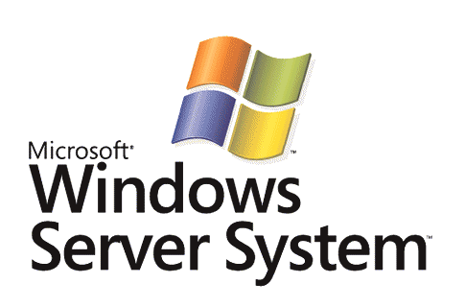

Microsoft Dynamic Systems Initiative Overview

Microsoft Corporation
Published: March 2004

Abstract
The Dynamic Systems Initiative (DSI) is an industry effort led by Microsoft to enhance the Microsoft® Windows® platform and deliver a coordinated set of solutions that dramatically simplify and automate how businesses design, deploy, and operate distributed systems. Microsoft is investing heavily in software research and development and working with partners to deliver end-to-end offerings integrated across application development tools, operating systems, applications, hardware, and management tools that will result in reduced costs, improved reliability, and increased responsiveness throughout the entire IT life cycle.


The information contained in this document represents the current view of Microsoft Corporation on the issues discussed as of the date of publication. Because Microsoft must respond to changing market conditions, it should not be interpreted to be a commitment on the part of Microsoft, and Microsoft cannot guarantee the accuracy of any information presented after the date of publication.
This White Paper is for informational purposes only. MICROSOFT MAKES NO WARRANTIES, EXPRESS, IMPLIED OR STATUTORY, AS TO THE INFORMATION IN THIS DOCUMENT.
Complying with all applicable copyright laws is the responsibility of the user. Without limiting the rights under copyright, no part of this document may be reproduced, stored in or introduced into a retrieval system, or transmitted in any form or by any means (electronic, mechanical, photocopying, recording, or otherwise), or for any purpose, without the express written permission of Microsoft Corporation.
Microsoft may have patents, patent applications, trademarks, copyrights, or other intellectual property rights covering subject matter in this document. Except as expressly provided in any written license agreement from Microsoft, the furnishing of this document does not give you any license to these patents, trademarks, copyrights, or other intellectual property.
Unless otherwise noted, the example companies, organizations, products, domain names, e-mail addresses, logos, people, places, and events depicted herein are fictitious, and no association with any real company, organization, product, domain name, email address, logo, person, place, or event is intended or should be inferred.
© 2003–2004 Microsoft Corporation. All rights reserved.
Microsoft, Active Directory, BizTalk, SQL Server, Visual Studio, Windows, Windows Server, and Windows Server System are either registered trademarks or trademarks of Microsoft Corporation in the United States and/or other countries.
The names of actual companies and products mentioned herein may be the trademarks of their respective owners.
Contents
Introduction 1
Dynamic Systems Initiative 2
System Definition Model 3
Long-Term SDM Solutions 8
Design for Operations 8
Deploying Dynamic Systems 9
Operating Dynamic Systems 10
Operating Existing Systems 12
Near-Term DSI Deliverables 13
Windows Server System and Windows Server 2003: The Foundation for the DSI 13
Windows Server Products Beyond Windows Server 2003 13
Enterprise Management Solutions 14
Application Development Tools 15
Partnership Opportunities 17
Summary 18
Appendix: Scenarios 19
Designing a Manageable System 19
Deploying an SDM-Based System 22
Automating Operations 22
Describing and Operating Existing Non-SDM Systems 23
Dynamic Data Center Driven By Business Policy 25
Related Links 26

Introduction
The evolution of application software from client-server architectures to multitier architectures, and more recently to Web services, has led to the creation of increasingly distributed, service-oriented applications. At the same time, low-cost, high-volume, industry-standard hardware—such as load balancers, switches, servers and centralized storage—have become common building blocks for, and an integral part of, these applications. The result is an IT environment in which the definition of a distributed application has evolved to include much more than just the software.
The nature of these distributed systems, and the associated interdependencies between hardware and software, have resulted in dramatically increased complexity throughout the entire IT life cycle. The design and implementation of new systems requires considerable time and cross-team coordination. The deployment of new systems requires the acquisition of new hardware and involves multiple iterations with the design and development teams to optimize the system. The manual nature of much of this process and of ongoing operations requires some customers to spend as much as 70 to 80 percent of their IT budget on maintaining their existing systems. Although many of these problems are experienced more acutely by large, enterprise customers, small and medium-sized businesses are also facing the challenges of increasing complexity in their IT infrastructures.
To address these challenges, software must fundamentally change from its focus on a single application or node to a perspective that encompasses the whole distributed system. This change must be effected in several key areas:
- Development models must evolve to enable the design and development of entire distributed systems, including applications and their related operational requirements, such as topology, configuration settings, instrumentation, and hardware resources.
- Operating systems must evolve from managing computing, storage, and network resources on a single server to managing distributed resources across a data center. Operating systems must have the ability to enable efficient and effective deployment and operation of distributed systems and provide a system-level view of all associated resources.
- Management solutions must evolve beyond an infrastructure view that focuses on individual pieces to provide a thorough, system-centric view that spans underlying hardware resources to enable administration that is automated, closed-looped, and abstracted from application-specific issues.
The Dynamic Systems Initiative (DSI) is an industry effort led by Microsoft® to effect these fundamental software changes.

Dynamic Systems Initiative
The Dynamic Systems Initiative (DSI) is an industry effort led by Microsoft to enhance the Microsoft Windows® platform and deliver a coordinated set of solutions that dramatically simplify and automate how businesses design, deploy, and operate distributed systems. Microsoft is investing heavily in software research and development and working with partners to deliver end-to-end solutions integrated across application development tools, operating systems, applications, hardware, and management tools that will result in reduced costs, improved reliability, and increased responsiveness throughout the entire IT life cycle. DSI solutions will not only address the complexity of enterprise IT infrastructures, but also deliver enterprise-like capabilities to small and medium-sized businesses in a simple and cost-effective way.
The Dynamic Systems Initiative will result in decreased operating costs and increased real business value. The Dynamic Systems Initiative exists to create a connection from the design of a system, to the operation of that system, on through to the end users using that system. By creating an integrated feedback loop spanning the entire life cycle of a system, we can facilitate the ongoing improvement of IT infrastructure with software. The Dynamic Systems Initiative is about maximizing people resources and delivering software that can decrease labor costs through the entire IT life cycle. For this effort to succeed, systems must be designed with operations in mind, with management a core attribute of the underlying platform.
Microsoft’s strategy for delivering solutions that support the Dynamic Systems Initiative is to combine a differentiated, long-term vision with a solid product roadmap. In the short term, customers can take a series of practical steps in line with the long-term vision of a drastic reduction in the complexity of their IT infrastructure.
The beginning of that product roadmap is Microsoft Windows Server™ 2003, the Microsoft server platform and the foundation of Microsoft Windows Server System™ integrated server infrastructure software. Windows Server 2003 provides a foundation on which customers can build dynamic systems and offers many improvements in resource management and provisioning, Web and application services, and core server manageability. These improvements are already helping customers to be more productive, deliver more applications, and increase overall efficiency. For the future, the Windows team has planned a robust set of feature packs that support of the Dynamic Systems Initiative. These feature packs will provide customers with ever-evolving platform improvements in deployment, security and patching, and resource management.
Launched simultaneously with Windows Server 2003, Microsoft Visual Studio® .NET 2003 offers enhancements for enterprise developers, including the targeting of the Microsoft .NET Framework 1.1, improved support for working with XML Web services, and the ability to easily instrument .NET-connected applications at design time for optimal manageability in operations.
Beyond the server platform and development tools, the following near-term enhancements have been delivered or are being planned for the Windows Server System management category:
- In 2003, Microsoft delivered Systems Management Server (SMS) 2003, which provides a comprehensive solution for change and configuration management for the Microsoft platform.
- Soon to follow in 2004 is a major upgrade to Microsoft Operations Manager (MOM), which will offer customers a variety of tools and services to improve the manageability of their Windows environments: comprehensive event management, proactive monitoring and alerting, reporting and trend analysis, and system- and application-specific knowledge.
- Later in 2004, Microsoft Virtual Server 2005 will be available as the highly cost-effective virtual machine solution designed for Windows Server 2003 that increases operational efficiency in software testing and development, application migration, and server consolidation scenarios. This product will help customers improve hardware utilization and increase server administrator productivity.
- To help provide information to developers on administrator and end-user experiences, Microsoft has also made available the Corporate Error Reporting (CER) 2.0 tool. This mechanism provides information about problems in an application to its vendor or in-house application developer.
Microsoft will continue to develop these product lines with a focus on delivering incremental customer value and ensuring that businesses are on the right path to manage complexity in their IT environments.
The System Definition Model (SDM) is the unifying model that makes possible the DSI goal of integrated innovation across application development tools, operating systems, applications, hardware, and management tools. The next section introduces SDM and explains how it will be used to solve critical customer challenges.

System Definition Model
The System Definition Model (SDM) is a language or a meta-model that is used to create models of distributed systems. A distributed system is a set of related software or software and hardware resources running on one or more computers that are working together to accomplish a common function. Multitier line-of-business (LOB) applications, Web services, e-commerce sites, and enterprise data centers are examples of distributed systems. Using the System Definition Model, vendors, system integrators, and administrators can create a live, dynamic “blueprint” of an entire system: a system model. This model can be created and manipulated with various software tools.
SDM is used to define system elements and to capture data pertinent to development, deployment, and operations of a system, making the model relevant for the entire life of the system as follows:
- Using SDM for design: Development tools built on SDM are used to model a system composed of software and hardware resources. This model contains all of the information necessary to deploy and operate a distributed system, including required resources, configuration, operational features, policies, and so on.
- Using SDM for deployment: During deployment, the same definition is used to automatically deploy the system by dynamically allocating and configuring software and hardware resources (server, storage, and network). A system can be deployed to different environments and to different scales.
- Using SDM for operations: Throughout operations, SDM Service (the runtime service responsible for maintaining the system model) provides a system-level view that can be used for managing the distributed system based on its model. This view enables new management tools to drive resource allocation, configuration management, upgrades, and process automation from the perspective of the system. As operational best practices are refined over the life of the system, these changes can be incorporated into the model to improve the operational efficiency of the system.
A system model based on SDM is a real-world application. It can be generated in the same way that a new software application is built, using tools designed to create system models. A model of an existing system can also be created using SDM authoring tools. After the model is created and deployed, SDM Service maintains the model, ensuring consistency between the model and the real-world system. SDM Service also provides a central point of management for changes to the model.

Defining the Blueprint of a Distributed System
A distributed system is composed of resources, endpoints, relationships, and subsystems. Definitions of each are declared in an SDM document. Resources can be software or hardware. Endpoints represent communications among systems. Relationships define associations among systems, resources, and endpoints. Subsystems are themselves complete, self-contained systems.
A system model is a collection of definitions from one or more SDM documents. This model of the system captures the basic structure and serves as the skeleton on which all other information is added. This structure is typically specified during the development process, by architects and developers, and does not change frequently. In addition to the structure, the system model can contain deployment information, installation processes, configuration information, events and instrumentation, automation tasks, health models, operational policies, and so on. Other information can be added by operations staff, vendors, and management systems across the life of a distributed system.
Microsoft SDM-compliant offerings will include an extensible set of base definitions and core models for software and hardware. These offerings include core models of Web applications, Web services, database, Web servers, Microsoft SQL Server™ servers, operating systems, and servers.

Using SDM To Model a Distributed Application
A distributed application is defined as a system that is primarily composed of software subsystems and resources. Figure 1 is an example system definition for a distributed application.
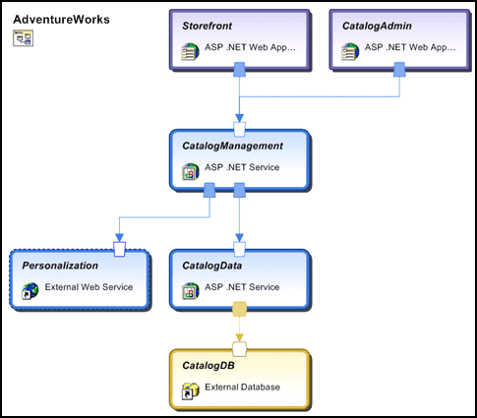
Figure 1. System Definition for a Distributed Application
AdventureWorks is a distributed system modeled using SDM and containing six subsystems. Each of the subsystems is defined using SDM. (Those definitions are not shown here.) For example, the StoreFront subsystem is based on the Web Application class and contains file and configuration resources. Each of the subsystems exposes one or more endpoints that are connected using communication relationships. Note that the definitions are scale-invariant: They do not capture the scale to which the system is deployed. The scale can be specified during deployment time.

Using SDM To Model a Deployment Environment
A distributed application that is composed of software elements, such as Web applications and a database, requires a deployment environment that includes hosts for these elements. This deployment environment typically includes definitions for servers such as SQL Server, Internet Information Services (IIS), and BizTalk® Server, as well as configuration information about those servers. Moving down the stack, SDM will enable you to specify settings for the operating system, network topology, security, and so on, all the way through to the hardware standards supported in the deployment environment.
The following diagram shows the SDM system model for the AdventureWorks deployment environment.
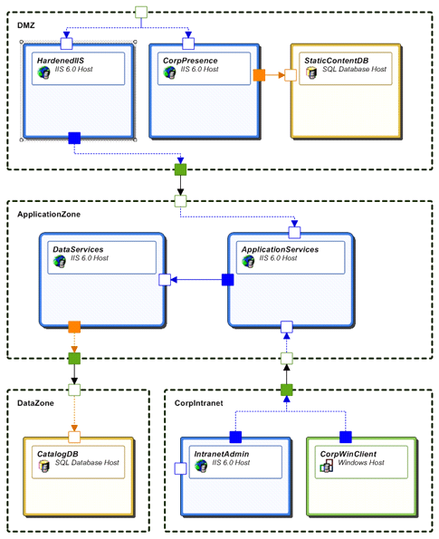
Figure 2. SDM System Model for the AdventureWorks Deployment Environment
This deployment environment contains a set of subsystems, including security zones and host servers. Each of these subsystems defines a set of resources, including their associated configuration information, such as IIS configurations, SQL configuration, and security policies.

Layers of a Distributed System
Typically, today’s distributed systems are tightly coupled with a deployment environment. Deployment of a distributed system often involves the allocation of a new set of servers as well as network and storage resource specifically targeted for that system. Certain scenarios are extremely difficult to achieve—for example, running the same distributed system across different deployment environments (such as development, test, and production) or to different scales.
In the AdventureWorks example described earlier, it was demonstrated how SDM enables modeling within individual layers of a system—the application layer, the host server layer, and so on. With SDM, you can also model between these layers of a system. Applications, application hosts, network topologies and operating systems, and hardware are all critical layers of a distributed system but are typically defined independently and owned by different teams or organizations. Layering is accomplished when systems in one layer define a set of constraints on systems in another layer and vice versa.
Figure 3 shows an example of different layers of a distributed system. Note that the actual number of layers and their contents will vary.
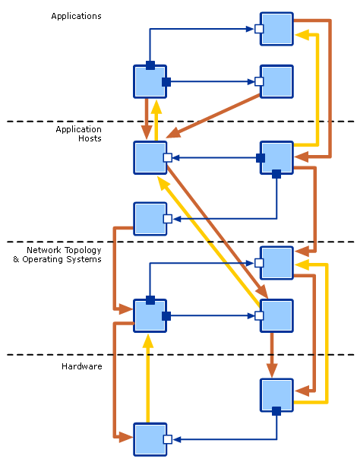
Figure 3. Layers of a Distributed System
With the layering model and the ability to enforce constraints across these layers, tools supporting SDM will enable organizations to separate management at each layer while maintaining consistency and enforcing appropriate validation of requirements and policies across the layers of the system and the organization. Thus the concept of layers enables development and management tools to support the organizational boundaries that exist in many businesses today:
- Development teams can work on different layers of a distributed system independently.
- Operations staff responsible for maintaining the server environment can manage the servers without being experts on the dependencies of specific applications.
- Operators who manage applications are not required to maintain knowledge of the hardware on which the applications run.

Long-Term SDM Solutions
The Dynamic Systems Initiative roadmap includes a comprehensive set of offerings across current and near-term development tools, operating systems, and management solutions based on SDM. At the same time, Microsoft and its partners are making long-term investments in all of these areas to expand SDM support. The resulting set of product and service offerings that support SDM will fundamentally change—and dramatically improve—the way that businesses design, deploy, and operate distributed IT systems.

Design for Operations
Decisions made during the design phase have a profound effect on deployment and operations of a distributed system. The experience gained from the operation and use of the system should, of course, guide improvements in the system design over time. SDM was created to facilitate an efficient transfer of system knowledge between all phases of the IT lifecycle: system structure, deployment requirements, operational behavior, operational environment, service level, and so on.
SDM will enable solutions that bring developers and operations staff closer together, enabling them to share knowledge and ensure that systems are “Designed for Operations.”
“Design for Manufacturability” studies once revealed that while typically only 8 percent of a product’s budget was spent by the time a product was designed, design decisions locked in 80 percent of the cost of the product.[1] The manufacturing industry learned from this and began to have production workers participate in the design process to ensure that design included manufacturing concerns. Essentially, with SDM, the same level of discussion is enabled between IT operations and application development—facilitated and enforced with SDM-compliant tools.

Developing Manageable Applications
Manageability must be engineered into an application from the beginning. Manageability can no more be added on after initial development than can scalability or security. Applications must have manageability interfaces built in; these interfaces and their schemas must be published, together with the models and behaviors behind them, prescriptive guidance for how to operate them, and any policies and service-level agreements that apply. Manageable systems depend on manageable applications, connected through manageable and published relationships. The publishing mechanism is an SDM system model that travels with the system and is consumed by software tools throughout the system’s life cycle.
Microsoft is making a number of investments to improve the manageability of individual applications and distributed systems. These investments include enhancements to the management infrastructure in Windows, development of management protocols based on the Web Services Architecture, enhancements to the management servers in Windows Server System, prescriptive guidance on how to design and build manageable applications, and capabilities in Microsoft development tools that enable developers to implement this guidance.
With the next major release of Windows, developers will be able to expose operational characteristics such as settings, instrumentation, and tasks using the simple attribution model used in the .NET Framework. The .NET Framework will include a new set of class libraries that expose the new management infrastructure. Visual Studio will offer a set of tools to help developers author manageable applications and systems.

Developing Systems, Not Just Applications
Development tools have traditionally focused on building applications that each fulfill a role in a larger distributed system, but few development tools take the perspective of the larger distributed system. In addition, these development tools tend to focus on producing executable files for simple applications and deployment packages for these applications, but not on packaging for the distributed system, which could include configuration for hardware resources. Good development and test environments for distributed applications do not commonly exist, which causes the deployment of a development environment for a distributed application to be a long and labor-intensive process. Similarly, debugging tools for distributed applications typically focus on the component view, resulting in less integration testing.
Future versions of Windows will include built-in support for automating the deployment of distributed systems based on SDM through the creation of complete deployment packages for entire distributed systems. This capability will work well with development tools that provide support for developing distributed systems as well as individual applications. The next release of Visual Studio will offer a number of features to improve the distributed application development experience. These include a set of visual designers that facilitate rapid development of distributed applications; architects and developers will be able to visualize and design the services in a service-oriented application.

Design-time Validation
Future development and authoring tools supporting SDM, such as Visual Studio .NET, will enable an IT professional to create a model of the deployment environment including a definition of the standards and policies supported in that environment. This is effectively the layer of a distributed system that can specify things like standard Web server configurations and database configurations, network topologies, and hardware configurations. In addition, SDM-compliant tools will enable application developers to fully describe the operational requirements of their applications, including such things as topology, instrumentation, configuration requirements, and resource requirements.
Developers will then be able to perform design-time validation of those applications against the policies previously defined by the IT professionals. Developers will no longer work without knowledge of the environment in which their applications will be deployed. For example, an SDM-compliant distributed system that contains a Web application subsystem might require that its host, IIS, support the “certificate” authentication scheme. If the IT staff has disabled this scheme in the data center, the developer will recognize this mismatch at design time. This design-time validation will significantly reduce the error of faulty deployments by formalizing the contract between operations and deployment in the tools.

Deploying Dynamic Systems
Today, deployment and installation technologies primarily handle individual software applications, not distributed systems. As a result, the deployment of a distributed system tends to be a rather complex process that is unique to each system and organization. A typical deployment involves appropriate ordering across multiple servers and network and storage resources, as well as coordination between multiple people or organizations. To address this deployment complexity, Microsoft will enhance Windows to provide the ability to both automate the deployment of distributed systems and dynamically allocate server, storage, and network resources to distributed systems based on business demands. In fact, Windows Server 2003 Automated Deployment Services (ADS) takes the first step in this direction by providing a fully automated solution for rapidly provisioning and re-provisioning operating systems and applications in a distributed server environment.

Capturing the Relevant Deployment Information
An SDM definition of a distributed system will contain all of the information required to deploy that system. With this information, Windows will be able to create a complete deployment of the system, including validation of requirements and operational policies, allocation of hardware resources, installation of software, and configuration. Because the SDM definition also captures the requirements of a distributed system on the deployment environment, the requirements will be enforced before a deployment is initiated and the operators will have aids to resolve discrepancies.
The SDM definition of the system can include information related to appropriate ordering of installations across multiple computers. Future deployment services in Windows will be designed to handle such complex operations across multiple computers. These deployment services will offer a reliable framework for specifying installation instructions for the various pieces of the system as well as a compensation process to recover from failures. The deployment process will be coupled with the SDM definition of a distributed system and it will support deployments to different deployment environments and at different scales.

“Virtualizing” Hardware Resources
To lower human costs associated with deploying and operating large-scale distributed systems and to help improve overall hardware utilization, Microsoft is working closely with hardware partners to deliver solutions that can centrally manage and dynamically provision servers, network, and storage devices, as well as allocate and remove resources from a particular application based on business and workload demands. Windows Server 2003, Automated Deployment Services (ADS), takes the first step in this direction by providing a fully automated solution for rapidly provisioning and re-provisioning operating systems and applications in a distributed server environment. Microsoft Virtual Server 2005, a virtual machine solution for Windows Server 2003, will add to this the ability to rapidly provision and change the configuration of virtual machines for improved hardware utilization.

Operating Dynamic Systems
Today, operational personnel face many technical challenges:
- Maintaining an up-to-date inventory or database of hardware and software components in a data center to assist with deploying, updating, and managing applications and systems.
- Manually administering or creating scripts to help automate administration tasks.
- Managing applications and systems in such a way that they are able to meet or exceed their service level agreements.
SDM will make possible a number of key innovations to directly address these challenges.

Authoritative Database Providing System-level Views
Because the SDM system model contains ever-growing knowledge of a distributed system, it provides a solid foundation for operational management. Windows will include SDM Service, which is associated with a central SDM Store, to provide a true system-level view. During deployment of a distributed system, the SDM Store is populated with the relationships among every software and hardware instance across a given deployment environment. This information is maintained throughout the life of a system. More than just documentation, the SDM Store becomes an authoritative configuration database for the operational system. By combining live information about how things are with the knowledge of how things should be from the application and IT policies, SDM Service acts as a base for core management functions.

Capture, Automation, and Reuse of Operational Best Practices
Operations personnel are an integral part of a distributed system. Although many of their tasks remain manual today, automation scripts are often used for tasks on a single computer, such as configuration and upgrade. What is needed is a framework for authoring and running automation scripts over a long period of time, across multiple computers, with the ability to recover from failure. There must also be a correlation between operational processes and distributed systems.
As described above, SDM Service will provide for authoring such long-running and reliable automation processes. These processes can be associated with distributed systems and operate over the individual subsystems as described in the model. While significant cost savings can be achieved through this automation, even more significant savings can be derived through the reuse of these operational best practices. Accordingly, these automation processes are a first-class component of an SDM-defined system. When the system is deployed in a different environment, the operational processes are deployed with it. These operational processes typically perform their tasks on components and relationships that are part of a distributed system and are portable between operational environments.

A New Type of System-level Configuration and Management Tools
For enterprise customers, future management solutions, such as the Microsoft System Center, will use the knowledge in the SDM Store and SDM Service to guide all aspects of operations management. For existing applications that are not designed for operations and that do not have SDM definitions, System Center will maintain information in the database using discovery technology.
Typical configuration management is guided by policies and normative configurations. However, in a complex distributed system, the configuration of one subsystem can affect the operation of another. For example, one subsystem may have a policy about authorization, and another component that connects to it must be configured to match that policy. The SDM Store contains the relationships that will allow System Center to validate configuration changes against such policies.
Policy impact may be dynamic. For example, consider a policy that a database used by a mission-critical application must be hosted on a redundant storage subsystem. When a client application that uses this database is promoted from test to production, the mission-critical status of the application flows on to the database and the policy requires a change in the configuration.
The system-wide view provided by the SDM Store and SDM Service also enables System Center to perform robust monitoring of system health state, engage in problem solving, and do end-to-end performance and service-level management. Understanding the complex dependencies that underlie modern distributed systems is essential to effective problem solving. Because the SDM Store and SDM Service contain detailed knowledge of how to deploy and configure systems, they enable automatic corrective action, both for hardware failures and for capacity deficiencies. Thus, a system policy can be written that automatically deploys an additional server and connects it into a scale-out cluster when the end-to-end service level is deficient.

Operating Existing Systems
The development tools provided as part of the Dynamic Systems Initiative will help ensure that future systems are “Designed for Operations”, but current IT systems have a long life cycle. Even when new systems are built, such as Web services, they often incorporate or cooperate with existing systems. Existing systems cannot be reengineered just to improve manageability.
With a little more effort and a lower level of automation, the tools built in support of the Dynamic Systems Initiative can be applied to existing systems. A small amount of effort will provide immediate benefits and make it possible to incorporate existing systems into this new environment.
One approach is to create an SDM system model of an existing system. The model is separate from the system and does not require alteration of the system. When a new system is built, future versions of Visual Studio will automate the generation of much of the information, but it is certainly possible to specify the information explicitly. If complete knowledge that a well-designed SDM system model should include is unavailable, or if the existing system does not have comprehensive instrumentation or event mechanisms, or if there is no cohesive health model behind the events, you can still define the system as it exists. A partial system model is better than none.
Much of the information in the SDM system model can be created during operations. Management solutions such as System Center include discovery tools that can identify the basic elements of the model; the operations staff has practical knowledge and policies that makes this basic model more valuable. The appendix to this paper, Scenarios, describes a scenario wherein System Center discovery is extended by the operations staff to enable automation of complex operational tasks.

Near-Term DSI Deliverables
The Dynamic Systems Initiative combines:
- A bold, long-term vision for how customers can drastically reduce complexity of IT infrastructure.
- A solid product roadmap that offers valuable near-term solutions that enable customers to take a series of practical steps in line with the long term vision.
Microsoft is delivering products across our application development tools, server applications, operating systems, and management solutions that provide immediate improvements to your ability to address the complexity in your IT environment.

Windows Server System and Windows Server 2003: The Foundation for the DSI
Windows Server 2003 is the foundation release for the DSI and includes improvements in resource management and provisioning, Web and application services, and core server management.

Resource Management and Provisioning
- Network load balancing features balance incoming IP traffic across nodes in a cluster.
- Windows Server clustering provides high availability and scalability for critical applications.
- Windows System Resource Manager enables the allocation of resources, including processor and memory resources, among multiple applications based on business priorities.
- Virtual Disk Service provides a vendor-independent API for identifying and configuring storage devices from multiple vendors in a unified way.
- ADS provides rapid server provisioning capabilities and the ability to administer large numbers of Windows Servers from one central location.

Web and Application Services
- Integrated support for the .NET Framework and ASP.NET provides a fully managed, protected, and feature-rich application execution environment for Web-based applications and XML Web services.
- IIS 6.0 is a full-featured Web server with a new fault-tolerant process model that increases the reliability of Web sites and applications.

Core Server Manageability
- Windows Management Instrumentation (WMI) tools provide administrators with unified and direct access to the management functions of local and remote systems.
- Software Update Services enable management of critical-patch releases from Microsoft to automatically deliver them to target computers in an organization from a single intranet.

Windows Server Products Beyond Windows Server 2003
In preparation for the next major server release, Microsoft will continue to innovate and deliver new products and feature packs to support the Dynamic Systems Initiative, such as Microsoft Virtual Server 2005. This product will help customers improve hardware utilization and increase server administrator productivity. Microsoft will offer a major set of enhancements to our patching and updating functionality with the release of Windows Update Services, offering improved administrative control, enhanced targeting, and support for Microsoft application updates beyond the base operating system.
For all servers in Windows Server System—such as BizTalk Server, SQL Server, and Exchange Server—Microsoft is distributing management packs for Microsoft Operations Manager, providing ready-to-use knowledge specifically for monitoring and managing these particular applications. These management packs provide predefined computer groups and processing rules, such as filters, alerts, performance sampling, threshold rules, computer attributes, providers, scripts, links to the Microsoft Knowledge Base, public views, and default notification groups. These elements integrate specialized research and expertise of the application directly into an operations environment.
To begin closing the communication loop from the operations environment to the application development process, Microsoft is providing core technology used within our own organization to help businesses improve the manageability of their environments. Windows Error Reporting is a feature included with Windows XP and Windows Server 2003 that helps Microsoft track and address operating system and application interoperability errors. Error notifications are sent back to Microsoft so that the cause can be investigated and a solution provided to the user the next time a problem occurs. Corporate Error Reporting includes a console and set of policies that allow administrators to redirect error reports from an end-user computer to a central shared directory on the corporate network, where the data can be reviewed and reported to Microsoft by the administrator through the Corporate Error Reporting console. Long-term customers will be able to use this technology to collect these notifications on a wide variety of third-party and custom applications to provide closed-loop feedback within an IT organization.

Enterprise Management Solutions
As part of the Windows Server System roadmap, Microsoft is introducing a series of management solutions that build upon the capabilities of Windows Server 2003 and provide real benefits as major early steps in the Dynamic Systems Initiative. These solutions are designed to address current enterprise environments while providing a path to future SDM-enabled environments:
- Systems Management Server 2003 was released in October 2003.
- Microsoft Operations Manager 2005 and System Center will be released in 2004.
Each product includes a wealth of partner extensions to extend the products’ relevance in Windows environments and to provide broad heterogeneous solutions for complex environments.

Systems Management Server 2003
- Enterprise patch management delivers tools to help administrators understand current patch status, deploy the latest patches with precise control, and report on success of the process from end to end.
- Application deployment tools provide WAN-aware capabilities to deploy applications such as Microsoft Office 2003 to thousands of workstations, connected and remote, across hundreds of sites with unparalleled reliability.
- Asset management tools enable detailed tracking and reconciliation of software and hardware assets, including monitoring of application and license usage.

Microsoft Operations Manager 2005
- Ease of use and deployment is achieved through new tools to help with deployment of Microsoft Operations Manager in environments of all sizes. Included tools improve state monitoring, diagnostics, data warehousing, and topological views. A task-based user interface makes operations even easier.
- Next-generation knowledge comes from dramatic improvements to management packs for Microsoft products, enabling deeper understanding of performance and problems. Tools to manage Web services in an integrated fashion are also included.
- Heterogeneous partner extensions are enabled through a connector framework for other management solutions. Operations Manager support is available for IBM Tivoli, CA Unicenter, and others.
- Third-party management packs bring knowledge about systems from suppliers other than Microsoft into the Operations Manager environment.

System Center
- The first integrated management suite for Windows Server System provides administrators with Systems Management Server and Operations Manager functionality in an integrated package that is easy to purchase and easy to deploy.
- New operating system deployment, device management and integrated reporting capabilities come in addition to new technology integration.

Application Development Tools
Providing “Design for Operations” capability in Microsoft development tools is a critical part of the Dynamic Systems Initiative strategy. With the release of Visual Studio .NET 2003, Microsoft began to deliver on that strategy by offering a range of enhancements for enterprise developers including the targeting of the Microsoft .NET Framework 1.1, improved support for working with XML Web services, and the ability to easily implement .NET–connected applications at design time for optimal manageability in operations.
Support for the Microsoft .NET Framework enables use of the management infrastructure of Windows, including the Windows Management Instrumentation APIs, extensive logging and tracing, and performance measurement functionality built into Windows. In addition, the .NET Framework enables use of that infrastructure for custom events, performance counters, and instrumentation to track business events. Manageability is increased further with the addition of the new Enterprise Instrumentation Framework (EIF). EIF significantly improves the ability to manage distributed applications for maximum reliability and availability, by providing a unified tracing and event model and set of operational services. This framework allows today’s increasingly decoupled, partitioned, and scaled-out applications to be instrumented consistently, enabling a “white-box” approach to managing application health state.
With the next major release of the Visual Studio development tools, Microsoft will deliver a service-oriented visual designer for application development that helps architects visually translate their requirements into distributed services-based applications and systems. The designer will provide modeling support for describing these applications and systems, along with corresponding policies for security, protocols, and more.
When creating mission-critical software, application architects often find themselves communicating with their counterparts who manage data center operations. The application’s logical design is often found to be at odds with the actual capabilities of the deployment environment at the time of delivery. Typically, this communication breakdown results in lost productivity as architects and operations managers reconcile an application’s capabilities with a data center’s realities. In the next major release of Visual Studio, Microsoft will mitigate these differences by offering a logical infrastructure designer tool that will enable operations managers to specify their deployment environment and architects to verify that their application will work within the specified deployment constraints.
Microsoft plans a steady stream of innovation in both tools and frameworks, offering the businesses of today and tomorrow premier tools with which to meet evolving business needs. Microsoft will continue its commitment to delivering tools that help customers take maximum productive advantage of the underlying platform and achieve success while building a wide range of software solutions.

Partnership Opportunities
Customers demand choices and have a wide variety of needs concerning their IT systems; Microsoft alone cannot satisfy all of these needs. As a result, a core tenet of the Microsoft business model has been to create a strong system of partners that can extend and enhance Microsoft platforms and products. The Dynamic Systems Initiative is true to that model, and Microsoft is working broadly across the industry with independent software vendors (ISVs), independent hardware vendors (IHVs), and services partners. That work is being directed through our existing partnership programs, including our Microsoft Certified and Gold Certified Partner Programs, the Microsoft Management Alliance (MMA), and the Visual Studio Industry Partner (VSIP) program.
DSI partnerships have already resulted in integrated solutions that make efficient use of Microsoft and partner products to reduce the cost of customer IT operations.
In the future, major Microsoft investments and its collaboration with DSI partners will focus on SDM. Microsoft will work closely with partners, enabling them to develop products in support of SDM that extend and enhance the functionality that will be delivered on the Windows platform. In addition, Microsoft will engage with the right partners and participate in standards organizations as required to create great solutions on the Windows platform that interoperate in heterogeneous environments.

Summary
Microsoft’s strategy for delivering the Dynamic Systems Initiative is to combine a differentiated, long-term vision with a solid product roadmap. Windows Server 2003 marked the beginning of a comprehensive DSI product roadmap, providing a foundation on which customers are beginning to build dynamic systems. Visual Studio .NET 2003 and the Windows Server System management products—Systems Management Server 2003 and Microsoft Operations Manager 2005—are great examples of current and near-term products that take full advantage of this strong foundation. With Windows Server System, the Dynamic Systems Initiative clearly signals that Microsoft is making a long-term commitment to reducing complexity across the IT life cycle and making it possible for IT professionals to deliver greater value to their businesses.
Initial DSI-related partnership collaboration has already resulted in integrated solutions that take advantage of Microsoft and partner products to reduce the cost of customer IT operations. Moving forward, collaboration with partners will only increase, providing customers a wider range of solutions to improve their experience on Windows and ensuring the creation of interoperable solutions for their heterogeneous environments.
Looking toward the future, Microsoft is working to develop products and enable partner solutions that will unleash the potential of SDM to simplify and automate information technology. Microsoft will both deliver and enable a new breed of application development tools that make it easier for companies to “Design for Operations.” Windows will evolve to manage distributed resources across a data center, provide users with system-level views of their environments, and offer new core services targeted at simplifying the deployment and operations of distributed systems. Windows Server System applications—such as SQL Server, Exchange Server, and BizTalk Server—and third-party applications will support SDM to deliver even higher levels of manageability for customers.
Finally, Microsoft will both deliver and enable a new category of closed-loop, system-level management solutions that provide new levels of automation in the data center and tie business policies directly to IT systems. By adopting solutions from Microsoft and its partners, businesses will realize dramatically reduced costs, improved reliability, and increased responsiveness throughout their entire IT life cycle.

Appendix: Scenarios
This section describes a few scenarios in the life cycle of a business application. You’ll see how the Dynamic Systems Initiative and its tools apply to the development, deployment, and operation of a newly built application and to existing systems that are part of an overall business solution.

Designing a Manageable System
Using Distributed Service Designer in the next major release of Visual Studio, AdventureWorks has designed a new Web-services-based system for handling their relationships with suppliers and customers. They design the structure of the application with all its subsystems as shown in Table 1.
Table 1. AdventureWorks Application Structure
Subsystem | Purpose
StoreFront | User interface Web site
CustomerManagement | Business logic for maintaining customer lists and activity
ContactManager | Data access layer for customer contact events
CustomerManager | Data access layer for customer lists
CatalogManagement | Business logic for browsing and placing orders from the catalog
CatalogManager | Data access layer for products catalog
CatalogAdmin | User interface for catalog maintenance: adding, updating items

AdventureWorks also adds a catalog database to the design; this database exists already and represents a service that the application system will use.
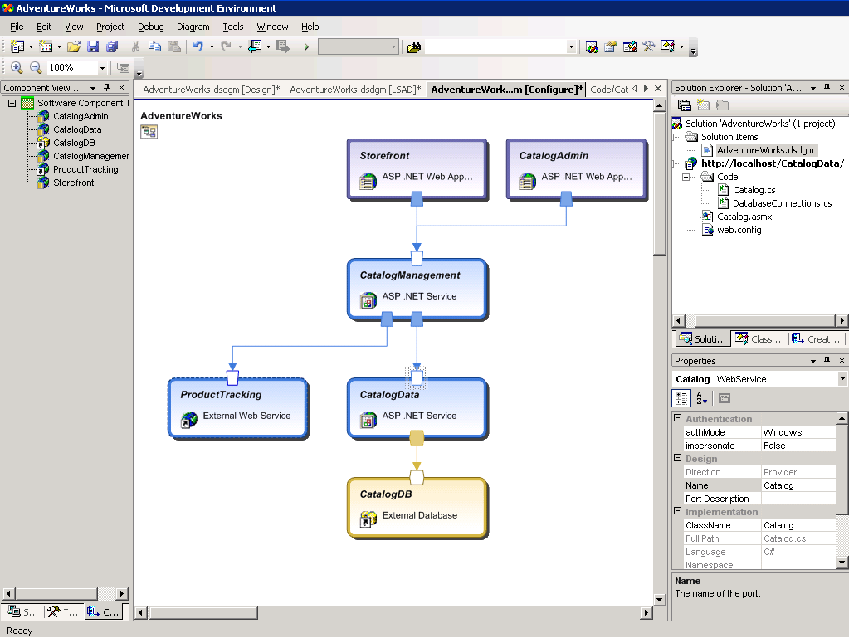
Figure 4.The Distributed Service Designer is used to design the structure of the application.
From this high-level structure, the AdventureWorks staff gradually refines the specification, modeling the details of the application, all the way down to the code. Using Logical System Architecture Designer in the next major release of Visual Studio, AdventureWorks also describes the structure of the data center where the application will be deployed, including the zones shown in Table 2.
Table 2. AdventureWorks Data Center Structure
Zone | Purpose
Perimeter Network Zone | Where users are authenticated to use the application
Application Zone | Where application’s business and data access layers will reside
Data Zone | Where the application’s database will reside

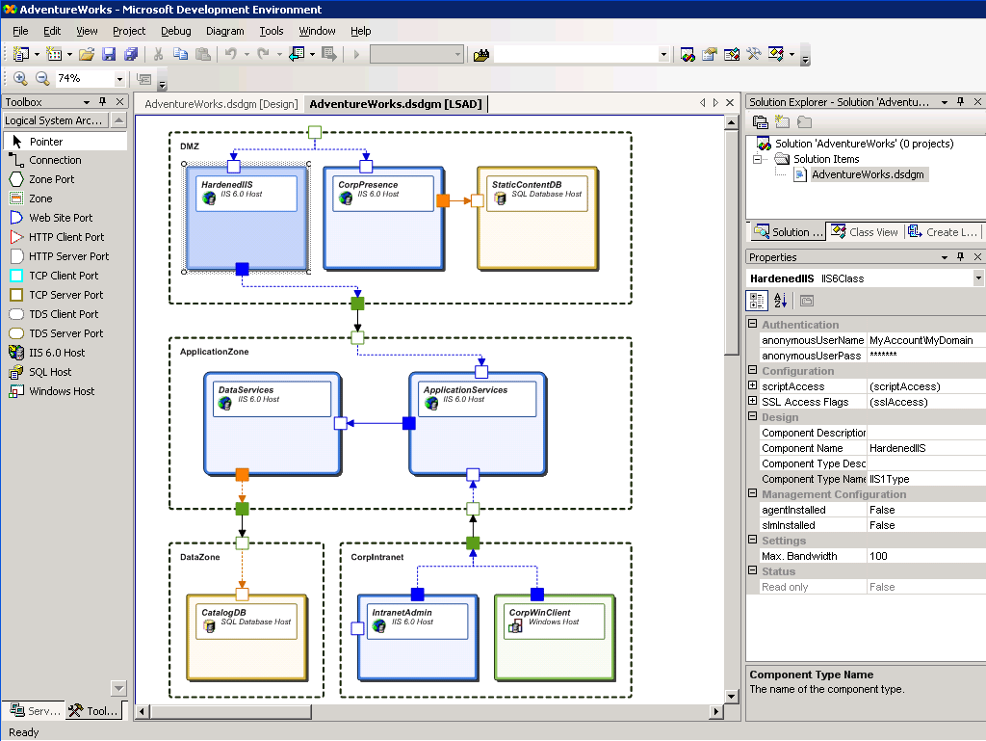
Figure 5. The Logical System Architecture Designer is used to describe the data center environment where the application will be deployed.
Again, the design will evolve from this high-level description of the types of systems used down to the physical environment—the actual computers and operating systems and storage and network systems. Of course, in many cases the data center exists already and the designers could import an existing design that had been created in Visual Studio or other tools supporting SDM.
The application model includes detailed specifications for the requirements the application places on the configuration of the systems on which it is hosted. Visual Studio includes validation tools that compare the requirements of the application with the configuration of the targeted environment—whether it exists or is only planned—and generate a report highlighting any problems, such as IIS being configured for a different authorization model than the application demands. Visual Studio also validates the constraints that flow over communication links: If the application has specific requirements on the database it works with, those are validated against the existing CatalogDB configuration.
In addition to the structural model, future development tools will also collect operational characteristics of the application. Some information, such as instrumentation schemas and control methods, is collected automatically from attributes in the code. Operational characteristics such as a health model must be specified by the architect. If the original application architects do not fill in all the information that should be in a complete operational manifest, operations staff can add information after deployment. In any case, operations staff will be maintaining the SDM model of the system during operations, adding IT policies and refining the specifications based on their experience with operating the system.

Deploying an SDM-Based System
When the application design is completed and validated, the SDM system model and all of the associated binaries are handed off to be deployed in the data center. This model describes the structure of the application, all the resources that are to be installed, and the hosting constraints. Using an SDM-based deployment tool, the operator can import that model, enter information to determine the scale of the initial application deployment, and let the SDM run-time service automatically provision the appropriate servers with the required base operating system, configure the network interconnections properly, allocate any needed storage, and deploy the application itself across this new hardware topology.
In this example, administrators have scaled out the front-end application servers to handle the traffic volume, placing them in a ScaleOutCluster, and configured the SQL Server database as an instance of HighAvailabilityCluster. SDM Service in the operating system understands such a configuration and knows how to set it up. Of course, deployment involves not only copying the executable code to the target nodes, but also configuring all of the subsystems to work together, to meet service-level requirements, and to conform to security policies. The SDM system model specifies these configuration rules and SDM Service implements them.
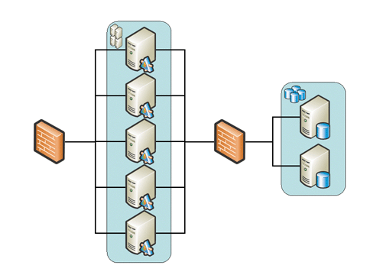
Figure 6. Deploying a Scaled-Out Application Based on an SDM System Model
Figure 6 focuses on the systems installed in the data center, but the complete system includes subsystems installed on desktops and laptops, and these must be installed and configured as well. If anything, maintaining correct configurations on these systems is both more difficult and more important than the servers in the data center—difficult because the personal computers tend to move away from the target configuration through the influence of users; important because these computers represent a greater number of potential entry and execution points for malicious users. System Center will make full use of SDM Service to install and configure the clients and will monitor and maintain their configurations, patching and upgrading them as required, and producing compliance reports and violation alerts.

Automating Operations
When the deployment is completed, a living record of the application’s topology, configuration, and management settings is stored in the SDM Store. Based on this information, a management system can intelligently monitor the health state of the system. For example, because the servers are clustered, the management system would know not to enter a high-alert mode if one redundant server fails; the management system might simply isolate the failed server, restart it, and connect it again.
The management system can also automate complex tasks such as performing a rolling patch installation without taking the entire cluster of front-end servers offline. The management system bases this operation on a library of standard functions specific to the type of object being managed—in this case a ScaledOutCluster of IIS servers. In this case, an operator could start the “rolling upgrade” function, and the management system would address the first server, make it stop accepting new sessions, allow the current sessions to finish processing requests, shut down the service, make the patch installation, restart the service as necessary, and then move on to the next server. Manually, this complex process is time-consuming and error-prone; writing a robust script for it is difficult, requiring cross-node coordination and error handling. Because the system architect designed the system for operations and included a complete SDM definition that describes the system structure and defines standard management functions, the operations staff can take advantage of this library of standard functions.
In many cases, the application architect or operations staff may need to build custom management scripts to meet the demands of a specific application. But many common operations will be provided with standard libraries. This lets the operations staff, security experts and other specialists focus on defining operational policies that use the standard operations.

Describing and Operating Existing Non-SDM Systems
In the previous section, the example application discussed is a new application, designed for operations from the ground up and delivered with a complete SDM system model, built up from one or more SDM documents and their underlying SDM definitions. As is so often the case, the new application shares its database, CatalogDB, with an existing application that was not built based on SDM. How can the operations staff effectively manage this existing system? Rebuilding it according to modern principles is not an option right now; the AdventureWorks staff is stretched thin by new business requirements.
Either the development staff or the operations staff can create a complete or partial SDM system model of the database for an existing application without requiring any modification of the application itself. Such a retrofitted model may lack some of the power provided when an entire application is designed for operations, but the model is still valuable: any operational and structural knowledge improves manageability.
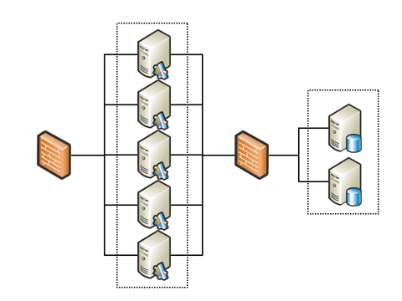
Figure 7. Creating an SDM model without changing the existing application allows automated management.
If the Web site in Figure 7 was constructed from existing systems that were not described with SDM definitions, the management tools have no way of knowing about the clusters. It is common in management systems that operations staff can manually declare the servers to be part of a group and use this group for reporting or targeting of actions or policies. For example, a simple health state rollup mechanism can show us the aggregate health state of the group, and we can target policies or patches to the group. Such a generic group carries with it no semantics: the management system cannot do a complex task such as a rolling patch installation if the management system has no knowledge of the structure of the group, if it does not know that the group is a cluster of IIS servers.
But if the operations staff instead specifies that these servers are in fact part of a ScaleOutCluster, and not just in a generic group, the staff can gain many of the benefits of knowledge-based management, such as intelligent monitoring and automation. There are limitations. For applications that are not designed for operations and are not deployed with SDM-aware tools, the structure may not be maintained automatically: if the site is scaled out to meet increased demand, the SDM Store may not automatically be updated. The operations staff would have to maintain this grouping by hand, adding a new node to the ScaleOutCluster. This is still more efficient than manually doing all of those tasks for each of the nodes in the cluster or editing a lot of complex scripts.
Why can an SDM system model not be constructed automatically through discovery? System Center can indeed reconstruct much of the information automatically. All nodes are discovered, as well as the software installed, running server roles, configurations, and settings. In some well-designed cases such as Active Directory® and Exchange, System Center can even reconstruct the relationships among systems. In most cases, though, while the actual configuration may be visible, the architect’s intent is not apparent. This is the essence of the problem of adding management after design time: strong management requires knowledge transfer, and that is what SDM enables. Without knowledge, the DSI systems are no better than conventional management systems.
The key to managing existing systems is that the knowledge can be captured, and an SDM-based description can be created, without modifying the system.

Dynamic Data Center Driven By Business Policy
If the application is deployed in a Dynamic Data Center, the virtualization of the hardware environment enables not only automation of the initial deployment, but also automatic scaling of the system to meet changing demands.
As traffic to the AdventureWorks site increases, System Center monitors the service level. Monitoring rules can automatically trigger the provisioning and deployment of additional servers as required. Monitoring rules can be set up for different styles of policies: since this is a critical service for Adventure Works, System Center can monitor trends and anticipate demand, provisioning more resources well before things slow down. For an internal site, a more conservative policy was set up: System Center waits, watching service levels until it is convinced that the increased load is long-lasting. If traffic decreases, System Center can remove servers that are no longer needed, recycling them into the general resource pool.
Initially, the AdventureWorks IT staff did not want the system to reconfigure resources completely automatically; the staff wanted to monitor the system and ensure that the automatic provisioning rules were reasonable. The staff configured the policy to request approval by a human: the administrator can approve the provisioning using e-mail or a portal.
The Dynamic Data Center virtualizes the entire system, top to bottom. It provisions servers, installing and configuring operating systems and SQL Server and other servers, and also addresses storage and network devices. Because the Dynamic Data Center has the detailed knowledge of the application structure in SDM Service and the SDM Store, it can deploy the application components on the new servers and integrate them correctly into the application system. Because the SDM Store maintains the correct description of the deployed system through these changes, all of the automated management functions described previously adapt to the changing configurations.

Related Links
See the following resources for further information:
- Design for Manufacturability, Optimizing Cost, Quality and Time-to-Market, Second ed., by David M. Anderson, CIM Press, 2001.
- Building a Dynamic Data Center, a white paper aimed at independent hardware vendors (IHVs) interested in collaborating with Microsoft around their Dynamic Data Center solution, available at http://www.microsoft.com/whdc/hwdev/platform/server/datacenter/dynamicdc.mspx
- Dynamic Systems Initiative Web site at http://www.microsoft.com/dsi

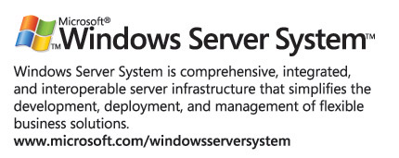
For the latest information about Windows Server System, see the Windows Server System Web site at http://www.microsoft.com/windowsserversystem.

Anderson, David M. Design for Manufacturability, Optimizing Cost, Quality and Time-to-Market, Second ed., CIM Press, 2001.

