Microsoft Dynamics CRM 3.0

Pricing and Licensing White Paper
Published: December 2005

Contents

Availability
Licensing Structure
Sales Channels & Availability
Pricing Summary
Product Registration
Internal Use Licensing for partners

Upgrading to Microsoft Dynamics CRM 3.0

CRM Software Adviser (CSA) Fee Claims Process

Continued availability of Microsoft CRM 1.2
Microsoft CRM 1.2 Incentive Programs Guidance

Special issues

Additional Information

Availability

Microsoft Dynamics CRM 3.0 will be available and orderable for customers on pricelists beginning December 1, 2005 in English, followed by language availability according to the table below.

Language | General Availability **
English | 12/1/2005
French | 1/1/2006
German | 1/1/2006
Russian | 1/1/2006
Dutch | 1/1/2006
Spanish | 2/1/2006
Danish | 2/1/2006
Brazilian Portuguese | 2/1/2006
Italian | 2/1/2006
Polish | 3/1/2006
Swedish | 3/1/2006
Hungarian | 3/1/2006
Czech | 3/1/2006
Turkish | 3/1/2006
Norwegian | 3/1/2006
Greek | 4/1/2006
Finnish | 4/1/2006
Portuguese (Iberian) | 4/1/2006
Japanese | 7/1/2006
Chinese Traditional | 5/1/2006
Chinese Simplified | 5/1/2006

** General Availability dates for localized software versions are
based on current RTM projections and are subject to change.

The English version is available for MSDN Subscribers via download on MSDN Subscriber Download Site downloads as of November 15, 2005. Microsoft Partners (including Registered, Certified and Gold Certified) will receive the Microsoft Dynamics CRM 3.0 media in their respective monthly subscription kits per standard release timelines. Microsoft Dynamics CRM 3.0 English will be included in the December 2005 kit shipments (including MAPS). Subsequent languages will be available via MSDN as above schedule permits.

Microsoft Dynamics CRM 3.0 available via MSDN is covered by MSDN licensing and available for development, test, design and demonstration purposes only.

Microsoft Gold Certified and Certified partners will receive Product Key for the MSDN version of Microsoft Dynamics CRM 3.0 via separate shipment. The general MSDN Product Key can be used as well. (Please note: Product Key mailed out on November 14, 2005 for Microsoft Dynamics CRM 3.0 does NOT work. The general MSDN Product Key will have to be used until an updated Product Key specific to Microsoft Dynamics CRM 3.0 is issued in December 2005.)

For internal usage, Microsoft partners will receive Microsoft Dynamics 3.0 with the regular quarterly shipment of “Action Pack” in Q1 2006. See later section on specifics for change in license rights for internal usage.

Partners who choose to download the software prior to receipt of their partner program subscription kits should use the MSDN Product Keys available on the download site, but should re-install and register using their official partner keys when available in order to receive the correct number of licenses eligible at each partner level. (The MSDN-specific keys unlock 10 users and bypass the registration process.)

It is planned to provide trial versions or evaluation kits for Microsoft Dynamics CRM 3.0 in Q1 of 2006.

Licensing Structure

Microsoft Dynamics CRM 3.0 will be available in 2 editions:
- Microsoft Dynamics CRM 3.0 - Professional Edition
- Microsoft Dynamics CRM 3.0 – Small Business Edition

For each edition there is a:
- Server License
- Client Access License (CAL)

In addition to server and client licenses mentioned above there will be:
- Microsoft Dynamics CRM 3.0 – External Connector (for Professional Edition only)
- Upgrade of Microsoft Dynamics CRM 3.0 – Small Business Edition to Microsoft Dynamics CRM 3.0 – Professional Edition

Please refer to separate documentation on technical requirements for running Microsoft Dynamics CRM 3.0. Licenses for Microsoft Dynamics CRM 3.0 do not include licenses for those products.

Microsoft Dynamics CRM 3.0 – Professional Edition
This edition includes all CRM features with no scalability limits on licensing.

Microsoft Dynamics CRM 3.0 – Small Business Edition
This edition includes all CRM features and requires Microsoft Small Business Server – Premium Edition and can only be installed on this server.

The scalability limits for licensing follows that of Microsoft Small Business Server – Premium Edition, meaning that it can only run on 1 server with a maximum of 75 Client Access Licenses. Special features related to the Microsoft Small Business Server – Premium Edition included with this edition are:
- Wizard Driven Install with less than 10 clicks
- Configuration “Consultant in-a-box”
- Data Migration from Microsoft Office Business Contact Manager
- Integration to Management Tools in Microsoft Small Business Server
- Integration to Fax Service in Microsoft Small Business Server

Mix of editions not allowed
Microsoft Dynamics CRM 3.0 – Professional Edition installations cannot be mixed with installations of Microsoft Dynamics CRM 3.0 – Small Business Edition.

Microsoft Dynamics CRM 3.0 – External Connector
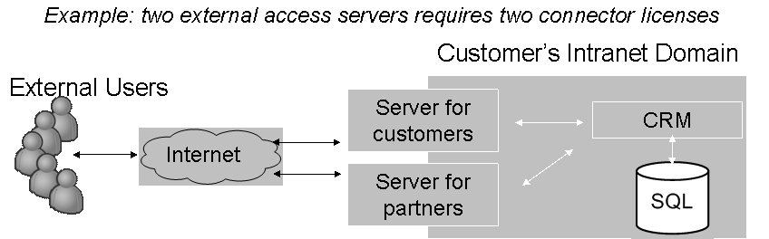
This is a new license type, available for Microsoft Dynamics CRM 3.0 – Professional Edition only. It is a license only, and does not include any physical software components.

Microsoft Dynamics CRM 3.0 – External Connector can be used to provide access to Microsoft Dynamics CRM 3.0 data to customers, partners and suppliers through any application/graphical user interface (GUI). External users should not be using the Microsoft Dynamics CRM 3.0 applications & GUIs directly. External Connector license is a per-server license, and hence must be purchased for each server that hosts an application that provides external access to Microsoft Dynamics CRM 3.0 data.

The license type cannot be used for providing access to Microsoft Dynamics CRM 3.0 data to internal employees, external users acting in an internal capacity, external users using the Microsoft Dynamics CRM 3.0 Outlook or Web Client. ALL such employees must have a Microsoft Dynamics CRM 3.0 – Professional Edition CAL or a Microsoft Dynamics CRM 3.0 – Small Business Edition CAL in order to access/interact with Microsoft Dynamics CRM 3.0 data.

The Microsoft Dynamics CRM 3.0 – External Connector does not include licensing for any other Microsoft products. If external scenarios integrate with Microsoft SQL Server, Microsoft Office SharePoint or any other product license rights for these must be established separately.

Microsoft Dynamics CRM 3.0 – External Connector enables deployments and solutions to be build and implemented in ways that was not possible with Microsoft CRM 1.2. We continue to encourage our partners and customers to help ensure that customer implementations and installs are in line with applicable license terms.

Server Licenses
Every server that runs Microsoft Dynamics CRM 3.0 requires a Server License

Client Access License (CAL)
Every internal user accessing Microsoft Dynamics CRM 3.0 requires a CAL. There is no concept of “light” user or “read only” user.

Software Assurance (SA)
Software Assurance at 25% per year of license is included with Microsoft Dynamics CRM 3.0 in customer facing Volume Licensing Programs.

Regardless of how customers purchase Microsoft Dynamics CRM 3.0 – through Full Packaged Product (FPP) or through one of the Volume Licensing programs, customers receive the following product enhancement benefits:

CustomerSource
Self-support resources, e.g. Knowledgebase, discussion forums and more. Reduces customer’s support costs by providing 24x7 self service support, as well contact to CRM Support Team online.

Updates and Upgrades
Product upgrades and updates.

In addition to the product enhancement benefits, all Microsoft Dynamics CRM customers also receive Training benefits:

- Subscriptions to the Foundation Library. With this benefit, users can access the Foundation Library - which provides self-directed tutorials via any PC with Internet access. This eLearning option helps customers learn the ins and outs of their solution with either 2, 4 or 6 subscriptions to the Foundation Library depending on their service plan.
- eCourses provide in-depth training with content equivalent to our classrooms while also supplying the convenience, flexibility and travel savings of online learning. Customers who enroll in Software Assurance get 3 eCourse credits each, and CRM customers who also enroll in Deluxe get the additional benefit of a 20% discount on additional eCourse purchases.

Software Assurance benefits depend on how Microsoft Dynamics CRM 3.0 has been acquired. If acquired through Open or Open Value, a foundation level of services is included:

- Two technical support incidents with a 3-hour guaranteed response time (available for customers with list prices of more than $3,000 USD)
- Discounts on Flex Support - Flex Per-Incident Support and Flex 5-Pack Support
- Managed Newsgroups - These online forums help customers collaborate with other customers to learn about their solution and solve technical issues. If questions aren’t answered by other customers within two business days, a Microsoft Business Solutions support engineer will respond. This is a great way to receive unlimited answers to your non-urgent technical questions, so you can save your support incidents for those times when you need urgent support.

When customers purchase through Select EA and Enterprise, their Software Assurance benefits scale with the volume of licenses they are committing to purchase:

- Unlimited technical support incidents with a 1-hour guaranteed response time – with the ability to proactively initiate Chat and ScreenSharing on support requests
- A TechNet subscription is the definitive resource of tools, software, and utilities that IT professionals rely on to plan, deploy, manage, and support the other Microsoft products and technologies that you use beyond your business solution, such as Microsoft Office, Microsoft Exchange Server, or Windows XP Professional.

Deluxe Support Services for Business Solutions
This support offering is available for customers with 50 users or more, multi- site and/or multi-national and have 24 x 7 support needs. These customers usually have expressed an interest in having a direct relationship with Microsoft and their partners and represent less than 1% of the MBS customer base. The customers must be enrolled in an Enhancement Plan in order to enroll in Deluxe.

CRM Software Advisor (CSA) Fee
Partners who sell the initial license & Software Assurance earn a CRM Software Advisor (CSA) fee. Partners who sell a Software Assurance renewal earns a CSA fee as well. Partners can also sign up for Support Alerts in PartnerSource, so they can be proactively notified by email whenever one of their customers contacts the CRM Support Team. Exact CSA fees per separate CSA guidelines.

Enhancements to Software Assurance program – March 2006.
Microsoft Volume Licensing team has announced enhancements to Software Assurance, which apply to many of the licensing programs and licensing pools. With Microsoft Dynamics CRM 3.0 in the Server pool of Volume Licensing, there will be additional benefits – effective in March 2006 - that will be available for customers who buys through Open Value, Select and Enterprise Agreement volume licensing programs.

The changes provide customers with additional problem resolution support benefits, on top of the support incidents they receive in their CRM SA plan. These additional support benefits can be used for support questions on the rest of their Microsoft solution – such as Exchange Server or their Operating System. The incidents included in their CRM SA plan can only be used for CRM application questions, so this provides them with additional, flexible support options.

- Earned incidents: The Select, Enterprise Agreement and Open Value programs of Volume Licensing will allow customers to “earn” support incidents based on Software Assurance spend. Customers will receive 1 incident for every $20,000 of SA spend, plus 1 incident per customer per SA enrollment. (Earned incidents are not applicable to Open License customers.)
- Unlimited web support: Customers will receive unlimited web support during business hours for covered servers for low-severity (Sev C) incidents. SA customers in the EA and Select programs currently receive this benefit, and now it is being extended to Open Value customers. (Unlimited web support is not applicable to Open License customers).
- 24x7 support: With this benefit, customers can use their earned telephone support incidents to submit an incident 24x7 for business critical outages on all Microsoft-supported products, including all server editions, MS Window and MS Office. Response times begin with a two-hour response time for a Sev A.

Sales Channels & Availability
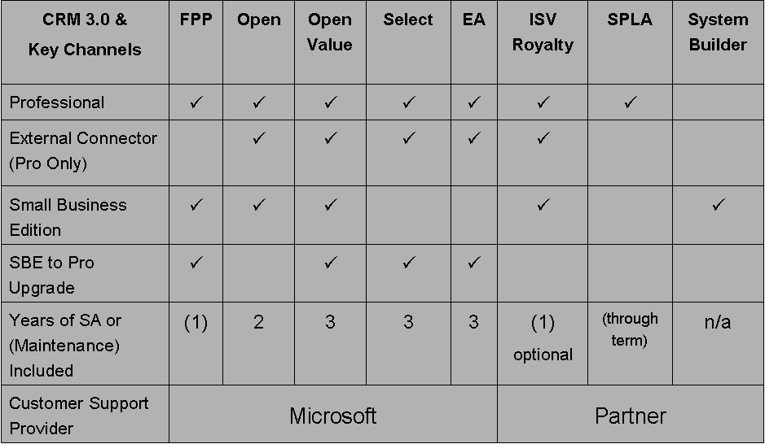
Microsoft Dynamics CRM 3.0 can be purchased through various channels. The following may vary depending on sales channel licensing model:
- Part Number Availability
- Software Assurance and Maintenance
- Customer Support Provider
- Program Term

In addition to previously available sales channels, Microsoft Dynamics CRM 3.0 will be available under the Microsoft Software Provider Licensing Agreement (January 1, 2006), the OEM program in the System Builder Channel (Q1 2006), and under Academic Licensing terms.

Microsoft Dynamics CRM 3.0 is part of the “Server Pool” within the Microsoft Volume Licensing program and purchases qualify as part of this pool. All Part Numbers of Microsoft Dynamics CRM 3.0 (Servers, CALs and External Connectors) qualify individually.

Academic Licensing
Microsoft Dynamics CRM 3.0 will be offered at a discounted rate to qualifying academic institutions via:
- Campus & School Agreement
- Academic Select
- Academic Open
- Microsoft Business Solutions Academic Alliance
- Service Provider License Agreement (SPLA)
- ISV Royalty Agreement
Learn more at http://www.microsoft.com/education/howtobuy.mspx

Software Provider Licensing Agreement
Customers are offered a choice of deployment – on premise or hosted. SPLA provides partners the opportunity to offer hosted Microsoft Dynamics CRM 3.0 as a service for a monthly fee to customers. The program automatically enables the SPLA partner to offer free 30 day trials to customers. Billing happen monthly based on partner reports. Licenses are referred to as “Subscriber Access License” (SAL). Prices are from Microsoft to partner – partners determine additional fees to customers based on partner services included. There are no requirements for a server license. This licensing capability will be available January 1, 2006.

Learn more at http://www.microsoft.com/serviceproviders/licensing/default.mspx

Technical information and further details will be published separately around availability of program.

OEM and System Builder Channel
Microsoft System Builder partners build generic servers and PC. Products are acquired through Microsoft Authorized Distributors, and own the customer relationship and support obligations. Microsoft Dynamics CRM 3.0 – Small Business Edition requires Microsoft Small Business Server – Premium Edition and will be offered to the System Builder channel in Q1 of 2006. Exact pricing still to be determined.

Open Subscription License (OSL) program
This program is a specific regional licensing program for EMEA which will be replaced by Open Value as of January 2006. As such, no new agreements will be signed for OSL as of January 2006. However, for the large amount of customers already on OSL we expect Microsoft Dynamics CRM 3.0 part numbers to be included in this programs price list in January 2006 or February 2006.

Multi-Year Open (MYO) program
This program is a specific regional licensing program for EMEA which will be replaced by Open Value as of January 2006. As such, no new agreements will be signed for MYO as of January 2006. However, for the large amount of customers already on MYO we expect Microsoft Dynamics CRM 3.0 part numbers to be included in this programs price list in January 2006 or February 2006.

Pricing Summary

Prices shown in table below are Estimated Retail Pricing ranges in U.S. dollars through Volume Licensing for license plus one year of Software Assurance.

Actual pricing and availability of Estimated Retail Pricing may vary by licensing program, geography, and Software Assurance term in compliance with applicable local legislation.

Please contact a local distributor or authorized reseller of CRM for exact pricing. Financing term assumes 10% annualized rate and may vary based on volume and geography and is subject to availability.

Exact prices and part numbers are available via pricelists and separate datasheet (Available December 1, 2005), with the following being the Estimated Retail Prices in the United States.

It is possible to upgrade to Microsoft Dynamics CRM 3.0 – Small Business Edition to Microsoft Dynamics CRM 3.0 – Professional Edition via separate part numbers.

Product Registration

Microsoft Dynamics CRM 3.0 will change from the Microsoft CRM 1.2 specific registration keys to using standard Microsoft Product Keys as found in Microsoft Windows, Microsoft Office and other Microsoft products.
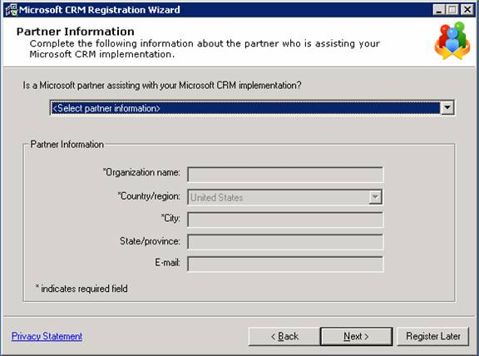
Upon installation of software, customers are required to register the product on-line (Internet Access is required) within 30 days. If the product is not registered within 30 days it will be disabled for any further use. However, product can be re-enabled for use upon registration any time if disabled due to the 30 day expiration. Additional CALs added to the installation after initial purchase does not require additional registration. Certain programs – such as SPLA and ISV Royalty Program, does not require registration.

As part of the one time registration process, customers are encouraged to provide information on partner involved in the purchase process. This is a change from Microsoft CRM 1.2 where customers had to connect to a separate web site to provide information on partner involvement. For more information on the CRM Software Advisor process see separate section on that.

Please note: For Microsoft Dynamics CRM 3.0 available initially, an easy workaround in the partner information registration process has to be applied. Even though the form does not indicate that it is required to fill in the “State/province” field, it is necessary to do so in order to complete the form without receiving an error. Please help ensure that this workaround is known and applied. This problem will be permanently fixed in January 2006 and made available via new CDs.
Customers in the Microsoft Volume Licensing program will never need new license keys, but are legally required to purchase additional licenses matching actual usage of Microsoft Dynamics CRM 3.0.

Internal Use Licensing for Microsoft Partners

Microsoft Dynamics CRM 3.0 licensing offers a higher number of licenses for internal use to Microsoft partners than was the case with Microsoft CRM 1.2.

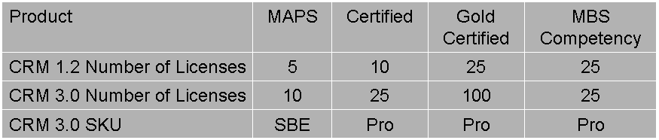

Numbers indicated in the “MBS Competency” column are additional licenses available to Certified and/or Gold Certified partners with MBS Competency.

Internal use products (English) will be available via the regular “Action Pack” shipment in Q1 2006. Partners implementing Microsoft Dynamics CRM 3.0 internally under this program will have to register the product as described in the Product Registration section. Additional language versions will be made available through regular Action Pack shipments upon availability.

For partners requiring additional CAL’s beyond numbers listed in above table, it is possible to acquire additional licenses through normal channels and with normal pricing.

For partners with affiliates in different countries, it is possible to buy additional MAPS subscriptions - limited to one organization per country though.

Upgrading to Microsoft Dynamics CRM 3.0

Customers upgrading to Microsoft Dynamics CRM 3.0 from Microsoft CRM are entitled to do so based on the following guidelines:
- Software Assurance has to be active as of General Availability date of Microsoft Dynamics CRM 3.0 in specific language version
- 1 Microsoft CRM 1.2 License equals 1 Microsoft Dynamics CRM 3.0 license

Customers on Enterprise Agreement (EA) and/or Select will automatically receive CDs with Microsoft Dynamics CRM 3.0 – Professional Edition upon General Availability. As described earlier – registration keys are included on CDs and registration will have to be completed within 30 days of installation as described in the Product Registration section.

Customers on Open and Open Value program, with Microsoft CRM 1.2 Professional or Microsoft CRM 1.2 Standard will need to have their authorization and enrollment numbers available when ordering the Microsoft Dynamics CRM 3.0 media from their channel partner – a nominal fee may apply.

As described earlier – registration keys are included on CDs and registration will have to be completed within 30 days of installation as described in the Product Registration section. As indicated in the table above, those customers will have to be aware of possibilities, limitations and consequences when choosing their upgrade path to either Microsoft Dynamics CRM 3.0 – Small Business Editions or to Microsoft Dynamics CRM 3.0 – Professional Edition. From the time of upgrade, pricing, licensing terms and other terms of the chosen upgrade path will apply. Example: A customer choosing upgrade path to Microsoft Dynamics CRM 3.0 – Professional Edition means that additional CALs purchased at a later stage will have to match, Software Assurance will be calculated accordingly etc.

Customers with products purchased under FPP will have to be manually contacted. Based on data available in registration database we will provide contact information for those customers. Further information and guidance to be provided during December 2005.

Customers with Microsoft CRM 1.2 for Small Business Server will be allowed to upgrade to Microsoft Dynamics CRM 3.0 – Small Business Edition.

Software Assurance Renewals occurring after General Availability of Microsoft Dynamics CRM 3.0 in relevant language version will be calculated based on the price of the relevant Microsoft Dynamics CRM 3.0 part number. As noted earlier, please ensure that customers are made aware of this consequence when choosing upgrade path (apply to customers on Open and Open Value).

Customers with expired Software Assurance will need to buy Microsoft Dynamics CRM 3.0 at normal price and license as other new customers.

Customers who purchased Microsoft CRM prior to Volume Licensing for Microsoft CRM 1.2 (Primarily North America)
We are looking into a program that will allow amnesty for customers who purchased Microsoft CRM before it entered the Volume Licensing, and will update you on the status of this effort. For customers who purchased Microsoft CRM after it entered Volume Licensing, amnesty programs for Software Assurance are not and will not be allowed

Changes in reporting tools for Microsoft Dynamics CRM 3.0
Microsoft Dynamics CRM 3.0 uses Microsoft SQL Server Reporting Services as reporting platform. That is a change from Microsoft CRM 1.2 where Crystal Reports were being used. Please refer to separate technical guidance on how to transition reports created for Microsoft CRM 1.2 via Crystal Reports to reports applicable to Microsoft Dynamics CRM 3.0. Customers who want to continue you to use Crystal Reports for reporting purposes will have to acquire Crystal Server Software separately from Business Objects.

CRM Software Adviser (CSA) Fee Claims Process

Partners promoting and working with customers in the purchasing and implementation process of Microsoft Dynamics CRM 3.0 are offered membership in the CRM Software Advisor (CSA) program. (Applies to Volume Licensing – does NOT apply to SPLA, ISV and System Builder/OEM)

To become part of the program the partner has to:
- Be “Registered Member” in the Microsoft Partner Program. (Accomplished by filling out profile online – no cost associated.)
- Sign Software Advisor Addendum
- Certify at least 2 people with Microsoft Dynamics CRM 3.0. (At least 3 specific exams on Microsoft CRM 1.2 or Microsoft Dynamics CRM 3.0 has the be passed to be certified)

In order to qualify for CSA Fees the partner has to:
- Recommend Microsoft Dynamics CRM 3.0 during the pre-sales phase
- Have been chosen as the primary implementation partner by the customer

As described in the Product Registration section, customers are encouraged to provide information about the CSA during the product registration process. Following this, the CSA partner can claim CSA fee via above link.

The customer part of this process has been simplified compared to procedures required as part of Microsoft CRM 1.2.

The CSA part of the claim process for Microsoft Dynamics CRM 3.0 is unchanged compared to Microsoft CRM 1.2 claim process.

Validation between customer registration and CSA claim will be done prior to fulfillment of claim.

Continued availability of Microsoft CRM 1.2

For customers who do not immediately upgrade to Microsoft Dynamics CRM 3.0, it will be possible to continue to buy licenses for Microsoft CRM 1.2.

It is necessary to keep Microsoft CRM 1.2 on the price list as adding additional users will require a new registration key as per Microsoft CRM 1.2 guidelines and processes on the “MBS Registration Site”.

With the change to using standard Microsoft licensing keys this will not be a necessary requirement with future releases.

Microsoft CRM 1.2 will continue to be available for the life of Microsoft Dynamics CRM 3.0 under Open, Open Value, Select and EA.

With the General Availability of respective language versions of Microsoft Dynamics CRM 3.0, Microsoft CRM 1.2 will be removed and made unavailable within the FPP program.

As of December 1, 2005, prices for Microsoft CRM 1.2 part numbers will be adjusted to match prices of Microsoft Dynamics CRM 3.0. These price changes will apply to all language versions as of December 1, 2005.

All customers purchasing Microsoft CRM 1.2 under any licensing program will receive a free license upgrade to Microsoft Dynamics CRM 3.0 provide all conditions are met per earlier description.

Customers purchasing Microsoft CRM 1.2 prior to December 1st receive a price break if they purchase Sales Pro or Service Pro, since they will receive rights to the full Microsoft Dynamics CRM 3.0 Professional suite. All customers that purchase Microsoft Dynamics CRM 1.2 on or after December 1st will pay the exact same price that will be in effect for Microsoft CRM 3.0.

Microsoft CRM 1.2 Incentive Programs Guidance
“Microsoft CRM 1.2 Buy Now Incentive”
As of December 1, 2005 all prices for Microsoft CRM 1.2 will adjust to match those of Microsoft Dynamics CRM 3.0 as described earlier and the “Microsoft CRM 1.2 Buy Now” incentive ends as communicated and defined at the start of the campaign. This applies to all language versions of Microsoft CRM 1.2 and to all licensing programs as described earlier.

See earlier sections for descriptions on how to upgrade from Microsoft CRM 1.2 to Microsoft Dynamics CRM 3.0.

Microsoft CRM 1.2 for Microsoft Small Business Server Promotion
This is not an actual promotion any more. It was introduced as a promotion in January 2005, but converted to a permanent offer in May 2005. As of December 1, 2005 prices for Microsoft CRM 1.2 for Microsoft Small Business Server will adjust to match those of Microsoft Dynamics CRM 3.0 – Small Business Edition.

See earlier sections for descriptions on how to upgrade from Microsoft CRM 1.2 to Microsoft Dynamics CRM 3.0.

“Microsoft CRM for Small Business Partner Incentive”
As announced and communicated as part of the incentive introduction, this incentive program will expire with the availability of Microsoft Dynamics CRM 3.0. Specifically this means that as of December 1, 2005 it will no longer be possible to use or claim under this inventive program. Expiration of this program applies to all language versions and geographies as of December 1, 2005.

Special Issues

Error with MSDN Product Key Issued for Certified and Gold Certified Partners
MSDN Product Key mailed out on November 14, 2005 for Microsoft Dynamics CRM 3.0 for Microsoft Certified and Microsoft Gold Certified partners does NOT work. The general MSDN Product Key will have to be used until an updated Product Key specific to Microsoft Dynamics CRM 3.0 is issued in December 2005.

Work around for “State/Province” requirement in registration process for partner information
For Microsoft Dynamics CRM 3.0 available initially, an easy workaround in the partner information registration process has to be applied. Even though the form does not indicate that it is required to fill in the “State/province” field, it is necessary to do so in order to complete the form without receiving an error. Please help ensure that this workaround is known and applied. This problem will be permanently fixed in January 2006 and made available via new CDs.

Additional Information

Microsoft Dynamics CRM  Licensing  Contact a Licensing Specialist  Information on Software Assurance and links to data sheets  Information on how to access CRM benefits  CustomerSource  For questions about any MBS service plan  CSA Important links  Enrollment  Re-enrollment  Microsoft CRM Software Advisor Addendum  Claim Microsoft CRM Software Advisor fees  View Status of Claims  View Fee Schedule and regional targets | www.microsoft.com/crm  https://partner.microsoft.com/US/productssolutions/business/businesscrm/  www.microsoft.com/licensing  partner.microsoft.com/licensing  www.microsoft.com/licensing/contact/default.mspx  http://www.microsoft.com/BusinessSolutions/support_options.mspx  http://www.microsoft.com/businesssolutions/crm/support/microsoft_crm_support.mspx  https://mbs.microsoft.com/downloads/customer/services/mscrm_services_guidebook.pdf  https://mbs.microsoft.com/customersource/productsservices/productoverview_crm.htm  mbsparsv@microsoft.com  https://partner.microsoft.com/global/program/enrollment/  https://partner.microsoft.com/global/program/reenrollment/  http://members.microsoft.com/partner/solutions/business/crm/csa.aspx  https://mbs.microsoft.com/mbsregistration/ChooseRelationship.aspx  https://mbs.microsoft.com/Members/MBSRegistration/CSAClaimList.aspx  https://mbs.microsoft.com/partnersource/resources/partneressentials/mbsfeeschedules

