

Step-by-Step Guide for Setting Up IPv6 in a Test Lab
Microsoft Corporation
Published: April, 2005
Author: Microsoft Corporation

Abstract
This guide describes how to configure Internet Protocol version 6 (IPv6) in a test lab using five computers. Of the five computers, one is a DNS server, two are clients, and two are routers. This guide also includes an exercise that ends the network connection between intranets and then uses Intra-Site Automatic Tunnel Addressing Protocol (ISATAP) to restore communication.

Information in this document, including URL and other Internet Web site references, is subject to change without notice. Unless otherwise noted, the example companies, organizations, products, domain names, e-mail addresses, logos, people, places, and events depicted herein are fictitious, and no association with any real company, organization, product, domain name, e-mail address, logo, person, place, or event is intended or should be inferred. Complying with all applicable copyright laws is the responsibility of the user. Without limiting the rights under copyright, no part of this document may be reproduced, stored in or introduced into a retrieval system, or transmitted in any form or by any means (electronic, mechanical, photocopying, recording, or otherwise), or for any purpose, without the express written permission of Microsoft Corporation.

Microsoft may have patents, patent applications, trademarks, copyrights, or other intellectual property rights covering subject matter in this document. Except as expressly provided in any written license agreement from Microsoft, the furnishing of this document does not give you any license to these patents, trademarks, copyrights, or other intellectual property.

© 2005 Microsoft Corporation. All rights reserved.

Microsoft, MS-DOS, Windows, Windows NT, and Windows Server are either registered trademarks or trademarks of Microsoft Corporation in the United States and/or other countries.

All other trademarks are property of their respective owners.

Contents
Step-by-Step Guide for Setting Up IPv6 in a Test Lab 5
Setting Up the IPv6 Infrastructure 5
DNS1 6
CLIENT1 13
ROUTER1 14
ROUTER2 15
CLIENT2 15
Creating a Static IPv6 Routing Infrastructure 16
Configuring the Test Lab to Use ISATAP 18
Conclusion 21
See Also 22

Step-by-Step Guide for Setting Up IPv6 in a Test Lab
This guide provides detailed information about how you can use five computers to create a test lab with which to configure and test IPv6 with the Microsoft® Windows® XP Professional with Service Pack 2 (SP2) operating system and the 32-bit versions of the Windows Server™ 2003 with Service Pack 1 (SP1) operating system. These instructions take you step-by-step through the configuration required for setting up IPv6 in the test lab.
Note:
The following instructions are for configuring a test lab using a minimum number of computers. Individual computers are needed to separate the services provided on the network and to clearly show the desired functionality. This configuration is neither designed to reflect best practices nor is it designed to reflect a desired or recommended configuration for a production network. The configuration, including IP addresses and all other configuration parameters, is designed only to work on a separate test lab network.

Setting Up the IPv6 Infrastructure
The infrastructure for the IPv6 test lab network consists of five computers performing the following services:
• A computer running Windows Server 2003 with SP1, Standard Edition, that is used as a Domain Name System (DNS) server. This computer is named DNS1.
• A computer running Windows XP Professional with SP2 that is used as a client. This computer is named CLIENT1.
• A computer running Windows Server 2003 with SP1, Standard Edition, that is used as a router. This computer is named ROUTER1.
• A computer running Windows Server 2003 with SP1, Standard Edition, that is used as a router. This computer is named ROUTER2.
• A computer running Windows XP Professional with SP2 that is used as a client. This computer is named CLIENT2.
The following figure shows the configuration of the IPv6 test lab.
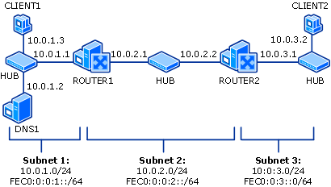

In the previous figure, there are three network segments:
• Subnet 1 uses the private IP network ID of 10.0.1.0/24 and site-local subnet ID of FEC0:0:0:1::/64.
• Subnet 2 uses the private IP network ID of 10.0.2.0/24 and site-local subnet ID of FEC0:0:0:2::/64.
• Subnet 3 uses the private IP network ID of 10.0.3.0/24 and site-local subnet ID of FEC0:0:0:3::/64.
All computers on each subnet are connected to a separate common hub or Layer 2 switch. The two router computers, ROUTER1 and ROUTER2, have two network adapters installed.
For the IPv4 configuration, each computer is manually configured with the appropriate IP address, subnet mask, default gateway, and DNS server IP address. For the IPv6 configuration, link-local addresses are used initially. Dynamic Host Configuration Protocol (DHCP) and Windows Internet Name Service (WINS) servers are not used.
The following sections describe how to configure each of the computers in the test lab with the basic IPv6 infrastructure. To create this test lab, configure the computers in the order presented.

DNS1
DNS1 is a computer running Windows Server 2003 with SP1, Standard Edition. It is providing DNS Server services for the testlab.microsoft.com DNS domain. To configure DNS1 for this service, perform the following steps.
Configure DNS1 to provide DNS Services
1. Install Windows Server 2003 with SP1, Standard Edition, as a stand-alone server. Set the Administrator password.
2. After restarting, log on as Administrator.
3. Configure the TCP/IP protocol with the IP address of 10.0.1.2, the subnet mask of 255.255.255.0, and the default gateway of 10.0.1.1.
Install the DNS Server service
1. Open Windows Components Wizard. To open the Windows Components Wizard, click Start, click Control Panel, double-click Add or Remove Programs, and then click Add/Remove Windows Components.
2. In Components, select the Networking Services check box, and then click Details.
3. In Subcomponents of Networking Services, select the Domain Name System (DNS) check box, click OK, and then click Next.
4. If prompted, in Copy files from, type the full path to the distribution files, and then click OK.
Define a forward lookup zone
1. Open DNS. To open DNS, click Start, click Control Panel, double-click Administrative Tools, and then double-click DNS.
2. In the console tree, right-click the DNS server DNS1, and then click New Zone to run the New Zone Wizard.
3. On the Welcome to the New Zone Wizard page, click Next.
4. On the Zone Type page, the option to create a primary zone is selected by default, as shown in the following figure.
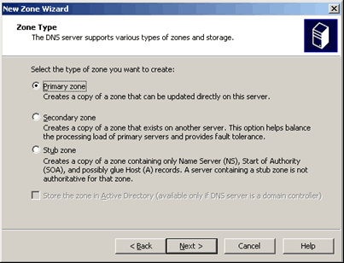

5. Click Next. On the Forward or Reverse Lookup Zone page, the option to create a forward lookup zone is selected by default, as shown in the following figure.
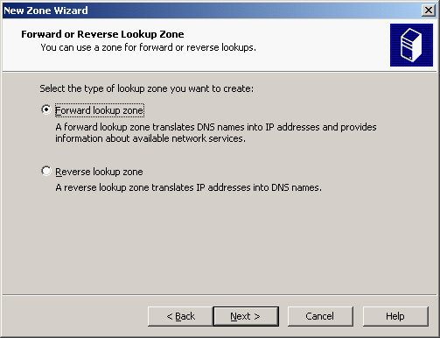

6. Click Next. On the Zone Name page, type testlab.microsoft.com in Zone name, as shown in the following figure.
Note:
The domain name testlab.microsoft.com is used here for example purposes only. You can use any domain name in your test lab configuration.
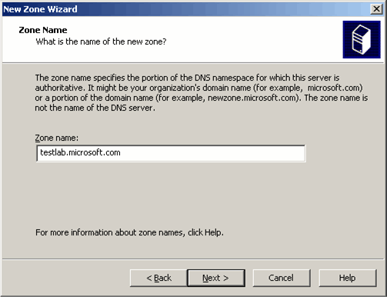

7. Click Next. On the Zone File page, the new zone file name testlab.microsoft.com.dns is automatically derived from the zone name entered on the previous page, as shown in the following figure.
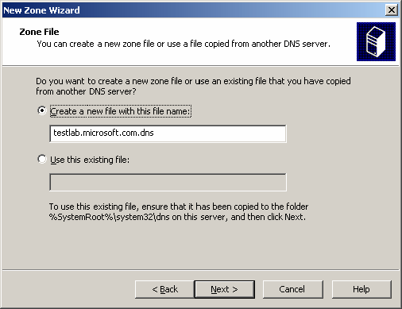

8. Click Next. On the Dynamic Update page, select Allow both nonsecure and secure dynamic updates, as shown in the following figure.
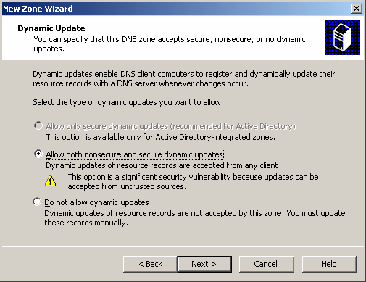

9. Click Next. On the Completing the New Zone Wizard page, click Finish, as shown in the following figure.
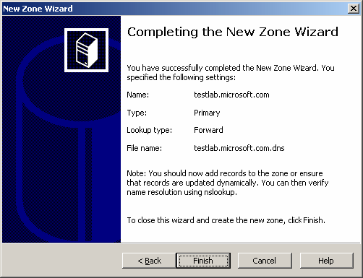

Install IPv6
• On DNS1, at the command prompt, type:
netsh interface ipv6 install

CLIENT1
CLIENT1 is a computer that is being used as a client.
Configure CLIENT1 as a client computer
1. Install Windows XP Professional with SP2 as a workgroup computer. Set the Administrator password.
2. After restarting, log on as Administrator.
3. At the command prompt, install the IPv6 protocol by typing:
netsh interface ipv6 install
4. Configure the TCP/IP protocol with the IP address of 10.0.1.3, the subnet mask of 255.255.255.0, a default gateway of 10.0.1.1, and the DNS server IP address of 10.0.1.2.
Configure Windows to allow communication between client computers
1. Click Start, point to Control Panel, and then click Security Center.
2. Click Windows Firewall, and then in the Windows Firewall dialog box, click the Advanced tab.
3. Click Settings for ICMP, and then click Allow incoming echo request.
4. Click OK twice to close Windows Firewall.

ROUTER1
ROUTER1 is a computer that is being used as a router between Subnet 1 and Subnet 2.
Configure ROUTER1 as a router
1. Install Windows Server 2003 with SP1, Standard Edition, as a workgroup computer. Set the Administrator password.
2. After restarting, log on as Administrator.
3. At the command prompt, install the IPv6 protocol by typing:
netsh interface ipv6 install
4. In Control Panel-Network Connections, rename the LAN connection connected to Subnet 1 to Subnet 1 Connection and rename the LAN connection connected to Subnet 2 to Subnet 2 Connection.
5. For Subnet 1 Connection, configure the TCP/IP protocol with the IP address of 10.0.1.1, the subnet mask of 255.255.255.0, and the DNS server IP address of 10.0.1.2.
6. For Subnet 2 Connection, configure the TCP/IP protocol with the IP address of 10.0.2.1, the subnet mask of 255.255.255.0, and a default gateway of 10.0.2.2.
7. Start the registry editor (Regedit.exe) and set HKEY_LOCAL_MACHINE\SYSTEM\CurrentControlSet\ Services\Tcpip\Parameters\IPEnableRouter to 1.
This step enables IPv4 routing between Subnet 1 and Subnet 2.
8. Restart the computer.

ROUTER2
ROUTER2 is a computer that is being used as a router between Subnet 2 and Subnet 3.
Configure ROUTER2 as a router
1. Install Windows Server 2003 with SP1, Standard Edition, as a workgroup computer. Set the Administrator password.
2. After restarting, log on as Administrator.
3. At the command prompt, install the IPv6 protocol by typing:
netsh interface ipv6 install
4. Open Network Connections, and rename the LAN connection connected to Subnet 2 to Subnet 2 Connection, and rename the LAN connection connected to Subnet 3 to Subnet 3 Connection.
5. For Subnet 2 Connection, configure the TCP/IP protocol with the IP address of 10.0.2.2, the subnet mask of 255.255.255.0, and a default gateway of 10.0.2.1.
6. For Subnet 3 Connection, configure the TCP/IP protocol with the IP address of 10.0.3.1 and the subnet mask of 255.255.255.0.
7. Start the registry editor (Regedit.exe) and set HKEY_LOCAL_MACHINE\SYSTEM\CurrentControlSet\ Services\Tcpip\Parameters\IPEnableRouter to 1.
This step enables IPv4 routing between Subnet 2 and Subnet 3.
8. Restart the computer.

CLIENT2
CLIENT2 is a computer that is being used as a client.
Configure CLIENT2 as a client computer
1. Install Windows XP Professional with SP2 as a workgroup computer. Set the Administrator password.
2. After restarting, log on as Administrator.
3. At the command prompt, install the IPv6 protocol by typing:
netsh interface ipv6 install
4. Configure the TCP/IP protocol with the IP address of 10.0.3.2, the subnet mask of 255.255.255.0, and a default gateway of 10.0.3.1.
5. Verify the integrity of the IPv4 routing infrastructure by pinging 10.0.1.3 from the CLIENT2 computer. On CLIENT2, type the following command:
ping 10.0.1.3
Configure Windows Firewall to allow communication between client computers
1. Click Start, point to Control Panel, and then click Security Center.
2. Click Windows Firewall, and then in the Windows Firewall dialog box, click the Advanced tab.
3. Click Settings for ICMP, and then click Allow incoming echo request.
4. Click OK twice to close Windows Firewall.

Creating a Static IPv6 Routing Infrastructure
Configure a static IPv6 routing infrastructure so that all test lab nodes are reachable by using IPv6 traffic.
Create a static IPv6 routing infrastructure
1. On ROUTER1, type the netsh interface ipv6 show address command to obtain the index of the interfaces connected to Subnet 1 Connection, Subnet 2 Connection, and their link-local addresses.
2. On ROUTER2, type the netsh interface ipv6 show address command to obtain the index of the interfaces connected to Subnet 2 Connection, Subnet 3 Connection, and their link-local addresses.
3. On ROUTER1, type the following commands:
netsh interface ipv6 set interface "Subnet 1 Connection" forwarding=enabled advertise=enabled
netsh interface ipv6 set interface "Subnet 2 Connection" forwarding=enabled advertise=enabled
netsh interface ipv6 add route fec0:0:0:1::/64 "Subnet 1 Connection" publish=yes
netsh interface ipv6 add route fec0:0:0:2::/64 "Subnet 2 Connection" publish=yes
netsh interface ipv6 add route ::/0 "Subnet 2 Connection" nexthop=ROUTER2AddressOnSubnet2 publish=yes
In the preceding command, ROUTER2AddressOnSubnet2 represents the link-local address assigned to the Subnet 2 Connection interface on ROUTER2.
For example, if the Subnet 2 Connection interface on ROUTER2 is FE80::2AA:FF:FE87:4D5C, type the last command as follows:
netsh interface ipv6 add route ::/0 "Subnet 2 Connection" nexthop=fe80::2aa:ff:fe87:4d5c publish=yes
4. On ROUTER2, type the following commands:
netsh interface ipv6 set interface "Subnet 2 Connection" forwarding=enabled advertise=enabled
netsh interface ipv6 set interface "Subnet 3 Connection" forwarding=enabled advertise=enabled
netsh interface ipv6 add route fec0:0:0:2::/64 "Subnet 2 Connection" publish=yes
netsh interface ipv6 add route fec0:0:0:3::/64 "Subnet 3 Connection" publish=yes
netsh interface ipv6 add route ::/0 "Subnet 2 Connection" nexthop=ROUTER1AddressOnSubnet2 publish=yes
In the preceding command, ROUTER1AddressOnSubnet2 represents the link-local address assigned to the Subnet 2 Connection interface on ROUTER1.
For example, if the link-local address of the Subnet 2 Connection interface on ROUTER1 is FE80::2AA:FF:FE9A:203F, type the last command as follows:
netsh interface ipv6 add route ::/0 "Subnet 2 Connection" nexthop=fe80::2aa:ff:fe9a:203f publish=yes
If ROUTER2 is running Windows Server 2003 with SP1, Standard Edition, type the additional commands:
netsh interface ipv6 set interface "Subnet 2 Connection" siteid=1
netsh interface ipv6 set interface "Subnet 3 Connection" siteid=1
5. Verify the integrity of the IPv6 routing infrastructure. On CLIENT2, type the following commands:
ping CLIENT1SiteLocalAddress
tracert -d CLIENT1SiteLocalAddress

Configuring the Test Lab to Use ISATAP
ISATAP is an address assignment and automatic tunneling technology that is used to provide unicast IPv6 connectivity between IPv6-enabled hosts on an IPv4 intranet, which are also known as ISATAP hosts. ISATAP is described in the Internet draft Intra-Site Automatic Tunnel Addressing Protocol (ISATAP). More information on ISATAP and the Internet draft can be found on MSDN. By default, the IPv6 protocol for Windows XP Professional with SP2 and Windows Server 2003 with SP1, Standard Edition, configures a link-local ISATAP address on the Automatic Tunneling Pseudo-Interface for each IPv4 address assigned to a computer.
To configure site-local or global ISATAP addresses, or to communicate beyond the logical subnet defined by the IPv4 intranet, you need an ISATAP router. An ISATAP router performs the following functions:
• Forwards IPv6 packets between ISATAP hosts on the IPv4 intranet and IPv6 hosts beyond it.
• Advertises its presence and address prefixes, enabling site-local or global ISATAP addresses to be configured.
An ISATAP router is typically configured to perform both functions, but can perform either individually. Most often, an ISATAP router acts as the forwarder between ISATAP hosts on an IPv4 intranet and IPv6 hosts on an IPv6-enabled portion of an intranet.
To demonstrate the use of an ISATAP router between IPv6 and IPv4 intranets, the following steps first separate the lab into a portion that has only IPv6 connectivity and another that has only IPv4 connectivity. Then, ROUTER1 is configured as an ISATAP router so that hosts on the IPv4-only portion of the intranet can communicate with hosts on the IPv6-enabled portion of the intranet.
To do this, we will disable IPv6 forwarding and advertising on the Subnet 2 Connection interface of ROUTER1 and both interfaces of ROUTER2. This emulates an intranet in which a portion is IPv6-enabled (Subnet 1) and a portion is not (Subnet 2 and Subnet 3).
Configure the test lab to use ISATAP
1. Disable forwarding and advertising on the Subnet 2 Connection interface.
a. On ROUTER1, at the command prompt, type:
netsh interface ipv6 set interface "Subnet 2 Connection" forwarding=disabled advertise=disabled
b. On ROUTER2, at the command prompt, type:
netsh interface ipv6 set interface "Subnet 2 Connection" forwarding=disabled advertise=disabled
2. Disable forwarding and advertising on the Subnet 3 Connection interface. On ROUTER2, at the command prompt, type:
netsh interface ipv6 set interface "Subnet 3 Connection" forwarding=disabled advertise=disabled
3. Renew CLIENT2 configuration to remove the site-local address and route. On CLIENT2, type the following command:
netsh interface ipv6 renew
4. Ping CLIENT1 from CLIENT2. On CLIENT2, type the following command:
ping CLIENT1SiteLocalAddress
This Ping command fails because there is no longer IPv6 connectivity between CLIENT2 and CLIENT1.
5. Configure ROUTER1 as an ISATAP router advertising the FEC0:0:0:10::/64 route to the logical ISATAP subnet consisting of Subnet 2 and Subnet 3.
a. Enable forwarding and advertising on the Automatic Tunneling Pseudo-Interface, using the following commands:
netsh interface ipv6 isatap set router 10.0.2.1
netsh interface ipv6 set interface "Automatic Tunneling Pseudo-Interface" forwarding=enabled advertise=enabled
b. Add a route for the subnet IDs of the logical subnet of the IPv4 intranet to the Automatic Tunneling Pseudo-Interface and configure it to be published. Use the following command:
netsh interface ipv6 add route fec0:0:0:10::/64 "Automatic Tunneling Pseudo-Interface" publish=yes
6. Add an ISATAP address (A) resource record to the DNS server for the IPv4 address of 10.0.2.1.
a. On DNS1, click Start, click Control Panel, double-click Administrative Tools, and then double-click DNS.
b. In the console tree, right-click testlab.microsoft.com in the Forward Lookup Zones folder, and then click New Host (A), as shown in the following figure.
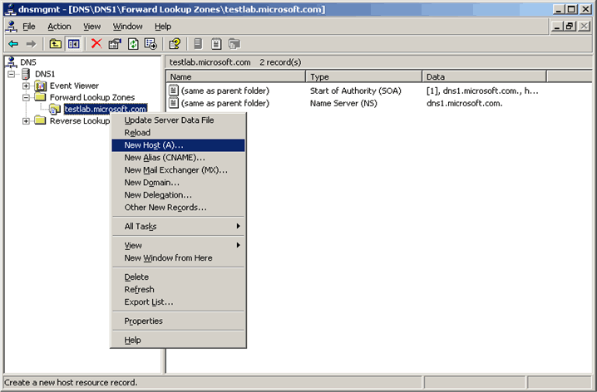

c. In the Name text box, type ISATAP and in the IP address text box, type 10.0.2.1, as shown in the following figure
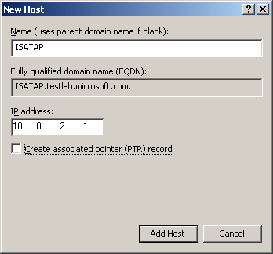

d. Click Add Host to add the new host record to the zone.
e. Modify the DNS configuration on CLIENT2 to include the DNS Server address, 10.0.1.2, and the DNS suffix, testlab.microsoft.com.
7. Renew the CLIENT2 configuration to recognize the ISATAP router IPv4 address of ROUTER1 and obtain an ISATAP address with the site-local prefix of FEC0:0:0:10::/64. On CLIENT2, type the following command:
netsh interface ipv6 renew
8. Ping CLIENT1 from CLIENT2. On CLIENT2, type the following command:
ping CLIENT1SiteLocalAddress
This ping command succeeds because IPv6 connectivity using ISATAP now exists between CLIENT2 and CLIENT1. On the link between CLIENT1 and ROUTER1, the IPv6 traffic is encapsulated as IPv4 packets.

Conclusion
This guide described the steps required to configure IPv6 in a test lab with five computers. It also described how to use ISATAP to provide IPv6 connectivity between IPv6-enabled hosts on an IPv4-only portion of an intranet and IPv6 hosts on an IPv6-enabled portion of an intranet.

See Also
Microsoft IPv6 Web site
Windows Server 2003 Web site

