

An ISV Opportunity: Migrating Microsoft Office Access Applications to Microsoft Office Small Business Accounting 2006
White Paper
Published: January 2006
For the latest information, please see msdn.microsoft.com/isv/technology/sba

Abstract
This white paper is for independent software vendors (ISVs) and developers who build applications for the small business market based on Microsoft® Office Access 2003. The purpose of the paper is to illustrate how ISVs can benefit by migrating Access 2003 applications to Microsoft Office Small Business Accounting 2006, although the principles illustrated in the paper can also be used to integrate with Access.
In addition to expanding their presence in the small business market segment, ISVs can add valuable functionality to the Microsoft Office System applications used by their customers. Integration of Small Business Accounting 2006 and Access can facilitate numerous new, efficient ways for small companies to increase their accounting productivity and manage their business more productively.
Contents
Small Business Accounting Offers New Opportunity for ISVs 1
Business Value of Microsoft Office Small Business Accounting 2006 2
For ISVs: Responding to Customer and Market Needs 2
For Customers: Enabling Effective, Forward-Looking Business Management 2
Migration and Integration Strategies for Access 2003 and Small Business Accounting 2006 4
A Real-Life Success Story: Erplite.com 4
A Growing Number of Successful Small Business Accounting 2006 and Microsoft Office System Integration Projects 5
Preparing an Access 2003 and Small Business Accounting 2006 Integration Project 7
Connecting Managed and Unmanaged Code 7
Enforce Business Rules by Validating at Code Level 8
Using Small Business Accounting 2006 and Access 2003: A Practical Example 9
Prerequisites 9
Sample Scenario 9
How We’ll Build the Project 10
Create a Visual Basic .NET Project 10
Add a Small Business Accounting 2006 Library Module 11
Connect to the Access Database 18
Import Inventory 24
Copy Customers into Small Business Accounting 2006 26
Selected ISV Resources 32
Conclusion 34

Small Business Accounting Offers New Opportunity for ISVs
Microsoft® Office Small Business Accounting 2006 delivers an easy-to-use and effective financial management program for small businesses. The Microsoft Office System applications are the world’s most commonly used business productivity software in the world. Because Small Business Accounting 2006 offers deep integration with Microsoft Office System programs, small businesses can be productive with Small Business Accounting immediately.
By any count—and there are many ways to define categories and arrive at numbers—the small business market in the United States is large. All of these businesses need to pursue their business goals as efficiently as possible with limited resources, and they need to manage finances and other areas of their operation with minimal financial and resource overhead. By offering effective software tools that have a low-adoption threshold, integrate with each other, help to streamline business management, and support specific business requirements, independent software vendors (ISVs) can add significant value to their customers.
ISVs and developers serving the small business market have a wealth of opportunities to design compelling, industry-specific solutions that support the users of Small Business Accounting. One productive strategy for ISVs and developers is to take advantage of the software development kit (SDK) of Small Business Accounting and the development tools within Microsoft Office Access 2003, integrate the two applications, and add their own solutions.
This paper examines how integration of Small Business Accounting 2006 with Access 2003 can benefit ISVs, particularly the Access developers designing solutions for the small business market. ISVs, in teaming with Microsoft in the Microsoft Partner Program, can make use of Microsoft developer resources, increase visibility in a broader market of small businesses, and deliver customer solutions that take advantage of the most flexible and capable technology available.

Business Value of Microsoft Office Small Business Accounting 2006
Small Business Accounting 2006 provides a strong and solid financial management application for small businesses. Designed for companies needing up to five installations of accounting software, Small Business Accounting provides the familiar, easy-to-use Microsoft Office System software environment that gives owners and managers a complete view of their business. With Small Business Accounting, an authorized employee can access any information, from sales and purchasing information to customer relationship processes. In one glance, owners and managers can review their company’s cash flow, including invoices, bills, payments, and more. This means they can make more informed decisions, reduce the time they spend on administrative tasks, and focus better on obtaining their business objectives.

For ISVs: Responding to Customer and Market Needs
The SDK provided for Small Business Accounting supports ISVs who want to customize the product and extend it with new solutions.
For example, ISVs can offer their customers additional functionality in financial management concerns, such as the general ledger, accounts receivable, and accounts payable, or they can provide support for additional lines of business, such as sales or distribution. Such targeted ISV solutions can include custom applications and Web services.
The main components of the Small Business Accounting 2006 include:
- Small Business Accounting 2006, a Microsoft .NET Framework-based program
- Small Business Accounting 2006 application programming interface (API)
- SBAUI.dll .NET assembly
- Microsoft SQL Server™ 2000 Database Engine (MSDE)
- Small Business Accounting 2006 SDK:
  - Help files
  - Code samples (for SBA API.dll)
  - Property fields customization template

For Customers: Enabling Effective, Forward-Looking Business Management
Small Business Accounting is a modern accounting solution unburdened by the limitations of legacy technology. Offered as a stand-alone solution or as part of the Microsoft Office Small Business Management Edition 2006, Small Business Accounting seamlessly integrates with all Microsoft Office 2003 programs. The ability to share information with all of these applications helps small business managers and owners easily manage their finances and increase their productivity.
Because many small business owners already use the Microsoft Office System, they are more likely to adopt the accounting software and use it within their environment. Small Business Accounting does not require technical training to install or accountant training to use.

Role-Based Security
Small Business Accounting can grow with a company. Owners and employees can access and prepare important accounting details, such as quotes, invoices, inventory, and orders. Customer-facing employees have access to account information when they need it, helping them build stronger customer connections. At the same time, role-based security helps limit employee access to data. Preset roles include owner, office manager, accountant, salesperson, and read-only.

Valuable Features of Small Business Accounting 2006
In addition, Small Business Accounting offers the following features:
- Seamless integration with leading payroll services provider Automatic Data Processing, Inc. (ADP) (for an additional fee).
- Inventory management, tracking, and forecasting.
- Automated bank accounts and customer payments.
- Bill payments and the ability to handle credit card purchases.
- Receipt and check printing.
- Cash flow monitoring and forecasting.
- 60 customizable reports.
- Simplified tracking of profit and loss.
- Audit trails and transactions tracking.
- A company dashboard that provides up-to-date customer financial information.
- Shared, secure, and reliable multi-user access for up to five users.

Migration and Integration Strategies for Access 2003 and Small Business Accounting 2006
With Access 2003, the data organization component of the Microsoft Office System, information workers can quickly create, modify, and store reports. They can create new reports based on already-existing ones, and share all reports easily across the company network. As a database application, Access 2003 can link disparate data sources. A major opportunity for ISVs and developers lies in having the ability to import and compare data from their tools with Small Business Accounting 2006. While this paper focuses on data migration, developers can also use Access 2003 as the common ground for sharing data between their own applications and Small Business Accounting 2006.

Build Applications That Organize and Compare Data
Small Business Accounting can export data to a variety of formats, including XML and Access. Therefore, it may make sense for ISV applications also to export the latest accounting data to Access, to offer small businesses additional ways of formatting and customizing financial information.

Import Data into Small Business Accounting 2006
In the opposite direction, ISVs can provide integration by importing data from Access to Small Business Accounting. For example, a business could migrate a home-grown Access solution to Small Business Accounting to take advantage of the accounting features built into Small Business Accounting. As an ISV, your customizations will have a much larger market because your software will integrate with a standardized and supported platform.

Extract Meaningful Information
Analysis Tools found within Small Business Accounting let users create database reports from Access and generate pivot table dynamic reports in Microsoft Office Excel® 2003. Both types of reports help small business owners and managers extract meaningful information from company data. Users can select from eight Access 2003 reports right out of the box. These reports can provide a simple yet thorough method to discover patterns and analyze trends. Developers can customize and extend this data in either Small Business Accounting or Access.

A Real-Life Success Story: Erplite.com
One ISV focusing on Access is Erplite.com (www.erplite.com) in Ontario, Canada. The company’s flagship product, ERPlite, is an Access-based application intended for small manufacturing companies. ERPlite meets the need of these businesses for an affordable, easy-to-use solution that can facilitate the management of work orders, purchase orders, and inventory; can track accounts payable and accounts receivable; can help to streamline shipping, schedule production, control costs; and can assist with other management tasks in a manufacturing business. Most ERPlite-user businesses don’t have an IT department and operate with basic software skills.
When Microsoft announced Small Business Accounting 2006, Erplite.com realized that the new application would have strong appeal for many small businesses, especially those already familiar with Microsoft Office System programs. Before Small Business Accounting 2006 became available, many small businesses used Excel 2003 spreadsheets and Access databases to track financial and manufacturing information.
Erplite.com decided to integrate its Access-based product with Small Business Accounting to create a seamless experience for customers. John Augustus, President of Erplite.com, explains, “By integrating Access and Small Business Accounting 2006, we can give our small manufacturing customers the ability to manage work orders, bills of materials, and inventory, create pick lists, review the consumption of raw materials and forecast production—and reflect all changes in financial values directly in Small Business Accounting.”
As Augustus points out, integrating and extending the familiar business productivity software environment is extremely valuable for small businesses because resources are limited, and the same people may handle such different functions as accounting and inventory management. With the integration of ERPlite and Small Business Accounting, users can view a customizable dashboard with critical information from both applications and, based on all current data, direct their manufacturing operation.
“We know that a significant number of small manufacturers need to practice effective, streamlined financial and operational management,” says Augustus. “Other industries have similar needs that ISVs can meet. Access developers have supported the small business community for many years. When they integrate their Access applications with Small Business Accounting, they can combine vertical industry expertise with a richly featured accounting solution to add significantly more value to customers.”
Augustus points out that his developers were very productive using the Small Business Accounting 2006 SDK and feels strongly about the business opportunity for other ISVs who want to integrate Access with Small Business Accounting. He says, “Microsoft provides us with the resources and tools we must have to enter vertical markets and deliver value-added, targeted software solutions. I expect accelerating growth in this market as more and more businesses adopt Small Business Accounting and begin to realize they could accomplish more with their software tools and spend less time and effort doing so than they do now.”

A Growing Number of Successful Small Business Accounting 2006 and Microsoft Office System Integration Projects
Developers integrating Small Business Accounting with either the Microsoft Office System or their own applications enjoy rapid development cycles and a shorter time-to-market. More than 75 third-party applications have already been designed to integrate with Small Business Accounting 2006 and with the Microsoft Office System.
Examples of ISVs delivering these types of applications include the following.
- Horizons International is releasing a small business manufacturing application that, combined with Small Business Accounting, provides small manufacturers with a feature-rich, fully integrated cost-accounting solution.
- Atlas Business Solutions integrates its human resources management solution, Staff Files, with Small Business Accounting so that customers can—instead of rekeying—import human resources data from Small Business Accounting into Staff Files and work with the data in that application.
- BQE Software is using its billing and project management software in tandem with Small Business Accounting.
- Z-Firm, an ISV that specializes in cost-effective shipping solutions, is integrating its existing shipping solution with Small Business Accounting.
- Taxsoftware.com, an Internet provider of tax software services, is integrating with Small Business Accounting to import Small Business Accounting data and e-file directly with the Internal Revenue Service and state tax agencies.
For more information about solutions, visit the Small Business Accounting solution Web site at http://sba.microsoft.com/solutions.html.

Preparing an Access 2003 and Small Business Accounting 2006 Integration Project
To integrate Small Business Accounting 2006 and Access 2003 successfully, ISVs need to understand the differences in each environment so they can prepare and plan solution development for best results. If you are not yet familiar with the Microsoft .NET Framework, you might find it helpful to learn about its features and capabilities. The resources listed in the “Selected ISV Resources” section of this paper helps you research any technical issues and get started. Here are a few important points to be aware of.

Small Business Accounting 2006 is Built Using the Microsoft .NET Framework
Small Business Accounting 2006 is written using the Microsoft .NET Framework, an integral component for the Windows® operating system. The .NET Framework provides a programming model and runtime for Web services, Web applications, and smart client applications. Small Business Accounting is a complete Microsoft .NET-connected application at all levels: the user interface (UI) layer uses Windows Forms, a component of the .NET Framework designed to let developers take full advantage of the UI features in Windows. The middle tier is written by using the Microsoft Visual C#® development tool, and the application uses the .NET Common Language Runtime (.NET CLR). The database for Small Business Accounting is the SQL Server 2000 Database Engine (MSDE), linking to the application through Microsoft ADO.NET.
Because Small Business Accounting is a .NET-connected application, it does not limit developers to a specific programming language such as Visual C#, but allows them to use any .NET-connected language, including Microsoft Visual Basic® .NET, Managed Extensions for Microsoft Visual C++® development system, or a .NET version of one of over 20 other languages. In fact, this paper uses Visual Basic .NET in its code samples.

Connecting Managed and Unmanaged Code
“Managed code” is a synonym for programs (code) running in the .NET environment, and “native code” or “unmanaged code” are both common ways of referring to code written in previous environments. Comparing and contrasting these two worlds is beyond the scope of this paper. However, Small Business Accounting can connect to both managed- and unmanaged-code applications. Small Business Accounting can communicate directly with other managed applications, and Small Business Accounting also can connect to non-managed applications either by using a message-based interface (such as traditional database calls) or by wrapping the unmanaged application in a .NET wrapper.
Microsoft’s Component Object Model (COM) is a specification developed by Microsoft for building software components that can be assembled into programs or that can add functionality to existing programs running on the Windows platform. Extensible and independent from any particular programming language, COM defines a standard for component interoperability and thereby outlines a software architecture in which components created by different ISVs can be combined into a variety of applications. COM components can be written in a variety of languages although most have been written in Visual C++ and can be unplugged from a program at run time without having to recompile the program. Office programs are COM “servers,” and the basis of interoperation between Office programs and .NET managed code is COM interop.
Note: Microsoft makes things even easier when you want to communicate with Microsoft Office Word 2003 or Excel 2003: A toolset known as Microsoft Visual Studio® Tools for Office (VSTO) allows developers to treat Word 2003 and Excel as if they were .NET applications—inside Visual Studio. Unfortunately Access does not offer VSTO integration.

Data Migration Focus of This White Paper
After highlighting several ways to integrate with other applications, this paper focuses on using database calls for Access integration. Microsoft believes that most Access developers already feel comfortable with such an approach, and that they will find it an intuitive development methodology. In other words, the paper does not illustrate unmanaged COM integration.

Sequence of Events in Application Integration
Consider the hypothetical case of an ISV who wants to import open orders from an Access 2003 database to Small Business Accounting 2006. Of course, first we need to import customer records and then import the orders.
- First we create an intermediate tool that reads data from Access and writes it to Small Business Accounting.
- Our program communicates with Access using ADO.NET to read relevant data.
- Our program then logs on to Small Business Accounting to write the Access data into its internal MSDE database.
Similar application scenarios might follow the same pattern. For example, if a business sells merchandise through an Internet retailer such as www.shopping.msn.com, it might have a program that downloads orders from MSN® into Access with a second module to move the orders from Access into Small Business Accounting.

Enforce Business Rules by Validating at Code Level
This example does not move data directly from database to database because we want to use the business rules in Small Business Accounting. For example, if a business rule said that an order or billing amount could not be zero, it might be detrimental to application functionality to have that rule bypassed by writing directly to Small Business Accounting.
When an application connects to Small Business Accounting 2006 through the SDK, as described above, validation of the data takes place within several layers of code and at the database level.

Using Small Business Accounting 2006 and Access 2003: A Practical Example
This portion of the white paper illustrates how to create a program to move data to Small Business Accounting 2006 from Access 2003 using Visual Basic .NET and the Small Business Accounting API. Creating this tool illustrates how to migrate data to a new environment. However, you will also see how existing Access applications can become more versatile, powerful, and extendable by seamlessly linking Access data with accounting data. In addition, time is saved and errors are reduced by not having multiple data entry points.
You may want to build a more functional application than shown in the illustration, but the purpose of this paper is to get you started.

Prerequisites
There are several Microsoft products you need to install to try out the samples here:
- Access 2003 with the Northwind Sample Database installed. Click Help and then choose Sample Databases. If Northwind is not already installed, then you are offered the opportunity to install it from the menu.
- You need Visual Studio to develop the solution described in this paper. Small Business Accounting 2006 is written in the 1.1 version of the .NET Framework; which means that add-ins designed to be loaded by Small Business Accounting 2006 must be written using Visual Studio 2003.
- For programs that interoperate with Small Business Accounting 2006, such as the sample in this paper, either Microsoft Visual Studio 2003 or Microsoft Visual Studio 2005 can be used. Accordingly, we used Microsoft Visual Studio 2005 to write these samples.
- Small Business Accounting 2006 is central to the task at hand—you can order a trial version from www.microsoft.com/sba, or find it on your MSDN® Subscription DVD.
- Finally, you need the Small Business Accounting SDK. This is a free download from www.sbadeveloper.com.

Note: Microsoft highly recommends MSDN subscriptions as a delivery vehicle for all Microsoft developer tools and products. This is the best way to obtain full versions of our products for development and demo purposes. Visit http://msdn.microsoft.com/subscriptions for details on options and pricing.

Sample Scenario
For the purposes of this paper, imagine the following: You are a developer hired by the Contoso Corporation. They have just purchased Northwind, and want to add Northwind’s open orders to the Small Business Accounting program.
Your task is to develop a tool that reads order data from Northwind’s Access database and populates it into Small Business Accounting. It’s important that you add the records using Small Business Accounting, not directly to the database, in order for business logic to be invoked. The business rules address details such as verifying that a valid customer record also exists. For the sake of simplicity, we assume that you previously imported the customers. And, of course, there are a number of other strategies to import sales orders.
Note: The “orders” in the Northwind database are actually what most people refer to as “invoices.” That is, these orders are fulfilled when most business people consider an order to be “booked, but not yet invoiced.” For the purposes of this paper, we’re going to pretend that orders have the common meaning of “not yet invoiced.”

How We’ll Build the Project
We build this Visual Basic .NET project in steps to create separate modules that can be tested independently. Our goal is to efficiently accomplish the project goal by testing as we go.
Development Order:
- Create a Visual Basic.NET project.
- Create a module that references Small Business Accounting and logs on to the database.
- Create a module that reads Access data.
- Create several modules to migrate records to Small Business Accounting.
Please exercise due caution:
- Do not try to experiment with an actual production database.
- Back up your development database first so you can try the import repeatedly.

Create a Visual Basic .NET Project
We’re going to use Visual Studio 2005 for this example.
- Start Visual Studio.
- On the File menu, click New, and then click Project.
- Set the project type to Visual Basic and choose a Windows application.
- Name your project SBA Access Demo.

The screenshot below may vary from your environment slightly if you have your default development environment set to Visual Basic .NET (the following screen capture is from an environment that uses Visual C# as a default).
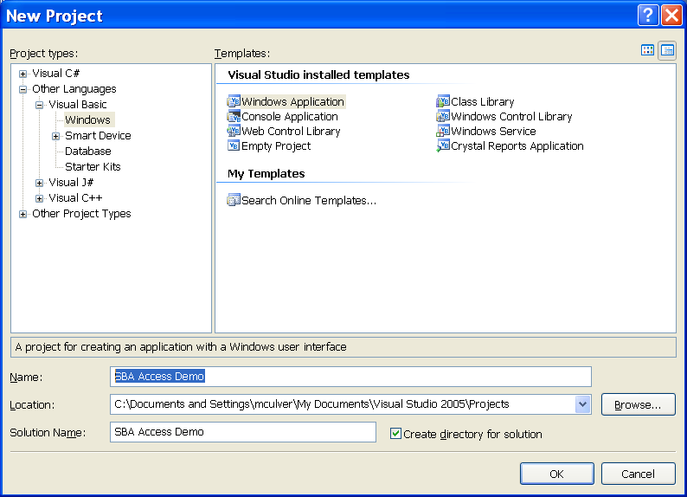
Figure 1: Create a new Visual Basic project named "SBA Access Demo."

Add a Small Business Accounting 2006 Library Module
This module is easy to create because we copy sample code that came with the SDK.
- Open the Concepts Manual that came with the SDK and find the topic titled “Retrieving an ISmallBusinessInstance Object Reference.”
- Paste the code into a new class named SBALib.vb.

These are the steps to use if you are new to Visual Studio 2005:
- Right-click the project name in the solution explorer (see illustration below).
- Click Add, followed by New Item.
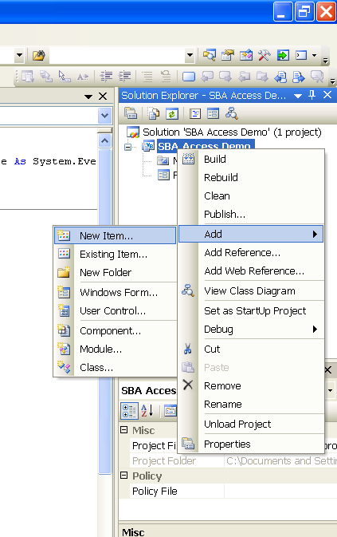
Figure 2: Right-click the project and add a new item.

- Choose a Class as item type, name the file SBALib.vb and click Add, as illustrated below:
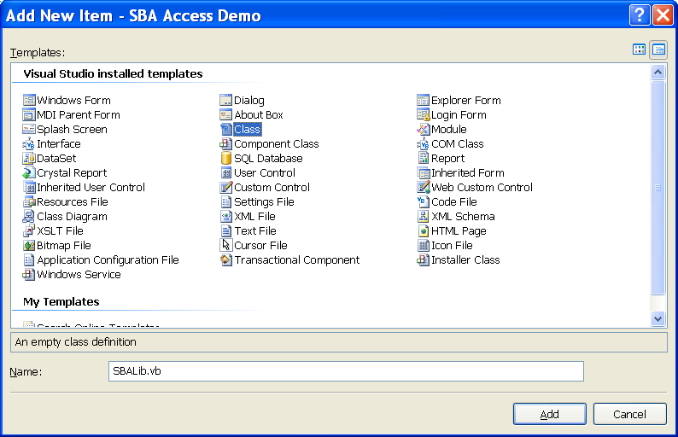
Figure 3: Add a new code file named SBALib.vb.

- Copy the code from the help topic “Retrieving an ISmallBusinessInstance Object Reference” and paste into the module here. The VB code is the second code module in the topic.
The result looks similar to the illustration below.
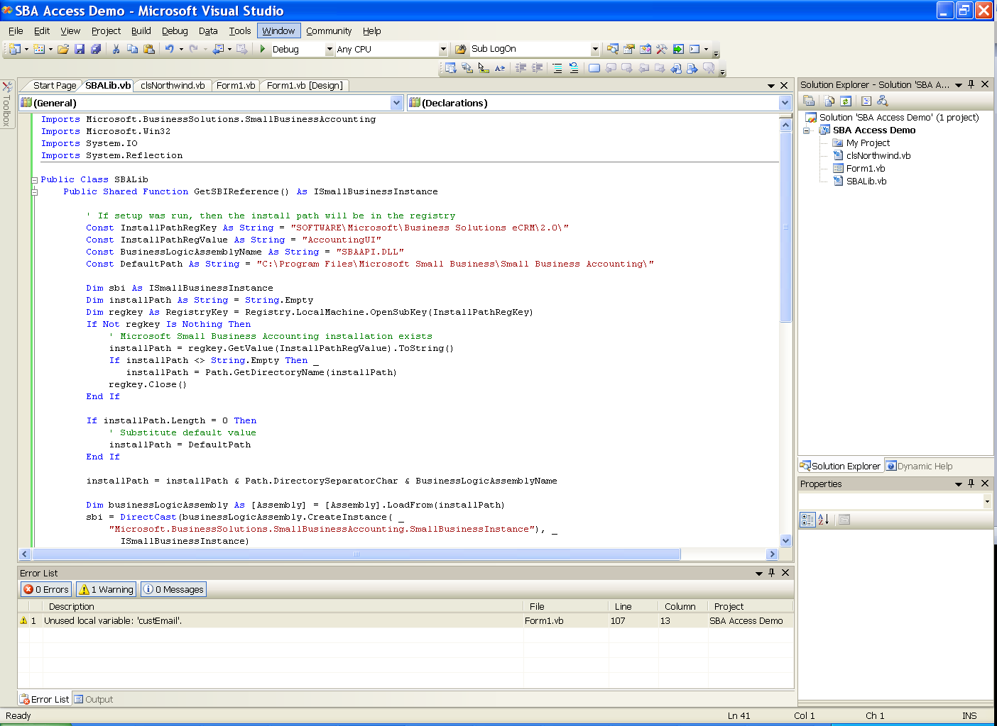
Figure 4: In Visual Studio 2005, the pasted sample code appears more or less like this.

You see errors reported in Visual Studio about undefined types and namespaces that are not valid. These errors are reported because we have not registered a reference to Small Business Accounting in our project. Note the underlined text in the editor that says:
“Imports Microsoft.BusinessSolutions.SmallBusinessAccounting”.
This is the missing reference, so register it now.
- Right-click the project name (SBA Access Demo) in the Solution Explorer, then choose Add Reference. Tip: If you right-clicked and did not see “Add Reference” as an option, you probably clicked the Solution name, not the project name in Solution Explorer.
- Browse for SBAAPI.DLL, which is located in the Small Business Accounting program directory (see below). Select SBAAPI.DLL and click OK to add it to your project.
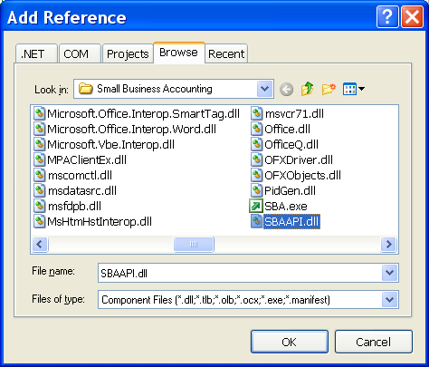
Figure 5: Browse for SBAAPI.DLL and add it to your project as a reference.
Most, but not quite all, of the errors disappeared.
There is one more reference you need to add.
- Right-click the project name, browse to the same directory and add SBAIAPI.DLL.
All of the errors should now be gone.

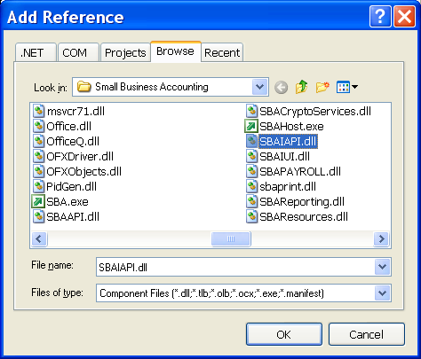
Figure 6: Adding SBAIAPI.DLL as the second reference eliminates remaining errors.

Add a Log-In Button
Next we’ll add a button to the form in our Visual Basic project to verify that the code works so far.
- Find Form1 in the project and drag a button from the toolbox to your design surface.
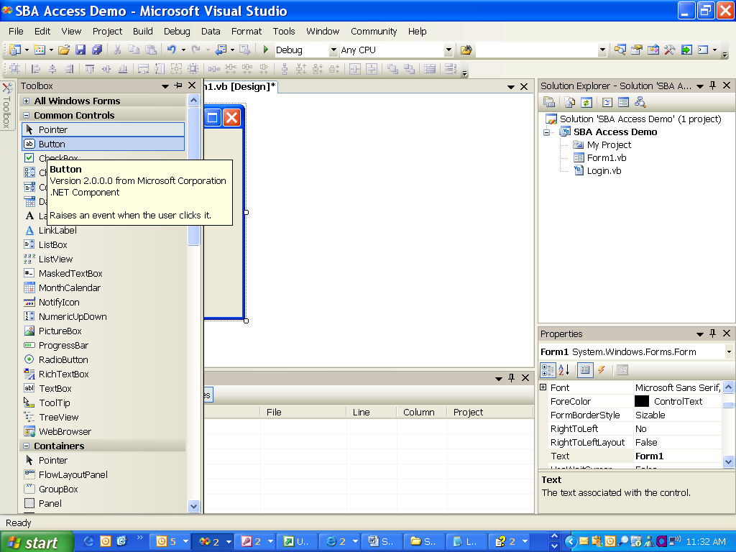
Figure 7: Add a button by dragging one from the Toolbox onto Form1.

- Click the button once, then set a couple of properties in the property window in the lower-right corner of the screen.
- Set the button name to btnLogIn, and change the text to read Log On to SBA. You’ll probably need to make the button a bit wider to accommodate the new text.
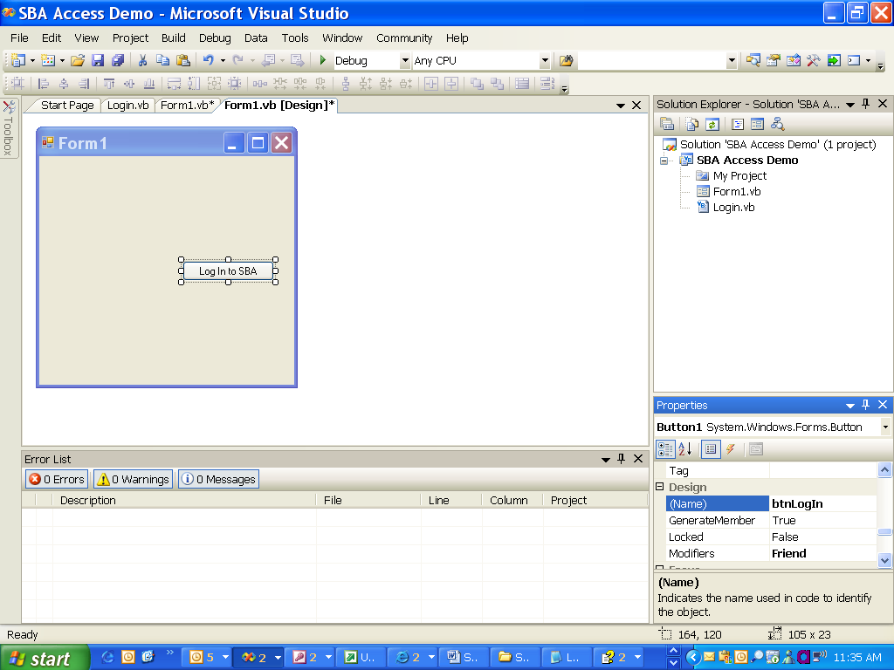
Figure 8: Add a button to the form, then set the name and caption.

Add a Status Strip
We also add a status bar and handle errors to make the application a bit more polished (and so you can find out what went wrong).
- Add a StatusStrip control to the bottom of the form by dragging it from the toolbox.
- Click the drop-down box in the control and set it to a label. Don’t change any of the properties in the property window.

Add Code
- Double-click the button to open up the code window with a click event visible.
It’s time to write our own code and add it to the button.
We add a couple of imports statements, some private variables to represent server name and database name, and then a bit of code to log on to the Small Business Accounting database. Note that in real life you would always check to see if the logon was successful. We’re trying to keep this example straight-forward.
Your final code in Form1.vb should look as follows:
Imports Microsoft.BusinessSolutions.SmallBusinessAccounting
Imports SBA_Access_Demo.SBALib
Imports System.Windows.Forms

Public Class Form1

Private database As String = "sampleproductcompany"
Private server As String = "(local)\MICROSOFTSMLBIZ"
Private sb As ISmallBusinessInstance = SBALib.GetSBIReference()

Private Sub btnLogIn_Click(ByVal sender As System.Object, ByVal e As System.EventArgs) Handles btnLogIn.Click
System.Windows.Forms.Cursor.Current = Cursors.WaitCursor
' Note: This is sample code designed to show data moving
' between systems. In real life you would never call a
' logon and assume it worked.
' (There would also be a password)
Try
sb.LogOn(database, server)
ToolStripStatusLabel1.Text = "Logged on to " & server
Catch ex As Exception
ToolStripStatusLabel1.Text = "Unable to log on to " & server
End Try
System.Windows.Forms.Cursor.Current = Cursors.Default
End Sub

Private Sub Form1_Load(ByVal sender As System.Object, ByVal e As System.EventArgs) Handles MyBase.Load
ToolStripStatusLabel1.Text = "Not logged on to SBA"
End Sub

Test the code to make sure it runs!

Connect to the Access Database
Most Access developers are on familiar ground here. We are going to use ADO.NET to attach to the Northwind database to retrieve the orders that need to be moved into Small Business Accounting. We’ll set up a class names clsNorthwind to keep this clean.
Make certain that NorthWind.mdb is installed on your computer. The beginning of this article outlined how to do that, and of course you’ll need to modify the path name to match any other location you may have placed the file. Make certain that you have write permissions to that directory, or strange errors could pop up at runtime.

Create the Class
- Right-click the project name, then click Add, and then click Class to add a new class.
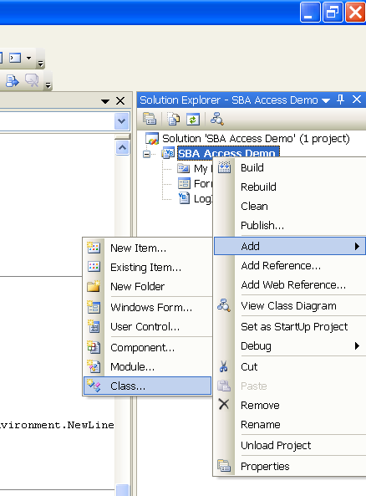
Figure 9: Right-click the project to add a new class.

- Name the class clsNorthwind.vb.
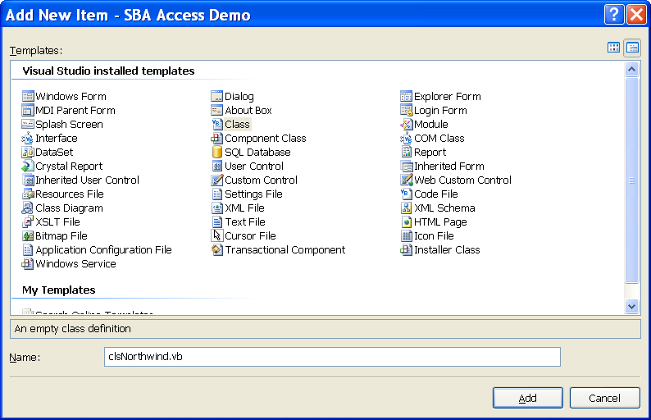
Figure 10: Rename the class.

Code for clsNorthwind.vb
The following code should be entered in the class:
Imports System.Data.OleDb
Imports System.Data.SqlClient
Imports System.Data.Sql

Public Class clsNorthwind
Private cn As New OleDbConnection()
Private m_ConnectionStatus As Boolean = False
Private m_ConnectFailed As Boolean = False
Private m_StatusText As String
Private m_StatusDetail As String

Public Sub New()
' Whenever the class is instantiated, this routine runs
End Sub

Public ReadOnly Property StatusString() As String
Get
Return m_StatusText
End Get
End Property

Public ReadOnly Property StatusDetail() As String
Get
Return m_StatusDetail
End Get
End Property

Public ReadOnly Property IsConnected() As Boolean
Get
Return m_ConnectionStatus
End Get
End Property

Public ReadOnly Property ConnectFailed() As Boolean
Get
Return m_ConnectFailed
End Get
End Property

Public Function DataReader(ByVal Query As String) As OleDbDataReader
' Not certain how ADO.NET compares to ADO?
' Visit http://samples.gotdotnet.com/quickstart/howto/doc/adoplus/employees.aspx
If IsConnected = False Then
OpenConnection()
End If
Dim cmd = New OleDbCommand(Query, cn)
Return cmd.ExecuteReader()
End Function

Public Function OpenConnection() As Boolean
Dim cnString As String = "Provider=Microsoft.Jet.OLEDB.4.0;Data Source=C:\Program Files\Microsoft Office\OFFICE11\SAMPLES\Northwind.mdb"
If m_ConnectionStatus = False Then
Try
cn.ConnectionString = cnString
cn.Open()
Catch ex As Exception
' This block executed only if problems
' with opening the connection
m_ConnectionStatus = False
m_ConnectFailed = True
m_StatusText = "Connection Failed"
m_StatusDetail = ex.Message
Return False
End Try
End If
' Reaches this part of the function only if
' the connection attempt was successful
m_ConnectionStatus = True
m_StatusText = "Connection Opened"
m_StatusDetail = ""
Return True
End Function

End Class

Add the Class and Buttons to Form1
We need to access the class form Form1, and we also need to add a button that processes data. Initially we’ll add some code to make certain we can read Access data without attempting to add anything to the Small Business Accounting database. In this way, we can ensure that our program is going to communicate with Access without actually modifying records.
We name the middle button btnInventory and the bottom button btnImport because this button imports both customers and orders. Also, we’re not showing screenshots of every step from here on out; you can refer to screen shots of similar steps earlier in this article if you are uncertain how to accomplish a task.
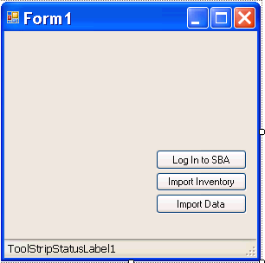
Figure 11: Form1 with the new button and StatusStrip.

- Double-click the button to open up a code window. Add this code to the click event.
Private Sub btnInventory_Click(ByVal sender As System.Object, ByVal e As System.EventArgs) Handles btnImport.Click
System.Windows.Forms.Cursor.Current = Cursors.WaitCursor
If Northwind.OpenConnection() = True Then
ToolStripStatusLabel1.Text = Northwind.StatusString
Dim dr As OleDbDataReader
dr = Northwind.DataReader("SELECT * FROM customers")
ListFieldNames(dr)
'ProcessRecords(dr)
Else
ToolStripStatusLabel1.Text = Northwind.StatusString
ShowBalloonTip()
End If
System.Windows.Forms.Cursor.Current = Cursors.Default
End Sub

- Add the following code to the bottom of Form1.vb to create the subroutines needed to process records.
Also listed is some error-handling logic in case the database access does not go so well.

Private Sub ListFieldNames(ByVal dr As OleDbDataReader)
Dim i As Integer
For i = 0 To dr.FieldCount - 1
Debug.WriteLine("Column " & i & " = " & dr.GetName(i).ToString())
Next
End Sub

Private Sub ProcessRecords(ByVal dr As OleDbDataReader)
Dim i As Integer
Do While (dr.Read)
For i = 0 To dr.FieldCount - 1
Debug.Write(dr.Item(i).ToString())
Debug.Write(", ")
Next
Debug.Write(vbNewLine)
Loop
End Sub

Private Sub ShowBalloonTip()
' Show extended detail about error
If Northwind.ConnectFailed = True Then
Dim tt As New ToolTip()

' Set up the delays for the tooltip.
tt.AutoPopDelay = 0
tt.InitialDelay = 0
tt.ReshowDelay = 500
' Force the tooltip text to be displayed whether or not the form is active.
tt.ShowAlways = True
tt.IsBalloon = True
tt.SetToolTip(Me, Northwind.StatusDetail)
End If
End Sub

Private Sub ToolStripStatusLabel1_MouseHover(ByVal sender As Object, ByVal e As System.EventArgs) Handles ToolStripStatusLabel1.MouseHover
ShowBalloonTip()
End Sub

Make sure that your code contains references to the class library and OleDB. The first few lines of code in your form should look like this:

Imports System.Data.OleDb
Imports Microsoft.BusinessSolutions.SmallBusinessAccounting
Imports System.Windows.Forms

Public Class Form1

Private database As String = "sampleproductcompany"
Private server As String = "(local)\MICROSOFTSMLBIZ"
Private Northwind As New clsNorthwind

Test the Code
It’s time to test the code before proceeding any further.
- Run the project and click the “import” button. You should see results in the “output” window. (You can display the output window by going to the View menu on the Visual Studio 2005 toolbar and clicking Output.)
As shown above, we have commented out the call to display each record in the table; however you can un-comment it. Also, try changing the SQL Server statement to read SELECT * FROM orders, because we’ll access that table once the project is running.

Import Inventory
- Add a function to clsNorthwind to return all records in the Products table.
Public Function AllProductItems() As OleDbDataReader
Return DataReader("SELECT * FROM products")
End Function

This import routine only adds records if they are not already in Small Business Accounting. The code below should be added to Form1.vb. For the sake of brevity we won’t discuss the code in this paper (it’s not the focus of what we’re doing), except to mention that the inventory class in Small Business Accounting requires Cost of Goods Sold properties, which was added straight out of the Small Business Accounting SDK.

Private Sub btnInventory_Click(ByVal sender As System.Object, ByVal e As System.EventArgs) Handles btnInventory.Click
' Before we can add sales orders,
' we need to have the inventory file
' imported to prevent errors on sales
' order detail
Dim drProducts As OleDbDataReader
drProducts = Northwind.AllProductItems()
Do While (drProducts.Read)
Call ImportProduct(drProducts)
Loop
End Sub
Private Sub ImportProduct(ByVal dr As OleDbDataReader)
If ItemExistsInSBA(dr.Item("ProductName").ToString()) = False Then
Dim item As IInventoryItemAccount = sb.CreateInventoryItemAccount()
item.Name = dr.Item("ProductName").ToString()
item.PurchaseDescription = dr.Item("ProductName").ToString()
item.SalesDescription = dr.Item("ProductName").ToString()
item.IsSold = True
item.SalesPrice = dr.Item("UnitPrice")
item.OnHandQuantity = dr.Item("UnitsInStock")
item.ReorderPoint = CDbl(dr.Item("ReorderLevel"))
' Ignoring the discontinued flag in Northwind
item.Active = True
Call SetInventoryFinancialAccounts(item)
item.Save()
ToolStripStatusLabel1.Text = "Importing " & dr.Item("ProductName")
End If
End Sub

Private Function ItemExistsInSBA(ByVal ItemName As String) As Boolean
' Look up by product name
' In real life you would probably
' have a sku to look up
' Find ItemAccount from input string
Dim ItemExists As Boolean
Dim ItemAccount As IAccount = sb.CreateInventoryItemAccount()
ItemAccount.Name = ItemName
ItemExists = ItemAccount.CheckHasDuplicatedNameInDB(AccountType.InventoryItemAccount)
If ItemExists Then
Return True
Else
Return False
End If
End Function

Private Sub SetInventoryFinancialAccounts(ByRef Item As IInventoryItemAccount)
' get the a financial account to use for COGs, Purchase,and Sales.
' This is straight out of the SDK
Dim financeAccounts As IFinancialAccountView = sb.FinancialAccounts

Dim strExpr As String = "Name = 'Cost of Goods - Materials'"
Dim foundRows As DataRow() = financeAccounts.DataView.Table.Select(strExpr)
Dim cogRow As DataRow = foundRows(0)
Dim financeGuid As Guid = CType(cogRow("GUID"), Guid)
Dim cogAccount As IFinancialAccount = CType(financeAccounts.GetByGuid(financeGuid), IFinancialAccount)

strExpr = "Name = 'Inventory Asset'"
foundRows = financeAccounts.DataView.Table.Select(strExpr)
Dim purchaseRow As DataRow = foundRows(0)
financeGuid = CType(purchaseRow("GUID"), Guid)
Dim purchaseAccount As IFinancialAccount = CType(financeAccounts.GetByGuid(financeGuid), IFinancialAccount)

strExpr = "Name = 'Sales'"
foundRows = financeAccounts.DataView.Table.Select(strExpr)
Dim salesRow As DataRow = foundRows(0)
financeGuid = CType(salesRow("GUID"), Guid)
Dim salesAccount As IFinancialAccount = CType(financeAccounts.GetByGuid(financeGuid), IFinancialAccount)

item.CogsFinancialAccount = cogAccount
Item.PurchaseFinancialAccount = purchaseAccount
Item.SalesFinancialAccount = salesAccount
End Sub

Test this code to be certain it works. You must be able to successfully import the products before proceeding to the next section of this paper.

Copy Customers into Small Business Accounting 2006
For each record in the orders table inside the Access database, we need to move the record to Small Business Accounting. First we’ll import customer records (for the sake of simplicity, we’re assuming that none of these customers were already in the Small Business Accounting database).
The code below performs the following functions:
- Copy customer records into Small Business Accounting.
- Copy orders into Small Business Accounting. Northwind.mdb uses alphanumeric keys for CustomerID, so we need to copy orders as a nested routine inside each customer insert.
- Copy order detail lines into Small Business Accounting for each order, assigning the appropriate order number along the way. (Each order is assigned a new number in Small Business Accounting.) Make certain that you ran the inventory import routine before trying this.

Add Customer Record Insertion Code
We are going to process each record in the Access database and insert it as a new customer record in Small Business Accounting using the following routine:
- At the bottom of Form1.vb create a new subroutine named ImportCustomer that accepts the Datareader object.
Rather than explaining the obvious here, we list the code:
Private Sub ImportCustomer(ByVal dr As OleDbDataReader)
' Create new customer object
Dim AccessCustID As String
Dim newCust As ICustomerAccount = sb.CreateCustomerAccount()
' Instantiate address object
Dim custAddr As ICustomerVendorAddress = newCust.CustomerVendorAddresses.GetByType(CustomerVendorAddressType.Business)
' Instantiate contact object
Dim mainContact As IContact = newCust.CreateContact
' Instantiate customer phone information object
Dim custPhone As ICustomerVendorPhone
' Instantiate email object
' We're not using here because there is no
' source email address
Dim custFax As ICustomerVendorFax

' Provide basic customer information
newCust.Name = dr.Item("CompanyName").ToString()
newCust.CreditLimit = New SqlMoney(5000.0) ' Define customer credit limit
newCust.Active = True

' Provide customer address information
custAddr.Address1 = dr.Item("Address").ToString()
custAddr.City = dr.Item("City").ToString()
custAddr.State = dr.Item("Region").ToString()
custAddr.ZipCode = dr.Item("PostalCode").ToString()

' Provide customer phone information
custPhone = newCust.CustomerVendorPhones.GetByType(CustomerVendorPhoneType.Business)
custPhone.PhoneNumber = dr.Item("Phone").ToString()

' Provide customer fax information
custFax = newCust.CustomerVendorFaxes.GetByType(CustomerVendorFaxType.Business)
custFax.FaxNumber = dr.Item("Fax").ToString()

' Provide customer contact information
mainContact.IsPrimary = True
mainContact.Email = ""
mainContact.Title = dr.Item("ContactTitle").ToString()
mainContact.Name = dr.Item("ContactName").ToString()
mainContact.Phone = dr.Item("Phone").ToString()

' Save new customer record
newCust.Save()
AccessCustID = dr.Item("CustomerID").ToString()
ImportCustomerOrders(AccessCustID, newCust)
End Sub

- Modify ProcessRecords to call this new routine. Your code should appear as follows:
Private Sub ProcessRecords(ByVal dr As OleDbDataReader)
Do While (dr.Read)
Call ImportCustomer(dr)
Loop
ToolStripStatusLabel1.Text = "Import from Access complete"
End Sub

Add Orders to the Database
There are a number of strategies for adding orders. We add them while adding customers; that is, we look for that customer’s orders in the Access database and add them to Small Business Accounting. That means that while adding an order we also need to loop through the detail lines and add them.
Small Business Accounting uses a guid as customer ID, so we need to capture the guid assigned to the customer, and of course use the ID originally assigned in the Northwind database.
Note: There is a method for sales orders, invoices, and so on. called SetAllPropertiesToDefaultValues. It is not necessary to call this method since all property values are set to default during construction, and using it can be problematic.

Sub CreateSalesOrder(ByRef Customer As ICustomerAccount, ByVal drOrders As OleDbDataReader)
Dim so As ISalesOrder = sb.CreateSalesOrder
so.CustomerAccount = Customer
' SBA won't let us use dates earlier than "first posted" date
' So we can't use original date
so.FinancialDateTime = Now()
so.DeliveryDate = CType(drOrders.Item("RequiredDate").ToString, DateTime)
so.InternalComments = "Imported Order ID " & drOrders.Item("OrderID").ToString
Dim ShippingAddress As ICustomerVendorAddress = _
Customer.CustomerVendorAddresses.GetByType(CustomerVendorAddressType.ShipTo)
ShippingAddress.Address1 = drOrders.Item("ShipAddress").ToString()
ShippingAddress.City = drOrders.Item("ShipCity").ToString
ShippingAddress.State = drOrders.Item("ShipRegion").ToString
ShippingAddress.ZipCode = drOrders.Item("ShipPostalCode").ToString
ShippingAddress.Country = sb.Countries.GetByFullName(drOrders.Item("ShipCountry").ToString())
so.ShippingAddress = ShippingAddress
Dim drDetailLines As OleDbDataReader
drDetailLines = Northwind.AllOrderDetailLinesForOrder(drOrders.Item("OrderID"))
Do While (drDetailLines.Read)
Call CreateSalesOrderLine(so, drDetailLines)
Loop
so.Save()
End Sub

Private Sub CreateSalesOrderLine(ByRef SalesOrder As ISalesOrder, ByRef drDetail As OleDbDataReader)
Dim salesOrderLine As IItemLine = CType(SalesOrder.CreateSalesOrderLine(DocumentLineType.ContractItemLineType), IItemLine)
Dim ItemView As DataView = sb.ItemAccounts.DataView
Dim SKU As String
SKU = Northwind.ItemDescriptionFromProductID(drDetail.Item("ProductID").ToString())
'salesOrderLine.SetAllPropertiesToDefaultValues()
SKU = Replace(SKU, "'", "''") ' Add escapes to handle apostrophes in string
Dim SelectedRows As DataRow() = ItemView.Table.Select("Name='" & SKU.ToString() & "'")
If SelectedRows.Length > 0 Then
'accountToBeAddedToSalesOrder = (IInventoryItemAccount)instance.ItemAccounts.GetByDataRow(dataRow)
salesOrderLine.LineItem = CType(sb.ItemAccounts.GetByDataRow(SelectedRows(0)), IInventoryItemAccount)
salesOrderLine.UnitPrice = CType(drDetail.Item("UnitPrice"), Double)
salesOrderLine.Quantity = CType(drDetail.Item("Quantity"), Double)
salesOrderLine.Description = Northwind.ItemDescriptionFromProductID(drDetail.Item("ProductID")).ToString
Else
Debug.Assert(True, SKU & " not found")
End If
End Sub

Private Sub btnInventory_Click(ByVal sender As System.Object, ByVal e As System.EventArgs) Handles btnInventory.Click
' Before we can add sales orders,
' we need to have the inventory file
' imported in order prevent errors on sales
' order detail
Dim drProducts As OleDbDataReader
System.Windows.Forms.Cursor.Current = Cursors.WaitCursor
drProducts = Northwind.AllProductItems()
Do While (drProducts.Read)
Call ImportProduct(drProducts)
Loop
ToolStripStatusLabel1.Text = "Products Import from Access complete"
System.Windows.Forms.Cursor.Current = Cursors.Default
End Sub

Private Sub ImportProduct(ByVal dr As OleDbDataReader)
If ItemExistsInSBA(dr.Item("ProductName").ToString()) = False Then
Dim item As IInventoryItemAccount = sb.CreateInventoryItemAccount()
item.Name = dr.Item("ProductName").ToString()
item.PurchaseDescription = dr.Item("ProductName").ToString()
item.SalesDescription = dr.Item("ProductName").ToString()
' Make certain you set IsSold to true
' Otherwise the item does not appear in SBA
item.IsSold = True
item.SalesPrice = dr.Item("UnitPrice")
item.OnHandQuantity = dr.Item("UnitsInStock")
item.ReorderPoint = CDbl(dr.Item("ReorderLevel"))
item.Active = True ' Ignoring the discontinued flag in Northwind
Call SetInventoryFinancialAccounts(item)
item.Save()
ToolStripStatusLabel1.Text = "Importing " & dr.Item("ProductName")
End If
End Sub

Private Function ItemExistsInSBA(ByVal ItemName As String) As Boolean
' Look up by product name
' In real life you would probably
' have a sku to look up
' Find ItemAccount from input string
Dim ItemExists As Boolean
Dim ItemAccount As IAccount = sb.CreateInventoryItemAccount()
ItemAccount.Name = ItemName
ItemExists = ItemAccount.CheckHasDuplicatedNameInDB(AccountType.InventoryItemAccount)
If ItemExists Then
ToolStripStatusLabel1.Text = ItemName & " exists in SBA"
Application.DoEvents()
Return True
Else
Return False
End If
End Function

You’ll also need to add the following functions to clsNorthwind.
Public Function AllOrdersForCustomerID(ByRef CustID As String) As OleDbDataReader
Return DataReader("SELECT * FROM orders WHERE CustomerID = '" & CustID & "'")
End Function

Public Function AllOrderDetailLinesForOrder(ByRef OrderID As Int32) As OleDbDataReader
Return DataReader("SELECT * FROM [Order Details] WHERE OrderID = " & OrderID)
End Function

Public Function AllProductItems() As OleDbDataReader
Return DataReader("SELECT * FROM products")
End Function

Public Function ItemDescriptionFromProductID(ByRef ProductID As Int32) As String
Dim dr As OleDbDataReader
dr = DataReader("SELECT ProductName FROM products WHERE ProductID = " & ProductID)
If dr.Read() Then
Return dr.Item("ProductName").ToString
Else
Return ""
End If
End Function

Test the Code
Before running this code, make certain that you backed up the Small Business Accounting database. There’s a lot going on in the code sample, and you’ll almost certainly want a “fresh copy” to try out. We assume that you already imported the inventory.
After running the code, double-click one of the newly-imported customers in SBA, then choose the financial history tab. You should see the imported sakes orders, and they should match the orders in Northwind.mdb.

Selected ISV Resources
We hope that this paper illustrated both why and how Access integration with SBA makes sense. We also trust that there is enough sample code to enable you to begin building your own software solution.
Make use of the references below, especially www.sbadeveloper.com. You’ll find a wealth of resources that can help you technically, and opportunities to jump-start your Small Business Accounting business opportunity.
- Developers can download the latest SDK for Small Business Accounting 2006 at www.microsoft.com/downloads/details.aspx?FamilyID=2dae9876-27b4-4103-97b4-4cd1d6c809d4&DisplayLang=en.
- Searches on the Microsoft Developer Network at msdn.microsoft.com/ provides a wealth of material on COM and interoperability issues, writing a COM interop wrapper, and related concerns.
  - Review a chapter on “Basics of Office Interoperability” from a book called Microsoft .NET Development for Microsoft Office at http://msdn.microsoft.com/library/default.asp?url=/library/en-us/odc_of2003_bk/html/OfficeInteroperabilityCh2.asp.
  - Read the “Overview of Managed/Unmanaged Code Interoperability” at http://msdn.microsoft.com/library/default.asp?url=/library/en-us/dndotnet/html/manunmancode.asp.
  - Learn about interop marshaling and customization of COM interop wrappers at msdn.microsoft.com/library/default.asp?url=/library/en-us/cpguide/html/cpconinteropmarshalingoverview.asp.
- Microsoft Visual Studio Tools for the Microsoft Office System under msdn.microsoft.com/office/understanding/vsto offers code samples, technical articles, code walkthroughs, training labs, presentations, and links ISVs can use to learn about creating applications that integrate with Microsoft Office System programs. Also consider the overview of Visual Studio Tools for Office at http://msdn.microsoft.com/library/default.asp?url=/library/en-us/dv_wrcore/html/wrconManagedCodeOfficeObjectModels.asp.
- The Microsoft Small Business Accounting Community resides at www.sbadeveloper.com. In addition to making Small Business Accounting available for download, these pages feature extensive product background, insight on the ISV business opportunity, webcasts and presentations from Microsoft partner events about Small Business Accounting, and more.
- The Microsoft Professional Accountants Network (MPAN) at www.microsoft.com/smallbusiness/accountants/partnerprog.mspx?cid=0059 is intended to assist professional accountants’ business and technical needs with the means of the Microsoft Partner Program, of which MPAN is a part, so accountants can maintain and extend their role of trusted advisor to their clients. MPAN membership registration is free and available to anyone in the accounting profession. Review the possible MPAN benefits at www.microsoft.com/smallbusiness/accountants/mpanbenefits.mspx.
- For Small Business Accounting application testing, see http://www.qualitylogic.com/altsite/certprograms/sba_test.html.
- A white paper about the integration between Access and other Microsoft Office System programs with Small Business Accounting 2006 is available under http://download.microsoft.com/download/9/5/e/95e9f1de-f689-460b-bbd8-876a37f11656/AccountingIntegrationWithOffice.doc.
- Download a white paper on the Small Business Accounting SDK at www.sbadeveloper.com/pdf/SmallBusinessAccounting_WP_SDK.pdf.
- Find out more about the Microsoft Partner Program for ISVs at partner.microsoft.com/us/40016182.
- The public Web site for Small Business Accounting 2006 is at office.microsoft.com/en-us/FX011956881033.aspx.

Conclusion
ISVs are critical to Microsoft’s effort to address critical small business needs. Microsoft continues to deeply invest in the ISV community, readying vast resources and locating new growth opportunities for ISVs to expand their lines of business. Microsoft believes that the potential of integrated solutions with Small Business Accounting 2006 will continue to excite the ISV community and inspire ISVs to build integrated applications that enhance small business management. Because ISVs understand the value of using Access 2003 as a data organizer for all the disparate data sources in a small business, they should continue to take advantage of the solutions and expertise they are already offering to customers. Access developers can connect Access-based applications with Small Business Accounting such that all software solution components can deliver their highest value to small businesses in a great number of vertical markets.
Small Business Accounting integrated with Access offers customers and value-added resellers with several significant advantages over and beyond competing solutions.
- Realize the potential of your small business. Small Business Accounting 2006 brings the power of Microsoft Office System programs to business finances. Companies can reuse data entered in other programs, saving time and eliminating data re-entry errors.
- Develop powerful solutions. The Microsoft Small Business Accounting SDK delivers a powerful and flexible set of tools and APIs that allow value-added providers and developers to quickly and easily create compelling, targeted solutions for the small business environment.
- Sell value-added components. For resellers and integrators, the Small Business Accounting SDK offers an excellent opportunity to create custom solutions with Microsoft Access 2003 and with other Microsoft Office programs.
- Get started quickly and easily. Small Business Accounting 2006 does not require technical training to install, or accounting training to use. The Startup Wizard, configured to meet company needs, helps get you up and running, and ready to migrate data, right away.

The information contained in this document represents the current view of Microsoft Corporation on the issues discussed as of the date of publication. Because Microsoft must respond to changing market conditions, it should not be interpreted to be a commitment on the part of Microsoft, and Microsoft cannot guarantee the accuracy of any information presented after the date of publication.
This white paper is for informational purposes only. MICROSOFT MAKES NO WARRANTIES, EXPRESS OR IMPLIED, IN THIS DOCUMENT.
Complying with all applicable copyright laws is the responsibility of the user. Without limiting the rights under copyright, no part of this document may be reproduced, stored in, or introduced into a retrieval system, or transmitted in any form or by any means (electronic, mechanical, photocopying, recording, or otherwise), or for any purpose, without the express written permission of Microsoft Corporation.
Microsoft may have patents, patent applications, trademarks, copyrights, or other intellectual property rights covering subject matter in this document. Except as expressly provided in any written license agreement from Microsoft, the furnishing of this document does not give you any license to these patents, trademarks, copyrights, or other intellectual property.
© 2006 Microsoft Corporation. All rights reserved.
The example companies, organizations, products, domain names, e-mail addresses, logos, people, places, and events depicted herein are fictitious. No association with any real company, organization, product, domain name, e-mail address, logo, person, place, or event is intended or should be inferred.
Microsoft, Excel, Outlook, the Office logo, Visual Basic, Visual Studio, Visual C#, Visual C++, and Windows are either registered trademarks or trademarks of Microsoft Corporation in the United States and/or other countries. All other trademarks are property of their respective owners.

