Establish a Web presence with Publisher
Applies to: Microsoft® Office Publisher 2003

The Web has opened up a new channel for advertising and contact that has become as established as the phone book. As a result, many businesses, large and small, have Internet sites on the World Wide Web.

If you've put off creating a Web site for your own business because of time or technical concerns, you don't have to wait any longer. You can quickly and inexpensively establish a Web presence using one of the Web Site Wizards in Publisher 2003.

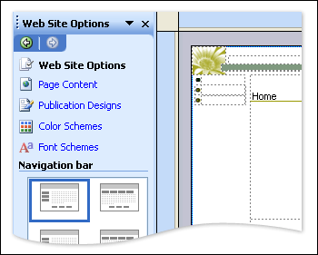
The Web Site Wizards create Web pages for you. You can use the Web Site Options task pane to design and customize your pages.

Plan your Web site
No wizard, however straightforward and simple to use, can make up for a lack of planning. Before you jump in to Publisher, take the time to think about what you want your Web site to accomplish. Who are you trying to reach with your Web site? How will you keep them coming back? Is your site's intention simply to publicize your business or do you want to use it to actually sell your products or services? By answering questions like these in advance, you will be able to make the most out of the features the Web Site Wizards offer.

Choose a wizard
Publisher includes four Web Site Wizards. The wizard you use depends entirely upon your site goals.

3-page Web Site
If you just want to get a basic site created that you know you'll add to in the future, this is the best wizard to use. Your site will include three pages, a Home page, About Us, and Contact Us.

Product Sales
Do you want to advertise and sell products from your site? If so, this is the wizard for you. In addition to the three basic pages (Home, About Us, Contact Us), the wizard creates a page where products are listed and also a detailed page for each product.

Professional Services
Does your organization provide services? This wizard creates the three basic pages (Home, About Us, Contact Us) for you, as well as a page where your services are listed, a detailed page for each service, and a project or client page, where you can list on-going and completed projects or provide client testimonials.

Easy Web Site Builder
Use this wizard if you want more choices up front about what types of pages your site will include. For example, you can add a calendar or schedule, employee information, links to other Web sites, and more.

Tip
No matter which Wizard you use initially to create your site, you can always add new pages and functionality later.

Create your site
When you use one of the Web Site Wizards to create your Web site, the pages are created for you. All you have to do, after you make some design and color decisions, is replace the placeholder information on the pages with information relevant to your business. Before you publish the Web site, be sure to preview it and test all the links and content thoroughly.

To create a Web site using a Web site Wizard
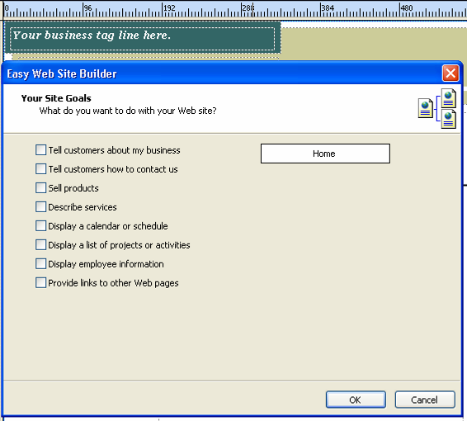
- Start Publisher. In the New Publication task pane, click Web Sites and E-mail, click Web Sites, and then click the name of the Wizard you want to use.
- On the right, click the Web site design you want.
- If you are using the Easy Web Site Builder Wizard, select the options that describe what you want you do with your site, and then click OK.
- The Personal Information dialog box may open. If you want to create a set of contact information, such as organization name and address, that Publisher can add automatically to all publications you create, fill in that information now, and then click OK. Filling in the information once now saves you from having to type your return address or contact information each time you start a new publication.
If you don't want to fill in any information now but might want to the next time you start a new publication, click Cancel.
If you don't want this dialog box to open when you start new publications, select Never show this dialog when starting a new publication. You can always open the Personal Information dialog again by clicking Personal Information on the Edit menu.

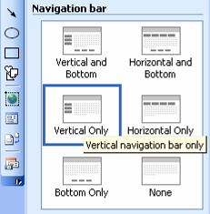
- In the Web Site Options task pane on the left, under Navigation bar, click the navigation bar style that you want for the pages.

- Toward the top of the task pane, click Page Content. Under Layout, click the layout that you want for the pages.
- If you want to use a different color scheme or font scheme on your site, click Color Schemes or Font Schemes toward the top of the task pane, and then choose the scheme you want.
- Replace the placeholder text and pictures on the Web site pages with your own content.
- To preview and test your Web site in a browser, on the File menu, click Web Page Preview. Use the navigation bar to move between pages.
- On the File menu, click Save As to name and save your Web site publication.

Note
Information about how to publish your Web site is available in the topic, Publish a Web site, listed under See also at the top left of this page.

Modify your site
After you create and publish your Web site, you're bound to get new ideas from employees and customers about how the site can work more effectively. You can easily add new pages and functionality to an existing site, and adjust the design. For example, you can an add an FAQ or News Article page. Or, you can include an order, response, or sign-up form. You can also add blank pages that you can design yourself.

To modify your Web site
- Open your Web site publication. If you don't see the Web Site Options task pane, on the View menu, click Task Pane.
- To add a new page, under Add to your Web site, click Insert a page. Choose the type of page you want, and then click OK.

Tip
If you want to add several pages at once that duplicate the current page, are blank, or have only one text box on each page, click More at the bottom of the Insert Web Page dialog box.

- To add a page or a series of pages related to a specific function you want the Web site to perform (for example, sell products or describe services), under Add to your Web site, click Add functionality. Choose the function you want, and then click OK
- To change the navigation bar style for the pages, under Navigation bar, click the style you want.
- To change the layout for any page, under Layout, choose the layout you want.

For more tips on using Microsoft Publisher visit: Microsoft Office

©2005 Microsoft Corporation. All rights reserved.

