Microsoft® Office Outlook® 2003 with Business Contact Manager


Converting from a Paper-Based System to Microsoft® Office Outlook® 2003 with Business Contact Manager

September 2003

The ability to effectively manage customer information is critical to the success of any small business. A customer information management system should be easy to use, allow you to connect with customers effectively, and manage your business more efficiently. This article will show you the advantages of using Microsoft® Office Outlook® 2003 with Business Contact Manager to manage customer information versus using traditional paper-based systems such as a Rolodex, day planner, manila folders, notebooks, and index cards. Finally, it will demonstrate how to increase your productivity by moving your customer information from paper-based systems into Outlook 2003 with Business Contact Manager.
Executive Summary

Two critical challenges for small businesses are effectively connecting with customers and efficiently managing sales leads and opportunities. To meet these challenges, businesses must organize contact and account information to ensure it is easily accessible and useful in daily customer communications and sales activities. Outlook 2003 with Business Contact Manager, unlike paper-based solutions, gives you the power to quickly and accurately store and access large amounts of information.

Outlook 2003 with Business Contact Manager provides a number of advantages over paper-based systems:
- Is easy to use.
- Keeps you connected with customers.
- Enables you to be more productive.

Businesses have traditionally invested significant time and money on paper-based systems. This article shows that converting information from a paper-based system to Outlook 2003 with Business Contact Manager is a simple process. In just a few steps you can enter all of your account, contact and business leads information. After you’ve converted to Outlook 2003 with Business Contact Manager, staying up to date is easier than ever before and you’re free to focus on growing your business.
Advantages of Business Contact Manager over traditional paper-based systems

Is easy to use:
Microsoft Outlook with Business Contact Manager maintains all customer information and communication in one place, making it easy to find customer-related documents instantly and link information such as e-mail messages, tasks, and files back to your business contacts, accounts, or opportunities.

Outlook 2003 with Business Contact Manager stores information in an easy to use format that allows updating, searching, and quick retrieval of information – tasks that are difficult and time-consuming with paper-based systems. It is easy to make mistakes or forget critical information with paper-based systems as they rely heavily on the user’s memory. This also makes paper-based systems nearly impossible to share with others. For example, if information is filed in manila folders and catalogued by account name, it may be nearly impossible to search for a single contact’s telephone number. You must first determine which account the contact belongs to, which may be hard to remember. With Outlook 2003 with Business Contact Manager, finding a contact’s telephone number is only a few clicks away.

Customer information is extremely valuable – losing that information can be catastrophic. Outlook 2003 with Business Contact Manager stores information in a database that can be backed up and restored. Paper-based systems, on the other hand, are risk prone: notebooks can be misplaced, coffee spilled, briefcases stolen or business cards and sticky notes accidentally thrown away. In addition, backing up a paper-based system typically presents a major challenge for businesses. This process involves hours and hours of photocopying or a complete manual duplication of the system. Many businesses simply do not have the time and resources to do it.

Keeps you connected with customers:
Outlook 2003 with Business Contact Manager is integrated with Microsoft Office and Microsoft bCentral™ services to give you the tools you need to stay connected with customers.

Through integration with Outlook, Outlook with Business Contact Manager is already part of your most valuable communication system. You can build stronger customer relationships with personalized communications such as e-mail messages and newsletters. Paper-based systems pose many barriers to staying connected with customers. For example, remembering birthdays and anniversaries require you to transcribe dates from your contact tracking system to a calendar or day planner. With Outlook 2003 with Business Contact Manager, you’re automatically reminded of these opportunities to connect with customers in personal and meaningful ways. You can also set reminders or create tasks to follow up with customers in a timely manner. Paper-based systems do not provide a reliable method to remind you about customer follow-ups. Sticky notes on monitors, bulletin boards or desks are unreliable.

Additionally, you can work with other Microsoft applications and bCentral services to create marketing materials and link documents to Outlook 2003 with Business Contact Manager. You can quickly create personalized newsletters and company brochures from a variety of professionally designed Microsoft Office Publisher 2003 templates that give your business a polished and professional look. Because Outlook with Business Contact Manager integrates with Microsoft Office Word 2003 and Publisher 2003, you can personalize and target direct marketing campaigns without the cost and complexity of hiring a creative design or marketing services firm.

Direct e-mail is one of the most effective methods for connecting with customers, helping you to maintain customer awareness of your business, make special offers, or announce a new product or service. Export your business contacts to bCentral List Builder and easily send your customers personalized, professional-looking e-mail messages. For example, if your business sells gourmet products, you can send your contacts a monthly newsletter with recipes and cooking tips that feature your products, including a short article about types of chili peppers or the use of garlic in Italian cuisine. Links to your Web site and order information can help facilitate an immediate sale. Afterwards, evaluate the effectiveness of your marketing efforts by tracking who opened your e-mail messages and which links they clicked. Expand your prospect base and acquire new customers by purchasing and importing targeted, qualified leads automatically from bCentral Sales Leads. Specify the demographic characteristics you want—for example, age, income, education level, geographical location, and so on—to help you zero in on customers who will be most interested in your business. You can build mailing lists quickly (no need to transcribe each new customer record to a paper-based system) to extend your marketing efforts and grow your business.

Enables you to be more productive:
Outlook 2003 with Business Contact Manager provides insight into your business, making you more productive. With built-in reporting, record history and product list tools, you can track your business and manage opportunities to maximize sales in ways that are simply not possible in paper-based systems.

Outlook 2003 with Business Contact Manager includes many pre-formatted reports that are ready-to-use, or you can create customized reports by sorting and filtering information to get just the information you need. Reports allow you to see customer information from all angles, giving you insight into sales performance and the ability to forecast future revenues. If needed, you can also export information for further analysis into Microsoft Excel or for incorporation into Microsoft PowerPoint® presentations. Paper-based systems lack reporting capabilities that let you quickly analyze your customers, sales and opportunities using the latest information. Given the complexity of paper-based systems, many small businesses do not generate reports. Without this information, you lack insight into your business, making it difficult to determine customer needs and sales opportunities.

You can further track customer information and communication with the activity history. When you send an email or create a task or appointment, an automatic link is made to the relevant business contact, account or opportunity. You can also link notes, phone calls and other documents. At a glance, you can see all communications, tasks, appointments and documents related to a customer. Creating and maintaining an activity log within a paper-based system is far too complex and time consuming for most small businesses. And once created, they remain inflexible and difficult to maintain as the business changes and grows. With Outlook 2003 with Business Contact Manager, the activity history takes almost no effort to create and maintain.

With the product list feature, you can track product name, price and quantity available. You can import an existing product list or create a new one. By creating an opportunity and using the product list, you get an instant view of the opportunity’s sales potential. Reports such as the Opportunity Funnel and Opportunity Forecast use the product list information to show potential revenue per opportunity and in aggregate for all opportunities. Additionally, by using the product list, you can create up-to-date quotes and proposals quickly and accurately. Creating this business intelligence in a paper-based system, while possible, is time-consuming and would have to be repeated for each individual opportunity.

With reporting, history, and product list tools, Outlook 2003 with Business Contact Manager provides insight into your business that makes you more productive. This allows you to spend more time with your customers and less with the complexities and inefficiencies of paperwork.
Maintaining information in Business Contact Manager

Maintaining information in Outlook 2003 with Business Contact Manager is faster and easier than paper-based systems. When a customer’s information changes, you can quickly update it by simply clicking on the appropriate business contact or account record and changing it once. With paper-based systems, you will likely have to update the information in multiple locations, taking time and potentially leading to errors.

By maintaining information in Outlook 2003 with Business Contact Manager, you can keep up to date with your customers and your business. Updated information allows you to stay connected with your customers to keep them informed of the latest products and services. When a new product or service becomes available, you’re sure to get the news out to all of your customers. Up-to-date information also gives you insight into your business with accurate sales performance and forecast reporting.

Maintaining information in Outlook 2003 with Business Contact Manager is faster and easier than paper-based solutions and allows you to stay more connected with customers. Outlook 2003 with Business Contact Manager also manages sales leads and opportunities more efficiently. This gives you more time to spend with your customers, building stronger relationships leading to increased customer satisfaction, repeat business and more referrals.

How to convert information to Business Contact Manager
Since Outlook 2003 with Business Contact Manager is integrated with Outlook, an application you use every day, your learning curve for Outlook 2003 with Business Contact Manager is dramatically reduced. By following these three simple steps you’ll be well on your way to tracking your business contacts and managing sales opportunities better so that you can grow your revenue and deliver improved customer service.

Step 1 – Create Accounts
Gather all the account information and follow the steps below for each account.

Create an account
- On the Outlook Bar, click the Business Contact Manager folder.  - Under the Business Contact Manager folder, click Accounts.  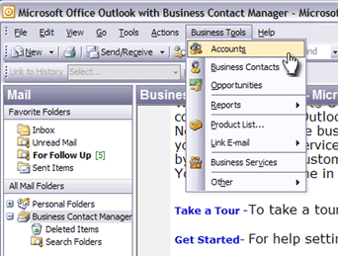  - On the Actions menu, click New Account.  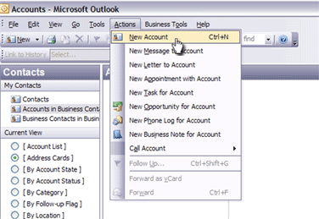  - On the Account form, enter information about the account.  - Click Save and Close.  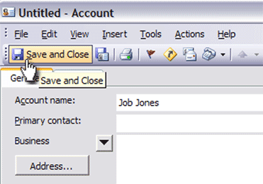 | Store important customer data in one place. Capture information about your accounts in the Outlook 2003 with Business Contact Manager default form with predefined fields. Once created, you can link Opportunity and Business Contact records to the account and add items and documents to the history.

Step 2 – Create Business Contacts
Gather all your contacts and follow the steps below for each contact.

Create a business contact
- On the Standard toolbar, click the down-arrow next to New.  - On the New menu, click New Business Contact.  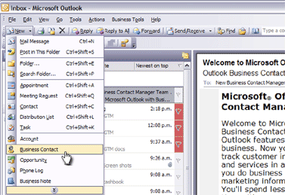  - In the Check Full Name dialog box, enter the name details, and then click OK.  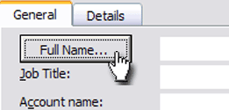  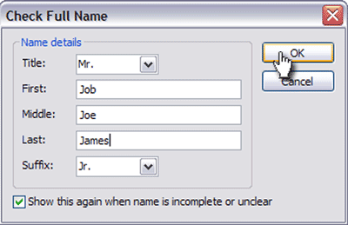  - Click the icon to the right of the Account field.  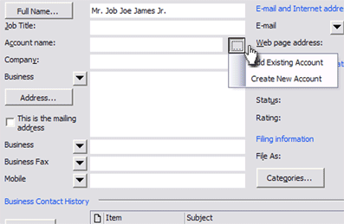  - In the Account dialog box, enter the account to you want to link to, and then click OK.  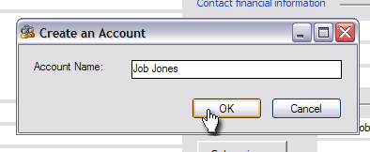  - On the Business Contact form, complete the information for the business contact.  - To enter another contact for the same account, click Save and New, or to save the record, click Save and Close.  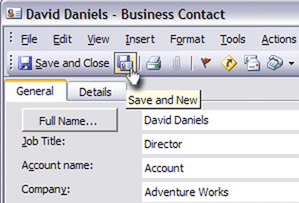  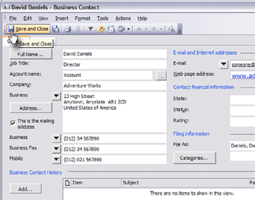 | Individual business contact information helps provide a complete picture of a customer account. Capture contact detail and link the record to a specific customer. Multiple contacts can be linked to the same account, helping you to understand every customer interaction with a specific company.

Step 3 – Create Opportunities
Gather all your sales leads and opportunities and follow the steps below for each of them.

Create an opportunity
- On the Standard toolbar, click the down-arrow next to New.  - On the New menu, click New Opportunity. 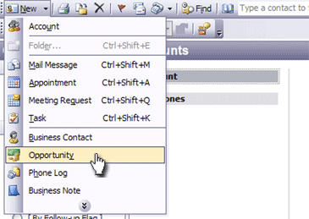  - Complete the Business Opportunity form. | Capture and track opportunities so you can follow-up effectively. Enter the details of an opportunity to sell your company’s products or services in the Opportunity form and then link it to a business contact or account record.

You’re done! This completes your conversion from a paper-based system to Outlook 2003 with Business Contact Manager.
Business Contact Manager – Additional Capabilities

The instructions below can help you explore some of the many other capabilities included in Outlook 2003 with Business Contact Manager.

Export business data files
- On the File menu, point to Import and Export, and then click Business Contact Manager.  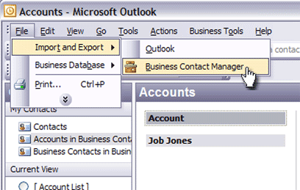  - Click Export a file, and then click Next.  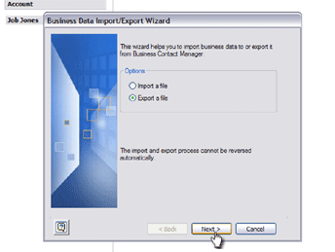  - Select the file type you want to export to, and then click Next.  - Follow the instructions in the Business Data Import/Export Wizard. | Efficiently re-use existing business data to launch a marketing campaign, print paper-based calendars and appointment lists or for analysis and reporting purposes. Export the data to another copy of Outlook with Business Contact Manager, Microsoft bCentral List Builder, or a Comma Separated Value file (.csv) for use in other applications such as Excel.

Import business data
- On the File menu, point to Import and Export, and then click Business Contact Manager.  - Click Import a file, and then click Next.  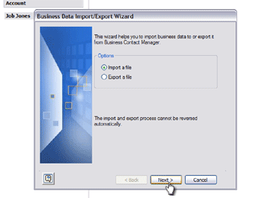  - Select the type of file that you want to import, and then click Next.  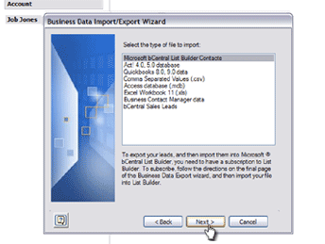  - Follow the instructions in the Business Data Import/Export Wizard. | Take advantage of existing customer information by importing it directly into Outlook with Business Contact Manager and eliminating the need to re-key. If you've stored your business data in another application, such as ACT!, Excel, bCentral List Builder, QuickBooks, or any application that can export to a Comma Separated Value file (.csv), you can quickly import the data into Account, Business Contact or Opportunity records in Outlook with Business Contact Manager.

Link history items to an account, business contact, or opportunity
- On the Outlook Bar, click the Contacts.  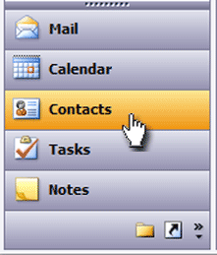  - Under the My Contacts folder, click Accounts in Business Contact Manager.  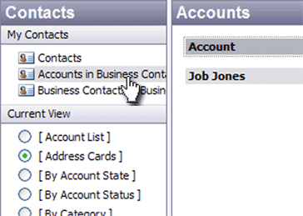  - In the Accounts list, double click the account you want to open.  - On the Account form, under Account History, click Add, and then select an item.  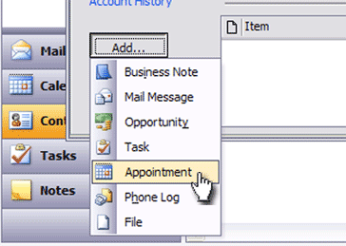  - In the dialog box for the item, enter the appropriate information.  - On the Business Contact Manager toolbar, click the arrow next to the Link to History list, and then select Account, Business Contact, or Opportunity.  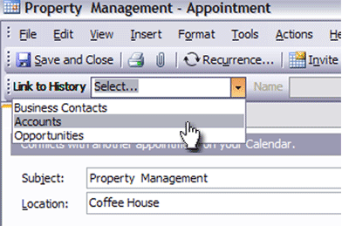  - Click the arrow next to the Name list and select a name.  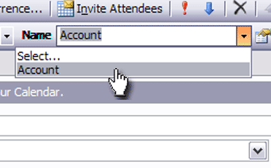  - Click Save and Close.  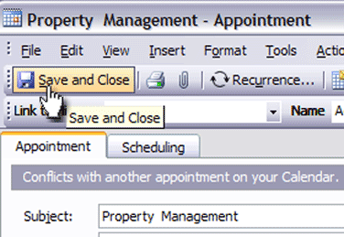 | Outlook with Business Contact Manager automatically links your e-mail messages, assigned tasks, appointments, and meetings to the appropriate Account, Business Contact, or Opportunity record. You can also manually link appointments, phone logs, tasks, business notes, and documents to records.

Generate reports
- On the Business Tools menu, point to Reports, point to Accounts, Business Contacts, Opportunities, or Other.  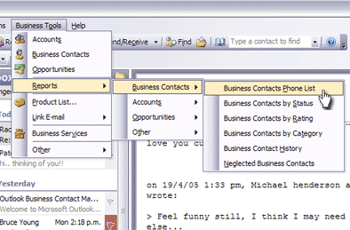  - Click the specific report you want to generate.  - Use the Report toolbar to sort report data, modify the information displayed, or print the report.  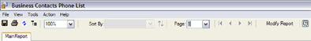 | View your customer information from all sides to gain insight into your sales performance and forecast potential revenues.

Import a product list
- On the Business Tools menu, click Opportunities.  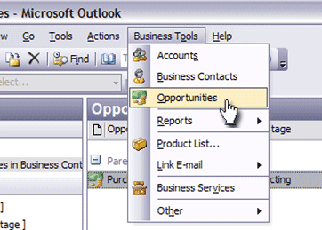  - Double-click the opportunity that you want to import a product list into.  - On the Opportunity form, under Products, click Add.  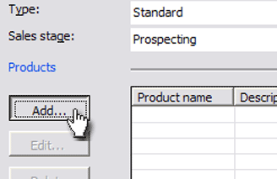  - In the Add/Edit Product Entry dialog box, click Product List.  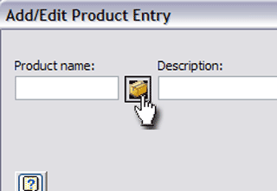  - In the Edit Master Product List dialog box, click Import.  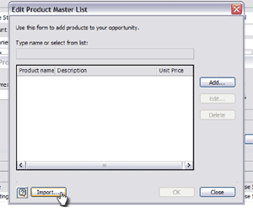  - Follow the instructions in the Products Import wizard.  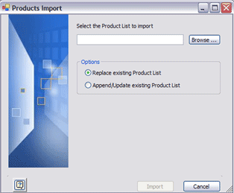 | To sell more effectively and help you determine the potential value of an opportunity, you can import a product list into an Opportunity record. With information at your fingertips, it’s easier to create up-to-date quotes and proposals quickly and accurately.

© 2003 Microsoft Corporation. All rights reserved.
The information contained in this document represents the current view of Microsoft Corporation on the issues discussed as of the date of publication. Because Microsoft must respond to changing market conditions, it should not be interpreted to be a commitment on the part of Microsoft, and Microsoft cannot guarantee the accuracy of any information presented after the date of publication. This document is for informational purposes only. MICROSOFT MAKES NO WARRANTIES, EXPRESS OR IMPLIED, IN THIS DOCUMENT.
Microsoft, Outlook, PowerPoint, and bCentral are either trademarks or registered trademarks of Microsoft Corporation in the United States and/or other countries. The names of actual companies and product mentioned herein may be the trademarks of their respective owners.

