|  |
| --- |
| Microsoft |
| Examples of how to configure the Microsoft Dynamics CRM Online E-mail Router in different deployment scenarios |
| Doc Version 1.2 |
| **2/9/2009** |

|  |
| --- |
| This document lists steps to configure Microsoft Dynamics CRM e-mail in different deployment scenarios. The scenarios included in this document focus on the following: The Microsoft Dynamics CRM E-mail Router, the forward mailbox, and the Microsoft Dynamics CRM Outlook client. |

Table of Contents

Overview 4

Deployment Considerations 4

The Microsoft Dynamics Client for Outlook 4

The Microsoft Dynamics CRM E-mail Router 4

The Forward Mailbox 5

How to configure Microsoft Dynamics CRM to use the Microsoft Dynamics CRM client for Outlook as the incoming and outgoing e-mail router 6

Requirements 6

Configuration settings in Microsoft Dynamics CRM 6

Set Personal Options in Microsoft Dynamics CRM 6

How to configure Microsoft Dynamics CRM to use the E-mail Router for incoming and outgoing e-mail 8

Configure the outgoing e-mail profile 8

Configure the incoming e-mail profile 9

Steps for Exchange E-mail Server Type 9

Steps for POP3 E-mail Server Type 10

Configure the Microsoft Dynamics CRM deployment 11

Configure the users to use the Microsoft Dynamics CRM e-mail router 12

Test and publish the new profiles and deployment 13

How to configure Microsoft Dynamics CRM to use the E-mail Router for outgoing e-mail and the forwarding mailbox for incoming e-mail 15

Configure the outgoing e-mail profile 15

Configure the incoming e-mail profile 16

Steps for Exchange E-mail Server Type 16

Steps for POP3 E-mail Server Type 17

Configure the Microsoft Dynamics CRM deployment 18

Configure the Microsoft Dynamics CRM forwarding mailbox 20

Create an Exchange Mailbox 20

Set up the Forward Mailbox 21

Configure the Microsoft Dynamics CRM users to use the forwarding mailbox 22

Deploy the Exchange rule using the Rule Deployment Wizard 22

Test and publish the new outgoing profile and deployment 23

Troubleshooting information 25

Using the Rule Deployment Wizard to deploy Microsoft Dynamics CRM e-mail rules 25

E-mail are not resolved 25

Users are not displayed after you click Load Data in the Configuration Wizard 25

Changing a user’s e-mail options 26

Troubleshooting information 26

Using the Rule Deployment Wizard to deploy Microsoft Dynamics CRM e-mail rules 26

User cannot resolve e-mail 26

Messages are not deleted from forward mailbox 27

Users are not displayed after you click Load Data in the Configuration Wizard 27

Changing a user’s e-mail options 28

More Information 28

Send Feedback on the article 28

**Examples of how to configure the   
Microsoft Dynamics CRM Online E-mail Router   
in different deployment scenarios**

Overview  
With Microsoft Dynamics CRM Online, the E-mail Router Configuration Manager makes sending and receiving e-mail from Microsoft Dynamics CRM Online much more flexible. This flexibility requires additional configuration for the e-mail router in Microsoft Dynamics CRM Online. This document lists steps to configure Microsoft Dynamics CRM e-mail in different deployment scenarios. The scenarios included in this document focus on the following:

* **The Microsoft Dynamics CRM Outlook client**
* **The Microsoft Dynamics CRM E-mail Router**
* **The Forward Mailbox**

Each scenario has advantages and disadvantages depending on the deployment scenario. A deployment can use a mixture of the scenarios. For example, some users can use the Microsoft Dynamics CRM Client for Outlook as the e-mail router and other users can use the Microsoft Dynamics CRM E-mail Router for sending and tracking e-mail in Microsoft Dynamics CRM Online.

Deployment Considerations

The Microsoft Dynamics Client for Outlook  
**Advantages**:

* This scenario does not require the Microsoft Dynamics CRM E-mail Router. The Microsoft Dynamics CRM Client for Outlook is able to send e-mail for each user whether the user sends it from within Outlook or in the Microsoft CRM Web Client, as well as receive and track e-mail in Microsoft Dynamics CRM.
* There are no user passwords to maintain for access to Microsoft CRM Online or to the user’s mailboxes.

**Disadvantages**:

* The Microsoft Dynamics CRM Client for Outlook client must be running to sent and track e-mail messages in Microsoft Dynamics CRM Online. If the Microsoft Dynamics Client for Outlook is not running the e-mails will be queued until Outlook is launched and connects to the Microsoft Dynamics CRM Server and to the mail server.
* This option cannot be used for Queues created in Microsoft Dynamics CRM Online.

### The Microsoft Dynamics CRM E-mail Router

**Advantages**:

* Can be used to connect to Exchange and POP3 mailboxes to track e-mail in Microsoft Dynamics CRM Online.
* Can be used in deployments where the Microsoft Dynamics CRM Client for Outlook is not installed.
* Can be used to monitor individual user mailboxes.

**Disadvantages**:

* For Pop3 accounts you must create an incoming profile for each Pop3 account and you must enter the password for each Pop3 account.
* Requires a dedicated computer that is always running.
* Can be more complex to setup and maintain when used to monitor a large number of users and mailboxes.

### The Forward Mailbox

**Advantages**:

* Reduces the number of incoming profiles that must be created and managed for organizations that monitor a large number of users and mailboxes.
* One central mailbox to monitor

**Disadvantages**:

* E-mail provider must have the ability to forward as an attachment. This is required to forward e-mails to a central mailbox that is monitored by the Microsoft Dynamics CRM E-mail Router.
* A mailbox rule must be deployed to each user to forward e-mails to the central mailbox.

# How to configure Microsoft Dynamics CRM to use the Microsoft Dynamics CRM client for Outlook as the incoming and outgoing e-mail router

If all Microsoft Dynamics CRM users will use Microsoft Outlook as the e-mail router, you do not have to install the Microsoft Dynamics CRM E-mail Router or the Rule Deployment wizard.

**Note**: If you configure Microsoft Outlook as the e-mail router, Microsoft Outlook must remain open for e-mail messages to be sent and received into Microsoft Dynamics CRM. For example, if a user is sending an e-mail message from the Microsoft Dynamics CRM Web client, the user must also have Microsoft Outlook open. If Microsoft Outlook is not open and an e-mail is sent or expected to be received into Microsoft Dynamics CRM, this action will not occur until Microsoft Outlook is opened. After Microsoft Outlook is opened and has successfully connected to the Microsoft Dynamics CRM and the mail server such as Exchange or a Pop3 account, the e-mail will be sent from Microsoft Dynamics CRM, or the e-mail will be received and created in Microsoft Dynamics CRM.

Requirements  
The following list contains requirements to configure Microsoft Outlook as the Microsoft Dynamics CRM e-mail router:

* The Microsoft Dynamics CRM Client for Outlook or the Microsoft Dynamics CRM Client for Outlook with Offline Access must be installed.
* Microsoft Outlook must be running.
* You must have an active connection to a Microsoft Exchange or Pop3 account and the Microsoft Dynamics CRM server.

Configuration settings in Microsoft Dynamics CRM  
All users are automatically configured to use Microsoft Outlook as the incoming and outgoing e-mail router. To check the E-mail Access Configuration settings, in the CRM Web client click Settings, click Administration and click Users. Double click each user to check their E-mail Access Configuration settings.

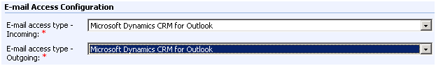

Set Personal Options in Microsoft Dynamics CRM

After the Microsoft Dynamics CRM Client for Outlook or the Microsoft Dynamics CRM Client for Outlook with Offline Access has been installed, the user will need to update their personal options to allow the sending and the tracking of e-mails. The user can send, receive and route e-mail to the Microsoft Dynamics CRM server.

To change the user’s personal options have the user launch the Microsoft Dynamics CRM Client for Outlook, click the **CRM** menu and click **Options.** Under the **E-mail** tab check the 2 boxes under the **Select how CRM for Outlook should integrate e-mail with Microsoft Dynamics CRM**.

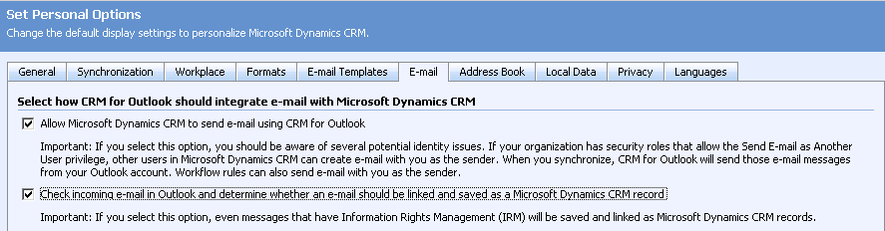

You have completed the steps to configure Microsoft Outlook as the Microsoft Dynamics CRM e-mail router.

# How to configure Microsoft Dynamics CRM to use the E-mail Router for incoming and outgoing e-mail

The following section lists how to configure the e-mail router for sending and receiving Microsoft Dynamics CRM related e-mail. First, you must configure outgoing e-mail.

## Configure the outgoing e-mail profile

1. In the E-mail Router Configuration Manager tool, click the **Configuration Profiles** tab, and then click **New**. Clicking **New** will open the new profile window.

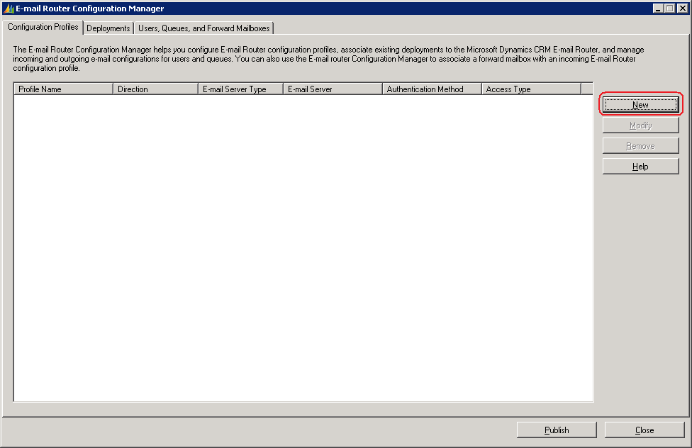

1. Type a profile name. For example, type *OutgoingEmail*.
2. Click **Outgoing** in the **Direction** list.
3. Verify **SMTP** is selected in the **E-mail server type** list.   
   **Note:** When you configure the outgoing e-mail profile, SMTP is the only option available in the **E-mail server type** list.
4. Change the value in the **Authentication Type** list to the authentication that your SMTP server accepts. Available authentication types include **Windows Authentication**, **Clear Text**, and **Anonymous**. If you are using the SMTP protocol from the Microsoft Exchange server, the authentication type that is supported is Windows Authentication.
5. Type the name of the SMTP server in the **Server** open text box. Type the NetBIOS name or the Fully Qualified Domain Name (FQDN) of the server.
6. Select how the e-mail router will gain access to the SMTP server in the **Access Credentials** list. The options include **Local System Account** or **Other Specified**.   
   **Note:** These credentials require rights to send e-mail to the SMTP server.
7. Click **OK**.

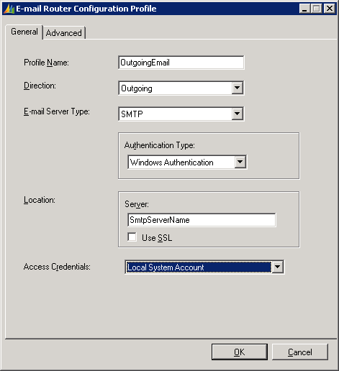

**Note:** If you will be configuring your Outgoing e-mail profile to use SMTP from Exchange, additional configuration may be required. The additional configuration steps are included in Microsoft Knowledge Base (KB) article [915827](http://support.microsoft.com/kb/915827/en-us). Review the information related to configuring the Microsoft Exchange server to enable relay messages from the Microsoft Dynamics CRM server.

## Configure the incoming e-mail profile

1. In the E-mail Router Configuration Manager tool, click **New**.
2. Type a profile name. For example, type *IncomingEmail*.   
   **Note:** If you will have multiple Incoming profiles make sure the name is unique and easy to understand as you will need this later in the configuration.
3. Verify **Incoming** is selected in the **Direction** list.
4. In the **E-mail Server Type** list there are two available selections. The first option is **Exchange**. The second option is **POP3**. Depending on the option you select in the **E-mail Server Type** list, this option will determine the remaining options and information you specify in this profile.

### Steps for Exchange E-mail Server Type

* + 1. If you select **Exchange** in the **E-mail Server Type** list you must select **Windows Authentication** in the **Authentication Type** list.
    2. Type the HTTP-DAV location of the Microsoft Exchange server in the **Server** open text box.   
       **Note:** This location is not the location of Outlook Web Access. Typically this location will be entered as <http://ExchangeServerName> or <http://ExchangeServerName.domain.com>   
       **Note:** If Exchange is not installed on the default website and port, you must include the port number. For example <http://ExchangeServerName:8080>
    3. In the **Access Credentials** list, select the credentials that will be used to access the Microsoft Dynamics CRM user’s mailbox. The available credentials include **Local System Account**, **User Specified**, or **Other Specified**.   
       **Note:** The account you specify requires full access to the Microsoft CRM user’s Exchange mailbox. You must verify the rights are set correctly within the mailbox of the account. The user’s mailbox rights can be changed in the Active Directory Users and Computers tool for Microsoft Exchange 2003. For Microsoft Exchange 2007 you must use the Exchange Management Shell tool in order to change permissions on the mailboxes.

**Note:** For CRM Online do not use **User Specified** in the **Access Credentials** list.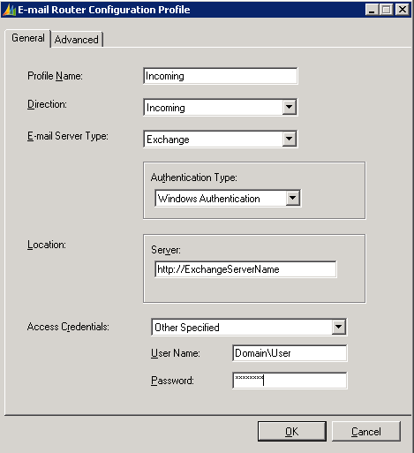

### Steps for POP3 E-mail Server Type

1. In the **E-mail Server Type** list, click POP3.
2. The **Authentication Type** list requires that you specify the authentication that is used to connect to the POP3 account. If you are connecting to an internal Exchange Pop3 server then **NTLM** can be used otherwise **Clear Text** will be used. If your POP3 account resides with your ISP, you should contact the ISP to provide the authentication type that is needed to access this account.
3. In the **Server** open text box, you type the POP3 server name and domain. For example, type *POP3servername.domain.com*. If the POP3 account resides with an ISP, you must contact the ISP to provide the server name.  
    **Note:** This will be the same incoming mail server name you would use to connect Outlook to the Pop3 account. To get the correct URL you will need to check with your Pop3 account connection information. This is usually found in the Help documentation on the site where you signed up for your Pop3 account.
4. In the **Access Credentials** list, available options include **User Specified** or **Other Specified**.   
   **Note:** For CRM Online do not use **User Specified** in the **Access Credentials** list.
5. Select **Other Specified**, and enter the password for the POP3 account.   
   **Note:** When using **Other Specified** you must enter the **Password** of the Pop3 account you will be connecting to. User Name field will be unavailable as the e-mail address for the Pop3 account will be stored on the Primary E-mail Address field of the user in Microsoft Dynamics CRM.   
   **Note:** Any user or queue that is set to use this incoming profile must have the same password in order to connect to the Pop3 account. However, you can create multiple incoming profiles for multiple POP3 accounts so each account has a unique password.
   * 1. Click **OK** to complete the configuration of the incoming profile.

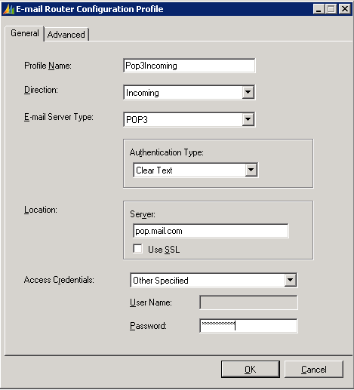

## Configure the Microsoft Dynamics CRM deployment

After you have created the outgoing and incoming e-mail profiles, click the **Deployments** tab in the E-mail Router Configuration Manager tool.

1. Click **New** to create a new deployment. The default **Deployment** option will be set to **Microsoft Dynamics CRM Online**.
2. In the **Microsoft Dynamics CRM Server** open text box it will default to https://dev.crm.dynamics.com/<OrganizationName> , replace the <OrganizationName> with the CRM Online organization name.
   * To find the unique name of your Organization login to the CRM web client and click **Settings**, click **Administration** and click **Organization Notifications and Status**. Here you will find the **Organization Name**.
   * If the organization name is Awc, you would type <http://dev.crm.dynamics.com/Awc> in the **Microsoft Dynamics CRM Server** open text box.   
     **Note:** The organization name is case-sensitive. Also, the organization name must be the unique name that you use when you type the url address to open Microsoft Dynamics CRM Online.   
     **Note**: If this value is entered incorrectly the deployment will be created successfully. However, errors will occur in other sections of the E-mail Router Configuration Manager tool.
3. In the **Access Credentials** list, the only option is **Other Specified**. The **Access Credentials** will need to be a Windows Live ID for a user in your CRM Online organization that has the System Administrator role.
4. In the **Incoming configuration profile**, select the incoming profile you created.
5. In the **Outgoing configuration profile**, select the outgoing profile you created.  
   **Note:**  Setting the Incoming and Outgoing configuration profiles on the Deployment will make these the default profiles for the users that are set to use the E-mail Router for incoming and outgoing e-mail. You can change it for each user in the **Users, Queues and Forward Mailboxes** tab.
6. Click **OK** to finish creating the deployment.

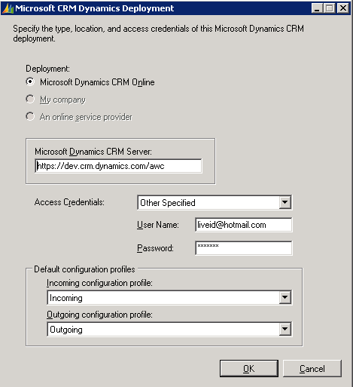

## Configure the users to use the Microsoft Dynamics CRM e-mail router

Before users can send and receive e-mail by using the Microsoft Dynamics CRM E-mail Router, you must configure each user for this functionality. To do this, follow these steps:

1. Open the Microsoft Dynamics CRM Web client as a user who is a member of the Microsoft Dynamics CRM system administrator role.
2. Click **Settings**, click **Administration**, click **Users**, and then open the user account.
3. Locate the **E-mail Access Configuration** section**.**
4. Select **E-mail Router** from the **E-mail access type – Incoming** list.
5. Select **E-mail Router** from the **E-mail access type – Outgoing** list.
6. Click **Save and Close**.
7. Perform steps I through VI for any remaining Microsoft Dynamics CRM users.

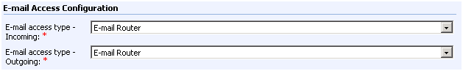

## Test and publish the new profiles and deployment

The last step is to publish the new incoming and outgoing profiles, and then publish the deployment. You publish the profiles and the deployment from the E-mail Router Configuration Manager tool. Before you start this step, you must test connectivity to verify that everything connects successfully. To do this, complete these steps:

1. Click the **Users, Queues and Forward Mailboxes** tab within the E-mail Router Configuration Manager tool.
2. In the **Select a CRM Deployment to view users and mailboxes** list, select the Microsoft Dynamics CRM deployment you created.
3. Click **Load Data**. This will display the Microsoft Dynamics CRM users configured to use the e-mail router.   
   **Note**: If you receive an error loading the data, verify the correct organization name is listed in the **Select a CRM Deployment to view users and mailboxes** list. Also, verify the organization name is entered with the correct case. The organization name is case sensitive.  
   **Note**: If no users are listed after you click **Load Data**, or if you are missing users, check the user’s settings by following the steps in the section titled ***“Configure the users to use the Microsoft Dynamics E-mail Router.”***
4. If you want to change the Incoming or Outgoing configuration profiles for certain users, double click the user and change the selection for the **Incoming Configuration Profile** or **Outgoing Configuration Profile** and click **OK**.
5. Click **Test Access**. Tests will be performed on all users for both profiles. A successful test will display a green succeeded message that resembles the following:

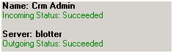

1. You can now publish the configuration. Click **Publish**. A successful publish will display the following message: 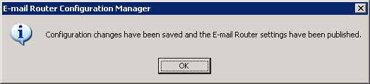  
   **Note**: Publishing saves the configuration to an .xml file that is located in the following directory:  
   <Drive>:\Program Files\Microsoft CRM Email\Service\Microsoft.Crm.Tools.EmailAgent.xml

You have now successfully configured Microsoft Dynamics CRM to use the e-mail router for incoming and outgoing CRM e-mail.

# 

# How to configure Microsoft Dynamics CRM to use the E-mail Router for outgoing e-mail and the forwarding mailbox for incoming e-mail

This section lists the steps that you should follow to configure the e-mail router to send Microsoft Dynamics CRM e-mail and to configure a forward mailbox to receive e-mail. To use the Forward Mailbox scenario your e-mail provider needs the ability to forward e-mails as an attachment.

First, you must configure outgoing e-mail.

## Configure the outgoing e-mail profile

1. In the E-mail Router Configuration Manager tool, click the **Configuration Profiles** tab, and then click **New**. Clicking **New** will open the new profile window.



1. Type a profile name. For example, type *OutgoingEmail*.
2. Click **Outgoing** in the **Direction** list.
3. Verify **SMTP** is selected in the **E-mail server type** list.   
   **Note:** When you configure the outgoing e-mail profile, SMTP is the only option available in the **E-mail server type** list.
4. Change the value in the **Authentication Type** list to the authentication that your SMTP server accepts. Available authentication types include **Windows Authentication**, **Clear Text**, and **Anonymous**. If you are using the SMTP protocol from the Microsoft Exchange server, the authentication type that is supported is Windows Authentication.
5. Type the name of the SMTP server in the **Server** open text box. Type the NetBIOS name or the Fully Qualified Domain Name (FQDN) of the server.
6. Select how the e-mail router will gain access to the SMTP server in the **Access Credentials** list. The options include **Local System Account** or **Other Specified**.   
   **Note:** These credentials require rights to send e-mail to the SMTP server.
7. Click **OK**.



**Note:** If you will be configuring your Outgoing e-mail profile to use SMTP from Exchange, additional configuration may be required. The additional configuration steps are included in Microsoft Knowledge Base (KB) article [939402](http://support.microsoft.com/kb/939402/en-us). Review the information related to configuring the Microsoft Exchange server to enable relay messages from the Microsoft Dynamics CRM server.

## Configure the incoming e-mail profile

1. In the E-mail Router Configuration Manager tool, click **New**.
2. Type a profile name. For example, type *IncomingEmail*.   
   **Note:** If you will have multiple Incoming profiles make sure the name is unique and easy to understand as you will need this later in the configuration.
3. Verify **Incoming** is selected in the **Direction** list.
4. In the **E-mail Server Type** list there are two available selections. The first option is **Exchange**. The second option is **POP3**. Depending on the option you select in the **E-mail Server Type** list, this option will determine the remaining options and information you specify in this profile.

### Steps for Exchange E-mail Server Type

* + 1. If you select **Exchange** in the **E-mail Server Type** list you must select **Windows Authentication** in the **Authentication Type** list.
    2. Type the HTTP-DAV location of the Microsoft Exchange server in the **Server** open text box.   
       **Note:** This location is not the location of Outlook Web Access. Typically this location will be entered as <http://ExchangeServerName> or <http://ExchangeServerName.domain.com>   
       **Note:** If Exchange is not installed on the default website and port, you must include the port number. For example <http://ExchangeServerName:8080>
    3. In the **Access Credentials** list, select the credentials that will be used to access the Microsoft Dynamics CRM user’s mailbox. The available credentials include **Local System Account**, **User Specified**, or **Other Specified**.   
       **Note:** The account you specify requires full access to the Microsoft CRM user’s Exchange mailbox. You must verify the rights are set correctly within the mailbox of the account. The user’s mailbox rights can be changed in the Active Directory Users and Computers tool for Microsoft Exchange 2003. For Microsoft Exchange 2007 you must use the Exchange Management Shell tool in order to change permissions on the mailboxes.

**Note:** For CRM Online do not use **User Specified** in the **Access Credentials** list.

### Steps for POP3 E-mail Server Type

1. In the **E-mail Server Type** list, click POP3.
2. The **Authentication Type** list requires that you specify the authentication that is used to connect to the POP3 account. If you are connecting to an internal Exchange Pop3 server then **NTLM** can be used otherwise **Clear Text** will be used. If your POP3 account resides with your ISP, you should contact the ISP to provide the authentication type that is needed to access this account.
3. In the **Server** open text box, you type the POP3 server name and domain. For example, type *POP3servername.domain.com*. If the POP3 account resides with an ISP, you must contact the ISP to provide the server name.  
    **Note:** This will be the same incoming mail server name you would use to connect Outlook to the Pop3 account. To get the correct URL you will need to check with your Pop3 account connection information. This is usually found in the Help documentation on the site where you signed up for your Pop3 account.
4. In the **Access Credentials** list, select the access credentials that will be used to access the Microsoft Dynamics CRM forward mailbox. The available options include **User Specified** and **Other Specified**.   
   **Note:** In the forwarding mailbox scenario and in CRM Online, you will not use **User Specified** in the **Access Credentials** list.
5. Select **Other Specified**, and enter the password for the POP3 account.   
   **Note:** When using **Other Specified** you need to enter the **Password** of the Pop3 account you will be connecting to. User Name field will be grayed out as the e-mail address for the Pop3 account will be stored on the Forward Mailbox that is setup later during the E-mail Router configuration.   
   **Note:** Any user or queue that is set to use this incoming profile that you created must have the same password in order to connect. You can create multiple incoming profiles for multiple POP3 accounts so each account can have its own unique password.
6. Click **OK** to complete the configuration of the incoming profile.



## Configure the Microsoft Dynamics CRM deployment

After you have created the outgoing and incoming e-mail profiles, click the **Deployments** tab in the E-mail Router Configuration Manager tool.

1. Click **New** to create a new deployment. The default **Deployment** option will be set to **Microsoft Dynamics CRM Online**.
2. In the **Microsoft Dynamics CRM Server** open text box it will default to https://dev.crm.dynamics.com/<OrganizationName> , replace the <OrganizationName> with the your CRM Online organization name.
   * To find the unique name of your Organization login to the CRM web client and click **Settings**, click **Administration** and click **Organization Notifications and Status**. Here you will find the **Organization Name**.
   * If the organization name is Awc, you would type <http://dev.crm.dynamics.com/Awc> in the **Microsoft Dynamics CRM Server** open text box.   
     **Note:** The organization name is case-sensitive. Also, the organization name must be the unique name that you use when you type the url address to open Microsoft Dynamics CRM Online.   
     **Note**: If this value is entered incorrectly the deployment will be created successfully. However, errors will occur when you try to click **Load Data** in the **Users, Queues and Forward Mailboxes** tab. in other sections of the E-mail Router Configuration Manager tool.
3. In the **Access Credentials** list, the only option is **Other Specified**. The **Access Credentials** will need to be a Windows Live ID for a user in your CRM Online organization that has the System Administrator role. This will be the user that is used to connect to your CRM Online organization to retrieve the list of users as well as any e-mails that need to be sent to the SMTP server.
4. In the **Incoming configuration profile**, select the incoming profile you created.
5. In the **Outgoing configuration profile**, select the outgoing profile you created.  
   **Note:**  Setting the Incoming and Outgoing configuration profiles on the Deployment will make these the default profiles for the users that are set to use the E-mail Router for incoming and outgoing e-mail. You can change it for each user in the **Users, Queues and Forward Mailboxes** tab.
6. Click **OK** to finish creating the deployment.



## Configure the Microsoft Dynamics CRM forwarding mailbox

A mailbox will need to be created that all the other CRM users will forward their e-mails to, to get processed by the E-mail Router. This can be an Exchange mailbox or a Pop3 mailbox. The steps below are for the Exchange Mailbox. To create a Pop3 mailbox you will need to follow the steps on your Pop3 accounts site to setup a new account.

### Create an Exchange Mailbox

1. Open Active Directory Users and Computers by clicking **Start**, click **Run**, type ***dsa.msc***, and then click **OK**.
2. Click the organizational unit where you want to create the forwarding mailbox user account, click **Actions**, point to **New**, and then click **User**.
3. Type a **First name**, **Last name**, **User logon name**, and **pre-Windows 2000 name** for the mailbox user account.
4. Click **Next**.
5. Enter a password, clear **User must change password**, and then click **Next**.
6. Verify **Create an Exchange mailbox** is marked, and then click **Next**.
7. Click **Finish** to create the mailbox user account.
8. Login to the newly created mailbox with Outlook Web Access or from a client machine to make sure the mailbox is setup and can receive e-mails.

After the forwarding mailbox is created you can configure the Microsoft Dynamics CRM user accounts to use the forwarding mailbox. Follow these steps to do this:   
**Note**: These steps must be completed for each Microsoft Dynamics CRM user who uses the forwarding mailbox.  
**Note:** Your e-mail provider needs the ability to forward e-mail as an attachment in order to use the Forward Mailbox scenario.

### Set up the Forward Mailbox

1. Open the Microsoft Dynamics CRM E-mail Router Configuration tool.
2. Click the **Users, Queues and Forward Mailboxes** tab.
3. In the **Select a CRM Deployment to view users and mailboxes** list, select the Microsoft Dynamics CRM deployment you created.
4. Click **Load Data**. This will display the Microsoft Dynamics CRM users who are configured to use the e-mail router.  
   **Note**: If you receive an error displaying the users, verify the correct organization name is listed in the **Select a CRM Deployment to view users and mailboxes** list. Also, verify the organization name is entered with the correct case. The organization name is case-sensitive.  
   **Note**: If no users are listed after you click **Load Data**, or if you are missing users, check the user’s settings by following the steps in the section titled ***“Configure the users to use the Microsoft Dynamics E-mail Router.”***
5. Click the **Forward Mailboxes** tab, and then click the **New**.
6. Type a name for the forward mailbox profile. For example type *CRMSystemMailbox* in the **Name** open text box.
7. Type the e-mail address for the forward mailbox in the **E-mail Address** open text box. This e-mail address is the address that you entered when you created the forward mailbox user account.
8. Click **OK**.

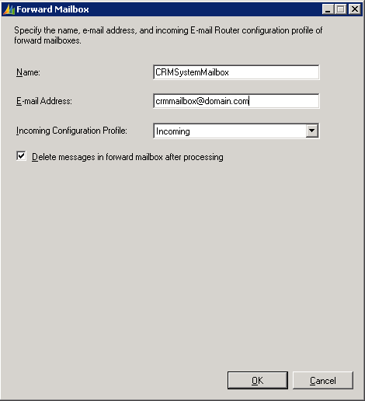

### Configure the Microsoft Dynamics CRM users to use the forwarding mailbox

**Note**: Any new users who you add to your CRM Online organization will automatically have the **E-mail Access Configuration** option set to Microsoft Dynamics CRM for Outlook so they will need to be changed in order for them to use the forward mailbox.

1. Open the Microsoft Dynamics CRM Web client as a user who is a member of the Microsoft Dynamics CRM system administrator role.
2. Click **Settings**, click **Administration**, click **Users**, and then open the user record.
3. Locate the **E-mail Access Configuration** section**.**
4. Select **Forward Mailbox** from the **E-mail access type – Incoming** list.
5. Select **E-mail Router** from the **E-mail access type – Outgoing** list.
6. Click **Save and Close**.
7. Perform steps 2-6 for any remaining Microsoft Dynamics CRM users.

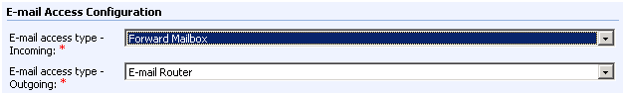

Deploy the Exchange rule using the Rule Deployment WizardYou can now use the Rule Deployment Wizard to deploy the Microsoft Dynamics CRM Exchange rule to each Microsoft Dynamics CRM user’s mailbox. This rule will forward e-mail to the Microsoft Dynamics CRM forwarding mailbox. After the rules have been deployed, any e-mail that is received in a user’s mailbox will be forwarded as an attachment to the forwarding mailbox. The Microsoft Dynamics CRM E-mail Router Service monitors the forward mailbox. The service will route Microsoft Dynamics CRM e-mail to Microsoft Dynamics CRM as an e-mail activity. If the e-mail is not related to Microsoft Dynamics CRM, the service will delete the e-mail message from the forwarding mailbox.

To configure the Microsoft Dynamics CRM Exchange rule, follow these steps:

1. Open the Microsoft Dynamics CRM Rule Deployment Wizard by clicking **Start**, point to **All Programs**, point to **Microsoft Dynamics CRM E-mail Router**, and then click **Rule Deployment Wizard**.
2. Click **Next** to start the wizard.
3. In the **Deployment** option leave the default option set to **Microsoft Dynamics CRM Online**.
4. In the **Microsoft Dynamics CRM Server** open text box, enter the same url address that was used in the Configuring the Microsoft Dynamics CRM Deployment section above.

Ex. https://dev.crm.dynamics.com/awc

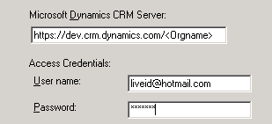

1. In the **Access Credentials** section put the Windows Live ID of a System Administrator in your CRM Online organization.
2. Click **Next**.
3. Type the forward mailbox e-mail address. This will be the e-mail address of the forward mailbox user account you created.
4. Click **Next**.
5. Select the Microsoft Dynamics CRM users who you want to deploy the rule to.   
   **Note:** If no users show up you will want to make sure you set the users e-mail settings to use the Forward Mailbox. See the **Configuring the Microsoft Dynamics CRM users to use the forward mailbox** section above.   
   **Note:** If the e-mail address on the user record in Microsoft CRM is different than the e-mail address that is showing in the **Rule Deployment Wizard** you will need to add a second e-mail address for that user in your Exchange environment. See troubleshooting section below for steps on adding a second e-mail address.
6. After you have selected the users, click **Next**.
7. Click **Deploy rule to user mailboxes**, and then click **Next**.   
   **Note**: If you are unsure if the rules have already been deployed, you can click **Verify rule in user mailboxes**.
8. After the rules have been deployed, click **Cancel** to close the wizard.

## Test and publish the new outgoing profile and deployment

The final step is to publish the new outgoing profile, publish the deployment, and publish the forward mailbox settings. You publish the profile and the deployment from the E-mail Router Configuration Manager tool. Before you start this step, you must test connectivity to verify that everything connects successfully. To do this, complete these steps to test connectivity:

1. Click the **Users, Queues and Forward Mailboxes** tab within the E-mail Router Configuration Manager tool.
2. In the **Select a CRM Deployment to view users and mailboxes** list, select the Microsoft Dynamics CRM deployment you created.
3. Click **Load Data**. This will display the Microsoft Dynamics CRM users configured to use the e-mail router.   
   **Note**: If you receive an error loading the data, verify the correct organization name is listed in the **Select a CRM Deployment to view users and mailboxes** list. Also, verify the organization name is entered with the correct case. The organization name is case sensitive.  
   **Note**: If no users are listed after you click **Load Data**, or if you are missing users, check the user’s settings by following the steps in the section titled ***“Configure the users to use the Microsoft Dynamics E-mail Router.”***
4. If you want to change the Incoming or Outgoing configuration profiles for certain users, double click the user and change the selection for the **Incoming Configuration Profile** or **Outgoing Configuration Profile** and click **OK**.
5. Click **Test Access**. Tests will be performed on all users for both profiles. A successful test will display a green succeeded message that resembles the following:

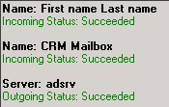

1. To publish the deployment, click **Publish**. A successful publish will display the following message:



You have now successfully configured Microsoft Dynamics CRM to use the Microsoft Dynamics CRM E-mail Router for outgoing e-mail and to use the forwarding mailbox for incoming e-mail.

# Troubleshooting information

## Using the Rule Deployment Wizard to deploy Microsoft Dynamics CRM e-mail rules

The account that you use to run the Rule Deployment Wizard requires Exchange administrator permissions. The account deploying the rules must have access the Microsoft Dynamics CRM user’s mailboxes to deploy the Microsoft Dynamics CRM forwarding rules.

You can do this by using one of the following methods:  
1. Grant the account running the wizard Exchange administrator permissions.  
2. Use the Run As command to run the wizard. The Run As command can be used by right-clicking **Rule Deployment Wizard**, and then click **Run As**. Next, enter the credentials of an Exchange Administrator, and then click **OK**. After the tool starts, it will be run under the context of the specified Exchange Administrator.

## E-mail are not resolved

If the e-mail address entered for the user in Microsoft Dynamics CRM Online does not exist in Exchange, the e-mail messages will not resolve.

You can add a second e-mail address to the users account in Exchange so the Rule Deployment Wizard can resolve the users e-mail to the user record in Exchange.

To do this in Exchange 2007

* 1. On the Exchange Server, click **Start**, click **All Programs**, click **Microsoft Exchange Server 2007**, and then click **Exchange Management Console**.
  2. Expand **Recipient Configuration**, and then click **Mailbox**.
  3. Right-click the user, and then click **Properties**
  4. Under the **E-Mail Address,** click **Add**, type the e-mail address that is used in the Microsoft Dynamics CRM user’s record, and then click **OK**.
  5. Re-run the **Rule Deployment Wizard**.

To do this in Exchange 2003

* 1. On the Exchange Server, click **Start**, click **All Programs**, click **Microsoft Exchange,** and then click **Active Directory Users and Computers**.
  2. Expand domain name, and then locate the user’s account.
  3. Right-click the user, and then click P**roperties**
  4. Under the **E-Mail Address**,click **New,** click **SMTP Address**, type the e-mail address that used in the Microsoft Dynamics CRM users record, and then click **OK**.
  5. Re-run the **Rule Deployment Wizard**.

## Users are not displayed after you click Load Data in the Configuration Wizard

1. Check to see what options are set for the **E-mail Access Configuration** for the user’s record. To do this, open Microsoft Dynamics CRM, click **Settings**, click **Administration**, and then open the user record.   
   **Note:** Only users who have the **Forwarding Mailbox** or the **E-Mail Router** options selected will display in the E-mail Router Configuration Wizard.
2. Verify the user has an e-mail address in the **Primary E-mail** field in Microsoft Dynamics CRM.

## Changing a user’s e-mail options

The e-mail router is very flexible. In one deployment you can have some users who use the Microsoft Dynamics CRM Client for Outlook as the e-mail router while other users are using the Forward Mailbox or E-Mail Router for incoming e-mail.

You can change these settings at any time. However, verify that if you change a user’s **E-mail Access Configuration** option, then you must run the E-mail Router Configuration Wizard to update and publish the user’s configuration.

# Troubleshooting information

## Using the Rule Deployment Wizard to deploy Microsoft Dynamics CRM e-mail rules

The account that you use to run the Rule Deployment Wizard requires Exchange administrator permissions. The account deploying the rules must have access the Microsoft Dynamics CRM user’s mailboxes to deploy the Microsoft Dynamics CRM forwarding rules.

You can do this by using one of the following methods:  
1. Grant the account running the wizard Exchange administrator permissions.  
2. Use the Run As command to run the wizard. The Run As command can be used by right-clicking **Rule Deployment Wizard**, and then click **Run As**. Next, enter the credentials of an Exchange Administrator, and then click **OK**. After the tool starts, it will be run under the context of the specified Exchange Administrator.

User cannot resolve e-mail   
A Microsoft Dynamics CRM user cannot resolve e-mail messages to Microsoft Dynamics CRM if the e-mail address that is created for the Microsoft Dynamics CRM user record is not found on the Exchange server.

You can add the e-mail address that is created for the Microsoft Dynamics CRM user to Exchange as a second e-mail address. Therefore the Rule Deployment Wizard can resolve the users e-mail to the user record in Exchange.

To do this in Exchange 2007, follow these steps:

* 1. On the Exchange Server, click **Start**, click **All Programs**, click **Microsoft Exchange Server 2007**, and then click **Exchange Management Console**.
  2. Expand **Recipient Configuration**, and then click **Mailbox**.
  3. Right-click the user, and then click **Properties**
  4. Under the **E-Mail Address** click **Add**, type the e-mail address that is used in Microsoft Dynamics CRM, and then click **OK**.
  5. Re-run the **Rule Deployment Wizard**.

To do this in Exchange 2003:

* 1. On the Exchange Server, click **Start**, click **All Programs**, click **Microsoft Exchange**,and then click **Active Directory Users and Computers**.
  2. Expand *domain name*, and then locate the user account.
  3. Right-click the user, click **Properties**,point to **E-Mail Address**, point to **New**,click **SMTP Address**, type the e-mail address that is used in the Microsoft Dynamics CRM, and then click **OK**.
  4. Re-run the **Rule Deployment Wizard**.

## Messages are not deleted from forward mailbox

When you install the CRM e-mail router and have the e-mail router poll an Exchange mailbox for messages to prompt into CRM, and the Outlook Web Access website is running on a Windows 2008 Server with IIS 7.0, you will notice that certain e-mails are not deleted from the mailbox after being processed by the e-mail router, even when you have enabled the setting to deleted processed messages.

In order to work around this issue run the following command on the IIS 7 server, replacing "Default Web Site" with the name of the web site that needs to be configured

%windir%\system32\inetsrv\appcmd set config "Default Web Site" -section:system.webServer/security/requestfiltering -allowDoubleEscaping:true

## Users are not displayed after you click Load Data in the Configuration Wizard

1. Check to see what options are set for the **E-mail Access Configuration** for the user’s record. To do this, open Microsoft Dynamics CRM, click **Settings**, click **Administration**, and then open the user record.   
   **Note:** Only users who have the **Forwarding Mailbox** or the **E-Mail Router** options selected will display in the E-mail Router Configuration Wizard.
2. Verify the user has an e-mail address in the **Primary E-mail** field in Microsoft Dynamics CRM.

## Changing a user’s e-mail options

The e-mail router is very flexible. In one deployment you can have some users who use the Microsoft Dynamics CRM Client for Outlook as the e-mail router while other users are using the Forward Mailbox or E-Mail Router for incoming e-mail.

You can change these settings at any time. However, verify that if you change a user’s **E-mail Access Configuration** option, then you must run the E-mail Router Configuration Wizard to update and publish the user’s configuration.

## More Information

Troubleshooting the Microsoft Dynamics CRM E-mail Router <http://blogs.msdn.com/crm/archive/2009/01/08/troubleshooting-the-microsoft-dynamics-crm-e-mail-router.aspx>

# [Send Feedback on the article](mailto:supdocfb@microsoft.com?subject=CRM%20Online%20Email%20Router%20Config%20Feedback)