|  |
| --- |
| Microsoft |
| Examples of how to configure the Microsoft Dynamics CRM 4.0 on-premise E-mail Router in different deployment scenarios |
| Doc Version 1.6 |
| **2/9/2009** |

|  |
| --- |
| This document lists steps to configure Microsoft Dynamics CRM 4.0 e-mail in different deployment scenarios. The scenarios included in this document focus on the following: The Microsoft Dynamics CRM E-mail Router, the forward mailbox, and the Microsoft Dynamics CRM Outlook client. |

Table of Contents

Overview 4

Deployment considerations 4

The Microsoft Dynamics CRM E-mail Router 4

The Forward Mailbox 4

The Microsoft Dynamics CRM Outlook client 5

How to configure Microsoft Dynamics CRM to use the E-mail Router for incoming and outgoing e-mail 6

Configure the outgoing e-mail profile 6

Configure the incoming e-mail profile 7

Steps for Exchange E-mail Server Type 7

Steps for POP3 E-mail Server Type 9

Configure the Microsoft Dynamics CRM deployment 10

Configure the users to use the Microsoft Dynamics CRM e-mail router 11

Test and publish the new profiles and deployment 12

How to configure Microsoft Dynamics CRM to use the E-mail Router for outgoing e-mail and the forwarding mailbox for incoming e-mail 13

Configure the outgoing e-mail profile 13

Configure the incoming e-mail profile 14

Steps for POP3 E-mail Server Type 15

Configure the Microsoft Dynamics CRM Deployment 16

Configure the Microsoft Dynamics CRM forwarding mailbox 18

Create the Exchange Mailbox 18

Set up the Forward Mailbox 19

Configure the Microsoft Dynamics CRM users to use the forwarding mailbox 20

Deploy the Exchange rule using the Rule Deployment Wizard 20

Test and publish the new outgoing profile and deployment 21

How to configure Microsoft Dynamics CRM to use the Microsoft Dynamics CRM Client for Outlook as the incoming and outgoing e-mail router 23

Requirements 23

Configuration settings in Microsoft Dynamics CRM 23

Set Personal Options in Microsoft Dynamics CRM 4.0 23

Configure Microsoft Outlook as the e-mail router for upgraded scenarios 24

Troubleshooting information 25

Using the Rule Deployment Wizard to deploy Microsoft Dynamics CRM e-mail rules 25

User cannot resolve e-mail 25

Messages are not deleted from forward mailbox 25

Users are not displayed after you click Load Data in the Configuration Wizard 26

Changing a user’s e-mail options 26

More Information 26

Send Feedback on the article 27

**Examples of how to configure the   
Microsoft Dynamics CRM 4.0 on-premise E-mail Router   
in different deployment scenarios**

Overview  
With Microsoft Dynamics CRM 4.0, the new E-mail Router Configuration Manager makes sending and receiving e-mail from Microsoft Dynamics CRM 4.0 much more flexible. This flexibility requires additional configuration for the e-mail router in Microsoft Dynamics CRM 4.0 that was not required for the e-mail router in Microsoft Dynamics CRM 3.0. This document lists steps to configure Microsoft Dynamics CRM e-mail in different deployment scenarios. The scenarios included in this document focus on the following:

* **The Microsoft Dynamics CRM E-mail Router**
* **The forward mailbox**
* **The Microsoft Dynamics CRM Outlook client**

Each scenario has advantages and disadvantages depending on the deployment considerations. A deployment can use a mixture of the scenarios. For example, if only some users use the Microsoft Dynamics CRM Client for Outlook, those users can use the Microsoft Dynamics CRM Client for Outlook as the e-mail router. Other users can use the Microsoft Dynamics CRM E-mail Router for sending and tracking e-mail in Microsoft Dynamics CRM 4.0.

Deployment considerations

The Microsoft Dynamics CRM E-mail Router  
**Advantages**

* Can be used to connect to Exchange and POP3 mailboxes to track e-mail into Microsoft Dynamics CRM 4.0.
* Can be used in deployments where the Microsoft Dynamics CRM Client for Outlook is not installed.
* Can be used to monitor individual user mailboxes.

**Disadvantages**

* For POP3 accounts, you must create an incoming profile for each POP3 account and you must enter the password for each POP3 account.
* Requires a dedicated computer that is always running.
* Can be more complex to setup and maintain if used to monitor a large number of user’s mailboxes.

### The Forward Mailbox

**Advantages**

* Reduces the number of incoming profiles that must be created and managed for organizations that monitor a large number of user’s mailboxes.
* One central mailbox to monitor.

**Disadvantages**

* E-mail provider must have the ability to forward as an attachment. This is required to forward e-mails to a central mailbox that is monitored by the Microsoft Dynamics CRM E-mail Router.
* A mailbox rule must be deployed to each user to forward e-mails to the central mailbox.

### The Microsoft Dynamics CRM Outlook client

**Advantages**

* This scenario does not require the Microsoft Dynamics CRM E-mail Router. The Microsoft Dynamics CRM Client for Outlook is able to send e-mail for each user whether the user sends it from within Outlook or within the CRM Web Client, as well as receive and track e-mail in Microsoft Dynamics CRM 4.0.
* There are no user passwords to maintain for access to Microsoft Dynamics CRM 4.0 or to the user’s mailboxes.

**Disadvantages**

* The Microsoft Dynamics CRM Client for Outlook must be running for e-mails to be sent or tracked in Microsoft Dynamics CRM. If the Microsoft Dynamics CRM Client for Outlook is not running, the e-mails will be queued until Outlook is launched and connects to the Microsoft Dynamics CRM server and to the mail server.
* This scenario cannot be used for Queues created in Microsoft Dynamics CRM 4.0.

# How to configure Microsoft Dynamics CRM to use the E-mail Router for incoming and outgoing e-mail

The following section lists how to configure the e-mail router for sending and receiving Microsoft Dynamics CRM related e-mail. First, you must configure outgoing e-mail.

## Configure the outgoing e-mail profile

1. In the E-mail Router Configuration Manager tool, click the **Configuration Profiles** tab, and then click the **New** button. Clicking the **New** button will open the new profile window.

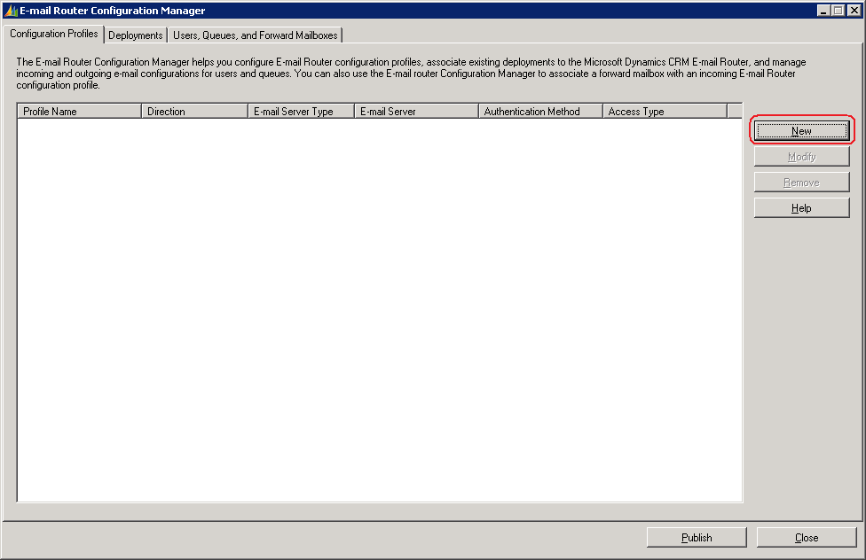

1. Type a profile name. For example, type *OutgoingEmail*.
2. Click **Outgoing** in the **Direction** list.
3. Verify **SMTP** is selected in the **E-mail server type** list.   
   **Note:** When you configure the outgoing e-mail profile, SMTP is the only option available in the **E-mail server type** list.
4. Change the value in the **Authentication Type** list to the authentication that your SMTP server accepts. Available authentication types include **Windows Authentication**, **Clear Text**, and **Anonymous**. If you are using the SMTP protocol from the Microsoft Exchange server, the authentication type that is supported is **Windows Authentication**.
5. Type the name of the SMTP server in the **Server** open text box. Type the NetBIOS name or the Fully Qualified Domain Name (FQDN) of the server.
6. Select how the e-mail router will gain access to the SMTP server in the **Access Credentials** list. The options include **Local System Account** or **Other Specified**.   
   **Note:** These credentials require rights to send e-mail to the SMTP server.
7. Click **OK**.

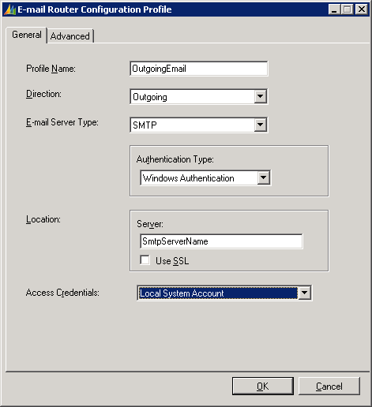

**Note:** If you will be configuring your Outgoing e-mail profile to use SMTP from Exchange, additional configuration may be required. The additional configuration steps are included in Microsoft Knowledge Base (KB) article [915827](http://support.microsoft.com/kb/915827/en-us). Review the information related to configuring the Microsoft Exchange server to allow relay messages from the Microsoft Dynamics CRM.

## Configure the incoming e-mail profile

1. In the E-mail Router Configuration Manager tool, click **New**.
2. Type a profile name. For example, type *IncomingEmail*.
3. Verify **Incoming** is selected in the **Direction** list.
4. In the **E-mail Server Type** list there are two available selections. The first option is **Exchange**. The second option is **POP3**. Depending on the option you select in the **E-mail Server Type** list, this option will determine the remaining options and information you specify in this profile.

### Steps for Exchange E-mail Server Type

* + 1. If you select **Exchange** in the **E-mail Server Type** list you must select **Windows Authentication** in the **Authentication Type** list.
    2. Type the HTTP-DAV location of the Microsoft Exchange server in the **Server** open text box.   
       **Note:** You should enter the url address that has the HTTP-DAV enabled. Outlook Web Access (OWA) endpoints typically have HTTP-DAV enabled. Typically this location will be entered as <https://ExchangeServerName> or <https://ExchangeServerName.domain.com>.   
       **Note:** If Exchange is not installed on the default website and port, you must include the port number. For example <https://ExchangeServerName:8080>
    3. In the **Access Credentials** list, select the credentials that will be used to access the Microsoft Dynamics CRM user’s mailbox. The available credentials include **Local System Account**, **User Specified**, or **Other Specified**.   
       **Note:** The account you specify requires full access to the Microsoft CRM user’s Exchange mailbox. You must verify the rights are set correctly within the mailbox of the account. The user’s mailbox rights can be changed in the Active Directory Users and Computers tool for Microsoft Exchange 2003. For Microsoft Exchange 2007 you must use the Exchange Management Shell tool in order to change permissions on the mailboxes.
    4. If you select **User Specified** in the **Access Credentials** list, each user must perform one additional configuration step to grant the e-mail router access to the Exchange mailbox. To do this, follow these steps:

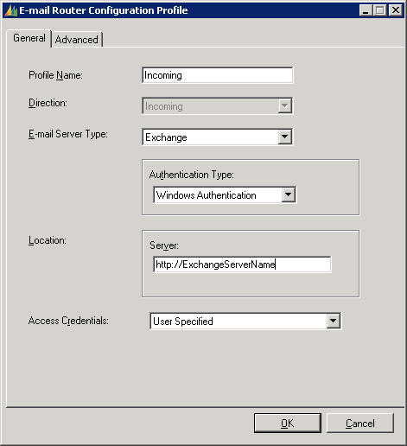

#### User configuration to allow Microsoft Dynamics CRM e-mail router access to mailbox

1. Open the Microsoft Dynamics CRM Web client.
2. Click **Tools** from the menu, and then click **Options**.
3. Click the **E-mail** tab.
4. Mark **Allow E-mail Router to use my credentials to send and receive e-mail on my behalf**.
5. Enter the domain and username in the **User name** open text box.
6. Enter the domain password in the **Password** open text box.
7. Click **OK**.

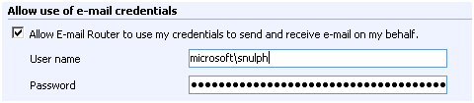  
 **Note**: If Microsoft CRM user’s passwords are set to expire periodically in Active Directory, you must complete these steps every time the password changes.

* + 1. Click **OK** to complete the configuration of the incoming profile.

### Steps for POP3 E-mail Server Type

1. In the **E-mail Server Type** list, click POP3.
2. The **Authentication Type** list requires that you specify the authentication that is used to connect to the POP3 account. If your POP3 account resides with your ISP, you must contact the ISP to provide the authentication type that is needed to access this account.
3. In the **Server** open text box, you type the POP3 server name and domain. For example, type *POP3servername.domain.com*. If the POP3 account resides with an ISP, you must contact the ISP to provide the server name.  
    **Note:** You may find this information in the account properties of the e-mail account located within Microsoft Outlook.
4. In the **Access Credentials** list, available options include **User Specified** or **Other Specified**.   
   If you select **User Specified** in the **Access Credentials** list, each user must perform one additional configuration step to grant the e-mail router access to the POP3 mailbox. To do this, follow these steps:

#### User configuration to allow Microsoft Dynamics CRM e-mail router access to mailbox

1. Open the Microsoft Dynamics CRM Web client.
2. Click **Tools** from the menu, and then click **Options**.
3. Click the **E-mail** tab.
4. Mark **Allow E-mail Router to use my credentials to send and receive e-mail on my behalf**.
5. Enter your domain and username in the **User name** open text box.
6. Enter your domain password in the **Password** open text box.
7. Click **OK**.

**Note:** **Allow credentials for the E-mail Router** option is also available on the Queue record in Microsoft Dynamics CRM.

1. If you select **Other Specified**, enter the password for the POP3 account.   
   **Note:** **Other Specified** is typically used for POP3 Microsoft Dynamics CRM queue accounts. Any user or queue that is set to use this incoming profile must have the same password if you select **Other Specified**. You can create multiple incoming profiles.
   * 1. Click **OK** to complete the configuration of the incoming profile.

## Configure the Microsoft Dynamics CRM deployment

After you have created the outgoing and incoming e-mail profiles, click the **Deployments** tab in the E-mail Router Configuration Manager tool.

1. Click **New** to create a new deployment. Leave the default **Deployment** option set to **My Company**.
2. In the **Microsoft Dynamics CRM Server** open text box, type the url address to open the Microsoft Dynamics CRM Web site. For example, assume the following:

* The Microsoft Dynamics CRM server name is CRMWEB
* The Microsoft Dynamics CRM Web site runs on port 5555
* The Organization name is Adventure Works Cycles   
  In this scenario, you would type [http://crmweb:5555/AdventureWorksCycles](http://crmweb:5555/AdventureWorksCyclese) in the **Microsoft Dynamics CRM Server** open text box.   
  **Note:** The organization name is case-sensitive. Also, the organization name must be the unique name that you use when you type the url address to open Microsoft Dynamics CRM.   
  You can verify the correct organization name by running the following Microsoft SQL query against the <*OrganizationName*>_MSCRM database:

*Select Name from OrganizationBase*

**Note**: If this value is entered incorrectly the deployment will be created successfully. However, errors will occur in other sections of the E-mail Router Configuration Manager tool.

1. In the **Access Credentials** list, the available options are **Local System Account** and **Other Specified**. If this is the only deployment of Microsoft Dynamics CRM, the **Access Credentials** that are used will be those that are starting the Microsoft Dynamics CRM E-mail Router service. By default this is set to **Local System Account**. **Other Specified** is typically used if another Microsoft Dynamics CRM deployment is created, and access to other environments require other credentials.
2. In the **Incoming configuration profile**, select the incoming profile you created.
3. In the **Outgoing configuration profile**, select the outgoing profile you created.
4. Click **OK** to finish creating the deployment.

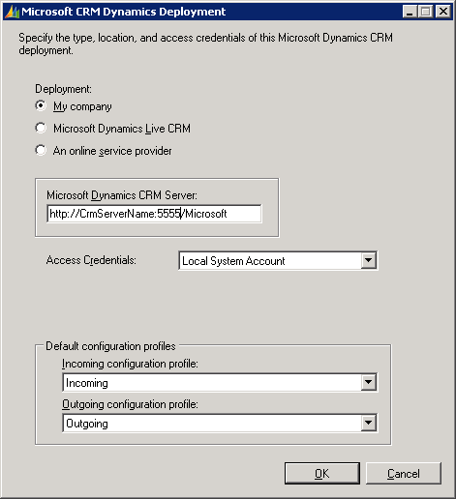

## Configure the users to use the Microsoft Dynamics CRM e-mail router

Before users can send and receive e-mail by using the Microsoft Dynamics CRM E-mail Router, you must configure each user for this functionality. To do this, follow these steps:

1. Open the Microsoft Dynamics CRM Web client as a user who is a member of the Microsoft Dynamics CRM system administrator role.
2. Click **Settings**, click **Administration**, click **Users**, and then open the user account.
3. Locate the **E-mail Access Configuration** section**.**
4. Select **E-mail Router** from the **E-mail access type – Incoming** list.
5. Select **E-mail Router** from the **E-mail access type – Outgoing** list.
6. Click **Save and Close**.
7. Perform steps I through VI for any remaining Microsoft Dynamics CRM users.

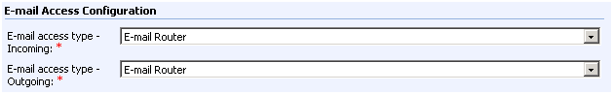

## Test and publish the new profiles and deployment

The last step is to publish the new incoming and outgoing profiles, and then publish the deployment. You publish the profiles and the deployment from the E-mail Router Configuration Manager tool. Before you start this step, you must test connectivity to verify that everything connects successfully. To do this, complete these steps:

1. Click the **Users, Queues and Forward Mailboxes** tab within the E-mail Router Configuration Manager tool.
2. In the **Select a CRM Deployment to view users and mailboxes** list, select the Microsoft Dynamics CRM deployment you created.
3. Click **Load Data**. This will display the Microsoft Dynamics CRM users configured to use the e-mail router.   
   **Note**: If you receive an error loading the data, verify the correct organization name is listed in the **Select a CRM Deployment to view users and mailboxes** list. Also, verify the organization name is entered with the correct case. The organization name is case sensitive.  
   **Note**: If no users are listed after you click **Load Data**, or if you are missing users, check the user’s settings by following the steps in the section titled ***“Configure the users to use the Microsoft Dynamics E-mail Router.”***
4. Click **Test Access**. Tests will be performed on all users for both profiles. A successful test will display a green succeeded message that resembles the following:

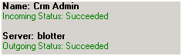

1. You can now publish the configuration. Click **Publish**. A successful publish will display the following message: 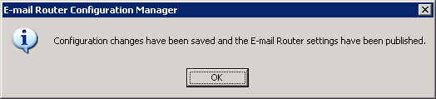  
   **Note**: Publishing saves the configuration to an .xml file that is located in the following directory:  
   <Drive>:\Program Files\Microsoft CRM Email\Service\Microsoft.Crm.Tools.EmailAgent.xml

You have now successfully configured Microsoft Dynamics CRM to use the e-mail router for incoming and outgoing CRM e-mail.

# How to configure Microsoft Dynamics CRM to use the E-mail Router for outgoing e-mail and the forwarding mailbox for incoming e-mail

This section lists the steps that you should follow to configure the e-mail router to send Microsoft Dynamics CRM e-mail and to configure a forward mailbox to receive e-mail. This option would give you the same type of setup that was used in Microsoft Dynamics CRM 3.0.

First, you must configure outgoing e-mail. This step is required even if you had outgoing e-mail setup in Microsoft Dynamics CRM 3.0, because the outgoing profile changed in Microsoft Dynamics CRM 4.0

## Configure the outgoing e-mail profile

1. In the E-mail Router Configuration Manager tool, click the **Configuration Profiles** tab, and then click **New**. Clicking **New** will open the new profile window.



1. Type a profile name. For example, type *OutgoingEmail*.
2. Click **Outgoing** in the **Direction** list.
3. Verify **SMTP** is selected in the **E-mail server type** list.   
   **Note:** When you configure the outgoing e-mail profile, SMTP is the only option available in the **E-mail server type** list.
4. Change the value in the **Authentication Type** list to the authentication that your SMTP server accepts. Available authentication types include **Windows Authentication**, **Clear Text**, and **Anonymous**. If you are using the SMTP protocol from the Microsoft Exchange server, the authentication type that is supported is Windows Authentication.
5. Type the name of the SMTP server in the **Server** open text box. Type the NetBIOS name or the Fully Qualified Domain Name (FQDN) of the server.
6. Select how the e-mail router will gain access to the SMTP server in the **Access Credentials** list. The options include **Local System Account** or **Other Specified**.   
   **Note:** These credentials require rights to send e-mail to the SMTP server.
7. Click **OK**.



**Note:** If you will be configuring your Outgoing e-mail profile to use SMTP from Exchange, additional configuration may be required. The additional configuration steps are included in Microsoft Knowledge Base (KB) article [939402](http://support.microsoft.com/kb/939402/en-us). Review the information related to configuring the Microsoft Exchange server to enable relay messages from the Microsoft Dynamics CRM server.

## Configure the incoming e-mail profile

1. In the E-mail Router Configuration Manager tool, click **New**.
2. Type a profile name. For example, type *IncomingEmail*.
3. Verify **Incoming** is selected in the **Direction** list.
4. In the **E-mail Server Type** list there are two available options. The first option is **Exchange**. The second option is **POP3**. Depending on the option you select in the **E-mail Server Type** list, this option will determine the remaining options and information you specify in this profile.
5. Steps for Exchange E-mail Server TypeSelect **Exchange** in the **E-mail Server Type** list.
6. Select **Windows Authentication** in the **Authentication Type** list.
7. Type the HTTP-DAV location of the Microsoft Exchange server in the **Server** open text box.   
   **Note:** You should enter the url address that has the HTTP-DAV enabled. Outlook Web Access (OWA) endpoints typically have HTTP-DAV enabled. Typically this location will be entered as <https://ExchangeServerName> or <https://ExchangeServerName.domain.com>.   
   **Note:** If Exchange is not installed on the default website and port, you must include the port number. For example <https://ExchangeServerName:8080>
8. In the **Access Credentials** list, select the access credentials that will be used to access the Microsoft Dynamics CRM forwarding mailbox. The available credentials include **Local System Account**, **User Specified**, or **Other Specified**.

**Note:** In the forwarding mailbox scenario, you will not use the **User Specified** option.

The account you select must have full access to the Microsoft CRM forwarding Exchange mailbox. You must verify access is set within the mailbox rights of the account. The user’s mailbox rights are stored in Active Directory.

1. Click **OK** to complete creating the incoming e-mail profile.

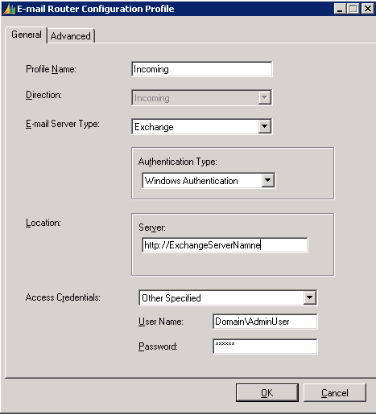

### Steps for POP3 E-mail Server Type

1. In the **E-mail Server Type** list, click **POP3**.
2. The **Authentication Type** list requires that you specify the authentication that is used to connect to the POP3 account. If you are connecting to an internal Exchange POP3 server, you can select **NTLM** authentication.If you are connecting to an external Exchange POP3 server, you can select **Clear Text** authentication.   
   **Note**: If the POP3 account resides with an ISP, you should contact the ISP to provide the authentication type that is needed to access this account.
3. In the **Server** open text box, you type the POP3 server name and domain. For example, type *POP3servername.domain.com*. If the POP3 account resides with an ISP, you must contact the ISP to provide the server name.  
    **Note:** This will be the same incoming mail server name you would use to connect Outlook to the POP3 account. To get the correct URL you must check with your POP3 account connection information. This is usually found in the Help documentation on the site where you signed up for the POP3 account.
4. In the **Access Credentials** list, select the access credentials that will be used to access the Microsoft Dynamics CRM forward mailbox. The available options include **User Specified** and **Other Specified**.   
   **Note:** In the forwarding mailbox scenario and in Microsoft CRM Online, you will not use **User Specified** in the **Access Credentials** list.
5. Select **Other Specified**, and enter the password for the POP3 account.   
   **Note:** When using **Other Specified** you must enter the Passwordof the POP3 account you will be connecting to. The **User Name** field will be unavailable as the e-mail address for the POP3 account will be stored on the Forward Mailbox that is setup later during the Microsoft Dynamics CRM E-mail Router configuration.   
   **Note:** Any user or queue that is set to use this incoming profile must have the same password in order to connect. You can create multiple incoming profiles for multiple POP3 accounts so that each account has a unique password.
6. Click **OK** to complete the configuration of the incoming profile.

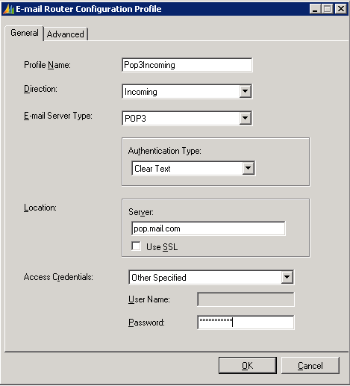

## Configure the Microsoft Dynamics CRM Deployment

After you have created the outgoing and incoming e-mail profiles, click the **Deployments** tab in the E-mail Router Configuration Manager tool.

1. Click **New** to create a new deployment. Leave the default **Deployment** option set to **My Company**.
2. In the **Microsoft Dynamics CRM Server** open text box, type the url address for the Microsoft Dynamics CRM Web site. For example, assume the following:

* The Microsoft Dynamics CRM server name is CRMWEB
* The Microsoft Dynamics CRM Web site runs on port 5555
* The Organization name is Adventure Works Cycles  
  In this scenario, you would type [http://crmweb:5555/AdventureWorksCycles](http://crmweb:5555/AdventureWorksCyclese) in the **Microsoft Dynamics CRM Server** open text box.   
  **Note:** The organization name is case-sensitive. Also, the organization name must be the unique name that you use when you type the url address to open Microsoft Dynamics CRM.   
  You can verify the correct organization name by running the following Microsoft SQL query against the <*OrganizationName*>_MSCRM database:

*Select Name from OrganizationBase*

**Note**: If this value is entered incorrectly, the deployment will be created successfully. However, errors will occur in other sections of the E-mail Router Configuration Manager tool.

1. In the **Access Credentials** list, the available options are **Local System Account** and **Other Specified**. If this is the only deployment of Microsoft Dynamics CRM, the **Access Credentials** that are used will be those that are starting the Microsoft Dynamics CRM E-mail Router service. By default this is set to **Local System Account**. **Other Specified** is typically used if another Microsoft Dynamics CRM deployment is created and access to other environments requires other credentials.
2. In the **Outgoing configuration profile**, select the outgoing profile you created.  
   **Note:** Because you are using the forward mailbox, you do not have to set an incoming profile. This will be set on the forwarding mailbox options.
3. Click **OK** to finish creating the deployment.

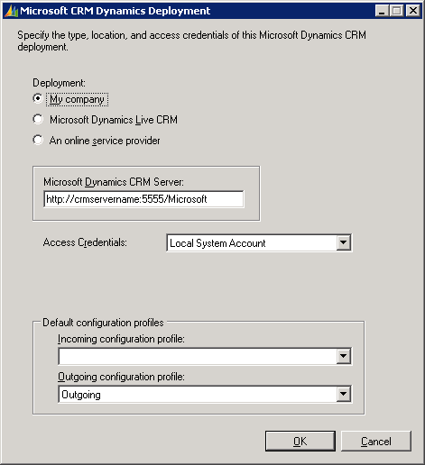

## Configure the Microsoft Dynamics CRM forwarding mailbox

If you have upgraded from Microsoft Dynamics CRM 3.0 to Microsoft Dynamics CRM 4.0 you may have created an Exchange mailbox that is used as the Microsoft Dynamics CRM forwarding mailbox. If this mailbox has not been created, you must follow these steps:

### Create the Exchange Mailbox

1. Open Active Directory Users and Computers by clicking **Start**, click **Run**, type ***dsa.msc***, and then click **OK**.
2. Click the organizational unit where you want to create the forwarding mailbox user account, click **Actions**, point to **New**, and then click **User**.
3. Type a **First name**, **Last name**, **User logon name**, and **pre-Windows 2000 name** for the mailbox user account.
4. Click **Next**.
5. Enter a password, clear **User must change password**, and then click **Next**.
6. Verify **Create an Exchange mailbox** is marked, and then click **Next**.
7. Click **Finish** to create the mailbox user account.

After the forwarding mailbox is created you can configure the Microsoft Dynamics CRM user accounts to use the forwarding mailbox. Follow these steps to do this:   
**Note**: These steps must be completed for each Microsoft Dynamics CRM user who uses the forwarding mailbox.

### Set up the Forward Mailbox

1. Open the Microsoft Dynamics CRM E-mail Router Configuration tool.
2. Click the **Users, Queues and Forward Mailboxes** tab.
3. In the **Select a CRM Deployment to view users and mailboxes** list, select the Microsoft Dynamics CRM deployment you created.
4. Click **Load Data**. This will display the Microsoft Dynamics CRM users who are configured to use the e-mail router.  
   **Note**: If you receive an error displaying the users, verify the correct organization name is listed in the **Select a CRM Deployment to view users and mailboxes** list. Also, verify the organization name is entered with the correct case. The organization name is case-sensitive.  
   **Note**: If no users are listed after you click **Load Data**, or if you are missing users, check the user’s settings by following the steps in the section titled ***“Configure the users to use the Microsoft Dynamics E-mail Router.”***
5. Click the **Forward Mailboxes** tab, and then click the **New**.
6. Type a name for the forward mailbox profile. For example type *CRMSystemMailbox* in the **Name** open text box.
7. Type the e-mail address for the forward mailbox in the **E-mail Address** open text box. This e-mail address is the address that you entered when you created the forward mailbox user account.
8. Click **OK**.

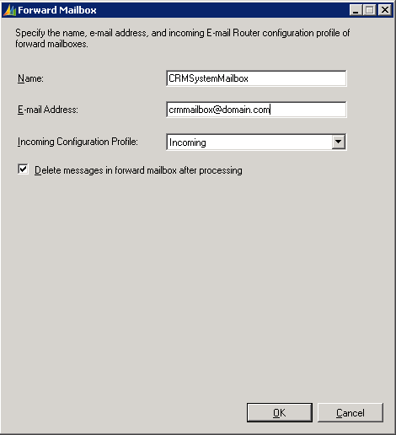

### Configure the Microsoft Dynamics CRM users to use the forwarding mailbox

**Note**: If you created a forward mailbox for Microsoft Dynamics CRM 3.0 and you upgrade to Microsoft Dynamics CRM 4.0, you do not have to complete these steps. The required settings will automatically be configured for the forward mailbox.   
**Note**: Any new users who you add after the upgrade will automatically have the **E-mail Access Configuration** option set to Microsoft Dynamics CRM for Outlook.

1. Open the Microsoft Dynamics CRM Web client as a user who is a member of the Microsoft Dynamics CRM system administrator role.
2. Click **Settings**, click **Administration**, click **Users**, and then open the user record.
3. Locate the **E-mail Access Configuration** section**.**
4. Select **Forward Mailbox** from the **E-mail access type – Incoming** list.
5. Select **E-mail Router** from the **E-mail access type – Outgoing** list.
6. Click **Save and Close**.
7. Perform steps 2-6 for any remaining Microsoft Dynamics CRM users.

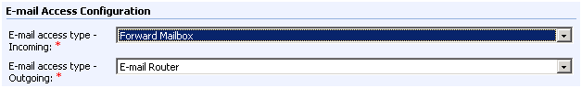

Deploy the Exchange rule using the Rule Deployment WizardYou can now use the Rule Deployment Wizard to deploy the Microsoft Dynamics CRM Exchange rule to each Microsoft Dynamics CRM user’s mailbox. This rule will forward e-mail to the Microsoft Dynamics CRM forwarding mailbox. After the rules have been deployed, any e-mail that is received in a user’s mailbox will be forwarded as an attachment to the forwarding mailbox. The Microsoft Dynamics CRM E-mail Router Service monitors the forward mailbox. The service will route Microsoft Dynamics CRM e-mail to Microsoft Dynamics CRM as an e-mail activity. If the e-mail is not related to Microsoft Dynamics CRM, the service will delete the e-mail message from the forwarding mailbox.

To configure the Microsoft Dynamics CRM Exchange rule, follow these steps: **Note**: If you have upgraded to Microsoft Dynamics CRM 4.0, and you are using the same forwarding mailbox that was used in Microsoft Dynamics CRM 3.0, you may not have to complete these steps. However, if you uninstalled the Microsoft Dynamics CRM 3.0 E-mail Router and during that process you removed the rules, you must complete these steps to redeploy the rules to the user’s mailbox.

1. Open the Microsoft Dynamics CRM Rule Deployment Wizard by clicking **Start**, point to **All Programs**, point to **Microsoft Dynamics CRM E-mail Router**, and then click **Rule Deployment Wizard**.
2. Click **Next** to start the wizard.
3. In the **Deployment** option leave the default option set to **My Company**.
4. In the **Microsoft Dynamics CRM Server** open text box, enter the url address, port number and organization name of the Microsoft Dynamics CRM installation.

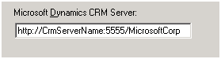

1. Click **Next**.
2. Type the forward mailbox e-mail address. This will be the e-mail address of the forward mailbox user account you created.
3. Click **Next**.
4. Select the Microsoft Dynamics CRM users who you want to deploy the rule to.
5. After you have selected the users, click **Next**.
6. Click **Deploy rule to user mailboxes**, and then click **Next**.   
   **Note**: If you are unsure if the rules have already been deployed, you can click **Verify rule in user mailboxes**.
7. After the rules have been deployed, click **Cancel** to close the wizard.

## Test and publish the new outgoing profile and deployment

The final step is to publish the new outgoing profile, publish the deployment, and publish the forward mailbox settings. You publish the profile and the deployment from the E-mail Router Configuration Manager tool. Before you start this step, you must test connectivity to verify that everything connects successfully. To do this, complete these steps to test connectivity:

1. Click the **Users, Queues and Forward Mailboxes** tab within the E-mail Router Configuration Manager tool.
2. In the **Select a CRM Deployment to view users and mailboxes** list, select the Microsoft Dynamics CRM deployment you created.
3. Click **Load Data**. This will display the Microsoft Dynamics CRM users configured to use the e-mail router.   
   **Note**: If you receive an error loading the data, verify the correct organization name is listed in the **Select a CRM Deployment to view users and mailboxes** list. Also, verify the organization name is entered with the correct case. The organization name is case sensitive.  
   **Note**: If no users are listed after you click **Load Data**, or if you are missing users, check the user’s settings by following the steps in the section titled ***“Configure the users to use the Microsoft Dynamics E-mail Router.”***
4. Click **Test Access**. Tests will be performed on all users for both profiles. A successful test will display a green succeeded message that resembles the following:

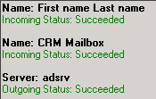

1. To publish the deployment, click **Publish**. A successful publish will display the following message:



You have now successfully configured Microsoft Dynamics CRM to use the Microsoft Dynamics CRM E-mail Router for outgoing e-mail and to use the forwarding mailbox for incoming e-mail.

# How to configure Microsoft Dynamics CRM to use the Microsoft Dynamics CRM Client for Outlook as the incoming and outgoing e-mail router

New functionality in Microsoft Dynamics CRM 4.0 lets you configure Microsoft Outlook as the Microsoft Dynamics CRM e-mail router.   
**Note**: If all Microsoft Dynamics CRM users will use Microsoft Outlook as the e-mail router, you do not have to install the Microsoft Dynamics CRM E-mail Router or the Rule Deployment wizard.

**Note**: If you configure Microsoft Outlook as the e-mail router, Microsoft Outlook must remain open for e-mail messages to be sent and received into Microsoft Dynamics CRM. For example, if a user is sending an e-mail message from the Microsoft Dynamics CRM Web client, the user must also have Microsoft Outlook open. If Microsoft Outlook is not open and an e-mail is sent or expected to be received into Microsoft Dynamics CRM, this action will not occur until Microsoft Outlook is opened. After Microsoft Outlook is opened and has successfully connected to the Microsoft Dynamics CRM and Exchange server, the e-mail will be sent from Microsoft Dynamics CRM, or the e-mail will be created in Microsoft Dynamics CRM.

Requirements  
The following list contains requirements to configure Microsoft Outlook as the Microsoft Dynamics CRM e-mail router:

* The Microsoft Dynamics CRM Client for Outlook or the Microsoft Dynamics CRM Client for Outlook with Offline Access must be installed.
* Microsoft Outlook must be running.
* You must have an active connection to the Microsoft Exchange and Microsoft Dynamics CRM server.

Configuration settings in Microsoft Dynamics CRM  
For a new installation of Microsoft Dynamics CRM 4.0, no additional configuration in Microsoft Dynamics CRM is required when you use Microsoft Outlook as the e-mail router. During a new installation of Microsoft Dynamics CRM 4.0, all users are automatically configured to use Microsoft Outlook as the incoming and outgoing e-mail router.

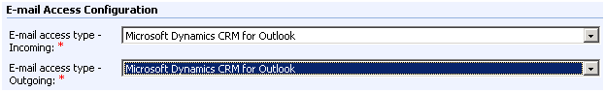

Set Personal Options in Microsoft Dynamics CRM 4.0  
After the Microsoft Dynamics CRM Client for Outlook or the Microsoft Dynamics CRM Client for Outlook with Offline Access has been installed, the user must update the personal options to allow the sending and the tracking of e-mails. The user can send, receive and route e-mail to the Microsoft Dynamics CRM server. To change the personal options, open the Microsoft Dynamics CRM Client for Outlook, click the **CRM** menu, and then click **Options.** Under the **E-mail** tab mark **Allow Microsoft Dynamics CRM to send e-mail using CRM for Outlook** and **Check incoming e-mail in Outlook and determine whether an e-mail should be linked and saved as a Microsoft Dynamics CRM record**. 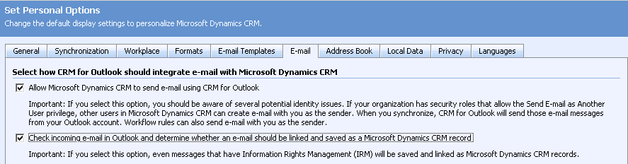

Configure Microsoft Outlook as the e-mail router for upgraded scenariosIf you have upgraded to Microsoft Dynamics CRM 4.0, you must follow these steps to configure Microsoft Dynamics CRM users to use the Microsoft Dynamics CRM Client for Outlook as the e-mail router:

1. Open the Microsoft Dynamics CRM Web client as a user who is a member of the Microsoft Dynamics CRM system administrator role.
2. Click **Settings**, click **Administration**, click **Users**, and then open the user record.
3. Locate the **E-mail Access Configuration** section.
4. Select **Microsoft Dynamics CRM for Outlook** from the **E-mail access type – Incoming** list.
5. Select **Microsoft Dynamics CRM for Outlook** from the **E-mail access type – Outgoing**  list.
6. Click **Save and Close**.
7. Perform steps 2-6 for any remaining Microsoft Dynamics CRM users.
8. Set the user’s personal options to allow the Microsoft Dynamics CRM Client for Outlook to send and receive e-mails by following the steps in the **Set Personal Options in Microsoft Dynamics CRM 4.0** section.

You have completed the steps to configure Microsoft Outlook as the Microsoft Dynamics CRM e-mail router.

# Troubleshooting information

## Using the Rule Deployment Wizard to deploy Microsoft Dynamics CRM e-mail rules

The account that you use to run the Rule Deployment Wizard requires Exchange administrator permissions. The account deploying the rules must have access the Microsoft Dynamics CRM user’s mailboxes to deploy the Microsoft Dynamics CRM forwarding rules.

You can do this by using one of the following methods:  
1. Grant the account running the wizard Exchange administrator permissions.  
2. Use the Run As command to run the wizard. The Run As command can be used by right-clicking **Rule Deployment Wizard**, and then click **Run As**. Next, enter the credentials of an Exchange Administrator, and then click **OK**. After the tool starts, it will be run under the context of the specified Exchange Administrator.

User cannot resolve e-mail   
A Microsoft Dynamics CRM user cannot resolve e-mail messages to Microsoft Dynamics CRM if the e-mail address that is created for the Microsoft Dynamics CRM user record is not found on the Exchange server.

You can add the e-mail address that is created for the Microsoft Dynamics CRM user to Exchange as a second e-mail address. Therefore the Rule Deployment Wizard can resolve the users e-mail to the user record in Exchange.

To do this in Exchange 2007, follow these steps:

* 1. On the Exchange Server, click **Start**, click **All Programs**, click **Microsoft Exchange Server 2007**, and then click **Exchange Management Console**.
  2. Expand **Recipient Configuration**, and then click **Mailbox**.
  3. Right-click the user, and then click **Properties**
  4. Under the **E-Mail Address** click **Add**, type the e-mail address that is used in Microsoft Dynamics CRM, and then click **OK**.
  5. Re-run the **Rule Deployment Wizard**.

To do this in Exchange 2003:

* 1. On the Exchange Server, click **Start**, click **All Programs**, click **Microsoft Exchange**,and then click **Active Directory Users and Computers**.
  2. Expand *domain name*, and then locate the user account.
  3. Right-click the user, click **Properties**,point to **E-Mail Address**, point to **New**,click **SMTP Address**, type the e-mail address that is used in the Microsoft Dynamics CRM, and then click **OK**.
  4. Re-run the **Rule Deployment Wizard**.

## Messages are not deleted from forward mailbox

When you install the CRM 4.0 e-mail router and have the e-mail router poll an Exchange mailbox for messages to prompt into CRM, and the Outlook Web Access website is running on a Windows 2008 Server with IIS 7.0, you will notice that certain e-mails are not deleted from the mailbox after being processed by the e-mail router, even when you have enabled the setting to deleted processed messages.

In order to work around this issue run the following command on the IIS 7 server, replacing "Default Web Site" with the name of the web site that needs to be configured

%windir%\system32\inetsrv\appcmd set config "Default Web Site" -section:system.webServer/security/requestfiltering -allowDoubleEscaping:true

## Users are not displayed after you click Load Data in the Configuration Wizard

1. Check to see what options are set for the **E-mail Access Configuration** for the user’s record. To do this, open Microsoft Dynamics CRM, click **Settings**, click **Administration**, and then open the user record.   
   **Note:** Only users who have the **Forwarding Mailbox** or the **E-Mail Router** options selected will display in the E-mail Router Configuration Wizard.
2. Verify the user has an e-mail address in the **Primary E-mail** field in Microsoft Dynamics CRM.

## Changing a user’s e-mail options

The e-mail router is very flexible. In one deployment you can have some users who use the Microsoft Dynamics CRM Client for Outlook as the e-mail router while other users are using the Forward Mailbox or E-Mail Router for incoming e-mail.

You can change these settings at any time. However, verify that if you change a user’s **E-mail Access Configuration** option, then you must run the E-mail Router Configuration Wizard to update and publish the user’s configuration.

## More Information

Troubleshooting the Microsoft Dynamics CRM E-mail Router <http://blogs.msdn.com/crm/archive/2009/01/08/troubleshooting-the-microsoft-dynamics-crm-e-mail-router.aspx>

When connecting the E-mail router over IFD you will need to make sure you are choosing the An online service provider option in the Deployments tab of the E-mail Router configuration and then enter https://<DiscoveryServerURL>/OrgName

**Note:** The Discovery service url will be the server that has the Platform Role installed on

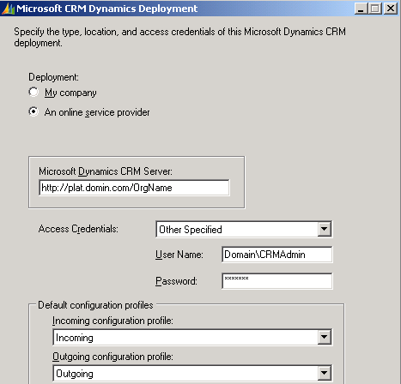

# [Send Feedback on the article](mailto:supdocfb@microsoft.com?subject=CRM%20OnPremise%20Email%20Router%20Config%20Feedback)