

SQL Server 2005: Decision Support Scalability Improvements

Author: Microsoft Corporation
Published: May 2005
Summary: The new release of the Microsoft SQL Server 2005 contains numerous enhancements designed to improve both overall performance and the ability to scale effectively as more storage systems are added to the configuration. This paper details two series of performance tests, run jointly by Microsoft and Network Appliance, which are designed to determine the effectiveness of the decision support system (DSS) enhancements in SQL Server 2005. Testing reveals significant gains in performance of SQL Server 2005 when compared with SQL Server 2000, as well as dramatic increases in scalability when more CPU resources are added to the configuration.
This is a preliminary document and may be changed substantially prior to final commercial release of the software described herein.
The information contained in this document represents the current view of Microsoft Corporation on the issues discussed as of the date of publication. Because Microsoft must respond to changing market conditions, it should not be interpreted to be a commitment on the part of Microsoft, and Microsoft cannot guarantee the accuracy of any information presented after the date of publication.
This White Paper is for informational purposes only. MICROSOFT MAKES NO WARRANTIES, EXPRESS, IMPLIED OR STATUTORY, AS TO THE INFORMATION IN THIS DOCUMENT.
Complying with all applicable copyright laws is the responsibility of the user. Without limiting the rights under copyright, no part of this document may be reproduced, stored in or introduced into a retrieval system, or transmitted in any form or by any means (electronic, mechanical, photocopying, recording, or otherwise), or for any purpose, without the express written permission of Microsoft Corporation.
Microsoft may have patents, patent applications, trademarks, copyrights, or other intellectual property rights covering subject matter in this document. Except as expressly provided in any written license agreement from Microsoft, the furnishing of this document does not give you any license to these patents, trademarks, copyrights, or other intellectual property.
© 2005 Microsoft Corporation. All rights reserved.
Microsoft, , Window Server, and Windows are either registered trademarks or trademarks of Microsoft Corporation in the United States and/or other countries.
The names of actual companies and products mentioned herein may be the trademarks of their respective owners.
Table of Contents
SQL Server 2005: Decision Support Scalability Improvements 1
Acknowledgements 1
Introduction 1
SQL Server 2005 Database Engine Enhancements 1
Memory Management 2
Query Processing 2
Test Environment 3
Servers 3
Storage 4
Test Setup 4
Network Appliance Value Add 5
Performance 6
Database Design 6
DSS Testing Queries 6
Test Results 7
SQL Server 2000 and SQL Server 2005 Performance Comparisons 8
Comparative Execution Times 8
Disk Read Performance 8
Processor Utilization 9
SQL Server 2005 Scaling Testing 10
Comparative Execution Times 10
Disk Read Performance 11
Processor Utilization 11
Summary 12
Appendix 13
Storage System Layout 13
Related Links 15

Acknowledgements
The SQL Server team would like to extend grateful thanks to the Network Appliance for their loan of storage hardware for the tests conducted in this white paper. Particular thanks to the Database Performance Engineering Team in Raleigh, NC, for their expertise and intensive support during testing, as well as for their input in the write up of this paper.

Introduction
Microsoft® SQL Server is used to support businesses in a number of mission-critical database processing functions, including online transaction processing (OLTP) and decision support system (DSS) workloads. The speed with which query results are returned is directly impacted by several key factors related to the following.
- Database—including the nature of the queries (DSS or OLTP, for example) run against the database, the size and complexity of the database, and the type of processing being performed (such as joins or aggregations).
- Hardware—commonly the speed and number of CPUs; more rarely, the number of disks.
- Software—the efficiency of the application algorithms used to execute the queries.
In this paper, we focus on performance testing in DSS environments. DSS workloads, unlike OLTP, are highly resource intensive, see Table 1 for more information. Characterized by long transactions with complex queries (either ad hoc or programmed, as with online analytical processing), DSS queries touch large amounts of data (often terabytes in size); as a consequence, DSS queries can potentially saturate both system CPUs and disk bandwidth.
Table 1 Characteristics of DSS (in comparison with OLTP)
Data Support Systems (including OLAP) | OLTP (Online transaction processing)
Long transactions  Complex queries  Large amounts of data accessed  Combines data from different sources  Resource intensive  Indexing enables higher performance | Short transactions  Limited number of standardized queries  Small amounts of data accessed  Uses data from only one source  Not resource intensive  Maintenance costs incurred with indexing

SQL Server 2005 Database Engine Enhancements
The database engine in the new Microsoft SQL Server has been extensively re-worked to improve both absolute performance and multiprocessor scaling in DSS environments, without the need for the administrator to manually tune the system. The details of these improvements are summarized below.

Memory Management
Memory management is a critical part of the server operation. Improvements in this area improve overall server performance, particularly in DSS environments. There are several major improvements in SQL Server memory management that contribute to improved memory support for complex, long-running, resource-intensive queries critical in DSS workloads.
- Uniform Memory Management. The uniform memory management framework in the SQL Server OS layer provides common memory brokerage between different components of the SQL Server, improving performance and providing flexible operations under a variety of memory pressures. One particular aspect of this framework, uniform dynamic caching, improves behavior/locality of the internal caches, improving performance in a wide range of operating conditions.
- NUMA Aware. SQL Server 2005 is non-uniform memory access (NUMA) architecture aware, which enables it to take advantage of memory locality, thereby conferring greater scalability.
- Dynamic Memory Management. SQL Server 2005 supports dynamic management of conventional, locked, and large-page memory. The new version of SQL Server also supports Hot Add Memory, reducing the need for reboots.
- Memory tracking. Major enhancements in memory tracking, including tracking of internal memory allocations between components, as well as external operating system-wide memory events, provide superior supportability features in memory management for SQL Server 2005.

Query Processing
SQL Server 2005 provides major advances in query processing capability for decision support applications. The query processor of SQL Server encompasses the execution environment, query optimizer, and query executor.
- Execution Environment. Controlling the query compilation and plan caching, one of the major enhancements of the execution environment is a new plan stability feature. This feature allows query hints to be attached to queries at runtime, even when the application cannot be modified. This is useful for tuning decision support applications purchased from Independent Software Vendors (ISVs).
- Query Optimizer. Responsible for finding the best plan for executing a query, the optimizer has been significantly improved for SQL Server 2005 for DSS environments. Improvements include:
- Full optimization capability for partitioned tables, including partition elimination capability that can avoid reading partitions that can be shown not to contain rows that contribute to the query result.
- A new date correlation optimization feature that allows many-fold speedups for join queries across tables with correlated date-time columns when there is a range filter on one of the date-time columns.
- The statistics subsystem of the optimizer provides improved statistics loading capability, loading the right statistics at the right time, every time, for improved cost estimation and better query plans. A new string summary statistics feature allows precise estimation of the selectivity of LIKE conditions that involve patterns with wildcards in any location, such as the string '%john%smith%'. Traditional histogram statistics also have improved accuracy.
- The optimizer provides another plan stability feature called plan forcing that enables the user to force the optimizer to choose a particular plan for a query. This can help solve the problem where a handful of queries in a large workload slow down after upgrade to a new service pack or release.
- Query Executor. Responsible for running the plan generated by the optimizer to solve a query, the SQL Server 2005 executor has been enhanced in a number of ways, including:
- Full support for partitioned tables
- New query execution operators to support T-SQL language extensions
- Improved hash join performance
- Improved nested loop performance
- Improved bitmap join optimizations
The query processing capabilities of SQL Server 2005 for decision support applications represents a tremendous advance over the already strong decision support features of SQL Server 2000.

Test Environment
The following sections detail the server and storage configurations used in the SQL Server performance testing comparisons. For a schematic of the test deployments, see Figure 1.
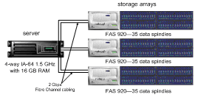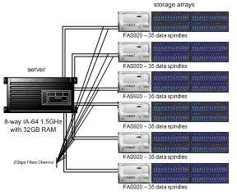
Figure 1. Schematic of 4- and 8-way servers and direct-attached Network Appliance storage.

Servers
All test systems ran Microsoft Windows Server™ 2003, Datacenter Edition, which provides 64-bit capabilities. Two sets of database performance comparisons were made: The first is between SQL Server 2000 and SQL Server 2005 Beta 2, and the second is between four-way and eight-way server configurations that are both running SQL Server 2005. For full details, see Table 2.
Table 2. Server Configuration
Component | Details
Operating System | Microsoft Windows Server 2003, Datacenter Edition for 64-bit Itanium-based Systems
Version | 5.2.3790 Service Pack 1, v.1433, build 3790
System Type | Itanium based
Database Servers | Microsoft SQL Server 2000 Enterprise Edition, SP4 build  Microsoft SQL Server 2005 post Beta 2, build 1099
Page File Space | 2.00 GB
 | 4-way | 8-way
Processor | 4 * 1500 MHz | 8 * 1500 MHz
Total Physical Memory | 16 GB | 32 GB
Total Virtual Memory | 17.57 GB | 33.57 GB

Storage
It was critical that SQL Server performance was truly stressed, and that potential bottlenecks outside the server space were identified and eliminated prior to testing. While the servers had finite CPU and memory resources (essentially, they were fixed variables), it was important that the storage subsystem was designed in such a way that there were no potential bottlenecks with respect to I/O demands and scaling capabilities.

Test Setup
Network Appliance FAS920 Fabric-Attached Storage systems provided direct-attached storage for the test setup. The Network Appliance storage solution is very scalable, both at four and eight -way server configuration, and as storage demands increased, the modular design and integrated management GUI made adding storage on the fly fast and simple.
All storage systems ran Data ONTAP version 6.5.2. Each storage system was configured with 56 x 72GB 15K RPM disks; of these, 35 spindles were configured to host four LUNs for data, and three spindles were configured as parity disks for RAID protection (see Figure 2 and Appendix for more details). Note that the storage system automatically distributes the data across all of the disks in the volume without the need for operator intervention.
For the SQL Server 2000 and SQL Server 2005 test runs on the four-processor system a total of 12*400GB LUNs were created, each containing 2*SQL Server database files. For the eight-processor system a total of 24*400GB LUNs were created, each containing 2 SQL Server database files. See Table 3 for full details.
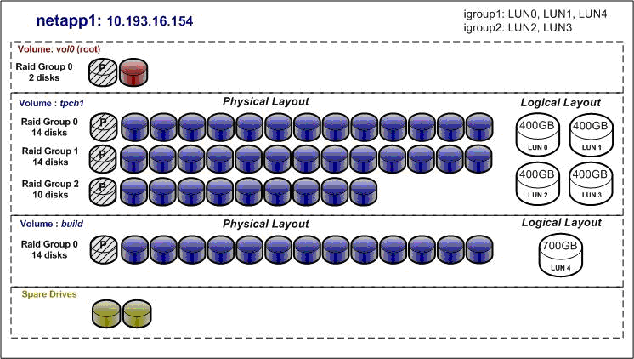
Figure 2 Disk layout for storage array FAS920-1

Network Appliance Value Add
The highly scalable storage subsystems of Network Appliance provide simple-to-manage, cost-effective, and reliable storage solutions for database infrastructures requiring mission-critical high availability solutions. As measured across the entire installed base today, Network Appliance storage solutions deliver availability in excess of 99.997%. In addition, Network Appliance storage solutions improve the usage of storage resources, and offer excellent data protection and rapid application testing.
Network Appliance storage solutions also provide advanced backups and recovery capabilities critical for keeping SQL highly available. SnapManager dramatically reduces SQL Server backup times—from hours to seconds—and makes every backup a full backup. Backups are based on NetApp Snapshot copies, allowing simultaneous backups of multiple databases of any size to be backed up and requiring minimal disk space for each additional full backup. SnapManager allows organizations to recover from SQL Server outages in minutes—not hours or days—making it one of the fastest backup and recovery solutions available and delivering an industry-leading combination of availability, scalability, and reliability for SQL Server environments.
Table 3 Storage Configuration
Component | Details
Operating System | Data ONTAP 6.5.2
Storage Interconnect | Emulex Lightpulse 9002 and 9802 HBAs (Queue depth set to the maximum of 254).
Storage Data Link Rate | 2 Gbps
 | 4-way | 8-way
Processor | 3 * Network Appliance FAS920 | 6 * Network Appliance FAS920
Disks | 114 * 72GB 15K RPM Drives | 228 * 72GB 15K RPM Drives
LUNs | 12 * 400GB | 24 * 400GB
Files | 24 | 48

Performance
The Network Appliance storage systems provided the high-performance and low-latency access to storage needed to demonstrate the abilities of SQL Server 2005. These systems each delivered up to 250 megabytes per second I/O each during large table scans.
More spindles were configured on the storage subsystems than would normally be required to support the workloads generated.
In order to ensure that the performance gains measured were a result of changes to SQL Server only, default storage array settings were used for all tests. The only exception to this was to disable pre-fetch during sequential read, since both SQL Server 2000 and SQL Server 2005 already generate sufficiently deep pre-fetch, enabling full system performance.

Database Design
The test database was fully normalized and fully indexed on primary and foreign keys. The size of the database, including tables and indexes, was 560 Gigabytes on disk.

DSS Testing Queries
A number of typical decision support queries were run to stress the system and evaluate changes as the system scaled. These queries, all of which differ from one another, were chosen for their complexity, their diversity in terms of data access patterns and query parameters, and because they access a large proportion of the available data. All of these queries benefit from effective memory management. All queries were run as separate job requests.
Profit Enhancement (PE). This query provides the total increase in profits, had certain discounts not been offered on products sold during a specified time period. The PE query assists in determining future product discounts.
Stress characteristics:
- I/O intensive
- intensive scan indexing required
Cost-Efficient Suppliers (CE). This query lists the supplier’s details for purchasing a specified part, from lowest to highest cost. The CE query identifies the supplier offering a specific part at the lowest cost, and can help a business identify the appropriate supplier in a given geographic region.
Stress characteristics:
- Complex query
- Query plan and optimization critical
High-Value Customers (HV). This query lists the top ‘N’ number of customers based on their order history. The HV query ranks customers based on the quantity of their orders, thereby helping to identify the most valuable customers for the company.
Stress characteristics:
- High number of random reads
- Intensive nested loop joins required
Specified Product Profit (SP). This query provides annual profit summaries for a specified product, itemized by geographic region. The SP query helps a company to determine its most profitable product by geographic region.
Stress characteristics:
- Complex query
- Query plan and optimization critical
Pricing Summary (PS). This query provides a total count and total price of all products sold during a specified time period. The time period was selected such that approximately 95% of the table was scanned. The PS query measures the total amount of business sales during the specified time frame.
Stress characteristics:
- Floating point calculations
- Expression evaluation performance critical
Unshipped Order Summary (UO). This query was used to extract a summary of a specified number of highest revenue generating orders not shipped by specified date. For example, if N=20, the query must return the highest 20 returns (unless fewer than 20 rows qualify for the SQL statement, in which case all rows must be returned). This query assists in identifying the shipment priority to meet company revenue goals.
Stress characteristics:
- Random reads
- Nested loop and hash joins critical
Late Received Orders (LR). This query provides a summary breakdown of products shipped to the customer prior to promised delivery date, but which were not received on time. The LR query, which summarizes late orders by shipping method, helps in selecting the best shipping method to ensure future on-time deliveries.
Stress characteristics:
- Random reads
- Nested loop and hash joins critical

Test Results
The following graphs summarize the results of the decision support system testing performed on SQL Server 2000 and SQL Server 2005.

SQL Server 2000 and SQL Server 2005 Performance Comparisons
For each query, tests were first run on SQL Server 2000 using a four-processor IA-64 platform, and then on SQL Server 2005 using the same physical configuration.

Comparative Execution Times
Figure 3 shows the query response times for High Value Customers (intensive joins), Specified Product Profit (complex queries), Pricing Summary (intensive floating point calculations), and Unshipped Orders (intensive joins), and Late Received Orders (high random reads). In all cases, response times for queries run on SQL Server 2005 were faster than those run on SQL Server 2000, indicating significant performance improvements. The response times for the remaining two variables, Cost-Efficient Suppliers and Profit Enhancement (not shown) are not significantly different, although in both cases, the SQL Server 2005 numbers are incrementally better.
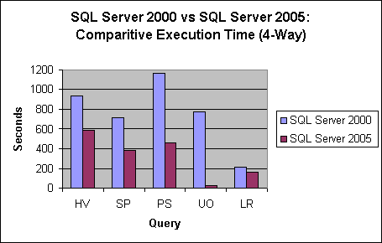
Figure 3 Comparative Response Times for HV, SP, PS and UO Queries
Note that the combination of SQL Server 2005 and Network Appliance storage is particularly powerful. While processing full table scans, both SQL Server 2000 and SQL Server 2005 were essentially I/O constrained. However, SQL Server 2005 was able to structure the data and the I/O requests more efficiently, delivering a throughput boost on disk-limited queries between 4% and 20%.

Disk Read Performance
Figure 4 compares total disk reads (megabytes/second) for SQL Server 2000 and SQL Server 2005. For all query types, SQL Server 2005 disk reads are either equivalent or dramatically faster than the equivalent test in SQL Server 2000.
The increase in disk reads was especially high for the Unshipped Order query, demonstrating very effective utilization of the disk subsystems. In addition to query execution improvements, the query optimizer generated a very effective plan utilizing data correlation optimizations.
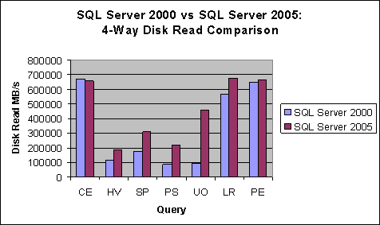
Figure 4 Comparison of Total Disk I/O

Processor Utilization
SQL Server 2005 delivers a faster query response than SQL Server 2000, but at what cost? The next round of DSS testing looks at system processor consumption—as measured by percent processor utilization—to determine whether SQL Server 2005 uses more system resources than its predecessor.
Figure 5 shows the results of four-way processor utilization. Overall, there is no significant change in CPU consumption between SQL Server 2005 and SQL Server 2000, indicating that the performance gains in SQL Server 2005 do not increase system resource costs.
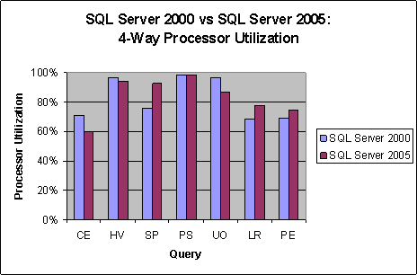
Figure 5 Comparative CPU Consumption

SQL Server 2005 Scaling Testing
In order to determine the performance impact of scaling from four processors to eight, additional SQL Server 2005 tests were run. Note that the eight-processor configuration was performed with storage arrays scaled up from three to six systems.

Comparative Execution Times
The decrease in response time on Figure 6 and 7 demonstrated that the overall system produced an almost linear improvement (1.9 times) in system scalability response time as the resources were doubled.
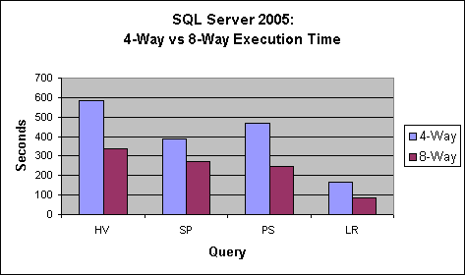
Figure 6 4-Processor / 8-Processor Execution Times
for HV, SP, PS and LR Queries
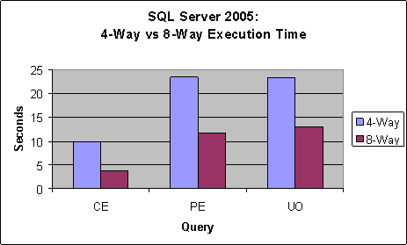
Figure 7 4-Processor / 8-Processor Execution Times
for CE, PE and UO Queries

Disk Read Performance
How is system throughput impacted by scaling from four to eight processors? As seen in Figure 8, storage system throughput measured as disk reads (megabytes/second) increases as the number of processors increases.
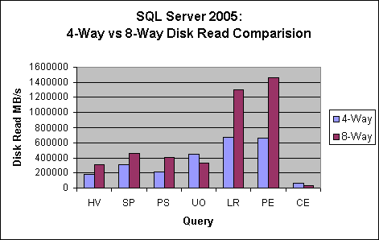
Figure 8 4-Processor / 8-Processor Disk Read Scaling

Processor Utilization
Although query response time increases as more system resources are added, how effective is SQL Server 2005 in making use of the overall system configuration? Figure 9 shows that CPU utilization of the four-processor and eight-processor systems are very similar, indicating that SQL Server 2005 uses system resources effectively.
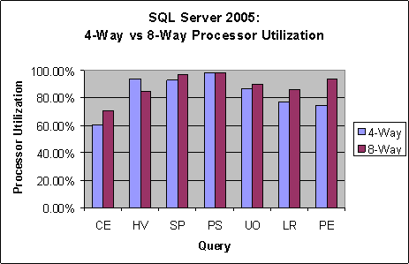
Figure 9 4-Way / 8-Way Comparative CPU Usage

Summary
This paper summarizes a number of improvements in SQL Server 2005 that enhance performance and scalability during decision support system queries.
A series of DSS queries were run against SQL Server 2000 and SQL Server 2005 to determine the effects of these changes on performance and resource utilization. Among the key results are the following:
- SQL Server 2005 has significantly improved the response time for certain DSS-type queries compared with SQL Server 2000.
- SQL Server 2005 and SQL Server 2000 consume equivalent amounts of CPU for the same types of queries.
- SQL Server 2005 generates equivalent or faster disk reads (measured in seconds) for the given queries than does SQL Server 2000.
A second series of tests compared the scalability of SQL Server 2005 with four or eight processors. Among the key results were the following:
- Speed with which query results are returned increases linearly with additional CPU.
- Overall, disk reads are faster when scaling from four to eight processors.
- System resource usage is very similar for both four and eight processor configurations.
Based on these tests, we have demonstrated that for complex DSS queries, SQL Server 2005 can make effective use of lead industry-leading SAN technology like Network Appliances FAS920 Storage Systems.

Appendix

Storage System Layout
The following Figures show the physical and logical layouts of the storage systems for hosting the SQL Server database files. All storage resources were provided by Network Appliance, as detailed in Table 3.
Figure 10 FAS920-1 Disk Layout

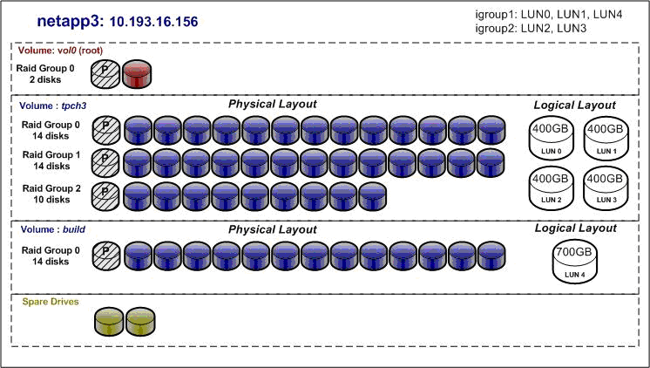
Figure 11 FAS920-3 Disk Layout

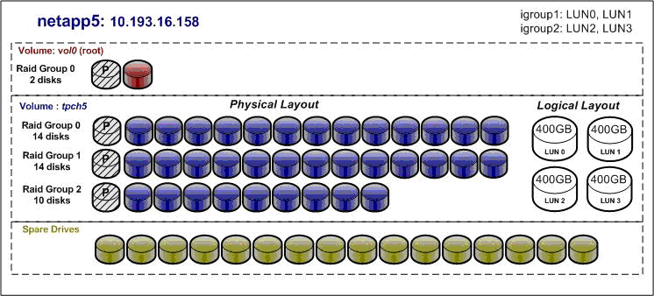
Figure 12 FAS920-5 Disk Layout

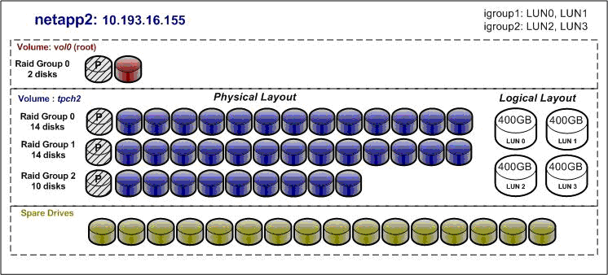
Figure 13 FAS920-2 Disk Layout

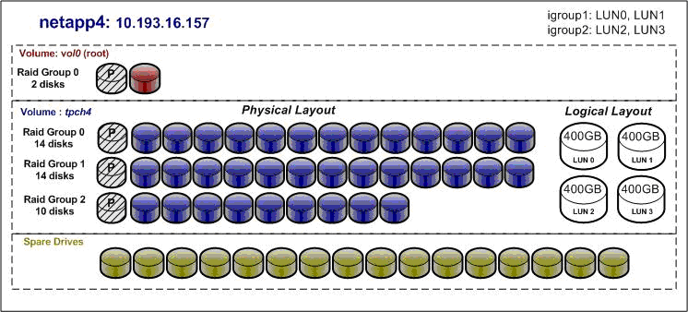
Figure 14 FAS920-4 Disk Layout

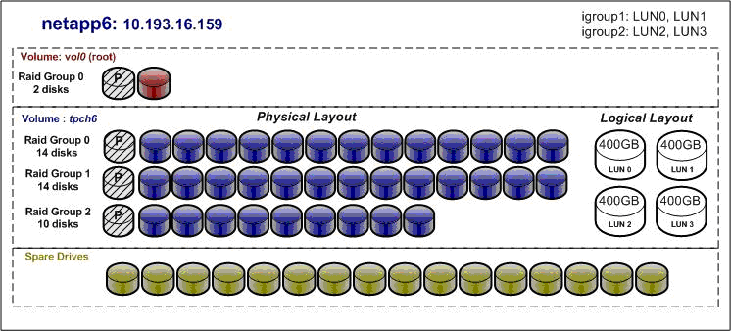
Figure 15 FAS920-6 Disk Layout

Related Links
See the following resources for more information:
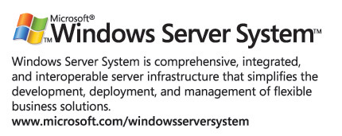
- For the latest information about SQL Server 2005, see the Microsoft SQL Server site at www.microsoft.com/sql/2005/.
- NetApp storage systems information at http://www.netapp.com/products/filer/index.html
- NetApp SnapManager for SQL Server at http://www.netapp.com/products/software/snapmanager-sql.html

A LUN (logical unit number) is a portion of available storage configured and presented to the Windows operating system as a physical disk drive.

