

RFID: An Introduction

By Simon Holloway
EMEA Manufacturing Industry Solutions Architect
Microsoft EMEA

Executive Summary
What ever you read on packaging, Supply Chain or Identification, you will come across an article or advertisement for RFID. Why does this technology seem to be being touted as the next best thing since sliced white bread? And is it just another piece of hype meant to confuse and make us invest money in another piece of technology?

Radio Frequency Identification (RFID) is evolving as a major technology enabler for identifying and tracking goods and assets around the world. It can help hospitals locate expensive equipment more quickly to improve patient care, pharmaceutical companies to reduce counterfeiting and logistics providers to improve the management of moveable assets. It also promises to enable new efficiencies in the supply chain by tracking goods from the point of manufacture through to the retail point of sale (POS).

As a result of the potential benefits of RFID:
- The automotive industry has been using closed-loop RFID systems to track and control major assemblies within a production plant for 30 odd years;

- Many of the world’s major retailers have mandated RFID tagging for pallets and cases shipped into their distribution centres to provide better visibility;

- There are moves in the defence and aerospace industry to mandate the use of RFID to improve supply chain visibility and ensure the authenticity of parts;

- Regulatory bodies in the US are moving to the use of ePedigrees based on RFID to prevent counterfeiting of prescription drugs,

- Hospitals are using RFID for patient identification and moveable asset tracking;

- RFID tags are being used to track the movement of farm animals to assist with tracking issues when major animal diseases strike.

But while the technology has received more than its fair share of media coverage over the last 12 to 18 months, many are still unfamiliar with RFID and the benefits it can offer. In the face of this need for clear, comprehensive information about RFID and its benefits, this paper defines the opportunities offered by the technology for all organisations involved in the production, movement or sale of goods. It is equally relevant for organisations wishing to track or locate existing goods, assets or equipment.
In addition, the paper seeks to outline the business and technical challenges to RFID deployment and demonstrates how these issues can be addressed with technology from Microsoft and its partners. Above all, it explains how Microsoft technology – which provides the software architecture underpinning the solution rather than tags or readers – can support the deployment of RFID-based solutions.

February 2006

The information contained in this document represents the current view of Microsoft Corporation on the issues discussed as of the date of publication. Because Microsoft must respond to changing market conditions, it should not be interpreted to be a commitment on the part of Microsoft, and Microsoft or its respective suppliers cannot guarantee the accuracy of any information presented after the date of publication.

This white paper is for informational purposes only. MICROSOFT AND ITS RESPECTIVE SUPPLIERS MAKES NO WARRANTIES, EXPRESS OR IMPLIED, AS TO THE INFORMATION IN THIS DOCUMENT.

Complying with all applicable copyright laws is the responsibility of the user. Without limiting the rights under copyright, no part of this document may be reproduced, stored in or introduced into a retrieval system, or transmitted in any form or by any means (electronic, mechanical, photocopying, recording, or otherwise), or for any purpose, without the express written permission of Microsoft Corporation.

Microsoft may have patents, patent applications, trademarks, copyrights, or other intellectual property rights covering subject matter in this document. Except as expressly provided in any written license agreement from Microsoft, the furnishing of this document does not give you any license to these patents, trademarks, copyrights, or other intellectual property.

© 2006 Microsoft Corporation. All rights reserved.

Microsoft, Windows, and the Windows logo are either registered trademarks or trademarks of Microsoft Corporation in the United States and/or other countries.

The names of actual companies and products mentioned herein may be the trademarks of their respective owners.

Microsoft Corporation  One Microsoft Way  Redmond, WA 98052-6399  USA

This document contains information of a proprietary nature. All information contained herein shall be kept in confidence and shall be for the original recipient’s use only. Any unauthorized reproduction by any other party shall constitute an infringement of copyright.

Contents
RFID: An Introduction 1
Executive Summary 1
Contents 1
1. The Origins of RFID 2
2. What is RFID Really? 3
2.1. RFID Bill of Materials 3
2.2. Automatic Identification 5
2.3. Different Types of RFID 6
2.4. So Why Now? 9
3. Market Overview 10
4. Understanding the challenges 10
4.1. Supply chain inefficiencies 10
4.2. Technology considerations 11
4.3. Additional Challenges 11
4.4. Solving these challenges 12
4.5. Microsoft and RFID standards 14
5. Data privacy 15
5.1. Key Issues for Consumers 15
5.2. Microsoft and Privacy 16
6. RFID in practice 17
6.1 Manufacturing 17
6.2. Retail 19
7. RFID Business Benefits 21
7.2. Improved Productivity and Cost Avoidance 21
7.3. Decreased Cycle Time and Taking Costs Out 22
7.4. Reduced Rework 22
7.5. Reduced Business Risk & Control of Assets 22
7.6. Improved Security and Service 22
7.7. Improved Utilisation of Resources 22
7.8. Increased Revenues 22
7.9. Exception Management 22
8. Applications for RFID 22
9 How does Microsoft BizTalk RFID address the Business needs 23
9.1. Microsoft’s Layered Approach 24
9.1.1. Devices layer 25
9.1.2. Data collection and management layer 25
9.1.3 Event processing engine 26
9.2. Business Benefits 27
10. Conclusion 28
Appendix A -- More Information about Microsoft BizTalk RFID 30
Appendix B – About the Author 30

1. The Origins of RFID
Well the first disturbing fact is that RFID is not a new technology. It was first used over sixty years ago by Britain to identify friend and foe aircraft in World War II and was part of refinement of Radar. It was during the Swinging Sixties that RFID started to be looked as a solution for the commercial world. The first commercial applications involving RFID followed during the Seventies and Eighties. These commercial applications were concerned with identify some asset inside a single location. They were based on proprietary infrastructures.

The third era of RFID started in 1998, when researchers at the Massachusetts Institute of Technology (MIT) Auto-ID Centre began to research new ways to track and identify objects as they move between physical locations. This research, which has a global outlook, centred on radio frequency technology and how information held on tags can be effectively scanned and shared with business partners in near real time.
To do this we needed standards. So the work of the Auto-ID Centre focused on:

- Reducing the cost of manufacturing RFID tags

- Optimising data networks for storing and delivering larger amounts of data

- Developing open standards

It became apparent that the ideas being proposed, combined with other ongoing technological and standardisation activities worldwide, would help to reduce the costs of RFID tagging. By 2003, the centre had over 100 sponsors from four continents. Its final task was to conduct a large field trial with 40 participating companies in 10 US cities. Today, the work of the Auto-ID Centre has helped to make RFID economically viable for pallet and carton-level tagging. The technology is also becoming more affordable for high-value items. The Auto-ID Centre officially closed on 26 October 2003, transferring all its technology to EPCglobal.

EPCglobal is now leading the development of industry-driven standards for the Electronic Product Code (EPC) Network to support the use of Radio Frequency Identification (RFID) in today’s fast-moving, information rich trading networks. EPCglobal is a member-driven organisation comprised of leading firms and industries focused on creating global standards for the EPCglobal Network. The EPCglobal Network is a set of technologies that enable immediate, automatic identification and sharing of information on items in the supply chain. In that way, the EPCglobal Network will make organisations more effective by enabling true visibility of information about items in the supply chain.

Figure 1: The (not so brief) History of RFID (Source: Deloitte Consulting)

2. What is RFID Really?
But what is RFID? RFID is the reading of physical tags on single products, cases, pallets, or re-usable containers which emit radio signals to be picked up by reader devices. These devices and software must be supported by a sophisticated software architecture that enables the collection and distribution of location-based information in near real time. The complete RFID picture combines the technology of the tags and readers with access to global standardised databases, ensuring real time access to up to date information about relevant products at any point in the supply chain. A key component to this RFID vision is the EPC Global Network (see www.epcglobalinc.org).

Tags contain a unique identification number called an Electronic Product Code (EPC), and potentially additional information of interest to manufacturers, healthcare organisations, military organisations, logistics providers and retailers, or others that need to track the physical location of goods or equipment. All information stored on RFID tags accompanies items as they travel through a supply chain or other business process. All information on RFID tags, such as product attributes, physical dimensions, prices or laundering requirements, can be scanned wirelessly by a reader at high speed and from a distance of several metres.

2.1. RFID Bill of Materials
So what is the bill of materials for RFID then? RFID Component parts are:

- Tag or Transponder – An RFID tag is a tiny radio device that is also referred to as a transponder, smart tag, smart label or radio barcode. The tag comprises of a simple silicon microchip (typically less than half a millimetre in size) attached to a small flat aerial and mounted on a substrate. The whole device can then be encapsulated in different materials (such as plastic) dependent upon its intended usage. The finished tag can be attached to an object, typically an item, box or pallet and read remotely to ascertain its identity, position or state. For an active tag there will also be a Battery.

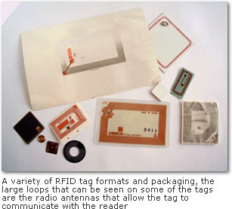
Figure 2: A variety of RFID Tags

- Reader or Interrogator – The reader, sometimes called an interrogator or scanner, sends and receives RF data to and from the tag via antennas. A reader may have multiple antennas that are responsible for sending and receiving radio waves.
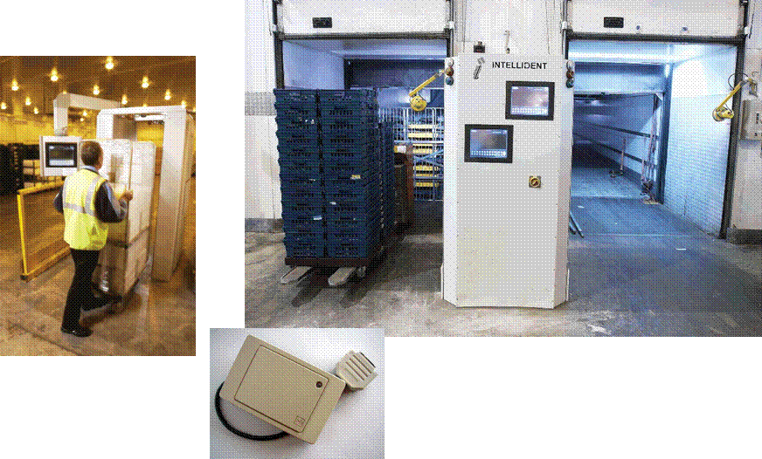
Figure 3: Examples of a Reader with Associated Electronics

- Host Computer – The data acquired by the readers is then passed to a host computer, which may run specialist RFID software or middleware to filter the data and route it to the correct application, to be processed into useful information.

The way this set of parts works is best describe in Figure 4.

Figure 4: Basic Operations of RFID (RFID Centre)

2.2. Automatic Identification
RFID technologies are grouped under the more generic Automatic Identification (Auto-ID) technologies. Examples of other Auto-ID technologies include Smartcards and Barcodes. RFID is often positioned as next generation bar coding because of its obvious advantages over barcodes. However, in many environments it is likely to co-exist with the barcode for a long time. Ok but what advantages does RFID have over these other means of identifying a person, product or asset? The real benefits of RFID can be summarised as:

- Line of sight not required
- Durability
- Range
- Data volume
- Multiple read –Speed
- Read/Write –Update

Rather than using light to collect or read a number from a bar code, radio waves are used to read a number from the RFID tag. RFID therefore does not need line-of-sight to operate. Using radio means that the tag no longer has to be visible on the object to which it is attached; the tag can be hidden inside the item or box that is to be identified and still be read. This minimises or eliminates the need for a person to have to present the reader to the tag as it can now be fixed to a wall for example. As the item is passed by the reader it will be read automatically, thus giving a potentially large saving in labour costs or substantial increase in throughput of scanned items.

Another feature of RFID is the ability to read many tags together at once. It is not necessary to present each tag to the reader separately (as is required for barcodes), instead all tags within the range of the reader can be read almost simultaneously as they pass the reader. Again, there is a huge savings potential in not having to manually present the reader to each item to be identified.

Furthermore, data can also be written to the tag, a feature not possible with barcodes. This latter feature has tremendous implications for IT systems and the potential benefits of RFID.

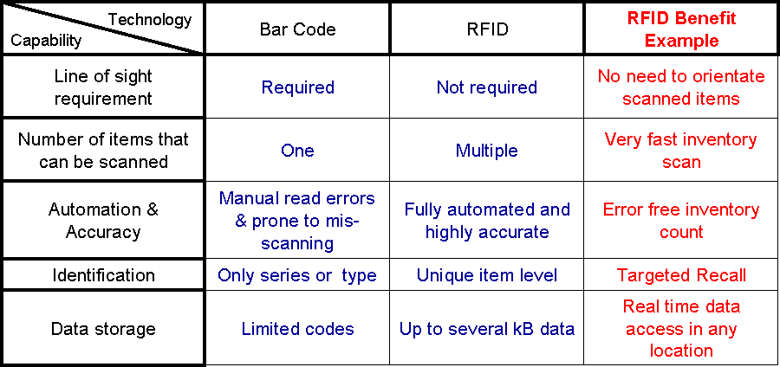
Figure 5: Comparison of RFID with Bar codes

2.3. Different Types of RFID
Now we need to be aware of the next complication to the so far simple description about what RFID is. This is that there are different sorts of Tags available in the market. This typing of tags can also be done in a number of different ways. The table in Figure 5 highlights these different typing approaches.

Active or passive | Other Classifications
Passive (no battery)  Smaller, Lighter  Shorter range (<3m)  Smaller data storage  Lower cost | Data storage (Programming)  Read Only  Write once  Read/write
Active (with battery)  Larger, Heavier  Longer range (up to 100m)  Larger data storage  Higher cost | Frequencies  Low –135 kHz  VHF –13.5 MHz  UHF –860MHz  Microwave –2.4 GHz

Figure 6: RFID Tags Types

There are several versions of RFID that operate at different radio frequencies. The choice of frequency is dependent on the business requirements and read environment – it is not a technology where ‘one size fits all’ applications.

Three primary frequency bands are being used for RFID:

- Low Frequency (125/134KHz) – Most commonly used for access control, animal tracking and asset tracking.

- High -Frequency (13.56 MHz) – Used where medium data rate and read ranges up to about 1.5 meters are acceptable. This frequency also has the advantage of not being susceptible to interference from the presence of water or metals.

- Ultra High-Frequency (850 MHz to 950 MHz) – offer the longest read ranges of up to approximately 3 meters and high reading speeds.

Figure 7 illustrates the different frequencies that are used for RFID Tags.
Figure 7: RFID Frequencies (RFID Centre)

Applications for RFID within the supply chain can be found at multiple frequencies and different RFID solutions may be required to meet the varying needs of the marketplace.
Since UHF (Ultra High Frequency) has the range to cover portals and dock-doors it is gaining industry support as the choice frequency for inventory tracking applications including pallets and cases.

RFID tags are further broken down into two categories:

- Active RFID Tags are battery powered. They broadcast a signal to the reader and can transmit over the greatest distances (100+ meters). Typically they can cost £5 - £20 or more and are used to track high value goods like vehicles and large containers of goods. Shipboard containers are a good example of an active RFID tag application.

- Passive RFID Tags do not contain a battery. Instead, they draw their power from the radio wave transmitted by the reader. The reader transmits a low power radio signal through its antenna to the tag, which in turn receives it through its own antenna to power the integrated circuit (chip). The tag will briefly converse with the reader for verification and the exchange of data. As a result, passive tags can transmit information over shorter distances (typically 3 meters or less) than active tags. They have a smaller memory capacity and are considerably lower in cost (less than £1) making them ideal for tracking lower cost items.

There are two basic types of chips available on RFID tags, Read-Only and Read-Write:

- Read only chips are programmed with unique information stored on them during the manufacturing process – often referred to as a ‘number plate’ application. The information on read-only chips can not be changed.

- With Read-Write chips, the user can add information to the tag or write over existing information when the tag is within range of the reader. Read-Write chips are more expensive that Read Only chips. Applications for these may include field service maintenance or ‘item attendant data’ – where a maintenance record associated with a mechanical component is stored and updated on a tag attached to the component. Another method used is something called a "WORM" chip (Write Once Read Many). It can be written once and then becomes "Read Only" afterwards.

2.4. So Why Now?
That’s good but why is everyone talking about RFID now? Well after 15 years of test, trials and live specialised use, a number of converging factors have increased the attention and momentum behind RFID. These are best summarised as in Figure 8 from Deloitte Consulting.

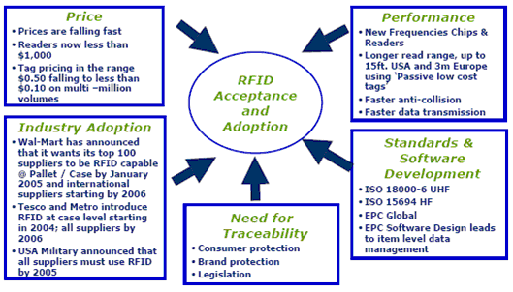

Figure 8: Why RFID Now? (Source: Deloitte Consulting)

3. Market Overview
Wal-Mart has announced that its 100 top suppliers must tag their deliveries (at pallet level) by 2005. This mandate for a phased rollout, in tandem with large pilots at Target, Albertson and other organisations, including some US pharmaceutical companies, have raised expectations for future market size and growth. This uptake in the supply chain is mirrored by RFID deployments by the US military and by a range of other applications in agriculture, tourism and asset management.

As a result of global RFID pilots and phased deployments, projections for 2005 indicate that growth in the worldwide transponder (RFID tag) market will be £464m, equating to 24 per cent. At the same time, the value of the reader market globally will grow by
59 per cent to £372m.

In Europe, Carrefour, METRO and a host of other organisations are already trialling RFID solutions. Manufacturers such as KiMS in Denmark are also piloting the technology. Research by RF & Microwave Industry News suggests that 41 per cent of European retailers are planning RFID pilots for 2004. According to estimates provided by leading pharmaceutical manufacturers following their pilots it is estimated that RFID-based solutions could save the industry more than $8 billion by 2007/8.

But what about Small and Medium Business, is RFID applicable to them? Nigel Montgomery of AMR Research states that, “RFID is not just applicable to large household named companies, whilst it would seem so from the names of most early pioneers. Nor is it only viable at high volume. If anything, small-medium sized companies should be able to benefit faster than larger companies. ……But the potential return on investment (ROI) on an RFID-based project should not be about volume, it’s more likely to be determined by pareto ranking, i.e. 20% of the products represent 80% of the value of inventory”

This global interest in RFID as a key enabler for the supply chain and for achieving greater traceability for goods and equipment is also stimulating the market for software that supports RFID. In 2005, this will increase by 40 per cent to £323m. ABI Research also highlights that RFID integration services will surpass RFID equipment revenues by 2007, reaching more than £0.82m by 2005.

4. Understanding the challenges

4.1. Supply chain inefficiencies
Today, many supply chain inefficiencies originate from inaccurate data about where products are in the supply chain. Retailers may provide point of sale (POS) data to the manufacturer, but without the knowledge of existing inventory levels and stock in transit, these data points are not sufficient for accurate demand planning.

While there is increasing pressure on manufacturers, distributors, and retailers to maximise efficiency, minimise cost and provide the best value to the end customer, these companies face the following challenges:

- Buffer stocks, out-of-stocks and late shipments impact on margins

- Inaccurate data causes expensive manual interventions 30 per cent of supplier transactions contain errors

- £16.3m is lost per year due to supply chain inefficiencies

- Discontinuous data flow across the supply chain leads to redundant data entry/duplication of effort

- Inability to trace products and ingredients to suppliers and customers makes information sharing and product recalls complex and expensive

- New legislation to track products from source to origin, including European Union directive 2001/95/EC and the Transportation Recall Enhancement, Accountability and Documentation (TREAD) Act

- Leading Government agencies, OEMs and retailers are mandating supply chain changes

4.2. Technology considerations
RFID presents a number of technology challenges. First, organisations must manage vast quantities of data generated by reading tags on individual pallets, cartons or high-value items. In addition, they must implement a fully-integrated software architecture that enables this data to be analysed and made available to internal and external systems in near real time.

4.3. Additional Challenges
Additional challenges include:

- Configuration and management of reader devices – where organisations deploy a large number of readers, the process can be simplified with highly automated tools for set-up, configuration and batch management.

- Tremendous data volumes – Each RFID tag is scanned several times per second and many facilities will be scanning hundreds of products simultaneously.

- Information maintenance and look-up – Each time a tag is scanned its key attributes must be looked up in a corresponding database in near real time.

- Ownership and partner data integration – In complex environments, such as the supply chain, supporting infrastructure must protect data owned by different business partners.

- Standards and architecture interoperability – Systems must be compliant with EPCglobal standards for defining product attributes and exchanging data.

4.4. Solving these challenges
To overcome these technical challenges, organisations need to establish clear strategies for RFID deployment. They should also build their solutions on highly scalable systems that are built on open standards such as XML. In this way, they can rapidly create interfaces to enable real-time data exchange between internal and external systems.
Typically, today’s trials are based on specific areas of the supply chain where immediate returns on investment can be realised with minimum disruption to existing business processes or technology infrastructure.
4.4.1. Global Standards
With so much trade being conducted globally, standards and regulations are important to ensure safety and the interoperability of tags and readers across national boundaries and between trading partners. A common misunderstanding is that RFID is regulated by one trade body – however it is in fact influenced by a number of official bodies for different aspects:

Frequencies, power levels and operating cycles are regulated in Europe by the European Telecommunications Standards Institute ( ETSI ).

Protocols for communication between tags and readers are proposed by a number bodies and equipment manufacturers. The two most prominent organisations for setting standards are the International Standards Organisation (ISO) and EPCglobal.

EPCglobal, a member-driven organisation comprised of leading firms and industries focused on creating global standards is developing a standards-based network to support RFID globally. This is to ensure that data created in one place can be read and interpreted anywhere in the global supply chain. EPC Global is part of GS1 which also manages the UCC-EAN system responsible for standardising barcodes, so they are well placed to develop, manage, promote and deploy the EPC standard.

The Electronic Product Code (EPC) is a key element of this RFID network. It is held on RFID tags and identifies specific items as they travel between locations. By providing a standard way to attach information to products, EPC enables organisations to share information more effectively. It also increases the speed of supply chain operations because all items are recognised quickly and easily worldwide. Whereas barcodes refer to a category of product, EPC codes refer to specific events related to a product. EPCs are typically embedded in low cost, passive RFID tags. When a reader scans the tag, it transmits back the unique EPC code. This is done with little to no manual effort required compared to the work needed to open boxes and scan barcodes. As a result, all supply chain partners achieve significant operational benefits.
4.4.2. Global Data Synchronisation
In order to partake in RFID, organisations must be able to communicate their product data globally. This product data must be validated, up to date, and contain the information needed by any third party with whom they wish to trade or communicate. With millions of products being manufactured, distributed and purchased across the globe on a daily basis, it is easy to understand that managing information about goods and services across the supply chain is a complex, time consuming and expensive exercise. Furthermore, the widespread deployment of new ERP and MRP (or indeed new versions of) has exacerbated the issue by disseminating the components of the required product data across more, not less, proprietary systems. The inability to seamlessly communicate product information between trading partners has been a long standing issue across manufacturers, distributors and retailers alike.

Global Data Synchronisation (GDS) is a process designed to help keep all trading organisations in sync by ensuring that basic product data, such as the description and category stored by one company, matches the data stored by their trading partners. Organisations are asked to submit their product data in a specified format to data pools around the globe which will then be validated against a global data registry and changes will be flagged immediately across the trading community. Capgemini forecasts that GDS can provide “Productivity improvements of 1 percent to 3 percent of supply chain costs, impacting the bottom line by 10 percent to 15 percent.”

All manufacturers and retailers who subscribe and embrace the GDS initiative and publish their product data to the data pools will also need to ensure that their internal product information is in the required standard and of the required quality to exchange with any third party and the EPCGlobal network.

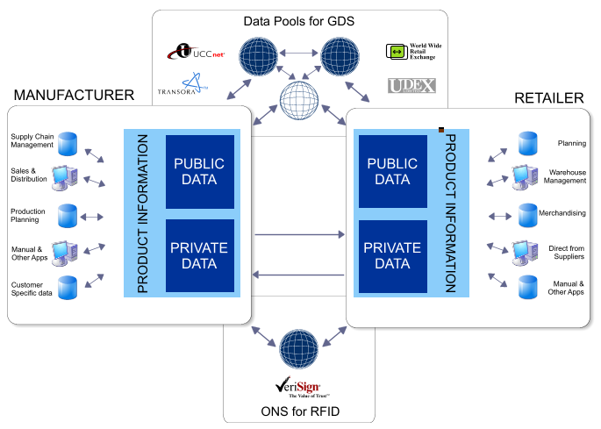
Figure 9: Global Data Synchronization

GDS standards are being steered by a group of retailers and manufacturers known collectively as the Global Commerce Initiative (GCI), and are being developed by EAN International and The Uniform Code Council (EAN UCC). The standards assign key attributes to product data, enabling manufacturers, suppliers, retailers and other supply chain players to share and understand product-related data worldwide.

EAN UCC says: “Imagine, as a manufacturer, that your product catalogue is available worldwide in an efficient and easy to search way. Imagine, as a retailer, that you could search for any type of product and have access to what is available worldwide. Imagine now that when you start doing business with your trading partner, data will be exchanged in a seamless and streamlined way all along the supply chain allowing for the right amount of goods to become available at the right place and at the right time.”

By cleaning and synchronising data, organisations create a firm foundation for the deployment of RFID. However, additional standards are required to support wide spread adoption of the technology. (For more details on Global Data Synchronization and Microsoft’s support please refer to Microsoft Whitepaper - Global Data Synchronization).

4.5. Microsoft and RFID standards
Microsoft is playing a key role in the development of RFID standards globally. It has been an active member of the EAN UCC working groups, collaborating with organisations such as GCI, CIES, UDEX and others to play a key role in defining standards for data synchronisation.

In April 2004 the company joined EPCglobal, supporting the organisation’s goal to make EPC the global standard for immediate, automatic and accurate identification of any item anywhere in the world. In February 2005, the company joined the NFC standards group.

As well as joining these standards bodies, Microsoft announced the formation of a new Microsoft RFID Council. The group will look at how industry can use RFID technology to identify objects of interest and then track them through a business process of interest.
The Council highlights a growing ecosystem of partners that are building innovative RFID solutions on the Microsoft platform to enhance control of key business processes, improve inventory visibility and provide better customer service for manufacturers, distributors and retailers. The Council, which operates worldwide, aims to deliver RFID solutions that comply with global standards. They will also be low-cost, simple to deploy and built on a robust, scalable technology infrastructure. Members of the Council already include major consulting firms, system integrators (SIs), independent software vendors (ISVs) and hardware manufacturers.

In the UK, Microsoft has sponsored a Department of Trade and Industry imitative around RFID that has led to the setting up of the RFID Centre in Bracknell (http://www.rfidcentre.com) to provide education on both business and technical issues. In France, Microsoft partners Manhattan Associates, Alien Technology and Printronix have an RFID showcase at the world renowned L’echangeur IT showroom in Paris.

5. Data privacy

5.1. Key Issues for Consumers
The benefits offered by RFID provide a compelling case for deployment within the supply chain. However, organisations must be mindful of privacy issues surrounding the technology.

Today, most RFID deployments are supply-chain applications such as tagging for shipping containers or pallets. These do not associate personally identifiable information (PII) with tag identification (EPC) numbers. But with ‘item-level’ tagging, unique identification numbers in EPCglobal tags might become associated with an individual at the POS when the tagged product, such as an item of clothing, is acquired.

The situation is of concern to privacy pressure groups because:

- RFID can be read through materials, items or packaging, so consumers can never be sure when a tag is present or being scanned

- RFID can be read at a small distance with no overt physical action required to scan the tag

- Data collected from RFID tags can potentially be held by multiple parties, including Internet-accessible databases, causing security concerns

- Tags can potentially remain active outside of the store environment

To ensure that customers’ concerns are addressed, retailers and other organisations must undertake initiatives to educate the public on the realities and myths of RFID. Increasingly, such initiatives will demonstrate that RFID is designed to track products and physical assets rather than people.

The kind of passive tags that will be deployed for most retail applications, for example, are only readable from a few metres, ensuring that customers cannot be tracked once they exit the store.

Tags can also be disabled as they leave the store, or placed inside labels that customers can remove from products once they have purchased them.

In addition, it is imperative that all customer-facing RFID-enabled solutions are optional. That means customers must always give their permission before data about them is used.

5.2. Microsoft and Privacy
Microsoft has a single principle that guides its policies around consumer privacy and data protection: Microsoft customers will be empowered to control the collection, use and distribution of their personal information.

Microsoft’s approach to putting consumers in control of their personal data is based on the widely-accepted concept of fair information practices, which form the basis of a number of privacy laws and industry guidelines. As such, Microsoft privacy policies provide a set of standards that apply to all PII, irrespective of the technology in use.

In brief, Microsoft follows the following policies relating to RFID:

- Conspicuous notification must be posted and the governing privacy statement must be available near readers and tags when RFID tags are in use

- Items or packaging tagged using RFID tags must be labelled accordingly

- Privacy statements must include information on the purposes for which tags and readers are being used

- Consumers must be provided with the choice to remove or deactivate tags on purchased items

- Consumers must be notified if personal data associated with RFID tags is being transferred to third parties and provide explicit consent for any secondary use

- Data transfers of personal data must include appropriate security measures

- Reasonable access must be provided for customers to their personal data so they can correct or amend it

- Appropriate security measures must be in place to protect personal information from unauthorised access, use or disclosure

- Reasonable steps must be taken to ensure personal data is relevant for its intended use

- Consumers must have a mechanism for resolving disputes with the RFID data collector

- There must also be an affordable, independent recourse mechanism when complaints or disputes cannot be resolved

6. RFID in practice
To fully understand the capabilities of RFID, it is helpful to consider how the technology can be beneficial in real business situations. The following examples illustrate how the technology can impact throughout the supply chain, delivering efficiencies for three types of organisation: manufacturers, distributors and retailers.

The scenarios focus on a bicycle manufacturer that produces high-end bicycles for the global market. All parts are purchased from vendors, except for the frames, which are made in-house from raw steel pipe. The description shows the potential of RFID to deliver benefits at every stage of the supply chain as the bikes are assembled, distributed to retailers and finally sold to customers.

6.1 Manufacturing
The company and all of its suppliers use RFID to share location and other information about the various bicycle parts and subassemblies. This enables vendor managed inventory (VMI) for bicycle components.

For example, a tyre company supplies the bicycle manufacturer with an in-house stock of tyres. Using VMI, this supplier takes responsibility for stock levels at the bicycle manufacturer, which never has to place an order. Each tyre contains an RFID tag that holds product information such as the item and batch number, enabling automated ordering when stocks run low. Both companies always know how many tyres are available in the warehouse and react to requirements in real-time.
6.1.1. Scheduling of assembly orders
Once the bicycle manufacturer has an order of frames ready, it ships them to a paint shop on RFID-tagged pallets containing the production order number and destination. The paint shop is equipped with readers that register specific orders when they are delivered. These are then routed to the correct workstations, paint booths or powder coating facilities.

When the frames have been painted, the system updates tags on the pallets with ‘production order complete’ status and are then shipped back to the manufacturer. When the goods leave the paint shop, the manufacturer is informed when the goods will return. If there were any problems, this information is entered onto the tag, allowing the manufacturer to take appropriate actions.

RFID readers at the manufacturer recognise the goods when they return from the paint shop. The system automatically notifies the final assembly facility and the order begins.
Distribution A wholesaler manages the distribution of the manufacturer’s bicycles to retailers of all sizes all over the world. This company works with a distributor to deliver a container of bicycles to a retailer. The lorry driver unloads the pallets of goods into the warehouse. As the pallets move from the truck into the warehouse, they pass an RFID reader. This reader picks up the information about the items received and displays them on a screen next to the doors so the driver can see what has been unloaded. Once all the goods are unloaded the trucker confirms that the order is correct and the retailer and distributor systems are updated in real time.
6.1.2. Picking
Picking at the warehouse is done on an order-by-order basis and the goods are shipped to stores on pallets. The pallets carry RFID tags which store the pick list for the order. Because the warehouse handles fulfilment of many sporting goods manufacturers to a number of outlets, the list may contain other items as well as the bicycles.

As new orders are released in the warehouse they are written to the tag on an empty pallet. The next available forklift operator picks up the next empty pallet. The reader on the forklift reads the pick list from the tag on the pallet and displays it on the operator’s screen.

The operator drives to the first location to pick the required items. The system monitors the goods collected, verifies that they are correct and deducts them from the pick list. If incorrect goods are collected a warning is triggered. Once the order is complete the operator brings the pallet to the packing area.

If, for example, the tyre manufacturer had a short run of bad tyres, the bicycle manufacturer may need to recall them. In this case, the system would notify the operator when a bike is on the recall list. The operator then takes any recalls to a special section of the warehouse, where they are automatically removed from inventory and put on a pallet for return shipment.
6.1.3. Checking the right goods are on the right truck
Each outbound door has an RFID reader which monitors all pallets that leave the warehouse. Once all the pallets that are being shipped have been loaded onto a truck the operator can confirm that this has been done correctly on screen. A warning is triggered if there are any errors.

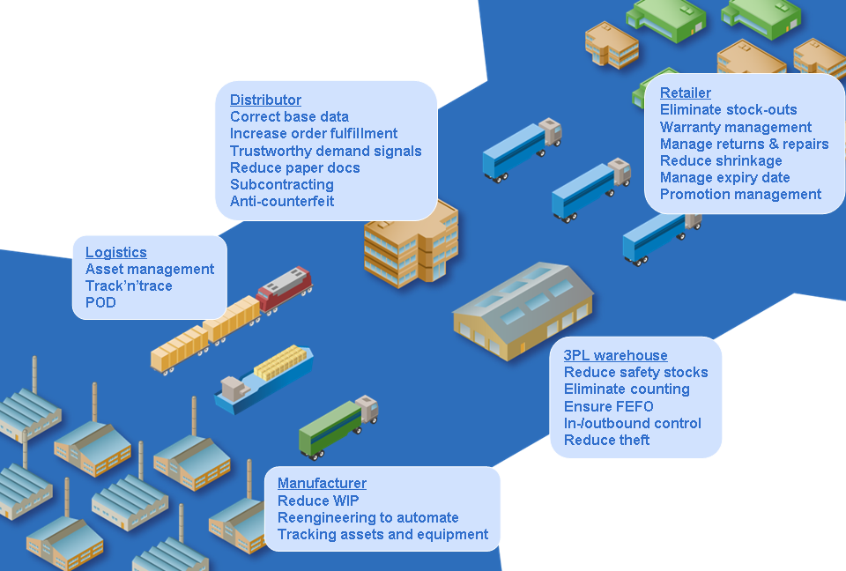
FIFO
Logistics
No Asset visibility
No transactional visibility
Distribution
Incorrect or unauthentic data
Low utilization & throughput
Counterfeit & Shrinkage

Retailer
Product availability
Spoilage of Perishables
Complex Merchandizing
In efficient Returns and Reverse Logistics
3PL warehouse
Excess inventory
Manual processes
Theft and counterfeit
Manufacturer
Excess WIP
Complex scheduling
Asset and Resource utilization
Across the SC
Barcode challenges (line of sight, no bulk reading, environmental issues)
Manual Processes
Lack of visibility
Figure 10: Extended Supply Chain Issues

6.2. Retail
Retailers track items using systems similar to those in the warehouse.
6.2.1. Store level inventory control
One of the bicycle manufacturers’ customers is an exclusive retailer in the United Kingdom. The retailer uses a perpetual SKU-level inventory scenario that tags and tracks items through the receiving process. In the future, it intends to extend this to tagging individual items and tracing them through to the POS.
6.2.2. Receiving
As soon as an order is despatched from the warehouse, the retailer receives information on when the goods will arrive. When the shipment is unloaded at the back of the store, data is collected from RFID tags attached to each pallet. This is accessed, summarised and compared to the expected shipment.

Any discrepancies are reported and considered as “shrinkage” until the discrepancy is resolved because the store will be charged for items present in the shipment data.
Receipts are logged into a store perpetual inventory database. Items that have been recognised are entered into the store inventory records. As a result, systems are updated automatically in real time, increasing the efficiency of their operations and ensuring the accuracy of data by eliminating human error.
6.2.3. Shelf stocking
As pallets of merchandise are received in the back room, the data is made available to a function for scheduling the stocking process. The application is ‘aware’ of current inventory levels in the store and will schedule stocking of merchandise that is either out-of-stock or at a low inventory level. Merchandise that is bulky or difficult to stock is scheduled for delivery when the store is closed or customer traffic is expected to be light. Merchandise is stocked in a sequence that spreads the available stocking labour throughout the store.

Available store labour resources are taken into account when a shop stocking schedule is produced. The stocking application can present the shop assistant with a shelf stocking list either on a printer or wireless terminal. The shelf stocking work list indicates the location of the merchandise on the pallet as well as indicating a shelf location for merchandise placement.

When the store assistant indicates that the shelf or rack stocking is complete, an RFID shelf-checker application audits the restocking function and the store shelf inventory levels. Some stores have backroom or secondary stocking areas within a store. The stocking function not only includes putting away new merchandise but also moving merchandise from secondary locations to primary selling areas.
6.2.4. Store replenishment and ordering
In the future, each item of stock will have an RFID tag attached at the point of manufacture. These will enable the store to check its inventory levels quickly and effectively. The item-level tags will be able to see discrepancies between the items on the shelves and the store inventory. These could then be noted and reported.

After checking inventory levels in store, the system will also generate an order and check it against the supply chain for any likely problems.
6.2.5. POS checkout process
Traditionally, all checkouts use barcode scanning. If a local cycling team bought new kit, the shop assistant currently scans the first item and then uses the quantity key to multiply that scan, instead of scanning each item individually. As a result, the retailer can’t collect accurate pricing information or details such as the size and colour of goods sold. To address these issues, the store plans to upgrade its checkout process to include RFID scanning of all products at the POS. This will enable the store to implement an
end-to-end automated inventory process. The proposed system will independently recognise each product sold at the register using RFID for inventory and the barcode for sales.

In addition, goods will be scanned at the POS with no human intervention as they pass within a certain distance of a reader. This makes the checkout process faster for the customer and more efficient for the retailer, who can deploy employees to other, more customer-facing activities.
6.2.6. Theft
The store is also planning a system to deactivate the tags as products leave the store. The devices that will disable tags can also potentially be used to determine whether items have been scanned at the POS before they leave the store. In doing so, these will help stores to detect shoplifters and reduce shrinkage accordingly.
6.2.7 Find merchandise in the store
The retailer could also use item-level tags to quickly locate items in the store, thereby increasing operational efficiency and service for the customer. Phone calls and wasted visits to the stock room will no longer be necessary.
6.2.8. Customer loyalty
The retailer caters to an exclusive clientele of racers and aficionados. As an ultimate goal, it would like to give each customer a store card with an embedded RFID tag. Customers who agree to have such a card could be scanned as they enter the store. Those who prefer not to be identified would have a privacy flag next to their details on the database. In this case, nothing would disturb the customer while shopping.

By tagging loyalty cards, the retailer could potentially harness information on customer shopping history to offer willing customers personalised offers in store. To enable this, a shop assistant would have to review customer data once they are identified by the system. The employee could then approach the customer and offer items that may be of interest. Eventually, this process could be fully automated, with offers and promotions made to customers’ phones or PDAs, through mobile devices mounted on shopping trolleys or through kiosks.

Item level tagging will mean that each bike sold eventually has a tag containing the date of sale, service plan and repair record. This would enable the retailer to effectively manage warrantee agreements and identification of bicycles in the event of theft.

7. RFID Business Benefits
Use of RFID technology can increase business productivity and reduce associated costs. To ensure that companies benefit from the advantages RFID provides it is important to understand how to adopt this technology. By analysing current practices and procedures 8 main areas of benefit can be identified. These are:

- Improved Productivity and Cost Avoidance
- Decreased Cycle Time and Taking Costs Out
- Reduced Rework
- Reduced Business Risk & Control of Assets
- Improved Security and Service
- Improved Utilisation of Resources
- Increased Revenues
- Exception Management

7.2. Improved Productivity and Cost Avoidance
Identifying items by RFID involves less work than using barcode scanning and other less automated ways. This leads to greater process effectiveness in many tasks such as receiving and putting away, picking and shipping goods where the time required and cost of identifying items by RFID is substantially less than other methods.

7.3. Decreased Cycle Time and Taking Costs Out
RFID scanning is not a serial process, like traditional Barcode scanning, so the business can perform identical tasks much more quickly. This means processes moving goods through a supply chain are more efficient leading to a reduction in the need for larger inventories.

7.4. Reduced Rework
As RFID scanning has a greater first time pass accuracy this reduces the number of errors that are generated and retries needed.

7.5. Reduced Business Risk & Control of Assets
RFID tagging enables better audit and asset control. The ability to track and trace items better means assets can be located more easily. The opportunity for enhanced data collection leads to increased accuracy of record keeping and improved asset maintenance. Regulatory compliance can be achieved more effectively.

7.6. Improved Security and Service
Being able to validate information relating to an item enables increased security. This individual identification contributes to more effective access control, reductions in shrinkage and other losses and the ability to provide fast and efficient services at the point of need. Ability to authenticate information can prevent activities like counterfeiting and fraud.

7.7. Improved Utilisation of Resources
Information obtained by RFID scanning can be used to improve planning. Processes can be improved, time can be saved, assets can be utilised better.

7.8. Increased Revenues
By eliminating uncertainty companies will suffer less “out of stock” situations and obtain greater item availability, reducing lost sales and increasing choice leading to more sales.

7.9. Exception Management
RFID enables processes and procedures to be measured better. Until a process can be measured accurately it often can’t be improved. Decisions that are based on limited, inaccurate, out-of-date information are often poor decisions. The contribution information captured by RFID offers to IT applications will allow managers in companies to be alerted when compensatory business decisions need to be taken.

8. Applications for RFID
Applications fall into two principal categories: firstly, short range applications where the reader and tag must be in close proximity (such as in access control) and secondly, medium to long application, where the distance may be greater (such as reading across a distribution centre dock door). A sample of applications is shown below:

- Access control for people ; there are many areas where RFID tags are carried by people to allow them to gain access to facilities or services:
  - Secure access to work place
  - Safety access to dangerous/secure equipment
  - Access to a computer or vehicle
  - Access to travel on trains/buses
  - Access to leisure facilities

- Access control for vehicles:
  - Secure access on site
  - Road tolling
  - Instant payment for fuel

- Manufacturing automation:
  - Control of flexible manufacturing processes by recognising items being built on a production line (mass customization enabler)
  - Labelling key components for later recycling

- Logistics and distribution:
  - Tracking parcels from shipment to end customer
  - Tracking goods from manufacture through to retail

- Retail:
  - Supply chain management
  - Stock taking
  - Reducing loss through shrinkage
  - Reverse logistics
  - Product availability

- Maintenance:
  - Plant & Equipment
  - Fixed assets
  - Patients

- Product security:
  - Tamper evidence
  - Product authentication
  - Anti-counterfeiting

9 How does Microsoft BizTalk RFID address the Business needs
To encourage widespread adoption of RFID technology and address the customer pains of managing multiple devices, smoothing the data, translating data into meaningful events and combating costly integrations, Microsoft is developing a layered RFID infrastructure, named BizTalk RFID, using an open building block approach. It relies on related Microsoft applications platform products and a growing number of integrated partner solutions. This approach provides a wealth of solutions for any size organization or industry vertical, including manufacturing, pharmaceutical or aerospace. Also, the combination of Microsoft’s technology platform plus partner solutions offers a multiplicity of applications reflecting the broad potential of RFID.

BizTalk RFID enables compliance, automation and business process transformation while shielding users from changing standards/regulations. Toward this end the company is developing core infrastructure components to support RFID applications and solutions. It is also RFID-enabling select systems within its family of Microsoft Dynamics enterprise applications products. The infrastructure provides a base set of tools for device abstraction and management, event processing and applications integration.

Independent hardware, software and systems integration partners play a key role in developing RFID applications based on the Microsoft .NET® foundation technologies and Microsoft’s applications platform products such as BizTalk Server, which provides data integration services for supply chain operations. BizTalk RFID can be embedded within third-party applications or used on its own to capture and interpret data from sensors and manage business events in an easy-to-deploy, user-friendly environment.

9.1. Microsoft’s Layered Approach
BizTalk RFID platform consists of layers (see Figure 11):
1. Devices, such as readers and sensors
2. The Device Service Provider Interface
3. Event processing engine
4. RFID APIs
5. Tools and Adapters
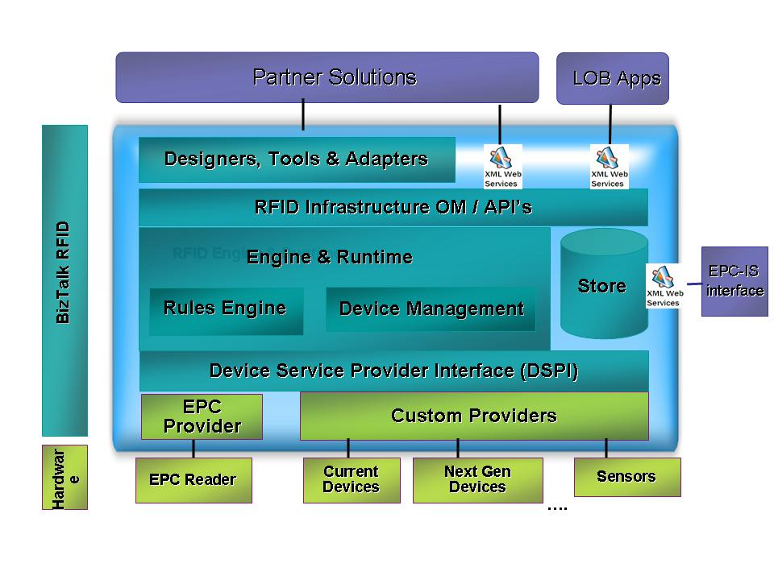Figure 11: BizTalk RFID Architecture (Source: Microsoft Corp., 2006)

Data transmissions from EPC readers and other devices from multiple vendors are processed via a Device Service Provider Interface included in BizTalk RFID. It provides a platform for independent software vendors and system integrators to install hardware in a plug-and-play fashion, resulting in a complete and seamless RFID solution.

Because the layers are tightly integrated, applications and devices can seamlessly interconnect. Here’s how the layers work together:

9.1.1. Devices layer
The bottom Devices Layer consists of hardware such as RFID readers, printers, sensors, barcode scanners, 802.1X access points for wireless local area networks, handheld terminals and Pocket PCs, which are provided by partners.

9.1.2. Data collection and management layer
To accommodate the potentially large variety and number of devices that could be resident in an RFID implementation, a Device Service Provider Interface (DSPI) provides a consistent way for devices from multiple hardware vendors to expose their device services to the Microsoft platform. DSPI provides a scalable, extensible infrastructure that allows customers to read data through any standards-based or non-standards-based sensor regardless of format, thereby reducing dependency on a specific technology and protecting RFID investments long term.

9.1.3 Event processing engine
This layer includes event and workflow management, messaging and a business rules engine. The Event engine enables context- or rules-based processing of RFID data to provide information directly to line-of-business applications. Information also can be delivered to business processes that span applications via Web services integration and orchestration products such as BizTalk Server. This layer provides the structure for integration across multiple facilities and partners. It also includes device management, to convert data into business process relevant information (see Figure 12).

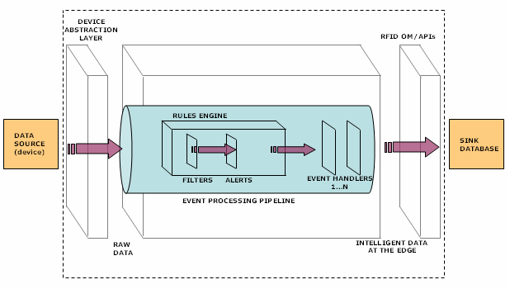
Figure 12: The Event Processing Layer (Source: Microsoft Corp., 2006)

An event, such as the movement of a box with an RFID tag from a conveyor belt to a pallet, triggers a data transmission that is processed by the Rules Engine. The Rules Engine determines which enterprise application is updated about the box movement and also automatically triggers any alerts that were incorporated into the business rules.

9.1.4. Services layer
The Services Layer includes product information resolution lookup, business process management, analytics/reports/notifications and enterprise content solutions.

BizTalk RFID makes it easy for partners to embed functionality directly into their application or build applications on the infrastructure. Open application programming interfaces (APIs) and .NET-centric tools allow partners to quickly create specialized vertical solutions across a wide range of applications.

The Services Layer also provides lookups to EPCIS servers where data about a tagged object resides.

9.1.5. Application solutions layer
This uppermost layer relies on services, data, and tools from the lower layers to implement application solutions that drive business processes for the end user. Microsoft relies on its partners to build out many of the solutions, which are divided between two classes of applications: real-time enterprise/point apps and batch-oriented enterprise apps. In addition, BizTalk RFID also supports the Microsoft Dynamics family of enterprise applications.

9.2. Business Benefits
BizTalk RFID offers many potential business and technology benefits to those considering RFID systems today. In all cases, careful attention has been placed on open standards and overcoming the shortcomings of today’s custom systems. Thus, BizTalk RFID is designed to lower total cost of ownership, simplify integration end-to-end from the device level to back-end applications, convert data into actionable information and provide a platform where Microsoft and its partners can build applications that take advantage of the volume and real-time nature of RFID data.

Lower total cost of ownership. One of the most significant potential benefits is helping clients leverage existing investments in Microsoft Windows Server 2003, SQL Server, and BizTalk Server as well as popular ERP and CRM systems, including Microsoft’s own ERP systems, Microsoft Dynamics. “The idea is for Microsoft, together with its partners, to provide one-stop shopping for an RFID solution,” says Anush Kumar, program manager, BizTalk RFID. These familiar tools also shorten the learning curve and make the applications easier to use.

Simplified integration. BizTalk RFID allows for seamless integration of devices with provisions for discovery, configuration, communication and management. Essentially, it provides ways “to integrate data from disparate sources from the physical layer such as shop floor, warehouse floor and trading partners and governs how information flows through the stack and ends up in business solutions that partners or Microsoft Dynamics provides,” says Alex Renz, RFID program manager, Microsoft Dynamics.

Because DSPI basically makes hardware such as readers and printers plug and play, it helps system builders assemble the optimum solution and to focus on larger project issues without worrying whether a driver exists. Meanwhile, organizations deploying RFID are better positioned to take advantage of the hardware innovation and falling prices that DSPI promotes.

Firmware updates can be performed remotely across an enterprise to eliminate the need for physical intervention. “With potentially hundreds of readers on a network, you want to be able to update firmware remotely,” says Overby of Forrester Research. “You don’t necessarily have IT staff at the distribution center to configure hardware so the network recognizes it.”

Hardware health can also be monitored remotely. “The platform sends readers health monitoring events to confirm they are working,” explains Microsoft’s Renz. If a reader doesn’t respond as expected, an administrator receives an alert so corrective action can be taken.

Converting data to actionable information. Above Microsoft’s Devices Layer, an Event Processing Engine filters incoming noise while providing alerts and transformations. It reduces the data “noise” created by the volumes of redundant data it receives and converts it into actionable information. This functionality is enhanced by the use of English-like vocabularies for rule creation and a high degree of built-in configurability, making it easy for users to modify. Similarly, performance and scalability are built in so large volumes of irregular event streams can be handled and deployment can be distributed.

Built-in edge processing includes a highly flexible and configurable rules engine that addresses potential business problems. For example, if a shipment of 24 cases is expected but only 20 tags are read when it arrives, the system can send an alert so the operator can check the pallet. The operator can then confirm the presence or absence of the four unread cases and transmit accurate receiving information to the enterprise application. Whether done at the edge or centrally, processing of data is transparent to the user.

Data management also requires context. Is the object arriving? Departing? This information can be provided by sensors on the device layer that show the direction of movement. Or it can be done by a combination of history and rules. For example, if the system has seen an object before, it would suggest it is departing rather than arriving. Adding the context of pending orders provides further confirmation of status.

Application platform. Open APIs and a rich Object Model make it easier for partners or users to build new RFID-enabled applications or integrate RFID data with back-end applications. “This enhances flexibility, reduces the expenses related to building applications and simplifies integration, particularly when legacy systems are involved,” explains Microsoft’s Ahuja. Tools include a centralized dashboard for device monitoring and configuration and a Tag Data Simulator which permits RFID events to be simulated without input from actual devices. Tight integration with BizTalk Server and existing enterprise software make it possible for partners and clients to convert RFID events to BizTalk Server messages and build closed loop “RFID aware”’ business processes..

Details of a sample of Microsoft’s key partners who are developing RFID-based solutions can be found on www.microsoft.com/partners

10. Conclusion
RFID offers new levels of visibility for companies that want to track physical items between locations. In the retail supply chain, goods tagged at the point of manufacture can now be traced from the factory to the shop floor, providing a real time view of inventory for all supply chain partners.

Awareness of RFID technology and the benefits it delivers is increasing across the industry in both the UK and globally. By playing a key role in developing the infrastructure required for RFID, Microsoft is contributing to the momentum of mass deployment.

The fully-integrated Microsoft architecture for RFID embraces a vision for increased operational efficiency and reduced costs. It enables the exchange of RFID- related data in near real time across disparate systems and corporate boundaries. It also supports standards for global data synchronisation and interoperability with EPC, which is a prerequisite for global adoption of RFID.

Microsoft is playing a leadership role in RFID, data alignment and traceability through participation in a number of industry initiatives and involvement in the development of standards for RFID. Our RFID Council is also contributing to the development of the technology by helping organisations track items more effectively.

Through a network of world-class partners, including ISVs, hardware vendors and systems integrators, Microsoft is delivering RFID solutions that add value to businesses and enable fast returns on technology investments.

Appendix A --
More Information about Microsoft BizTalk RFID

The following organizations provided invaluable research and insights for this white paper and the author would like to thank them for their contributions. Industry officials interested in obtaining more information about the research cited in this report should contact the organizations at these Web sites:

Research Firms and Microsoft Solution Partners Mentioned
EPCGlobal | www.epcglobalinc.org/
Deloitte Consulting | www.deloitte.com
The RFID Centre (UK) | www.rfidcentre.co.uk
AMR Research | www.amrresearch.com
ABI Research | www.abiresearch.com
CapGemini | www.capgemini.com/
Manhattan Associates | www.manh.com
Alien Technology | www.alientechnology.com
Printronix | www.printronix.com

Appendix B – About the Author
Simon Holloway is Manufacturing Industry Architect at Microsoft EMEA. He is responsible for defining and developing solution-based architectures within the manufacturing sector. He is the EMEA Manufacturing lead on RFID and Shop Floor Security.

His background spans some 20 years as an IT consultant specializing in IS/IT strategy planning, information management, corporate data and process modeling, business process reengineering, structured business analysis, software selection and project management. He has worked in a wide variety of industry and service based companies. Simon is the author of 8 books on the subject of data management, development approaches and open systems.

Lawrence Huntley, RFID – Why Now?, RFID Forum June 2004, Deloitte.
Dr Carol David Daniel, Introduction to RFID, RFID Forum December 2004, RFID Centre
Dr Carol David Daniel, Introduction to RFID, RFID Forum December 2004, RFID Centre
Lawrence Huntley, RFID – Why Now?, RFID Forum June 2004, Deloitte.
Venture Development Corporation, 16th March, 2004
RF & Microwave Industry News, 5 February, 2004
RFID in Manufacturing, Nigel Montgomery, AMR Research, 2006
RF & Microwave Industry News, 5 February, 2004
ABI Research, 10 February, 2004
Market estimates
Market estimates

