
The Business Value of RFID
By Hallie Forcinio

Executive Summary
RFID, short for Radio Frequency Identification, is a rapidly evolving technology that can dramatically improve operational efficiencies and customer service. RFID will fundamentally transform the way information about products, equipment, animals and even people is gathered and analyzed in real time, providing new business opportunities.
This white paper describes for C-level executives and line-of-business managers the opportunities and business benefits of RFID. In addition, it includes a high-level view of the systems foundation for achieving those benefits while minimizing financial and technological risks.
Highlights of this white paper include:
- RFID will revolutionize materials handling and supply chain management;
- Healthcare, veterinary medicine, casinos and a wide variety of other industries are adopting RFID, following the lead of manufacturers, retailers and government agencies;
- More widespread RFID deployment awaits completion of international standards and lower cost devices

To encourage widespread adoption of RFID technology, Microsoft is developing a layered RFID infrastructure and platform, using an open building block approach. The infrastructure described in this white paper enables independent hardware, software and systems integration partners to offer a robust variety of cost-effective and standards-compliant RFID applications.

January 2006

The information contained in this document represents the current view of Microsoft Corporation on the issues discussed as of the date of publication. Because Microsoft must respond to changing market conditions, it should not be interpreted to be a commitment on the part of Microsoft, and Microsoft or its respective suppliers cannot guarantee the accuracy of any information presented after the date of publication.

This white paper is for informational purposes only. MICROSOFT AND ITS RESPECTIVE SUPPLIERS MAKES NO WARRANTIES, EXPRESS OR IMPLIED, AS TO THE INFORMATION IN THIS DOCUMENT.

Complying with all applicable copyright laws is the responsibility of the user. Without limiting the rights under copyright, no part of this document may be reproduced, stored in or introduced into a retrieval system, or transmitted in any form or by any means (electronic, mechanical, photocopying, recording, or otherwise), or for any purpose, without the express written permission of Microsoft Corporation.

Microsoft may have patents, patent applications, trademarks, copyrights, or other intellectual property rights covering subject matter in this document. Except as expressly provided in any written license agreement from Microsoft, the furnishing of this document does not give you any license to these patents, trademarks, copyrights, or other intellectual property.

© 2006 Microsoft Corporation. All rights reserved.

Microsoft, Windows, and the Windows logo are either registered trademarks or trademarks of Microsoft Corporation in the United States and/or other countries.

The names of actual companies and products mentioned herein may be the trademarks of their respective owners.

Microsoft Corporation • One Microsoft Way • Redmond, WA 98052-6399 • USA

This document contains information of a proprietary nature. All information contained herein shall be kept in confidence and shall be for the original recipient’s use only. Any unauthorized reproduction by any other party shall constitute an infringement of copyright.

Contents

Business Benefits Overview 2
Applications Well Suited to RFID 2
Improving Operational Efficiency 4
Operational Scenarios 5
The manufacturing floor. 5
Distribution centers. 5
Shipping. 6
Retail supply chain. 6
Vendor-managed inventory. 6
“Smart” appliances. 6
The Role of Electronic Product Code in RFID 7
Challenges to Deployment 7
Established bar-coding infrastructure. 8
Lack of integration. 8
Lack of skilled personnel. 8
Evolving standards. 8
Data overload. 9
Data noise. 9
Privacy issues. 9
BizTalk RFID 10
Microsoft’s Layered Approach 10
Devices layer. 12
Data collection and management layer. 12
Event processing engine. 12
Application solutions layer. 13
Business Benefits 13
Lower total cost of ownership. 13
Simplified integration. 13
Application platform. 14
BizTalk RFID In Action 15
Summary and Recommendations 16
Appendix A -- More Information About BizTalk RFID 17
Appendix B – About the Author 17

The Business Value of RFID 1

Business Benefits Overview
Radio frequency identification (RFID) is a data collection system based on tiny microchips attached to a box, pallet or individual item that communicate with other devices using radio waves. Device readers capture data from the tags and, in some cases, write to them as well. Software then collects, organizes and distributes the data. The combination of these chips, sensors and software technology vastly improves supply chain operations and is increasingly providing substantial business benefits in other venues.
In recent years, adoption has been accelerated due to mandates from Wal-Mart Stores, the U.S. Department of Defense, the U.S. Food and Drug Administration, the European Union and other companies or government agencies. However, these systems are doing much more than just improving the supply chain operations of manufacturers and retailers or enabling regulatory compliance. The ability to precisely track the location and condition of items as small as a poker chip or as large as a military transport vehicle offers a wide range of organizations new ways to optimize their operations.
While there are many variations in frequencies, tag design and form factor, it’s the potential for this wireless technology to revolutionize the tracking, tracing or monitoring of just about anything that most captures management attention today.
Because RFID technology offers several advantages over manual methods or other automatic identification technologies such as bar coding, businesses in many industries hope to gain many new benefits. These include realizing greater control over inventory, gathering more accurate production forecasting, reducing losses from counterfeiting and theft and achieving more timely order fulfillment. When compared against bar code systems, RFID has significant advantages:
- Tags do not have to be in the line of sight of the reader to be read  - Tags can be read in bulk almost simultaneously  - Tags generally can carry more data than a bar code  - Reading can be completely automated (no human operator)  - Data accuracy is extremely high | - Identifies individual items (bar codes only identify classes of objects)  - Data can be more granular due to the potential for more frequent collection  - Tagged objects can be counted automatically  - Read/write tags can receive new information throughout an item’s life cycle

Applications Well Suited to RFID
RFID is already used to some extent in many business sectors, including manufacturing, healthcare, transportation, defense, retail and agriculture. It is particularly well-suited to applications that require more accurate data, or more data collection points, according to Christine Overby of Forrester Research, Boston, Mass. In addition, RFID is a great data collection mechanism where processes are chaotic or bar codes are not feasible.
The wide variety of applications and increasing global interest can be seen in the strong growth forecast by market analysts. IDTechEx predicts the market for tags, systems and services will skyrocket to $24.63 billion USD in 2015 from an estimated $1.85 billion USD in 2005.
The proliferation of tags indicates the strong interest and widespread adoption predicted for RFID systems. Pallet/case tagging will grow dramatically between now and 2010, with item-level tagging leading the market between 2010 and 2015, according to IDTechEx (see table, “Forecast for Global Sales of RFID Tags”). The firm explains that "forecasts by region show that by 2010, 48% of RFID tags will be sold in East Asia, followed by 32% in North America."
Forecast for Global Sales of RFID Tags
Total number of tags sold by type and year, in billions of units
 | 2005 | 2010 | 2015
Item tags | 0.04 | 27.0 | 400.0
Pallet/case tags | 0.15 | 10.0 | 35.0
Other tags | 0.4 | 3.8 | 7.6
All categories (Total) | 0.6 | 40.8 | 442.6
Source: IDTechEx, 2005/2006
The growth of sales of RFID tags is being paced by new applications beyond the manufacturing and supply chain core. Many are related to new regulatory mandates, but most are focused on business opportunities:
Chips in chips: Casinos in Las Vegas are starting to use RFID chips embedded into betting chips, to monitor gamblers activities, identify counterfeits and make sure the person cashing the chip is the real owner.
Passports: the United States, Austria, New Zealand, Germany and more than 20 other countries currently are either using RFID chips in passports or testing the concept. The recent use of tags in identification paperwork associated with the hurricane Katrina relief effort is a good example of how the technology can support a wide variety of challenges.

Smart shoes: Field tests have shown that apparel and footwear stores would dramatically improve their inventory management and other operations, according to a report by Kurt Salmon Associates.
Toll takers: Automated payment systems such as SpeedPass (which automates payment for purchases at gas stations and other retail outlets) or E-Z Pass vehicle tags (which automate payment of highway tolls) are moving from the novelty to the commonplace.
Chips for Pills: Some states have passed laws requiring pharmaceutical companies to establish an electronic record, called an “e-pedigree,” for each bottle of medication to documents its trip through the supply chain. Intended primarily to prevent diversion and confirm product authenticity, this RFID record also can help manage inventory and prevent dosing errors. “It’s hard to imagine how e-pedigree requirements could be affordably met without automated tracking systems like that provided by RFID,” said Bryan Tracey, chief architect at GlobeRanger, a provider of RFID software and Microsoft partner based in Richardson, Tex.

Improving Operational Efficiency
Experienced users of RFID technology within manufacturing say they can achieve significant operational benefits from RFID. Tracking goods moving through the supply chain can provide total supply chain visibility. This makes it possible to shorten the order-to-cash cycle, detect and resolve delivery exceptions, prevent out-of-stock situations, and pinpoint affected product in a recall, while minimizing inventory and safety stock levels (see chart, “RFID’s Impact on the Order-To-Cash Process”).
Real-time visibility supports vendor-managed inventory programs, helps prevent shrinkage and diversion and discourages counterfeiting by making it easier to identify fake products. End-to-end visibility also supports the record keeping needed for e-pedigree tracking for the pharmaceutical industry.
RFID’s Impact on the Order-to-Cash Process
RFID Data | Process Step | Improvement
Retailer’s product availability data generates an automated – and more accurate – purchase order | Order Capture | More accurate ordering means less inventory in supply chain and lower carrying costs
Manufacturer’s shipping and receiving data can be used to locate inventory in the supply chain | Order Routing and Tracking | Incremental benefits can be limited when bar coding already does a good job and instant data is not required
 | Order Fulfillment
Manufacturer’s shipping data creates more granular ASNs that include case EPCs | Shipping | Customer service levels increase with higher shipping accuracy
Manufacturer’s shipping data generates invoice that includes case EPCs | Billing | Fewer instances where shipment doesn’t match invoice
Retailer’s receiving data generates receipt of goods that includes case EPCs | Payment Receipt | Invoice and receipt can be checked against one another for greater accuracy and less administration time
Source: Forrester Research, 2005

Operational Scenarios
Based on the experience of manufacturers, health care providers, retailers and others that have pioneered the use of RFID, here are a selection of operational scenarios where RFID can deliver value in a short time:
The manufacturing floor. RFID can help track work-in-process and provide predictive analytics and an early warning of pending system failure. It also can be used to track reusable assets such as rolling cages, pallets, racks and ingredient vessels.
Distribution centers. RFID can impact both sending and receiving of goods. Automating receiving reduces the amount of labor needed to manually check-in incoming items as well as the time and energy spent resolving proof of delivery issues. RFID can also confirm that outgoing shipments are accurate, complete and loaded on the correct truck. Because RFID tracks the movement of goods/assets within a facility and beyond it also can help combat theft and shrinkage.
Shipping. With products in transit, RFID can help protect against theft, diversion and tampering. When combined with environmental sensors to monitor ambient conditions like temperature, light, humidity, radiation, shock and vibration, the technology can also provide a warning if environmental parameters are exceeded and help pinpoint the time/place where the problem occurred. With a record of product movement, RFID can support e-pedigree record keeping that documents the movement of products like pharmaceuticals through the supply chain, thereby helping authenticate product and identify counterfeit goods. Documenting product movement makes it easier to resolve discrepancies between what a vendor ships and what a customer receives, thus providing a powerful deductions management tool and preventing fines for late or incomplete shipments.
Retail supply chain. RFID can provide the visibility needed to prevent out-of-stock situations throughout the supply chain, but particularly in the critical geography between the store’s loading dock and its stock room. The system will be able to identify the location of goods outside of the stock room and can help prevent “lost” goods which were really just misplaced. The technology can support promotions management, ensuring product is delivered in a timely manner and moves to the sales floor to meet demand. It also can help discourage diversion of product to stores not included in the promotion.
Vendor-managed inventory. The improved visibility RFID provides into product movement gives vendors the information they need to automatically replenish fast-moving items or take steps to boost sales of slow-moving product.
Animal tracking. RFID tags are commonly implanted into household pets so they can be identified if they are lost. Livestock also is being tagged to provide the ability to track an animal from birth to the consumer’s table. This capability has taken on new importance due to rising concerns about mad cow disease or other ailments.
Smart shelves and cabinets. RFID opens the door to smart items that can communicate with other systems and generate alerts to problems. For example, a smart shelf on a sales floor can provide an alert when it’s time to restock or of a potential shoplifting situation if an unusual number of products are removed simultaneously. In hospital settings, an RFID-equipped drug cabinet can provide better control of access and inventory and provide alerts when supplies run low.
“Smart” appliances. An RFID-equipped microwave oven could communicate with the package and set itself up to cook/warm the food at optimal settings. RFID-enabling a medicine cabinet could provide the patient with alerts about when to take a medication, calculate when it’s time to order a refill and analyze whether a new prescription will pose an interaction problem with existing medications.

The Role of Electronic Product Code in RFID
Supply chain tracking applications commonly rely on the Electronic Product Code (EPC), a 96-bit identifier, and an associated network developed by the Auto-ID Center at the Massachusetts Institute of Technology. The technology is now overseen by EPCglobal, a nonprofit organization responsible for developing and administering global RFID standards.
The EPC is a globally unique serial number that identifies an item as it moves through manufacturing, transport and use. The unique number allows inquiries to be made about a single item, wherever it is.
The EPC is part of the EPCglobal Network™, a framework that enables immediate, automatic identification and sharing of information on items in a supply chain or in use in a hospital, office building or casino. The EPCglobal Network includes:
- EPC-compliant tags and readers;
- A Physical Markup Language (which describes physical objects in the EPC Network and their attributes);
- Readers and applications; and,
- The savant, or software system.
The savant sits between readers and enterprise applications to capture, filter, aggregate, transform, analyze and transmit EPC data, according to business rules.
An Object Naming Service and EPC Information Service (EPCIS) support the collection of track-and-trace information as a tagged item moves through the supply chain.

Challenges to Deployment
Implementing RFID involves a multitude of challenges. Multiple goals of an RFID deployment can lead to a complex project. It’s better to focus on a few clear objectives. “The fragmentation of the business case is forcing people to be more cautious and more analytical in how they approach the technology,” Overby of Forrester Research said in an interview.
The other big challenge, she says, “continues to be cost,” although Overby predicted that the adoption of the EPC Class 1, Gen 2 standards will put downward pressure on pricing. The Gen 2 standard makes the use of one, secure tag possible worldwide and it is expected to aid adoption of RFID across all industries. Other challenges include:
Resistance to change. Many organizations today rely heavily on manual processes or bar code scanning to track goods. In any organization, moving from the familiar to new technology poses a challenge especially when it requires process change.
Established bar-coding infrastructure. In many manufacturing facilities and distribution centers, bar code systems have been used for many years. Since bar code systems are efficient and represent a substantial investment, it can be difficult to justify a change to RFID.
Nevertheless, pressure to move to a more automated supply chain solution is being exerted by retailers such as Wal-Mart, the military and other organizations, which are mandating that their suppliers use RFID. Most such mandates recognize that switching to RFID takes time, so they allow suppliers to take a phased approach. This results in many suppliers moving forward just enough to tag only a small portion of their products. While a more complete implementation of RFID would likely generate a higher return on their investment, limited rollouts make it difficult for these suppliers to justify the higher process re-engineering expense.
No one size fits all. Today’s RFID systems are customized for each deployment. “In fact, a successful implementation typically requires considerable experimentation to achieve adequate read rates and the delivery of actionable information to appropriate recipients,” says Alok Ahuja, Senior Product Manager, RFID.
Environment. The physical properties of the products to be tagged, the antenna design and other environmental factors can make it difficult for readers to work reliably. Liquids absorb radio frequency signals, metal reflects them.
As a result, performance can be affected by the item on which the tag is attached. For example, a tag placed on a corrugated case holding steel cans of green beans will be easier to read if the tag can be positioned between cans rather than at the point where the can touches the corrugated container. External factors like RF noise from nearby electric motors can also impact performance. However, as RFID technology matures and experience increases, tag and reader placement will become less an art and more of a science.
Lack of integration. Lack of integration and isolated islands of automation can pose other problems for those considering RFID. Manufacturers’ enterprise resource planning systems may not be linked in real time to shop floor systems. Currently, integration with back end systems generally requires creation of custom interfaces, an often time-consuming and expensive undertaking.
Lack of skilled personnel. RFID-knowledgeable IT personnel are hard to find. Many organizations, regardless of size, will discover they have no qualified IT personnel in certain locations.
Evolving standards. Managing multiple readers and related hardware can be a challenge, especially across multiple facilities. That’s because global standards governing how RFID devices communicate with higher level systems are evolving. At present, communication between hardware and software requires custom configuration. The situation is similar to that found in the early days of personal computing when a specific vendor driver was required to link a printer to a PC and print documents. For those moving forward with RFID deployments, the fluid standards situation makes it imperative that system components provide an easy, inexpensive upgrade path.
Data overload. An RFID reader will continuously scan each tag several times per second as long as it remains in its read range, so the potential for data overload must also be considered. Some readers can be programmed to eliminate duplicate information, but data volume still can be overwhelming to the network. The reason: RFID systems can capture information at more points than was practical with manual or bar code systems.
Because few ERP systems were originally built to accept a high volume of low level data, RFID system designers typically include some data filtering at the edge (device level). This approach leaves middleware to refine and augment data to the point where it is usable by enterprise systems. “You have to distribute computing power close to the source or edge so problems can be flagged right away, says GlobeRanger’s Tracey.
Data noise. The torrent of RFID data (called “noise”) can overwhelm readers or cause ambiguity, especially in dense reader environments where scanning areas may overlap. Read rates are improving but often not anywhere near 100% due to unreadable, damaged or missing tags. In addition, because reading is based on proximity, mistakes can happen. A reader, for example, may read the tag on an item passing by on a forklift rather than on a stationary target. To prevent inaccurate data from being transmitted to enterprise applications, a successful RFID solution must be able to deal with erroneous or missing information.
Multiplicity of vendors. No single vendor does it all, so most RFID systems must be assembled from multiple sources. This can create integration obstacles if hardware and software doesn’t work together.
Resistance to information sharing. In systems that depend on information from various trading partners, information sharing issues must be resolved to achieve maximum benefit.
Privacy issues. Finally, some privacy advocates claim RFID will violate consumer privacy and have become vocal opponents of the technology. Although much of what they fear isn’t currently practical (or in some cases, technically feasible) these critics are being heard. Of particular concern is the use of RFID technology without advising the consumer of its presence and how it is being used. Vendors and users of RFID should be committed to using the technology responsibly and vigilant about any perceived or actual misuse of personal data.

BizTalk RFID
To encourage widespread adoption of RFID technology and address the customer pains of managing multiple devices, smoothing the data, translating data into meaningful events and combating costly integrations, Microsoft is developing a layered RFID infrastructure, named BizTalk RFID, using an open building block approach. It relies on related Microsoft applications platform products and a growing number of integrated partner solutions. This approach provides a wealth of solutions for any size organization or industry vertical, including manufacturing, pharmaceutical or aerospace. Also, the combination of Microsoft’s technology platform plus partner solutions offers a multiplicity of applications reflecting the broad potential of RFID.
BizTalk RFID enables compliance, automation and business process transformation while shielding users from changing standards/regulations. Toward this end the company is developing core infrastructure components to support RFID applications and solutions. It is also RFID-enabling select systems within its family of Microsoft Dynamics enterprise applications products. The infrastructure provides a base set of tools for device abstraction and management, event processing and applications integration.
Independent hardware, software and systems integration partners play a key role in developing RFID applications based on the Microsoft .NET® foundation technologies and Microsoft’s applications platform products such as BizTalk Server, which provides data integration services for supply chain operations. BizTalk RFID can be embedded within third-party applications or used on its own to capture and interpret data from sensors and manage business events in an easy-to-deploy, user-friendly environment.

Microsoft’s Layered Approach
BizTalk RFID platform consists of layers (see chart, “Microsoft’s Real Time Enterprise Platform”):
- Devices, such as readers and sensors
- The Device Service Provider Interface
- Event processing engine
- RFID APIs
- Tools and Adapters

BizTalk RFID Architecture

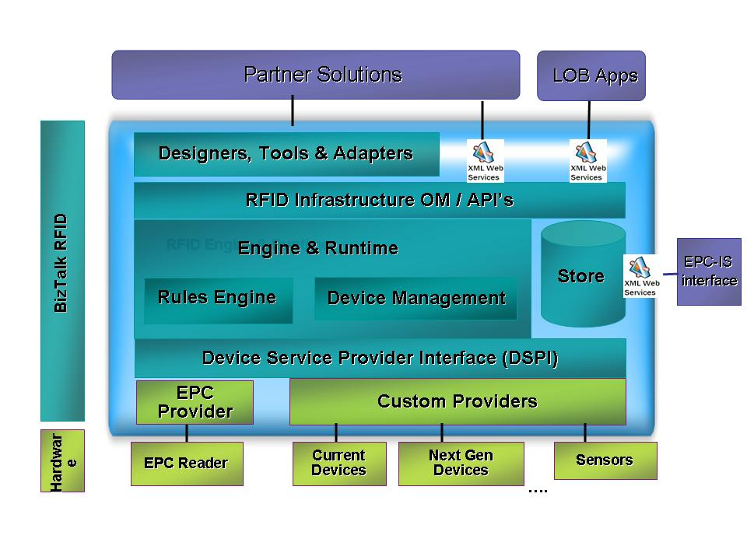
Data transmissions from EPC readers and other devices from multiple vendors are processed via a Device Service Provider Interface included in BizTalk RFID. It provides a platform for independent software vendors and system integrators to install hardware in a plug-and-play fashion, resulting in a complete and seamless RFID solution.
Source: Microsoft Corp., 2006
Because the layers are tightly integrated, applications and devices can seamlessly interconnect. Here’s how the layers work together:
Devices layer. The bottom Devices Layer consists of hardware such as RFID readers, printers, sensors, barcode scanners, 802.1X access points for wireless local area networks, handheld terminals and Pocket PCs, which are provided by partners.
Data collection and management layer. To accommodate the potentially large variety and number of devices that could be resident in an RFID implementation, a Device Service Provider Interface (DSPI) provides a consistent way for devices from multiple hardware vendors to expose their device services to the Microsoft platform. DSPI provides a scalable, extensible infrastructure that allows customers to read data through any standards-based or non-standards-based sensor regardless of format, thereby reducing dependency on a specific technology and protecting RFID investments long term.
“DSPI enables software to consistently communicate to a variety of different RFID-oriented devices,” says Tracey. “For a company like GlobeRanger, there are well over a dozen proprietary reader protocols that have to be supported. DSPI provides a consistent way for software to talk to these different devices. It saves a huge amount of time in terms of development.”
Event processing engine. This layer includes event and workflow management, messaging and a business rules engine. The Event engine enables context- or rules-based processing of RFID data to provide information directly to line-of-business applications. Information also can be delivered to business processes that span applications via Web services integration and orchestration products such as BizTalk Server. This layer provides the structure for integration across multiple facilities and partners. It also includes device management, to convert data into business process relevant information (see diagram, “The Event Processing Layer”).
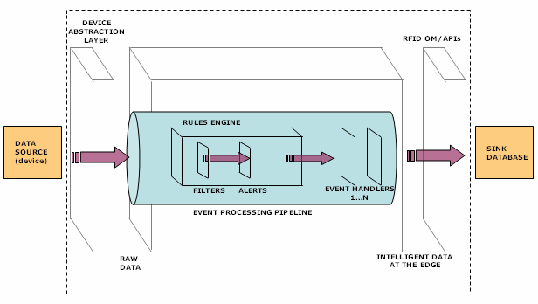
The Event Processing Layer
An event, such as the movement of a box with an RFID tag from a conveyor belt to a pallet, triggers a data transmission that is processed by the Rules Engine. The Rules Engine determines which enterprise application is updated about the box movement and also automatically triggers any alerts that were incorporated into the business rules.
Source: Microsoft Corp., 2006
Services layer. The Services Layer includes product information resolution lookup, business process management, analytics/reports/notifications and enterprise content solutions.
BizTalk RFID makes it easy for partners to embed functionality directly into their application or build applications on the infrastructure. Open application programming interfaces (APIs) and .NET-centric tools allow partners to quickly create specialized vertical solutions across a wide range of applications.
The Services Layer also provides lookups to EPCIS servers where data about a tagged object resides.
Application solutions layer. This uppermost layer relies on services, data, and tools from the lower layers to implement application solutions that drive business processes for the end user. Microsoft relies on its partners to build out many of the solutions, which are divided between two classes of applications: real-time enterprise/point apps and batch-oriented enterprise apps. In addition, BizTalk RFID also supports the Microsoft Dynamics family of enterprise applications.

Business Benefits
BizTalk RFID offers many potential business and technology benefits to those considering RFID systems today. In all cases, careful attention has been placed on open standards and overcoming the shortcomings of today’s custom systems. Thus, BizTalk RFID is designed to lower total cost of ownership, simplify integration end-to-end from the device level to back-end applications, convert data into actionable information and provide a platform where Microsoft and its partners can build applications that take advantage of the volume and real-time nature of RFID data.
Lower total cost of ownership. One of the most significant potential benefits is helping clients leverage existing investments in Microsoft Windows Server 2003, SQL Server, and BizTalk Server as well as popular ERP and CRM systems, including Microsoft’s own ERP systems, Microsoft Dynamics. “The idea is for Microsoft, together with its partners, to provide one-stop shopping for an RFID solution,” says Anush Kumar, program manager, BizTalk RFID. These familiar tools also shorten the learning curve and make the applications easier to use.
Simplified integration. BizTalk RFID allows for seamless integration of devices with provisions for discovery, configuration, communication and management. Essentially, it provides ways “to integrate data from disparate sources from the physical layer such as shop floor, warehouse floor and trading partners and governs how information flows through the stack and ends up in business solutions that partners or Microsoft Dynamics provides,” says Alex Renz, RFID program manager, Microsoft Dynamics.
Because DSPI basically makes hardware such as readers and printers plug and play, it helps system builders assemble the optimum solution and to focus on larger project issues without worrying whether a driver exists. Meanwhile, organizations deploying RFID are better positioned to take advantage of the hardware innovation and falling prices that DSPI promotes.
Firmware updates can be performed remotely across an enterprise to eliminate the need for physical intervention. “With potentially hundreds of readers on a network, you want to be able to update firmware remotely,” says Overby of Forrester Research. “You don’t necessarily have IT staff at the distribution center to configure hardware so the network recognizes it.”
Hardware health can also be monitored remotely. “The platform sends readers health monitoring events to confirm they are working,” explains Microsoft’s Renz. If a reader doesn’t respond as expected, an administrator receives an alert so corrective action can be taken.
Converting data to actionable information. Above Microsoft’s Devices Layer, an Event Processing Engine filters incoming noise while providing alerts and transformations. It reduces the data “noise” created by the volumes of redundant data it receives and converts it into actionable information. This functionality is enhanced by the use of English-like vocabularies for rule creation and a high degree of built-in configurability, making it easy for users to modify. Similarly, performance and scalability are built in so large volumes of irregular event streams can be handled and deployment can be distributed.
Built-in edge processing includes a highly flexible and configurable rules engine that addresses potential business problems. For example, if a shipment of 24 cases is expected but only 20 tags are read when it arrives, the system can send an alert so the operator can check the pallet. The operator can then confirm the presence or absence of the four unread cases and transmit accurate receiving information to the enterprise application. Whether done at the edge or centrally, processing of data is transparent to the user.
Data management also requires context. Is the object arriving? Departing? This information can be provided by sensors on the device layer that show the direction of movement. Or it can be done by a combination of history and rules. For example, if the system has seen an object before, it would suggest it is departing rather than arriving. Adding the context of pending orders provides further confirmation of status.
Application platform. Open APIs and a rich Object Model make it easier for partners or users to build new RFID-enabled applications or integrate RFID data with back-end applications. “This enhances flexibility, reduces the expenses related to building applications and simplifies integration, particularly when legacy systems are involved,” explains Microsoft’s Ahuja. Tools include a centralized dashboard for device monitoring and configuration and a Tag Data Simulator which permits RFID events to be simulated without input from actual devices. Tight integration with BizTalk Server and existing enterprise software make it possible for partners and clients to convert RFID events to BizTalk Server messages and build closed loop “RFID aware”’ business processes.

BizTalk RFID in Action
The following two diagrams (“Microsoft RFID: From Assembly Line to Dock Door”) demonstrate how the Microsoft RFID platform enables a manufacturing facility to add tags to cases, adjust inventory and production data, prepare shipping notices and generate purchase order status reports.
BizTalk RFID: From Assembly Line to Dock Door
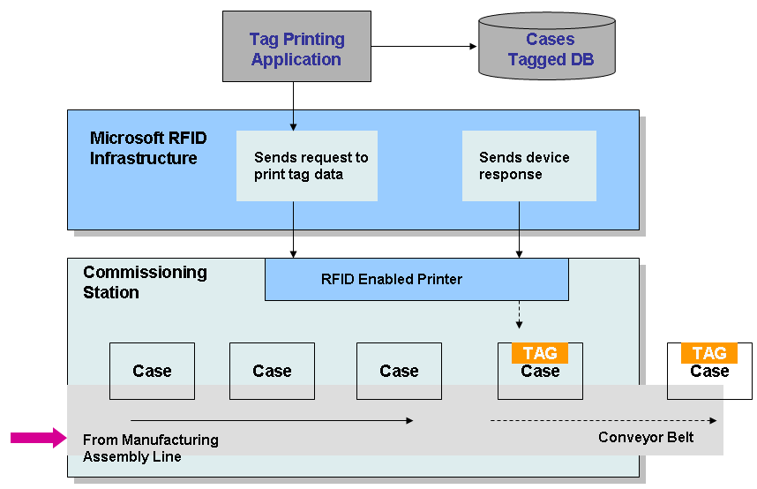

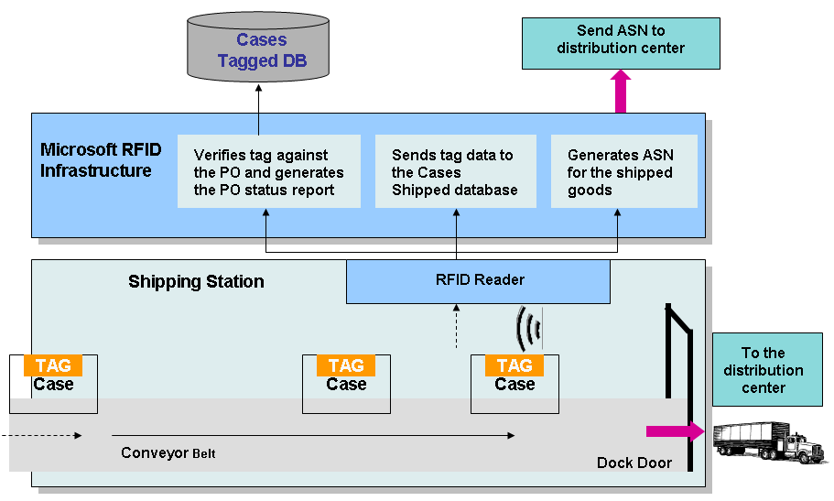

Source: Microsoft Corp., 2006

Summary and Recommendations
Use of RFID technology is growing rapidly and will be widespread in many industries by the end of the decade. Business processes likely to feel the greatest impact include fulfillment and distribution management, asset management, inventory control, and sales and marketing. However, RFID also plays a role in product lifecycle management, supply management, production management, demand management and aftermarket services.
In addition, RFID can help organizations address many challenges facing them such as the accelerating pace of business and increasing supply chain complexity, the need to optimize labor and control costs, and compliance with customer and regulatory requirements.
While RFID standards, device interoperability and data management capability are evolving, Microsoft has developed a layered RFID infrastructure, named BizTalk RFID, that provides a low cost, high value platform to take advantage of the benefits while obviating the risks of unsettled standards. The existing Microsoft applications platform products such as BizTalk Server and SQL Server, plus the new BizTalk RFID, provide a flexible, robust platform for a broad array of RFID innovators to provide standards-based, RFID solutions.
Microsoft has a history of “making computing affordable in a distributed environment” sums up Tracey of solutions provider GlobeRanger. RFID is another enabler that puts business intelligence close to the point of action. ▅

Appendix A --
More Information About BizTalk RFID

The following organizations provided invaluable research and insights for this white paper and the author would like to thank them for their contributions. Industry officials interested in obtaining more information about the research cited in this report should contact the organizations at these Web sites:

Research Firms and Microsoft Solution Partners Mentioned
Forrester Research
IDTechEx
GlobeRanger Corp.

Appendix B – About the Author
Hallie Forcinio is a technology analyst for Triangle Publishing Services Co. Inc., Newton, Mass. A specialist in automatic identification topics, she has been writing about RFID for several years and has covered bar coding since the 1980s.
Forcinio has been published in many magazines, including Managing Automation, where she serves as a contributing editor. She is also co-author of the third edition of the “Handbook of Package Engineering.” Prior to specializing in technical writing, she spent 10 years as an editor on a trade magazine focused on packaging.

“RFID Forecasts, Players and Opportunities, 2005-2015,” By Dr Peter Harrop and Raghu Das, IDTech Ex, Cambridge, UK
“Vegas casino bets on RFID,” By Alorie Gilbert, ZDNet News: February 9, 2005, http://news.zdnet.com/2100-1009_22-5568288.html?tag=st.prev
“New Zealand Passports Carrying Philips Chips,” RFID Journal, Dec.9, 2005, http://www.rfidjournal.com/article/articleview/2038/1/1/
“Moving Forward with Item-level Radio Frequency Identification in Apparel/Footware,” Kurt Salmon Associates, December 2005, http://www.kurtsalmon.com/content/main/White%20Paper-VICS%20AAFA%20RFID%20vF.pdf

