**Product Guide for   
Windows Home Server**

Microsoft Corporation

Published: January, 2009

Version: 1.1

**This Product Guide provides an overview of the features and functionality of Windows® Home Server software.**

****



**Contents**

[Overview 3](#_Toc177447225)

[Before You Begin 4](#_Toc177447226)

[Network Requirements 4](#_Toc177447227)

[Supported Operating Systems for Home Computers 4](#_Toc177447228)

[Wireless Support](#_Toc177447229) 4

[Setup 5](#_Toc177447227)

[Windows Home Server Console 6](#_Toc177447234)

[Home Computer Backup and Restore 7](#_Toc177447227)

[Home Network Health Monitoring 9](#_Toc177447232)

[Shared Folders and Server Storage 10](#_Toc177447228)

[Media Sharing and Streaming 12](#_Toc177447233)

[Remote Access 1](#_Toc177447229)3

[Windows Home Server Add-ins 15](#_Toc177447235)

Additional Sources [for Information 15](#_Toc177447232)

[Windows](#_Toc177447231) Home Server Product Features ………………………………………16

*The information contained in this document represents the current view of Microsoft Corporation on the issues discussed as of the date of publication.  Because Microsoft must respond to changing market conditions, it should not be interpreted to be a commitment on the part of Microsoft, and Microsoft cannot guarantee the accuracy of any information presented after the date of publication.*

*This Product Guide is for informational purposes only.  MICROSOFT MAKES NO WARRANTIES, EXPRESS, IMPLIED OR STATUTORY, AS TO THE INFORMATION IN THIS DOCUMENT.*

*Complying with all applicable copyright laws is the responsibility of the user.  Without limiting the rights under copyright, no part of this document may be reproduced, stored in or introduced into a retrieval system, or transmitted in any form or by any means (electronic, mechanical, photocopying, recording, or otherwise), or for any purpose, without the express written permission of Microsoft Corporation.*

*Microsoft may have patents, patent applications, trademarks, copyrights, or other intellectual property rights covering subject matter in this document.  Except as expressly provided in any written license agreement from Microsoft, the furnishing of this document does not give you any license to these patents, trademarks, copyrights, or other intellectual property.*

*Unless otherwise noted, the companies, organizations, products, domain names, e-mail addresses, logos, people, places, and events depicted in examples herein are fictitious.  No association with any real company, organization, product, domain name, e-mail address, logo, person, place, or event is intended or should be inferred.*

*Microsoft, Windows, Windows Server, Windows Vista, and Xbox 360 are trademarks of the Microsoft group of companies.*

*UPnP is a certification mark of the UPnP Implementers Corporation.*

*All other trademarks are property of their respective owners.*

*© 2009 Microsoft Corporation.  All rights reserved.*

# Overview

Microsoft® Windows® Home Server software was designed for households and home-based businesses that have more than one personal computer. Your life has gone digital - it is time to simplify your life so you can easily access your files, photos, videos and music from any PC or TV in your home, or even while away from home.

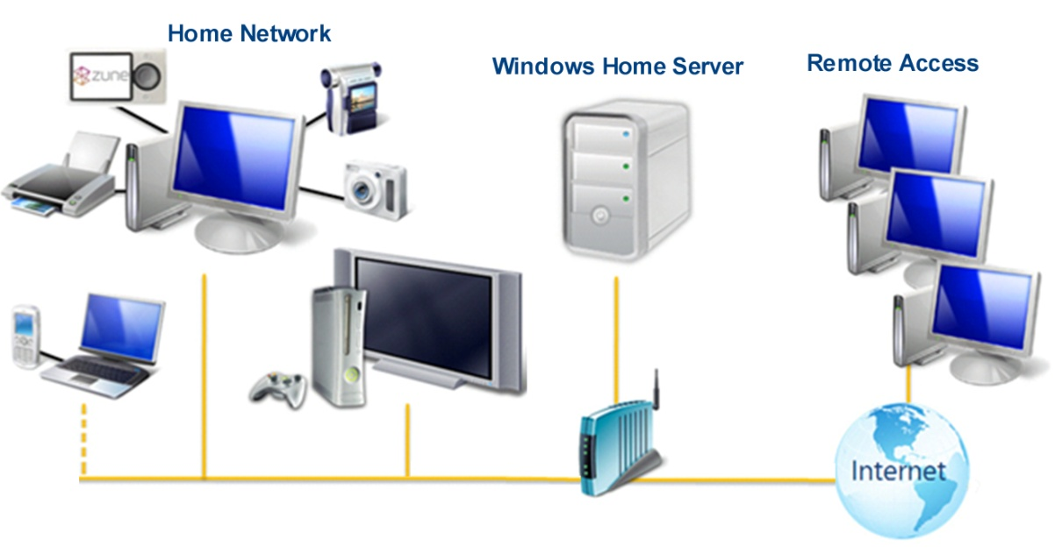

**Features at a Glance**

* Automated imaged-based backup of up to 10 computers every day, also known as “No button backup”. No need for CDs and external hard drives because Windows Home Server does your backups for you.
* Simple to restore an entire PC, a specific hard drive or individual files and folders from the backups stored on your home server.
* Store more files, photos, videos, recorded TV shows, etc. simply by adding more internal or external hard drives to your home server. Also, you do not have to deal with remembering those annoying drive letters (C:, D:, etc.) anymore.
* Store your files and media in shared folders that are automatically duplicated - so you will have 2 copies of your important stuff on 2 different hard drives to protect you against the failure of a hard drive.
* Share your favorite photos with friends and family via your own family web site.
* Home-based businesses can easily share lots of documents, presentations, and spreadsheets with their clients through a built-in remote access web site.
* Remotely access some of your PCs while away from home, so that you can run an application to check your e-mail, peruse financial information, or look up an address or a phone number.
* Windows Home Server is an extensible platform with over 70 Add-Ins already developed, with more on the way.

**Before You Begin**

Find a suitable location to put your home server before you begin the Windows Home Server Setup. The location you choose must have a wired network connection either to your broadband router or to a network switch that is connected to your broadband router.

**Network Requirements**

To successfully use Windows Home Server software, your home network must meet the following requirements:

|  |  |
| --- | --- |
| **Requirement** | **Minimum Specification** |
| Home server connection | 100 Mbps wired connection |
| Home computers | One or more computers that are running a supported operating system, with either a wired or a wireless network connection. |
| Internet connection | Broadband connection |
| Broadband router/firewall device | An external Internet broadband router/firewall device with 100 Mbps wired Ethernet connection.  Additionally, Windows Home Server assumes that your home computers get their IP address from the router/firewall device on your home network. |

**Supported Operating Systems for** **Home Computers**

The following operating systems for home computers are able to run the Windows Home Server Connector software:

* Windows 7
* Windows Vista and Windows Vista X-64 editions
* Windows XP with Server Pack 2 and higher

In addition, home computers running earlier versions of Microsoft Windows, and computers running Apple MacOS 10.4 and higher can easily connect to a home server over your home network to access files and media stored in the shared folders on the home server.

**Wireless Support**

Windows Home Server must be connected through a wired connection directly to your router or other home network device. Connecting the home server to your home network through a wireless connection is not supported. However, using home computers that are connected through a wireless router is supported.

**Setup**

You can get Windows Home Server up and running in three easy steps:

**Step 1: Connect and Power On**

Plug in the power cord and Ethernet cable to the back of your home server.

**Step 2: Install the Windows Home Server Connector Software**

From one of your home computers, place the Windows Home Server Connector software CD in the optical drive and follow the on screen instructions.

**Step 3: Complete Windows Home Server Setup**

From the computer where you install the Windows Home Server Connector software, you will be prompted to complete the Windows Home Server Setup. This is a one-time task and you must complete this step successfully to ensure Windows Home Server functions properly.

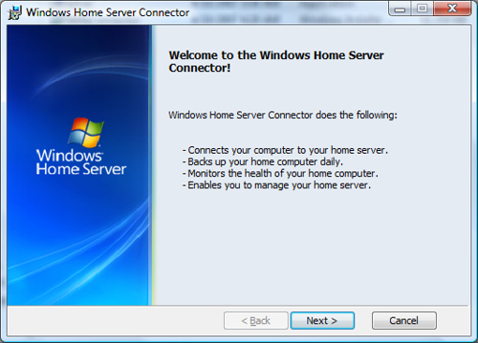

Image: Windows Home Server Connector setup screen.

**Windows Home Server Console**

The Windows Home Server Console is used to configure your home server. It is intended to be used by the person responsible for the home network and computers in your household.

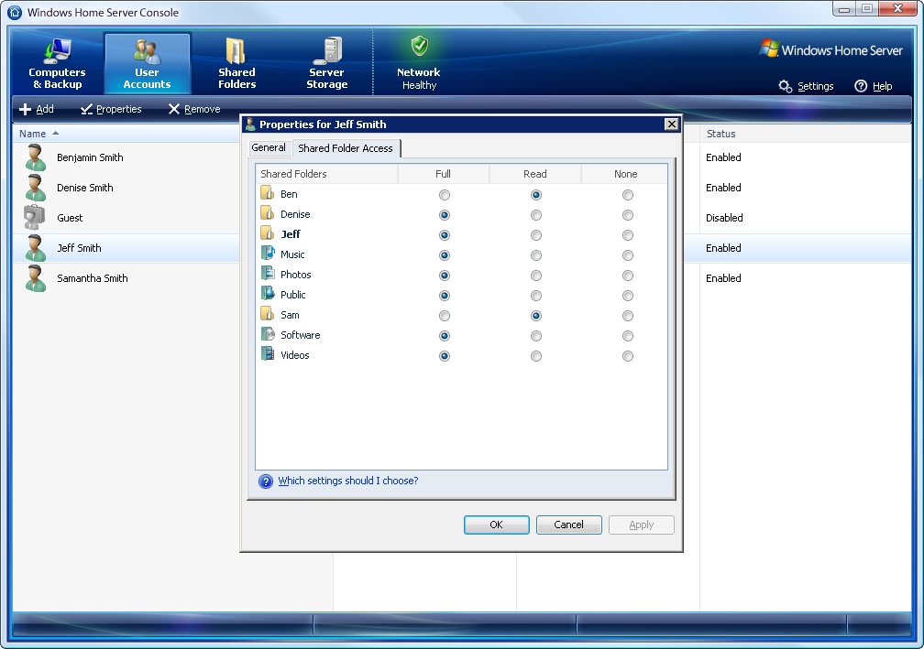You access the Windows Home Server Console from any computer that has the Windows Home Server Connector software installed by double-clicking the Windows Home Server taskbar icon. When you run the program it will ask you for the Windows Home Server password and then will connect to your home server.

* **View the Backup Status of your Home Computers**

The Computers & Backup tab allows you to view the backup status and configure backups on the computers that have the Windows Home Server Connector software installed.

* **Configure User Accounts**

The User Accounts tab allows you to add up to 10 user accounts. You can change the Shared Folders that users have access to, and enable remote access for each user. Each user will automatically be provided with a Shared Folder that only they (by default) have access to. (e.g. \\server\users\jeff).

* **Configure Shared Folders**

The Shared Folders tab allows you to add, remove and change properties of Shared Folders. If you have two or more hard drives in your home server, when you create a new folder, you can select **Enable Folder Duplication** that provides a level of redundancy for your files in the case of a single hard drive failure.

* **Configure Server Storage**

The **Server Storage** tab allows you to view, add, and remove hard drives on your home server. You can see the status of your home server storage, and attempt to repair any hard drives that show an unhealthy status. You can also see a graphical representation of the total space usage on your home server.

* **View the Health Status of your Home Network**

The **Network Health** indicator provides you with Healthy, At Risk and Critical health notifications for your home server and your home computers.

* **Adjust Windows Home Server Settings**

You can change the configuration settings for your home server, such as: Windows Update settings, Computer Backup settings, Password policy, and the date and time. Additionally, you will find the option to shutdown and restart your home server.

## Home Computer Backup and Restore

WindowsHome Server software will automatically back up as many as 10 home computers and allow you to easily restore the entire computer or an individual file or folder to a previous point in time. The WindowsHome Server Backup solution uses an innovative method to back up only the data that has changed since the previous backup. If you have several copies of the same data on different computers, the data is backed up only once on your home server which keeps track of what data was stored on each home computer on each day. This makes it very efficient in terms of the time it takes for backups to complete and also the amount of space that is used on your home server.

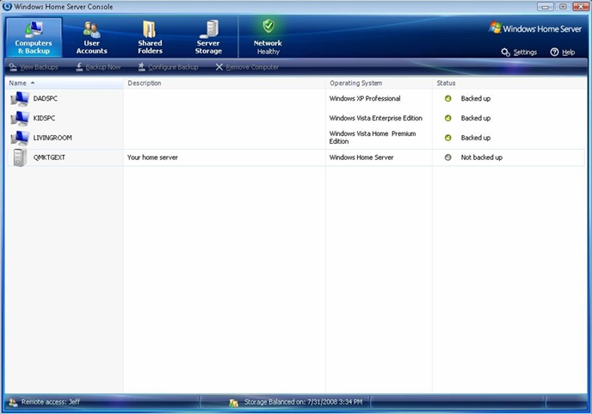

Image: Computers & Backup tab in Windows Home Server Console

* **Automated Image-based Backup of your Home Computers**

Computer backups are automatically configured when you install the Windows Home Server Connector software on your computers. Backup is performed on a daily basis for every configured computer.

* **Restore an Entire Home Computer**

Restoring a home computer to a previous point in time is easy. Simply boot the home computer using the Home Computer Restore CD. The computer will connect to your home server and provide a wizard for restoring a single hard drive or multiple hard drives from a backup of that computer that is stored on your home server.

* **Restore Individual Files and Folders**

You can also restore individual files or folders by selecting a home computer and a specific backup of that computer from the Windows Home Server Console. A Windows Explorer window is displayed with the files and folders that were backed up for that computer on that day. You can easily drag and drop individual files or entire folders from this Windows Explorer window and store them on your Windows Desktop or another location on your home computer.

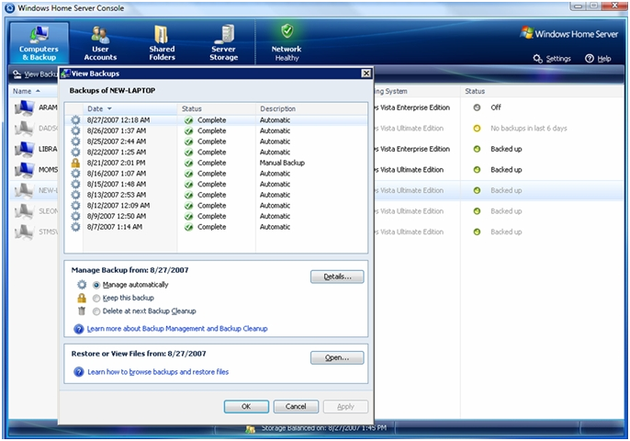

Image: Computers & Backup tab in Windows Home Server Console

|  |
| --- |
| Learn more by reviewing the [Back Up and Restore Step-by-Step](http://www.microsoft.com/windows/products/winfamily/windowshomeserver/restore.mspx).  For additional information please read the [Home Computer Backup Technical Brief](http://download.microsoft.com/download/1/8/0/18096c95-4850-4176-9821-970691b98aaf/Windows_Home_Server_Technical_Brief_-_Home_Computer_Backup_and_Restore.docx) available at <http://www.microsoft.com/windowshomeserver> |

## Home Network Health Monitoring

WindowsHome Server monitors its own health status and the status of your computers on your home network, and it notifies you of any issues or problems that are found. WindowsHome Server monitors the following health information:

* **Home Computer Backups**

Monitors that your home computers are being backed up on a regular basis and that the backups are completing successfully.

* **Server Storage and Shared Folder Duplication**

Monitors the hard drives in your home server and helps ensure that there is adequate space available for Shared Folders.

* **Home Computer Health Monitoring**

Monitors the Security Center status for home computers running Windows 7 and Windows Vista, so you can have a single view into the health of your home network.

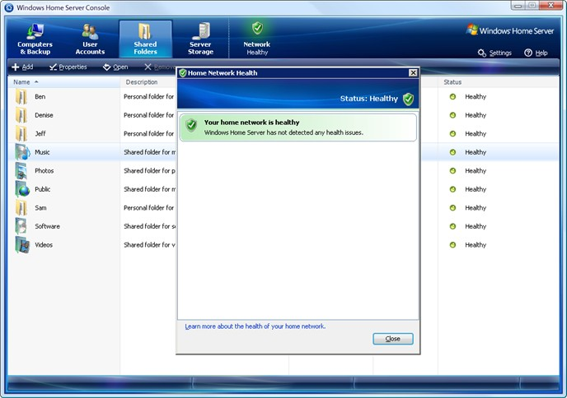

Image: Network Health tab in Windows Home Server Console

The taskbar application provides you with a high-level indicator of the health of your home network. If a problem is found, you can connect to the WindowsHome Server Console to get more detailed information.

tray_status_healthy_16 Green – your home network is healthy

tray_status_at_risk_16 Yellow – your home network is at risk

tray_status_critical_16 Red – your home server has found a critical problem

tray_status_busy_16 Blue – this computer is currently being backed up to your home server

## Shared Folders and Server Storage

WindowsHome Server Drive Extender is a revolutionary new storage technology that enables you to use internal and/or external hard drives of varying sizes for additional storage on your home server.

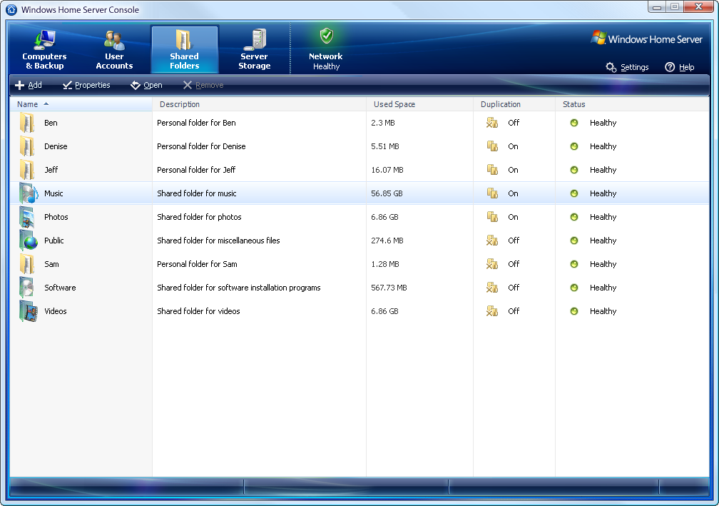

Image: Shared Folders tab in Windows Home Server Console

* **Pre-Defined Shared Folders**

Your home server is pre-configured with the following Shared Folders: Photos, Music, Videos, Public, and Software. From the Windows Home Server Console you can easily specify the user permissions for these folders and create any number of new shared folders.

* **Shared Folder Duplication**

If you have two or more hard drives in your home server, Windows Home Server helps protect against a single hard drive failure by ensuring that files stored in Shared Folders are automatically duplicated across multiple hard drives. Folder Duplication is configurable for each individual Shared Folder.

|  |
| --- |
| For additional information please read the [User Accounts and Shared Folders Technical Brief](http://download.microsoft.com/download/9/4/8/94861e44-7dd3-4737-be41-aa061eabc786/Windows%20Home%20Server%20Technical%20Brief%20-%20User%20Accounts%20and%20Shared%20Folders.docx) available at <http://www.microsoft.com/windowshomeserver> |

* **Easy to Add More Storage**

From the WindowsHome Server Console you can add a new hard drive to your home server using a simple wizard. The amount of storage available to your shared folders and home computer backups increases proportionally. The hard drives you add can be either internal or external (e.g. USB 2.0, FireWire or eSATA).

As you add more hard drives to your home server, they are represented in Server Storage as a single large collection of available storage space. You no longer need to deal with E:, F:, G:, etc. drive letters as you add more hard drives.

With Folder Duplication enabled, important data will be stored on separate hard drives helping to provide protection against a single hard drive failure.

It is also easy to remove hard drives through the Windows Home Server Console. When you select Remove Drive within the Windows Home Server Console, files and folders on the hard drive will be automatically moved. You might want to do this if a hard drive is failing or you want to replace an older, smaller hard drive after adding a newer, larger hard drive.

***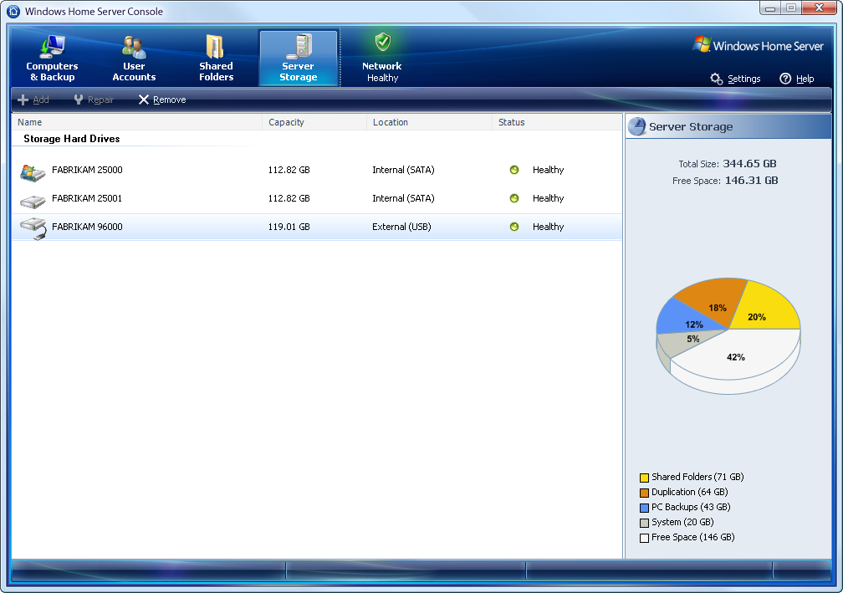***

Image: Server Storage tab in Windows Home Server Console

|  |
| --- |
| Learn more by reviewing the [Increase Data Storage Step-by-Step](http://www.microsoft.com/windows/products/winfamily/windowshomeserver/storage.mspx).  For additional information please read the [Drive Extender Technical Brief](http://download.microsoft.com/download/2/f/c/2fc09c20-587f-4f16-aa33-c6c4c75fb3dd/Windows%20Home%20Server%20Technical%20Brief%20-%20Drive%20Extender.docx) available at <http://www.microsoft.com/windowshomeserver> |

## Media Sharing and Streaming

Your home server is pre-configured with the following Shared Folders that can be used to store your media files: Photos, Music, and Videos. Additionally, these Shared Folders can be enabled for media streaming from the Windows Home Server Console. You can selectively turn on Media Library Sharing for each of these Shared Folders so that your music, photos, and/or videos can be accessible from an Xbox 360™ entertainment system or another supported digital media receiver that is attached to your home network.

* **View Photo Slideshows from a Home Computer**

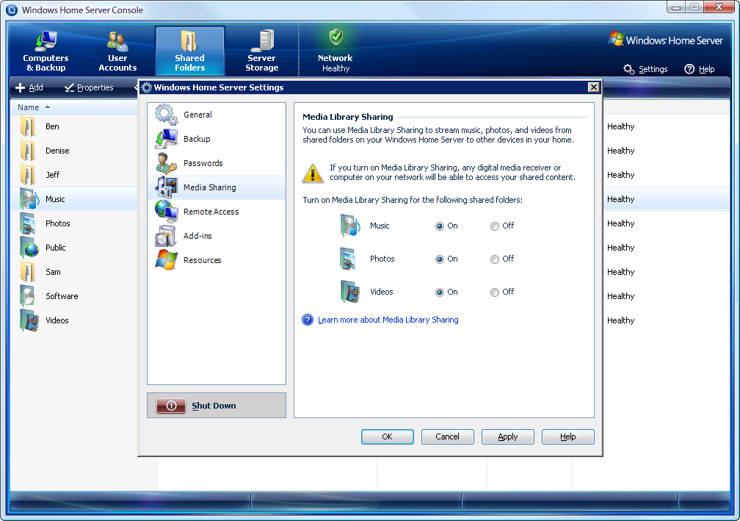You can store your digital photos in the Photos folder on your home server so you access them from your home computers or from an Xbox 360 in your home.

Image: Media Sharing Settings in Windows Home Server Console

* **Stream Music in your Home**

Similarly, you can store your music on your home server so you can access and play it from any of your home computers or a digital music receiver on your home network.

* **Store your Videos on your Home Server**

Your home server can be used to store your collections of videos and recorded TV from a computer running Windows Media Center, so that you can easily grow your collections and access them from any TV in your home.

|  |
| --- |
| Learn more by reviewing [Stream Digital Files Step-by-Step](http://www.microsoft.com/windows/products/winfamily/windowshomeserver/share.mspx).  For additional information please read the [Media Sharing Technical Brief](Media%20Sharing%20Technical%20Brief) available at <http://www.microsoft.com/windowshomeserver> |

## Remote Access

Using the WindowsHome Server Console 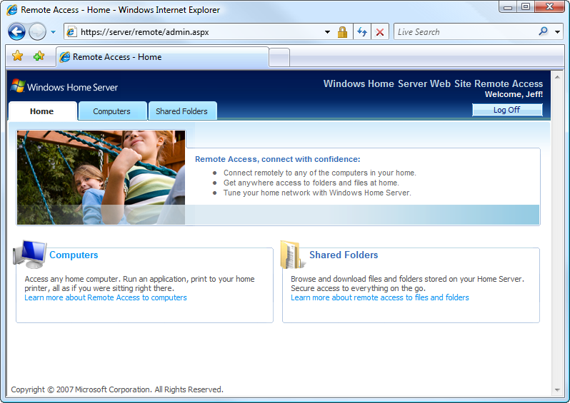you can turn on Remote Access and configure a user account with a username and a secure password. When you configure Remote Access you will receive a personalized Internet address that you will use to remotely access your home server.

**Remote Access to Shared Folders**

Image: Remote Access home page

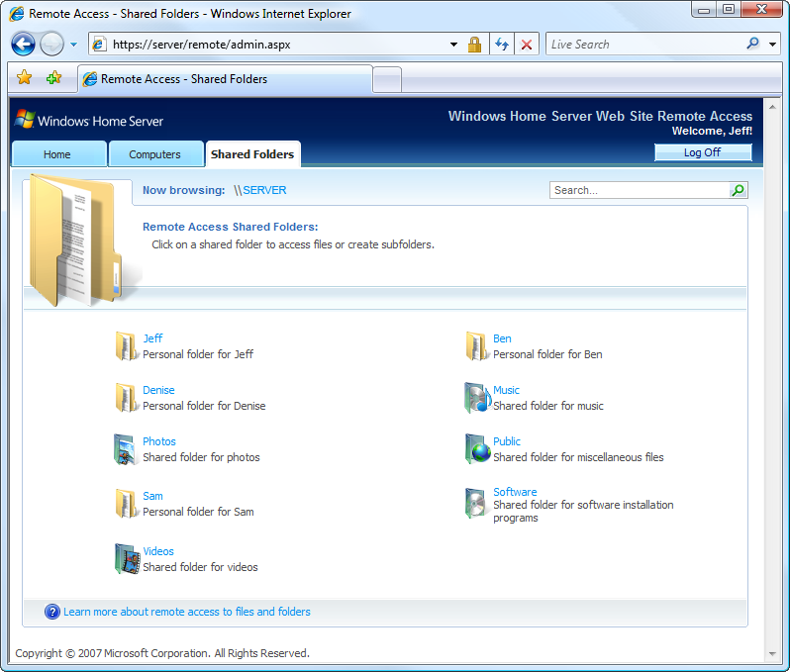Users can browse folders and files on the home server, as well as upload files to the Shared Folders on their home server while away from home. You can also search through the Shared Folders when you are trying to locate a specific file. Permission to access specific folders is configured under the User Accounts tab in the Windows Home Server Console.

* **Remote Access to Home Computers**

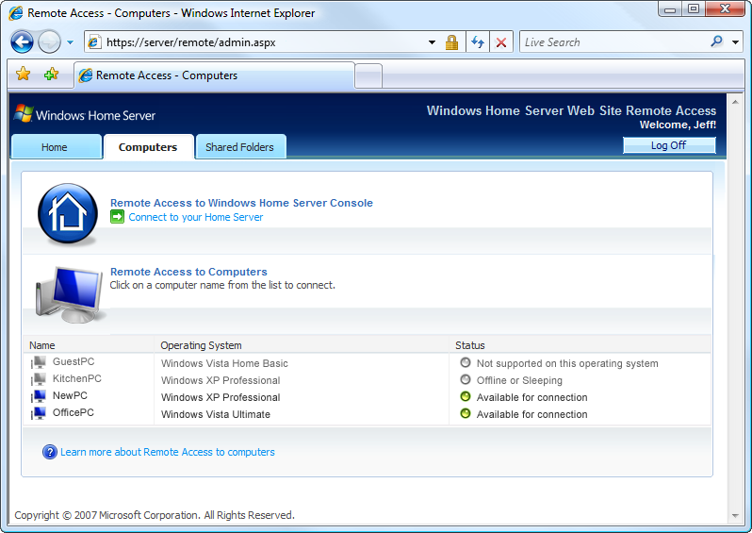After logging into your home server, you may be able to connect to a home computer and run an application as if you were sitting in front of that computer. Your home computer must be running a version of Windows that supports Remote Desktop connections, such as: Windows XP Professional with Service Pack 2 (SP2), Windows XP Media Center Edition 2005, Windows Vista Ultimate, Windows Vista Business, Windows Vista Enterprise, Windows 7 Professional and Windows 7 Ultimate.

Image: Remote Access Computers page

* **Remotely Connect to the Windows Home Server Console**

If the need arises, you can access the Windows Home Server Console while away from home to add new users, add new Shared Folders or check the health of your home network.

|  |
| --- |
| Learn more by reviewing the [Connect and Upload Step-by-Step](http://www.microsoft.com/windows/products/winfamily/windowshomeserver/photos.mspx).  For additional information please read the [Home Networking Technical Brief](http://download.microsoft.com/download/d/6/6/d66fdc35-519b-4768-8c68-06804fb61bf7/Windows%20Home%20Server%20Technical%20%20Brief%20-%20Home%20Networking.docx) and [Remote Access Technical Brief](Remote%20Access%20Technical%20Brief) available at <http://www.microsoft.com/windowshomeserver> |

## Windows Home Server Software Add-ins

* **Your Home Server Can Do More**

Windows Home Server has been designed with extensibility in mind, so that software developers can create innovative Add-In software. New Add-Ins for Windows Home Server are continually being developed, with multiple solutions available in the following categories:

* + Media Streaming & Archiving
  + Family Web Site / Photo Sharing
  + Home Automation
  + Power Management
  + Online Backup
  + Anti-Virus
  + Mobile Phone solutions
  + Home-based Business applications

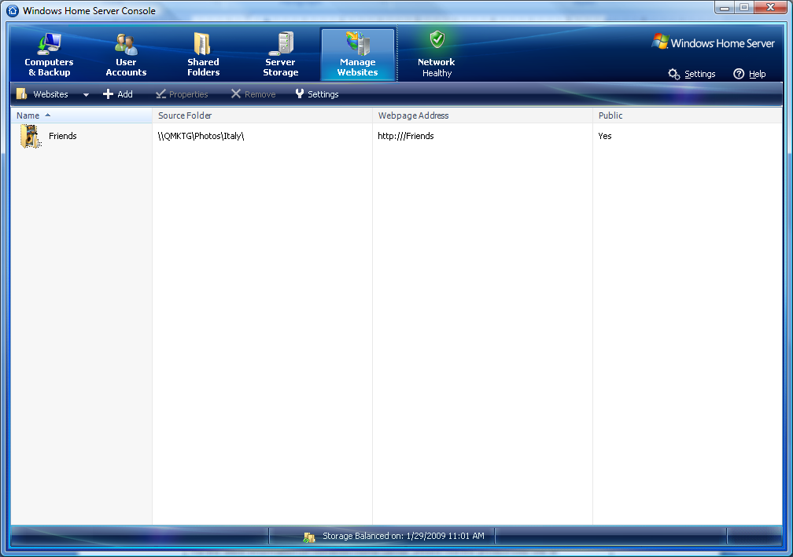

Image: Windows Home Server add-in, Whiist, for sharing photos with friends and family

|  |
| --- |
| For the latest information on Windows Home Server, please visit the product web site at [http://www.microsoft.com/windowshomeserver](http://go.microsoft.com/fwlink/?LinkId=100260).  The Windows Home Server team blog is also a useful source of the latest news, insights and information, available at [http://blogs.technet.com/homeserver](http://go.microsoft.com/fwlink/?LinkId=100265).  For technical support regarding Windows Home Server, please visit the [Windows Home Server Support Center](http://support.microsoft.com/default.aspx/ph/12624).  Join the growing community of Windows Home Server users at the [Windows Home Server Community](http://www.microsoft.com/windows/products/winfamily/windowshomeserver/community.mspx).  Check out a list of the more popular Windows Home Server Add-In at [Most Popular Windows Home Server Add-Ins](http://www.microsoft.com/windows/products/winfamily/windowshomeserver/add-ins.mspx) page. And follow links to learn more about all of the available Add-Ins. |

# WindowsHome Server Features-at-a-Glance

|  |  |
| --- | --- |
| Product Features | Functions |
| Windows Home Server Console | * Configure User Accounts * Configure Shared Folders * Configure Server Storage * View the Health Status of your Home Network * Adjust Home Server Settings * View the Backup Status of your Home Computers |
| User Accounts | * User accounts are required in order to control access to the shared folders |
| Home Computer Backups | * Automated Daily Image-based Backup of up to 10 home computers |
| Home Computer Restore | * Entire Home Computer * One or more hard drives * Individual Files and Folders |
| Pre-Defined Shared Folders | * Music, Photos, Videos, Software, Public * A secure personal shared folder for each user account |
| Easy to Add Server Storage | * External USB 2.0 hard drive * External FireWire hard drives * eSATA hard drives * Internal hard drives |
| Shared Folder Duplication | * Duplication is configurable on a per shared folder basis helping protect you from the failure of a single hard drive on your home server |
| Media Sharing and Streaming | * Enjoy slideshows of your digital photos stored on your home server from any PC in your home, or from a digital photo frame * Stream music throughout your home from your home server * Watch videos and movies stored on your home server from any TV in your home |
| Remote Access | * To Shared Folders * To Home Computers * To Windows Home Server Console * Using Personalized Internet Address * Permissions set for each user |
| Home Network Health Monitoring | * Home Computer Backups * Home Server Storage * Shared Folder Duplication * Security Center Status for PCs running Windows Vista |
| Third Party Add-ins | New Add-Ins for Windows Home Server are continually being developed, with multiple solutions available in the following categories:   * Media Streaming & Archiving * Family Web Site / Photo Sharing * Home Automation * Power Management * Online Backup * Anti-Virus * Mobile Phone solutions * Home-based Business applications |