

# Understanding Database Pricing and Licensing

Writers: Darmadi Komo

Technical Reviewers: Kajal Deepak, Bernardo Zamora

Published: May 2005

Updated: September 2007

Applies To: SQL Server 2005

Summary: This white paper compares the database pricing and licensing policies of three top database vendors: Microsoft, Oracle, and IBM.

### Copyright

The information contained in this document represents the current view of Microsoft Corporation on the issues discussed as of the date of publication. Because Microsoft must respond to changing market conditions, it should not be interpreted to be a commitment on the part of Microsoft, and Microsoft cannot guarantee the accuracy of any information presented after the date of publication.

This White Paper is for informational purposes only. MICROSOFT MAKES NO WARRANTIES, EXPRESS, IMPLIED OR STATUTORY, AS TO THE INFORMATION IN THIS DOCUMENT.

Complying with all applicable copyright laws is the responsibility of the user. Without limiting the rights under copyright, no part of this document may be reproduced, stored in or introduced into a retrieval system, or transmitted in any form or by any means (electronic, mechanical, photocopying, recording, or otherwise), or for any purpose, without the express written permission of Microsoft Corporation.

Microsoft may have patents, patent applications, trademarks, copyrights, or other intellectual property rights covering subject matter in this document. Except as expressly provided in any written license agreement from Microsoft, the furnishing of this document does not give you any license to these patents, trademarks, copyrights, or other intellectual property.

 2007 Microsoft Corporation. All rights reserved.

Microsoft, Vista, and Windowsare either registered trademarks or trademarks of Microsoft Corporation in the United States and/or other countries.

The names of actual companies and products mentioned herein may be the trademarks of their respective owners.

### Table of Contents

Executive Summary 1

Introduction 1

Editions 2

Options 3

Multicore Licensing 4

User Licensing 6

Virtualization 8

Maintenance and Support 8

Price Comparison 9

Microsoft SQL Server 2005 and Oracle 11g 9

Microsoft SQL Server 2005 and IBM DB2 9 11

Total Cost of Ownership (TCO) 12

Conclusion 13

Reference 13

#### Executive Summary

This paper explains the different ways in which databases are priced and compares pricing for the three leading database vendors: Microsoft®, Oracle, and IBM. Understanding the direct and indirect costs of deploying and managing an enterprise database solution allows customers to make a more informed decision when considering which database is best for their organization. Knowing all components of the licensing models and multicore technology and how these influence the overall cost of a database system is a crucial step in understanding database pricing.

For example, Microsoft has adopted a simple multicore licensing policy, in which it reduces enterprise software costs by licensing physical processors, not cores, for Microsoft software that is licensed on a per-processor basis. Licensing requirements for per-processor software is determined by the number of processors, not the number of cores. Other vendors such as Oracle and IBM have more complex licensing policies such as licensing per core or by processor value unit where customers end up paying substantially more for multicore systems. As systems with more cores become available, the difference will become even more dramatic.

For companies making the initial database decision, this paper also explains the general pricing philosophy employed by each vendor so that organizations can avoid typical pitfalls or pricing traps.

When evaluating different databases, customers should be aware of what functionality is included in the base product and what can be obtained only through options. For example, some vendors such as IBM and Oracle include limited functionality in their base products and offer additional functionality through "options" or "add-ons." These options can be very expensive and sometimes end up costing more than the base product itself. In comparison, Microsoft customers do not have to buy any additional options or add-ons for additional functionality.

If you do the critical analysis, Microsoft SQL Server® 2005 proves to be a cost-effective solution that meets users’ high service-level expectations. With savings across hardware, software, operations, and maintenance, the benefits of SQL Server 2005 are substantial.

The following table shows the different licensing options available from each vendor; these are covered in more detail in this paper.

|  |  |  |  |
| --- | --- | --- | --- |
| ***Licensing Option*** | ***Microsoft SQL Server 2005*** | ***IBM DB2 9*** | ***Oracle 11g*** |
| Choice of Processor or User Licensing | checked | checked | checked |
| Out-of-the-box features without options | checked |  |  |
| Lower Cost Multicore Licensing | checked |  |  |
| Supports Virtualization Licensing | checked | checked |  |
| Lower Cost Named User Licensing | checked |  |  |

#### Introduction

Historically, database pricing has been very hard to understand. Complex pricing and licensing models make side-by-side comparisons difficult. At first glance, some database software products may seem inexpensive, but some vendors impose hidden costs beyond the initial purchase price and, over time, customers are forced to pay exorbitant amounts of money for functionality that they had assumed to be part of the original product. When considering database pricing, it is important to take into account not only the direct costs of deploying and using the solution, but also the indirect costs.

In addition, advancements in hardware and software technology play a major role in database pricing. As organizations continue to streamline costs, IT departments are looking for cost-effective solutions that meet their high-level expectations. They are being asked to reduce costs, yet deliver higher levels of data availability, performance, and reliability to support business needs.

Following are some of the database pricing topics that are covered in this paper:

* Editions
* Options/add-ons
* Multicore licensing
* User licensing
* Virtualization
* Maintenance and support
* Price comparison
* Total cost of ownership (TCO)

#### Editions

The first concept to consider when buying database software is that of editions. Database editions allow companies to get access to different levels of functionality at varying price points. Vendors take different approaches to editions and typically target their editions at specific market segments, making some options only available on certain editions.

Typically, database editions fall under four tiers:

* **Free:** Targeted at organizations that need to deploy a local data store and are willing to accept limits on features, memory, database size, number of users, and scalability.
* **Basic:** Targeted at small- to medium-sized businesses that have basic data-management requirements. These editions provide simplified management tools and basic database capabilities but are limited to the number of CPUs, and may also have limitations on memory, database size, or number of users.
* **Standard:** Targeted at medium-sized business or departmental solutions. Standard editions are sometimes limited to a certain number of CPUs, and lack some of the sophisticated features of enterprise editions.
* **Enterprise:** Targeted at large companies, for applications that require large volumes of data and/or high transaction throughput. Enterprise editions include features such as high availability, clustering, and advanced management tools; they typically have no CPU or memory limitations.

The following table explains these four tiers in more detail:

| Tier | Features | Sample Products | Price |
| --- | --- | --- | --- |
| **Free** | * Limited database functionality * Memory limits, database size limits, functionality limits | * SQL Server Express Edition | $0 |
| **Basic** | * Basic database functionality * Simplified management tools * Basic security * Up to two CPUs, memory limits | * Microsoft SQL Server Workgroup Edition * Oracle Standard Edition One * DB2 Express Edition | $500–$5,000 per CPU |
| **Standard** | * Availability * Full database functionality * Basic management tools * Up to four CPUs or nodes | * Microsoft SQL Server Standard Edition * Oracle Standard Edition * DB2 Workgroup Edition | $5,000–$15,000 per CPU |
| **Enterprise** | * High availability * Scalability * High-end management tools * Enterprise security * No CPU limit | * Microsoft SQL Server Enterprise Edition * Oracle Enterprise Edition * DB2 Enterprise Edition | $25,000–$40,000 per CPU |

**Note**All prices are per processor and reflect pricing for purchases within the United States and are in United States dollars. Pricing based on information available on vendor Web sites is listed in the Reference section.

#### Options

Some vendors include the full functionality in the base product. For example, Microsoft customers do not have to buy any add-ons for additional functionality. However, some other vendors such as IBM and Oracle include limited functionality in their base products and offer additional functionality through options or add-ons. These options can be very expensive and may end up costing more than the base product itself. When evaluating different databases, customers should be aware of what functionality is included in the base product and what can be obtained only through options.

For IBM and Oracle, add-ons are very frequently required for anything but the most basic applications. Examples of add-ons offered by these vendors include: security, online analytical processing (OLAP), database tuning and management, advanced security, partitioning, and data mining. To complicate matters, most of the management, security, and business intelligence options that IBM and Oracle offer are only available with the Enterprise edition of their databases. This means that, in many cases, customers may have to upgrade from Standard Edition to Enterprise Edition at a significant cost when all they need is a specific option, such as OLAP for a business intelligence application.

In contrast, Microsoft provides full data management and analysis functionality in its Standard and Enterprise SQL Server database editions; customers know they will not incur large incremental costs to run their data management systems.

The following graph and table highlight the impact that options have on the total license cost for a database. It’s easy to see how options can dramatically change the total cost of a database solution.

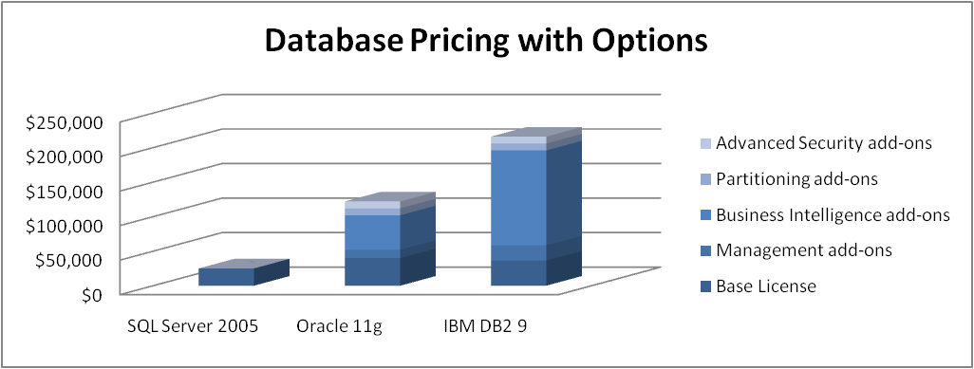

**Note**All prices are per processor and reflect pricing for purchases within the United States and are in United States dollars. Pricing is based on information available on vendor Web sites. The Microsoft SQL Server 2005 base product includes all the functionalities in the other products’ add-ons.

|  | Microsoft | Oracle | IBM |
| --- | --- | --- | --- |
| **Enterprise Edition Base License** | $24,999 | $40,000 | $36,400 |
| **Management Tools Add-on** | Included | $3,000 (Diagnostics Pack)  $3,000 (Tuning Pack)  $3,000 (Configuration Mgmt Pack)  $3,000 (Change Mgmt Pack)  Total = $12,000 | $12,000 (Recovery Expert)  $10,000 (Performance Expert)  Total = $22,000 |
| **OLAP Server and Data Mining Add-on** | Included | $40,000 (OLAP and Data Mining Option) | $75,000 (DB2 Data Warehouse Enterprise Edition) |
| **Enterprise ETL Add-on** | Included | $10,000 (Warehouse Builder Enterprise ETL) | $62,500 (WebSphere DataStage) |
| **Partitioning Add-on** | Included | $10,000 (Partitioning Option) | $10,000 (Database Partitioning) |
| **Advanced Security Add-on** | Included | $10,000 (Advanced Security Option) | $10,000 (Advanced Access Control) |
| **Total Cost** | **$24,999** | **$122,000** | **$215,900** |

**Note**All prices are per processor (or the equivalent IBM’s Processor Value Unit based on Intel/AMD processor) and reflect pricing for purchases within the United States and are in United States dollars. Pricing is based on information available on vendor Web sites.

#### Multicore Licensing

After reviewing database editions and options, the next item to consider is the overall licensing model. This section reviews per-processor licensing models in detail, as this is an area where technological advances in hardware may lead to wide cost discrepancies between vendors. Multicore is a technological innovation that will continue to drive database performance over the next few years. Because leading enterprise operating systems and most applications are ready to support the multithreaded environment, multicore chips are expected to deliver performance increases of more than 50 percent.

Following are the licensing models for each vendor:

* **Processor Value Unit (PVU).** IBM has recently adopted a new approach to processor licensing called Processor Value Unit (PVU). A PVU is a unit of measure used to differentiate licensing of middleware on distributed processors. Over time, PVU will evolve to differentiate processor families based on their relative performance. For example, Intel and AMD multicore processors give a PVU of 50 per core while SUN UltraSPARC T1 has PVU of 30 per core, and IBM Power6 has PVU of 120 per core.
* **Licensing Per Core.** Oracle's policy is to charge 0.5 times the number of cores in a system for Intel and AMD, 0.25 times the number of cores for UltraSPARC T1 processor, and 0.75 times the number of cores in other systems, rounded up to the nearest whole number. For example, an Oracle customer with one Intel or AMD processor, quad-core server is charged for the equivalent of two processors (0.5 x 4 cores = 2 for licensing purposes). As systems with more cores become available, the difference will become even more dramatic. For an 8-core system, customers will pay four times as much.
* **Licensing Per Processor.** In contrast, Microsoft has adopted a simplified multicore licensing policy, in which it continues to reduce enterprise software costs by licensing physical processors, not cores, for Microsoft software that is licensed on a per-processor basis. In other words, licensing requirements for per-processor software is determined by the number of processors, not the number of cores.

The following table and graph show the impact of multicore pricing on Enterprise editions, based on multicore systems that have four processors.

|  |  |  |  |
| --- | --- | --- | --- |
| ***Licensing Comparison based on Intel or AMD system*** | | | |
| **System** | **Microsoft SQL Server 2005** | **IBM DB2 9** | **Oracle 11g** |
| Dual-Core | $100,000 | $145,600 | $160,000 |
| Quad-Core | $100,000 | $291,200 | $320,000 |
| Octi-Core | $100,000 | $582,400 | $640,000 |

**Note**All prices are for purchases within the United States and are in United States dollars. Pricing is based on information that is available on vendor Web sites.

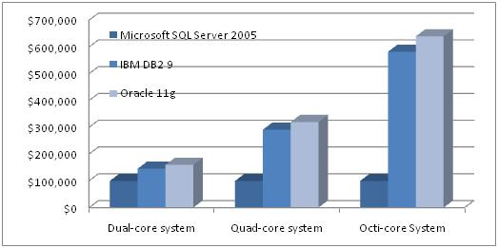

**Note**All prices are for purchases within the United States and are in United States dollars. Pricing is based on information that is available on vendor Web sites for Enterprise Edition.

#### User Licensing

This section compares user licensing among SQL Server 2005, Oracle 11g, and IBM DB2 9.

Microsoft employs a **Server plus User CALs (Client Access Licenses) Licensing Model.** This licensing model states that a Server license is required for each operating system environment that runs an instance of SQL Server, as well as a CAL for each user who accesses a system running SQL Server. A Server plus user Client Access License (CAL) license requires a separate server license for each server on which the software is installed, plus a user CAL for each user accessing the server. Users only pay the Server CAL once to access multiple servers for the entire organization.

Oracle employs a **Named User Plus Licensing Model**. This licensing model states that a Named User Plus license is required per user to access an instance of 11g installed on a single server or multiple servers. Users must purchase a Name User Plus license for every server in the organization that uses an Oracle Database instance. Oracle Database Enterprise Edition for Intel or AMD systems requires a minimum of 25 Named Users Plus per Processor.

IBM employees an **Authorized User Licensing Model**. This licensing model states that an Authorized User license is required for each user who accesses an instance of DB2 installed on a single server or multiple servers. DB2 Enterprise has a minimum of 25 authorized users that must be licensed for every 100 PVUs for which your server is rated.

Following are two scenarios that compare the pricing among each vendor for User Licensing.

Scenario 1: Price comparison for a single server

The following graph compares prices based on a database application with two processors of a dual-core server (4 cores x 50 PVUs / core = 200 PVUs) and 25 heavy-usage users.

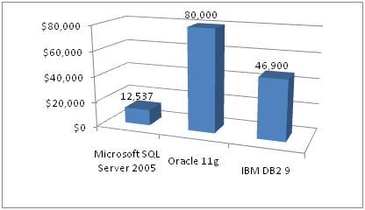

**Note**   All prices are per processor and reflect pricing for purchases within the United States and are in United States dollars. Pricing is based on information available on vendor Web sites.

* **Microsoft SQL Server 2005 Enterprise Edition**  
  25 users (CALs) x $162 / CAL + $8,487 / Server = **$12,537**
* **Oracle 11g Enterprise Edition (base license without options)**Named User Plus minimum (25 Named Users Plus per Core) = 25 x 4 = 100 Named Users Plus x $800 / Named Users Plus = **$80,000**
* **IBM DB2 Enterprise Edition (base license without options)**Authorized User minimum (25 Authorized Users per 100 PVUs) = 25 x 2 = 50 Authorized Users x $938 / Authorized Users = **$46,900**

Scenario 2: Price comparison for disaster recovery

The following graph compares prices based on a scenario using multiple servers. This example includes a database application with two servers (primary and remote) with two processors dual-core (8 cores x 50 PVUs / core = 400 PVUs) and 25 heavy-usage users.

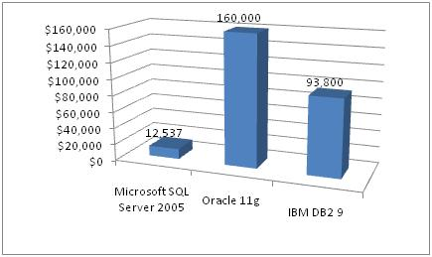

**Note**All prices are per processor and reflect pricing for purchases within the United States and are in United States dollars. Pricing is based on information available on vendor Web sites.

* **Microsoft SQL Server 2005 Enterprise Edition**25 users (CALs) x $162 / CAL + $8,487 / Server = **$12,537.** Remote mirroring server is considered standby server and requires no additional SQL Server license.
* **Oracle 11g Enterprise Edition (base license without options)**Primary + Remote Mirroring Server: Named User Plus minimum (25 Named Users Plus per Processor) = 25 x 4 = 100 Named Users Plus x $800 / Named Users Plus * 2 servers = **$160,000**. 11g must be licensed at primary and remote site.
* **IBM DB2 Enterprise Edition (base license without options)**Primary + Remote Server: Authorized User minimum (25 Authorized Users per 100 PVUs) = 50 Authorized Users x $938 / Authorized Users x 2 servers = **$93,800**

#### Virtualization

*Virtualization* is defined broadly as the running of software in a "virtual environment." A virtual environment exists when an operating system (OS) is emulated, or does not run directly on the physical hardware. When software is virtualized, one or several applications and their associated operating systems can run on one physical server inside their respective virtual environments. One benefit of a virtualized scenario is that multiple applications can run concurrently on a server with isolation at the OS level.

Following are comparisons of how each vendor supports virtualization.

* **Microsoft SQL Server 2005**When SQL Server 2005 runs inside a virtual operating environment, it requires at least one license per virtual operating environment. Several copies or instances of SQL Server 2005 can run inside a single virtual operating environment. For SQL Server Enterprise Edition, if all processors in a machine are licensed, the customer may run unlimited instances of SQL Server 2005 on an unlimited number of virtual operating environments on that same machine.
* **Oracle 11g**Oracle does not support production deployments of Oracle software on virtualization software such as Microsoft Virtual Server or VMWare.
* **IBM DB2 9**IBM supports its software running in a virtual environment under a subcapacity licensingmechanism. A customer may license a software program for use on less than the full processor capacity of a machine, when the software program is used within one or more partitions.

#### Maintenance and Support

In addition to databases licenses, customers typically purchase maintenance and support. These are often priced as a percentage of list price, typically 20 to 25 percent. Because Oracle and IBM tend to have significantly higher license costs than Microsoft, maintenance costs are typically higher for those vendors as well.

Maintenance gives customers the right to newer versions of the software. Vendors normally offer different levels of support, ranging from support during business hours all the way up to dedicated, onsite support. In contrast to Microsoft, Oracle and IBM require a maintenance agreement for the provision of service packs and security patches.

Given the longevity of databases, it’s important to consider the much higher ongoing cost that is required to maintain an Oracle or IBM database.

Microsoft Software Assurance gives customers automatic access to new technology and provides productivity benefits, support, tools, and training to help them efficiently deploy and use software. In addition to new version rights, benefits include:

* [Spread payments](http://download.microsoft.com/download/e/2/3/e2341d27-107f-4613-ad97-eb277b48241e/UndrstDBPrcng.doc)
* Desktop deployment planning services
* [Information Work Value Discovery Workshop](http://www.microsoft.com/licensing/sa/benefits/iwss.mspx)
* [Information Work Architecture Design Session](http://www.microsoft.com/licensing/sa/benefits/iwss.mspx)
* Microsoft Windows® pre-installation environment
* Windows Vista™ Enterprise
* [Microsoft Desktop Optimization Pack](http://www.microsoft.com/windows/products/windowsvista/enterprise/mdopoverview.mspx)
* [Microsoft Virtual PC Express](http://www.microsoft.com/windows/products/winfamily/virtualpc/default.mspx)
* Training vouchers
* E-learning
* [Home Use Program (HUP)](http://www.microsoft.com/licensing/sa/benefits/home_use_rights.mspx)
* [Employee Purchasing Program (EPP)](http://download.microsoft.com/download/b/6/f/b6fbaee0-2465-49ad-92b7-fd31d6bc9ee4/SACustomer_Guide.doc)
* [Enterprise Source Licensing Program (ESLP)](http://www.microsoft.com/resources/sharedsource/Licensing/Enterprise.mspx)
* Twenty-four-hour-a-day seven-day-a-week problem resolution support
* [Corporate Error Reporting](http://www.microsoft.com/licensing/sa/benefits/cer.mspx)
* Cold backups for disaster recovery
* TechNet Plus subscription media and newsgroup
* [Windows Fundamentals for Legacy PCs](http://www.microsoft.com/licensing/sa/benefits/fundamentals.mspx)
* Extended hotfix support

For more information on the Microsoft Software Assurance program, see [Microsoft Software Assurance](http://www.microsoft.com/licensing/programs/sa/default.mspx).

#### Price Comparison

This section compares the different vendor database solutions side by side.

##### Microsoft SQL Server 2005 and Oracle 11g

SQL Server 2005 provides management, security, and business intelligence capabilities as an integrated solution at no additional cost. Oracle sells these important features as add-ons and most of these features are available only with Oracle 11*g* Enterprise Edition. These include:

* Key management features such as diagnostic tools, performance monitoring tools, and tuning tools. These management tools are included as standard features in SQL Server 2005 Standard and Enterprise Edition. However, these tools are only available as extra-cost options with both editions of Oracle 11*g*.
* Advanced security features such as data encryption, public key infrastructure (PKI), and single sign-on support. These important security capabilities are included with SQL Server 2005 Standard and Enterprise editions at no additional cost. Oracle provides these features as extra-cost options and only makes them available with the Enterprise edition. This means that users of Oracle 11*g* Standard Edition must find alternative solutions or install add-on security products from third-party software providers.
* Business intelligence components such as online analytical processing (OLAP), enterprise reporting, and data mining. Again, these features are included in SQL Server 2005 Standard and Enterprise Edition. Oracle, however, offers these items only as extra-cost options and only with Oracle 11*g* Enterprise Edition.

In the following table and graph, significant price differences between SQL Server 2005 and Oracle 11g arise when comparing the costs associated with these key data management features. These price differences are accentuated when considering multicore processors.

|  | Oracle 11g |  | Microsoft SQL Server 2005 |  |
| --- | --- | --- | --- | --- |
| Database Components | Enterprise Edition | $40,000 | Enterprise Edition | $24,999 |
| Management Packs | $12,000 | Management Tools | Included |
| Advanced Security and Partitioning | $20,000 | Encryption, single sign-on, PKI, partitioning | Included |
| Business Intelligence (OLAP and Data Mining add-on) | $40,000 | Integration, Reporting and Analysis services | Included |
| **Subtotal** |  | **$112,000** |  | **$24,999** |
| High availability | Additional passive database instance for high availability | $112,000 | Additional passive database instance for high availability | Included |
| **Subtotal** |  | **$224,000** |  | **$24,999** |
| Multicore | Cost of additional core (quad-core processor) | $224,000 | Cost of additional core | Included |
| **Total Enterprise Cost** |  | **$448,000** |  | **$24,999** |

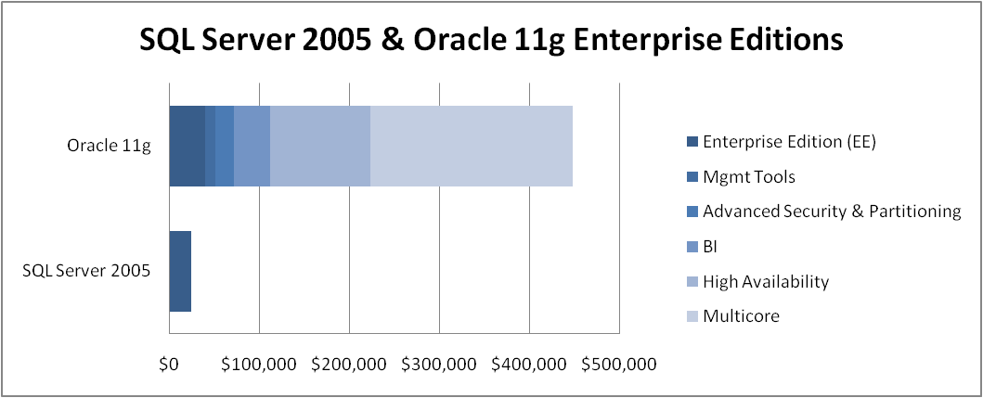

**Note**All prices are per processor and reflect pricing for purchases within the United States and are in United States dollars. Pricing based on information available on vendor Web sites. These are the cost savings per processor. The savings increase when additional processors are added.

For more information and comparisons between Oracle and SQL Server, see [Comparing SQL Server 2005 and Oracle](http://www.microsoft.com/sql/evaluation/compare/oracle/default.mspx).

##### Microsoft SQL Server 2005 and IBM DB2 9

Although the base prices for IBM DB2 version 9 Enterprise Server Edition and SQL Server 2005 Enterprise Edition are comparable, IBM charges considerably more for important add-on features such as online analytical processing (OLAP), data transformation, and data mining, items that Microsoft includes as standard product features in SQL Server 2005. Even for the base licensing, IBM DB2 raised the price for version 9 to $36,400 from $25,000 per processor. The following table and graph compare the prices differences between SQL Server 2005 and DB2 9. As before, these price differences are accentuated with considering multicore processors.

|  | IBM DB2 version 9 |  | Microsoft SQL Server 2005 |  |
| --- | --- | --- | --- | --- |
| Database Components | Enterprise Edition | $36,400 | Enterprise Edition | $24,999 |
|  | Warehouse Server Add-on | $75,000 | Integration, Reporting and Analysis Services | included |
| **Subtotal** |  | **$111,400** |  | **$24,999** |
| High Availability | Additional database instance for high availability | $111,400 | Additional database instance | Included |
| **Subtotal** | **$222,800** |  | **$24,999** |
| Multicore | Cost of multiple core (quad-core processor) | $222,800 | Cost of additional core | Included |
| **Total Enterprise Cost** |  | **$445,600** |  | **$24,999** |

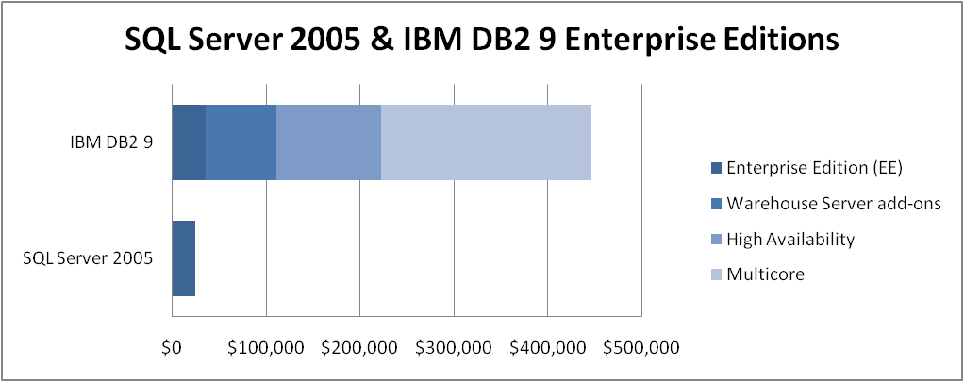

**Note**All prices are per processor and reflect pricing for purchases within the United States and are in United States dollars. Pricing is based on information available on vendor Web sites. These are the cost savings per processor. The savings increase when additional processors are added.

For more information and comparisons between IBM DB2 and SQL Server, see [Comparing SQL Server 2005 to IBM](http://www.microsoft.com/sql/evaluation/compare/ibm/default.mspx).

#### Total Cost of Ownership (TCO)

After looking at the cost of database software, the next step is to bring everything together with a comparison of total cost of ownership (TCO). Independent third-party studies have validated that SQL Server offers lower TCO across multiple cost categories, with the largest savings usually coming from ongoing operations. In fact, a study by NerveWire[1] found that SQL Server cost advantages versus the competing product translated into a *47* *percent cost savings over the three-year period* covered in the survey. The results of the study are summarized as follows.

| Application Type | Cost | SQL Server TCO | Competing Product TCO | Percentage Savings |
| --- | --- | --- | --- | --- |
| Cross Organizational Applications (100+ users) | Ongoing operations | $511,928 | $926,078 | 45% |
| Design and development | $158,381 | $181,875 | 13% |
| Software licensing | $75,000 | $225,000 | 67% |
| Hardware | $101,500 | $221,500 | 54% |
| Maintenance | $64,500 | $145,125 | 56% |
| Training | $12,627 | $31,388 | 60% |
| **Total TCO** | **$923,936** | **$1,730,966** | **47%** |
| Departmental Applications (50-100 users) | Ongoing operations | $209,411 | $312,886 | 33% |
| Design and development | $37,474 | $49,274 | 24% |
| Software licensing | $15,000 | $45,000 | 67% |
| Hardware | $34,300 | $74,300 | 54% |
| Maintenance | $12,900 | $29,025 | 56% |
| Training | $1,681 | $3,643 | 54% |
| **Total TCO** | **$310,767** | **$514,128** | **40%** |

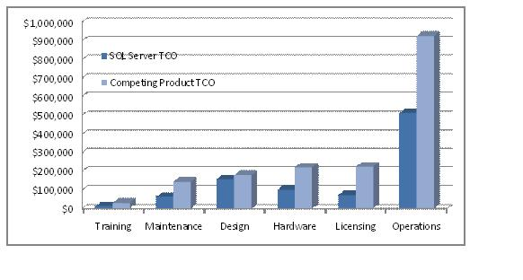

**Note**All prices are per processor and reflect pricing for purchases within the United States and are in United States dollars. Pricing based on information available on vendor Web sites.

#### Conclusion

Understanding the direct and indirect costs of deploying and managing an enterprise database solution allows customers to make a more informed decision when deciding which database is best for their organization. Knowing all components of the licensing models and the new multicore technology and how these influence the overall cost of a database system is necessary to understanding database pricing.

For those who have done the critical analysis, SQL Server 2005 has repeatedly been proven to provide a cost-effective solution that is well able to meet users’ high service-level expectations. With savings across hardware, software, operations, and maintenance, the benefits of SQL Server 2005 are substantial.

* Lower hardware costs
* Lower software licensing costs
* Reduced support and maintenance costs
* Ability to meet business and user requirements

Compared with other database management solutions, SQL Server 2005 features lower hardware costs, decreased software licensing, and significantly reduced support and maintenance costs.

#### Reference

SQL Server Licensing

* [How to Buy SQL Server](http://www.microsoft.com/sql/howtobuy/default.mspx)
* [Virtualization](http://www.microsoft.com/sql/howtobuy/virtualization.mspx)

IBM Licensing

* [Which Edition of DB2 Is Right for You?](http://www.ibm.com/developerworks/db2/library/techarticle/dm-0611zikopoulos/#authorizeduserdefinition)
* [IBM Software Online Catalog](http://www-306.ibm.com/software/info/app/ecatalog/index.html)

Oracle Licensing

* [Licensing](http://oraclestore.oracle.com/OA_HTML/ibeCCtpSctDspRte.jsp?section=11365&media=os_g_english_help_licensing)
* [User Minimums](http://oraclestore.oracle.com/OA_HTML/ibeCCtpSctDspRte.jsp?section=11365&media=os_user_minimums)
* [Software Investment Guide](http://www.oracle.com/corporate/pricing/sig.html)
* [Oracle Pricing List](http://www.oracle.com/corporate/pricing/applications-price-list.pdf)

For more information:

* [SQL Server Web site](http://www.microsoft.com/sql/default.mspx)
* [SQL Server TechCenter](http://technet.microsoft.com/en-us/sqlserver/default.aspx)
* [SQL Server Developer Center](http://msdn2.microsoft.com/en-us/sqlserver/default.aspx)

Did this paper help you? Please give us your feedback. Tell us on a scale of 1 (poor) to 5 (excellent), how would you rate this paper and why have you given it this rating? For example:

* Are you rating it high due to having good examples, excellent screenshots, clear writing, or another reason?
* Are you rating it low due to poor examples, fuzzy screenshots, unclear writing?

This feedback will help us improve the quality of white papers we release. [Send feedback](mailto:sqlfback@microsoft.com?subject=White%20Paper%20Feedback:%20Understanding%20Database%20Pricing).

1. <http://www.microsoft.com/sql/evaluation/compare/tco.asp>