
Project Controller

Microsoft Dynamics™ SL

Improve your project profitability by providing project managers with the accurate, meaningful information needed to gain control over project revenue and expenses-enough control to make even low-margin projects profitable.

Benefits
- Structure your projects flexibly
Design your projects to match the way
you do business, with multiple levels of
information and user-defined account
categories. Customized structures not only
conform to your business practices for
greater profitability, but give you greater
visibility into project performance.

- Gain control over project costs
Track, view, and analyze costs and
revenues for individual projects that are
still in progress. Margins can be predicted
and controlled and future expenses easily
viewed without waiting until the end of an
accounting period.

- Increase your access to information
Maintain complete and real time up-
to-date information about your project by
sharing key project accounting data with the
enterprise project management version of
Microsoft® Office Project 2003.

- Enhance project teamwork
Provide accountants and project managers
with a single system that enables them to
use the same set of data for better analysis
and project accountability. Project data can
then be presented in terms that are easy
for project managers to understand and
use.

- Improve project productivity
Take advantage of flexible project
structures, billing rates, user-defined fields,
and more to make your project run as
smoothly as possible. Costs are collected
and charged to individual projects within a single integrated solution.

Set up project
information quickly and easily, including integration with Microsoft Office Project 2003.

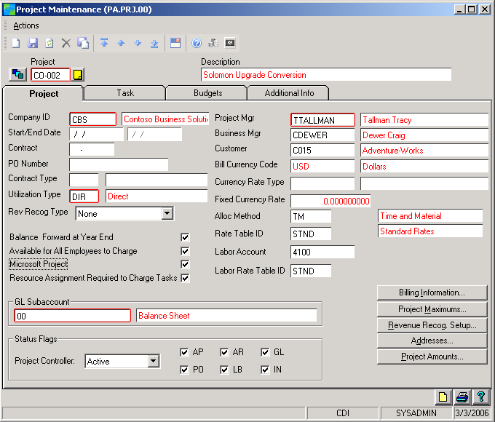

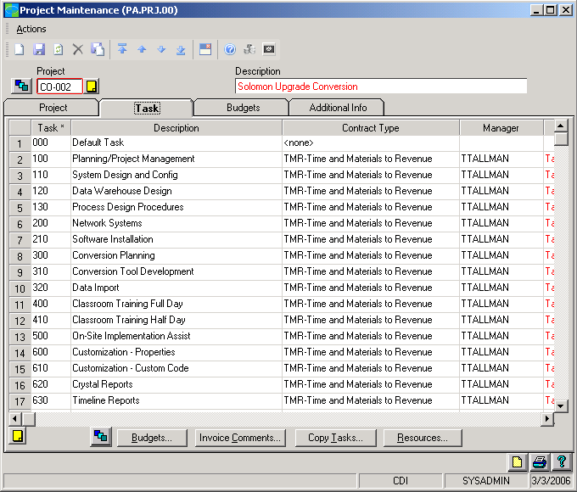

Review
a multi-level task
list for an instant assessment of project performance.

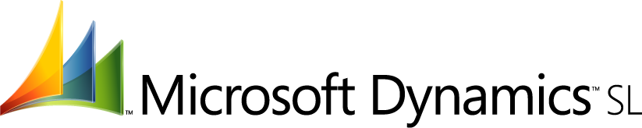

FEATURES

BENEFITS

Flexible Project and Task Structure | Design projects to fit the way you do business by defining a flexible project or task structure with as many as twelve levels of information. Project structures can include factors such as client, contract, job, phase, task, sub-task, activity code, work breakdown structure, and cost code to allow better visibility into project performance.
Extensive Data Views | View project data in a project summary, drilling down to view underlying  information and get specific details about project transactions.
Full View of Project Performance. | Maintain visibility into all phases of your projects, from planning to final  billing, through real-time data sharing with the enterprise project  management version Microsoft Office Project 2003.
Automatic Computation Rules | Ensure that project information meets the standards you need by  Defining rules that automatically compute and apply rates, multipliers,  and percentages to project transactions for analysis and billing purposes.
Accounting and Project Integration | Simplify timely analysis and project accountability by providing a single  system that allows accountants and project managers to analyze a  common set of data.
Easily Understandable Information | Enable project managers to analyze information more effectively by  presenting project and task data in familiar profit and loss (P&L) formats  with easy-to understand categories such as labor, travel, and materials  instead of cryptic account codes.
Instant Expense Visibility | Take known or expected expenses into account by sharing information  across Microsoft Dynamics SL. Record expenses such as  subcontractors, purchasing, and unposted labor charges as commitments  as soon as they are entered—even before the end of an accounting  period—to allow for the future cost.
DCAA Rate Compliance | Apply indirect rate calculations that comply with Defense Contract Audit  Agency (DCAA) labor transaction requirements.

For more information about Microsoft Dynamics™ SL, visit: http://www.microsoft.com/dynamics/sl

This document is for information purposes only.
MICROSOFT MAKES NO WARRANTIES, EXPRESS, IMPLIED, OR STATUTORY, AS TO THE INFORMATION IN THIS DOCUMENT.

© 2005 Microsoft Corporation. All rights reserved.
Microsoft, The Microsoft Dynamics Logo, are either registered trademarks or trademarks of Microsoft Corporation or Microsoft Business Solutions ApS in the United States and/or other countries. Microsoft Business Solutions ApS is a subsidiary of Microsoft Corporation.

