

Compilation of Activation and Client Access Licensing Help
Microsoft Corporation
Published: April 2005
Version: 1

Abstract
This document contains all of the Activation and Licensing Help information for Windows Small Business Server 2003. It conveniently gathers this information in one place so you don't have to search for it on a computer running Windows SBS.
For the most up-to-date product documentation, see the Microsoft Web site at http://go.microsoft.com/fwlink/?LinkId=33326.

The information contained in this document represents the current view of Microsoft Corporation on the issues discussed as of the date of publication. Because Microsoft must respond to changing market conditions, it should not be interpreted to be a commitment on the part of Microsoft, and Microsoft cannot guarantee the accuracy of any information presented after the date of publication.

This White Paper is for informational purposes only. MICROSOFT MAKES NO WARRANTIES, EXPRESS, IMPLIED OR STATUTORY, AS TO THE INFORMATION IN THIS DOCUMENT.

Complying with all applicable copyright laws is the responsibility of the user. Without limiting the rights under copyright, no part of this document may be reproduced, stored in or introduced into a retrieval system, or transmitted in any form or by any means (electronic, mechanical, photocopying, recording, or otherwise), or for any purpose, without the express written permission of Microsoft Corporation.

Microsoft may have patents, patent applications, trademarks, copyrights, or other intellectual property rights covering subject matter in this document. Except as expressly provided in any written license agreement from Microsoft, the furnishing of this document does not give you any license to these patents, trademarks, copyrights, or other intellectual property.

© 2005 Microsoft Corporation. All rights reserved.

Microsoft, Windows, and Windows Server are either registered trademarks or trademarks of Microsoft Corporation in the United States and/or other countries.

All other trademarks are property of their respective owners.

Contents
Compilation of Activation and Client Access Licensing Help 5
Objective 5
Concepts 5
Overview 5
Server Activation 6
Activation reminders 6
How the software handles activation 7
Methods for activation 7
Reactivation (rarely needed) 8
Product activation compared to product registration 8
Client Access Licensing 8
Types of CAL activation 9
The To Do List 10
Activate Your Server 11
Add Client Licenses 11
License Code Activation Failure 12
Using Licensing Wizards 12
Manage Your Licenses 14
Understanding the Taskpad 15
Tasks 16
Procedures 17
Wizard Help 20
Welcome 21
License Code Information 23
Telephone Information 24

Compilation of Activation and Client Access Licensing Help

Objective
This paper is a compilation of the activation and client access licensing Help files that are available on a computer running the Microsoft® Windows® Small Business Server 2003 server software (Windows SBS). You can access this same information in Help and Support Center and also in the activation and licensing wizards in Windows SBS. The purpose of this paper is to make this information available on the Web to customers who do not have a computer running Windows SBS immediately available to them.
Important:
Any reference to a computer CAL (client access license), which is also called a device CAL, also applies to a user CAL.
For more information about Windows SBS Licensing, see "Frequently Asked Questions About Windows Small Business Server 2003 Licensing" at the Microsoft Web Site (http://go.microsoft.com/fwlink/?LinkId=44529).
This paper has three sections: "Concepts," which contains general, conceptual information; "Procedures," which contains detailed procedural instructions; and Wizard Help, which contains additional Help topics from the Add License Wizard.

Concepts

Overview
Product activation is quick, simple, unobtrusive, and it protects your privacy. The activation process is designed to reduce software piracy (the number of illegal copies of a product) and is required to ensure that core services function properly. You do not need to give your name or other personal information when you activate the server.
Windows Small Business Server 2003 includes licenses for five client computers. A client access license (CAL) gives either a client computer or a user the legal right to access a computer running Windows Small Business Server 2003 and the services supported by that server. You can purchase and add additional CALS using the Manage Client Access Licenses tool in Windows Small Business Server 2003.

Server Activation
Product activation and product registration are not the same. Activation is completely anonymous; it requires absolutely no personally identifiable information to complete. Activation is required and ensures that each Windows product is not installed on more than the limited number (usually one) of computers allowed in the software's end user license agreement, or EULA. Activation is also required to ensure that core services function properly.
During activation, you can also register your copy of Windows. Registration is not required; however, registering your copy ensures that you receive product support, product update information, and other benefits. The process of registration takes only a few minutes to complete. Personal information (for example, "contact" information such as name and address) is required if you decide to register.
You have a short grace period in which to activate your Windows product installation. If the grace period expires and you have not completed activation, some features, such as adding client access licenses, cannot be performed until the server is activated.
You must activate your server after completing Setup. If you acquired your computer from an original equipment manufacturer (OEM), the manufacturer may have already activated it for you.
Product activation is required and ensures that each Windows product is not installed on more than the limited number of computers (usually one) allowed in the end-user license agreement (EULA). Activation is also required to ensure that core services function properly.
You don't need to give your name or other personal information when you activate your server. Microsoft is committed to your privacy. For more information about the kind of information collected during product activation, see the Microsoft Windows product activation Privacy Policy at the Microsoft Web site (http://go.microsoft.com/fwlink/?LinkId=42980).

Activation reminders
Until you activate your server, you will receive a reminder each time you log on and at regular intervals until the end of the activation grace period. If the grace period expires and you do not activate the server, you will be unable to access core services until the computer is activated. This will result in loss of server functionality.

How the software handles activation
When you activate the operating system, the product key will be associated with the computer on which it is installed. Following activation, the product key cannot be used for activating the software on other computers.
During the activation process, the product key is combined with a coded number to create the Installation ID that uniquely represents the hardware components that make up your computer.
When you activate your computer, you provide the Installation ID to Microsoft, through the Internet or by telephone, so it can be confirmed as representing a legal installation. After activation is complete, if someone attempts to install the operating system on another computer using your software, or an illegal copy of your software, the Installation ID will show that your product key is already associated with a particular set of hardware (your computer), and the attempted activation will not work. The Installation ID is used only for the purpose of product activation.

Methods for activation
After installing the operating system, you will automatically be prompted to activate your server. You can also initiate activation by clicking Activate Windows on the Start menu, or by clicking the key icon that appears in the notification area, at the far right of the taskbar. By following the instructions that appear, you can activate your computer using the Internet or the telephone:
• Internet. When you activate using the Internet, your computer transmits coded information that shows that your product key is associated with your computer hardware. Activation is carried out using a secure connection to Microsoft. A Confirmation ID is passed back to your computer, automatically activating your product. This process normally takes just a few seconds to complete. No personally identifiable information is required to activate your product.
• Phone. When you activate by phone, the Windows Product Activation wizard guides you through a few simple steps. After you choose the country or region where you are located, a phone number (toll-free wherever possible) appears on the screen. When you call the number, you will be prompted for the Installation ID that is displayed on the screen. When the Installation ID is verified, you will be provided with a Confirmation ID to type into the spaces provided on the screen. After entering the Confirmation ID, repeat the process if you have other Installation IDs to verify, or finish the wizard to complete the activation process.

Reactivation (rarely needed)
If you make significant changes to the configuration of your server, the operating system might view your hardware as a completely different computer, not the one you originally activated. In this situation, you will need to reactivate the product by calling the telephone number displayed on the telephone activation screen.

Product activation compared to product registration
Product activation is not the same as product registration. As just discussed, product activation is required and is completely anonymous. Product registration, in contrast, is completely optional, and it collects personal information, such as your name and address. Registration entitles you to receive information about product updates and special offers directly from Microsoft. All registration information is stored securely, and no information is ever loaned or sold to third parties.
For more information, see To Activate Windows Small Business Server.

Client Access Licensing
A client access license (CAL) provides a client computer with the legal right to access a computer running Microsoft Windows Small Business Server 2003 and the services supported by that server.
The default installation of your server includes five CALs. If you have more than five client computers, you must purchase and activate additional CALs for the client computers to access the server.
Note:
It is not necessary to activate the five CALs that are included with the default installation of Windows Small Business Server.
Legal access to the server is not provided by purchasing a Microsoft operating system such as Windows XP Professional or a member of the Windows Server™ 2003 family.
Every client connection requires a CAL if the client computer accesses network or server application services, such as:
• Exchange services: Using e-mail and messaging.
• File services: Sharing and managing files or disk storage.
• Printing services: Sharing and managing printers.
• Remote access services: Accessing the server from a remote location through a network connection.
The number of client connections is not always the same as the number of users. For example, when the same user is logged on to two workstations simultaneously and is connected to a server from both workstations, this is considered two client connections.
When you purchase additional CALs, you will receive a paper license that contains unique license codes. These license codes are similar to product keys and uniquely identify groups of CALs. CALs can be purchased in groups of 5 or 20, after which they are activated online or by telephone using the Add License Wizard. For more information, see To add client access licenses.

Types of CAL activation
If you have determined that you need to buy additional CALs for your organization, you must activate the additional CALs. There are three CAL activation types. Before you can activate client access licenses, you must activate the server. For more information, see Server Activation.

New activation
New activation applies to CALs that have not previously been activated. After purchasing a group of CALs, you must first activate it to provide additional client computers access to the network. Using the Add License Wizard, you will enter each license code that you have purchased. Microsoft will then validate the license codes and provide confirmation IDs that authorize the activation.
When you purchase additional client access licenses (CALs), you are provided with a license document that contains a 25-character license code. This code is associated with that particular set of CALs.
For more information, see To add client access licenses.

Reissue of licenses
License reissue is similar to new activation. It may become necessary to reissue CALs if they have not been backed up and if they are accidentally deleted or become corrupted. CALs can only be reissued to the same server that they were previously installed on. If there has been a significant change to the hardware configuration of the server, you will be prompted to initiate a license transfer by contacting a Customer Support Representative.
For more information, see To reissue client access licenses.
As a best practice, back up your CALs before you add new client licenses. If your CALs are then deleted or become corrupted, you can easily recover them by using the Restore Licenses task on the Licensing taskpad in Server Management.
For more information, see To back up or restore client access licenses.

Transfer of licenses
It will be necessary to transfer CALs if you install the server software on a new computer, or if you significantly alter the hardware configuration of the existing server. You must use the telephone method of activation when transferring CALs. When you run the Transfer License Wizard you will be prompted to enter the license codes that you were provided at the time you purchased your CALs and the country or region from which you are calling. After doing this, call Microsoft by using the phone number provided on the Confirmation Information screen. A toll-free number will be provided whenever possible. Using the Transfer License Wizard, you can transfer client access licenses (CALs) from one server to another. You may need to do this after making significant changes to server hardware.
Before you continue with the Transfer License Wizard, you will need to:
• Activate your server. For more information about activating your server, see Server Activation.
• Provide the license codes received at the time the CALs were purchased. After you continue with the wizard, be prepared to provide the Installation IDs from the Confirmation Information page in the wizard. If you enter more than one license code to activate, Installation IDs will appear on more than one sequential Confirmation Information pages.
Note:
If you upgrade or migrate from Small Business Server 4.0, Small Business Server 4.5, or Small Business Server 2000, you will need to purchase new or upgrade CALs.

The To Do List
The To Do List includes two tasks that help you activate or add client access licenses (CALs) to Windows Small Business Server 2003.
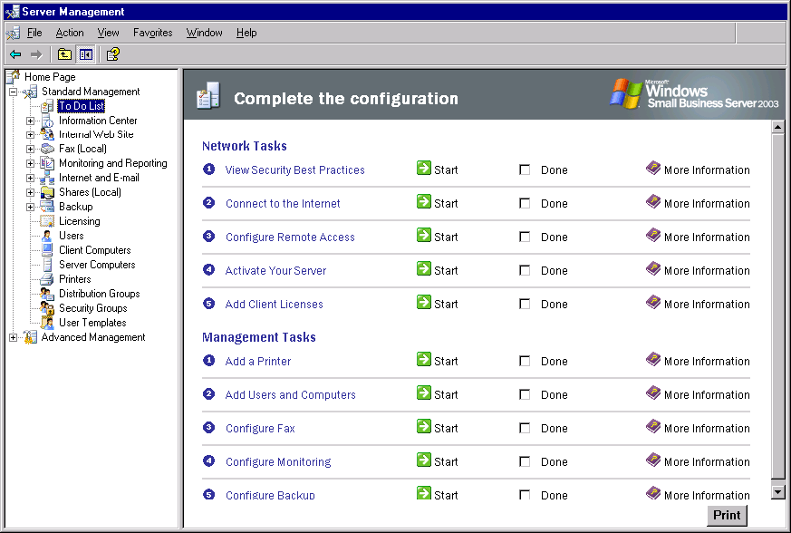

Activate Your Server
Complete this task to activate your installation of Windows Small Business Server. When you click Start for this task, the Activate Windows wizard appears. For more information about server activation, see Server Activation.

Add Client Licenses
Complete this task to add and activate new CALs. When you click Start for this task, the Add License Wizard appears. The Add License Wizard allows you to activate CALs automatically over the Internet or manually by telephone. After specifying which method you will use, follow the instructions to enter each license code that you were provided at the time you purchased your CALs. Microsoft will then automatically validate the license codes and provide confirmation IDs that authorize the activation.
Using the Add License Wizard, you can activate new client access licenses (CALs) or reissue existing CALs on the same computer after reinstalling the server software.
While using the wizard, you will be prompted to contact Microsoft one of two ways:
• Use the Internet. It is recommended that you use the Internet to activate CALs online.
• Use the telephone. Use the telephone only if you do not have an Internet connection. You will be provided with the phone numbers.
Before you continue with the Add License Wizard, you will need to:
• Activate your server. For more information about activating your server, see Server Activation.
• Provide the license codes that were provided at the time the CALs were purchased.
If you will be using the telephone method, be prepared to:
• Provide the Installation IDs from the Telephone Information page in the wizard.
• Write down the Confirmation IDs that you receive when you call to activate your CALs.

License Code Activation Failure
License code activation can fail if any of the following conditions occur:
• Your connection to the Internet is interrupted.
• A connection cannot be made to the Microsoft Clearinghouse.
• Significant changes have been made to the hardware configuration of your server.
• One or more license codes cannot be verified.
Ensure that you are connected to the Internet, and then run the wizard again. If you still cannot connect using the Internet, you can use the telephone method for activation.
If the problem persists, contact Microsoft Product Support Services.
Note:
If you are unable to connect to the Internet, run the Configure E-mail and Internet Connection Wizard. To run the wizard, click Connect to the Internet in the Internet and E-mail snap-in in Server Management.

Using Licensing Wizards
To help you manage your client access licenses (CALs), four wizards are included with your server installation.

Wizard | Description
Add License Wizard | Adds new CALs or reissues existing CALs for the same server. To add or reissue CALs, you must contact Microsoft in one of two ways:  • Use the Internet. It is recommended that you use the Internet to add CALs online.  • Use the telephone. Use the telephone only if you do not have an Internet connection. You will be provided with the phone numbers during the activation process.  For more information, see To add client access licenses.
Transfer License Wizard | Reactivates CALs after making significant changes to server hardware or after migrating the server software to a different computer. This wizard requires that you use the telephone method to contact Microsoft.  For more information, see To transfer client access licenses.
Back Up License Wizard | Backs up your CALs only. This wizard does not back up your system files. This is a recommended practice and can reduce downtime if you ever need to recover from loss or corruption of a CAL.  For more information, see To back up or restore client access licenses.
Restore License Wizard | Restores your CALs on the same computer following loss or corruption of your licenses. You can use this wizard only if you have previously used the Back Up License Wizard to back up your licenses.  If you do not have a valid backup, you may not be able to recover your CALs using the Restore License Wizard.  If you are unable to restore your CALs from backup, you must add or reissue CALs to the server.  For more information, see To back up or restore client access licenses.

Note:
To manage CALs or view details about installed licenses and usage, click Start, point to Administrative Tools, and then click Licensing.
For more information about client access licenses, see To add client access licenses.

Manage Your Licenses
Using the Manage Your Licenses taskpad, you can manage client access licenses (CALs) and view license information and history.
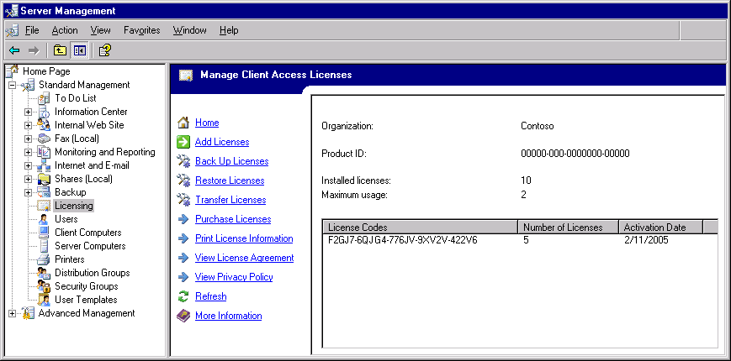

Understanding the Taskpad
The following table describes the information listed on the taskpad.

Taskpad Information | Description
Product ID | Displays the product ID for the server, for support purposes. The IDs for the individual licenses are in the License Codes column in the table at the bottom of the taskpad.
Installed licenses | Displays the total number of licenses installed on the server, including the five licenses that are included with Windows Small Business Server 2003.
Maximum usage | Tracks the number of licenses in use by polling the licensing service on the server. Use this information to determine if you need to purchase more licenses.  Note:  Because the licensing service is polled periodically, rather than on an ongoing basis, the Maximum usage number might not reflect the exact number of licenses in use at all times.
License Codes table | Lists the license codes for licenses added beyond the five licenses that are included with Windows Small Business Server 2003.

Tasks
The following table describes the tasks on the Manage Your Licenses taskpad.

Task | Description
Add Licenses | Starts the Add License Wizard, enabling you to activate the client access licenses you have purchased. You can activate licenses either over the Internet (recommended) or by telephone.
Back Up Licenses | Starts the License Backup Wizard, enabling you to create a backup of your client access licenses.
Restore Licenses | Starts the License Restore Wizard, enabling you to restore client access licenses that were previously backed up by using the License Backup Wizard.
Transfer Licenses | Starts the Transfer License Wizard, enabling you to reactivate licenses after making significant changes to server hardware. License transfers require the telephone method of contact.
Purchase Licenses | Opens a site on the Microsoft.com Web site where you can purchase additional client access licenses online. An Internet connection is required.
Print License Information | Displays license information in the Web browser, from which it can be printed.
View License Agreement | Displays the end-user license agreement (EULA) in the Web browser, from which it can be printed
View Privacy Policy | Displays the privacy policy in the Web browser, from which it can be printed.

Procedures
This section contains quick procedures for accomplishing common tasks.
To activate Windows Small Business Server
1. Click Start, point to All Programs, and then click Activate Windows.
2. From the Windows Product Activation Wizard, click Yes, let's activate Windows over the Internet now. After this selection, you will be given the option to register now or later.
Note:
Alternatively, to open the Windows Product Activation Wizard, click Start, click Run, and then type the following:
oobe /msoobe /a
To prevent system downtime, you should not use the server until it has been activated.
If you do not have an Internet connection, you can activate Windows by phone.
1. Click Start, click All Programs, and then click Activate Windows.
2. In Windows Product Activation, select Yes, I want to telephone a customer service representative to activate Windows.
3. After you select the appropriate location, you are provided with a telephone number and an installation ID that you can give to the customer service representative to complete the activation process.
To complete the following procedure, you must be logged on as a member of the Domain Admins security group.
To add client access licenses
1. Click Start, point to Administrative Tools, and then click Licensing.
2. Details about your currently installed client access licenses (CALs) appear in the details pane.
3. In the details pane, click Add Licenses to open the Add License Wizard, and then follow the wizard instructions.
4. On the Contact Method page, select whether you will use the Internet or the telephone to activate licenses.
5. After completing the wizard, refresh the details pane to verify the successful activation of your CALs.
Note:
Before you add CALs, you must activate your server. For more information, see Server Activation.
You will be required to provide the license codes that you received when you purchased your CALs.
If you have the option between using the telephone or the Internet to activate CALs, it is recommended that you use the Internet.
If you are using the telephone to activate the CALs, be prepared to provide a customer service representative with the Installation IDs from the Confirmation Information page in the wizard. You can print both the contact information and Installation IDs from the Confirmation Information wizard page.
To complete the following procedure, you must be logged on as a member of the Domain Admins security group.
To reissue client access licenses to the same server
1. Click Start, point to Administrative Tools, and then click Licensing.
2. Details about your currently installed client access licenses (CALs) appear in the details pane.
3. In the details pane, click Add Client Licenses to open the Add License Wizard, and then follow the wizard instructions.
4. On the Contact Method page, select whether you will use the Internet or the telephone to reissue licenses.
5. After completing the wizard, refresh the Licensing console to verify the successful reissue of your CALs.
Note:
You will be required to provide the license codes that you received when you purchased your CALs.
If you have the option between using the telephone or the Internet to activate CALs, it is recommended that you use the Internet.
If you are using the telephone to activate the CALs, be prepared to provide a customer service representative with the Installation IDs from the Confirmation Information page in the wizard. You can print both the contact information and Installation IDs from the Confirmation Information wizard page.
If you have made changes to the hardware configuration of your computer since first adding the CALs, you may be required to transfer licenses rather than reissue them.
To avoid the need to reissue CALs, it is recommended that you restore licenses from backup whenever possible.
To complete the following procedure, you must be logged on as a member of the Domain Admins security group.
To transfer client access licenses
1. Click Start, point to Administrative Tools, and then click Licensing.
2. Details about your currently installed client access licenses (CALs) appear in the details pane.
3. In the details pane, click Transfer Licenses to open the Transfer Licenses Wizard, and then follow the wizard instructions.
4. After completing the wizard, refresh the Licensing console to verify the successful transfer of your CALs.
Note:
Before you add CALs, you must activate your server. For more information, see Server Activation.
You will be required to provide the license codes that you received when you purchased your CALs.
You will be prompted to use the telephone to complete the transfer of CALs. You will be provided with the phone numbers.
To complete the following procedure, you must be logged on as a member of the Domain Admins security group.
To back up or restore client access licenses
1. Click Start, point to Administrative Tools, and then click Licensing.
2. Details about your currently installed client access licenses (CALs) appear in the details pane.
3. Do one of the following:
• To back up licenses, click Back Up Licenses.
• To restore licenses, click Restore Licenses.
4. Follow the instructions to specify a file name and location for your backup file, and then complete the wizard.
Note:
Before you can back up or restore CALs, you must activate your server. For more information, see Server Activation.

Wizard Help
The following contains additional Help topics from the Add License Wizard.

Welcome
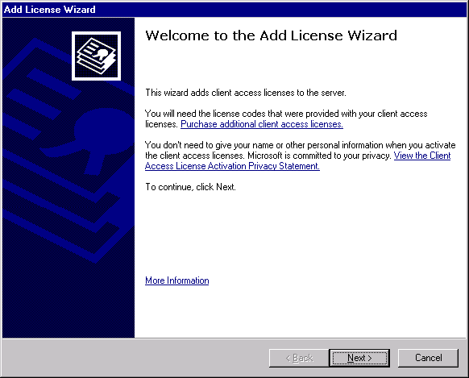

Using the Add License Wizard, you can activate new client access licenses (CALs) or reissue existing CALs on the same computer after reinstalling the server software.
While using the wizard, you will be prompted to contact Microsoft one of two ways:
• Use the Internet. It is recommended that you use the Internet to activate CALs online.
• Use the telephone. Use the telephone only if you do not have an Internet connection. You will be provided with the phone numbers.
Before you continue with the Add License Wizard, you will need to:
• Activate your server. For more information about activating your server, see Server Activation.
• Provide the license codes that were provided at the time the CALs were purchased.
If you will be using the telephone method, be prepared to:
• Provide the Installation IDs from the Telephone Information page in the wizard.
• Write down the Confirmation IDs that you receive when you call to activate your CALs.
Note:
You cannot use the Add License Wizard to transfer CALs from one computer to another. To transfer CALs, use the Transfer License Wizard.
Microsoft does not collect any personal information during the CAL activation process. To learn more about the type of information that is collected, and how it is used, read the Privacy Policy. A link to this policy is included on the Welcome page of the wizard.
For more information about your CALs, see the end-user license agreement (EULA). You can view the EULA by clicking View License Agreement in the Licensing snap-in.

License Code Information
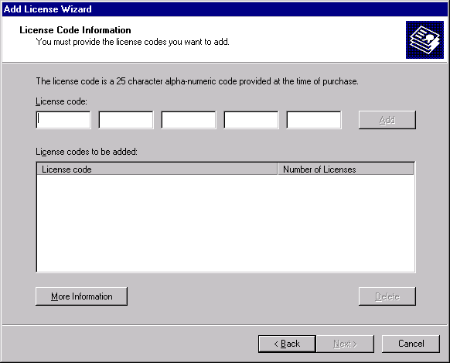

When you purchase additional client access licenses (CALs), you are provided with a license document that contains a 25-character license code. This code is associated with that particular set of CALs.
On this page of the wizard, under License Code, type the license code for each set of CALs that you want to activate, and then click Add.
After adding the license codes to the list, verify that each code is accurate. This will help prevent delays during the activation process. If you find an error in a license code, delete it from the list, and then retype it.
Once you have added all license codes to the list and verified their accuracy, click Next to continue with the license activation process.

Telephone Information
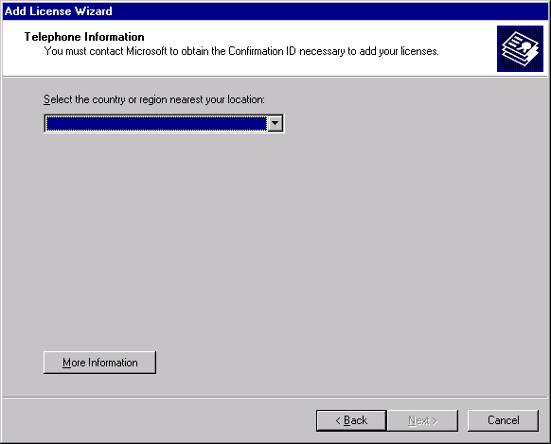

On this wizard page, select the country or region nearest your location.
When you click Next, the wizard determines the appropriate telephone number to call and displays it on the next page. Whenever possible, you will be provided with a toll-free number to call.
On the next page of the wizard, you will also be provided with an Installation ID that is generated for your license code. Provide the Installation ID to Microsoft when you call. In return, you will be provided with a Confirmation ID, which you will then type in the space provided. If you entered more than one license code to activate, click Next to receive the next Installation ID. Continue this process until you have entered a Confirmation ID for each Installation ID that is generated.

