Microsoft Office

Project Standard 2007

Project Professional 2007

April 2006

February 2006

February 2006



Table of Contents

Cover is for   
position only

Overview of Microsoft Office Project Standard 2007 and Office Project Professional 2007 1

Get Productive Quickly 2

Understand and Control Project Schedules and Finances 2

Effectively Communicate and Present Project Information 3

Get Productive Quickly 3

Learn to Use Project 4

Follow the Project Guide 4

Tap Office Online Help and Training 5

Save Time with Templates 5

Use Predefined or Office Online Templates 5

Create Your Own Template 6

Understand and Control Project Schedules and Finances 8

Trace the Source of Issues 8

Reverse Changes (and Typos) 9

See the Effects of a Change 10

Control Project Finances 11

Establish Budgets 11

Assign Costs to Tasks with Cost Resources 12

Effectively Communicate and Present Project Information 13

Use Project Views to Convey Information 13

Use Predefined Reports in Project 14

Build Professional Reports 14

Export Project Information to Office System Programs 15

Create Report Templates in Excel or Visio 15

Summary of Product Benefits 18

Backward Compatibility 18

Resources 19

System Requirements 20

# Overview of Microsoft Office Project Standard 2007 and Office Project Professional 2007

Designed for workers with deadlines and deliverables, as well as project managers who work as individual contributors, Microsoft® Office Project Standard 2007 gives you the solution to plan, manage, and communicate project information, resulting in increased productivity and effectiveness.

Project provides you robust project management tools with the right blend of usability, power, and flexibility, so you can manage projects more efficiently and effectively. You can stay informed and control project work, schedules, and finances; keep project teams aligned; and be more productive through integration with familiar Microsoft Office system programs.

In several key areas, Microsoft Office Project 2007 empowers users to:

* Achieve individual excellence by creating work plans that help to ensure timely project deliverables.
* Understand the impact of scope changes to help control work, schedule, and finances.
* Align efforts by communicating effectively and reporting on project information.

With Project, you can quickly create project plans using templates, importing task lists, following the online guide or building your own. Track your people, equipment, and other resources in Project for insight into utilization and scheduling. Test scenarios with a clearer understanding of their impact on the schedule—and easily reverse your changes. New financial capabilities give you budgets, cost tracking, and rich analytics. Set expectations of all stakeholders in your work with clear communications, either directly in Project reports or through integration with other Microsoft Office system applications.

If you think that your needs will grow and you will want to collaborate with others, then you should consider obtaining Microsoft Office Project Professional 2007, which in addition to all the capabilities of Office Project Standard 2007 also includes the ability to connect with Microsoft Office Project Server 2007. Please refer to the documentation on Microsoft Office Enterprise Project Management Solution to learn more about how Office Project Server 2007 enables collaborative project management for teams. (Note that Office Project Standard 2007 does not connect to Office Project Server 2007.) Office Project Professional 2007 can also be used as a stand-alone desktop tool without the server.

### Get Productive Quickly

Quickly master the project management process with the Project Guide, a step-by-step, interactive tool to get you started. With Office Project 2007, you can easily assign resources to tasks and adjust their assignments to resolve conflicts and over-allocations. Use the numerous predefined templates of Office Project 2007 for a quick start, or create your own custom template, which can be sent to other users to create consistency.

### Understand and Control Project Schedules and Finances

Set realistic expectations with project teams, management, and customers using Office Project 2007 to build schedules, allocate resources, and manage budgets. Understand the schedule with features like Task Drivers for understanding the start date of a task, Multiple Level Undo for testing scenarios, and cell change highlighting for automatically shading the data affected by a change.

* **New!** **Tasks Drivers** show prerequisites and resource constraints that drive the start date of the selected task. Simply click these drivers to link to relevant information.
* **New!** Determine the impact of each change you make with **Visual Change Highlights** on all other dependent tasks.
* **New!** Reverse the most recent series of changes: undo and redo changes to views, data, and options with **Multiple Level Undo**. With this functionality you can also undo actions or sets of actions from macros or third-party applications.
* **New!** Pre-defined financial fields, such as cost codes, improve mapping to the financial fields tracked in project accounting systems.
* **New!** Use **Budget Tracking** to define a budget at a high level (program or project) so the project manager can allocate funds and track costs against the budget.
* **New!** Now planned and actual costs can be assigned to a task with **Cost Resources**, which also supports integration of Project with accounting systems.

### Effectively Communicate and Present Project Information

Easily present information in various formats according to the needs of stakeholders. You can format and print one-page schedules or other reports. Smoothly export project-related data into Microsoft Office Word for formal documents, Microsoft Office Excel® for custom charts or spreadsheets, Microsoft Office PowerPoint® for crisp presentations, or Microsoft Office Visio® for diagrams.

* **New!** Use Excel and Microsoft Office Visio Professional to product charts, graphs, and diagrams based on Project data by means of the **Visual Reports** feature. You can easily define custom report templates and share these with other Project users. These reports include a data cube for drill downs and pivots.
* **New!** **Background Cell Highlighting** enables you to shade cells, similar to how you can in Excel, in order to convey additional meaning.
* **New!** With enhancements to the **Calendar Interface** and the addition of **3-D Gantt bars**, you can create even more visually effective reports.

# Get Productive Quickly

Project helps you better organize work and people to help ensure that projects are delivered on time and within budget.

* Learn to use Project by following the Project Guide, an interactive step-by-step planning aid, which helps you to quickly master the project management process.
* Save time with project templates. Select from a template that ships in the box. Or download a template from the Microsoft Office Online Template Gallery to start your projects, rather than starting from scratch.

## Learn to Use Project

Project enhances your productivity and effectiveness by helping you easily learn and apply project management practices with a familiar interface, user assistance, and a helpful online Project Guide that directs you through the project management process. The Project Guide includes four areas: Tasks, Resources, Track, and Report. The opportunities to learn are not limited to the product. You can take advantage of online Help and training to access relevant and up-to-date support.

### Follow the Project Guide

Quickly master the project management process with the Project Guide, a step-by-stepinteractive aid that helps you set up projects, manage tasks and resources, track schedules, and report project information. The Project Guide, which can be turned on or off as needed, helps you learn, explore, and discover available features while quickly navigating through the project management process. With the provided instructions and wizards, you can quickly complete activities, such as defining your project, entering [tasks](javascript:AppendPopup(this,'pjdefTask_2')), assigning resources, and reporting project information to stakeholders and team members. You can also customize data fields and analytics for information specific to your projects. As you become familiar with the project management process, simply turn off the Project Guide, which is displayed by default. You can even create custom Project Guides that can be used to maintain consistency or deploy a sepcific project management methodology within your corporation.

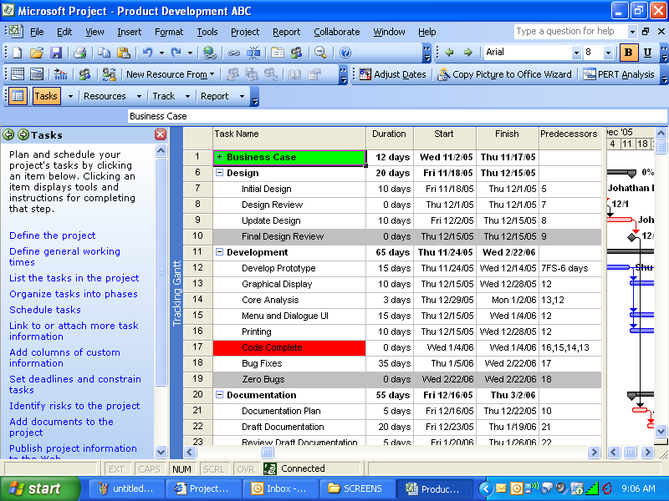

Figure 1: The Gantt view with the Project Guide’s Tasks pane showing on the left

### Tap Office Online Help and Training

Get quick help while you work. Project provides a wealth of assistance for both novice and experienced users. Project includes a robust Help search engine, Smart Tags, and wizards, and is further enhanced with online access (requires Internet connection) to training courses, templates, articles, and more. Note that Internet service provider fees and connect-time charges may apply.

## Save Time with Templates

Project provides a wide range of predefined templates to help speed your project management process. Templates give you a quick start that automatically populate a new project with useful information. A template, in the Office Project .mpt file format, can capture task and resource information, formatting, macros, and other project-specific settings.

### Use Predefined or Office Online Templates

When creating a new project, you can opt for templates that are provided from the Project installation, or go to Microsoft Office Online to download templates from the gallery on the Web. The Microsoft Office Online templates can be used just like any other Project template: simply download the template you need. The out-of-the box templates cover a range of industries, functional areas, and business problems. Templates include areas such as Commercial Construction, Engineering, Project Office, and New Product—all of which are designed to fulfill a specific objective that meets your industry and project management needs.

There are also two templates that you can use in Microsoft Office Excel 2003 to start a new project, create a task list, and include resources; you can then import this information to Project. These templates automatically map fields and information directly to Office Project Standard 2007 or Office Project Professional 2007. Office Project Standard 2007 and Office Project Professional 2007 Task List Import template helps you build a basic task list. Office Project Standard 2007 and Office Project Professional 2007 Plan Import Export template enables you to create the task list, add resources, and make assignments. This template can be imported to Office Project Standard 2007 or Office Project Professional 2007 and exported back to Office Excel for revising.

### Create Your Own Template

In addition to the predefined and Microsoft Office Online templates, you can create your own templates based on previous projects. Take advantage of your own best practices by creating your own custom template. This enables you to reuse an existing project as the basis for future projects. You can send templates to other users in e-mail to share best practices and create consistency.

Office Project 2007 in Action: Creating a new project

Doris Hartwig, a project manager for Fabrikam, has been assigned to develop the next version of a Fabrikam product. To get started, Doris turns to a file share of Project templates that capture best practices to be followed. Selecting the appropriate template, she creates a new project. Using Task pane prompting in the Project Guide, she tailors the template to her needs by adding columns for custom information, identifying risks, and adding documents. The Resource pane prompts her to specify people and equipment; for the former, she imports coworkers on Fabrikam’s Microsoft Exchange Server. The Resource pane then guides her to define the coworkers’ booking types, (committed vs. proposed) working times, and other details before assigning specific resources to replace the generic ones in the template. In the Track pane of the Project Guide, Doris sees a reference to a baseline plan. Curious, she uses the links to the Project Help system to learn more. She decides a baseline would be useful for obtaining reliable progress tracking information throughout the project. She follows the guidance to create a baseline of her plan. After saving the project, Doris talks to her colleagues to gather more ideas.

# Understand and Control Project Schedules and Finances

With Project you can manage and understand your project schedules by tracing the source of issues, testing alternative scenarios, and seeing the effects of a change. You can better organize your projects and people with the scheduling power and capabilities of Project.

* See the immediate reasons for a task’s start date, and trace back through these constraints. The Task Drivers pane shows the constraints that drive a task’s start time and help you backtrack and analyze the constraints. Track and evaluate effects of schedule and resources changes to overall project plans.
* Multiple Level Undo enables you to test what-if scenarios and then undo the changes.
* As you test each scenario, the effects of the most recent change automatically become shaded with Visual Change Highlights. Now you can quickly see how the schedule reacts as you alter resources and tasks.
* Gain better control of project finances with Budget Tracking and Cost Resources.

## Trace the Source of Issues

Task Drivers show the constraints that drive a task’s start time and help you backtrack to analyze the constraints. Providing quick access to factors affecting task dates and enabling easy tracing of critical paths in project plans, you can trace the source of issues and promote accountability. Determine the factor (such as task dependency, calendar constraints, schedule date, or vacation time) driving the start date of the task, and follow a chain of factors to find the root cause of a particular delay. This understanding enables you to set and manage realistic expectations with project teams, management, and customers.

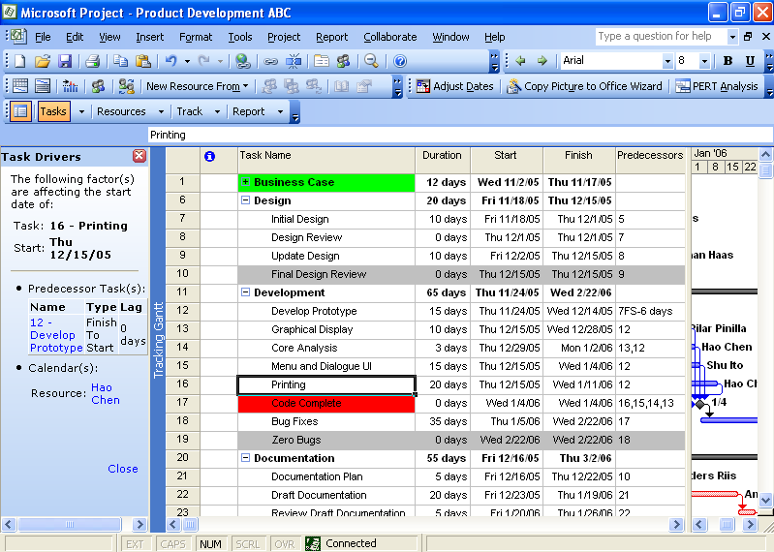

Figure 2: Task Drivers pane

## Reverse Changes (and Typos)

When changes to a project are necessary, Project makes it easy to test these changes with the new Multiple Level Undo feature. Increasing ease of use and the ability to experiment with different scenarios, Multiple Level Undo enables you to make, undo, and redo changes to views, data, and options. You can undo actions or sets of actions from macros or non-Microsoft applications, enabling you to test several what-if scenarios in order to fully understand the implications of each choice while making scope changes. While we don’t expect you’ll never make a typo, now your safety is enhanced, even if you realize a mistake several steps after the typo occurred.

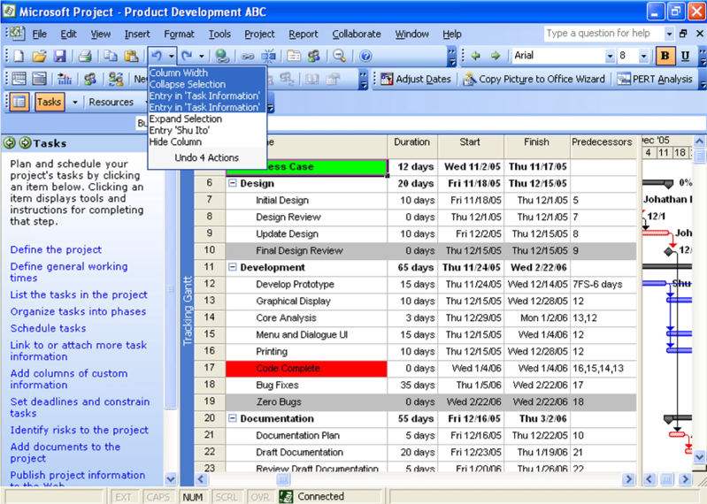

Figure 3: Expanded Multiple Level Undo menu

## See the Effects of a Change

Determine the impact of each change on all other dependent tasks with Visual Change Highlights. Office Project 2007 can automatically highlight all items that shift as a result of the most recent change you make. This feature works in conjunction with the Task Drivers pane, which shows why tasks start when they do—so you can work back to resolve slips for control of delivery.

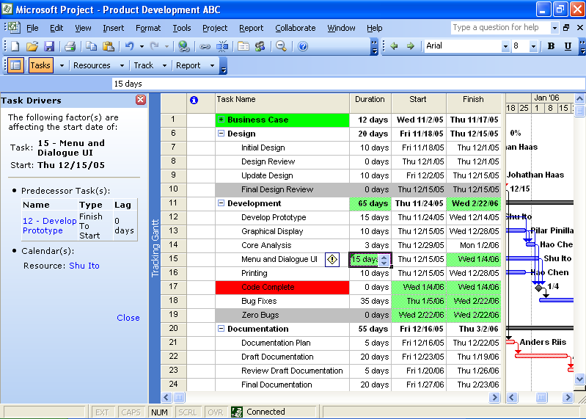

Figure 4: Green highlights indicating the effects of an edit to task 15’s duration

## Control Project Finances

With Project, you can easily control finances with Budget Tracking, so you can assign budgets to projects and programs. The new Cost resource type improves cost estimation and tracking. Other cost enhancements include more predefined fields that map to financial fields tracked in project accounting systems. User-defined budget categories, from Travel and Entertainment to Cost of Goods, provide a finer level of control.

### Establish Budgets

Historically, Project aggregated actual costs from the bottom up as work occurred on tasks. This permits very accurate reporting on progress. Now you can assign a budget number to an entire project or program.

### Assign Costs to Tasks with Cost Resources

In the previous version, Project included two types of resources: Work and Material. In Office Project 2007, you gain an additional type of resource: Cost. Now for each task, you can assign multiple arbitrary costs (not based on work time) and use custom fields to specify cost type or financial code. Using Cost resources, you can more accurately monitor project financials and keep your project in sync with data in your accounting systems.

Office Project 2007 in Action: Testing alternative scenarios

The Fabrikam project that Doris is managing has been falling behind schedule and losing control of costs. Doris wonders what would happen if she made resource changes to her project and reallocated staff for the next phase. She experiments with reassigning resources to different tasks. Considering several possible approaches, she makes a first change. The Visual Change Highlights feature shows her how the first change has affected dependent tasks. She continues making the changes for one approach to getting back on track. Unfortunately, this first approach leads to new scheduling problems in later phases of the project and also pushes her further out of compliance with her initial top-down budget. So, using Multiple Level Undo, Doris reverses the entire set of changes. She then goes on to explore other approaches that could help get the project back on track.

# Effectively Communicate and Present Project Information

Project helps you set realistic expectations with project teams, management, and customers. Project helps you communicate progress and issues effectively.

* Print and convey information by formatting different views available on the desktop. These views can then be shared with other users.
* Quickly increase your impact at work by communicating and presenting ideas and information in flexible predefined reports.
* Use other Microsoft Office system programs for reporting. Analyze and report Office Project 2007 data in professional reports and charts by using the Visual Reports feature, which generates reports using Visio diagrams and Excel charts based on Project data.

## Use Project Views to Convey Information

Updated views and visual capabilities within Project make better reports possible. For example, change the background color of a cell or row to convey additional meaning with the Background Cell Highlighting feature, similar to the ability you have in Excel.

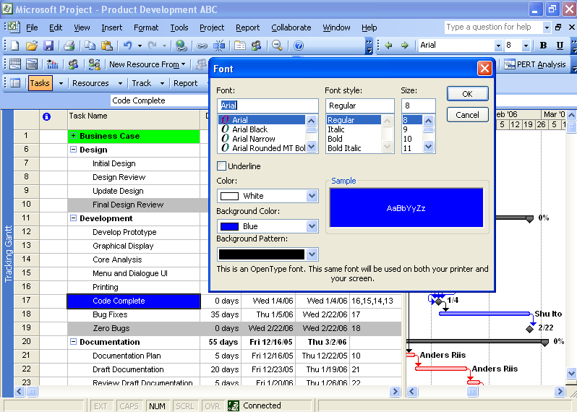

Figure 5: Background Cell Highlighting

## Use Predefined Reports in Project

You can simply select, preview, and print the most frequently used information needed to manage projects, track resources, maintain costs, and communicate progress to your team. Project includes predefined task, resource, and cross-tab reports for you to print. You can adapt any of these reports to present the specific information you want to display. You can also specify the format of details such as column totals, gridlines, or borders.

Information is gathered through selected fields within your project, and is then presented in a report design that take only a few minutes to generate, reflecting the latest changes made by your team.

## Build Professional Reports

Present information to project stakeholders by using integration with other Microsoft Office system programs. The Copy Picture to Office Wizard takes static snapshots of Project information. With Visual Reports, you send a cube of data, not just a single static view. The cubes you create in the Visual Reports permit filters and pivots, which give you a deeper understanding of the status of your projects’ resources, costs, and schedules. You can easily create professional charts and reports with outstanding visuals, and create custom report templates that may be reused with different Project data.

### Export Project Information to Office System Programs

In previous versions of Project, you could create a picture to copy to another application such as PowerPoint by using the Copy Picture command. Through a bit of trial and error, you could select the right options to give you what you wanted. The process is greatly streamlined with the Copy Picture to Office Wizard. The wizard guides you through the steps of creating a picture for a targeted application.

To start the wizard, from the **View** menu, click **Toolbars**, and then select **Copy Picture to Office**. Next, on that toolbar, click the **Copy Picture to Office Wizard** button. The wizard guides you through the steps of creating a picture for a targeted program.

### Create Report Templates in Excel or Visio

The new Visual Reports feature is a flexible solution that uses Office Excel 2003 or later and Microsoft Office Visio Professional 2007 to produce great-looking charts, graphs, and diagrams based on Office Project 2007 data. Specifically, you can drill into project data, using PivotTable® and PivotChart® views in Excel and PivotDiagram views in Visio. Easily export Project data to Excel or Visio to create custom reports, and even save the reports as templates for others to use. Publish report templates to shared folders or Microsoft Office Groove 2007 to share with other team members.

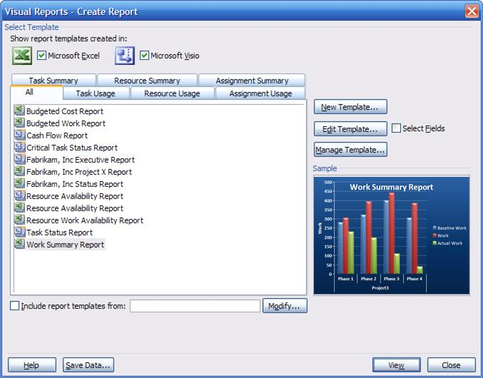

Figure 6: The Visual Reports window with an Excel report

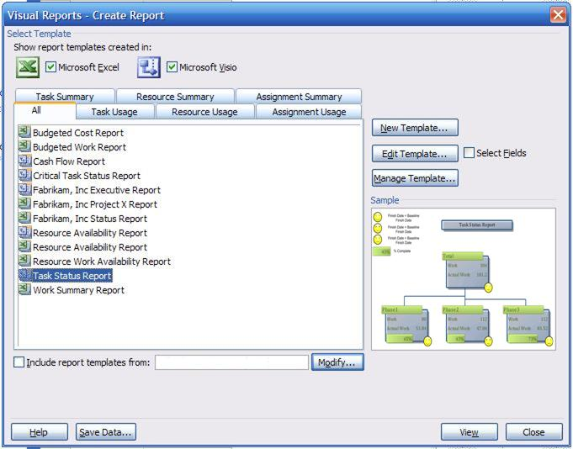

Figure 7: The Visual Reports window with a Visio report

Office Project 2007 in Action: Managing stakeholders’ expectations

Doris is meeting with the executive management team in just a few minutes, to provide an update on the project she is managing. In order to provide a clear presentation of how resources and costs are being allocated, Doris has already prepared a PowerPoint presentation. She wants to include the latest information available from that day, and uses the Visual Reports feature to quickly export her Office Project 2007 data to Office Visio Professional 2007, creating a great-looking diagram that she can place in her PowerPoint slides. She also chooses to prints the predefined reports (which take only minutes to generate) providing key information in a cross-tab report on cash flow and another on resource usage. The reports pull all the information and display trends so she can readily address the management team’s concerns with professional results.

During the meeting, the diagram comes under scrutiny. Doris launches Office Visio 2007 opening the file. Clicking on the lowest level, she adds another level and drills down for a record’s details. Fortunately, the diagram’s backed by a cube of data from Office Project 2007 that permits filtering.

# Summary of Product Benefits

Project is a leading project management tool for people who want to make an impact at work by being able to better plan, manage, and communicate project information.

* You can plan work with the Project Guide and control work with new financial features.
* You can effectively track and analyze projects with a better understanding of the schedule as well as the ability to test and reverse multiple changes.
* You can clearly communicate project information to set expectations for management and to keep all stakeholders on the same page.

To download a trial version of Microsoft Office Project Standard 2007 or Microsoft Office Project Professional 2007, visit [Microsoft Office Online](http://ipoappre101/en-us/products/HA101741481033.aspx).

# Backward Compatibility

Both Office Project Standard 2007 and Office Project Professional 2007 can open files created in previous versions of Project. You can save project plans in prior formats, for example Microsoft Project 98 .mpp file format or Project 2003, Project 2002, and Project 2000 file formats. Any features that do not map to prior file formats will be discarded when a project is saved in that older file format.

Office Project Standard 2007 and Office Project Professional 2007 saves to file formats including XML, CSV (comma-separated values), text (tab-delimited), Microsoft Office Excel workbook, Microsoft Office Excel PivotTable, Web page, and Microsoft Office Project Standard 2003 and Office Project Professional 2003. Microsoft Office Project 2000 and earlier versions no longer save project plans to the .mpx format. Office Project Standard 2007 and Office Project Professional 2007 no longer support OLEDB.

# Resources

To learn more about Office Project Standard 2007 or Office Project Professional 2007, please refer to the following list of related links for additional resources and information.

* **Microsoft Office Project Home Page**

http://www.microsoft.com/office/project

* **Business Value from Microsoft Office Enterprise Project Management** <http://www.microsoft.com/business/epm.aspx>
* **Microsoft Project Association**

<http://www.mympa.org>

* **Microsoft Project Community**

<http://www.microsoft.com/technet/community/en-us/project/default.mspx>

* **Microsoft Office Project Developer Center** <http://msdn.microsoft.com/office/understanding/project/default.aspx>
* **Microsoft Office Project TechNet**

<http://www.microsoft.com/technet/prodtechnol/project/default.mspx>

* **Microsoft Office Project Support Information**

<http://support.microsoft.com/default.aspx?pr=offpr2003>

# System Requirements

For complete system requirements, visit [www.microsoft.com/office/project](http://www.microsoft.com/office/project).

This document is developed prior to the product’s release to manufacturing, and as such, we cannot guarantee that all details included herein will be exactly as what is found in the shipping product. The information contained in this document represents the current view of Microsoft Corporation on the issues discussed as of the date of publication. Because Microsoft must respond to changing market conditions, this document should not be interpreted to be a commitment on the part of Microsoft, and Microsoft cannot guarantee the accuracy of any information presented after the date of publication. The information represents the product at the time this document was printed and should be used for planning purposes only. Information is subject to change at any time without prior notice.

This document is for informational purposes only. MICROSOFT MAKES NO WARRANTIES, EXPRESS OR IMPLIED, IN THIS DOCUMENT.

© 2006 Microsoft Corporation. All rights reserved. Microsoft, Excel, the Office logo, PivotChart, PivotTable, PowerPoint, and Visio are either registered trademarks or trademarks of Microsoft Corporation in the United States and/or other countries. All other trademarks are property of their respective owners.