Windows Azure
Customer Solution Case Study
 |  |  |   City Government Improves Service Offerings, Cuts Costs with ”Cloud” Services Solution

Overview  Country or Region: United States  Industry: Government  Customer Profile  The City of Miami encompasses approximately 36 square miles of land in southeastern Florida. Its municipal government provides a range of services to more than 425,000 citizens.  Business Situation  The city wanted to improve its applications that use powerful mapping technology. With shrinking IT budgets, the city needed a solution that was cost-effective and scalable.  Solution  The City of Miami chose the Windows Azure platform, along with Bing maps, to deliver to residents its 311 application, which takes advantage of sophisticated mapping technology.  Benefits  - Reduced IT maintenance costs  - Fast time-to-market  - Improved service offerings for citizens  - Cost-effective disaster recovery |  |  | “Windows Azure is the future for the City of Miami IT department.”  Conrad Salazar, Project Manager, City of Miami
 |  |  | The City of Miami, even when limited by a tight budget, looks for ways to improve the services it offers citizens. The city wanted to develop an online application to record, track, and report on nonemergency incidents, but the application’s sophisticated mapping technology would require significant computing resources. Further constrained by long hardware-procurement cycles, the city needed a cost-effective, scalable solution that would maximize its available resources. The city developed its 311 application on the Windows Azure platform, taking advantage of scalable storage, processing power, and hosting provided by Microsoft. As a result, the city was able to reduce IT costs, improve the services it offers citizens, and deliver those services faster than before. It also now relies on a cost-effective disaster-recovery model, an important benefit in this hurricane-prone region.
 |  |  | 

Situation
“[With Windows Azure,] we don’t have to worry about managing a costly infrastructure and can focus on delivering new services that positively impact citizens and our organization.”
James Osteen, Assistant Director of Information Technology, City of Miami

The City of Miami in southeastern Florida offers its citizens and visitors a tropical climate with beautiful beaches, a dynamic urban center, and a wealth of cultural, historical, and recreational attractions. The city’s 3,600 employees work in 83 locations and rely on a centralized IT department to provide reliable, cost-effective services.

The IT department for the city has not been unscathed in the midst of a turbulent economic climate and must continue to support the IT infrastructure and ongoing initiatives and develop new applications, all of which offer key services to Miami citizens. In fact, in three years, the IT department went from 104 personnel to only 80 and, by February 2010, saw its IT budget cut by 18 percent. In addition, the city was asked to further identify ways to cut another 10 percent of its operating budget. Adding to this challenge, the rest of the city is also operating under strict budgetary constraints, creating a conundrum for the IT department. With its shrinking budget, the IT department has witnessed a sharp increase in the number of service requests it receives to deliver new services, yet has fewer resources to address them.

Despite working with less budget and fewer personnel, the City of Miami’s IT department prides itself on improving services for citizens. For instance, one service that the city provides is the 311 nonemergency telephone line used to record and track issues reported by citizens. By dialing 3-1-1, residents can report issues, such as potholes on the street, incidents of illegal dumping, or a missed garbage collection. Residents are then issued a service-request number to track progress of the issue to resolution.
To improve the 311 service, the IT department wanted to develop a Web application that would enable citizens to track service requests online and also see other requests in their area. The city had already converted one of its zoning applications to Bing maps for enterprise and wanted to replace some other outdated Internet mapping applications that disseminate the city’s spatial data to the public.

Mapping applications are typically processing-power intensive, and the IT department was unsure that it had the server load and computing power to handle new mapping applications. Compounding the issue, the City of Miami hosts and maintains its own servers and has a five-year life span on its server hardware and maintenance. The IT department can only procure new server hardware once every five years and must predict server needs for five years in advance.

However, it is difficult to accurately predict load requirements over a five-year period with an IT department that regularly develops new applications to support the city, leading to potentially under-supported applications and poor application performance. For example, the city previously purchased a storage area network (SAN) and originally estimated that it needed 4 terabytes of storage for a five-year period. Three years after the purchase, the SAN was using 27 terabytes of storage—six times the predicted usage. “We can’t always anticipate what requirements will come up,” explains James Osteen, Assistant Director of Information Technology for the City of Miami. “As a government entity, we don’t have the luxury of upgrading our infrastructure whenever demand increases. We give it our best estimate and hope for the best.” At the same time that the IT department was concerned about under-performing applications due to inaccurate estimates, it also didn’t want to overspend and buy more server hardware than necessary, considering its budget.

Adding to its server procurement challenges, the City of Miami IT department must also take into consideration disaster recovery. In the hurricane-prone location, the IT department must ensure that it has enough server redundancy to keep its infrastructure running in the event of a disaster.

Furthermore, the IT department struggled with an application development process that was time-consuming. Multiple environments ran on separate servers for the building, testing, debugging, and quality-assurance (QA) processes, and different team members were responsible for each environment. To complete a project, developers had to submit separate work orders to each person in charge of an environment. “To fix a few lines of code—a task that should take 15 to 20 minutes—could take up to four days to complete,” says Conrad Salazar, Project Manager at the City of Miami. “Most of this time was spent just waiting for work orders to be resolved.” As a result, the IT department was occasionally slow to respond to business needs.

To succeed at its mission to deliver improved services to Miami residents while remaining a cost-effective, efficient organization, the IT department needed a solution that would offer enough processing power and storage to host applications with sophisticated mapping technologies. Any solution would also need to provide the ability to scale up and scale down—without requiring near-impossible accurate predictions for processing power and server load over a five-year period. In addition, the organization wanted a solution that would help simplify and speed its application development and deployment processes.

Solution
In an effort to address its needs for a scalable, cost-effective solution that would yield significantly more processing power, the City of Miami chose the Windows Azure platform from Microsoft. Windows Azure is a cloud services operating system that serves as the development, service hosting, and service management environment for the Windows Azure platform. Windows Azure provides developers with on-demand compute and storage to host, scale, and manage Web applications on the Internet through Microsoft data centers.

The city chose Windows Azure over other cloud services providers based on several factors. First, the city already supports its infrastructure with Microsoft products and technologies, including the Microsoft .NET Framework 3.5. “The bottom line is that we have a very small budget and very few individuals supporting our infrastructure, so we have to be very careful and minimize the number of platforms we use to make the most of our investment—and we do that with the Microsoft platform,” says Osteen. Second, the City of Miami chose Windows Azure because the IT department had recently evaluated the beta 2 release of the Microsoft Visual Studio 2010 development system and was impressed with its seamless integration with the development fabric in Windows Azure. (The development fabric simulates the Windows Azure environment on a local computer so that the city can run and test a product locally before deploying it.) Finally, the city based its decision in part on the pay-as-you-go pricing model for Windows Azure, which it found attractive considering the budget challenges it faced. “The pricing model is easy to understand and calculate, which was a huge advantage over other cloud offerings,” adds Osteen.

Powerful Mapping Technology in a Scalable Solution
The City of Miami teamed with Microsoft Gold Certified Partner ISC, a provider of rich, interactive mapping software for geospatial visualization and analysis, to develop the city’s 311 application, which is hosted entirely over the Internet. With the nearly limitless processing power offered by Windows Azure, the City of Miami can easily implement more
Built on Windows Azure, the Miami 311 application enables citizens to report and track nonemergency incidents.
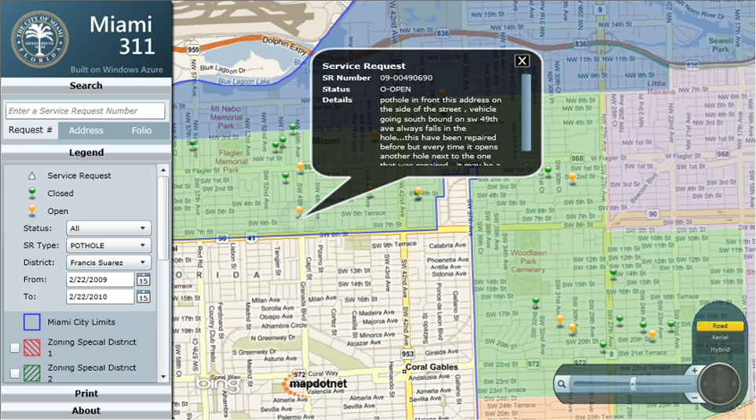
powerful mapping applications that require significant computing power.

The City of Miami used an off-the-shelf product from ISC called MapDotNet UX, which provides rich, interactive geospatial visualization and analysis. The latest version of MapDotNet UX is built specifically for Windows Azure and includes prepackaged Web services and a template for the Microsoft Silverlight 3 browser plug-in that integrates with Windows Azure storage services and with Bing maps for enterprise. The city uses Blob Storage to store spatial data, originally in a common shapefile or Keyhole Markup Language format, which are both popular formats for geospatial data.

Easy Development and Deployment
Developers at the City of Miami are excited about the development experience with Windows Azure. They can take the Silverlight template and compile it to a local development fabric. Then, they can extend application functionality or deploy it directly to Windows Azure. “With a local fabric, developers are able to quickly promote applications between development, staging, and production environments. They can do everything from their local instance, which results in quicker delivery of solutions to our clients: the citizens and businesses,” says Osteen.

In addition, with the development fabric of Windows Azure, applications are isolated from one another and developers are not concerned about new applications or feature upgrades interfering with existing applications. This also helps make for a cost-effective solution when the city is procuring server hardware. “With our five-year purchasing cycle, we had to make sure to put as many compatible services on one server,” explains Salazar. “When we made upgrades, it could cause us to spend more time modifying and fine-tuning our code because we’d find that the applications interfered with an existing production application. Because Windows Azure isolates applications, we don’t have to worry about that and have much cleaner deployments.”

Opportunities for Future Development
The cost-effective solution and easy development and deployment processes open the door for the IT department at the City of Miami to continue enhancing existing services and developing new services for citizens. After the initial launch of the 311 solution in March 2010, developers plan to add more functionality to the application, including the ability for users to submit service requests with photos, global positioning system location, and a description directly from their Windows phone or Apple iPhone. In addition, the city could send status updates and notifications to users by e-mail message or short message service (SMS). “Windows Azure is the future for the City of Miami IT department,” sums Salazar.
“The pricing model is easy to understand and calculate, which was a huge advantage over other cloud offerings.”
James Osteen, Assistant Director of Information Technology, City of Miami

Benefits
By using the Windows Azure platform, the City of Miami efficiently implemented its 311 nonemergency response application. The scalable solution, which has near limitless storage and processing power, enables the city to reduce costs—critical to the department’s success in a global economic crisis. In addition, the city is able to bring new applications to market more quickly and has improved its ability to offer new, enhanced services to Miami residents. And by relying on hosting at Microsoft data centers, the hurricane-prone city improved its disaster-recovery strategy.

Reduced IT Costs
With a tight IT budget that continues to shrink, the City of Miami runs lean IT operations and relies on an easily managed IT infrastructure. With Windows Azure, the city can eliminate much of its need to procure, host, and manage its own physical servers—representing a 75 percent savings in the first year over hosting the application on premises. It also does not need to redirect valuable developer resources or hire additional staff to deploy and manage the server infrastructure. Instead, because the solution is hosted by Microsoft, the city can rely on enterprise-class service for maintenance tasks.

The ability to scale vertically and horizontally also enables the IT department to reduce costs. Instead of running the risk of buying too much server hardware during its five-year procurement cycle, the city can now forego an often inaccurate process for estimating storage and processing needs, and simply use, and pay for, what it needs to run its applications. During peak traffic, such as during hurricane season, the city can increase its server capacity in the Windows Azure environment and then scale down when the peak period is over.

Fast Time-to-Market
Previously, developers at the City of Miami had to use several different development environments, each managed by a different team member, causing delays in the amount of time it took to deploy applications. Now, with the development fabric in Windows Azure, developers can build and deploy applications from the same local instance, eliminating the need for an unnecessarily protracted testing, debugging, and QA process. As a result, the IT department is able to deploy new solutions to citizens quickly. “We already had an efficient development team, and developing in Windows Azure is equally as fast since we already use Visual Studio 2010, the C# programming language, and the .NET Framework,” explains Salazar. “However, with Windows Azure and the ability to deploy locally, we’re able to speed up our time-to-market.”

Greater Ability to Offer New Services to Citizens
Citywide budget cuts mean that fewer personnel are trying to accomplish more with fewer resources, including looking for ways to automate processes while still improving services. “Even though the IT department is equally affected in terms of budget, everyone relies on technology even more in a budget crunch,” says Osteen. “With Windows Azure, we’re relying on a trustworthy solution—everything is hosted at Microsoft in data centers in multiple geographic locations—to make things simpler for our organization. We don’t have to worry about managing a costly infrastructure and can focus on delivering new services that positively impact citizens and our organization.”
“With Windows Azure and the ability to deploy locally, we’re able to speed up our time-to-market.”
Conrad Salazar, Project Manager,
City of Miami

Improved, Cost-Effective Disaster Recovery
The Miami area is often faced with destructive hurricanes, and while there is a recognized hurricane season, the storms are unpredictable. Previously, the IT department for the city had to ensure that it had enough servers for disaster-recovery purposes, resulting in a number of extra, underused servers during periods of low demand. With Windows Azure, the city is not only confident in its disaster recovery across Microsoft data centers, but it will also be able to eliminate the need for unused server hardware previously used in the event of catastrophic events, such as hurricanes, further avoiding unnecessary expenses for the city and its citizens.

Windows Azure Platform
For More Information
For more information about Microsoft products and services, call the Microsoft Sales Information Center at (800) 426-9400. In Canada, call the Microsoft Canada Information Centre at (877) 568-2495. Customers in the United States and Canada who are deaf or hard-of-hearing can reach Microsoft text telephone (TTY/TDD) services at (800) 892-5234. Outside the 50 United States and Canada, please contact your local Microsoft subsidiary. To access information using the World Wide Web, go to:
www.microsoft.com

For more information about ISC products and services, call (850) 893-6741 or visit the Web site at: www.goisc.com

For more information about the City of Miami, call (888) 311-3233 or visit the Web site at:
www.miamigov.com

Additional Resources:
Download: Windows Azure Tools and SDK
View: Architecting and Developing for Windows Azure

This case study is for informational purposes only. MICROSOFT MAKES NO WARRANTIES, EXPRESS OR IMPLIED, IN THIS SUMMARY.

Document published February 2010

Software and Services  - Windows Azure Platform  - Windows Azure  - Blob Storage  - Bing Maps for Enterprise | - Microsoft Visual Studio  - Microsoft Visual Studio 2010  - Technologies  - Microsoft .NET Framework 3.5  - Microsoft Silverlight 3  Partners  - ISC

The Windows Azure platform provides an excellent foundation for expanding online product and service offerings. The main components include:
- Windows Azure. Windows Azure is the development, service hosting, and service management environment for the Windows Azure platform. Windows Azure provides developers with on-demand compute and storage to host, scale, and manage Web applications on the Internet through Microsoft data centers. In addition, Windows Azure serves developers’ connectivity needs through the following services.
- Windows Azure AppFabric. Windows Azure AppFabric enables users to build and manage applications more easily both on-premises and in the cloud.
- The AppFabric Service Bus connects services and applications across network boundaries to help developers build distributed applications.
- The AppFabric Access Control provides federated, claims-based access control for REST Web services.
- Microsoft SQL Azure. Microsoft SQL Azure offers the first cloud-based relational and self-managed database service built on Microsoft SQL Server 2008 technologies.

To learn more about the Windows Azure platform, visit:
www.windowsazure.com

