

Operating System

Troubleshooting File and Printer Sharing in Microsoft Windows XP

Microsoft Corporation
Published: November 2003
Updated: August 2004

Abstract
File and printer sharing for Microsoft® Windows® XP allows you to share the contents of selected folders and locally attached printers with other computers on a home and small office network. File and printer sharing must first be enabled, and to share files you can use the Shared Documents folder, simple file sharing, or advanced file sharing. Once a folder or printer is shared, other users on the home network can connect to it using a variety of methods. This article describes how to create and connect to file and printer shares, the most common problems with file and printer sharing, and the set of tools used to troubleshoot file and printer sharing issues.

The information contained in this document represents the current view of Microsoft Corporation on the issues discussed as of the date of publication. Because Microsoft must respond to changing market conditions, it should not be interpreted to be a commitment on the part of Microsoft, and Microsoft cannot guarantee the accuracy of any information presented after the date of publication.
This document is for informational purposes only. MICROSOFT MAKES NO WARRANTIES, EXPRESS OR IMPLIED, AS TO THE INFORMATION IN THIS DOCUMENT.
Complying with all applicable copyright laws is the responsibility of the user. Without limiting the rights under copyright, no part of this document may be reproduced, stored in or introduced into a retrieval system, or transmitted in any form or by any means (electronic, mechanical, photocopying, recording, or otherwise), or for any purpose, without the express written permission of Microsoft Corporation.
Microsoft may have patents, patent applications, trademarks, copyrights, or other intellectual property rights covering subject matter in this document. Except as expressly provided in any written license agreement from Microsoft, the furnishing of this document does not give you any license to these patents, trademarks, copyrights, or other intellectual property.
© 2003 Microsoft Corporation. All rights reserved.
Microsoft and Windows are either registered trademarks or trademarks of Microsoft Corporation in the United States and/or other countries.
The names of actual companies and products mentioned herein may be the trademarks of their respective owners.

Contents
File and Printer Sharing Overview 1
Types of File Sharing in Windows XP 1
Shared Documents Folder 1
Simple File Sharing 1
Advanced File Sharing 2
Enabling File and Printer Sharing 4
Sharing a Folder 5
Connecting to a Shared Folder 6
Using Start-Run 6
Using My Network Places 7
Mapping a Network Drive 8
Sharing a Printer 10
Connecting to a Shared Printer 10
From the Add Printer Wizard 10
Using Start-Run 12
Using My Network Places 12
Common Problems with File and Printer Sharing 14
Cannot Connect to a Shared Folder Through Start-Run 14
Cannot See All of My Computers in My Network Places 15
Cannot Share a Folder or Printer 16
Troubleshooting Tools and Techniques 17
Troubleshooting Tools 17
The Ping Tool 17
The File and Printer Troubleshooter 17
Network Diagnostics 17
The Shared Folders Snap-in 18
The Services Snap-in 18
The System Event Log 20
The Nsw.log File 20
Verify Client Computer Configuration 20
Verify Server Computer Configuration 21
Summary 23
Related Links 24

File and Printer Sharing Overview
File and printer sharing is the ability of a computer running Windows XP to share a folder or attached printer with other computers on a network.
- File sharing allows you to make files and folders in a shared folder accessible to others on the network to view, copy, or modify.
For example, with file sharing, you can store all of your documents on a central computer and share the folder that contains them. Then, from another computer attached to the same network as the computer that contains the files, you can connect to the shared folder and work with the documents as if they were locally stored. For example, you can access files that are stored on a central desktop computer from a wireless laptop computer that you can carry from room to room in your home.
- Printer sharing allows you to make an attached printer available to other computer users on the network.
For example, a color printer is attached to a central computer in your home. You share the color printer. Then, from another computer attached to the same network as the computer to which the printer is attached, you can add the printer as a network printer and print to is as if it were locally attached. When you print to a shared printer, the information normally sent to the locally attached printer is sent across the network to the print server, which stores the print information and then sends it as a normal print job to its locally attached printer.
In a file or printer sharing connection, there is a client computer (the computer making the connection to a shared folder or printer) and a server computer (the computer with the shared folder or printer).

Types of File Sharing in Windows XP
Windows XP supports three different ways of sharing files:
- The Shared Documents folder
- Simple file sharing
- Advanced file sharing
These three different types are described in the following sections.

Shared Documents Folder
Windows XP Home Edition file sharing is simplified by using a special folder named the Shared Documents folder. This folder is available in My Computer and Windows Explorer. Any file or folder within the Shared Documents folder is automatically shared on the network. You do not have to configure file sharing on separate folders. You only have to either move or copy the file or folder you want to share on the network to the Shared Documents folder.

Simple File Sharing
Windows XP Home Edition supports a file sharing mode known as simple file sharing for folders other than the Shared Documents folder. A computer running Windows XP Professional when it is a member of a workgroup also supports simple file sharing. With simple file sharing, the act of enabling file sharing on a folder and specifying the type of access is simplified to the following choices:
- Whether to enable sharing for the folder
- The name of the share
- Whether to allow network users to change files in the folder
The Sharing tab for simple file sharing is shown in the following figure.
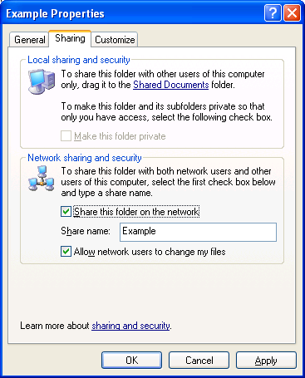

Advanced File Sharing
For a computer running Windows XP Professional (when it is a member of a workgroup), you can optionally disable simple file sharing and enable advanced file sharing, also known as classic file sharing. Advanced file sharing is the file sharing mode used by Windows 2000 and all versions of Windows NT 4.0. With advanced file sharing you can specify:
- Whether to enable sharing for the folder
- The share name
- A comment or description for the share
- The maximum number of computers that can connect to the share
- Permissions on the share, which include the list of user or group accounts and their level of access
- Offline folder settings
- If modifying the settings of an existing shared folder, whether to create a new share
The Sharing tab for advanced file sharing is shown in the following figure.
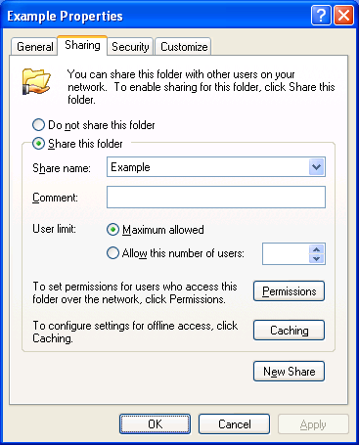
To enable advanced file sharing on a computer running Windows XP Home Edition or Windows XP Professional (when it is a member of a workgroup), do the following:
- Click Start, and then click My Computer.
- In My Computer, click Tools, and then click Folder Options.
- In Folder Options, click the View tab.
- In Advanced settings, clear the Use simple file sharing (Recommended) check box. An example is shown in the following figure.
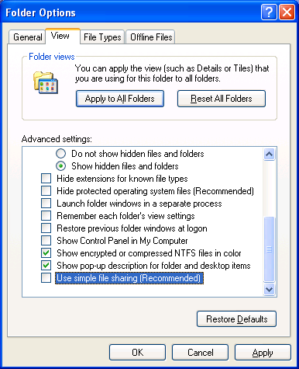
- Click OK.
For a computer running Windows XP Professional that is a member of a domain, advanced file sharing is the only mode of file sharing.
The following table summarizes the different types of file sharing supported in Windows XP.
Windows XP Home Edition | Shared Documents folder, simple file sharing
Windows XP Professional (when it is a member of a workgroup) | Simple file sharing, advanced file sharing
Windows XP Professional (when it is a member of a domain) | Advanced file sharing

Enabling File and Printer Sharing
For computers that are running Windows XP Home Edition and Windows XP Professional that are members of a workgroup, file and printer sharing is disabled by default. If you attempt to share a folder, the Sharing tab contains two links with which you can enable sharing. An example is shown in the following figure.
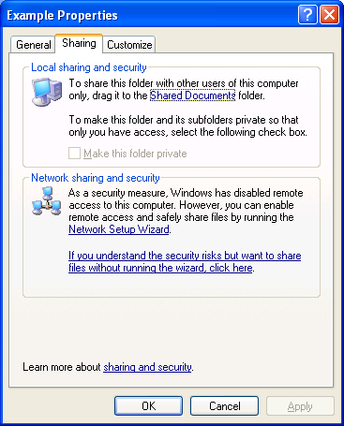
Similarly, if you attempt to share a printer before enabling file sharing, the Sharing tab contains two links with which you can enable sharing. An example is shown in the following figure.
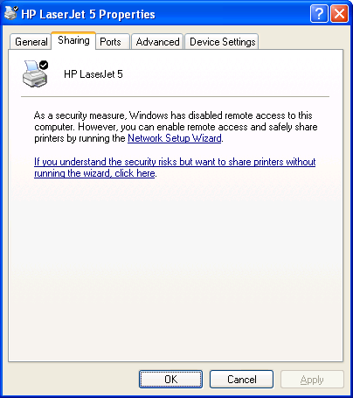
To enable file and printer sharing, you can either click the link to run the Network Setup Wizard or click the link to enable file and printer sharing without running the Network Setup Wizard. When you click the link to run the Home Network Setup Wizard, the Home Network Setup Wizard is run, which asks you a set of questions to automatically configure network settings. The Home Network Setup Wizard automatically enables file and printer sharing.
When you click the link to enable file sharing without running the Network Setup Wizard, you are prompted with an Enable File Sharing dialog box, as shown in the following figure.
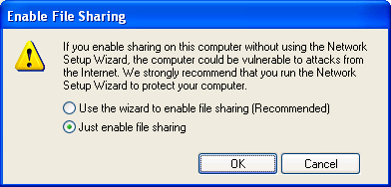
Click Just enable file sharing, and then click OK.
When you enable file and printer sharing, you are enabling file and printer sharing using simple file sharing. To enable advanced file sharing on a computer running Windows XP Professional, see the procedure in the "Advanced File Sharing" section of this article.

Sharing a Folder
Once file sharing has been enabled for a computer running Windows XP Home Edition, you can share a folder or an individual file by copying or moving it to the Shared Documents folder. If you want to create a separate share for a folder, rather than using the Shared Documents folder, right-click the folder in My Computer, and then click Sharing and Security. Alternately, you can click the folder in My Computer, and then click Share this folder in the list of File and Folder Tasks.
From the Sharing tab for the folder's properties, do the following:
- For simple file sharing, click Share this folder on the network, make other changes as needed, and then click OK.
- For advanced file sharing, click Share this folder, make other changes as needed, and then click OK.
To share a folder from Windows Explorer, right-click the folder name in the tree pane, and then click Sharing and Security.

Connecting to a Shared Folder
There are many ways to connect to a shared folder, including the following:
- Using Start-Run to open a window containing the shared folder contents
- Using My Network Places to open a window containing the shared folder contents
- Mapping a network drive to the shared folder

Using Start-Run
The easiest way to make a connection to a shared folder is by doing the following:
- Click Start, and then click Run.
- In Open, type \\ComputerName\ShareName (in which ComputerName is the name of the computer sharing the folder and ShareName is the name of the share when the folder was shared), and then press ENTER.
For example, to open the share named STUFF on the computer named HOMESRV, you would type \\HOMESRV\STUFF. You can use upper or lowercase letters for the computer and share names. If the share name contains spaces, enclose the entire \\ComputerName\ShareName in quotes. For example, to open the Shared Documents share on the computer named MOMSPC, you would type "\\MOMSPC\Shared Documents".
If you don't remember the name of the share, you can do the following:
- Click Start, and then click Run.
- In Open, type \\ComputerName and then press ENTER.
The window that is displayed contains the file and printer shares of the specified computer. An example is shown in the following figure.
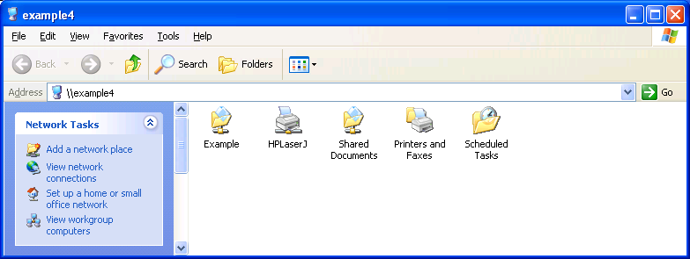
From this window, you can open the shared folders of the computer.

Using My Network Places
To use My Network Places to display the contents of a shared folder, do the following:
- Click Start, and then click My Network Places.
- In the Network Tasks list, click View workgroup computers.
A window is displayed containing the set of computers in your home or small office workgroup. An example is shown in the following figure.
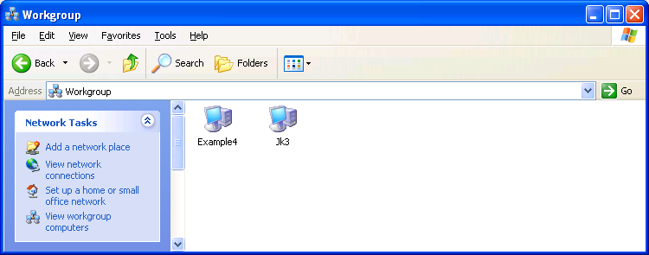
- From the workgroup window, double-click the computer containing the shares, and then double-click the desired shared folder.
The contents of the workgroup window depend on the configuration of the workgroup name on all the computers on your network. All of the computers on your network should be configured with the same workgroup name. The workgroup name is normally configured during the Network Setup Wizard.
To manually change the workgroup name on a computer running Windows XP, do the following:
- Click Start, and then click Control Panel.
- In Control Panel, double-click System.
- In System Properties, click the Computer Name tab, and then click Change.
- In Computer Name Changes, type the name of the workgroup in Workgroup, and then click OK.
By default, the Network Setup Wizard uses the workgroup name MSHOME, but you can use any workgroup name you want. However, all the computers on your network should use the same workgroup name.
To manually change the workgroup name on a computer running Windows 2000, do the following:
- Right-click My Computer, and then click Properties.
- In System Properties, click the Network Identification tab, and then click Properties.
- In Identification Changes, type the name of the workgroup in Workgroup, and then click OK.
To manually change the workgroup name on a computer running Windows 98 or Windows Millennium Edition, do the following:
- Right-click Network Neighborhood (for Windows 98) or My Network Places (for Windows Millennium Edition), and then click Properties.
- In Network, click the Identification tab.
- Type the name of the workgroup in Workgroup, and then click OK.
If the computers on your network are using different workgroup names, then you can view all the workgroups on your network from the workgroup window by clicking on the Address bar, and then clicking Microsoft Windows Network. The resulting window displays all of the workgroups on your network, from which you open the desired workgroup, computer, and shared folder.
The contents of the workgroup window also depend on the operation of the Windows Computer Browser service. The Computer Browser service operates by collecting periodic announcement messages sent by the computers on your network. Due to timing issues, the workgroup window might not contain all the active computers on your network or might contain computers that are no longer active on your network. If the computer to which you want to connect does not appear in the workgroup window, then use the procedure described in the "Using Start-Run" section of this article.

Mapping a Network Drive
It is also possible to create a network drive that appears in My Computer as a drive but is actually mapped to a shared folder. To create a network drive, do the following:
- Click Start, and then click My Network Places.
- In My Network Places, click Tools, and then click Map Network Drive.
- In Map Network Drive, you can specify the following:
- The network drive letter. By default, Windows XP uses the last available drive letter.
- The folder name, which is the combination of computer and share name using \\ComputerName\ShareName. If you do not remember the computer or share name, click Browse and use the Browse window to locate the desired shared folder,
- Whether to automatically reconnect the network drive when you log on to the computer.
- Whether you want to use a different name and password to connect to the shared folder.
- Whether you want to sign up for online storage or create a shortcut to a network resource.
An example is shown in the following figure.
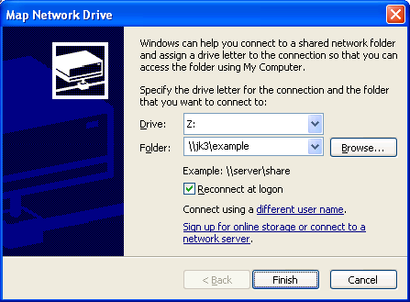
- Click Finish to map the network drive.
- A window appears displaying the contents of the newly mapped network drive. An example is shown in the following figure.
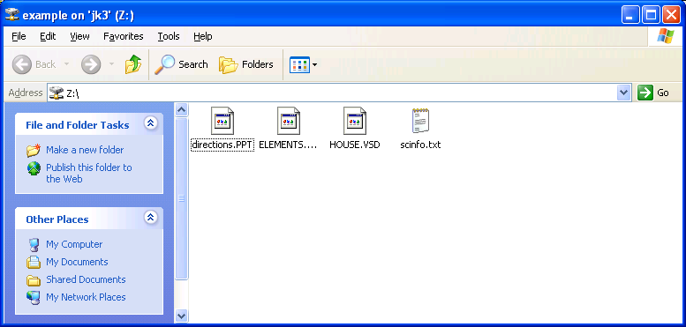
The mapped network drive also appears in My Computer. An example is shown in the following figure.
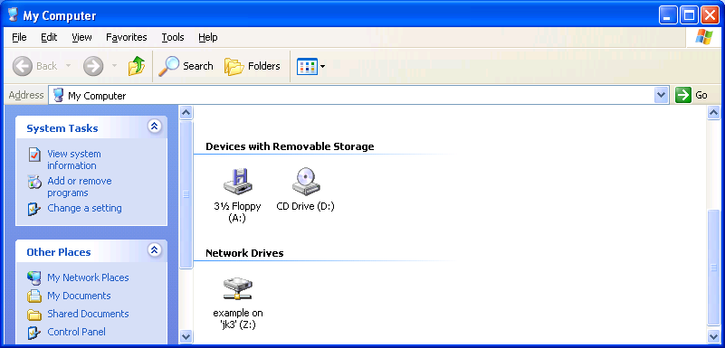

Sharing a Printer
Once file sharing has been enabled, you can share a printer from the Printers and Faxes folder by doing the following:
- Click Start, click Control Panel, click Printers and Other Hardware, and then click Printers and Faxes.
- In Printers and Faxes, right-click the printer and click Sharing. Alternately, you can click the printer and then click Share this printer in the Printer Tasks list.
- From the Sharing tab, click Share this printer, and then click OK.

Connecting to a Shared Printer
There are several ways to connect to a shared printer, including the following:
- From the Add Printer Wizard
- Using Start-Run to open a window containing the shared printer
- Using My Network Places to open a window containing the shared printer

From the Add Printer Wizard
To connect to a shared printer from the Add Printer Wizard, do the following:
- Click Start, click Control Panel, click Printers and Other Hardware, and then click Printers and Faxes.
- In Printers and Faxes, click Add a printer in the Printer Tasks list.
- On the Welcome to the Add Printer Wizard page of the Add Printer Wizard, click Next.
- On the Local or Network Printer page, click A network printer, or printer attached to another computer. An example is shown in the following figure.
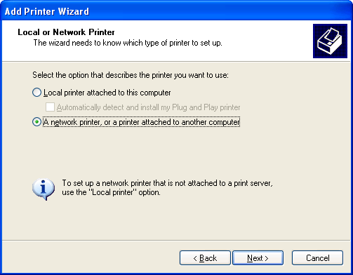
- On the Specify a Printer page, you can do one of the following:
- Click Browse for a printer to use a Browse window to locate a shared printer on your network.
- Click Connect to this printer and type the \\ComputerName\SharedPrinterName (in which ComputerName is the name of the computer sharing the printer and SharedPrinterName is the name of the print share).
- Click Connect to a printer on the Internet or on a home or office network and type the Uniform Resource Locator (URL) address of the shared Internet printer.
An example of using the Connect to this printer option is shown in the following figure.
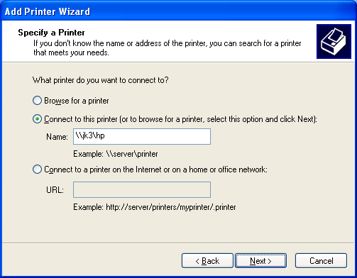
- Click Next.
- On the Default Printer page, click Yes if you want to make this network printer the default printer. Otherwise, click No. Click Next.
- On the Completing the Add Printer Wizard page, click Finish.
The shared printer should now appear in your Printers and Faxes folder. An example is shown in the following figure.
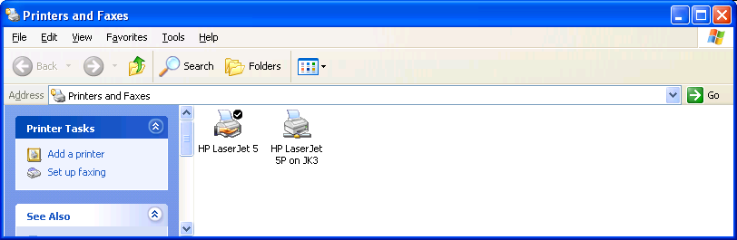

Using Start-Run
Another way to make a connection to a shared printer is by doing the following:
- Click Start, and then click Run.
- In Open, type \\ComputerName\SharedPrinterName, and then press ENTER.
For example, to connect to the shared printer named COLOR on the computer named HOMESRV, you would type \\HOMESRV\COLOR. You can use upper or lowercase letters for the computer and printer share names.
If you don't remember the name of the share, you can do the following:
- Click Start, and then click Run.
- In Open, type \\ComputerName and then press ENTER.
The window that is displayed contains the file and printer shares of the specified computer. An example is shown in the following figure.
From this window, you can double-click the shared printer icon to create a connection to it. Alternately, you can open the Printers and Faxes folder and double-click the shared printer icon.

Using My Network Places
To use My Network Places to display the contents of a shared folder, do the following:
- Click Start, and then click My Network Places.
- In the Network Tasks list, click View workgroup computers.
A window is displayed containing the set of computers in your home or small office workgroup. An example is shown in the following figure.
- From the workgroup window, double-click the computer containing the shared printer, and then double-click the shared printer.

Common Problems with File and Printer Sharing

Cannot Connect to a Shared Folder Through Start-Run
If you cannot connect to a shared folder by typing \\ComputerName\ShareName from the Open dialog box of Start-Run, it could be due to the following:
- The computer name is incorrect.
Try \\ComputerName instead. If the computer does not exist on your network, you might receive the error message "The network path was not found."
If the computer name is correct, but \\ComputerName still does not work, obtain the Internet Protocol (IP) address of the server computer. You can do this by clicking the network connection in the Network Connections folder and noting the IP Address from the Details list (lower left-hand corner). Then, try \\IPAddress. For example, if the IP address of the server computer is 192.168.0.17, you would try \\192.168.0.17. If this works, then there is a problem with resolving the name of the server computer to its IP address.
If \\IPAddress does not work, verify whether the Internet Connection Firewall (ICF) or Windows Firewall is enabled on the server computer. If ICF is enabled, it must be configured with a set of service definitions that allow file and printer sharing traffic. For more information about this issue, see the "Common Problems with ICF" section of the Troubleshooting Internet Connection Firewall on Microsoft Windows XP article at http://www.microsoft.com/downloads/details.aspx?FamilyID=b3d01193-ad93-492f-b74b-97c2fc44e08b&DisplayLang=en. If Windows Firewall is enabled, you must enable the File and Printer Sharing exception from the Exceptions tab of the Windows Firewall Control Panel applet.
ICF is included with Windows XP and Windows XP with Service Pack 1. Windows Firewall is included with Windows XP with Service Pack 2.
- The share name is incorrect.
If the computer name is correct and the share name is not correct, you might receive the error message "The network path was not found." Try \\ComputerName and then opening the share from the window that contains all the shared folders and printers of the server computer.
In some cases, the computer and share name are correct, but you are prompted to type or select a user name and password. An example is shown in the following figure.
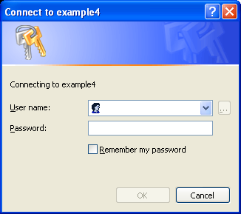
This could be due to one of the following:
- File sharing is not enabled on the server computer.
Enable file sharing on the server computer from the Sharing tab of a folder or printer.
- The client computer is a member of a domain.
This can happen when you bring your work laptop computer home and attempt to access shared folders and printers on a home computer that is a member of a workgroup. In this case, type the account name and password that corresponds to a computer administrator account on the server computer.
- The server computer is a member of a domain.
This can happen when you bring your work laptop computer home and attempt to share a folder with a home computer that is a member of a workgroup. In this case, type the account name and password that corresponds to a local account on the server computer running Windows XP Professional.
- The Guest account is not active.
For more information, see "Verify Server Computer Configuration" in this article.

Cannot See All of My Computers in My Network Places
If the workgroup window of My Network Places does not contain all the computers in your home or small office workgroup, then it could be due to the following:
- ICF is enabled on the network connection
For more information, see the "Common Problems with ICF" section of the Troubleshooting Internet Connection Firewall on Microsoft Windows XP article at http://www.microsoft.com/downloads/details.aspx?FamilyID=b3d01193-ad93-492f-b74b-97c2fc44e08b&DisplayLang=en.
- Windows Firewall is enabled
Enable the File and Printer Sharing exception from the Exceptions tab of the Windows Firewall Control Panel applet.
- The Computer Browsing service does not have the current list of computers in the workgroup
The Computer Browsing service collects the list of computers in the workgroup by listening for periodic messages advertised by computers in the workgroup and by electing a computer on the network to maintain the list of computers in the workgroup. This computer, known as the browse server, is elected automatically. The election of the current browse server for your workgroup can be affected when you start or stop computers on your network. The election of the browse server and the collection and distribution of the list of computers in the workgroup becomes more complex when there are different versions of Windows running on your network.
If you know that the desired computer is running and connected to the network, then it just means that the browser server computer has not received the periodic announcement message from the desired computer and updated its list.
If the desired computer does not appear in the workgroup window, try to connect to it through Start-Run.

Cannot Share a Folder or Printer
If the Sharing tab is not present from the properties of a folder or printer, then the File and Printer Sharing for Microsoft Networks component is either not installed or is installed but disabled. To verify that the File and Printer Sharing for Microsoft Networks component is installed and enabled, do the following:
- Click Start, click Control Panel, click Network and Internet Connections, and then click Network Connections.
- Click the connection that is connected to your home network, and then click Change settings of this connection in the Tasks pane.
- In the properties of the network connection, under This connection uses the following items, verify that the File and Printer Sharing for Microsoft Networks component is installed and enabled (the check box is checked). The following figure shows an example.
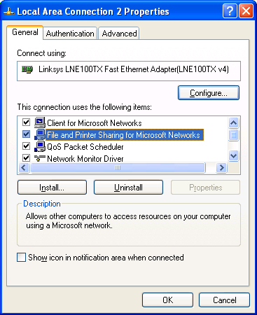
- If it is not installed, click Install.
- In Select Network Component Type, double-click Service.
- In Select Network Service, double-click File and Printer Sharing for Microsoft Networks.
- Click Close.
If the File and Printer Sharing for Microsoft Networks component is installed and enabled on the connection connected to your network, then verify that the Server service, which corresponds to the File and Printer Sharing for Microsoft Networks component, is running. For more information, see "The Services Snap-in" section of this article.

Troubleshooting Tools and Techniques
This section describes the troubleshooting tools provided with Windows XP for file and printer sharing and a common set of conditions to check on the client computer and server computer when troubleshooting file and printer sharing issues.

Troubleshooting Tools
Windows XP provides the following tools for troubleshooting file and printer sharing issues:
- The Ping tool
- The File and Printer Troubleshooter
- Network Diagnostics
- The Shared Folders snap-in
- The Services snap-in
- The system event log
- The Nsw.log file

The Ping Tool
The Ping tool is a command-line tool that tests basic connectivity between computers running Transmission Control Protocol/Internet Protocol (TCP/IP). The Ping tool sends echo messages to the computer being pinged, which responds with echo reply messages. The basic syntax of the Ping tool is ping AddressOrName, in which AddressOrName is either an IP address or the name of the computer to which you want to test basic connectivity.

The File and Printer Troubleshooter
The File and Printer Troubleshooter is part of Windows XP Help and Support and is used to help you troubleshoot common problems with logging on and accessing shared folders and printers. To run the File and Printer Troubleshooter, do the following:
- From the Windows XP desktop, click Start and then click Help and Support.
- Under Pick a Help Topic, click Networking and the Web.
- Under Networking and the Web, click Fixing networking or Web problems.
- In the details pane under Fix a problem, click File and Printer Troubleshooter.
Use the questions of the File and Printer Troubleshooter to help you determine the problem and its solution.

Network Diagnostics
The Network Diagnostics facility is part of Windows XP Help and Support and is used to scan your system to gather information about your hardware, software, and network connections. To run the Network Diagnostics, do the following:
- From the Windows XP desktop, click Start and then click Help and Support.
- Under Pick a Help Topic, click Networking and the Web.
- Under Networking and the Web, click Fixing networking or Web problems.
- In the details pane under Pick a task, click Diagnose network configuration and run automated networking tests.
- In the details pane under Network Diagnostics, click Scan your system.
In the details pane under Network Diagnostics, scan through the information provided, noting any items that indicate FAILED.

The Shared Folders Snap-in
The Shared Folders snap-in is used to view and manage your shares, connected computers, and files that are open on your computer by connected computers. To open the Shared Folders snap-in, do the following:
- Click Start, click Control Panel, click Performance and Maintenance, click Administrative Tools, and then double-click Computer Management.
- In Computer Management, double-click Shared Folders under System Tools.
An example is shown in the following figure.
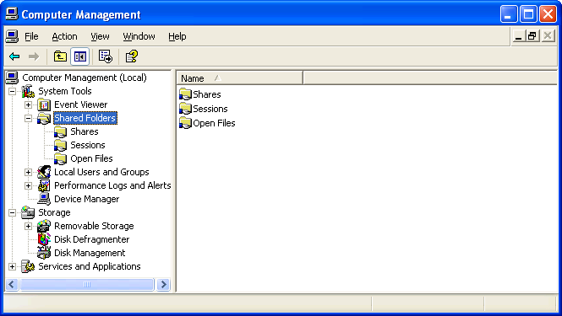
Using the Shared Folders snap-in, you can view:
- The set of shared folders shared on the computer (the Shares folder).
You can also stop the sharing of a shared folder or create a new shared folder.
- The names of the computers that are currently connected to the computer (the Sessions folder).
You can also manually disconnect a computer that is currently connected.
- The files that are open by remote computers (the Open Files folder).
You can also manually close a file that is open by a connected computer.

The Services Snap-in
The Services snap-in is used to check the status of services (programs running on your computer that provide capabilities to other application programs you might run). For file and printer sharing troubleshooting, use the Services snap-in to check the status and properties of the Workstation (corresponding to the Client for Microsoft Networks component) and Server (corresponding to the File and Printer Sharing for Microsoft Networks) services. Both the Workstation and Server services in the Services snap-in should be started and configured to automatically start.
To use the Services snap-in to check the status of the Workstation and Server services, do the following:
- Click Start, click Control Panel, click Performance and Maintenance, click Administrative Tools, and then double-click Services.
- In the details pane of the Services snap-in, double-click the Workstation service.
Startup type should be set to Automatic and the Service status should be Started.
An example is shown in the following figure.
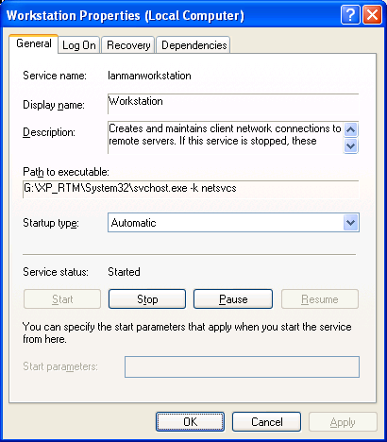
- In the details pane of the Services snap-in, double-click the Server service.
Startup type should be set to Automatic and the Service status should be Started.
An example is shown in the following figure.
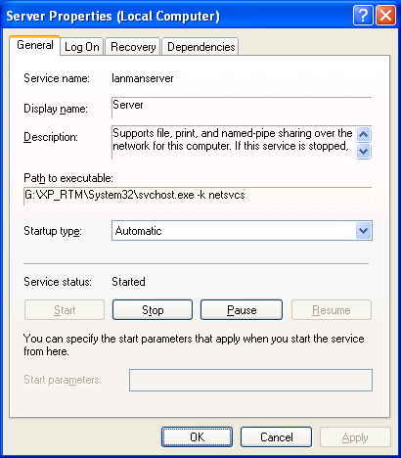

The System Event Log
If the Workstation or Server services are unable to start, then they will add entries to the system event log with information about why they could not start. The system event log is one of several logs that you can view using the Event Viewer snap-in. To view the entries in the system event log with the Event Viewer snap-in, do the following:
- Click Start, click Control Panel, click Performance and Maintenance, click Administrative Tools, and then double-click Event Viewer.
- In the console tree (the left-hand pane) of the Event Viewer snap-in, click System.
- In the details pane of the Event Viewer, look for Error events.

The Nsw.log File
If you used the Network Setup Wizard to configure your network settings, the Nsw.log file contains information and errors about the configuration process. To view the contents of the Nsw.log file, click Start, click Run, type nsw.log, and then press ENTER.

Verify Client Computer Configuration
When troubleshooting the client computer, you need to verify the following:
- That the Client for Microsoft Networks component is installed and enabled on the network connection connected to your home or small office network.
- That the Workstation service is running. If it is not, check the system event log for errors and information about why the Workstation service did not start.
- That you can ping the server computer by its IP address and its name.
- That the client computer is not using TCP/IP filtering, which might be preventing response messages from the server computer.
To check whether TCP/IP filtering is enabled, do the following:
- Click Start, click Control Panel, click Network and Internet Connections, and then click Network Connections.
- Right-click the network connection that corresponds the network adapter attached to your private network, and then click Properties.
- On the General tab, double-click Internet Protocol (TCP/IP) in the This connection uses the following items list.
- On the General tab, click Advanced.
- On the Advanced TCP/IP Settings dialog box, click the Options tab.
- Under Optional settings, click TCP/IP Filtering, and then click Properties.
- To disable TCP/IP filtering, clear the Enable TCP/IP Filtering (all adapters) check box, and then click OK.

Verify Server Computer Configuration
When troubleshooting the server computer, you need to verify the following:
- That the File and Printer Sharing for Microsoft Networks component is installed and enabled on the network connection connected to your home or small office network.
- That file sharing is enabled.
- That the Server service is running. If it is not, check the system event log for errors and information about why the Server service did not start.
- That the server computer is sharing the desired folder or printer.
- That if the server computer has ICF enabled on the network connection attached to the home or small office network, then service definitions are defined to allow incoming file and printer sharing traffic.
- That if the server computer has Windows Firewall enabled, then the File and Printer Sharing exception from the Exceptions tab of the Windows Firewall Control Panel applet is enabled.
- That the server computer is not using TCP/IP filtering, which might be preventing response messages from the client computer.
- That the guest account is active for network connections.
In User Accounts (available from Control Panel-User Accounts) the Guest account is off by default. However this setting only applies to the ability to log on the local computer using the Guest account. Simple file sharing relies on guest access to shared folders and printers. To verify that the Guest account is active for network access, do the following:
- Log on to Windows XP with an administrator account.
- Click Start, click Run, type cmd, and then press ENTER.
- In the Command Prompt window, type net user guest, and then press ENTER.
- If the account is active, a line appears in the output of the command that states Account active Yes.
- If the account is not active, type net user guest /active:yes and then press ENTER.
- Type exit and press ENTER to close the Command Prompt window.

Summary
Windows XP file and printer sharing allows you to share folders and locally attached printers with other computers on a network. You can enable file and printer sharing through the Network Setup Wizard or from the Sharing tab of a folder or printer. You can share a folder from the Sharing tab for the properties of a folder. You can share a printer from the Sharing tab for the properties of a printer. You can connect to a shared folder through Start-Run, My Network Places, or by mapping a network drive. You can connect to a shared printer through the Add Printer Wizard, through Start-Run, or through My Network Places. The most common problems with file and printer sharing are the inability to share a successfully connect to a file or print share, the lack of computers appearing in My Network Places, and the inability to share a folder or printer. Windows XP provides several tools to gather information for troubleshooting file and printer sharing issues.

Related Links
See the following resources for further information:
- Home and Small Office Networking with Windows XP at http://www.microsoft.com/homenet
- File and Printer Sharing with Microsoft Windows at http://www.microsoft.com/downloads/details.aspx?FamilyID=87c0a6db-aef8-4bef-925e-7ac9be791028&DisplayLang=en
- Troubleshooting Home Networking in Windows XP at http://support.microsoft.com/default.aspx?scid=kb;en-us;308007
- Description of File Sharing and Permissions in Windows XP at http://support.microsoft.com/default.aspx?scid=kb;en-us;304040
- How to Troubleshoot Network Printing Problems in Windows XP at http://support.microsoft.com/default.aspx?scid=kb;en-us;314073
- Sharing Files and Folders from the Windows XP Professional Resource Kit at http://www.microsoft.com/technet/treeview/default.asp?url=/technet/prodtechnol/winxppro/reskit/prde_ffs_flez.asp

For the latest information about Windows XP, see the Windows XP Web site at http://www.microsoft.com/windowsxp.

