
Cash Manager

Microsoft Dynamics™ SL

Benefits
- Suit your business needs
Define various default values, selection
options, and control information, including general ledger posting options, data retention requirements, and entry of cleared amounts or transactions during reconciliation. Set up items that affect future cash balances to strengthen your ability to project cash flows.

- Control account data
Access current cash balance information
instantly while entering transactions, to
help you track what is in the bank on a
daily basis. Transferring funds between
different cash accounts is easy, so you
can manage your money effectively while accurately displaying critical information at a moment’s notice.

- Simplify processes
Reconcile bank statements easily
according to your schedule and your
business demands. Assemble daily cash
balances from subsidiary databases into a “consolidated” database, so cash account balances for the entire organization are available to view in one application.

- Manage and track cash data
Designate accounts as active or inactive,
control the status of transaction batches,
and determine which accounts and
transaction types are valid. All transactions
that affect cash are tracked, creating a
complete audit trail.

- Mine data effectively
Extract complete audit trail information for any cash management transaction using a variety of standard reports and extended reporting options. To help ensure that each transaction is properly documented, print automatic batch control reports for all entries.
Take the guesswork out of cash accounting, gain instant access to your current cash balance, and automate bank reconciliation. Powerful and integrated, Microsoft Dynamics SL Cash Manager is automatically updated when batches are released by other Microsoft Dynamics SL modules.

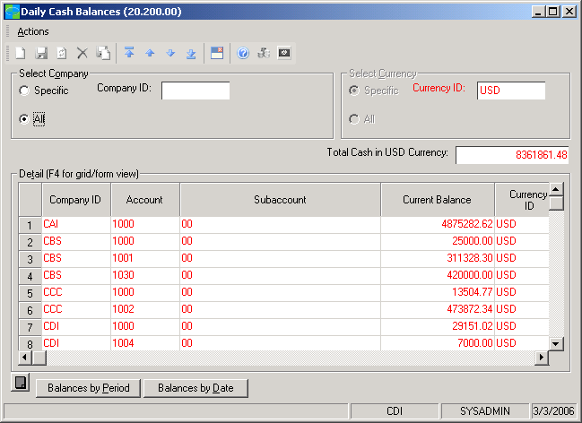
Define
various default values selection options, and control information.

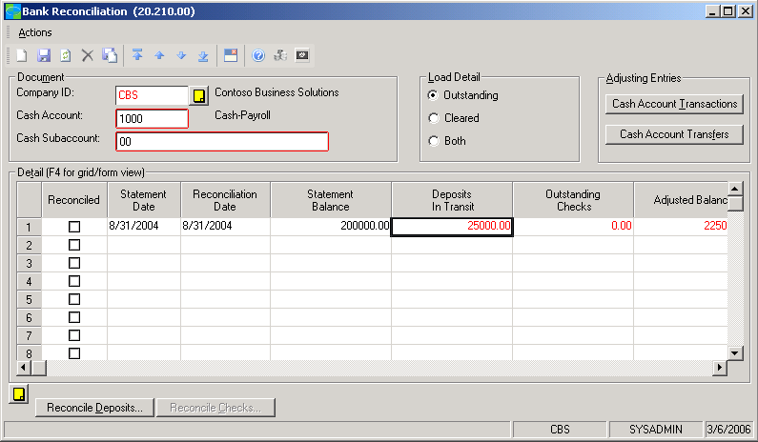

Reconcile
bank statements easily according to your schedule and your business demands.

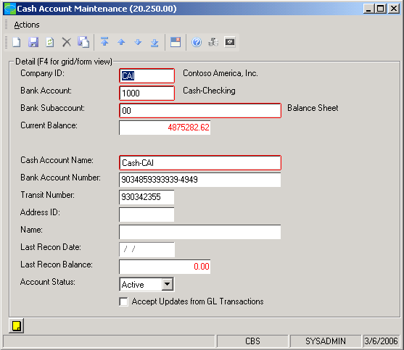

Designate
accounts as active
or inactive, and determine which accounts and transaction types
are valid.

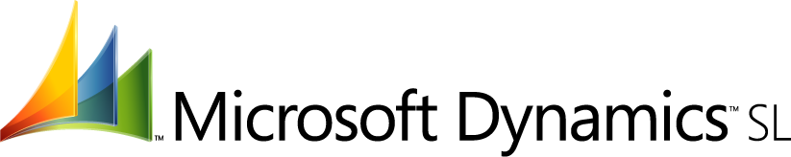

features

BENEFITS

Powerful Integration | Work with Microsoft Dynamics SL General Ledger and all subsidiary ledgers  that impact cash balances. Use with Microsoft Dynamics SL Multi-Company,  for example, and define a “central” company as the cash controller for subsidiaries.
Multiple Accounts Management | Integrate transactions into a streamlined activity to balance cash Accounts  between the bank statement, daily cash balance, and general ledger account  balance. Up to 30 characters may be used for each bank account number.
Valuable Forecasting | Set up recurring items such as capital expenditures, bonuses, tax refunds,  and stock proceeds that will impact future cash balances to project future  cash flow. Multiple “what if” scenarios help you compare possible  outcomes.
Cash Flow Prediction | Forecast cash flow for seven periods that you identify. Information is retrieved from both Microsoft Dynamics SL Accounts Payable and Microsoft Dynamics SL Accounts Receivable, open purchase orders, and any anticipated items entered in the Cash Flow Items screen.
Flexible Reconciliation | Reconcile bank statements quickly and easily from a central location and at any time of the month, including daily processing, through the Bank Reconciliation screen, which shows all related activity for a specified period.
Simplified Adjustments | Reconcile at the check/deposit level and easily enter transactions that  affect cash but are not captured in other Microsoft Dynamics SL modules,  such as bank service charges, wire transfers or other cash transaction  types that you create.
Global Operations Management | Use with Microsoft Dynamics SL Currency Manager and work with cash  accounts in banks around the world that use a variety of currencies.  View balances in the account’s native or your base currency.
Daily Balance Monitoring | Get immediate access to your current cash balance for individual cash  accounts or a grand total of all accounts. Drill down to the detail  transactions that make up the cash balance.
Electronic Data Import | Use the electronic bank transaction import feature to receive cleared check and deposit information from a bank (in a delimited ASCII file), then automatically clear these checks and deposits.
For more information about Microsoft Dynamics™ SL, visit: http://www.microsoft.com/dynamics/sl

This document is for information purposes only.
MICROSOFT MAKES NO WARRANTIES, EXPRESS, IMPLIED, OR STATUTORY, AS TO THE INFORMATION IN THIS DOCUMENT.

© 2005 Microsoft Corporation. All rights reserved.
Microsoft, The Microsoft Dynamics Logo, are either registered trademarks or trademarks of Microsoft Corporation or Microsoft Business Solutions ApS in the United States and/or other countries. Microsoft Business Solutions ApS is a subsidiary of Microsoft Corporation.

