

Using Microsoft® Virtual PC 2007 for Application Compatibility
White Paper

Published: August 2006
For the latest information, please see http://www.microsoft.com/windows/virtualpc/default.mspx

© 2006 Microsoft Corporation. This work is licensed under the Creative Commons Attribution-NonCommercial License. To view a copy of this license, visit http://creativecommons.org/licenses/by-nc/2.5/ or send a letter to Creative Commons, 543 Howard Street, 5th Floor, San Francisco, California, 94105, USA.

Contents
Application Compatibility on Microsoft® Windows® XP and Windows Vista™ 1
Overview of Virtual PC 2007 2
Virtual PC Host and Guest Operating Systems 2
Licensing Implications 3
Virtualized Devices 3
Virtual PC Scenarios 4
Running Incompatible Applications on 64-bit Windows Operating Systems 5
Running the Application on 64-bit Windows Vista 5
Installing Virtual PC 5
Creating and Configuring the Virtual Machine 6
Installing the Guest Operating System 8
Installing the Application 9
Configuring the Guest Operating System and Application 10
Running the Application on 32-bit Windows Vista 10
Comparing Virtual PC with Other Solutions 11
Supporting Applications on Virtual PC 2007 12
Summary 13
For More Information 13

Application Compatibility on Microsoft® Windows® XP and Windows Vista™
Each release of Microsoft® Windows® includes new features and capabilities while maintaining the highest levels of compatibility possible for existing applications that ran with previous versions of Microsoft Windows. However, customers should confirm their applications continue to behave normally as part of the deployment of any operating system update.
For Microsoft Windows Vista, most applications that ran with Microsoft Windows XP Service Pack 2 (SP2) should continue to run with Windows Vista. While Windows XP SP2 introduced a more comprehensive security model, Windows Vista builds on this security.
Note The focus of this article is about application compatibility, not hardware device compatibility. For more information about device compatibility, see Hardware Guidance listed in the “For More Information” section.
The security improvements in Windows Vista that may affect application compatibility include:
- Windows Resource Protection (WRP) of system files and protected registry locations. Windows Vista includes protected system file and registry locations for better security and stability. Most applications that previously referenced these locations will automatically be redirected to temporary locations during that session, to ensure application compatibility. However; If your applications’ data is attempting to persist date in these protected system areas, you will need to modify those applications, as the temporary locations are removed after each application session.
- Windows Vista User Account Control (UAC). If you are implementing a “Standard User” environment in your organization, applications will need to support standard user permissions as defined in Windows Vista to allow for both Administrative and Standard-User scenarios.
- Running Microsoft Internet Explorer in Protected Mode. To protect the integrity of Windows Vista, Internet Explorer 7 in Windows Vista will now run with Standard User rights, typically not allowing access to all registry or system files. Internet and intranet applications may need to be modified to run in this more restrictive security scenario.
- New firewall/antivirus application programming interfaces (APIs). New system APIs expose the layers of the Windows Vista operating system for antivirus software and firewall manipulation. Applications that perform these functions will need appropriate modifications by using the new system APIs.
- Newly architected Windows Login. Gina is no longer the Windows Login process used in Windows Vista. If you have applications that perform pass-through authentication with Windows, you may need to re-architect these applications.
In addition to the security improvements, there are other Windows Vista innovation features that may affect application compatibility:
- Concerns with 64-bit versions of Windows Vista.
- 16-bit applications and 32-bit drivers are not supported on 64-bit versions of Windows Vista.
- Automatic registry and system file redirection is not supported in the 64-bit environment. These changes require that 64-bit applications must adhere to a stronger set of Windows Vista application standards.
- Applications that check operating system version. Applications may check for a specific version of operating system, such as Microsoft Windows 98 Second Edition, Windows 2000, or Windows XP. Although the application may run correctly on Windows Vista, logic in the application may prevent the application from installing if a specific operating system version is not discovered. You can mitigate this issue by running applications in other operating compatibility modes within Windows Vista. Microsoft has been testing hundreds of applications and a broad range of partners have tested applications for Windows Vista compatibility and Microsoft has created the Application Compatibility Toolkit (ACT) version 5.0 to help identify application compatibility problems in a corporate environment.
As you can see, there are a rich set of tools that should address most application compatibility concerns. However, there still may be legacy applications in your environment that will not run on Windows Vista, or you may not be ready to re-engineer or retire. To address these application requirements in your organization, Microsoft Virtual PC 2007 provides a no-charge solution to meet your needs.
Note While Microsoft Virtual PC 2007 is freely available, you must have a license for each operating system running within Virtual PC 2007.

Overview of Virtual PC 2007
Virtual PC allows you to run multiple operating systems at the same time on a single computer and you can easily switch between virtual machines with the click of a button. You can use Virtual PC to run many different versions of operating systems (such as MS-DOS®, Windows 98, Windows XP or OS/2) All while moving forward with your deployment of Windows Vista
Virtual PC 2007 is next version of Virtual PC and includes all the previous features and capabilities found in Virtual PC 2004, plus the following improvements:
- Optimized for Windows Vista. The virtualization architecture has been optimized for Windows Vista to provide improvements in performance, system resource usage, and stability.
- Improved performance based on Microsoft Virtual Server 2005 R2. Virtual PC 2007 leverages the performance improvements introduced in Virtual Server 2005 R2.
- Provides support for 64-bit host operating systems. You can run Virtual PC 2007 on 64-bit versions of Windows Vista. This means you can run 16-bit operating systems (such as Windows 98 SE) which are not supported natively on 64-bit versions of Windows Vista.
- Provides support for sound devices in Windows Vista guest operating systems. Virtualized sound device drivers are available to Windows Vista guest operating systems. This allows Windows Vista guest operating systems to play sounds through the host operating system sound devices. Other guest operating systems will continue to have sound support as it exists in Virtual PC 2004 today

Virtual PC Host and Guest Operating Systems
In relation to Virtual PC, the operating system running on the physical computer is known as the host operating system. Virtual PC 2007 is optimized to use Windows Vista as the host operating system.
Each operating system running in Virtual PC is known as a guest operating system. Virtual PC can run both current and previous versions of operating systems. While previous versions of operating systems might be compatible with Virtual PC, the operating system may no longer be supported by Microsoft. Only those operating systems that are supported in a non-virtualized environment are supported as guest operating systems in Virtual PC. For example, MS-DOS is compatible with Virtual PC but not supported. However, Windows XP SP2 is both compatible with and supported in Virtual PC.
Figure 1 illustrates one use of Virtual PC for a customer who is running a 64-bit version of Windows Vista as the host operating system. One of the virtual machines is running a 16-bit guest operating system (Windows 98 SE). The other guest operating systems are 32-bit operating systems.
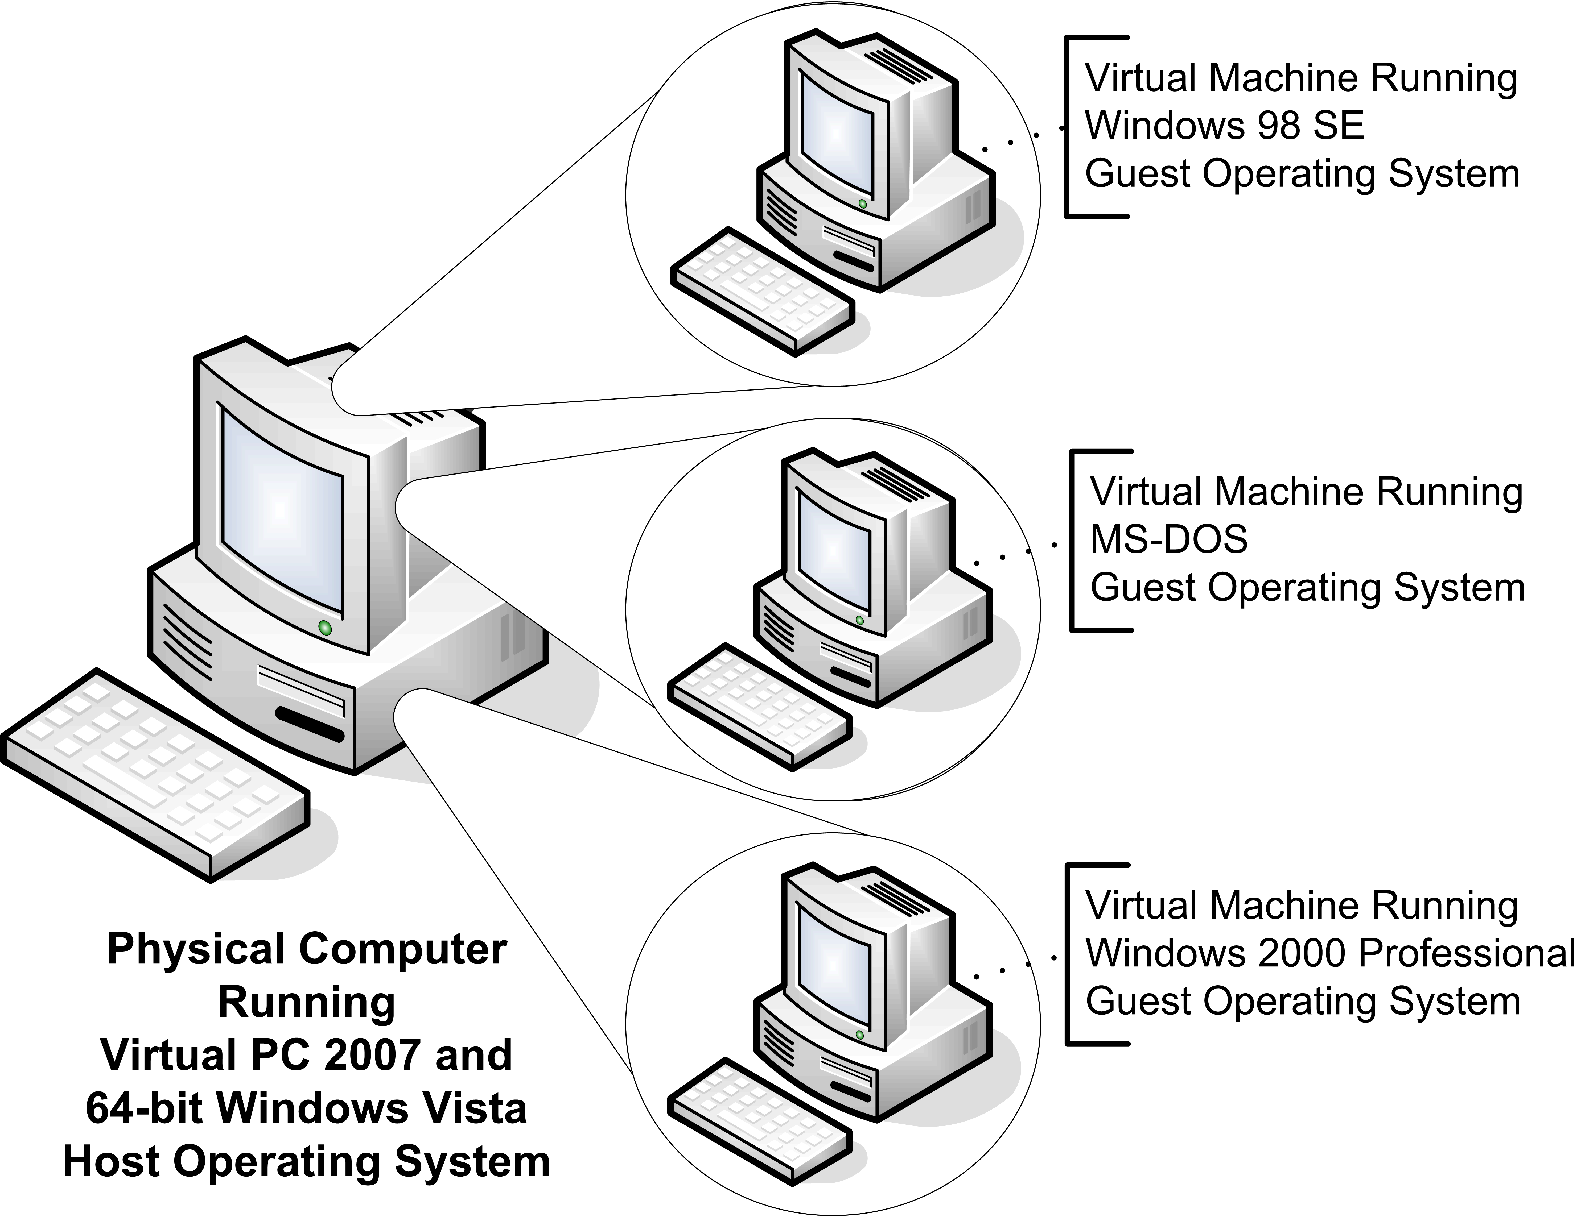Figure 1. 64-bit Windows Vista host operating system and guest operating systems

Licensing Implications
Customers should ensure they are properly licensed for all operating systems installed in virtual machines. In most cases customers are required to purchase a separate license for every operating system installed in a virtual machine. Microsoft Windows Vista Enterprise Edition is ideally suited to virtualization scenarios as it uniquely includes the right to install four copies of the operating system in a virtual machine as part of a single license.

Virtualized Devices
For each guest operating system you want to run in Virtual PC, you will create a virtual machine. This virtualizes the common hardware found on a computer (such as processor, sound card, video adapter, and network adapter). These virtualized hardware devices are unique for each virtual machine created; therefore, each guest operating system has a unique set of hardware devices.
As Figure 2 shows, guest operating systems can directly access some physical devices on the computer (such as parallel ports, serial ports, or CD-ROM drives). However, most other devices are virtualized. Virtual machine–specific drivers, known as Virtual Machine Additions, are installed in most Windows-based guest operating systems. Virtual Machine Additions include device drivers that are optimized for the virtualized devices.

Note: For more information about Virtual Machine Additions, see Virtual PC Help.
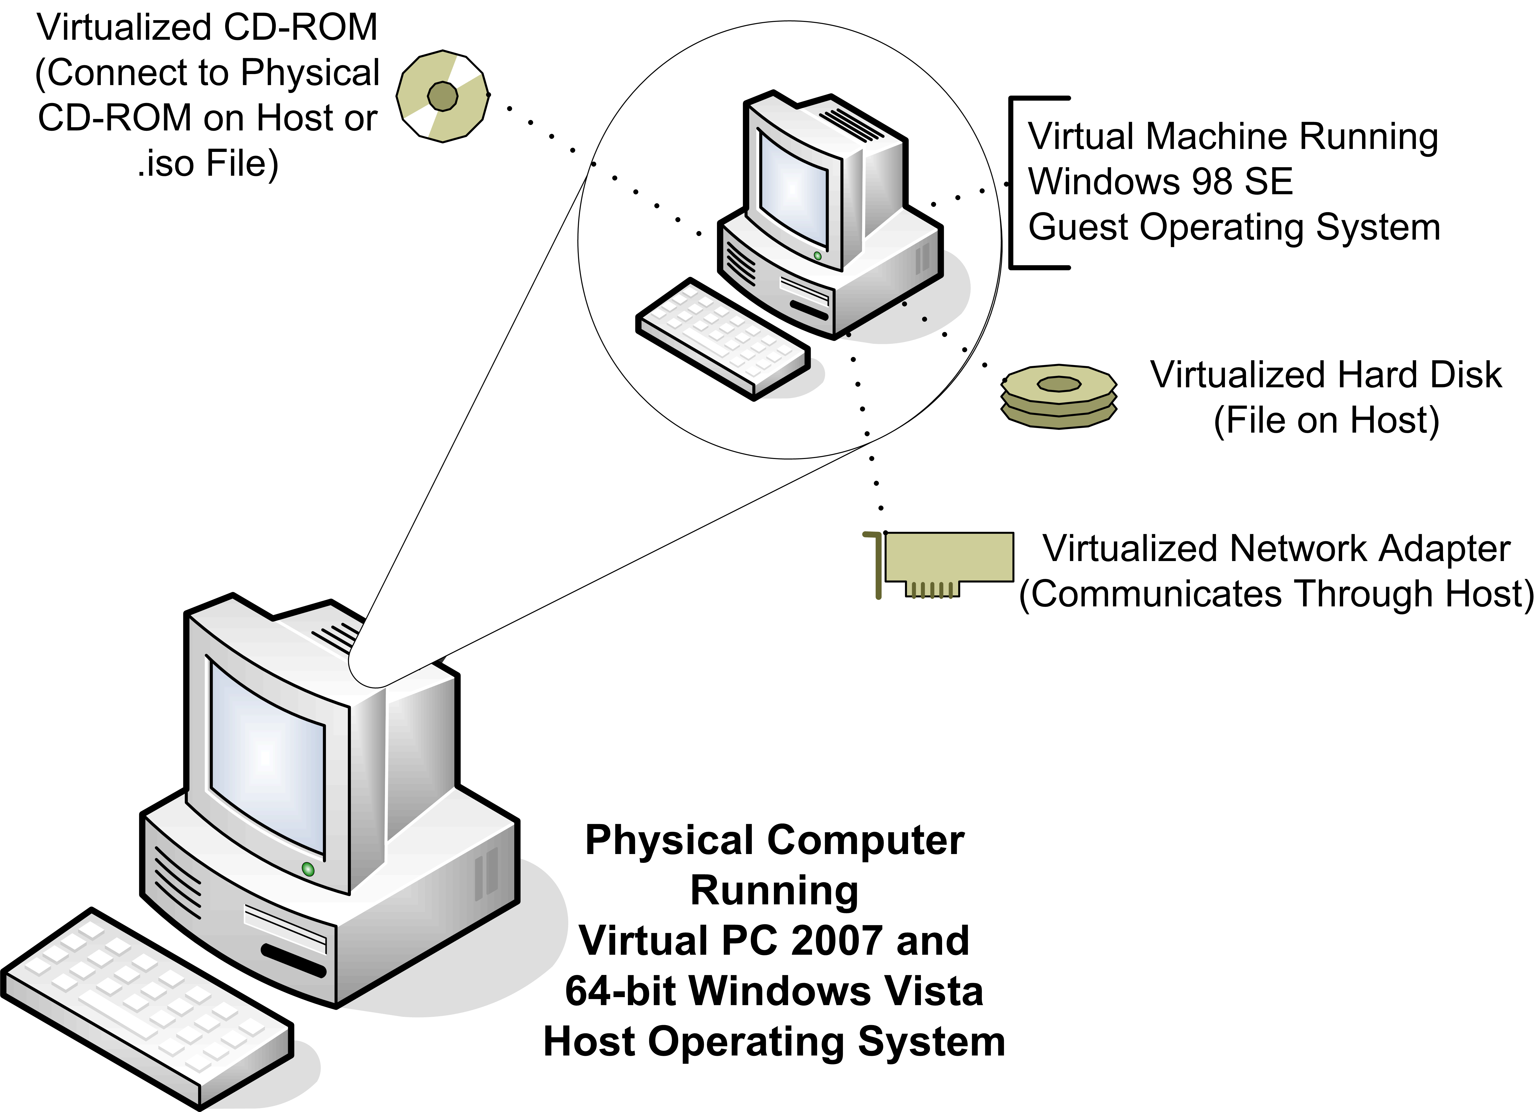
Figure 2. Virtualized devices and guest operating systems

Virtual PC Scenarios
A number of scenarios are supported by Virtual PC:
- Application Compatibility. Lets you run legacy applications while continuing your migrating to Windows Vista. You can also perform testing of Windows Vista in a controlled, fail-safe environment before deployment in your production environments.
- Development and Test. Helps you develop and test application software on various hardware platforms. The Undo Disks feature allows you to easily restore the environment back to a known configuration and reduce the amount of time required to develop and test applications.
- Technical support. Permits your technical support staff to support multiple operating systems on a single computer without rebooting the computer or buying additional computers. Your staff can set up numerous user-specific configurations on a single computer for real-time scenario testing and evaluation.
- Quality assurance. Helps you test and document software running on multiple operating systems on one computer. You can compare an application’s look and feel in multiple environments simultaneously. Virtual PC allows you to test potentially unstable prerelease software in a safe, isolated environment.
- Training. Allows you to train people on any x86 operating system without purchasing additional computers. Virtual PC also dramatically reduces classroom reconfiguration time by instantly switching configurations
The Virtual PC application compatibility scenario enables you to run mission-critical legacy applications that are incompatible with Windows Vista. You can continue to migrate to Windows Vista while providing a low-cost safeguard for maintaining these applications during migration (even when faced with unanticipated application compatibility issues), letting you take advantage of the Return on Investment (ROI) and productivity gains of Windows Vista.
Note: For the purposes of this document, the only scenario that is covered is the application compatibility scenario. For more information about the other scenarios, see the Microsoft Virtual PC 2004 Technical Overview at http://www.microsoft.com/windows/virtualpc/evaluation/techoverview.mspx.

Running Incompatible Applications on 64-bit Windows Operating Systems
Consider the situation in which you have a 16-bit x86 fleet management application that is running on Windows 98 SE. You are going to deploy 64-bit versions of Windows Vista in your organization. However, 16-bit x86 applications are not supported on 64-bit versions of Windows Vista. In addition, the application runs only on Windows 98.
The application vendor is no longer in business, and you do not have access to the source code. You need to run the fleet management application for the short term until you can find another fleet management application that runs on 64-bit versions of Windows Vista. This is a perfect situation for using Virtual PC.

Running the Application on 64-bit Windows Vista
The steps for running the fleet management application in Virtual PC on a 64-bit version of Windows Vista are as follows:
- Install Virtual PC 2007 on the 64-bit version of Windows Vista.
- Create and configure a virtual machine for the application in Virtual PC 2007.
- Install guest operating system (Windows 98 SE) in the virtual machine.
- Install the application in Windows 98 SE in the virtual machine.
- Configure the guest operating system (Windows 98 SE) and the application to use the proper printer.

Installing Virtual PC
After you have installed the 64-bit version of Windows Vista on the computer, you need to install Virtual PC. Install Virtual PC as a user that is a member of the local Administrators group. The installation process requires that you verify the location to which Virtual PC will be installed (as Figure 3 shows). The installation process does not require you to restart the computer.
Note At the time of this publication Virtual PC 2007 beta is not yet available. The steps below apply for Virtual PC 2004 and 2007. Also note that during the installation of the Virtual PC network switch driver, the networking adapters in the physical computer will momentarily lose network connection.
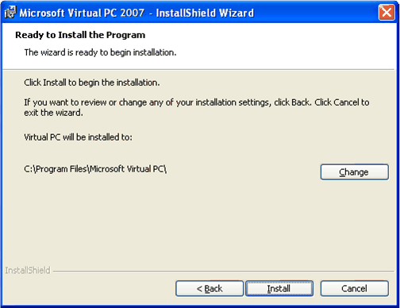
Figure 3. Installation wizard for Virtual PC 2007

Creating and Configuring the Virtual Machine
The first time you start Virtual PC, it starts a wizard to create a new virtual machine. If you have started Virtual PC before, then you need to start the wizard from the Virtual PC Console.
To create a new virtual machine
- In the Virtual PC Console, click New. The New Virtual Machine Wizard starts.
- Complete the New Virtual Machine Wizard by following the steps in Table 1 and accepting the defaults when no action is specified.
Table 1. New Virtual Machine Wizard Steps
On this wizard page | Do these actions
Welcome to the New Virtual Machine Wizard | Click Next.
Options | Ensure that Create a virtual machine is selected and then click Next.
Virtual Machine Name and Location | In the Name and Location box, enter virtual_machine_name and then click Next (where virtual_machine_name is the name of the virtual computer).  This name should be descriptive of the computer (such as the computer name or the name of the application).
Operating System | In the Operating system list box, select operating_system and then click Next (where operating_system is the guest operating system).
Memory | Ensure that Using the recommended RAM is selected and then click Next.  Note You can modify the recommended RAM value later if required.
Virtual Hard Disk Option | Ensure that A new virtual hard disk is selected and then click Next.
Virtual Hard Disk Location | In the Name and location box, type virtual_hard_disk_file and then click Next (where virtual_hard_disk_file is the fully qualified path to where you want to store the virtual hard disk file, including the file name).
Completing the New Virtual Machine Wizard | Verify the information and then click Finish.

The virtual machine you created appears in the Virtual PC Console, which Figure 4 shows. For the fleet management application, we called the new virtual machine Fleet Management Application.
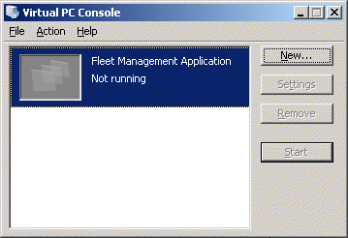
Figure 4. New virtual machine in the Virtual PC Console
The next step in the process is to configure any virtual machine settings.
To configure the new virtual machine settings
- In the Virtual PC Console, select virtual_machine, and then click Settings (where virtual_machine is the name of the virtual machine for which you want to configure settings).
- In the Settings for virtual_machine dialog box, select the appropriate settings and make the necessary modifications (where virtual_machine is the name of the virtual machine you selected in Step 1).
For the fleet management application, the default amount of memory, 32 megabytes (MB), is increased to 64 MB (as Figure 5 shows).
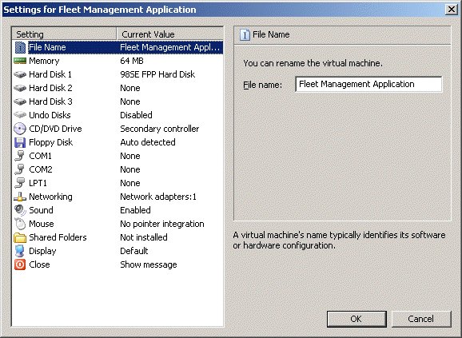
Figure 5. Configuration settings for the new virtual machine
You can configure each virtual machine in Virtual PC individually. As illustrated in Figure 5, you can change most of the virtualized devices for the virtual machine (such as memory, hard disks, CD-ROM, or floppy disks). Most of these settings can be configured only when the virtual machine is inactive. These settings take effect the next time the virtual machine is started.
Note The list of virtualized devices in Figure 5 is fixed. You cannot add or remove virtualized devices from the list.

Installing the Guest Operating System
After you have properly configured the virtualized hardware of the virtual machine, you are ready to install the guest operating system. The process for installing the guest operating system is the same for a virtual machine as for a physical computer. Figure 6 shows the BIOS boot process in a virtual machine, which mirrors the same process on a physical computer.
Figure 6. Virtual machine starting before installing Windows 98 SE
For example, if you usually install the operating system by booting from a CD-ROM, then you can install the operating system from a CD-ROM in the virtual machine. Virtual PC allows you to connect to .iso files as though they are actual CD-ROMs. You can also create virtual floppy disk images of software.
Because the fleet management application runs on only Windows 98 SE, Windows 98 SE is installed and configured in the virtual machine. The process for installing Windows 98 SE is the same as installing Windows 98 SE on a physical computer.
In most instances, you need to install the Virtual Machine Additions in the guest operating system. The Virtual Machine Additions contain device drivers for the guest operating system that are optimized for the virtualized hardware. For operating systems for which no Virtual Machine Additions are available, the virtualized hardware emulates common hardware.

Installing the Application
The installation of the application in a guest operating system is identical to installing the operating system on a physical computer. The only difference is how the guest operating system accesses the source media for the application.
For example, if the application is installed from a CD-ROM, then you can put the application’s CD-ROM in the physical computer’s CD-ROM drive and install the application from the guest operating system’s virtual CD-ROM drive. Optionally, you can create .iso images of the application’s CD-ROM and mount the .iso file on the virtual machine.
Figure 7 illustrates the fleet management application installed and running in the virtual machine.
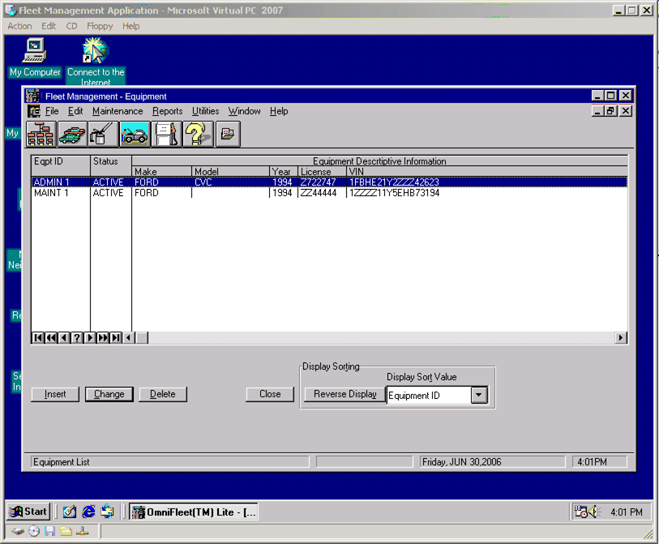
Figure 7. Fleet management application running in Windows 98 SE on the virtual machine

Configuring the Guest Operating System and Application
The final step in the process is to perform any final configuration for the guest operating system and application. Sometimes, this means connecting to the appropriate network drives or network printers.
In the case of older applications and operating systems, such as MS-DOS, you have to connect the network printer to a logical MS-DOS LPT port. Also, some applications require that you specify the type of printer that the application is printing to. For example, an MS-DOS application may need to select the printer driver that matches the network printer. The process for newer operating systems, such as Window XP, is the same as when the guest operating system is running on a physical computer.

Running the Application on 32-bit Windows Vista
The steps for running the application on a 32-bit version of Windows Vista are the same as for running the application on a 64-bit version of Windows Vista. The only difference is that running 16-bit x86 applications is supported in 32-bit versions of Windows Vista. As a result, you may be able to use one of the following application compatibility solutions:
- Applying updates or service packs to the application
- Modifying the configuration of the application
- Modifying the security configuration
- Using application compatibility tools

Comparing Virtual PC with Other Solutions
Virtual PC is an excellent solution for mitigating application compatibility as a short-term solution that allows you to continue with Windows Vista deployment. However, you should consider selecting a longer-term solution.Other available mitigation options include:
- Applying updates or service packs to the application. When updates or service packs are available to make the application compatible, apply the updates or service packs. Then test the updated application in your test environment to ensure the compatibility issue is mitigated.
- Modifying the configuration of the existing application. In some instances, you can resolve compatibility issues by modifying the configuration of the application (such as moving files to different folders, modifying registry entries, or changing file and folder permissions). For commercially available software, contact the software vendor to determine whether any workarounds are available for compatibility.
- Upgrading the application to a compatible version. When a newer version of the application is known to be compatible, upgrading to the newer version is the best long-term mitigation. The disadvantages to this approach include:
- The financial affect of the cost to upgrade.
- Problems of coexistence with earlier versions of the application.
- Modifying the security configuration. You can modify the security configuration when your organization’s security requirements are uncompromised. Before selecting this method as a final mitigation solution, obtain consensus from your organization’s Security feature team regarding the modifications.
- Modifying the application. When you have access to the application source code, you can modify the applications to mitigate the compatibility issues. Depending on the extent of the modifications, the affect of the project may be minimal or very significant on the overall Windows Vista deployment project timeline.
In addition, you may not have access to the application source code (the vendor may have gone out of business or is unwilling to release the source code). If the modifications are too costly, you cannot complete them within the deployment project timeline, or you cannot obtain the source code, another method must be selected.
- Using application compatibility tools. The ACT version 5.0 application compatibility tools may also provide software updates to incompatible applications that mitigate the problems. For more information about ACT 5.0, see the Application Compatibility page at http://www.microsoft.com/technet/windowsvista/appcompat/default.mspx.
- Consider retirement of your legacy application. It may be time to consider upgrading to a newer version of your application, or even looking at ISV applications that will meet the needs of your business and have support for Windows Vista. Disadvantages to this mitigation might be:
- The cost of the new application.
- Any user and support training required to introduce the new application into your organization.
- Running the application in a virtualized environment. When all other methods are unavailable, you can run the application in an earlier version of the Windows operating system by using the following:
- Virtualization tools. This includes Virtual PC 2007 or Virtual Server 2005 R2.
- Remote desktop tools. This includes Windows Server 2003 Terminal Server running on an earlier Windows Server operating system (such as Microsoft Windows NT® Server 4.0 or Windows 2000 Server).
Virtual PC 2007 provides an excellent bridging solution for your existing applications until you are ready to decide on how to implement a full Windows Vista supported application.
Figure 8 illustrates a comparison of the advantages and disadvantages for each method of mitigating application compatibility.
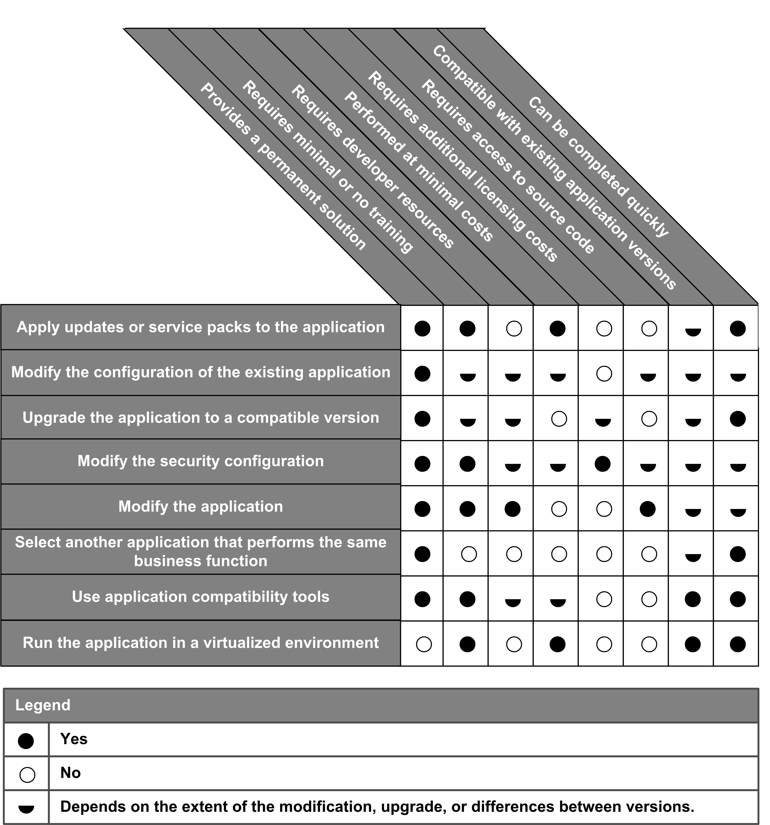
Figure 8. Comparison of methods for mitigating application compatibility

Supporting Applications on Virtual PC 2007
After your application is running in Virtual PC 2007, the focus now turns to support for the application. Although the application will continue to function as well as it did before on the earlier operating system running on the original recommended hardware, you will want to eventually replace the application with a solution that can provide long-term support. You can use one of the other methods discussed in the section “Comparing Virtual PC with Other Solutions” to help you identify the best solution for replacing your incompatible application.
You should replace the application with a new solution when any of the following are no longer supported by the respective vendors:
- Application. Ongoing, long-term support for the application is necessary in the event the application needs modification or updates. For example, a change in laws may require updates to the application to be updated to comply with these new laws.
- Guest operating system. The application requires an earlier operating system that is now longer supported (although the application, and other dependencies, may be supported). For example, the application may require Windows NT Workstation 4.0, which is no longer supported by Microsoft.
- Hardware devices. Sometimes the application may require hardware devices that are no longer supported by the vendor. For example, a point-of-sale application might communicate with a cash register drawer that is no longer supported.

Summary
Virtual PC 2007 lets you run additional operating systems on Windows Vista, without using multiple computers. This allows you to proceed with your Windows Vista deployment, rather than delay because of application incompatibility. Your organization can take full advantage of the new features and capabilities in Windows Vista and still provide end users access to run their legacy mission-critical applications, allowing you to realize your return on investment faster than other short-term solutions.

For More Information
The following are additional resources that you can review for more information about the topics covered in this document:
- The Windows Vista Developer Story: Application Compatibility Cookbook at http://msdn.microsoft.com/library/en-us/dnlong/html/AppComp.asp?frame=true
- The Windows Vista Application Compatibility Guidance at http://www.microsoft.com/technet/windowsvista/appcompat/
- The Application Compatibility Feature Team Guide (Enterprise Edition) at http://www.microsoft.com/technet/desktopdeployment/bdd/enterprise/AppCompact.mspx
- The Application Compatibility Feature Team Guide (Standard Edition) at http://www.microsoft.com/technet/desktopdeployment/bdd/standard/AppCompact.mspx
- The Microsoft Virtual PC 2004 Technical Overview page at http://www.microsoft.com/windows/virtualpc/evaluation/techoverview.mspx
- The Hardware Guidance page at http://www.microsoft.com/technet/windowsvista/evaluate/hardware/default.mspx
- The Microsoft Application Compatibility Toolkit 5.0 page at http://www.microsoft.com/technet/windowsvista/appcompat/act5feat.mspx

