Windows Vista™ Hardware Start Button
Version 1.02
April 23, 2007
© 2007 Microsoft Corporation. All rights reserved.
Abstract
This specification provides hardware designers and product planners with the requirements and recommendations for implementing the Windows Vista™ Hardware Start Button in their products.
The Hardware Start Button, an update to the Windows Key for keyboards, is designed to be an attractive and discoverable actuator for launching the new Start menu and search experiences in the Windows Vista family of operating systems. The Hardware Start Button creates and deepens affinity between physical hardware and the Windows Vista user experience while complementing the brand platforms and product design languages of hardware manufacturers. The Windows Vista Beta includes a preliminary version of the new Start menu.
Contents
What’s new in Version 1.02? 3
Conventional Keycap Design Requirements (page 7-8) 3
What is the Hardware Start Button? 4
Hardware Start Button Requirements 6
Windows Logo Program 6
Detailed Hardware Start Button Requirements 6
Conventional Keycap Design Requirements 7
Non-Conventional Keycap Design Requirements 11
Resources 21
Logo Lens Insert Supplier List 21
Appendix A 22
Conventional Keycap Recommendations 22
Non-Conventional Keycap Recommendations 23

Disclaimer
The information contained in this document represents the current view of Microsoft Corporation on the issues discussed as of the date of publication. Because Microsoft must respond to changing market conditions, it should not be interpreted to be a commitment on the part of Microsoft, and Microsoft cannot guarantee the accuracy of any information presented after the date of publication.

This document is for informational purposes only. MICROSOFT MAKES NO WARRANTIES, EXPRESS, IMPLIED OR STATUTORY, AS TO THE INFORMATION IN THIS DOCUMENT.

Complying with all applicable copyright laws is the responsibility of the user. Without limiting the rights under copyright, no part of this document may be reproduced, stored in or introduced into a retrieval system, or transmitted in any form or by any means (electronic, mechanical, photocopying, recording, or otherwise), or for any purpose, without the express written permission of Microsoft Corporation.

Microsoft may have patents, patent applications, trademarks, copyrights, or other intellectual property rights covering subject matter in this document. Except as expressly provided in any written license agreement from Microsoft, the furnishing of this document does not give you any license to these patents, trademarks, copyrights, or other intellectual property.

You have no obligation to give Microsoft any suggestions, comments or other feedback ("Feedback") relating to the information contained in this document. However, any Feedback you voluntarily provide may be used in Microsoft Products and related specifications or other documentation (collectively, "Microsoft Offerings") which in turn may be relied upon by other third parties to develop their own Products. Accordingly, if You do give Microsoft Feedback on any version of this document or the Microsoft Offerings to which they apply, You agree: (a) Microsoft may freely use, reproduce, license, distribute, and otherwise commercialize Your Feedback in any Microsoft Offering; (b) You also grant third parties, without charge, only those patent rights necessary to enable other Products to use or interface with any specific parts of a Microsoft Product that incorporate Your Feedback; and (c) You will not give Microsoft any Feedback (i) that You have reason to believe is subject to any patent, copyright or other intellectual property claim or right of any third party; or (ii) subject to license terms which seek to require any Microsoft Offering incorporating or derived from such Feedback, or other Microsoft intellectual property, to be licensed to or otherwise shared with any third party.

© 2007 Microsoft Corporation. All rights reserved.

Microsoft and Windows Vista are either trademarks or registered trademarks of Microsoft Corporation or its affiliates in the United States and/or other countries.

The names of actual companies and products mentioned herein may be the trademarks of their respective owners.



What’s new in Version 1.02?

Conventional Keycap Design Requirements (page 7-8)
The following exception:
A matte finish with a consistent texture of MT11000 or equivalent may be used on the Hardware Start Button dome and chamfer instead of an SPI A2 gloss finish.

Now requires the following revised conditions be met:
- the keyboard meets all European Union (EU) requirements for keyboards for use in a workplace environment, including the EU Directives 89/391/EEC and 90/270/EEC, and
- the keyboard is distributed in the EU
Note: This exception enables manufacturers to develop keyboards with the Hardware Start Button that will not conflict with gloss regulations or requirements in EU markets. Any specific keyboard model that implements the gloss finish exception, and meets all of the above conditions, may also be distributed outside the EU, provided it is the same model number and product as the EU version. An SPI A2 finish is recommended whenever possible, and in particular for keyboards sold in markets outside the EU.

What is the Hardware Start Button?
The Hardware Start Button for the Windows Vista family of operating systems is designed to be an attractive and easily discoverable actuator to launch both the Start menu and the powerful new search experience in Windows Vista™. The Hardware Start Button creates and deepens affinity with Windows Vista while complementing the brand platforms and products of hardware manufacturers.
Because the new Start experience in Windows Vista provides a text search that users would typically access from the keyboard, it’s now more compelling to launch the Start menu from the keyboard—with the Hardware Start Button—than it was in previous Windows operating systems. The Windows Vista Beta includes a preliminary version of the new Start menu.
This specification describes requirements and recommendations for creating a keyboard with one or more Hardware Start Buttons, which each consist of a polished area containing a Windows Flag Logo applied to the keycap.
The Hardware Start Button is a visual update to the Windows Key previously found on a typical PC keyboard. It functions the same. It sends the same scan codes or Human Interface Device (HID) usages as the Windows Key.
Figure 1 shows two sample implementations. Products that implement a Hardware Start Button must use the term “Windows Start Button” to describe it in any documentation or packaging.
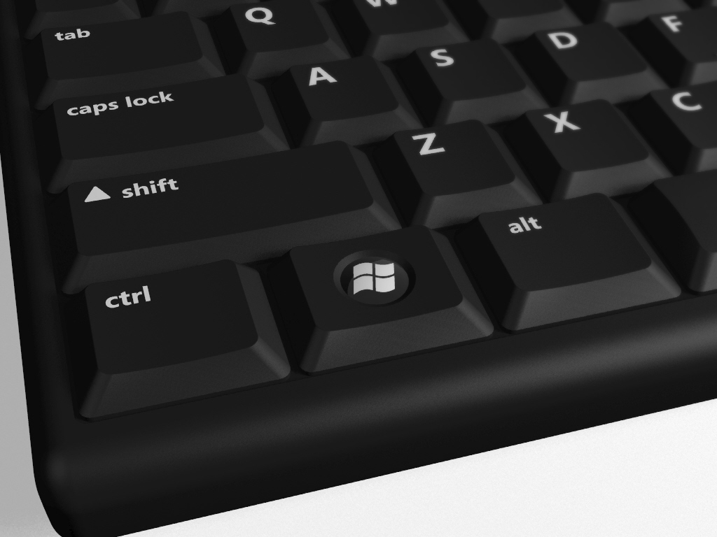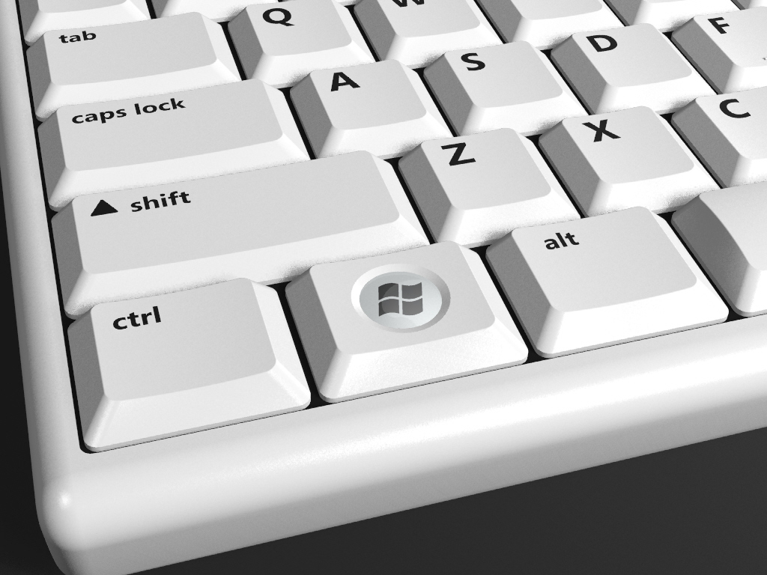

Figure 1: Sample implementation of the Hardware Start Button

The perspective renderings in Figure 2 show sample implementations in standard, very short, and very small keycap sizes.
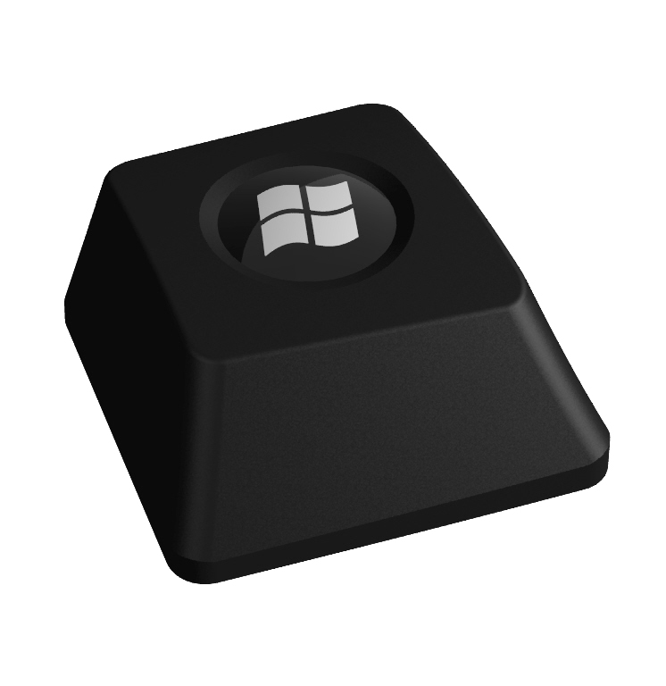
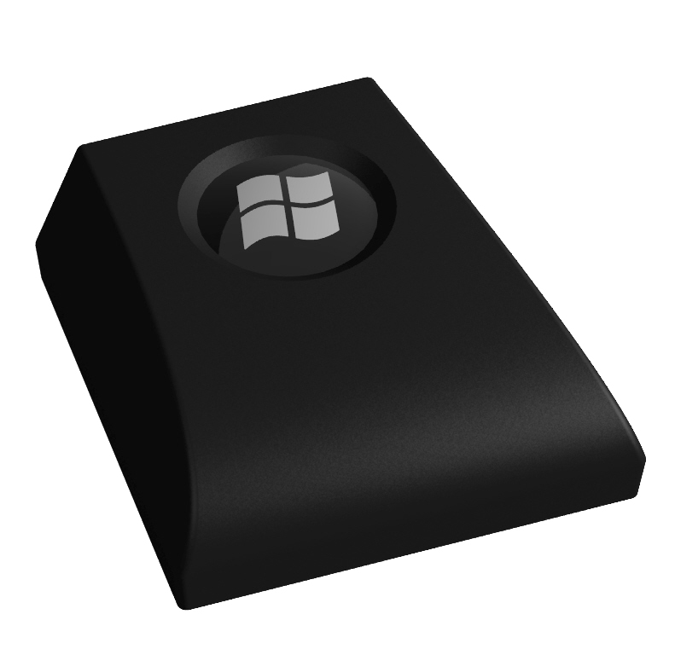
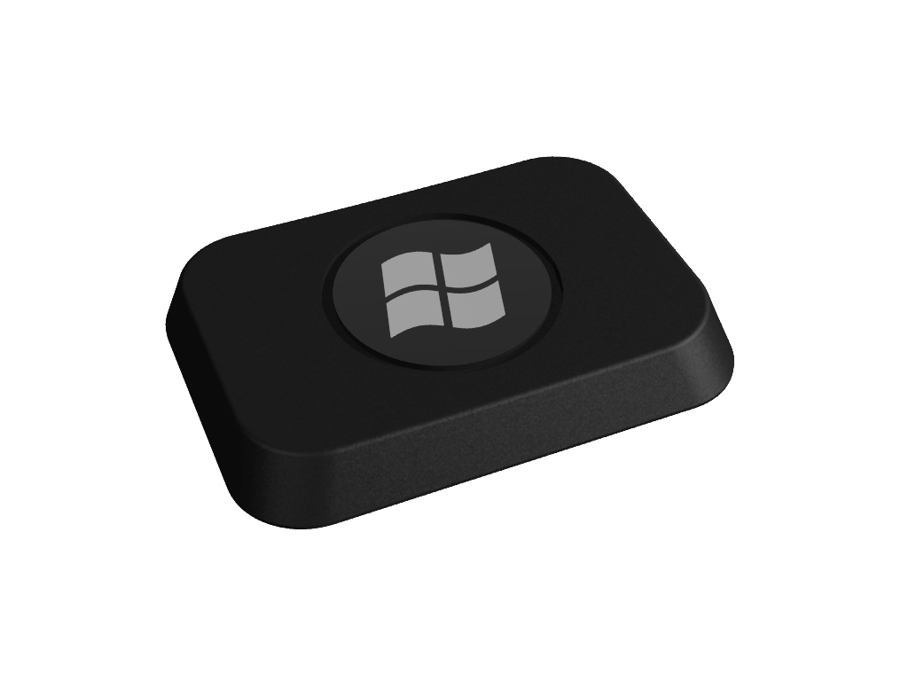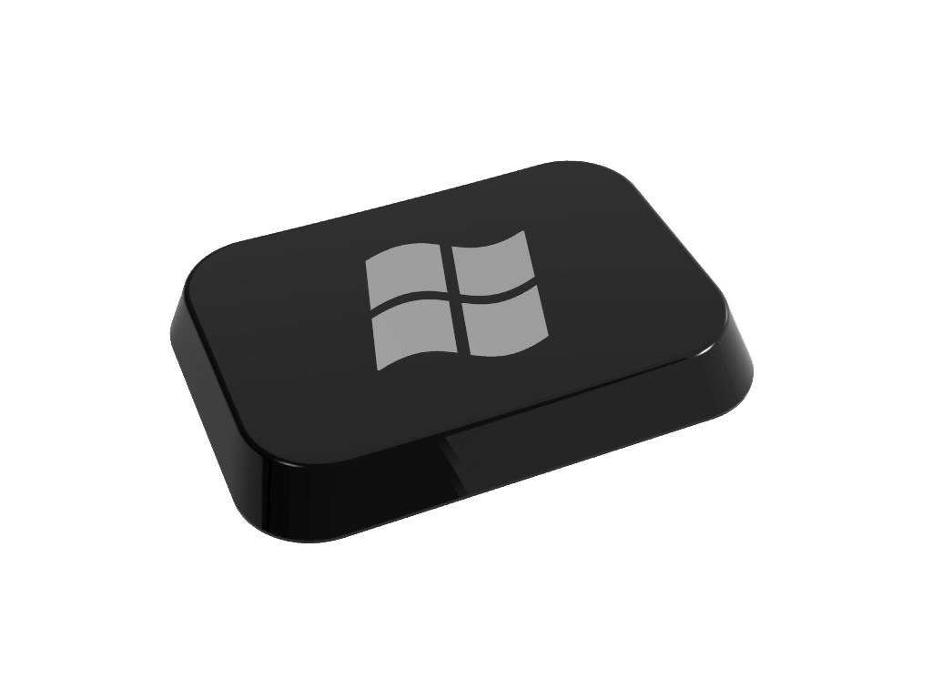
Figure 2: Perspective renderings of sample Hardware Start Button implementations in various keycap sizes

Hardware Start Button Requirements
This section includes the requirements and recommendations for implementing the Hardware Start Button functionality. See Appendix A for sample implementations of some of these requirements and recommendations.

Windows Logo Program
The Windows Logo Program Device Requirements for Windows Vista Client and Windows Server code named “Longhorn” Version 3.0 document requires the implementation of the Hardware Start Button on keyboards. Implementing any one of the of the Start Button implementation options described in this document will satisfy the Logo Program requirement.
These Logo requirements are available to Hardware Logo partners. Please see the Windows Logo Program Device Requirements for Windows Vista Client and Windows Server code named “Longhorn” Version 3.0 document for additional details.
A link to the Windows Logo Program Device Requirements for Windows Vista Client and Windows Server code named “Longhorn” Version 3.0 is included in the appendix.

Detailed Hardware Start Button Requirements
Hardware Start Button implementations must meet all of the detailed requirements for one of the Start Button implementation options listed in this document. The Conventional Keycaps and Hero Start Button options may be implemented on any keyboard. The Non-conventional, Very Short Keycaps and Very Small Keycaps options may be implemented only on keyboards with keycaps that meet the dimensional eligibility requirements defined for those options.

Keyboards may have more than one Start Button keycap, but the same design option must be used on all the Start Button keycaps on the keyboard. For example, if a keyboard design uses a Very Short Keycap Start Button option, all Start Buttons on that keyboard must be implemented using the Very Short Keycap Start Button option. There is one exception: the Hero Start Button may be implemented in addition to another Start Button option. However, it is recommended that if the Hero Start Button is implemented, that it should be the only Start Button on the keyboard.

All Conventional Start Buttons must meet the requirements listed below for conventional keycaps. All Non-conventional Start Buttons, including the Very Short Keycaps, Very Small Keycaps and Hero Start Buttons implementations, must meet all the conventional keycaps requirements, as well as the additional requirements specific to their non-conventional keycap implementation options.

When implementing a non-conventional keycap design option, in the event there is a conflict between a conventional and non-conventional keycap implementation requirement, the non-conventional keycap requirement specific to that implementation option takes precedence.

If not explicitly noted, all tolerances are two percent.

Conventional Keycap Design Requirements

Keycaps must meet these requirements
The following list defines the requirements for implementing the molded dome and associated chamfer on a conventional, rectangular keycap. Keycaps must meet the all the requirements for conventional keycaps listed below. Exceptions to the requirements are specifically stated in the “Non-Conventional Keycap Design Requirements” section in this specification.

- The dimensions of dome in the keycap must meet the size requirements in Table 1.
- The molded dome must be separated from any keycap edge or feature by the distance specified in the offset requirements listed in Table 1 below.
- The dome must be polished to an SPI SPE industry specification of A2 or equivalent.
- The Windows Flag Logo must be applied to the dome and centered horizontally and vertically with reference to the dome as illustrated in Figure 6.
- The Windows Flag Logo must be monochrome.
- The Windows Flag Logo must have a contrast ratio of at least 3:1 with respect to background it is applied to.
- The Windows Flag Logo must be between 68 and 78 percent of the diameter of the dome. It is recommended that it be 77.5 percent of the diameter of the dome. The size of the flag is measured from the lower-left tip to the upper-right tip of the flag as illustrated in Figure 11.
- The Windows Flag Logo must be oriented vertically with a 0 degree angle of offset in relationship to the keycap orientation as illustrated in Figure 6.
- The outer diameter of the chamfer must be 120 percent of the diameter of the dome. The dome must be centered within the chamfer.
- The chamfer must be polished to SPI SPE industry specification of A2 or equivalent.
- The depth of the chamfer must meet the requirements as specified in Table 1 below.
- If a coating (for example, a UV coating) is applied to the Windows Flag Logo, it must meet the following requirements:
  - The coating must completely cover the flag.
  - The coating must not extend past the polished area of the Hardware Start Button.
  - If the coating extends more than 1 mm beyond the Windows Flag Logo onto the polished surface of the Hardware Start Button, it must provide a smooth gloss surface, the equivalent of an A2 or better polish.
  - To provide the best appearance, it is recommended that either no coating is applied or that a coating providing an equivalent finish to A2 or better covers the entire polished surface.
- The dome must be positioned on the keycap to allow the user’s finger to strike naturally, directly and comfortably on the dome. Typically this is best done by centering the dome horizontally and vertically on the keycap.
- A matte finish with a consistent texture of MT11000 or equivalent may be used on the Hardware Start Button dome and chamfer instead of an SPI A2 gloss finish, provided the following requirements are met:
  - the keyboard meets all European Union (EU) requirements for keyboards for use in a workplace environment, including the EU Directives 89/391/EEC and 90/270/EEC, and
  - the keyboard is distributed in the EU
This exception enables manufacturers to develop keyboards with the Hardware Start Button that will not conflict with gloss regulations or requirements in EU markets. Any specific keyboard model that implements the gloss finish exception, and meets all of the above conditions, may also be distributed outside the EU, provided it is the same model number and product as the EU version. An SPI A2 finish is recommended whenever possible, and in particular for keyboards sold in markets outside the EU.

Figures 3–5 provide a reference for applying the requirements and recommendations above when implementing a molded dome on a keycap.

For additional samples of conventional keycap designs, see the “Conventional Keycap Recommendations” section in Appendix A.

Table 1: Determining Standard Keycap Dimensions
Dimension | Minimum | Recommended | Maximum
Diameter of the Dome | The larger of 48% of the MinSS* or 6.6mm | 56% of the MinSS* | 64% of the MinSS*
Diameter of the Chamfer | 120% of the diameter of the dome | 120% of the diameter of the dome | 120% of the diameter of the dome
Diameter of the Offset | 130% of the diameter of the chamfer | 150% of the diameter of the chamfer | N/A
Chamfer Depth | The larger of either 0.25mm or 2.8% of the diameter of the dome | 6.6% of the diameter of the dome | N/A
Dome Height | 6.6% of the diameter of the dome | 6.6% of the diameter of the dome | 10% of the diameter of the dome
* The Minimum Strike Surface (MinSS) is equal to the smaller of the width of the strike surface (WSS) dimension or the depth of the strike surface (DSS) dimension. See Figure 8 for examples of how to determine the MinSS.

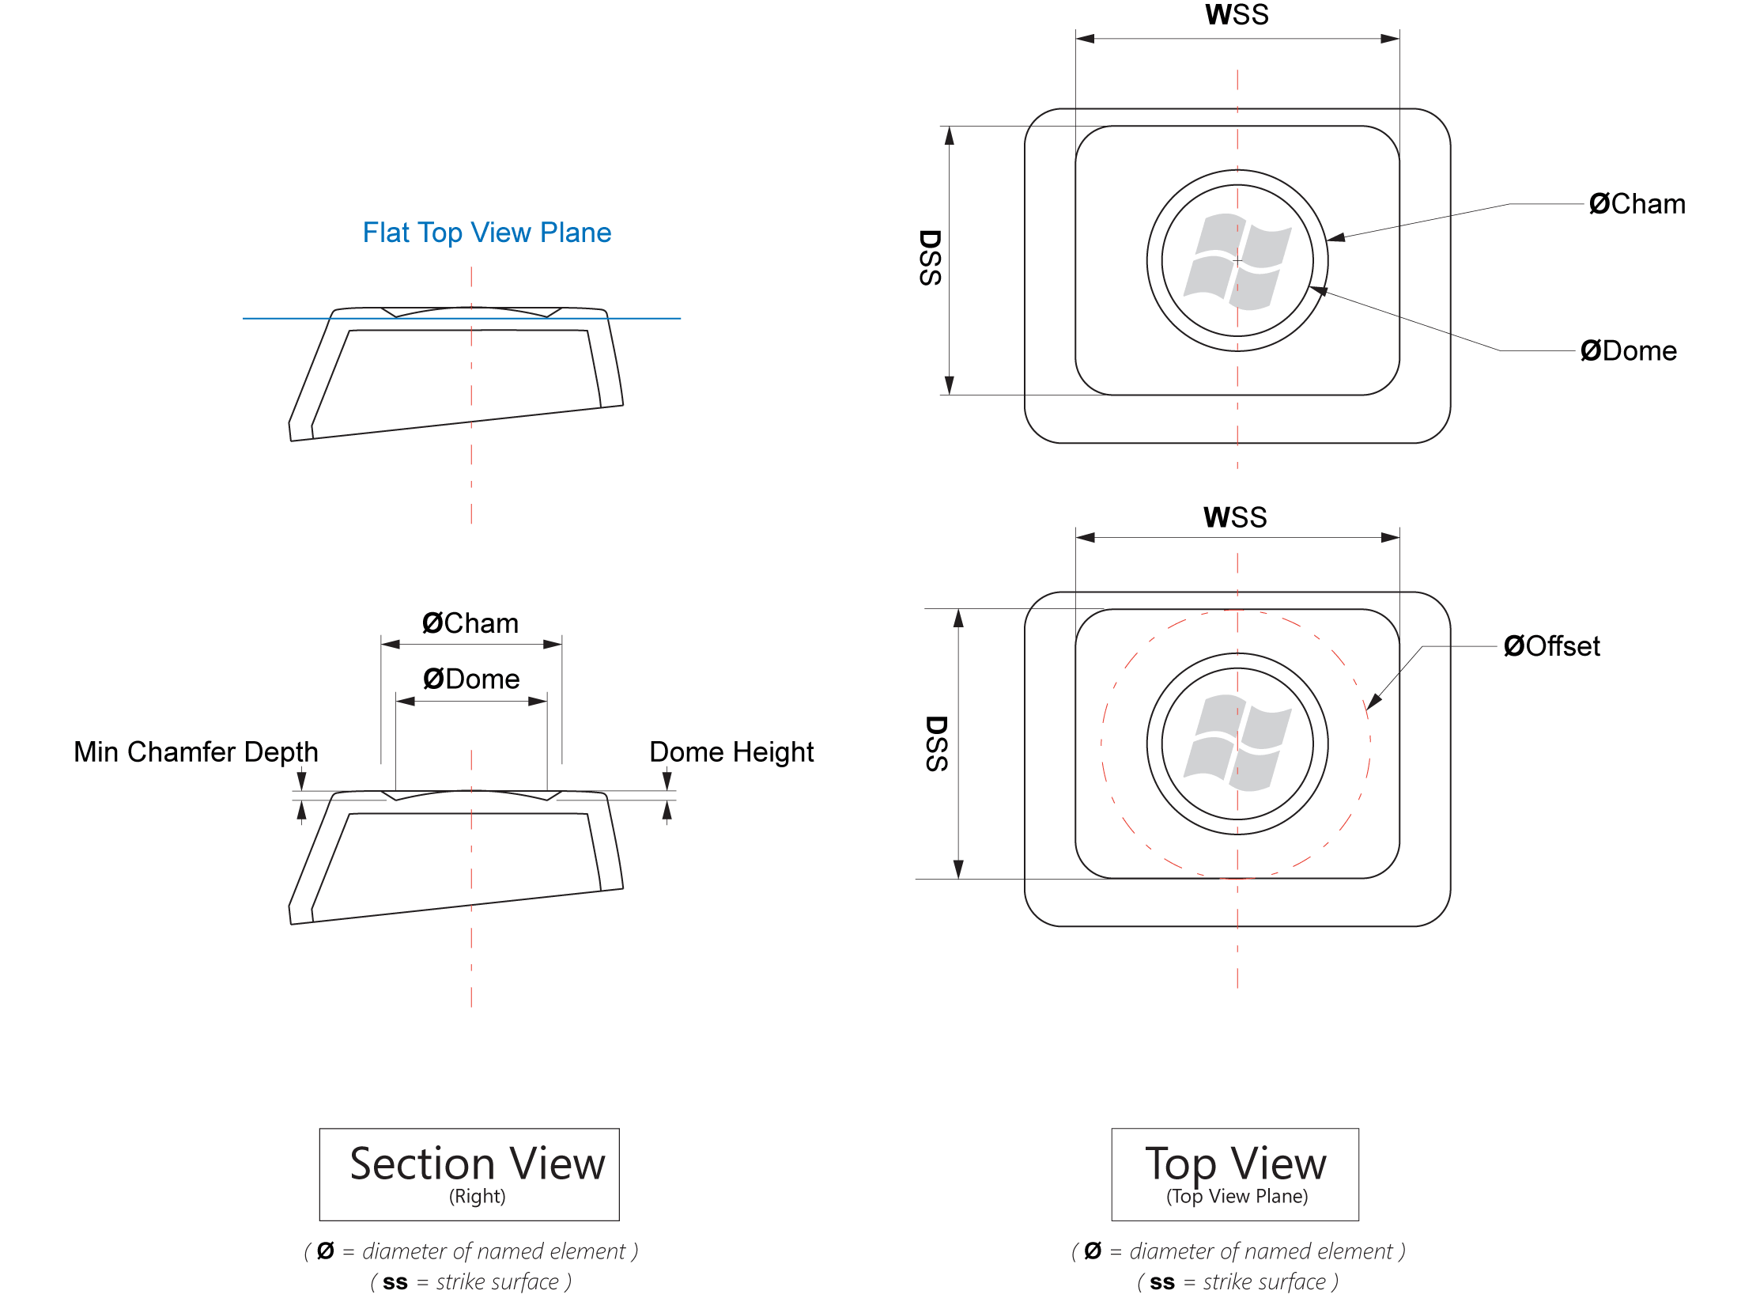
Figure 3: Keycap dimensions for flat keycaps
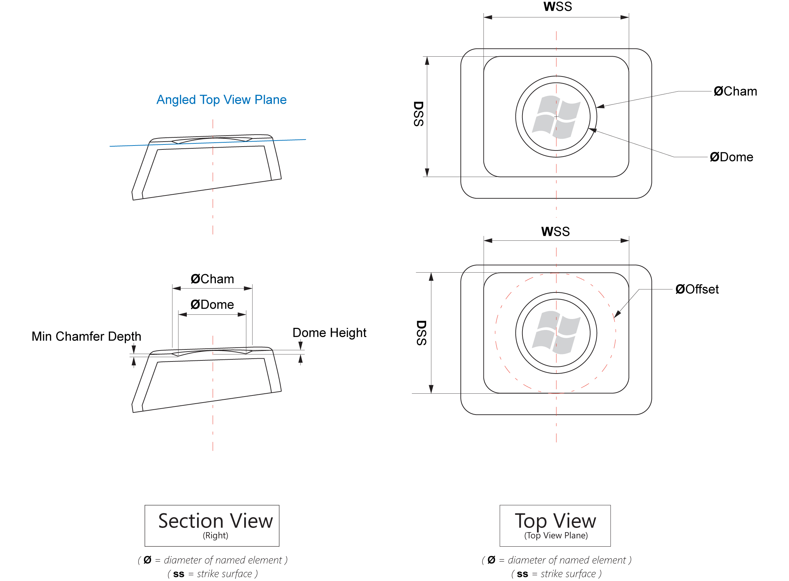

Figure 4: Keycap dimensions for concave keycaps
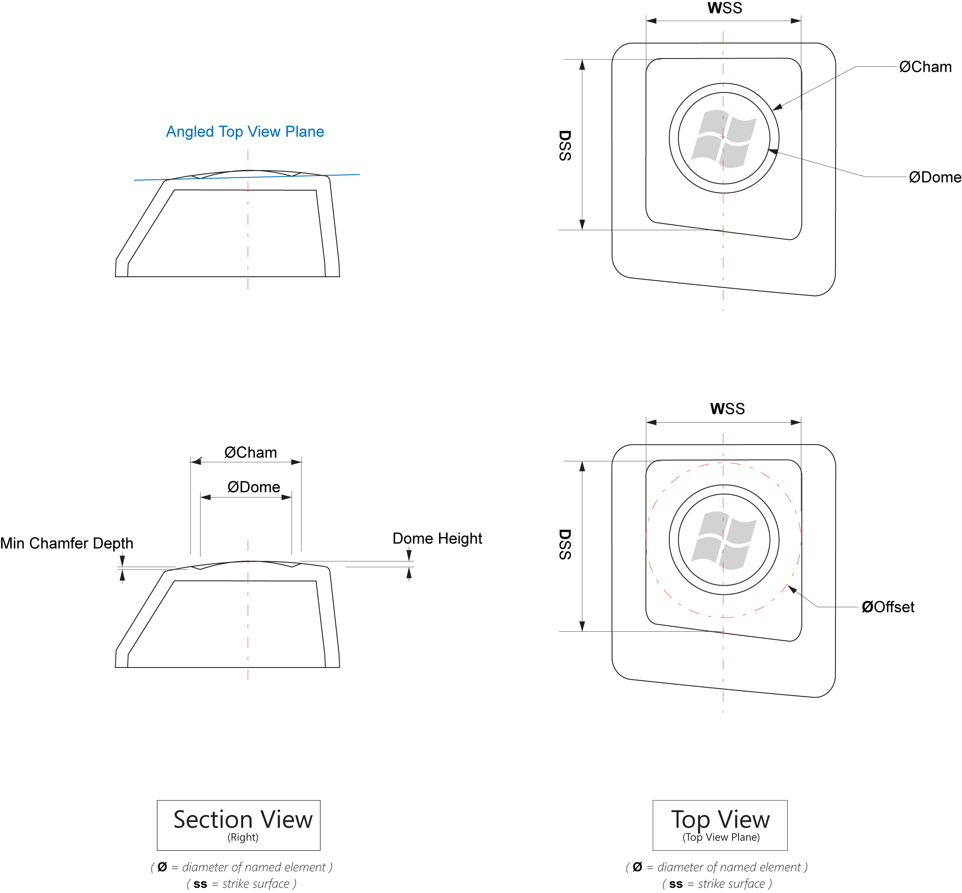

Figure 5: Keycap dimensions for convex keycaps

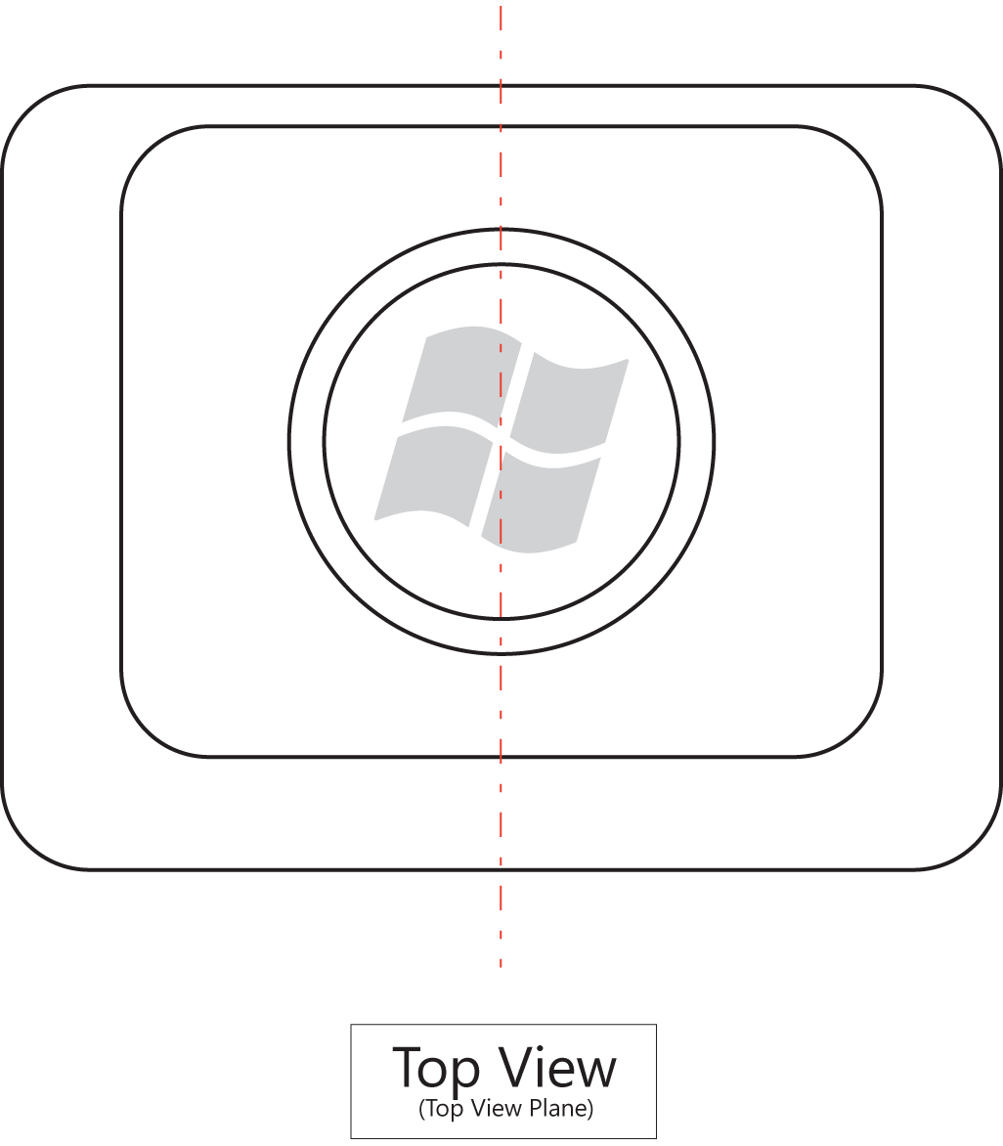
Figure 6: Determining the Windows Flag Logo positioning, orientation and size
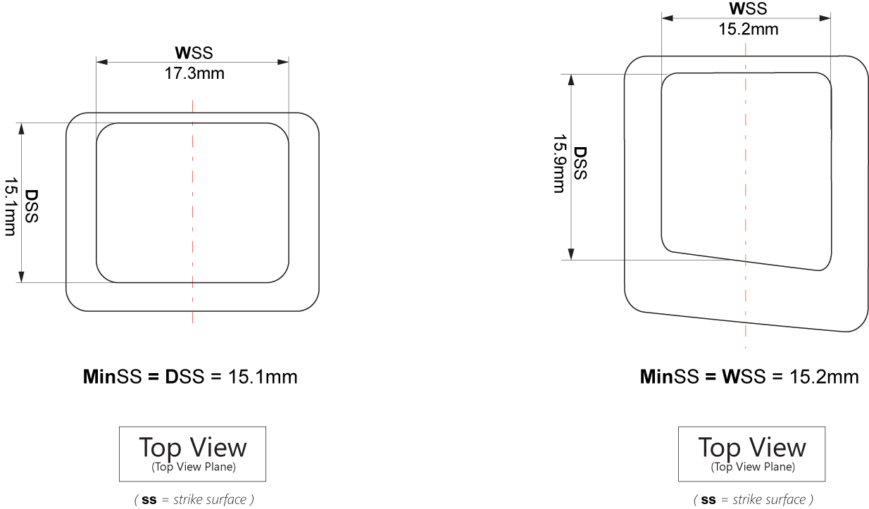
Figure 7: Two examples of determining the MinSS dimension

Non-Conventional Keycap Design Requirements
There are certain common keycap designs that require additional requirements to implement the Hardware Start Button. All requirements of a conventional keycap apply except where explicitly noted.

Very Short Keycap (Laptop) Designs

2.0 Very short keycaps must meet additional requirements
If the distance from the base of keycap to the strike surface is less than 2.7mm, the keycap qualifies as a very short keycap. Keycap height is determined by measuring from the base of the keycap to the highest point, not including any post or other mounting hardware (if present). See Figure 8 for an illustration of how to measure keycap height. Keycaps with a very short keycap height may use a fully-polished circle with an optional reveal (or in the case of painted keycaps, a circle applied to the Windows Flag Logo) or a printed graphic instead of a dome with a chamfer if vertical height of the keycap makes a dome and chamfer impractical. On a very short keycap, if a dome is not implemented, the following set of requirements must be implemented:
- Keycaps must have a textured strike surface with a centered circle containing a centered Windows Flag Logo as shown in Figure 9 and defined in Table 2.
- Either 1.) the circle must be fully polished to an SPI/SPE industry specification of A2 or the equivalent. The complete surface of the circle must be polished evenly from the edge to the center; or 2.) the circle around the Windows Flag Logo may be applied to the keycap (for example, by using printing or laser etching). The Windows Flag Logo would remain unpainted and would match the rest of the painted keycap after the circle is applied. This technique of applying a graphic is sometimes referred to as a “knock-out.” See Figure 10 for an example of how this technique would appear. Note: this technique can be used to allow backlighting on painted keycaps.
- The circle must meet the requirements for a reveal as specified in Figure 9 and Table 2. Note: if a reveal is implemented, the circle is measured from the inner edge of the reveal.

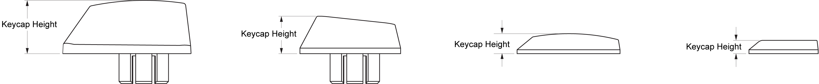
Figure 8: Determining keycap height
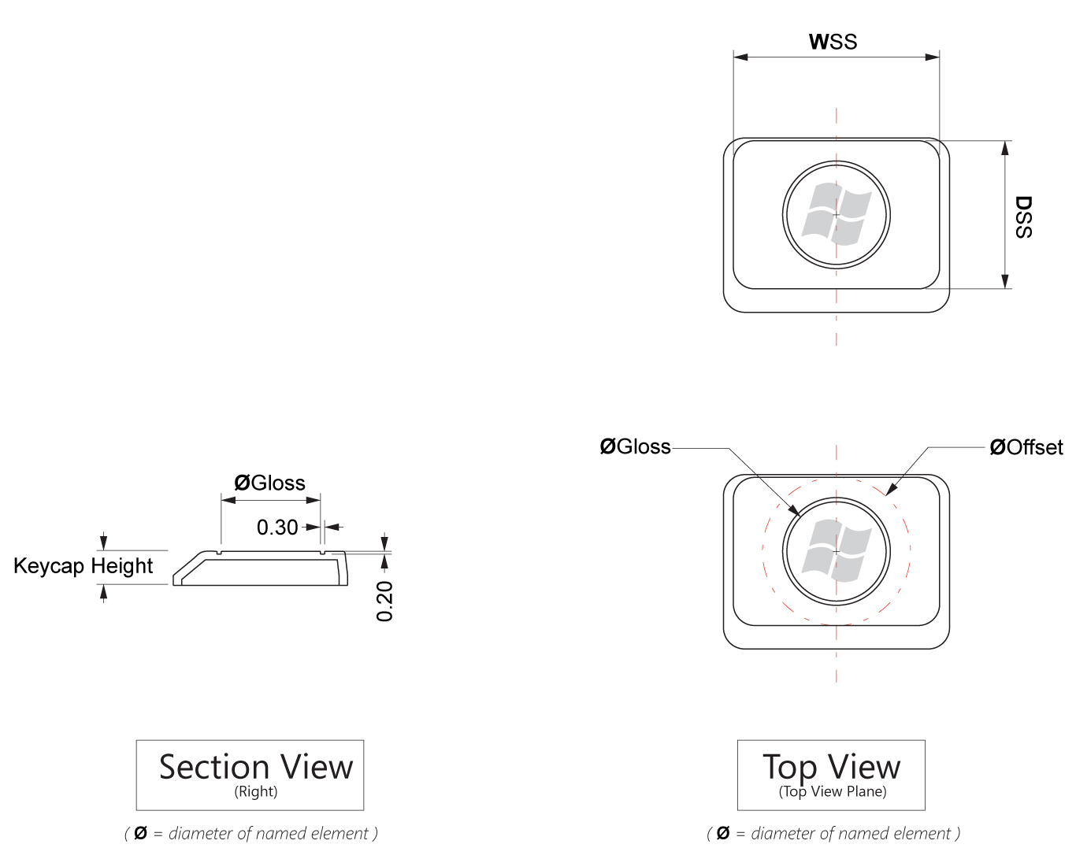
Figure 9: Determining keycap dimensions for very short keycaps

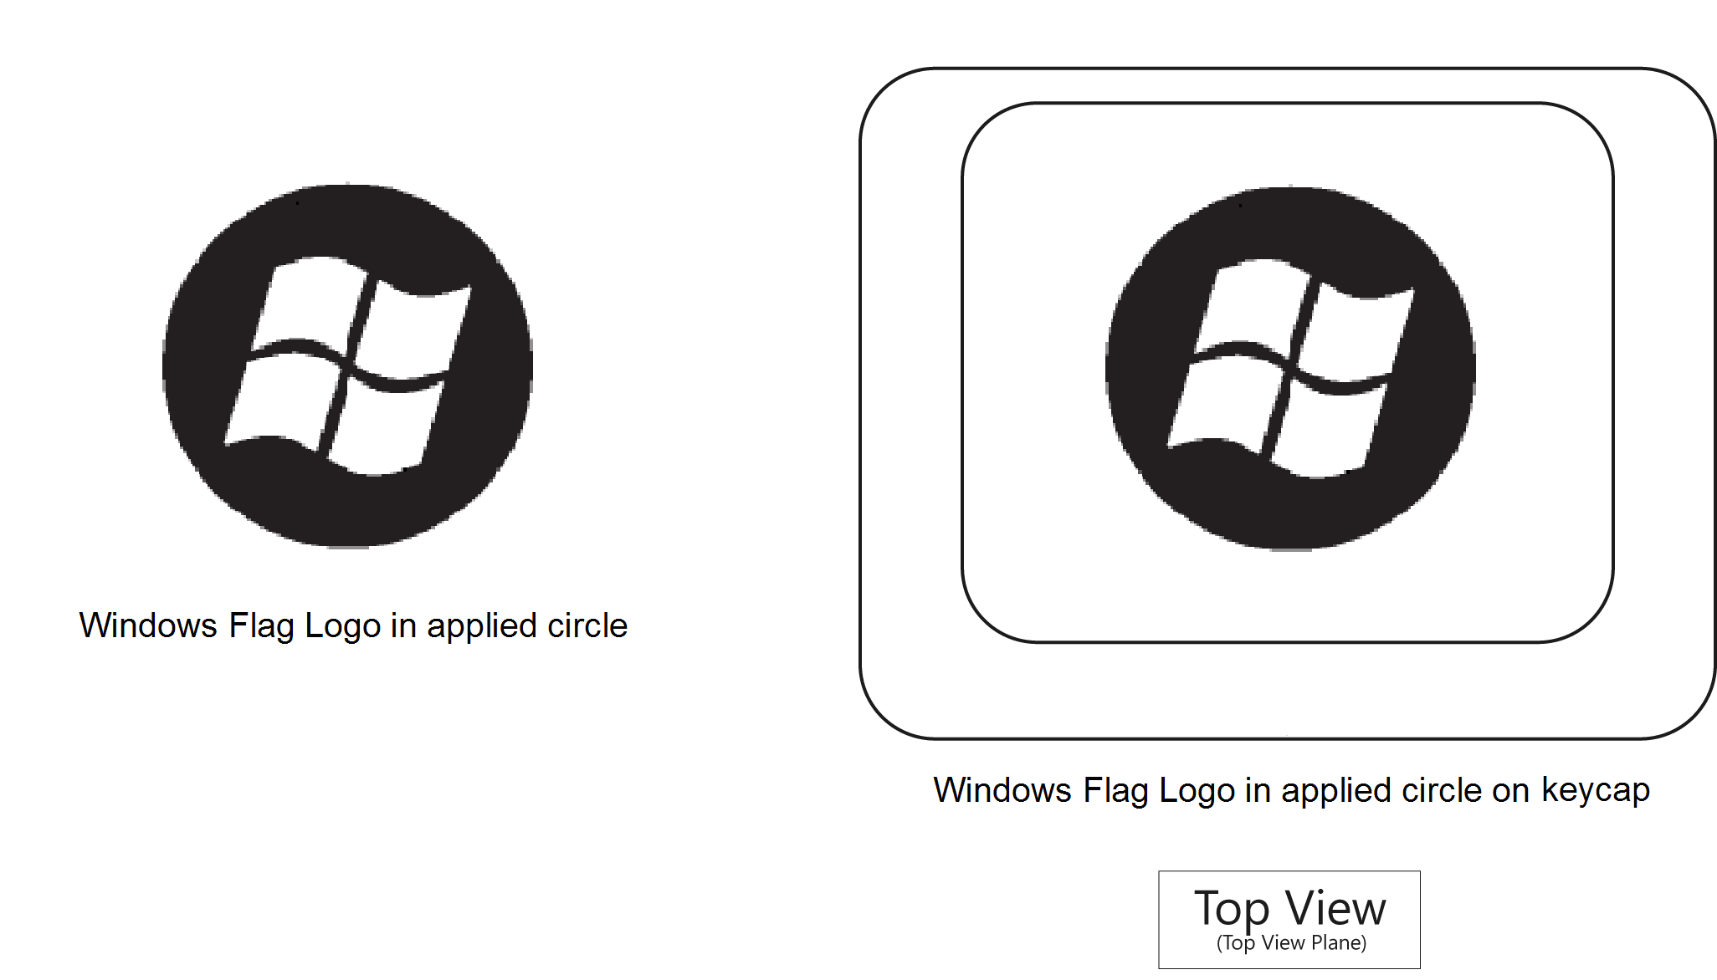
Figure 10: Windows Flag Logo in applied circle
Note: In this example, the keycap is painted white and the flag portion of the logo is the same color as the rest of the keycap. The black circle around the Windows Flag Logo and the black lines between the corners of the flag are printed or laser printed in black onto the keycap.

Table 2: Determining Dimensions for Very Short Keycaps
Dimension | Requirement
Diameter of offset | 100 percent of the MinSS
Diameter of polished circle | 66 percent of the MinSS
Reveal depth and width | - No reveal is required. If no reveal is used, maintain a crisp clean line between the textured and polished portions of a keycap.  - If implemented, the diameter of inner edge of the reveal is equal to the diameter of the polished circle.  - If implemented, the reveal must be 0.1mm deep and 0.3mm wide.  - If implemented, the reveal should be 0.2mm deep and 0.3mm wide.
Size of Windows Flag Logo | The flag must be 77 to 85 percent of the diameter of the polished circle. The size of the flag is measured from the lower-left tip to the upper-right tip of the flag as illustrated in Figure 11. It is recommended that the flag be 77.5 percent of the polished circle.

Very Small Keycap (Ultramobile PC or Small Device) Designs

3.0 Very small keycaps must meet additional requirements
If the MinSS is less than 8.2mm, then the keycap qualifies as a very small keycap. The MinSS dimension is equal to the smaller of either the WSS dimension or the DSS dimension. See Figure 7 for examples of how to determine the MinSS dimension. Very small keycaps must use a Windows Flag Logo centered on a fully polished strike surface instead of a dome or polished circle, regardless of keycap height. The following additional requirements must also be met:
- The Windows Flag Logo must be centered on the keycap.
- The Windows Flag Logo must be large enough that 122 percent of the Windows Flag Logo is equal to the MinSS size, as illustrated in Figure 11.
- If the keycap is not coated, painted or made from rubber, the entire strike surface of the keycap must be polished to SPI SPE industry specification of A2 or equivalent.
- The non-strike surface of the keycap must be textured to match the surrounding keycaps.

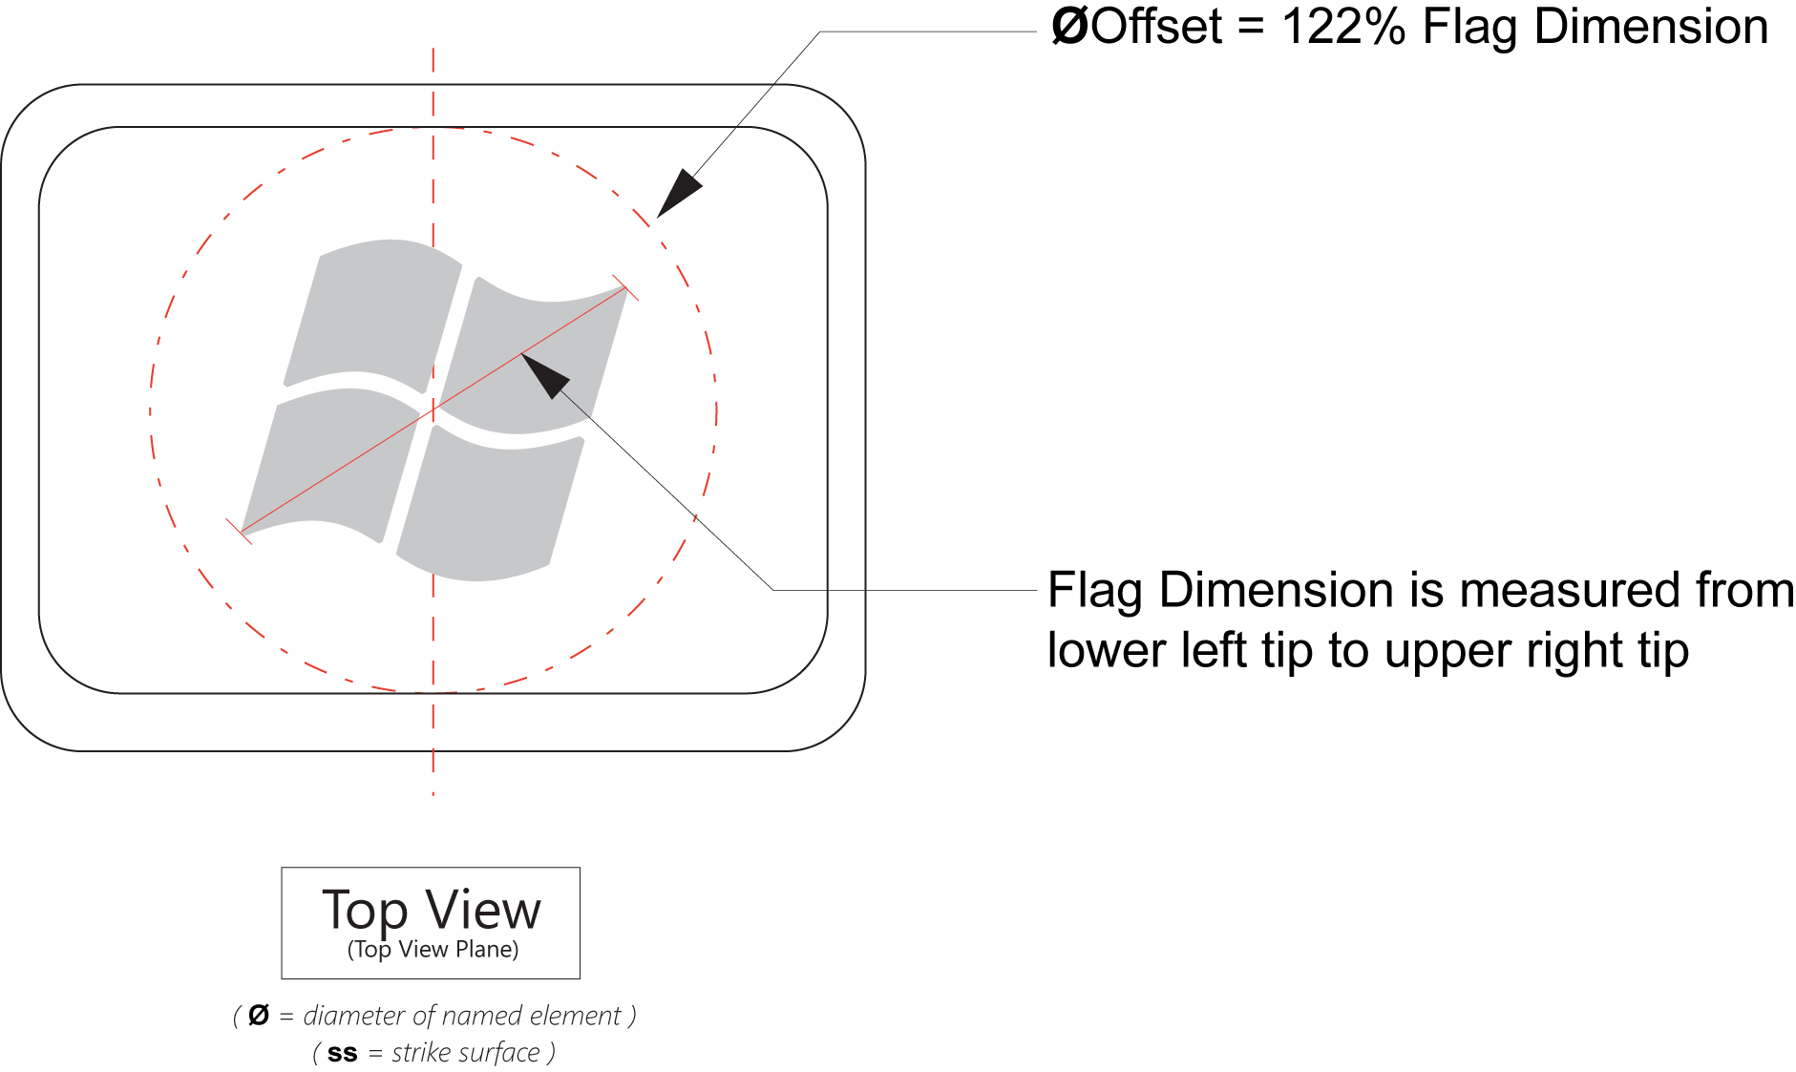

Figure 11: Applying the Windows Flag Logo to very small keycaps

Parallelogram Keycap Designs

4.0 Parallelogram keycap must meet design requirements
Figure 12 illustrates how to implement the standard Hardware Start Button keycap requirements on a parallelogram keycap design. Use this figure with Table 1 to determine the correct dimensions and dome placement.
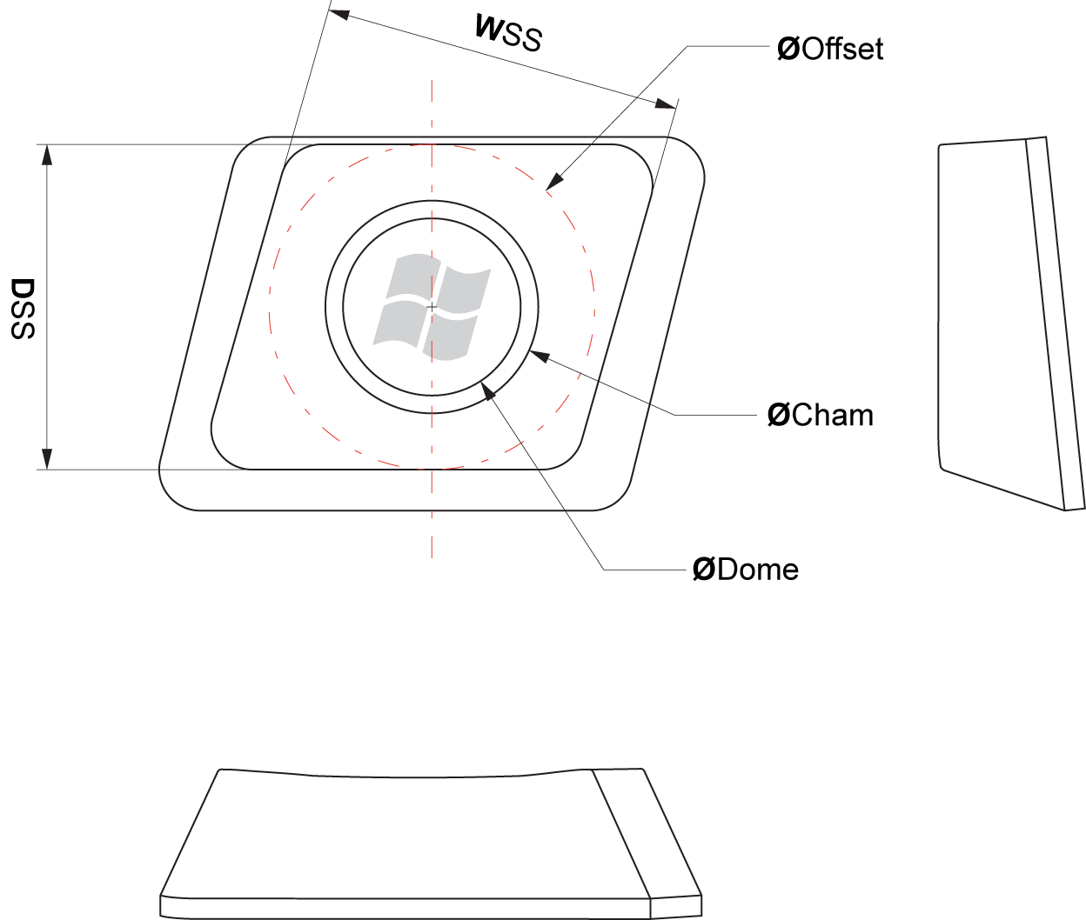
Figure 12: Parallelogram keycap example

Soft Keycap Designs

Soft keycap must meet design requirements
Soft keycaps do not have a clean obvious break between the strike surface and the front keycap surface, but a soft, sloping keycap surface that terminates at the front edge of the keycap. Figure 13 illustrates how to implement the Hardware Start Button requirements on a soft keycap design. Use this figure with Table 1 to determine the correct dimensions and dome placement.
Note: When implementing the Hardware Start Button on soft keycaps, particular attention must be placed on determining the placement of the dome to ensure that when a user presses key on the dome, pressure is applied in such a way to prevent binding of the post or other mechanical elements.
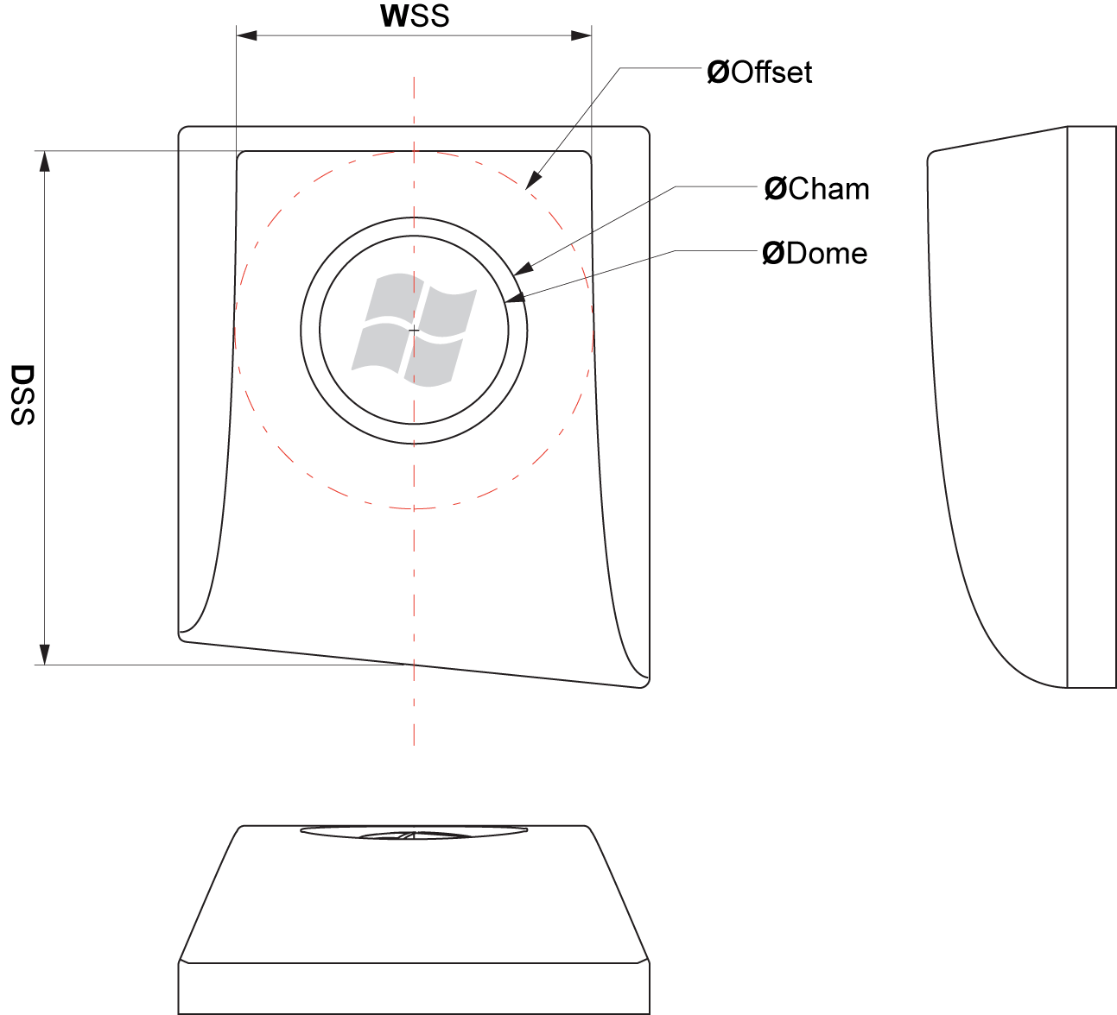
Figure 13: Soft keycap specifications

Circular Keycap Designs

Circular keycaps must meet design requirements
Figures 14 and 15 illustrate how to implement the Hardware Start Button requirements on a circular keycap design. The circular keycap must meet the following requirements:
- The dome must be 8.4mm in diameter or greater.
- On circular Hardware Start Button keycap designs, the standard offset requirements do not apply.
- For circle-on-square keycap designs, a minimum of a 1-mm clearance is required between the keycap edge and the outer chamfer edge, as illustrated in Figure 14.

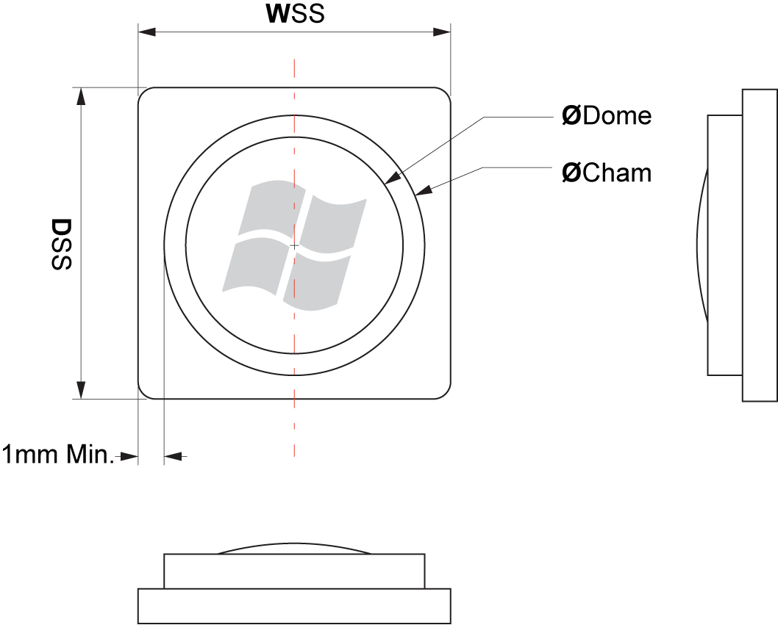
Figure 14: Circle on square keycap example
For sample implementations of non-conventional keycaps, see the “Non-Conventional Keycap Recommendations” section in Appendix A.

Dome Requirements

7.0 Dome must be parallel to the top view plane
The dome must be parallel to a top view plane keycap. This prevents the dome from appearing to be at an odd angle to the keycap or keyboard. For examples of how to implement this requirement, see Figures 3–5 and 11–14.

Defining the Top View Plane
A top view plane is defined as a plane passing through four corner points of the top of the keycap. The top surface of the keycap is aligned with the top view plane, but the top surface of the keycap may be flat, convex, or concave. This method of determining the top view applies to keys with both concave and convex top surfaces. Examples of top view planes as applied to concave and convex keys are illustrated in Figure 15.
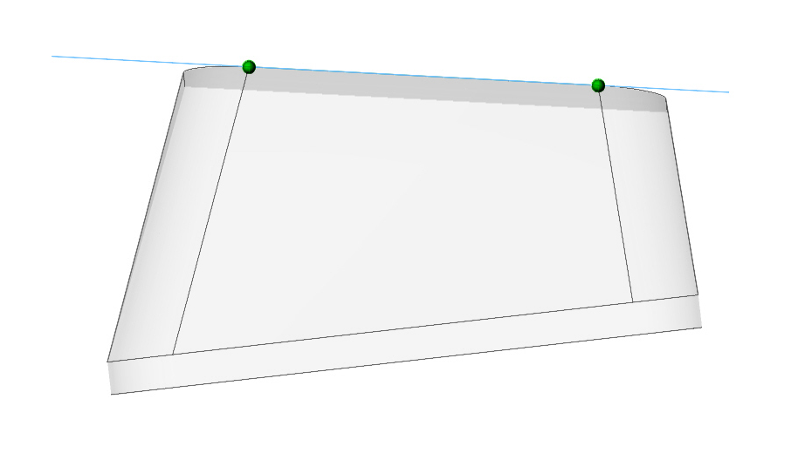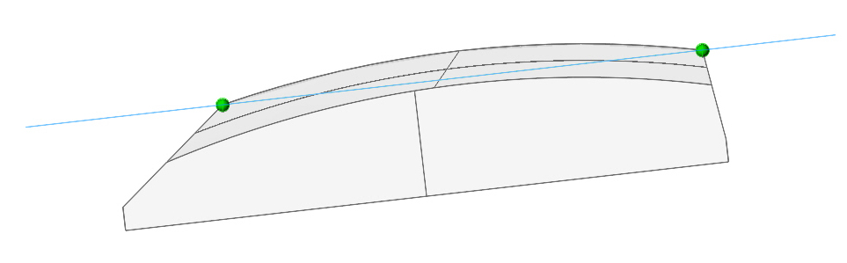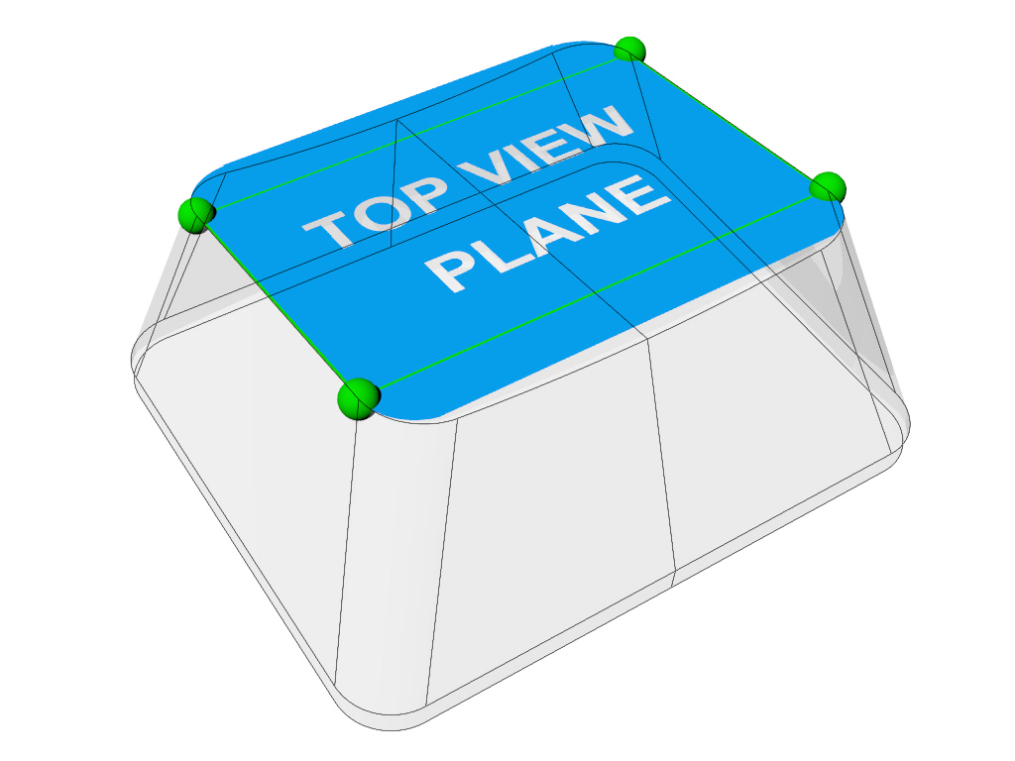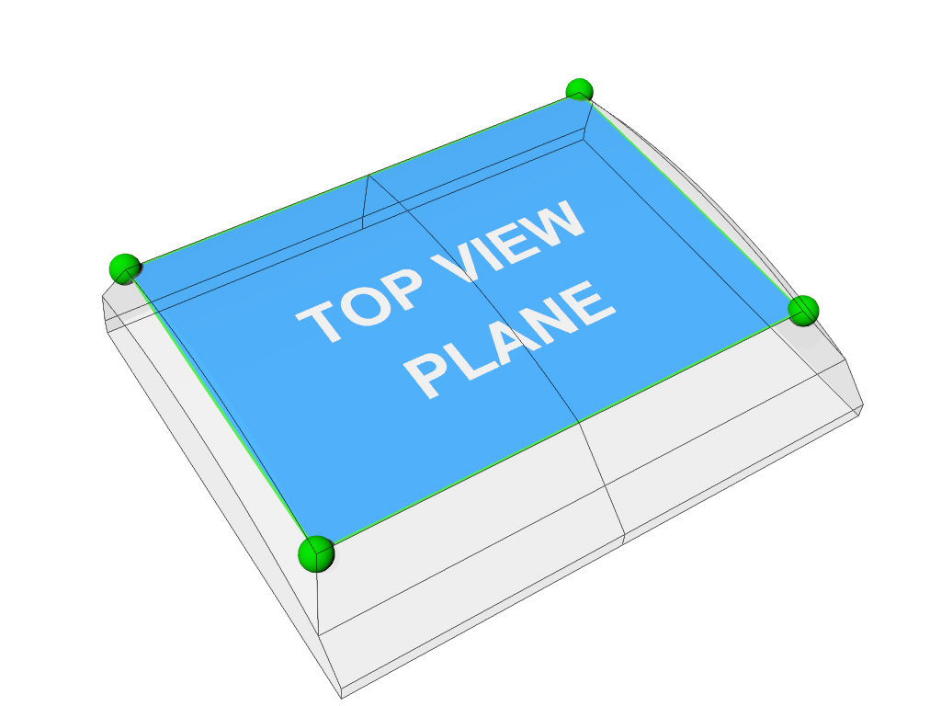
Figure 15: Examples of top view planes on concave and convex keys

Hero Hardware Start Button Designs

8.0 Hero Hardware Start Button must meet design requirements
The Hero Start Button functions as a Start Button just like the other implementations in this specification. It is not required and is provided as an option for keyboard manufactures that want to take advantage of its more dramatic look—its larger size, clear dome, and full-color printing and placement on the keyboard. The Hero Start Button uses a lens insert and is placed directly below the space bar. If implemented, the Hero Start Button must meet the following requirements:
- The Lens Insert must be acquired from a licensed Windows Start Button Logo Lens Insert manufacturer. See the “Resources” section for a list of licensed Logo Lens Insert manufacturers.
- The approved lens insert will be 15 mm in diameter and the carrier, or backing, for the Windows Start Button Logo Lens Insert is not specified and may be designed specifically for the keyboard it will be used in.
- The diameter of the chamfer around the lens insert must be 19.1 mm.
- The minimum depth of the chamfer is .42 mm.
- The chamfer and lens are separate. The chamfer is fixed and does not move when the Hero Start Button is actuated.
- On Hero Hardware Start Button keycap designs, the standard offset requirements do not apply.
- The center of the lens must be located within 20 mm below the lower edge of the space bar and the center of the lens should be directly below the center of the space bar.
- The Lens Insert must be parallel to the surrounding keyboard surface. This prevents the dome from appearing to be at an odd angle to the keyboard.
- It is recommended that the Hero Hardware Start Button utilize the scan code for the left Start Button.
- The Hero Hardware Start Button may be used either with or without additional Start Buttons on the keyboard.
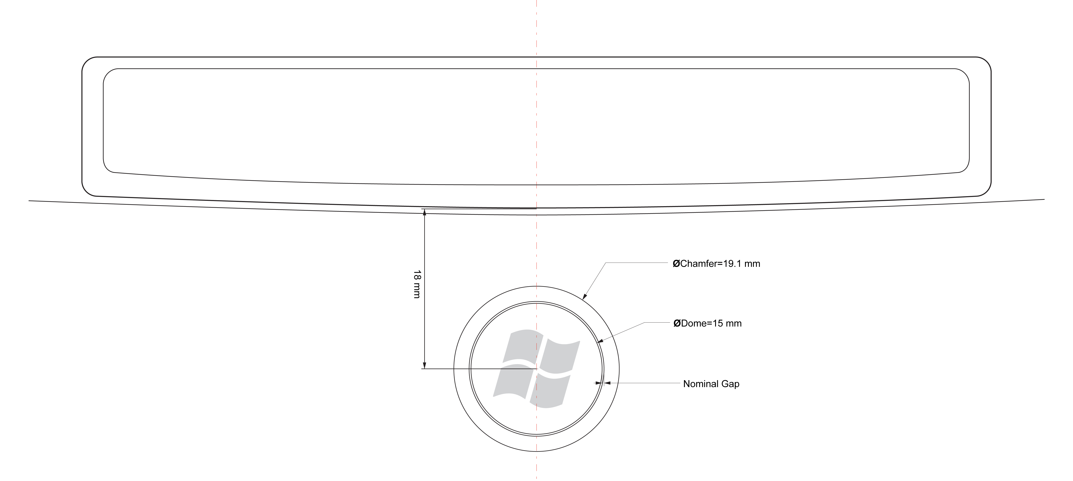
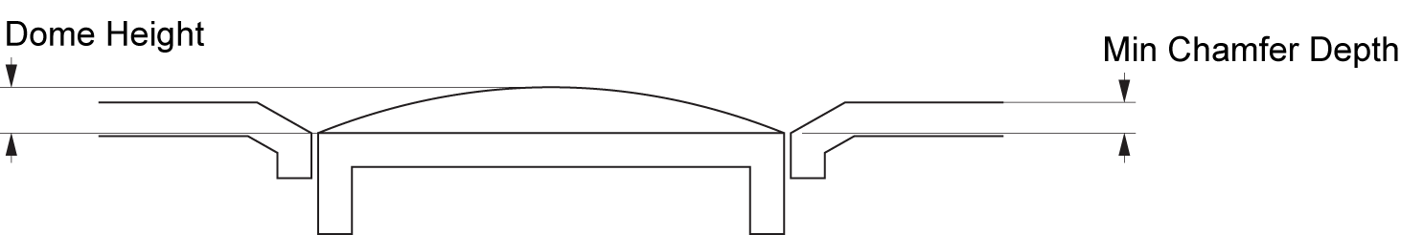
Figure 16: Hero Hardware Start Button example

9.0 Hero Hardware Start Button must use approved Lens Insert
A Windows Start Button Logo Lens Insert is a transparent dome that contains a full-color Windows Start Button Logo and composes the surface of the Hero Start Button, as illustrated in Figure 17.
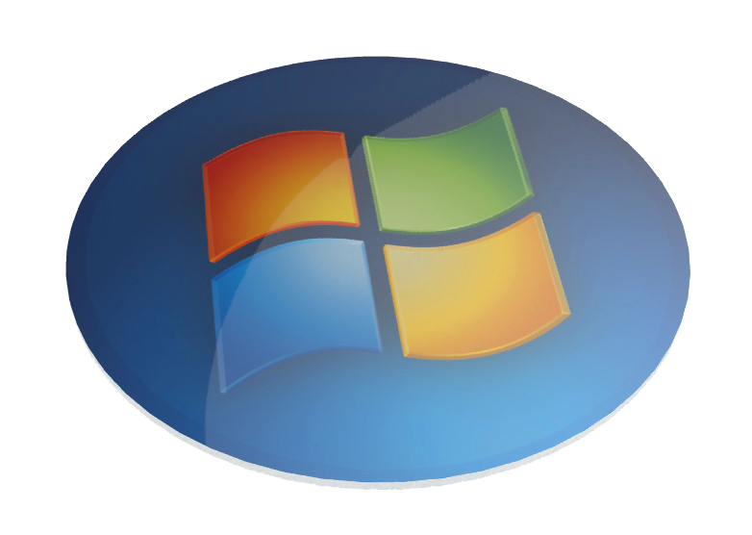
Figure 17: Windows Start Button Logo Lens Insert example
If implemented, the Hero Hardware Start Button must use a Windows Start Button Logo Lens Insert acquired from a licensed Windows Start Button Logo Lens Insert manufacturer.

Details of the Windows Start Button Logo Lens Insert
The details of the lens insert requirements are listed here for reference only, in order to enable keyboard manufactures to prepare to integrate an insert from a licensed lens insert manufacturer. Licensed insert manufacturers must meet the following requirements to provide a lens insert:
- The lens dome must be manufactured from a non-tacky urethane or epoxy, or molded polycarbonate.
- The lens must achieve a high-durometer rating of at least 55 Shore D, or equivalent.
- The lens must provide UV protection to prevent yellowing.
- The logo substrate must be Mylar or equivalent.
- The insert must feature either a keyed backing or a mechanism designed for enabling a mechanical application technique for orientation.
- Inserts will be available in a 15-mm diameter.
- The lens insert must include an image of the full-color Windows Start Button Logo.

See the “Resources” section for a list of licensed logo lens insert manufacturers.

10.0 Lens Insert must be correctly oriented on Hero Hardware Start Button
A mechanical keying mechanism or a mechanism designed for enabling a mechanical application of the lens must be used to guarantee that the lens insert, and therefore the Windows Start Button Logo, is oriented vertically with a zero-degree angle (tolerance of 2.5 degrees) of offset in relationship to the keycap and keyboard, as illustrated in Figure 18. Hardware manufacturers may work with an approved lens supplier to design the keying mechanism to preference. This keying mechanism must not affect the visual appearance of the lens when implemented on the keyboard.
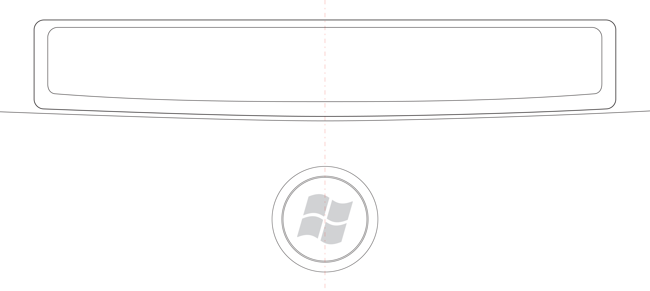
Figure 18: Lens Insert orientation
The manufacturing process must guarantee this offset either through a keying device on the keycap and Windows Start Button Logo Lens Insert, or through an automated mechanical application of the Windows Start Button Logo or Lens Insert.

Resources
Future versions of this specification will provide additional resources for Hardware Start Button design and manufacturing, including links to licensed insert manufacturers of the Windows Start Button Logo Lens Insert.

"Designed for Windows" Logo Program for Hardware
- Windows Logo Program Device Requirements for Windows Vista Client and Windows Server code named “Longhorn” Version 3.0
http://www.microsoft.com/whdc/winlogo/hwrequirements.mspx
- The Microsoft Windows Start Button Logo License Agreement (see the May 2006 or later edition)
https://winqual.microsoft.com/members/legal_agreements.asp
and "Key Support, Keyboard Scan Codes, and Windows"
http://www.microsoft.com/whdc/device/input/Scancode.mspx

Additional Resources for HID Devices
- Input/HID – Architecture and Driver Support for Microsoft Windows
http://www.microsoft.com/whdc/device/input/default.mspx
- Device Class Definitions for HID and other HID-Related Specifications:
http://www.usb.org/developers/hidpage/#Class_Definition
Additional Resources for Molded surfaces
- SPI/SPE (Society of Plastic Engineers/Society of the Plastics Industry)
http://www.4spe.org
http://www.plasticsindustry.org
- MT (Mold-Tech, a Standex company)
http://www.mold-tech.com/

Logo Lens Insert Supplier List
- Contact the Windows Hardware Logo Program team for future versions of this specification, which will include a list of licensed Windows Start Button Logo Lens Insert suppliers.

Appendix A
This appendix includes sample implementations and recommendations for Hardware Start Button design and manufacturing.

Conventional Keycap Recommendations
The examples in Figure 19 are representative of keycaps designed for standard keyboard keys.
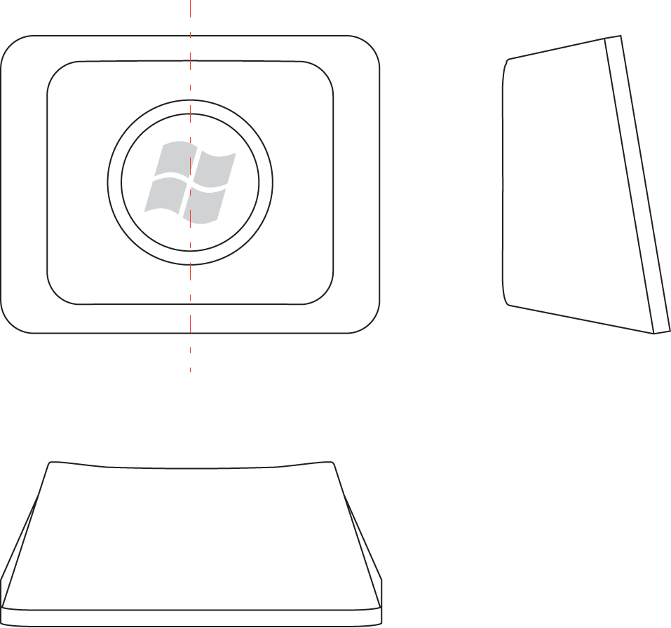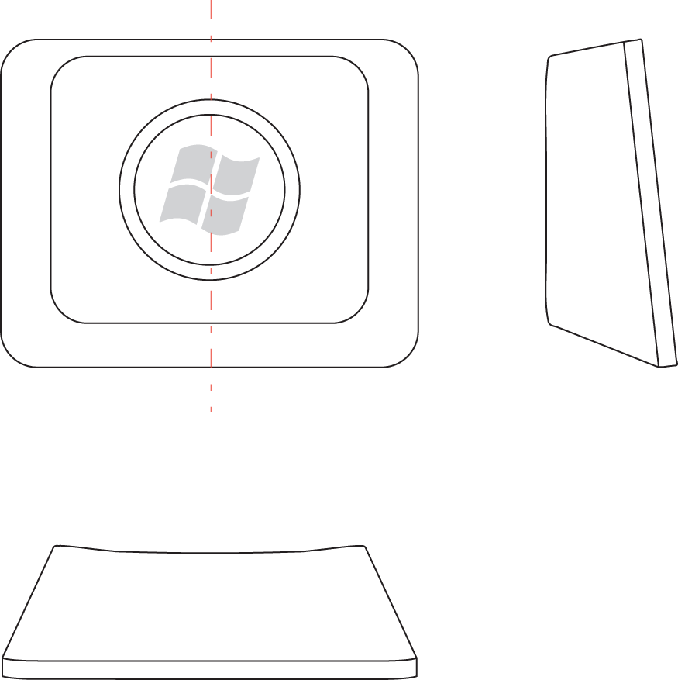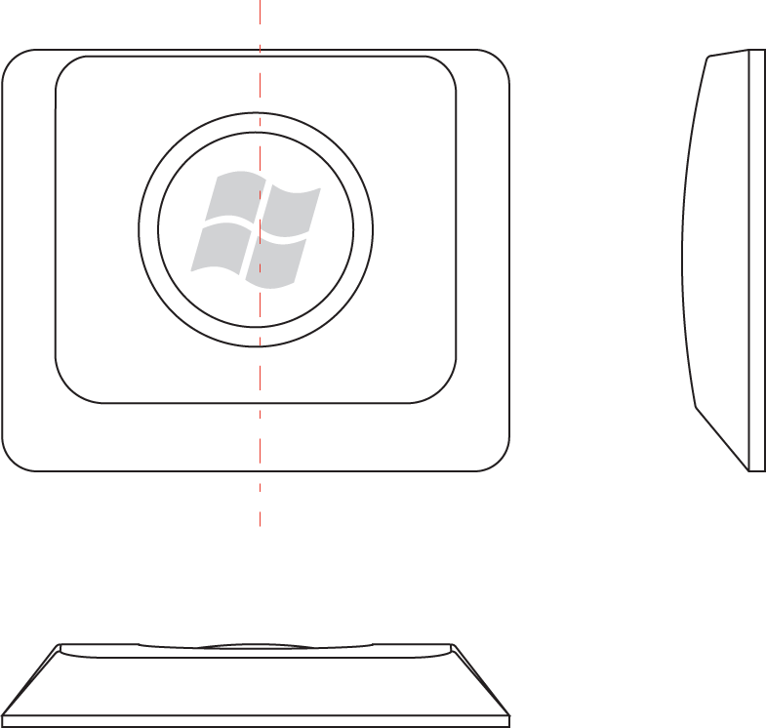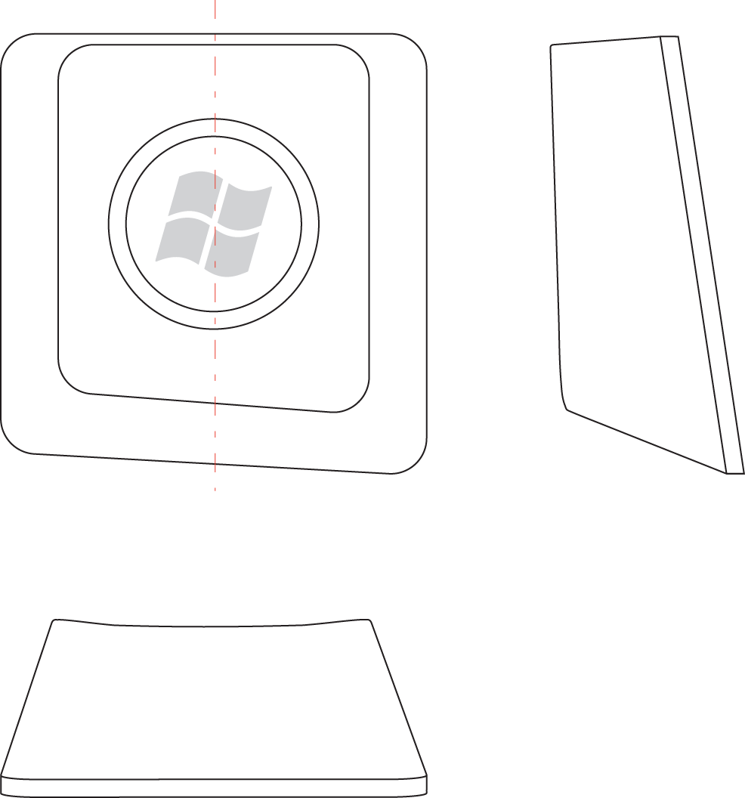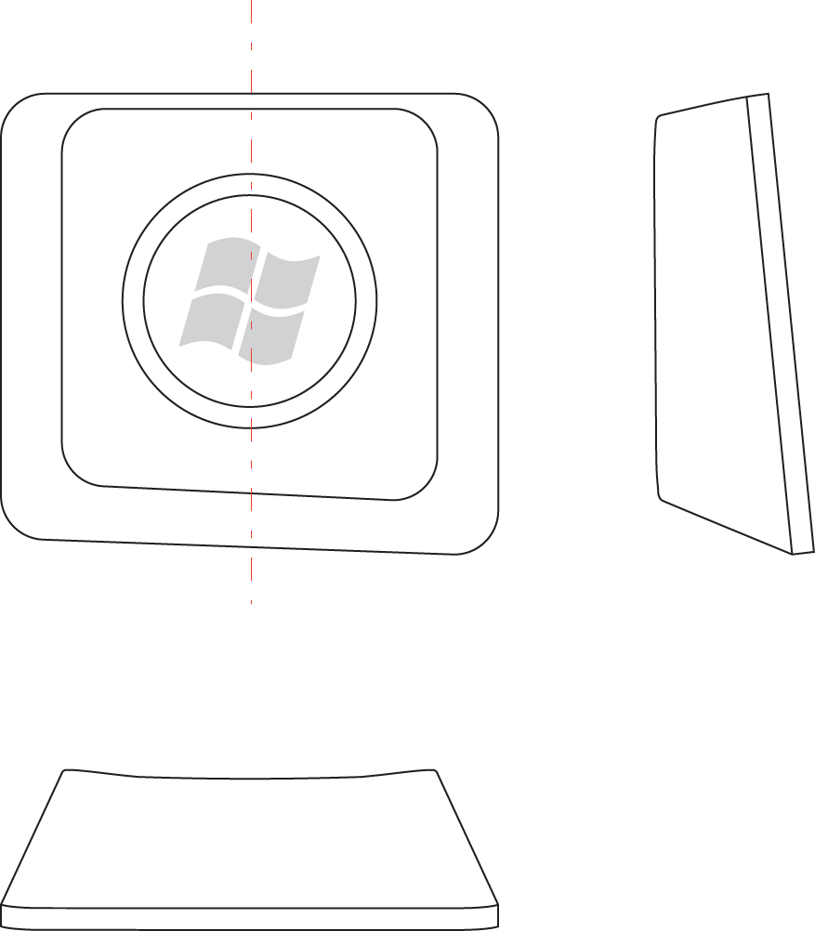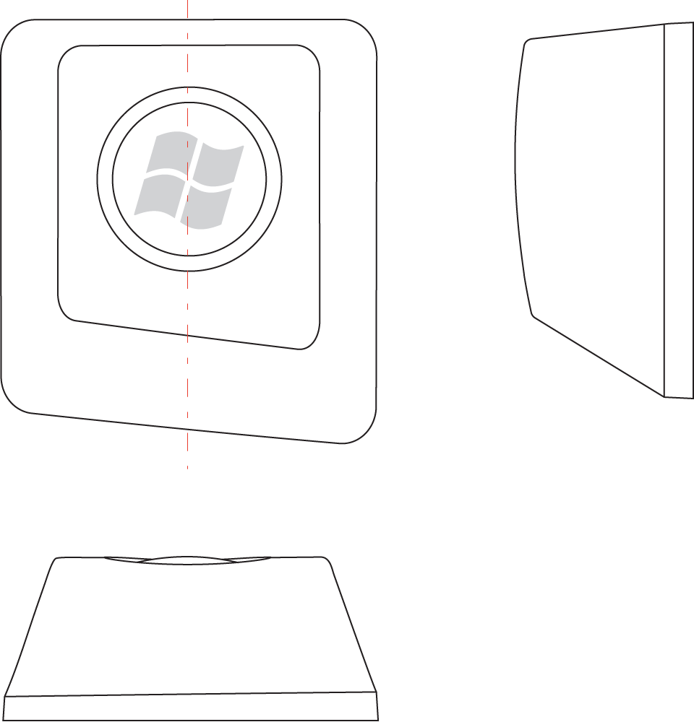
Figure 19: Sample views of the Hardware Start Button for standard keyboard keycaps
The examples in Figure 20 are representative of small form factor keycaps designed for keyboards such as mobile, or small embedded keyboards.

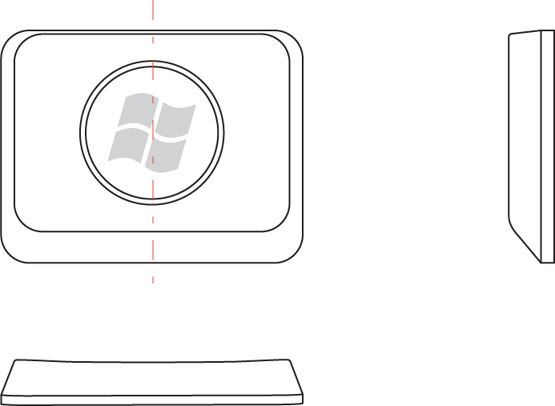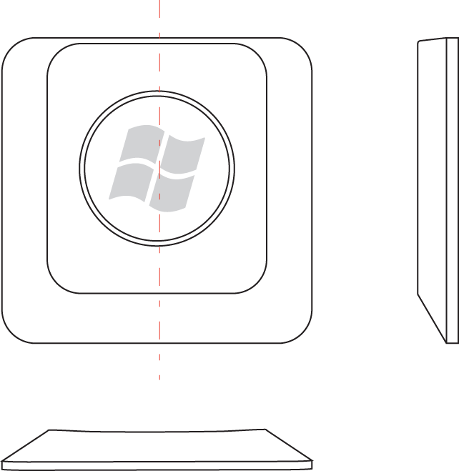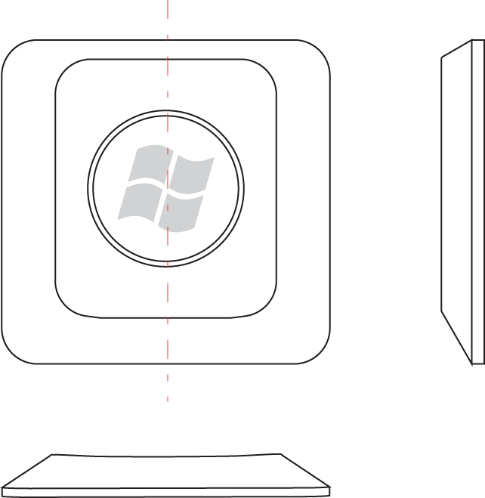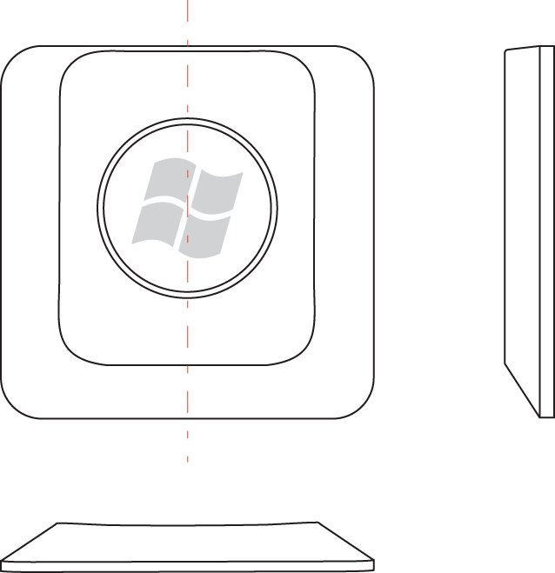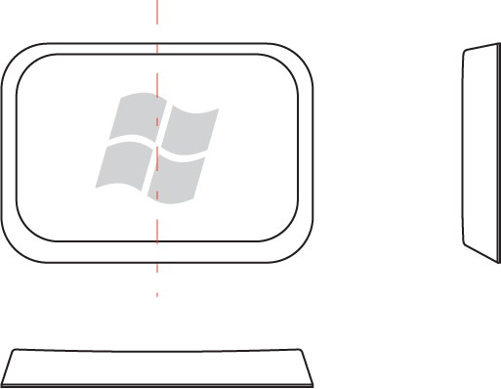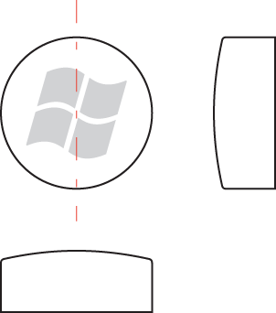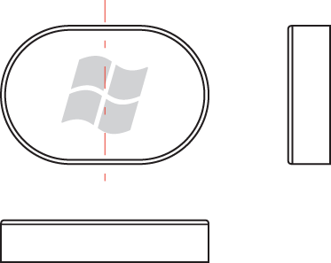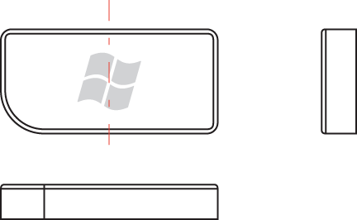
Figure 20: Sample views of the Hardware Start Button for very short keycap and very small keycaps

Non-Conventional Keycap Recommendations
The examples in Figure 21 include one conventional keycap design and two non-conventional keycap designs for reference.
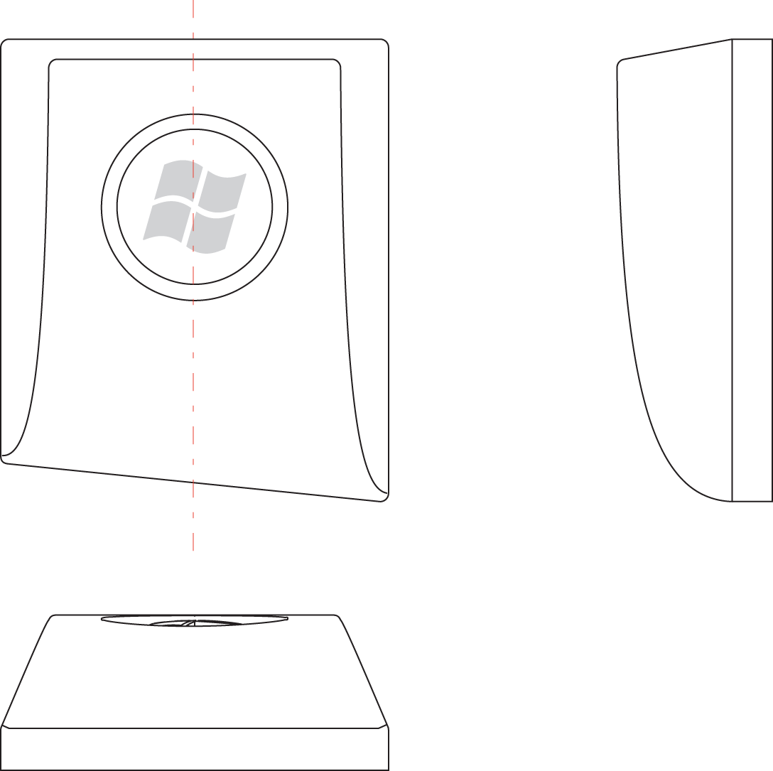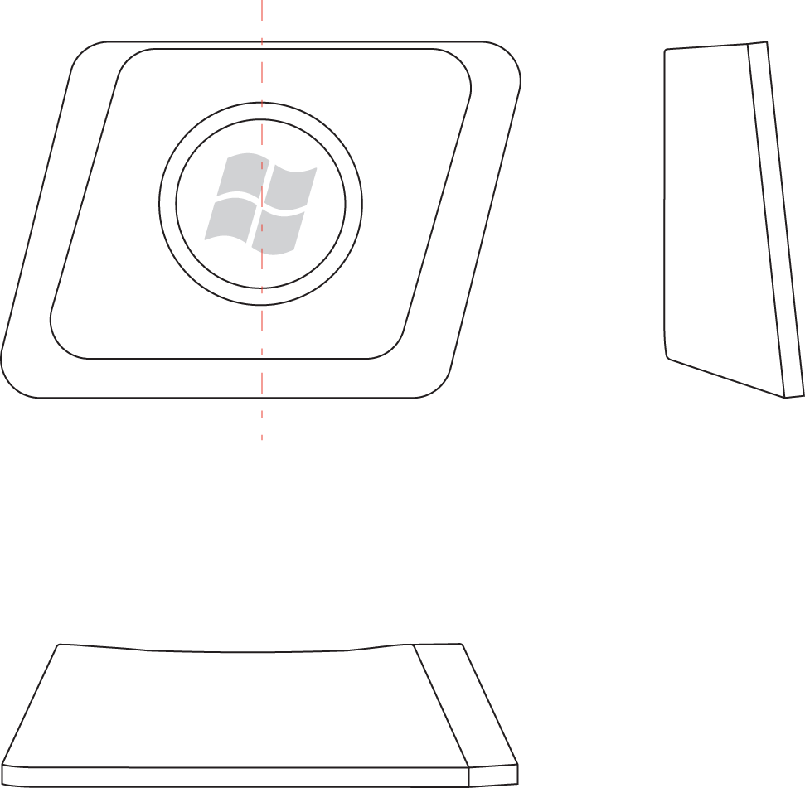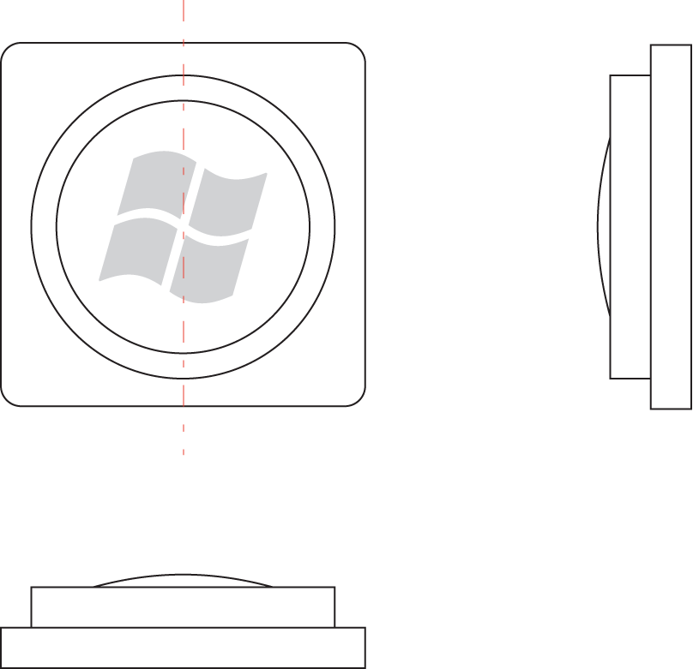
Figure 21: Sample views of Hardware Start Buttons for non-conventional keyboard keycaps (with a conventional keycap for reference)

